# Project Description

## **Overview**

Our project for assignment 3 will be the development of an application to be used in the Childcare industry of Australia to monitor and track the required observations of learning outcomes for children in a day care setting.

In the Child Care industry each child’s learning outcomes are assessed on a monthly basis which is primarily a manual task. Our project deliverable is to design and develop a Java application that will be to be used across multiple platforms that aims to reduce the amount of time spent on paperwork and thus allowing educators to focus their time on children, improving their education experience.

.

This project will involve work in several IT areas including:

* Developing the application using a Java IDE
* Server-side knowledge for hosting and potential data storage
* Using a GitHub repository to store and access the project files
* Applying a testing and QA methodology to identify any issues and provide a feedback on changes
* Providing an easy to use and effective UI experience
* Implementing secure data security, storage, and encryption for private information

## **Motivation**

Currently in Australia there are more than 15,000 childcare and education services that operate under the national quality framework. Workers across these services must record the observations of multiple learning outcomes for each child in their care, today this is a manual process which involves tracking these observations manually.

Improving the working capacity of employees in an essential industry by providing an alternative that is easy to learn and use for all users, regardless of background of IT knowledge is a key motivation for our team and this project.

Providing an easy to use mobile application – or application that can be used across multiple devices – to replace potentially redundant manual work is something that is all too familiar in today’s IT landscape. Improving business processes and ways of working is a key aspect of Information Technology and targeting an industry as critical as child care in Australia will provide a lot of exposure and potentially a lot of users.

Technically using a programming language such as Java and utilising a cloud storage option providing essentially 24/7 availability is becoming the norm with most applications in the IT industry.

Completing this project would demonstrate to a future employer a number of positive aspects:

* Competency in a commonly used development language (Java)
* Knowledge in maintaining storage of data – and potentially exposure to encryption and various aspects of data security
* Working effectively in a team – assigning tasks, high-level communication and escalation management
* Showing initiative in learning new skills and exploring what options are available for designing and completing a project

## **Landscape**

Based on our group’s research we believe there is little to no competitors that we would be up against the in this space and industry. This could be due to several reasons:

* Barriers to change that exist within the industry such as users not willing to adopt new processes or change. A lot of industries use legacy processes and ways of working because they are familiar and have worked in the past. This can make it difficult to implement change or introduce new systems.
* A heavily regulated industry such as the childcare industry could be intimidating and prove too difficult to approach with a new solution or application. However, we have shown so far that with the correct planning and ensuring that any application and software that has the flexibility to adapt to these changes can be successful.

Although we have not been able to uncover any information on competing applications that are also targeting this space it would be naïve to assume, we are the only application vying for change in the market. This must be reflected in our overall project plan and it must be robust and flexible enough to be able to go head-to-head against potential competitors.

## **Detailed Description**

### Aims

The aim of our application is to make redundant the manual work that is currently done to record observations of learning outcomes in day care centres. These outcomes must be recorded per child throughout the course of a year at these centres, some 15,000+ across Australia, which results in loss of time spend educating children. Recording and maintaining almost any sort of vital information in any industry should be looked at as potentially an issue – user error, damage and even storage of paper-based sensitive information can be hazardous and poses an unnecessary risk when compared to the alternatives an IT solution such as our application could offer.

Our aim is to be the primary used application across day care centres in Australia for recording these observations, essentially being a market-leader due to the current lack of competitors in the field and because of the innovation and updating of current business processes we will target,

The first goal must be to provide a practical and intuitive UI as our target market is potentially end-users with limited or no IT knowledge and background. The application must be easy to use and incorporate into every-day practice – users must clearly see the benefits of adopting a new solution or tool to ensure a high level of user adoption. Disrupting an industry-wide practice regardless of the potential positive impact is very challenging and without an easy to use application we risk not making it past an early hurdle.

Ongoing development and future scalability of features means that the application must be developed in a well-know, robust programming language. Because of this the design up until this point has been done in Java. This should somewhat ‘future-proof’ the application in regard to maintaining code as well as potentially expanding the scope of the application and even having other developers review and contribute to the code. Java is a very common programming language that is widely used in the development of applications – so we are reducing the risk of developing in a language that may become outdated or sub seeded by another programming language (or tool) in popularity.

Due to the industry that the application is targeting another goal will be to ensure that all government regulations and requirements relating to the childcare industry and the use of technology are met. Regulations and processes around storing of sensitive and personal data (names, addresses, age etc) along with how this information is encrypted and accessed are key areas that will require on-going attention. Our goal is to ensure that the application is flexible enough from a development standpoint that the ever-evolving regulations and rules can be met and any changes aren’t detrimental to the application – or would result in long-term downtime of the application.

### Plans and Progress

Here you should give as much detail as you can about what your project will do, and how you will do it. This should also include how far you have got with developing any features or outcomes from your project. Tell us about the “story" of your project – how it began, how it has progressed, and what stage of the plan you are up to. Include any dead-ends you may have followed, decisions made, and changes that have been made to the project plan. This will need to include a significant amount of detail, so that it is easily seen what precisely you have done and are planning to do. If it helps, imagine the information that would be required if you were to hand this project over at the end of the semester to a new team to complete the job. What would you want to know, if you were one of the people taking over? *There is no set length for this section, but it is hard to believe that less than two pages could be adequate. Three or four pages is far more likely.*

1. ***How application began – history and background***
2. ***What has progressed since Assignment 2?***

* Significant development work
* UI update
* Should we provide detail on the programming here? Code changes?

1. ***Tools used for development and development process?***

The primary tool that has been used is Java SE Development Kit (JDK) which is a software development environment used for development of Java applications. Our team has also continued to use a Git Hub repository, so all members have access to the project files, and the ability to make changes, complete testing, and quality assurance throughout this project phase.

Although not a development tool, Microsoft Teams has been extensively utilised throughout the project. Teams has allowed the entire group to stay in regular communication, used to assign deployment tasks and provide feedback and updates to other team members. Project management is a key and potentially underestimated aspect of a development project, keeping on top of tasks and admin work is vital to ensure that deadlines can be met.

1. ***What stage are we at now that Assignment 3 has finished?***
2. ***Development problems that have been encountered***

Due the fact the application has been developed using Java ensuring backwards compatibility with older Java versions has been something that we need to consider. For example a project compiled on the latest version of Java won’t run on an older version of Java – which shouldn’t be an issue for people with a background or knowledge in IT, however in the wider context of the project would mean that all devices utilising the application would have a minimum version requirement. This is challenging as is it can be somewhat out of the hands of our team once an end-user(s) starts using the application. Ensuring users update their devices is not an uncommon problem for applications, however this could potentially be a serious challenge.

Another key issue which has impacted the development of the application has been keeping in line with the national framework used by the childcare industry in Australia – these requirements and regulations are constantly evolving and means that any changes to the application (data storage, form information, observation notes, etc) might need to be made at short-notice. Most applications and projects have a roadmap based on ideas and innovations they wish to see in the future, however we would need to ensure that some future capacity is designated to the possibility of this framework changing.

1. ***Any changes from the original idea?***

The original idea was to develop an application that could provide a way to tack the learning outcomes for a particular observation for a child digitally that would reduce the need for paper work and records whilst also reducing the overall time spent by an educator documenting these observations.

We feel that the original idea still exists, the application however has needed to evolve to match the current needs and environment of the childcare industry. There have been no major changes to the original idea that been made due to the changing needs and requirements.

1. ***Testing and QA process in Assignment 3***

Given that the project had to be completed in a fairly short amount of time along with the fact that there were a number of development changes and subsequent testing, we required a proven testing & QA methodology to follow to ensure that a robust and well tested application was the end result. Several popular methodologies were considered (Agile, Waterfall, Extreme programming) however we decided that the iterative method would be the most effective for a project of this size and number of team members.

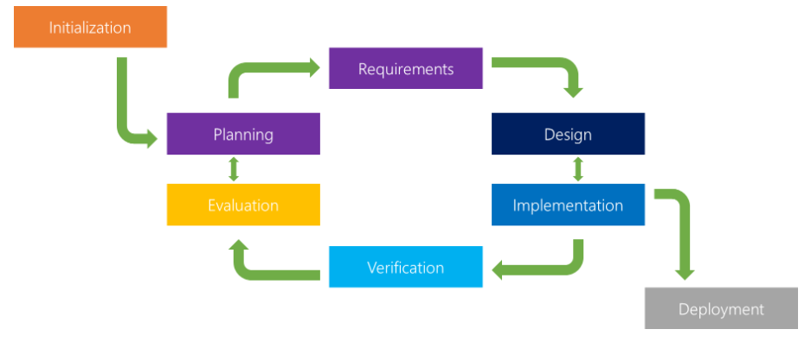

Figure 1 Example Iterative QA Methodology Workflow

Following assignment 2 we had an initial version of the Childcare Observations application – this meant that for the planning & requirements we could simply build on the original version and add a subset of requirements and goals that would be targeted for assignment 2.

During the assignment there were a number of iterative changes made to the application (Code changes, UI changes, changes to executable file) which resulting in a various ‘cycles’ of the QA process to ensure that all changes were tested, verified and evaluated by the team before any further changes were planned and developed.

The strength of this QA process is that it allows for smaller, ongoing changes to the application to be completed and tested prior to the final deployment. This means that any issues or bugs with the changes or usability of the application are identified quickly and are less likely to impact a final deployment or deadline.

1. ***Future plans and opportunities to improve application***

Several improvements to the application that could be targeted in the future have been identified and incorporated into our extended timeline (+10 weeks). These include both new features and functionality as well as making improvements to some existing functionality that has been developed up until this point.

A key development change will be a design change to allow the application to run in 1 window – currently pop-up windows are required when navigating the application and selecting different menu options. This change would increase the usability and overall UI experience for the end-user.

From an infrastructure & hosting perspective changes will be made to allow the secure saving of a file type other than .csv – which is currently the file type that is saved. Ideally some form of encryption at rest and a secure transfer method would be required given the data that will be saved. Personal information as well as details on the child’s observations are potential risks and is data that would need to be securely stored.

Prior to end-user testing changes have also been planned to accommodate an improved menu as well as help files. During end-user testing any FAQ’s that users may need to review – or the ability to log feedback and issues found – means that some further development changes must be made to the application to allow this.

### Roles

It is sometimes useful to define roles for particular participants, such as Lead Developer, or Technical Designer, or User Interface Designer. It is also possible that roles are changed from week to week, depending on what needs to be done next. Have you defined any specific roles for your project? If so, describe and justify these. If not, describe your process and justify why there are no specific roles.

* **Development (Multiple Roles)**
* **Project Management**
* **Testing and QA**

### Scope and Limits

*“There's no such thing as perfection. You're never finished with a film. You run out of time.” -- Peter Jackson, director of `The Lord of the Rings’ and ‘The Hobbit’ trilogies*

One of the more difficult parts of project planning and execution is to define the scope and limits of the project. As mentioned above, you never really complete project like these; all you can ever do is your best in the time available. Part of that involves setting priorities and accepting that there will be features that will take too long to develop. This means that it is important to set a scope for your project, as a means of ensuring that you make the most of the time available. For example, if you are developing a game, you might consider only producing one level and two or three characters, in order to show a proof-of-concept, rather than develop three levels and ten characters.

The scope is probably the most crucial part of your plan, and also the most difficult to define. One way to define the scope is to think of the deliverables for your project, i.e. what outcomes would you be able to show to someone who asks you to see the results of your work. This will also include several statements about what will not be part of the project. For example, if you are using Open Street Maps to show the location of all your favourite shops, the deliverables would include the updated map, but not the Open Street Maps technology itself. It would also not include many other features of Open Street Maps, or other interesting location -- just those which show your favourite shops.

Also, be aware of the phenomenon of `scope creep', which is the tendency for projects to incorporate more and more features. There is nothing wrong with being ambitious, but you only have a certain amount of time. At least one paragraph is expected.

* **In scope v out of scope diagram. Out of scope would be future items we intend to include.**

### Tools and Technologies

A number of tools and technologies have been used for the development process and for the eventual deployment of our project. They have been broken down into their various components and uses in the following tables.

|  |  |
| --- | --- |
| Windows or Linux Development Environments | |
| *Software* | *Development License Required* |
| Eclipse IDE | <https://www.eclipse.org/legal/epl-v10.html> |
| Java JDK 13 & 14 | <https://www.oracle.com/downloads/licenses/javase-license1.html> |
| Microsoft Teams | <https://www.microsoft.com/en-au/servicesagreement> |
| Adobe Acrobat Pro | <https://acrobat.adobe.com/au/en/acrobat/pricing.html> |
| Brackets | <https://creativecommons.org/licenses/by-sa/2.5/> |
| Notepad++ | <https://www.gnu.org/licenses/gpl-3.0.html> |
| Git | <https://opensource.org/licenses/GPL-2.0> |
| Chrome | <https://www.google.com/chrome/terms/> |
| Firefox | <https://www.mozilla.org/en-US/MPL/> |

|  |  |
| --- | --- |
| Deployment Environment Requirements | |
| *Software* | *Commercial use License* |
| MS Win10 | [https://microsoft.com/en-us/licensing/product-licensing/windows10](https://www.microsoft.com/en-us/licensing/product-licensing/windows10) |
| Java SE 8 | <https://www.oracle.com/java/java-se-subscription.html> |

|  |  |
| --- | --- |
| Programming Languages, Markup Languages & File Formats. | |
| *Format/Language* | *Information* |
| Java | <https://www.java.com/en/> |
| C++ | <https://www.w3schools.com/cpp/cpp_intro.asp> |
| CSV | <https://tools.ietf.org/html/rfc4180> |
| HTML | <https://www.w3schools.com/html/html_intro.asp> |
| XML | <https://www.w3schools.com/xml/xml_whatis.asp> |
| PDF | <https://acrobat.adobe.com/au/en/acrobat/about-adobe-pdf.html> |

|  |  |
| --- | --- |
| Hardware Required for Development and Deployment | |
| *Development* | *Deployment* |
| Desktop Computer/s & peripherals capable of running Microsoft Windows 10 | Desktop Computer/s & peripherals capable of running Microsoft Windows 10 |
| Router or modem for internet connection |  |

|  |  |  |  |  |  |  |
| --- | --- | --- | --- | --- | --- | --- |
| Imagine Dragoons Technology Experience Level Matrix | | | | | | |
|  | *Individual Member’s* | | | | | |
| *Technology* | Ryan | Ben | Morgan | Douglas | Ty | Robert |
| Java |  | 1 |  |  |  |  |
| C++ |  | 1 |  |  |  |  |
| HTML |  | 3 |  |  |  |  |
| Eclipse |  | 1 |  |  |  |  |
| Acrobat Pro |  | 0 |  |  |  |  |
| Git |  | 2 |  |  |  |  |
| Office Apps |  | 4 |  |  |  |  |

*Table Legend:* Cells coloured Red indicate a non-professional level of experience as a self-assessed rating of 0 (nil experience) to 5 (high experience). Cells coloured Yellow indicate professional level of experience in numbered years.

### Testing

Throughout the assignment we have been following an iterative testing methodology that has given our team the flexibility to continue development of different areas of the application before testing and receiving feedback verification of changes from the team members. Ideally, we would continue to use the iterative testing methodology for future planning, development and subsequent QA and testing of the application.

Although the iterative methodology has been successful for the initial development phase eventually, we will require end-user testing the application, which we will need to take a different approach to testing and receiving feedback.

After reviewing different methodologies for end-user testing, we have decided to the most suitable for our application would be unmoderated remote usability testing. Given that the industry our application will be utilised in wouldn’t be suitable for on-site or guerrilla testing we need an approach without a moderator present, whilst still provide enough users to produce a large enough sample size for feedback and reporting of any issues.

Unmoderated remote usability testing occurs remotely without a moderator, it’s quick and inexpensive whilst still providing testing results and feedback. We would ask end-users to trial the application in their day-to-day roles and provide a platform for them to provide feedback or report any issues – most likely via a quick survey, or by providing a contact email.

We would potentially have access initially to a sample size of test end users given Ryan’s history and contacts within the childcare industry. This would be a good way initially to gauge how successful testing is and what type of feedback and issues are encountered initially before extending the scope of test users.

One drawback would be that without a moderator present we would receive less detailed information, or users would have to wait to receive feedback for any questions they had or any issues that were encountered with the software. However, weighing up the available options we feel that this is the less intrusive way to have a large number of potential end-users to test the application and provide the feedback that would be required.

### Timeframe

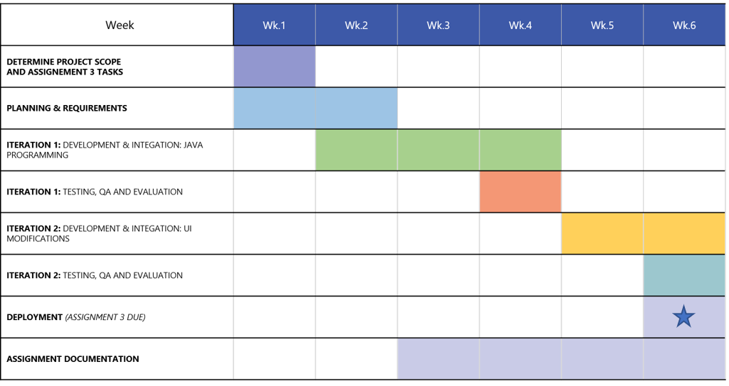

**Future Plan to Improve Application:**

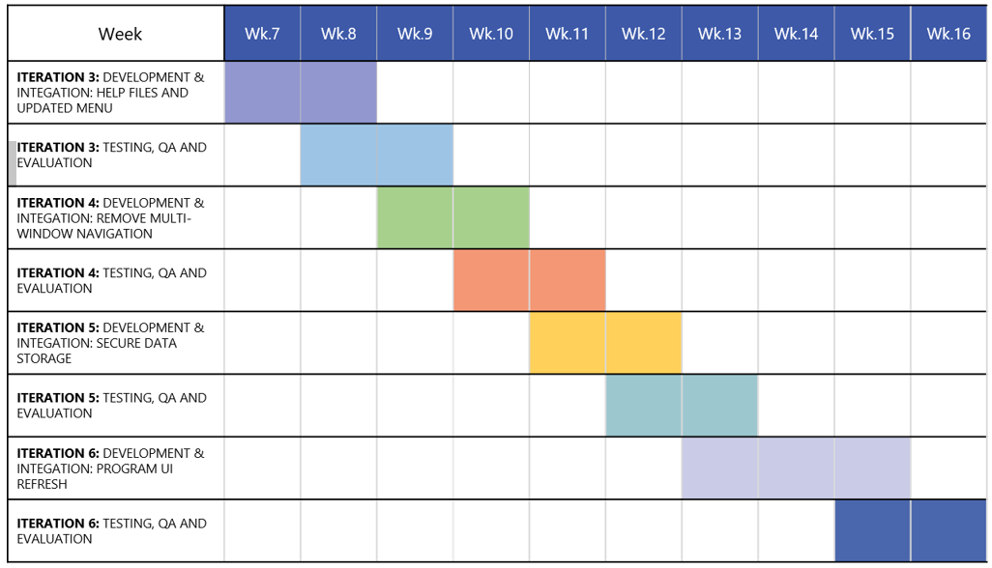

### Risks

As with any IT project and application there are going to be risks that might impact the project either partially or proceed to be a critical or ‘showstopper’ risk that cannot be mitigated. We have outlined numerous times in this document the childcare industry must operate a strict and evolving set of government and industry regulations, and although we have ensured that the application and development has taken this into consideration thus far – and also makes plans in our future timeline – there is a risk that changes to policies around data storage, childcare policies or even applications that may be approved for usage are all potential risks that might be encountered deeper into the lifecycle of this application.

Another key risk that might be potentially overlooked is successful user adoption of a new tool that will become a part of the everyday business process for some people. This is often a major challenge and involves ensuring that future end-users of the application feel that there is enough benefit to making a change to a new tool and have the confidence in that it will improve their current processes whilst being easy to use and learn. Any lack in confidence or issues with the application heightens the risk of users simply moving back to their old ways of working – which although we know can be improved, have been proven to work in the past.

### Group processes and communications

During the early stages of this semester when our group was first formed, we have been utilising Microsoft Teams as the primary communication tool for our group. This has been extremely helpful in almost all aspects of managing this assignment and ensuring that all members have a direct line of communication for feedback, updates and general communication and discussion throughout the semester.

Primarily flagged as a communication tool we have also been able to use Teams for other aspects of our assignment such as,

**Project Management**

* + Creating channels for the breakdown of the assignment and requirements for each section
  + Assigning and volunteering for tasks for the assignment
  + Sign-off of completed sections and work once available for review

Fortunately, we have not had to implement any escalation procedures during this assignment – or in the previous assignment this same team completed earlier this semester. Ideally if there were non-responders or missing/not completed work we could discuss internally in the team and as a last resort potentially escalate to a tutor for the course.

Thankfully, we have been able to focus solely on the assignment work and details and not be distracted or feel like the quality of work has diminished because of having to deal with negative aspects of team communication.