PROSTATEx-2 Challenge 2017

# SPIE-AAPM-NCI Prostate MR Gleason Grade Group Challenge

# Training Set Release

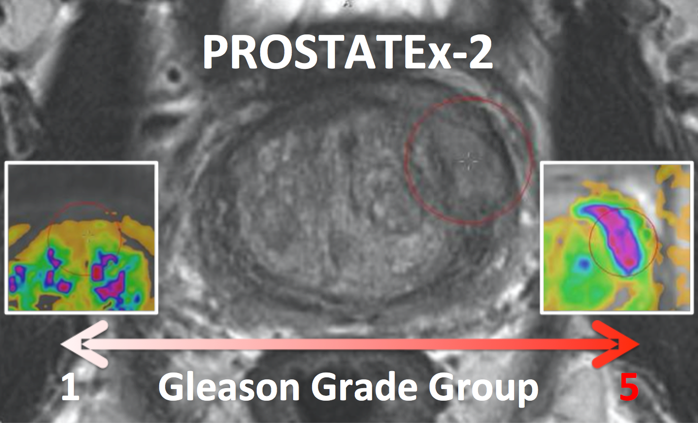

For more information: [www.aapm.org/GrandChallenge/PROSTATEx-2/](http://www.aapm.org/GrandChallenge/PROSTATEx-2/)

PROSTATEx-2 Challenge website: http://spiechallenges.cloudapp.net/competitions/7

This document provides information about the annotated prostate MR images provided with the PROSTATEx-2 Challenge and available on TCIA under that same name.

This document should be accompanied by two files: ProstateX2-Findings-Train.csv and ProstateX2-Images-Train.csv.

H.J.Huisman, May 2017 

# Images (see the file ProstateX2-Images-Train.csv)

Prostate MR in accordance with ACR PIRADS2.0 comprises at least 3 types of images or parameters that should be jointly analyzed for the assessment of prostate cancer. The prostate MR imaging was performed at the Radboud University Medical Centre (Radboudumc) in the Prostate MR Reference Center under the supervision of Prof. Dr. Barentsz. The Radboudumc is located in Nijmegen, The Netherlands. The dataset was collected and curated for research in computer-aided diagnosis of prostate MR under the supervision of Dr. Huisman (Radboudumc) as documented in:

G. Litjens, O. Debats, J. Barentsz, N. Karssemeijer and H. Huisman. "Computer-aided detection of prostate cancer in MRI", *IEEE Transactions on Medical Imaging* 2014;33:1083-1092.

If you use this data for research, then please refer to the above publication.

The images come in two encodings. The acquired MR images are provided in DICOM format. Additionally, Ktrans images are provided in mhd format; Ktrans is a key pharmacokinetic parameter computed from the available dynamic contrast-enhanced T1-weighted series. Each patient has one study with three sets of DICOM images (transaxial T2-weighted images, sagittal T2-weighted images, and apparent diffusion coefficient (ADC) images computed from diffusion-weighted (DWI) imaging) and one set of Ktrans images. The Ktrans images are encoded in two files ProstateX-[ProxID]-Ktrans.[mhd/zraw], where ProxID is the ProstateX patient identifier. The DICOM images comprise several series each comprising several instances. The DICOM files are documented in the ProstateX2-Images-Train.csv file. The columns in that file contain the following:

* ProxID – PROSTATEx-2 patient identifier
* Name – Series description
* studydate – Study date
* fid – Finding ID
* pos – Scanner coordinate position of the finding
* WorldMatrix – Matrix describing image orientation and scaling
* ijk – Image column (i), row (j), and slice (k) coordinates of the finding; using the VTK/ITK/Python array convention, (0,0,0) represents the first column and first row of the first slice
* SpacingBetweenSlices – Scalar spacing between slices
* VoxelSpacing – Vector with x,y,z spacing scalars
* Dim – Vector with 4D dimensions of the image
* DCMSerDescr – Original DICOM series description
* DCMSerNum – DICOM series number
* DCMSerUID – DICOM series UID

For example, to get the ADC image of patient ProstateX-0123 do the following. Import the DICOM files into your environment, go to patient ProstateX-0123, and find the series with ADC in it. In this case it is ‘ep2d_diff_tra_DYNDIST_ADC0’. It has SeriesNumber 8. The DICOM images in that series form the ADC image for this challenge. Image slice j at coordinate i,j contains a finding fid. See below for more details on findings.

# Findings (see the file ProstateX2-Findings-Train.csv)

The findings are a subset of the prior PROSTATEx findings of cancer lesions with biopsy information. All image and finding encodings are the same for PROSTATEx-2 as they were for PROSTATEx. The provided data for PROSTATEx-2 is a subset containing only the selected findings.

The training findings are documented in the ProstateX2-Findings-Train.csv file. Documentation for the columns in that file is as follows:

* ProxID – PROSTATEx-2 patient identifier
* fid - Finding ID
* pos - Scanner coordinate position of the finding
* zone – Anatomic zone containing the lesion within the prostate
  + AS – Anterior fibromuscular stroma
  + PZ – Peripheral zone
  + SV – Seminal vesicle
  + TZ – Transition zone
* ggg – Gleason Grade Group