Listlerden devam et
“xxcomebackxx” is the code for problematic parts in files. Search and find easily.
App/conf/local is realted with hard coded relations, I suppose
Helpful links
https://providence.readthedocs.io/en/latest/dataModelling/profiles/XMLSchema.html
https://manual.collectiveaccess.org/providence/user/dataModelling/listsAuthorities.html
https://collectiveaccess.org/support/index.php?p=/discussion/300853/related-places
https://manual.collectiveaccess.org/providence/user/editing/preferences.html

Issues
Resources
Unique Identifiers
We have ID elements different for objects, projects(collections), participants(entities) and vocabularies. Should we have 1 element to be used in all different tables or should we create individual ID elements for each table? Right now I am creating different elements for each tables.
Member of
This is actually represent parent collection. We use ca_collections bundle to map. I leave the metadataElement code empty for now.
Resource Title Preferred
Using the preferred_title bundle but it is default. I leave the metadataElement code empty for now.
Digital Representation
Normally system uses ca_object_representation in the system. I leave the metadataElement code empty for now. Also data type could be url. Excluded it from the list. We can directly use default media element with ca_object_representation.
Language
Also problematic. Should we use primary and other language as two different metadata, or only one? Need to add list names here.
Geolocations
How can we create them if we create geolocations in places table. Something to think about.
-datatype=”Places” is an option
<settings>
<setting name="restrict_to_types">country</setting>
</settings>
Dates
I am creating only one element for three element types. With type and value sub elements. A not will be written. Info inside is empty.

Participants
Id
Same Issue with resources id
Add multiple button for elements/
Language of material looks bad.
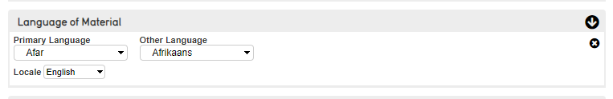

access_statues list used for Anonymised. But didn’t work somehow. Need to check again.
Country elements name must be more clear. Participant birthplace or what?

Lists
Place_types
Address, imaginary, region to be add
Date_types
Digitisation, birthdate to be add

Relationships
rightsholder, creator, contributor to be add

