Contents

**Part 1: Tower Definition** 2

**Main Tower** 3

**Robot5** 4

**Robot2** 5

**Robot7** 6

**Robot10** 7

**Robot12** 8

**Part 2: Element power** 9

**Ice** 9

**Fire** 9

**Poison** 9

**Dark** 9

# **Part 1: Tower Definition**

Damage formula:

float healthLose = ((float)this->attack / (0.5 + target->defense / 100.0));

// defense >= 0

Basic statistics (stats) meaning:

Health: Object will die if this stat <= 0

Attack: Affect Object's output damage

Defense: Affect Object's damage receive

Speed: Affect Object's movement speed

Attack Rate: Affect Object's attack speed

Range: Affect Object's attack range

Regeneration: Affect Object's Health regeneration, =0 in most cases.

DPS (damage per second) = Attack * (1 / AttackRate) + Exception, to estimate gold cost

Durability = Health * (0.5 + Defense / 100), to estimate gold cost

## **Main Tower**

Description: Destroy your opponent's Main Tower to win the game. This tower is strong a bit enough to protect itself in early game, and recoverable. You should upgrade this tower ASAP to unlock new units, and upgrade your army.

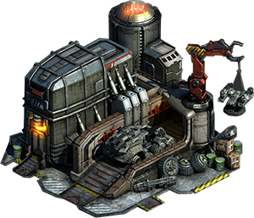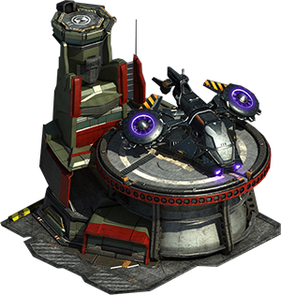

Health 1000 / 1200 / 1400

Attack: 100 / 120 / 150

Defense: 50 / 75 / 100

Speed: 0

Attack Rate: 1 / 0.75 / 0.5

Range: 800 / 900 / 1000

Regeneration: 1 / 2 / 3 (Health per second)

DPS: 100 / 160 / 300

Durability: 1000 / 1500 / 2100

Can upgrade 2 times: Main Tower 2: 200 gold, 3 energy

Main Tower 3: 500 gold, 5 energy

## **Robot5**

Description: normal and cheapest unit.

Cost: 50 gold



Health 300 / 500 / 700

Attack: 20 / 25 / 30

Defense: 50 / 50 / 75

Speed: 10

Attack Rate: 1 / 0.75 / 0.75

Range: 450 / 500 / 500

Regeneration: 0

DPS: 20 / 33 / 40

Durability: 300 / 500 / 875

Can upgrade 2 times: Robot5 2: 200 gold, 1 energy

Robot5 3: 350 gold, 1 energy (require MainTower 2)

## **Robot2**

Description: long-range unit

Cost: 75 gold

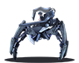

Health 300 / 400 / 500

Attack: 30 / 45 / 60

Defense: 20 / 35 / 50

Speed: 8

Attack Rate: 0.9 / 0.8 / 0.7

Range: 700 / 750 / 800

Regeneration: 0

Special: Lucky Shot: the 3 / 4 / 5th shot will deal x1.5 / 1.75 / 2 damage

DPS: 33 / 56 / 85

Durability: 210 / 340 / 500

Can upgrade 2 times: Robot5 2: 350 gold, 2 energy (require MainTower 2)

Robot5 3: 650 gold, 3 energy (require MainTower 3)

## **Robot7**

Description: melee and tanky warrior

Cost: 75 gold

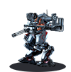

Health 500 / 1000

Attack: 15 / 15

Defense: 100 / 150

Speed: 5

Attack Rate: 0.5 / 0.5

Range: 150 / 200

Regeneration: 0

DPS: 30 / 30

Durability: 750 / 2000

Can upgrade 1 times: Robot7 2: 800 gold, 3 energy (require MainTower 3)

## **Robot10**

Description: Crazy wolf, fast speed and regeneration

Cost: 100 gold (require MainTower 2)

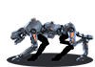

Health 300 / 500

Attack: 50 / 50

Defense: 100 / 100

Speed: 13 / 15

Attack Rate: 0.75 / 0.75

Range: 75 / 75

Regeneration: 6 / 12 (h/s)

Special: Enraged: double amount of recover when health below 50%

tripple amount of recover when health below 25% (upgraded)

DPS: 67 / 67

Durability: 450 / 750

Can upgrade 1 times: Robot10 2: 800 gold, 5 energy (require MainTower 3)

## **Robot12**

Description: multi-target helicopter

Cost: 125 gold (require MainTower 3)

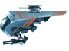

Health 500

Attack: 150

Defense: 50

Speed: 8

Attack Rate: 2

Range: 700

Regeneration: 0

Special: Keen Eyes: Attack upto 2 targets, can attack all lines

DPS: 75

Durability: 500

# **Part 2: Element power**

## **Ice**

Add Special to MainTower: Frozen Kingdom: Whoever entered this tower range will be cold, decrease Attack Rate by 25%

## **Fire**

Add Special to MainTower: Flaming Kingdom: Whoever attacked this tower will be burned, receiving 50% of the attacking tower's damage.

## **Poison**

Add Special to MainTower: Rotted Kingdom: Whoever entered this tower range will be rotted, decrease 8% Health per second.

## **Dark**

Add Special to MainTower: Cursed Kingdom: Whoever entered this tower range will be rotted, decrease 25% Attack.