ABC

123

*do X*

*do X*

*do Y*

*do Y*

ABC

100101001

*Do X*

*Inverse*

⚫⚫⚫⚫

⚫⚫⚫⚫

*transform*

⚫⚫⚫⚫

⚫⚫

*distinct*

⚫⚫

*distinct*

⚫⚫⚫⚫

⚫

⚫⚫⚫

⚫

⚫

⚫⚫

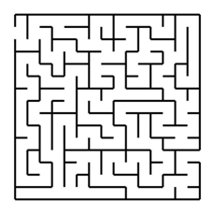

⚫

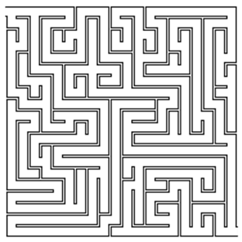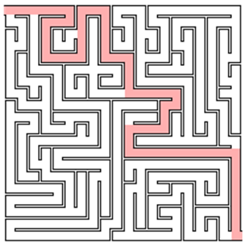

ABC

ABC

123

123

*Compare*

*System under test*

*Test Oracle*

[1;2;3]

?

*do ?*

*do ?*

*List.sort*

*List.sort*

[2;3;1]

[3;4;2]

[2;3;4]

[1;2;3]

*+1*

*+1*

*List.sort*

*List.sort*

[2;3;1]

[2;3;4; -2147..]

[-2147..; 2;3;4;]

[1;2;3]

*Append   
-2147483648*

*List.sort*

*List.sort*

*Prepend   
-2147483648*

[2;3;1]

[-2;-3;-1]

[-3;-2;-1]

[1;2;3]

*Negate*

*List.sort*

*List.sort*

*Negate  
 then reverse*

[2;3;1]

[2;3;1;x]

[x;1;3;2]

[1;3;2]

*Append x*

*List.rev*

*List.rev*

*Prepend x*

[2;3;1]

[-2;-3;-1]

[ ]

[ ]

*Negate*

*List.evilSort*

*List.evilSort*

*Negate  
 then reverse*

*Implies   
pairwise order*

[1;2;3]

[3;2;1]

*reverse*

*reverse*

[2;3;1]

(1<=2) (2<=3)

[1;2;3]

*List.sort*

“a,b,c”

*split*

“a”

“b”

“c”

“a,b,c”

*Combine and verify*

[2;3;1]

[1; 2; 3]; [2; 1; 3]; [2; 3; 1];   
[1; 3; 2]; [3; 1; 2]; [3; 2; 1]

[1;2;3]

*List.sort*

*Must be one of these  
permutations*

x

Dollar (x)

Dollar (x*y)

x*y

*Create*

*Times(y)*

*\* y*

*Create*

x

Dollar (x)

Dollar (x*y)

x*y

*Create*

*Times(y)*

*\* y*

*Amount*

x

Dollar (x)

Dollar (x*y)

x*y

*Create*

*Times(y)*

*\* y*

*Create*

Dollar (x*y+z)

x*y+z

*Add(x)*

*+ z*

x

Dollar (x)

Dollar (f x)

f x

*Create*

*Map f*

*f*

*Create*

x

Option (x)

Option (f x)

f x

*Create*

*Map f*

*f*

*Create*

Parent

Child

Child

Subset of capabilities

Full Authority  
(Configuration)

All capabilities

Subset of capabilities

*Private*

Client

Restricted  
capabilities

Full Authority  
(Database)

All  
capabilities

Capability   
Provider

Parent

Child

Child

Restricted capability

Full Authority  
(Database)

All capabilities

Restricted capability

Capability Filter

Restricted

Client

Authorization  
Service

Resource  
Service

1) Present Claims

2) Get Auth Token

3) Present Auth Token

Idle

Lost

Won

In process

initGame

move

reset

Need help with F#?

**fsharp**Works

The premier team for F# training & consulting.

Need help with F#?

**fsharp**Works

The premier team for F# training & consulting.

**Coupling  
Cohesion  
oint of highest abstractio**

|  |  |  |
| --- | --- | --- |
| X | O |  |
|  | X | O |
|  | X |  |

"1"  
"2"  
"3"  
"4"  
...  
"a"  
"b"  
"c"

1  
2  
3  
4

Invalid

"North"  
"East"  
"South"  
"West"  
...  
""  
"a"  
"b"  
"abcdef"

North  
East  
South  
West

Empty

NotValid

TooLong



Too Concrete

Too Abstract

Just right!

Function  
(before)

Dependency1

Dependency2

Param1

Param2

Output

Function  
(after)

Param1

Param2

Output

*Partial Application*