Summer 2019

CSE221 Algorithms

Lab Final

Total Marks: 20 (**Answer any 2**)

1. [CO: ]Given a square matrix, count the number of squares inside the matrix. A square is a shape that has 4 equal sides. Please refer to the examples below for a clear understanding. You must take input from a text file.

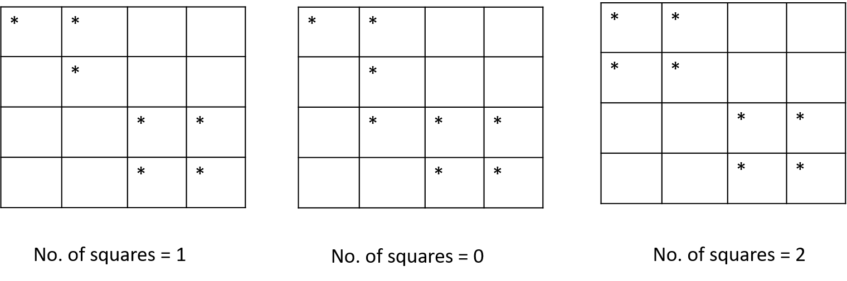

1. [CO: ]Given a Tree color the vertices with alternate colors. Problem Description: Each vertex has a property named color. You will have to paint the vertices with either black or red and the coloring must follow a strict manner. You will start coloring from one vertex, let’s say you colored it black, then its children must be colored red and the red’s children must be black. In this way you have to paint all the vertices. Refer to the diagram below for a better understanding. After painting print the vertices with their colors. [A – black, B – red …..] You must take input from a text file.

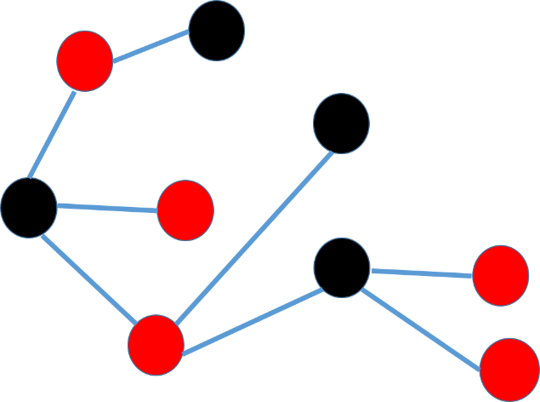

1. Write a program to implement the 0/1 Knapsack algorithm. At first ask the user for the capacity, then number of input, then ask for the weights and corresponding values. Then print the max value in the sack and the items picked.