|  |
| --- |
| In a Bipartite graph, vertices can be divided into two sets, where a vertex from one set is **only** connected to vertices from the other set. Thus, no two vertices within the same set are adjacent.  **Algorithm to find Bipartite Graph using 2-color scheme :**  1. Assign RED color to the source vertex (putting into set U). 2. Color all the neighbors (adjacent vertices) with BLUE color (putting into set V). 3. Color all neighbors’ neighbor with RED color (putting into set U). 4. This way, assign color to all vertices such that it satisfies all the constraints of m way coloring problem where m = 2. 5. While assigning colors, if we find an adjacent neighbor which is already colored with same color as current vertex, then the graph cannot be colored with 2 vertices (or graph is not Bipartite) |

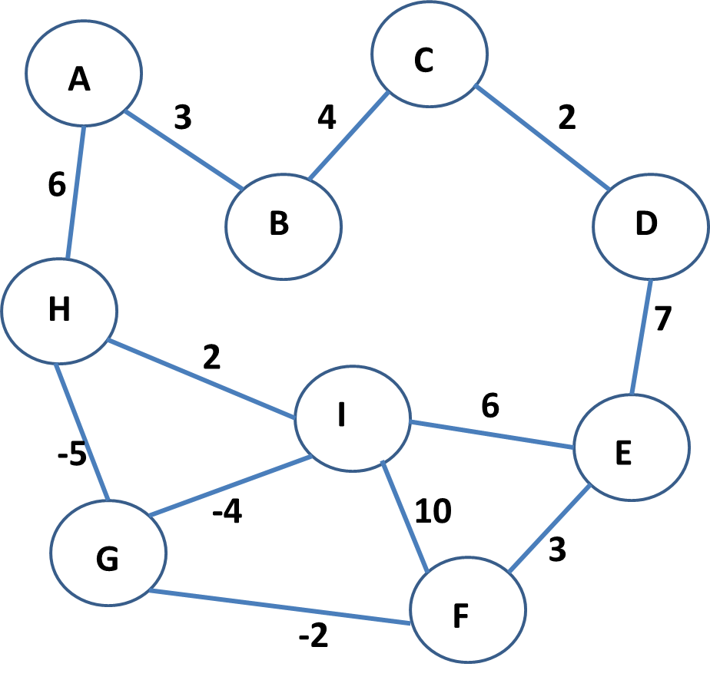

Based on the algorithm above write a code to determine whether a graph is Bipartite or not. Print the colors of each vertex. Start from A.

HINT: Simulate before you code.