At today's meeting to discuss about sql from start create database, table until combine 2 pieces of table or more using join function. while the query used is:

* the first query creates the database by CREATE DATABASE KAMPUS;
* then use database with query USE KAMPUS;
* then make a first table with query CREATE TABLE MAHASISWA (NIM INT NOT NULL, NAMA VARCHAR (20) NOT NULL, ALAMAT VARCHAR (20) NOT NULL, THN_MASUK INT NOT NULL, NO_HP INT, PRIMARY KEY (NIM));
* 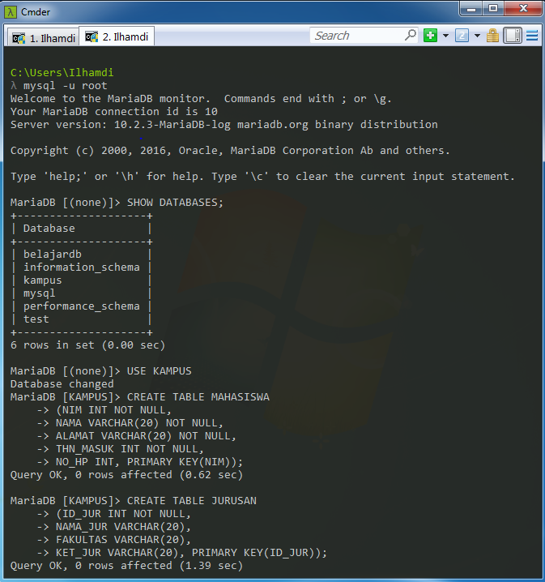then make a second table with query CREATE TABLE JURUSAN (ID_JUR INT NOT NULL, NAMA_JUR VARCHAR(20), FAKULTAS VARCHAR(20), KET_JUR VARCHAR(20), PRIMARY KEY(ID_JUR));

The query entered data into the table.

* INSERT INTO MAHASISWA (NIM, NAMA, ALAMAT ,THN_MASUK, NO_HP) VALUES (1,”IMAM FAHMI F”,”SUBANG”,2012,0897387); and
* INSERT INTO JURUSAN (ID_JUR, NAMA_JUR, FAKULTAS ,KET_JUR) VALUES (1,”TEKNIK INFORMATIKA”,”SAINTEK”,”MOH IRFAN”);

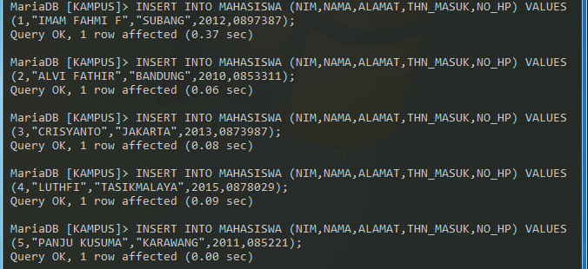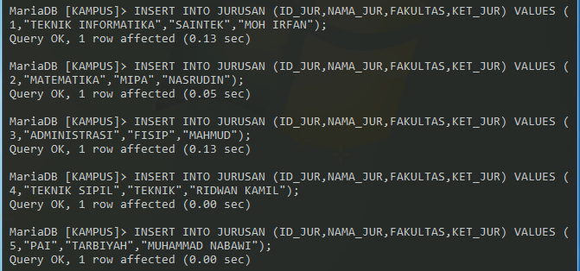

Then displays the table with the query

* 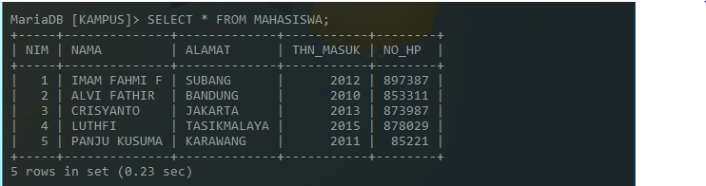SELECT * FROM MAHASISWA;
* 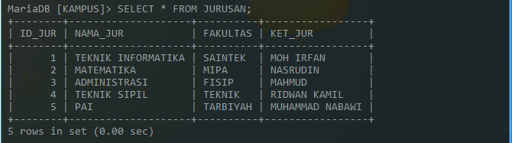SELECT * FROM JURUSAN;

Then combine the table using the join function. there are several join functions include:

1. INNER JOIN

SELECT NIM, NAMA, THN_MASUK, NAMA_JUR, FAKULTAS FROM MAHASISWA INNER JOIN JURUSAN ON MAHASISWA.NIM=JURUSAN.ID_JUR;

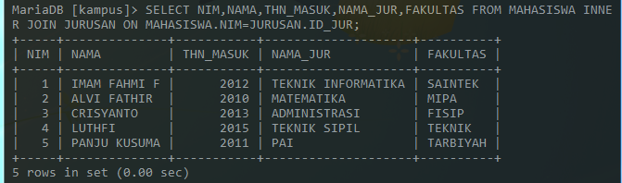

1. LEFT JOIN

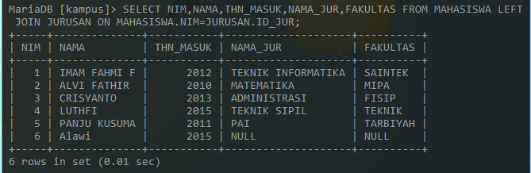SELECT NIM, NAMA, THN_MASUK, NAMA_JUR, FAKULTAS FROM MAHASISWA LEFT JOIN JURUSAN ON MAHASISWA.NIM=JURUSAN.ID_JUR;

1. RIGHT JOIN

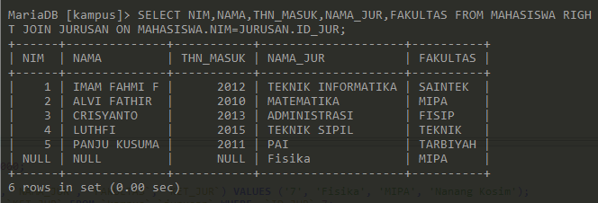SELECT NIM, NAMA, THN_MASUK, NAMA_JUR, FAKULTAS FROM MAHASISWA RIGHT JOIN JURUSAN ON MAHASISWA.NIM=JURUSAN.ID_JUR;

1. FULL JOIN

SELECT NIM, NAMA, THN_MASUK, NAMA_JUR, FAKULTAS FROM MAHASISWA RIGHT JOIN JURUSAN ON MAHASISWA.NIM=JURUSAN.ID_JUR;

UNION ALL

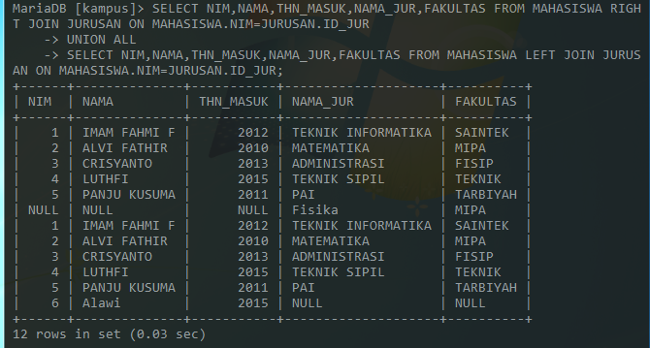SELECT NIM, NAMA, THN_MASUK, NAMA_JUR, FAKULTAS FROM MAHASISWA LEFT JOIN JURUSAN ON MAHASISWA.NIM=JURUSAN.ID_JUR;

1. SELF JOIN

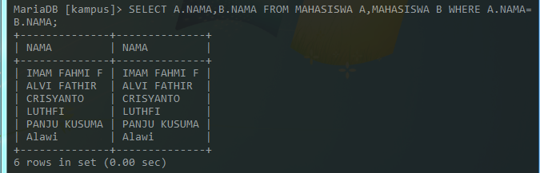SELECT A.NAMA, B.NAMA FROM MAHASISWA A, MAHASISWA B WHERE A.NAMA=B.NAMA;

1. CARTESIAN OR CROSS JOIN

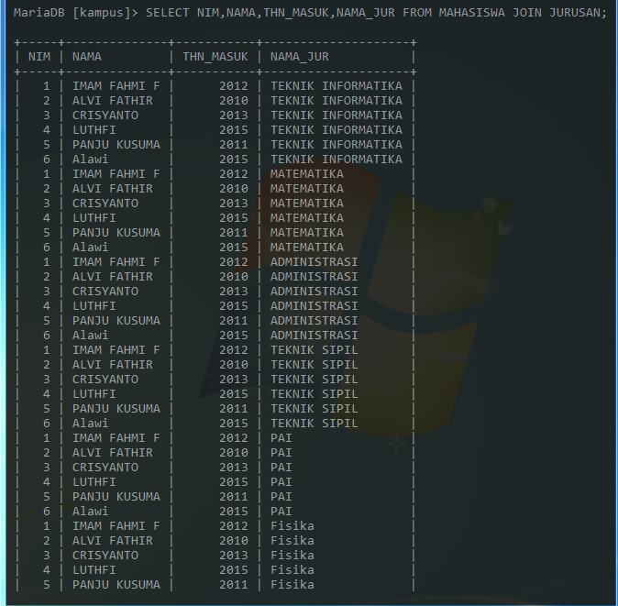SELECT NIM, NAMA,THN_MASUK, NAMA_JUR FROM MAHASISWA JOIN JURUSAN;