**IMAMA KAINAT**

**22F3661**

**SE-4A**

**QUESTION1**

**Question 1**

DECLARE

V_EMPNO INT:= 7369;

V_ENAME VARCHAR2(50):= 'SAREA';

V_EMP_NO EMP.EMPNO%TYPE; -- Corrected variable name

V_EMP_NAME EMP.ENAME%TYPE; -- Corrected variable name

V_EMP_JOB EMP.JOB%TYPE;

V_EMP_MGR EMP.MGR%TYPE;

V_EMP_HIREDATE EMP.HIREDATE%TYPE;

V_EMP_SAL EMP.SAL%TYPE;

V_EMP_COMM EMP.COMM%TYPE;

V_EMP_ROW EMP%ROWTYPE;

V_DEPT_ROW DEPT%ROWTYPE;

BEGIN

SELECT EMPNO, ENAME, JOB, MGR, HIREDATE, SAL, COMM

INTO V_EMP_NO, V_EMP_NAME, V_EMP_JOB, V_EMP_MGR, V_EMP_HIREDATE, V_EMP_SAL, V_EMP_COMM

FROM EMP

WHERE EMPNO = 7788;

DBMS_OUTPUT.PUT_LINE('EMPNO: ' || V_EMP_NO);

DBMS_OUTPUT.PUT_LINE('ENAME: ' || V_EMP_NAME);

DBMS_OUTPUT.PUT_LINE('JOB: ' || V_EMP_JOB);

DBMS_OUTPUT.PUT_LINE('MGR: ' || V_EMP_MGR);

DBMS_OUTPUT.PUT_LINE('HIREDATE: ' || TO_CHAR(V_EMP_HIREDATE, 'DD-MON-YYYY'));

DBMS_OUTPUT.PUT_LINE('SAL: ' || V_EMP_SAL);

DBMS_OUTPUT.PUT_LINE('COMM: ' || V_EMP_COMM);

END;

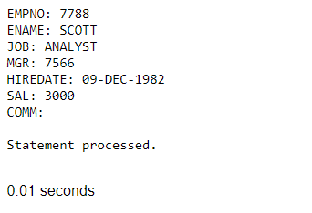

**QUESTION 2**

**DECLARE**

**EMP_INCENTIVE INT := 5;**

**V_EMPNO EMP.EMPNO%TYPE;**

**V_EMPNAME EMP.ENAME%TYPE;**

**V_EMPSAL EMP.SAL%TYPE;**

**V_EMP_UPDATESALARY EMP.SAL%TYPE; -- Added for the updated salary**

**BEGIN**

**SELECT EMPNO, ENAME, SAL, SAL * EMP_INCENTIVE**

**INTO V_EMPNO, V_EMPNAME, V_EMPSAL, V_EMP_UPDATESALARY**

**FROM EMP**

**WHERE EMPNO = 7788;**

**DBMS_OUTPUT.PUT_LINE('EMPLOYNUMBER: ' || V_EMPNO);**

**DBMS_OUTPUT.PUT_LINE('EMPLOYSNAME: ' || V_EMPNAME);**

**DBMS_OUTPUT.PUT_LINE('EMPLOYSALARY: ' || V_EMPSAL);**

**DBMS_OUTPUT.PUT_LINE('EMPLOYUPDATESALARY: ' || V_EMP_UPDATESALARY);**

**END;**

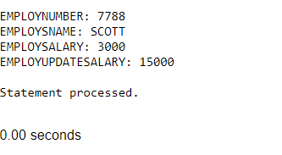

**QUESTION 3**

**DECLARE**

**N NUMBER := 1432;**

**R NUMBER;**

**BEGIN**

**R := MOD(n, 2);**

**IF R = 0 THEN**

**dbms_output.Put_line('Even');**

**ELSE**

**dbms_output.Put_line('Odd');**

**END IF;**

**END;**

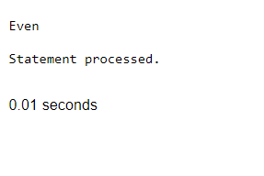

**DECLARE**

**N NUMBER := 1431;**

**R NUMBER;**

**BEGIN**

**R := MOD(n, 2);**

**IF R = 0 THEN**

**dbms_output.Put_line('Even');**

**ELSE**

**dbms_output.Put_line('Odd');**

**END IF;**

**END;**

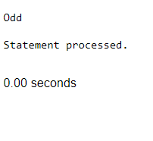

**QUESTION 4**

**DECLARE**

**num1 NUMBER := 14;**

**BEGIN**

**IF num1 < 0 THEN**

**DBMS_OUTPUT.PUT_LINE ('The number '||num1||' is a negative number');**

**ELSIF num1 = 0 THEN**

**DBMS_OUTPUT.PUT_LINE ('The number '||num1||' is equal to zero');**

**ELSE**

**DBMS_OUTPUT.PUT_LINE ('The number '||num1||' is a positive number');**

**END IF;**

**END;**

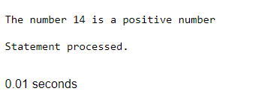

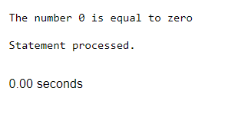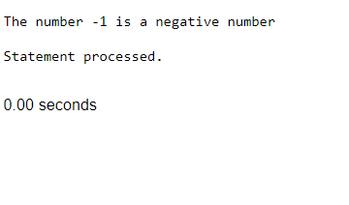

**QUESTION 5**

**DECLARE**

**V_TOTAL_EMPLOYEES INT;**

**V_VACANCIES INT := 45;**

**BEGIN**

**SELECT COUNT(EMPNO) INTO V_TOTAL_EMPLOYEES**

**FROM EMP**

**WHERE DEPTNO = 50;**

**DBMS_OUTPUT.PUT_LINE('TOTAL NUMBER OF EMPLOYEES IN DEPARTMENT 50: ' || V_TOTAL_EMPLOYEES);**

**IF V_TOTAL_EMPLOYEES < V_VACANCIES THEN**

**DBMS_OUTPUT.PUT_LINE('There are vacancies in Department 50.');**

**ELSE**

**DBMS_OUTPUT.PUT_LINE('No vacancies in Department 50.');**

**END IF;**

**END;**

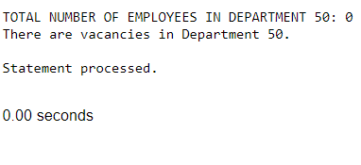

**QUESTION 6**

**DECLARE**

**A NUMBER := 10;**

**B NUMBER := 5;**

**OPERATOR CHAR(1) := '/'; -- Change the operator to perform different operations**

**RESULT NUMBER;**

**BEGIN**

**CASE OPERATOR**

**WHEN '+' THEN**

**RESULT := A + B;**

**DBMS_OUTPUT.PUT_LINE('Addition Result: ' || RESULT);**

**WHEN '-' THEN**

**RESULT := A - B;**

**DBMS_OUTPUT.PUT_LINE('Subtraction Result: ' || RESULT);**

**WHEN '*' THEN**

**RESULT := A * B;**

**DBMS_OUTPUT.PUT_LINE('Multiplication Result: ' || RESULT);**

**WHEN '/' THEN**

**IF B != 0 THEN**

**RESULT := A / B;**

**DBMS_OUTPUT.PUT_LINE('Division Result: ' || RESULT);**

**ELSE**

**DBMS_OUTPUT.PUT_LINE('Error: Division by zero');**

**END IF;**

**ELSE**

**DBMS_OUTPUT.PUT_LINE('Error: Invalid Operator');**

**END CASE;**

**END;**

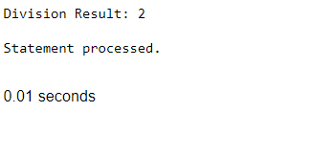

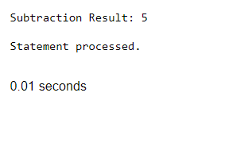

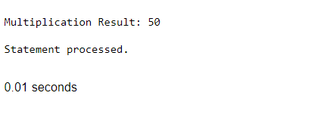

**QUESTION 7**

**DECLARE**

**num INT := 5; -- Change the number to calculate its factorial**

**factorial INT := 1;**

**BEGIN**

**FOR i IN 1..num LOOP**

**factorial := factorial * i;**

**END LOOP;**

**DBMS_OUTPUT.PUT_LINE('Factorial of ' || num || ' is: ' || factorial);**

**END;**

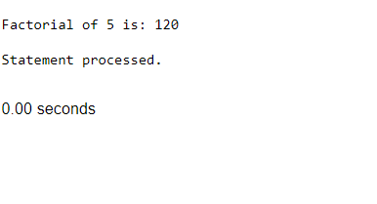

**QUESTION 8**

**DECLARE**

**v_empno EMP.EMPNO%TYPE := 7788;**

**v_new_salary EMP.SAL%TYPE;**

**v_mid_range_salary NUMBER;**

**v_old_salary EMP.SAL%TYPE;**

**v_job EMP.JOB%TYPE;**

**BEGIN**

**SELECT SAL, JOB INTO v_old_salary, v_job**

**FROM EMP**

**WHERE EMPNO = v_empno;**

**SELECT AVG(SAL) INTO v_mid_range_salary**

**FROM EMP**

**WHERE JOB = v_job;**

**IF v_old_salary > v_mid_range_salary THEN**

**v_new_salary := v_old_salary * 1.08; -- Increase salary by 8%**

**ELSE**

**v_new_salary := v_mid_range_salary;**

**END IF;**

**UPDATE EMP**

**SET SAL = v_new_salary**

**WHERE EMPNO = v_empno;**

**IF v_old_salary > v_mid_range_salary THEN**

**DBMS_OUTPUT.PUT_LINE('Salary of employee ' || v_empno || ' increased by 8% to ' || v_new_salary);**

**ELSE**

**DBMS_OUTPUT.PUT_LINE('Salary of employee ' || v_empno || ' updated to mid-range: ' || v_new_salary);**

**END IF;**

**END;**

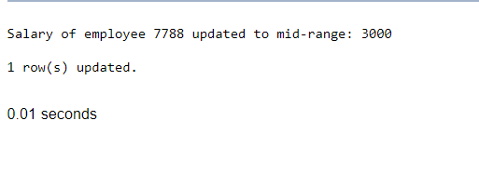

**QUESTION 9**

**CREATE TABLE emp_TEMPORARY(**

**emp_id NUMBER,**

**emp_email VARCHAR2(100)**

**);**

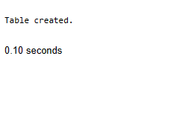

**DECLARE**

**NUMBER_OF_EMP NUMBER;**

**BEGIN**

**SELECT COUNT(EMPLOYEE_ID) INTO NUMBER_OF_EMP**

**FROM EMP;**

**FOR EMP_REC IN (SELECT EMPLOYEE_ID FROM EMP) LOOP**

**INSERT INTO EMP_TEMP (EMP_ID, EMP_EMAIL)**

**VALUES(EMP_REC.EMPLOYEE_ID, 'NOT AVAILABLE NOW');**

**END LOOP;**

**DBMS_OUTPUT.PUT_LINE('INSERTION COMPLETED SUCCESSFULLY.');**

**EXCEPTION**

**WHEN OTHERS THEN**

**DBMS_OUTPUT.PUT_LINE('AN ERROR OCCURRED: ' || SQLERRM);**

**END;**