**Imama Kainat**

**22F3661**

**SE-4A**

Question 1

CREATE OR REPLACE PACKAGE employee_count_pkg AS

FUNCTION get_employee_count(p_job_title VARCHAR2) RETURN NUMBER;

END employee_count_pkg;

CREATE OR REPLACE PACKAGE BODY employee_count_pkg AS

FUNCTION get_employee_count(p_job_title VARCHAR2) RETURN NUMBER IS

v_employee_count NUMBER := 0;

BEGIN

SELECT COUNT(*) INTO v_employee_count

FROM emp

WHERE job = CLERK;

RETURN v_employee_count;

EXCEPTION

WHEN OTHERS THEN

RETURN NULL;

END get_employee_count;

END employee_count_pkg;

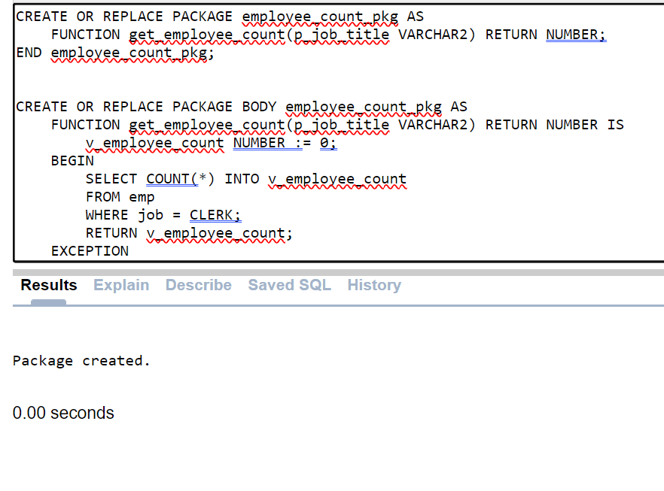

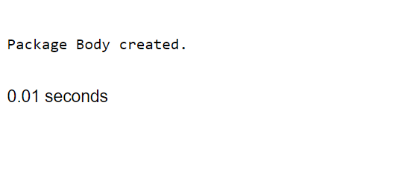

**Question 2**

CREATE OR REPLACE PACKAGE EmpPackage AS

TYPE EmployeeRecord IS RECORD (

emp_id NUMBER,

emp_name VARCHAR2(100),

emp_salary NUMBER

);

TYPE EmployeeTable IS TABLE OF EmployeeRecord;

FUNCTION GetTopEmployees(N IN NUMBER)

RETURN EmployeeTable;

END EmpPackage;

CREATE OR REPLACE PACKAGE BODY EmpPackage AS

FUNCTION GetTopEmployees(N IN NUMBER) RETURN EmployeeTable IS

top_employees EmployeeTable;

BEGIN

SELECT empno, ename,sal

BULK COLLECT INTO top_employees

FROM (SELECT empno, ename, sal

FROM emp

ORDER BY sal DESC)

WHERE ROWNUM <= N;

RETURN top_employees;

END GetTopEmployees;

END EmpPackage;

DECLARE

top_employees EmpPackage.EmployeeTable;

BEGIN

top_employees := EmpPackage.GetTopEmployees(5);

FOR i IN 1..top_employees.COUNT LOOP

dbms_output.put_line('Employee ID: ' || top_employees(i).emp_id || ', Name: ' || top_employees(i).emp_name || ', Salary: ' || top_employees(i).emp_salary);

END LOOP;

END;

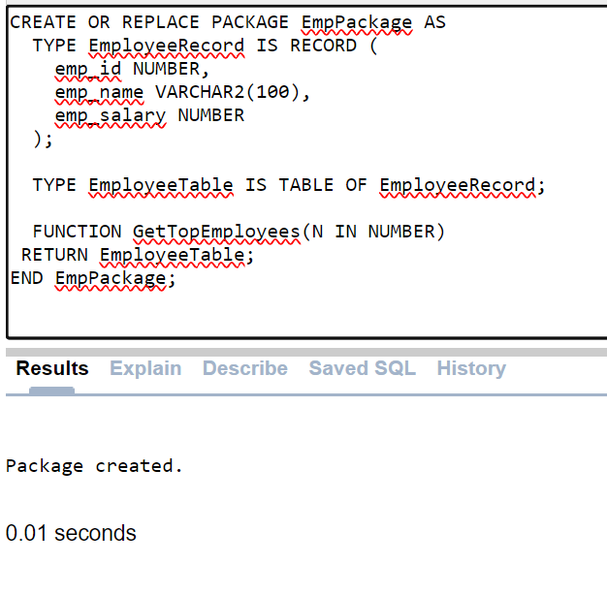

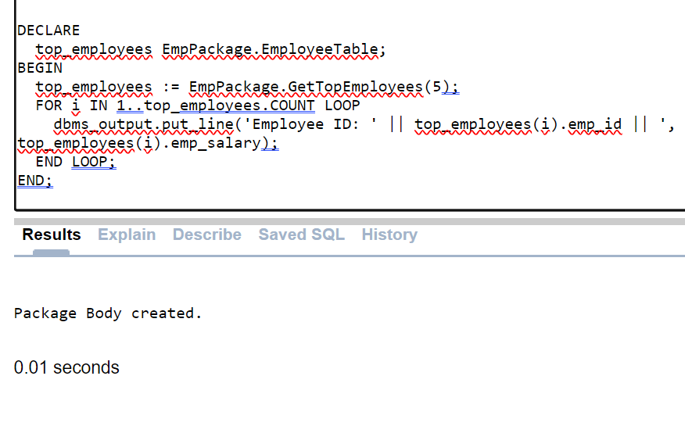 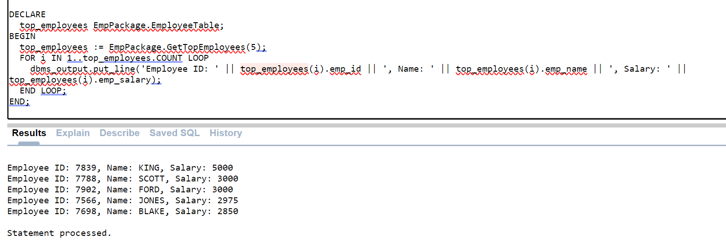

**Question 3**

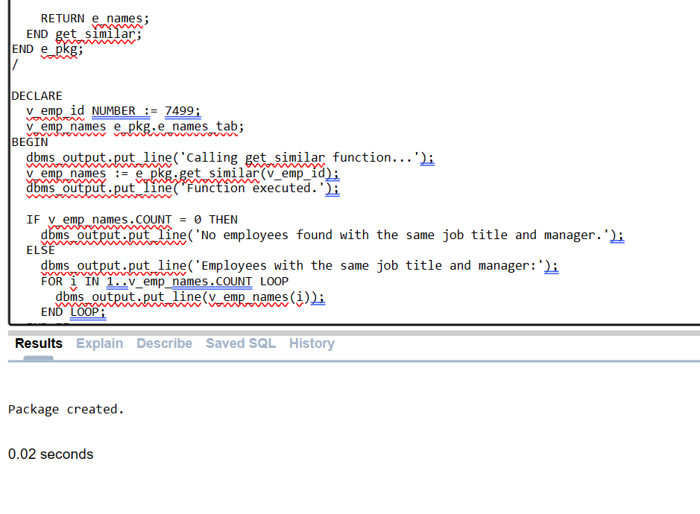

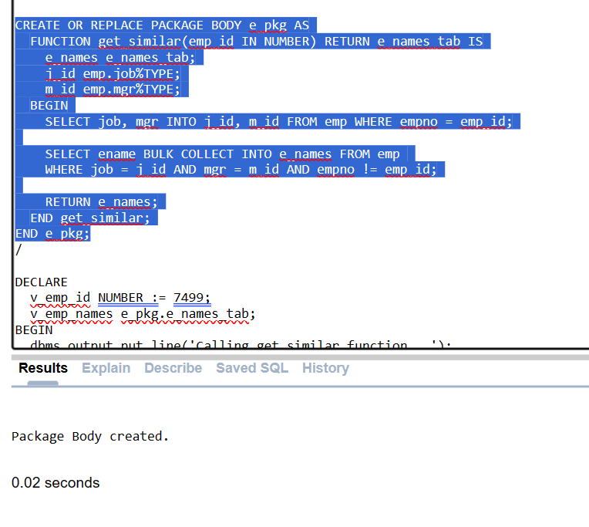

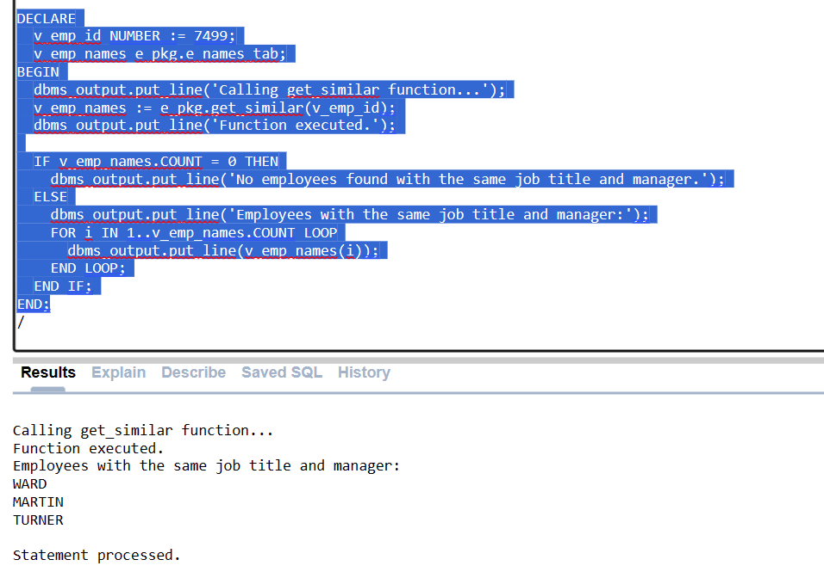

CREATE OR REPLACE PACKAGE e_pkg AS

TYPE e_names_tab IS TABLE OF VARCHAR2(100) INDEX BY PLS_INTEGER;

FUNCTION get_similar(emp_id IN NUMBER) RETURN e_names_tab;

END e_pkg;

/

CREATE OR REPLACE PACKAGE BODY e_pkg AS

FUNCTION get_similar(emp_id IN NUMBER) RETURN e_names_tab IS

e_names e_names_tab;

j_id emp.job%TYPE;

m_id emp.mgr%TYPE;

BEGIN

SELECT job, mgr INTO j_id, m_id FROM emp WHERE empno = emp_id;

SELECT ename BULK COLLECT INTO e_names FROM emp

WHERE job = j_id AND mgr = m_id AND empno != emp_id;

RETURN e_names;

END get_similar;

END e_pkg;

/

DECLARE

v_emp_id NUMBER := 7499;

v_emp_names e_pkg.e_names_tab;

BEGIN

dbms_output.put_line('Calling get_similar function...');

v_emp_names := e_pkg.get_similar(v_emp_id);

dbms_output.put_line('Function executed.');

IF v_emp_names.COUNT = 0 THEN

dbms_output.put_line('No employees found with the same job title and manager.');

ELSE

dbms_output.put_line('Employees with the same job title and manager:');

FOR i IN 1..v_emp_names.COUNT LOOP

dbms_output.put_line(v_emp_names(i));

END LOOP;

END IF;

END;

/

**Question 4**

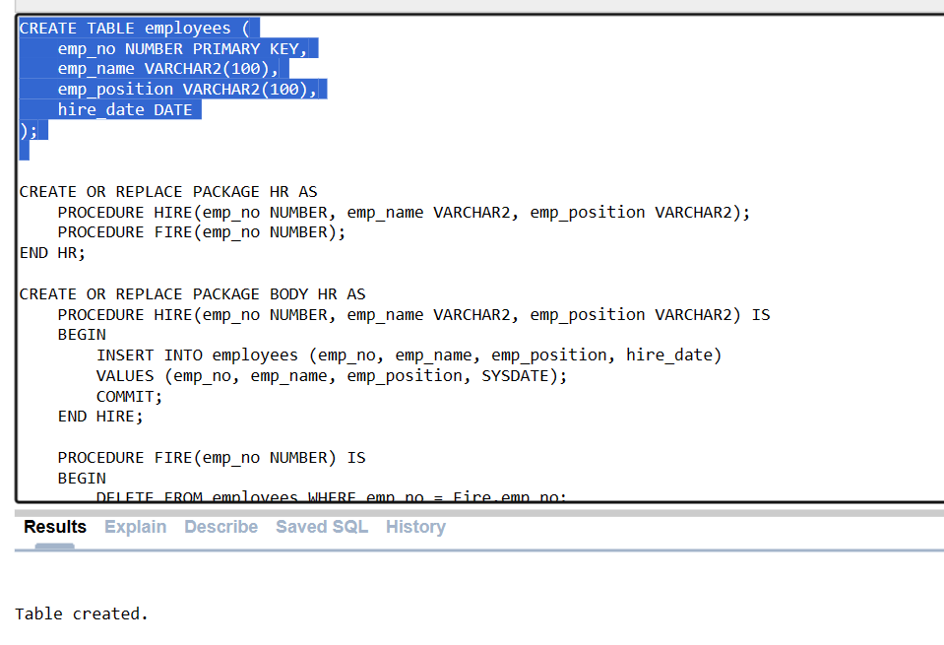

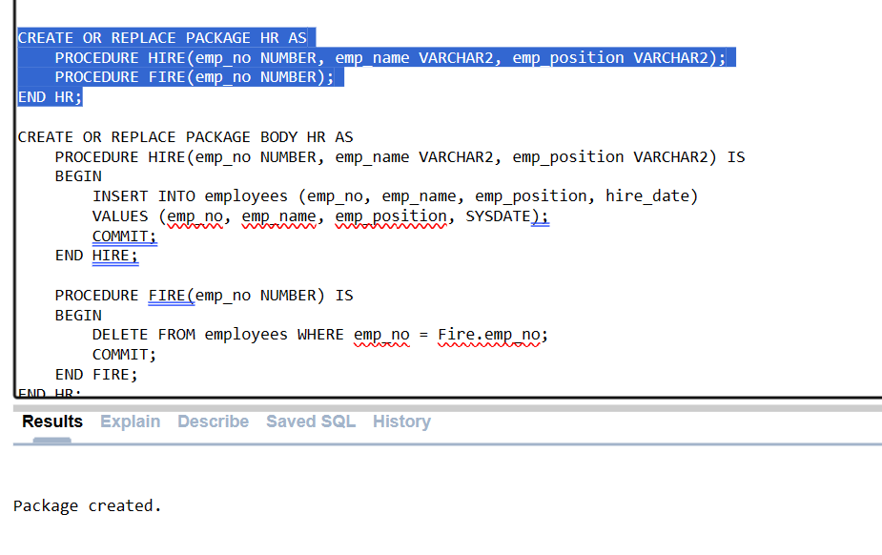

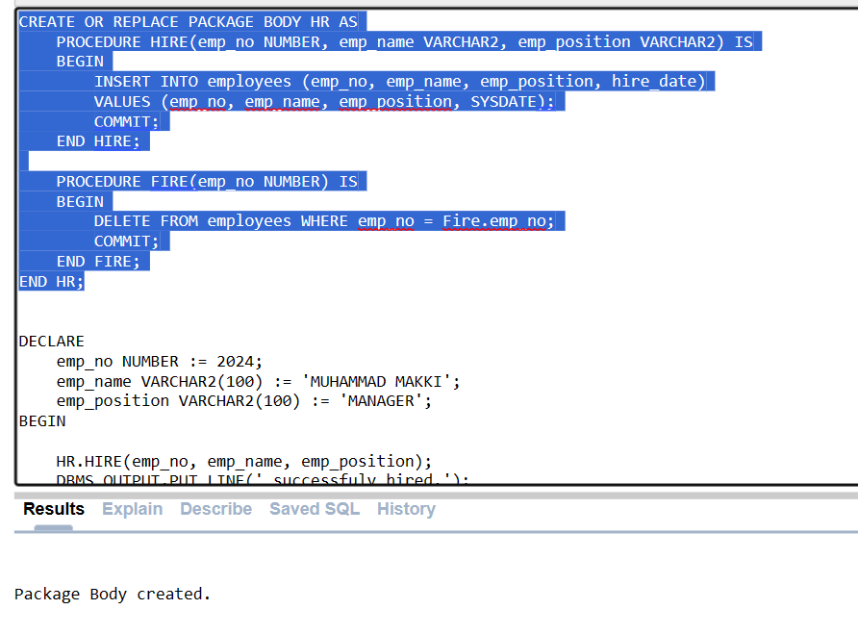

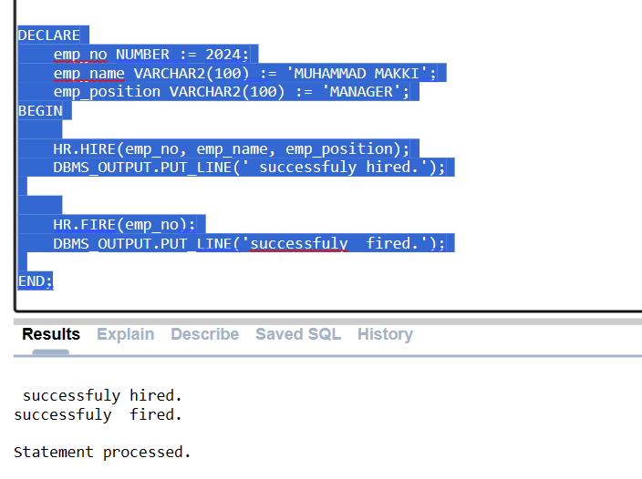

CREATE TABLE employees (

emp_no NUMBER PRIMARY KEY,

emp_name VARCHAR2(100),

emp_position VARCHAR2(100),

hire_date DATE

);

CREATE OR REPLACE PACKAGE HR AS

PROCEDURE HIRE(emp_no NUMBER, emp_name VARCHAR2, emp_position VARCHAR2);

PROCEDURE FIRE(emp_no NUMBER);

END HR;

CREATE OR REPLACE PACKAGE BODY HR AS

PROCEDURE HIRE(emp_no NUMBER, emp_name VARCHAR2, emp_position VARCHAR2) IS

BEGIN

INSERT INTO employees (emp_no, emp_name, emp_position, hire_date)

VALUES (emp_no, emp_name, emp_position, SYSDATE);

s COMMIT;

END HIRE;

PROCEDURE FIRE(emp_no NUMBER) IS

BEGIN

DELETE FROM employees WHERE emp_no = Fire.emp_no;

COMMIT;

END FIRE;

END HR;

DECLARE

emp_no NUMBER := 2024;

emp_name VARCHAR2(100) := 'MUHAMMAD MAKKI';

emp_position VARCHAR2(100) := 'MANAGER';

BEGIN

HR.HIRE(emp_no, emp_name, emp_position);

DBMS_OUTPUT.PUT_LINE(' successfuly hired.');

HR.FIRE(emp_no);

DBMS_OUTPUT.PUT_LINE('successfuly fired.');

END;

**Question 5**

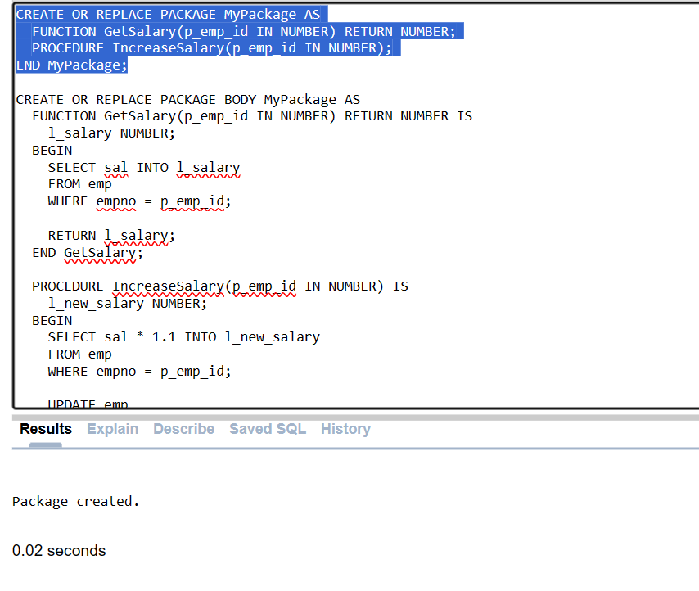

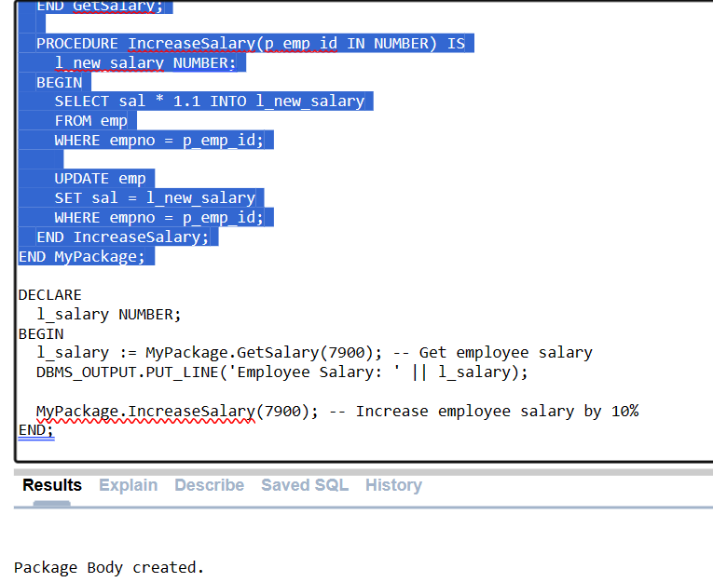

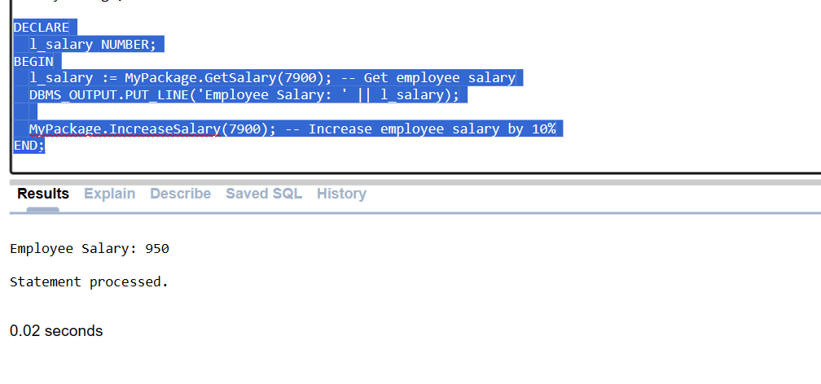

CREATE OR REPLACE PACKAGE MyPackage AS

FUNCTION GetSalary(p_emp_id IN NUMBER) RETURN NUMBER;

PROCEDURE IncreaseSalary(p_emp_id IN NUMBER);

END MyPackage;

CREATE OR REPLACE PACKAGE BODY MyPackage AS

FUNCTION GetSalary(p_emp_id IN NUMBER) RETURN NUMBER IS

l_salary NUMBER;

BEGIN

SELECT sal INTO l_salary

FROM emp

WHERE empno = p_emp_id;

RETURN l_salary;

END GetSalary;

PROCEDURE IncreaseSalary(p_emp_id IN NUMBER) IS

l_new_salary NUMBER;

BEGIN

SELECT sal * 1.1 INTO l_new_salary

FROM emp

WHERE empno = p_emp_id;

UPDATE emp

SET sal = l_new_salary

WHERE empno = p_emp_id;

END IncreaseSalary;

END MyPackage;

DECLARE

l_salary NUMBER;

BEGIN

l_salary := MyPackage.GetSalary(7900); -- Get employee salary

DBMS_OUTPUT.PUT_LINE('Employee Salary: ' || l_salary);

MyPackage.IncreaseSalary(7900); -- Increase employee salary by 10%

END;

**MY notes**

Procedurrs

Functions

Camnadnd line variesble

;x

BIND VARIALBLE

SUB PROGRAM

PROCEDURE:ACTION

FUNCTION:COMPUTATION (LOCAL (ONLY ONE BLOCK )OR STORE(STIRED UB THE FORM OF OBJECT)

IS AND AS

PACKAGE

CREAT REPLACE

PARAMETER (IN(BAHIR SE) , OUT, IN OUT) (IN ,OUT)PASS BY REFERENCE

CAN MAKE MULTIPLE PACKAGES

IN BY DEFAULT TYPE

OUT OUT AND CAN MODIFY.CANT TAKE THE IN

IS FUNC +PROCE ( NESTED BLOCKS) LOCAL

AS STORED ,ANYONYMOUS BLOCK ,STANDALONE STORED

* FUNCITONS ALWASYS RETURN
* ASLWAYS BE TYPE OF IN
* EXECTUTABLE KO BEGIN KE UNDER HO GA

PACKAGES

PACKAGE KE THROUGH HI EXECUTE HO GA NOT LIKE FUNCITON

PACKAGE -> SIMILAR TYPE OF PROCEDURE ,FUNCITONS

WHOLE PACKAGE CANT BE EXECUTED

SPCIFICATION

BODY

PACKAGE.