**22F3661**

**Imama Kainat**

**SE-4A**

**My notes (Trigger)**

A trigger is a stored procedure in a database that automatically invokes whenever a special event in the database occurs.

create trigger [trigger_name]

[before | after]

{insert | update | delete}

on [table_name]

[for each row]

[trigger_body]

**Explanation of Syntax**

1. Create trigger [trigger_name]: Creates or replaces an existing trigger with the trigger_name.
2. [before | after]: This specifies when the trigger will be executed.
3. {insert | update | delete}: This specifies the DML operation.
4. On [table_name]: This specifies the name of the table associated with the trigger.
5. [for each row]: This specifies a row-level trigger, i.e., the trigger will be executed for each affected row.
6. [trigger_body]: This provides the operation to be performed as the trigger is fired

**Create a trigger that will fire when employee’s name is about to update and store old value**

**in another table before new updating in employee table.**

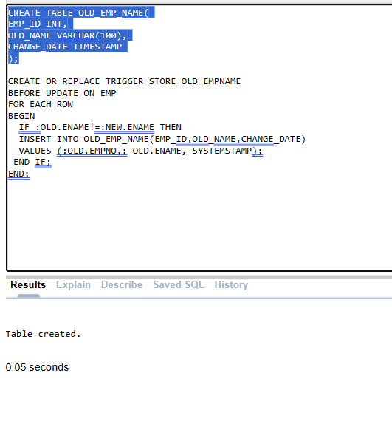

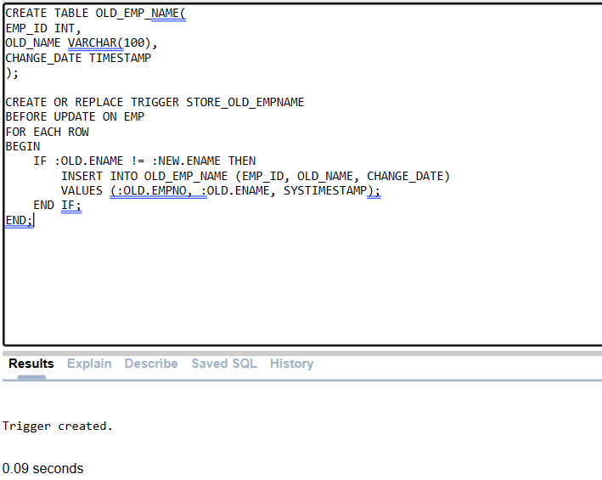

CREATE TABLE OLD_EMP_NAME(

EMP_ID INT,

OLD_NAME VARCHAR(100),

CHANGE_DATE TIMESTAMP

);

CREATE OR REPLACE TRIGGER STORE_OLD_EMPNAME

BEFORE UPDATE ON EMP

FOR EACH ROW

BEGIN

IF :OLD.ENAME != :NEW.ENAME THEN

INSERT INTO OLD_EMP_NAME (EMP_ID, OLD_NAME, CHANGE_DATE)

VALUES (:OLD.EMPNO, :OLD.ENAME, SYSTIMESTAMP);

END IF;

END;

**QUESTION 2**

**Create a trigger that will fire if the increase in an employee salary is greater than 10% of his**

**salary. Trigger will display the old &amp; new salary of the employee with his complete info.**

CREATE OR REPLACE TRIGGER check_salary

BEFORE UPDATE OF SAL ON EMP

FOR EACH ROW

DECLARE

SAL_INCREASE NUMBER;

BEGIN

IF :NEW.SAL > :OLD.SAL THEN

SAL_INCREASE := ((:NEW.SAL - :OLD.SAL) / :OLD.SAL) * 100;

IF SAL_INCREASE > 10 THEN

DBMS_OUTPUT.PUT_LINE('HIRE DATE: ' || :OLD.HIREDATE);

DBMS_OUTPUT.PUT_LINE('OLD SALARY: ' || :OLD.SAL);

DBMS_OUTPUT.PUT_LINE('NEW SALARY: ' || :NEW.SAL);

DBMS_OUTPUT.PUT_LINE('DEPARTMENT NUMBER: ' || :OLD.DEPTNO);

DBMS_OUTPUT.PUT_LINE('EMPLOYEE ID: ' || :OLD.EMPNO);

DBMS_OUTPUT.PUT_LINE('EMPLOYEE NAME: ' || :OLD.ENAME);

DBMS_OUTPUT.PUT_LINE('JOB: ' || :OLD.JOB);

DBMS_OUTPUT.PUT_LINE('MANAGER ID: ' || :OLD.MGR);

END IF;

END IF;

END;

/

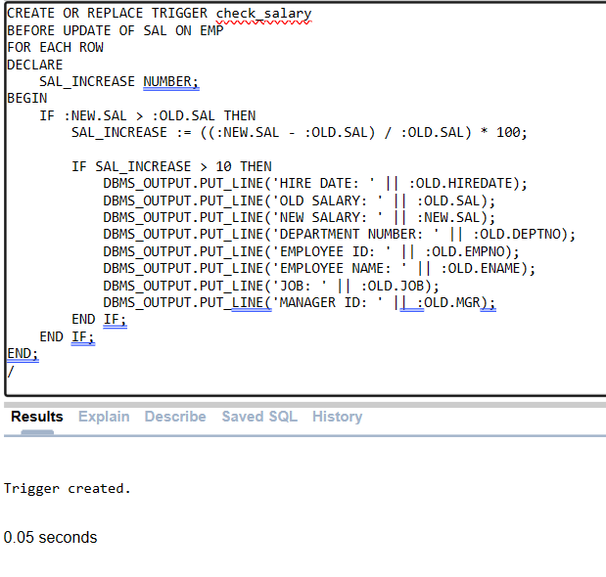

**QUESTION 3**

**Create a trigger that will fire when a department is about to delete. Trigger will fire before**

**the deletion query of department and will delete record of all the employees belonging to**

**that department.**

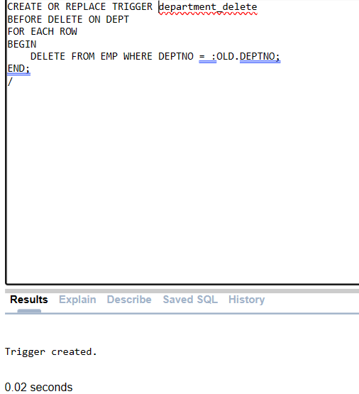

CREATE OR REPLACE TRIGGER department_delete

BEFORE DELETE ON DEPT

FOR EACH ROW

BEGIN

DELETE FROM EMP WHERE DEPTNO = :OLD.DEPTNO;

END;

/

**CURSOR**

**QUESTION 1**

**Create a PLSQL query to display complete information of table employee by using Explicit Cursor.**

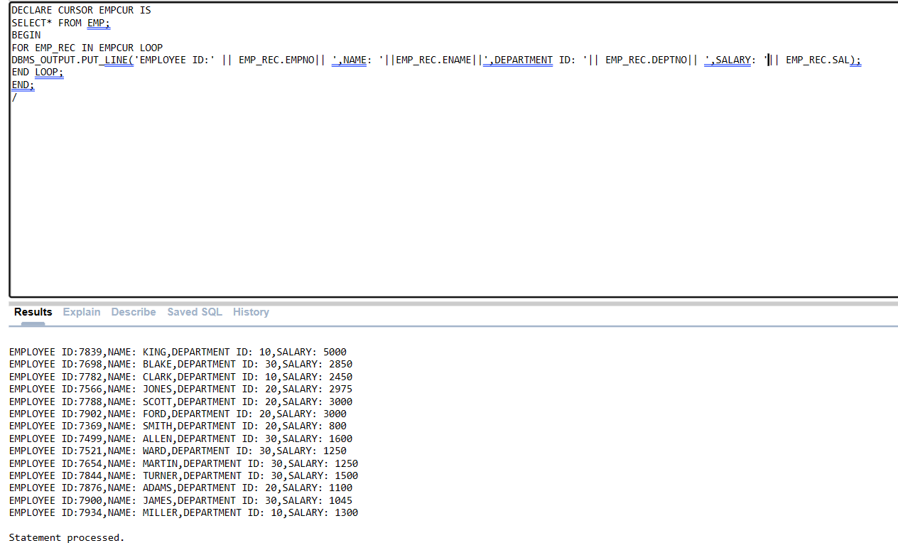

DECLARE CURSOR EMPCUR IS

SELECT* FROM EMP;

BEGIN

FOR EMP_REC IN EMPCUR LOOP

DBMS_OUTPUT.PUT_LINE('EMPLOYEE ID:' || EMP_REC.EMPNO|| ',NAME: '||EMP_REC.ENAME||',DEPARTMENT ID: '|| EMP_REC.DEPTNO|| ',SALARY: '|| EMP_REC.SAL);

END LOOP;

END;

/

**QUESTION 2**

**Create a cursor to display the records of the employees whose salary is greater than 3500 AND are**

**working in Sales Department. (By using Cursor for Loop)**

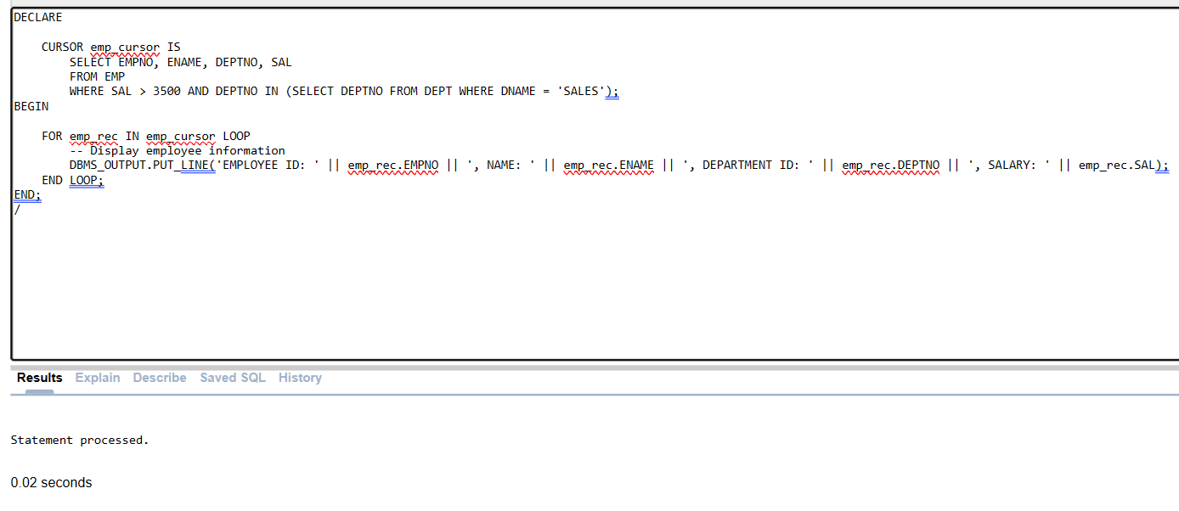

DECLARE

CURSOR emp_cursor IS

SELECT EMPNO, ENAME, DEPTNO, SAL

FROM EMP

WHERE SAL > 3500 AND DEPTNO IN (SELECT DEPTNO FROM DEPT WHERE DNAME = 'SALES');

BEGIN

FOR emp_rec IN emp_cursor LOOP

-- Display employee information

DBMS_OUTPUT.PUT_LINE('EMPLOYEE ID: ' || emp_rec.EMPNO || ', NAME: ' || emp_rec.ENAME || ', DEPARTMENT ID: ' || emp_rec.DEPTNO || ', SALARY: ' || emp_rec.SAL);

END LOOP;

END;

/

**QUSTION 3**

**Write a cursor that selects all the departments from the department table and displays their**

**department_id, department_name, and the total number of employees in each department. (by using**

**Cursor open-fetch method).**

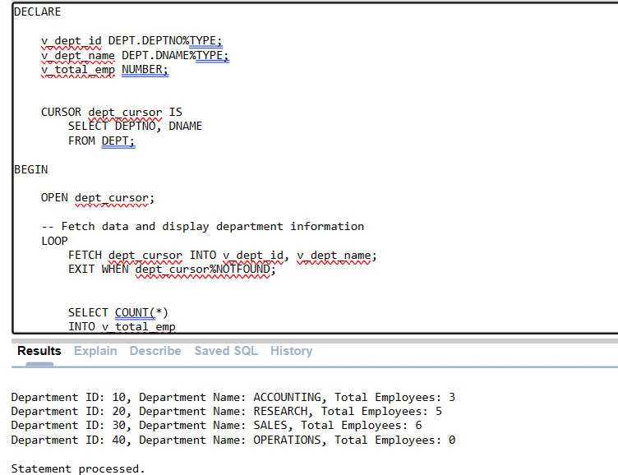

DECLARE

v_dept_id DEPT.DEPTNO%TYPE;

v_dept_name DEPT.DNAME%TYPE;

v_total_emp NUMBER;

CURSOR dept_cursor IS

SELECT DEPTNO, DNAME

FROM DEPT;

BEGIN

OPEN dept_cursor;

-- Fetch data and display department information

LOOP

FETCH dept_cursor INTO v_dept_id, v_dept_name;

EXIT WHEN dept_cursor%NOTFOUND;

SELECT COUNT(*)

INTO v_total_emp

FROM EMP

WHERE DEPTNO = v_dept_id;

DBMS_OUTPUT.PUT_LINE('Department ID: ' || v_dept_id || ', Department Name: ' || v_dept_name || ', Total Employees: ' || v_total_emp);

END LOOP;

-- Close cursor

CLOSE dept_cursor;

END;

/