22F3661
SE-6A
Imama Kainat
Question 1-4 ( connecting sql and with ajex , jquery handle the crud operations)
File Structure
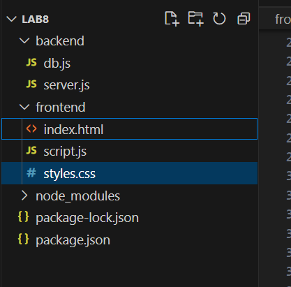
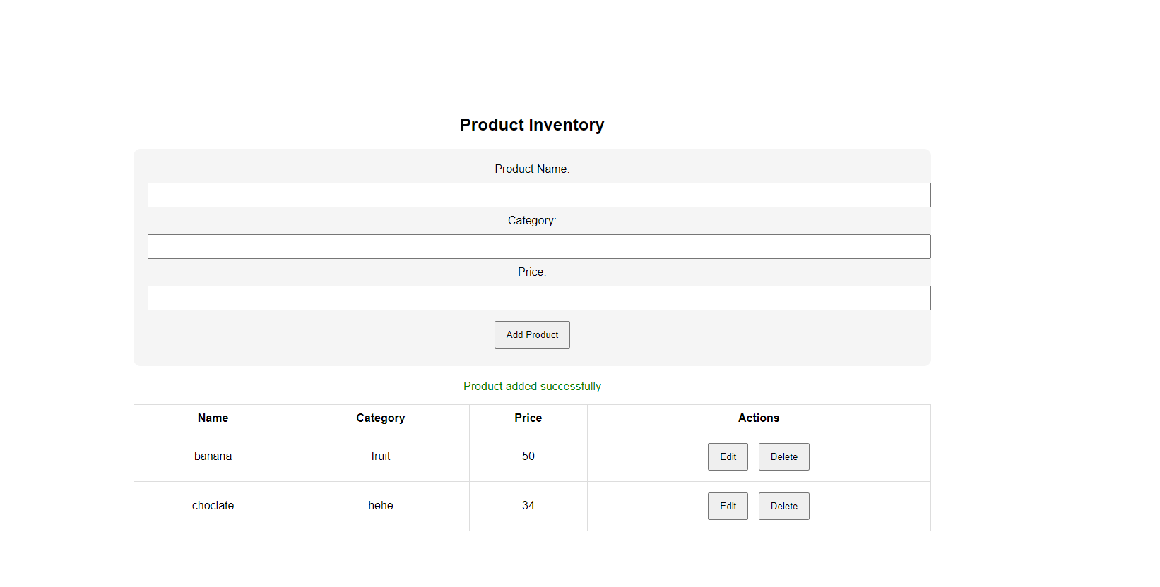
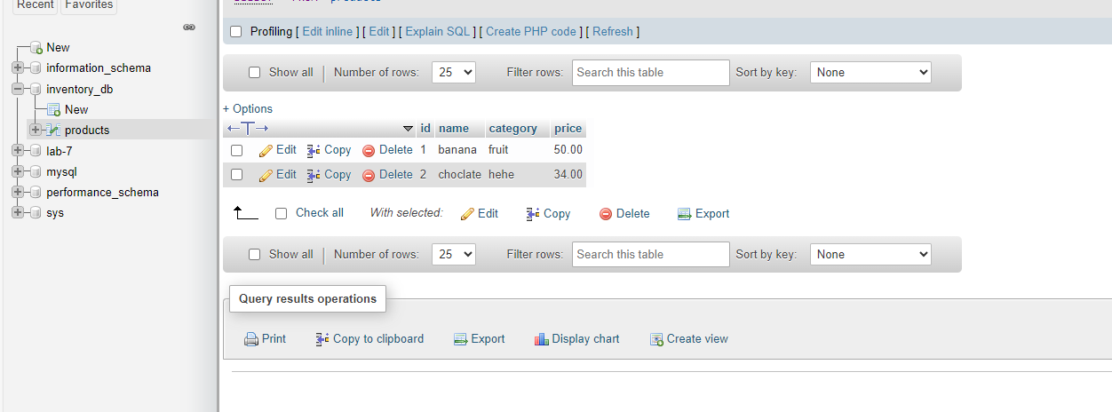

Question 5-6
Make student db
 