
Flexible Meal Service
Website, Admin Portal & Backend System Specification
Working brand name is intentionally treated as replaceable. The software architecture does not depend on the final name.
Goal
Create one simple system for customers to buy meal credits, schedule lunch or dinner, skip without losing value, choose a hostel/office hub, pay, receive meals, and submit feedback — while the admin team manages menus, kitchen quantities, payments, hubs, deliveries and reports from one dashboard.

Recommended stack: Next.js + Supabase + Vercel
Prepared for MVP planning • Lahore, Pakistan • September 2026

01 — SYSTEM SPECIFICATION
Recommended Technology Stack
Use boring, proven components. The business is food delivery; it does not need a distributed-systems research project.
Layer | Choice | Why
Frontend | Next.js (App Router) | One responsive web app for customer, admin and partner portals. Good SEO for public pages and strong full-stack support.
UI | Tailwind CSS + component library | Fast responsive implementation; consistent buttons, forms, cards and tables.
Backend / Database | Supabase | Managed PostgreSQL plus Auth, Storage, RLS, Realtime and Edge Functions in one service.
Hosting | Vercel | Straightforward deployment for Next.js; preview deployments help testing.
Images / Files | Supabase Storage | Menu photos, payment proofs, invoices and partner documents.
Server logic | Next.js server routes + Supabase Edge Functions | Use server logic for payment callbacks, credit transactions, notifications and scheduled tasks.
Analytics | PostHog or Plausible later | Do not add analytics complexity until the ordering funnel exists.
Notifications | Email + WhatsApp/SMS later | Start with email + admin-triggered WhatsApp; automate once message volume justifies it.

Why Supabase
Every Supabase project uses a real PostgreSQL database. Supabase Auth can work with RLS, Storage can be secured with RLS policies, and Edge Functions provide server-side TypeScript for webhooks or integrations. This keeps the MVP architecture compact.

Keep the MVP simple
Do not add a separate backend server, native mobile apps, microservices or AI recommendations until the core ordering workflow is proven.

02 — SYSTEM SPECIFICATION
Users, Roles & Permissions
Role | Main access | Should NOT access
Guest | Home, menu preview, pricing, hubs, signup. | Customer history, admin data.
Customer | Wallet, orders, planner, profile, hubs, payments, feedback. | Other customers or admin screens.
Admin | Everything required to run the business. | Database secrets / service keys.
Kitchen Staff | Production list, quantities, packing status. | Pricing configuration, customer balances.
Delivery Staff | Assigned route/hubs, box counts, delivery status. | Full customer database or financial reporting.
Hostel/Office Partner | Their hub summary, meal count, member list where permitted. | Other hubs, kitchen costs, global customer data.
Finance/Admin | Payments, credits, refunds, invoices, reconciliation. | Unneeded operational controls.

Permission rule
Use role-based UI permissions, but enforce the same rules in the database using Row Level Security (RLS). Hiding a button is not security; it is interior decoration.

03 — SYSTEM SPECIFICATION
Public Website & Customer Acquisition Pages
Page / Section | Purpose | Core elements
Home | Explain the concept in under 10 seconds. | Hero, “how it works”, today’s sample menu, service areas, plans, CTA.
How It Works | Explain credits and flexibility. | Buy credits → plan → skip/switch → collect/eat.
Menu | Show current and upcoming meals. | Lunch/dinner tabs, photos, allergens, portion, price/credit cost.
Plans | Sell starter packs and subscriptions. | 5/10/20 meal packs, validity, per-meal value, terms.
Delivery Hubs | Show active hostel/office hubs. | Area, pickup point, times, active/inactive status.
For Hostels | Recruit new hubs. | Benefits, minimum order, host commission option, inquiry form.
For Companies | B2B lead page. | Employee plans, subsidy model, one invoice, office drop.
FAQ | Reduce repetitive support. | Cutoffs, skips, refunds, allergies, delivery, expired credits.
Contact | Support and sales. | WhatsApp, phone, email, inquiry form.

Homepage order of sections
1. Hero: “Plans changed? Your meal does not disappear.”
2. How it works in 3–4 steps.
3. Today / tomorrow menu preview.
4. Meal wallet / flexible schedule benefits.
5. Hostel & office delivery hubs.
6. Starter pricing.
7. Customer reviews once real reviews exist.
8. FAQ + clear signup CTA.

04 — SYSTEM SPECIFICATION
Customer Account & Dashboard
Authentication
MVP recommendation: email + password, with mobile number required in profile. Add phone OTP later when a reliable SMS provider and budget are confirmed. This avoids blocking the launch on telecom integration.
Dashboard card | What customer sees | Primary action
Wallet | 13 meals / PKR balance remaining. | Buy more credits.
Today | Selected meal, hub, delivery time, status. | Change/skip if cutoff allows.
Tomorrow | Meal options and current selection. | Schedule meal.
Week | Mon–Sun lunch/dinner states. | Plan week.
Hub | Current default pickup point. | Change hub.
Notifications | Cutoff reminders, payment/order updates. | Open related order.

Main usability rule
A returning customer should be able to schedule today’s meal in roughly 3 taps from the dashboard.

05 — SYSTEM SPECIFICATION
Customer Features — Detailed Behaviour
Feature | How it works
Meal Wallet | Customer buys a credit pack. Every successful meal order creates a wallet debit transaction. Refunds/adjustments create separate credit transactions; never silently edit the balance.
Weekly Planner | Calendar shows Lunch / Dinner / Skip for each day. Customer can pre-plan the week. Changes are blocked after the configured cutoff.
Skip Without Loss | Before cutoff: cancel order and return credit automatically. After cutoff: show policy message and require admin exception if allowed.
Lunch ↔ Dinner Switch | If both meal periods are available and the dinner cutoff is open, cancel the original reservation and create the new one in a single database transaction.
Move My Meal | Customer can change to another approved hub that serves that date/meal period. Hub capacity and cutoff are checked before saving.
Meal Choice | Show only meals available for selected date/period. Each item includes portion, allergens, spice level options if offered, and credit/price.
Add-ons | Customer can add raita, drink, dessert or extra protein. Keep add-ons cash-priced or as simple fractional credits; do not make the wallet confusing.
Order Status | Scheduled → Confirmed → Preparing → Packed → Out for Hub → Delivered / Collected / Cancelled.
Feedback | After delivery, ask 1–5 score plus taste, portion, packaging and delivery. Store structured scores for reporting.
Referral | Generate referral code. Reward only after the referred customer completes a paid order; prevent self-referral.
Support | Order-specific “Need help?” opens WhatsApp/support form with order number prefilled.

06 — SYSTEM SPECIFICATION
Checkout, Payments & Credit Packs
Recommended MVP payment process
1. Customer selects a meal pack or single paid order.
2. Website shows JazzCash / Easypaisa / bank transfer instructions or available gateway method.
3. For manual transfer, customer uploads receipt/reference number.
4. Admin verifies payment and clicks Approve.
5. System creates payment record and adds credits to wallet.
6. Later replace manual approval with gateway callback/webhook.
Important
Wallet credits should only be issued from a verified payment or an explicit admin adjustment. Store every balance change in a transaction ledger.

Payment status | Meaning
Pending | Created but not yet verified.
Paid | Payment confirmed; credits/order can be fulfilled.
Failed | Gateway/manual verification failed.
Refunded | Money returned; related credit adjustment recorded.
Partially refunded | Only part of payment reversed.
Expired | Manual payment window passed without confirmation.

Credit pack fields
- Name: Starter 5, Flex 10, Monthly 20, etc.
- Credits included, selling price, validity period, active/inactive flag.
- Optional bonus credits and first-order promotion.
- Terms shown before checkout.

07 — SYSTEM SPECIFICATION
Admin Portal — Core Modules
Module | Admin can do
Dashboard | See today’s orders, meals by type, revenue, pending payments, hub counts, late items and alerts.
Customers | Search users, view profile/history/wallet, block account, add notes, adjust credits with reason.
Menus | Create meals, photos, ingredients/allergens, portion, price/credit value, availability.
Menu Calendar | Assign meals to date + lunch/dinner; set capacity and cutoff.
Orders | Filter by date/status/hub/meal; edit exceptional cases; export.
Kitchen | See production quantities and printable packing list grouped by meal and hub.
Hubs | Create hostel/office hubs, service days, pickup time, capacity, address/contact.
Delivery Runs | Group hubs into routes; assign driver; mark dispatch and delivery.
Payments | Approve manual payments, reconcile gateway payments, issue refunds.
Wallet / Credits | See ledger; make controlled adjustments with audit trail.
Promos | Create coupon codes, referral rules, first-order offers.
Feedback | Review low ratings, meal averages, recurring complaints.
Reports | Revenue, orders, repeat customers, food demand, skips, hub performance.
Users & Roles | Invite staff and assign least-privilege roles.
Settings | Cutoffs, contact info, cancellation policy, default delivery windows.

08 — SYSTEM SPECIFICATION
Kitchen & Delivery Operations
Kitchen dashboard
The kitchen should not work from individual customer orders. It should receive aggregated production quantities.
View | Example
Production summary | Chicken Karahi: 42 regular + 8 Protein+; Daal: 19.
Packaging summary | Hub A: 21 boxes; Hub B: 17; Office C: 31.
Special labels | Mild spice, no salad, extra roti — only options the kitchen actually supports.
Packing list | Customer/order ID + meal + hub + add-ons.
Status control | Preparing → Packed → Handed to delivery.

Delivery flow
One delivery run contains one or more hubs. Driver sees only required information: hub, contact, meal count, expected time and status.
1. Admin freezes production after cutoff.
2. Kitchen prepares and labels boxes.
3. Admin/dispatcher creates route.
4. Driver marks “Picked up”.
5. At hub, driver marks “Delivered”.
6. Customer receives notification and collection instructions.

09 — SYSTEM SPECIFICATION
Hostel / Office Partner Portal
This portal is optional for MVP but valuable once hubs become a sales channel.
Feature | Partner experience
Hub overview | Today’s total boxes, delivery ETA, contact person.
Member list | Only people assigned to that partner hub, where consent/policy allows.
Meal count | Aggregated lunch/dinner counts, not kitchen cost details.
Invoice / subsidy | For companies paying or subsidizing employee meals.
Hub request | Change contact, holiday, temporary closure or pickup location.
Referral / commission | Track agreed commission or referral incentive.
Support | Escalate missing/late batch to admin.

Privacy rule
Partners normally need order counts and collection information, not unrestricted access to customer profiles.

10 — SYSTEM SPECIFICATION
System Architecture
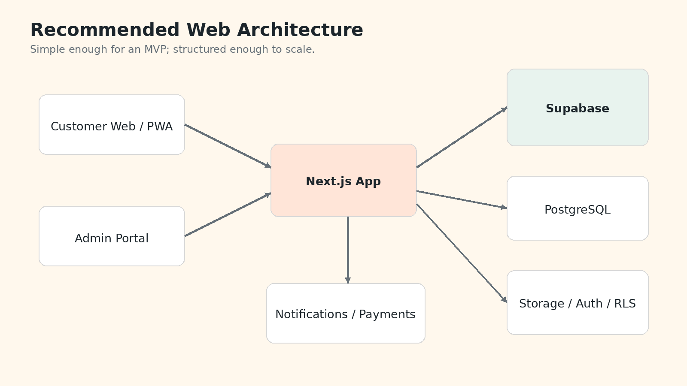
Request flow
- Browser/PWA sends authenticated request to Next.js/Supabase.
- Supabase Auth identifies the customer or staff user.
- RLS decides which database rows that user may read/write.
- Complex operations such as wallet debit, payment callback or refund run server-side.
- PostgreSQL stores business data; Storage holds images/documents.
- Scheduled functions send reminders and perform expiry/cleanup jobs.

11 — SYSTEM SPECIFICATION
Database Design — Main Tables
Table | Important fields | Purpose
profiles | id, name, phone, email, role, default_hub_id | Customer/staff profile linked to auth user.
hubs | id, name, type, address, contact, capacity, active | Hostel/office pickup points.
hub_memberships | user_id, hub_id, status | Optional customer/partner association.
meals | id, name, description, image, allergens, active | Reusable meal catalogue.
menu_slots | id, date, period, meal_id, price, credit_cost, capacity, cutoff | Actual menu offered on a specific day.
orders | id, user_id, hub_id, date, period, status, total | One meal reservation/order.
order_items | order_id, meal_id, qty, variant, add_on | Meal and extras inside order.
wallets | user_id, balance | Cached current balance for fast display.
wallet_transactions | id, user_id, type, amount, order_id, payment_id, reason | Immutable credit ledger.
credit_packs | id, name, credits, price, validity_days, active | Products customers can buy.
payments | id, user_id, amount, method, status, reference, proof_path | Payment/reconciliation record.
delivery_runs | id, date, driver_id, status | One route/run.
delivery_run_hubs | run_id, hub_id, sequence, eta, delivered_at | Stops on the route.
feedback | order_id, rating, taste, portion, packaging, delivery, comment | Structured quality data.
coupons | code, type, value, limits, start/end | Promotional rules.
referrals | referrer_id, referred_id, status, reward_txn | Referral tracking.
notifications | user_id, channel, template, status, sent_at | Message log.
audit_logs | actor_id, action, entity, entity_id, metadata | Admin/staff accountability.

12 — SYSTEM SPECIFICATION
Data Integrity & Business Rules
Rules that should live in the backend
- Never allow wallet balance to go below zero.
- Wallet debit and order creation must succeed together or fail together.
- Changing or skipping an order must respect server-side cutoff time, not the user’s browser clock.
- Hub capacity and menu capacity must be checked before confirming an order.
- An order cannot be delivered twice.
- A payment callback must be idempotent: repeated callbacks must not add credits twice.
- Admin credit adjustments require a reason and audit log.
- Customers can read only their own order/payment/wallet data.
- Kitchen and delivery roles receive only data needed for their job.
Wallet model
Use a ledger
wallet_transactions is the source of truth. The wallet balance is the sum/cache. This makes refunds, promotions and mistakes traceable instead of turning finance into archaeology.

13 — SYSTEM SPECIFICATION
Server Functions / API Actions
Action | Runs where | Main job
create_order | Server action / function | Validate menu, cutoff, hub capacity; debit wallet; create order.
change_order | Server | Validate cutoff; move meal period/hub; adjust credit difference.
skip_order | Server | Cancel eligible order and return credit.
approve_manual_payment | Admin server action | Verify pending payment and add wallet credits.
payment_webhook | Edge Function | Verify gateway signature; mark payment; issue credits exactly once.
create_delivery_run | Admin server action | Group hubs and counts into route.
send_reminders | Scheduled function | Send cutoff / delivery reminders.
expire_credits | Scheduled function | Apply expiry rules if the business chooses to have them.
daily_kitchen_summary | Scheduled/server | Generate locked production totals after cutoff.
referral_reward | Server | Reward both sides after qualifying paid order.

14 — SYSTEM SPECIFICATION
End-to-End Customer Flow
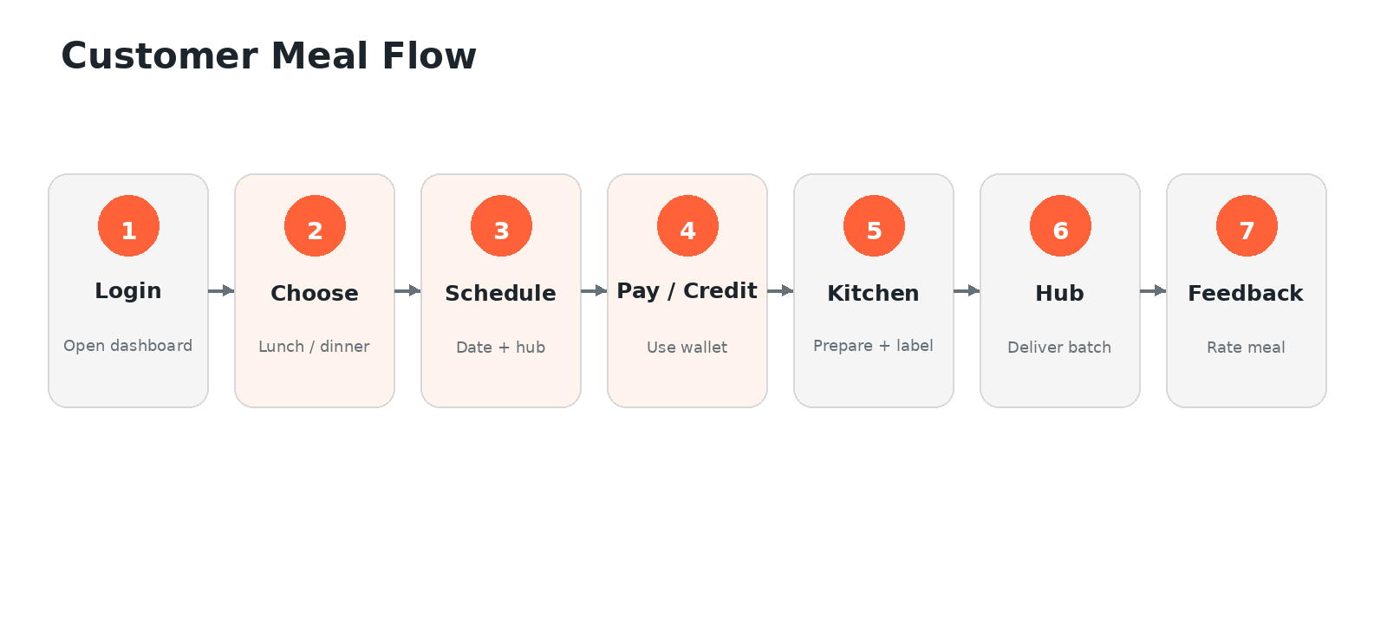
Example: Tuesday lunch
1. Customer opens dashboard and sees Tuesday lunch options.
2. Chooses Chicken Karahi, default hostel hub and 12:45 PM batch.
3. System checks wallet, menu capacity, hub capacity and cutoff.
4. 1 credit is reserved/debited and order is confirmed.
5. At cutoff, kitchen dashboard aggregates all confirmed orders.
6. Box receives order/customer label and is grouped by hub.
7. Driver delivers hub batch and marks stop complete.
8. Customer gets collection/delivery message and later a feedback prompt.

15 — SYSTEM SPECIFICATION
Notifications & Communication
Event | MVP channel | Message
Signup | Email | Welcome + how credits work.
Payment approved | Email / WhatsApp manual | Credits added.
Order confirmed | On-screen + email | Meal, date, hub, cutoff.
Cutoff approaching | Email / later WhatsApp | Reminder to schedule/change.
Out for delivery | Later WhatsApp/SMS | Hub ETA.
Delivered to hub | Later WhatsApp/SMS | Collection message.
Low wallet | Email | Buy another pack.
Feedback | In-app/email | Rate meal.
Order problem | WhatsApp/support | Admin response.

Avoid notification spam
Only send messages that change customer action or confidence. Nobody needs six notifications to learn that lunch exists.

16 — SYSTEM SPECIFICATION
Security, Privacy & Reliability
Row Level Security
Enable RLS on every exposed application table. Customers see only their own data; staff access is explicitly scoped.
Service secrets
Keep service-role keys, payment secrets and webhook secrets only on trusted server/Edge Function environments.
File access
Payment proofs and internal documents should be private storage; menu images can be public.
Audit trail
Log admin wallet adjustments, refunds, menu changes and role changes.
Backups
Use managed database backups; export critical finance/order reports periodically.
Validation
Validate prices, credits, cutoffs and roles server-side. Never trust values posted by the browser.
Rate limiting
Protect signup, login, coupon/referral and public forms against abuse.
Data minimization
Do not collect CNIC or unnecessary personal data for a lunch service.

17 — SYSTEM SPECIFICATION
Reports & KPIs
Report | What it tells you | Why it matters
Daily production | Meals by item, period and hub. | Kitchen purchasing and prep.
Revenue | Paid orders/packs by day/week/month. | Cash performance.
Repeat rate | Customers who order again. | Core product-market fit signal.
Meal popularity | Orders + rating by recipe. | Menu decisions.
Skip/switch rate | How often flexibility is used. | Validates the differentiator.
Hub economics | Orders and delivery cost by hub. | Close weak routes, grow dense ones.
Waste proxy | Prepared vs delivered/cancelled. | Operational efficiency.
Complaints | Low ratings by category. | Quality control.
Wallet liability | Outstanding customer credit balance. | Finance/accounting awareness.

18 — SYSTEM SPECIFICATION
Build Roadmap — Keep Version 1 Small
Phase | Build | Do NOT build yet
Phase 0 — Manual pilot | Landing page, WhatsApp, menu image, Google Sheet/manual order tracking. | Wallet automation, partner portal, delivery app.
Phase 1 — MVP | Auth, profile, menu calendar, wallet, order/skip/change, hubs, manual payments, customer dashboard, admin menus/orders/kitchen. | Native app, route optimization, loyalty tiers.
Phase 2 — Operations | Delivery runs, automated notifications, referrals, feedback analytics, partner view. | AI forecasting unless volume supports it.
Phase 3 — Scale | Payment gateway, corporate invoicing, subscriptions, advanced reporting, reusable-box tracking. | Complex features without proven demand.

Suggested development sequence
1. Database + Auth + roles.
2. Admin: meals, menu calendar, hubs.
3. Customer: dashboard + schedule order.
4. Wallet + transactions.
5. Manual payment approval.
6. Skip / switch / move-hub logic.
7. Kitchen aggregation.
8. Feedback + basic reports.
9. Notifications.
10. Only then polish marketing/partner features.

19 — SYSTEM SPECIFICATION
Sitemap
Customer/public
/ • /menu • /plans • /how-it-works • /hubs • /for-hostels • /for-companies • /faq • /login • /signup
/app • /app/today • /app/planner • /app/wallet • /app/orders • /app/hubs • /app/payments • /app/referrals • /app/profile • /app/support
Admin
/admin • /admin/orders • /admin/menu • /admin/calendar • /admin/kitchen • /admin/customers • /admin/payments • /admin/wallets • /admin/hubs • /admin/delivery • /admin/feedback • /admin/reports • /admin/staff • /admin/settings
Partner
/partner • /partner/hub • /partner/orders • /partner/invoices • /partner/support
Routing advice
Use one Next.js project with protected route groups for customer, admin and partner areas. Separate projects are unnecessary at this stage.

20 — SYSTEM SPECIFICATION
MVP Acceptance Checklist
- ☐ A new customer can create an account and complete profile.
- ☐ Admin can create a hub and a meal, then assign that meal to a date/period.
- ☐ Customer can buy/receive credits and see wallet balance.
- ☐ Customer can create an order only if credit, capacity and cutoff rules pass.
- ☐ Customer can skip before cutoff and receive credit back exactly once.
- ☐ Customer can switch meal period/hub before cutoff where availability exists.
- ☐ Admin sees accurate production totals by meal and hub.
- ☐ Kitchen can mark orders/batches packed without seeing financial information.
- ☐ Admin can approve manual payment and see audit record.
- ☐ Customer sees order history and submits feedback.
- ☐ RLS prevents one customer reading another customer’s orders/payments.
- ☐ Repeated payment callback cannot duplicate credits.
- ☐ Mobile layout works at common phone widths.
- ☐ All critical actions show clear success/failure messages.

21 — SYSTEM SPECIFICATION
What to Initialize First
Day 1 — Project foundation
1. Create GitHub repository.
2. Create Next.js project and deploy empty app to Vercel.
3. Create Supabase project.
4. Create dev/staging environment variables.
5. Set up database migrations rather than manually editing production.
6. Create profiles, hubs, meals, menu_slots, orders, wallets and wallet_transactions first.
7. Enable RLS before customer data is added.
Day 2–3 — Admin before customer polish
1. Build admin login/role check.
2. Create meal CRUD.
3. Create menu calendar.
4. Create hubs.
5. Create basic order list and kitchen summary.
Day 4–7 — Customer MVP
1. Signup/profile.
2. Today/menu page.
3. Wallet display.
4. Schedule order.
5. Skip/change flow.
6. Manual payment request.
7. Mobile QA.
Best practical approach
Run the real food pilot while the software is being built. Use manual operations as the fallback. Software should remove proven pain points, not postpone the business until every screen is finished.

22 — SYSTEM SPECIFICATION
Technical References
Next.js Documentation: https://nextjs.org/docs
Supabase Database: https://supabase.com/docs/guides/database/overview
Supabase Auth: https://supabase.com/docs/guides/auth
Supabase Row Level Security: https://supabase.com/docs/guides/database/postgres/row-level-security
Supabase Storage Access Control: https://supabase.com/docs/guides/storage/security/access-control
Supabase Edge Functions: https://supabase.com/docs/guides/functions
Vercel Documentation: https://vercel.com/docs
Technology details were checked against current official documentation in September 2026. Payment-provider availability, fees and onboarding requirements should be re-verified immediately before implementation.
Final architecture decision
Recommended MVP
Next.js + Supabase PostgreSQL/Auth/Storage/RLS + Vercel. Start with manual payment verification and a single mobile-first web application. Add automated payment, WhatsApp/SMS, partner portals and route optimization only after the first operating workflow is stable.

