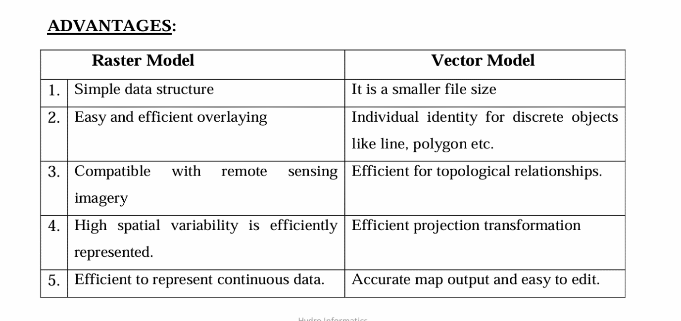

2) Mann-Kendall trend test

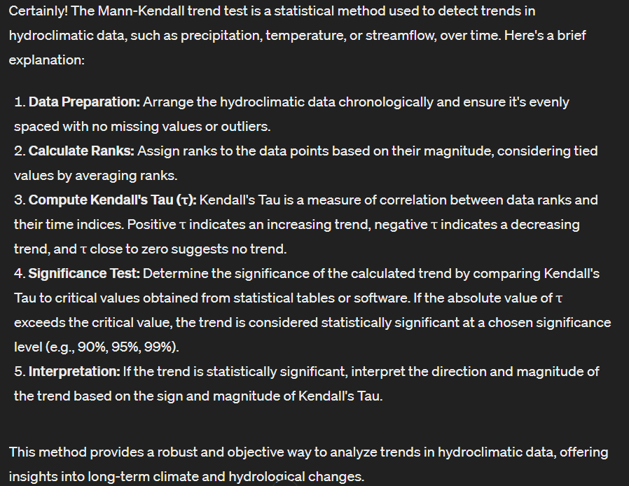

3)

The dependency measures of Pearson, Spearman's, and Kendall's coefficients are statistical methods used to quantify the strength and direction of the relationship between two variables. Here's an explanation of each:

1. **Pearson's Correlation Coefficient (r):**

Pearson's correlation coefficient measures the linear relationship between two continuous variables. ^ It ranges from -1 to 1, where: r = 1 indicates a perfect positive linear relationship. R = -1 indicates a perfect negative linear relationship. r = 0 indicates no linear relationship. ^ Pearson's coefficient assumes that the relationship between variables is linear and that both variables are normally distributed.

1. **Spearman's Rank Correlation Coefficient (ρ or rs):**

Spearman's rank correlation coefficient measures the strength and direction of the monotonic relationship between two variables. ^ Spearman's coefficient ranges from -1 to 1, where: ρ = 1 indicates a perfect monotonic positive relationship. ρ = -1 indicates a perfect monotonic negative relationship. ρ = 0 indicates no monotonic relationship. ^ Spearman's coefficient is more robust to outliers and does not assume a linear relationship.

1. **Kendall's Tau (τ):**

Kendall's Tau measures the strength and direction of the ordinal association between two variables. ^ It compares the number of concordant and discordant pairs of data. ^ Kendall's Tau also ranges from -1 to 1, where: τ = 1 indicates a perfect positive association. τ = -1 indicates a perfect negative association. τ = 0 indicates no association. ^ Kendall's Tau is suitable for ordinal or ranked data and is robust to outliers.

**Key Differences:**

Pearson's correlation measures linear relationships between continuous variables. Spearman's correlation measures monotonic relationships between variables based on their ranks. Kendall's Tau measures ordinal associations between variables based on concordant and discordant pairs.

5)

Drought is a prolonged period of abnormally dry weather that persists long enough to cause a serious hydrological imbalance, leading to water shortages and adverse impacts on agriculture, ecosystems, water resources, and society. Droughts can occur in various forms and can be categorized based on different factors such as duration, intensity, and spatial extent. Here's an explanation of various forms of drought:

Meteorological Drought: Meteorological drought occurs when there is a prolonged period of below-average precipitation. It is typically characterized by a deficit in rainfall or snowfall over an extended period, leading to soil moisture depletion and potential impacts on agriculture and water resources.

Agricultural Drought: Agricultural drought refers to the impact of meteorological drought on agricultural activities. It occurs when soil moisture deficits affect crop growth and yield, leading to agricultural losses and impacts on food production.

Hydrological Drought: Hydrological drought is characterized by below-average streamflow, groundwater levels, and reservoir levels. It occurs when prolonged periods of low precipitation led to decreased water availability in rivers, lakes, and aquifers, impacting water supply for various uses such as drinking water, irrigation, and industrial purposes.

Socioeconomic Drought: Socioeconomic drought occurs when water shortages and hydrological imbalances affect human activities, economies, and societies. It encompasses the impacts of meteorological, agricultural, and hydrological droughts on various sectors such as agriculture, industry, tourism, and public health.

6) SPI

The Standardized Precipitation Index (SPI) quantifies precipitation anomalies relative to the long-term average. It's calculated by fitting a probability distribution to historical precipitation data, transforming it into a standardized normal distribution.

Using SPI, drought can be characterized as follows:

Frequency: Analyzing how often negative SPI values occur indicates drought frequency.

Intensity: The magnitude of negative SPI values reflects drought severity, with larger negatives indicating more severe droughts.

Areal Extent: Widespread negative SPI values across a region suggest a large area affected by drought.

Duration: Consecutive periods with negative SPI values reveal drought duration, indicating persistence.

SPI analysis provides valuable insights into drought occurrence, severity, spatial extent, and duration, aiding in drought monitoring and management.

DEPENDENCE MEASURES – PEARSON’S CORRELATION COEFFICIENT

One of the primary measures of dependence is the Pearson’s product moment correlation coefficient.

It is a linear dependence related to observations at pairwise points.

It is a measure of the distance between two patterns.

Measures the extent to which two patterns are similar with each other.

SPEARMAN’S RANK CORRELATION COEFFICIENT

The Spearman rank correlation coefficient, also known as Spearman's rho, is a nonparametric (distribution-free) rank statistic proposed by Spearman in 1904 as a measure of the strength of the associations between two variables.

The Spearman correlation coefficient is defined as the Pearson correlation coefficient between the rank variables.

After raw data, x and y, are converted to ranked data, the Spearman correlation coefficient is defined.

KENDALL’S RANK CORRELATION COEFFICIENT

Non-parametric rank-based correlation metric, which is defined based on the number of concordant and discordant pairs in the two hydroclimate extreme events.

Test the similarity in the ordering of data when it is ranked by quantities, instead of observations as the basis.

It uses pairs of observations and determine the strength of association based on the pattern of concordance and discordance between the pairs.

Let (x1, y1), (x2, y2), …, (xn, yn) be a set of joint observations from two random variables X and Y respectively, such that all the values of (xi) and (yi) are unique. •Any pair of observations (xi, yi) and (xj, yj) are said to be concordant if the ranks for both elements agree: that is, if both xi > xj and yi > yj or if both xi < xj and yi < yj. •They are said to be discordant, if xi > xj and yi < yj or if xi < xj and yi > yj. •If xi = xj or yi = yj, the pair is neither concordant nor discordant.

Concordant: Ordered in the same way (consistency). A pair of observations is considered concordant if (x2 — x1) and (y2 — y1) have the same sign. o Discordant: Ordered differently (inconsistency). A pair of observations is considered concordant if (x2 — x1) and (y2 — y1) have opposite signs. Kendall’s Tau = (C– D / C + D) Where C is the number of concordant pairs and D is the number of discordant pairs.

Time Series Plots: • Time series plots are widely used to visualize the temporal variation of hydro-climatic variables over time. • The x-axis represents time (e.g., days, months, years), while the y-axis represents the variable of interest (e.g., temperature). precipitation, • Multiple time series can be plotted on the same graph to compare different variables or locations.

Monthly time series plot showing the variation of observed and simulated runoff at the bottom axis and precipitation at the top axis. • Best example for multiple time series plot where two variables are plotted on the same graph to compare.

Scatter Plots: • Scatter plots are useful for exploring relationships between two continuous variables, such as precipitation and stream flow. • Each data point represents a combination of values for the two variables, with one variable plotted on the x-axis and the other on the y-axis. • Trend lines or regression lines can be added to identify patterns or correlations in the data.

Scatter plots of temperature anomaly and precipitation anomaly over the world and Eastern Asia during the period of 1850–1989. Solid lines indicate linear relationships between temperature anomaly and precipitation anomaly.

Heatmaps: • Heatmaps are effective for visualising spatial patterns and distributions of hydro-climatic variables geographic area. across a • They use colour gradients to represent variations in intensity or magnitude, with warmer colours indicating higher values and cooler colours indicating lower values. • Heatmaps can be generated for variables like precipitation, temperature, or soil moisture over a specific region or watershed.

Contour Plots: • Contour plots are similar to heatmaps but use contour lines to represent isovalues (lines of constant value) of a hydro climatic variable. • They provide a visual representation of elevation or gradient changes in the variable across a geographic area. • Contour plots are commonly used for variables like precipitation, temperature levels.

GIS Maps: • Geographic Information System (GIS) maps are powerful tools for visualizing hydro-climatic data in a spatial context. • They allow users to overlay different layers of data, such as precipitation, land cover, elevation, and hydrological features, to analyze relationships and patterns. spatial • GIS maps can be used to create thematic maps, flow maps, or 3D terrain visualizations, depending on the specific application.

Radial Plots: • Radial plots, also known as polar plots, are unconventional but effective for visualizing cyclic or periodic patterns in hydro-climatic data. • They represent data around a circular axis, with each data point plotted at a specific angle and distance from the center. • Radial plots are often used to analyze diurnal or seasonal variations in variables like temperature, wind speed, or solar radiation.

Box Plots: • Box plots are useful for visualizing the distribution and variability of hydro climatic variables. • They display summary statistics such as median, quartiles, and outliers, providing insights into the central tendency and spread of the data. • Box plots are particularly useful for comparing the distribution of variables between different groups or categories.

