The Flexbox Layout (Flexible Box) module (a W3C Candidate Recommendation as of October 2017) aims at providing a more efficient way to lay out, align and distribute space among items in a container, even when their size is unknown and/or dynamic (thus the word “flex”).
The main idea behind the flex layout is to give the container the ability to alter its items’ width/height (and order) to best fill the available space (mostly to accommodate to all kind of display devices and screen sizes). A flex container expands items to fill available free space or shrinks them to prevent overflow.
Most importantly, the flexbox layout is direction-agnostic as opposed to the regular layouts (block which is vertically-based and inline which is horizontally-based). While those work well for pages, they lack flexibility (no pun intended) to support large or complex applications (especially when it comes to orientation changing, resizing, stretching, shrinking, etc.).
Note: Flexbox layout is most appropriate to the components of an application, and small-scale layouts, while the Grid layout is intended for larger scale layouts.
Since flexbox is a whole module and not a single property, it involves a lot of things including its whole set of properties. Some of them are meant to be set on the container (parent element, known as “flex container”) whereas the others are meant to be set on the children (said “flex items”).
If “regular” layout is based on both block and inline flow directions, the flex layout is based on “flex-flow directions”. Please have a look at this figure from the specification, explaining the main idea behind the flex layout.

Items will be laid out following either the main axis (from main-start to main-end) or the cross axis (from cross-start to cross-end).
- main axis – The main axis of a flex container is the primary axis along which flex items are laid out. Beware, it is not necessarily horizontal; it depends on the flex-direction property (see below).
- main-start | main-end – The flex items are placed within the container starting from main-start and going to main-end.
- main size – A flex item’s width or height, whichever is in the main dimension, is the item’s main size. The flex item’s main size property is either the ‘width’ or ‘height’ property, whichever is in the main dimension.
- cross axis – The axis perpendicular to the main axis is called the cross axis. Its direction depends on the main axis direction.
- cross-start | cross-end – Flex lines are filled with items and placed into the container starting on the cross-start side of the flex container and going toward the cross-end side.
- cross size – The width or height of a flex item, whichever is in the cross dimension, is the item’s cross size. The cross size property is whichever of ‘width’ or ‘height’ that is in the cross dimension.

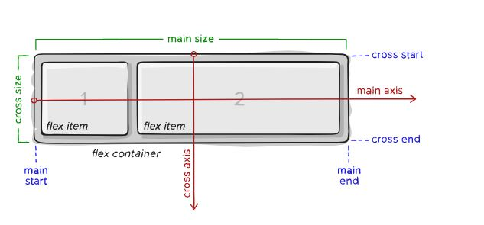
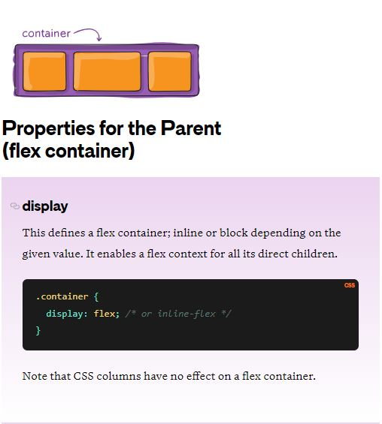

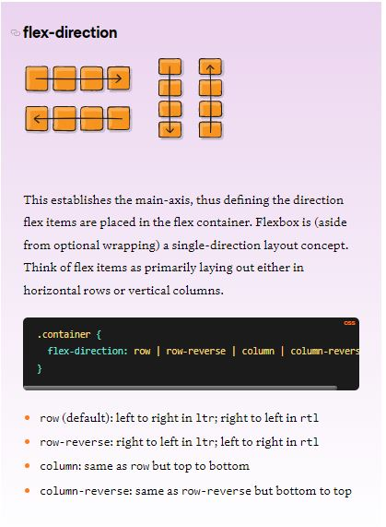

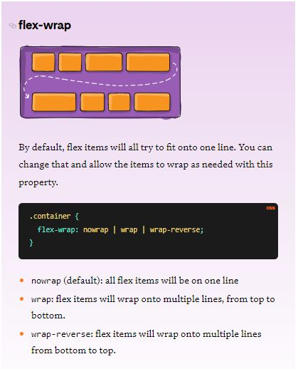

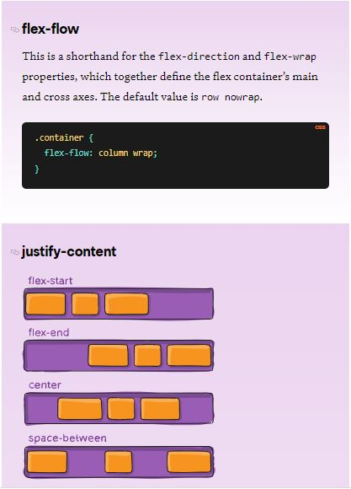

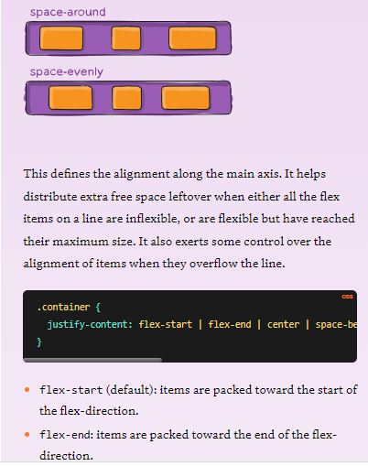

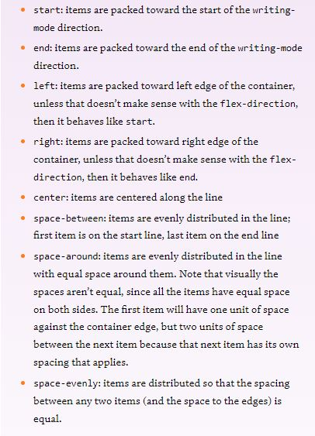

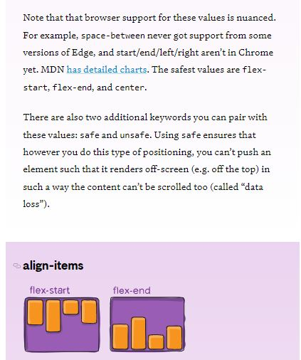

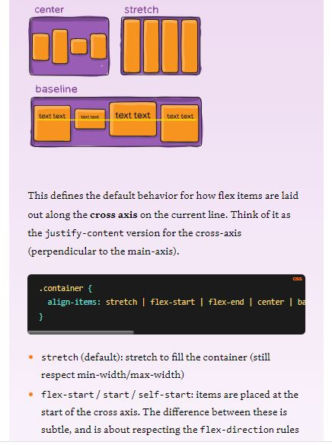

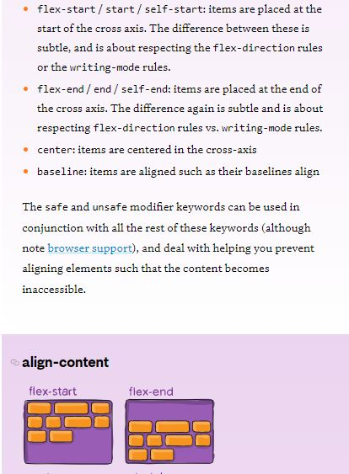

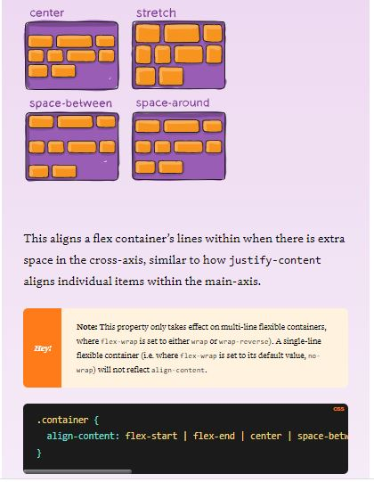

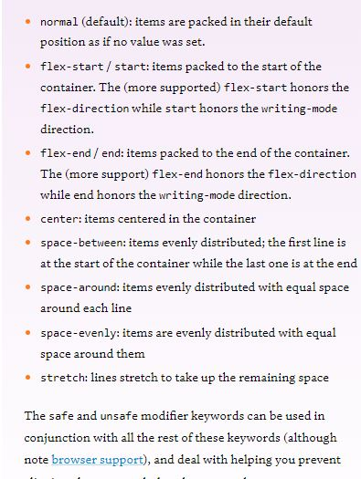

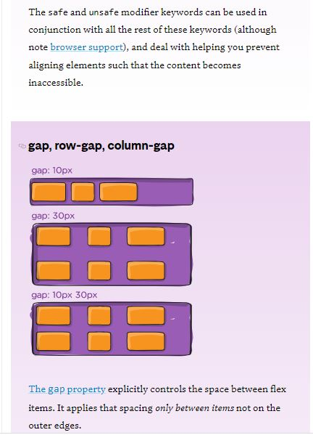

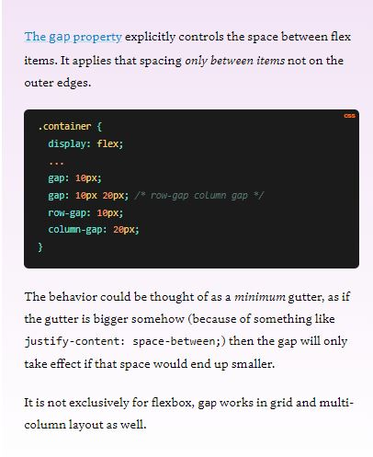

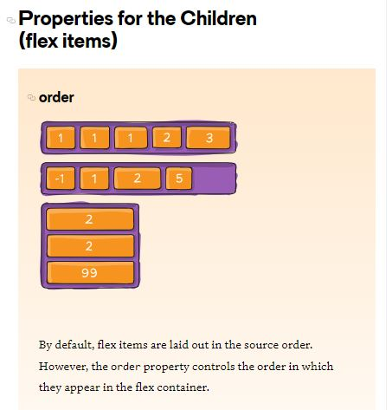

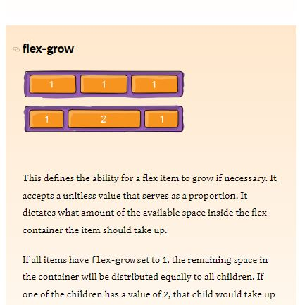

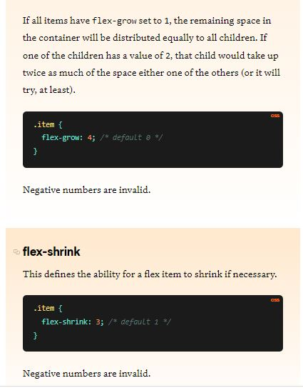

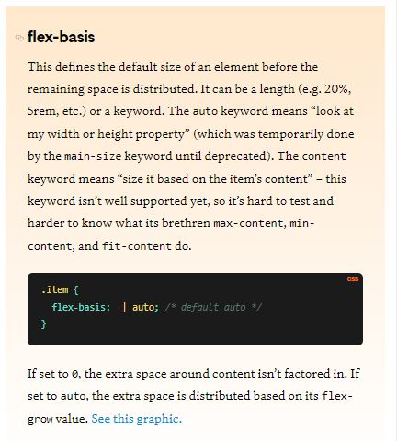

Let’s start with a very very simple example, solving an almost daily problem: perfect centering. It couldn’t be any simpler if you use flexbox.
.parent {
display: flex;
height: 300px; /* Or whatever */
}

.child {
width: 100px; /* Or whatever */
height: 100px; /* Or whatever */
margin: auto; /* Magic! */
}
This relies on the fact a margin set to auto in a flex container absorb extra space. So setting a margin of auto will make the item perfectly centered in both axes.
Now let’s use some more properties. Consider a list of 6 items, all with fixed dimensions, but can be auto-sized. We want them to be evenly distributed on the horizontal axis so that when we resize the browser, everything scales nicely, and without media queries.
.flex-container {
/* We first create a flex layout context */
display: flex;

/* Then we define the flow direction
and if we allow the items to wrap
* Remember this is the same as:
* flex-direction: row;
* flex-wrap: wrap;
*/
flex-flow: row wrap;

/* Then we define how is distributed the remaining space */
justify-content: space-around;
}
Done. Everything else is just some styling concern. Below is a pen featuring this example. Be sure to go to CodePen and try resizing your windows to see what happens.
Let’s try something else. Imagine we have a right-aligned navigation element on the very top of our website, but we want it to be centered on medium-sized screens and single-columned on small devices. Easy enough.
/* Large */
.navigation {
display: flex;
flex-flow: row wrap;
/* This aligns items to the end line on main-axis */
justify-content: flex-end;
}

/* Medium screens */
@media all and (max-width: 800px) {
.navigation {
/* When on medium sized screens, we center it by evenly distributing empty space around items */
justify-content: space-around;
}
}

/* Small screens */
@media all and (max-width: 500px) {
.navigation {
/* On small screens, we are no longer using row direction but column */
flex-direction: column;
}
}
Let’s try something even better by playing with flex items flexibility! What about a mobile-first 3-columns layout with full-width header and footer. And independent from source order.
.wrapper {
display: flex;
flex-flow: row wrap;
}

/* We tell all items to be 100% width, via flex-basis */
.wrapper > * {
flex: 1 100%;
}

/* We rely on source order for mobile-first approach
* in this case:
* 1. header
* 2. article
* 3. aside 1
* 4. aside 2
* 5. footer
*/

/* Medium screens */
@media all and (min-width: 600px) {
/* We tell both sidebars to share a row */
.aside { flex: 1 auto; }
}

/* Large screens */
@media all and (min-width: 800px) {
/* We invert order of first sidebar and main
* And tell the main element to take twice as much width as the other two sidebars
*/
.main { flex: 3 0px; }
.aside-1 { order: 1; }
.main { order: 2; }
.aside-2 { order: 3; }
.footer { order: 4; }
}

