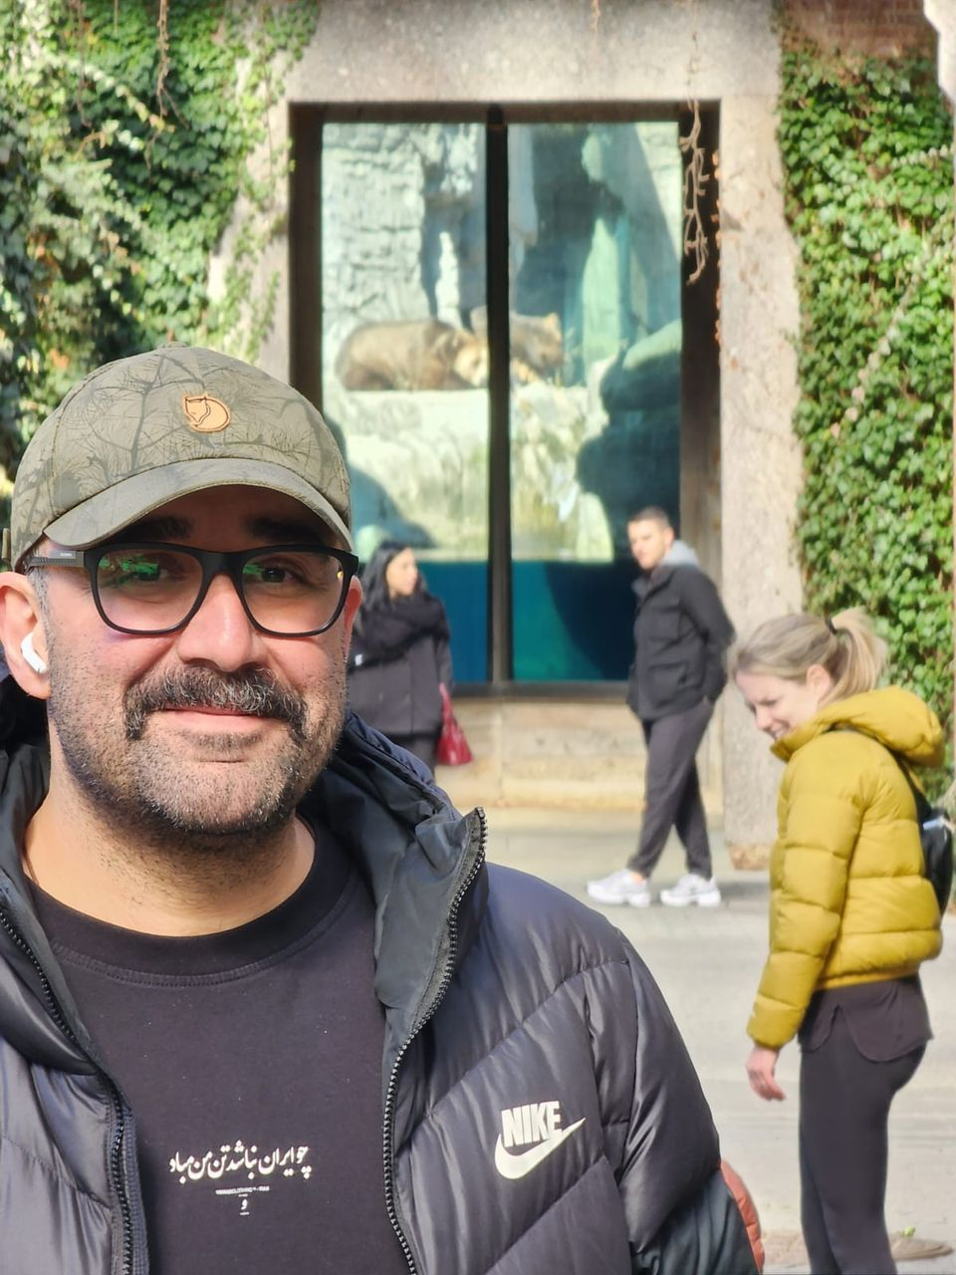Curriculum Vitae – Dr. Iman Memarian, DVM

Email: imanmemarianvet@gmail.com

Cellphones: +98 912 295 6918 (WhatsApp), +12528645929 (WhatsApp)

Phones: +98 21 44354875-6 (Iran)

Addresses: 302 Dupont Circle, Greenville NC 27858, US

Date of Birth: December 28, 1982 (Tehran, Iran)

Contents

1**. Education and Training**

**2. Research Interests**

**3. Professional Experience**

**4. Field Research and Conservation Projects**

**5. Teaching and Capacity-Building Activities**

**6. Publications**

• Journal Articles and Technical Publications

• Books and Field Guides

**7. International Conference Presentations**

**8. National Conference Presentations**

**9. Awards and Honors**

**10. Professional Affiliations**

**11. Media and Outreach**

**12. Veterinary Licenses**

**1.⁠ ⁠Education and Training**

## • Doctor of Veterinary Medicine (DVM), University of Tehran – Graduated 2007.

## Dissertation: “Radiology of Persian Squirrel (Sciurus anomalus): An Atlas of Normal Anatomy and Positioning.” Grade: 20/20.

## • Wildlife Immobilization Training Program – Namibia (2009), 2009.

## • International Training Course in Cheetah Conservation Biology (Namibia) – Nov–Dec 2009: Completed an intensive 4-week program at Cheetah Conservation

## • Wildlife Medicine Training Program – Netherlands (2008), 2008.

## • Young Wildlife Anesthetists Training Program – Spain (2007), 2007.

## • Intern Veterinarian, Exotic Animal Medicine Department, University of Tehran – 2006–2008. Completed a 24-month internship focusing on zoo and wildlife medicine at the university’s teaching hospital and Tehran Zoo, including hands-on training in exotic pet and wildlife cases.

Fund, Namibia, later recognized as “Best Overall Student” of the course (see Awards). Gained expertise in cheetah ecology, genetics, and conservation strategies.

**2.⁠ ⁠Research Interests**

## • Wildlife Medicine and Conservation

## • Zoological Medicine (Zoo Animal Health)

## • Anesthesia of Wild Animals

## • Wildlife Capture and Chemical Immobilization

## • Conservation Medicine (One Health approach in wildlife)

## • Human wildlife conflict mitigation

**3.⁠ ⁠Professional Experience**

## • Founder & Chief Veterinarian, Dr. Memarian Veterinary Clinic (Tehran, Iran) — 2007–Present: Established a private veterinary clinic focusing on companion animal and exotic pet medicine; lead veterinarian since inception.

## • Wildlife Veterinarian, Foundation for the Preservation of Wildlife and Cultural Assets (FPWC, Armenia) — 2021–2022: Provided veterinary care for wildlife rescue projects (including rehabilitation of Syrian brown bears in Armenia).

## • Wildlife Veterinarian, International Animal Rescue (Armenia) — 2021–2022: Collaborated on a bear rescue project in northern Armenia, responsible for health assessments, anesthesia, and treatment of Asiatic brown bears.

## • Senior Veterinarian, Cheetah Conservation Fund (Namibia) — 2020–2021: Oversaw clinical care, immobilization, and rehabilitation of cheetahs and other African wildlife; contributed to research on cheetah health and reproduction.

## • Chief Veterinarian & Director, Tehran Zoological Garden (Eram Zoo, Iran) — 2012–2019: Led the veterinary department and later managed overall zoo operations. Achievements include successful natural breeding of Persian leopards in captivity (2019) and improving zoo animal care standards to be EAZA member.

## • Wildlife Veterinarian, Pardisan Wildlife Rehabilitation Center (Tehran, Iran) — 2010–2017: Provided medical care and rehabilitation for injured wild animals (native carnivores, birds of prey, etc.) at Iran’s Department of Environment center.

## • Wildlife Veterinarian, Asiatic Cheetah Breeding & Research Center (Tehran, Iran) — 2010–2019: Veterinary care for the Asiatic Cheetah captive breeding program; involved in health management of cheetahs “Kushki” and “Delbar” and helped facilitate breeding efforts.

## • Emergency Veterinarian, Tehran Pet Hospital – Dec 2007–Apr 2008. Provided emergency and critical care for companion animals in a busy urban clinic.

**4.⁠ ⁠Field Research and Conservation Projects**

• Persian Leopard GPS-Collaring Project (NE Iran): Participated in capturing and fitting iridium GPS collars on wild Persian leopards (Panthera pardus tulliana) in Tandoureh Protected Area to study their ecology and mitigate human-leopard conflict.

• Gray Wolf Telemetry Project (W Iran): Captured and anesthetized wild gray wolves (Canis lupus) in Hamedan Province to fit satellite collars, establishing new protocols for field immobilization of wolves.

• Wild Ruminant Disease Surveys (Iran): Investigated Canine Distemper Virus (CDV) prevalence in livestock guardian dogs and small carnivores within Persian leopard and Asiatic cheetah habitats, to understand disease risks to endangered carnivores.

• Wildlife Anatomy Imaging Atlases: Conducted advanced imaging studies (radiography, ultrasonography, CT scans) on various wildlife species to create reference atlases: e.g., Lesser Kestrel (Falco naumanni) and Imperial Eagle (Aquila heliaca) normal anatomy positioning guides for veterinary use.

• Persian Wildlife Field Guides: Authored comprehensive field manuals on wildlife diseases (see Publications: 2013, 2014) to aid veterinarians and researchers in Iran. These guides cover major diseases, parasites, capture techniques, and anesthesia protocols for regional wildlife.

• “Khojir’s Sunset” Wildlife Documentary (2009): Served as scientific advisor and on-screen wildlife veterinarian for an award-winning Persian-language documentary film about Coenurus serialis parasitic infection in wild sheep. Provided narration and demonstration of field veterinary work (Cinema Verité Festival, 2009).

• Anesthesia Protocol Development: Developed and tested new safe anesthesia protocols for challenging species: achieved the first successful field anesthesia of the Persian onager (Equus hemionus onager) in Iran, and devised improved immobilization techniques for striped hyena (Hyaena hyaena) and gray wolf to minimize risk during research and translocation.

• Persian Leopard Conservation Project (Panthera.org) – NE Iran, 2014–Present: Project manager for a long-term conservation initiative to monitor and increase the Persian leopard population in northeastern Iran. Responsibilities include strategic planning, field team training, community engagement to reduce poaching and human-leopard conflict, and veterinary support for any leopard handling.

• Collaboration with Zoos and Reserves: Worked as an expert veterinary consultant with Yerevan Zoo (Armenia, 2019) to improve carnivore care, and provided emergency response in 2022 to rescue a Persian leopard caught in a snare trap on the Iraq-Turkey border, assisting with its sedation, injury treatment, and release.

**5.⁠ ⁠Teaching and Capacity-Building Activities**

• Wildlife Rescue, Rehabilitation, and Release Workshop – Exotic and Wildlife Veterinarians Association, Kerman, Iran (2024). Hands-on training program on wildlife triage, stabilization, and ethical release protocols.

• Wildlife Rescue and Rehabilitation Webinar – Golvani Environmental Group (Persian, 2020): Practical online training for public volunteers on first response techniques for injured wild animals in Iran.

• Wildlife Anesthesia Webinar Series – Payesh Salamat Asia (Persian, 2021): Multi-session series for veterinarians, covering chemical immobilization protocols for native carnivores and ungulates.

• University of Shahid Chamran (Ahvaz) Online Lecture – Wildlife Health Management (2021): Invited speaker to veterinary students on rescue and rehabilitation protocols for large mammals.

• Public Veterinary Webinar on Human–Carnivore Conflict (2024): Focused on mitigation strategies in rural Iran, broadcast live on Instagram and Zoom.

• Iranian Cheetah Society (ICS) English Lecture – International Audience (2023) (2023): Titled “Veterinary Approaches in Conservation of Persian Big Cats.” Delivered as part of an international webinar on carnivore conservation.

• Azad University of Shahrekord – Wildlife Medicine Workshop (2022): Online hands-on sessions for Iranian veterinary faculty and students on field diagnostics and anesthesia in wildlife.

• Asiatic Cheetah Reproduction Panel – Iranian Cheetah Society (Iranian Cheetah Society (ICS)) (2022): Expert panelist discussing reproductive biology and breeding strategies for the critically endangered Asiatic cheetah (online forum in Persian).

• Workshop Instructor, Tehran University (Iran) – May 20–27, 2012: Led an “Exotic Pet Care and Medicine” workshop for veterinary students, providing hands-on training in the handling, nutrition, and common ailments of exotic pets and wildlife in captivity.

• Workshop Instructor, Tehran University (Iran) – June 20–27, 2012: Conducted an “Ultra-Short Course in Wildlife Medicine” for veterinary students, focusing on wildlife clinical techniques, anesthesia, and rehabilitation.

• Workshop Instructor, Babol University (Iran) – 2017: Taught a workshop on “Principles of Wildlife and Zoo Management” to Iranian veterinary students, covering zoo management ethics, wildlife nutrition, and preventive medicine (held alongside the 11th National Veterinary Student Congress).

• Workshop Instructor (Fire & Rescue), Tehran, Iran – June 20–27, 2012: Trained Tehran firefighting and rescue personnel in a course on “Handling and Immobilization of Wild Animals” to improve their capacity for safely managing wildlife encounters (e.g., capturing stray bears or big cats in urban areas).

• Wildlife Veterinary Course Instructor, Nature Iraq (Sulaimani, Iraq) – July 16–21, 2010: Invited to teach “Wildlife Care, Immobilization and Anesthesia” to Iraqi environmentalists. Trained participants in safe capture techniques, anesthesia dosing, and field triage for wildlife.

• Wildlife Vet Course Instructor, Nature Iraq (Iraq) – June 8–15, 2013: Expanded course combining “Wildlife Medicine & Immobilization” for Iraqi academics, veterinarians, and students, held in Sulaymaniyah. Covered advanced topics in wild animal anesthesia and field pathology.

• Wildlife Vet Course Instructor, Kurdistan, Iraq – June 15–22, 2013: Delivered an extended training in Duhok (Kurdistan Region) for Iraqi veterinary faculty and students, focusing on wildlife diagnostics, immobilization protocols, and conservation challenges in the region.

• Wildlife Seminar Lecturer, Iranian Cheetah Society (Tehran) – April 26, 2015: Gave an introductory seminar on “Wildlife Veterinary Medicine” at the 21st WildTalk seminar (Iranian Cheetah Society (ICS)), sharing insights from zoo and field veterinary work with ~50 researchers and students.

• Wildlife Medicine Course Instructor, Conservation Society (Mashhad, Iran) – Dec 12–19, 2011: Taught conservation NGO staff and veterinarians an “Ultra-Short Course of Wildlife Medicine” emphasizing field surgery, disease surveillance, and emergency response for wildlife.

• Wildlife Medicine Course Instructor, Conservation Society (Karaj, Iran) – Dec 12–19, 2012: Repeated the above comprehensive course in Karaj, Iran, training additional conservation professionals in wildlife health and management practices.

• Wildlife Immobilization Workshop Instructor, Conservation Society (Mashhad) – Dec 19–26, 2011: Led a practical workshop on “Handling and Immobilization of Wild Animals”, demonstrating darting techniques and anesthesia monitoring for species ranging from ungulates to carnivores.

• Wildlife Immobilization Workshop Instructor, Conservation Society (Karaj) – Dec 19–26, 2012: Conducted an identical training in Karaj, reinforcing wildlife capture and anesthesia skills among local vets and field researchers.

• Visiting Lecturer, University of Tehran – 2023: Guided conservation biology graduate students in a seminar series on human-wildlife conflict mitigation and wildlife disease management, drawing on field experience in Iran and abroad.

• Visiting Lecturer, Shiraz University (Iran) – 2023: Delivered guest lectures and practical demos to veterinary students on wildlife immobilization and conservation medicine, as part of an exchange to build wildlife veterinary capacity in Iran.

• Visiting Lecturer, Armenian National Agrarian University (Yerevan, Armenia) – 2022: Invited to lecture to veterinary students on zoo and wildlife medicine practices, sharing case studies from Iran and international projects.

• Guest Lecturer, West Azerbaijan Veterinary Network (Iran) – 2017: Provided training sessions for practicing veterinarians in West Azerbaijan province on wildlife health management and rescue techniques for native fauna.

**6.⁠ ⁠Publications**

Journal Articles and Technical Publications

•Iman Memarian, Stéphane Ostrowski, Hesamodin Kordestani, Farbod Khakpour and Nima Pouyanshad., 2018. The illegal use of snares and gin traps threatens endangered leopards in Iran. Cat News 67 Spring 2018, 10-16.

• Zehtabvar, O., Memarian, I., et al. 2022. Anatomical study of the scleral ring and eyeball of the long-eared owl (Asio otus) with gross dissection and diagnostic imaging. Veterinary Medicine and Science 8(6): 2620–2632.

• Vajhi, A.R., Soroori, S., Memarian, I., et al. 2023. Computed tomographic anatomy and normal radiography of the skull of the rhesus monkey (Macaca mulatta). Veterinary Medicine and Science 9(5): 2278–2293.

• Rostami, A., Vajhi, A.R., Memarian, I., et al. 2023. (in press) Atrial thrombosis in the golden Syrian hamster (Mesocricetus auratus): clinical findings in diagnosis and treatment. Journal of Exotic Pet Medicine. (Accepted, forthcoming 2023).

• Sadeghinezhad, J., Sheibani, M.T., Memarian, I., Chicchetti, R. 2017. Morphological study of the tongue of the Persian leopard (Panthera pardus saxicolor). Anatomia, Histologia, Embryologia 46(5): 414–420. DOI: 10.1111/ahe.12263.

• Memarian, I., Rostami, A., Zahraei Salehi, T., Dehghan, M.M., Masoudifard, M., Ashrafi-Tamai, I. 2011. Salmonella Typhimurium in a European grass snake (Natrix natrix): detection and identification by culture and multiplex PCR. International Journal of Veterinary Research 5(4): 256–259.

• Memarian, I., Rostami, A., Dehghan, M.M., Masoudifard, M., Shahiferdous, M.M. 2007. A case of periapical abscess in the carnassial tooth of a Eurasian lynx (Lynx lynx). Wildlife Middle East 2(3): (Dec 2007).

• Memarian, I., Rostami, A., Ashrafi-Tamai, I., et al. 2012. Severe dermatophytosis due to Trichophyton mentagrophytes var. interdigitale in a colony of green iguanas (Iguana iguana). Journal of Small Animal Practice 53(5): 286–291.

• Farhadinia, M., Memarian, I., Shahrdari, A., et al. 2015. Capturing an old problem: Persian leopard close to the Iran–Turkmenistan border. Cat News 62: 4–7.

Books and Field Guides

• Memarian, I. 2020. Felids and Hyenas of the World. – Contributed to this comprehensive reference on the biology, husbandry, and conservation of wild cats and hyenas globally. (Authored sections on husbandry and medical care; published in Persian).

• Memarian, I. 2016. Zoo and Wildlife Capturing and Anesthesia. Wildlife Conservation Society. – Practical field guide on chemical immobilization techniques for zoo and wild animals, including species-specific anesthesia protocols.

• Memarian, I. 2014. Major Diseases and Parasites Common to Wild and Domestic Animals in Iran. Wildlife Conservation Society (WCS). – Field handbook for veterinarians and wildlife rangers covering diagnosis and management of prevalent diseases shared between wildlife and livestock.

• Memarian, I. 2013. Wildlife Disease in Iran: A Concise Field Guide. Wildlife Conservation Society (Bronx, NY). – Guidebook (in Persian) for Iranian veterinarians, summarizing common wildlife diseases, their symptoms, and control measures, to support conservation efforts.

• Memarian, I. 2009. Persian squirrel (Sciurus anomalus) biology and husbandry. Noskheh Magazine, Fall 2009 issue. (Persian)

• Memarian, I. 2006. Hamster biology and husbandry. Noskheh (Veterinary Students Journal, Tehran Univ.), Fall 2006 issue. (Persian)

(Note: Publications marked “Persian” were written in Farsi for local journals or audiences. Several other technical reports and translations by Dr. Memarian have been produced for internal use by conservation organizations.)

**7.⁠ ⁠International Conference Presentations**

(Full list of papers and posters presented at international conferences and congresses, with Dr. Memarian as author or co-author):

• 2024 – “The Precarious Future of the Asiatic Cheetah (Acinonyx jubatus venaticus): Hopes and Challenges.” 17th Asian Society of Conservation Medicine (ASCM) Conference, Sept 30 – Oct 4, 2024, Ulaanbaatar, Mongolia. – Oral Presentation and Session Chair, “Snow Leopard Conservation in High Asia”.

• Invited Speaker, International Congress on Exotic, Zoo and Wild Animals Medicine (Paris, France) – Sep 29–30, 2023: Gave a featured talk on “Conservation Medicine for Big Cats (Persian Leopard & Asiatic Cheetah)” at a global conference, sharing Iran’s challenges and successes in big cat conservation and veterinary care.

• 2023 – “Free-ranging dogs impact on wildlife in north and east of Tehran, Iran.” 16th Asian Society of Conservation Medicine (ASCM) Conference: “Strengthening Partnerships in Wildlife Health and Conservation”, Oct 9–13, 2023, Jeju, South Korea. – Oral presentation.

• 2022 – “Human–brown bear (Ursus arctos syriacus) conflict management in Armenia.” EAZA Conservation Forum, May 17–20, 2022, Zagreb, Croatia. – Oral presentation sharing findings from Armenian field project.

• 2022 – “Free-ranging dogs impact on wildlife in Northeast Iran.” European Wildlife Disease Association Conference, May 24–28, 2022, Emmen, Netherlands. – Oral presentation on feral dog threats to wildlife (Dr. Memarian presenting research outcomes).

• 2020 – “Intraspecific killing among Persian leopards (Panthera pardus tulliana): evidence from GPS collar data, virtopsy, and necropsy.” 14th International Meeting of ASCM (joint with WDA-Asia Pacific), Oct 2020 (hosted in Japan – held online). – Oral presentation of forensic investigation confirming a rare case of leopard-leopard predation.

• 2019 – “First reproductive health evaluation of captive Asiatic cheetahs (Acinonyx jubatus venaticus) in Iran.” Zoo and Wildlife Health Conference, May 2019, Kolmården, Sweden. – Poster presentation (Lueders, Memarian et al.) on a collaborative cheetah breeding study.

• 2019 – Session Chair: Wildlife Disease Association Asia session, 12th International ASCM Conference, Phnom Penh, Cambodia, Sept 2019. Also presented “Wildlife trade for zoos and collectors: a new threat for Iran’s native species” (ASCM 2019; invited talk highlighting illegal wildlife trade impacts in Iran).

• 2018 – “Stormy abortion due to Brucella melitensis infection threatens the Persian goitered gazelle (Gazella subgutturosa) with local extinction (Kish Island, Iran).” 11th Wildlife Disease Association Australasia (WDAA) Conference, Nov 1–5, 2018, Bali, Indonesia. – Oral presentation (Memarian et al.) – Excellent Oral Presentation Award (see Awards).

• 2018 – “Religion-related wild boar population increase as a threat to endangered species in Iran.” 11th ASCM Conference, Oct 28–30, 2018, Bali, Indonesia. – Oral presentation (Memarian et al.) examining how cultural practices affecting wild boar populations impact ecosystems – Excellent Oral Presentation Award.

• 2018 – “First report of megaesophagus in a Syrian brown bear (Ursus arctos syriacus).” 11th ASCM Conference, Oct 2018, Bali, Indonesia. – Poster presentation (Kordestani, Memarian et al.) describing a novel clinical case in an endangered bear.

• 2018 – “Chemical immobilization of wild-caught common buzzards (Buteo buteo) with two anesthetic protocols (medetomidine–ketamine vs. medetomidine–ketamine–butorphanol).” 11th ASCM Conference, Oct 2018, Bali, Indonesia. – Poster presentation (Amirahmadi, Memarian et al.) – Excellent Poster Award (see Awards).

• 2017 – “Ultrasonographic evaluation of abdominal organs in the Asiatic cheetah (Acinonyx jubatus venaticus).” Zoo and Wildlife Health Conference 2017, Berlin, Germany. – Poster presentation (Aramesh, Memarian et al.) on diagnostic imaging in an endangered felid.

• 2017 – “CT-scan virtopsy and necropsy confirm a young female Persian leopard was killed by an adult female conspecific.” Zoo and Wildlife Health Conference 2017 (Joint EAZWV/Leibniz-IZW), May 24–27, 2017, Berlin, Germany. – Oral presentation (forensic pathology case from Iran).

• 2016 – “Ultrasonographic findings of intestinal ascariasis with concurrent cholecystitis in an Asiatic cheetah.” Joint AAZV/EAZWV/IZW Conference 2016, Apr 2016, Atlanta, USA. – Poster presentation highlighting a clinical case and imaging diagnostics in cheetahs.

• 2016 – “Serological detection of canine distemper virus (CDV) antibodies in wild canids of North-east Iran.” 12th EWDA Conference 2016, Berlin, Germany. – Poster presentation (Memarian co-author) investigating disease exposure in wolves and jackals.

• 2016 – “Capturing Persian leopards using foot-snares and anesthetizing with ketamine-medetomidine for GPS collar deployment in NE Iran.” 12th European Wildlife Disease Association (EWDA) Conference, Aug 2016, Berlin, Germany. – Oral presentation on field techniques for leopard research.

• 2015 – “Capturing a problematic Persian leopard at the Iran–Turkmenistan borderland.” International Conference on Zoo and Wild Animal Diseases 2015, Barcelona, Spain. – Poster presentation (Farhadinia, Memarian et al.) on the transboundary leopard conflict case.

• 2015 – “Brucellosis and mass abortion in Persian goitered gazelles (Gazella s. subgutturosa).” International Conference on Diseases of Zoo and Wild Animals 2015, May 2015, Barcelona, Spain. – Case report presentation on a brucellosis outbreak in an Iranian gazelle population.

• 2014 – “Extinction shadows over Persian leopards (Panthera pardus saxicolor) due to human–animal conflict.” International Conference on Diseases of Zoo and Wild Animals 2014, May 2014, Warsaw, Poland. – Oral presentation – Best Presentation Award (see Awards) for highlighting human-wildlife conflict issues.

• 2014 – “Dental prosthesis in a Persian leopard: post-and-core restoration of a fractured canine.” International Conference on Diseases of Zoo and Wild Animals 2014, Warsaw, Poland. – Poster presentation (Memarian et al.) detailing a veterinary dental surgery case at Tehran Zoo.

• 2014 – “Cheetah and Persian Leopard: Conservation Challenges in Iran.” Awareness Event and Public Presentation at Parc des Félins, Nesles, France.

• 2012 – Invited Seminar: “Human–wildlife conflict involving large carnivores (with focus on the Persian leopard).” Saint Louis Zoo, Oct 2012, St. Louis, USA. – Special lecture by Dr. Memarian sharing Iran’s leopard conflict mitigation efforts with an international zoo audience.

• 2010 – “Ultrasonography of the urinary system in male Persian squirrels (Sciurus anomalus).” International Zoo & Wildlife Conference 2010, Madrid, Spain. – Poster (Vajhi, Memarian et al.) contributing to imaging references for rodents.

• 2010 – “Ultrasonography of the male reproductive tract in hamsters.” International Zoo & Wildlife Conference 2010, Madrid, Spain. – Poster (Masoudifard, Memarian et al.) on diagnostic imaging in exotic small mammals.

• 2010 – “Surgical removal of an ingested aquarium filter from a red-tailed catfish (Phractocephalus hemioliopterus).” International Zoo & Wildlife Conference 2010, Madrid. – Poster (Soroori, Memarian et al.) describing an unusual foreign-body surgery in a fish.

• 2010 – “Repair of a femoral fracture in a green iguana (Iguana iguana) with intramedullary pinning.” International Zoo & Wildlife Conference 2010, Madrid, Spain. – Poster (Dehghan, Memarian et al.) on orthopedic surgery in a reptile with metabolic bone disease.

• 2010 – “Radiology of the Persian squirrel (Sciurus anomalus): establishing normal anatomical reference.” International Conference on Diseases of Zoo and Wild Animals 2010, May 12–16, 2010, Madrid, Spain. – Oral presentation (Memarian et al.) derived from D.V.M. thesis work.

• 2010 – “Normal ultrasonography and histology of the male genital accessory glands in Persian squirrel (Sciurus anomalus).” International Conference on Zoo and Wild Animal Diseases 2010, Madrid, Spain. – Poster presentation (Mohammadi, Memarian et al.).

• 2010 – “Evaluating medetomidine–propofol anesthesia in a viper (Montivipera latifii).” International Conference on Zoo and Wild Animal Diseases 2010, Madrid, Spain. – Poster (Rostami, Memarian et al.) on reptile anesthesia.

• 2009 – “Salmonella infection in a grass snake (Natrix natrix) – culture and PCR diagnosis.” Joint EAZWV/IZW Conference 2009, Hilvarenbeek, Netherlands. – Poster (Memarian et al.) on the same study later published in IJVR.

• 2009 – “Rehabilitation of 20 Persian squirrels (Sciurus anomalus) after 3 years in captivity for population reinforcement: a conservation tactic.” Joint EAZWV/IZW International Conference on Zoo and Wild Animal Health 2009, May 20–24, 2009, Hilvarenbeek, Netherlands. – Oral presentation (Memarian et al.) on a release project for rehabilitated squirrels.

• 2009 – “Pyometra in Syrian hamsters: reports of 12 cases – diagnosis, pathogens, and treatment outcomes.” Joint EAZWV/IZW Conference 2009, Hilvarenbeek, Netherlands. – Oral presentation (Memarian et al.) sharing findings from multiple hamster clinical cases.

• 2009 – “Iron deficiency anemia in a 3-month-old African lion (Panthera leo): a case report.” Joint EAZWV/IZW Conference 2009, Hilvarenbeek, Netherlands. – Poster presentation (Mohammadi, Memarian et al.) – Highly Commended Presentation Award.

• 2009 – “First report of mixed apocrine sweat gland carcinoma in a Syrian hamster.” Joint EAZWV/IZW Conference 2009, Hilvarenbeek, Netherlands. – Poster (Rostami, Memarian et al.) documenting a novel neoplasm in a small pet mammal.

• 2008 – “Streptobacillus moniliformis causing pyometra in a pet hamster.” EAZWV Conference 2008, Leipzig, Germany. – Poster (Mohammadi, Memarian et al.) about a bacterial infection leading to reproductive disease.

• 2008 – “Dermal melanocytoma in a Syrian hamster: a case report.” EAZWV Conference 2008, Leipzig, Germany. – Poster presentation (Memarian, Rostami et al.) describing diagnosis and pathology of a skin tumor.

• 2008 – “Coenurus (Taenia serialis) infection in an Armenian mouflon sheep (Ovis orientalis gmelini).” EAZWV Conference 2008, Apr 30–May 3, 2008, Leipzig, Germany. – Oral presentation (Memarian et al.) reporting a rare parasitic case in wildlife.

• 2008 – “Atrial thrombosis in a golden Syrian hamster (Mesocricetus auratus): diagnosis and treatment experiences.” EAZWV Conference 2008, Leipzig, Germany. – Oral presentation (Rostami, Memarian et al.) on cardiovascular disease in an exotic pet.

• 2007 – “Pre-apical tooth abscess in a Eurasian lynx (Lynx lynx dinniki) – a case report.” EAZWV Conference 2007, May 2007, Edinburgh, UK. – Oral presentation (Memarian et al.) detailing a dental infection in a zoo carnivore.

**8.⁠ ⁠National Conference Presentations (Iran)**

(Full list of presentations at Iranian national conferences and congresses):

• 2025 – “Human-Wildlife Conflict: The Case of Persian Leopard Attacks in Iran.”21st Iranian Veterinary Congress, Wildlife Panel, Tehran, Iran. Panel chaired by Dr. Amir Rostami. Presentation focused on causes, outcomes, and veterinary response to Persian leopard–human conflict events.

• 2019 – “Rescue, Rehabilitation, and Reintroduction of Wild Animals to Nature.” First National Congress of Wildlife Diseases and Conservation, Iran.

• 2018 – “Wildlife medicine and wild animal management in Iran.” 20th Iran Veterinary Congress, July 23–25, 2018, Tehran, Iran. – Invited oral presentation on the state of wildlife veterinary practices in Iran.

• 2010 – “Rehabilitation of 20 Persian squirrels after long-term captivity as a conservation tactic.” 16th Iranian Veterinary Congress, Apr 27–29, 2010, Tehran, Iran. – Oral presentation (Memarian et al.) on a successful wildlife reintroduction effort.

• 2010 – “Iron deficiency anemia in a juvenile common fox (Vulpes vulpes): case report.” 16th Iranian Veterinary Congress, 2010, Tehran, Iran. – Poster (Mohammadi, Memarian et al.) describing diagnosis of anemia due to ectoparasites in a wild fox.

• 2010 – “Fibrosarcoma of the cheek pouch in a Syrian hamster (Mesocricetus auratus): first report from Iran.” 16th Iranian Veterinary Congress, 2010, Tehran. – Poster (Aghamohammadi, Rostami, Memarian et al.) detailing a surgical pathology case.

• 2008 – “Report of Salmonella Typhimurium in a grass snake (Natrix natrix) – culture and PCR identification.” 15th Iran Veterinary Congress, 2008, Tehran, Iran. – Oral presentation (Rostami, Memarian et al.).

• 2008 – “Radiographic diagnosis of terrapin diseases: experiences from clinical cases.” 15th Iran Veterinary Congress, 2008, Tehran. – Poster (Masoudifard, Memarian et al.) on diagnosing turtle ailments via X-ray.

• 2008 – “Atrial thrombosis in the golden Syrian hamster – Part I: clinical diagnosis.” 15th Iran Veterinary Congress, 2008, Tehran. – Oral presentation (Vajhi, Rostami, Memarian et al.).

• 2008 – “Atrial thrombosis in the golden Syrian hamster – Part II: treatment outcomes.” 15th Iran Veterinary Congress, 2008, Tehran. – Oral presentation (Rostami, Vajhi, Memarian et al.).

• 2008 – “Demodicosis in Syrian hamsters: report of two cases.” 15th Iran Veterinary Congress, 2008, Tehran. – Poster (Memarian et al.) describing diagnosis of mite infestation in pet hamsters.

• 2008 – “Pyometra in Syrian hamsters: ten cases reviewed.” 4th Iranian Small Animal Veterinary Association (ISAVA) Congress, 2008, Tehran. – Oral presentation (Memarian, Rostami et al.).

• 2008 – “Otitis media in a Persian squirrel (Sciurus anomalus): a case report.” 4th ISAVA Congress, 2008, Tehran. – Poster (Rostami, Memarian et al.).

• 2008 – “Iron deficiency anemia in a three-month-old African lion cub (Panthera leo).” 4th ISAVA Congress, 2008, Tehran. – Poster (Memarian, Rostami et al.) on a zoo case, also presented internationally in 2009.

• 2008 – “Bilateral atrial thrombosis in a pet Syrian hamster: first report from Iran.” 4th ISAVA Congress, 2008, Tehran. – Oral presentation (Memarian, Rostami et al.).

• 2008 – “Atrial thrombosis in a male Syrian hamster: first occurrence noted in Iran.” 4th ISAVA Congress, 2008, Tehran. – Oral presentation (Memarian, Rostami et al.) on a related case to the above.

• 2008 – “Bedding-associated dermatitis in Syrian hamsters (4 cases).” 5th Convention of Iranian Veterinary Clinicians, Feb 2008, Ahvaz, Iran. – Poster (Memarian, Rostami et al.) linking improper bedding to dermatologic issues in rodents.

• 2008 – “Pododermatitis in pet rabbits (3 cases): causes and management.” 5th Convention of Iranian Veterinary Clinicians, Feb 2008, Ahvaz. – Poster (Rostami, Memarian et al.).

• 2008 – “Intestinal impaction of the colon in a Syrian hamster: a case report.” 5th Convention of Iranian Veterinary Clinicians, Feb 2008, Ahvaz. – Poster (Mohammadi, Memarian et al.).

• 2005 – “1st Iranian Symposium of Veterinary Surgery, Anesthesia & Radiology.” Shahrekord University, Iran, 2005. – Participant (attended sessions on advanced veterinary surgery and imaging).

• 2005 – “2nd WSAVA Continuing Education Program in Iran.” Nov 18, 2005, Tehran, Iran. – Participant in an international small animal veterinary CE workshop.

• 2004 – “Megaesophagus in a cat (3 cases): report and surgical management.” 1st ISAVA Congress, 2004, Tehran, Iran. – Oral presentation (Rostami, Memarian et al.) of feline megaesophagus cases.

(Note: Early career entries (2004–2005) were participations in national vet conferences to build expertise. From 2007 onward, Dr. Memarian actively presented original cases and research findings.)

**9.⁠ ⁠Awards and Honors**

• Poster Presentation Award – Zoo & Wildlife Health Conference (2019, Kolmården, Sweden): “The illegal use of snare and gin traps threatens endangered Persian leopards in Iran” (Memarian I., Ostrowski S., Abazari M.) – Recognized as an outstanding poster at the 2019 EAZWV/ECZM conference for highlighting critical conservation issues.

• Presentation Award (Highly Recommended) – EAZWV (2009): “Iron deficiency anemia in a three-month-old African lion (Panthera leo)” – Awarded at the Joint Conference on Zoo and Wild Animal Diseases 2009 (Beekse-Bergen, NL) for excellence in case presentation.

• “Best Overall Student” – Cheetah Conservation Biology Course (2009): Earned top honors in the intensive international training program at Cheetah Conservation Fund (Namibia), Nov–Dec 2009, for academic performance and practical skills.

• Documentary Film Honor – Cinema Vérité Festival (Tehran, 2009): “Khojir’s Sunset” wildlife film (featuring Dr. Memarian as consulting veterinarian) received recognition at Iran’s premier documentary festival for its contribution to wildlife conservation awareness.

• Poster Award – International Zoo & Wildlife Conference (2010, Madrid): “Normal ultrasonography of the urinary system in male Persian squirrels” – Best poster in its category, highlighting Dr. Memarian’s pioneering imaging work (May 2010).

• Best Presentation Award – International Zoo & Wildlife Conference (2014, Warsaw): “Extinction shadows over Persian leopards due to human–animal conflict” – Selected as the best overall oral presentation at the 2014 EAZWV conference for impact and quality.

• Excellent Oral Presentation Awards (2) – ASCM/WDAA Conferences (2018, Bali): Received dual honors for presentations on (1) wild boar population impacts (ASCM 2018) and (2) Brucella-induced abortions in gazelles (WDA Australasia 2018), recognizing exceptional clarity and importance of these talks.

• Excellent Poster Presentation Award – ASCM Conference (2018, Bali): For the poster on buzzard anesthesia protocols (Amirahmadi, Memarian et al.), underscoring the practical significance of this veterinary research.

• 2019 – Recognition of Service, First National Wildlife Diseases and Conservation Congress (Iran).

• 2025 – Certificate of Presentation and Panel Recognition, Wildlife Panel.  
Awarded for expert participation and presentation during the 21st Iranian Veterinary Congress – Wildlife Panel (Tehran, May 2025).

**10.⁠ ⁠Professional Affiliations**

• European Association of Zoo and Wildlife Veterinarians (EAZWV) – Member since 2007; active contributor and conference presenter.

• Asian Society of Conservation Medicine (ASCM) – Member since 2018; collaborative research and conference involvement across Asia-Pacific region.

• Wildlife Disease Association (WDA) & EWDA (European Section) – Member; participating in global wildlife health network and research exchanges.

• European Association of Zoos and Aquaria (EAZA) – Veterinary Advisor in EAZA Taxon Advisory Groups (TAG) for Felids and Deer since 2018, providing expertise on Persian leopard and ungulate health and husbandry in European zoos.

• Iran Veterinary Council – Licensed Veterinary Practitioner in Iran; served as a core member of the Council’s Wildlife, Conservation, and Environment Committee (2016–2018) to integrate wildlife health into national veterinary policies.

• Iranian Small Animal Veterinary Association (ISAVA) – Member; contributed case reports and lectures in national congresses aimed at advancing exotic and wildlife pet medicine in Iran.

• Iranian Cheetah Society (Iranian Cheetah Society (ICS)) – Scientific Collaborator; works with this NGO on wildlife health aspects of cheetah conservation programs and public educational seminars.

• Persian Wildlife Heritage Foundation (PWHF) – Scientific Collaborator; works with this NGO on health aspects of wildlife conservation programs and public educational seminars.

• Conservation of Asiatic Cheetah Project (CACP)– Scientific Collaborator; works with this Project and UNDP on wildlife health aspects of cheetah conservation programs and public educational seminars.

**11.⁠ ⁠Media and Outreach**

• Interview, Tehran Times (Dec 2016): Featured alongside Iran’s Cheetah Project director in an article for International Cheetah Day , discussing challenges in Asiatic cheetah conservation and veterinary efforts to support the few remaining cheetahs in Iran.

• Quote, Mehr News Agency (Feb 2019): Provided expert commentary on the first successful natural mating of Persian leopards in Tehran Zoo , explaining the significance for conservation breeding programs. The news was circulated widely, highlighting Dr. Memarian’s role in the project.

• Interview, Peace-Mark Magazine (Nov 2024): In-depth interview titled “From the Streets to the Wilderness: The Looming Shadow of Stray Dogs” about the stray dog crisis in Iran and its impact on wildlife, conducted by Pedram Tahsini. Dr. Memarian discussed disease risks (rabies, parasites) and the need for humane management of feral dog populations.

• Quote, The Guardian (Mar 2016): Cited in an article about Iran’s stray dog sanctuary movement , referencing remarks Dr. Memarian made to Jam-e Jam newspaper on zoonotic disease concerns from stray dogs. This brought international attention to the public health side of wildlife and feral animal management.

• WildTalk Seminar Coverage (Apr 2015): The Iranian Cheetah Society reported on Dr. Memarian’s guest lecture in its WildTalk series , noting his dual role as Chief Vet of Tehran Zoo and Pardisan Wildlife Center and summarizing his introduction of wildlife veterinary medicine to a broad audience of students and researchers.

• Television and Radio: Frequently appears on Iranian media as a wildlife expert – for instance, giving advice on state TV about urban wildlife encounters, and participating in a BBC Persian radio panel on zoo animal welfare (2018).

• Public Outreach: Actively engages in community education, from leading zoo visitor workshops on wildlife conservation to writing popular science articles in Persian, aiming to inspire the next generation of veterinarians and conservationists in the region.

**12. Veterinary Licenses**  
  
• Veterinary License Number: 2010243 – Issued by Iran Veterinary Organization.   
 - Name: Dr. Iman Memarian  
 - Date of Birth: 28/12/1982 (Tehran, Iran)  
 - National ID: 0068302584 | Birth Certificate No: 10966 | GMC No: 2010243  
 - Clinic Name: Dr. Memarian’s Special Veterinary Clinic for Small Livestock  
 - Clinic Address: Unit 13, 3rd Floor, No. 22, Yas 3 Alley, First of Toghani, Shahran, Tehran County, Tehran Province, Iran – Postal Code: 1478665680  
 - License Numbers: 0520806180007 (Establishment), 160806180008 (Business)  
 - Issued: 16/08/2022 | Valid Through: 15/01/2026

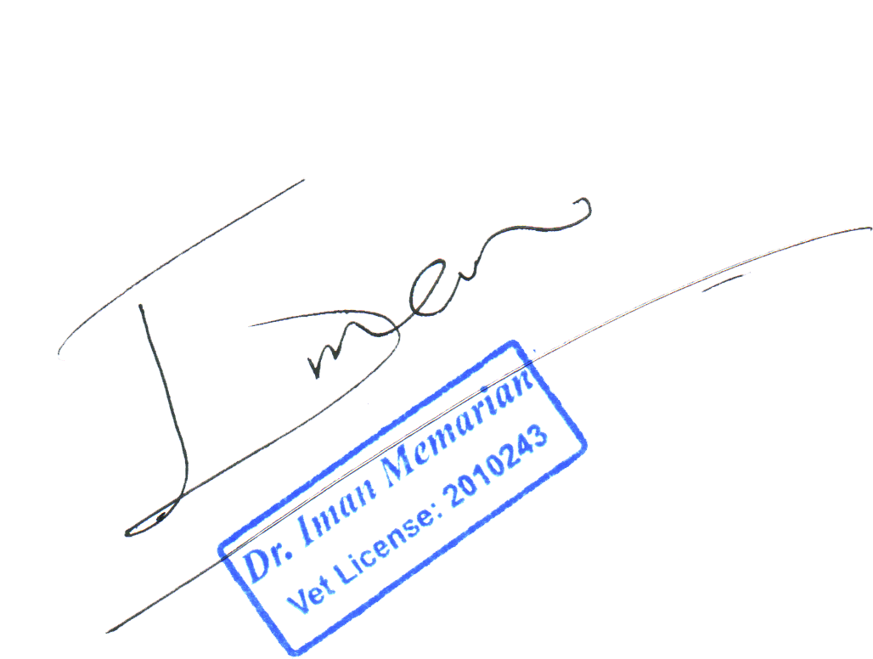Dr. Iman Memarian’s comprehensive experience as a wildlife veterinarian, researcher, and instructor demonstrates a unique blend of clinical veterinary expertise and conservation impact. His contributions span peer-reviewed research, on-the-ground wildlife rescue operations, capacity building in multiple countries, and public education. This curriculum vitae reflects his commitment to advancing zoo and wildlife medicine in Iran and internationally, bridging gaps between local action and global conservation science.