AWS EC2 Multi-Service Deployment Lab (NGINX, MongoDB, Zabbix)
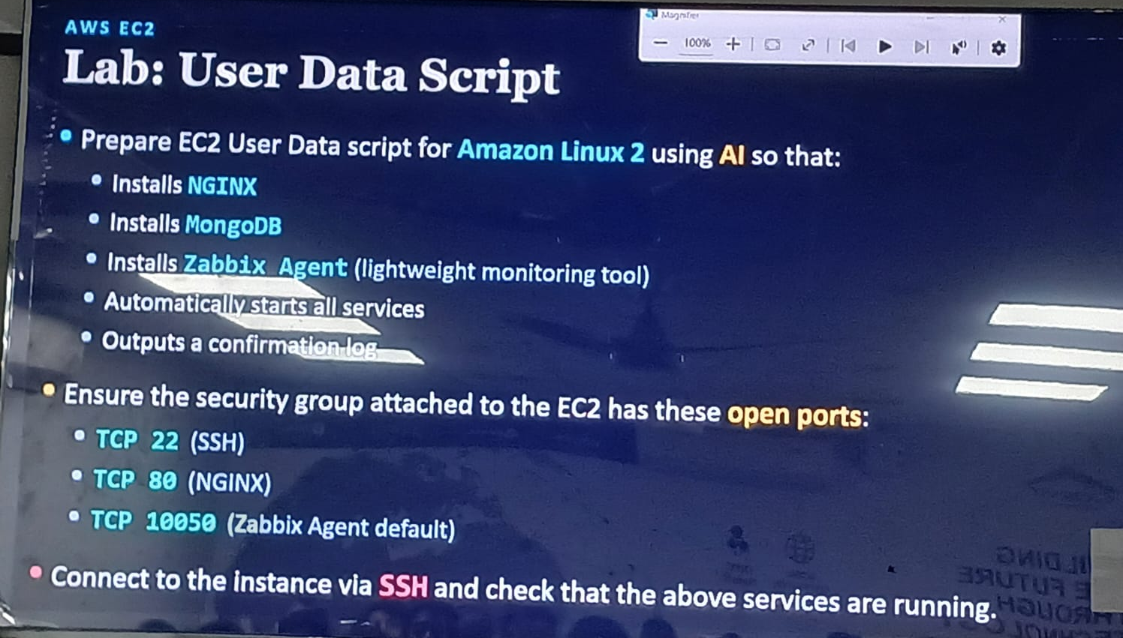

EC2 (Security Group)
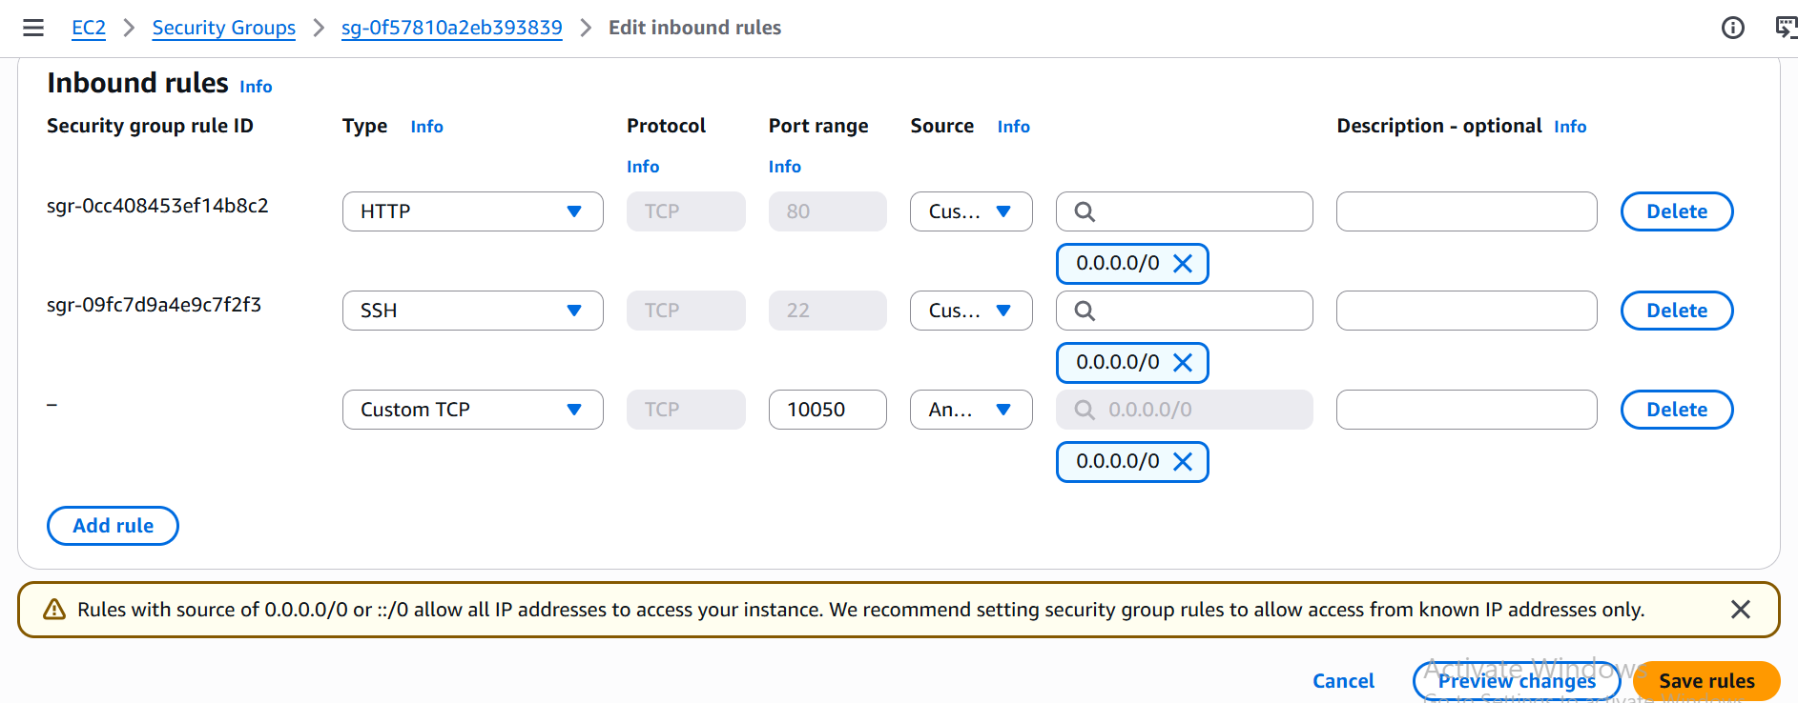

EC2 (Instances)
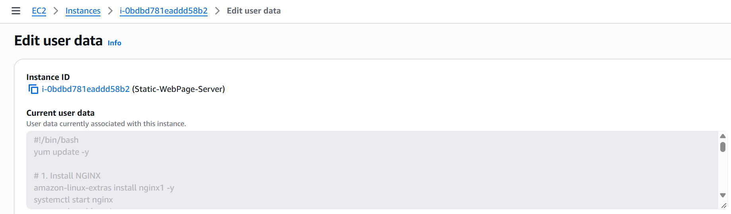

NGINX ACTIVE
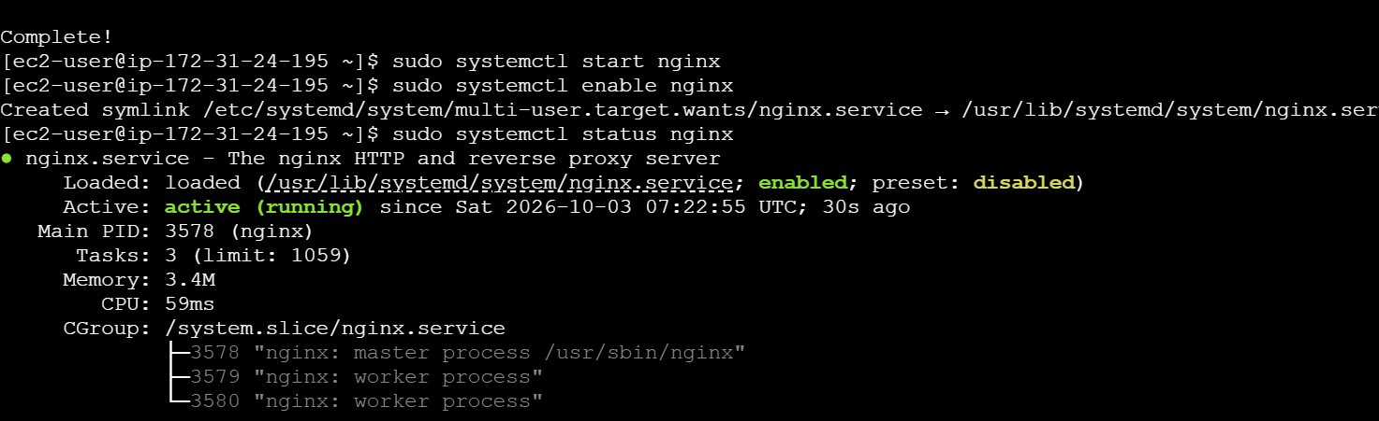

MONGOD ACTIVE
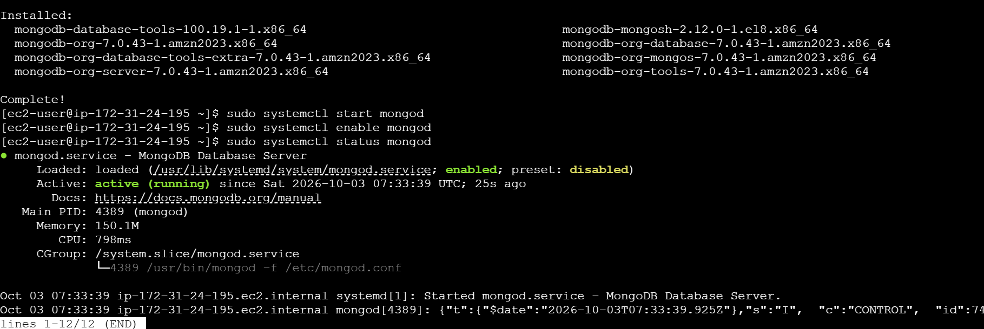

ZABBIX ACTIVE
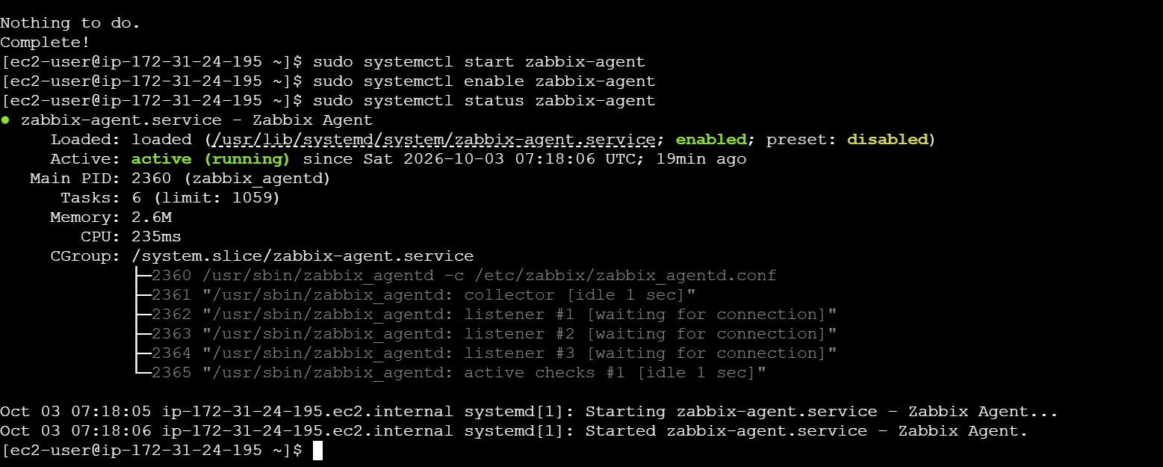

Testing
