Bandit Level 0
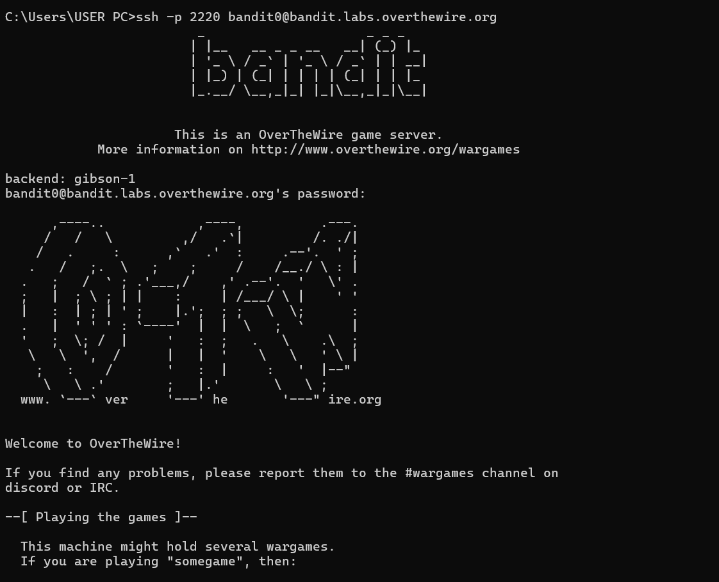

Bandit Level 0 → Level 1
Goal: Login to the Bandit server using SSH.
Command :ssh bandit0@bandit.labs.overthewire.org -p 2220
Skills learned:
- SSH connection
- Remote server access
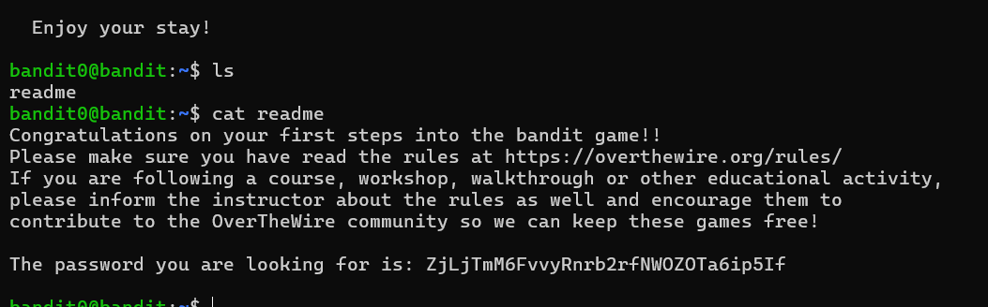

Bandit Level 1 → Level 2
Goal: Read a file named "-" (special filename).
Command: cat ./-
Skills learned: Handling special filenames
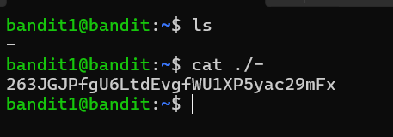

Bandit Level 2 → Level 3
Goal: Read a file with spaces in its name.
Command: cat "spaces in this filename"
Skills learned: Escaping spaces in filenames
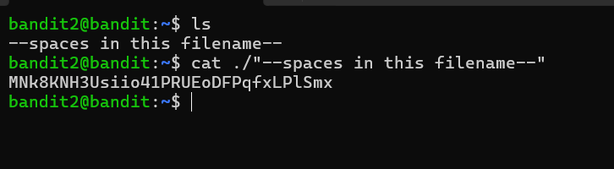

Bandit Level 3 → Level 4
Goal: Find a hidden file.
Command:
- ls -a
- cat .hidden
Skills learned: Hidden files in Linux
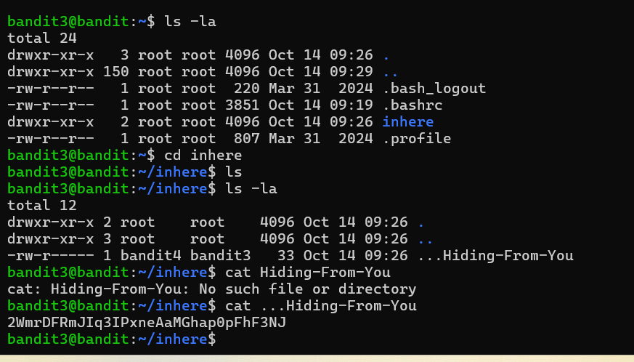

Bandit Level 4 → Level 5
Goal: Find the human readable file.
Command: file ./*
Skills learned: Identifying file types
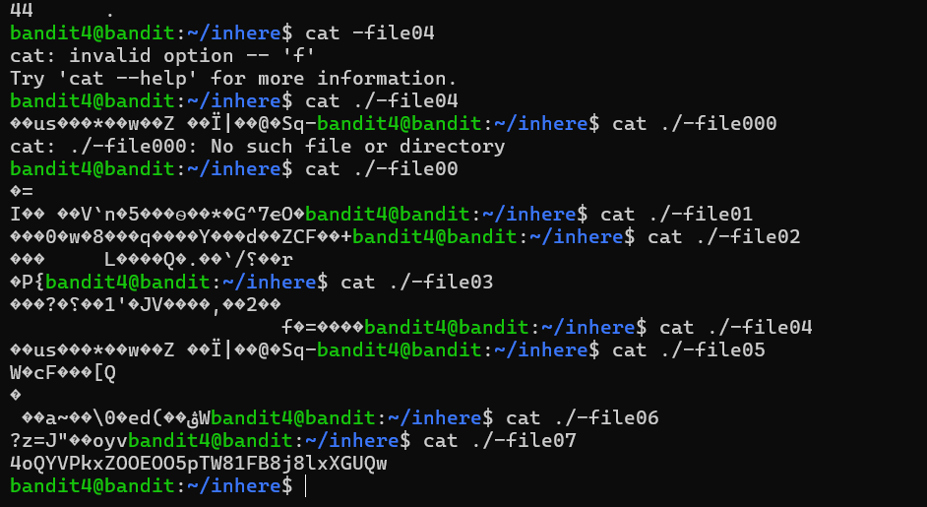

Bandit Level 5 → Level 6
Goal: Find a file with specific size and permissions.
Command: find . -type f -size 1033c ! -executable
Skills learned: Using the find command

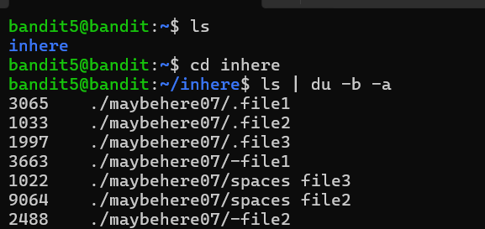
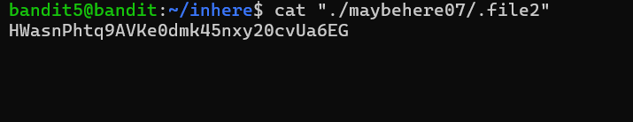

Bandit Level 6 → Level 7
Goal: Find a file owned by specific user and group.
Command: find / -user bandit7 -group bandit6 2>/dev/null
Skills learned:Searching system-wide files
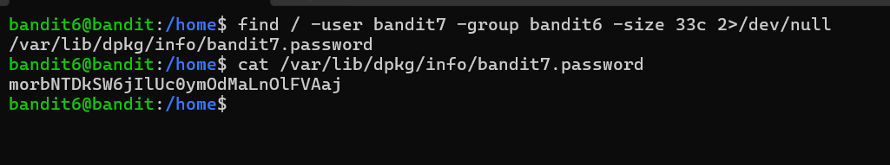

Bandit Level 7 → Level 8
Goal: Find the line containing the word "millionth".
Command: grep millionth data.txt
Skills learned: Text searching with grep
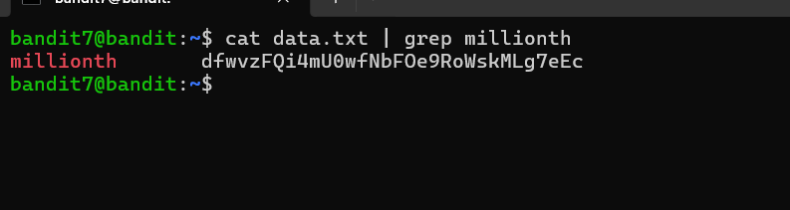

Bandit Level 8 → Level 9
Goal: Find the unique line.
Command: sort data.txt | uniq -u
Skills learned: Sorting and filtering text
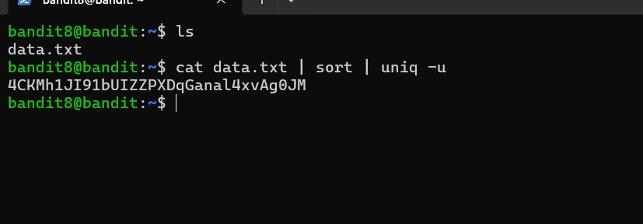

Bandit Level 9 → Level 10
Goal:Extract readable strings.
Command: strings data.txt | grep ===
Skills learned: Extracting readable strings

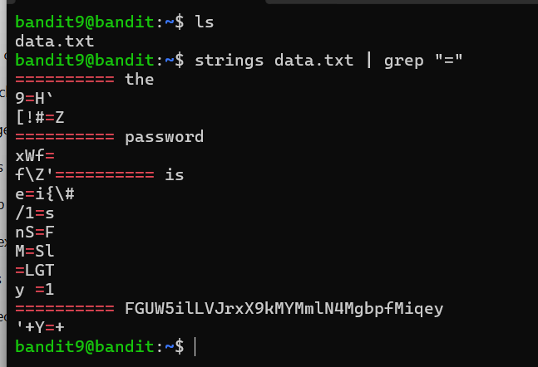

Bandit Level 10 → Level 11
Goal: Decode base64 data.
Command: base64 -d data.txt
Skills learned: Base64 decoding

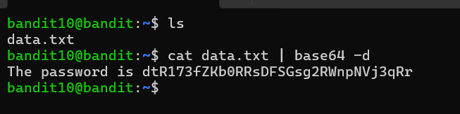

Bandit Level 11 → Level 12
Goal: Decode ROT13 text.
command: tr
Skills learned: Simple cipher decoding
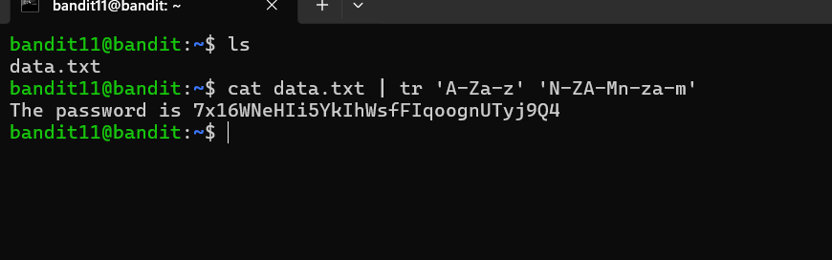

Bandit Level 12 → Level 13
Goal:Extract data from multiple compressed files.
Commands:
- xxd
- gzip
- bzip2
- tar
Skills learned:
- File extraction
- Compression formats
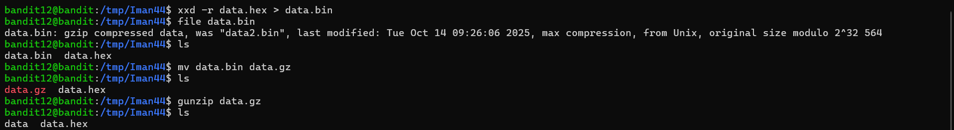
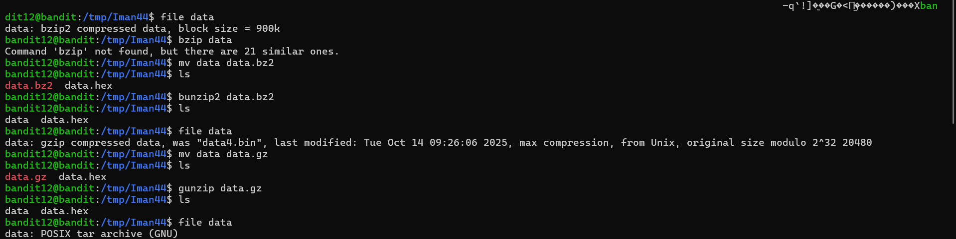
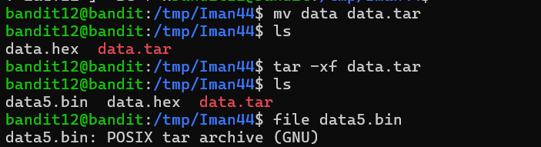
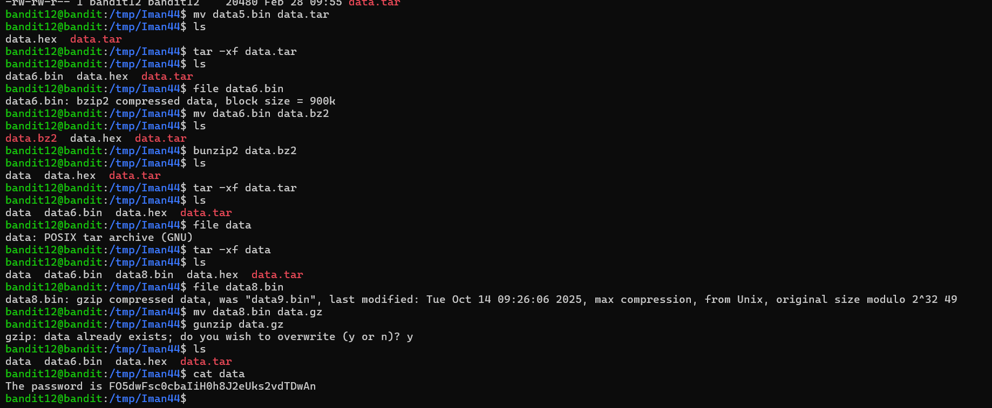

Bandit Level 13 → Level 14
Goal: Use private SSH key to login.
Command: ssh -i sshkey.private bandit14@localhost -p 2220
Skills learned: SSH key authentication

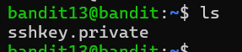
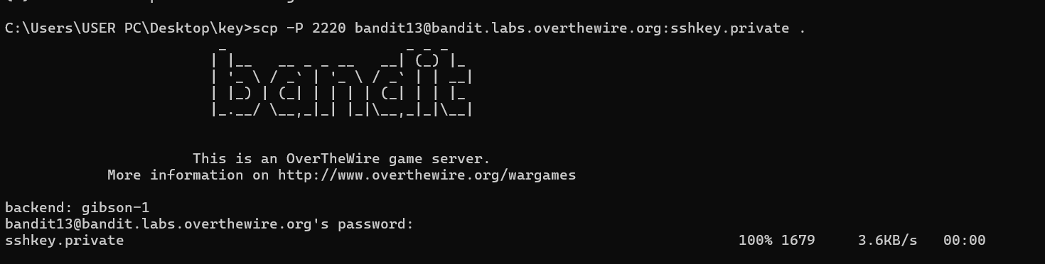
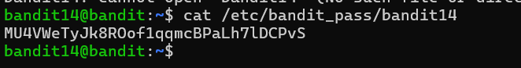

Bandit Level 14 → Level 15
Goal: Send password to a port.
Command: nc localhost 30000
Skills learned: Using netcat
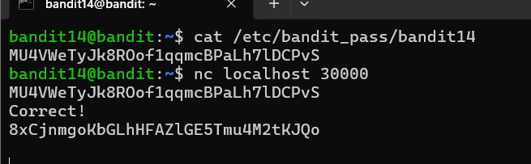

Bandit Level 15 → Level 16
Goal: Connect using SSL.
Command: openssl s_client -connect localhost:30001
Skills learned: SSL connections

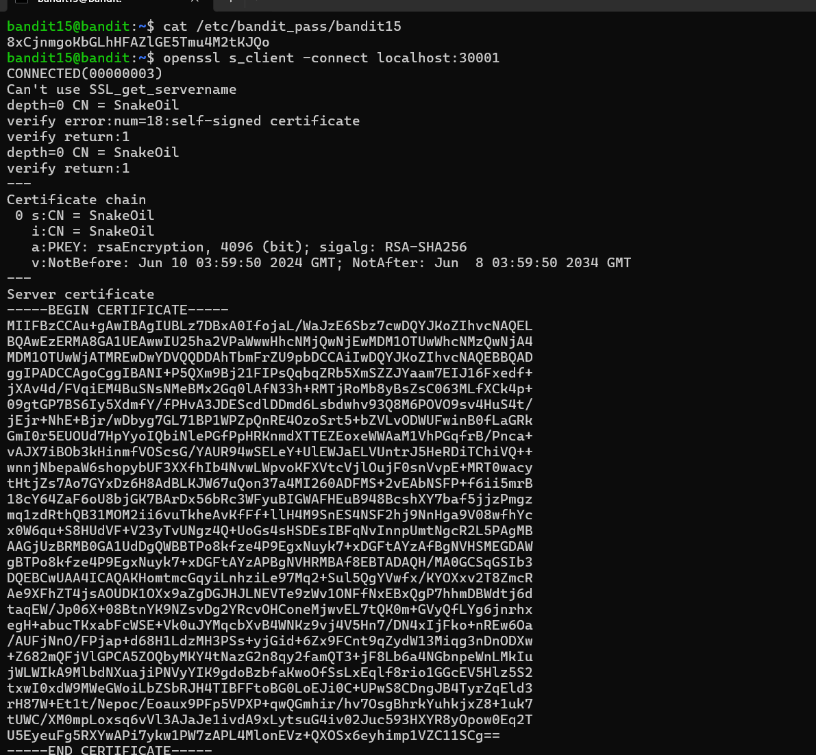
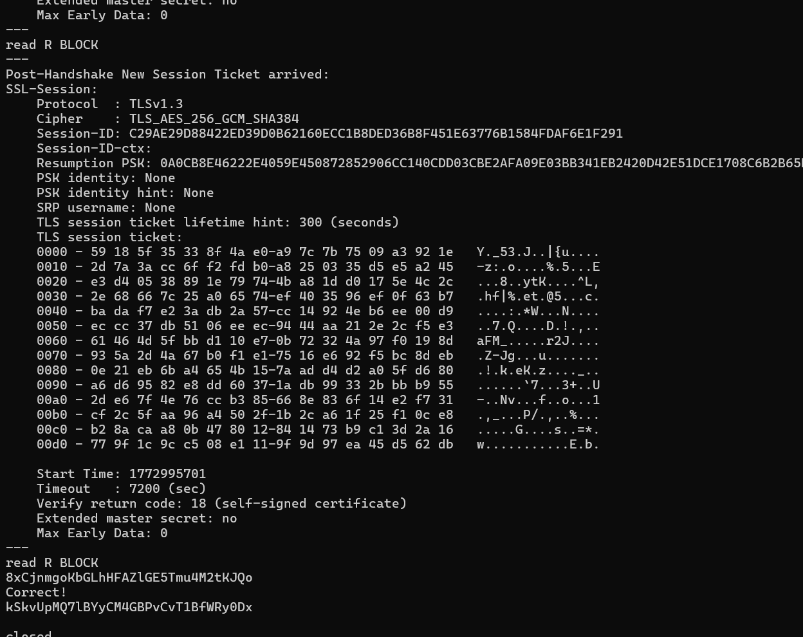

Bandit Level 16 → Level 17
Goal: Scan open ports.
Command: nmap -p 31000-32000 localhost
Skills learned: Port scanning
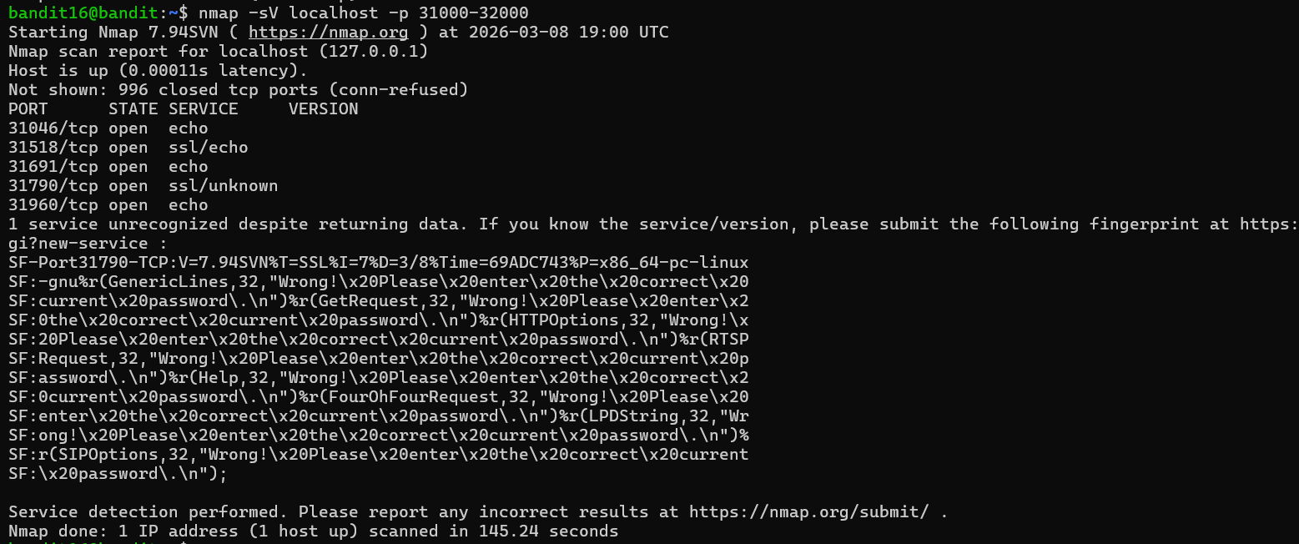
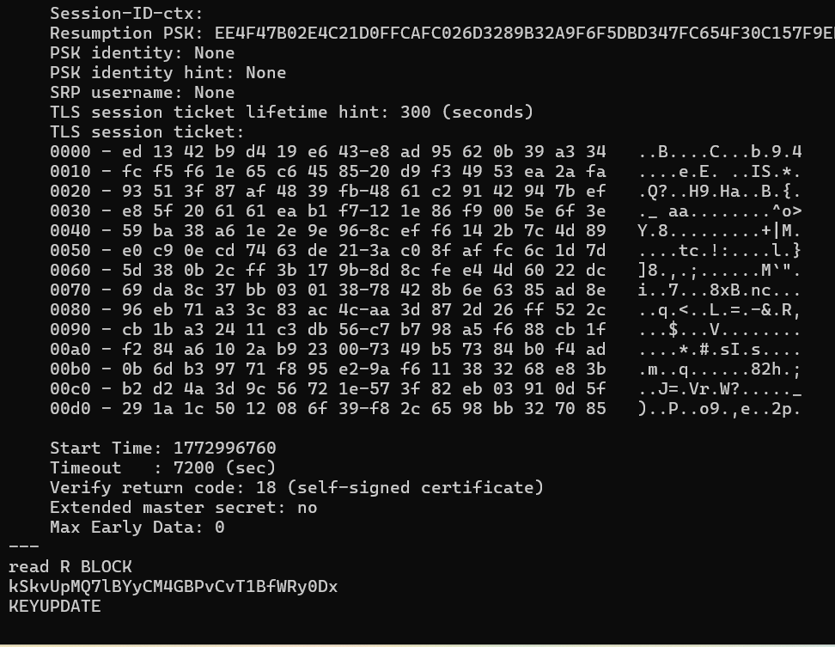
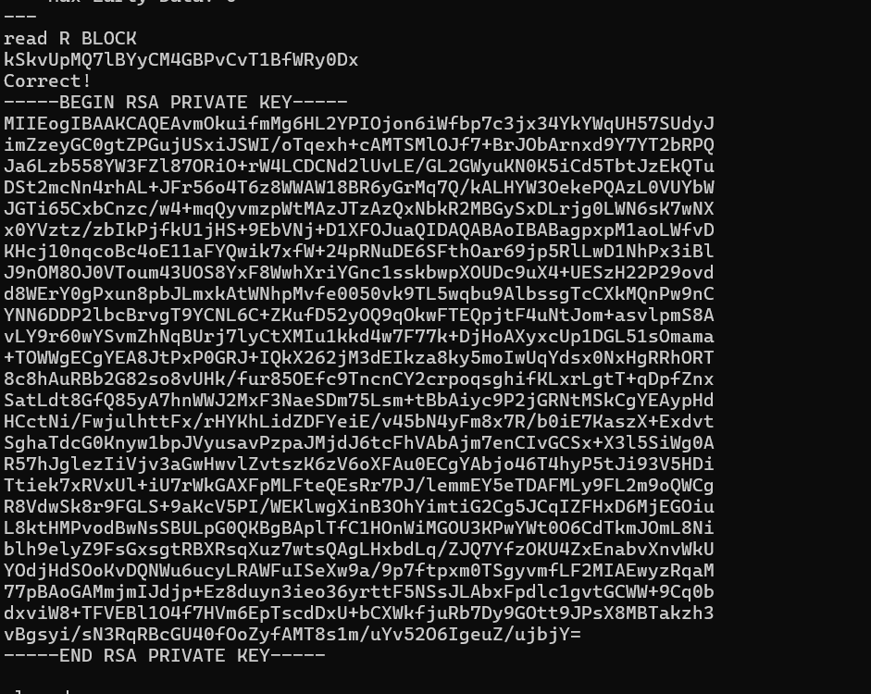

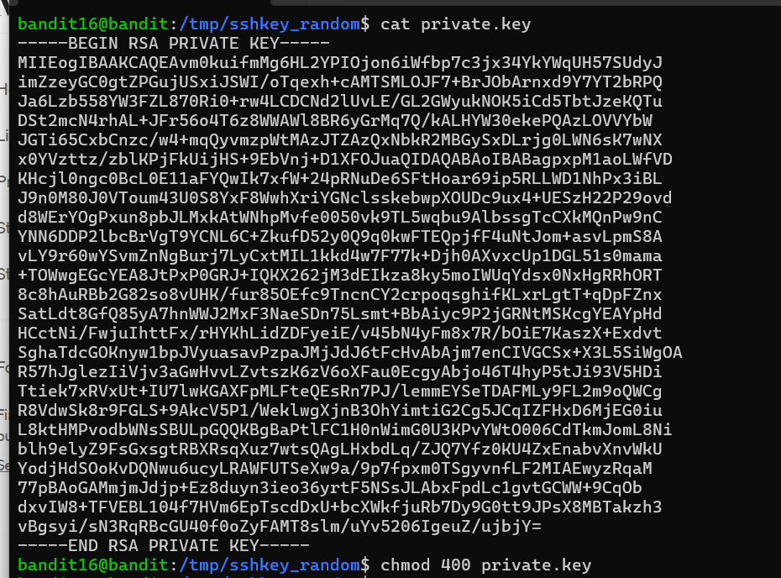
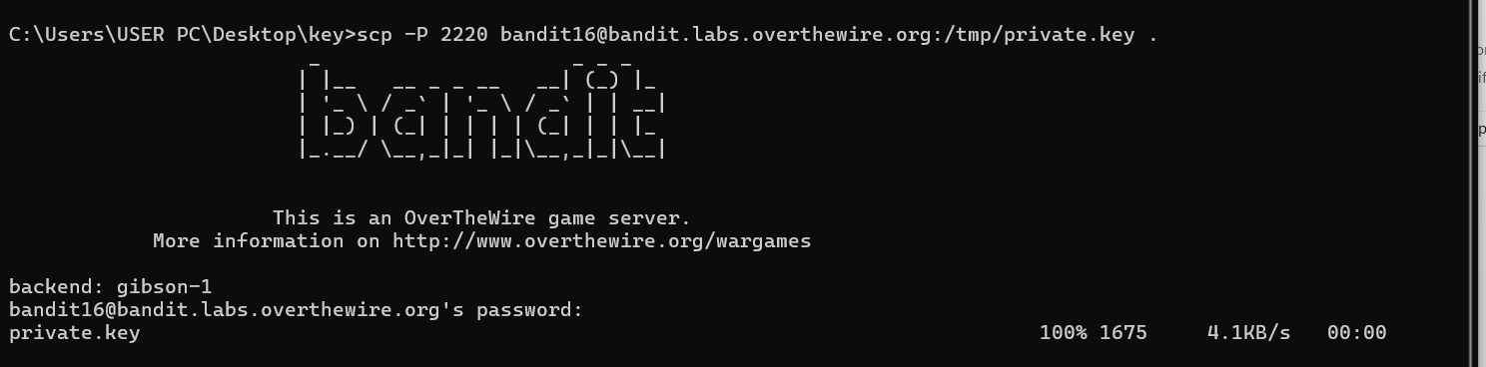

Bandit Level 17 → Level 18
Goal: Find difference between files.
Command: diff passwords.old passwords.new
Skills learned: Comparing files
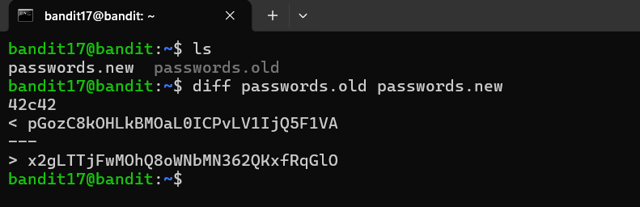

Bandit Level 18 → Level 19
Goal: Execute command despite restricted shell.
Command: ssh bandit18@bandit.labs.overthewire.org -p 2220 cat readme
Skills learned: Running remote commands
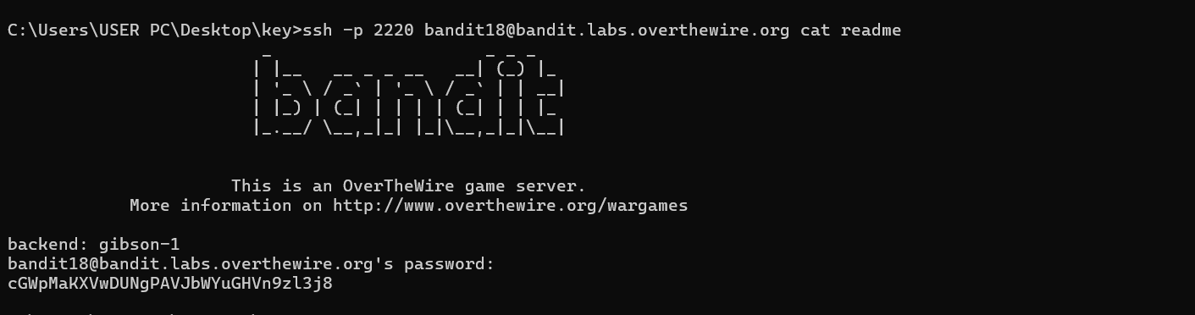

Bandit Level 19 → Level 20
Goal: Use setuid program.
Command: ./bandit20-do cat /etc/bandit_pass/bandit20
Skills learned: Privilege escalation basics
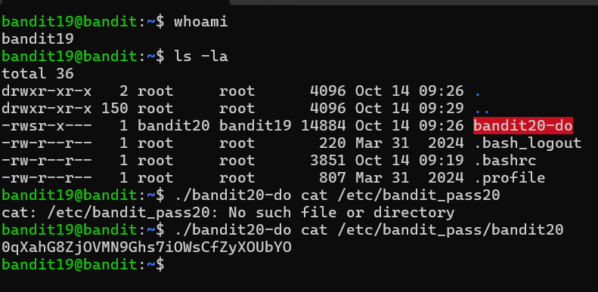

Bandit Level 20 → Level 21
Goal: Use netcat listener.
Commands: nc -lvp port
Skills learned: Network communication
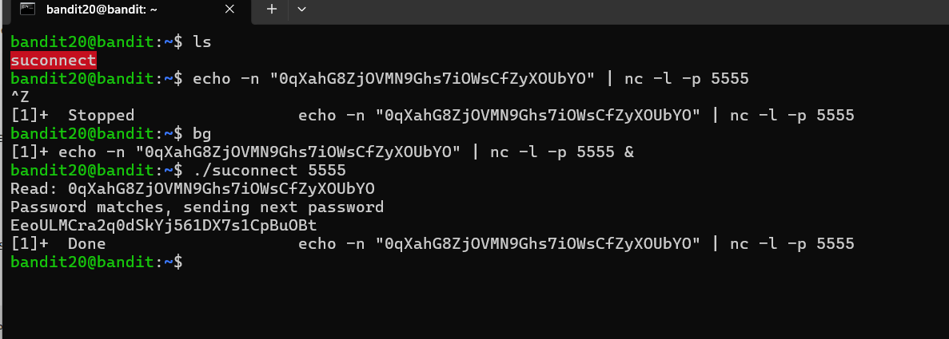

Bandit Level 21 → Level 22
Goal: Read cron job script.
Command: cat /etc/cron.d/...
Skills learned: Cron jobs analysis
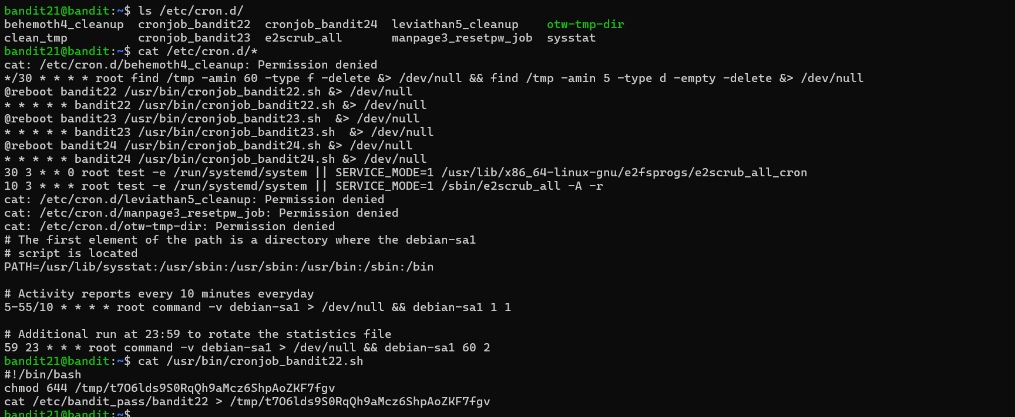

Bandit Level 22 → Level 23
Goal: Read cron job script.
Command: cat /etc/cron.d/cronjob_bandit23
Skills learned: Cron jobs analysis

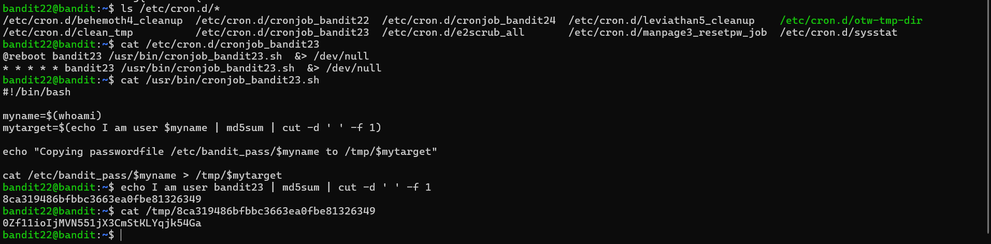

Bandit Level 23 → Level 24
Goal: Read cron job script location.
Command: cat /usr/bin/cronjob_bandit23.sh
Skills learned: Script analysis

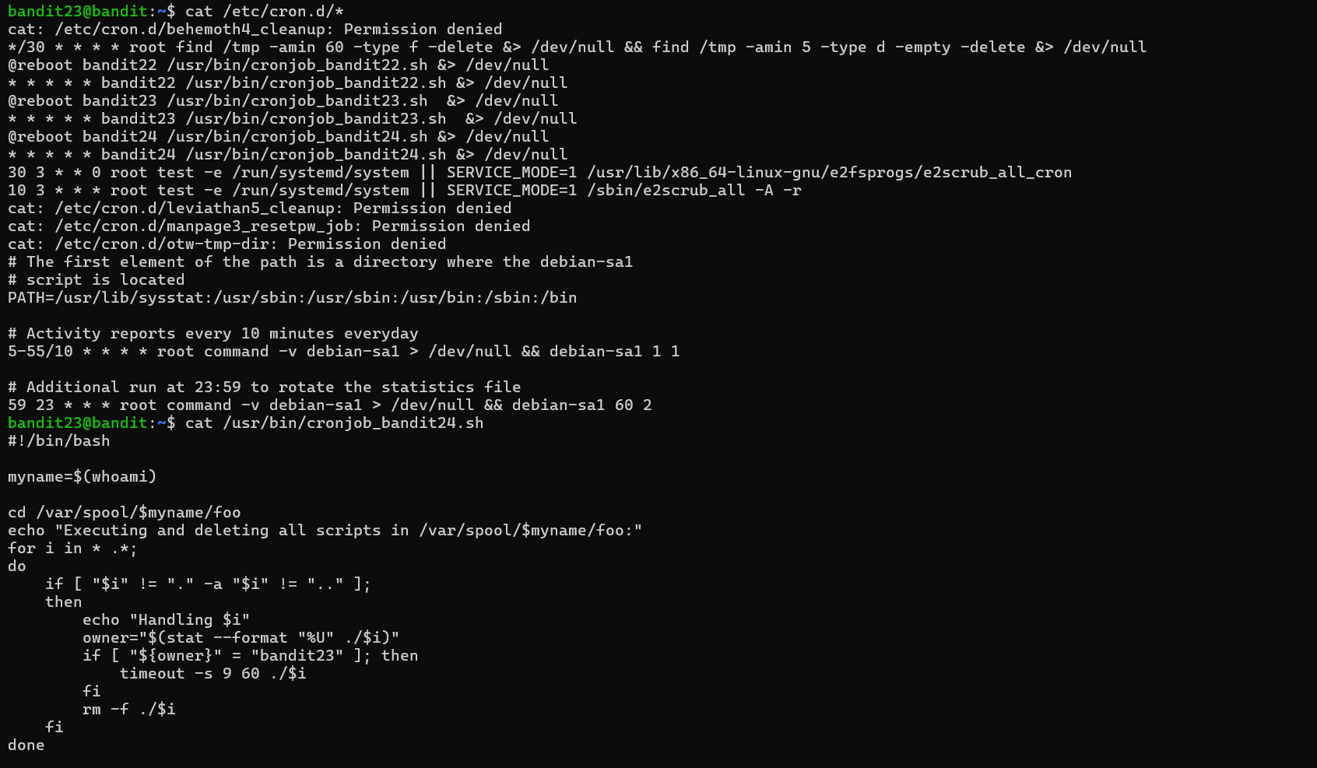
mkdir /tmp/iman99999
chmod 777 /tmp/iman99999
cd /tmp/iman99999
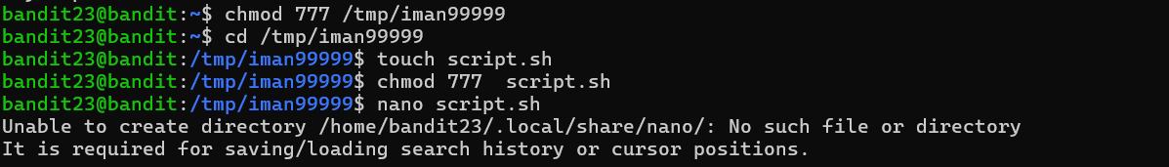
#!/bin/bash
cat /etc/bandit_pass/bandit24 > /tmp/gameplan1/password
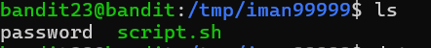

Bandit Level 24 → Level 25
Goal: Brute force the PIN code.
Command: nc localhost 30002
Skills learned: Brute force basics

Cd /tmp/iman99999
nano brute.sh
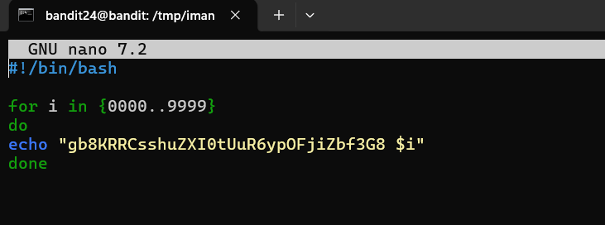
chmod +x brute.sh
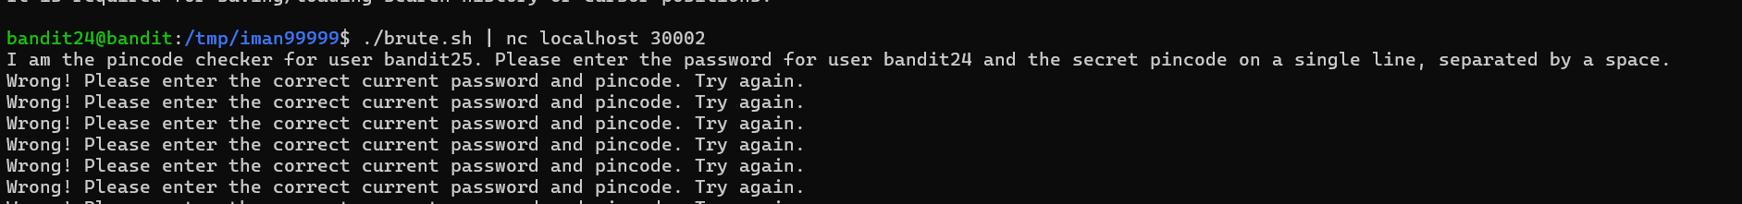
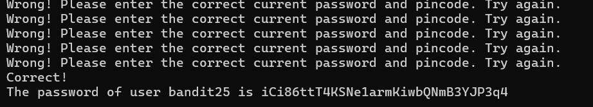

Bandit Level 25 → Level 26
Goal: Escape restricted shell.
Command: v (inside more → opens vim)
Skills learned: Shell escape

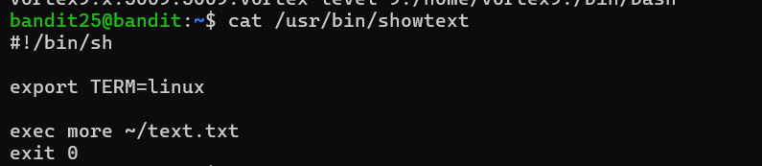


Bandit Level 26 → Level 27
Goal: Spawn a shell from vim.
Command: :shell
Skills learned: Vim shell access

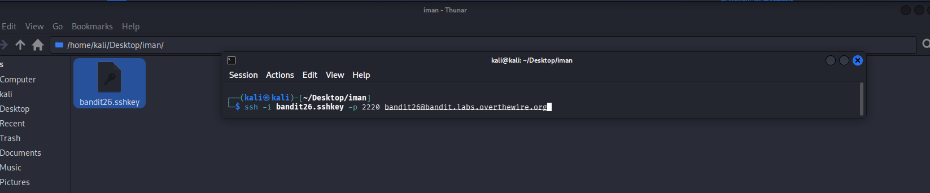
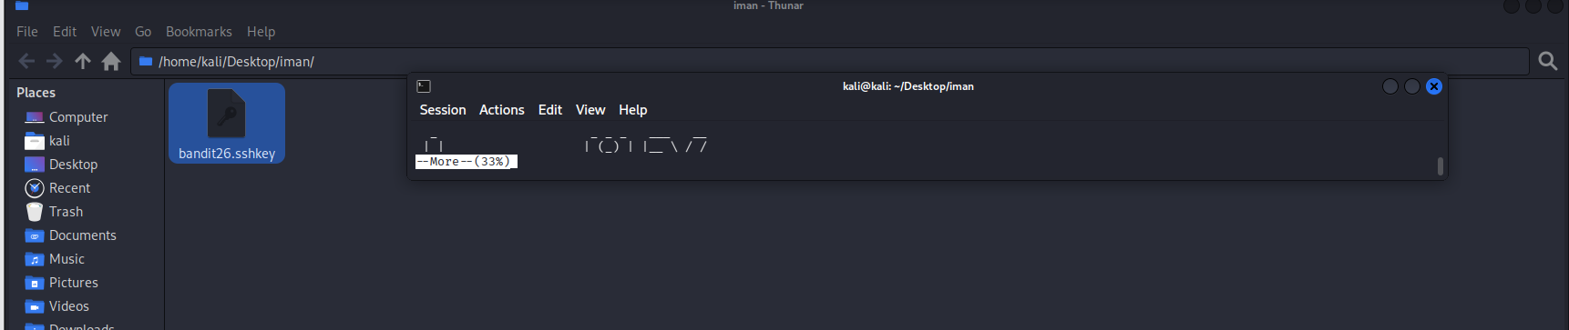
Press v to inters vim text editor mode
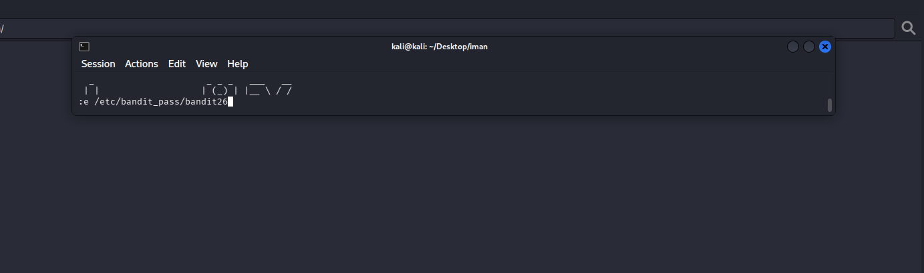
Enter
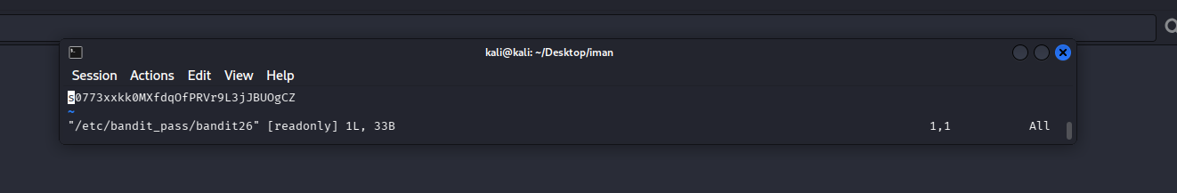
Password level 26:
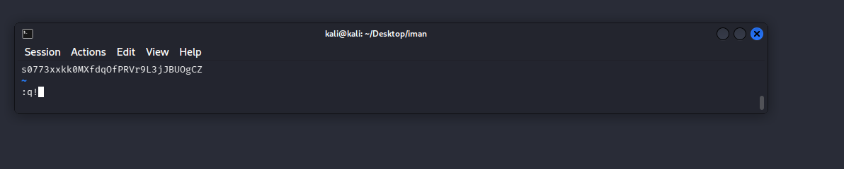
Enter again
:set shell=/bin/bash
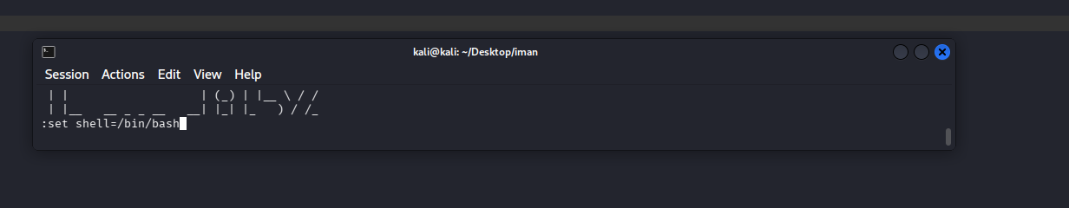
shell
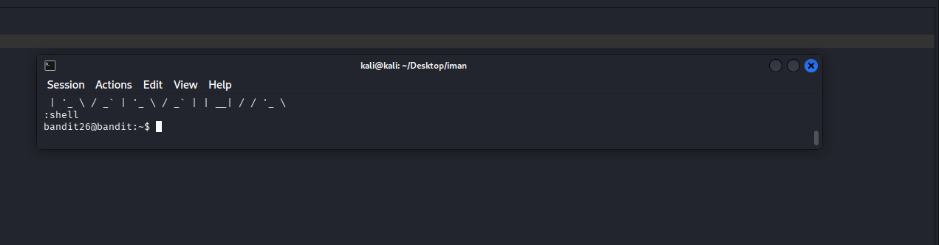
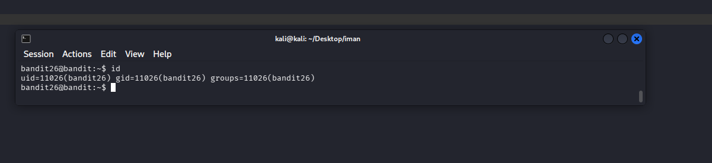
Ls -la
