***Politecnico of Turin***



**Department of ELECTRONICS and TELECOMUNICATION**

Master Degree in Mechatronic Engineering

2020/2021

**Technologies for Autonomous Vehicle – M.Canale**

**Homework 01 – Adaptive Cruise Control simulation**

Friday, May 7, 2021

**TEAM N° 1**

* Christian Cancedda, s277249
* Iman Ostovar, s272561
* Francesco Pasculli, s277977
* Luca Crupi, s283447
* Andreas Jonsson, s279956
* Lorenzo De Persiis, s276911

1. **Objective**

The goal of this Homework is to simulate an **Adaptive Cruise Control** (ACC) which is an Advanced Driver Assistance System (ADAS) that improves the CC features and aims at maintaining a set distance from the vehicle ahead, by controlling throttle and brake.  
Conventional ACC is intended to assist the driver at relatively high speeds in a highway by performing smooth maneuvers (using limited acceleration values), so it cannot be used as a collision avoidance system.  
ACC detects the relative distance and speed with respect to the vehicle ahead by means of either **LIDAR** or **RADAR** systems, and comparing the relative distance value to the safe distance it can operates in 2 modes:  
- **Velocity control:** if there is no leading vehicle, the host vehicle travels at target speed (i.e. CC mode)  
- **Spacing control:** the host vehicle maintains a safe distance from the leading vehicle.  
In our study scenario no V2X communication is assumed.

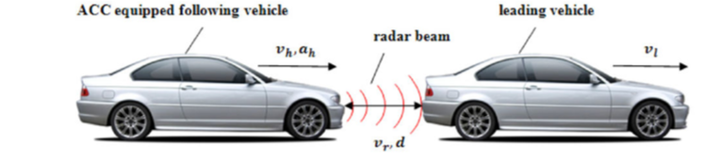

The following data are used in order to perform the simulation:

