Software Quality Engineering
22F-3645
22F-3715
Muhammad Zain Javed
Iman Fatima
BSE-5A
Task no 2
Member 1:
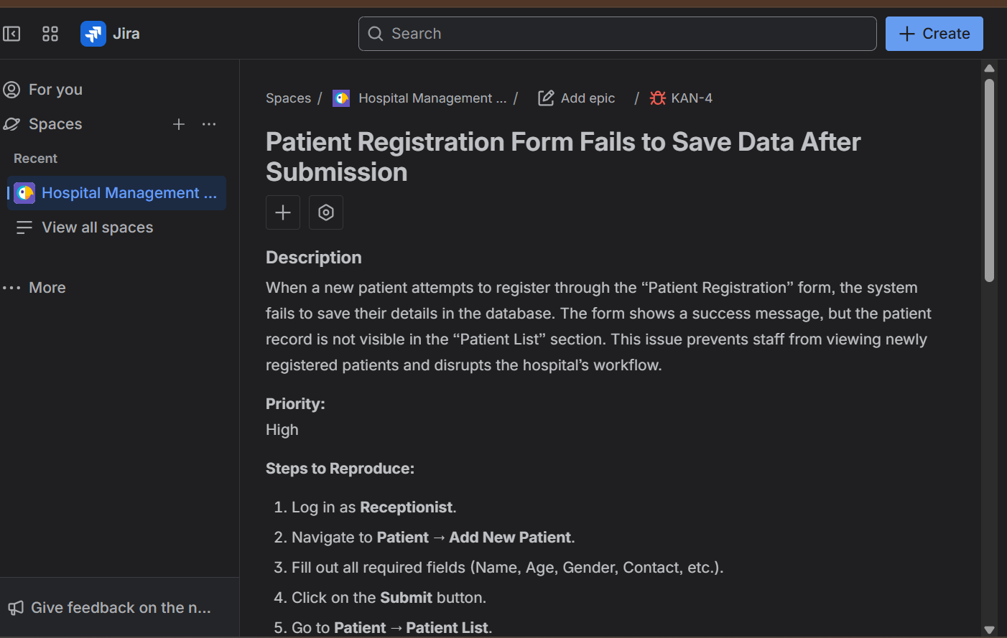

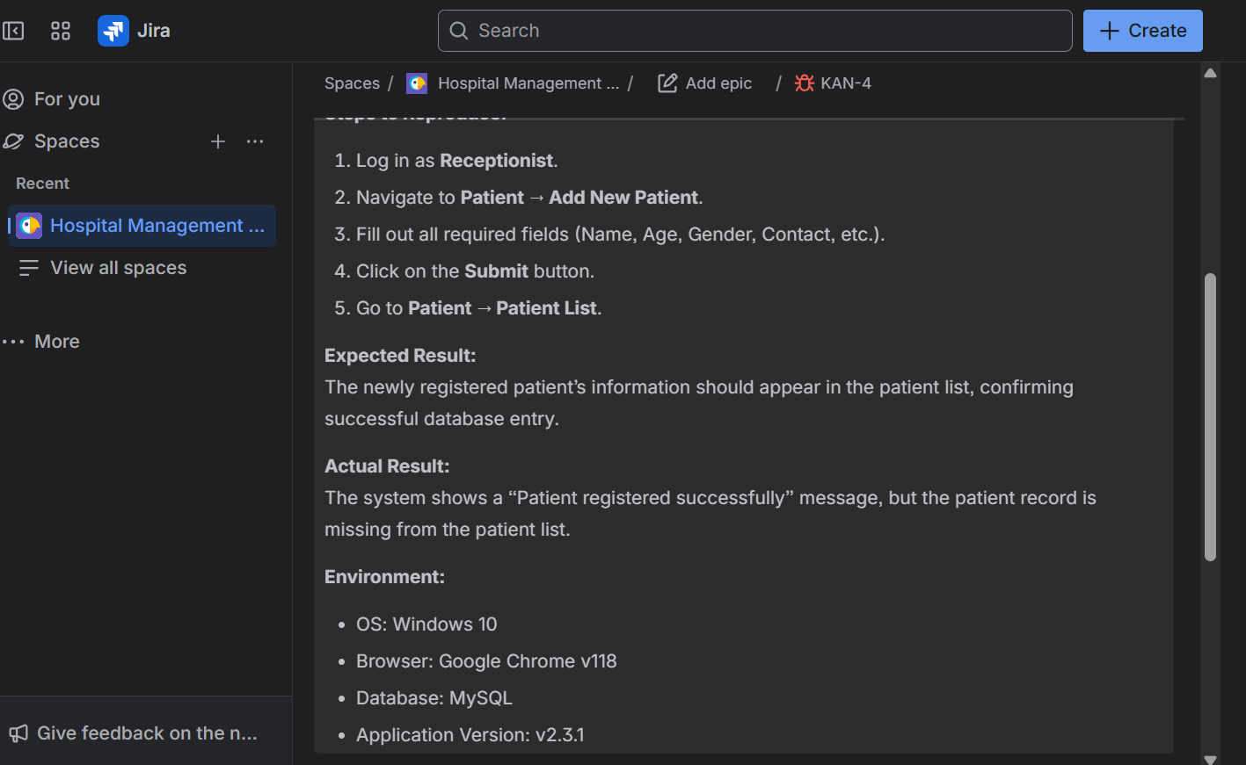

Member 2:

