Campus Lost and Found System
Project description and design A reusable C# class library with a console demonstration.

01 Problem and proposed solution
Lost-property records can become difficult to manage when item details and ownership claims are spread across messages or paper records. Staff need a consistent way to record found items, review competing claims and track completed returns.
The proposed system stores found items (with categories and photos), campus locations, students, staff, lost reports and ownership claims in one in-memory model. A student supports a claim with evidence and receives notifications as it is reviewed; staff record the handover in a collection record. The manager class coordinates adding and searching items, submitting and approving claims, and recording collections.

02 Target users
User | Purpose
Students | Report a lost item, search recorded items, submit a claim with supporting evidence and read notifications about their claims.
Lost-and-found staff / security | Record found items with photos, review evidence, approve or reject claims and record the collection handover.

03 Objectives
1. Maintain organised records of found items, their categories, photos and locations.
2. Let students report lost items and link each claim to one student and one item, supported by evidence.
3. Prevent duplicate pending claims and further claims on items that are returned or already approved.
4. Record who collected an item and when, and keep a notification trail for each claim.
5. Provide keyword search of the recorded found items.

04 Scope
This design demonstrates the domain using twelve classes, two enums and a console application. Data lasts for the current program run. A database, GUI, login, real e-mail or SMS delivery (notifications are simulated by printing them in the demo), automatic matching of lost reports to found items and automatic proof verification are outside this project. User roles describe intended usage; role-based access control is not implemented.

Classes and relationships

05 Required classes
Class | Responsibility
Student | Stores a student's ID, name and e-mail. Files lost reports and submits claims.
LostReport | A student's report of a lost item: owner, description, where it was last seen, date lost and whether the report is closed.
Location | A campus place with a name and building; used for where items were found and where lost items were last seen.
Staff | A staff member (ID, name, e-mail) who hands approved items back to students.
Claim | Links one student to one found item. Holds the claim status, supporting evidence and notifications, and can be approved or rejected once.
FoundItem | A handed-in item with its description, date found, location, category, photos and claims. Its status is derived from its claims and from whether it has been returned.
ItemCategory | A category (ID, name, description) used to group found items. Now a class rather than an enum.
CollectionRecord | Records the handover of an approved claim: which staff member handled it, when it was collected and any remarks. Can print a receipt.
ClaimEvidence | One piece of proof of ownership (description and optional file path) attached to a claim.
ItemPhoto | A photo of a found item (file path and caption) that helps students and staff identify it.
Notification | A message about a claim with its creation time and read flag. Delivery is simulated in the console demo.
LostAndFoundManager | Holds all found items. Adds and searches items, submits claims, approves a claim (rejecting its rivals) and records the collection.

06 Relationships and multiplicities
Relationship | Multiplicity / interpretation
Manager - FoundItem (manages found items) | One manager aggregates 0..* found items (hollow diamond). Each item is held by one manager.
Student - LostReport | One student can file 0..* lost reports; each report has exactly one owner.
LostReport - Location | Each report has one last-seen location; one location can appear in 0..* reports.
Location - FoundItem (found at) | One location can have 0..* found items; every found item has exactly one location.
FoundItem - ItemCategory | One category can group 0..* items; every item has exactly one category.
Student - Claim | One student can submit 0..* claims; each claim refers to exactly one student.
Claim - FoundItem | One item can receive 0..* claims; each claim refers to exactly one item.
Claim - ClaimEvidence | One claim can hold 0..* pieces of evidence; each piece belongs to exactly one claim.
Claim - Notification (notifications) | One claim can generate 0..* notifications; each notification belongs to exactly one claim.
FoundItem - ItemPhoto | One item can have 0..* photos; each photo belongs to exactly one item.
Claim - CollectionRecord (approved claim) | A claim has 0..1 collection record (only after approval and handover); each record refers to exactly one approved claim.
Staff - CollectionRecord | One staff member can handle 0..* collections; each record has exactly one staff member (HandledBy).

Enums (not counted in the 12 classes): ItemStatus = Unclaimed, ClaimPending, Returned.
ClaimStatus = Pending, Approved, Rejected.
ItemCategory is now a class (see FoundItem - ItemCategory above), so it is no longer an enum.

Complete UML class diagram
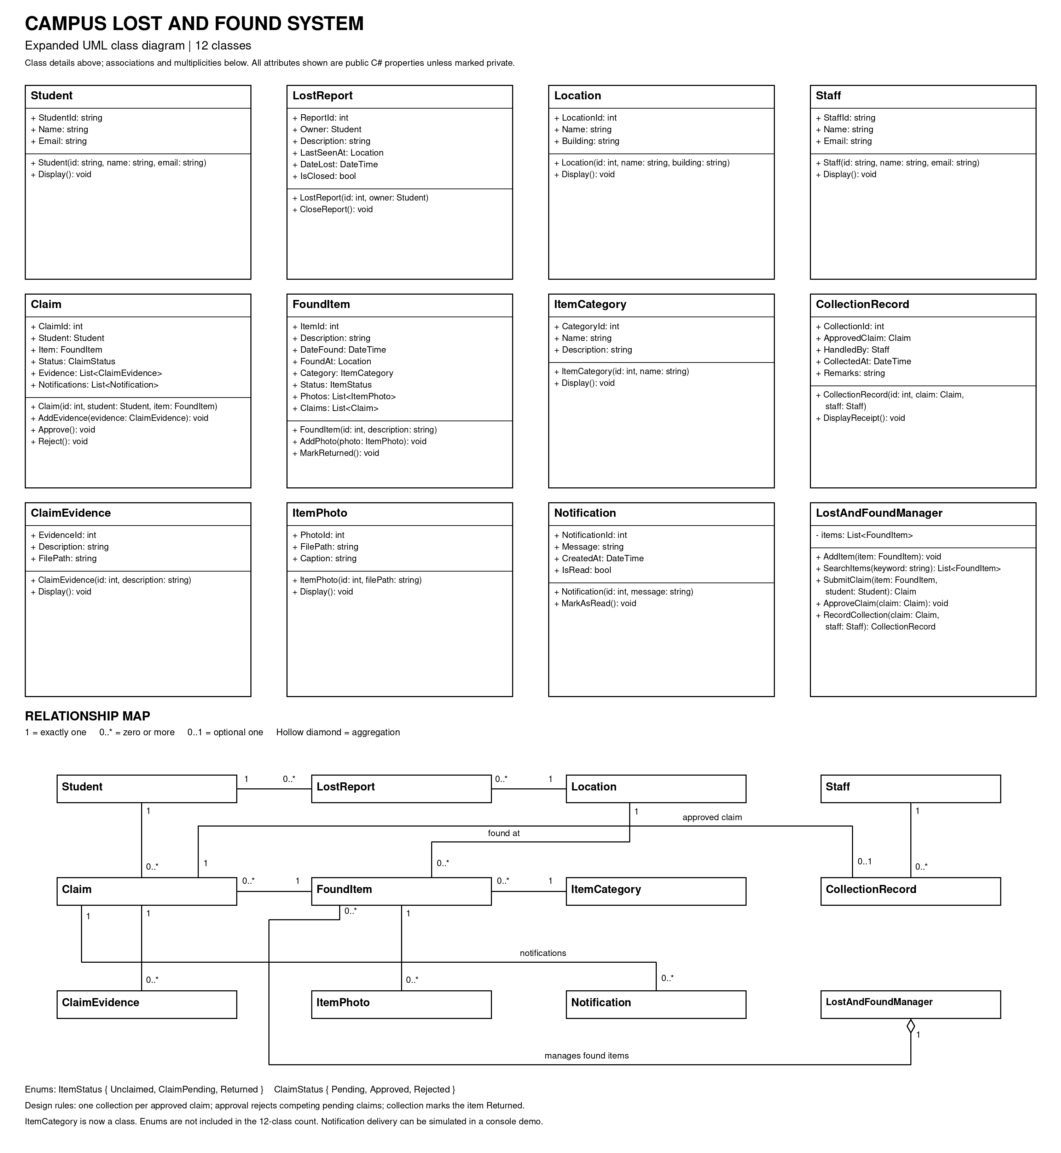

Rules and design decisions

07 Encapsulation and consistency
The console application works through the public LostAndFoundManager methods: AddItem(), SearchItems(), SubmitClaim(), ApproveClaim() and RecordCollection(). As the UML shows, all class members are public, so the rules are protected inside the classes: Claim.Status, Notification.IsRead and LostReport.IsClosed have private setters and can only change through Approve(), Reject(), MarkAsRead() and CloseReport(). The manager keeps its items in a private list, and SearchItems() returns a new list rather than the internal one.
FoundItem.Status is derived rather than stored: Returned once MarkReturned() has been called; otherwise ClaimPending while any claim is pending or approved; otherwise Unclaimed. MarkReturned() only works when the item has an approved claim and only once, so approval and collection cannot conflict. An approved claim keeps the item at ClaimPending until staff record the collection.

08 Business rules
Rule | Behaviour
Identity and records | Item IDs must be unique within the manager. The manager allocates claim IDs (next number across all claims); a collection record reuses its claim's ID because each approved claim has at most one collection. Other IDs are supplied when the object is created.
Valid records | Required text (names, descriptions, e-mail, file paths) cannot be blank. Before AddItem() accepts an item it must have a location, a category and a found date that is set and not in the future.
Submitting claims | The item must be recorded by the manager and must not be returned. A student cannot hold two pending claims on the same item, and no new claims are accepted once a claim has been approved.
Evidence and notifications | Evidence can only be added while a claim is pending. Each claim records a notification when it is received, approved, rejected and collected.
Resolving claims | Only pending claims can be approved or rejected. ApproveClaim() rejects every competing pending claim for the same item.
Collection and handover | Only an approved claim can be collected, and only once. RecordCollection() creates the CollectionRecord, marks the item Returned and adds a notification. Staff approve a claim only after checking the evidence; proof is recorded as text and is not verified automatically.
Search | SearchItems() matches description, category name, location name and building (ignoring case) across all items, including returned ones. A blank keyword returns every item.
Lost reports | A lost report must have an owner and can be closed once. Reports are not matched to found items automatically.

Error handling: blank required data uses ArgumentException (null objects use ArgumentNullException); invalid state changes, such as claiming a returned item or approving a claim twice, use InvalidOperationException. The demo catches the expected invalid actions.

Application demonstration
The supplied Program.cs creates a manager, a lost report, two found items (one with a photo) and three claims with evidence. It then demonstrates search, approval, rejection, collection, blocked actions and notifications. The two project folders separate the reusable class library from the console application.
using CampusLostAndFound.Library;
var manager = new LostAndFoundManager();
// ---- Set up people, places and categories ----
var library = new Location(1, "Main Library", "Library Building");
var cafeteria = new Location(2, "Student Cafeteria", "Block C");
var electronics = new ItemCategory(1, "Electronics") { Description = "Phones, chargers, laptops" };
var clothing = new ItemCategory(2, "Clothing") { Description = "Jackets, hoodies, scarves" };
var aisyah = new Student("S1001", "Aisyah Rahman", "aisyah@example.com");
var daniel = new Student("S1002", "Daniel Lim", "daniel@example.com");
var hafiz = new Staff("ST01", "Hafiz Karim", "hafiz@example.com");
Heading("People, places and categories");
aisyah.Display(); daniel.Display(); hafiz.Display();
library.Display(); cafeteria.Display();
electronics.Display(); clothing.Display();
// ---- A student reports a lost phone ----
Heading("Lost report");
var report = new LostReport(1, aisyah)
{
Description = "Black smartphone with cracked case",
LastSeenAt = library,
DateLost = DateTime.Today.AddDays(-2)
};
Console.WriteLine($"Report #{report.ReportId} by {report.Owner.Name}: {report.Description} " +
$"(last seen at {report.LastSeenAt?.Name})");
// ---- Staff record found items ----
var phone = new FoundItem(1, "Black smartphone with cracked case")
{ DateFound = DateTime.Today.AddDays(-1), FoundAt = library, Category = electronics };
phone.AddPhoto(new ItemPhoto(1, "photos/phone-front.jpg") { Caption = "Front of the phone" });
var hoodie = new FoundItem(2, "Grey hoodie, size M")
{ DateFound = DateTime.Today.AddDays(-1), FoundAt = cafeteria, Category = clothing };
manager.AddItem(phone);
manager.AddItem(hoodie);
Heading("Search results");
Console.WriteLine($"\"library\": {manager.SearchItems("library").Count} item(s)");
Console.WriteLine($"\"clothing\": {manager.SearchItems("clothing").Count} item(s)");
Console.WriteLine($"All items: {manager.SearchItems("").Count}");
// ---- Students submit claims; two students want the same phone ----
Heading("Claims");
var claim1 = manager.SubmitClaim(phone, aisyah);
claim1.AddEvidence(new ClaimEvidence(1, "Can unlock the phone with her PIN") { FilePath = "evidence/unlock.jpg" });
var claim2 = manager.SubmitClaim(phone, daniel);
claim2.AddEvidence(new ClaimEvidence(2, "Says he has a purchase receipt"));
var claim3 = manager.SubmitClaim(hoodie, daniel);
claim3.AddEvidence(new ClaimEvidence(3, "Name tag inside the collar"));
Console.WriteLine($"Phone: {phone.Status} ({phone.Claims.Count} claims)");
Console.WriteLine($"Hoodie: {hoodie.Status} ({hoodie.Claims.Count} claim)");
// ---- Staff review the evidence ----
Heading("Review");
manager.ApproveClaim(claim1); // also rejects Daniel's competing claim
claim3.Reject(); // evidence could not be verified
Console.WriteLine($"Claim 1 (Aisyah, phone): {claim1.Status}");
Console.WriteLine($"Claim 2 (Daniel, phone): {claim2.Status}");
Console.WriteLine($"Claim 3 (Daniel, hoodie): {claim3.Status}");
Console.WriteLine($"Phone: {phone.Status} (approved, waiting for collection)");
Console.WriteLine($"Hoodie: {hoodie.Status}");
// ---- Collection ----
Heading("Collection");
var receipt = manager.RecordCollection(claim1, hafiz);
receipt.Remarks = "Student ID card checked.";
receipt.DisplayReceipt();
Console.WriteLine($"Phone: {phone.Status}");
// ---- Rules that stop invalid actions ----
Heading("Blocked actions");
Try(() => manager.SubmitClaim(phone, daniel));
Try(() => manager.RecordCollection(claim1, hafiz));
Try(() => claim2.Approve());
// ---- Notifications (delivery is simulated by printing) ----
Heading("Notifications for Aisyah's claim");
foreach (var n in claim1.Notifications)
{
Console.WriteLine($"[#{n.NotificationId}] {n.Message}");
n.MarkAsRead();
}
Console.WriteLine($"Unread: {claim1.Notifications.Count(n => !n.IsRead)}");
// ---- Close the lost report ----
Heading("Summary");
report.CloseReport();
Console.WriteLine($"Lost report #{report.ReportId} closed: {report.IsClosed}");
Console.WriteLine($"Claims: {phone.Claims.Count + hoodie.Claims.Count} | " +
$"Returned items: {manager.SearchItems("").Count(i => i.Status == ItemStatus.Returned)}");
static void Heading(string text)
{
Console.WriteLine();
Console.WriteLine($"--- {text} ---");
}
static void Try(Action action)
{
try { action(); Console.WriteLine("No error"); }
catch (InvalidOperationException ex) { Console.WriteLine($"Blocked: {ex.Message}"); }
}

Verification and submission

09 Demonstration output
The following output was produced by building and running the supplied code (the solution built with 0 errors and 0 warnings). The dates in the receipt and in the collection notification show the day the demo is run.
--- People, places and categories ---
Student S1001: Aisyah Rahman <aisyah@example.com>
Student S1002: Daniel Lim <daniel@example.com>
Staff ST01: Hafiz Karim <hafiz@example.com>
Location #1: Main Library (Library Building)
Location #2: Student Cafeteria (Block C)
Category #1: Electronics - Phones, chargers, laptops
Category #2: Clothing - Jackets, hoodies, scarves
--- Lost report ---
Report #1 by Aisyah Rahman: Black smartphone with cracked case (last seen at Main Library)
--- Search results ---
"library": 1 item(s)
"clothing": 1 item(s)
All items: 2
--- Claims ---
Phone: ClaimPending (2 claims)
Hoodie: ClaimPending (1 claim)
--- Review ---
Claim 1 (Aisyah, phone): Approved
Claim 2 (Daniel, phone): Rejected
Claim 3 (Daniel, hoodie): Rejected
Phone: ClaimPending (approved, waiting for collection)
Hoodie: Unclaimed
--- Collection ---
Receipt #1: 'Black smartphone with cracked case' collected by Aisyah Rahman, handled by Hafiz Karim on 25 Oct 2026.
Remarks: Student ID card checked.
Phone: Returned
--- Blocked actions ---
Blocked: Item has already been returned.
Blocked: Item has already been collected.
Blocked: Claim #2 is already rejected.
--- Notifications for Aisyah's claim ---
[#1] Claim #1 for 'Black smartphone with cracked case' was received and is pending review.
[#2] Claim #1 was approved. Please collect 'Black smartphone with cracked case' from staff.
[#3] 'Black smartphone with cracked case' was collected on 25 Oct 2026.
Unread: 0
--- Summary ---
Lost report #1 closed: True
Claims: 3 | Returned items: 1

10 Code package and run command
CampusLostAndFound.Library/ contains twelve class files (Student, Staff, Location, ItemCategory, LostReport, FoundItem, ItemPhoto, Claim, ClaimEvidence, Notification, CollectionRecord, LostAndFoundManager), Enums.cs and its project file.
CampusLostAndFound.Demo/ contains Program.cs and its project file.
docs/ contains this design report and the UML class diagram. README.md explains setup and scope.
With the .NET 8 SDK (or newer) installed, run from the extracted project folder:
dotnet run --project CampusLostAndFound.Demo/CampusLostAndFound.Demo.csproj

11 GitHub repository - action required
Repository URL: pending upload. No verified repository URL was supplied. Upload the two project folders and supporting files to your group's GitHub repository, then replace this notice with the actual link before submitting the PDF.

12 Final checks
1. Build and run the demo; compare its output with the example above.
2. Check that duplicate pending claims, claims on returned items and repeat approval or collection are rejected.
3. Add your group members' names and student IDs if required by your lecturer.
4. Insert the real GitHub link and confirm the lecturer can access the code.

