Criteria to prioritize the requirement

1. User demand : what the user want the most.

2. Performance Enhancers: These are requirements that go beyond the basic functionality of the product and add value by improving performance.

3. Must have feature : essential of the product.

4. Profit : which feature can get the most profit

5. Delighters: The requirements that are not necessary for the basic functionality of the product but can provide an element of surprise or increase user satisfaction.

make user journey from the first feature to be implementing via the link below and List document as follows:

first feature to be implement

Customizable Insurance and Selection

-Allow users to customize their insurance coverage based on their specific needs and allow them to easily add insurance to their accommodation booking at the check out process.

-Displays clear and in-depth description of what the insurance covers what it includes, and allows a transparent transaction.

URS

URS-01 : Users can look over the insurance options from the given package.

URS-02 : Users can see the insurance options for the details.

URS-03 : User can be access in-depth information about each specific coverage option

URS-04 : Users must be able to adjust their insurance coverage based on their specific need.

URS-05 : The cost of the chosen insurance coverage must be clearly indicated.

URS-06 : User can see summary of their selection

SRS

- URS-01 : Users can look over the insurance options from the given package.

- SRS-01 : System display a list of available insurance options.

- URS-02 : Users can see the insurance options for the details.

- SRS-02 : Each listed insurance option must be clickable.

- URS-03 : User can be access in-depth information about each specific coverage option.

- SRS-03.1 : System shows the details of the options.

- SRS-03.2 : System should fetch and display the options according to a user's chosen package.

- URS-04 : Users must be able to adjust their insurance coverage based on their specific need.

- SRS-04.1 : System should provide checkboxes or toggles next to each insurance option

- SRS-04.2 : System should register and remember the user's selection.

- URS-05 : The cost of the chosen insurance coverage must be clearly indicated.

- SRS-05 : system immediately recalculate and display the updated cost.

- URS-06 : User can see summary of their selection.

- SRS-06.1: System shows summary of the user selection.

- SRS-06.2: System asks user for the confirmation of what the user had selected.

use case diagram

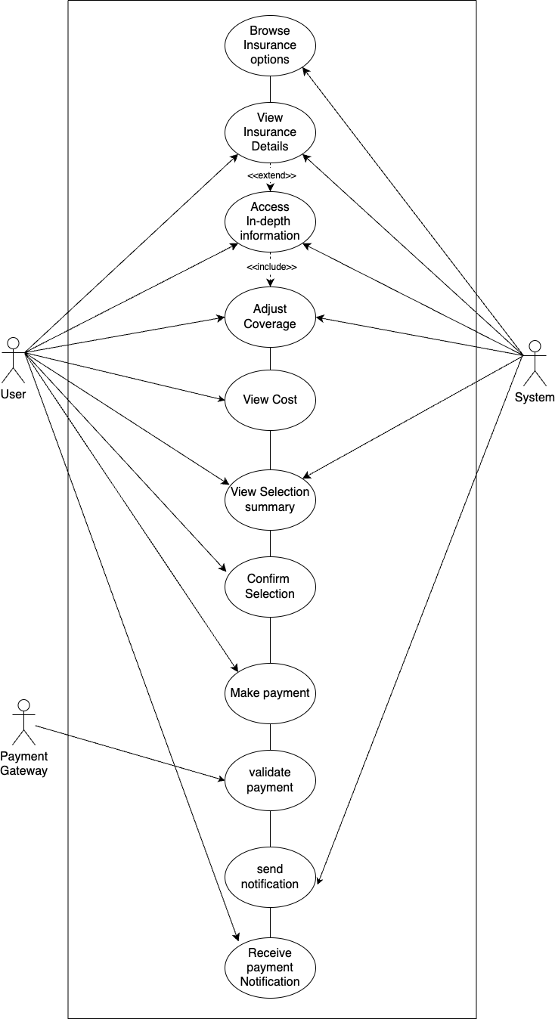

use case description

|  |  |  |  |
| --- | --- | --- | --- |
| Use Case ID | UC-01 | | |
| Use Case Name | Insurance Customization | | |
| Created By | Jireh Mae Muyana | Last Update By |  |
| Date Created | September 17, 2023 | Last Revision Date |  |
| Actors | User |  |  |
| Description | Users must be able to adjust their insurance coverage based on their specific needs. | | |
|  |
| Trigger | User clicks on an insurance package that they want. | | |  |
| Preconditions | User has logged in to the system.  User has stated travel details.  User has read in depth descriptions of insurance packages. | | |  |
| Use Case Input Specification | | |  |  |
| Input | Type | Constraint | Example |  |
| Tick Checkbox | String | If user wants to add the inclusion, checkbox is ticked, but if user does not want the inclusion, checkbox is not ticked. |  |  |
| Post Conditions | user's insurance are successfully saved and reflected in their booking details. | | |  |
|  |
| Normal Flows | | | |  |
| User | | System | |  |
| 1. User logs into travel website/application account. | | 1. System verifies account.   [A1: Account is incorrect.] | |  |
| 1. User inputs travel details (destination, dates, room type). | |  | |  |
|  | | 1. System shows insurance page and options.   [A2: Issue occurs and System does not show the insurance package options.]  [E1: No internet connection, page wouldn’t load.] | |  |
| 1. User clicks on an insurance option for a detailed information about the insurance package.   [E2: No internet Connection. page wouldn’t load.] | |  | |  |
| 1. User clicks the icon associated with option. | | 1. System detect user interaction and retrieve data for selected option. | |  |
|  | | 1. Display a pop-up containing the in-depth detail of selected insurance. | |  |
| 1. Reads the detailed and decided to choose this option to their insurance. | | 1. Closes the detail to turn the list of insurance option. | |  |
|  | | 1. System shows an insurance page and options. | |  |
| 1. User clicks on an insurance option for detailed information about the insurance package. | |  | |  |
| 1. User clicks the insurance package they want to customize.   [A3: User do not need customization.] | | 1. System allows customization. | |  |
| 1. User adjusts the package depending on their needs.   [E3: Customization limit.] | |  | |  |
| 1. User submits the customized package, and confirms the transaction. | |  | |  |
|  | | 1. Retrieve the detail of the selected insurance including its cost. | |  |
|  | | 1. Provided the current cost based on user’s selection. | |  |
|  | | 1. Clearly display the cost associated with selected insurance coverage.   [E4: The pricing system encounters an error in retrieving or calculating the cost.] | |  |
| 1. Making decision. | |  | |  |
| 1. User clicks on the confirm button after customizing the chosen insurance package. | | 1. System detects the customization/changes. | |  |
|  | | 1. System prints out a breakdown of the cost of the inclusions of the insurance package customization. | |  |
| 1. User clicks on the confirm button of the insurance selection and customization. | | 25) System prints a detailed information (insurance package, inclusions, costs) in the summary page.  [A4: For backup, breakdown will also be sent to the user’s email.) | |  |
|  | |  | |  |
| Alternative Flow | [A1: Account is incorrect], the system will redirect the user to log in page again to re input account information and log in to the application again.  [A2: Issue occurs and System does not show the insurance package options.], the user may view the insurance packages description on the home page of the travel website.  [A3: User do not need customization.], the user may click and utilize the pre made packages if they think that they do not need customization.  [A4: For backup, breakdown will also be sent to the user’s email.] | | |  |
|  |
| Exception Flow | [E1 & E2: No Internet Connection, page wouldn’t load.], the user may continue the transaction when internet is available.   [E3: Customization limit.] means that the user may have adjusted a certain insurance inclusion beyond its limit, in this case, the system may show an alert and the user may fix input.  [E4: The pricing system encounters an error in retrieving or calculating the cost.], an error message should be displayed to the user. | | |  |
|  |
| Assumption | The insurance information database is accessible whenever the user chooses which to view.  The pricing system provided real-time and no hidden cost. | | |  |
|  |

Non-functional requirement

usability

- The system should support both Thai and English language.

- the text should be readable

- the process of customize insurance option should not exceed 3 step

Performance

- the system must be load available within 2 second

- Any changes should reflect in a real time , with maximum delay of 1 second

Availability

- If system or network failure, ensure that user informed no data lost

- Security

- sensitive data such as personal detail related to insurance claim should be encrypted

UI (wireframe or prototype)

https://www.figma.com/file/5OvYx0ECvfxT2PnN8lu9Oe/UI?type=design&node-id=1%3A2&mode=design&t=sk4d5S0RgBXmrAUs-1

wireframe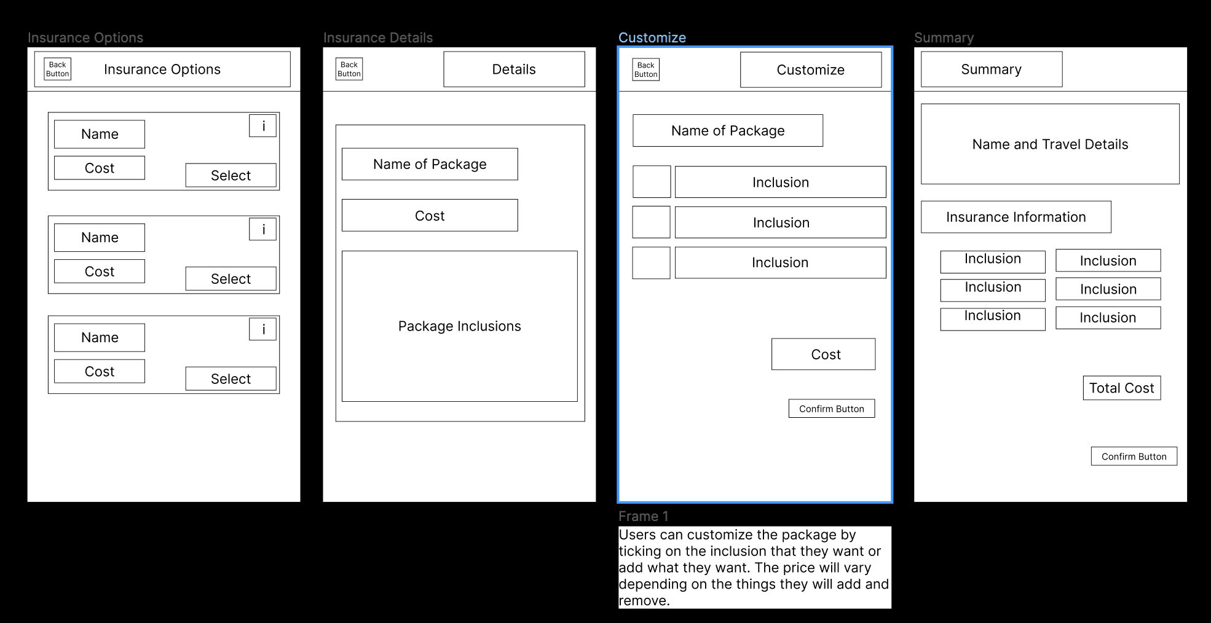

prototype

