**HomeWork_2 (02/Nov./2022)**

1. **Problem1_A_Loops.py**

**while True**:  
 **try**:  
 input_list=list(input(**"input a list of integers"**).split(**" "**))  
 print(input_list)

int_list=[int(i) **for** i **in** input_list]  
 print(int_list)  
  
 **break  
 except**:  
 print(**"your input must be integer numbers"**)  
  
*#return the list of integers that accept the division by 5:*out_list=[i **for** i **in** int_list **if** i%5==0]  
  
print(**"The integers that accept division by 5 ="**,out_list)

Figure : Output Sample of Problem1_A

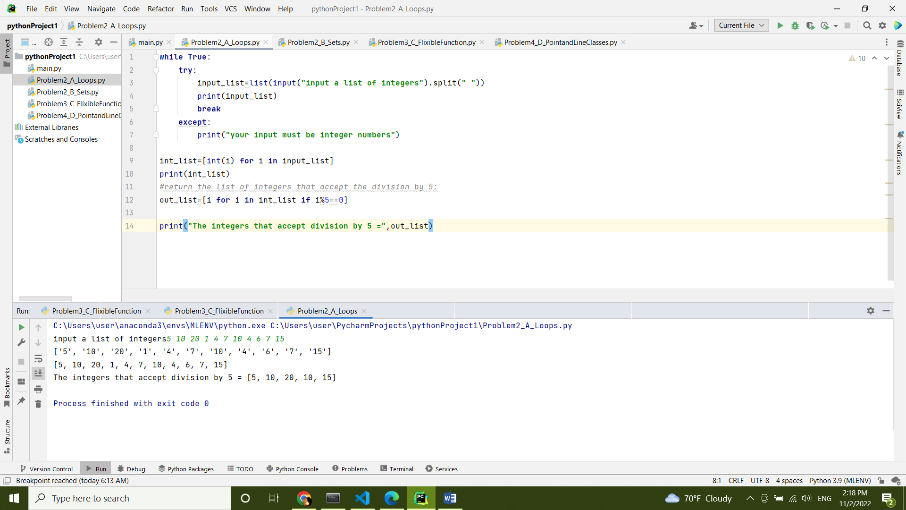

1. **Problem2_B_Sets.py**

no_of_lines = 2  
lines =[]  
**try**:  
 *#let the user to input multiple list of integers, convert the list to set find the unique values* **for** i **in** range(no_of_lines):  
 input_list=set(input(**f"inter list {**i+1**}"**).split(**" "**))  
 lines.append(input_list)  
  
**except**:  
 print(**"please try a gain!"**)  
  
print(lines)  
output=lines[0]  
*#apply intersection on the all sets entered by the user and find the duplicated keywords:***for** n **in** range(no_of_lines-1):  
 output &= lines[n+1]  
print(**"common words"**,output)

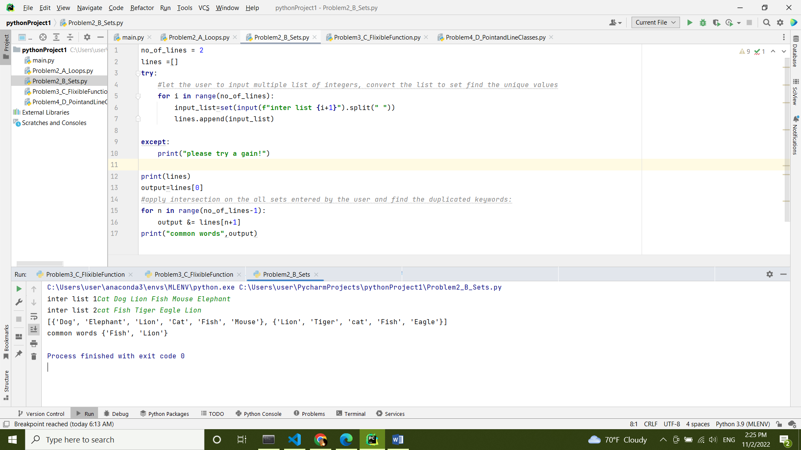

Figure :Output Sample of Problem2_B

1. **Problem3_C_FlixibleFunction.py**

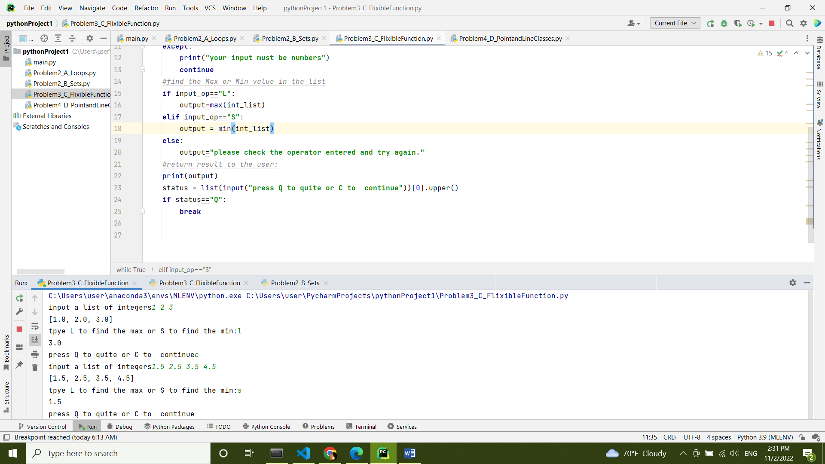**while True**:  
 **try**:  
 *#let the user to input the list of integers:* input_list=list(input(**"input a list of integers"**).split(**" "**))  
 *#convert the list of strings to list of floats:* int_list = [float(i) **for** i **in** input_list]  
 print(int_list)  
 *#let the user to choose the operant L,Large,large,l=Max and S,Small,small,s=Min:* input_op=input(**"tpye L to find the max or S to find the min:"**)[0].upper()  
  
 **except**:  
 print(**"your input must be numbers"**)  
 **continue** *#find the Max or Min value in the list* **if** input_op==**"L"**:  
 output=max(int_list)  
 **elif** input_op==**"S"**:  
 output = min(int_list)  
 **else**:  
 output=**"please check the operator entered and try again."** *#return result to the user:* print(output)  
 status = list(input(**"press Q to quite or C to continue"**))[0].upper()  
 **if** status==**"Q"**:  
 **break**

Figure :Output Sample of Problem3_C (Case_0)

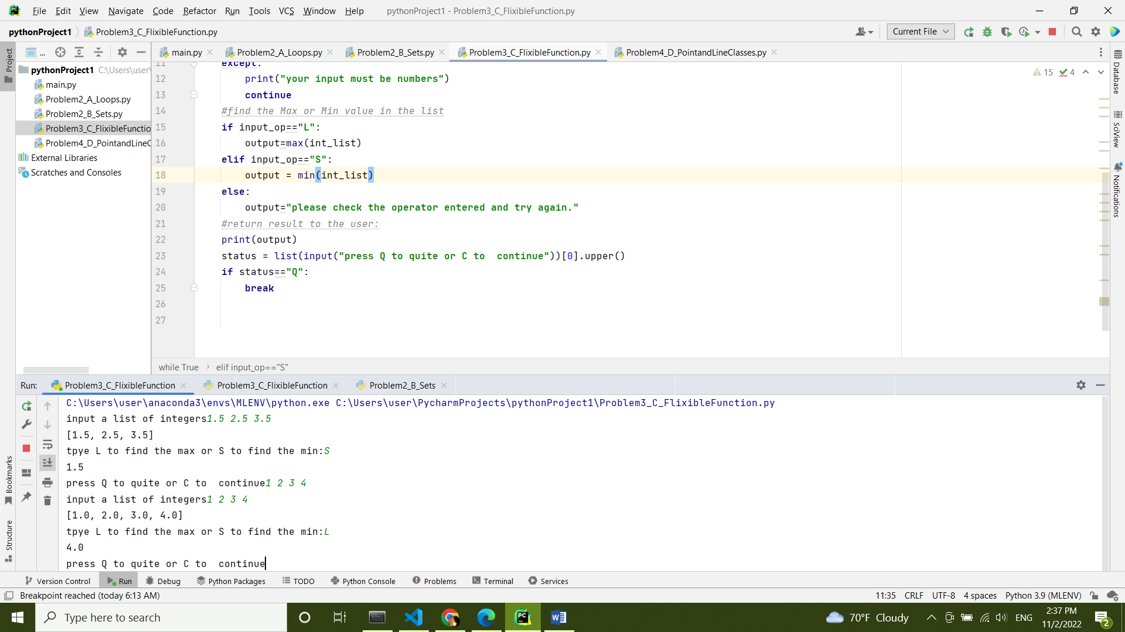

Figure : :Output Sample of Problem3_C (Case_1)

1. **Problem4_D_PointandLineClasses.py**

**import** math  
*#Point Class***class** Point():  
 **def** __init__(self,x,y):  
 self.x=x  
 self.y=y  
*#Line Class***class** Line(Point):  
 **def** __init__(self,line_start,line_end):  
 *# super(Line,self).__init__([line_start[0],line_end[0]],[line_start[1],line_end[1]])  
 #create two points instances* self.point1=Point(line_start[0],line_start[1])  
 self.point2=Point(line_end[0],line_end[1])  
 print(self.point1.x,self.point1.y)  
 print(self.point2.x,self.point2.y)  
  
  
 *#claculate the length of line* **def** line_length(self):  
 length=math.sqrt((self.point2.x-self.point1.x)**2+(self.point2.y-self.point1.y)**2)  
 **return** length  
**while True**:  
 **try**:  
 *#take the coordinates from user as input* input_coordinate=list(input(**"please input the coordination of teh line x1,y1,x2,y2 respectively:"**).split(**" "**))  
 *#check the length of input values(must be 4)* **if** len(input_coordinate)<4:  
 print(**"please input 4 values of type number"**)  
 **continue** *#if the input values more that 4 elements it takes the first 4 elements:* **if** len(input_coordinate)>=4:  
 input_coordinate=input_coordinate[0:4]  
 *#convert the list of strings to list of floats:* input_coordinate=[float(i) **for** i **in** input_coordinate]  
 **except**:  
 print(**"check the input to be 4 numbers"**)  
 **continue** *#create new line instance from the line class and find the length by calling line_lingth function.* new_line=Line([input_coordinate[0],input_coordinate[1]],[input_coordinate[2],input_coordinate[3]])  
 length=new_line.line_length()  
 print(**"the length of line ="**,length)

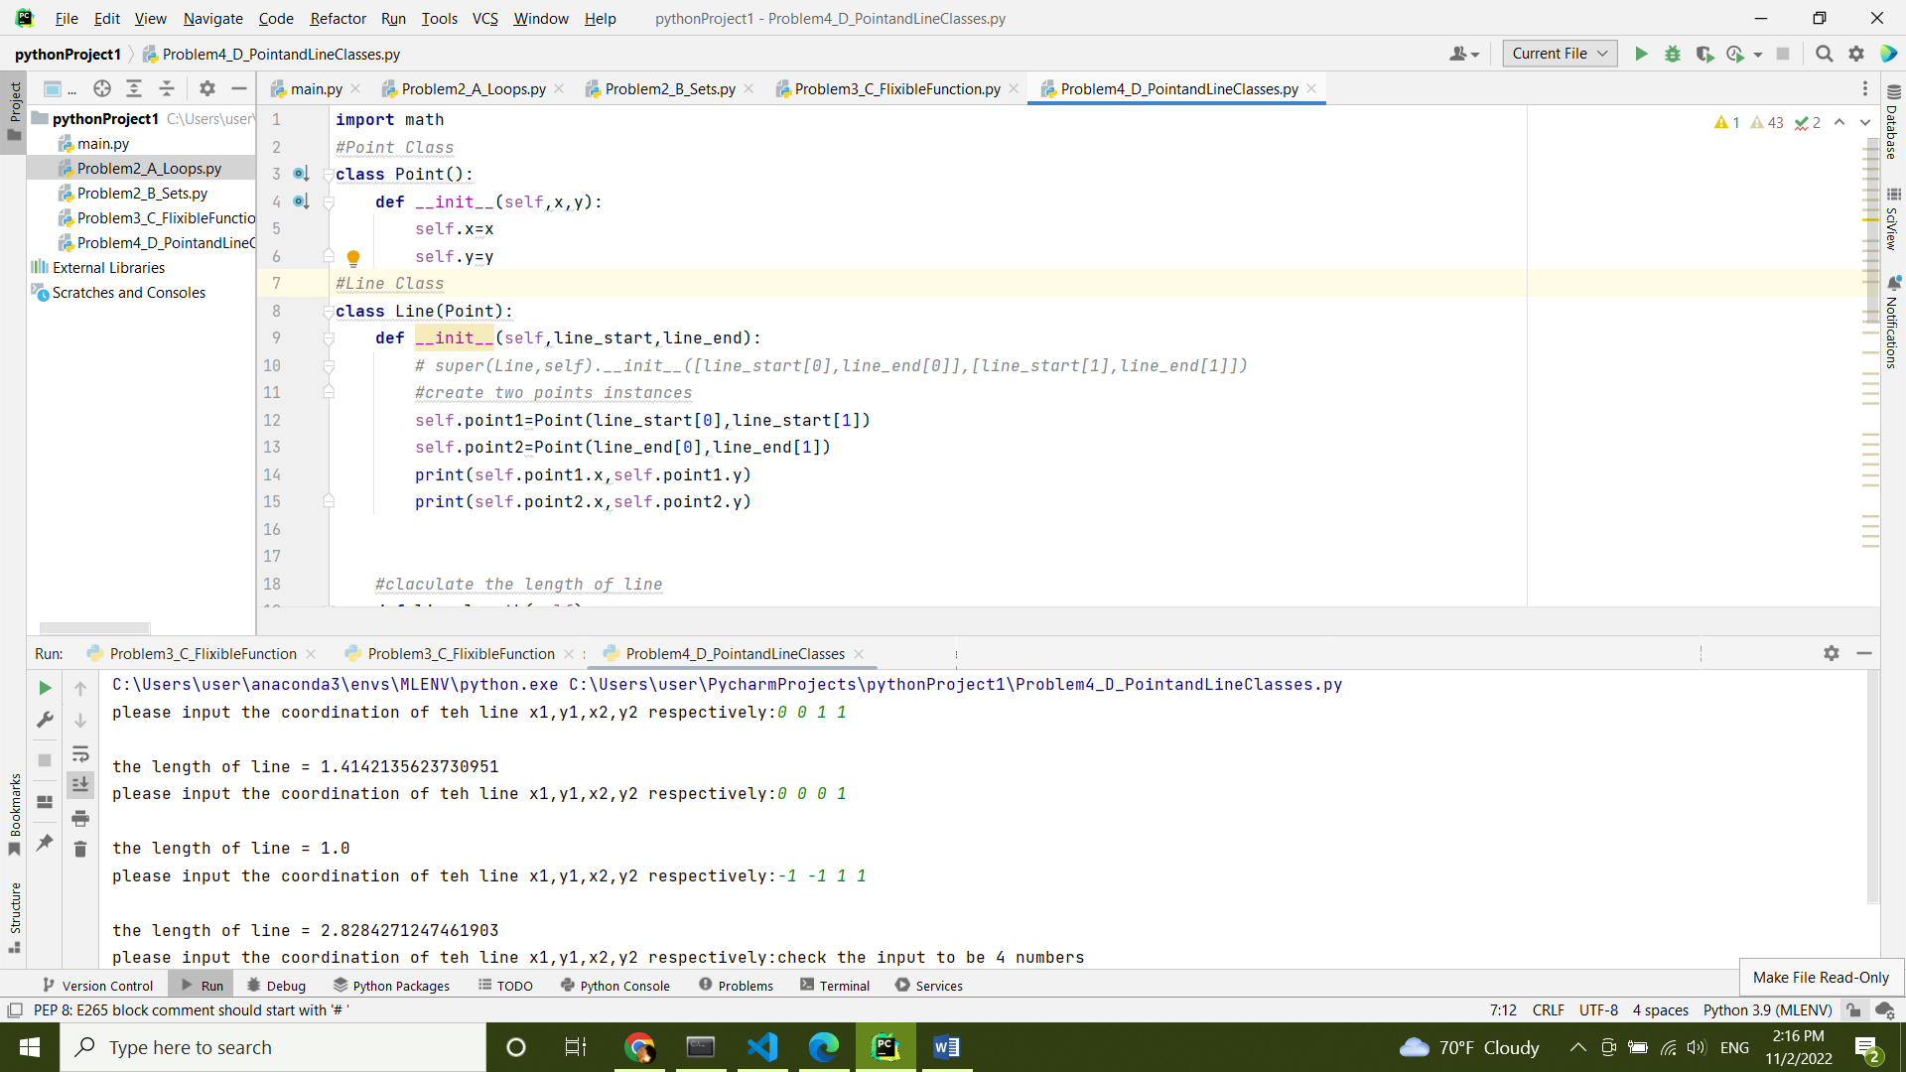

Figure : :Output Sample of Problem4_D