ew examples as below for the Nominal variable:

* Red, Yellow, Pink, Blue
* Singapore, Japan, USA, India, Korea
* Cow, Dog, Cat, Snake

Example of Ordinal variables:

* High, Medium, Low
* “Strongly agree,” Agree, Neutral, Disagree, and “Strongly Disagree.”
* Excellent, Okay, Bad

There are many ways we can encode these categorical variables as numbers and use them in an algorithm. I will cover most of them, from basic to more advanced ones, in this post. I will be comprising these encoding:

1) One Hot Encoding  
2) Label Encoding  
3) Ordinal Encoding  
4) Helmert Encoding  
5) Binary Encoding  
6) Frequency Encoding  
7) Mean Encoding  
8) Weight of Evidence Encoding  
9) Probability Ratio Encoding  
10) Hashing Encoding  
11) Backward Difference Encoding  
12) Leave One Out Encoding  
13) James-Stein Encoding  
14) M-estimator Encoding

15) Thermometer Encoder (To be updated)

For explanation, I will use this data frame, which has two independent variables or features(Temperature and Color) and one label (Target). It also has Rec-No, which is a sequence number of the record. There is a total of 10 records in this data frame. Python code would look as below.

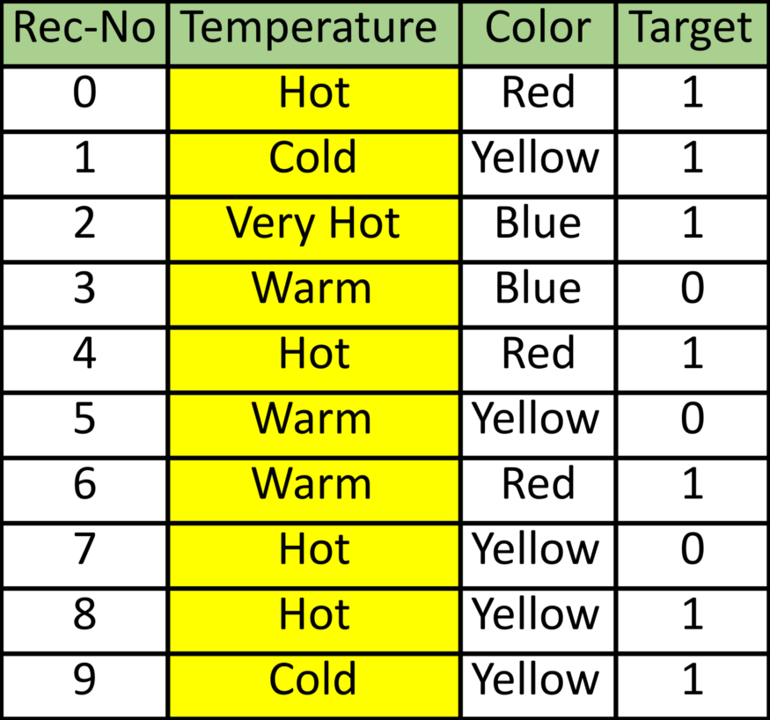

Image by Author

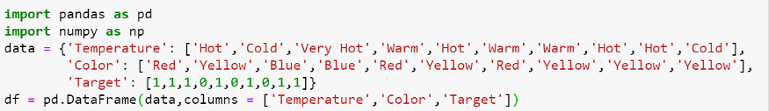

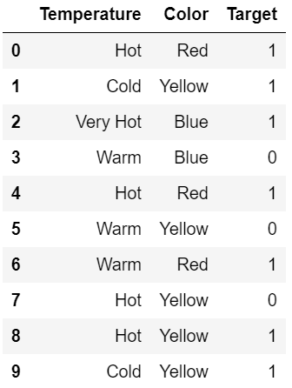

We will use Pandas and Scikit-learn and category_encoders (Scikit-learn contribution library) to show different encoding methods in Python.

**One Hot Encoding**

In this method, we map each category to a vector that contains 1 and 0, denoting the presence or absence of the feature. The number of vectors depends on the number of categories for features. This method produces many columns that slow down the learning significantly if the number of the category is very high for the feature. Pandas has **get_dummies** function, which is quite easy to use. The sample data-frame code would be as below:

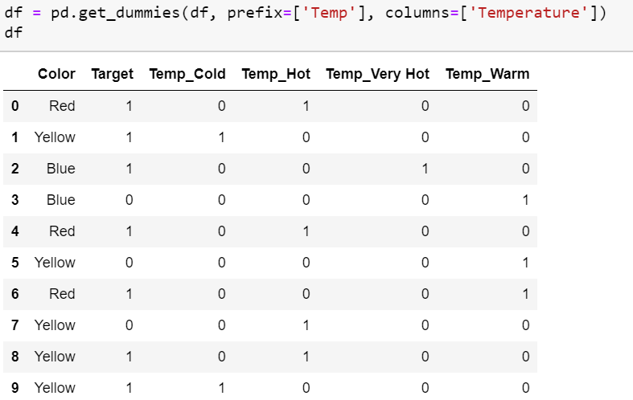

Scikit-learn has **OneHotEncoder**for this purpose, but it does not create an additional feature column (another code is needed, as shown in the below code sample).

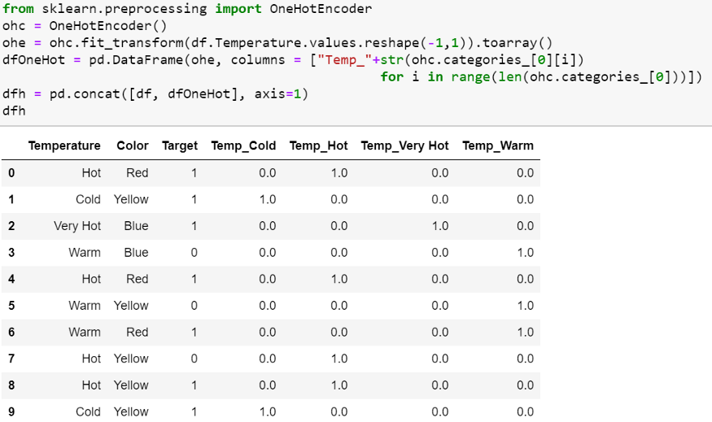

One Hot Encoding is very popular. We can represent all categories by N-1 (N= No of Category) as sufficient to encode the one that is not included. Usually, for Regression, we use N-1 (drop first or last column of One Hot Coded new feature ). Still, for classification, the recommendation is to use all N columns without as most of the tree-based algorithm builds a tree based on all available variables. One hot encoding with N-1 binary variables should be used in linear Regression to ensure the correct number of degrees of freedom (N-1). The linear Regression has access to all of the features as it is being trained and therefore examines the whole set of dummy variables altogether. This means that N-1 binary variables give complete information about (represent completely) the original categorical variable to the linear Regression. This approach can be adopted for any machine learning algorithm that looks at **ALL** the features **simultaneously** during training—for example, support vector machines and neural networks as well as clustering algorithms.

We will never consider that additional label in tree-based methods if we drop. Thus, if we use the categorical variables in a tree-based learning algorithm, it is **good practice** to encode it into N binary variables and don’t drop.

**Label Encoding**

In this encoding, each category is assigned a value from 1 through N (where N is the number of categories for the feature. One major issue with this approach is there is no relation or order between these classes, but the algorithm might consider them as some order or some relationship. In below example it may look like (Cold<Hot<Very Hot<Warm….0 < 1 < 2 < 3 ) .Scikit-learn code for the data-frame as follows:

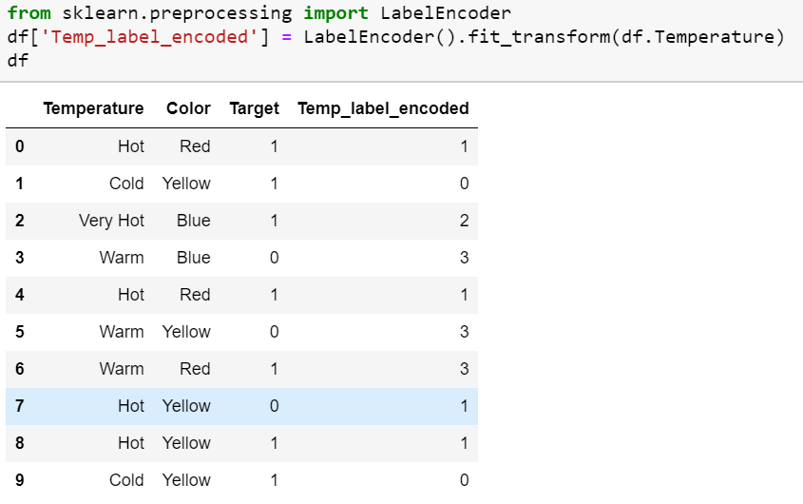

Pandas **factorize** also perform the same function.

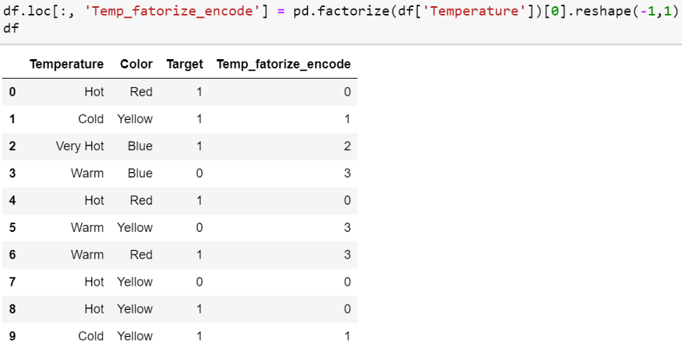

**Ordinal Encoding**

We do Ordinal encoding to ensure the encoding of variables retains the ordinal nature of the variable. This is reasonable only for ordinal variables, as I mentioned at the beginning of this article. This encoding looks almost similar to Label Encoding but slightly different as Label coding would not consider whether the variable is ordinal or not, and it will assign a sequence of integers

* as per the order of data (Pandas assigned Hot (0), Cold (1), “Very Hot” (2) and Warm (3)) or
* as per alphabetically sorted order (scikit-learn assigned Cold(0), Hot(1), “Very Hot” (2) and Warm (3)).

If we consider the temperature scale as the order, then the ordinal value should from cold to “Very Hot. “ Ordinal encoding will assign values as ( Cold(1) <Warm(2)<Hot(3)<”Very Hot(4)). Usually, Ordinal Encoding is done starting from 1.

Refer to this code using Pandas, where first, we need to assign the original order of the variable through a dictionary. Then we can map each row for the variable as per the dictionary.

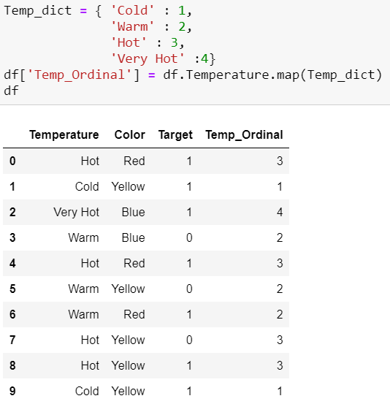

Though it’s very straightforward, it requires coding to tell ordinal values and the actual mapping from text to an integer as per the order.

**Helmert Encoding**

In this encoding, the mean of the dependent variable for a level is compared to the mean of the dependent variable over all previous levels.

The version in category_encoders is sometimes referred to as Reverse Helmert Coding. The mean of the dependent variable for a level is compared to the mean of the dependent variable over all **previous levels**. Hence, the name ‘**reverse’** is used to differentiate from forward Helmert coding.

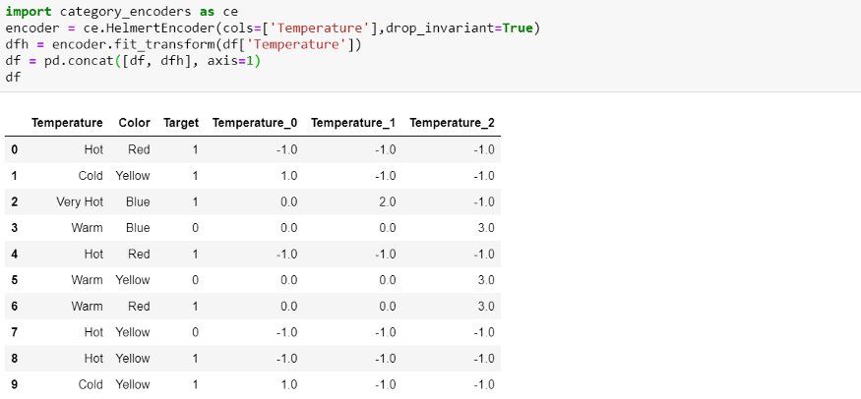

**Binary Encoding**

Binary encoding converts a category into binary digits. Each binary digit creates one feature column. If there are **n** unique categories, then binary encoding results in the only log(base 2)ⁿ features. In this example, we have four features; thus, the binary encoded features will be three features. Compared to One Hot Encoding, this will require fewer feature columns (for 100 categories, One Hot Encoding will have 100 features, while for Binary encoding, we will need just seven features).

For Binary encoding, one has to follow the following steps:

* The categories are first converted to numeric order starting from 1 (order is created as categories appear in a dataset and do not mean any ordinal nature)
* Then those integers are converted into binary code, so for example, 3 becomes 011, 4 becomes 100
* Then the digits of the binary number form separate columns.

Refer to the below diagram for better intuition.

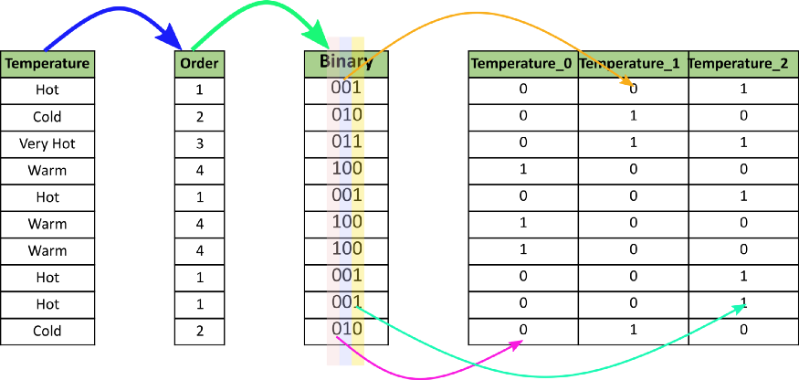

Image by Author

We will use the category_encoders package for this, and the function name is **BinaryEncoder**.

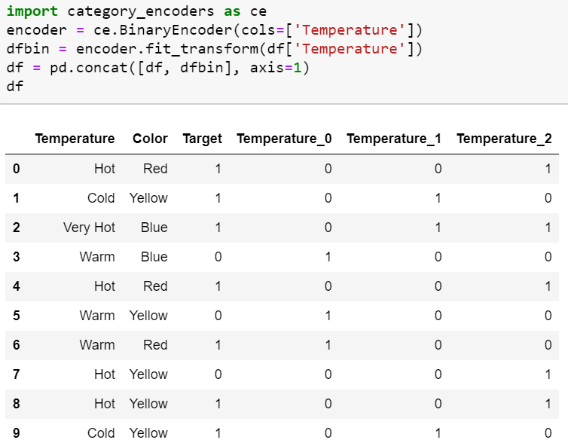

**Frequency Encoding**

It is a way to utilize the frequency of the categories as labels. In the cases where the frequency is related somewhat to the target variable, it helps the model understand and assign the weight in direct and inverse proportion, depending on the nature of the data. Three-step for this :

* Select a categorical variable you would like to transform
* Group by the categorical variable and obtain counts of each category
* Join it back with the training dataset

Pandas code can be constructed as below:

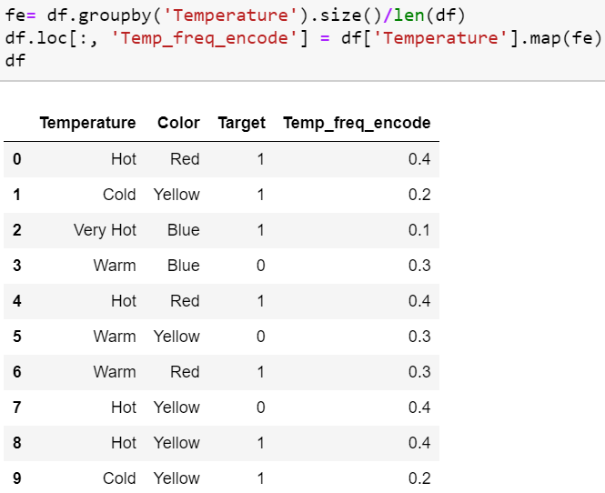

**Mean Encoding**

Mean Encoding or Target Encoding is one viral encoding approach followed by Kagglers. There are many variations of this. Here I will cover the basic version and smoothing version. Mean encoding is similar to label encoding, except here labels are correlated directly with the target. For example, in mean target encoding for each category in the feature label is decided with the**mean value of the target variable** on training data. This encoding method brings out the relation between similar categories, but the connections are **bounded within the categories and target itself**. The advantages of the mean target encoding are that it **does not affect the volume of the data** and helps in faster learning. Usually, Mean encoding is notorious for over-fitting; thus, a regularization with cross-validation or some other approach is a must on most occasions. Mean encoding approach is as below:

1. Select a categorical variable you would like to transform.

2. Group by the categorical variable and obtain aggregated sum over the “Target” variable. (total number of 1’s for each category in ‘Temperature’)

3. Group by the categorical variable and obtain aggregated count over “Target” variable

4. Divide the step 2 / step 3 results and join it back with the train.

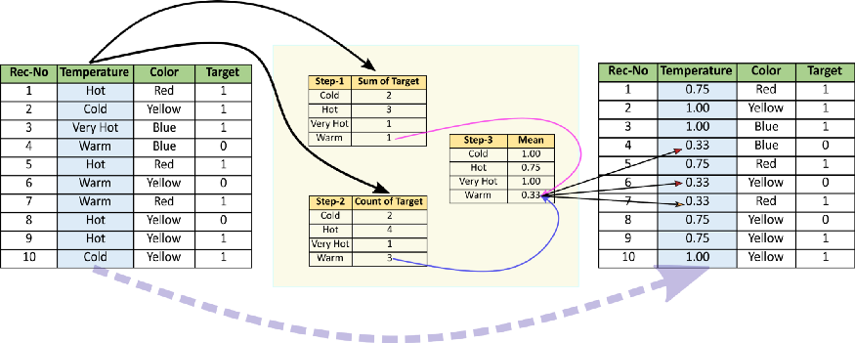

Mean Encoding: Image by Author

Sample code for the data frame:

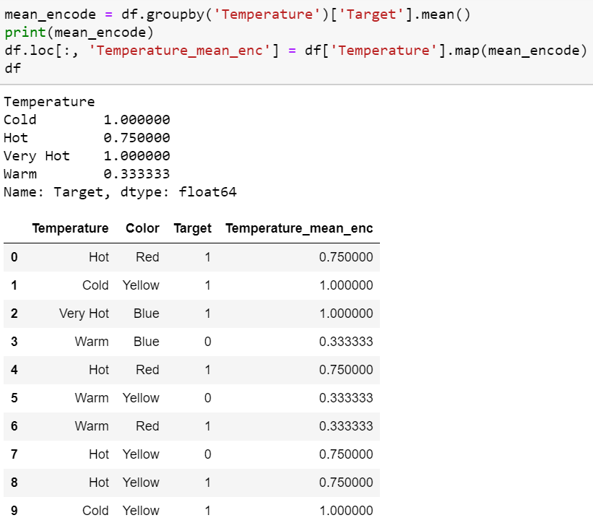

Mean encoding can embody the target in the label, whereas label encoding does not correlate with the target. In the case of many features, mean encoding could prove to be a much simpler alternative. Mean encoding tends to group the classes, whereas the grouping is random in label encoding.

There are many variations of this target encoding in practice, like smoothing. Smoothing can implement as below:

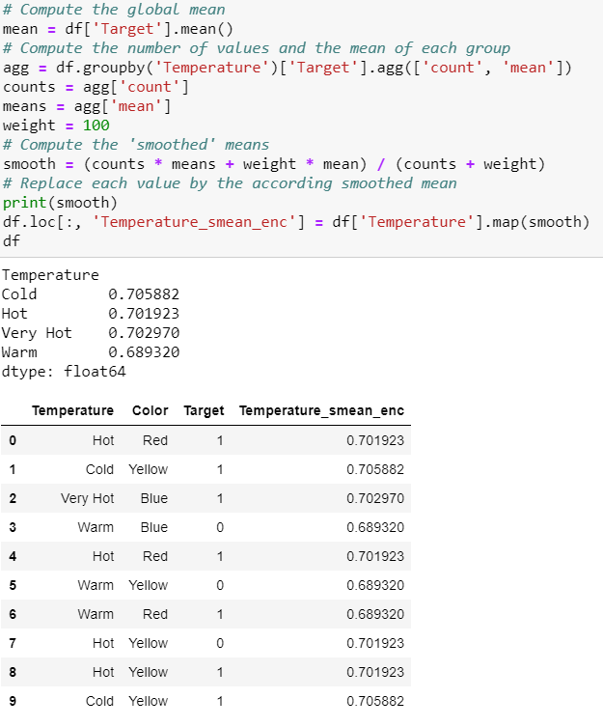

**Weight of Evidence Encoding**

Weight of Evidence (WoE) measures the “**strength”** of a grouping technique to separate good and bad. This method was developed primarily to build a predictive model to evaluate the risk of loan default in the credit and financial industry. Weight of evidence (WOE) measures how much the **evidence** **supports or undermines a hypothesis**.

It is computed as below:

https://miro.medium.com/max/281/1*AqcqDwUB4fk8rcmbvxGiEQ.gif

WoE will be 0 if the P(Goods) / P(Bads) = 1. That is, if the outcome is random for that group. If P(Bads) > P(Goods) the odds ratio will be < 1 and the WoE will be < 0; if, on the other hand, P(Goods) > P(Bads) in a group, then WoE > 0.

WoE is well suited for Logistic Regression because the Logit transformation is simply the log of the odds, i.e., ln(P(Goods)/P(Bads)). Therefore, by using WoE-coded predictors in Logistic Regression, the predictors are prepared and coded to the same scale. The parameters in the linear logistic regression equation can be directly compared.

The WoE transformation has (at least) three advantage:  
1) It can transform an independent variable to establish a monotonic relationship to the dependent variable. It does more than this — to secure a monotonic relationship it would be enough to “recode” it to any ordered measure (for example 1,2,3,4…), but the WoE transformation orders the categories on a “logistic” scale which is natural for Logistic Regression  
2) For variables with too many (sparsely populated) discrete values, these can be grouped into categories (densely populated), and the WoE can be used to express information for the whole category  
3) The (univariate) effect of each category on the dependent variable can be compared across categories and variables because WoE is a standardized value (for example, you can compare WoE of married people to WoE of manual workers)

It also has (at least) three drawbacks:  
1) Loss of information (variation) due to binning to a few categories  
2) It is a “**univariate” measure,**so it does not take into account the correlation between independent variables  
3) It is easy to manipulate (over-fit) the effect of variables according to how categories are created

Below code, snippets explain how one can build code to calculate WoE.

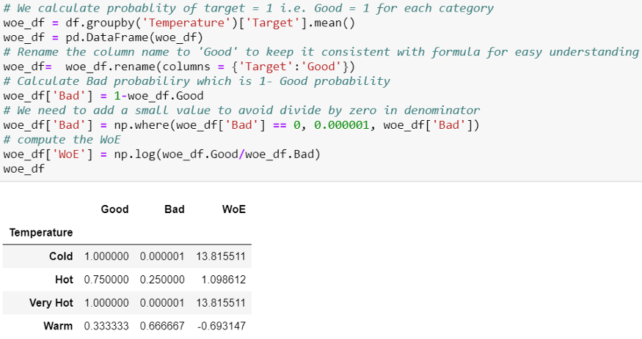

Once we calculate WoE for each group, we can map back this to Data-frame.

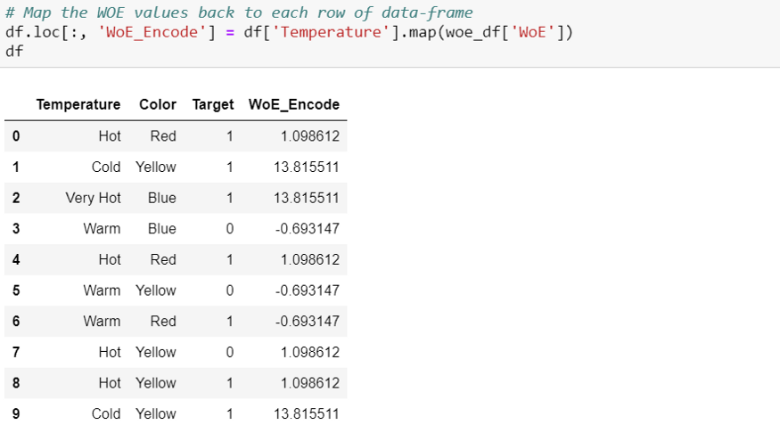

**Probability Ratio Encoding**

Probability Ratio Encoding is similar to Weight Of Evidence(WoE), with the only difference is the only ratio of good and bad probability is used. For each label, we calculate the mean of target=1, that is, the probability of being 1 ( P(1) ), and also the probability of the target=0 ( P(0) ). And then, we calculate the ratio P(1)/P(0) and replace the labels with that ratio. We need to add a minimal value with P(0) to avoid any divide by zero scenarios where for any particular category, there is no target=0.

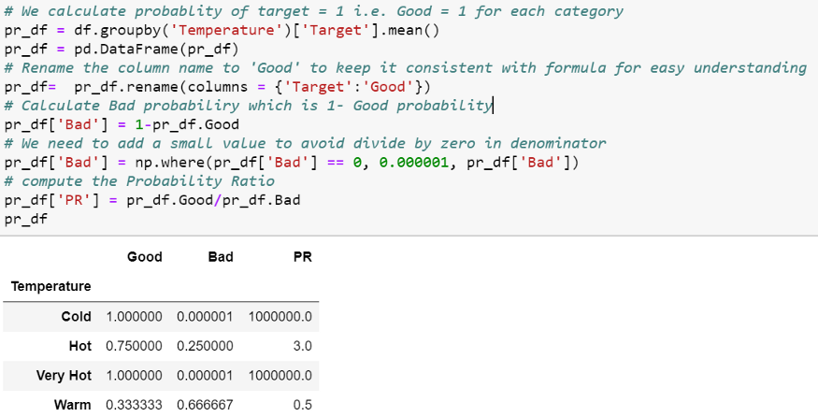

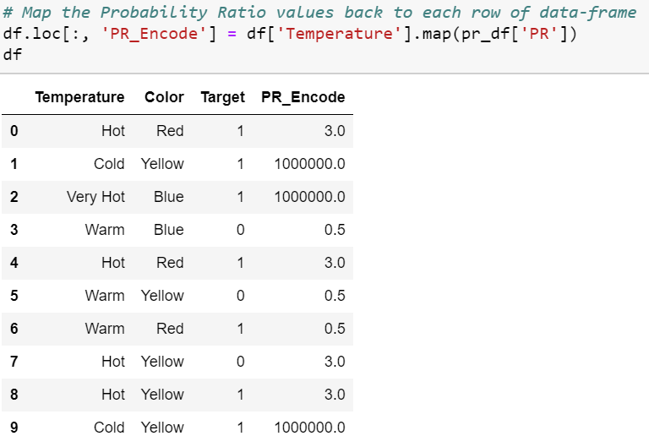

**Hashing**

Hashing converts categorical variables to a higher dimensional space of integers, where the distance between two vectors of categorical variables is approximately maintained by the transformed numerical dimensional space. With Hashing, the number of dimensions will be far less than the number of dimensions with encoding like One Hot Encoding. This method is advantageous when the cardinality of categorical is very high.

*(Sample Code — I Will update in a future version of this article)*

**Backward Difference Encoding**

In backward difference coding, the mean of the dependent variable for a level is compared with the mean of the dependent variable for the prior level. This type of coding may be useful for a nominal or an ordinal variable.

This technique falls under the contrast coding system for categorical features. A feature of K categories, or levels, usually enters a regression as a sequence of K-1 dummy variables.

*(Sample Code — Will be updated in a future version of this article)*

**Leave One Out Encoding**

This is very similar to target encoding but excludes the current row’s target when calculating the mean target for a level to reduce outliers.

*(Sample Code — Will be updated in a future version of this article)*

**James-Stein Encoding**

For feature value, the James-Stein estimator returns a weighted average of:

1. The mean target value for the observed feature value.
2. The mean target value (regardless of the feature value).

The James-Stein encoder *shrinks* the average toward the overall average. It is a target based encoder. James-Stein estimator has, however, one practical limitation — it was defined only for normal distributions.

*(Sample Code — I Will update in a future version of this article)*

**M-estimator Encoding**

M-Estimate Encoder is a simplified version of Target Encoder. It has only one hyper-parameter — **m**, which represents the power of regularization. The higher the value of m results, into stronger the shrinking. Recommended values for **m** is in the range of 1 to 100.

*(Sample Code — I Will update in a future version of this article)*

**FAQ:**

I received many queries related to using or how one can treat the test data when there is no target. I am adding a Faq section here, which I hope would assist.

**Faq 01: Which method should I use?**

**Answer:** There is no single method that works for every problem or dataset. You may have to try a few to see, which gives a better result. The general guideline is to refer to the cheat sheet shown at the end of the article.

**Faq 02: How do I create categorical encoding for a situation like a target encoding as, in test data, there won’t be any target value?**

**Answer:** We need to use the mapping values created at the time of training. This process is the same as scaling or normalization, where we use the train data to scale or normalize the test data. Then map and use the same value in testing time pre-processing. We can even create a dictionary for each category and mapped value and then use the dictionary at testing time. Here I am using the mean encoding to explain this.

**Training Time**

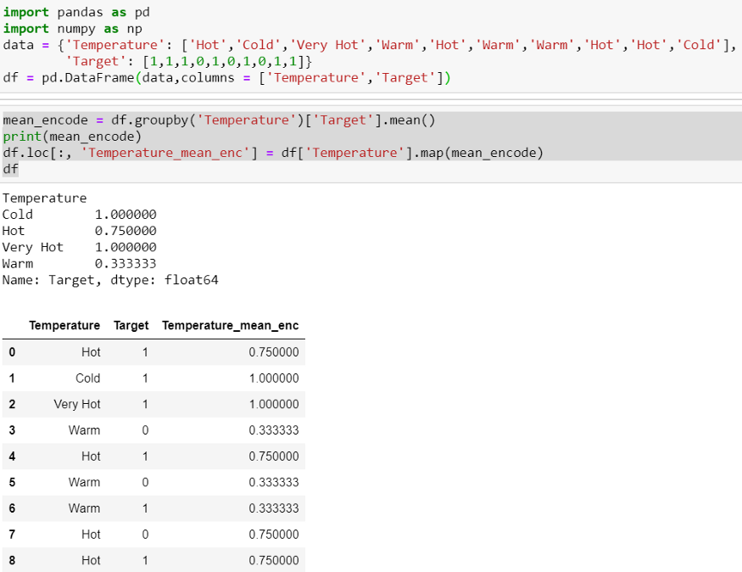

**Testing Time**

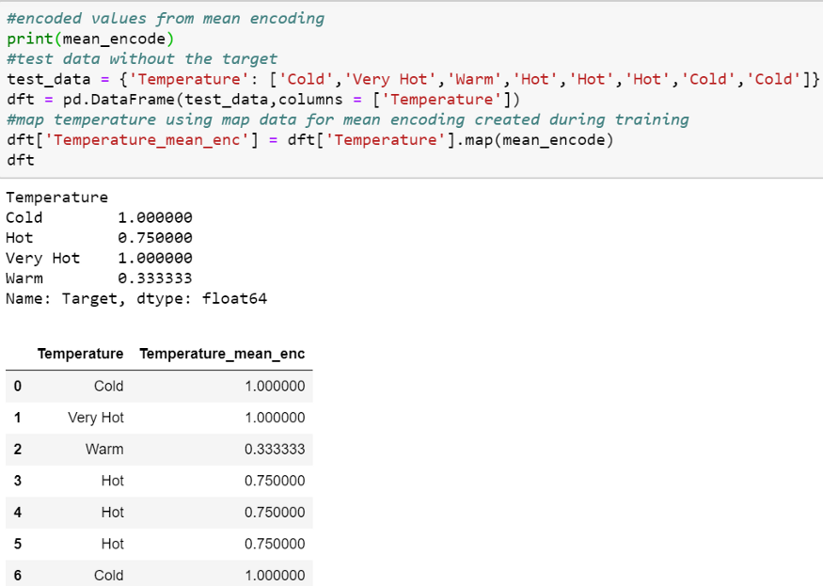

**Conclusion**

It is essential to understand that all these encodings do not work well in all situations or for every dataset for all machine learning models. Data Scientists still need to experiment and find out which works best for their specific case. If test data has different classes, some of these methods won’t work as features won’t be similar. There are few benchmark publications by research communities, but it’s not conclusive which works best. My recommendation will be to try each of these with the smaller datasets and then decide where to focus on tuning the encoding process. You can use the below cheat-sheet as a guiding tool.

tool.

