Competitive Learning and Adaptation in Autonomous Robot-Sumo: Multi-Seed Deep Reinforcement Learning Benchmarking and Asymmetric Veteran–Novice Self-Play
Original Research Article
Iman Hindi
Department of Industrial Engineering, School of Engineering Technology, Al Hussein Technical University, Amman, Jordan
Corresponding author: Iman Hindi; E-mail: iman.hindi@htu.edu.jo

Abstract
Autonomous Robot-Sumo is an embodied-control problem requiring target search, contact acquisition, sustained pushing, and edge-safe navigation. This study develops a reproducible Webots benchmark based on official 3 kg geometry and compares Advantage Actor-Critic, Proximal Policy Optimization (PPO), Deep Q-Network, and Recurrent PPO under identical sensing, actuation, curriculum, reward, and evaluation conditions. Five independent seeds were trained per algorithm for 500,000 steps and evaluated in 6,000 valid frozen-policy bouts. PPO achieved the highest mean win rates against scripted (10.4%) and aggressive (11.8%) opponents and the most contact-assisted wins, but algorithm-level differences were not statistically significant because of between-seed variability. A predeclared asymmetric self-play extension paired five pretrained PPO veterans with newly initialized novices for another 500,000 steps of simultaneous adaptation. Role-swapped evaluation showed a transient novice mean advantage at 200,000 self-play steps but no reproducible novice takeover; at 500,000 steps veteran and novice official win rates were 10.8% and 3.7%, respectively, with 85.5% draws and no significant paired difference (Wilcoxon p=0.655). Causal attribution altered the interpretation: final novice forced-win rate (2.0%) exceeded veteran forced-win rate (0.8%), while much of the veteran's nominal advantage arose from novice self-outs. External evaluation showed marked degradation of veteran performance against fixed moving opponents after self-play. The results demonstrate strong seed sensitivity in competitive embodied reinforcement learning and show that causal interaction, safety, and external generalization should be evaluated alongside nominal win rate and reward.
Keywords: deep reinforcement learning; competitive robotics; Robot-Sumo; curriculum learning; multi-agent reinforcement learning; asymmetric self-play

1. Introduction
Deep reinforcement learning (DRL) has become an influential approach for learning control policies directly from interaction, particularly when analytical models are incomplete or when effective behavior depends on long-horizon state–action sequences [1–5]. Robotics is an attractive but difficult application domain because learned policies must coordinate perception, motion, contact dynamics, safety constraints, and delayed task outcomes. Competitive robotics adds another layer of difficulty: the usefulness of a behavior depends not only on the robot and environment but also on the response of an opponent. These properties make competitive mobile-robot tasks valuable test beds for embodied decision making, but they also expose weaknesses in conventional reinforcement-learning evaluation, including sensitivity to random seeds, reward hacking, unstable convergence, and misleading conclusions based on a small number of trials [6,7].
Robot-Sumo provides a particularly concise embodiment of these challenges. Two autonomous mobile robots are placed on a circular Dohyo and attempt to force the opponent outside the arena while avoiding their own ring-out. In the 3 kg class, the official rules constrain the robot footprint to 20 cm × 20 cm and the mass to 3 kg, and define a 1.54 m diameter Dohyo with a 5 cm inward white boundary [8]. The task combines target acquisition, pursuit, frontal alignment, contact control, traction management, opponent displacement, and edge avoidance. Prior Robot-Sumo control research includes neuro-fuzzy motor control [9], finite-state/discrete-event supervisory control [10], and embedded fuzzy-logic opponent detection and motion control [11], while the platform has also been studied as an integrated learning-by-doing robotics activity [12]. These approaches demonstrate the value of structured intelligent control, but they do not resolve how stochastic deep reinforcement-learning policies compare under a common physically grounded benchmark.
Applying DRL to Robot-Sumo is not simply a matter of selecting an algorithm and maximizing episode return. Early versions of the environment developed for this study exposed several failure modes that are broadly relevant to embodied RL. Policies learned to survive rather than fight when timeouts were cheaper than exploratory self-outs; benchmark opponents could inflate nominal win rates by leaving the arena without being forced; sparse contact events made credit assignment difficult; and behavioral metrics initially misclassified curved forward motion as non-forward movement. These observations motivated a progressively audited benchmark in which the physical model, reset protocol, opponent logic, observation/action semantics, reward design, and terminal-event attribution were explicitly validated before the final comparison.
The work therefore addresses a broader scientific question than “which algorithm wins Robot-Sumo?” The central question is how different DRL families organize competitive behavior under the same embodied constraints, and how reliably those behaviors emerge across independent training runs. This emphasis follows recommendations for rigorous RL evaluation, where a small number of favorable seeds can otherwise create an exaggerated impression of algorithmic superiority [6,7]. Five independent seeds are used per algorithm, and test episodes are treated as repeated measurements of each trained policy rather than independent training replicates.
The main contributions are fivefold. First, an official-geometry Webots benchmark is developed for a professional-reference 3 kg autonomous Robot-Sumo robot with identical competitors, multi-ray opponent sensing, edge sensing, realistic drivetrain limits, and physical ring-out detection. Second, the benchmark introduces a staged curriculum and privileged training-only contact/distance telemetry to improve credit assignment without changing the deployment observation vector. Third, official match outcomes are complemented by contact-assisted ring-out attribution so that genuine pushing performance can be distinguished from opponent self-outs. Fourth, A2C, PPO, DQN, and Recurrent PPO are compared under identical step budgets over five seeds, with outcome, behavioral, safety, contact, and action-diversity metrics reported across 6,000 valid frozen-policy evaluations. Fifth, the study adds a predeclared asymmetric veteran–novice PPO self-play experiment that tests whether a newly initialized learner can close or reverse a 500,000-step experience deficit, whether any apparent takeover is causally supported by contact-assisted wins, and whether self-play adaptation generalizes to frozen external opponents. The overall experimental workflow is summarized in Fig. 1.
The benchmark results show that the highest nominal activity is not equivalent to the best competitive effectiveness. PPO produces the strongest descriptive balance between wins, contact pressure, outward displacement, and safety, but its success is concentrated in a subset of seeds. The subsequent asymmetric self-play experiment reveals equally strong path dependence: the novice transiently exceeds the veteran in mean head-to-head win rate at 200,000 self-play steps, but this advantage is not sustained across seeds or at the final checkpoint. Causal attribution further reveals that final official outcomes can diverge from genuine pushing efficacy, while external evaluation indicates that continued co-adaptation can degrade the veteran’s previously learned general-purpose behavior. Together, these findings support a view of competitive embodied RL as a multi-attractor, non-stationary optimization problem in which algorithm choice, initialization, opponent distribution, and safety behavior jointly determine the strategies that emerge.

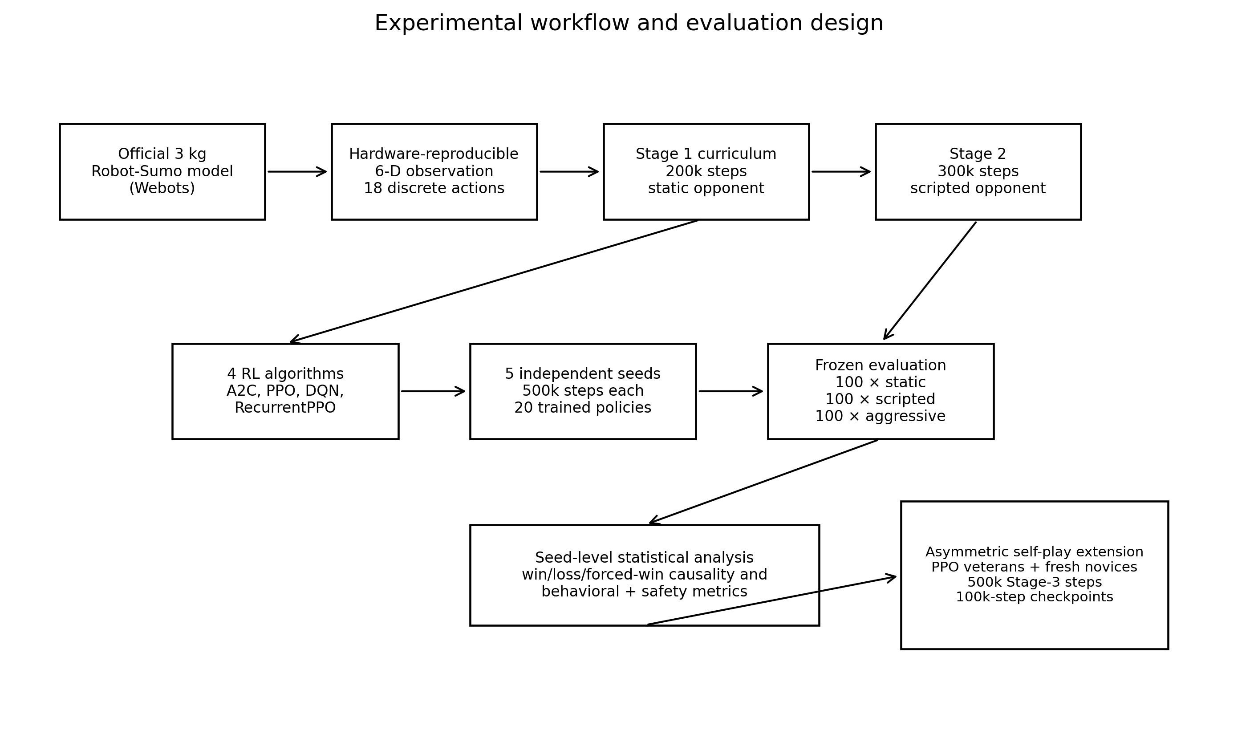
Fig. 1. Main algorithm-benchmark workflow. Each algorithm is trained from five independent seeds for a common 500,000-step budget and evaluated as a frozen policy under three opponent conditions; the subsequent asymmetric self-play extension uses the five PPO policies as veterans.

2. Related work

2.1. Deep reinforcement learning for robotic control
Deep Q-Networks demonstrated that neural function approximation and experience replay can support high-dimensional sequential control in discrete action spaces [2]. Actor–critic methods subsequently improved the practicality of policy optimization for continuous and discrete control. A3C introduced asynchronous actor–critic learning [3], while PPO stabilized policy updates through a clipped surrogate objective that limits destructive policy changes [4]. A2C is a synchronous actor–critic variant, whereas recurrent extensions of PPO incorporate memory through long short-term memory (LSTM) units. The present study compares representatives from these families using Stable-Baselines3 and sb3-contrib implementations [5].
Robot learning in simulation is attractive because deep reinforcement learning often requires hundreds of thousands or millions of interactions that are expensive, slow, or unsafe to obtain on hardware. Webots provides rigid-body dynamics, programmable sensors and actuators, contact modeling, and supervisory access for controlled robotics experiments [13]. Nevertheless, simulation-based results must be interpreted with respect to the reality gap. Domain randomization and dynamics randomization are established approaches to improving transfer robustness [14,15], and reviews emphasize calibration, actuator modeling, sensor realism, and structured randomization as central requirements for sim-to-real reinforcement learning [16–18]. More recent methods such as cyclic policy distillation and offline domain-randomization estimation address sample efficiency and simulator-parameter uncertainty [19,20]. The present paper therefore treats the Webots benchmark as an embodied algorithm-comparison environment, not as evidence of zero-shot hardware transfer.

2.2. Curriculum learning and competitive environments
Curriculum learning organizes training examples from easier to harder cases and can improve optimization in non-convex learning systems [21]. In robotics, curriculum-guided deep reinforcement learning has recently been used to structure difficult contact and manipulation tasks [22]. The same principle is relevant to Robot-Sumo: learning search, alignment, collision, and sustained pushing simultaneously from random initial states can produce a conservative local optimum in which a robot avoids decisive interaction. The curriculum used here therefore begins with a nearby stationary opponent and progressively introduces orientation error, search, and a moving opponent.
Competition can itself generate curricula. Multi-agent reinforcement-learning research has shown that competitive interaction can induce strategy diversity, adaptation, and emergent complexity [23–27]. Bansal et al. included physically simulated Sumo tasks for humanoid and ant agents [24], while Zhong et al. later evaluated principled opponent selection in a simulated robot-sumo game [28]. The main algorithm benchmark in this study deliberately uses static or scripted opponents to avoid the non-stationarity of simultaneous multi-agent learning and to permit controlled cross-algorithm evaluation. A separate predeclared extension then reintroduces non-stationarity through asymmetric self-play: each pretrained PPO veteran co-adapts with a newly initialized novice under the same frozen Robot-Sumo physics, sensing, reward, and action model. This two-part design separates the question of algorithm comparison from the distinct question of competitive adaptation under unequal prior experience.

2.3. Robot-Sumo control and the evaluation gap
Robot-Sumo research spans hardware-oriented competition and education [12], neuro-fuzzy control with hardware validation [9], supervisory finite-state/discrete-event control [10], and recent embedded fuzzy logic for opponent localization and motor response [11]. These studies establish Robot-Sumo as a legitimate autonomous-control testbed rather than only a recreational competition. In learned control, physically simulated sumo-style tasks have also appeared in competitive self-play research [24,28]. However, the literature still contains comparatively little peer-reviewed evidence on official-geometry 3 kg autonomous Robot-Sumo under controlled, multi-seed deep-reinforcement-learning evaluation. This motivates a benchmark that reports run-to-run uncertainty, physically grounded ring-out causality, explicit action semantics, and behavioral metrics in addition to nominal win rate.
This evaluation gap is important because nominal win rate alone can be misleading. An opponent may leave the arena without being forced, a policy can accumulate shaped reward while rarely winning, and a single seed may discover an effective strategy while other seeds collapse to passive behavior. Henderson et al. [6] and Agarwal et al. [7] have shown that RL conclusions can change substantially when uncertainty and run-to-run variability are considered. The benchmark in this paper was designed around those concerns.

3. Problem formulation

3.1. Competitive task
The learning problem is modeled as a partially observed episodic Markov decision process (POMDP). At each 5 ms Webots simulation step, the learning robot receives a compact hardware-reproducible sensor observation, selects one of 18 discrete differential-drive commands, and receives a shaped reward. An episode terminates when a descendant solid of either robot physically contacts the lower safety floor outside the Dohyo, when both robots ring out simultaneously, or when the 3,000-step benchmark horizon is reached. A single-robot ring-out produces a win for the opponent and a loss for the robot that exited; simultaneous ring-out is treated as a draw-like double-ring-out event. The 3,000-step horizon corresponds to 15 s of simulated time and is used as a controlled RL benchmarking horizon rather than as a reproduction of the complete official three-minute tournament procedure. The corresponding arena, robot, and sensing architecture are summarized in Fig. 2.
The official outcome rule is preserved: if the opponent leaves the Dohyo first, the learner wins regardless of why the opponent left. For scientific interpretation, wins are additionally labeled as contact-assisted when robot–robot contact occurred within the preceding 200 simulation steps (1.0 s). Otherwise, the event is labeled an unforced self-out. This is an operational attribution heuristic, not a claim of formal causal identification, but it distinguishes direct pushing success from benchmark-opponent mistakes.

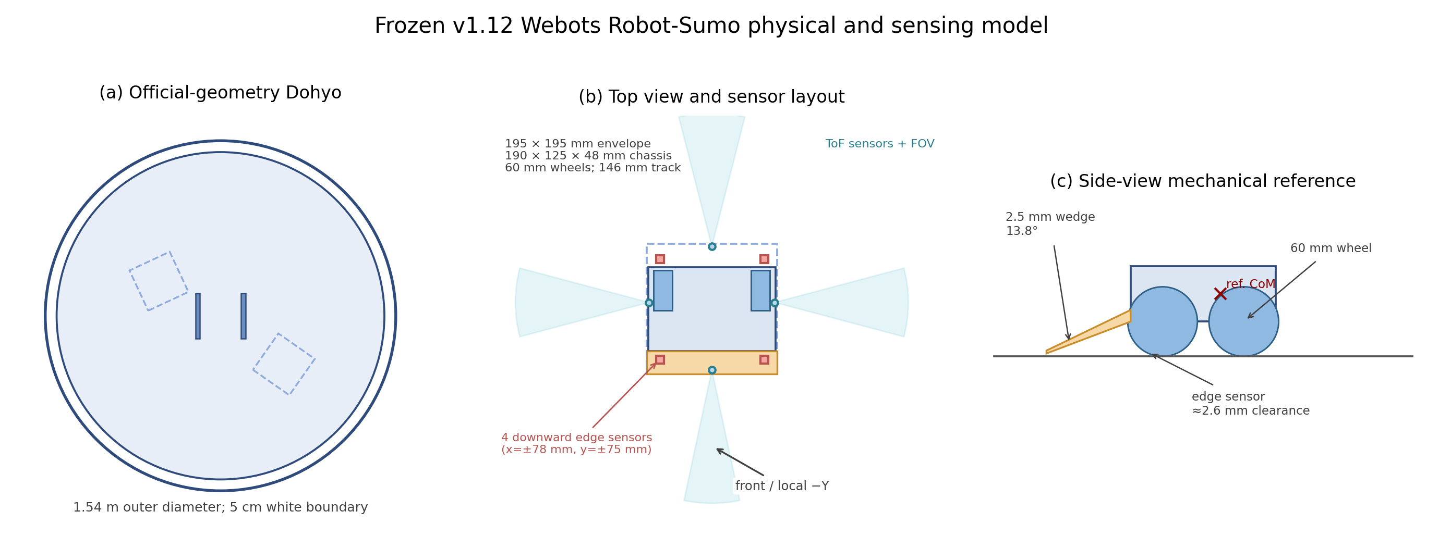
Fig. 2. Frozen v1.12 Webots physical model. (a) Official-geometry 3 kg Dohyo and safety area. (b) Top-view robot geometry, wheel track, four opponent range-sensor fans, and four edge-sensor locations. (c) Side-view reference showing wheel diameter, wedge inclination, edge-sensor clearance, chassis envelope, and reference center of mass. Sensor-ray lengths in the drawing are schematic; numerical ranges and poses are reported in Section 3.2 and Table 3.

3.2. Observation space
The deployed policy observes six values, o_t = [p_f, I_r, p_l, p_r, I_eL, I_eR]^T ∈ [0,1]^6: normalized front opponent proximity p_f; a binary rear-opponent indicator I_r; normalized left and right opponent proximity p_l and p_r; and binary left- and right-side edge-risk indicators I_eL and I_eR. For each opponent range sensor, the Webots output v is normalized as p = clip(v/1000, 0, 1). The configured lookup tables map near objects to larger normalized proximity values and the end of the sensing range to zero. Rear detection is binarized at 0.10. Four downward edge sensors are normalized by the same 1000-count scale; front and rear sensors on each side are logically aggregated so that either local edge indication can assert the corresponding side-risk flag. Supervisor positions, velocities, contact states, opponent radial position, curriculum progress, and global pose are never included in the policy observation.
The sensor geometry is fixed in the robot body frame, whose local forward direction is −Y. The front sensor is located at (0, −91, +5) mm and uses nine rays over a 0.42 rad aperture with 0.85 m range. The rear sensor is located at (0, +94, +8) mm and uses five rays over 0.50 rad with 0.65 m range. Left and right sensors are located at (+94, +10, +8) mm and (−94, +10, +8) mm, respectively; each uses seven rays over 0.52 rad with 0.70 m range. The four downward edge sensors are mounted at x=±78 mm and y=±75 mm, approximately 2.6 mm above the nominal Dohyo surface, with 0.03 m lookup range. This arrangement deliberately preserves a compact, local, hardware-realizable observation while providing frontal acquisition, lateral search, rear awareness, and boundary protection.

3.3. Action space
The action space contains 18 discrete motor commands formed by six motion primitives at three speed levels. The primitives are forward, backward, left-curving, right-curving, spin-left, and spin-right. Speed magnitudes are 7, 12, and 18 rad/s. Curved actions command both wheels in the same forward direction but at a 2:1 speed ratio; hence they are classified as translational-forward actions rather than pure turns. This distinction is important for behavioral auditing because a learned policy may attack through a curved trajectory rather than through perfectly straight motion. The exact wheel-speed commands are listed in Table 1.
Action family | Low | Medium | High | Physical interpretation
Forward | (+7,+7) | (+12,+12) | (+18,+18) | Straight forward translation
Backward | (-7,-7) | (-12,-12) | (-18,-18) | Straight reverse translation
Left | (+3.5,+7) | (+6,+12) | (+9,+18) | Curved forward, left
Right | (+7,+3.5) | (+12,+6) | (+18,+9) | Curved forward, right
Spin left | (-7,+7) | (-12,+12) | (-18,+18) | In-place rotation
Spin right | (+7,-7) | (+12,-12) | (+18,-18) | In-place rotation
Table 1. Discrete action map. Ordered pairs denote left- and right-wheel angular velocities in rad/s.

3.4. Reward design and privileged training telemetry
The reward was designed so that the official competitive outcome remains dominant while dense terms improve credit assignment for rare approach/contact events. Let m_t denote the curriculum-dependent attack multiplier. The per-step reward is r_t = r_term + r_time + r_edge + r_search + r_turn + r_approach + m_t(r_attack + r_visible + r_first-contact + r_contact-pressure) + r_push. Terminal rewards are +12 for an official win, −12 for an official loss, and −4 for a timeout; a contact-assisted win adds +3, while an unforced self-out by the learner adds −3. Dense terms reward safe search, correct reorientation, distance reduction toward a detected opponent, committed forward translation when the opponent is frontal, first physical contact, sustained translational pressure during contact, and positive opponent radial displacement. Penalties discourage edge exposure, backward motion without edge justification, retreat from a visible target, spinning or failing to translate when a frontal target is available, and contact without forward pressure. The exact frozen coefficients are reported in Table 2.
Attack/contact shaping is intentionally strongest in the easiest curriculum phases and decays as task difficulty increases: m_t=1.8 in Stage 1A (close attack), 1.4 in Stage 1B (orient-and-approach), 1.15 in Stage 1C (static search), 1.2 in Stage 2A (moving-near), and 1.0 in Stage 2B and evaluation. Privileged Supervisor telemetry is used only to compute approach distance, contact onset, sustained contact, and outward displacement during training/diagnostics; it is not appended to o_t. This separation allows dense physical credit assignment without changing what a future onboard controller would need to sense.
Three quantities are available through Webots Supervisor telemetry only during training and evaluation diagnostics: center-to-center robot distance, physical contact state, and radial positions. These variables improve reward credit assignment for approach, first contact, and outward pushing but are not provided to the policy. This form of privileged training information preserves deployability of the six-dimensional sensor policy while reducing ambiguity in sparse contact rewards.
Reward component | Value / scale | Purpose
Official win | +12 | Primary task objective
Official loss | −12 | Primary failure signal
Timeout | −4 | Discourage passive survival
Contact-assisted win bonus | +3 | Additional credit when recent robot contact precedes opponent ring-out
Unforced self-out penalty | −3 additional | Penalize unsafe learner exit
Time penalty | −0.0003 per step | Mild pressure toward decisiveness
Edge risk | −0.03 per step | Strong boundary-safety shaping
Safe forward search | +0.00012 per step | Allow controlled translation when opponent is not visible
Scan in place | +0.00025 per step | Encourage target reacquisition without drift
Correct side turn | +0.0004 per step | Orient toward stronger left/right opponent signal
Rear reorientation | +0.0003 per step | Encourage turning after rear detection
Attack commitment | +0.0035 × m_t | Reward forward-translational attack when frontal proximity ≥0.38
Medium/high attack bonus | +0.0008 / +0.0018 × m_t | Favor stronger committed attack when appropriate
Approach distance | +0.45 × Δd toward opponent | Reward physical distance reduction while target is detected
Retreat distance | −0.22 × |Δd| away | Penalize separation from a detected target
Visible target but non-forward | −0.0015 × m_t | Discourage refusing to attack a frontal target
Backward from visible target | −0.002 × m_t | Additional penalty for retreating from frontal target
Spin with frontal target | −0.0008 × m_t | Discourage unnecessary in-place rotation when target is centered
First physical contact | +0.75 × m_t | Bridge sparse contact credit
Sustained translational contact | +0.0035 × m_t per step | Maintain forward pressure while in contact
Contact without forward pressure | −0.0006 per step | Discourage passive/non-pushing contact
Outward push | +0.75 × positive radial displacement | Reward physically useful opponent displacement
Backward without edge risk | −0.001 per step | Discourage unnecessary reverse motion
Curriculum attack multiplier m_t | 1.8, 1.4, 1.15, 1.2, 1.0 | Stages 1A, 1B, 1C, 2A, and 2B/evaluation, respectively
Table 2. Main reward terms in the frozen v1.12 benchmark. Values are identical across algorithms and seeds.

4. Simulation and experimental methodology

4.1. Arena and robot model
The simulation was implemented in Webots using a 5 ms basic time step [13]. Arena geometry follows the official 3 kg class specification [8]: 1.54 m outer diameter, 0.05 m platform height, a 0.05 m inward white boundary (therefore a 0.72 m black-region radius), two 0.02 m × 0.20 m brown Shikiri lines positioned ±0.10 m from the center, and a 3.60 m × 3.60 m surrounding safety area. The white boundary is part of the Dohyo. Ring-out is detected from physical contact between any descendant robot solid and the lower safety floor outside the platform footprint; a conservative center-height check is retained only as a fail-safe. Cosmetic surface scuffs are visual only and do not introduce geometric roughness.
Both competitors instantiate the same SumoRobot2 PROTO and are mechanically identical; only body color, controller identity, and learned policy differ. The inspection envelope is 0.195 m × 0.195 m. A low-profile 0.190 m × 0.125 m × 0.048 m central chassis is protected by side rails and a rear bumper/skid. The front pushing element is a 0.195 m-wide, 0.075 m-long, 0.0025 m-thick stainless-steel reference wedge tilted by 0.240 rad (≈13.8°) with a non-sharpened polished leading edge. Two 0.060 m-diameter, 0.028 m-wide drive wheels are centered at x=±0.073 m and y=+0.028 m, giving a 0.146 m wheel-track center distance. Each wheel is assigned 0.18 kg and the main rigid body 2.64 kg, yielding a total simulated mass of 3.00 kg. The reference body center of mass is [0, +0.028, −0.010] m in robot coordinates. Motor limits are 22 rad/s and 1.5 N·m per wheel; the largest policy command is 18 rad/s, equivalent to a nominal wheel-rim speed of 0.54 m/s.
Contact parameters are fixed across every algorithm and seed. Wheel–Dohyo Coulomb friction is 1.20, robot-body–Dohyo friction is 0.32, body–body friction is 0.75, wheel–body friction is 0.90, and wheel–wheel friction is 1.00; bounce is zero for all defined pairs. Wheel–safety-floor and body–safety-floor friction are 0.90 and 0.45, respectively. Soft contact regularization parameters are held constant across the benchmark. These values are intended to provide a stable, reproducible contact-control environment; they are not claimed to be calibrated measurements of a particular physical tournament surface.
Parameter | Value
Webots basic time step | 5 ms
Dohyo outer diameter | 1.54 m
Black-region radius | 0.72 m
White boundary width | 0.05 m inward; part of Dohyo
Platform height | 0.05 m
Shikiri lines | 0.02 m × 0.20 m; centers at ±0.10 m
Safety area | 3.60 m × 3.60 m
Episode horizon | 3,000 steps = 15 s
Robot inspection envelope | 0.195 m × 0.195 m
Main chassis | 0.190 m × 0.125 m × 0.048 m
Robot total mass | 3.00 kg (2.64 kg body + 0.18 kg per wheel)
Reference body CoM | [0, +0.028, −0.010] m
Wheel diameter / width | 0.060 m / 0.028 m
Wheel center locations | x=±0.073 m, y=+0.028 m; 0.146 m track
Motor limits | 22 rad/s, 1.5 N·m per wheel
Policy speed levels | 7, 12, 18 rad/s; 18 rad/s ≈0.54 m/s wheel-rim speed
Wedge | 0.195 m × 0.075 m × 0.0025 m; tilt 0.240 rad (≈13.8°)
Front opponent sensor | pose (0, −0.091, +0.005) m; 0.85 m; 9 rays; 0.42 rad
Rear opponent sensor | pose (0, +0.094, +0.008) m; 0.65 m; 5 rays; 0.50 rad
Left opponent sensor | pose (+0.094, +0.010, +0.008) m; 0.70 m; 7 rays; 0.52 rad
Right opponent sensor | pose (−0.094, +0.010, +0.008) m; 0.70 m; 7 rays; 0.52 rad
Edge sensors | 4 downward IR sensors at x=±0.078 m, y=±0.075 m; 0.03 m range
Nominal edge-sensor clearance | ≈0.0026 m above Dohyo surface
Wheel–Dohyo friction | Coulomb coefficient 1.20; bounce 0
Body–Dohyo friction | Coulomb coefficient 0.32; bounce 0
Body–body friction | Coulomb coefficient 0.75; bounce 0
Wheel–wheel friction | Coulomb coefficient 1.00; bounce 0
Wheel–safety-floor friction | 0.90; bounce 0
Body–safety-floor friction | 0.45; bounce 0
Table 3. Frozen physical and simulation parameters used for all publication benchmark runs.

4.2. Curriculum
Every training run uses the same two-stage curriculum. Stage 1 lasts 200,000 environment steps against a stationary opponent and progresses through three levels. During 1A (45% of Stage 1), the opponent is 0.24–0.32 m away with almost zero heading error, emphasizing direct attack and contact. During 1B (to 78%), separation increases to 0.30–0.46 m and the learner heading error increases to ±0.5 rad, emphasizing orientation and approach. During 1C, separation increases to 0.40–0.65 m and the learner heading is fully randomized, introducing search.
Stage 2 continues from the same learned policy for 300,000 additional steps against a moving standard scripted opponent. Stage 2A occupies the first 55% with separation 0.34–0.50 m and moderate orientation error; Stage 2B uses separation 0.45–0.72 m with fully randomized headings. The evaluation distribution is kept separate, using 0.45–0.78 m separation and fully randomized headings. DQN preserves its replay buffer across the Stage 1 to Stage 2 transition.

4.3. Scripted benchmark opponents
Three frozen opponent conditions are used in evaluation. The static opponent does not move. The standard scripted opponent searches, turns toward detected targets, attacks, and executes deterministic edge recovery. The aggressive opponent uses the same logic but higher search, turn, attack, and edge-escape speeds. A directional edge guard is applied to both moving opponents: front-edge detection commands an inward reverse escape, rear-edge detection commands forward escape, lateral edge detections trigger turning away from the boundary, and ambiguous states rotate in place. A short post-edge guard prevents immediate re-attack. This controller was introduced specifically to minimize unforced benchmark-opponent self-outs.

4.4. Algorithms and hyperparameters
Four algorithms were selected to represent distinct learning families while remaining compatible with the discrete action space: A2C, PPO, DQN, and Recurrent PPO. All feed-forward policies use two hidden layers of 128 units. Recurrent PPO adds one 128-unit LSTM layer. Hyperparameters were fixed before the final benchmark and were not tuned using the reported test evaluations. Stable-Baselines3 2.6.0 and sb3-contrib 2.6.0 were used with PyTorch 2.5.1 on CPU. Each algorithm received the same 500,000 environment-step budget per seed. The complete algorithm hyperparameters are reported in Table 4.
Parameter | A2C | PPO | DQN | Recurrent PPO
Learning rate | 7e-4 | 3e-4 | 1e-4 | 3e-4
Rollout / n_steps | 128 | 1024 | — | 1024
Batch size | — | 256 | 256 | 256
Epochs/update | — | 10 | — | 10
γ | 0.99 | 0.99 | 0.99 | 0.99
GAE λ | 0.95 | 0.95 | — | 0.95
Entropy coefficient | 0.01 | 0.01 | — | 0.01
Clip range | — | 0.2 | — | 0.2
Replay buffer | — | — | 100,000 | —
Learning starts | — | — | 10,000 | —
Target update | — | — | 5,000 steps | —
Exploration final ε | — | — | 0.05 | —
Network | 128-128 | 128-128 | 128-128 | 128-128 + LSTM-128
Table 4. Algorithm hyperparameters used in all five seeds.

4.5. Reset integrity and episode validity
A phased reset protocol prevents residual physics or asynchronous controller state from contaminating the next episode. The protocol freezes both robots, quiesces motor commands, clears rigid-body velocity, applies new poses, clears physics again, simulates a settling window, verifies the realized pose, waits for learner reset acknowledgement, and then releases both controllers. The pose tolerance is 0.025 m in the horizontal plane and 0.03 m vertically. A 20-step post-reset integrity guard marks any immediate safety-floor contact as an invalid reset artifact. Such artifacts receive zero terminal reward, are excluded from evaluation statistics, and are retried. In the completed benchmark, all 6,000 requested evaluation episodes were valid and no reset-integrity failure entered the publication dataset.

4.6. Experimental design and evaluation
Five independent training seeds (0–4) were used for each algorithm, giving 20 independently trained final policies. After training, models were frozen and evaluated deterministically for 100 episodes against each of the static, scripted, and aggressive opponents. The same randomized evaluation profile was used across algorithms. The resulting design contains 500 episodes per algorithm-condition and 1,500 episodes per algorithm, for 6,000 evaluation episodes in total.
The primary performance metrics are official win rate, contact-assisted win rate, unforced-win rate, loss rate, and draw rate. Secondary behavioral metrics include forward translation, attack ratio, opponent engagement, physical contact, forward contact pressure, outward-push progress, aggression index, edge-risk ratio, and empirical action entropy. These metrics are computed per trained seed before algorithm-level aggregation. This distinction is important because the 100 evaluation episodes estimate the performance of a trained policy, whereas the five training seeds constitute the independent algorithm replicates.

4.7. Statistical analysis
For each opponent condition, algorithm comparisons use the five seed-level win rates. Results are summarized as mean, standard deviation, and 95% confidence interval. A Kruskal–Wallis test is used as the omnibus nonparametric comparison because of the small number of seeds and strongly non-Gaussian, zero-inflated performance distributions. Pairwise Mann–Whitney U tests are reported with Holm correction for multiple comparisons. Following recommendations for reliable RL evaluation [6,7], no inferential claim treats the hundreds of within-seed test episodes as independent training replications. The asymmetric self-play extension uses the same seed-as-unit principle: paired veteran and novice outcomes are compared across the five matched veteran–novice pairs, with paired Wilcoxon signed-rank tests and seed-bootstrap 95% confidence intervals. Repeated bouts characterize each frozen pair precisely but do not increase the inferential sample size.
Seed is treated as a first-class experimental factor because competitive DRL is path-dependent: different neural initializations and exploration histories alter which rare early contacts, edge events, and curriculum transitions enter the learning trajectory. In self-play this sensitivity is further amplified because both policies change concurrently, making the opponent distribution non-stationary. Accordingly, large between-seed differences are reported rather than averaged away; they are interpreted as evidence about reproducibility and strategy selection, not as independent evidence that any one favorable seed is representative.
As an exploratory mechanism analysis, Spearman correlations are computed across the 20 algorithm-seed units after averaging the two moving-opponent conditions. These correlations relate contact-assisted win rate to attack/contact variables and relate loss rate to edge risk. They are interpreted as descriptive associations rather than causal effects.

4.8. Asymmetric veteran–novice self-play extension
The self-play experiment was specified before inspecting its outcomes and was conducted as an add-on to the frozen v1.12 benchmark rather than as a retuning of the four-algorithm comparison. For each PPO seed 0–4, Agent 0 (the veteran) was initialized from the corresponding final PPO policy obtained after the 200,000-step stationary-opponent stage and 300,000-step scripted-opponent stage. Agent 1 (the novice) was newly initialized with the same PPO architecture and hyperparameters and no pretrained weights. Both agents then learned simultaneously for an additional 500,000 Stage-3 environment steps. Thus, the veteran entered self-play with a 500,000-step experience advantage but was not frozen; asymmetric initialization was followed by symmetric continued adaptation. The observation vector, 18-action motor space, reward function, 3 kg robot geometry, Dohyo, ring-out logic, contact-assisted attribution, and clean-reset protocol were unchanged from the main benchmark.
Stage-3 self-play used the randomized evaluation spawn distribution rather than an easier curriculum. Checkpoints were stored every 50,000 steps. Deterministic head-to-head evaluations were conducted at 100,000, 200,000, 300,000, 400,000, and 500,000 Stage-3 steps. At each checkpoint both policies were evaluated in both robot slots using matched spawn seeds to reduce slot and spawn bias. Intermediate checkpoints used 50 episodes per slot (100 bouts per seed/checkpoint), while the final checkpoint used 100 episodes per slot (200 bouts per seed). The primary head-to-head outcomes were veteran win rate, novice win rate, draw rate, contact-assisted forced-win rate, and the novice-minus-veteran win-rate difference.
After 500,000 Stage-3 steps, both final policies were independently evaluated for 100 episodes against each frozen external opponent (static, standard scripted, and aggressive scripted). The same deterministic evaluation seed used in the original PPO benchmark was reused, allowing a paired comparison of each veteran before versus after self-play. This design distinguishes head-to-head exploitation from external generalization and provides a direct test for catastrophic forgetting. The trained seed/pair (n=5) remained the independent inferential unit. Final novice-versus-veteran win-rate differences and veteran pre/post forced-win differences were assessed with paired Wilcoxon signed-rank tests and seed-level bootstrap 95% confidence intervals; because n=5, effect trajectories and consistency across seeds were emphasized over dichotomous significance claims.

4.9. Software implementation and AI-assisted development
The benchmark and self-play pipelines were implemented in Python and Webots. During software development, OpenAI ChatGPT was used as an AI-assisted tool for code drafting, debugging support, documentation, and consistency checks. All executable code, environment parameters, action mappings, reward terms, reset logic, training runs, evaluation outputs, statistical analyses, and figures were independently executed, inspected, and validated by the author. The AI system did not autonomously run experiments, select reported results, or make final scientific decisions. The end-of-manuscript declaration provides the corresponding disclosure for manuscript preparation.

5. Results

5.1. Training dynamics
The Stage-2 learning curves are highly non-monotonic (Fig. 3). Short intervals of successful ring-outs appear for all feed-forward algorithms, but high win-rate bins do not persist consistently through the 300,000 moving-opponent steps. DQN exhibits the largest intermittent peaks, while A2C and PPO show lower but recurring bursts of success. Recurrent PPO remains mostly near zero. The absence of a smooth monotonic increase is consistent with competitive control as a multi-attractor problem: policy updates can move between aggressive, conservative, and unsafe strategies even when the physical task is unchanged.
This pattern is important when considering whether simply extending training would improve the final result. The curves do not show an unambiguous late-stage upward trend that would justify assuming more steps will monotonically increase performance. Longer training may help some seeds but may also move previously effective policies away from successful behaviors. Consequently, the 500,000-step budget is treated as a controlled comparison budget rather than as a claim of asymptotic convergence.

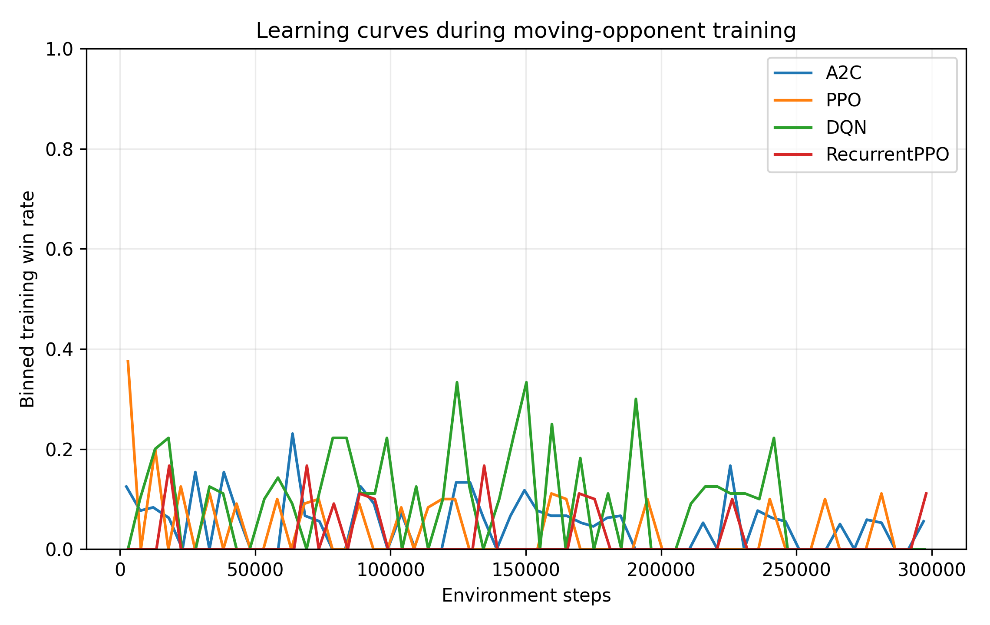
Fig. 3. Binned Stage-2 training win rate versus environment steps. The curves are noisy and non-monotonic, indicating that additional training is not guaranteed to produce monotonic improvement.

5.2. Frozen-policy competitive outcomes
Algorithm | Opponent | Wins | Contact-assisted wins | Unforced wins | Losses | Draws
A2C | Static | 19/500 (3.8%) | 19/500 (3.8%) | 0/500 (0.0%) | 0/500 (0.0%) | 481/500 (96.2%)
A2C | Scripted | 9/500 (1.8%) | 9/500 (1.8%) | 0/500 (0.0%) | 1/500 (0.2%) | 490/500 (98.0%)
A2C | Aggressive | 15/500 (3.0%) | 15/500 (3.0%) | 0/500 (0.0%) | 1/500 (0.2%) | 484/500 (96.8%)
PPO | Static | 11/500 (2.2%) | 11/500 (2.2%) | 0/500 (0.0%) | 0/500 (0.0%) | 489/500 (97.8%)
PPO | Scripted | 52/500 (10.4%) | 51/500 (10.2%) | 1/500 (0.2%) | 1/500 (0.2%) | 447/500 (89.4%)
PPO | Aggressive | 59/500 (11.8%) | 59/500 (11.8%) | 0/500 (0.0%) | 4/500 (0.8%) | 437/500 (87.4%)
DQN | Static | 2/500 (0.4%) | 2/500 (0.4%) | 0/500 (0.0%) | 40/500 (8.0%) | 458/500 (91.6%)
DQN | Scripted | 38/500 (7.6%) | 38/500 (7.6%) | 0/500 (0.0%) | 41/500 (8.2%) | 421/500 (84.2%)
DQN | Aggressive | 24/500 (4.8%) | 24/500 (4.8%) | 0/500 (0.0%) | 45/500 (9.0%) | 431/500 (86.2%)
RecurrentPPO | Static | 0/500 (0.0%) | 0/500 (0.0%) | 0/500 (0.0%) | 0/500 (0.0%) | 500/500 (100.0%)
RecurrentPPO | Scripted | 28/500 (5.6%) | 7/500 (1.4%) | 21/500 (4.2%) | 1/500 (0.2%) | 471/500 (94.2%)
RecurrentPPO | Aggressive | 5/500 (1.0%) | 5/500 (1.0%) | 0/500 (0.0%) | 1/500 (0.2%) | 494/500 (98.8%)
Table 5. Aggregate frozen-policy evaluation outcomes. Each row contains 500 episodes (five seeds × 100 episodes).
Table 5 and Figs. 4–5 summarize the main competitive outcomes. PPO achieves the highest mean win rate against the two moving opponents: 10.4% against the standard scripted opponent and 11.8% against the aggressive opponent. It also incurs only five losses across all 1,500 evaluations (0.33%). DQN reaches 7.6% scripted and 4.8% aggressive win rates but suffers substantially more losses: 126/1,500 evaluations (8.4%). A2C has the highest static-opponent win rate (3.8%) but lower scripted and aggressive performance. Recurrent PPO produces no static wins and is dominated by draws.
The static opponent is difficult for every algorithm. Because it contributes no motion toward the boundary, the learner must both locate the robot and sustain directed pressure long enough to displace a full-mass 3 kg opponent. Moving opponents, by contrast, create interception opportunities and can approach the boundary while interacting with the learner. Therefore, a higher dynamic-opponent win rate does not imply that the dynamic opponent is intrinsically weaker; it reflects a different physical interaction structure.

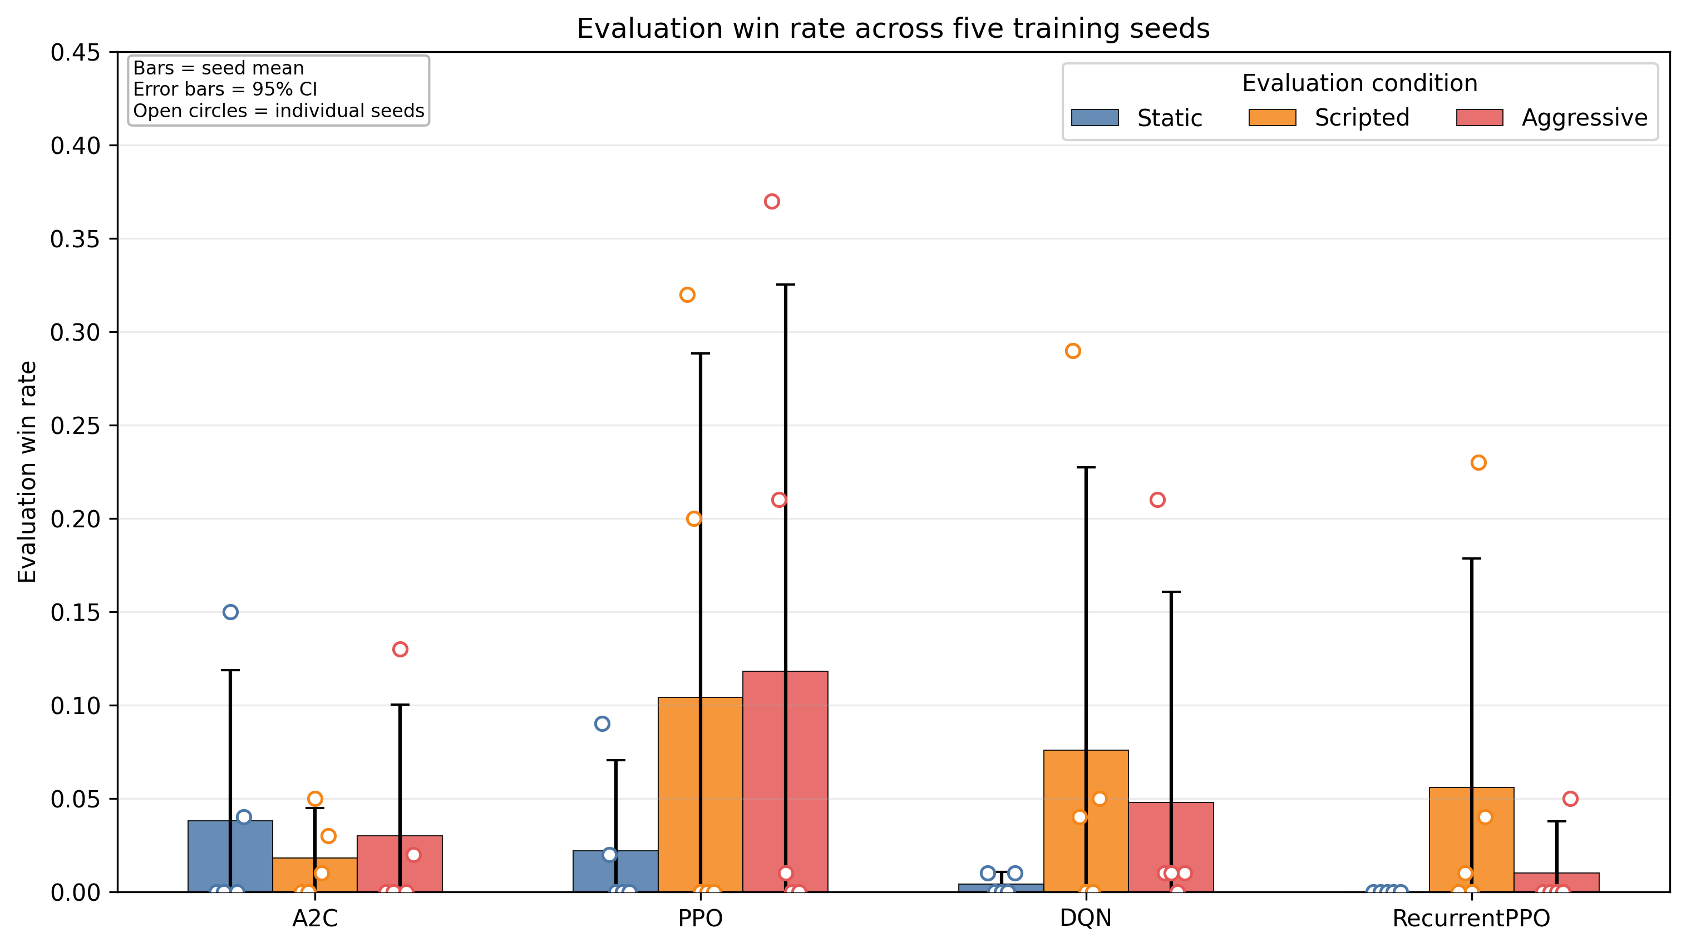
Fig. 4. Seed-level evaluation win rates. Bars show the five-seed mean with 95% confidence-interval error bars; open circles show individual trained seeds. Large within-algorithm dispersion is evident for PPO, DQN, and A2C.

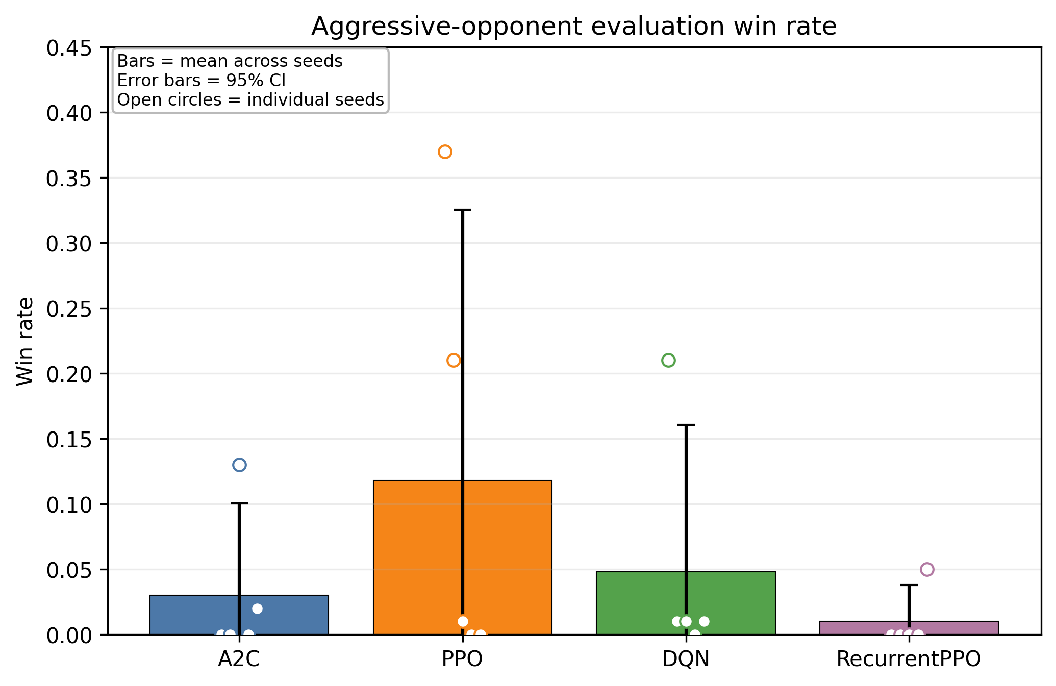
Fig. 5. Mean win rate against the aggressive scripted opponent with uncertainty across the five training seeds. PPO is descriptively highest, but variability is large.

5.3. Contact-assisted versus unforced wins
Outcome attribution substantially changes the interpretation of Recurrent PPO. PPO, DQN, and A2C obtain almost all wins through recent robot–robot contact. PPO records 121 contact-assisted wins across 1,500 evaluations; DQN records 64 and A2C 43. Recurrent PPO records 33 nominal wins, but only 12 are contact-assisted. The remaining 21 are unforced scripted-opponent self-outs, all concentrated in the scripted condition. As shown in Fig. 6, nominal win rate can therefore overstate active competitive effectiveness when outcome causality is not audited. The complete win/draw/loss composition is shown in Fig. 7.
The contact-assisted label is intentionally conservative: it only asserts that recent physical contact preceded the ring-out within the fixed one-second window. It does not prove that the learner was the unique physical cause of the opponent leaving the arena. Nevertheless, the distinction is valuable because it separates outcomes with direct combat interaction from those that occur in its absence.

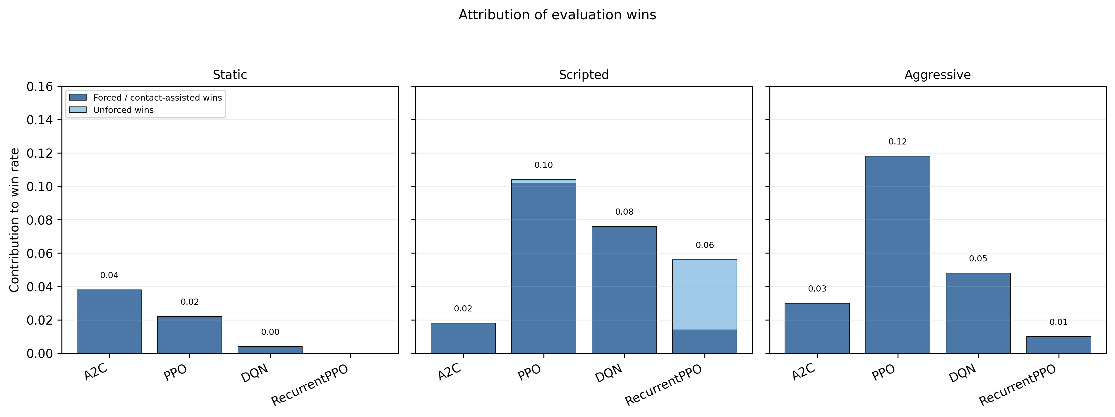
Fig. 6. Attribution of official wins into contact-assisted and unforced opponent self-outs. Recurrent PPO’s scripted-opponent result contains a substantial unforced component, whereas PPO’s moving-opponent wins are almost entirely contact-assisted.

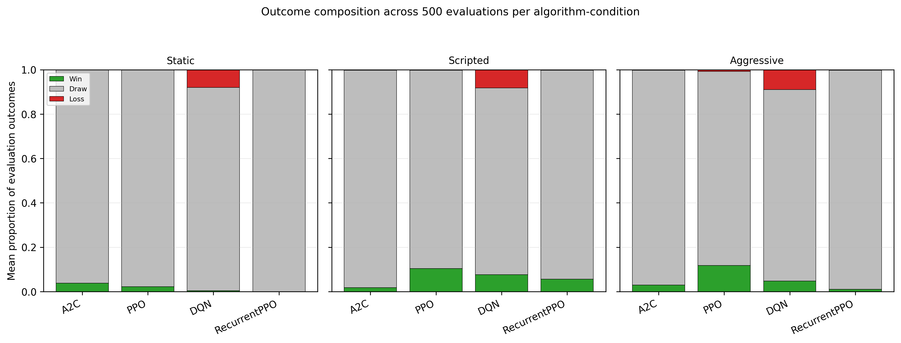
Fig. 7. Win/draw/loss composition across 500 evaluations per algorithm-condition. Draws dominate most conditions; DQN exhibits the largest loss fraction.

5.4. Learned behavioral strategies
Algorithm | Forward | Attack | Contact | Forward contact | Outward push | Edge risk | Aggression | Action entropy
A2C | 0.348 | 0.087 | 0.065 | 0.060 | 0.045 | 0.100 | 0.306 | 0.315
PPO | 0.173 | 0.104 | 0.117 | 0.100 | 0.076 | 0.163 | 0.233 | 0.502
DQN | 0.277 | 0.066 | 0.101 | 0.060 | 0.039 | 0.306 | 0.247 | 1.247
RecurrentPPO | 0.049 | 0.021 | 0.027 | 0.018 | 0.013 | 0.046 | 0.136 | 0.869
Table 6. Mean behavioral metrics across all three evaluation conditions and five seeds.
The algorithms learn qualitatively different behaviors (Table 6 and Figs. 8–9). A2C exhibits the highest average forward-translation ratio (0.348) and the highest aggression index (0.306), yet this activity translates into comparatively few ring-outs. PPO moves forward less frequently (0.173) but attains the highest attack ratio (0.104), physical-contact ratio (0.117), forward-contact pressure (0.100), and outward-push progress (0.076). This pattern suggests that PPO is more effective at converting selected engagement opportunities into mechanically useful pressure.
DQN exhibits the highest empirical action entropy (1.247), consistent with a broader action distribution, but also the highest edge-risk ratio (0.306) and by far the highest loss rate. The combination indicates exploration without equally strong safety control. Recurrent PPO exhibits the lowest forward, attack, contact, and aggression metrics and correspondingly produces a draw-dominated outcome profile. Its low loss rate should therefore be interpreted as conservative non-engagement rather than superior defensive performance.
The relationship between nominal aggression and success is consequently non-monotonic. A2C is more aggressive than PPO by the benchmark aggression index, yet PPO wins more often against moving opponents. Effective competitive behavior appears to require not merely movement but sequencing: detection, orientation, approach, contact, sustained forward pressure, outward displacement, and timely edge recovery.

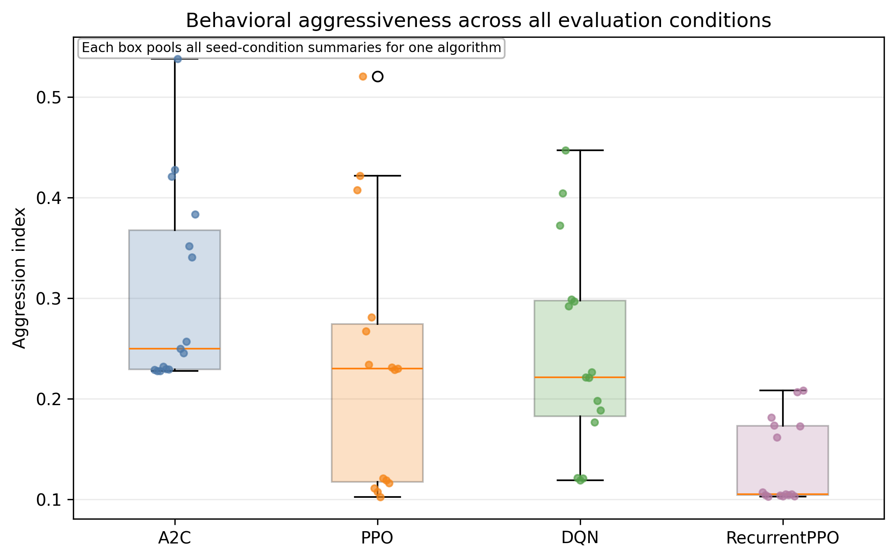
Fig. 8. Distribution of the aggression index across evaluation conditions and seeds. A2C is behaviorally more aggressive on average than PPO, illustrating that aggression alone does not determine win rate.

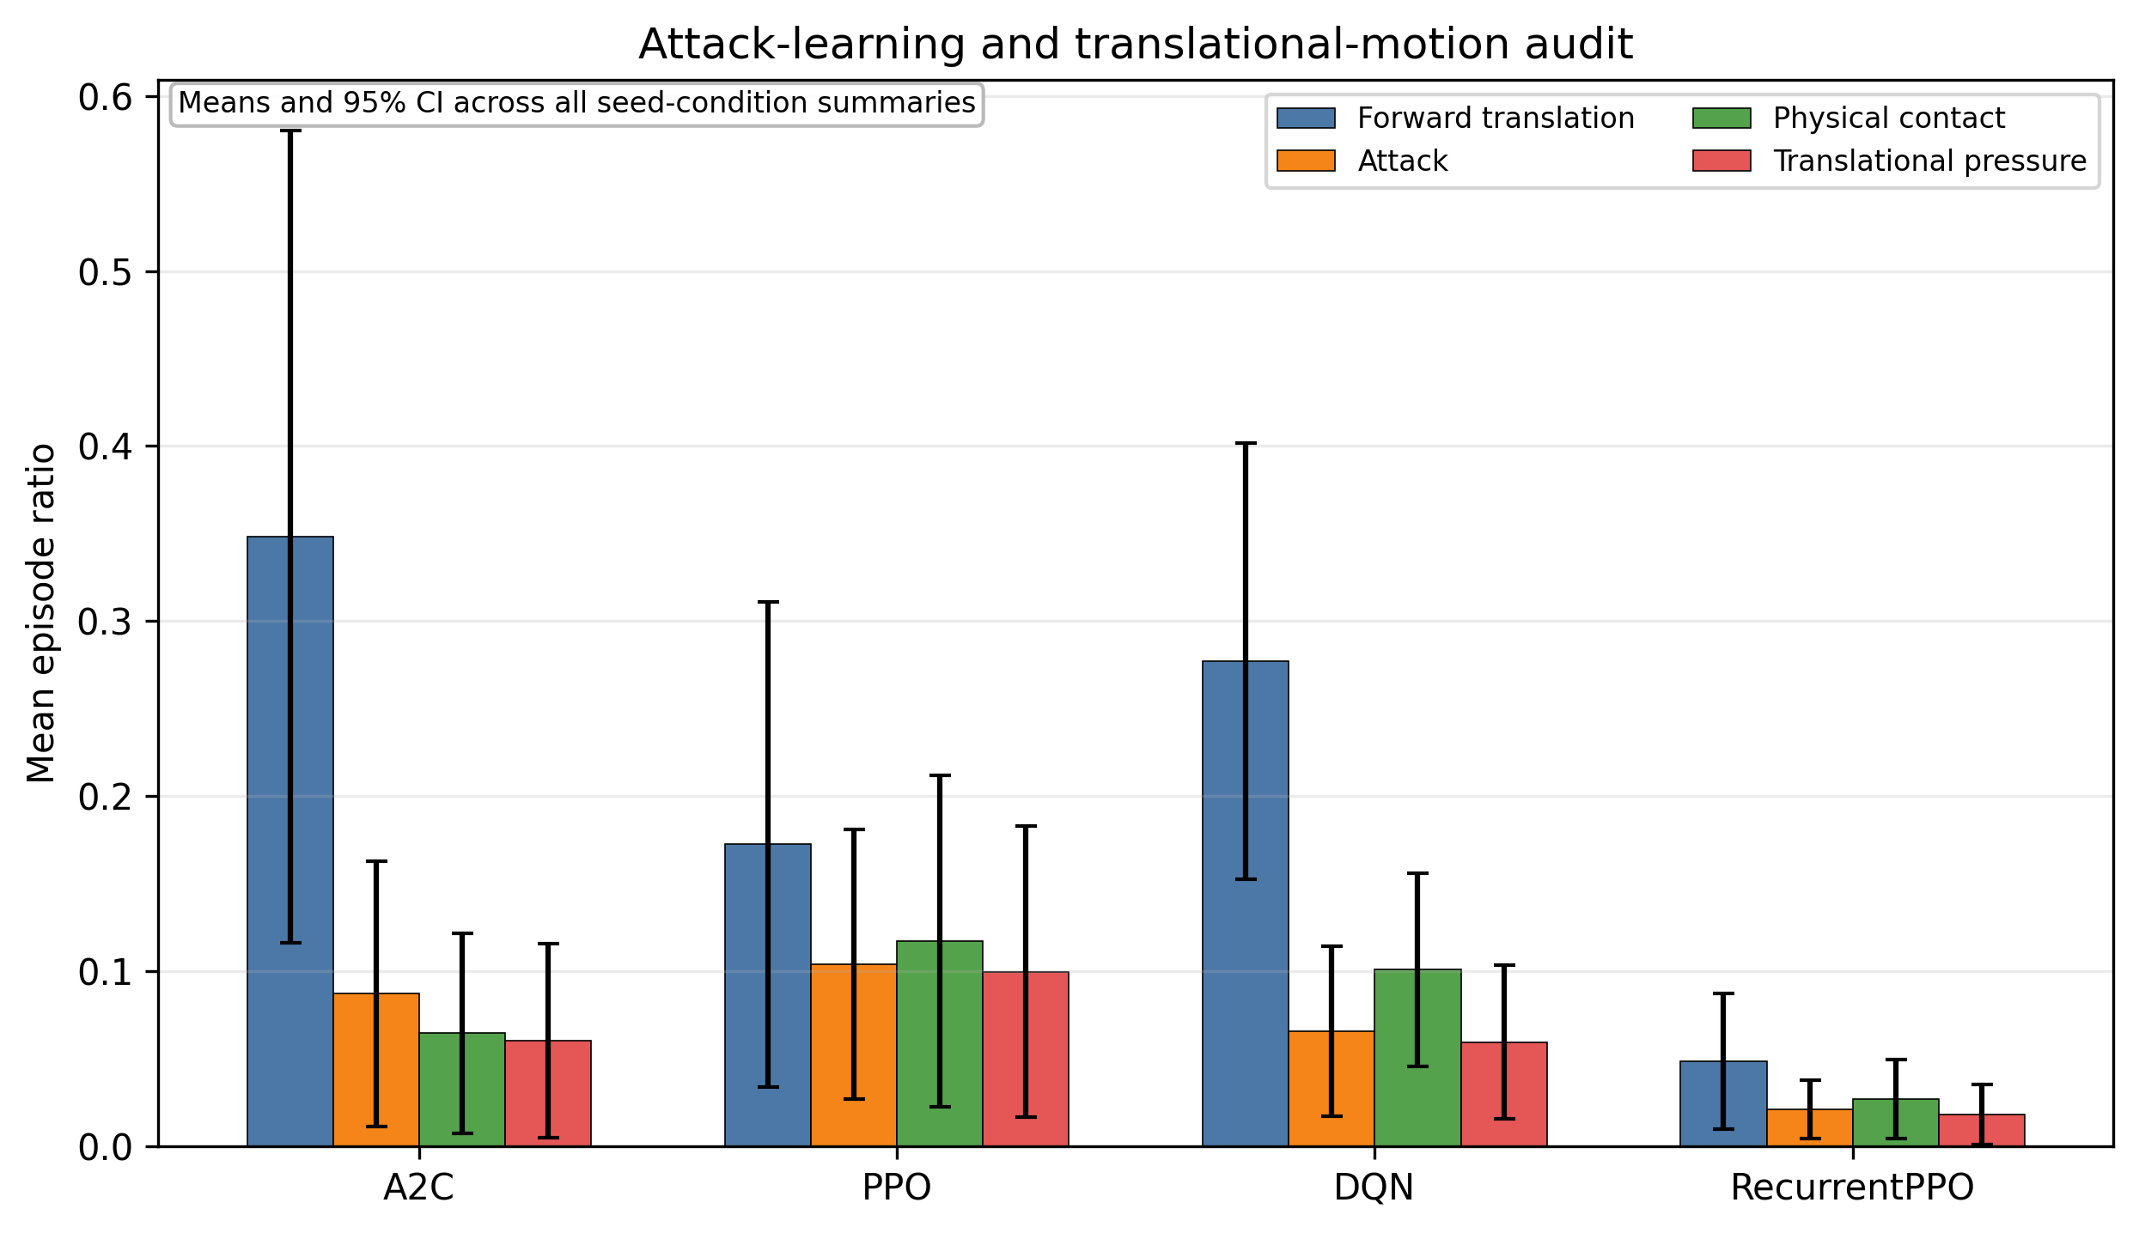
Fig. 9. Mean forward translation, attack, physical contact, and forward-contact pressure. PPO shows the strongest conversion of movement into contact-centered competitive behavior.

5.5. Seed sensitivity and strategy bifurcation
Algorithm | Seed | Static | Scripted | Aggressive
A2C | 0 | 0% | 0% | 0%
A2C | 1 | 0% | 0% | 0%
A2C | 2 | 15% | 5% | 13%
A2C | 3 | 0% | 1% | 0%
A2C | 4 | 4% | 3% | 2%
PPO | 0 | 9% | 32% | 37%
PPO | 1 | 2% | 20% | 21%
PPO | 2 | 0% | 0% | 1%
PPO | 3 | 0% | 0% | 0%
PPO | 4 | 0% | 0% | 0%
DQN | 0 | 1% | 29% | 21%
DQN | 1 | 0% | 4% | 1%
DQN | 2 | 0% | 0% | 1%
DQN | 3 | 0% | 0% | 0%
DQN | 4 | 1% | 5% | 1%
RecurrentPPO | 0 | 0% | 0% | 0%
RecurrentPPO | 1 | 0% | 1% | 0%
RecurrentPPO | 2 | 0% | 0% | 0%
RecurrentPPO | 3 | 0% | 23% | 0%
RecurrentPPO | 4 | 0% | 4% | 5%
Table 7. Win rate by individual training seed. Each cell is based on 100 frozen-policy evaluations.
The most important reliability finding is the magnitude of between-seed variation (Table 7 and Fig. 10). PPO seed 0 achieves 32% scripted and 37% aggressive win rates, and PPO seed 1 achieves 20% and 21%, whereas seeds 3 and 4 produce essentially no wins. A2C seed 2 reaches 15% static, 5% scripted, and 13% aggressive wins, while two A2C seeds never win in any condition. DQN seed 0 reaches 29% scripted and 21% aggressive wins, yet DQN seed 4 becomes unsafe and loses 37–40% of episodes depending on the opponent. Recurrent PPO seed 3 records a 23% nominal scripted win rate, but 21 percentage points arise from unforced opponent self-outs rather than direct contact-assisted ring-outs.
These results are not consistent with a simple model in which every seed converges to one policy family with only small performance noise. Instead, under identical environment, hyperparameters, budget, and evaluation protocol, training reaches qualitatively different behavioral attractors: active attack, high-risk exploration, low-contact conservative behavior, or effective sustained pushing. This seed sensitivity is therefore an empirical reproducibility result rather than a software defect. Plausible mechanisms include stochastic network initialization, exploration history, rare early contact/ring-out events, curriculum path dependence, and—in Stage 3—the additional non-stationarity created by a simultaneously adapting opponent. This finding is precisely why the individually trained seed, rather than each evaluation bout, is the statistical replication unit.

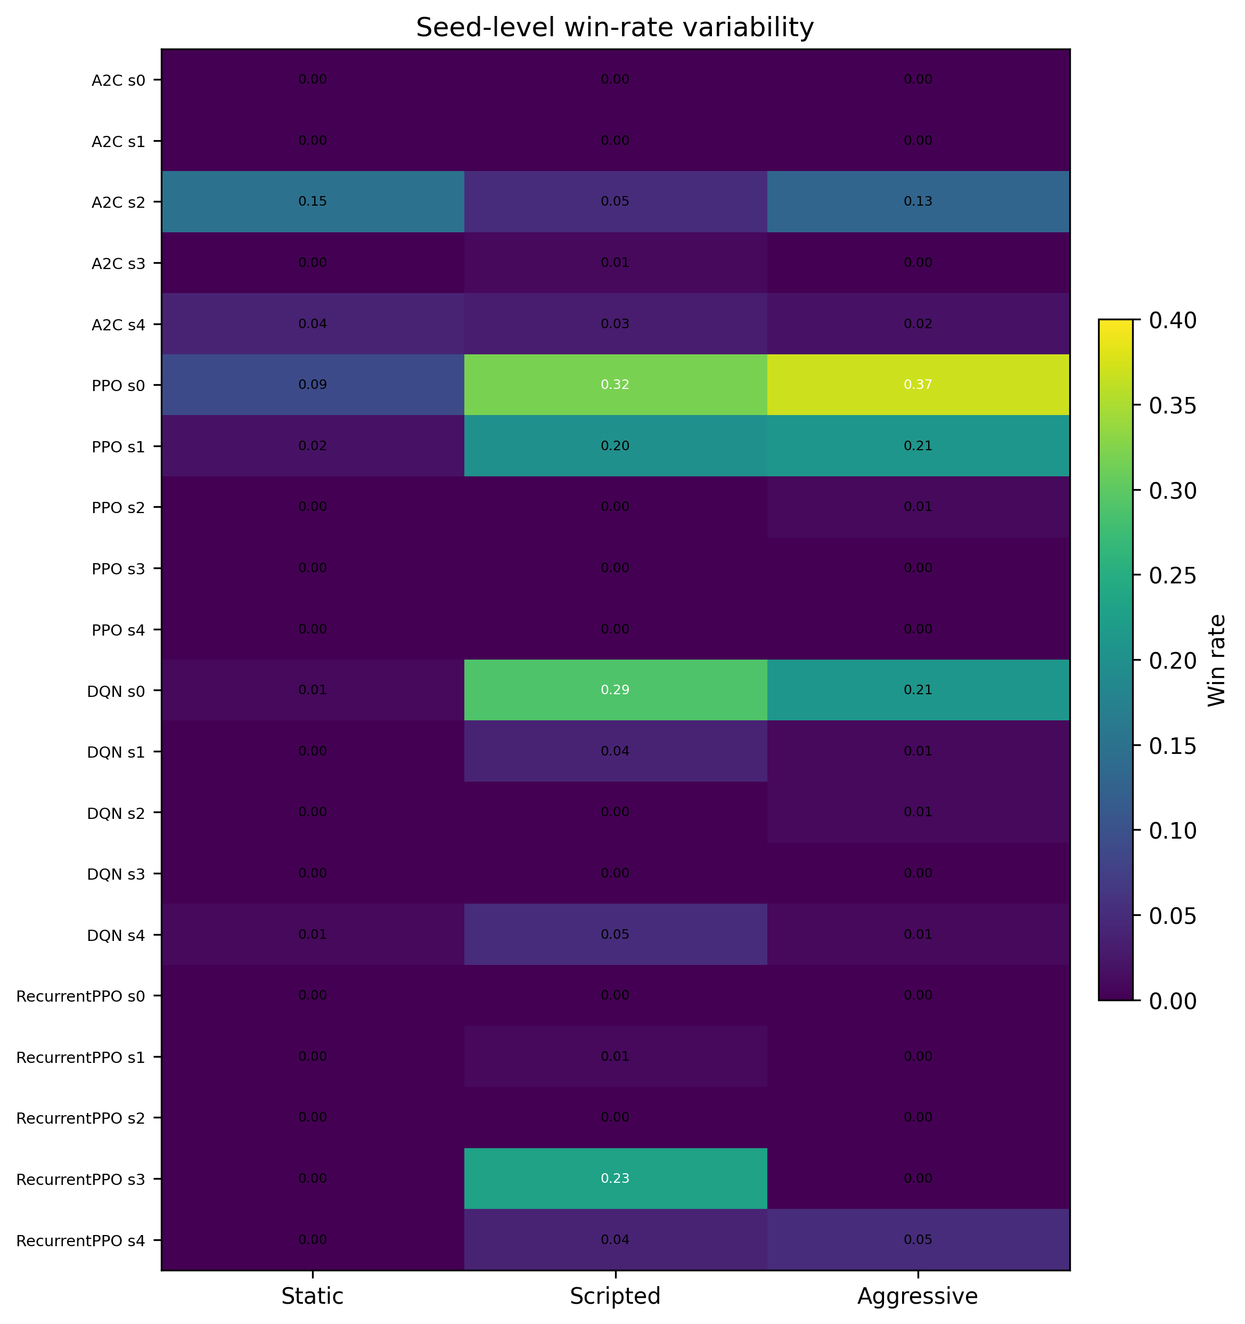
Fig. 10. Seed-level win-rate heatmap. The strong within-algorithm heterogeneity demonstrates strategy bifurcation and cautions against conclusions from a single training seed.

5.6. Inferential statistics
Opponent condition | Kruskal–Wallis H | p-value | Significant at α=0.05?
Static | 2.835 | 0.418 | No
Scripted | 0.321 | 0.956 | No
Aggressive | 2.618 | 0.454 | No
Table 8. Omnibus comparison of seed-level win rates across algorithms.
Table 8 summarizes the omnibus seed-level tests. Despite PPO’s higher descriptive moving-opponent performance, the seed-level Kruskal–Wallis tests do not detect statistically significant differences among algorithms: H=2.835, p=0.418 for the static condition; H=0.321, p=0.956 for the scripted condition; and H=2.618, p=0.454 for the aggressive condition. All Holm-corrected pairwise Mann–Whitney comparisons have adjusted p=1.0. The correct conclusion is therefore that PPO achieved the highest observed mean moving-opponent win rate, not that PPO statistically outperformed the other algorithms under five-seed inference.
Exploratory Spearman analysis across the 20 algorithm-seed units provides a complementary mechanism view. After averaging scripted and aggressive conditions, contact-assisted win rate is strongly associated with physical contact (ρ=0.871, p<10^-6), forward-contact pressure (ρ=0.817, p=1.1×10^-5), outward-push progress (ρ=0.817, p=1.1×10^-5), attack ratio (ρ=0.805, p=1.9×10^-5), and forward translation (ρ=0.802, p=2.1×10^-5). In contrast, mean reward is only weakly associated with contact-assisted win rate (ρ=0.139, p=0.559). Edge-risk ratio is positively associated with loss rate (ρ=0.530, p=0.016). These results support the physical validity of the behavioral metrics while also showing that shaped return is not a sufficient proxy for competitive effectiveness.

5.7. Asymmetric veteran–novice self-play

5.7.1. Head-to-head adaptation is transient and strongly seed-dependent
The role-swapped head-to-head trajectory does not support a general monotonic novice takeover (Table 9 and Fig. 11). At 100,000 Stage-3 steps, the veteran retains a mean official win-rate advantage (15.6% versus 6.0%), with 78.4% draws. At 200,000 steps, the novice transiently exceeds the veteran in the five-seed mean (11.4% versus 7.2%), yielding a +4.2 percentage-point novice advantage. This reversal is not sustained: the mean novice advantage returns negative at 300,000 (−7.0 points) and 400,000 steps (−14.4 points). At the final 500,000-step checkpoint the mean veteran and novice win rates are 10.8% and 3.7%, respectively, while 85.5% of bouts end in draws. The paired final novice-minus-veteran difference is −7.1 percentage points (median 0; bootstrap 95% CI −24.0 to +2.7 points) and is not statistically significant (Wilcoxon signed-rank statistic=1.0, p=0.655).
Table 9. Five-seed role-swapped veteran–novice head-to-head outcomes across Stage-3 self-play checkpoints.
Stage-3 | Veteran win | Novice win | Draw | Veteran forced | Novice forced | Novice − veteran
100k | 15.6% | 6.0% | 78.4% | 6.6% | 0.6% | -9.6 pp
200k | 7.2% | 11.4% | 81.4% | 6.6% | 5.4% | +4.2 pp
300k | 7.8% | 0.8% | 91.4% | 4.8% | 0.8% | -7.0 pp
400k | 15.0% | 0.6% | 84.4% | 11.0% | 0.6% | -14.4 pp
500k | 10.8% | 3.7% | 85.5% | 0.8% | 2.0% | -7.1 pp

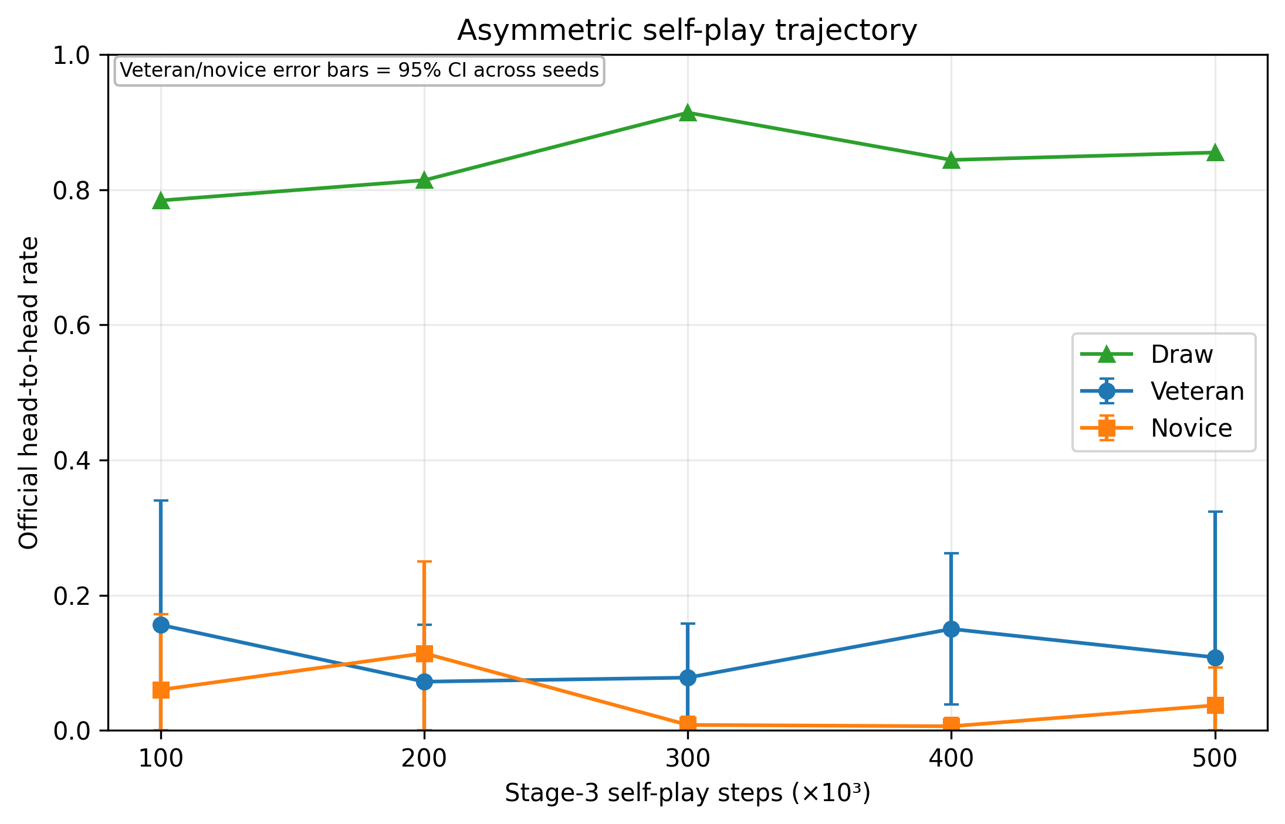
Fig. 11. Role-swapped head-to-head outcome trajectory during asymmetric self-play. Points show five-seed means; error bars show seed-bootstrap 95% confidence intervals for veteran and novice official win rates. Draws remain dominant, and the transient novice mean advantage at 200,000 steps is not sustained.

5.7.2. Causal attribution changes the interpretation of final head-to-head outcomes
The final official outcome difference is driven primarily by one highly asymmetric seed rather than by a reproducible causal advantage. Seed 0 ends with a 54.0% veteran official win rate versus 14.0% for the novice, whereas seeds 1, 3, and 4 end in 100% draws and seed 2 gives the novice a modest 4.5% win rate (Table 10; Fig. 12). Importantly, contact-assisted attribution reverses the aggregate final picture: mean veteran forced-win rate is only 0.8%, whereas novice forced-win rate is 2.0%. The corresponding mean unforced-win components are 10.0% for the veteran and 1.7% for the novice. Thus, much of the veteran’s nominal final advantage is explained by novice self-outs, especially in seed 0, rather than by the veteran physically forcing the novice from the ring. This divergence confirms that official win rate and causal competitive efficacy are not interchangeable metrics in co-adaptive settings.
Table 10. Final 500k self-play outcomes and earliest novice parity by seed.
Seed | First novice parity | Veteran win | Novice win | Novice advantage | Veteran forced | Novice forced
0 | — | 54.0% | 14.0% | -40.0 pp | 4.0% | 5.5%
1 | 200k | 0.0% | 0.0% | +0.0 pp | 0.0% | 0.0%
2 | 100k | 0.0% | 4.5% | +4.5 pp | 0.0% | 4.5%
3 | 100k | 0.0% | 0.0% | +0.0 pp | 0.0% | 0.0%
4 | 100k | 0.0% | 0.0% | +0.0 pp | 0.0% | 0.0%

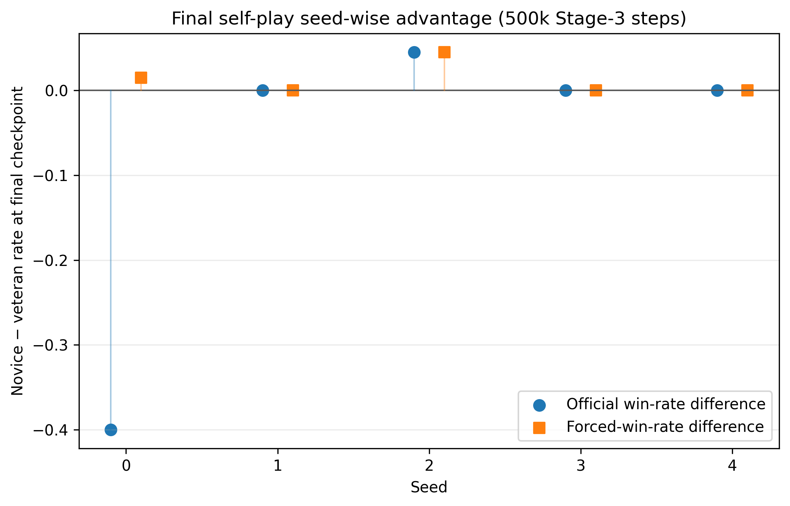
Fig. 12. Seed-specific novice-minus-veteran differences at the final 500,000-step checkpoint. Official outcomes and contact-assisted forced outcomes can point in different directions; positive values favor the novice.

5.7.3. Self-play adaptation is non-monotonic at the behavioral level
Attack and contact behavior also evolve non-monotonically (Fig. 13). Averaged across seeds, veteran attack ratio rises from 0.060 at 100,000 steps to 0.144 at 200,000, then declines to 0.055 by 500,000. The novice shows a similar but delayed pattern, increasing from 0.003 to 0.111 at 200,000 before declining and partially recovering to 0.053 at the final checkpoint. Mean contact ratios peak near 0.20 for both agents at 200,000 steps and again around 0.18–0.20 at 400,000 steps, but fall to 0.102 (veteran) and 0.088 (novice) at 500,000. This oscillatory trajectory is consistent with moving strategy attractors rather than monotonic skill accumulation. It also explains why transient parity at 200,000 steps does not imply permanent novice superiority.

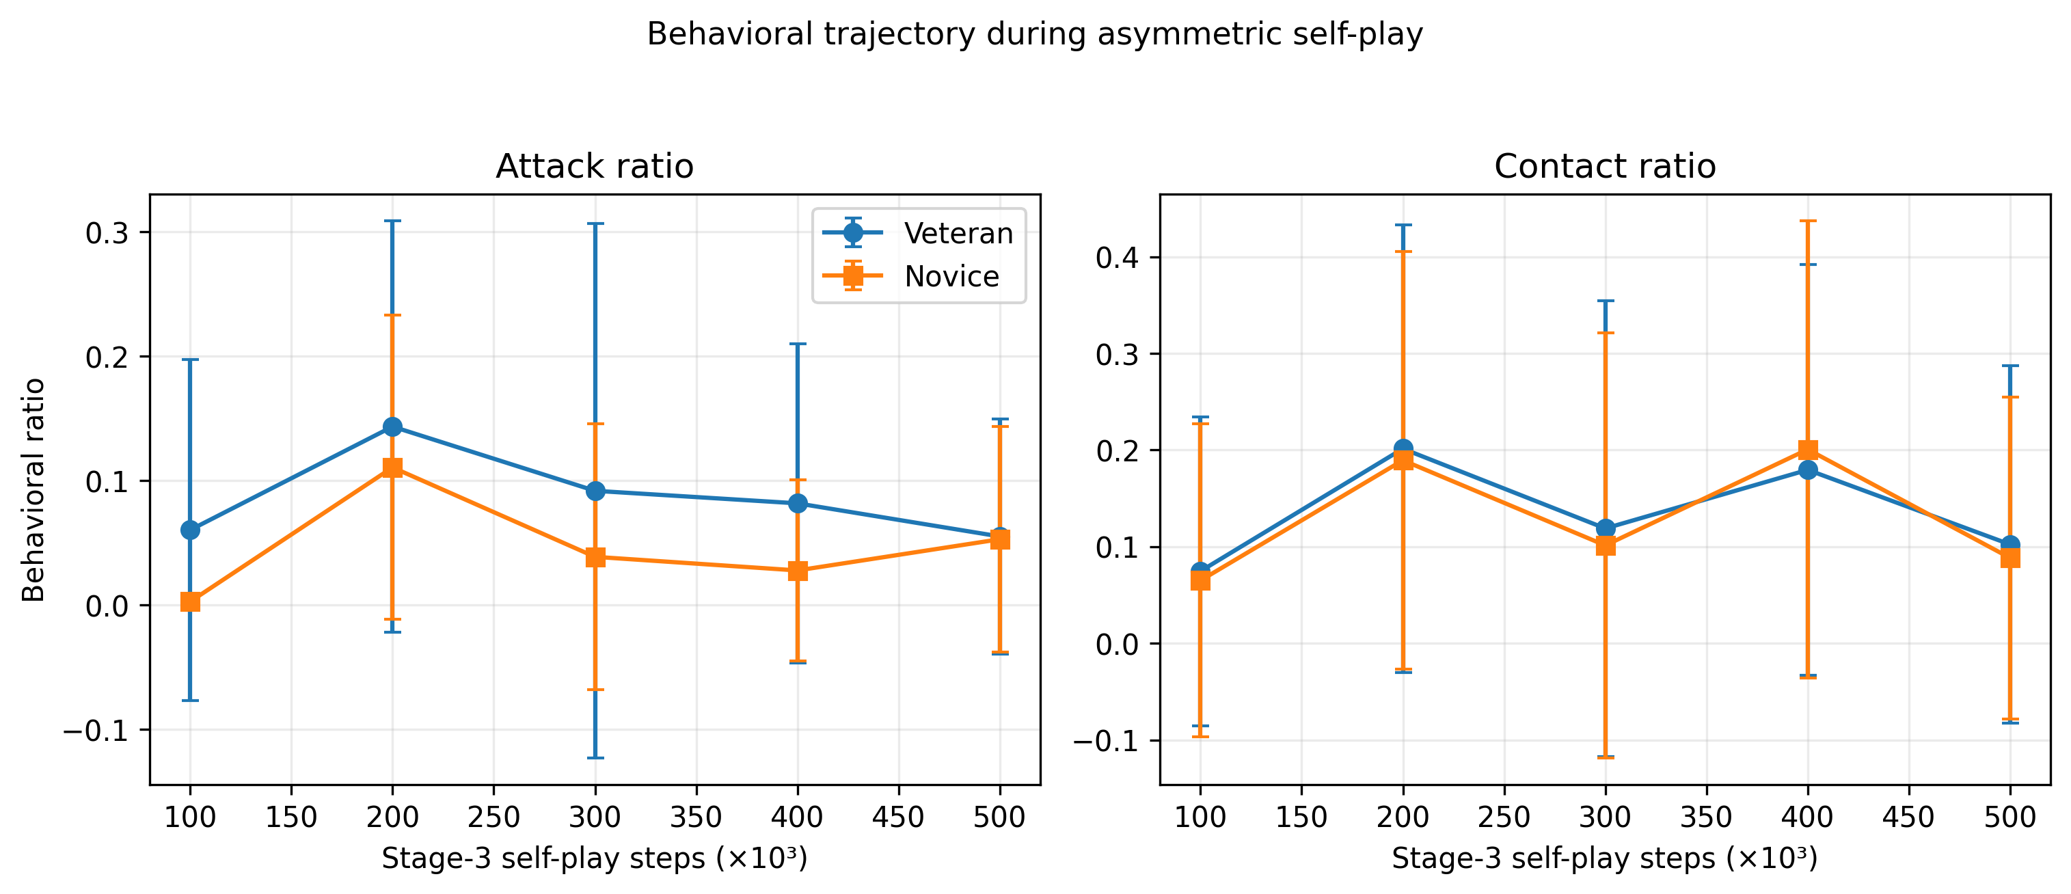
Fig. 13. Mean attack and physical-contact ratios during deterministic role-swapped self-play evaluation. Both agents exhibit non-monotonic behavioral adaptation, with pronounced activity around 200k and 400k checkpoints rather than steady improvement.

5.7.4. External evaluation reveals co-adaptation and possible veteran forgetting
External frozen-opponent evaluation provides the clearest evidence that continued self-play changes general-purpose competence (Table 11 and Fig. 14). Before Stage 3, the PPO veterans achieve mean forced-win rates of 2.2% against the static opponent, 10.2% against the standard scripted opponent, and 11.8% against the aggressive opponent. After 500,000 steps of co-adaptation, the corresponding veteran rates fall to 0.2%, 1.4%, and 2.2%. The novices reach 0.4%, 4.6%, and 4.0%, respectively. Thus, the novice generalizes better than the post-self-play veteran against both moving external opponents, but remains substantially below the original veteran. Paired veteran pre/post forced-win differences are −2.0, −8.8, and −9.6 percentage points for static, scripted, and aggressive opponents. The Wilcoxon tests are not significant at n=5 (p=0.180, 0.180, and 0.109), although the seed-bootstrap 95% CI for the mean aggressive-opponent decline is entirely negative (−20.2 to −0.2 points). The appropriate interpretation is therefore suggestive, not confirmatory, evidence of catastrophic forgetting or opponent-specific co-adaptation.
Table 11. Mean contact-assisted forced-win rate against frozen external opponents before and after Stage-3 self-play.
External opponent | Veteran pre | Veteran post | Novice post
Static | 2.2% | 0.2% | 0.4%
Scripted | 10.2% | 1.4% | 4.6%
Aggressive | 11.8% | 2.2% | 4.0%

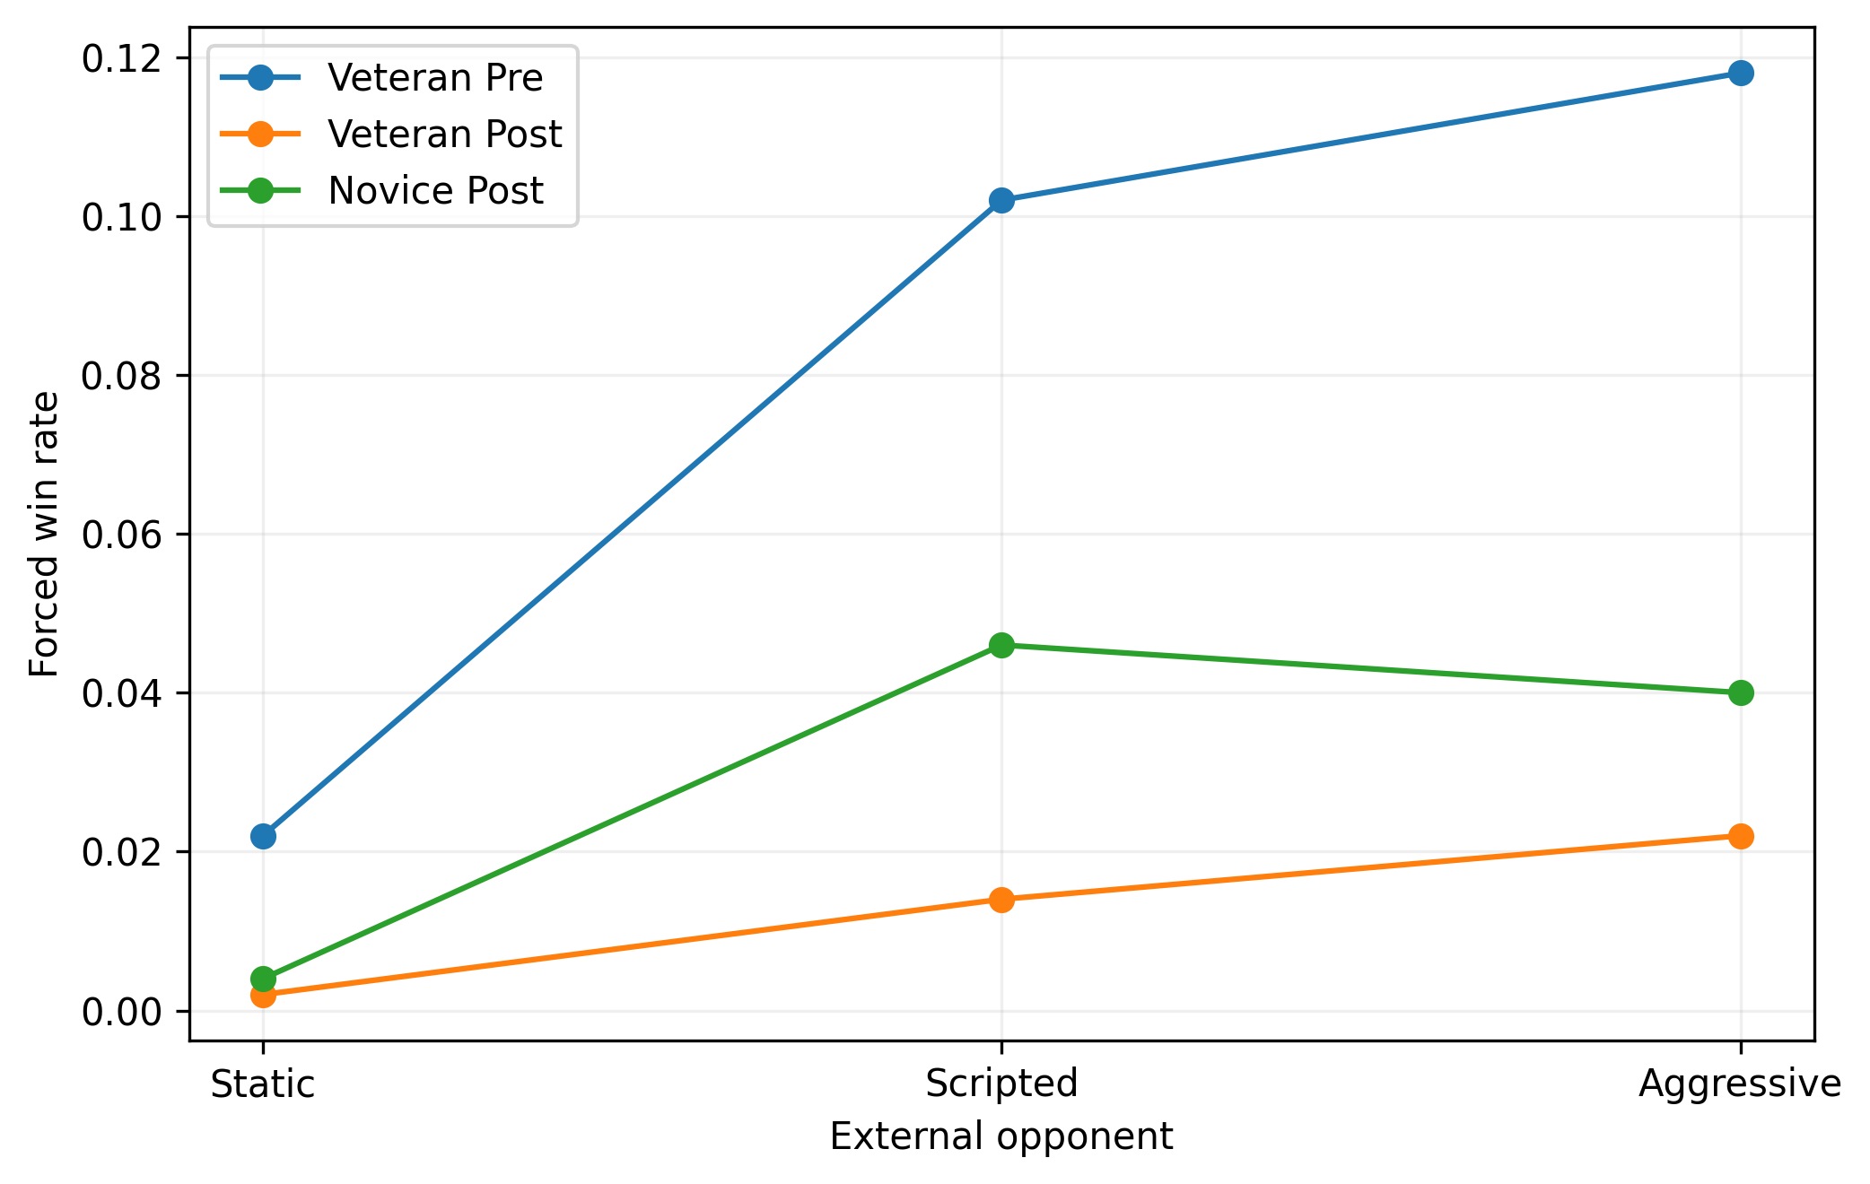
Fig. 14. External generalization after asymmetric self-play. The original veteran is strongest before self-play; after co-adaptation, veteran forced-win performance decreases markedly, while the novice retains modest performance against moving opponents.

6. Discussion

6.1. PPO offers the strongest descriptive offense–safety trade-off
The principal empirical observation is not that one algorithm universally dominates, but that PPO most often produces a useful offense–safety balance under the frozen benchmark. Across 1,500 evaluations, PPO achieves 122 official wins, 121 of which are contact-assisted, while losing only five episodes. Its moving-opponent mean win rates are the highest among the tested methods, and its behavioral profile shows comparatively high contact, forward pressure, and outward displacement without the extreme edge risk observed for DQN.
This result is consistent with the design motivation of PPO: clipped policy updates can preserve useful behavior while still allowing iterative policy improvement [4]. However, the seed-level results show that this mechanism does not guarantee discovery of an effective strategy. Three of five PPO seeds obtain almost no moving-opponent wins. Thus, PPO increases the observed probability of learning an effective competitive policy in this experiment, but it does not eliminate stochastic strategy selection.

6.2. Activity, reward, and competitive effectiveness are different quantities
A2C and Recurrent PPO illustrate two opposite forms of metric mismatch. A2C has the highest average forward motion and aggression index but relatively low win rates. Recurrent PPO has the least negative mean reward yet the lowest contact-assisted win rate. These findings show why evaluating embodied RL through a single scalar reward can be misleading. Reward is an optimization signal constructed by the experimenter; competition success is a terminal physical outcome. Dense shaping can improve learning but also changes the geometry of the optimization landscape, allowing policies to accumulate favorable intermediate reward without reliably completing the task.
For Robot-Sumo, the mechanistically relevant chain is not “move more” but “detect → align → close distance → contact → maintain translational pressure → displace opponent outward while remaining inside the ring.” The strong correlations between contact-assisted wins and contact/pressure/outward-push metrics support this interpretation. Future reward-design studies should therefore evaluate how each shaping component changes the probability of reaching this sequence rather than relying on episode return alone.

6.3. Why DQN is competitive but unsafe
DQN’s best seed is highly competitive, demonstrating that value-based learning can discover strong policies in the discrete action formulation. At the same time, DQN has the highest action entropy, the highest edge-risk ratio, and a loss rate an order of magnitude larger than the other methods. The most extreme example is seed 4, which loses approximately 40% of static and aggressive evaluations. The replay-based value learner appears more willing to explore a diverse action distribution but does not consistently learn the same margin of edge safety as the actor–critic methods.
This result is particularly relevant for physical deployment because unsafe exploratory behavior has a direct hardware cost. In a real 3 kg Robot-Sumo platform, leaving the arena can damage the robot or surrounding equipment. If DQN were transferred to hardware, safety shielding or a rule-based edge override would be advisable even if it reduced policy autonomy.

6.4. Why recurrence did not help in the present formulation
Recurrent PPO might be expected to benefit from partial observability because the six-dimensional observation does not directly encode opponent velocity or a global pose. In this benchmark, however, recurrence does not translate into better competitive performance. The recurrent policies generally learn low-activity strategies and produce 97.7% draws overall. There are several plausible explanations: the observation may already contain sufficient local information for reactive engagement; sparse decisive events may make recurrent credit assignment more difficult; the fixed 500,000-step budget may be insufficient for the larger recurrent policy; or the LSTM may stabilize conservative action sequences that avoid edge risk but fail to create pushing opportunities. These explanations should be tested rather than assumed.

6.5. Should the agents simply be trained for longer?
The current data do not justify a blanket conclusion that longer training will improve the benchmark. The Stage-2 curves are non-monotonic, effective and ineffective seeds coexist under the same budget, and some policies become conservative rather than progressively stronger. Extending every run after observing the present outcomes would also be a post-hoc change to the experimental protocol and would require retraining all algorithms under the same new budget to preserve fairness.
For the present paper, the 500,000-step comparison should therefore remain the primary frozen experiment. Re-running the same study for longer only after seeing the present results would change the protocol post hoc and would not guarantee improvement because the observed learning trajectories are non-monotonic. If training-budget sensitivity is pursued, it should be declared as a separate secondary experiment with fixed checkpoints (for example 0.5, 0.75, 1.0, and 1.5 million steps), identical held-out evaluation, and equal budget rules for every algorithm included in the comparison. Such an extension would test whether the probability of discovering effective strategies increases with experience; it should not replace the current dataset.
The asymmetric self-play extension reported in Section 5.7 confirms why simply doubling single-agent training would have been a weaker next step. The additional 500,000 competitive steps do not yield monotonic improvement; instead they expose transient parity, seed-dependent strategy shifts, safety-driven nominal wins, and deterioration of the veteran’s external performance. Future increases in training budget should therefore be accompanied by opponent-pool or retention mechanisms rather than interpreted as automatically beneficial.

6.6. What asymmetric self-play reveals about competitive adaptation
The asymmetric self-play experiment does not confirm the intuitive hypothesis that a novice will reliably become stronger than a veteran simply because it learns against a more experienced opponent. Instead, the experiment reveals a non-stationary and seed-dependent adaptation process. The novice achieves a transient mean official advantage at 200,000 steps and reaches parity or superiority in several individual seeds at intermediate checkpoints, but only seed 2 retains a positive final official advantage. The final paired comparison is non-significant and dominated by draws. Consequently, novice takeover should be described as possible but not reproducible under the present protocol.
Causal attribution provides a deeper interpretation. At the final checkpoint, novices have a higher mean forced-win rate than veterans despite a lower official win rate. This occurs because the veteran’s apparent official advantage is largely produced by novice self-outs in one seed. The result demonstrates that self-play can alter not only offensive competence but also safety behavior; a policy may lose officially because it becomes unstable at the boundary even if its opponent does not actively force the ring-out. For competitive robotics, this distinction is particularly important because safety failures can dominate tournament outcomes while remaining invisible in reward or contact statistics.
The external evaluations indicate a second form of adaptation risk. Continued mutual adaptation substantially reduces the veteran’s mean forced-win rate against the original scripted and aggressive opponents. Meanwhile, novices retain modest external performance and exceed the post-self-play veterans against the two moving opponents, but neither novice nor post-self-play veteran matches the original veteran. This pattern is consistent with opponent-specific co-adaptation and possible catastrophic forgetting: policies become specialized to the current adversary distribution while losing previously useful general-purpose behavior. Population-based opponent sampling, historical-policy replay, or explicit retention objectives are therefore promising extensions for stabilizing competitive learning.

6.7. Implications for reproducible embodied RL
The benchmark-development process itself provides methodological lessons. First, evaluation opponents must be behaviorally audited: a high nominal win rate can be produced by opponent self-outs. Second, reset correctness is a scientific requirement in physics simulators; residual dynamics can silently contaminate outcome counts. Third, action metrics must reflect physical motor semantics. In this study, curved actions command both wheels forward and therefore must count as translational attack motion. Fourth, reward shaping should be separated conceptually from outcome measurement. Finally, multiple seeds are indispensable. A paper based only on PPO seed 0 would have suggested 32–37% moving-opponent win rates; a paper based on PPO seed 3 would have suggested total failure. The five-seed benchmark reveals both observations as incomplete.

7. Limitations
Several limitations constrain the interpretation of the results. First, the study is simulation-only. The robot geometry is intentionally hardware-buildable, but the current results do not demonstrate sim-to-real transfer. Wheel–surface friction, motor dynamics, battery sag, sensor noise, center-of-mass tolerances, chassis compliance, and wedge–opponent contact may differ on hardware. A physical validation study is needed before claiming competition-ready transfer.
Second, the 15 s episode horizon is an RL benchmarking choice rather than the complete official tournament procedure. Official Robot-Sumo uses a longer match format and Yuko-based scoring [8]. A tournament-style evaluator should therefore be added when comparing final competition readiness.
Third, five training seeds provide substantially more evidence than a single run but remain a small sample for highly stochastic DRL. This limitation is reflected in wide confidence intervals and non-significant omnibus tests. The present conclusions emphasize descriptive patterns and behavior mechanisms rather than definitive algorithm rankings.
Fourth, the benchmark compares one predefined hyperparameter configuration per algorithm. The study therefore evaluates algorithm-plus-configuration packages rather than the mathematically optimal implementation of each method. Hyperparameter sweeps would require a separate validation budget to avoid tuning on the test conditions.
Fifth, the moving opponents are scripted rather than learned. This improves control and reproducibility but does not capture adaptive strategic counterplay. Future self-play experiments should evaluate policy co-adaptation and opponent exploitation.
Sixth, the asymmetric self-play study contains only five matched veteran–novice pairs and is dominated by draws at several checkpoints. Simultaneous updating also makes the learning target non-stationary, so the experiment cannot isolate whether novice adaptation is caused by the veteran’s competence, by the veteran’s concurrent policy drift, or by ordinary PPO stochasticity. A fixed-veteran control and a population-based self-play condition would strengthen causal interpretation.

8. Future work
The next competitive-learning extension should compare three controlled regimes: novice learning against a fixed pretrained veteran, simultaneous veteran–novice co-adaptation as used here, and population-based self-play with historical-policy sampling. Such a design would separate transfer from a competent teacher-opponent, non-stationary co-adaptation, and forgetting-resistant opponent diversity. Policy snapshots should be evaluated against a fixed external panel to quantify generalization throughout training rather than only at the end.
A second extension is physical implementation. The simulated design should be converted to manufacturing CAD, with measured mass distribution, motor torque–speed curves, tire friction, sensor poses, and battery characteristics fed back into Webots. Domain randomization can then be applied around calibrated parameter distributions using established and recent sim-to-real methods [14–20]. A small set of real bouts can be used to estimate the remaining simulator mismatch before zero-shot or limited-fine-tuning transfer is attempted.
A third extension is reward and curriculum ablation. The current benchmark was deliberately frozen only after removing passive-draw and opponent-self-out failure modes. A controlled ablation should compare sparse terminal reward, curriculum without privileged shaping, and the full contact-aware reward. This would quantify which design elements are responsible for the emergence of effective pushing behavior.
Finally, algorithm evaluation can be strengthened with training-budget curves, bootstrap confidence intervals, interquartile-mean performance, and probability-of-improvement measures advocated for few-run RL benchmarks [7]. These analyses would complement the current nonparametric tests and better characterize heavy-tailed seed performance.

9. Conclusion
This study introduced a reproducible, official-geometry 3 kg Robot-Sumo benchmark for comparative deep reinforcement learning and used it to evaluate A2C, PPO, DQN, and Recurrent PPO under a common 500,000-step curriculum. The completed benchmark contains 20 independently trained policies and 6,000 valid frozen-policy evaluations. PPO achieved the highest mean win rates against both moving-opponent conditions and the largest number of contact-assisted ring-outs while maintaining a low loss rate, but no statistically significant algorithm-level win-rate difference was detected across five seeds. The benchmark therefore shows that strategy discovery is highly stochastic and that competitive effectiveness must be interpreted through seed-level uncertainty, physical interaction, edge safety, and causal ring-out attribution rather than reward or nominal activity alone.
The asymmetric veteran–novice extension adds a complementary result: continued self-play does not produce a reproducible novice takeover. The novice temporarily exceeds the veteran in mean head-to-head win rate at 200,000 Stage-3 steps, but the final paired difference is non-significant and strongly seed-dependent. At the same time, contact-assisted attribution shows that novices can become causally competitive even when official results are distorted by self-outs, and external evaluation reveals that continued co-adaptation can substantially reduce the veteran’s previously learned performance against fixed opponents. Together, the two experiments show that embodied competitive RL is governed by multiple interacting phenomena—strategy bifurcation, non-stationary co-adaptation, safety failures, opponent-specific specialization, and forgetting. Reliable evaluation therefore requires frozen external references, role-swapped testing, multi-seed replication, and causal behavioral metrics in addition to official win rate.

Declarations

Data and code availability
The complete raw benchmark dataset comprises 6,000 frozen-policy evaluation episodes together with per-seed and algorithm-level summaries. The asymmetric self-play extension adds 3,000 role-swapped head-to-head evaluation bouts across five checkpoints and five matched veteran–novice pairs, plus 3,000 post-self-play external-opponent evaluations (veteran and novice) that are paired with the original 1,500 veteran baseline evaluations. The frozen v1.12 benchmark configuration, v1.14 self-play protocol, training scripts, trained-model checkpoints, analysis code, and tabular results are included in the associated public reproducibility release, with archival metadata prepared for Zenodo DOI assignment.

Funding
This research received no specific grant from any funding agency in the public, commercial, or not-for-profit sectors.

Declaration of competing interest
The author declares that there are no known competing financial interests or personal relationships that could have appeared to influence the work reported in this paper.

CRediT authorship contribution statement
Iman Hindi: Conceptualization; Methodology; Software; Validation; Formal analysis; Investigation; Data curation; Visualization; Writing – original draft; Writing – review & editing.

Declaration of generative AI and AI-assisted technologies in the manuscript preparation process
During the preparation of this work, the author used OpenAI ChatGPT to assist with software debugging and code drafting, language editing, manuscript organization, and consistency checking. After using this tool, the author reviewed and edited the content as needed, independently executed and validated the simulations and analyses, verified the statistical results and references, and takes full responsibility for the content of the publication.

References
[1] R.S. Sutton, A.G. Barto, Reinforcement Learning: An Introduction, 2nd ed., MIT Press, Cambridge, MA, 2018.
[2] V. Mnih, K. Kavukcuoglu, D. Silver, et al., Human-level control through deep reinforcement learning, Nature 518 (2015) 529–533. https://doi.org/10.1038/nature14236.
[3] V. Mnih, A.P. Badia, M. Mirza, et al., Asynchronous methods for deep reinforcement learning, in: Proceedings of the 33rd International Conference on Machine Learning, PMLR 48, 2016, pp. 1928–1937.
[4] J. Schulman, F. Wolski, P. Dhariwal, A. Radford, O. Klimov, Proximal policy optimization algorithms, arXiv:1707.06347 (2017). https://doi.org/10.48550/arXiv.1707.06347.
[5] A. Raffin, A. Hill, A. Gleave, A. Kanervisto, M. Ernestus, N. Dormann, Stable-Baselines3: Reliable reinforcement learning implementations, Journal of Machine Learning Research 22 (268) (2021) 1–8.
[6] P. Henderson, R. Islam, P. Bachman, J. Pineau, D. Precup, D. Meger, Deep reinforcement learning that matters, Proceedings of the AAAI Conference on Artificial Intelligence 32 (1) (2018). https://doi.org/10.1609/aaai.v32i1.11694.
[7] R. Agarwal, M. Schwarzer, P.S. Castro, A.C. Courville, M.G. Bellemare, Deep reinforcement learning at the edge of the statistical precipice, Advances in Neural Information Processing Systems 34 (2021) 29304–29320.
[8] FUJISOFT Inc., All Japan Robot-Sumo Tournament: Rules and 3 kg class specifications, 2026. https://www.fsi.co.jp/sumo/rule/ (accessed 18 September 2026).
[9] H. Erdem, Application of Neuro-Fuzzy Controller for Sumo Robot control, Expert Systems with Applications 38 (8) (2011) 9752–9760. https://doi.org/10.1016/j.eswa.2011.02.024.
[10] C.R.C. Torrico, A.B. Leal, A.T.Y. Watanabe, Modeling and supervisory control of mobile robots: A case of a Sumo Robot, IFAC-PapersOnLine 49 (32) (2016) 240–245. https://doi.org/10.1016/j.ifacol.2016.12.221.
[11] M.S. Mohd Shukri, N. Abdul Rahim, B. Ilias, Development of an intelligent sumo robot based on embedded fuzzy logic, International Journal of Autonomous Robotics and Intelligent Systems 1 (1) (2025) 93–105. https://doi.org/10.58915/ijaris.v1i1.2345.
[12] G. Carbone, E.M. Curcio, S. Rodinò, F. Lago, A Robot-Sumo student competition at UNICAL as a learning-by-doing strategy for STEM education, STEM Education 2 (3) (2022) 262–274. https://doi.org/10.3934/steme.2022016.
[13] O. Michel, Cyberbotics Ltd. Webots™: Professional mobile robot simulation, International Journal of Advanced Robotic Systems 1 (1) (2004) 39–42. https://doi.org/10.5772/5618.
[14] J. Tobin, R. Fong, A. Ray, J. Schneider, W. Zaremba, P. Abbeel, Domain randomization for transferring deep neural networks from simulation to the real world, in: 2017 IEEE/RSJ International Conference on Intelligent Robots and Systems (IROS), 2017, pp. 23–30. https://doi.org/10.1109/IROS.2017.8202133.
[15] X.B. Peng, M. Andrychowicz, W. Zaremba, P. Abbeel, Sim-to-real transfer of robotic control with dynamics randomization, in: 2018 IEEE International Conference on Robotics and Automation (ICRA), 2018, pp. 3803–3810. https://doi.org/10.1109/ICRA.2018.8460528.
[16] F. Muratore, F. Ramos, G. Turk, W. Yu, M. Gienger, J. Peters, Robot learning from randomized simulations: A review, Frontiers in Robotics and AI 9 (2022) 799893. https://doi.org/10.3389/frobt.2022.799893.
[17] R. Tiwari, S. Khapre, A. Singh, Reinforcement learning in robotic systems: A review on sim-to-real transfer, Robotics and Autonomous Systems 198 (2026) 105327. https://doi.org/10.1016/j.robot.2025.105327.
[18] W. Zhu, X. Guo, D. Owaki, K. Kutsuzawa, M. Hayashibe, A survey of sim-to-real transfer techniques applied to reinforcement learning for bioinspired robots, IEEE Transactions on Neural Networks and Learning Systems 34 (7) (2023) 3444–3459. https://doi.org/10.1109/TNNLS.2021.3112718.
[19] Y. Kadokawa, L. Zhu, Y. Tsurumine, T. Matsubara, Cyclic policy distillation: Sample-efficient sim-to-real reinforcement learning with domain randomization, Robotics and Autonomous Systems 165 (2023) 104425. https://doi.org/10.1016/j.robot.2023.104425.
[20] G. Tiboni, K. Arndt, V. Kyrki, DROPO: Sim-to-real transfer with offline domain randomization, Robotics and Autonomous Systems 166 (2023) 104432. https://doi.org/10.1016/j.robot.2023.104432.
[21] Y. Bengio, J. Louradour, R. Collobert, J. Weston, Curriculum learning, in: Proceedings of the 26th International Conference on Machine Learning, 2009, pp. 41–48. https://doi.org/10.1145/1553374.1553380.
[22] C.-Y. Huang, A. Efendi, Y.-C. Wang, Curriculum-guided deep reinforcement learning with fuzzy rewards for autonomous push-grasp manipulation in cluttered environments, Robotics and Autonomous Systems 198 (2026) 105325. https://doi.org/10.1016/j.robot.2025.105325.
[23] R. Lowe, Y. Wu, A. Tamar, J. Harb, P. Abbeel, I. Mordatch, Multi-agent actor-critic for mixed cooperative-competitive environments, Advances in Neural Information Processing Systems 30 (2017) 6379–6390.
[24] T. Bansal, J. Pachocki, S. Sidor, I. Sutskever, I. Mordatch, Emergent complexity via multi-agent competition, in: International Conference on Learning Representations (ICLR), 2018.
[25] B. Baker, I. Kanitscheider, T. Markov, Y. Wu, G. Powell, B. McGrew, I. Mordatch, Emergent tool use from multi-agent autocurricula, in: International Conference on Learning Representations (ICLR), 2020.
[26] D. Silver, J. Schrittwieser, K. Simonyan, et al., Mastering the game of Go without human knowledge, Nature 550 (2017) 354–359. https://doi.org/10.1038/nature24270.
[27] Z. Ning, L. Xie, A survey on multi-agent reinforcement learning and its application, Journal of Automation and Intelligence 3 (2) (2024) 73–91. https://doi.org/10.1016/j.jai.2024.02.003.
[28] Y. Zhong, Y. Zhou, J. Peng, Efficient competitive self-play policy optimization, arXiv:2009.06086 (2020). https://doi.org/10.48550/arXiv.2009.06086.

Appendix A. Reproducibility checklist
Item | Frozen value / status
Package | v1.12 clean-reset-translational-attack (main benchmark)
Python | 3.9.23
PyTorch | 2.5.1+cpu
Stable-Baselines3 | 2.6.0
sb3-contrib | 2.6.0
Gymnasium | 1.1.1
NumPy | 2.0.2
Training seeds | 0, 1, 2, 3, 4
Stage 1 budget | 200,000 steps
Stage 2 budget | 300,000 steps
Total per trained policy | 500,000 steps
Evaluation | 100 episodes × 3 opponents × 20 policies
Valid evaluation episodes | 6,000
Reset-integrity failures included | 0
Webots world/version target | R2025a (frozen world header and external PROTO target)
Self-play extension | v1.14 asymmetric veteran–novice self-play; frozen v1.12 physics/reward/sensing
Self-play pairs | 5 matched PPO veteran–novice pairs; 500,000 additional simultaneous Stage-3 steps per pair
Self-play evaluation | Role-swapped checkpoints at 100k, 200k, 300k, 400k, 500k; final external generalization against static/scripted/aggressive opponents
The software, training, evaluation, and self-play reproducibility settings are summarized in Table A1.
Table A1. Reproducibility information to accompany the public artifact.

