**Part 1: training without constrained**

**Model: MLP**

|  |  |  |  |  |
| --- | --- | --- | --- | --- |
| Building | R2 | MSE | MAE | MAPE |
| CenterHall | 0.95 | 94.026 | 7.21 | 7.73 |
| EastCampus | 0.73 | 90.84 | 7.24 | 7.18 |
| GalbraithHall | 0.95 | 142.6 | 9.1 | 5.03 |
| GeiselLibrary | 0.94 | 648.9 | 19.23 | 3.75 |
| Gilman | 0.78 | 128.8 | 8.58 | 13.33 |
| Hopkins | 0.61 | 34.35 | 4.23 | 7.91 |
| Mandeville | 0.78 | 21.5 | 3.34 | 10.99 |
| MusicBuilding | 0.81 | 55.71 | 5.06 | 6.16 |
| PepperCanyon | 0.94 | 29.06 | 3.92 | 7.28 |
| RadyHall | 0.89 | 32.93 | 4.43 | 8.09 |
| RobinsonHall | 0.56 | 96.98 | 8.17 | 9.37 |
| SocialScience | 0.86 | 59.37 | 6.02 | 4.21 |
| StudentServices | 0.95 | 94.91 | 7.33 | 6.02 |

average r2: 0.8312990627317409

average mae: 7.267628559513698

average mse: 117.71276873341141

average mape: 7.267628559513698

**Model: SVR**

|  |  |  |  |  |
| --- | --- | --- | --- | --- |
| Building | R2 | MSE | MAE | MAPE |
| CenterHall | 0.82 | 330.07 | 14.14 | 14.51 |
| EastCampus | 0.26 | 248.77 | 12.6 | 13.15 |
| GalbraithHall | 0.39 | 1786.92 | 34.85 | 18.94 |
| GeiselLibrary | 0.76 | 2871.38 | 41.22 | 8.083 |
| Gilman | 0.35 | 389.22 | 15.27 | 25.47 |
| Hopkins | 0.41 | 52.96 | 5.12 | 9.29 |
| Mandeville | 0.66 | 33.55 | 3.99 | 12.77 |
| MusicBuilding | 0.55 | 134.722 | 8.88 | 9.99 |
| PepperCanyon | 0.79 | 100.67 | 7.47 | 13.73 |
| RadyHall | 0.75 | 78.09 | 6.79 | 12.35 |
| RobinsonHall | 0.31 | 151.88 | 10.5 | 11.95 |
| SocialScience | 0.75 | 111.42 | 8.12 | 5.7 |
| StudentServices | 0.79 | 469.43 | 16.02 | 12.48 |

average r2: 0.5871367208891191

average mae: 14.178574329104285

average mse: 519.934257868761

average mape: 14.178574329104285

**Model: XGBoost**

|  |  |  |  |  |
| --- | --- | --- | --- | --- |
| Building | R2 | MSE | MAE | MAPE |
| CenterHall | 0.90 | 175.54 | 10.18 | 11.68 |
| EastCampus | -0.16 | 340.19 | 15.63 | 13.22 |
| GalbraithHall | 0.69 | 910.11 | 23.58 | 11.63 |
| GeiselLibrary | 0.45 | 5135.09 | 66.50 | 14.2 |
| Gilman | -0.02 | 1232.9 | 32.1 | 69.98 |
| Hopkins | 0.39 | 71.37 | 6.24 | 11.85 |
| Mandeville | 0.65 | 44.55 | 4.32 | 12.622 |
| MusicBuilding | 0.48 | 170.8 | 9.91 | 10.05 |
| PepperCanyon | 0.85 | 69.25 | 5.41 | 11.38 |
| RadyHall | 0.75 | 90.83 | 7.38 | 13.31 |
| RobinsonHall | 0.11 | 264.06 | 12.86 | 13.97 |
| SocialScience | 0.59 | 196.77 | 11.43 | 9.248 |
| StudentServices | 0.89 | 211.65 | 10.29 | 9.37 |

average r2: 0.509

average mae: 16.607

average mse: 685.62

average mape: 16.60

**Part 2: training with constrained (MLP)**

The sum of the estimations should be the same as the total power. We implemented two approaches:

1. New loss function: we revised the loss function used in the training stage. The loss function is the sum of the MSE and the distance between the true total power and the predicted total power. This is the new loss function:

def custom_loss(y_true, y_pred):

    # Calculate the mean squared error

    mse_loss = MeanSquaredError()(y_true, y_pred)

    # Calculate the sum of predictions and the sum of true values

    pred_sum = K.sum(y_pred, axis=1)

    true_sum = K.sum(y_true, axis=1)

    # Mean squared error between the summed predicted and true total power

    sum_loss = K.mean(K.square(true_sum - pred_sum))

    # Total loss is a combination of both terms

    return mse_loss + sum_loss

In other words, we forced the model to estimate the power consumption of the buildings such that their sum be the same the total power inserted as input.

|  |  |  |  |  |
| --- | --- | --- | --- | --- |
| Building | R2 | MSE | MAE | MAPE |
| CenterHall | 0.801 | 372.405 | 15.22 | 16.39 |
| EastCampus | 0.25 | 253.95 | 12.904 | 13.11 |
| GalbraithHall | 0.38 | 1814.471 | 34.78 | 19.84 |
| GeiselLibrary | 0.72 | 3389.64 | 46.78 | 9.30 |
| Gilman | 0.354 | 387.57 | 15.82 | 28.38 |
| Hopkins | 0.415 | 52.68 | 5.26 | 9.63 |
| Mandeville | 0.655 | 34.03 | 4.37 | 15.01 |
| MusicBuilding | 0.538 | 138.87 | 9.25 | 10.42 |
| PepperCanyon | 0.748 | 125.62 | 8.62 | 17.34 |
| RadyHall | 0.724 | 88.33 | 7.44 | 14.08 |
| RobinsonHall | 0.283 | 159.31 | 10.79 | 12.11 |
| SocialScience | 0.73 | 120.48 | 8.53 | 5.95 |
| StudentServices | 0.73 | 588.77 | 19.18 | 16.08 |

Average R²: 0.5647504839694275

Average MAE: 15.30883840547965

Average MSE: 578.9374925231376

Average MAPE: 14.439137046190394

We can see that the average MAPE is increased in compare to what we achieved in part 1. The sum of the estimated powers is very close to the total power but jot exactly the same.

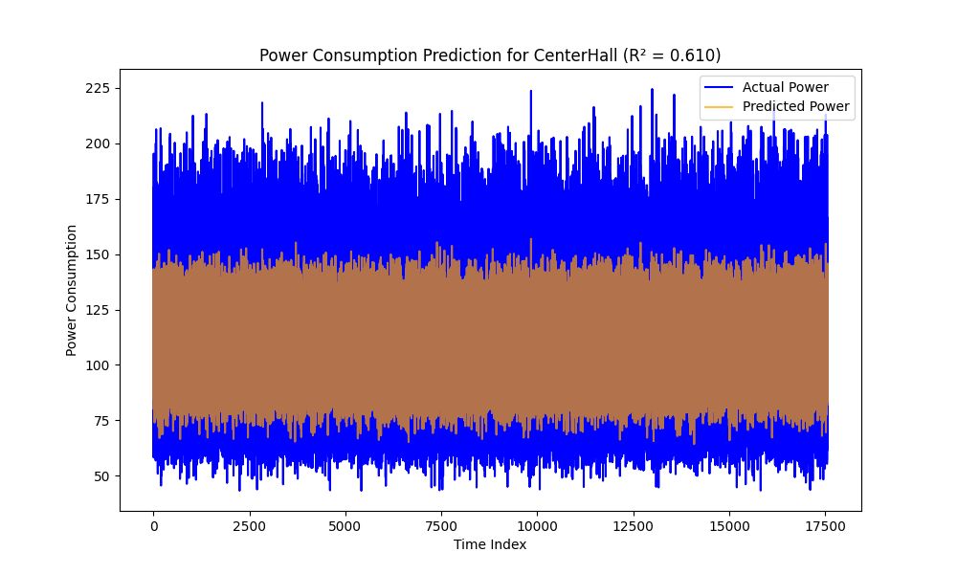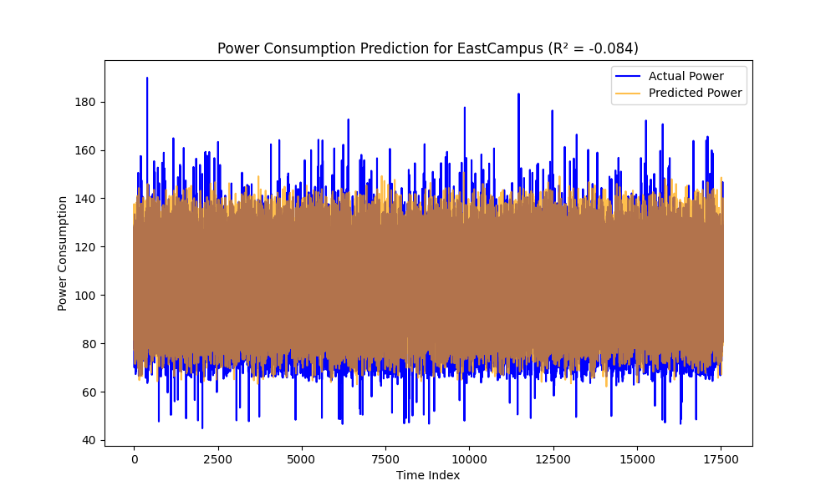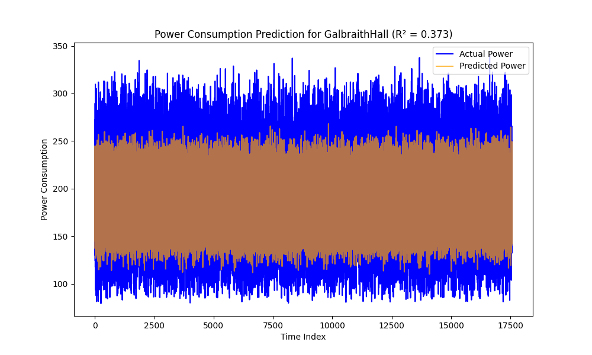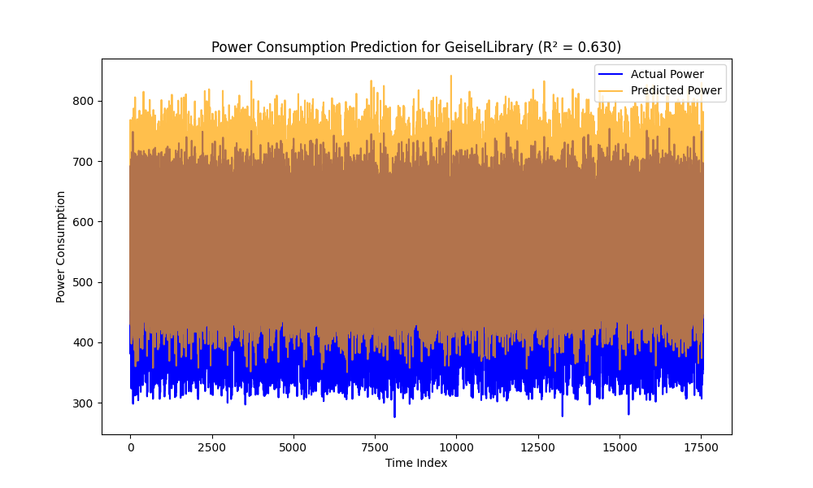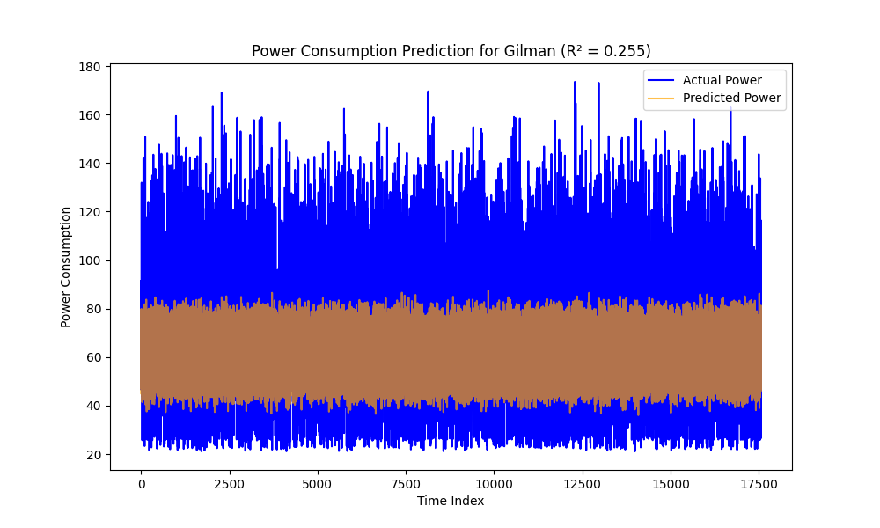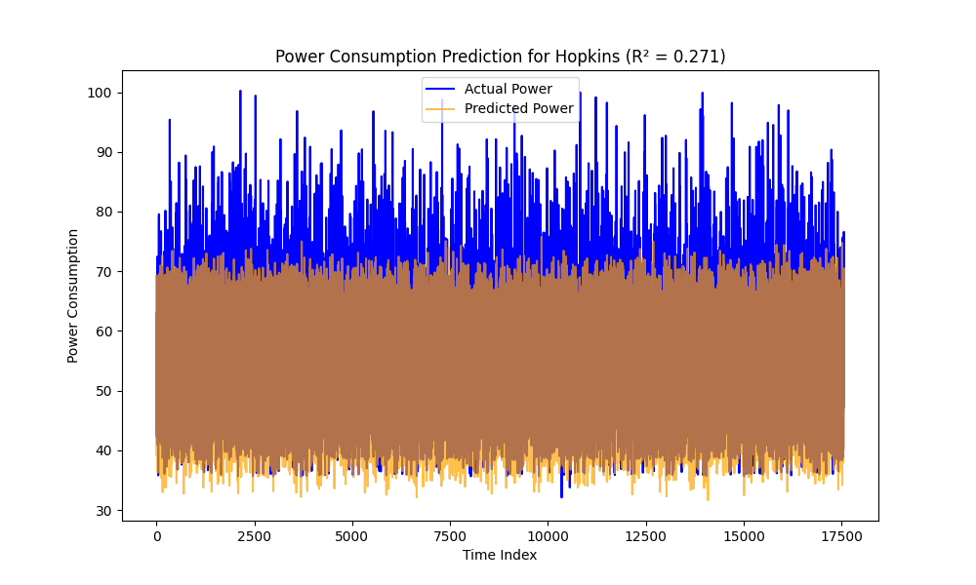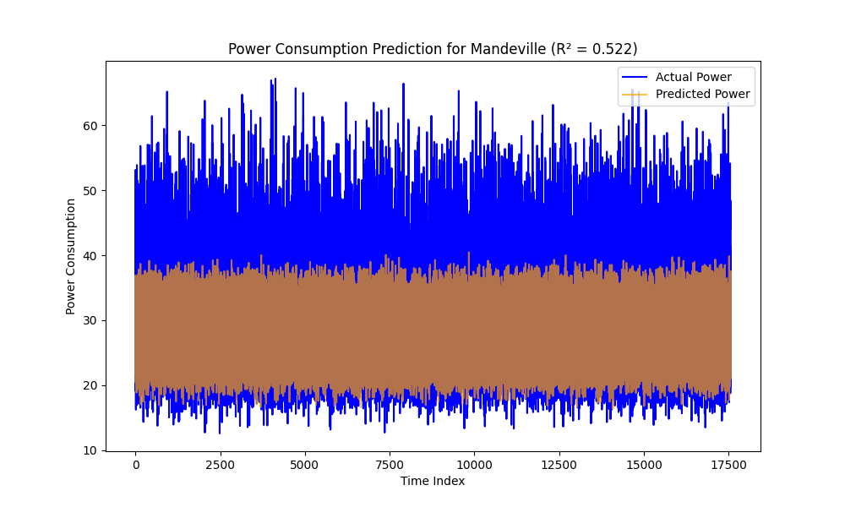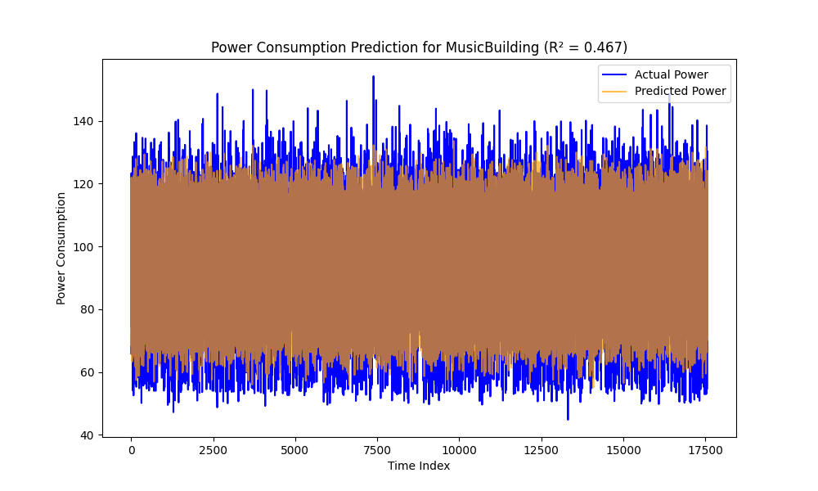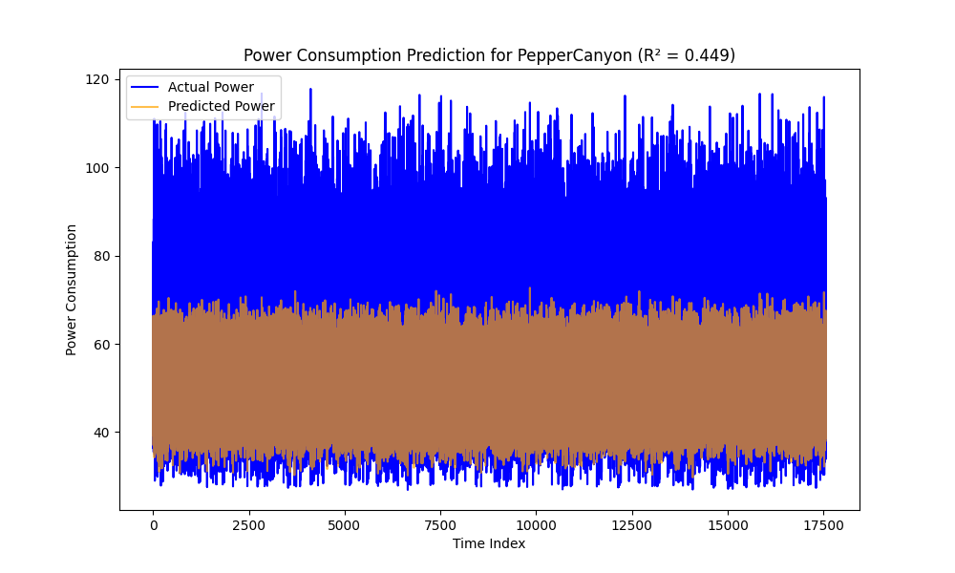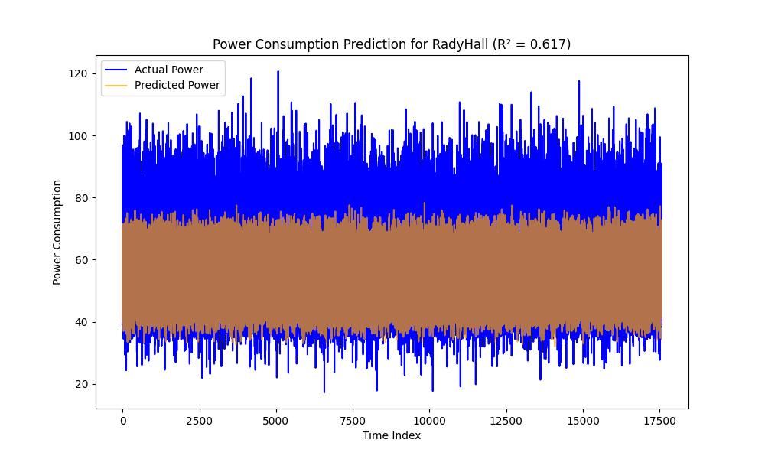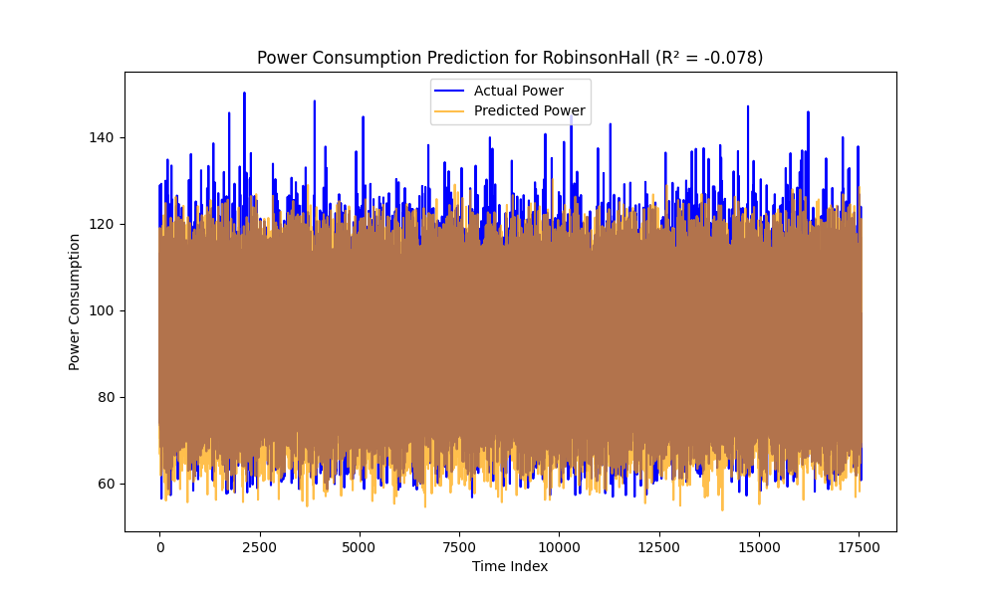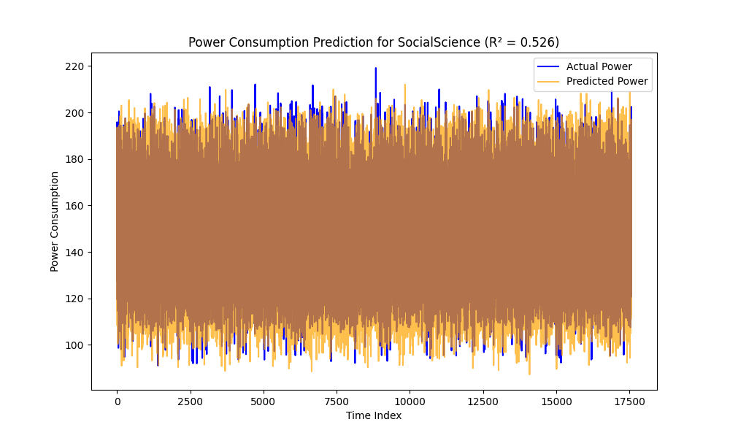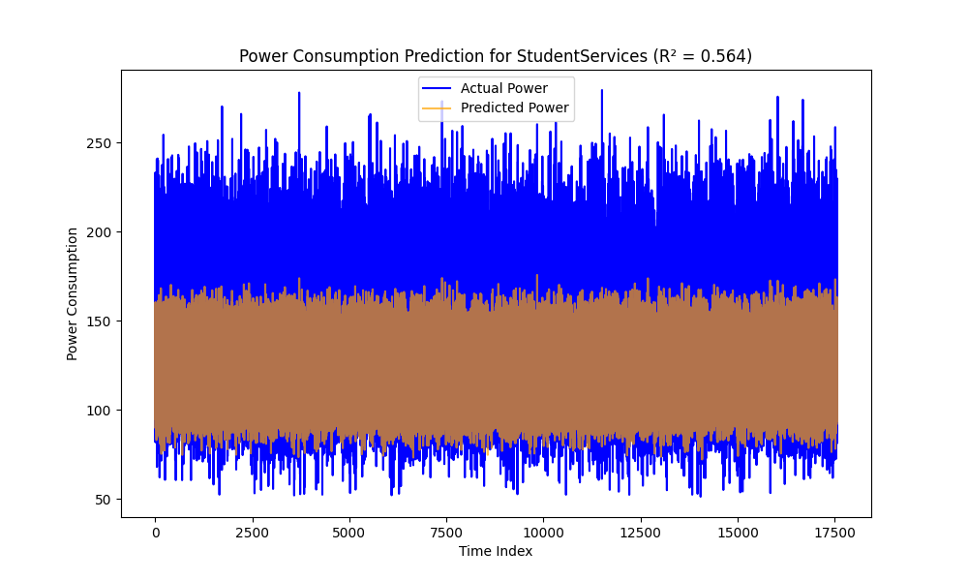

1. Using softmax acivatation function un the last layer.

time_features_input = Input(shape=(X_train.shape[1] - 1,), name="time_features_input") # Exclude summed_RealPower

summed_real_power_input = Input(shape=(1,), name="summed_real_power_input") # Summed power as a separate input

hidden = Dense(64, activation='relu')(time_features_input)

hidden = Dense(32, activation='relu')(hidden)

output_proportions = Dense(y_train.shape[1], activation='softmax', name="proportions_output")(hidden) # Softmax layer

# Scale the output proportions by summed_RealPower

output_scaled = Multiply(name="scaled_output")([output_proportions, summed_real_power_input])

# Combine into a model

model = Model(inputs=[time_features_input, summed_real_power_input], outputs=output_scaled)

|  |  |  |  |  |
| --- | --- | --- | --- | --- |
| Building | R2 | MSE | MAE | MAPE |
| CenterHall | 0.97 | 41.21 | 4.53 | 4.42 |
| EastCampus | 0.87 | 44.01 | 4.5 | 4.36 |
| GalbraithHall | 0.97 | 83.99 | 6.87 | 3.74 |
| GeiselLibrary | 0.97 | 310.17 | 11.1 | 2.18 |
| Gilman | 0.95 | 26.45 | 3.76 | 5.77 |
| Hopkins | 0.83 | 15.99 | 2.87 | 5.36 |
| Mandeville | 0.90 | 9.64 | 2.23 | 7.52 |
| MusicBuilding | 0.91 | 27.81 | 3.97 | 4.38 |
| PepperCanyon | 0.96 | 16.86 | 2.90 | 5.33 |
| RadyHall | 0.93 | 21.08 | 3.43 | 6.32 |
| RobinsonHall | 0.61 | 86.5 | 7.5 | 8.42 |
| SocialScience | 0.93 | 29.17 | 4.11 | 2.87 |
| StudentServices | 0.97 | 52.787 | 5.23 | 4.2 |

Average R²: 0.91

Average MAE: 4.85

Average MSE: 58.9

Average MAPE: 4.9

In this case the sum of the estimations is exactly the same as the total power

