CHAPTER

# 10

## Kingdom Animalia

*Animation 10.1: Growth and development* [*Source & Credit: Wikispaces*](http://anatomyeshs.wikispaces.com/Ch.16+Respiratory+System)

### INTRODUCTION

Animalia kingdom includes all the animals. The name animalia is derived from Latin, anima = breath or soul.

In traditional two-kingdom systems, the multicellular animals were referred to broadly as Metazoa to distinguish them from one-celled animals, the Protozoa. In this text book we have followed the ive kingdom classiication system introduced by Robert Whittaker. In this system of classiication the traditional Protozoa belong to kingdom Protoctista. Kingdom Animalia consists of all animals which are multicellular, diploid eukaryotic, ingestive heterotrophs and develop from two dissimilar haploid gametes, a large egg and a smaller sperm. In this chapter we will discuss various groups and subgroups with details of the phyla in your curriculum.

Virtually all biologists agree that animals evolved from protoctists; however, which protoctists, when, and in what sort of environments, are questions that are still actively debated.

**Table 10.1 The relationship of diferent phyla discussed in this chapter.**

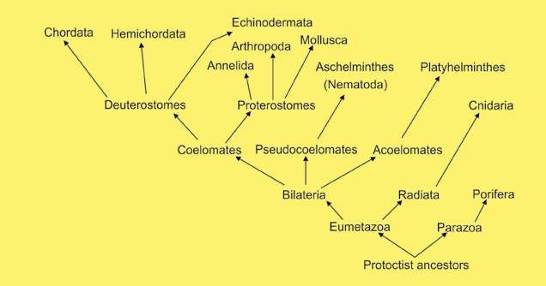

### DEVELOPMENT OF COMPLEXITY IN ANIMALS

Although multicellularity is found in all the kingdoms, Fungi, Plantae and Animalia but it has developed most impressively in animals- their cells are joined by complex junctions, this ensures control of communications and low of materials between cells. The animals are a diverse group distinct in their form. The smallest are microscopic, which are smaller than many protoctists and the largest today are whalessea mammals, included in phylum Chordata.

The simplest of the animals belong to subkingdom **Parazoa** (phylum Porifera). These animals lack tissues organised into organs and have indeterminate shape, and are asymmetrical. The sub kingdom **Eumetazoa** includes animals of other phyla. These animals have tissues organised into organs and organ systems. These include radially symmetrical animals (grade **Radiata**) and bilaterally symmetrical animals (grade **Bilateria**). Grade Radiata includes simplest of the Eumetazoa (phylum **Cnidaria**). They are much simpler in their organisation compared to the animals belonging to other Eumetazoa. Most of the phyla which belong to kingdom **Animalia** (about 29) belong to subkingdom Eumetazoa. These animals have been divided into three groups on the basis of presence, absence or type of body cavity found in them. The animals which do not have a body cavity have been grouped under **Acoelomata**. The animals which have a false coelom, the **pseudocoele**, have been grouped under **Pseudocoelomata**. The animals which have a true coelom have been grouped under **Coelomata**.

### GRADE RADIATA

In this group animals with radial symmetry have been included. All the animals which are included here are also diploblastic. This is a condition or organization in which the parts of the body are arranged around a central axis in such a way that any plane passing through the central axis divides the animal in halves that are almost mirror image of each other e.g. as in cnidaria (coelenterata).

The cylindrical body of a sea-anemone can be cut in two equal halves vertically in any plane.

### GRADE BILATERIA

This group includes animals with bilateral symmetry. In an animal where the right side is approximately the same as the left side and where there is a distinct anterior end is said to have bilateral symmetry. The animal can be divided into two equal parts by an imaginary line only in one plane. In most multicellular animals there is a clearly diferentiated head present at the anterior end and a distinct posterior end. Also there are clearly deined dorsal and ventral surfaces. The animals belonging to phyla, Platyhelminthes, Nematoda, Annelida, Mollusca, Arthropoda, Echinodermata, Hemichordata and Chordata are included in this grade. It must be mentioned here that the animals belonging to phylum echinodermata, have developed bilateral symmetry, as is evident, from the study of structure of their larvae. However, the adult Echinoderms, have secondarily developed radial symmetry, due to their special mode of life. All the animals included in grade Bilateria are triploblastic. These may be acoelomate, pseudocoelomate or coelomate.

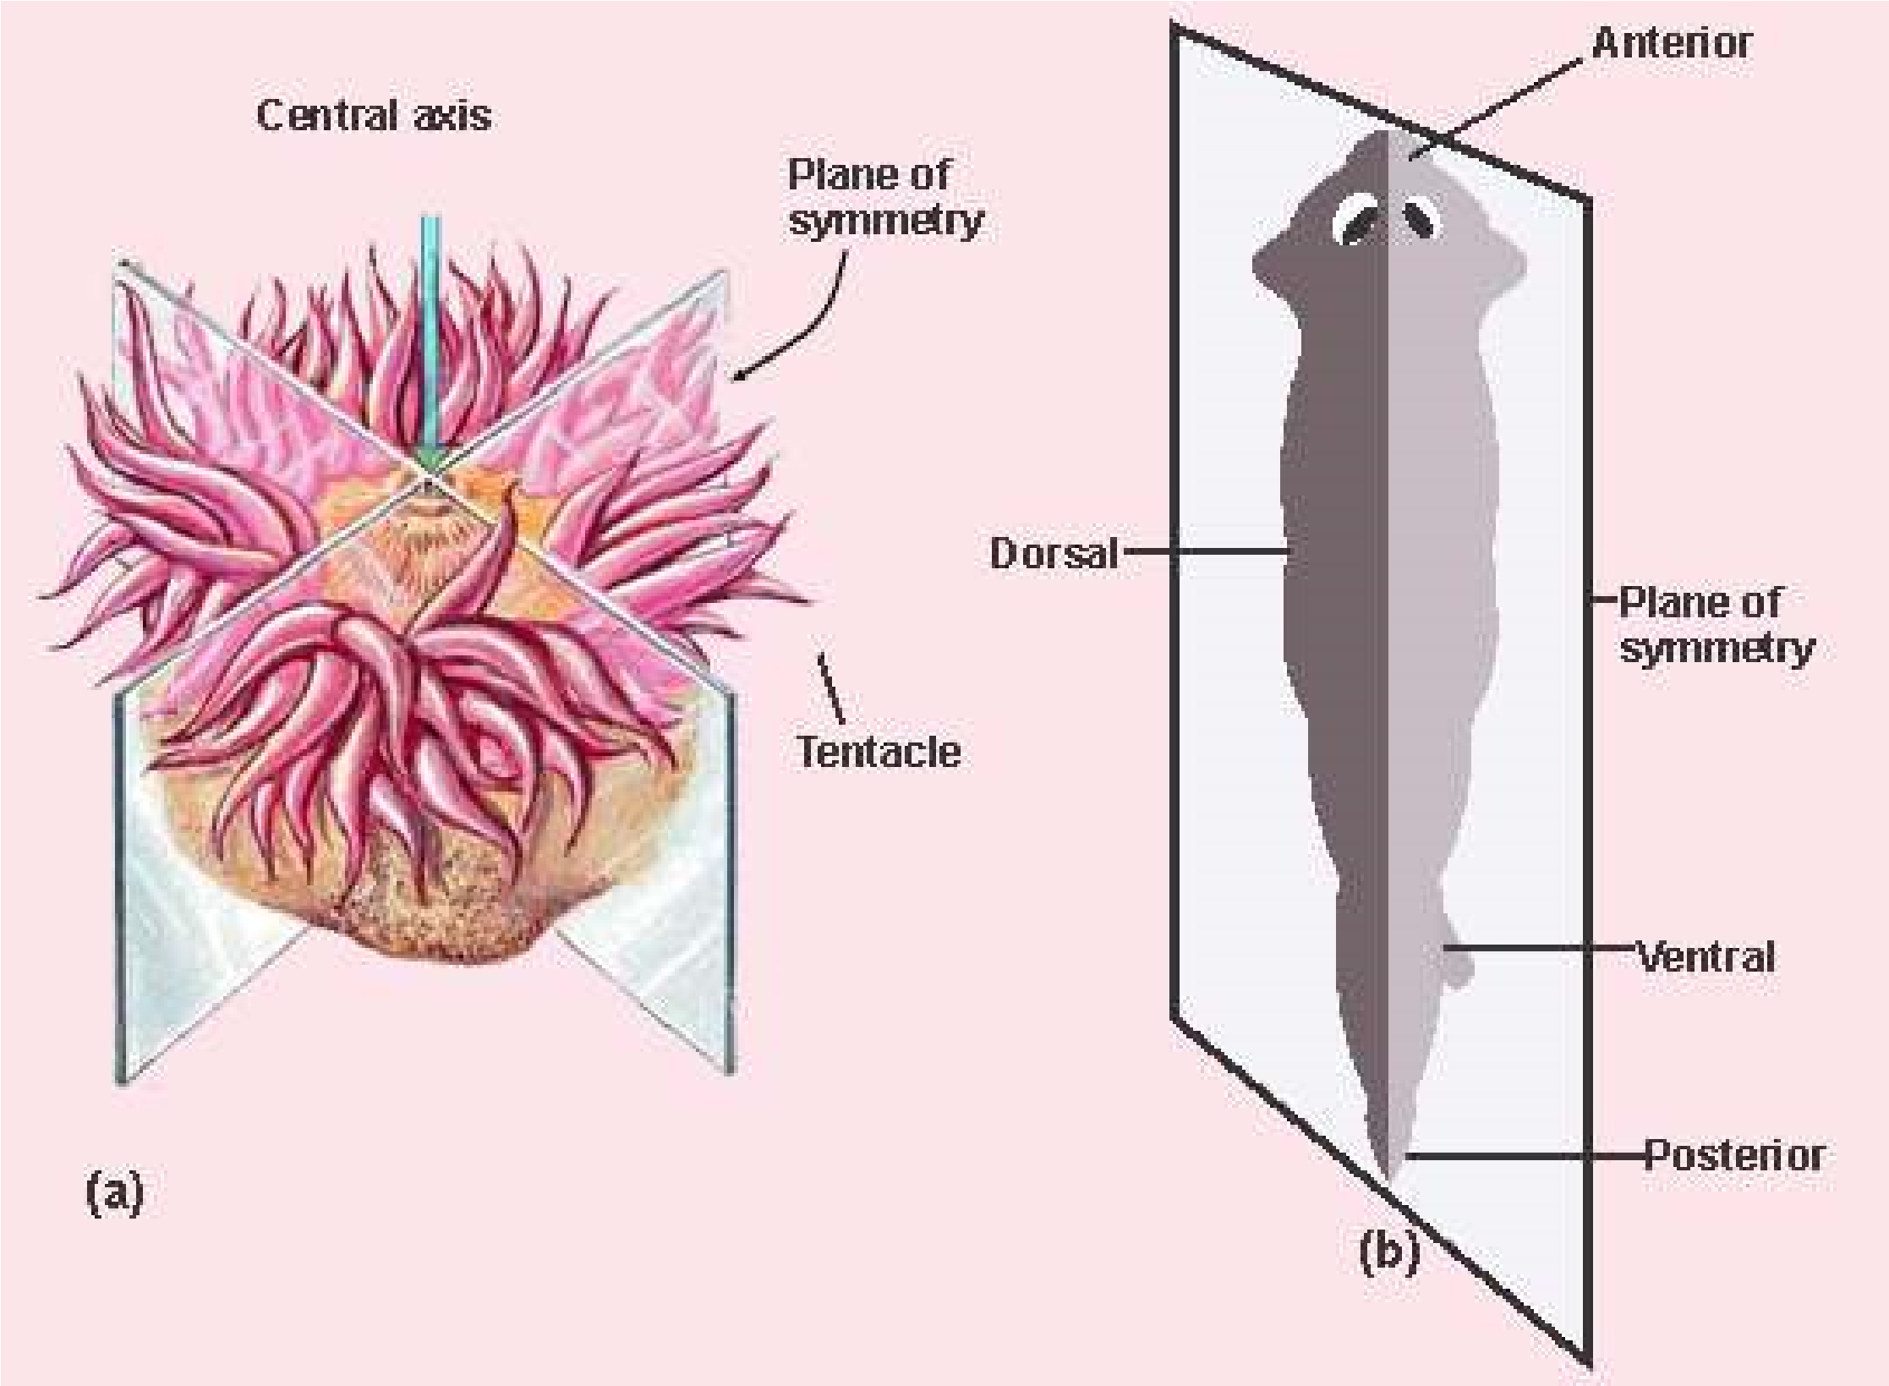

*Fig. 10.1 (a) Radial (b) Bilateral symmetry*

|  |  |
| --- | --- |
| **Series Proterostomia (Protostomes)** | **Series Deuterostomia: (Deuterostomes)** |
| 1. Cleavage or division of the zygote is spiral and determinate. 2. During development process the mouth in these animals arises from the blastopore or from its anterior margin. 3. Coelom or body cavity is formed due to splitting of mesoderm (schizocoelous). 4. Mesoderm is derived from cells on anterior lip of blastopore. 5. This series proterostomia includes animals belonging to phyla aschelminthes (nematoda) annelida, mollusca and arthropoda | 1. Cleavage is radial and indeterminate. 2. During embryonic developmentmouth is formed at some distance anterior to the blastopore and blastopore forms the anus.      1. Coelom is developed as an outpouching of archenterons (enterocoelous). 2. Mesoderm is derived from wall of developing gut (archenteron). 3. This series includes animals belonging to phyla echinodermata, hemichordata and chordata. |

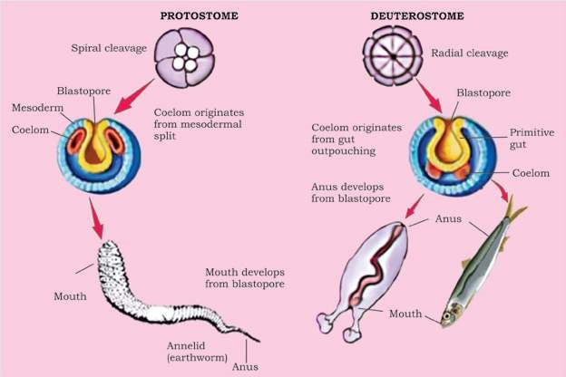

*Fig. 10.2 Patterns of embryonic development of coelom and of egg cleavage In protostomes and deuterostomes.*

A **spiral and determinate** cleavage is that in which the lines or planes of cleavage are not symmetrical between poles instead these are diagonal to the polar axis and produce unequal cells around the axis of polarity and all the blastomeres have determined role to play in the formations of embryo. The fate of each blastomere is foretold.

In **radial and indeterminate** cleavage the planes of cleavage are symmetrical to the polar axis and produce tiers of cells on top of each other and the fate of each blastomere is not pre-determined.

In some anyone blastomere can produce a complete embryo.

#### DIPLOBLASTIC AND TRIPLOBLASTIC ORGANISATION

Diploblastic animals belong to division radiata. The body of these animals consists of two layers of cells, ectoderm and endoderm. There is a jelly like mesenchyme or mesogloea which in most cases is non cellular. Diploblastic animals show lesser degree of specialisation and they do not form specialised organs. There is no special transport system in these animals. Most substances are distributed within their body by process of difusion. There is no central nervous system in these animals. A neuron net is present. These animals have radial symmetry. There is only one cavity in the body called gastrovascular cavity which has only mouth which serves for the entry of food and water and also for the removal of wastes along with water. This is known as sac like digestive system. Diploblastic animals are included in phylum Cnidaria (coelenterate) which would be discussed in detail later in the chapter.

Triploblastic animals are included in phyla which have been placed in grade bilateria/ The body of these animals is made from three layers ectoderm, mesoderm and endoderm. After embryonic development these layers in most triploblastic animals are not distinct as separate layers of cells, but are represented by the structures formed from them. The cells of these animals show greater degree of specialisation. These have specialised organs and organs systems. Special transport systems i.e. blood vascular system is present in most of the cases. The systems such as integumentary and nervous develop from ectoderm. Mesodem gives rise to muscular, skeletal and reproductive systems. Endoderm forms the lining of digestive tract and glands of digestive system, such as liver. The digestive system is of tube type i.e. having mouth at the anterior end and the anus at the posterior end. Triploblastic animals may be acoelomate, pseudocoelomate or coelomate.

**Acoelomates, Pseudocoelomates and Coelomates**

The following account would help to explain the above mentioned terms.

#### Acoelomates

In phylum Platyhelminthes there is no body cavity or coelom, and the mesoderm forms a loose, cellular tissue called mesenchyma or parenchyma which ills the space between the ectoderm and endoderm. It forms a packing around the internal organs of the animals to support and protect them. Such animals are called acoelomates (Fig. 10.3). In acoelomates the gut is sac-type and there is no special transport system. Only excretory system is developed for the transport of excretory products. This system consists of lame cells, excretory ducts and excretory pores. However the nervous system is well developed.

#### Pseudocoelomates

In Aschelminthes the space between the body wall and the digestive tube is called pseudocoelom (false body cavity). Pseudocoelom is not homologous to true coelom because: it is not lined by coelomic epithelium. It has no relation with the reproductive and excretory organs. It develops from the blastocoel of the embryo and it is bounded externally by the muscles and internally by the cuticle of the intestine. The animals having pseudocoelom are called pseudocoelomates

#### Coelomates

Coelom is cavity present between the body wall and the alimentary canal and is lined by mesoderm. The mesoderm splits into outer parietal layer which under lines the body wall and the visceral layer which covers the alimentary canal and the cavity between them is the true coelom. It is illed with luid called **coelomic luid.** The animals which possess coelom or true body cavity are called coelomates e.g. animals from annelids to chordates.

In coelomates gut attains more complexity and neuro-sensory system is well developed along with excretory system, circulatory system, respiratory and reproductive systems.

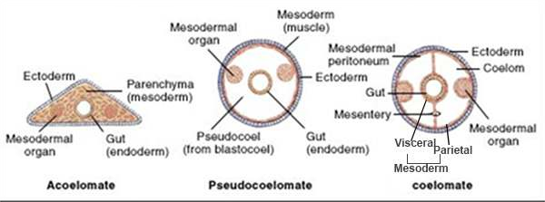

*Fig. 10.3 General body plan of acoefomate, pseudocoelomate and coelomate.*

### PARAZOA

#### Phylum: Porifera the most primitive animals

The name porifera is derived from Latin *porus* = pore, *ferra* = to bear

The Porifera are pore-bearing animals, commonly called the sponges. All are aquatic. Out of total 5000 species 150 species live in fresh water while all others are marine.

#### General Characteristics

These animals are composed of many cells however there is no tissue organization and have no organs. Sponges lack symmetry. In most sponges the body wall is formed of an outer layer, pinacoderm, made up of cells called pinacocytes: and an inner layer choanoderm made of lagellated collar cells called choanocytes. Between these two

*Scolymastra joubini- a barrel like glass sponge of* layers is present gelatinous mesenchyme which may *Antarctica is more than a metre tall.* contain amoeboid cells and spicules or sponging ibres.

The poriferans range in size from few millimeter wide to more than one metre tall. They are macroscopic i.e., can be seen with naked eye. There is a single cavity inside the body, the **spongocoel**. In most sponges the spongocoel may be divided into lagellated chambers or canals, lined by lagellated choanocytes.

Numerous pores are present in the body wall. The pores through which water enters the body are called **ostia**, and pore by which the water leaves the body is known as osculum (main opening). There are no respiratory or circulatory organs.

Since the sponges are sessile, therefore these depend upon the food coming to them along with water currents brought about by movement of lagella of choanocytes. This includes small animals, (zooplankton) and plants, (phytoplankton) which constitute about 20% of their food. 80% of their food consists of detrital organic particles. The food enters the spongocoel cavity through Ostia. The food is ingested by the lagellated cells, the **choanocytes**. The waste products either difuse out of the sponge directly through the body wall or low out through osculum.

The adult sponges are stationary, spending their lives attached to the rocks at the bottom or other solid objects. However, their larvae are able to move (swim).

There is no deinite nervous system, however neurosensory and neuron cells are probably present which seem to coordinate the low of water.

The skeleton is in the form of variously shaped needle-like structures called spicules. These may be calcareous or siliceous. The bath sponge has a skeleton of spongin ibres. The skeleton is present among pinacocytes and provides support. Spicules are also present around osculum and ostia.

Sponges reproduce both by asexual and sexual methods of reproduction.

The **asexual reproduction** in sponges is by **budding**. The buds may be external or internal, The internal buds are called **gemmuies**. Both types of buds develop into new sponges.

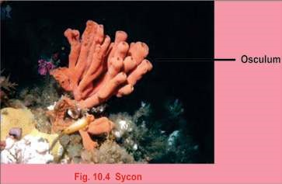Some sponge species reproduce sexually. These are mostly **hermaphrodite**, mostly **protandrous**, i.e. male sex cells develop irst. In some sponges the sexes are separate. Sperms released in water are carried to the eggs by amoeboid cells. Fertilization occurs in mesenchyme and zygote is formed. The embryo development includes blastula and larval stages.

Examples of sponges are :

1. ***Sycon:*** It is a typical marine sponge.
2. ***Leucoselenia:*** A sponge that consists of group of erect tubes. iii. ***Euplectella:*** It is beautiful and delicate sponge made up of glassy framework. It is commonly called Venus lower basket. iv. ***Spongilla:*** It is freshwater sponge.

#### Importance

The skeleton of sponges have long been used by man mostly for washing and bathing. Although many artiicial sponges have been made from synthetic material, still the natural sponges are in demand and is an important industry in many parts of the world. The best commercial sponges are found in the warm waters of Mediterranean Sea. Sponges have great capacity to absorb water. They are used in surgical operations for absorbing luids and blood. They are also used for sound absorption in buildings.

### GRADE RADIATA

#### Phylum Coelenterata / Cnidaria - Diploblastic Animals

The name Cnidaria has been given to this group of animals due to the presence of special cells called **cnidocytes**. These cells give rise to **nematocysts**-the stinging cells, characteristic of this group.

Cnidarians have double layer organization and are therefore diploblastic having tissue grade organization and have organs. During the development two germinal layers are formed the outer ectoderm and inner endoderm from which their bodies are constructed. The ectoderm forms outer covering and some cells of this layer in most animals give rise to nematocysts while the endoderm cells become specialized for digestion of food. Between the two layers is a jelly-like mesoglea. In these animals there is only one cavity which serves as digestive as well as body cavity which is called **gastrovascular cavity or enteron** and opens to the outside by only one opening the mouth. So the animals of this group have sac like digestive cavity.

In coelenterates the arrangement of body parts is in relation to centralized axis (symmetrical). An object is symmetrical where there is a correspondence in form and arrangement of parts so that a plane passing through the center divides it into similar halves. The coelenterates have radial symmetry and are aquatic, found both in marine and freshwater habitats.

The coelenterates range in size from microscopic *Hydra* to macroscopic, Branchioceranthus, a hydrozoan polyp that may reach two metres in length. Cnidarians are found in two basic forms the **polyps** and the **medusae**. Polyps are cylindrical animals, which in most cases are nutritive in function, hence named as **gastrozoids**. The medusae are umbrella like in form. These are free swimming. The medusae are involved in sexual reproduction as they have gonads.

The mouth is surrounded by a series of tentacles. These bear stinging cells or nematocysts, which are organs of defense and ofense.

The coelentrates are carnivores and feed upon small organisms which come into contact with them. These organisms are immobilized by nematocysts and taken into the digestive cavity as food where it is digested and then distributed by difusion.

The nervous system is in the form of a network of neuron cells forming an irregular net or plexus in the body-wall. There is no central nervous system.

Many colonial coelenterates such as corals produce a hard exoskeleton formed of calcium carbonate (CaC03). It is secreted by epidermal cells that take lime from sea water. The skeleton of coral is responsible for formation of small coral islands or large coral reefs.

Most species are sessile, for example *Hydra,* Obelia, sea-anemone and corals, while other are free living and motile e.g. jelly ishes etc. Many live as solitary individuals e.g. *Hryda* jelly ishes and seaanemones and quite a large number are colonial e.g. physalia, vellela etc. A colony is an aggregation of individuals or zooids that perform diferent functions for the colony.

In Coelenterates reproduction takes place by asexual as well as sexual means e.g. *Hydra* reproduces asexually by the formation of buds on its surface. The bud after some time separate from the parent and develops into a new individual. In *Obelia* for example there is asexual as well as sexual reproduction. It has a kind of zooid known as blastostyle which gives rise to individual zooids called medusae by asexual method. The medusae when released in water develop reproductive organs which produce gametes that unite to form zygote from which *Obelia* colony is again formed.

The life cycle of coelenterates is characterized by the presence

of alternation of generations. There are two generations, one Some of colonial members reproduces by sexual means and the other by asexual means. have upto ive diferent types Both generations are diploid. Often the two generations consist of zooids, performing diferent of one free-living and one attached stage. Therefore asexual functions for the colony e.g. generation and sexual generation alternate with one another. Physalia (portuguese man of This is known as alternation of generations e.g., *Obelia*. war).

#### Polymorphism - A Characteristic Feature of Coelenterates (Cnidaria)

The occurrence of structurally and functionally more than two diferent types of individuals, called the zooids within the same organism is called **polymorphism**.

For example, in *Obelia* there are feeding individuals, the gastrozooids; the individuals capable of asexual reproduction only, the gonozooids, blastostyles and free-living or sexually reproducing individuals, the medusae..

The common examples ofcoelenterates are:

1. ***Hydra*** : A freshwater - coelenterate. It exists only in polyp form, therefore alternation of generations is absent.

1. ***Obelia*** : A marine colonial that exhibits alternation of generations.
2. 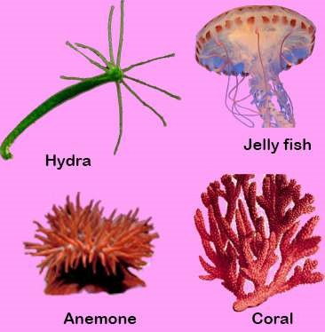***Aurelia*** (jelly ish) : The polyp is reduced and medusa is dominant in jellyish.
3. **Actinia** (sea anemone) : The body consists of polyp only, enteron is divided by large partitions called mesenteries.
4. ***Madrepora*** : The body is covered with hard calcareous skeleton formed of calcium carbonate. They are commonly called **corals**. The skeleton forms large coral reefs and even small islands.

*Fig. 10.5 Coelenterates (Cnidarians)*

##### Coral reefs

Corals are formed from the secretions produced by specialized polyps that are present in certain coelenterates. These polyps become covered by stony cups due to hardening of their secretions. From the mouth of the stony cup a polyp can pass out its tentacle for the purpose of feeding and withdraw itself where not feeding. Most such Coelenterates are colonial. The stony net-work or mass of such Coelenterates are called Corals. Living polyps are found on the surface layer of corals whereas underneath the mass are dead stony structures only and there are no polyps inside. The *The corals because of their massive structure serve asliving place for a variety of sea life.* stony masses that are formed in this way are called **coral reefs.** These are mostly formed of calcium carbonates (lime-stone).

Coral reefs are found in the coastal waters of Florida, West Indies, East Coast of Africa, Australia and Island of Coral Sea.

### GRADE - BILATERIA

**Triploblastic animals -The Acoelomates**

**Phylum: Platyhelminthes -The Flatworms**

#### General Characteristics

The name Platyhelminthes means “latworms”. The body of these animals is soft and dorsoventrally compressed.

The Platyhelminthes are triploblastic acoelomates. There is development of a third layer, the mesoderm, which separates the ectoderm and endoderm. The Platyhelminthes exhibit bilateral symmetry, and body is unsegmented.

With few exceptions the Platyhelminthes are parasites, mostly endoparasites, i.e., live inside their hosts. The most common examples are Taenia solium (tapeworm), *Fasciola hepatica* (liver luke) and *Schistosoma* (blood luke). The parasites are more common in tropics. Some of these cause diseases in humans. A few species are free living and found in freshwater, for example *Dugesia* (planaria).

Their size ranges from few millmeters (10 mm in case of Planaria) to several meters (tapeworm).

Much of the body space is taken up by a branching sac type digestive system. The digestive system is poorly developed in some species or may be absent as in the tape-worms.

The excretory system consists of branching tubes ending in bulb-like cells, the **lame cells.**

A well developed nervous system is present in Platyhelminthes. It is in the form of either a simple network of nerves or ganglia. The sense organs are present at the anterior end. Respiratory and circulatory systems are absent.

The parasitic species absorb nutrients from the hosts. The free-living species (Planaria) feed on small animals and bodies of dead and decaying animals.

The free-living forms are motile. They move by cilia present on their undersides (Planaria). In parasitic forms the movement is restricted.

The Platyhelminthes reproduce both by sexual and asexual means of reproduction. Asexual reproduction is by ission in which the animal constricts in the middle into two pieces, each of which regenerates the missing part. The sexually reproducing species are **hermaphrodite**, i.e., both male and female reproductive organs are present in the same individual. Larval form is sometimes present.

The common examples of latworms are:

1. ***Dugesia* (Planaria)** : A free-living latworms with a ciliated outer surface.
2. ***Fasciola*** **(Liver luke)** : It is an endoparasite in sheep and occasionally in human beings. It has suckers used for attachment to host tissue. It completes its life cycle in two hosts, a snail, sheep or man. It lives in the bile duct of its hosts.
3. ***Taenia*** **(Tape worm)** : An endoparasite of humans, cattle and pig, that completes its life cycle in two hosts. The intermediate host is pig or cattle. The body is ribbon-like and divided into segments called proglottids which contain mainly sex organs. The segments continue to break of and are passed out from the intestine along with faeces.

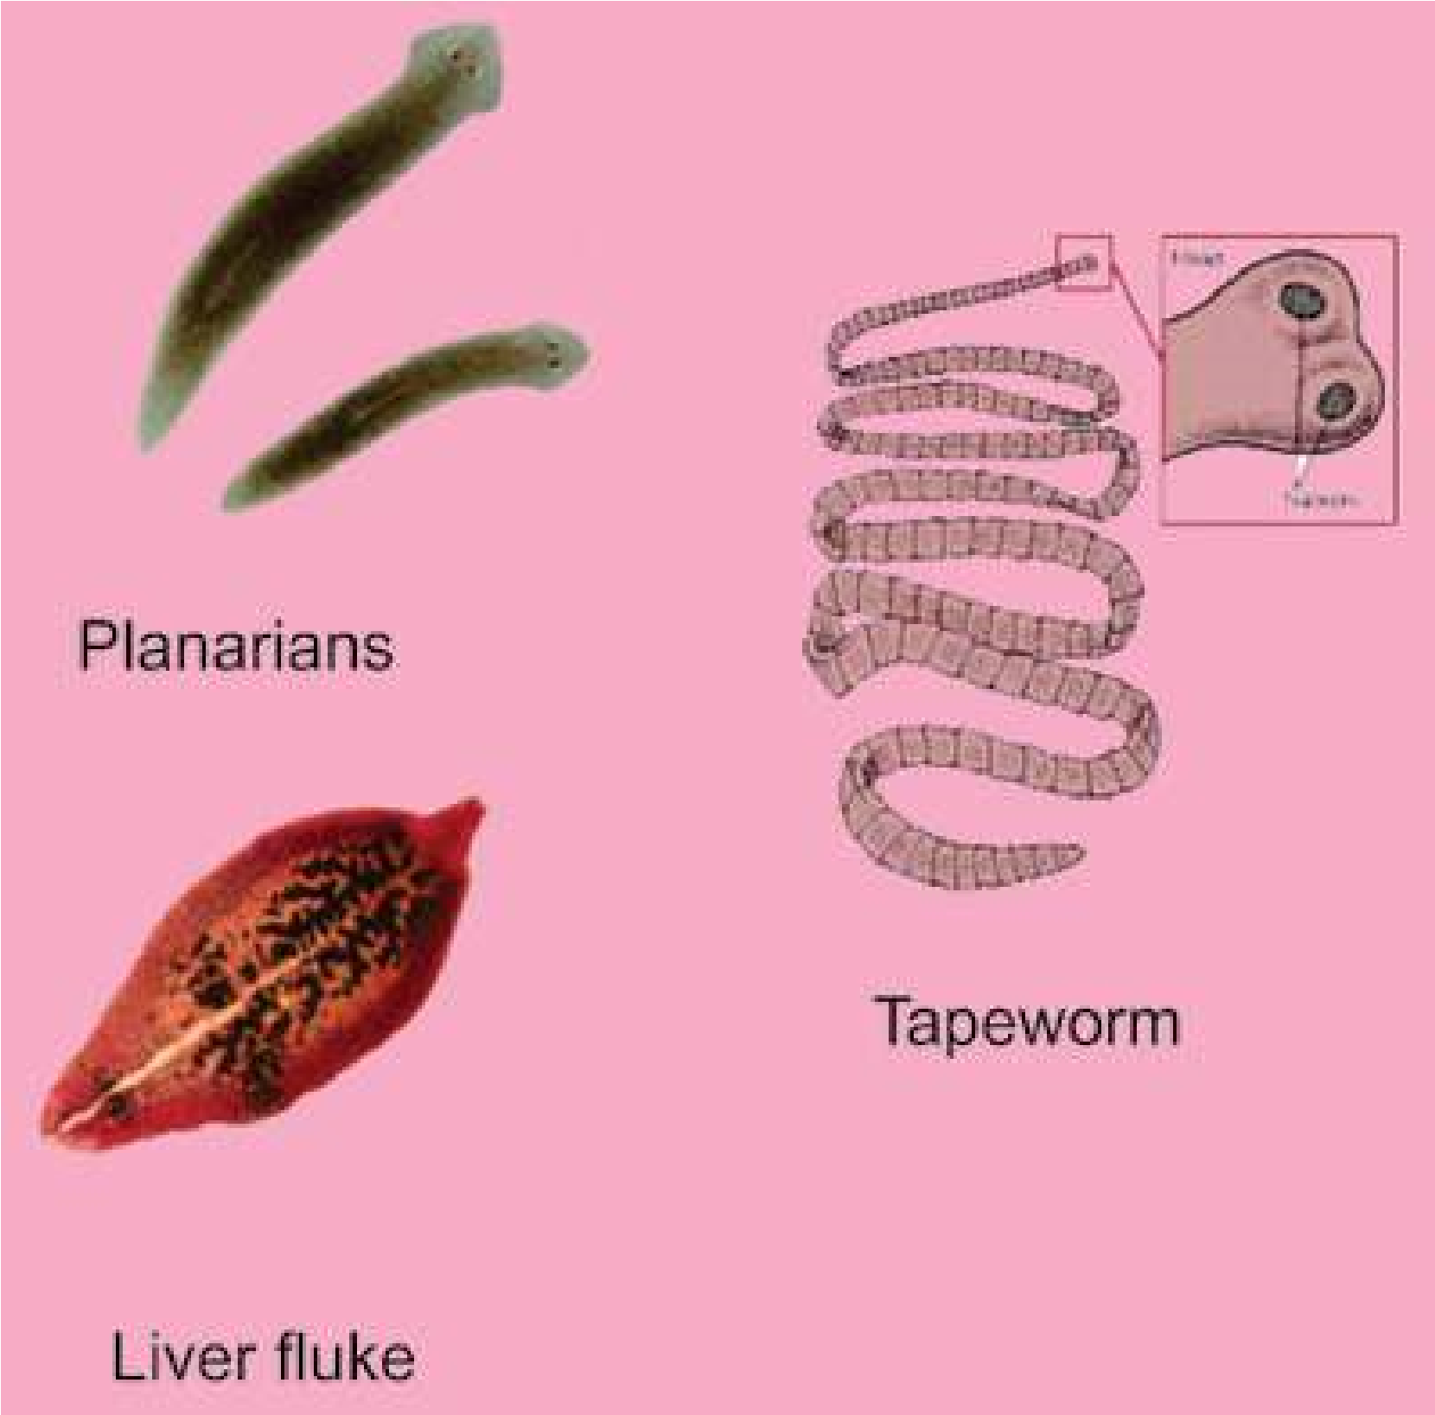

*Fig. 10.6 Example of animals of platyhelminthes.*

##### Adaptations for parasitic mode of life

The parasitic Platyhelminthes have completely adapted themselves to parasitic mode of life by the development of the following characteristics:

1. The epidermis is absent and there is the formation of resistant cuticle for protection.
2. They have developed adhesive organs, such as suckers and hooks, for attachment to the host.
3. There is degeneration of muscular system and nervous system.
4. The digestive system has become simpliied due to increased dependence on host.
5. The reproductive systems are complicated and the ova are produced in huge numbers to ensure continuity of the species.
6. The complexity of life cycle and presence of more than one host during the life cycle is also an important parasitic adaptation.

##### Infestation

In Taenia (tape worm), the development of the zygote begins while it is still inside the uterus of female. The last segments or proglottids and their uteri contain completely developed embryo. The fully mature proglottids break of from the body and pass out of the body of man along with faeces (undigested waste). The embryo inside the egg is round in shape and has six chitinous hooks. It shows limited movement of contraction. In order to develop further it must reach a second host which may be a cow. The parasite remains embedded in the voluntary muscles of cow. If an improperly cooked beef is eaten by a person, the parasite which has not been killed begins to develop further in the intestine of man.

##### Disinfestation

Once the parasite has entered the intestine of man it is diicult to remove it completely. In this respect care should be taken to cook beef properly before eating it. So that there is no chance of the parasite entering the digestive system but if it has entered then certain medicines are taken to remove it. Its complete removal is necessary because if only head remains inside the intestine it can grow into new tape-worm once again. Besides treatment with drugs, physicians also give anema to the patient, to fully remove the parasite.

**Triploblastic Animals - Pseudocoelomates**

**Aschelminthes (Phylum Nematoda) - The Round worms**

##### General Characteristics

The name Nematoda means “pointed ends”. The animals included in this group nave elongated worm like body with pointed ends. The nematodes are triploblastic and pseudocoelomates. One end of the body is anterior, however the head is not clearly marked and there are no special sense organs at this end. The nematodes exhibit bilateral symmetry and the body is unsegmented. The body cavity is **pseudocoelom**. It is derived from the hollow space, the **blastocoel**, situated in the **blastula**, an early stage in embryological development, and not from the mesoderm. It consists of a number of vacuolated cells illed with a protein-rich luid which develops high hydrostatic pressure.

The nematodes range from small microscopic forms, to some form reaching a length of upto one metre. The digestive system is in the form of alimentary canal with two openings. The opening at the anterior end is mouth and at the posterior end is the anus. In parasitic nematodes the digestive system is simple. A luid illed space is present between the body wall and alimentary canal. It provides “tube within tube” type structure in nematodes. The excretory system consists of

two longitudinally running excretory canals which unite at the anterior end to form a single canal that opens to the exterior through an excretory pore on the ventral surface. There is a nerve ring around the pharynx, which give rise to dorsal, ventral and lateral nerve cords running throughout the length of the worms. The sense organs are in the form of sensory **papillae** present on the lips at the anterior end. The circulatory and respiratory systems are absent. The gaseous exchange takes place through general body surface. Locomotion is by undulating waves of contraction and relaxation of muscles. These muscles are arranged in four bands, two dorso-lateral and two ventrolateral. The circular muscles are absent, therefore the bending is dorso-ventral only.

The sexes are separate. The female gonads are ovaries and these produce eggs. These male gonads are testes which produce sperms. A larval stage is present in the life cycle.

##### Importance - Parasitic Diseases

Aschelminthes is important from the point of view of its parasites of which it has a great variety qausing some very serious diseases in man and plants.

*Ascaris* lumbricoides is an intestinal parasite of man.

The genus *Rhabditis* contains numerous species normally found in soil, organic matter or water and feces of man or animals. ***Enterobius vermicularis*** commonly known as pin worm is cosmopolitan but more common in Europe and America. Pinworms are

parasites in the human caecum, colon and appendix. *Round worms are everywhere outdoors, where they playan important role in breaking down organic matter. A*

Their movement causes intense itching of anus, *single rotting apple may contain 90,000 worms. Billions* inlammation of mucous membrane of colon and *thrive in each acre of topsoil.* appendix resulting in insomnia and loss of appetite.

***Ancylostoma duodenale*** is commonly known as hook worm. It is a parasite of human small intestine in Asia, North Africa and Europe. It is very dangerous because it holds the villi of intestine and sucks blood and body luid. During feeding they produce an anticoagulant to prevent clotting of blood and after feeding leave the wound bleeding. In children it can cause severe anemia and retard physical and mental growth.

**Triploblastic Animals - Coelomates**

**Phylum Annelida The Segmented Worms**

##### General Characteristics

Most of the worms with which we are familiar are included in this phylum. They are segmented and commonly called annelids, (from the Latin word for “ little ring”)

The body is metamerically segmented. The body becomes divided transversely into a number of similar parts or segments. The subdivisions may be indicated externally by constrictions of the body surface. Internally, the segments are separated from each other by septa extending across the coelom. However, the various systems of body such as gut, blood vessels, and nerve cord are continuous throughout the length of body penetrating each individual segment.

The animals are triploblastic and coelomate, showing bilateral symmetry. The annelids include worms, which may be marine (*Nereis*), freshwater (*stylaria*) or found in damp soil (*earthworms*). Some are parasites, for example, *Hirudo* - (leech).

The annelids show specialization of body structures. The organ systems are well developed.

Digestive system is in the form of alimentary canal which is divided into distinct parts, each performing a speciic function. It has two openings, the mouth at the anterior end, and the anus at the posterior end. The mouth is overhung by a lobed structure, the **prostomium**. In parasitic species, the digestive system is poorly developed.

Annelids have true coelom i.e. the mesoderm splits into parietal layer which lines the body wall, and the visceral layer which covers the alimentary canal, the space between the two layers of mesoderm, is the coelom, and is illed in by coelomic luid, which serves- as hydrostatic skeleton also.

Excretion takes place by specialized structures called **nephridia**. These are ciliated organs present in each segment in the body cavity.

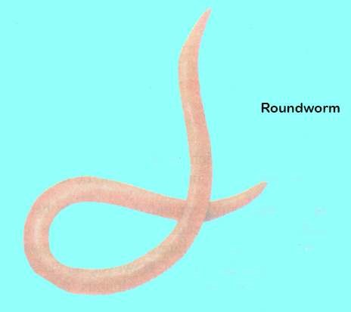

A well developed central nervous system is present in annelids. It comprises of a simple brain and a solid double, longitudinal, ventral nerve cord. Nerves arise in each segment from the nerve cord.

Annelids are the irst group of invertebrates which have developed a closed circulatory system - a system in which a circulatory luid called blood lows in a network of vessels known as blood vessels. It transports gases and nutrients.

The respiratory system is absent. The exchange of gases is by difusion through the skin in to blood capillaries. The skin is kept moist by ,mucus, and coelomic luid.

The body wall contains muscles which help in locomotion. The muscles are of two types:

1. **Circular Muscles :** These are arranged along the circumference of the body.
2. **Longitudinal Muscles :** These are arranged along the length of the body.

The locomotion is brought about by the interaction of muscles and hydrostatic skeleton. Contraction of circular muscle produces a pressure in the coelomic luid that forces the body to elongate. Similarly contraction of longitudinal muscles produce a pressure in the coelomic luid that would cause the body to widen. The organs of locomotion in annelids are chitinous chaetae or setae embedded in sacs (earthworm) or on . parapodia present in the body wall (e.g., *Nereis*). Chaetae are absent in leech.

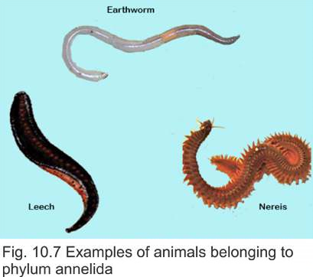The common mode of reproduction is sexual. Most annelids (Earthworm, leech) are hermaphrodite. In some annelids (e.g., *Nereis*) the sexes are separate, the fertilization is external and a free swimming **trochophore larva** is produced during the life cycle.

Burrowing activity of earthworms permits greater penetration of air into the soil, and improves drainage capacity of the soil. It also enables roots to grow downwards through the soil more easily. Mixing and churning of the soil is brought about when earth which contains inorganic particles is brought up to the surface from lower regions. Earthworm is perhaps most active segmented worm in churning the soil, therefore it is commonly termed as natural plough.

Phylum Annelida comprises :

1. Class Polychaeta
2. Class Oligochaeta 3. Class Hirudinea

#### Class Polychaeta

These have a distinct head region with eyes and structure known as **palps** and **tentacles**. Sexes are usually separate. The organs of locomotion are parapodia. They are mostly aquatic (marine). During development these give rise to a trochophore larva. Important examples are ***Nereis, Chaetopterus***.

##### Class Oligochaeta

These animals have internal and external segmentation. Organs of locomotion are **setae**. Head region not prominent or distinct. They are hermaphrodite (bisexual). No larva formed during development e.g. *Lumbricus terrestris*, *Pheretima posthuma* and other earthworms. They may be terrestrial or aquatic.

#### Class Hirudinea

They have body with ixed number of segments. Each segment has additional circular rings or markings called **annuli. They do not have organs of locomotion and** move due to the contraction of their body and with tne nelp of suckers. Mostly hermaphrodite and trochophore larva is formed during development. They are aquatic. No distinct head is present but leeches have chitinous jaws for making a puncture in the skin of the host. They also have an anticoagulant secretion which is passed into the wound to allow smooth low of blood into its digestive system where it can be stored for a long time e.g. *Hirudo medicinalis* (medicinal leech).

**Phylum : Arthropods - Animals with Jointed Legs**

##### General Characteristics

The phylum contains more species than any other phylum. They are commonly called Arthropods (arthron = joint + pods = feet). Insects (cockroaches, grasshoppers, butterlies, mosquitoes) are most commoh arthropods on the earth.

The body is segmented. Each segment is attached to its neighbour by means of a modiied portion of cuticle which is thin and lexible. They possess jointed appendages. These appendages have been modiied for specialized functions.

These are believed to have common origin with annelids because both have some common characteristics such as segmented body, appendages and cuticle.

Arthropods have exploited every type of habitat on land and in water. The aquatic species include both freshwater and marine. Many of these can ly, therefore visit air periodically.

Arthropods are variable structurally. Some are worm-like centipedes while the others are lying insects with the body divided into distinct regions, the head, thorax and abdomen. The body is covered with waterproof chitinous cuticle secreted by the epidermis.

The coelom is not present as the main body cavity. Instead a haemocoel has developed. It is reduced coelom and communicates with blood vascular system.

The digestive system is in the form of alimentary canal with two openings, the mouth and anus. It is divided into diferent parts each performing a speciic function. The food comprises of small plants and animals.

A well developed excretory system comprising of Malpighian tubules is present in arthropods. The nitrogenous wastes are excreted in the form of solid uric acid.

A highly deyeloped nervous system is present. It consists of paired ganglia (simple brain) connected to a ventral double nerve cord. A ganglion is present in each segment. Nerves arise from these ganglia. The sensory organs are usually a pair of compound eyes and antennae etc.

Most arthropods possess an extensive tracheal system formed of air tubes called tracheae for the exchange of gases. Main tubes open to the exterior through paired openings, called spiracles. Aquatic art hropods respire through gills and book lungs.

The blood circulatory system in arthropods is unique. It is open circulatory system. The blood lows in the body cavity bathing the tissues of the body. However, there is a primitive heart and a main blood vessel situated dorsaliy. Blood is colourless as it is without haemoglobin.

The skeleton is external, i.e., exoskeleton. It is in the form of an outer covering, the cuticle which is light in weight; and is formed chiely of chitin. It provides surface for the attachment of muscles which help in locomotion.

The arthropods exhibit active and swift movements. They swim, crawl or ly depending upon the habitat they occupy. The organs of locomotion are paired appendages and in some cases paired wings also.

**Reproduction and Life History**

The sexes are separate. The testes and ovaries, produce sperm’s, and eggs respectively.

##### Metamorphosis

Life history of insects is characterized by metamorphosis (meta = change + morphe = form). This is an abrupt change of form or structure during the life cycle. There are three morphologically distinct stages in the life cycle, the egg “*inally*“ develops into larva which is converted into motionless pupa that inally develops into an adult. In some primitive insects the metamorphosis is incomplete. The larva resembles adult and is called nymph or instar. It lives in the same habitat as adult.

##### Classiication

Phylum Arthropoda is a large group consisting of great variety among them. Some of its important classes are as follows.

1. 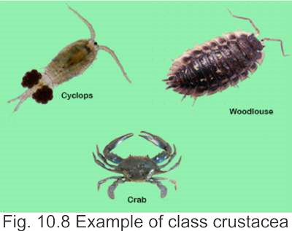**Class Crustacea :** These arthropods are aquatic and have gills for respiration. On the dorsal side of the cephalothorax the exoskeleton is in the fofm of carapace. In the exoskeleton deposition of salts in addition to chitin makes it more irm. The appendages are modiied for capturing food, walking, swimming, respiration and reproduction. Coelom is reduced and is in the form of hemocoel. Head has two pairs of antennal appendages, one pair of mandibles (jaws) and two pairs of maxillae. Sexes are mostly separate e.g. *Daphnia, Cyclops*, Crabs, lobsters, prawn, wood louse etc. (Fig. 10.8)
2. 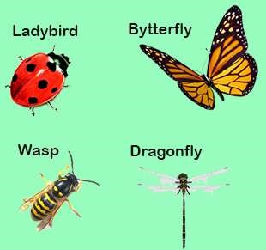**Class Insecta :** This is the largest group not only of Arthropoda but of all the animal kingdom and has great variety. Insects are found everywhere, many show social behaviour. The body in, insects has three distinct regions head, thorax and abdomen. There are a pair of antennae and compound eyes on the head. The head is usually vertical to the body and jaws are ventrally placed. The thorax has three segments in which are present three pairs of jointed legs and in many one or two pairs of wings. Abdomen has varying number of segments. Brain is formed of fused ganglia and double nerve cord is ventral. Sexes are separate and animals are oviparous. Metamorphosis takes place during development e.g. dragonly mosquito, butterlies, moths,

wasps, and beetles etc. (Fig. 10.9). Fig. 10.9 Insects

1. **Class Arachnida :** Body has the anterior segments that are fused to form a combined cephalothorax, with a pair of appendages called chelicerae with claws, two pairs as pedipalps and four pairs of legs. There are no antennae and no true jaws. Abdomen may be segmented or unsegmented with or without appendages. Respiration is by

*gills* or special structures called book lungs, excretion is by the *Most spiders have eight eyes placed in sucha way as to give them panoramic view of*

Malpighian tubules. Eyes simple, sexes are separate. They are *the predators and prey.*

oviparous (lay eggs). No true metamorphosis e.g. scorpions, spiders, mites and ticks.

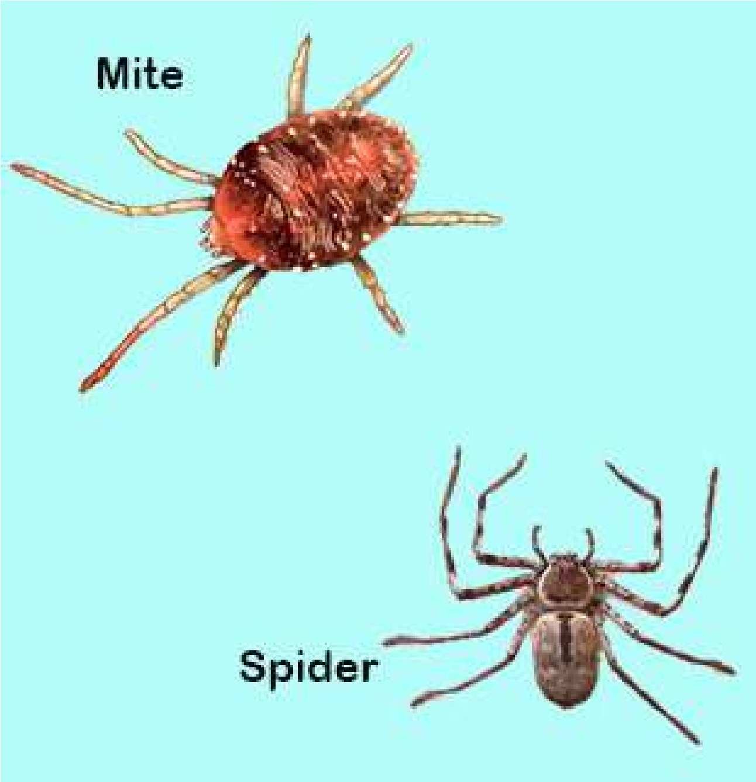

*Fig. 10.10 Arachtiids*

1. **Class Myriapoda:**

The body is divided into large number of segments each having a pair of legs. A pair of antennae and a pair of eyes are present on head e.g. centipedes and millipedes.

###### General organization of Arthropods

Arthropods have characteristics of higher forms such as bilateral symmetry, triploblastic, coelomic cavity and organ systems and have reached the peak of invertebrate evolution. Two of their main achievements are the chitinous exoskeleton and locomotary mechanism. These animals can walk, swim and ly. The jointed appendages (limbs) have been modiied or diversiied for various uses in the diferent sub-groups of Arthropoda.

Chitin is non-living, non-cellular and is secreted by the under lying epidermis. It is made of polysaccharide.On the outer side of chitin,there is a waxy layer. In some Arthropods and in certain parts in other Arthropods chitin is soft and lexible, in others it is hard. In general, it is for protection but it also serves as lever for the movement of muscles of jointed limbs. The chitin in the jaws is used for biting and crushing food. It also forms lens of the compound eyes the copulatory organs and organs of defence and ofence.

In the young Arthropods such as insect larvae, chitinous exoskeleton is shed from time to time to allow the growth of the larva. This process of shedding of exoskeleton is called moulting or ecdysis. In short the exoskeleton of chitin in the Arthropods is one of the primary factors in the success of Arthropoda as it helps them to adapt to a wide variety of habitat.

Arthropods share with annelids the characteristic of having the body divided into similar segments. In Arthropoda however segmentation is not metameric and organs are not repeated in the diferent segments. Each somite typically is provided with a pair of jointed appendages. But this arrangement is often modiied with both segments and appendages specialized for diferent functions in diferent habitats. However, in all kinds of habitat the jointed appendages provide an eicient means of locomotion, ofence and defence and also help in reproduction.

###### Economic Importance

Man and insects have been at war for the same food, same place to live in. Insects attack man, his domestic animals and also his crops, causing a number of diseases. They are not only a health hazard but also cause economic loss to man by destroying his property and crops. Some insects are also useful to him such as the honey bee or the silk worm. Insects are therefore of great importance to mankind.

**1. Harmful Insects :** Many types of mosquitoes, lies, leas, lice and bugs transmit disease causing organisms to man and domestic animals. We are familiar with mosquito of genus *Anopheles*, the female of which transmits *Plasmodium* that causes malaria in man. The Tse-tse ly of African countries transmits Trypanosoma, the cause of sleeping sickness and skin diseases. The common house ly carries disease causing organisms to contaminate food and cause cholera, hepatitis etc. Some species of *Trypanosoma* cause diseases in cattle, also.

A number of insects lay eggs on fruits and other commercial crops such as sugarcane, maize, cotton and also on vegetables etc. The larvae of these insects damage fruits and the crops resulting in economic loss to farmers. The locusts that move in large numbers from country to country cause damage to standing crops and other plants.

**2. Beneicial insects :** The useful insects are the honey bee that provides man with honey and also wax. Similarly the silk worm gives us silk. There are some insects that are predaceous on other harmful insects. Some insects are scavengers and they eat up dead animal and vegetable matter. Insect larvae are source of food for ish.

**PHYLUM MOLLUSCA (L. Molluscus - soft)**

###### General Characters

The phylum Mollusca consists of diverse group of organisms which include slow-moving snails and slug, bivalved clams, and highly active cephalopods. The phylum includes over 50,000 living species and is the second largest phylum of invertebrates. Giant squid is the largest invertebrate animal.

Molluscs also show a great diversity of form but all are built on the same basic plan.

Molluscs are triploblastic coelomates which exhibit bilateral symmetry. Most animals possess shell.

The body is covered by a glandular epithelial envelope called mantle which secretes calcareous shell. The shell is protective, however it is handicap to locomotion, therefore some of the more active molluscs show a reduction or loss of shell.

Molluscs are widely distributed. Some groups are exclusively aquatic (e.g., cephalopoda), freshwater or marine. The others include terrestrial animals (land snail) living mostly in moist places.

The body is unsegmented and soft. The body can be divided into head, a ventral muscular foot and a dorsal visceral mass containing most of the internal organs. Over the visceral mass mantle is present which secretes a shell. The space between the shell and mantle cavity contains gills in some animals. In the mouth cavity of many molluscs there is a rasping tongue-like **radula** provided with many horny teeth.

The body is highly organized with complex digestive, respiratory, circulatory, excretory, nervous and reproductive systems.

Digestive system consists of gut with two openings, the mouth and the anus.

The excretory organs are paired nephridia.

Except for Cephalopoda, the circulatory system is open. The coelom is divided into sinuses or blood spaces. Heart pumps the blood into the sinuses. A respiratory pigment of blue in color, called **haemocyanin** is present.

The gaseous exchange is by gills mostly. In some cases such as snail, the mantle cavity is converted into a lung.

The nervous system consists of three pairs of interconnected ganglia present in the head, foot and body regions.

The organ of locomotion is a muscular foot, however in many species the movement is slow. The others are sessile i.e. unable to move.

The sexes are separate. Trochophore larva develops during embryological development.

**Classiication**

The molluscs are classiied into six classes. The major classes are:

##### (i) Gastropoda

These are asymmetrical and their body is covered with usually coiled one piece shell. The animal can withdraw itself into the shell. Both aquatic and terrestrial species are included in this class. The aquatic species have gills while in land forms the mantle cavity is converted into lungs.

The common examples are:

i. ***Helix aspersa :*** It is commonly termed garden snail. ii. **Limax** the slug

##### (ii) Bivalvia (Pelecypoda)

This class includes bilaterally symmetrical aquatic molluscs. The body is laterally compressed and is enclosed by two pieces of shells hence the name bivalves. They respire by plate-like gills.

The common examples are:

(i) ***Mytilus***: (marine mussel). (ii) ***Anodonta***: (freshwater mussel), (iii) ***Ostrea***: (oyster).

###### (iii) Cephalopoda

The members of this class are bilaterally symmetrical with dorso-ventrally lattened body. All species are aquatic. The shell is much reduced and internal. In most cases it is absent. The animals are highly developed and active.

The common examples are:

1. **Loligo**: (squid).
2. **Sepia**: (cuttleish). iii. **Octopus**

*Fig. 10.11 Examples of molluscs*

Economic Importance of Mollusca

Some molluscs are indirectly harmful to man but most of them are beneicial. The harmful molluscs are slugs and shipworms. Slugs are injurious to gardens and cultivations. They not only eat leaves but also destroy plants by cutting their roots and stems. Teredo, a shipworm damages wooden parts of ships. But many molluscs are great source of food for man in many parts of world. Large quantities of clams, oysters and mussels are eaten in Far-east, Europe and America. Oysters are regarded as delicacy.

Shells of freshwater mussels are used in button *The brain of octopus is exceptionally large and complex for an* industry. Also shells of oysters are mixed with *and endows the octopus with highly developed capabilities toinvertebrate brain. It is enclosed in a shell-like case of ‘Cartilage’,* tar for making roads in America. Shells in *learn and remember. In laboratory, octopus can rapidly learn to* certain parts of the world are also used for *associate certain symbols and can open a screw cap jar to obtain food.* making ornaments. Some oysters also make valuable pearls e.g. the pearl oyster.

**PHYLUM ECHINODERMATA - The Spiny skinned animals**

General Characteristics

There are over 5,000 known species of echinoderms. They are marine organisms living at the sea bottom.

The body is covered by delicate epidermis. The mesodermal cells develop a irm calcareous endoskeleton which may bear spines and because of its origin, from mesoderm it is called endoskeleton.

Echinoderms are triploblastic coelomates and exhibit radial symmetry. The mouth is on lower surface (oral) and anus is on upper surface (aboral).

The echinodermata are exclusively marine and most of them are found at the bottom along shorelines in shallow seas. Most species are free) moving however some are attached to the substratum.

All the larval forms of these animals exhibit bilateral symmetry but the adults show radial symmetry which is an adaptation for their special mode of life.

The body may be lattened like biscuit (cake urchin), star-shaped with short arms (starish) globular (sea urchin), star-shaped with long arms (brittle star) or elongated (sea-cucumber). There is a central disc from which arms radiate.

The most unique characteristics of echinoderms is that a water vascular system is present in their coelom. It is a complex system of tubes and spaces surrounding the mouth and passing into the arms and tube feet. The water circulates through these channels. Water enters these canals through a sieve-like plate called madreporite present on the aboral body surface.

The motile species move with the help of tube feet. Each tube foot is a soft saclike structure present along the edges of grooves present in the arms.

The echinoderms exhibit low degree of organization. There are specialized organs for digestion and reproduction, but there are no specialized organs for respiration or excretion. The nervous system is also poorly developed. There is no brain, however a nerve ring is present around the pharyngeal region. Similarly the circulatory system is poorly organized.

The sexes are separate and the fertilization is external. The larvae such as **bipinnaria** and **brachiolaria** are complex, exhibit bilateral symmetry, and resemble those of chordates.

**Regeneration**, the ability to reform lost organs is common among echinoderms, starish, sea cucumber, sea lily, brittle star and sea-urchin exhibit this characteristics.

The echinoderms are comparatively simple in structure, organization and physiology, and deserve a place slightly below the annelid worms. However, these are placed at the top of the list of invertebrate phyla. This is because there are a number of striking resemblances, between the echinoderms and chordates, such as :

1. There is radial cleavage during the development of embryos in both phyla.
2. 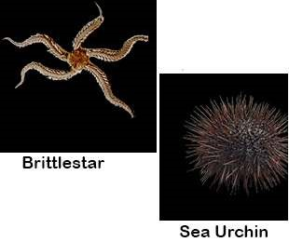The blastopore forms the anus in echinoderms as well in chordates (Deuterostomes).
3. There are certain common biochemical peculiarities among echinoderms and chordates e.g. phosphocreatin is present in both.

The common examples are:

*Asterias* (starish):

Sea urchin Sea cucumber

Cake urchin Brittle star

*Fig. 10.12 Examples of Echinoderms.*

Echinodermata / Afinities

Echinodermata do not show close relationship to most invertebrates, but they do show ainities with hemichordata. Both these have a number of common features among which are the formation of coelom and retention of blastopore as the site for future anus. In both mesoderm is derived from the cells close to the blastopore. Both possess mesodermal endskeleton where as the exoskeleton is ectodermal in orgin while in invertebtrates the blastopore develops into mouth.

The above resemblances between two phyla are neither accidental nor due to convergent evolution but are because the two are closely related and both emerged from the same (common) ancestor. Echinoderms also show very close resemblance with chordates because both have mesodermal skeleton, are deuterostomous, in both lower chordates and echinoderms the early development is almost similar. That is why they have been placed closest to phylum chordata.

Phylum Hemichordata

Hemichordates are a group that has a combination of both invertebrate (Echinoderm) and chordate characteristics.

The hemichordate along with Echinoderms and chordates belong to the group deuterostome branch of animal kingdom.

Because of their close relationship to chordates these animals are called prechordates. The common examples of this phylum are *Balanoglossus* and *Saccoglossus*.

General Characters

1. Soft bodied worm-like animali.
2. Body is divided into an anterior proboscis, collar and trunk.
3. Body wall is made of unicellular epidermis with mucus-secreting cells.
4. Digestive tract is straight and may show variations.
5. Coelomic cavities correspond to each of the three body regions i.e. that of proboscis, collar and trunk coelomic pouches.
6. Circulatory system consists of a median dorsal and a median ventral vessel.
7. Respiratory system is composed of gill-slits forming a dorsal row behind collar.
8. Excretory system has single glomerulus connected to blood vessels.
9. Nervous system has a sub-epidermal plexus of cells and ibres.

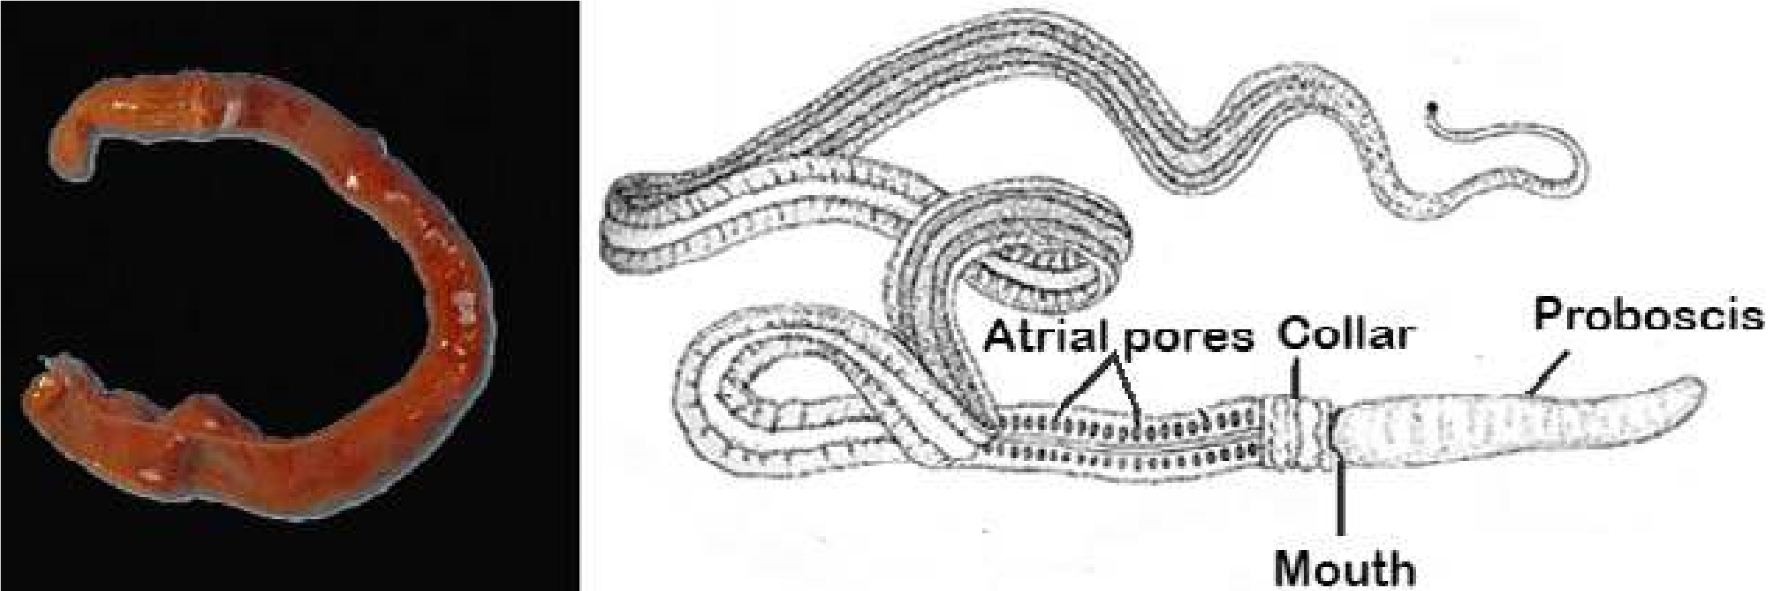

*Fig. 10.13 Balanoglossus and Saccoglossus*

Phylum Chordata

This great phylum derives its name from one of the few common characteristics of the group - The notochord. This structure is possessed by all members of the phylum either in the larval or embryonic stages or through out life. The notochord is a rod-like semi rigid body of vacuolated cells which are illed with proteinaceous material which extends in most cases the length of the body between enteric canal and the dorsal hollow central nervous system. Its primary purpose is to support and to stifen the body that is to act as skeletal axis.

It seems that the endoskeleton is the chief basic factor in the development and specialization of higher animals.

The animals most familiar to us belong to the chordates including man himself.

The chordates show great variety and inhabit all kinds of habitat. All chordates possess three basic characters which are as follows:

1. As already mentioned all possess the notochord.
2. All chordates have central nervous system that is dorsal in position and is hollow.
3. All chordates develop paired gill openings in embryonic stage. In some these are non-functional, while in others they are functional for some period in their liie history e.g. frogs etc. in still other these are functional throughout life e.g. amphioxus, and ishes etc.

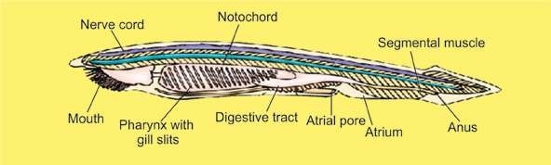

*Fig. 10.14 Amphioxus*

Chordates have been divided into lower chordates, e.g. *Amphioxus* etc. and higher chordates which are the vertebrates in which the notochord is replaced by the vertebral column and a bony brain case cranium is also formed due to which they are also called craniates. Phylum Chordata has been sub-divided as follows:

Protochordata (Acrania) (Lower Chordates)

**Sub-phylum: Urochordata :** Notochord and nerve cord only in the fee-swimming larvae. Adults are sessile and enclosed in a covering called tunic. Therefore, they are also called tunicates e.g. *Molgula.*

**Sub-phylum:** Cephalochordata: Notochord and nerve cord extend along the entire length of the body and persist throughout life e.g. Amphioxus.

Table 10.2 Classiication of Phylum Chordates

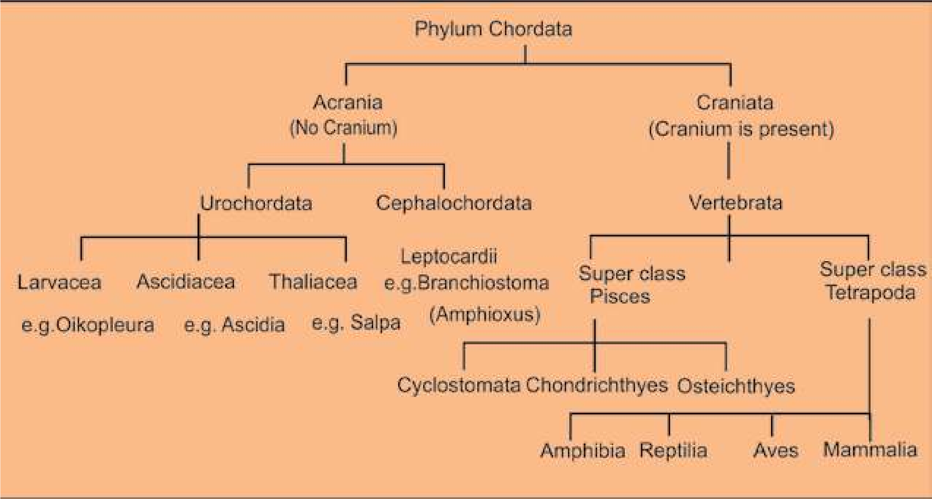

Sub-Phylum Vertebrate (Craniate) (Higher chordates)

It includes animals which have cranium in which the brain is enclosed. It includes animals with vertebral column that means that all chordates in this, group are under subphylum vertebrata and are therefore vertebrates. Table 10.2 gives an outline of classiication of sub-phylum vertebrata.

It is customary to place vertebrates into two super classes.

1. Pisces (Fishes) which includes class cyclostomata, class chondrichthyes, class osteichthyes.
2. Tetrapoda (Four footed) which includes the classes amphibia, reptilia, aves and mammalia.

The former is made up of strictly aquatic forms and the latter of the land dwelling animals. Vertebrates maybe divided into anamniotes or those without foetal membranes (cyclostomata, chondrichthyes, osteichthyes and amphibia) and amniota or those with foetal membranes (reptilia, aves and mammals)

Superclass Pisces

This super class includes classes, cyclostomata, chondrichthyes and osteichthyes. The class cyclostomata includes most primitive living vertebrates which are without jaws. This distinguishes them from the rest of the vertebrates. They are represented by the lampreys and hagish. Some of their characteristics are as follows:

1. Body is long eel-like. 2. Scales absent.

3. No paired appendages. 4. Cartilaginous Skeleton.

5. Ventral Suctorial mouth. 6. Heart with one auricle.

7. Six to fourteen pairs of gills. 8. Digestive system lacks stomach.

1. Sexes are separate in lampreys. Hag ishes are hermaphrodite.
2. Fertilization external and there is a long larval period in Lamprey.

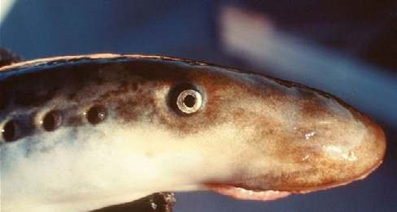

*Fig. 10.15 Lamprey*

Class Chondrichthyes

This group includes the sharks and rays which have skeleton of cartilage but have many resemblances to the bony ishes, the cartilaginous skeleton is considered a degeneratedjbharacter rather than primitive character. Their main features are:

1. Body fusiform.
2. Mouth ventral olfactory sacs not connected to mouth cavity.
3. Placoid scales on the body.
4. Endoskeleton entirely cartilaginous.
5. Digestive system with J-shaped stomach.
6. Circulatory system has many pairs of aortic arches.
7. Respiration by means of 5 - 7 pairs of gills without the covering i.e. operculum.
8. No swim bladder.
9. Sexes separate.
10. Oviparous or viviparous

With the exception of whale the sharks are the largest living vertebrates, some reaching 30 - 50 feet in length.

The skates and rays are bottom dwelling ishes. In these the anterior pairs of ins (Pectoral ins) are much enlarged and are used for swimming like wings. Two members of this group are of special interest (1) the sting rays and (2) electric rays.

In the sting ray the tail is long & whip-like and has sharp spines which can inlict very dangerous wounds. The electric ray on the other hand has certain dorsal muscles modiied into powerful electric organ which can give severe shocks & stun their prey.

Sharks are of economic importance; most are highly destructive to ish, lobsters & crabs. In some parts of the world sharks are used as food by man. Commercially shark liver oil is extracted and used in medicine as a source of vitamin A and D and shark skin leather is used for making articles.

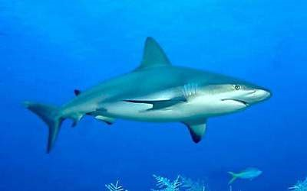

*Fig. 10.16 Shark*