Following are the characteristics of bony ishes :

1. They have more or less bony skeleton which has replaced the cartilaginous skeleton.
2. Notochord may persist in parts.
3. The skin has embedded dermal scales which may be ganoid, cycloid or ctenoid scales. No placoid scales.
4. Fins both, median (single) or paired and have in rays of cartilage or bone.
5. Mouth is terminal. Jaws either with or without teeth.
6. Respiration by gills supported by bony gill arches and covered by operculum.
7. A swim bladder is usually present with or without connection with the pharynx. This helps in bouyancy.
8. Two chambered heart with one atrium and one ventricle. Blood has nucleated red cells.
9. Brain with 10 pairs of cranial nerves.
10. Sexes are separate, gonads paired. Fertilization is usually external.

**Adaptations to Aquatic Life:**

The major adaptations in ishes for the aquatic mode of life are as follows:

1. **Stream - lined body** (boat shaped) The body of ish is such that it ofers little resistance to water while swimming.
2. **Swim bladder:** This is found in most bony ish except a few; it may or may not be connected to pharynx. It is mainly a hydrostatic organ & can change the gravity of ish by illing itself with gas. The ish qan thus loat high or sink lower in water. The gases that ill the swim bladder are either oxygen, carbon dioxide and nitrogen and may be secreted by the gland in the swim bladder itself. In those ishes in which the swim bladder is connected to pharynx the bladder may be illed by gulping of air.
3. **Fins:** Fins are another important adaptation to aquatic life and are of two types

(1) paired ins (Pectoral and Pelvic) and (2) unpaired ins which are dorsal, caudal (tail) and anal ins. Fins help in swimming as they keep balance of ish in water.

1. **Circulatory System :** Heart with two chambers, with aferent & eferent branchial system.
2. **Respiratory system:** In most ishes respiratory organs are the gills, adapted to receive oxygen dissolved in water and remove carbon dioxide in water as the gills have network of blood capillaries

**Excretory Organs:** Kidneys of ish are also modiied for excretion in the aquatic environment.

The vertebrates already considered are adapted to strict aquatic life. The group of ancient ish known as **dipnoi** showed modiication of aquatic breathing system to meet the conditions of terrestrial life by developing lungs. But this case is only an incident in the transition to land. There are a number of diferences between water and land habitats.

1. Oxygen is more in the air than in water.
2. Dissolved substances are present in water for example diferent kinds of salts.
3. Temperature changes are more drastic in the terrestrial environment.
4. Land habitat provides a great variety of cover and shelter than aquatic habitat.
5. As a medium water provides greater support to the body than air.
6. Land afords a greater variety of breeding places than does water.

In their transition from aquatic to land environment animals had to undergo modiications or adaptations to cope with the above conditions on land. This included:

1. Development of skin for protection against dry conditions of land.
2. The eggs of land animals are protected by shells from drying and mechanical injury. Also the size of the egg is large to provide space for storage of food.
3. The terrestrial animals developed lungs in place of gills which could take oxygen from air.
4. In connection with the development of lungs there are corresponding changes in the circulatory system to take oxygen from air.
5. For locomotion the paddle-like ins are replaced by jointed appendages modiied for walking, running, climbing and lying.
6. Sensory organs have become more advanced and specialized.

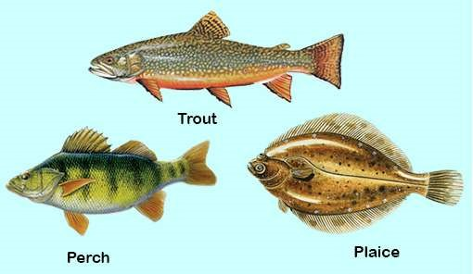

*Fig. 10.17 Bony ishes*

**Super class Tetrapoda:** These have 2 pairs of jointed limbs (tetrapods) **Class Amphibia**

**Amphibians** are on the border line between aquatic and true terrestrial animals. Fossil evidence from the **Devonian** period of earths history suggests that a large population of ish belonging to the group lobe-ins (dipnoi) came to live in shallow fresh water. Some of these crawled from one pool to another and therefore spent some time on land. This gave rise to the group that we recognize as amphibians which are the irst vertebrates to come on land. Although amphibians have acquired certain characters enabling them to live on land but at the same time they have retained some aquatic characters as the result of their dependence on aquatic habitat. This double life is expressed in their name. Structurally they are between the ish on one hand and the reptiles on the other. In the transitions from water to land amphibians have developed limbs in place of ins, lungs in place of gills and some changes in skin. Their circulatory system’ provides for lung circulation but all of them in larval form retain their link with aquatic life by having gills, circulation of blood, digestive system which are representative of aquatic mode of life. Because of their dependence on water for their life history they are not a very successful group of vertebrates and are conined to areas only where they can ind water or moist conditions.

The characteristic features of amphibians therefore are:

1. Skeleton is mostly bony. Body form varies greatly in the diferent amphibians, tailed or without tail.
2. Limbs usually four (tetrapod condition) but some are legless (e.g. caecilians). Webbed feet often present.
3. Skin smooth and moist with many glands. In some glands are poisonous, pigment cells (chromatophores) present in the skin. Scales absent.
4. Respiration takes place by gills in the larval stage and by lungs and skin in the adult.
5. Heart is 3-chambered with respect to atria and ventricle sinus venosus, truncus arteriosus are present, double circulation takes place through the heart.
6. Sexes separate, fertilization external, larval stage present.
7. Changes into adult by metamorphosis. Amphibians are anamniotes.
8. Amphibians are cold blooded (poikilothermic) animals and hibernate in winter. Examples frogs, toads, and salamander.

**Class Reptilia:**

Reptiles are adapted for existence solely on land in contrast to amphibians that are still tied more or less to water or moist habitat. This indicates that reptiles have certain adaptations not found in amphibians. Some of these advancements shown by reptiles are their characteristic features which are as follows:

1. Reptiles have developed some sort of copulatory organ necessary for internal fertilization.
2. In amniotic eggs of reptiles the shell is leathery which can resist dryness and injury. They have large yolky eggs.
3. Reptiles have dry scaly skin which is adapted to land life.
4. Reptiles have protective embryonic membranes amnion, allantois, and chorion.
5. In reptiles the ventricle of heart is incompletely partitioned ensuring more oxygen supply through blood circulation to all parts of the body. In crocodiles ventricle is completely partitioned into two.
6. Most reptiles have better developed limbs well adapted for eicient locomotion.
7. Reptiles like amphibians are cold blooded (poikilothermic) and hibernate in winter.

The above characteristics are for terrestrial habitat in which the reptiles mostly live. However, it is an established fact that reptiles have evolved from amphibians by undergoing the above changes and have become fully terrestrial.

Reptiles lourished throughout Mesozoic era (225-65 million years). The climate which had been suitable for reptiles in that period, became less favourable to them in tertiary period. So most of them became extinct. The existing reptiles belong to four, out of a dozen or more main lines that existed in the past.

The present day reptiles are, irstly, the lizards and snakes. Secondly the tuatra (sphenodon) of New Zealand, which have survived upto today with little change. Thirdly the crocodiles, which are an ofshoot from the stock from which modem birds were derived. The reptiles of today have been derived from dinosaurs of Jurassic (195-136 million years), and cretaceous period (136-65 million years).

The modem reptiles for the most part live in the temperate and tropical zones indeed they lourish only in the latter.

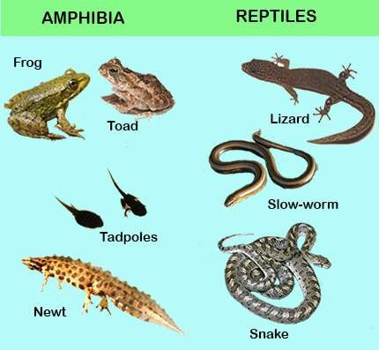

*Fig. 10.18 Amphibians and Reptiles*

Class Aves - Birds

Birds are one of the most interesting and most widely known group of animals. Birds share with mammals the highest development in the animal kingdom. It is believed that both birds and mammals have evolved from reptiles along diferent lines. The earliest known bird fossil is that of archaeopteryx, two species of which have been found from rocks of Jurassic period of earth’s history. The fossil shows that archaeopteryx, was about the size of a crow with skull similar to that of present day birds. It had bony teeth in the jaw socket unlike modem birds which do not have teeth. Jaws extended into a beak and there was a long tail. Each wing had three claws. With the exception of feathers these birds showed resemblance to the dinosaurs (giant reptiles of the past). Many fossils of birds from later eras of earth history have also been found that had teeth. The above evidence suggests that birds evolved from reptilian ancestors. The archaeopteryx and others had characteristic of both reptiles and birds and therefore form a connecting link between

the two distinct groups.

**Archaeopteryx**

In eagle both

ovaries and

oviducts are

functional.

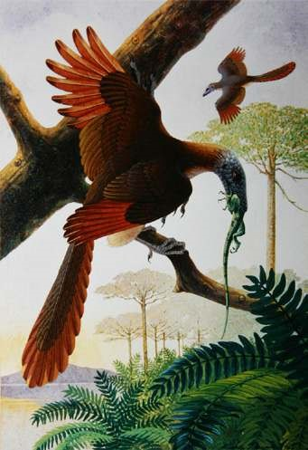

Characters of Birds

1. Body is stream-lined and spindle shaped with four divisions, viz; head, neck, trunk and tail. These are warm-blooded (homeothermic).
2. Limbs are adapted for lying. The fore-limbs are modiied into wings and hind limbs for perching and in some birds for running as in ostrich.
3. There is the epidermal exoskeleton of feathers, legs bear scales.
4. The skeleton is light due to air spaces which is an adaptation for lying.
5. The skull has large sockets, jaws extend into homy beak, teeth are absent.
6. The circulatory system has 4-chambered heart and there is only right aorta which curves to the right side and then bends backwards.
7. The lungs have extensions known as air-sacs which extend into the bones also.
8. The organ of voice is called syrinx, it is situated at the lower end of trachea near the origin of the two bronchi.
9. Excretory system does not have a bladder, urine is semi solid.
10. Sexes are separate. Fertilization is internal and eggs are of large size with much yolk. Only one ovary and oviduct is functional.
11. Since birds do not have teeth they have developed a thick muscular structure (Gizzard) which is used for crushing food.
12. Some birds have secondarily lost the power of light and are called running birds e.g. Ostrich,

Kiwi, etc.

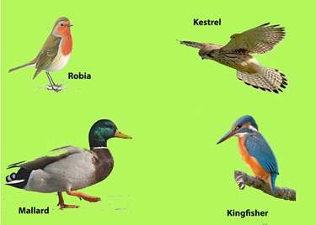

*Fig. 10.19 Birds*

Class Mammalia - Mammals

The term mammal was given by Linnaeus to the group of animals which are nourished by milk from the breast of the mother. The group is considered to be the highest in the animal kingdom. Their advancement over other groups is quite pronounced. The most important advancement is the evolution and development of their brain (nervous system) over the other vertebrates. It is universally accepted by biologists that mammals have evolved from reptilian ancestors, the **cotylosaurs**. This has been determined on the basis of the fossil record which is easily available because of the hard bones that were preserved as fossils, unlike the birds which have soft bones and mostly have not been preserved. The ancestors of mammals lived simultaneously along with reptiles during the Jurassic times and have been called mammal-like reptiles. Some were only of the size of mice and lived on trees. One of these early reptile was **varanope** that was found as fossil in Texas. Probably at least ive groups of such mammal-like reptiles developed mammalian characters and were 50% mammals. Mammals became dominant in the **Cenozoic period.**

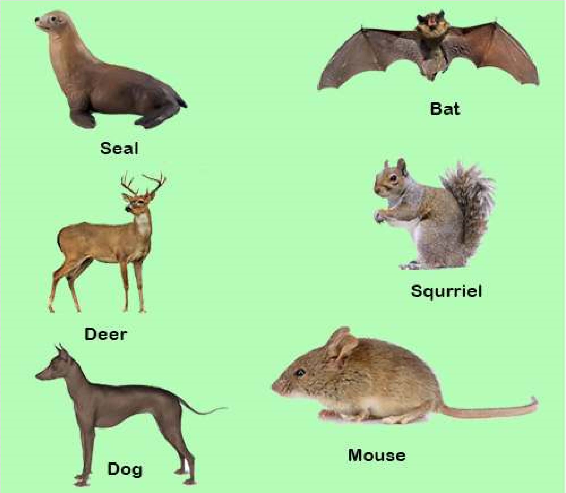

*Fig. 10.20 Mammals*

General Characters of Mammals

Although mammals have evolved from reptiles they show many important structural diferences. These diferences are in fact the general characters of mammals which are as follows:-

1. Most mammals have a body covering of hair instead of scales.
2. There is a muscular diaphragm in mammals that separates the thoracic and abdominal cavities. This structure is not found in any previous group.
3. The lower jaw in mammals is composed of only one large bone and articulates directly with skull.
4. External ear or pinna in present. There is a chain of three bones in the ear **Malleus, Incus & Stapes.**
5. Mammals have deciduous and permanent teeth in some mammals e.g. man the teeth are in two sets, one in early life the milk teeth and later the permanent teeth.
6. Mammals have 4-chambered heart and only left aortic arch (in birds it is right).
7. Mammals are warm blooded (Homeothermic) animals.
8. The red blood cells are non-nucleated.
9. Mammals have well developed voice apparatus, the larynx and epiglottis.
10. Most mammals give birth to young (viviparous).
11. Mammals feed their young on milk produced by mammary glands of mother. Mammals are

classiied into three sub-classes.

1. Prototheria - egg-laying mammals
2. Metatheria - pouched mammals
3. Eutheria - Placental mammals including man
4. **Sub-Class Prototheria** The Prototheria is that group which has characteristics of both reptiles and mammals and therefore form a connecting link between the two. They also provide evidence of the evolution/origin of mammals from reptilian stock. Certain members of this sub-class are adapted for aquatic life as the duck bill which has a bill similar to that of a duck and has webbed toes. It has thick fur on its body. The female has mammary glands to feed the young. Both these are mammalian characters. At the same time these animals have cloaca and cloacal opening instead of separate openings for digestive system and urinogenital system. Both these characters are reptilian characters. These animals are found in Australia, e.g. Duck bill Platypus & Echidna (Spiny anteater).
5. **Sub-Class Metatheria** Next to Prototheria, the Metatheria are the most primitive mammals They are characterized by an abdominal pouch the **marsupium** where they rear their young. The young when born are immature and are carried by the mother in the marsupium till they develop to their maximum. During this period they are fed on the milk produced by the milk glands of mother, the nipples of which are in the marsupium. For this reason these animals are also called marsupials or pouched mammals, e.g. Opossum, Kangaroo and Tasmanian wolf found in Australia and America.
6. **Sub-Class Eutheria** This sub-class includes placental mammals. In the body of mother development of young is maximum and the young when bom are fully developed. In these mammals during development a structure known as **placenta** is formed through which the fetus is nourished. Also the placenta has endocrine function i.e. it produces certain hormones, for this reason these mammals are also called **placental mammals.** Placental mammals have maximum mammalian characters but in some the hair have become modiied into scales (pangolin) and spines (porcupine). Examples are man, whale, elephant, horse, rat, mice, bat, dolphin, etc.

Mammals being a very successful group live in all kinds of habitat i.e. land, fresh water and sea for which their bodies are modiied.

##### EXERCISE

**Q1. Fill in the blanks.**

1. Frotozons have been placed in a separate kingdom known as _________________ .
2. The sponges do not have any symmetry and are therefore called______ .

1. Between ectoderm and endoderm the coelenterate have a non cellular _____________.
2. *Taenia solium* has_______ and ________ for attachment to the intestine of host.
3. In annelids the body segmentation of the type known as _____________ .
4. In insects there are ______________ pairs of legs present in the ___________region of the body.
5. The organ of locomotion in molluscs is th e____________ .
6. In animals where there are deinite left & right sides the symmetry is _______________.
7. The system in which water move inside the body of an echinoderm is called

_____________.

1. Coelom is the body cavity formed from the_________________ layer.

**Q.2. Each question has few options. Encircle the correct answer.**

Vertebrates that develop embryonic membranes around their embryo are called (Amniotes, Anamniotes)

1. In animals the bodies of which can be divided in two equal halves only in one plane are (asymmetrical, bilaterally symmetrical, radially symmetrical)
2. Animals that have their body cavity illed with parenchyma are (Acoelomates, Coelomate, Pseudocoelomates)
3. The vertebrates in which placenta is formed during the development of faetus are (Pisces,Aves, Mammalia)
4. In amphibians the necessary requirements to spend their life history are (land, water, or both)
5. Trypanosoma causes the diseases (Malaria, Sleeping sickness)
6. ln annelids the organs or excretion are (lame-fcells, nephridia, kidneys) In arthropoda the body cavity is (pseudocoeloms, enterocoel, haemocoel) (vii) In mollusca the foot is used for (capturing prey, locomotion, or both)

**Q .3. Extensive questions.**

1. What are Cnidaria? Explain the diploblastic origin, alternation of generations in cranidaria.
2. Describe the parasitic adaptations in phylum platyhelminthes - How does tape worms afect a person.

1. Give the symptoms of the disease caused by certain nematodes.
2. Give an account of the major groups of Arthropods. What is the economic importance of insects.
3. Give the two major classes of the pisces and explain the adaptations of aquatic mode of life in ishes.
4. Give the adaptations for aerial mode of life in birds. What is their origin.
5. What are the general characteristics of mammals? How do the three subclasses protheria, metatheria and eutheria difer from one another.
6. Distingnish between the following by giving examples (a) Radial and Bilateral Symmetry.
   1. Diploblastic and triploblastic animals.
   2. Anamniotes and amniotes.

CHAPTER

# 11

## BIOENERGETICS

*Animation 11: Bioenergetics*

[*Source & Credit: Wikispaces*](http://anatomyeshs.wikispaces.com/Ch.16+Respiratory+System)

Bioenergetics is the quantitative study of energy relationships and energy conversions in biological systems. Biological energy transformations obey the laws of thermodynamics.

All organisms need free energy for keeping themselves alive and functioning. All life on this planet Earth is powered, directly or indirectly, by solar energy. But no organism can make direct use of sunlight as source of energy for metabolism; all can use chemical energy in the food such as sugars etc. The chloroplasts of the plants capture light energy coming from the sun and convert it into chemical energy that gets stored in sugar and then in other organic molecules.

With the emergence of photosynthesis on earth, molecular oxygen began to accumulate slowly in the atmosphere. The presence of free oxygen made possible the evolution of respiration. Respiration releases great deal of energy, and couples some of this energy to the formation of adenosine triphosphate (ATP) molecules. ATP is a kind of chemical link between **catabolism** and **anabolism**.

The process of photosynthesis helps understand some of the principles of energy transformation (Bioenergetics) in living systems. Photosynthetic organisms (higher land plants for instance) use solar energy to synthesize organic compounds (such as carbohydrates) that can not be formed without the input of energy. Energy stored in these molecules can be used later to power cellular processes and can serve as the energy source for all forms of life. Whereas photosynthesis provides the carbohydrate substrate, **glycolysis** and respiration are the processes whereby the energy stored in carbohydrate is released in a controlled manner. So the photosynthesis acts as an energycapturing while respiration as an energy releasing process.

**PHOTOSYNTHESIS**

### (CONVERSION OF SOLAR ENERGY INTO CHEMICAL ENERGY)

**Photosynthesis** can be deined as the process in which energy-poor inorganic oxidised compounds of carbon (i.e. C02) and hydrogen (i.e. mainly water) are reduced to energy-rich carbohydrate (i.e. sugar-glucose) using the light energy that is absorbed and converted into chemical energy by chlorophyll and some other photosynthetic pigments. The process of photosynthesis in green plants can be summarised as:

6CO + 12H O + light 2 2 →chlorophyll  C H O + 6O + 6H O6 12 6 2 2

(carbon dioxide) (water) (glucose) (oxygen) (water)

#### Photosynthetic Reactants and Products

From above overall reaction of photosynthesis it becomes evident that carbon dioxide, water and light are the reactants while glucose and oxygen are the products. Water appears on both sides of the equation because water is used as reactant in some reactions and released as product in other. However, because there is no net yield of H20, we can simplify the summary equation of photosynthesis for purpose of discussion:

6CO + 6H O + light energy → C H O + 6O 2 2 6 12 6 2

This is almost exactly opposite to the overall equation of aerobic respiration (C H O + 6O6 12 6 2 → 6CO + 6H O + energy2 2 ).Photosynthesis uses the products of respiration and respiration uses the products of photosynthesis. There is another important diference between the two processes : Photosynthesis occurs only during day time, whereas respiration goes on day and night. During darkness leaves (and other actively metabolizing cells) respire and utilize oxygen and release carbon dioxide. At dawn and dusk, when light intensity is low, the rate of photosynthesis and respiration may, for a short time, equal one another. Thus the oxygen released from photosynthesis is just the amount required for cellular respiration. Also, the carbon dioxide released by respiration just equals the quantity required by photosynthesizing cells. At this moment there is no net gas exchange between the leaves and the atmosphere. This is termed as **compensation point**. As the light intensity increases, so does the rate of photosynthesis and hence the requirement for more carbon dioxide increases which respiration alone cannot supply. Similarly, the oxygen produced during photosynthesis is more than the need of the respiring cells, so the result is the net release of oxygen coupled with the uptake of carbon dioxide.

#### Water and Photosynthesis

Oxygen released during photosynthesis comes from water, and is an important source of atmospheric oxygen which most organisms need for aerobic respiration and thus for obtaining energy to live. In 1930s, Van Niel hypothesized that plants split water as a source of hydrogen, releasing oxygen as a by-product. Niel’s hypothesis was based on his investigations on photosynthesis in bacteria that make carbohydrate from carbon dioxide, but do not release oxygen.

Niel’s hypothesis that source of oxygen released during photosynthesis is water and not carbon dioxide, was later conirmed by scientists during 1940s when irst use of an isotopic tracer (O18) in biological research was made. Water and carbon dioxide containing heavy-oxygen isotope O18 were prepared in the laboratory. Experimental green plants in one group were supplied with H20 containing O18 and with C02 containing only common oxygen O16. Plants in the second group were supplied with H20 containing common oxygen O16 but with C02 containing O18.

It was found that plants of irst group produced O18 but the plants of second group did not.

Group-1 Plants: CO2 + 2H O2 18 → CH O2 + H O2 + O218

Group-2 Plants: CO218 + 2H O2 → CH O2 18+ H O2 18 + O2

Water is thus one of the raw materials of photosynthesis, other being carbon dioxide. Hydrogen produced by splitting of water reduces NADP to NADPH2  (NADPH + H+).

NADPH is the “reducing power” which, along with ATP also formed during **‘light reactions’,** is used to reduce C02 to form sugar during **‘dark reactions’.**

### CHLOROPLASTS - THE SITES OF PHOTOSYNTHESIS IN PLANTS

All green parts of a plant have chloroplasts, but the leaves are the major sites of

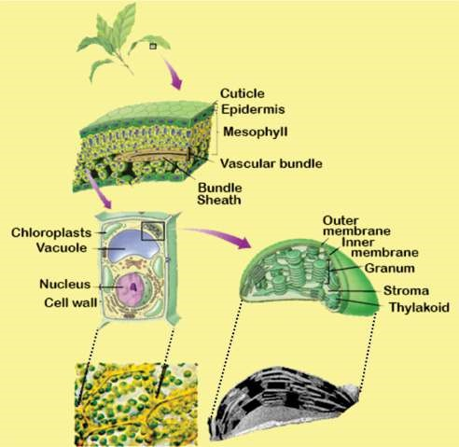

*Fig. 11.1 A plant possesses thick layer of mesophyll cells rich in chloroplasts. Thylakoids in chloroplasts are stacked into grana. Light reactions take place on the grana, and dark reactions in the stroma.*

photosynthesis in most plants. Chloroplasts are present in very large number, about half a million per square millimeter of leaf surface. Chloroplasts are present mainly in the cells of mesophyll tissue inside the leaf (Fig. 11.1). Each mesophyll cell has about 20-100 chloroplasts. Chloroplast has a double membrane envelope that encloses dense luid-illed region, the **stroma** which contains most of the enzymes required to produce carbohydrate molecules. Another system of membranes is suspended in the stroma. These membranes form an elaborate interconnected set of lat, disc like sacs called **thylakoids**. The thylakoid membrane encloses a luid-illed **‘thylakoid interior space’** or **lumen**, which is separated from the stroma by thylakoid membrane. In some places, thylakoid sacs are stacked in columns called **grana** (sing **granum**). Chlorophyll (and other photosynthetic pigments) are found embedded in the thylakoid membranes and impart green colour to the plant. Electron acceptors of photosynthetic ‘Electron Transport Chain’ are also parts of these membranes. Thylakoid membranes are thus involved in ATP synthesis by **chemiosmosis**.

Chlorophyll (and other pigments) absorb light

energy, which is converted into chemical energy *Photosynthetic prokaryotes lack chloroplasts but they dohave unstacked photosynthetic membranes which work like* of ATP and NADPH, the products which are used *thylakoids.* to synthesize sugar in the stroma of chloroplast.

### PHOTOSYNTHETIC PIGMENTS

Light can work in chloroplasts only if it is absorbed. Pigments are the substances that absorb visible light(380-750 nm in wave length). Diferent pigments absorb light of diferent wave lengths (colours), and the wave lengths that are absorbed disappear. An instrument called **Spectrophotometer** is used to measure relative abilities of diferent pigments to absorb diferent wavelengths of light. A graph plotting absorption of light of diferent wave lengths by a pigment is called **absorption spectrum** of the pigment.

Thylakoid membranes contain several kinds of pigments, but **chlorophylls** are the main photosynthetic pigments. Other, accessory photosynthetic pigments present in the chloroplasts include yellow and red to orange **carotenoids; carotenes** are mostly red to orange and **xanthophylls** are yellow to orange. These broaden the absorption and utilization of light energy.

#### Chlorophylls

There are known many diferent kinds of chlorophylls. Chlorophyll a, b, c and d are found in eukaryotic photosynthetic plants and algae, while the other are found in photosynthetic bacteria and are known as **bacteriochlorophylls.**

Chlorophylls absorb mainly violet-blue and orange-red wave lengths. Green, yellow and indigo wave lengths are least absorbed by chlorophylls and are transmitted or relected, although the yellows are often masked by darker green colour. Hence plants appear green, unless masked by other pigments (Fig. 11.4).

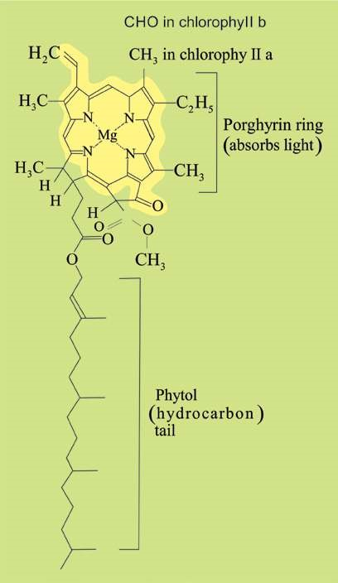A chlorophyll molecule has two main parts : One lat, square, light absorbing hydrophilic head and the other long, anchoring, hydrophobic hydrocarbon tail. The head is complex **porphyrin ring** which is made up of 4 joined smaller pyrrole rings composed of carbon and nitrogen atoms. An atom of magnesium is present in the centre of porphyrin ring and is coordinated with the nitrogen of each pyrrole ring (Fig. 11.2) That is why magnesium deiciency causes yellowing in plants.

**Haem** portion of haemoglobin is also a porphyrin ring but containing an ironatom instead of magnesium atom in the centre.

Long hydrocarbon tail which is attached to one of the pyrrole rings is **phytol** (C20 H39). The chlorophyll

molecule is embedded in the hydrophobic core of thylakoid membrane by this tail.

Chlorophyll a and chlorophyll b difer from each other in only one of the functional groups bonded to the porphyrin; the methyl group (-CH3 ) in chlorophyll a is replaced by a terminal carbonyl group (-CHO) in chlorophyll b.

*Fig. 11.2 A molecule of chlorophyll*

The molecular formulae for chlorophyll a and b are:

Chlorophyll a : C55 H72 05 N4 Mg Chlorophyll b : C55 H70 06 N4 Mg

Due to this slight diference in their structure, the two chlorophylls show slightly diferent absorption spectra and hence diferent colours. Some wave lengths not absorbed by chlorophyll a are very efectively absorbed by chlorophyll b and vice-versa. Such diferences in structure of diferent pigments increase the range of wave lengths of the light absorbed. Chlorophyll a is blue-green while chlorophyll b is yellow-green.

Of all the chlorophylls, chlorophyll a is the-most abundant and the most important photosynthetic pigment as it takes part directly in the light-dependent reactions which convert solar energy into chemical energy. It is found in all photosynthetic organisms except photosynthetic bacteria. Chlorophyll a itself exists in several forms difering slightly in their red absorbing peaks e.g. at 670, 680, 690, 700 nm.

Chlorophyll b is found alongwith chlorophyll a in all green plants (embryophytes) and green algae.

Chlorophylls are insolube in water but souble in organic solvents, such as carbon tetrachloride,alcohol etc.

#### Carotenoids-accessory pigments

Carotenoids are yellow and red to orange pigments that absorb strongly the blueviolet range, diferent wave lengths than the chlorophyll absorbs. So they broaden the spectrum of light that provides energy for photosynthesis.

These and chlorophyll b are called **accessory pigments** because they absorb light and transfer the energy to chlorophyll a, which then initiates the light reactions. It is generally believed that the order of transfer of energy is:

#### carotenoids → chlorophyll b → chlorophyll a

Some carotenoids protect chlorophyll from intense light by absorbing and dissipating excessive light energy, rather than transferring energy to chlorophyll. (Similar carotenoids may be protecting human eye).

### LIGHT-THE DRIVING ENERGY

Light is a form of energy called electromagnetic energy or radiations. Light behaves as waves as well as sort of particles called **photons**. The radiations most important to life are the **visible** **light** that ranges from about 380 to 750 nm in wave length.

It is the sunlight energy that is absorbed by chlorophyll, converted into chemical energy, and drives the photosynthetic process. Not all the. light falling on the leaves is absorbed. Only about one percent of the light falling on the leaf surface is absorbed, the rest is relected or transmitted.

**Absorption spectrum** for chlorophylls (Fig. 11.4) indicates that absorption is maximum in blue and red parts of the spectrum, two absorption peaks being at around 430 nm and 670 nm respectively. Absorption peaks of carotenoids are diferent from those of chlorophylls.

Diferent wavelengths are not only diferently absorbed by photosynthetic pigments but are also diferently efective in photosynthesis. Graph showing relative efectiveness of diferent wavelengths

(colours) of light in driving photosynthesis is called *The irst action spectrum was obtained by German*

**action spectrum**

of photosynthesis (Fig. 11.4)

*biologist, T.W.Engelmann in 1883. He worked o*

*n*

*Spirogyra.*

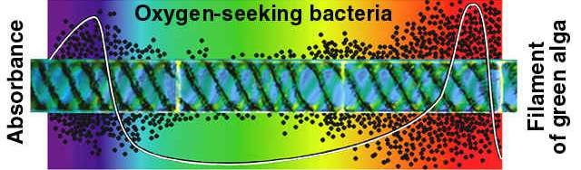

*Fi.g 11.3 Engel man illuminated a ilament of Spirogyra with light that had been passed through a prism. Aerobic bacteria moved toward the portions of the algal ilament emitting the most oxygen, along the cells in blue and red portion of the spectrum.*

**Action spectrum** can be obtained by illuminating plant with light of diferent wavelengths (or colours) and then estimating relative C02 consumption or oxygen release during photosynthesis.

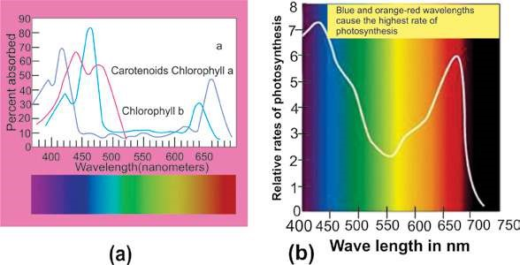

*Fig. 11.4 (a) Absorption spectrum of chlorophyll and carotenoids.*

*(b) Action spectrum for photosynthesis.*

As is evident from above igure 11.4, action spectrum of photosynthesis corresponds to absorption spectrum of chlorophyll. The same two peaks and the valley are obtained for absorption of light as well as for CO2 consumption. This also shows that chlorophyll is the photosynthetic pigment.

However, the action spectrum of photosynthesis does not parallel the absorption specturm of chlorophyll exactly. Compared to the peaks in absorption spectrum, the peaks in action spectrum are broader, and the valley is narrower and not as deep.

(Photosynthesis in the most absorbed range is more than the absorption itself. Likewise, photosynthesis in 500-600 nm (including green light) is more than the absorption of green light by the chlorophyll). This diference occurs because the accessory pigments, the carotenoids, absorb light in this zone and pass on some of the absorbed light to chlorophylls which then convert light energy to chemical energy. When equal intensities of light are given, there is more photosynthesis in red than in blue part of spectrum.

**ROLE OF CARBON DIOXIDE :**

### A PHOTOSYNTHETIC REACTANT

Sugar is formed during **light - independent reactions** of photosynthesis by the reduction of CO2, using ATP and NADH, the products of **light - dependent reactions**. Obviously photosynthesis does not occur in the absence of CO2.

About 10 percent of total photosynthesis is carried out by terrestrial plants, the rest occurs in oceans, lakes and ponds. Aquatic photosynthetic organisms use dissolved CO2, bicarbonates and soluble carbonates that are present in water as carbon source. Air contains about 0.03 - 0.04 percent CO2. Photosynthesis occurring on land utilizes this atmospheric C02.

Carbondioxide enters the leaves through **stomata** and gets dissolved in the water absorbed by the cell walls of mesophyll cells. Stomata are found in a large number in a leaf; their number being proportional to the amount of gas difusing into the leaf. Stomata cover only 1 - 2 percent of the leaf surface but they allow proportionalety much more gas to difuse.

The entry of C02 into the leaves depends upon the opening of stomata. The guard cells guarding the stoma, because of their peculiar structure and changes in their shape, regulate the opening and closing of stomata.

Stomata are adjustable pores that are

usually open during the day when CO2 is *Daily rhythmic opening and closing of stomata is also due to an internalclock located in the guard cells. Even if a plant is kept in a dark closet,* required for photosynthesis and partially *stomata will continue their daily rhythm of opening and closing.* closed at night when photosynthesis stops.

### REACTIONS OF PHOTOSYNTHESIS

Photosynthesis is a **‘redox process’** that can be represented by the following simpliied summary equation:

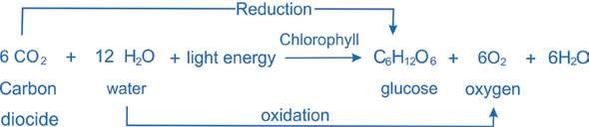

However, it is not a simple, single step process, but is a complex one that is completed by a series of simple steps or reactions. These reactions of photosynthesis consist of two parts:

**The light-dependent reactions (light reactions)** which use light directly and

**The light-independent reactions (dark reactions)** which do not use light directly.

**Light dependent reactions** constitute that phase of photosynthesis during which light energy is absorbed by chlorophyll and other photosynthetic pigment molecules and converted into chemical energy. As a result of this energy conversion, **reducing** and **assimilating power** in the form of NADPH (NADPH + H+) and ATP, are formed, both temporarily storing energy to be carried alongwith H to the light independent reactions.

NADPH provides energized electron (and H+), while ATP provides chemical energy for the synthesis of sugar by reducing CO2, using reducing power and chemical energy of NADPH and ATP respectively, produced by light reactions. The energy is thus stored in the molecules of sugar. This phase of photosynthesis is also called **dark reactions** because these reactions do not use light directly and can take place equally well both in light and dark provided NADPH2 and ATP of light reactions are available.

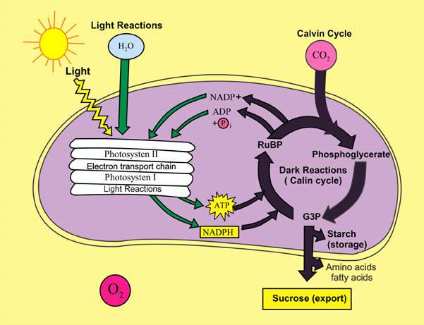

*Fig. 11.5 An overview of photosynthesis : Light - Dependent Reactions (Energy - conversion) and Light - Independent Reactions (Energy*

*- conservation)*

**Light dependent Reactions**

#### (Energy-conversion phase; formation of ATP and NADPH)

As has been described previously, sunlight energy which is absorbed by photosynthetic pigments drives the process of photosynthesis. Photosynthetic pigments are organized into clusters, called **photosystems**, for eicient absorption and utilization of solar energy in thylakoid membranes (Fig.

11.6).

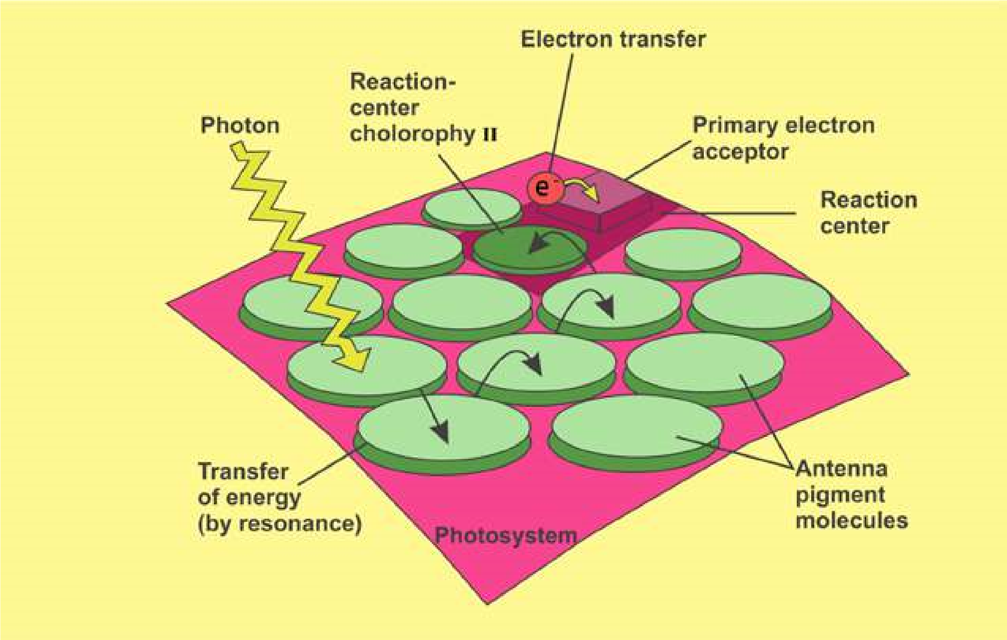

*Fig. 11.6: Light harvesting photosystem. Energy of light (photon) absorbed by photosynthetic pigment molecules is transferred from molecule to molecule, and inally reaches the reaction centre where actual energy conversion begins.*

Each **photosystem** consists of a light-gathering **‘antenna complex’** and a **‘reaction center’**. The antenna complex has many molecules of chlorophyll a, chlorophyll b and carotenoids, most of them channeling the energy to reaction center. Reaction center has one or more molecules of chlorophyll a along with a **primary electron acceptor**, and associated electron carriers of **‘electron transport system’**. Chlorophyll a molecules of reaction center and associated proteins are closely linked to the nearby electron transport system. Electron transport system plays role in generation of ATP by **chemiosmosis** (which will be discussed in later section). Light energy absorbed by the pigment molecules of antenna complex is transferred ultimately to the reaction center. There the light energy is converted into chemical energy.

There are two photosystems, **photosystem I (PS I)** and **photosystem II (PS II)**. These are named so in order of their discovery. **Photosystem** **I** has chlorophyll a molecule which absorbs maximum light of 700 nm and is called **P700,** whereas reaction center of photosystem II has P680, the form of chlorophyll a which absorbs best the light of 680 nm. A specialized molecule called, **primary electron acceptor** is also associated nearby each reaction center. This acceptor traps the high energy electrons from the reaction center and then passes them on to the series of electron carriers. During this energy is used to generate ATP by chemiosmosis.

In predominant type of electron transport called **non-cyclic electron low,** the electrons pass through the two photosystems. In less common type of path called **cyclic electron low** only photosystem I is involved. Formation of ATP during non-cyclic electron low is called **non-cyclic phosphorylation** while that during cyclic electron low is called **cyclic phosphorylation**.

##### Non-cyclic Phosphorylation

1. When photosystem II absorbs light, an electron excited to a higher energy level in the reaction center chlorophyll P680 is captured by the primary electron acceptor of PS II. The oxidized chlorophyll is now a very strong oxidizing agent; its electron “hole” must be illed.
2. This hole is illed by the electrons which are extracted, by an enzyme, from water. This reaction splits a water molecules into two hydrogen ions and an oxygen atom, which immediately combines with another oxygen atom to form O2. This water splitting step of photosynthesis that releases oxygen is called **photolysis**. The oxygen produced during photolysis is the main source of replenishment of atmospheric oxygen.
3. Each photoexcited electron passes from the primary electron acceptor of photosystem II to photosystem I via an **electron transport chain.** This chain consists of an electron carrier called **plastoquinone** (Pq), a complex of two cytochromes and a copper containing protein called **plastocyanin** (Pc).
4. As electrons move down the chain, their energy goes on decreasing and is used by thylakoid membrane to produce ATP. This ATP synthesis is called **photophosphorylation** because it is driven by light energy. Speciically, ATP synthesis during non-cyclic electron low is called **non cyclic photophosphorylation**. This ATP generated by the light reactions will provide chemical energy for the synthesis of sugar during the Calvin cycle, the second major stage of photosynthesis.
5. The electron reaches the “bottom” of the electron transport chain and ills an electron “hole” in P700, the chlorophyll a molecules in the reaction center of photosystem I. This hole is created when light energy is absorbed by molecules of P700 and drives an electron from P700 to the primary acceptor of photosystem I.
6. The primary electron acceptor of photosystem I passes the photoexcited electrons to a second electron transport chain, which tmasmits them to **ferredoxin (Fd)**, an iron containing protein. An enzyme called NADP reductase then transfers the electrons from **Fd** to **NADP**. This is the redox reaction that stores the high-energy electrons in NADPH. The NADPH molecule will provide reducing power for the synthesis of sugar in the Calvin cycle.

The path of electrons through the two photosystems during non-cyclic photophosphorylation is known as **Z-scheme** from its shape.

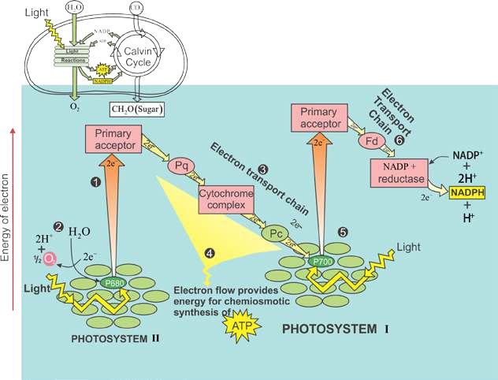

*Fig 11.7: Non-cyclic electron low during photosynthesis ATP, NADPH and oxygen are generated. The arrows trace the current of lightdriven electrons from water to NADPH. Each photon of light excites single electron, but the diagram tracts two electrons at a time, the number of electrons required to reduce NADP+. The numbered steps are described in the text.*

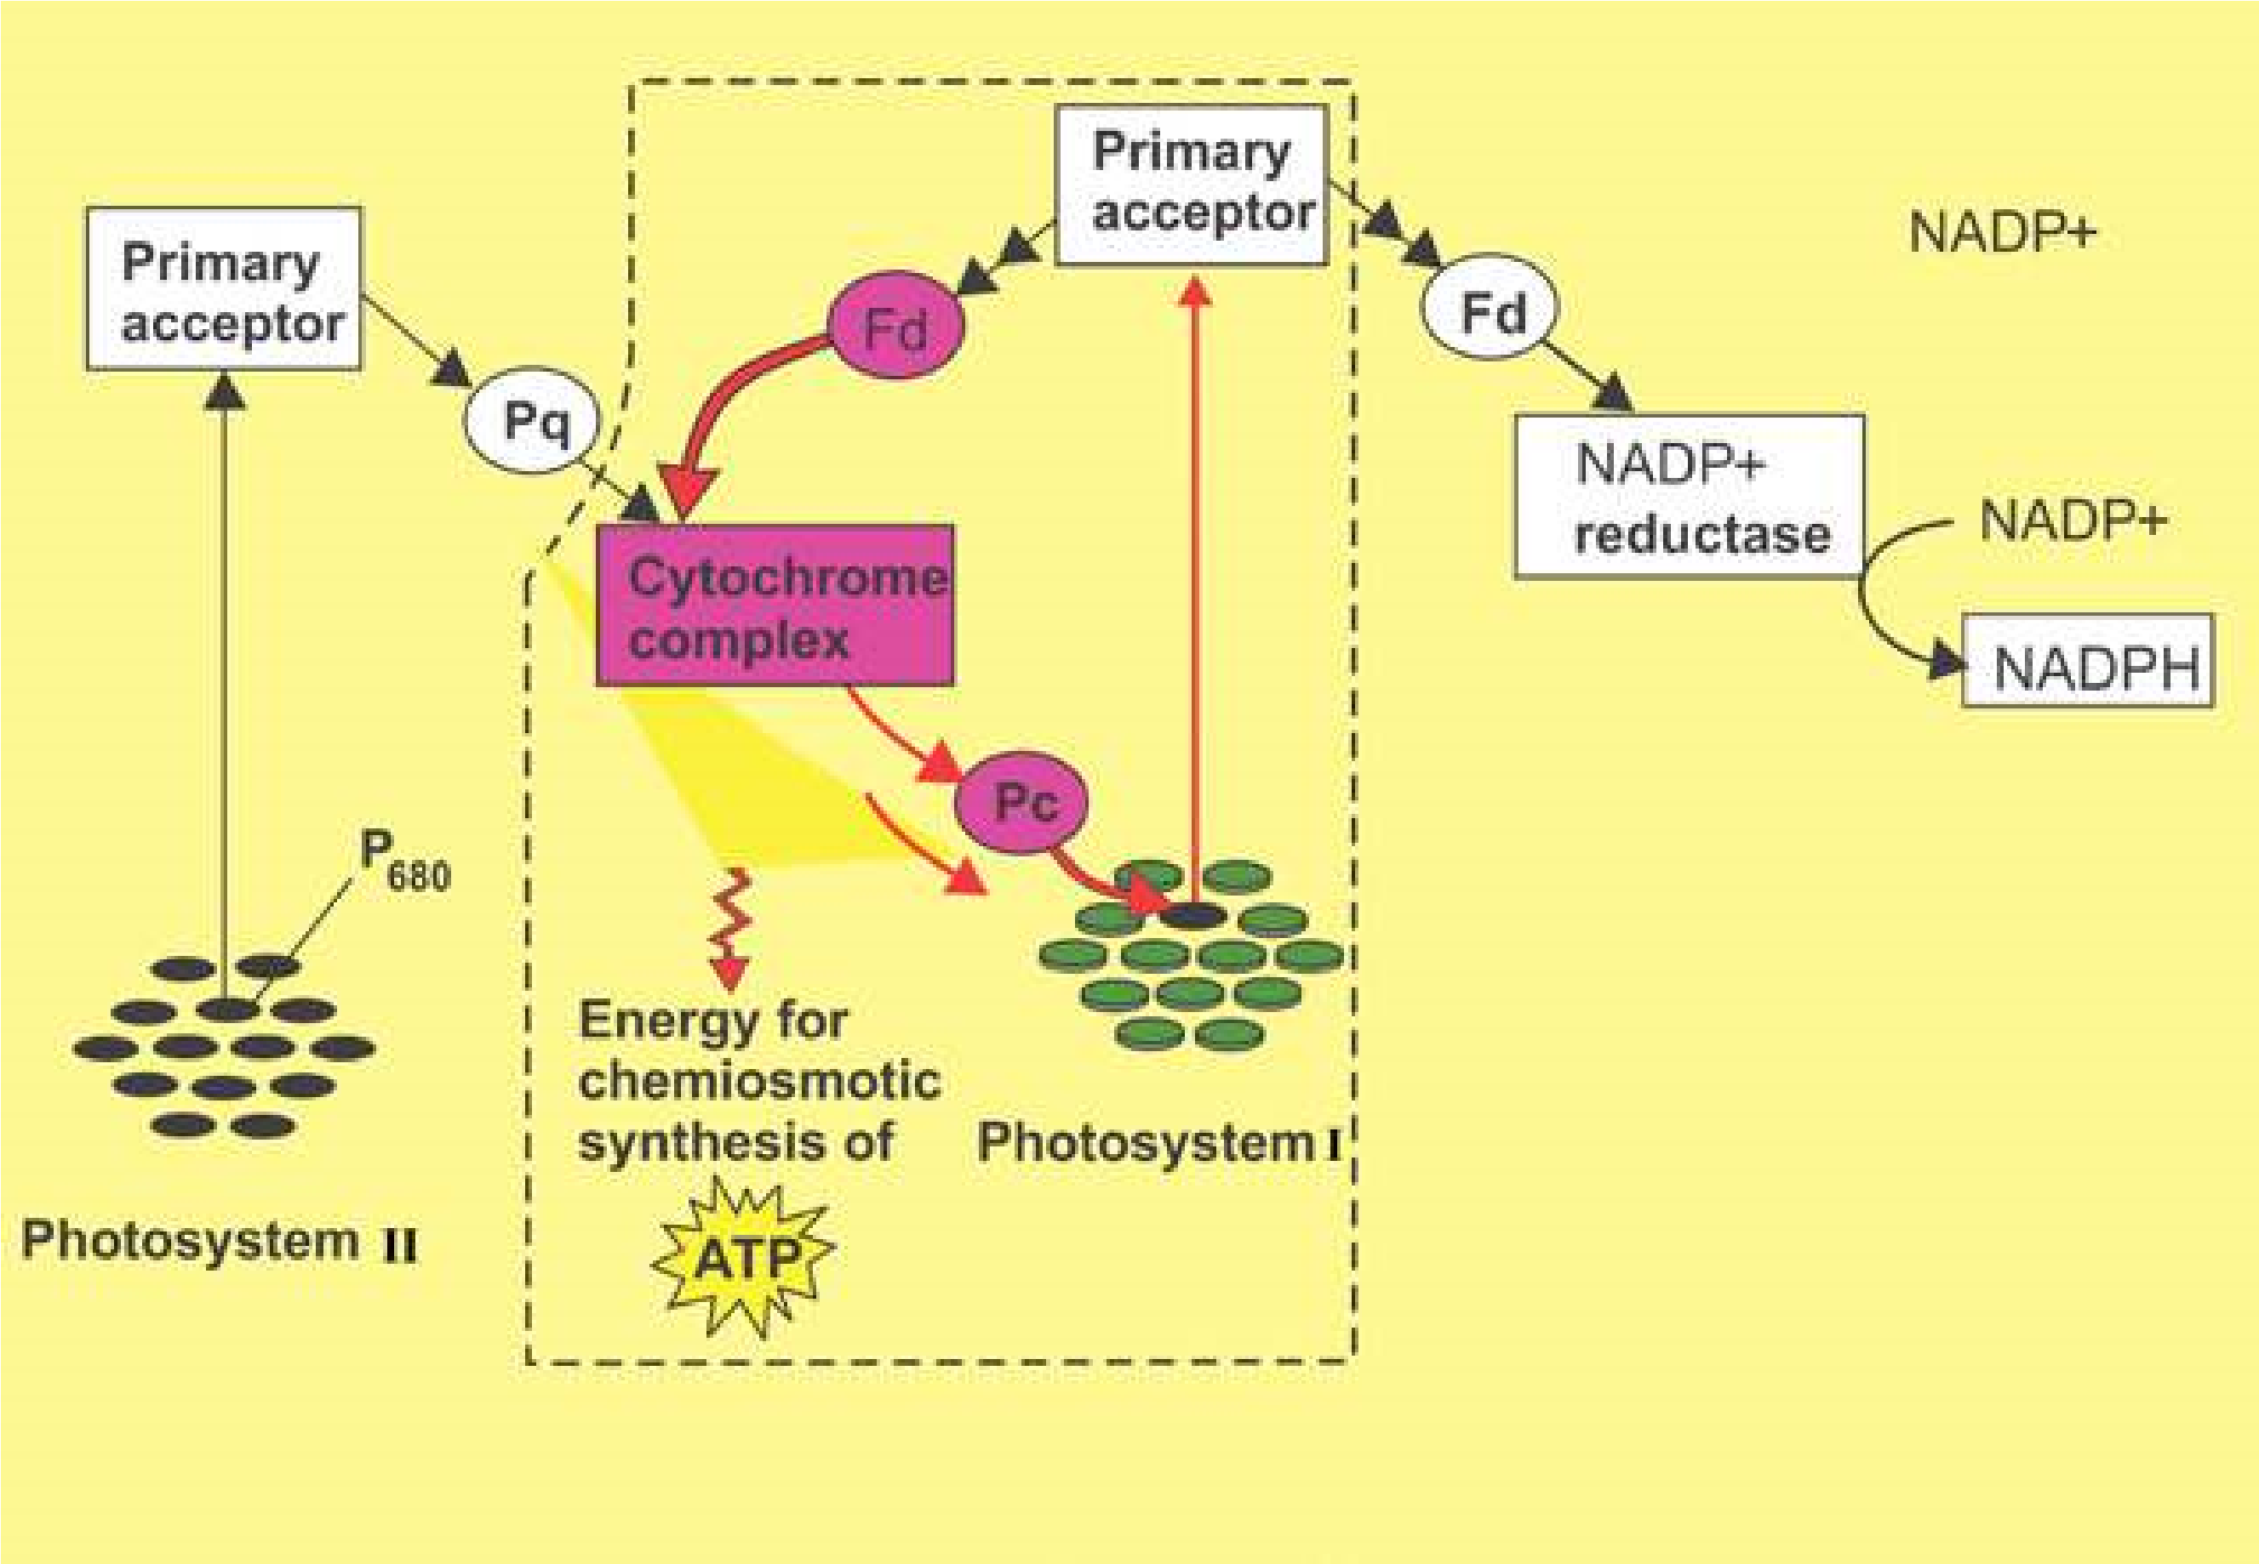

*Fig. 11.8: Cyclic electron low in box. Only PS I involved. ATP is generated but no NADPH and oxygen.*

#### Chemiosmosis

In both cyclic and non-cyclic photophosphorylation, the mechanism for ATP synthesis is **chemiosmosis**, the process that uses membranes to couple redox reactions to ATP production. Electron transport chain pumps protons (H+) across the membrane of thylakoids in case of photosynthesis into the thylakoids space. The energy used for this pumping comes from the electrons moving through the electron transport chain. This energy is transformed into potential energy stored in the form of H+ gradient across the membrane. Next the hydrogen ions move down their gradient through special complexes called **ATP synthase** which are built in the thylakoid membrane. During this difusion of H+ the energy of electrons is used to make ATP (Fig. 11.9).

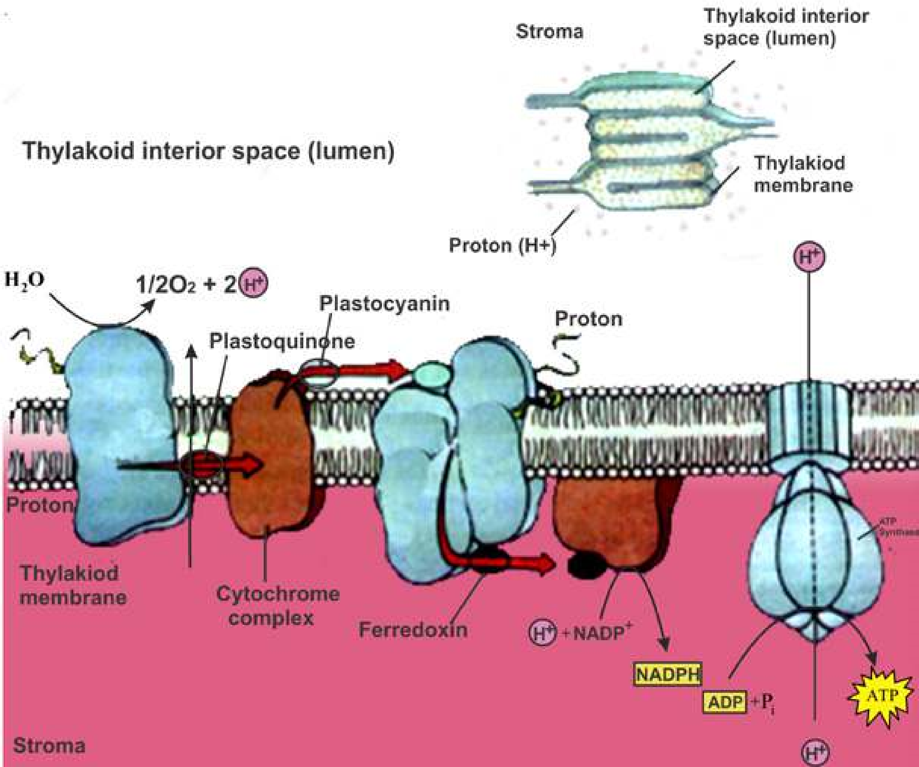

*Fig. 11.9 Electron Transport chain and chemiosmosis, coupling of ETC and formation of ATP by chemiosmosis.*

**Light independent (or Dark) Reactions**

#### Calvin cycle : carbon ixation and reduction phase, synthesis of sugar

The **dark reactions** take place in the stroma of chloroplast. These reactions do not require light directly and can occur in the presence or absence of light provided the assimilatory power in the form of ATP and NADPH, produced during light reactions is available. Energy of these compounds is used in the formation of carbohydrates from C02, and thus stored their in. These reactions can be summarised as follows (Fig. 11.10 ):

3CO + 6NADPH + 9ATP 2 → (CH O) + 6NADP + 9ADP + 9Pi +3H O2 3 2

(carbohydrate)

The details of path of carbon in these reactions were discovered by Melvin Calvin and his colleagues at the University of California. Calvin was awarded Nobel Prize in 1961.

The cyclic series of reactions, catalyzed by respective enzymes, by which the carbon is ixed and reduced resulting in the synthesis of sugar during the dark reactions of photosynthesis is called **Calvin Cycle**.

The **Calvin cycle** can be divided into three phases: Carbon ixation, Reduction, and Regeneration of CO2 acceptor (RuBP) (Fig 11.10).

**Phase 1: Carbon ixation:** Carbon ixation refers to the initial incorporation of CO2 into organic material. Keep in mind that we are following three molecules of CO2 through the reaction (because 3 molecules of CO2 are required to produce one molecule of carbohydrate, a triose). The Calvin cycle begins when a molecule of CO2 reacts with a highly reactive phosphorylated ive - carbon sugar named **ribulose bisphosphate (RuBP).** This reaction is catalyzed by the **enzyme ribulose bisphosphate carboxylase**, also known as Rubisco (it is the most abundant protein in chloroplasts, and probably the most abundant protein on Earth). The product of this reaction is an highly unstable, six - carbon intermediate that immediately breaks into two molecules of three - carbon compound called **3 - phosphoglycerate (phosphoglycerie acid-PGA).** The carbon that was originally part of CO2 molecule is now a part of an organic molecule; the carbon has been “ixed”. Because the product of initial carbon ixation is a three - carbon compound, the Calvin cycle is also known as **C3 pathway**.

**Phase 2: Reduction:** Each molecule of (PGA) receives an additional phosphate from ATP of light reaction, forming **1,3 - bisphosphoglycerate** as the product. 1,3 bisphosphoglycerate is reduced to **glyceraldehyde 3-phosphate(G3P)** by receiving a pair of electrons donated from NADPH of light reactions. G3P is the same three-carbon sugar which is formed in glycolysis (irst phase of cellular respiration) by the splitting of glucose. In this way ixed carbon is reduced to energy rich G3P with the energy and reducing power of ATP and NADPH (both the products of light-dependent reactions), having the energy stored in it. Actually **G3P**, and not glucose, is the carbohydrate produced directly from the Calvin cycle. For every three molecules of CO2 entering the cycle and combining with 3 molecules of ive-carbon RuBP, six molecules of G3P (containing 18 carbon in all) are produced. But only one molecule of G3P can be counted as a net gain of carbohydrate. Out of every six molecules of G3P formed, only one molecule leaves the cycle to be used by the plant for making glucose, sucrose starch or other carbohydrates, and other organic compounds; the other ive molecules are recycled to regenerate the three molecules of ive-carbon RuBP, the CO2 acceptor.

**Phase 3: Regeneration of CO2 acceptor, RuBP:** Through a complex series of reactions, the carbon skeletons of ive molecules of three-carbon G3P are rearranged into three molecules of **ive-carbon ribulose phosphate (RuP)**. Each RuP is phosphorylated to ribulose bisphosphate (RuBP), the very ive-carbon C02 acceptor with which the cycle started. Again three more molecules of ATP of light reactions are used for this phosphorylation of three RuP molecules. These RuBP are now prepared to receive C02 again, and the cycle continues.

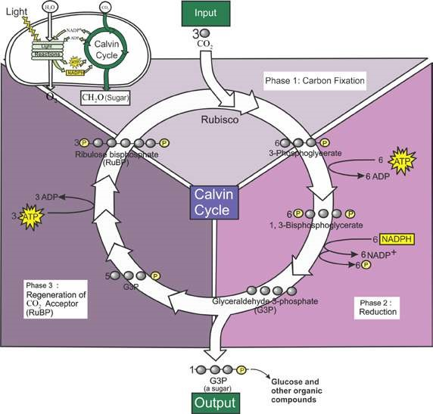

*Fig. 11.10: The Calvin cycle occurs in stroma of chloroplast. Carbon is ixed and reduced to sugar.*

#### RESPIRATION

Living organisms need energy to carry on their vital activities. This energy is provided from within the cells by the phenomenon of respiration. Respiration is the universal process by which organisms breakdown complex compounds containing carbon in a way that allows the cells to harvest a maximum of usable energy.

In biology the term respiration is used in two ways. More familiarly the term respiration means the exchange of respiratory gases (CO2 and O2) between the organism and its environment. This exchange is called **external respiration**. The cellular respiration is the process by which energy is made available to cells in a step by step breakdown of C-chain molecules in the cells.

##### Aerobic and Anaerobic Respiration

The most common fuel used by the cell to provide energy by cellular respiration is glucose,. The way glucose is metabolized depends on the availability of oxygen. Prior to entering a mitochondrion, the glucose molecule is split to form two molecules of pyruvic acid. This reaction is called **glycolysis** (glycolysis literally means splitting of sugar), and occurs in the cytosol and is represented by the equation:

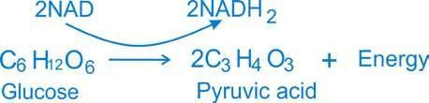

This reaction occurs in all the cells and biologists believe that an identical reaction may have occurred in the irst cell that was organized on earth.

The next step in cellular respiration varies depending on the type of the cell and the prevailing conditions (Fig. 11.11).

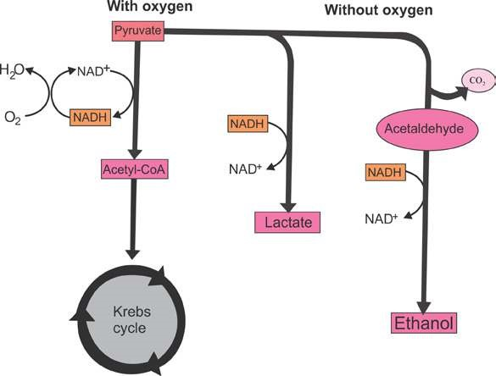

*Fig. 11.11 Pyruvate, the end product of glycolysis, follows diferent catabolic pathways depending on the organism and the metabolic condition.*

Cell processes pyruvic acid in three major ways, alcoholic fermentation, lactic acid fermentation and aerobic respiration. The irst two reactions occur in the absence of oxygen and are referred to as anaerobic (without oxygen). The complete breakdown of glucose molecule occurs only in the presence of oxygen, i.e. in aerobic respiration. During aerobic respiration glucose is oxidized to CO2 and water and energy is released.

##### Anaerobic Respiration

1. **Alcoholic Fermentation:** In primitive cells and in some eukaryotic cells such as yeast, pyruvic acid is further broken down by alcoholic fermentation into alcohol (C2 H5 OH) and CO2.

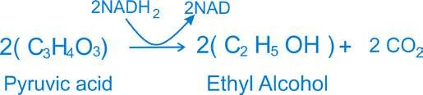

1. **Lactic acid fermentation:** In lactic acid fermentation, each pyruvic acid molecule is converted into lactic acid C3 H6 O3 in the absence of oxygen gas:

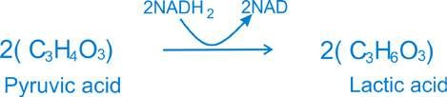

This form of anaerobic respiration occurs in muscle cells of humans and other animals during extreme physical activities, such as sprinting, when oxygen cannot be transported to the cells as rapidly as it is needed.

Both alcoholic and lactic acid fermentations yield relatively small amounts of energy from glucose molecule. Only about 2% of the energy present within the chemical bonds of glucose is converted into adenosine triphosphate (ATP).

**Aerobic respiration** (Discussed in detail under cellular respiration).

**Role of mitochondria in respiration** Mitochondria are large granular or ilamentous organelles that are distributed throughout the cytoplasm of animal and plant cells. Each mitochondrion is constructed of an outer enclosing membrane and an inner membrane with elaborate folds or **cristae** that extend into the interior of the organelle.

Mitochondria play a part in cellular respiration by transferring the energy of the organic molecules to the chemical bonds of ATP. A large “battery” of enzymes and coenzymes slowly release energy from the glucose molecules. Thus mitochondria are the **“Power houses”** that produce energy necessary for many cellular functions.

**Adenosine triphosphate and its importance** Adenosine triphosphate, generally abbreviated ‘ATP’ is a compound found in every living cell and is one of the essential chemicals of life. It plays the key role in most biological energy transformations.

Conventionally, ‘P’ stands for the entire phosphate group. The second and the third phosphate represent the so called “high energy” bonds. If these are broken by hydrolysis, far more free energy is released as compared to the other bond in the ATP molecule. The breaking of the terminal phosphate of ATP releases about 7.3 K cal. of energy. The high energy ‘P’ bond enables the cell to accumulate a great quantity of energy in a very small space and keeps it ready for use as soon as it is needed.

The ATP molecule is used by cells as a source of energy for various functions for example, synthesis of more complex compounds, active transport across the cell membrane, muscular contraction, and nerve conduction, etc.

**Biological oxidation** The maintenance of living system requires a continual supply of free energy which is ultimately derived from various oxidation reduction reactions. Except for photosynthetic and some bacterial chemosynthetic processes, which are themselves oxidation reduction reactions, all other cells depend ultimately for their supply of free energy on oxidation reactions in respiratory processes. In some cases biological oxidation involves the removal of hydrogen, a reaction catalyzed by the **dehydrogenases** linked to speciic coenzymes. Cellular respiration is essentially an oxidation process.

**Cellular Respiration**

Cellular respiration may be sub-divided into 4 stages:

i. Glycolysis ii. Pyruvic acid oxidation iii. Krebs cycle or citric acid cycle iv. Respiratory chain

Out of these stages the irst occurs in the cytosol for which oxygen is not essential, while the other three occur within the mitochondria where the presence of oxygen is essential.

**i. Glycolysis** Glycolysis is the breakdown of glucose upto the formation of pyruvic acid. Glycolysis can take place both in the absence of oxygen (anaerobic condition) or in the presence of oxygen (aerobic condition). In both, the end product of glucose breakdown is **pyruvic acid.** The breakdown of glucose takes place in a series of steps, each catalyzed by a speciic enzyme. All these enzymes are found dissolved in the cytosol. In addition to the enzymes, ATP and **coenzyme NAD (nicotinamide adenine dinucleotide)** are also essential.

Glycolysis can be divided into two phases, a preparatory phase and an oxidative phase (Fig. 11.12). In the preparatory phase breakdown of glucose occurs and energy is expended. In the oxidative phase high energy phosphate bonds are formed and energy is stored.

**Preparatory phase** The irst step in glycolysis is the transfer of a phosphate group from ATP to glucose. As a result a molecule of glucose-6 -phosphate is formed. An enzyme catalyzes the conversion of **glucose-6-phosphate** to its isomer, **fructose-6 - phosphate**. At this stage another ATP molecule transfers a second phosphate group. The product is fructose 1,6-bisphosphate. The next step in glycolysis is the enzymatic splitting of fructose 1 ,6 -bisphosphate into two fragments. Each of these molecules contains three carbon atoms. One is called 3 - phospo- glyceraldehyde, 3-PGAL or Glyceraldehyde **3-phosphate (G3P)** while the other is **dihydroxyacetone phosphate.** These two molecules are isomers and in fact, are readily interconverted by yet another enzyme of glycolysis.

**Oxidative (payof) phase** The next step in glycolysis is crucial to this process. Two electrons or two hydrogen atoms are removed from the molecule of 3- phosphoglyceraldehyde (PGAL) and transferred to a molecule of NAD. This is of course, an oxidation-reduction reaction, with the PGAL being oxidized and the NAD being reduced. During this reaction, a second phosphate group is donated to the molecule from inorganic phosphate present in the cell. The resulting molecule is called **1,3 Bisphosphoglycerate(BPG)**.

The oxidation of PGAL is an energy yielding process. Thus a “high energy” phosphate bond is created in this molecule. At the very next step in glycolysis this phosphate group is transferred to a molecule of adenosine diphosphate (ADP) converting it into ATP. The end product of this reaction is **3-phospho glycerate (3-PG)**. In the next step 3-PG is converted to **2-Phosphoglycerate (2PG).** From 2PG a molecule of water is removed and the product is **phosphoenol pyruvate (PEP)**. PEP then gives up its ‘high energy’ phosphate to convert a second molecule of ADP to ATP. The product is pyruvate, pyruvic acid (C3 H4 O3). It is equivalent to half glucose molecule that has been oxidized to the extent of losing two electrons (as hydrogen atoms).

1. **Pyruvic add oxidation:** Pyruvic acid (pyruvate), the end product of glycolysis, does not enter the Krebs cycle directly. The pyruvate (3- carbon molecule) is irst changed into 2-carbon acetic acid molecule. One carbon is released as CO2 (decarboxylation). Acetic acid on entering the mitochondrion unites with coenzyme-A (Co A) to form acetyl Co A (active acetate). In addition, more hydrogen atoms are transferred to NAD (Fig. 11.13).
2. **Krebs cyde or citric add cycle:** Acetyl CoA now enters a cyclic series of chemical reactions during which oxidation process is completed. This series of reactions is called the Krebs cycle (after the name of the biochemist who discovered it), or the citric acid cycle. The irst step in the cycle is the union of acetyl CoA with oxaloacetate to form citrate. In this process, a molecule of CoA is regenerated and one molecule of water is used. Oxaloacetate is a 4-carbon acid. Citrate thus has 6 carbon atoms.

After two steps that simply result in forming an isomer of citrate, isocitrate another NAD- mediated oxidation takes place. This is accompanied by the removal of a molecule of CO2. The result is a**-ketoglutarate**. It, in turn, undergoes further oxidation (NAD + 2H —> NADH) followed by decarboxylation (CO2) and addition of a molecule of water. The product then has one carbon atom and one oxygen atom less. It is **succinate**. The conversion of a-ketoglutarate into succinate is accompanied by a free energy change which is utilised in the synthesis of an ATP molecule. The next step in the Krebs cycle is the oxidation of succinate to **fumarate**. Once again, two hydrogen atoms are removed, but this time the oxidizing agent is a coenzyme called **lavin adenine dinucleotide (FAD),** which is reduced to **FADH2**.

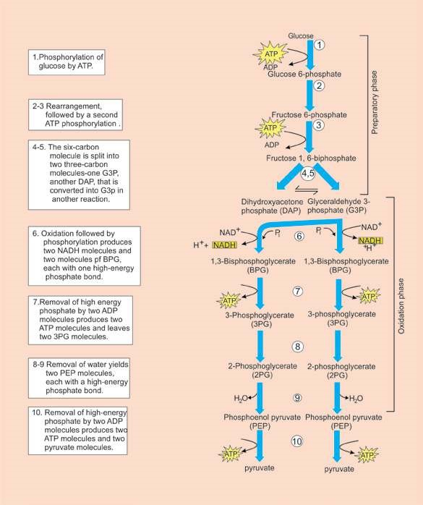

*Fig. 11.12 Two phases of glycolysis. All of these reactions take place in the cytosol.*

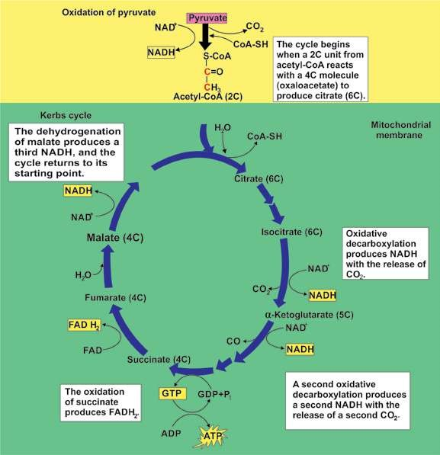

*Fig. 11.13 Outline of the Krebs cycle. The brackets give the number of carbon atom in each intermediate of the cycle.*

With the addition of another molecule of water, fumarate is converted to **malate**. Another NAD mediated oxidation of malate produces **oxaloacetate,** the original 4-carbon molecule. This completes the cycle. The oxaloacetate may now combine with another molecule of acetyl CoA to enter the cycle and the whole process is repeated (Fig. 11.13).

**iv. Respiratory chain:** In the Krebs cycle NADH and H+ are produced from NAD+. NADH then transfers the hydrogen atom to the respiratory chain (also called **electron transport system**) where electrons are transported in a series of oxidation-reduction steps to react, ultimately, with molecular oxygen. (Fig. 11.14).

The oxidation reduction substances which take part in respiratory chain are: i. A coenzyme called coenzyme Q ii. A series of cytochrome enzymes (b,c,a,a3) iii. Molecular oxygen (02)

**Cytochromes** are electron transport intermediates containing **haem** of related prosthetic groups, that undergo valency changes of iron atom. Haem is the same iron containing group that is oxygen carrying pigment in haemoglobin. The path of electrons in the respiratory chain appears to be as follows.

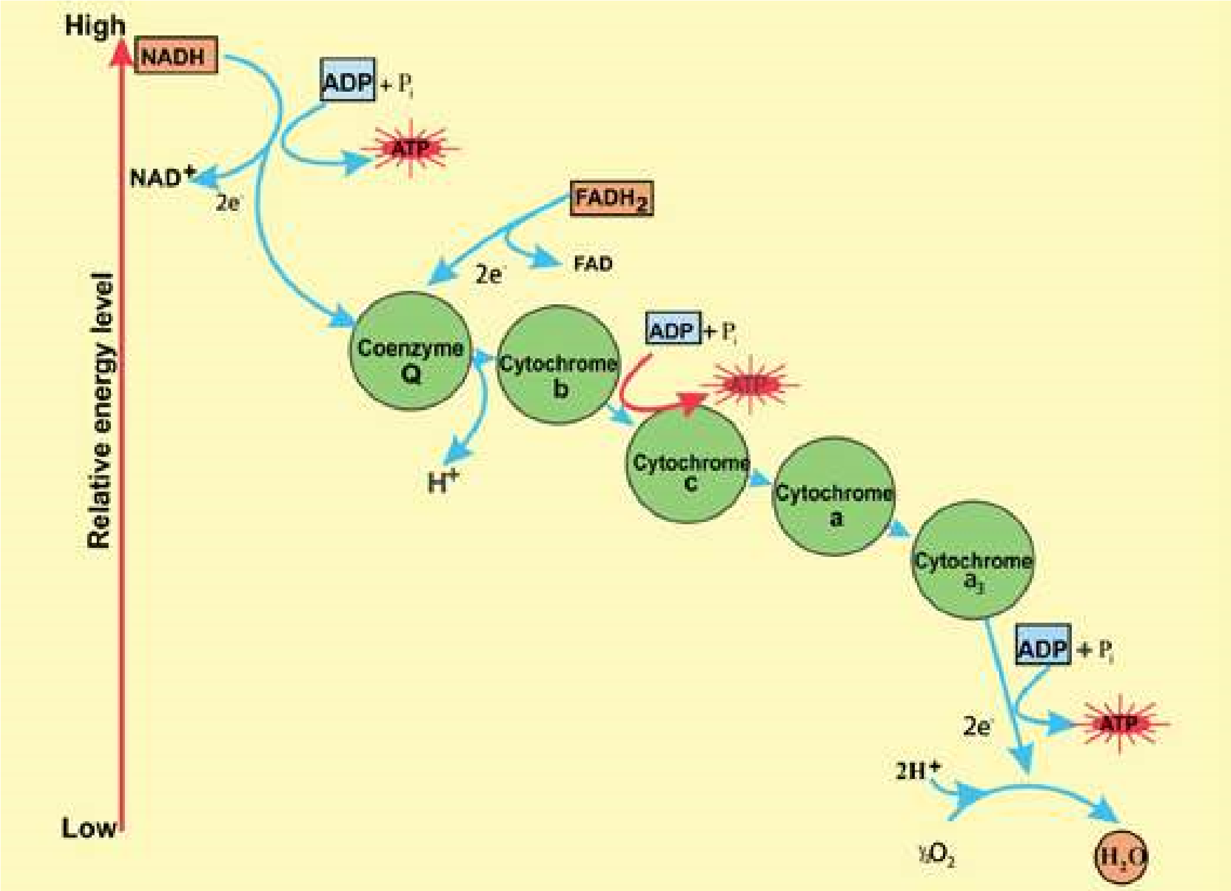

*Fig. 11.14 The repiratory electron transport chain and its coupling with oxidative phosphorylation.*

NADH is oxidized by **coenzyme Q.** This oxidation yields enough free energy to permit the synthesis of a molecule of ATP from ADP and inorganic phosphate. Coenzyme Q is in turn oxidized by cytochrome b which is then oxidized by cytochrome c. This step also yields enough energy to permit the synthesis of a molecule of ATP. Cytochrome c then reduces a complex of two enzymes called cytochrome a and as (for convenience the complex is referred as cytochrome a). Cytochrome a is oxidized by an atom of oxygen and the electrons arrive at the bottom end of the respiratory chain. Oxygen is the most electronegative substance and the inal acceptor of the electrons. A molecule of water is produced. In addition, this inal oxidation provides enough energy for the synthesis of a third molecule of ATP.

**Oxidative phosphorylation:** Synthesis of ATP in the presence of oxygen is called oxidative phosphorylation. Normally, oxidative phosphorylation is coupled with the respiratory chain. As already described ATP is formed in three steps of die respiratory chain (Fig. 11.14). The equation for this process can be expressed as follows:

NADH + H + 3ADP + 3Pi + 1/2 O + **2** →NAD + H O + 3ATP**+** 2 Where Pi is inorganic phosphate.

The molecular mechanism of oxidative phosphorylation takes place in conjunction with the respiratory chain in the inner membrane of the mitochondrion. Here also, as in photosynthesis, the mechanism involved is chemiosmosis by which electron transport chain is coupled with synthesis of ATP. In this case, however the pumping/movement of protons (H+) is across the inner membrane of mitochondrion folded into cristae, between matrix of mitochondrion and mitochondrion’s intermembrane space. The coupling factors in respiration are also diferent from those in photosynthesis.

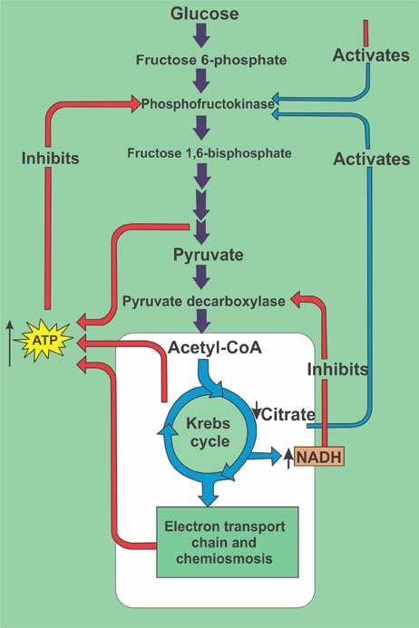*Fig. 11.15 Stages in aerobic respiration. Stage 1: Formation of acetyl-CoA from pyruvate. Stage 2: The Krebs cycle. Stage 3: Respiratory chain and oxidative phosphorylation. Each pair of H atoms entering the respiratory chain as NADH yields 3 ATPs.*

#### EXERCISE

**Q1. Write whether the statement is ‘true’ or ‘false’ and write the correct statement if it is false.**

1. Hydroponics are the plants grown in water culture.

1. Calcium is an essential element for chlorophyll formation.

1. Chlorosis means yellowing of leaves due to deiciency of certain essential element of plant nutrition.

**Q.2. Short questions.**

1. List four features of a leaf which show that it is able to carry out photosynthesis efectively.
2. Summarise the role of water in photosynthesis.
3. What are T.W. Engelman and Melvin Calvin famous for?
4. What is the diference between an action spectrum and an absorption spectrum?

(V) What is the role of accessory pigments in light absorption?

1. When and why is there not net exchange of C02 and O2 between the leaves and the atmosphere?
2. What is the net production of ATP during glycolysis?
3. What is the main diference between photophosphorylation and oxidative phosphorylation?
4. What is the location of ETC and chemiosmosis in photosynthesis and cellular respiration?

(X) How did the evolution of photosynthesis afect the metabolic pathway?

1. How does absorption spectrum of chlorophyll a difer from that of chlorophyll b?
2. Why are the carotenoids usually not obvious in the leaves? They can be seen in the leaves before leaf fall. Why?
3. How is the formation of vitamin A linked with eating of carrot?

**Q.3. Extensive questions**

1. Explain the roles of the following in aerobic respiration: (a) NAD+ and FAD (b) oxygen.
2. Sum up how much energy (as ATP) is made available to the cell from a single glucose molecule by the operation of glycolysis, the formation of acetyl CoA, the citric acid cycle, and the electron transport chain.
3. Trace the fate of hydrogen atoms removed from glucose during glycolysis when oxygen is present in muscle cells; compare this to the fate of hydrogen atoms removed from glucose when the amount of the available oxygen is insuicient to support aerobic respiration.
4. Sketch Kreb’s cycle and discuss its energy yielding steps.
5. Describe various steps involved in oxidative break down of glucose to pyruvate.
6. Sketch respiratory electron transport chain. Discuss the signiicance of ETC.
7. Compare photosynthesis with respiration in plants.
8. Explain the diference between the cyclic and non-cyclic photophosphorylation with the help of Z scheme.
9. Give an account of light-independent reactions of photosynthesis.