CHAPTER

# 5 Variety of Life

1

*Animation 5: Virus*

[*Source & Credit: w*](http://anatomyeshs.wikispaces.com/Ch.16+Respiratory+System)[*hyiles*](http://whyfiles.org/)

Over one and a half million species of animals and over a half million species of plants are known. To deal with such a large collection of dissimilar forms, certainly we need some system by which species can be classiied in a reasonable way. Many types of classiications are possible. We could , for example , classify lowering plants according to their colour, height, or any other character. This type of classiication is not meaningful since it does not provide any information about the basic diferences and similarities among diferent individuals.

All organisms are related to one another at some point in their **evolutionary** **histories**. However, some organisms are more closely related than others. Sparrows are more closely related to pigeons than either to the insects. Classiication is based on relationship amongst individuals, that is, similarity in form or structure. Biologists have classiied all living things into groups showing similarities, based upon homologies, comparative biochemistry, cytology and genetics. Large groups are divided into smaller groups upto species level. **“A species is a group of natural population which can interbreed freely among themselves and produce fertile ofsprings, but are reproductively isolated from all other such groups in nature”.** However “interbreeding” cannot be used as a criterion for species recognition among predominantly asexually reproducing organisms. Each species possessed its own distinct structural, ecological and behavioral characteristics, hence species are independent evolutionary units. Diferent species do not exchange genes between them. Since long the living things are divided in two **kingdoms: plants** and **animals.** Next each kingdom is divided into smaller groups called phyla (also divisions for plants, algae and fungi).

A phylum, in turn, is divided into **classes,** classes into **orders,** and an order into **families**. A family contains related **genera,** and a genus is composed of one or more **species.** Species is the basic unit of classiication. Conversely speaking, the organisms are grouped into larger, more inclusive categories (taxa), each category is more general than the one below it and has emergent properties. The taxonomic categories from species to kingdom form a hierarchy as described in the classiication of corn.

**Biological classiication of Corn, Zea mays**

Kingdom.................................................... Plantae

Division (Phylum)...................................... Anthophyta (Tracheophyta)

Class .......................................................... Angiospermae

Order ......................................................... Poales

Family ........................................................ Poaceae

Genus ........................................................ Zea

Species ...................................................... mays

Members of a lower category resemble one another more than do the members of a higher taxon.

## NOMENCLATURE

From the earliest times plants and animals have been given common names by the people. Since no system was used in choosing common names, in many cases, various regions had their own names for the same plant or animal . Take ‘Onion’ for example; its common urdu name is ‘Piyaz’ but in diferent regions of Pakistan it is also known as ‘ganda’ or ‘bassal’ or ‘vassal’. In diferent countries it would have another set of names. Similarly ‘amaltas’, ‘argvad’, ‘gurmala’, ‘golden shower’, purging cassia’ are common names for the same plant. Thus the same plant may have diferent names. In some cases, a single name refers to several diferent plants or animals. What is ‘blue bell’? Dozen of plants with bell shaped lowers are called **‘blue bells’**. Similarly the word **‘black bird’** would mean a crow as well as a raven.Common names have no scientiic basis. To a biologist, a ish is a vertebrate animal with a backbone, ins and gills. But ‘silver ish’ is an insect, and a ‘cray ish’, ‘jelly ish’ and ‘starish’ do not it the biologist’s deinition of a ish.

Common names had long caused confusion. During the 18th century, Carlous Linnaeus (1707-1778), a Swedish botanist, devised a system for naming and classifying all the organisms known to him. His system is used today internationally. He discarded the common names of **plants** and gave each one a scientiic name. He took the scientiic name from Latin word. Linnaeus publishes the list of names of plants in 1753. The scientiic name of each plant had two parts. Usually, the name referred to some characteristics of the organisms or the person who collected it. His system spread rapidly and became so popular that he used it later on in naming **animals** and published his list in 1758. Many of his names are in use today.

Linnaeus’s system of giving each species a scientiic name comprising two words is known as **binomial nomenclature.** The irst name refers to the **genus** (p1. genera) and is called generic name and always begins with a capital letter. The **speciic** name follows the generic name and begins with small letter. Scientiic name for onion is *Allium cepa,* for amaltas *Cassia istula* and for man *Homo sapiens*. Botanical name for potato is *Solanum tuberosum* and for brinjal *Solanum melangena*. The same generic name for potato and brinjal relects close relationship between theses two-species. Every specie has only one scientiic name the world over. Initially the classiication was based on the appearance or **morphology** of plants and animals but with advancement in the knowledge of cytology, physiology, genetics and molecular biology the classiication of organism has been modiied.

## TWO TO FIVE KINGDOM CLASSIFICATION SYSTEMS

Diferent classiication systems recognize two to six kingdoms. For centuries , the living organisms have been classiied into two kingdoms, **plants** and **animals**. Plants can prepare their own food from simple inorganic material and store energy **(autotrophs)**, while animals can not synthesize their own food from simple inorganic material and depend for their food either on autotrophs or on decaying organic matter **(heterotrophs)**. Bacteria were included in plants. Many biologists found this system satisfactory, while others found it unworkable’ for many unicellular organisms like Euglena that have both plant like (presence of chlorophyll) and animal like (lack of cell wall) characters and also because it ignores the diferences between prokaryotic and eukaryotic cells. In 1866, Ernst Hackel proposed a third kingdom protista to accommodate Euglena like organisms and bacteria. In 1937, E-Chatton suggested diferentiating terms **procariotique** (from Greek pro, meaning before, and karyon, meaning nucleus) used to describe bacteria and blue-green algae, and the term **eu-cariotique** (from Greek eu, mean true) to describe animal and plant cells. Some biologists also disagree about the classiication of **fungi,** such as bread mold, yeast and mushrooms, which resemble plants in many ways but are not autotrophs. Fungi are special forms of heterotrophs that obtain energy and structural material by breaking down **(decomposing)** and **absorbing** food substances from the surroundings, and possess chitin as a major structural component in their cell walls.

A relatively recent system of classiication, the ive kingdom system, was proposed by Robert Whittaker (1969). This system of classiication shown in Fig 5.1 is based on three diferent levels of cellular organization associated with three principal modes of nutrition- **photosynthesis, absorption** and **ingestion.** The ive kingdoms proposed (i) the prokaryotic unicellular organisms **(Monera)** such as bacteria, (ii) the eukaryotic predominantly unicellular organisms **(Protista)** such as *Euglena* and *Amoeba*, (iii) the eukaryotic multicellular autotrophs **(Plantae),** (iv) the eukaryotic multicellular reducers (Fungi) for example mushrooms and (v) the eukaryotic multicellular consumers (Animalia). Plants are autotrophic in nutritional mode, making their own food by photosynthesis such as mosses, ferns, lowering plants. Fungi are heterotrophic organisms that are absorptive in their nutritional mode. Most fungi are decomposers that live on organic material, secrete digestive enzymes and absorb small organic molecules which are produced by digestion. Animals live mostly by ingesting food and digesting it within specialized cavities. They lack cellulose and show movements for example birds and reptiles. In ive kingdom classiication, all eukaryotes that did not it the deinition of plants, fungi or animalia were included in Protista. Most Protists are unicellular forms, but this kingdom also includes relatively simple multicellular organisms that are believed to be direct descendants of unicellular protists.

Lynn Margulis and Karlene Schwartz (1988) modiied ive kingdom classiication of Whittaker by considering cellular organization , mode of nutrition, cytology, genetic and organelles of symbiotic origin (mitochondria , chloroplast). These ive kingdoms are **Prokaryotae** (Monera), **Protoctista** (Protists), **Plantae, Animalia** and **Fungi** (Fig 5.1).

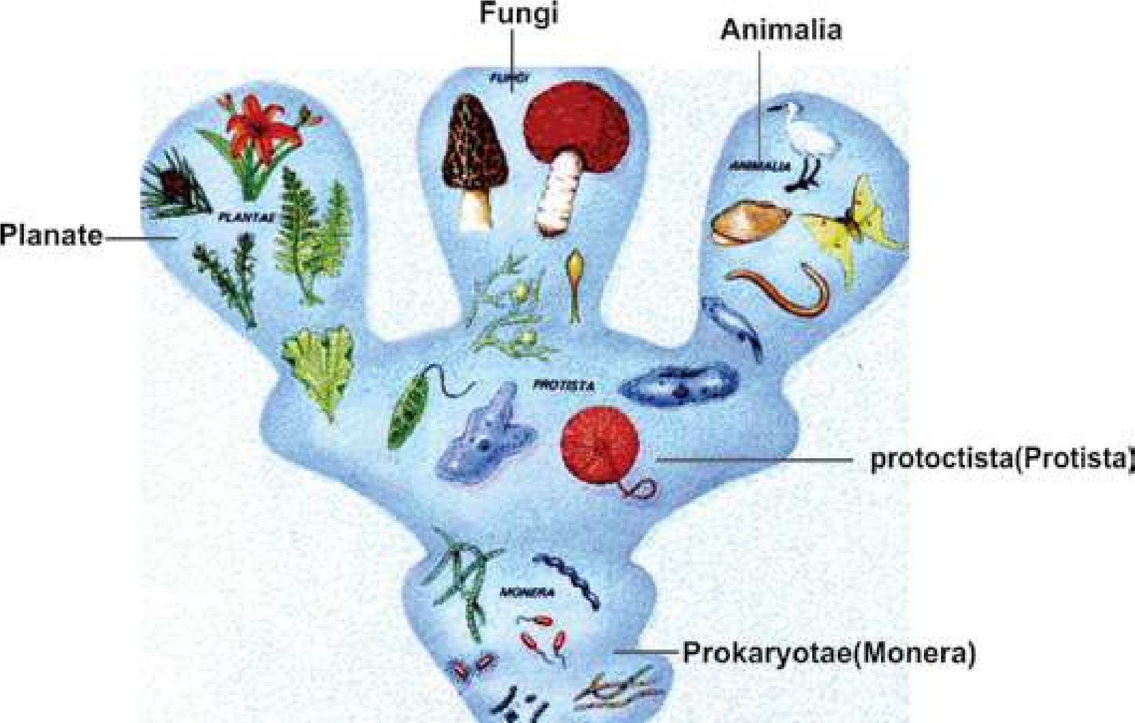

*Fig 5.1 Relationship of Five kingdom*

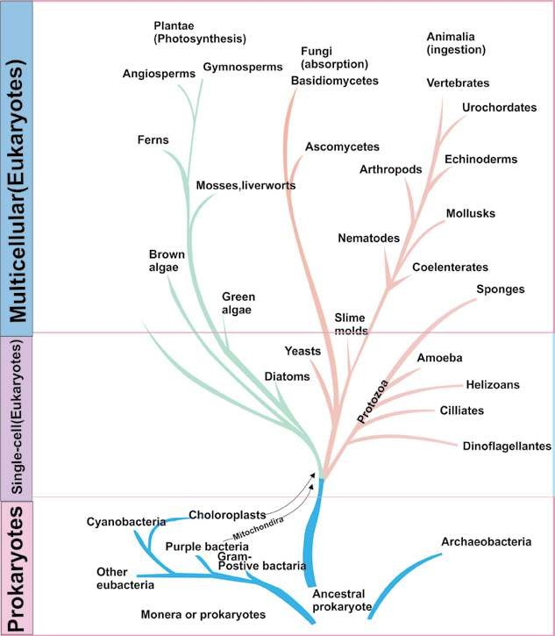

*Fig. 5.2 Five kingdom classiication by Whittaker*

## VIRUSES

About a century ago at the time of Louis Pasteur (1822-1895) and Robert Koch (1843-1910), the word “virus” was generally referred to as a poison associated with disease and death. The present notion of virus is entirely diferent. Now viruses are recognized as particles of nucleic acid often with a protein coat. They replicate in living cells and cause many diseases such as inluenza, hepatitis, small pox and AIDS. In this section the focus is on the properiies of viruses and life cycle of bacterial viruses, also known as bacteriophages. Some diseases caused by viruses shall also be discussed in this section. The branch which deals with the study of viruses is known as **virology**.

The word virus is derived from Latin word **venome** meaning poisonous luid. It can be deined as non cellular infectious entities which contain either RNA or DNA, normally encased in proteinaceous coat, and reproduce only in living cells. Viruses utilize the biosynthetic machinery of the host for its own synthesis and then transfer themselves eiciently to other cells.

Some viral diseases have been known for centuries. In fact, the irst infectious disease against which efective method of prevention was developed was a viral disease. In 1796, Edward Jenner irst vaccinated an 8 years old boy with material removed from cowpox lesion on the hand of milkmaid. After six weeks the boy was inoculated with pus from a small pox victim, but he did not develop the disease. Later, Jenner used material for vaccination from cowpox lesions and successfully vaccinated 23 persons. As the material he used was obtained from cow (latin **vacca**), latter the term **vaccination** was used by Louis Pasteur for inoculation against disease.

In 1884, one of Pasteur’s associates, Charles Chamberland, found that bacteria can not pass through porcelain ilters, while agent responsible for rabies (a disease which is transferred to human by bites of rabid dogs, foxes, cats, bats and other animals) can pass through these ilters. As in those days the word virus was loosely used to describe any toxic substance that caused disease, those unseen ilterable agents of disease were described as ilterable viruses. In 1892, Ivanowski discovered that the agent which caused tobacco mosaic disease was ilterable. He obtained bacteria free iltrate from ground up infected plants and placed it on healthy leaves of tobacco. He observed that iltrate produced the disease in healthy plants. After that, presence of similar ilter-passing, ultramicroscopic agents was seen in the victims of many diseases, including foot and mouth disease (1898) and yellow fever (1901).

The ilterable agents were irst puriied in 1935, when

Stanley was successful in crystallizing the

**tobacco mosaic**

**virus**

d

. Chemical analysis of these particles showe

that they contained only nucleic acid and protein. This

suggested that, unlike other forms, viruses are of simple

chemical composition.

*Bacteriophages, viruses that infect bacteria, wer*

*e*

*discovered independently by Twort in 1915 an*

*d*

*D’Herelle in 1917. Twort observed that bacteria*

*l*

*colonies sometimes undergo Lysis (dissolved an*

*d*

*disappeared) and that this lysis can be transferre*

*d*

*from one colony to other. Even highly dilute*

*d*

*c*

*material from lysed colony can transfer the lyti*

*efect. However, heating the iltrate destroye*

*d*

*e*

*its lytic property. From these observations h*

*concluded that lytic agent might be a virus. D’Herell*

*e*

*rediscovered this phenomena in 1917 and used th*

*e*

*word bacteriophages meaning “bacteria eater”.*

*Animation 5.1: Virus*

*Source and Credit:*

*geocitie*

[*s*](http://www.geocities.ws/micro2052000/viruses.htm)

### Characteristics

Viruses are extremely small infectious agents, which can only be seen under an electron microscope. They range in size from 250 nanometer (nm) of poxviruses to the 20 nm of parvoviruses. They are 10 to 1000 times smaller than most bacteria, so they can pass through the pores of ilter, from which bacteria cannot pass. Viruses cannot be grown on artiicial media. They can reproduce only in animal and plant cells or in microorganisms, where they reproduce by replication (a process by which many copies or replicas of virus are formed). Thus the viruses are **obligate intracellular parasites**. Viruses lack metabolic machinery for the synthesis of their own nucleic acid and protein. They depend on the host cell to carry out these vital functions. During reproduction in the host cells, viruses may cause disease. All viruses are generally resistant to broad range of available antibiotics such as penicillin, streptomycin and others.

#### Structure

The complete, mature and infectious particle is known as **virion**. The virions are composed of a central core of **nucleic acid**, either DNA or RNA, which is also known as **the genome** and is surrounded by a protein coat, **the capsid**. Capsid gives deinite shape to virion. Capsid is made up of protein subunits known as **capsomeres**. The number

of capsomeres is characteristics of a particular virus. *The most recently discovered (1983) and leastupderstood micro organisms are the* **prions,**

For example 162 capsomeres are present in the capsid *which may be infectious proteins. Their nature is* of **herpes virus** and 252 in the capsid of **adenovirus** *very controversial. They are composed of protein only that contains the information that codes* which cause some common colds. In some animal viruses *for their own replication. All other organisms* the **nucleocapsid** (nucleic acid and capsid) is covered *contain their genetic information in nucleic acid* by another membrane derived from the host cell, **the** *(cow infection and mysterious brain infection inDNA or RNA). Prions are responsible for mad* **envelope**. Non enveloped viruses are known as naked *man.*

virions. Animal and plant viruses may be polyhedron

(having many sides), helical (Spiral), enveloped or complex.

Bacterio-phages occur in two structural forms having cubical or helical symmetry. In general appearance cubical phages are regular solid or **icosahedral** (having 20 faces), and **helical** phages are rod shaped. Many phages consist of head and tail. In those cases heads are polyhedral but tails are rod shaped. Morphology of some viruses and bacteriophages has been shown in Fig 5.3.

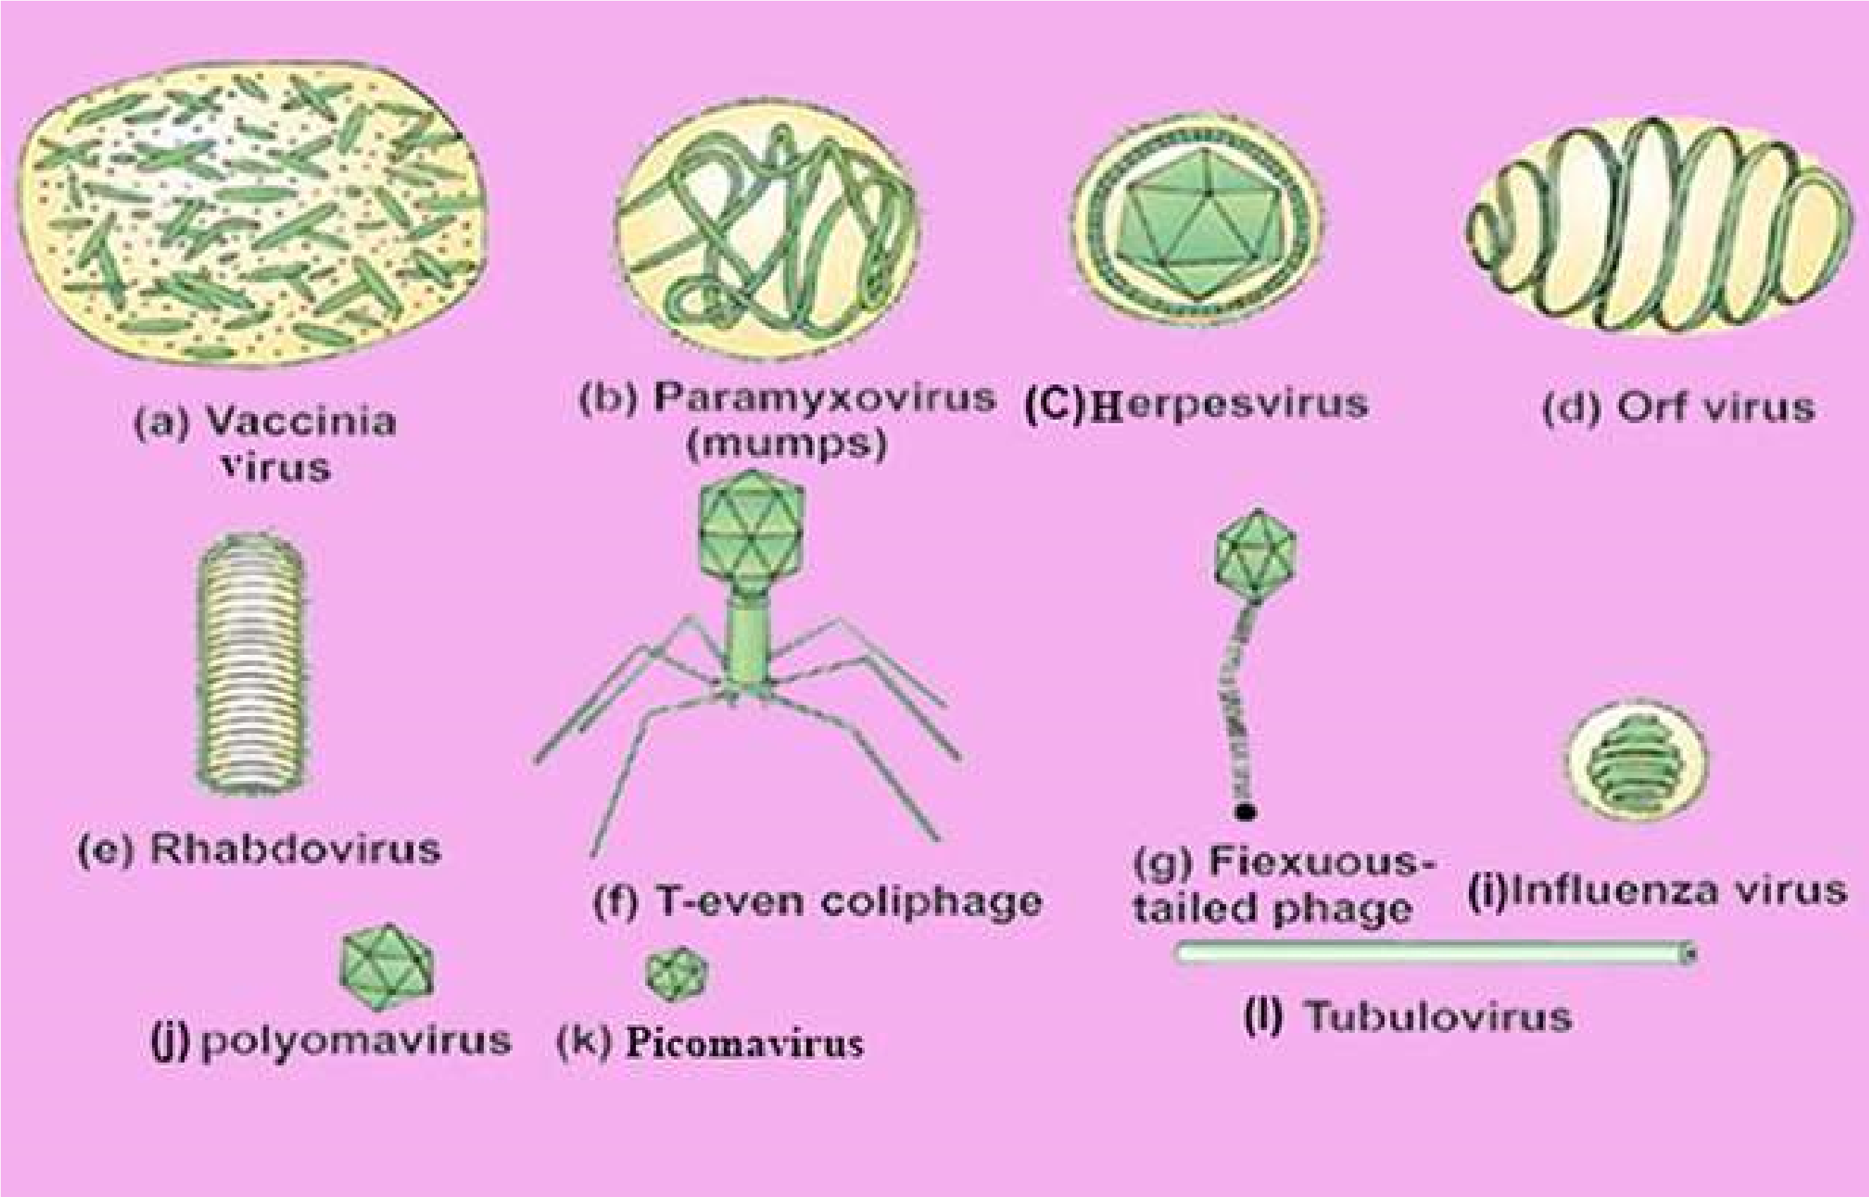

[*Fig. 5.3 Diferent types of viruses*](http://www.sabaq.pk/video-page.php?sid=sindh-biology-11th-4.4&v=b-the%20cell-29)

[**Life Cycle of Bacteriophages**](http://www.sabaq.pk/video-page.php?sid=sindh-biology-11th-4.4&v=b-the%20cell-29)

[Earlier researches on bacteriphages were mainly on limited number of phages that infect *Escherichia coli***.** Of these the best known phages are T phages (T for type).](http://www.sabaq.pk/video-page.php?sid=sindh-biology-11th-4.4&v=b-the%20cell-29)

[Among T phages, the T2 and T4 phages are mainly used in phage studies. The overall structure of T4, studied with electron microscopy, resembles that of tadpole, consisting of head and tail (Fig 5.4). The head is an elongated pyramidal (having two triangular structures with common base), hexagonal , prism -shaped structure, to which straight tail is attached. Within the head double stranded DNA molecule is present. The structure of phage tail is more complex than head. A layer of distinct protein forms the inner tube or core, which is enclosed in **sheath** made up of another type of protein. On one side of sheath is **collar** and on other side is end plate. To end plate six **tail**](http://www.sabaq.pk/video-page.php?sid=sindh-biology-11th-4.4&v=b-the%20cell-29)

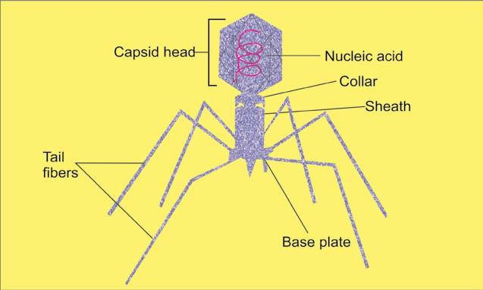

*Fig. 5.4 A Bacteriophage*

**ibers** are attached, which are the structures for attachment. The volume of the phage is about 1/1000 of the host.

The bacteriophage replicates only inside the bacterial cell. The irst step in the replication of a bacteriophage is its **attachment (adsorption)** to host cell at receptor site on the cell wall of bacterium. During attachment, week chemical union between virion and **receptor site** takes place. In the next step, **penetration**, the tail releases the enzyme **lysozyme** to dissolve a portion of the bacterial cell wall. The tail sheath contracts and tail core is forced into the cell through cell wall and cell membrane. The virus injects its DNA into the cell just as the syringe is used to inject the vaccine. The protein coat, which forms the phage head and tail structure of virus remains outside the cell (Fig 5.5). Many animal viruses, however enter the host cell as a whole.

Immediately after entering the host cell , the viral nucleic acid takes the control of the host’s biosynthetic machinery and induces the host cell to synthesize necessary viral components (DNA, proteins), and starts **multiplying**. About 25 minutes after initial infection, approximately 200 new bacteriophages are formed, bacterial cell bursts, i.e., it undergoes lysis. Newly formed phages are released to infect the bacteria and another cycle, **the lytic** **cycle** begins (Fig. 5.6). The phage which causes lysis of the host cell is known as **lytic or virulent phage.**

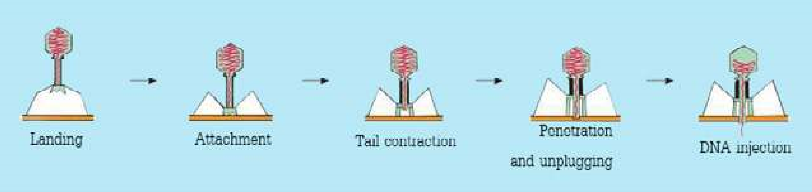

*Fig 5.5 A phage injecting its DNA in to host*

*Animation 5.2: Viruses*

*Source and Credit:*

*geocities.w*

[*s*](http://www.geocities.ws/micro2052000/viruses.htm)

*Video 5.3: Endoplasmic Reticulum (ER),Ribosomes*

*Source and Credit:*

*Saba*

[*q*](http://www.sabaq.pk/)

*Animation 5.4: Life Cycle of Bacteriophages*

*Source and Credit:*

*faculty.ccbcm*

[*d*](http://faculty.ccbcmd.edu/courses/bio141/lecguide/unit4/viruses/lytlc.html)

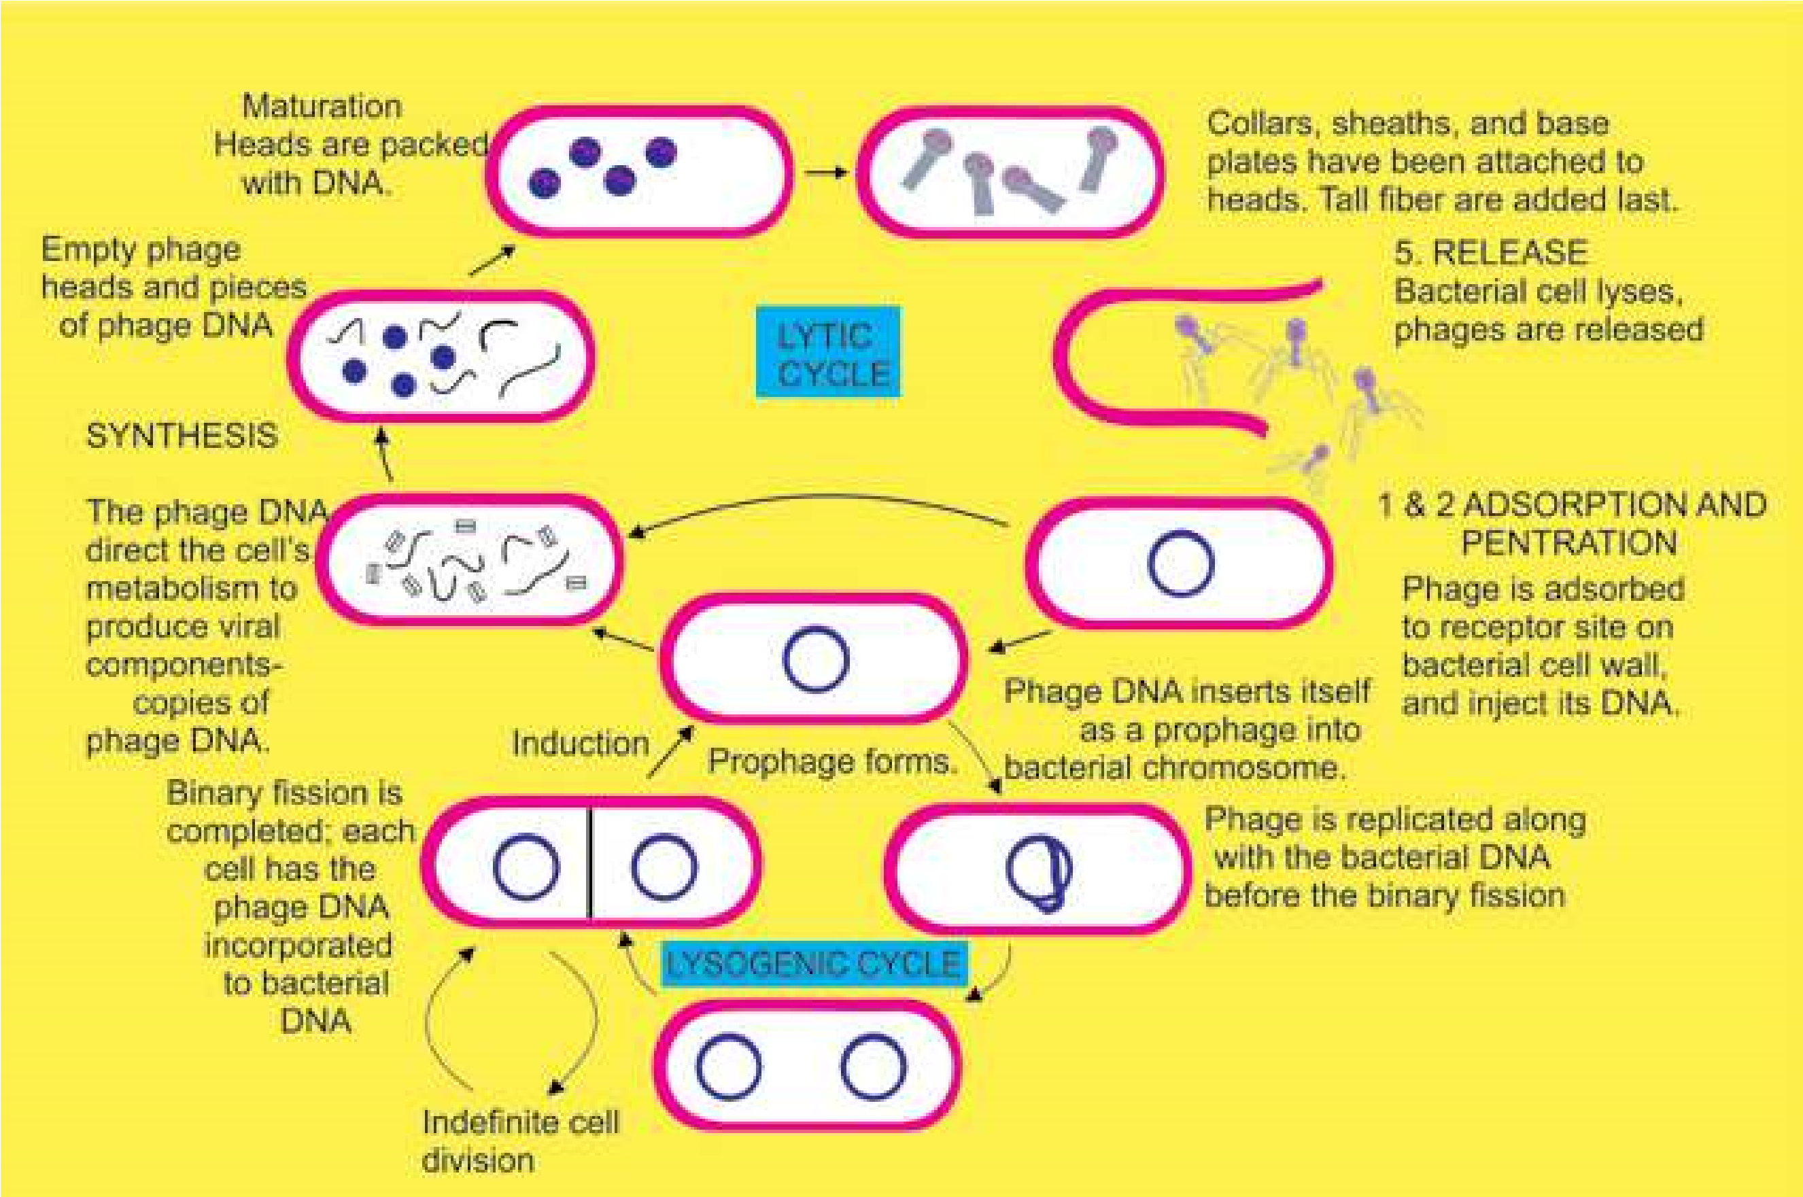

*Fig. 5.6 Replication of a bacteriophage. After adsorption and penetration, the virus DNA undergoes prophage formation (1) In the Iysogenic cycle, phages can exist harmlessly as a prophage with in the host cell for long periods of time. Each ti.ne the bacterial chromosome is replicated, the prophage also is replicated, and hence all daughter bacterial cell are “infected”! with the prophage. Induction involves either a spontaneous or environmentally induced excision of the prophage from the bacterial chromosome. (2) A typical lytic cycle, involves synthesis and maturation of phage and new phages are released.*

All infections of bacterial cells by phages do not result in lysis. In some cases viral DNA, instead of taking over the control of host’s machinery, becomes incorporated into the bacterial chromosome. Phage in this state is called **prophage** and this process is known as **lysogeny.** In this condition the bacterium continues to live and reproduce normally. Viral DNA being the part of bacterial chromosome passes to each daughter cell in all successive generations. Some times, however, the viral DNA gets detached from the host’s chromosome and lytic cycle starts. This process is called **induction.** Lysogenic bacteria are resistant to infection by the same or related phages. The phage which causes lysogeny is called **temperate (lysogenic) phage**.

### Classiication of Viruses

Virus morphology and nucleic acid properties are most important for classifying plant, animal and bacterial viruses. The genetic material may be DNA or RNA naked, enveloped or complex. On the basis of morphology viruses are classiied into rod shaped (T.M.V), spherical (poliovirus) and tadpole like bacteriophage viruses etc. Fig. 3.5 and 5.4.

### Some Viral Diseases

There are many diseases which are caused by viruses. Only those are being mentioned here which have been or are common in Pakistan.

**Small pox:** Smallpox, which is caused by pox viruses (the DNA enveloped virus) is an ancient disease that is known to have occurred as epidemic in China as early as the twelfth century B.C. Until the early twentieth century , small pox was a common disease throughout the world. In small pox, raised luid-illed vesicles are formed on the body which become pustules later on and form pitted scars, **the pocks**. By 1950’s immunization and other control measures had largely decreased the danger, but it is still present in the third world countries where many people are afected. In 1980, it was declared by World Health Organization that small pox has been eradicated from the world.

**Herpes simplex:** Herpes virus (DNA virus) is responsible for this disease. It is naturally occurring disease of mankind. In this vascular lesions in the epithelial layers of ectodermal tissues are formed. Most commonly this disease occurs in the mouth, on the lips, and at other skin sites.

**Inluenza:** Inluenza viruses are enveloped RNA viruses. Inluenza is wide spread disease in man and occurs in epidemic form.

**Mumps and Measles:** Mumps and Measles viruses belong to group **paramyxoviruses**. They are large, enveloped, RNA viruses. Mumps is highly contagious, wide spread, but seldom fatal. About 60% of adults are immune to it. Measles is one of the commonest diseases of the childhood and adult human population is equally susceptible the world over. This disease develops immunity in its victim.

**Polio:** Poliomyelitis, caused by polio virus, is found all over the world . It occurs mostly in childhood.

The age at which primary infection occurs varies with social and economic factors. The polioviruses are the smallest known viruses and contain RNA in spherical capsid. Some common human viral dieases are shown in Fig 5.7.

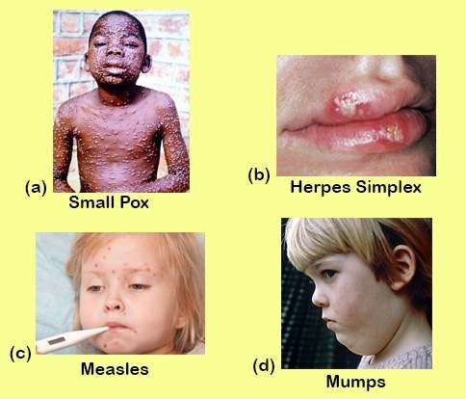

*Fig. 5.7 Some common human viral diseases*

#### Retroviruses

RNA tumor viruses have been known for many years. These viruses are widely distributed in nature and are associated with tumor production in a number of animal species, such as fowl, rodents and cats. The most familiar of viruses is the **human immunodeiciency virus (HIV)** which causes **acquired immune deiciency syndrome (AIDS).**

The single stranded RNA tumor viruses, which also include **retroviruses (oncoviruses),** are spherical in form , about lOOnm in diameter and enveloped by host plasma membrane. Although a few retroviruses are non speciic that is they can infect any cell, most of them can infect only host cells that possess required receptors. In the case of AIDS virus, the host cell possesses a receptor that allows the viral adsorption and penetration in several types of **leukocytes** (white blood cells) and tissue cells. The retroviruses have a special enzyme called **reverse transcriptase,** which can convert a single -stranded RNA genome into double stranded viral DNA. Not only this DNA can infect host cells, but it also can be incorporated into host genome as a **provirus** that can be passed on to progeny cells. In this way, some of retroviruses can convert normal cells into cancer cells.

### Acquired Immune Deiciency Syndrome (AIDS)

The AIDS was reported by some physicians in early 1980’s in young males having one or more of complex symptoms such as severe pneumonia , a rare vascular cancer, sudden weight loss, swollen lymph nodes and general loss of immune functions. All these young patients were homosexuals. Soon after the disease was discovered in nonhomosexual patients who were given blood (blood transfusion) or blood products. In 1984 the agent causing the disease was identiied by research teams from Pasteur Institute in France and National Institute of health in USA. In 1986 the virus was named as **human immunodeiciency virus (HIV)** (Fig 5.8). The major cell infected by HIV is the helper **T-lymphocyte**, which is major component of immune system. As the HIV infection continues in the host, the decrease of helper T-lymphocytes results in failure of the immuhe system and the infected person becomes susceptible to other diseases. Cells in central nervous system can also be infected by HIV Fig. 5.9. Recent studies on HIV reveal that the virus infects and multiplies in monkey but does not cause disease in them, which means that HIV is **host speciic.**

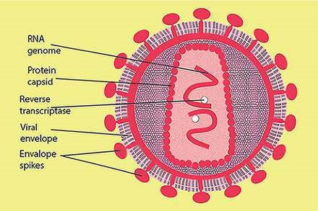

*Fig. 5.8 Human immunodeiciency virus (HIV)*

The HIV is transmitted by intimate sexual contact, contact with blood and breast feeding. Healthcare workers can also acquire HIV during professional activities. Avoiding the direct contact with HIV is important measure for preventing the disease. Prevention of’ intravenous drugs with common syringes and use of sterile needles/syringes and utensils is important. Now vaccine against HIV has been synthesized and its experimental administration in humans started in early 2001 in South Africa.

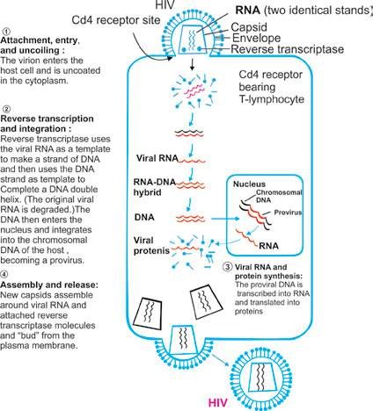

*Fig 5.9 Infection cycle of HIV*

### Hepatitis

Hepatitis is an inlammation of the liver. It is usually caused by viral infection, toxic agents or drugs. It is characterized by jaundice, abdominal pain, liver enlargement, fatigue and some times fever. It may be mild or can be acute and can lead to liver cancer. The diferent types of viral hepatitis are **Hepatitis A** (formerly called infectious hepatitis is transmitted by contact with faeces from infected individuals.) **Hepatitis B** (serum hepatitis). **Hepatitis C** (formerly called non-A, non-B hepatitis) passes through blood, from mother to child during pregnancy and afterward and by sexual contact. **Hepatitis D** (delta hepatitis), **Hepatitis E** (a virus transmitted through the faeces of an infected person), **Hepatitis F, G** (caused by viruses yet unidentiied). Viruses of hepatitis A, B and C are better known. Hepatitis A virus **(HAV)** is an RNA virus (non enveloped), which causes mild short term, less virulent disease. Hepatitis C virus **(HCV)** is also RNA virus (enveloped) causes infusion hepatitis, which is less severe than hepatitis A or hepatitis B, but hepatitis C often leads to chronic liver disease. Most recent work of Halbur and coworker (2001) reveals that pig could be the source of infection of hepatitis E.

Hepatitis B **(HBV)** is the second major form of hepatitis. It is caused by DNA virus which is very common in Asia, China, Philippines, Africa and the Middle East. Hepatitis B is transmitted by the exchange of body luids, for example blood serum, breast milk and saliva, from mother to child during birth or afterward and by sexual contact.. During acute attacks of Hepatitis B fatigue, loss of appetite and jaundice are reported. Infected persons can recover completely and become immune to the virus. People with chronic hepatitis infection are at the risk of liver damage. Hepatitis can be controlled by adopting hygienic measures, with routine vaccination and screening of blood/ organ/ tissue of the donor.

Genetically engineered vaccine is available for HBV.

Vaccine is also available for HAV but not for HCV.

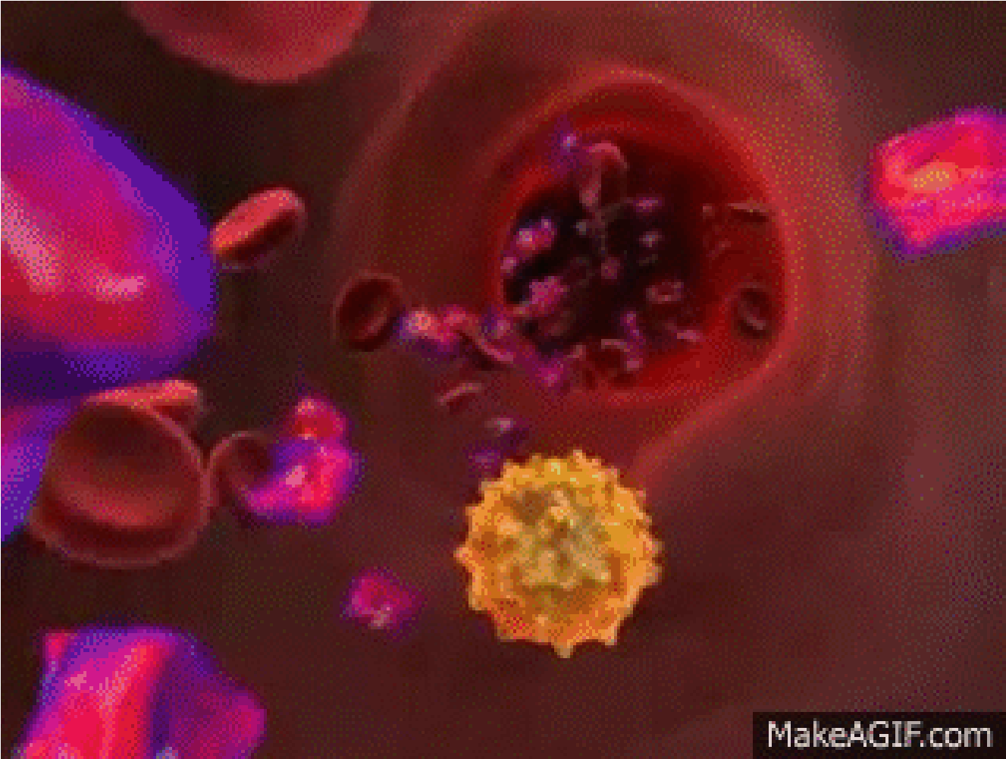

*Animation 5.5: HIV*

*Source and Credit:*

*makeagi*

[*f*](http://makeagif.com/CIRXAi)

**EXERCISE**

#### Q.1. Fill in the blanks

1. C. Linneaus divided all known forms of life into two kingdoms: _______ a n d ____. Bacteria were placed in the kingdom ________ because they have cell walls, and protozoa were placed in the kingdom ___________because they move from place to place and ingest food.
2. The most common system of classiication used today, developed in 1969 by Robert Whittaker of Cornell University, uses ive kingdoms: _________ and________.
3. Whittaker’s ive kingdom system of classiication recognizes two basic types of cells : __________ and _____________ .
4. In ive kingdom system of classiication proposed by Margulis and Schwartz organelles of symbiotic origin such a s an d _______ were also considered.
5. A bacteriophage reproduces by using the metabolic machinery of______________.
6. The protein coat that encloses the viral genome is called :___________ It is made up of__________ .
7. Retroviruses are ___________ viruses which have speciic enzymes _______________ by which they convert RNA to DNA.
8. HIV infects ___________ and the defects in these cells lead to failure in ____________ system.
9. Hepatitis is caused by ________ .
10. Viral Hepatitis is of _________types. Hepatitis A and C are caused by ___________ virus whereas _________ virus is the causative agent of Hepatitis B.

CHAPTER

6 Kingdom

Prokaryotae

# )Monera(

*Animation 6.1: Enzyme*

[*Source & Credit: Wikispaces*](http://anatomyeshs.wikispaces.com/Ch.16+Respiratory+System)

1

Kingdom Prokaryotae consists of organisms with prokaryotic cells. In Greek the word *Pro* **means** “before” and *karyon* means nucleus. Microbiologists place bacteria in two major categories: eubacteria (Greek for “true bacteria”) and a much smaller division, the archaeobacteria (Greek for “ancient bacteria”).

## DISCOVERY OF BACTERIA

It had long been suspected that small creatures exist which are too small to be seen with naked eye. But their discovery was linked to the invention of microscope. A Dutch Scientist “AntonieVan Leeuwenhoek” (1673) was the irst to report the microbes such as bacteria and protozoa. He used a simple microscope to describe bacteria and protozoa with accurate drawings and descriptions and called these small creatures as **“animalcules”**. He irstly observed small creatures in rain water, then conirmed these in saliva, vinegar, infusions and other substances.

The progress in understanding the nature and importance of these tiny organisms has been slow. The existance of microbes was further conirmed by Louis Pasteur’s work. Pasteur went on making many discoveries in the ield’of microbiology and medicine. His main achievements are the development of vaccines for disease **anthrax, fowl cholera** and **rabies.** He also made signiicant contributions in development of pasteurization process and development of fermentation industries. He proved that microorganisms could cause disease.

Rohert Koch formulated the **‘germ theory of disease’**. He isolated typical rodshaped bacteria with squarish ends (baccilli) from (he blood of sheep that had died of anthrax. Then he discovered bacteria that caused **tuberculosis** and cholera. He formulated four **postulates,** which are the main pillars of the germ theory of disease. These are used to ind out whether the organism found in disease lesions is the causal agent of the disease or not.

1. A speciic organism can always be found in association with a given disease.
2. The organism can be isolated and grown in pure culture in the laboratory.
3. The pure culture will produce the disease when inoculated into susceptible animal.
4. It is possible to recover the organism in pure culture from experimentally infected animal.

Koch and his colleagues invented many techniques concerning inoculation, isolation, media preparation, maintenance of pure cultures and preparation of specimens for microscopic examinations.

## OCCURRENCE OF BACTERIA

Bacteria are wide spread in their occurrence. They are found almost everywhere, in air, land, water, oil deposits, food, decaying organic matter, plants, man and animals. Their kind and number vary according to locality and environmental conditions. Some bacteria are always present and contribute towards the natural lora. Others are present in speciic environments such as hot springs, alkaline/ acidic soil, highly saline environments, in highly polluted soils and waters.

*Animation 6.2: Bacteria Animate*

[*d*](http://www.sabaq.pk/video-page.php?sid=punjab-biology-11th-6.1&v=b-k-prokaryotae-3)

*Source and Credit:*

*pintere*

[*s*](https://www.pinterest.com/pin/457326537136238880/)

[*t*](https://www.pinterest.com/pin/457326537136238880/)

## STRUCTURE OF BACTERIA

All bacterial cells invariably have a cell membrane, cytoplasm, ribosome, and chromatin bodies. The majority have a cell wall, which gives shape to the bacterial cell. Speciic structures like capsule, slime, lagella, pili, imbriae and granules are not found in all bacteria (refer to Fig. 4.17).

### Size

Bacteria range in size from about 0.1 to 600 nm over a single dimension. Bacteria vary in size as much as in shape. The smallest (e.g., some members of *Recently a huge bacterium has been* the genus *Mycoplasma*) are about 100 to 200 nm in diameter, *discovered in the intestine of the brown* approximately the size of the largest viruses (poxviruses) *surgeonish, Epulopiscium ishelsoni grows as large asAcanthurus nigrofuscus. Escherichia coli,* a bacillus of about average size, is 1.1 to 1.5 *600 nm by 80 nm, a little smaller than a* nm wide by 2.0 to 6.0 nm long. Some spirochetes occasionally *printed hyphen. It is now clear that a fewbacteria are much larger than the average* reach 500 nm in length whereas Staphylococci and Streptococci *eukaryotic cell.* are 0.75 - 1.25n in diameter.

### Shape of Bacteria

On the basis of general shape, bacteria are classiied into three categories. These shapes are known as cocci, bacilli and spiral .Although most of the bacterial species have fairly constant characteristic cell shape, yet some cells are pleomorphic and they can exist in a variety of shapes.

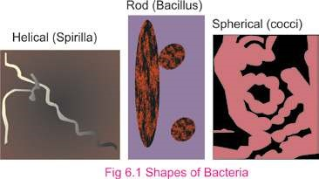*Exceptions to the above shapes are trichome forming, sheathed, stalked, square, starshaped, spindle-shaped, lobed and ilamentous bacteria.*

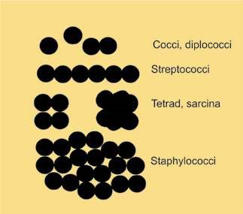The **cocci** are spherical or oval bacteria having one of several distinct arrangements based on their planes of division. If division is in one plane it will produce either a **diplococcus** or **streptococcus** arrangement. When cocci occur in pairs then arrangement is diplococcus, whereas when cocci form long chain of cells then arrangement is called as streptococci. When the division of cell is in two planes it will produce a **tetrad** arrangement. A tetrad is a square of 4 cocci. Thirdly, when the division is in three planes, it will produce a **sarcina** arrangement. Sarcina is a cube of 8 cocci. When division occurs in random planes, it will produce a **staphylococcus** arrangement in which cocci are arranged in irregular, often grape-like clusters. *Diplococcus pneumoniae* and *Staphylococcus* *aureus* are some examples of cocci.

*Fig. 6.2 Cocci*

*Animation 6.3: Bacteria shape*

*Source and Credit:*

*gif2l*

[*y*](http://www.gif2fly.com/Bacillus%20Bacteria.html)

**Bacilli**

are rod-shaped bacteria. Bacilli all

divide in one plane producing a

**bacillus,**

**streptobacillus,**

or

**diplobacillus**

. Bacillus

is a single cell of bacteria. Streptobacillus is

a chain of bacilli. When rod shaped bacteria

occur in pairs then arrangement of cells

is known as diplobacilli. Examples of rod

shaped bacteria are

*Escherichia coli, Bacillus*

*subtilis*

,

*Pseudomonas.*

**The spiral**

shaped bacteria are spirally

coiled. Spirals come in one of three forms, a

**vibrio**

, a

**spirillum,**

or a

**spirochete**

. Vibrio

is curved or comma-shaped rod. Spirillum

is a thick, rigid spiral. Spirochete is a thin,

lexible spiral. Examples of spiral shaped

bacteria are

*Vibrio, Hyphomicrobium.*

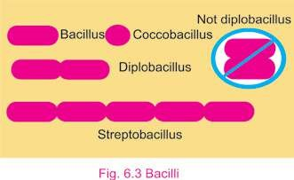

*Animation 6.4: Bacillus Bacteria*

[*y*](http://www.gif2fly.com/Bacillus%20Bacteria.html)

*gif2l*

*Source and Credit:*

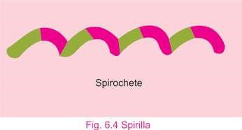

*Animation 6.5: Spirillum*

*Source and Credit:*

*gifsou*

[*p*](http://gifsoup.com/view/3788307/spirillum.html)

### Bacterial Cell Structure

**Flagella and their frictions :** These are extremely thin, hair like appendages. They come out through cell wall and originate from basal body, structure just beneath the cell membrane in the cytoplasm. They are made up oif protein **lagellin**. On the basis of presence of lagella, pattern of attachment of lagella and the number of lagella present bacteria are classiied into diferent taxonomic groups. **Atrichous** means bacteria are without any lagella. When single polar lagellum is present then condition is known as **monotrichous.** If tuft of lagella is present only at one pole of bacteria then these are lophotrichous lagella. **Amphitrichous** is a condition when tuft of lagella at each of two poles is present. In **peritrichous** form, lagella surround the whole cell. Most of bacilli and spiral shaped bacteria have lagella. Cocci very rarely have lagella.

Primary function of lagella is to help in motility.With the help of lagella, lagellate bacteria can also detect and move in response to chemical signals which is a type of behaviour called as *Chemotaxis.*

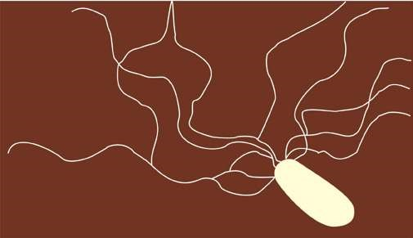

*Animation 6.6: Flagel*

[*o*](http://www.sabaq.pk/video-page.php?sid=punjab-biology-11th-6.1&v=b-k-prokaryotae-3)

*Source and Credit:*

*gifso*

[*u*](http://gifsoup.com/view/4678852/flagelo.html)

[*p*](http://gifsoup.com/view/4678852/flagelo.html)

*Fig. 6.5 Rod shaped bacterium with lagella (lophotricous)*

### Pili and their Functions

These are hollow, nonhelical, ilamentous appendages. **Pili** are smaller than lagella and are not involved in motility. True pili are only present on gram-negative bacteria. They are made up of special protein called **pilin**. They are primarily involved in a mating process between cells called **conjugation** process. Some pili function as a **means** of attachment of bacteria to various surfaces.

### The cell envelope: The outer wrapping of bacteria

Bacterial surface and walls are very diverse. Collectively complexes of layer external to the cell protoplasm are called as cell envelope and include capsule, slime and cell wall.

**Capsule :** Bacteria produce capsule, which is made up of repeating polysaccharide units, and of protein, or of both, capsule is tightly bound to the cell. It has a thicker, gummy nature that gives sticky characters to colonies of encapsulated bacteria. It provides pathogenicity.

**Slime :** Some bacteria are covered with loose, soluble shield of macromolecules which is called as slime capsule and slime provides greater pathogenicity to bacteria and protects them against phagocytosis.

**Cell Wall:** Beneath the extracellular substances and external to cytoplasmic membrane cell wall is present. It is a rigid structure. It determines the shape of bacterium. Cell wall also protect the cells from osmotic lysis. Cell wall is only absent in mycoplasmas. Christain Gram developed the technique of gram stain. Bacteria could be divided into two groups based on their response to gram staining procedure. By this Staining technique **Gram-positive bacteria** are stained purple (retain the primary dye due to formation of CV-I complex) and **Gram-negative bacteria** are stained pink (retain secondary dye) in colour. There are many structural diferences between two groups (Table 6.1) which are the primary basis for diference in staining behaviour.

**Table 6.1: Comparison of Gram-positive and Gram-negative cell walls.**

|  |  |  |
| --- | --- | --- |
| **Characteristics** | **Gram-Positive** | **Gram-negative** |
| Number of major layers | 1 | 2 |
| Chemical make up | Peptidoglycan (50% of dry weight in some bacterial cells)  Teichoic acid  Lipoteichoic acid | Lipopolysaccharides  Lipoproteins  Peptidoglycan  10% dry weight of some  bacterial cells |
| Overall thickness | Lipids (1-4%) 20-80 nm | Lipids (11-12%) 8-11 nm |
| Outer membrane | No | Yes |
| Periplasmic space | Present in some | Present in all |
| Permeability | More permeable | Less permeable |

The cell walls of most bacteria have a unique macromolecule called as **peptidoglycan**. Its amount varies in diferent types of bacteria. It is composed of framework of long glycan chains cross-linked with peptide fragments. The intact cell wall also contains chemical constituents such as sugar molecules, teichoic acid, lipoproteins and lipopolysaccharides, which are linked to peptidoglycan.

Several bacterial groups lack the cell wall structure characteristic of Gram positive or Gram negative bacteria, and some bacteria have no cell wall at all. Cell walls of archacnbactcria are diferent from eubacteria. They do not contain peptidoglycan. Their cell walls are composed of proteins, glycoproteins and polysaccharides).

*Animation 6.7: Bacteria, gram positive*

*bacilli*

*Source and Credit:*

*gif2l*

[*y*](http://www.gif2fly.com/Bacillus%20Bacteria.html)

### Cell Membrane

Just beneath the cell wall is the cell membrane or plasma membrane. It is very thin, lexible and completely surrounds the cytoplasm. Plasma membrane is very delicate in nature any damage to it results in death o f the organism. Bacterial membranes difer from eukaryotic membranes in lacking sterols such as cholesterol.

Cell membrane regulates the transport of proteins, nutrients, sugar and electrons or other metabolites. The plasma membranes of bacteria also contain enzymes for respiratory metabolism.

### Cytoplasmic matrix

The cytoplasm of prokaryotic cell lacks membrane bound organelles and cytoskeleton (microtubules). The cytoplasmic matrix is the substance present between the plasma membrane and the nucleoid. It has gel like consistency. Small molecules can move through it rapidly. The plasma membrane and every thing present within it is known as protoplast. Thus the cytoplasmic matrix is a major part of protoplast. Other large discrete structures such as chromatin /nuclear body, ribosomes, mesosomes and granules and nucleoid are present in this matrix.

#### Nucleoid

A bacterial cell unlike the cells of eukaryotic organisms lacks discrete chromosomes and nuclear membrane. The nuclear material or DNA in bacterial cells occupies a position near to the center of cell. This material is a single, circular and double *Other names for nucleoid are nuclear body, chromatin* stranded DNA molecule. It aggregates as an *body and nuclear region.*

irregular shaped dense area called the **nucleoid**. *It is visible in the light microscope after staining with* This **chromatin** **body** is actually an extremely long *Feulgen stain.*

molecule of DNA that is tightly folded so as to it *Excherichi coli closed circle chromosome measures* inside the cell component. Since bacteria have a *approximately 1,4000 nm* single chromosome, they are haploid.

#### Plasmid

Many bacteria contain plasmids in addition to chromosomes. These are the circular, double stranded DNA molecules. They are self-replicating and are not essential for bacterial growth and metabolism. They often contain drug resistant, heavy met- *Plasmids are important vectors, in modem genetic* als, disease and insect resistant genes on them. *engineering techniques.*

#### Ribosomes

Ribosomes are composed of RNA and proteins. Some may also be loosely attached to plasma membranes. They are protein factories. There are thousands of ribosomes in each healthy growing cell. They are smaller than eukaryotic ribosomes.

#### Mesosomes

The cell membrane, invaginates into the cytoplasm forming structure called as **mesosome**. Mesosomes are’in the form of vesicles, tubules or lamellae. Mesosomes are involved in DNA replication and cell division where as some mesosomes are also involved in export of exocellular enzyme. Respiratory enzymes are also present on the mesosomes.

### Granules and storage bodies

Since bacteria exist in a very competitive environment where nutrients are usually in short supply. They tend to store extra nutrients when possible. These may be glycogen, sulphur, fat and phosphate. In addition, cells contain waste materials that are subsequently excreted. For example, common waste materials are alcohol, lactic acid and acetic acid.

### Spores

Certain species of bacteria produce spores, either external to the vegetative cells (exospores) or [within the vegetative cells (endospores). They are metabolically dormant bodies and are produced at a late-stage of cell growth. Spores are resistant to adverse physical environmental conditions such as light, high temperature, desiccation, pH and chemical agents, Under favorable conditions they germinate and form vegetative cells.](http://www.sabaq.pk/video-page.php?sid=sindh-biology-11th-4.4&v=b-the%20cell-29)

[**Cysts**](http://www.sabaq.pk/video-page.php?sid=sindh-biology-11th-4.4&v=b-the%20cell-29)

[Cysts are dormant, thick-walled, desiccation resistant forms and develop during diferentiation of vegetative cells which can germinate under suitable condition. They are not heat resistant.](http://www.sabaq.pk/video-page.php?sid=sindh-biology-11th-4.4&v=b-the%20cell-29)

[**Nutrition of Bacteria**](http://www.sabaq.pk/video-page.php?sid=sindh-biology-11th-4.4&v=b-the%20cell-29)

[Like other organisms bacteria need energy for their growth, maintenance and reproduction. Most bacteria are **heterotrophic** i.e.. they cannot synthesize their organic compounds from simple inorganic substances. They live either as saprophytes or as parasites. **Saprophytic bacteria** get their food from dead organic matter. Soil is full of organic compounds in the form of humus. Humus is the material resulting from the partial decay of plants and animals. Many soil inhabiting bacteria have vety extensive enzyme system that breaks down the complex substances of humus to simpler compounds. The bacteria can then absorb and utilize these simpler substances as a source of energy. **Parasitic bacteria** for their nutrition are fully dependent on their host.](http://www.sabaq.pk/video-page.php?sid=sindh-biology-11th-4.4&v=b-the%20cell-29)

[Some kinds of bacteria are **auotrophic** i.e., they can synthesize organic compounds which are necessary for their survival from inorganic substances.These bacteria may be separated into two groups : **photosynthetic autotrophs** and **chemosynthetic autotrophs. Photosynthetic bacteria** possess chlorophyll which difers from the chlorophyll of green plants. Unlike most green plants, which have their chlorophyll in chloroplasts, bacterial chlorophyll is dispersed in the cytoplasm. During photosynthesis the autotrophic bacteria utilize hydrogen sulphide (H2S) instead of water as a hydrogen source and liberate sulphur instead of oxygen. Nitrifying bacteria are chemosynthetic. **Chemosynthetic bacteria** oxidize inorganic compounds like ammonia, nitrate, nitrite, sulphur or ferrous iron and trap the energy thus released for their synthetic reactions. The overall reaction of photosynthesis in photosynthetic bacteria can be written as :](http://www.sabaq.pk/video-page.php?sid=sindh-biology-11th-4.4&v=b-the%20cell-29)

[**Light**](http://www.sabaq.pk/video-page.php?sid=sindh-biology-11th-4.4&v=b-the%20cell-29)

[**CO2 + 2H2S $(CH2O)n + H2O +2S Chlorophyll**](http://www.sabaq.pk/video-page.php?sid=sindh-biology-11th-4.4&v=b-the%20cell-29)

[Green sulphur bacteria, purple sulphur bacteria and purple non-sulphur bacteria are photosynthetic bacteria.](http://www.sabaq.pk/video-page.php?sid=sindh-biology-11th-4.4&v=b-the%20cell-29)

### Respiration in Bacteria

Respiration in bacteria may be aerobic (requiring free oxygen) or anaerobic not requiring free oxygen. Bacteria, which are able to grow in the presence of oxygen, are called aerobic bacteria. While those which can grow in the absence of oxygen are known *Pseudomonas is an aerobic bacterium.*

as **anaerobic bacteria**. Some bacteria are neither aerobic *Spirochete is an anaerobic bacterium.* nor anaerobic, but facultative. **Facultative bacteria** grow either in the presence or absence of oxygen. Some bacteria *E.coli is a facultative anaerobic bacterium.*

require a low concentration of oxygen for growth and are *Campylobacter is a microaerophilic bacterium.* known as **microaerophilic.**

### Growth and Reproduction

Bacterial growth refers commonly to increase in number of bacterial cells. Bacteria increase in number by an asexual means of reproduction, called binary ission. In binary ission parent cell enlarges, its chromosome duplicates, and plasma membrane pinches inward at the center of the cell. When nuclear material has been evenly distributed, the cell wall grows inward to separate cell into two. This sequence is repeated at intervals by each new daughter cell which in turn increases the population of cells. Once the division is complete, bacteria grow and develop their unique features. The interval of time until the completion of next division is known as generation time. Four distinct phases are recognized in bacterial growth curve.

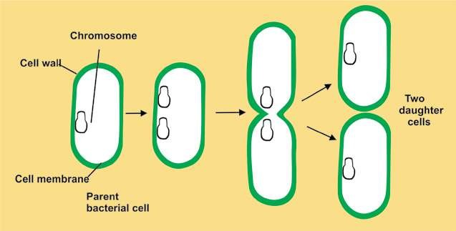

*Fig. 6.6 Binary Fission in bacteria*

1. Lag phase: It is phase of no growth. Bacteria prepare themselves for division.
2. Log phase: It is phase of rapid growth. Bacteria divide at exponential rate.3) Stationary phase: Bacterial death rate is equal to bacterial rate of reproduction and multiplication.

4) Death/Decline phase: Bacteria start dying. Here the death rate is more than reproduction rate.

Bacteria lack traditional sexual reproduction and mitosis. However, some bacteria transfer genetic material from a donor bacterium to a recipient during a process called **conjugation**. Some conjugating bacteria use specialized **sex pili** to transfer genetic material. Conjugation produces new genetic combinations that may allow the resulting bacteria to survive under great variety of conditions.

## IMPORTANCE OF BACTERIA

### Ecological importance

Bacteria are ecologically very important. They are highly adaptable as a group and are found nearly everywhere. They are able to decompose organic matter and play a signiicant role in the completion of cycles of nitrogen, phosphorus, sulfur and carbon.

### Economic Importance

Bacteria are used in number of industries, including food, drugs (production of antibiotics and vaccines) and in biotechnology. Bacteria are also responsible for spoilage of food and vegetables. Many plant pathogens adversely afect the agricultural industry.

### Medical Importance

Bacteria are very common pathogens of humans. Approximately 200 species are known to cause diseases in humans. Many bacteria normally inhabit the bodies of man and other animals.

### Control of bacteria

Control of microorganisms is essential in home, industry as well as in medical ields . By controlling microorganisms one can prevent and treat diseases. Spoilage of foods and other industrial products can be inhibited by controlling microorganisms.

Microorganisms can be controlled by various methods.

**Physical methods :** In this, steam, dry heat, gas, iltration and radiation are used to control bacteria. The process in which we use physical agents to control bacteria/microorganism is known as **sterilization process**. Sterilization is destruction of all life forms.

High temperature is usually used in microbiological labs for control of microbes. Both dry heat and moist heat are efective. Moist heat causes coagulation of proteins and kills the microbes. Dry heat causes oxidation of chemical constituents of microbes and kills them.

Certain electromagnetic radiations below 300 nm are efective in killing of microorganisms. Gamma rays are in general used for sterilization process.

Heat sensitive compounds like antibiotics, seras,-hormones etc. can be sterilized by means of membrane ilters.

**Chemical methods:** One can use **antiseptics**, **disinfectants** and **chemotherapeutic** agents for microbial control. Chemical substances used on living tissues that inhibit the growth of microorganism are called **antiseptics.**

The important chemical agents used for disinfection are oxidising and reducing agents. For example halogens and phenols, hydrogen peroxide, Potassium **permanganate**, alcohol and formaldehyde etc. inhibit the growth of vegetative cells and are used on nonliving materials.

*Microbicidal efect is one that kills the microbes*

**Chemotherapeutic** agents and **antibiotics** work with *immediately* natural defense and stop the growth of bacteria and

other microbes. These are Sulfonamides, tetracycline; *Microbistatic inhibits the reproductive capacities ofthe cells and maintains the microbial population at* penicillin, etc. They destroy or inhibit the growth of *constant size.* microorganisms in living tissues. *Modes oI action of diferent chemical and physical*

*agents of control vary. Damage can result malfunctions in cell wall, cell membranes, cytoplasmic enzymes, or nucleic acid.*

#### Immunization and Vaccination : Methods

of prevention and treatment that have been introduced to control microbial diseases include **immunization** (e.g. **vaccination**), **antisepsis** (procedures to eliminate or reduce the possibility of infection), **chemotherapy** and public health measures (e.g. water puriication, sewage disposal, and food preservation).

Pasteur made many discoveries concerning the cause and prevention of infectious diseases. In 1880’s he isolated the bacterium responsible for **chicken cholera**. He grew it in a pure culture. To prove that he really had isolated the bacterium responsible for this disease Pasteur made use of the fundamental techniques devised by Koch. He arranged experiments for a public demonstration in which he repeated an experiment that had been successful in many previous trials in his laboratory.

He inoculated healthy chicken with his pure cultures and waited for them to develop chicken cholera and die. But to his dismay, the chickens failed to get sick and die. Reviewing each step of the experiment, Pasteur found that he had accidentally used the cultures several weeks old instead of fresh one grown especially for the demonstration. He soon discovered that somehow bacteria could lose their virulence, or ability to produce disease, after standing and growing old. But these attenuated, or less virulent, bacteria could still stimulate the host (in this case the chicken) to produce antibodies, substances that protect the host (in this case the chicken) against infection due to subsequent exposure to the virulent organism.

Pasteur next applied this principle of inoculation with attenuated cultures to the prevention of anthrax, and again it worked. He called the attenuated cultures of bacterial **vaccine** (a term derived from the Latin **Vacca**, “cow”) and immunization with attenuated cultures of bacteria, **vaccination.**

Pasteur honoured Edward Jenner (1749-1823), who had successfully vaccinated a boy against small pox in 1796. Jenner had learned that milkmaids who contracted cowpox from the cows, they milked, never subsequently contracted the much more virulent small pox. Accordingly he tested this hypothesis by inoculating young James Phipps irst with cowpox causing material and later with small pox causing material. The boy did not get small pox.

Then Pasteur also made a vaccine for **hydrophobia**, or rabies, a disease transmitted to people by bites from rabid dogs, cats, and other animals.

## USE AND MISUSE OF ANTIBIOTICS

Antibiotics is a Greek word (**Anti-against-and Bios life)**. Antibiotics are the chemotherapeutic chemical substances which are used in treatment of infectious diseases. Antibiotics are synthesized and secreted by certain bacteria, actinomycetes and fungi. Today, some antibiotics are synthesized in the laboratory. However, their origins are living cells. To determine drug of choice, one must

know its mode of action, possible adverse side efects in *Use antibiotics as prescribed by the physicians.Take dose at regular intervals and complete the* the human beings. *treatment as advised by the doctor.*

Massive quantities of antibiotics are being prepared and used, which are followed by the widespread problems of drug resistance in microorganisms. This results in an increasing resistance against disease treatments. Misused antibiotics can interact with the human metabolism and in severe cases can cause death of human beings. Misuse of antibiotic such as penicillin can cause allergic reactions. Similarly streptomycin can afect auditory nerve thus causing deafness. Tetracycline and its related compounds cause permanent discoloration of teeth in young children.

## CHARACTERISTICS OF CYANOBACTERIA

The cyanobacteria are the largest and most diverse group of photosynthetic bacteria which was previously known as **‘blue green algae’**. Cyanobacteria are true prokaryotes. They vary greatly in shape and appearance. They range in diameter from about 1-10um and may be unicellular, exist as colonies of many shapes, or form **ilaments** consisting of **trichomes** (chains of cells) surrounded by mucilaginous sheath. They have normal Gram-negative type cell wall. They lack lagella and often use gas vesicles to move in the water, and many ilamentous species have gliding motility.

Their photosynthetic system closely resembles that of eukaryotes because they have chlorophyll a and photosystem II.They carry out oxygenic photosynthesis, i.e., they use water as an electron donor and generate oxygen during photosynthesis. Cyanobacteria use **phycobilins** as accessory pigments. Photosynthetic pigments and electron transport chain components are located in thylakoid membranes linked with particles called **phycobilisomes. Phycocyanin** pigment (blue) is their predominant phycobilin and C02 in them is assimilated through the Calvin cycle.

Reserve food material in cyanobacteria is **glycogen.** Cyanobacteria reproduce by binary ission, fragmentation. In cyanobacteria h**ormogonia, akinetes** and **heterocysts** are present.

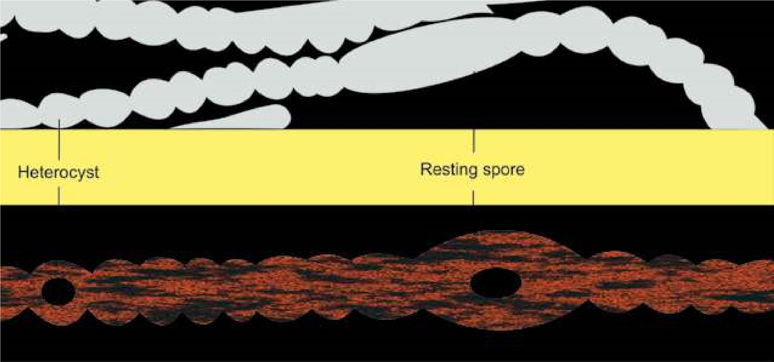

Fig. 6.8 Cyanobacterium *Anabaena*

## ECONOMIC IMPORTANCE

They help in reclamation of alkaline soils . Cyanobacteria have **heterocysts**, which are helpful in the ixation of atmospheric nitrogen. They release O2 in the environment due to their photosynthetic activity. *Oscillatoria* and few other cyanobacteria

can be used as pollution indicator. They have *Super Blue green algae are basically expensive pond scum, in* symbiotic relationship with protozoa, fungi, *which cyanobacterium is a single celled organism that produces* and nitrogen ixing species form associations *its own food through photosynthesis. It serves as a “completewhole food“ which contain 60% protein with all essential amino* with angiosperms. They are photosynthetic *acids in perfect balance.* partners in most of lichen association.

Many species of cyanobacteria form **water blooms** where they often impart unpleasant smell and due to large amount of suspended organic matter water becomes unit for consumption. Some species produce toxins that kill live stock and other animals that drink the water.

## NOSTOC

### Habitat and occurrence

*Nostoc* is common as terrestrial and subaerial cyanobacterium. It is widely distributed in alkaline soils and on moist rocks and clifs. *Nostoc* forms a jelly like mass in which numerous ilaments are embedded.

### Structure

Trichomes are unbranched and appear beaded. Individual cells are mostly spherical but some times barrel shaped or cylindrical.

All cells in trichome are mostly similar in structure but at intervals are found slightly large , round, light yellowish thick walled cells called as **heterocysts.** Trichome mostly breaks near heterocyst and forms **hormogonia** and thus help in fragmentation.

### Reproduction

There is no sexual reproduction but it reproduces asexually by formation of hormogonia. Hormogonia are formed when ilament break at diferent points into smaller pieces.This is due to death and decay of the ordinary cell or the heterocyst may serve as a breaking point. Reproduction can also be due to akinete formation. **Akinetes** are thick walled , enlarged vegetative cells which accumulate food and become resting cells. On arrival of favourable conditions they form normal vegetative cell.

**EXERCISE**

**Q.1. Fill in the blanks.**

1. A bacterial arrangement in packets of eight cells is described as a-------------.
2. The shape and arrangement of is diplococci
3. Pili are tubular shafts in bacteria that serve as a means of-----------.
4. -------------- are unusual type of bacteria that live in extreme habitats.
5. ------------- is a bacterium that is photosynthetic.
6. -------------- is a cyanobacterium.
7. ---------------- called as bloom forming organism.

(vii) Use of antibiotics is one of the means of controlling ------------- diseases.

**Q.2. Short questions.**

1. (a) Name general characteristics that could be used to deine the prokaryotes.

(b) Do any other microbial groups besides bacteria have prokaryotic cells? (c) In what habitats are bacteria found? Give some general means by which bacteria derive nutrients.

1. (a) List functions that the cell membrane performs in bacteria.

(b) What are mesosomes and some of their possible functions?

1. What is unique about the structure of bacterial ribosomes?

1. Draw the three bacterial shapes.
2. Name a bacterium that has no cell wall.
3. A gram stained discharge from an dbcess shows cocci in irregular grape like clusters. What is the most likely genus of this bacterium
4. Draw an outline and label (i) streptobacilli, (ii) diplococci, (iii) staphylococci.

1. You observe a culture of predominantly round (presumably spherical) bacteria that though apparently fully divided, nevertheless have failed to separate, thus resulting in long chains of cells. What, generally, might you call such an arrangement?
2. Match the following descriptions with the best answer.
   * 1. Division in one plane; cocci arranged in pairs (a) Bacillus
     2. Division in one plane; cocci arranged in chains (b) Streptobacillus
     3. Division in two planes; cocci arranged in a square of four
        + 1. Spirochete
          2. Division in one plane; rods completely separate

after division. (d) Spirillum

* + - * 1. Division in one plane; rods arranged in chains. (e) Vibrio
        2. A comma shaped bacterium (f) Streptococcus
        3. A thin, lexible spiral. (g) Staphylococcus
        4. A thick, rigid spiral. (h) Diplococcus
        5. Tetrad
        6. Sarcina

**Q.3. Extensive Questions**

1. Describe in detail the structure of bacterial cell wall, emphasizing Gram positive and Gram negative properties.
2. Write an account of diferent methods used for controlling microbes.
3. Discuss the role of antibiotics and immunization in controlling bacterial diseases. What problem can arise due to misuse of antibiotics.
4. Describe general characteristics of Cyanobacteria with special reference to

Nostoc.

1. Write Notes on :

(a) Koch’s postulates (b) Shape of bacteria

(c) Flagella and pili (d) Growth in bacteria.