CHAPTER 15 Homeostasis

*Animation 15 : Homeostasis*

[*Source & Credit: Wikispaces*](http://anatomyeshs.wikispaces.com/Ch.16+Respiratory+System)

# CONCEPTS IN HOMEOSTASIS

Each organism of a species has assumed, in evolutionary history, a speciic set up of internal environment at various levels of organization suitable to its surroundings i.e., external environment. External environment and its components luctuate continuously, however, the organism resists and manages these changes by making adjustments to keep its own internal luctuations within a narrow range thus protecting internal environment from the harms of the external luctuations. The protection of internal environment from the harms of luctuations in external environment is termed as **homeostasis**. The homeostasis keeps the internal luctuations in a narrow range with various control systems compared to wider external luctuations.

Most susceptible components of internal environment that may be afected by luctuations in external environments are water, solutes and temperature. Also the mechanism an organism has adapted to eliminate harmful nitrogenous wastes depends upon the availability of water. The mechanism of regulation, generally between organism and its environment, of solute and the gain and loss of water is **osmoregulation**. The mechanism which eliminates nitrogenous waste is referred as **excretion**, whereas maintenance of internal temperature within a tolerable range is designated as **thermoregulation**.

Homeostasis is the central requirement in the maintenance of an organism, which compels the adaptations in the constant changing conditions and contribute in evolutionary process.

Likewise the control systems among intracellular and extracellular internal environment of an organism also at cell level keep luctuating in narrow range in intracellular, within cell membrane, compared to in extracellular (vascular and other interstitial luids) environment. Here, in addition to solute and water various essential metabolites, hormones etc. are kept in a required range.

Homeostasis does not mean to keep a ixed internal environment as changes maintained within a speciic range are necessary for normal body functions. For example, water availability may luctuate tremendously for the organisms in the external environment from abundant supply to almost dry conditions, however, the quantity of water in the body i.e. internal environment may vary in response to abundant supply and dry condition, but in a narrow range. The control systems would not let the body looded with water in abundant supply and also not to dehydrate in dry conditions. Furthermore, adaptation to lower level of range in dry conditions and to higher level of range in abundant supply of water is good for the organism to feel normal within internal luctuations forced by drastic external luctuations.

The control systems have been acquired for the variety of homeostatic regulations. These living control systems work exactly on the mechanism of physical control system. It has three components: receptor, control centre and an efector. In a physical control system e.g. temperature control system, there is a sensor (thermometer) that monitors temperature change from a set point and signals to control centre to take action by switching on heater or cooling units in response to drop or rise in the temperature compared to set point. Similar to it in living system there is set point in temperature regulated (endothermic) animals. The receptors (sensor) detect temperature change, e.g. of increase and signal to control centre for action of cooling systems and the vice versa. Detection of change and signalling for efector’s response to control system is a feedback mechanism. In these processes there is an inverse efector’s response to the change in external environment as there is generally cooling efector’s response to warmth sensing in external environment, thus are termed as negative feedback (Fig. 15.1).

*Animation 15.1 : Homeostasis*

*Source & Credit:* [*Dynamic*](http://http://www.dynamicscience.com.au/tester/solutions1/biology/feedbackloops/negtvfdbk.html) *Science*

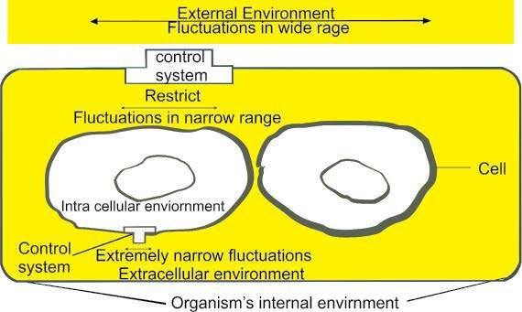

*Fig.15.1. Homeostasis: Controlling systems lower luctuations in internal environments*

# OSMOREGULATION

## Water relations of cell

Water is the solvent of the solutes in the cell. Each cell has been adapted to a deined quantity of water in relation to salts in it to perform its functions. Homeostatic mechanisms generally maintain this concentration.

## Balance of water and solutes in the body

Cells consistently encounter changing extracellular environment. It may be of diluted solution compared to the cell concentration, thus designated as **hypotonic** environment. The more concentrated external environment is termed as **hypertonic** and that resembles to internal solution is the **isotonic**.

The hypotonic environment osmotically causes entry of water into the cell and renders the cell solutions diluted. The cell

also becomes turgid. Thus it may be harmed (Fig. 15.2a). The hypertonic environment, on the other hand; renders cell solutions concentrated and shrinks the cell due to loss of water (Fig. 15.2c). To prevent these situations cells osmoregulate themselves to keep water and salts balance in plants and animals.

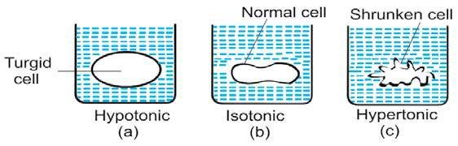

*Fig. 15.2 Response of the cell to various external environments i.e. diferent concentrations of solution without any regulation with control system at cell membrane, cell remains in normal state despite .diferences in its internal to external environments.*

*Animation 15.2: Osmoregulation*

*Source and Credit:* [*Andrew Biology*](http://http://andrewbiology.blogspot.com/2011_11_01_archive.html)

# Osmoregulation in Plants

Plants are distributed in diferent habitats of aquatic, moderate and severely dry terrestrial nature, thus termed as hydrophytes, mesophytes and xerophytes, respectively.

**Hydrophytes** have the adaptations to remove the looding of its cells in fresh water. In this type the surface area of leaves is very large to transpire water excessively. Extensive stomata are present on the upper surface facing the atmosphere to promote loss of water (Fig. 15.3a).

**Mesophytes** have moderate water availability. In suicient supply of water stomata are kept open to promote loss of excess water, however, in restricted supply stomata close to prevent the loss e.g. Brassica, rose, mango etc.

**Xerophytes** have the adaptations for reduced rate of transpiration. Many xerophytes possess small, thick leaves to limit water loss by reducing surface area proportional to the volume. Their cuticle is thick, waxy and leathery. Stomata are on lower surface of leaves and located in depression. Some as cacti, during the driest season, shed their leaves to restrict transpiration completely, thus stems are the photosynthetic organs. In rainy season, stem stores water for use in dry conditions (Fig. 15.3b).

*Animation 15.3: Osmoregulation in plants*

*Source and Credit:* [*Ameoba Sisters*](http://http://www.amoebasisters.com/)

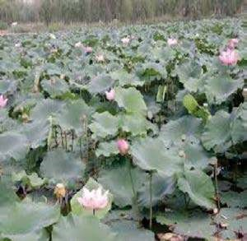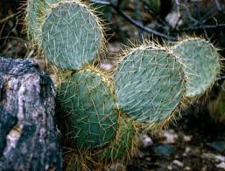

*Fig. 15.3a. A hydrophytic plant Fig.15.3b. A xerophytic plant*

## Osmoregulation in Animals

Animal cells require more critical balance of water and solutes in the body as they cannot survive a net water gain or loss. Water continuously leaves and enters the cells; however, the quantity of the water and the solutes is kept in balance. There are two approaches in maintaining this balance.

1. Animal body luids are kept isotonic to the external environment even for marine saltwater environment. These animals thus do not require actively to adjust their internal osmotic state, so are known as **osmoconformers**.
2. The animals whose body luid concentrations difer noticeably the outside environment actively regulate to discharge excess water in hypotonic and excrete salts in hypertonic conditions therefore, are called as **osmoregulators**. Animals inhabiting diferent environments have distinct adaptations to regulate osmotic balance, e.g. marine, fresh water and terrestrial environments.

### Osmoregulation in Diferent Environments

**Marine:** Most marine invertebrates are osmoconformers. Among the vertebrates hagishes are isotonic with the surrounding sea’s water. Most cartilaginous ishes maintain lower, internal salt concentration than that of seawater. Their kidneys for osmoregulation excrete salts through gills and also possess salt excreting organs such as rectal glands. These employ active transport mechanism to remove salt against osmotic gradient. Some ishes have relatively low salts in body luids but have rendered these hypertonic to that of seawater by retaining urea in adequate concentration. Because urea in high concentration is damaging so these ishes retain another chemical trimethylamine oxide(TMAO) for protection against urea. Bony ishes, the descendents of fresh water ancestors but later became marine constantly lose water from their hypotonic body luids to hypertonic environments. These ishes have adapted themselves to drink large amount of seas water and excrete concentrated urine resulting in maximum salt excretion and minimum water loss (Fig. 15.4a).

Osmoregulation has enabled the animals and plants to distribute themselves in wide range of habitats.

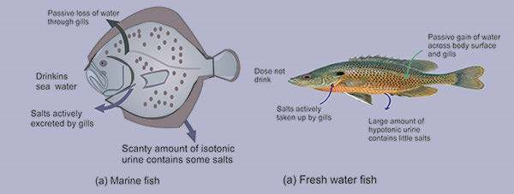

*Fig.15.4. Osmoregulation in: (a) Marine ish (b) Fresh water ish*

**Fresh Water:** Fresh water animals are constantly facing the osmotic looding of body luids and loss of salts. Fresh water protozoa, Amoeba and Paramecium pump out excess water by structures **contractile vacuoles**. Many fresh water animals including ishes remove excess water by producing large volumes of very dilute urine. The loss of salts is compensated by preference of salt containing food and by active uptake of salts by gills and skin (Fig. 15.4b).

**Terrestrial:** The evaporative loss of water leading to dehydration is the major problem for terrestrial life. Arthropods and vertebrates have successfully adapted to terrestrial mode of life. Terrestrial animals are covered by body surface, which prevents loss of water as the waxy exoskeletons of insects and multi-layered dead, keratinized skin cells of most terrestrial vertebrates. Drinking and eating moist foods compensate the loss of water. These animals also have metabolic and behavioral adaptations. Some desert mammals e.g. kangaroo rat survives without drinking water by feeding on seeds of desert plants containing more carbohydrates, which produce water of metabolism. Terrestrial animals produce concentrate urine in their kidneys that reabsorb most iltered water in the process of excretion. Terrestrial animals can tolerate dehydration and it difers in various animals. This characteristic is known as **anhydrobiosis**.

# EXCRETION

Among the assimilated nutrients in animals, carbohydrates and lipids are metabolized to CO2 and H20. Proteins and nucleoproteins metabolism produces waste nitrogen in various forms in diferent animals. The waste nitrogen proves toxic if it is concentrated in the cell, therefore, it must be removed from the body. The elimination of wasteful metabolites, mainly of the nitrogenous nature is called excretion.

In contrast, the mechanism of excretion in plants is diferent. Plants in their autotrophic mode of life produce oxygen and in metabolism produce C02 and H20 as the excretory products. Plants also produce several organic and inorganic compounds which are stored for various purposes and are also removed when necessary.

Plant cells have large vacuoles; these can be used for either storage of useful compounds, or the storage of waste substances. These may accumulate at the concentrations that lead to crystal formation in the vacuoles. Plants produce certain wastes of inorganic and organic nature, which are stored in certain organs.

The leaves are the prominent organs for this purpose. These leaves are destined to fall of, as is the case of autumn leaves in plants or die of as happens in the leaves and stalk of certain bulbs e.g. bluebell, leaving the bulb underground. This is the reason gardener ind rotted autumn leaves a good source of minerals. The falling of yellow leaves in autumn is th seasonal time for the plants to get rid of the accumulated wastes and because of the reason leaves are said to be **excretophore**. According to an explanation the change in color in these leaves is not due to removal of chlorophyll as the microscopic examination of autumn leaves shows that leaves are loaded with pigmented compounds prior to falling of and many toxic materials like heavy metals increase sharply as the yellowing proceeds.

Some trees deposit strange chemicals in their branches and trunks, especially in old xylem which is no longer used for water transport. This takes place in **ebony** which produces very black wood in the center.These are considered to be, waste materials by plant physiologists.

Some plants will actively secrete waste compounds into the soil, occasionally using them as chemical weapons against other competing plants e.g conifers.

*Animation 15.4: Osmoregulation in plants*

*Source and Credit:* [*Living BIo.net*](http://http://leavingbio.net/excretion/excretion.htm)

Keeping in view the deinition of excretion, as discussed earlier, that it is the elimination of waste metabolites several products may be included in the list of excretory products. Water due to its removal in hypo osmotic environment is labelled as an excretory product in these speciic conditions.Similarly, salts removed by animals in hypertonic environment are the excretory products for these animals. Otherwise, overwhelmingly, nitrogenous waste metabolites constitute the excretory products. Primarily, in the catabolism of animo acids the amino group (---NH2) is released **(deamination)** or transferred to another molecule for removal or reuse. Amino group not reused for recycling of amino acids is essentially dissolved in water and excreted to avoid toxic rise in the plasma. Elevated levels of these wastes can cause convulsions, coma and eventually death. Mostly excess nitrogen is excreted by animals as **ammonia, urea or uric acid** (Fig. 15.5). Lower quantities of nitrogen are excreted in the form of other compounds such as **creatinine,** **creatine** or **trimethylamine oxide** and in very small quantities as amino acids, purines and pyrimidines. Metabolism of purine and pyrimidine bases produces signiicant amount of nitrogenous wastes of **hypoxanthine**, **xanthine**, **uric acid**, **allantoin**, **urea** and **ammonia**.

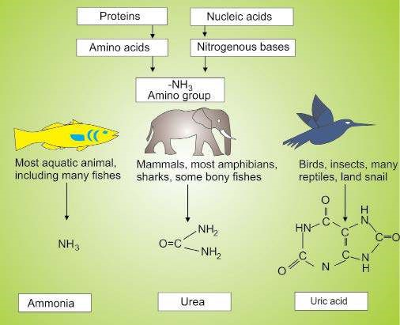

## Nature of Excretory Products in Relation to Habitats

Ammonia is very toxic and dissolves quickly in body luids. Thus, it must be kept in low concentration in the body. To maintain its low concentration below that of body requires large volume of water also to eliminate it in urine as it is produced. This is possible in an hypotonic environment. Therefore, ammonia kept as the excretory product of the animals inhabiting hypotonic (e.g. fresh water) environment. About 500 ml water is needed to excrete lg of ammonia nitrogen.

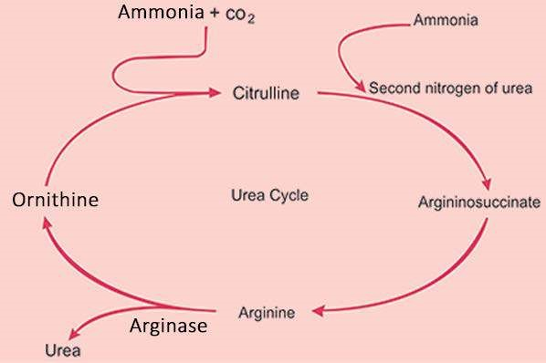

*Fig 15.6: Metabolic pathways in urea cycle*

In restricted supply of water, ammonia cannot be kept as excretory product, the other alternative is to change it into less toxic substance such as urea. Urea requires only 50 ml of water for its lg of nitrogen removal. Here excretory nitrogen is metabolically converted into urea by urea cycle (Fig. 15.6) in the animals inhabiting environment with restricted supply of water e.g. terrestrial mammals.

Aimals inhabiting environment with acute shortage of water supply require an excretory product which can be excreted with minimum amount of water. Only 1ml water is required to eliminate lg of nitrogen in the form of uric acid. Therefore the reptiles and birds that inhabit arid environment, excrete uric acid as excretory product. Animals excreting ammonia, urea .and uric acid are called as **ammonotelic, ureotelic** and **uricotelic** respectively. Ureotely and uricotely are evolutionary adaptations of nitrogenous waste in their habitats. Animals have adapted not only the chemical nature of excretory products but also the various adaptations have been obtained to provide diversity in excretory structures. The main representative models are described below:

# EXCRETION IN REPRESENTATIVE ANIMALS

## Excretion in Hydra

Hydra, a cnidarian, does not have specialized excretory structures. In it waste products simply difuse into the isosmotic surroundings.

## Excretion in Planaria

Planaria the animals of the group of latworms have simple tubular excretory system called **protonephridium**. A protonephridium is a network of closed tubules without internal openings. Tubular system is spread throughout the body and branches are capped by a cellular setup termed as **lame cell**. Each lame cell has a tuft of cilia, whose beating propels interstitial luid into the tubular system (The beating of cilia looks like a lickering lame, therefore these cells are termed lame cells). The tubular system is drained into excretory ducts, which open to the exterior through several nephridiopores (Fig. 15.7).

Fresh water latworms excrete very dilute urine. The parasitic latworms, which are isotonic to the host environment mainly function in disposing nitrogenous wastes.

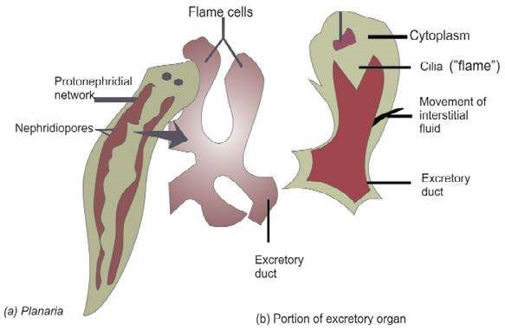

*Fig.15.7. Excretory system in Planaria*

## Excretion in Earthworm

Earthworm is an ideal example of another type of tubular excretory system called as **metanephridium.** Each segment of earthworm has a pair of metanephridia. This system has an internal ciliated opening the **nephrostome** immersed in coelomic luid and enveloped by a network of capillaries. Nephrostome collects coelomic luid. As luid moves along the tubule, epithelium reabsorbs salt from the lumen and sends to blood vessels surrounding the nephridium. The left over appears as urine containing nitrogenous waste (Fig. 15.8).

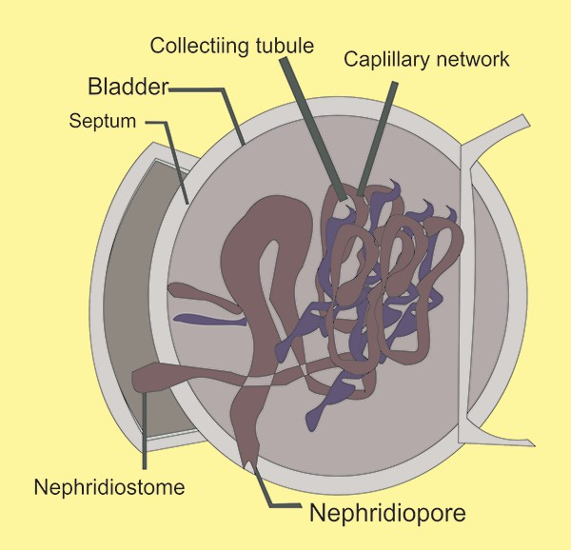

*ig: 15.8 : Excretory system in earthworm*

## Excretion in Cockroach

Terrestrial arthropods particularly in the insects, the excretory structures are adapted to collect excretory products from hemolymph in sinuses through suspended tubular structures called **Malpighian tubules**. These Malpighian tubules remove nitrogenous waste from the hemolymph. These are the only excretory structures in animal kingdom that are associated with digestive tract. The epithelial lining of the tubules transports solutes including salts and nitrogenous waste from haemolymph into tubules lumen. Fluid then passes to hind gut into the rectum. Rectum reabsorbs most of the salts and water, thus nitrogenous wastes are excreted as solid excreta, in the form of uric acid crystals along the feces.

This kind of adaptation in excretion is the success of these animals on land with acute shortage of water (Fig. 15.9)

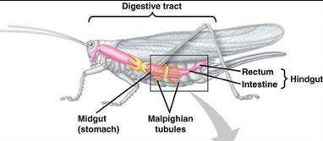

*Fig. 15.9 Excretory system in insect*

Insects are the only group of animals, which eliminate excretory waste with feces, in all other animals, there is no structural and functional relationship between nutritive and excretory system.

# EXCRETION IN VERTEBRATES

The ancestors of vertebrates, the invertebrate chordates have segmentally arranged excretory structures throughout the body like the metanephridia in earthworm. This character is well represented in the primitive vertebrate hagishes which have kidneys with segmentally arranged tubules. However, the contrasting developments proceeded in evolution in other vertebrates with the appearance of kidneys. Kidneys contain numerous tubules, not arranged segmentally, closely associated with dense network of capillaries. The basic functional structure in the kidneys is **nephron**.

# Excretion in Human

**Normal Mechanisms :** Considering the chemical basis of life and its sustainability on metabolic pathways, the generation of wastes is primarily done at metabolic level and these are called **metabolic wastes**.

These include urea, produced from the metabolism of amino acids; creatinine, produced from muscle creatine; uric acid, from nucleic acids; bilirubin, end products of haemoglobin breakdown and metabolites of various hormones.

Metabolic wastes also include the toxins produced within the body and ingested into the body such as pesticides, drugs and food additives. The presence of wastes in the body causes serious hazards, thus are eliminated by excretory system.

**Excretory Organs:**

Liver and kidneys are the primary structure for eliminating waste products.

Liver is the central station of metabolism and consequently the body’s central metabolic clearing house. Due to this characteristic, liver functions are pivotal to homeostasis and involve interaction with most of body’s organs systems. Liver supports the excretory role of the kidney by detoxifying many chemical poisons and produce ammonia, urea and uric acids from the nitrogen of amino acids. Removal of salts with water by the sweat glands and of sebum by sebaceous glands seems to be excretory in nature. The removal of water and salts from sweat glands is for the purpose of thermoregulation and of sebum on the skin is for protection against microorganism. Therefore in context of deinition of excretion, skin may not be considered as an excretory organ. Among the various nitrogenous wastes described earlier, urea is the principal excretory product and liver form it from the waste nitrogen. The metabolic pathways involved in the production of urea are termed as **urea cycle**. Two ammonia and one carbon dioxide molecules are shunted into the cycle to generate one molecule of urea. One ammonia molecule combines with carbon dioxide and already available precursor from previous cycle **ornithine** to form **citrulline**, subsequently another ammonia combines to form **arginine**. The arginine is split by **arginase** to form urea and the precursor ornithine for next cycle (Fig. 15.6).

## Table 15.1. Major homeostatic functions of the liver

|  |
| --- |
| **Functions Major efects on homeostasis** |
| **Synthesis:** Nitrogenous wastes: **NH3**, urea, uric Supports kidney in waste disposal acid |
| Plasma proteins: like a) prothrombin, ibrinogen a) Blood clotting b) maintain osmotic balance of  b) albumin etc. blood |
| Bile Emulsiies fats in small intestine |
| Lipids, cholesterol, lipoproteins Regulate blood chemistry, store energy and help to maintain cell membranes |
| **Storage:** Iron Oxygenation of tissues as constituent of haemoglobin |
| Glycogen Energy reserves |
| **Conversion:** Excess glucose in blood to glycogen, Energy storage and use lactic, acid to glycogen and stored glycogen to glucose |
| **Recyclings:** Contents of old red blood cells (e.g., Oxygenation of tissue iron and other constitution of haemoglobin) |
| **Detoxiication:** Many harmful chemicals (e.g., Assist kidney in toxin disposal food additives, pesticides, drugs etc) |

Liver is not only involved in the synthesis of nitrogenous wastes to assist kidney in their disposal, but also has numerous crucial functions of homeostasis importance. These functions belong to synthesis, storage, conversion, recycling and detoxiication categories (Table 15.1).

Urea is detoxiied form of ammonia in urea cycle, which can be retained in the body in greater amounts than ammonia and can be eliminated with 1/10 quantity of water as compared to ammonia.

## Urinary System

A pair of kidneys consists of millions of functional units, nephrons. The nephrons have extensive blood supply via the renal arteries, which leave each kidney via the renal vein. The function of kidney and blood in clearing wastes is very evident from the fact that weight of kidneys accounts for less than 1% of the total body weight while receive 20% of blood supplied with each cardiac beat. Following iltration of blood and further processing through tubular system urine is collected in a central cavity of the kidney, **pelvis.** Urine leaves the kidney through a duct **ureter**. The ureters of both the kidneys drain into **urinary bladder** through ureteral oriice. Urine leaves the body, during urination, from the bladder through a tube called the **urethra**, which empties near the vagina in females or through the penis in males. Sphincter muscles near the junction of the urethra and the bladder control the urine in bladder (Fig. 15.10).

*Animation 15.4: Urinary System*

*Source and Credit:* [*Renal Pathology*](http://http://library.med.utah.edu/WebPath/RENAHTML/RENAL123.html)

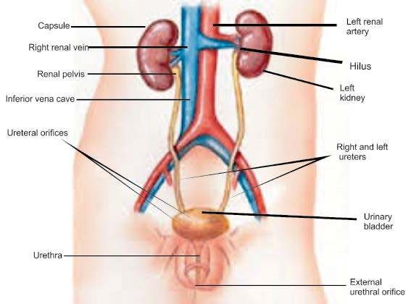

*Fig. 15.10. Human urinary system*

**Nephron:** The functional units, nephrons, in human kidneys are arranged along two distinct regions, an outer **cortex** and an inner **medulla**. The nephrons arranged along the cortex are called as **cortical**, however, those arranged along the border of cortex and medulla with their tubular system looping deep in inner medulla are **juxtamedullary** nephrons These juxtamedullary nephrons are speciically instrumental in the production of concentrated urine (Fig. 15.11).

In each nephron inner end forms a cup-shaped swelling, called **Bowman’s capsule** and it is around a ball of capillaries called **glomerulus**. Glomerulus circulates blood through capsule as it arrives through **aferent arteriole** and leaves the capsule by **eferent arteriole**. The blood vessel subdivides again into another network of capillaries, the **peritubular capillaries**. Bowman capsule continues as extensively convoluted **proximal tubule**, **loop of Henle** and the **distal tubule**, which empties into collecting tubules. The **collecting tubules** open into pelvis. The iltrate from glomerulus passes through these structures and is processed ultimately for urine formation. The peritubular capillaries intermingle with proximal and distal tubules of the nephron. In juxtamedullary nephrons additional capillaries extend down to from a loop of vessels, **vasa recta**.

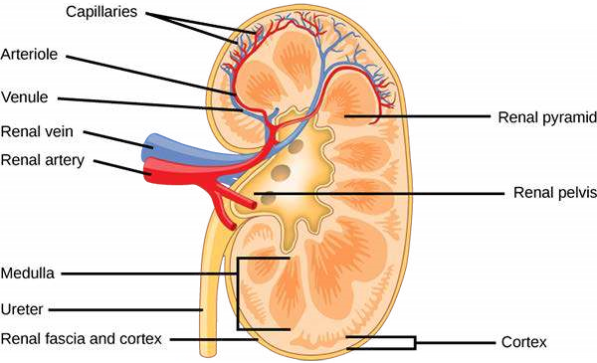

*Fig. 15.11. The structure of a kidney*

**Filtration:** Blood passing through glomerulus is iltered into Bowman’s capsule. It is speciically iltered here, unlike at the other parts of the vessels, because glomerulus walls are porous, and the fraction of the blood pressure reaching here provides the **iltration pressure**. The iltrate appearing in Bowmans capsule is called as **glomerular iltrate**, which contains numerous useful substances such as glucose, amino acids, salts etc in aqueous solution.

**Reabsorption:** All the useful constituents of the glomerular ilterate are reabsorbed in proximal tubules and when iltrate leaves proximal tubules, it mostly contains nitrogenous wastes.

**Secretion:** The tubular epithelium also secretes substances into the lumen, this secretion is very selective and is mainly of hydrogen ions to balance pH value of the iltrate passing through the tubule.

## Concentration of Excretory Products

In restricted supply of water, the conservation of water is the principal function of the body. This is done by concentration of the iltrate by counter current and hormonal mechanisms. In the suicient or excess supply of water, reabsorption of water from the iltrate is reduced, speciically due to inhibition of release of antidiuretic hormone in the presence of hyposomotic body luids.

The reduction in reabsorption causes large volumes of diluted urine. Mammalian kidney including human is adapted to conserve water by over 99.5% reabsorption of glomerular iltrate.

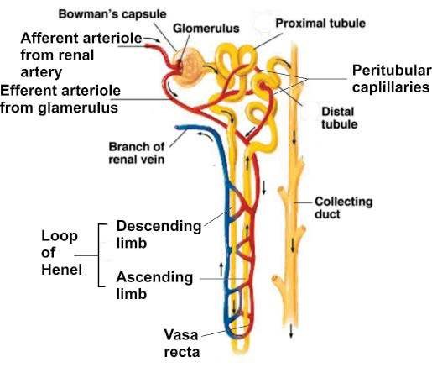

*Fig:15.12. a nephron with vascular supply*

The interstitial luid of the kidney is gradually concentrated from cortical to medullary part, thus inner medulla is highly concentrated with the presence of urea and through a mechanism of **countercurrent multiplier**. This mechanism causes gradual osmotic outlow of water from the iltrate back to kidney as it passes downward in the descending loop of Henle. Furthermore, ascending loop of Henle does not allow outlow of water from its iltrate, instead actively transport Na ions into kidney interstitium to sustain its high concentration.

**Hormones:** The active uptake of sodium in the ascending limb or thick loop of Henle is promoted by the action of **aldosterone**, the hormone secreted from **adrenal cortex**. The other site in the nephron, where reabsorption of water takes place is collecting tubules. **ADH** released from **posterior pituitary lobe** acts to actively transport water from iltrate in Distal tubules and collecting tubules back to kidney.

Gradually increasing osmotic concentration from cortex to inner medulla is a main factor for the production of hypertonic (concentrated) urine in mammals including human.

# Kidney as Osmoregulatory Organ

The production of varied concentrations of urine depending on the availability of water exhibits clearly that kidney functions as an osmoregulatory organ along its excretory role of nitrogenous wastes.

*Animation 15.5: Kidney As Osmoregulatory Organ*

*Source and Credit:* [*Blobs*](http://http://www.blobs.org/science/article.php?article=63)

# Kidney Problems and Cures

Unusual situations may arise in the function of kidney by factors originating within kidney or outside. These cause serious kidney diseases.

**Kidney Stones:** Stony materials are found in the kidney and these cause urinary obstruction and are generally complicated by infections. These stones have speciied chemical nature. These are formed in metabolic disease, **hypercalcemia** i.e. high level of circulating calcium in blood because of other diseases. **Hyperoxaluria** i.e. higher blood level of oxalates is other contributing factor in the formation of calcium oxalate stones. Oxalates are present in green vegetables and tomatoes therefore may be the source of hyperoxaluria. The incidence of calcium oxalate type stones are 70% of all the kidney stones. The incidence of other types of stones of calcium phosphate and of uric acid is 15% and 10% respectively. These salts are precipitated out during urine formation and accumulate later to form stone (Fig. 15.13).

*Animation 15.6: Kidney Problems*

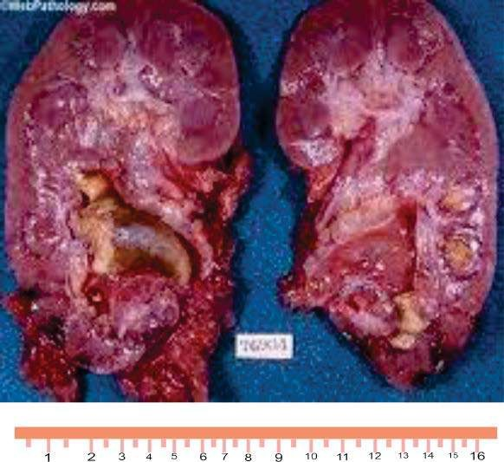

*Fig. 15.13. The kidney stones: Stone of phosphates are formed and trapped in the pelvis area*

**Lithotripsy:** The kidney stones have been removed by kidney surgery. Presently lithotripsy is used for non-surgical removal of kidney stone. It is the technique used to break up stones that form in the kidney, ureter or gall bladder. There are several ways to do it, although the most common is extracorporeal shock wave lithotripsy. High concentrations of X-ray or ultrasound are directed from a machine outside the body to the stone inside. The shock waves break the stone in tiny pieces or into sand, which are passed out of the body in urine.

**Renal Failure:** Various factors of pathological and chemical nature may progressively destroy the nephron, particularly its glomerular part. This results in increase in the plasma level of urea and other nitrogenous wastes. The rise in urea causes complications of increase in blood pressure and anemia etc.

**Dialysis :** In chronic renal failure, the function of the kidney is completely lost and is unable to remove nitrogenous waste. To remove nitrogenous waste, particularly the urea, the blood of the patient is treated through dialysis. It cleans the blood either by passing it through an artiicial kidney or by iltering it within the abdomen. The wastes and excess water are removed during the treatment as is done by the healthy kidneys.

There are two types of dialysis: **hemodialysis** and **peritoneal dialysis.**

Hemodialysis means ‘cleaning the blood’. In this procedure blood is circulated through a machine which contains a **dialyzer** also called an artiicial kidney. Dialyzer has two spaces separated by thin membrane. Blood passes from one side of the membrane and dialysis luid on the other. The wastes and excess water pass from the blood through the membrane into the dialysis luid.

Peritoneal dialysis work on the same principle except that abdomen has a **peritoneal cavity**, lined by a thin epithelium called **peritoneum**. Peritoneal cavity is illed with dialysis luid that enters the body through a catheter. Excess water and wastes pass through the peritoneum into the dialysis luid. This process is repeated several times a day. Dialyzer is a kidney machine that works on the same principle as in a kidney for removal of nitrogenous wastes and excess water from the blood. It is used after kidney failure and dialysis is done again and again until a matching donor’s kidney is transplanted.

**Kidney Transplant:** Dialysis may be used as a temporary measure. In high degree renal failure also called as **uremia** or **end-stage renal disease**, the dialysis can not be done hence thus the surgical transplantation of a matching donor kidney is the only option left for as the permanent treatment.

# THERMOREGULATION

Control systems operate in organisms to cope with environmental stresses including temperature extremes.

## Adaptations in Plants to Low and High Temperature

**High Temperature :** High temperature denatures the enzymes and damages the metabolism, therefore, it harms or kills the plants. Plants use evaporative cooling to manage with high temperature. Hot and dry weather, however, causes water deiciency resulting in closing of stomata, thus plants sufer in such conditions. Most plants have adapted to survive in heat stress as the plants of temperate regions face the stress of 40°C and above temperature. The cells of these plants synthesize large quantities of special proteins called **heat-shock proteins**. These proteins embrace enzymes and other proteins thus help to prevent denaturation.

**Low Temperature** : In low temperature the luidity of the cell membrane is altered, because lipids of the membrane become locked into crystalline structures, which afects the transport of the solutes. The structure of the membrane proteins is also afected. Plants respond to cold stress by increasing proportion of unsaturated fatty acids, which help membrane to maintain structure at low temperature by preventing crystal formation. This adaptation requires time because of this reason rapid chilling of plants is more stressful than gradual drop in air temperature.

Freezing temperature causes ice crystal formation. The coninement of ice formation around cell wall does not afect as badly and plants survive, however, formation of ice crystals within protoplasm perforates membranes and organelles hence killing the cells. The plants native to cold region such as oaks, maples, roses and other plants have adapted to bring changes in solutes composition of the cells, which causes cytosol to super cool without ice formation, although ice crystals may form in the cell walls.

## MECHANISMS IN ANIMALS Body Heat, Heat Gain and Loss

Temperature of an animal depends upon the rate of change of body heat which in turn depends on rate of heat production through metabolic processes and the rate of external heat gain and rate of heat loss. This transfer of heat between an animal and its environment is done in numerous ways. Principally, infrared thermal radiation and direct and relected sunlight transfer heat into the animal; whereas radiation and evaporation transfer heat out to the environment.

## Temperature Classiication of Animals

Animals deal with variation in the thermal characteristics of their environment. There are animals in which body temperature tends to luctuate more or less with ambient temperature where air or water temperatures are changed, these are **poikilotherms**, all invertebrates, ish, amphibians and reptiles are considered in this category. The other exposed to changing air or water temperature maintain their body temperature are the **homeotherms** and include birds and mammals. Several diiculties arise with this terminology with studies. It is observed that deep sea ishes maintain their body temperature due to the constant natural surroundings and lizards regulate their body temperature; and in contrast numerous birds and mammals vary their body temperature.

Therefore, a more widely applicable temperature classiication scheme is based on the source of heat production. According to this animals that generate their own body heat through heat production as by-product during metabolism are **endotherms** include lying insects, some ishes, birds and mammals. **Ectotherm** is the other type, which produce metabolic heat at low level and that is also exchanged quickly with the environment, however, absorb heat from their surroundings. Most invertebrates, ish, amphibians and reptiles are in this category. A third category, **heterotherms** is of those animals who are capable of varying degrees of endothermic heat production but generally do not regulate their body temperature within a narrow range e.g. bats, humming bird etc.

## Regulation of Heat Exchange between Animals and Environment

Animals use diferent mechanism for such regulation and these are of structural, physiological and behavioral nature.

**Structural Adaptations:** These may be long term changes in sub dermal fatty layer insulation and **pelage**. The presence of **sweat glands** and lungs modiied for **panting**.

**Behavioral Adaptations:** These include moving of the animal to an environment where heat exchange between these is minimal e.g. ground squirrels move to burrows in midday heat and lizards bask in sun to gain heat. Animals also control the amount of surface area available for heat exchange by adjusting their postures.

# THERMOREGULATION IN MAMMALS (HUMAN)

## Regulatory Strategies

Mammals including human maintain their high body temperature within a narrow range of about 36-38 °C because of their endothermic characteristics. The origin of endothermy in birds and mammals have provided the opportunity to keep high metabolic rate and availability of energy round the clock, thus has acquired greater ability to adaptations and has assisted in much of their wider diversity and distribution in diversiied regions of the earth.

These regulate the rate of metabolic heat production, balancing it with the rate at which they gain or lose heat from the surroundings. The rate of heat production is increased by increased muscle contraction by movements or shivering so called as **shivering thermogenesis**. Also hormones trigger the heat production as do thyroid hormones and are termed as **non-shivering** thermogenesis. Some mammals possess brown fat, which is specialized for rapid heat production. In overproduction of heat it is dissipated through exposed surfaces by increasing blood low or the evaporative cooling. In mammals, it is observed that skin has been adapted as the organ of thermoregulation. (Fig. 15.14)

**In Cold Temperature :** Mammals have various mechanisms that regulate heat exchange with their environment. Vasodilation and vasoconstriction efect heat exchange and may contribute to regional temperature diferences with in an animal. On a cool day a human’s temperature may be several degrees lower in the arms and legs than in the trunk, where the most vital glands are situated. Most land mammals respond to cold by raising their furs thereby trapping the thicker layer of still air and it acts as good insulator between animal skin and the surroundings. Human mostly rely on a layer of fat just insulating beneath the skin as insulating material against heat loss. Similarly marine mammals such as whales and seals inhabit much colder water than their body temperature, have a very thick layer of insulating fat called as blubber just under the skin.

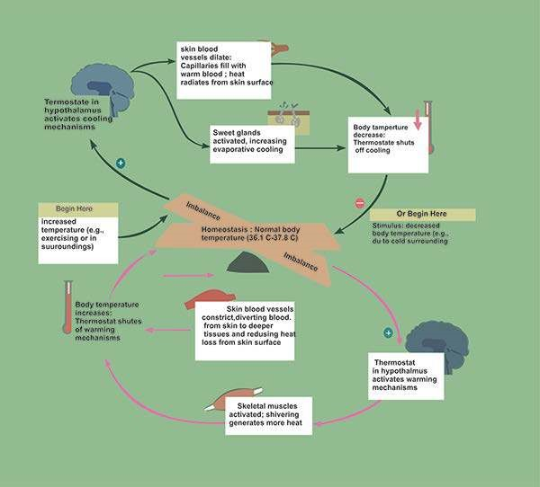

*Fig. 15.14 The thermostat function of the hypothalamus and feed back control mechanisms in human thermoregulation.*

**In Warm Temperature :** Marine mammals dispose of their excess heat into warm seas by large number of blood vessels in the outer layer of the skin. This dissipates the heat from the skin surface. In terrestrial mammals, in contrast is the mechanism of evaporative cooling. The sweat gland activity and the evaporative cooling is the one of the major temperature reducing strategies. Panting, the evaporative cooling in the respiratory tract, is’the other mechanism as represented in the dogs. Bats etc use saliva and urine for evaporative cooling.

## Thermostat Function and Feedback Controls in Human

The body temperature regulation in humans is based on complex homeostatic systems facilitated by feedback mechanisms. The homeostatic thermostat is present in the hypothalamus, a brain part. It responds to the changes in the temperature above and below a set point which is 37°C.

In case of increase in temperature above the set point, certain warm temperature sensitive thermoreceptors in skin, hypothalamus and other parts of nervous systems send the signals to the system that increase the blood low to the skin and also cause sweat gland activation and the sweat is evaporated for the cooling.

In cold temperature, the cold receptors send the impulses to hypothalamus to inhibit heat loss mechanisms and activate the heat conservation mechanisms. This includes constriction of supericial blood vessels and stimulating shivering and non shivering mechanisms.

## Temperature in fever (Pyrexia)

In bacterial and viral infections mainly, leukocytes increase in number. These pathogens and the blood cells produce chemicals called as pyrogens. Pyrogens displace the set point of hypothalamus above the normal point of 37° C. Fever or high temperature helps in stimulating .the protective mechanisms against the pathogens

## Exercise

**Q.2. Fill in the blank.**

(i) ___________________is the ability of an organism to regulate its luid contents. (ii) The detoxiication of ammonia to ________________ requires the precursor of ornithine.

1. In kidney nephron is closely associated with network of______________________ .
2. In insects salt and water reabsorption takes places in the___________________.(v) The antidiuretic hormone act on_________________ to promote reabsorption of water in vertebrate nephron.
3. The nephrons arranged along the border of cortex and medulla, with tubular system looping deep in the inner medulla, are called __________________ . nephrons.
4. The non surgical procedure of removing kidney stone is termed as______________ .(viii) ___________ is the homeostatic thermostat in human.

**Q.3. Short questions**

1. Diferentiate between osmoconformers and osmoregulators.
2. Deine anhydrobiosis with an example.
3. Why does iltration takes place only at glomeruli part of nephron and nowhere else?

(vi) Mention two metabolic altered states that generally (70%) cause kidney stone formation.

1. What is a renal failure?
2. Account one each main adaptation in plants to high and low temperatures.

**Q.4. Extensive questions**

1. Discuss nature of excretory products in animal to various habitats, speciically in association of water availability.
2. Account the excretory system in earthworm.
3. Highlight the role of liver as an excretory organ.

(vi) Draw a labeled diagram of a vertebrate nephron with all blood supply. State the function of each part.

1. Describe thermoregulatory strategies in mammals including human in cold temperature.
2. Discuss excretion in plants.
3. Discuss some kidney problems with their cures.