* Promote bud initiation in shoots but sometimes antagonistic to cytokinins and is inhibitory.
* Promote apical dominance and fruit growth. They can sometimes induce parthenocarpy.
* Cause delay in leaf senescence (aging) in a few species.
* Inhibit abscission.

**Commercial applications:** Discovery of IAA led to the synthesis of wide range of compounds by chemists. The synthetic auxins are economical than IAA to produce and often more active because plants generally do not have necessary enzymes to break them down.

|  |  |
| --- | --- |
| **Synthetic auxins** |  |
| NAA (Naphthalene acetic acid) Indole propionic acid | Stimulates fruiting - help natural fruit set. Sometimes causes fruit setting in absence of pollination (parthenocarpy) |
| 2,4 D (2,4 Dichloro phenoxy acetic acid) | Selective weed killer Kills broad leaved species (dicots). Used in cereal crops and lawns to eliminate weeds.  Inhibits sprouting of potatoes.  Prevents premature fruit drop (retards abscission) |

**(b) Gibberellin:** These are produced commercially from fungal cultures.

* Promote cell enlargement in the presence of auxins. Also promote cell division in apical meristem and cambium.
* Promote ‘bolting’ of some rosette plants.
* Promote bud initiation in shoots of chrysanthemum callus.
* Promote leaf growth and fruit growth. May induce parthenocarpy.
* In apical dominance, enhance action of auxins.
* Break bud and seed dormancy.
* Sometimes may substitute for red light. Therefore, promote lowering in longday plants, while inhibit in short-day plants.
* Cause delay in leaf senescence in a few species.

**Commercial applications:** Some of their commercial applications are as under.

1. GA promote fruit setting e.g. in tangerines and pears and are used for growing seedless grapes (parthenocarpy) and also increase the berry size.
2. GA3 is used in the brewing industry to stimulate a-amylase production in barley and this promotes malting.
3. To delay ripening and improve storage life of bananas and grape fruits.

**(c) Cytokinins:**

* Promote stem growth by cell division in apical meristem and cambium.
* Inhibit primary root growth.
* Promote lateral root growth.
* Promote bud initiation and leaf growth.
* Promote fruit growth but can rarely induce parthenocarpy.
* Promote lateral bud growth, also break bud dormancy.
* Cause delay in leaf senescence.
* Promote stomatal opening.

**Commercial application:** Cytokinins delay aging of fresh leaf crops, such as cabbage and lettuce (delay of senescence) as well as keeping lowers fresh. They can also be used to break dormancy of some seeds.

**(d) Abscisic acid :**

* Inhibits stem and root growth notably during physiological stress, e.g. drought, and waterlogging.
* Promotes bud and seed dormancy.
* Promotes lowering in short day plants, and inhibits in long day plants (antagonistic to gibberellins).
* Sometimes promotes leaf senescence.
* Promotes abscission.
* Promotes closing of stomata under conditions of water stress (wilting).

**Commercial application:** Abscisic acid can be sprayed on tree crops to regulate fruit drop at the end of the season. This removes the need for picking over a large time-span.

**(e) Ethene:**

* Inhibits stem growth, notably during physiological stress.
* Inhibits root growth.
* Breaks dormancy of bud.
* Promotes lowering in pineapple.
* Promotes fruit ripening.

**Commercial application:** Ethene induces lowering in pineapple. Stimulates ripening of tomatoes and citrus fruit. The commercial compound ethephon breaks down to release ethene in plants and is applied to rubber plant to stimulate the low of latex.

**CO-ORDINATION IN ANIMALS**

It is brought about in higher animals by nervous co-ordination and chemical co-ordination.

### NERVOUS CO-ORDINATION

This type of co-ordination involves specialised cells or neurons linked together directly or via the central nervous system, to form network that connects the cell or organs which receive stimuli (receptors) and those which carry out actions or responses (efectors). The neuron has the capacity to generate and conduct impulses which travel across the synapse and pass from the receptors to the efectors, brings about nervous coordination. The elements of nervous system which help in co-ordination are:

1. Receptors. 2. Neurons 3. Efectors.

#### 1. Receptors

The neuron ibres and cell bodies can be excited by small electric shocks, mechanical, chemical, light and temperature stimuli. Receptors detect changes in the external and internal environment of the animal. The receptor may be a cell, or neuron ending or a receptor organ. Receptors are classiied as follows :

1. **Chemoreceptors:** These are for smell taste and for blood CO2 oxygen, glucose, amino acids and fatty acid (e.g. receptors in the hypothalamus)
2. **Mechanoreceptors:** These detect stimuli of touch pressure, hearing and equilibrium (eg. Free nerve endings + expanded lip endings + stray endings) !
3. **Photoreceptors** (electromagnetic receptors), these respond to stimuli of light for example in eyes, rods and cones.
4. **Thermoreceptors:** These are free nerve endings. These show response to cold and warmth.
5. **Nociceptors:** (Undiferentiated endings) which produce the sensation of pain.

Each type of the principal type of sensation that There are many receptors which respond to the we can experience pain, touch, sight, sound mechanical conditions of the internal organs. and so forth are called modalities of sensation. Examples are the receptors of the stomach wall Yet despite the fact that we experience these which may be concerned with arousal of ‘hunger’; diferent modalities of sensation; nerve ibres stretch receptors in the carotid and aortic arteries transmit only impulses. How is it that diferent of tetrapods have important roles in the regulation nerve ibres transmit diferent modalities of of blood pressure; endings with similar properties sensation? The answer to this question is: are found in the branchial vessels of ishes.

1. Each nerve tract terminates at a speciic point in the CNS; and the type of sensation is determined by the point in the nervous system to which the ibre leads. So touch stimulus is carried by nerve impulse in the ‘touch’ area of the brain. Similarly ibres from the eyes (retina) terminate in the visual cortex of the brain.
2. Moreover, each receptor organ is specialised to receive a particular type of stimulus and this is carried to the particular area of the brain.

*Animation17.5: Neuroanim*

*Source and Credit:*[*pia-magazine*](http://www.p-i-a.com/Magazine/Issue3/Physics_3.htm)

#### Working of Sensory Receptors with Special Reference to Skin

In the skin there are at least 3 diferent types of sensory endings involved in touch stimulus reception. In skin, the receptors are concerned with atleast ive diferent senses: touch, pressure, heat, cold and pain.

1. Situated at the base of hairs, hair end organs receive touch stimulus.
2. Meissner’s corpuscles (encapsulated endings) which lie in papillae which extend into the ridges of the ingertips. The corpuscle consists of spiral and much twisted endings, each of which ends in a knob. These are touch receptors.
3. Pacinian corpuscles - situated quite deep in the body. These are also encapsulated neuron endings and receive deep pressure stimulus. Those located in the limbs probably form a basis for vibration sense.

The intensity of stimulus received would either be transmitted in the form of repeated impulses or by more ibres carrying the impulse to the CNS.

The relative abundance of various types of receptors difers greatly e.g. pain receptors are nearly 27 times more abundant than cold receptors. The cold receptors are nearly 10 times more abundant than heat or temperature receptors. The receptors are not distributed evenly over the entire surface of the body e.g. touch receptors are much more numerous in the inger tips than in the skin of the back, as might be expected in view of the normal functions of those two parts of the body. The detection of vibrations of the ground by terrestrial vertebrates is probably achieved by receptors in the joints.

The stimulus received by the receptors in the skin which are the endings of sensory neurons is passed to the motor neurons via inter or associative neurons which are present in the brain and via spinal cord impulse is sent by the motor neurons to the efectors, which are muscles and glands (Fig. 17.1).

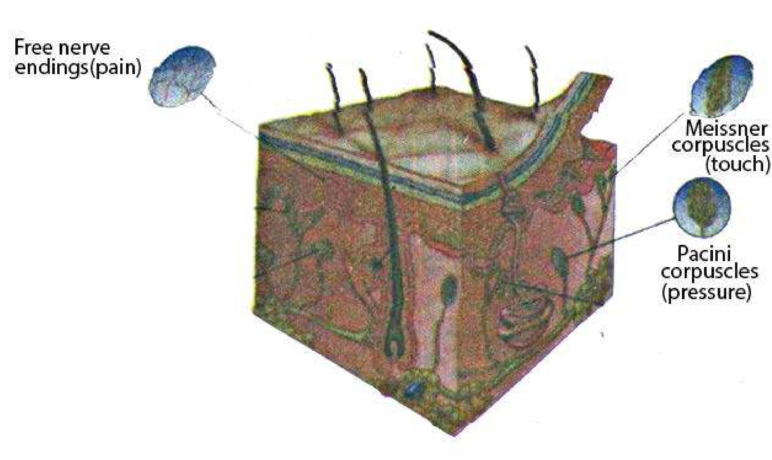

*Fig. 17.1 Sensory receptors of the skin.*

The sensations of touch, pressure, heat, cold, and pain are detected by modiied sensory neurons having naked nerve endings (touch and pain receptors) or specialized cellular corpuscles (pressure, hot and cold receptors).

##### 2. Neurons

The chief structural and functional units of the nervous system are neurons, but there are other cells, in higher animals, and in humans called **neuroglia**, which make up as much as half of the nervous system. Neuroglia play a vital role in the nutrition of neurons and their protection by myelin sheath. There are three functional types of neurons-the sensory, associative (intermediate/ relay) and motor neurons, in mammals (Fig. 17.2)

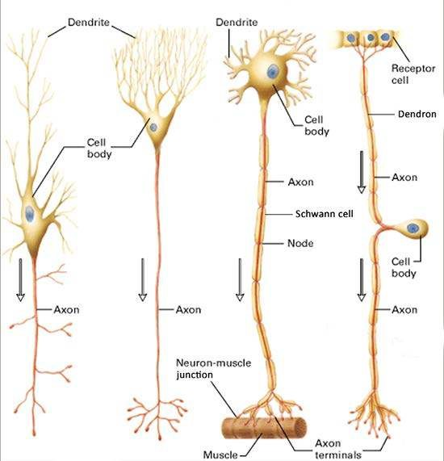

*Fig 17.2 Avariety of neuron types in human, beings.*

(a) The dendrites unlike the axon, often give a spiny look. (b)The dendrites of certain brain cells branch profusely, giving cell a treelike appearance, (c) Motor neurons have long axons that run from the C. nervous system to the efector (muscle); these axons are frequently,”but not always myelinated. Note the presence of many granules ip the cell body and dendrites and their absence from the axon.(d) Many sensory neurons have only one iber, which branches a short distance from the cell body, one branch (peripheral) running between the receptor site and the dorsal-root ganglion in which the cell body is located, and the other branch (central) running from the ganglion into the spinal cord or brain. Except for its terminal portions, the entire iber is structurally and functionally of the axon type, even ‘though the peripheral branch c mducts impulses toward the cell body. A sensory neuron of this type thus has no true dendrites a though the peripheral branch is often called a dendron because of the direction in which it conducts impulses.

The neuron has protoplasmic processes arising from its cell body containing nucleus and various organelle embedded in the cytoplasm. There are two main types of cytoplasmic processes or ibres. The one which carry impulse towards cell body is called **dendron**, if it is a single ibre but if smaller ibres _they are called **dendrites** (singular: dendrite). The processes conducting impulses away from cell body are termed axons. These may be more than a meter long in some neurons. **Nissl’s granules** which are groups of ribosomes associated with rough E.R, and Golgi apparatus are present in the cell body. Microtubules, neuroibrils, rough endoplasmic recticulum and mitochondria are present throughout the axoplasm (cytoplasm of axon) of the neuron.

The cell body or soma is the main nutritional part of the cell and is concerned with the biosynthesis of materials necessary for the growth and maintenance of the neuron. If the cell body of the neuron remains intact, it can regenerate axonal and dendrite ibres; but neurons once mature, do not divide any further.

###### 3. Efectors

These are the structures which respond when they are stimulated by impulse coming via motor neuron. The principal efectors are glands, which respond by secreting; and muscles which respond by contracting. Flow of information through the nervous system is explained with the help of a relex arc.

##### Relex Arc

Flow of impulse through the nervous system involving receptors, neurons, and efectors will be clear if we study an example of a relex arc.

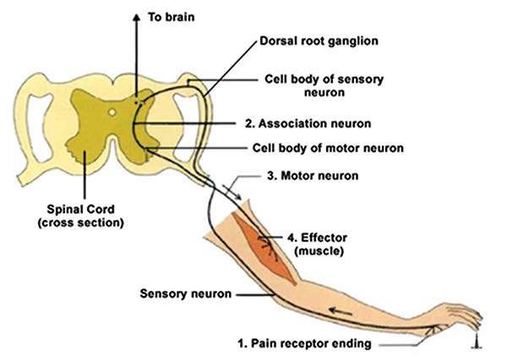

*Fig. 17.3 The pain-withdrawal relex*

This simple relex circuit includes each of the four elements of a neural pathway. (1) The sensory neuron has pain-sensitive endings in the skin and a long iber leading to the spinal cord. That neuron stimulates (2) an association neuron in the spinal cord, which in turn stimulates (3) a motor neuron, also in the cord. The axon of the motor neuron carries action potentials to (4) muscles, causing them to contract and withdraw the body part from the damaging stimulus. The sensory neuron also makes a synapse on association neurons not involved in the relex that carry signals to the brain, informing it of the danger.

Relex arc is the path way of passage of impulse during a relex action. Relex action is a type of involuntary action. (Fig. 17.3). The direction of stimulus is from receptors to sensory neuron to associative (association / relay) neuron and then through motor neuron to the efectors.

*Animation17.7: Relex rotuline*

*Source and Credit:* [*Corpshumain*](http://www.corpshumain.ca/en/Touche_en.php)

#### Nerve Impulse

Nerve impulse is a wave of electrochemical changes, which travels along the length of the neuron involving chemical reactions and movement of ions across the cellmembrane. Electrical potential is a measure of the capacity to do electrical work. It represents a type of stored energy which is- manifested during separation of charges across a barrier. In the case of neuron, the charges are positive and negative ions, and the charge separating barrier is the plasma membrane. The electrical potential that exists across a cell membrane is known as **membrane potential**. A typical neuron at rest is more positive electrically outside than inside the cell membrane. This net diference in charge between the inner and the outer surface of a non-conducting neuron is called the **resting membrane potential.** The major factors which are involved in resting membrane potential are:

1. **Sodium and potassium ions:** Of the many kinds of ions present in the nerve cells and the surrounding luid, sodium (Na+) and potassium (K+) ions are the most important. Sodium ions are tenfold higher in concentration outside than inside the membrane surface, whereas potassium ions are twenty times more concentrated inside than outside. All the neurons have very active sodium and potassium pumps located in their cell membranes. Driven by the splitting of ATP, these pumps transport Na+ out and K+ into the cell, both against their respective concentration gradients. For every two K+ that are actively transported inward, three Na+ are pumped out. So inside becomes more negative than the outside ofthe cell membrane o f neurons. (Fig. 17.4)
2. **Negative organic ions:** The large negative organic ions (such as proteins, organic acids etc) are much more inside the membrane than outside, where they are only in negligible concentration. This makes the inside of neuron membrane more negative.
3. **Leakage of K+ ions from neurons:** The cell membrane is virtually impermeable to all ions except K+. Since the membrane is slightly permeable to K+, some of it leaks out of the cell. The loss of this positive ion from the neuron by difusion accounts for more negative’charges inside than outside the cell membrane of neuron.

##### 4. No conduction of nerve impulse

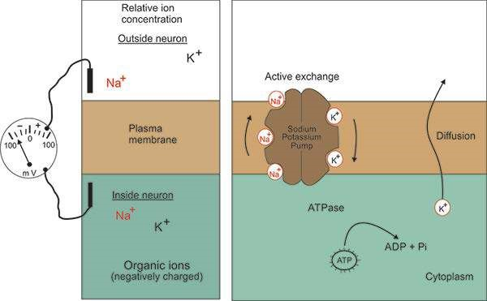

*Fig. 17.4 Resting potential*

(a) In the unstimulated state, a neuron has a membrane potential of approximately - 70mV. The relative concentrations of the principal ions inside and outside the neuron are indicated by the sizes of the chemical’”symbols (Na+ = sodium ion, K+ = potassium ion), (b) Two of the major processes that contribute to the negative resting potential are the active exchange of Na+ for K+, .and the outward difusion of K+. The sodium - potassium pump actively transports Na+ out and K+ into the cell, and is powered by the splitting of ATP by an associated enzyme, ATPase.

**Initiation of nerve impulse:** Under normal conditions a nerve impulse is initiated by an appropriate stimulus (called threshold stimulus) applied at one end of the neuron and it results in a remarkable localized change in the resting mefmbrane potential.

*Animation17.8: Diporepol*

*Source and Credit:* [*cybercuba*](http://www.cybercuba.com/ni.html)

It disappears for a brief instant and is replaced by a new potential called **action** or **active membrane** potential which is in the form of impulse. During this state, the inner membrane surface becomes more positive than the outside. This change is so brief (for perhaps a millisecond) that only a portion of the neuron is in the active membrane potential state.

The major factors involved in changing the resting membrane potential to active membrane potential are: (Fig 17.5)

1. **Na+ and K+ ions movement:** The passage of nerve impulse is associated with increase in permeability of Na+ ions moving inwards upsetting the potential momentarily, making the inside more positive than outside. Neurophysiologists believe that the increased permeability is due to the opening of speciic pores in the membrane, termed “sodium gates”. When these gates open, sodium ions rush into the neuron by difusion. Some K+ moves out.
2. **Charges are reversed:** The inner side of the cell membrane has excess of positive ions (thus positive charges) at its internal surface, and the outer surface becomes more negative.

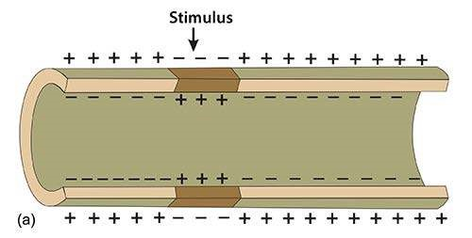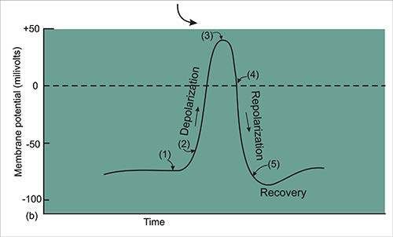

*17.5 Active or action potential*

(a) When a neuron is stimulated, the cell membrane at the point of stimulation undergoes a momentary reversal in charge (dark color) called an action potential. Perhaps for a millisecond, the inside of the membrane becomes positive relative to the outside, (b) Sequence of membrane potential changes associated with an action potential: (1) resting potential (polarized state); (2) sodium gates open and Na+ difuses into the cell, causing a depolarization of the membrane; (3) ; sodium gates close and potassium gates open; (4) K+ difuses out, causing a repolarization of the membrane; (5) sodium - potassium pump restores original ion gradients and resting potential (recovery). Steps (2) - (5) take a mere 2- - 3 milliseconds.

1. **Passage of nerve impulse:** During active membrane potential, the neuron conducts the impulse in the form of nerve impulse.
2. **Membrane potential:** Active membrane potential of +0.05 volts (+50mv) exists.

These changes occur along the length of neuron till the impulse reaches synapse. Soon after passage of the impulse, the resting membrane potential is restored by the movement of a small number of ions especially K+ moving out. This neuron now is ready to conduct another impulse.

It may be added that in myelinated neurons the impulse jumps from node to node (node of Ranvier). This is called **saltatory impulse.**

The normal speed of nerve impulse in humans is 100 meters per second but maximum speed recorded is 120 meters per second.

#### Synapse

Consecutive neurons are so arranged that the axon endings of one neuron are connected to the dendrites of the next neuron. There is no cytoplasmic connection between the two neurons and microscopic gaps are left between them. Each of these contact points is known as **synapse.**

A single neuron may form synapses with many incoming ibres of diferent neurons.

A nerve impulse is passed from one neuron to the other through the synapse, but a single impulse does not necessarily get across the synapse. It may take two or three impulses arriving in rapid succession or perhaps simultaneously from two or more ibres to start an impulse in the next neuron.

The action potential cannot jump from one neuron to the next in line; rather the message is transmitted across synapse in the form of chemical messenger called neurotransmitter.

**a b**

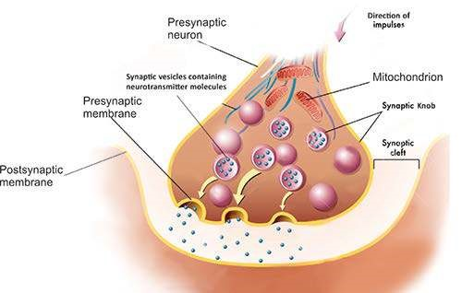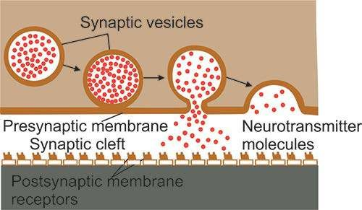

*Fig 17.6 Communication across a synapse*

When an impulse reaches a synaptic knob, synaptic vesicles within fuse with the presynaptic membrane, causing the release of neurotransmitter molecules into the synaptic cleft. The neurotransmitter molecules bind to the receptors, on the postsynaptic membrane, triggering an action potential in the postsynaptic neuron, by causing changes in its permeability to certain ions. (Fig. 17.6)

Neurotransmitters are chemicals which are released at the axon ending of the neurons, at synapse. Many diferent types of neurotransmitters are known. These are: acetylcholine, adrenaline, norepinephrine, serotonin and dopamine.

Acetylcholine is the main transmitter for synapses that lie outside the central nervous system. Others are mostly involved in synaptic transmission within the brain and spinal cord.

##### Evolution of Nervous System

There are two designs of nervous system in the animal kingdom.

1. A difused nervous system, such as that of Cnidarians (Hydra, jelly ish and their relatives)
2. A centralized nervous system, found to varying degrees in more complex organisms, from platyhelminthes to chordates including humans.

To understand the organization of the above mentioned types of nervous system, we would study them in *Hydra*, *Planaria* and humans. Nervous system design is highly co-related with the animal’s life style. The irst main type of nervous system is a difused nervous system. Hydra shows this type of nervous system (Fig. 17.7a).

*Hydra,* a cnidarian, is a small animal which is sedentary in its life style and prey and other dangers are equally likely to come from any direction. Its nervous system consists of a network of neurons, which is present between the ectoderm and endoderm. There is no head in this animal and so there is no centralized nervous system i.e. no brain and nerve cords etc. However, a cluster cell of bodies of neuron’s forming ganglia can be seen here and there. It has been observed that neurons are so arranged in the network that it is not possible to distinguish them in connected functional types of neurons as in higher animals i.e. there are no sensory, associative (inter/relay) neurons, or motor neurons, there are no specialized sense, organs in this animal. It has been observed and studied that when an appropriate stimulus is given, *Hydra* responds - and almost the whole body of the animal responds as a unit. The tentacles are more responsive and react to the stimulus instantaneously (Fig. 17.7a).

The second type of nervous system is present in Planaria (Fig. 17.7b) and humans. It is centralized nervous system. The nervous system of *Planaria* is better developed as compared with that of *Hydra* because in *Planaria*:

1. There is beginning of a centralized nervous system. In the anterior brain region of the body of *planaria,* there is a bilobed mass composed of two ganglia. This acts as a ‘‘brairr “or a centralized collection of neurons. This receives and sends impulses from and to diferent parts of the body. There is no such concentration of neurons or a coordinating centre in *Hydra* - only a network of neurons is present.
2. There is diferentiation of neurons into sensory associative and motor neurons. In *Planaria*, associative neurons are present in the brain and longitudinal nerves. Sensory neurons carry impulse to ‘brain’ or nerves and motor neurons carry impulse from central nervous system to diferent parts of the body. In *Hydra* there is no diferentiation of neurons.
3. In *Planaria* at the anterior region, sense organs in the form of eyes and chemoreceptors are present. There are no specialized sensory organs in *Hydra*.
4. The receptor cells sensitive to pressure and touch-are present in *Planaria*. There are no specialized sensory cells in *Hydra*, but some nerve cells are moo, sensitive, to a particular stimulus - chemical or mechanical, than others.
5. There are deinite nerves, the longitudinal and lateral in Planaria. There are no nerves in *Hydra.* (vi) In **Planaria** in addition to a supericial nerve net just below epidermis, there is a deeper plexus embedded in the parenchyma. In 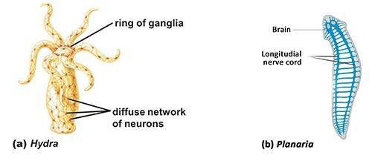*Hydra* only a supericial nerve net is present (Fig 17.7a).

*Fig. 17.7 Nervous systems in Hydra and Planaria.*

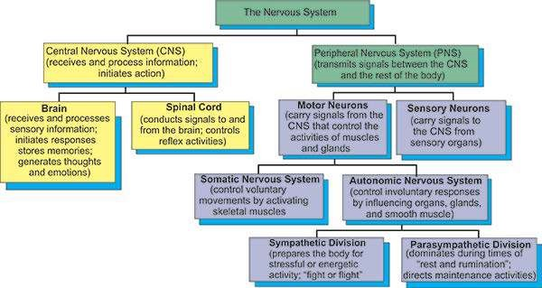

*17.8 Classiication of the human nervous system*

#### HUMAN NERVOUS SYSTEM

Human nervous system is a type of centralized nervous system. Its classiication in diferent subdivisions and diferent functions performed by these subdivisions are given in Fig 17.8.

##### Central Nervous System (CNS)

The CNS consists of brain (Fig. 17.9) and spinal cord, which are both protected in three ways. Cranium, which is a part of skull, protects the brain and neural arches, of vertebrae of vertebral column protect the spinal cord. The brain and spinal cord are also protected by triple layers of meninges. The cerebrospinal luid (CSF), similar in composition to blood plasma, bathes the neurons of brain and spinal cord and it cushions against the bumps and jolts. Both brain and spinal cord are hollow. The spinal cord has central canal and brain has many cavities (ventricles) illed by CSF, which is also present between the meninges.

**Brain:** The brain can be divided into forebrain, midbrain and hindbrain. Forebrain is further divided into three functional parts, the thalamus, the limbic system (Fig. 17.10) and the cerebrum. Thalamus carries sensory information to the limbic system and cerebrum. The information includes sensory input from auditory and visual pathways, from the skin and from within the body.

The limbic system is located in an arc between the thalamus and cerebrum. Limbic system works together to produce our most basic and primitive emotions, drives, and behaviours, including fear, rage, tranquillity, hunger, thirst, pleasure and sexual responses. Portion of limbic system is also important in the formation of memories. The limbic system consists of hypothalamus, the amygdala, and hippocampus, as well as nearby regions of cerebrum. The hypothalamus through its hormone production and neural connections acts as a major co-ordinating centre controlling body temperature, hunger, the menstrual cycle, water balance, the sleep-wake cycle etc. n the amygdala, clusters of neurons produce sensation of pleasure, punishment or sexual arousal when stimulated. It is also involved in the feelings of fear and rage.

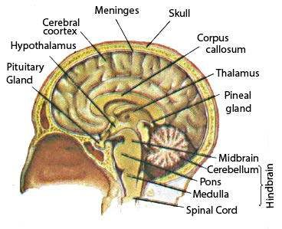*17.9 The human brain*

A section through the midline of the human brain reveals some of its major structures.

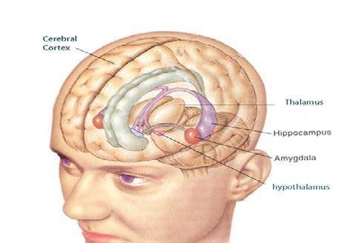17.10 The limbic system and thalamus

The limbic system extends through several brain regions. It seems to be the center of most unconscious emotional behaviors, such as love, hatred, hunger,

Isexual responses, and fear. The thalamus is a crucial relay center among the senses, the limbic system, and the cerebral cortex.

Hippocampus plays an important role in the formation of long term memory, and thus is required for learning. Cerebrum is the largest part of the brain and is divided into two halves, called cerebral hemispheres. These halves communicate with each other by means of a large band of axons, called corpus callosum.

Tens of billions of neurons are packed into this part. The outer region, the cerebral cortex, forms folds called convolutions, which greatly increase its surface area. This part receives sensory information, processes it, stores some in memory for future use, directs voluntary movements, and is responsible for the poorly understood process that we call thinking.

The cerebral cortex contains primary sensory areas where signals originating in sensory organs such as eyes and ears are received and converted into subjective impressions, such as light and sound. Nearby association areas interpret this information. This area is also involved in speech and also receives and interprets sensations of touch from all parts of the body. This area is also a centre for sending impulses to voluntary muscles, controlling movements. This is also involved in intelligence, reasoning and judgement.

The left cerebral hemisphere controls the right side of the body, and right cerebral hemisphere controls the left side of the body. **Midbrain** is reduced in humans, and it contains auditory relay centre and centre that controls relex movements of eyes. Midbrain contains reticular formation, which is a relay centre connecting hindbrain with the forebrain. Reticular formation is very important in screening the input information, before they reach higher brain centres. **Hindbrain** includes the medulla, pons and cerebellum. Medulla controls several automatic functions, such as breathing, Heart rate, blood pressure and swallowing. Certain neurons in pons, located above the medulla, appear to inluence transitions between sleep and wakefulness, and the rate and pattern of breathing. The cerebellum is important in co-ordinating movements of the body. The cerebellum guides, smooth and accurate motions and maintains body position. The cerebellum is also involved in the learning and memory storage for behaviours. It is best developed in bird , which is engaged in the complex activity of light.

**Spinal Cord:** Medulla oblongata narrows down into an oval shaped hollow cylinder, the spinal cord, running through the vertebral column. It is made up of a very large number of neurons, the cell-ibres and bodies of which are arranged in a deinite pattern. In cross section, the spinal cord shows an inner butterly shaped grey matter, containing a central canal and the outer portion composed of white matter. Gray matter, as in other parts of nervous system consists of cell bodies and non-myelinated nerve ibres or tracts. White matter is made up of myelinated nerve ibres or tracts.

The spinal cord is the centre for great many relexes and it serves as a pathway for conduction of impulses to and from diferent parts of the body and brain (Fig 17.11).

###### Peripheral Nervous System (PNS)

It comprises of sensory neurons and motor neurons, which may form ganglia and the nerves. Ganglia are the concentrations of cell bodies of neurons. The nerves are the bundles of axons or dendrites, bounded by connective tissue. They may be sensory motor or mixed nerves depending upon the direction of impulse they conduct. In humans, there are 12 pairs of nerves, which arise from the brain, or lead to the brain. These nerves are called **cerebral** or **cranial nerves**. Some of these nerves are sensory, some motor, and some are mixed. From the spinal cord 31 pairs of spinal nerves arise or lead to spinal cord. All these nerves are mixed having ibres of both sensory and motor neurons.

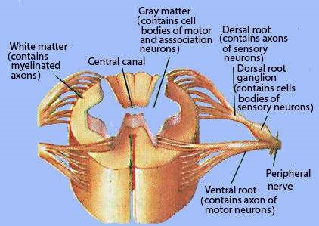

*17.11 The Spinal cord*

~~Motor neurons form somatic nervous system, which controls voluntary movements, which are~~ under the conscious control of the body, involving skeletal muscles. Motor neurons also form autonomic nervous system, which controls involuntary responses by inluencing organs, glands and smooth muscles. The autonomic nervous system is further divided into sympathetic nervous system and para sympathetic nervous system (Fig 17.9).

##### Autonomic Nervous System

The motor neurons of autonomic nervous system are divided into the sympathetic and para sympathetic system. Both of these systems function automatically, innervate all internal organs, utilize two neurons and one ganglion for each impulse.

**Sympathetic system :** Most ganglion ibres of the sympathetic system arise from the middle protion of the spinal cord and almost terminate in ganglia that lie near the cord. This system is important during emergency situations and is associated with “ight or light.” This system accelerates the heart beat, dilates the pupil and inhibits the digestion of food etc.

**Parasympathetic system :** A few cranial nerves including the vagus nerve together with the nerves from the bottom portion of spinal cord, form the parasympathetic nervous system. It promotes all the internal responses which are associated with the relaxed state i.e. contraction 6f the pupils, promotes digestion of food, retards heart beat etc.

###### Nervous Disorders

Following are some of the common disorders of nervous system in humans:

1. **Parkinson’s disease :** It is a nervous disorder, characterized by involuntary tremors, diminished motor power and rigidity. The mental faculties are not afected. The disease is believed to be caused by cell death in a brain area that produces dopamine. Onset of disease is usually in 50’s and 60’s. The disease is slowly progressive; the patient may live for many years. The disease may result by head trauma. Efective drugs are available such as L- dopa. A naturally occuring protein called glial cell-line derived: neurotrophic factor (GDNF) has been shown to boost uptake’ofdopamine, when delivered to lab. rats and monkeys. GDNF may be used in near future for humans in the treatment of this disease.
2. **Epilepsy:** It is one of the convulsive disorders of nerves which are characterized by abrupt transient symptoms of motor, sensory, psychic or autonomic nature, frequently associated with changes in consciousness. These changes are believed to be secondary to sudden transient alterations in brain function associated with excessive rapid electric discharges in the gray matter. The onset of epilepsy is usually before age 30. Later age onset suggests organic disease. In some patients, emotional disturbances play a signiicant “trigger” role. Electroencephalography is the most important test in the study of epilepsy. Anticonvulsant drugs are used. Alcohol aggravates epilepsy, so persons sufering from epilepsy should avoid alcohol.
3. **Alzheimer’s disease:** Alzheimer’s disease was irst described by Alois Alzheimer in 1907. It is characterized by the decline in brain function. Its symptoms are similar to those diseases that cause dementia (memory loss). There is a genetic predisposition to the disease in some people, so it tends to run in families. There is also evidence that high levels of aluminium may contribute to the onset of this disease. There is also decline in brain function with age.

Efect of Drugs on Coordination

**Action of Nicotine:** Nicotine afects post synaptic membrane in CNS and PNS. It mimics the action of acetylcholine on nicotine receptors, so it is stimulant of nerve impulse. It increases the heart beat rate, blood pressure and digestive tract mobility. Nicotine may induce vomiting and diarrhoea and even may cause water retention relation by kidneys.

#### CHEMICAL COORDINATION

In animals, it involves endocrine system which comprises endocrine glands in various parts of the body, which secrete hormones. The endocrine or ductless glands are, with a few exceptions, discrete groups of cells, which make speciic chemical compounds called hormones (Greek hormone is exciting, setting in motion). Endocrine system consists of some 20 endocrine glands/tissues lying in diferent parts of the body.

##### Hormones

Hormones are organic compounds of varying structural complexity (see below). They are poured directly and are transported to blood to respective target tissues. The hormones afect the target cells. They do not initiate new biochemical reactions but produce their efects by regulating enzymatic and other chemical reactions, already present. They may either stimulate or inhibit a function. Hormones may also control some long term changes, such as rate of growth, rate of metabolic activity and sexual maturity.

Chemically hormones may be of following four types:

(i) Proteins (e.g. insulin and glucagon .) (ii) Amino acids & derivatives (e.g. Thyroxine, epinephrine and norepinephrine) (iii) Polypeptides (e.g. vasopressin or anti-diuretic hormone and oxytocin), and (iv) Steroids (e.g. oestrogens, testosterone and cortisone.)

### ENDOCRINE GLANDS OF MAMMALS

#### Hypothalamus

It is a part of the forebrain. It is here that many of the sensory stimuli of nervous system are converted into hormonal responses. It is believed that oxytocin and antidiuretic hormone (ADH) are produced in hypothalamus and travel down the nerves to the posterior lobe of pituitary to be stored. They are released from their storage after receiving nerve impulses from the hypothalamus. (Fig 17.13)

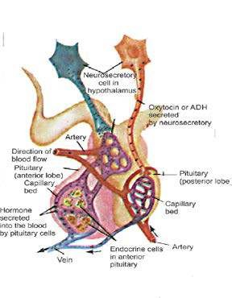

*17.13 The Hypothalamus - Pituitary Connection.*

Neurosecretory cells in the hypothalamus produce and secrete a variety of hormones. One of the nerve clusters synthesizes oxytocin and vasopressin, then stores them in nerve endings located in the posterior pituitary. Upon proper stimulation from the brain, oxytocin and vasopressin are released into the blood supply of the posterior pituitary. Other nerve clusters in the hypothalamus produce and secrete a battery of releasing and inhibiting hormones, which are carried by the blood to the anterior pituitary. There, they regulate the secretion of various tropic hormones, growth hormone, and prolactin manufactu red by the anterior pituitary cells.

#### The Pituitary Gland

In man, the pituitary gland or hypophysis cerebri is an ovoid structure about 0.5 gm in the adult and is connected to brain through a short stalk (the infundibulum). It has three lobes viz, anterior, median and posterior. The anterior lobe is often referred to as the master gland, because in addition to producing primary hormones it produces the tropic hormones which control the secretion of homones in many of the other endocrine glands (Fig. 17.13).

**Anterior lobe:** Anterior lobe of pituitary secretes the following hormones:

1. **Somatotrophin hormone (STH) :** Somatotrophin releasing factor (SRF) is secreted from hypothalamus throughout the life. When growth has mostly ceased after adolescence, the hormone continues to promote protein synthesis throughout the body. If produced in excess during early life, leads to gigantism or if later in life causes the abnormal development of hands, feet, jaws, etc. (known as acromegaly). If there is undersecretion, dwarism results, as well as other symptoms associated with lack of thyroid and adrenal hormone.
2. **Thyroid stimulating hormone (TSH) :** Release of thyrotroph in releasing factor from the hypothalamus is controlled by the levels of nuyoxine in the blood. In the presence of low levels of thyroxine, there is increasing production of TSH and vice versa (Fig 17.16). It is secreted throughout life but particularly reaches high levels during the periods of rapid growth and development. It acts directly on the cells of the thyroid gland, increasing both their numbers and their secretory activity

(Fig. 17.15).

##### 3. Adrenocorticotrophic hormone (ACTH) (Corticotrophic hormone): Release of

corticotrophin releasing factor from the hypothalamus is controlled by steroid levels in the blood and by direct nervous stimulation of the hypothalamus as a result of stress e.g. cold, heat, pain, fright, infections. Excess and deiciency results ui disturbance of normal adrenal functions.

**4. Gonadotrophic hormones (GH) :** These are follicle stimulating hormone (FSH), luteinising hormone (LH also called interstitial cell stimulating hormone ICSH, in the male), prolactin (sometimes inappropriately called luteotrophic hormone, LTH).

FSH and LH/1CSH share a common hypothalamic releasing factor. Prolactin is continuously produced from the pituitary and is inhibited by prolactin inhibiting factor (PIH) from the hypothalamus. Prolactin stimulates milk production and acts with LH as described below. FSH in females stimulates follicle development and secretion of oestrogens from the ovaries; in males it stimulates development of the germinal epithelium of the testis and sperm production. LH works with FSH to stimulate oestrogen secretion and rupture of mature follicles to release egg or ovum. It also causes the lutenisation (lit. “turning yellow’) of the latter and acts synergistically with prolactin to maintain the corpus luteum (and hence the progesterone it secretes). ICSH in the male stimulates the interstitial cells of the testis to secrete testosterone.

**Median lobe :** Median lobe secretes the following hormone :

**Melanophore stimulating hormone (MSH) :** Its inhibition of secretion is controlled by hypothalamus. External light governs its secretion. More secretion in pregnancy stimulates melanocytes in skin to produce brown pigment, melanin, which darkens the skin. Excess MSH is secreted in Addison’s disease. One of the symptoms of which is darkening of the skin.

**Posterior lobe:** Posterior lobe of the pituitary gland secretes the following hormones:

1. **Antidiuretic hormone (ADH) or Vasopressin:** Its secretion iscaused by decrease in blood pressure, blood volume, and osmotic pressure of the blood which is detected by osmoreceptors in hypothalamus. External’ sensory stimuli also inluence hypothalamic neurosecretory cells. Increased levels cause increased water reabsorption in distal parts of nephron. A lack of this hormone produce diabetes insipidus, characterized by production of large quantities o f dilute urine and great thirst.
2. **Oxytocin :** Its release is stimulated by distension of cervix, decrease in progesterone level in blood, and neural stimuli during parturition and suckling. Primary action is on smooth muscle, particularly in the uterus during childbirth, and also causes milk ejection from mammary glands.

#### Thyroid gland

In mammals it consists of two lobes situated below the larynx (Fig. 17.15). It produces thyroxine (or tetraiodo-thyonine: T4), tri-iodothyronine or T3 (which has a structure similar to thyroxine with 3 iodine atoms rather than 4) and calcitonin hormone. The thyroid is active continuously but produces higher levels of secretions during periods of rapid growth and sexual maturation and in stress situations such as cold and hunger.

Thyroxine and tri-iodothyronine, the two hormones act in essentially the same way. They act on the basal metabolic rate by stimulating the breakdown of glucose and release of heat and generation of ATP. They also act in conjunction with somatotropin in bringing about growth, and act directly on brain cells causing them to diferentiate. In amphibians, they bring about the process of metamorphosis. If secretion of thyroid is deicient,, tadpole larva of frog does not metamorphose to develop into frog, but instead grow to a large sized tadpole.

Excess thyroxine produces a condition called Graves’ disease, with exophthalmic goiter and increase in the basal metabolic rate. This can lead to cardiac failure if prolonged. The cause of Graves’ disease is the production of an abnormal body protein which continuously stimulates the thyroid to excessive secretion.

If congenitally deicient, the lack of thyroxine causes cretinism, where the individual fails to develop normally. They are small, have coarse scanty hair, thick yellowish scaly skin and are mentally retarded. They also fail to develop sexually. Deiciency later in life, perhaps due to iodine shortage in diet, produces swelling of the neck (goiter) and may lead to deposition of excess fat as a result of which’weight is increased. The condition is known as myxoedema, and it is characterized by puiness of hands and skin.

All bodily and mental processes are retarded. High Ca+ ion concentration in the blood causes stimulation of the synthesis and release of calcitonin; low levels of Ca++ ions suppress its manufacture. Excess or deiciency leads to disturbance of calcium metabolism with its associated efects on nerve, skeleton, muscle, blood etc. Calcitonin is antogonistic to parathormone hormone.

Table salt with iodine is recommended so that there is no deiciency of iodine and thus o

f

thyroxine in the body.

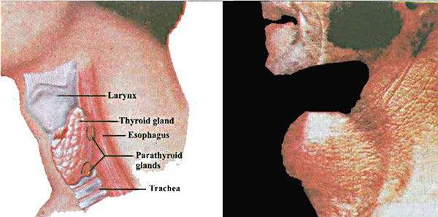

*17.15 The thyroid and parathyroid glands*

(a) The thyroid and parathyroid glands are Iocatevl Mow the Uirynx in the neck’, (b) Individuals with iodine-deicient diets may have goiter, a condition in which the thyroid becomes greatly enlarged.

#### Parathyroids

In man the glands are found embedded in the posterior part of the lateral lobes of the thyroid. These produce a hormone called parathormone. Low levels of blood Ca++ ions stimulate the parathyroid directly to increase parathormone production whereas high evels of Ca++ ions suppress its release. Under-activity causes a drop in blood Ca++ ions which in turn leads to muscular tetany. Over-activity would lead to a progressive demineralization of the bones similar to rickets, as well as to the formation of massive kidney stones. Both conditions may be fatal.

#### Islets of Langerhans (Pancreas)

This is under control of the pituitary trophic hormones STH and ACTH and also responds directly to the level of blood glucose. The islets contain large number of p cells associated with insulin production. The smaller number of a cells secrete glucagon. In general, insulin depresses blood glucose levels, in a variety of ways which include increasing glycogen synthesis and increasing cell utilization of glucose. It also stimulates conversion of glucose into lipid and protein, which in turn reduce glucose levels.

Insulin inhibits the hydrolysis of glycogen in the liver and the muscles. Failure to produce insulin leads to a condition called **diabetes mellitus**. The symptoms of this are high level of blood sugar, sugar in the urine, a disturbance of the body’s osmotic equilibrium and derangement of the nervous system. Toxic metabolites from fat (which need ‘glucose energy’ for their oxidation) also accumulate and are only lost from the kidney with valuable metal cations. The body becomes dehydrated. If excess insulin is produced the utilization of sugar is too great and its level falls in the blood (hypoglycaemia) which upsets nerve and muscle functioning.

Glucagon is essentially antagonistic to insulin and causes an increase in blood glucose level s. It does this mainly by promoting breakdown of glycogen to glucose in the liver and muscles. It also increases the rate of breakdown of fats.

Glucagon abnormalities seem rare as endocrine disorders. Tumors on the a cells will cause excess glucagon secretions and consequently high blood glucose levels. This in turn damages the a cells with the results described above.

#### Adrenals

A pair of adrenal gland is present, one on top of each kidney. Its outer layer in called adrenal cortex and inner is adrenal medulla. The medulla produces the hormones adrenaline (epinephrine) and noradrenaline (norepinephrine) The adrenal cortex secretes cortico-steroids such as cortisol, corticosterone, aldosterone, and androgenic hormones. (Fig. 17.16)

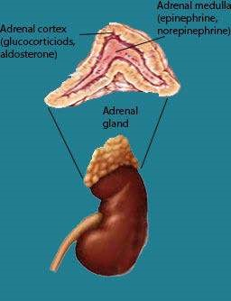

*17.16 The adrenal gland*

**Adrenaline and noradrenaline hormones:** Both adrenaline and noradrenaline are secreted in stress situations. Essentially adrenaline dilates blood vessels in certain parts of the body such as the skeletal muscles and increases the heart’s output. Noradrenaline constricts blood vessels but again only in certain areas, such as the gut, so the efects of the two hormones are synergistic in raising blood pressure. Adrenaline and noradrenaline promote the release of glucose from liver glycogen and reinforce the efects of the sympathetic system. Rarely found, but in excess, these hormones lead to abnormally high blood pressures. In rats whose adrenal medulla has been removed surgically, the ability to withstand any stress situation - such as cold - is markedly diminished.

**Cortical hormones:** The adrenal cortex is active at all times but especially so following shock or stress situations and infections. Cortisol is the glucocorticoid, and brings about an increase in blood glucose level mainly by its production fronr protein and by antagonizing the action of insulin.

Corticosterone is both a glucocorticoid and a mineralocorticoid; it increases blood glucose levels and regulates mineral ion balance. Aldosterone is the principal mineralo-corticoid and conserves the level of Na+ ions in the body by preventing their loss from the kidney tubules.

The destruction of the adrenal cortex, such as occurs in Addison’s disease, will lead to general metabolic disturbance, in particular weakness of muscle action and loss of salts. Stress situations, such as cold, which would normally be overcome, lead to collapse and death. The reverse of this is found in Cushing’s disease where too much cortical hormone is produced. Symptoms are an excessive protein breakdown resulting muscular and bone weakness. The high blood sugar disturbs the metabolism as in diabetes. Androgens cause development of the secondary male characteristics. Very small amounts of androgens are secreted in both male and female by adrenal glands. A tumor on the inner part of the adrenal cortex in a female can cause excess of androgens to be produced and thus the development of certain male characteristics. Such cases are very rare.

#### Gut

Many parts of the gut function as endocrine tissue. The important hormones produced are:

1. **Gastrin:** Gastrin is the hormone produced by mucosa of the pyloric region of the stomach. It stimulates the secretion of gastric juice. It is produced under the inluence of protein food in the stomach after it is partially digested.
2. **Secretin:** It is produced from the duodenum when acid food touches its lining. It afects the pancreas to produce and release pancreatic juice and also afects the rate of bile production in the liver.

#### Gonads (a) Ovary

1. **Oestrogen :** Oestrogen is secreted by ripening follicles (and, in many species, by interstitial cells of the ovary) whose development has been initiated by FSH from the pituitary. Oestrogens bring about the development of the secondary sexual characters in the female, cause thickening of the uterine wall and, at a point during the oestrous or menstrual cycle, exert a positive feedback which results in a sharp rise in LH output by the pituitary. They also aid in healing and repair of uterine wall after menstruation. Under the inluence of oestrogen, some of the cells of uterine wall become glandular and start secreting proteinaceous secretions which are taken up by the embryo during its early stages of development. Deiciency of the sex hormones, for one reason or another, leads in the young of failure to mature sexually and sterility in the adult.
2. **Progesterone :** Produced by the ruptured follicle in response to LH from the pituitary. Progesterone inhibits further FSH secretion from the pituitary, thus preventing any more follicles from ripening. It also afects the uterus, causing further thickening and vascularization of its wall, and other areas of the female body, preparing it for maintaining the state of pregnancy. It suppresses ovulation. That is why it is a major constituent of birth control pill.

##### (b) Testes

The testes consist of many coiled seminiferous tubules where the spermatozoa develop and, between the tubules, regions of interstitial cells produce gonadal hormones called testosterone and 17 b-hydroxytestosterone.

After the initiation of development, the sex organs in the foetus produce them, and their level rises fairly consistently until puberty. After puberty the supply of LH (ICSH), and therefore, the level of testosterone, remains constant. In the foetus, it initiates the development of the sex organs. At puberty it brings about development of the male secondary characteristics and promotes the sex drive. The castrated male fails to develop secondary sexual characteristics and his body tends more towards the form of the immature female.

##### Feedback Mechanism

It is a type of interaction in which a controlling mechanism is itself controlled by the products of reactions it is controlling.

For proper body functions, two opposing systems are needed, if there are accelerators, there must be inhibitors. If one hormone in the body promotes or stimulates a reaction, another hormone would be checking the same. In the body, interaction is mainly maintained due to feedback mechanism. In this way, concentration of secretions is itself controlled because certain information is passed to the source or in other words is fed back so that the output of the secretion is adjusted accordingly, depending on the activity of the body. The interaction between the. pituitary and other endocrine glands, over which it exerts control, is an example of feedback mechanism and this mechanism is very common in living systems. Feedback in thyroid gland function is described. (Steps correspond to the ig. 17.17).

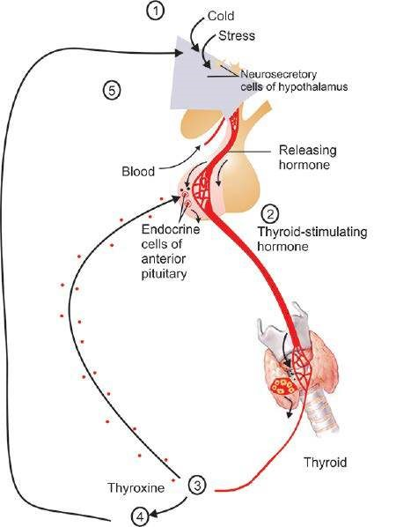

*Fig. 17.17 Negative feedback in thyroid gland function*

1. Low body temperature or stress stimulates neurosecretory cells of the hypothalamus, whose releasing hormones trigger the release of 2.Thyroid-stimulating hormone (TSH) in the anterior pituitary. 3. The TSH then stimulates the thyroid gland to release thyroxine. 4. Thyroxine causes an increase in the metabolic activity of most body cells, generating ATP energy and heat. 5. Both raised the body temperature and higher thyroxine levels in the blood inhibit the releasing-hormone cells and the TSH-producing cells.

**Comparison of Nervous Coordination and Chemical Coordination Similarities:**

1. Both hormone producing cells and nerve cells (neurons) synthesize chemical “messenger”.
2. Both release the messenger chemicals in extra cellular spaces of the body.
3. Both help in co-ordination of the body.
4. Both function in response to speciic stimuli either from within the body or fromthe external environment.
5. Both are homeostatic in function.

**Diferences:**

|  |
| --- |
| **Nervous Coordination Chemical Coordination** |
| 1. Neurons (sensory, associative and motor), 1. Hormone producing cells and neuro secretory are the basic units of structure and function. In cells (such as those found in the hypothalamus), addition neuroglial cells are also present, which release hormones and are units of structure provide nutrition and protection to neurons. and function. 2. Chemicals produced by neuron endings act 2. Chemicals produced (the hormones or neuro where they are produced i.e. very close to the hormone) are poured into and are transported cells they inluence, commonly from less than by blood. These hormones afect the target cells, a micrometer away For example, acetylcholine which are far away from where the hormones produced by nerve endings at synapse, excites are produced. ADH is produced from posterior the next neuron. lobe of pituitary giand; but afects the target cells   present in the nephron and collecting tubule of kidney, to control re-absorption of water.   1. in this system the neurons release its 3. The blood borne hormones bathe millions of neurotransmitter into one or a small group of cells indiscriminately and only a few respond to speciic cells. these hormones.   4 This has immediate efect or show response 4. There may have immediate efects (e.g.  to a stimulus instantly. insulin), but mostly hormones have prolonged or delayed efects for example growth hormone.  5. This control is afected through the electrical 5. This control involves only chemical stimulation signals that travel within the cell itself and it and the target cells are far away from them: releases its neuro transmitters only where it reaches its target  6, This shows faster or rapid efect. The speed 6. it is not very rapid; but shows slow but of impulse in most cases is 100 meters/second; prolonged efects. but maximum speed of nerve impulse recorded in the human beings is 120 meters/second.  7. The chemicals involved in this system (the 7. The hormones are the chemicals, which neurotransmitters or neuro hormones) are remain active for much longer duration within short lived i.e. broken down shortly after .heir the blood; and thus have much longer duration release. Thus the efects of messengers sent by for their actions. neurons tend to be of much shorter duration. |

#### BEHAVIOUR

Behaviour is divided into two main types, innate behaviour and learned behaviour.

##### Innate Behaviour

It is a collection of responses that are predetermined by the inheritance of speciic nerve or cytoplasmic pathways in multicellular or unicellular (acellular) organisms. As a result of the built in pathways,a given stimulus would produce invariably the same response. All plant behaviour is innate.

These behaviour patterns have been developed and been reined over many generations (selected) and their primary adaptive signiicance lies in their survival value to the species.

Another feature is the economy it places on nerve pathways within multicellular organisms since it does not demand on the higher centre of the nervous system.

Types of innate behaviour:

###### 1. Orientation

1. **Kineses:** It is a behaviour in which an organism changes the speed of random movements which help them to survive in the environment e.g. this type of behaviour enables pilibugs to reach the moist area which is required for their life.
2. **Taxes:** In contrast to kineses a taxis (plural: taxes) is a directed movement either towards (positive taxis ) or away from (negative taxis) a stimulus.

###### 2. Relexes and instincts

These are extremely complex behaviours and include biological rhythms, territorial behaviour, courtship, mating, aggression, altruism, social hierarchies and social, organizations.

##### Instincts & Learning

Darwin (1859) was the irst to propose an objective deinition of instincts in terms of animal behaviour. He treated instincts as complex relexes made up of units compatible with the mechanisms of inheritance, and thus a product of natural selection, that had evolved together with the other aspects of life. Thus instinctive behaviour is a part of one’s inherited structure by which the individual responses to a particular stimulus. This response is similar in members of a species. All animals inherit certain responses which equip them to live having abilities like walking, moving running and eating etc.

The early ethologists (Uexkull 1934, Lorenz 1935) thought that animals sometimes respond instinctively to speciic though often complex stimuli. Such stimuli came to be called “sign stimuli”. A sign stimulus is a part of stimulus coniguration and may be relatively simple part. For example a male three-spined stickle back ish has a characteristic red belly when in breeding condition. This is a ‘sign stimulus’ that elicits aggression in other territorial males.

Instincts equip an animal with speciic response to a particular stimulus, thus enabling it to adapt to its environment. Learning on the other hand, depends on the experiences in one’s own life but for this to occur, depends upon the development and evolution of the nervous system of that animal. So the higher animals have higher level of learning. Lower animals because of poorly developed systems to responds to a particular stimulus learn very slowly, and even in some cases do not have the ability to modify or change their instinctive behaviour. The selective responses to stimuli suggested that there must be some built-in mechanism by which sign stimuli were recognized. This mechanism came to be called the innate releasing mechanism (IRM). The important aspect of this concept is that the mechanism is envisaged as being innate, that is, both the recognition of the sign stimulus and the resulting response to it are inborn and characteristic of the species.

Instinct can equip an animal with series of responses. This is important for animals with short life spans and with little or no parental care. For example, a female digger wasp (*Ammophila adriaansei*) prepares a nest, catches caterpillars, kills them by sting, puts them in nest, lays eggs on them and then closes the nest. After doing all this, she dies. The larvae after emerging from the eggs, start feeding on caterpillars killed by their mother before death and grow to digger wasps. All this is completed within few weeks and is done by instincts of digger wasp, which may be responding to perception of a caterpillar (the possible sign stimulus) in diferent ways.

|  |
| --- |
| **Instinctive behaviour Learning behaviou**r |
| * This is the type of behaviour that depends • This type of behaviour depends on the on the heredity material which the animal environmental inluence, but the ability inherits. The animal may be born with the to modify the behaviour depends on the right responses built in the nervous system heredity material.   as part of its inherited structure.   * Experience has no obvious inluence on this • Experience has an obvious inluence on this type of behaviour. type of behaviour. * This type of behaviour depends on the • This type of behaviour depends on the selection operating during the history of selection operating during the history of the species, so that it helps in the adaptability of individual (during one’s life-time) so as to help the organism in the environment. the organism in its adaptability in the given environment. * Instinct can equip an animal with a series of • Learning can equip an animal with a set of responses. This is advantageous for animals adaptive responses to its environment. This with short life spans, and with little or no is advantageous for those animals -which parental care. have long life spans and have parental care,   so that they can modify the behaviour by previous experiences.   * This type of behaviour evolves slowly in the • This type of behaviour evolves during the species. life cycle of the individual but the ability of   learning depends on the genetic basis of the individual.  For example: For example:   1. Honey bees inherit the ability to form wing (i) Conditioned relex type I, in case of dogs muscles and wings for light. They inherit the where dogs learn to salivate on ringing of bell tendency to ly towards lowers to seek nectar alone.   and pollen.   1. Trial and error learning in case of cat, when (ii) Behaviour of digger wasp is instinctive; but it learns to press, the lever to open the door of it does learn certain things during its brief life, the cage.   such as locality of each of its nests, where it has  to return after hunting. (iii) Crawling snail on a sheet of glass, learns that  tapping has no harmful efect and ceases to respond after few early responses. |

#### Learning Behaviour (Modiication through experience)

Thorpe deined learning as that process which manifests itself by adaptive changes in individual behaviour as a result of experience.

Thorpe classiied learning behaviour into six types:

1. Imprinting
2. Habituation
3. Conditioning or conditioned relex type i.
4. Operent conditioning or conditioned relex type ii.
5. Latent learning(6) Insight learning.
6. **Imprinting :** Imprinting is a form of learning which is best known in birds such as geese, ducks, and chickens, which are all precocial birds. Shortly after hatching, ducklings and other young birds have a tendency to follow moving objects in their surroundings. They show a brief sensitive period during which the shape of form of objects can be ‘imprinted’, with the result that the young birds will follow them. Normally, of course, the irst moving object encountered is the mother bird, and it is obviously adaptive for the young birds to learn her appearance and to follow her. However, if its parents are absent, a young bird may imprint on other species of birds, human beings, or inanimate objects.
7. **Habituation :** Habituation is the simplest form of learning and involves modiication of behaviour through a diminution of response to repeated stimuli. A loss of receptivity to repetitious stimuli can be useful in preventing a drain of energy and attention for trivial purposes. For examples:
8. A snail crawling on a sheet of glass retracts into its shell when glass is tapped. After a pause, it emerges and continues moving. A second tap causes retraction again but it emerges more quickly.

Ultimately, tapping has no efect and snail ceases to respond.

1. Rodents respond to alarm calls by others in their group, if these calls are continued and no danger is conirmed, further calls may be ignored.
2. **Conditioning or conditioned relex type** I**:** Conditioning or conditioned relex type I involves the pairing of an irrelevant stimulus with a natural primary stimulus that elicifs an automatic response.

Pavlov conditioned the dogs to secrete saliva on ringing of the bell, which is not normal stimulus for secretion of saliva. In his experiments, he would ring the bell just before giving food to the dogs, so the dogs became conditioned to secondary stimulus or conditioned stimulus (ringing of bell) and started secreting saliva in response to it as if it were the natural stimulus. This type of learning broadens the ability of an organism to react appropriately to environmental changes, since the conditioning process removes dependence on one kind of relex symbol for action.

1. **Operent conditioning or conditioned relex type** II**:** Operent conditioning or conditioned relex type II (also called trial and error learning) is a more complex type of learning than habituation. This type of learning has been demonstrated and studied by Thorndike and B.F. Skinner, a Harvard psychologist. Under natural conditions, the achievement of a particular goal is the reward that directs random activities into a behavioural pattern. Trial and error repetitions, step by step, lead to inal achievement. Experiments on rats and cats were performed to run a maze to either get or ind food, or to depress a lever and come out of the cage. In this case irst experience is accidental and then it is rewarded, animal learns with latter experience.
2. **Latent learning:** Thorpe deined latent learning as the association of indiferent stimuli or situations without patent reward.

Suppose we put a rat in a maze as it wanders about and accidentally gets food. Did he learn anything before getting the food in the irst experience? If we put the rat in the same maze again, it may directly reach the food. That means when the rat was wandering, it did learn something without even the incentive of any reward.

1. **Insight learning:** Kohler performed many experiments on chimpanzees, and showed that they have higher form of learning called insight learning. Insight learning is an extreme case of behavioural modiication involving the application of insight or reasoning to a novel situation. If an animal can direct its behaviour to solve a problem for which it has no previous experience then reasoning is involved. Reasoning in humans appears to involve a recasting of an external situation in the imagination and a manipulation of the concepts to produce a solution that can be applied to situations. However, such insight or reason may be found in other primates. This is the highest form of learning. For example: A chimpanzee is placed in a cage in which a choice piece fruit hangs from the ceiling. This chimpanzee cannot reach the fruit, but the keeper has placed some boxes of diferent sizes in the cage. After a short period of head scratching, the chimpanzee moves the largest box and piles other smaller boxes over it, and climbs up to reach the fruits.

##### Exercise

**Q.1 .Fill in the blanks**

1. Neurotransmitter molecules bind to the receptors on the _____________ membrane at synapse.
2. Excess of ___________________ hormone is secreted in Addison’s disease.
3. Operent learning has been demonstrated and studied by ___________ and _________________.
4. ____________________ are plant hormones which delay the life of fresh leaf crops.
5. All membranes of neurons have very active_________and ________pumps.

**Q.2 Write whether the statement is true or false and write the correct statement and pumps.**

1. Impulses travel much more rapidly along myelinated neurons.
2. All glial tissue consist of glial cells.
3. Saltatory conduction is carried out by those nerve ibres that have nodes of Ranvier.
4. The myelin sheath of neuron is particularly good conductor of electric impulse.
5. The resting membrane potential is maintained largely by the sodium pump.(vi) Hormones initiate new biochemical reactions in the body.

**Q.4. Short questions**

1. Deine cir-cadian rhythm.
2. What is the diference between CNS and PNS?
3. What are the functions of parathyroid gland?
4. Deine the term hormone.
5. What are the commercial applications of auxins?
6. List diferent types of tropisms.
7. Write a note on Alzheimer’s disease.

**Q.5. Extensive questions.**

1. Describe diferent types of learning behaviour.
2. Describe in detail the role of adrenal glands.
3. Deine nerve impulse. Explain the mechanism involved by labelled diagrams.
4. How is the nervous system of Planaria better developed than that of *Hydra*?
5. Describe the structure and functions of the diferent parts of human brain.
6. Writea note on pituitary gland.