CHAPTER

# 22

## VARIATION AND

GENETICS

*Animation 22:: Variation and Genetics*

[*Source & Credit: Wikispaces*](http://anatomyeshs.wikispaces.com/Ch.16+Respiratory+System)

### GENES, ALLELES AND GENE POOL

Hereditary characteristics pass from parents to ofspring through genes in their gametes. Gene is the basic unit of biological information. In fact DNA stores all sorts of biological information coded in the sequence of its bases in a linear order, and genes are actually parts of DNA comprising its base sequences. The position of a gene on the chromosome is called its locus.

Genes are responsible for producing startling inherited resemblences as well as distinctive variations among generations. When these pass in the form of intact parental combination between generations, inherited similarities are conserved; but when these shule, mutate or juggle with each other, variations emerge. Genes form pairs on pairs of homologous chromosomes. One member of a gene pair is located on one homologue, and the other member on the other homologue. Partners of a gene pair are called alleles. Each allele of a gene pair occupies the same gene locus on its respective homologue. Both alleles on one locus may be identical, or diferent from each other. (Fig. 22.1).

*Animation 22: Gene Pool*

*Source & Credit:* [*GIF SOUP*](http://http://gifsoup.com/view/5291123/alleles.html)

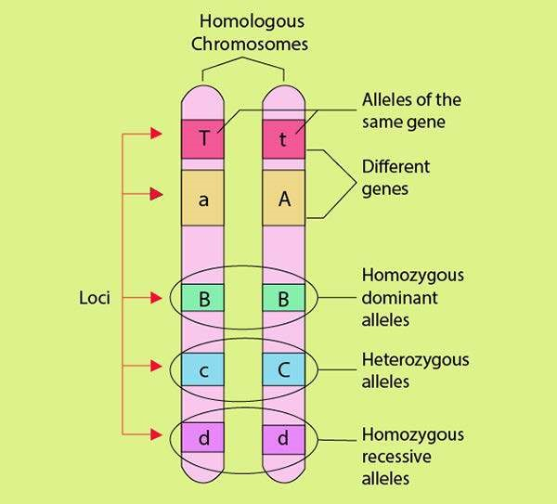

### *Fig 22.1 Allelic pairs on a homologous pair of chromosomes*

Phenotype is the form of appearance of a trait. Genotype is the genetic complement i.e., the genes in an individual for a particular trait. A lower may be red or white in colour. Flower colour is a trait and red and white are its two phenotypes. Each form of expression is determined-by a diferent allele of the colour gene. Allele “R” is the determiner for redness, while “r” is the determiner for whiteness.

**GENE POOL**

Any group of interbreeding organisms of the same species that exist together in both time and space is called a population. All the genes/alleles found in a breeding population at a given time are collectively called the gene pool. It is the total genetic information encoded in the total genes in a breeding population existing at a given time.

If we imagine population not as a group of individuals, but as a group of individually segregating and randomly assorting alleles, we can understand the concept of “beanbag genetics”. The alleles are like beans in a beanbag. The entire beanbag full of beans is the gene pool of the population. In the beanbag approach we can imagine the entire gene pool comprising all the alleles for all the diferent traits at once, or we can just focus on some subset, such as all the alleles for a single trait.

Jumping genes do not settle peacefully on their loci, they keep on hopping on diferent loci on the same chromosome or other chromosomes.

For convenience, we can focus on the gene pool for a single particular trait. A sample population of 100 diploid plants, some of which bear red lowers, others bearing white lowers has a sum total of 200 of all the diferent alleles (R or r) for lower colour trait as its gene pool.

**MENDEL’S LAWS OF INHERITANCE**

Gregor Johann Mendel (1822 - 1884) laid the foundation of classical genetics by formulating two laws of heredity; law of segregation and law of independent assortment. He was a priest. He performed series of breeding experiments on garden pea, Pisum sativum in his monastery garden for eleven years (1854 — 1865). Pisum sativum was easy to cultivate and it grew well in his garden. Its lowers were hermaphrodite. It was normally self-fertilizing, but could also be cross-fertilized. As the time gap between generations was short, Mendel could raise many generations of pea within a short time. Pea had many sharply distinct traits. Each trait had two clear cut alternative forms or varieties; e.g., seed shape had a round or wrinkled phenotype, plant height was either tall or short, seed colour could be yellow or green. Mendel called them contrasting pair of a trait. He focussed on seven such pairs (Fig. 22.2).

He irst established true-breeding lines or varieties for each trait. A true - breeding variety upon self - fertilization always produced ofspring identical to the parents, e.g., a true breeding “round” seed plant produced only “round” seeds. Similarly, a true breeding “wrinkled” seed plant produced only “wrinkled” seeds.

After establishing 14 pure - breeding lines of seven characters, he cross-fertilized plants that difered in one character only. The ofspring of such a cross were called monohybrids. He cross-fertilized a true breeding round-seeded male plant with a true breeding wrinkled-seeded female plant (Fig. 22.3).

*Animation 22.2:Mendel’s Law of Inheritance*

*Source & Credit:* [*Ms.Anderson Biology Class*](http://http://msandersonbio.weebly.com/heredity.html)

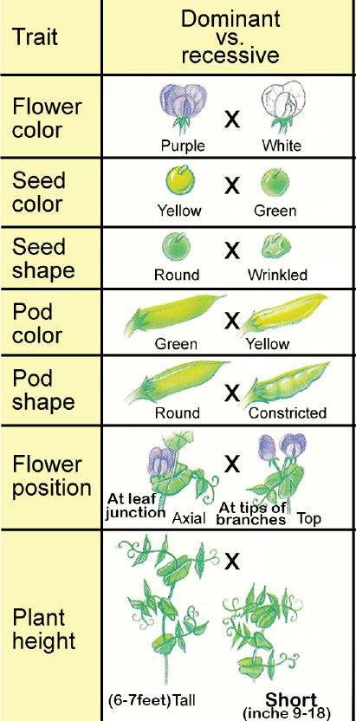

*Fig 22.2 Seven traits of garden pea studied by Mendel.*

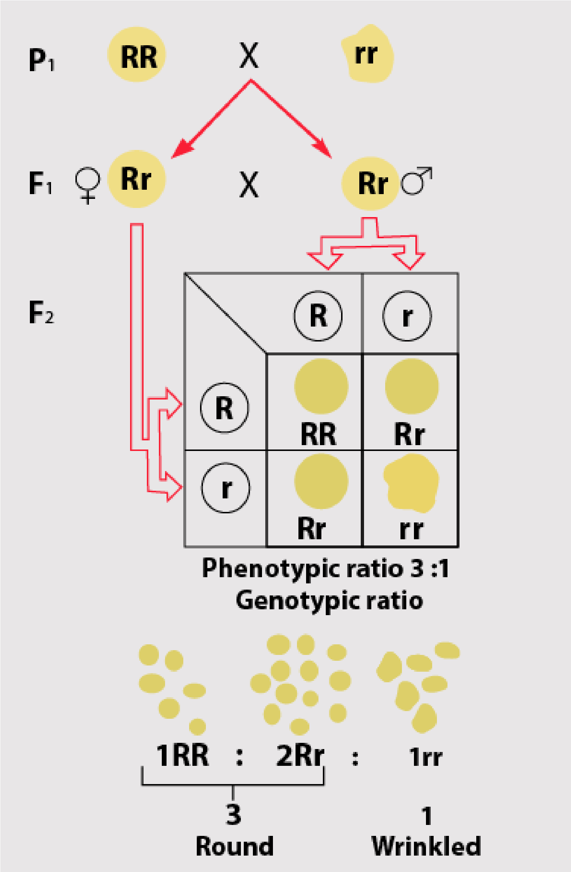He called it irst parental generation (Pi). Their ofspring were called Fi or irst ilial generation. All Fi ofspring were round like one of the parents. Wrinkled phenotype did not appear at all. Round dominated wrinkled. Its dominance was complete because no ofspring intermediate between parents was found. He called the trait that appeared in F, as dominant; while the trait, which was masked, as recessive.

Then Mendel allowed self-

fertilization among F| monohybrids to raise F2 progeny. As a result of monohybrid cross 3A of F2 were round and lA wrinkled.

Mendel got similar results and the same 3:1 ratio in ofspring of monohybrid crosses for all the seven contrasting pairs of traits. Mendel proceeded a step ahead.

He self- fertilized F2 plants to raise F3. He noted that 1/3 of F2 round produced only round, while 2/3 of F2 round produced both round and wrinkled in . 3:1 ratio; but F1 wrinkled produced only wrinkled.

He concluded that 1/3 of F2 rounds were true-breeding like Pi round, and 2/3 of F2 rounds were monohybrids like Fj round.

*Fig 22.3 Mendel’scross to study single trait inheritance in pea.*

#### Mendel’s Interpretations

Mendel proposed that each contrasting form of a trait, e.g., roundness or wrinkledness of seed was determined by particulate hereditary factors, which he called ‘elementen’. These factors carrying hereditary information were transmitted from parents to ofspring through gametes. Each pea plant had a pair of these factors, one derived from male parent and the other from female parent. Both of these factors together controlled expression of a trait. He designated dominant factor with a capital letter and recessive factor with a small letter; e.g., R for roundness factor and r for wrinkledness factor. Johannsen renamed them as ‘genes’.

The true - breeding round seed plant of P| generation carried ‘RR’ alleles while the true - breeding wrinkled seed plant of Pi carried ‘it’ alleles. When both the alleles of a gene pair in an organism are same, the organism is homozygous for that gene pair. An individual with a homozygous genotype is a homozygote.

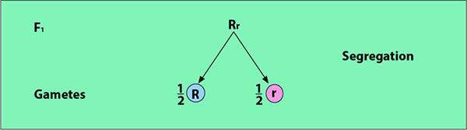

*Fig 22.4 Segregation of alleles during gamete formation*

Mendel inferred that the factors of a pair (alleles) separated from each other during gamete formation so that each gamete got only one factor (allele) for each trait. So half the gametes got one allele, and the other half carried the other allele. Fertilization was random. When male gamete carrying factor (R) fertilized female gamete with factor (r), the complete set of the two factors (Rr) for the trait was restored in zygote.

The zygote developed into Fj ofspring that was heterozygous ‘Rr’, because the two alleles of its gene pair were diferent from each other. An individual with a heterozygous genotype is a heterozygote. Fi ofspring (Rr) was a monohybrid for seed shape; it was round in phenotype but heterozygous in genotype. Its alleles also segregated during gamete formation (Fig. 22.4).

Punnett square indicates that lA of F2 progeny would have been ‘RR’ (homozygous round), lA + lA = Yi Rr (heterozygous round), and lA rr (wrinkled).

Mendel actually observed 3 ; 1 phenotypic ratio in F2. His phenotypic data of F3 can also be explained on the basis of 1 : 2 : 1 genotypic ratio of F2. Mendel compared the results of all the seven separately studied characters, and found them strikingly similar to formulate law of segregation.

**Law of Segregation** : According to law of segregation, the two coexisting alleles for each trait in an individual segregate (separate) from each other at meiosis, so that each gamete receives only one of the two alleles. Alleles unite again at random fertilization of gametes when zygote is formed.

##### Test Cross

Mendel devised a cross called test cross, which is used to test the genotype of an individual showing a dominant phenotype. It is a mating in which an individual showing a dominant phenotype is crossed with an individual showing its recessive phenotype. This cross inds out the homozygous or heterozygous nature of the genotype (Fig.

22.5).

*Animation 22: Test Cross*

*Source & Credit:* [*Pinterest*](http://https://www.pinterest.com/pin/88594317644664140/)

|  |  |
| --- | --- |
| Case 1 | Case 2 |
| If the seed is homozygous round(RR) it will grow into a pea plant that forms all gametes with only `R` allele.Wrinkled seed plant is always homozygous recessive.it will form all gametes with `r` allele.Fertilization will result in 100% round seed progeny. | If the seed is heterozygous round (Rr), it will grow into a plant that forms half the gametes, with ‘R`and half with `r` allele. Wrinkled seed plant will form only `r` type of gametes. Fertilization will result into 50% round and 50% wrinkled seed progeny. Even a single wrinkled seed in the progeny is a convincing proof for  Heterozygous nature of the round parent. |

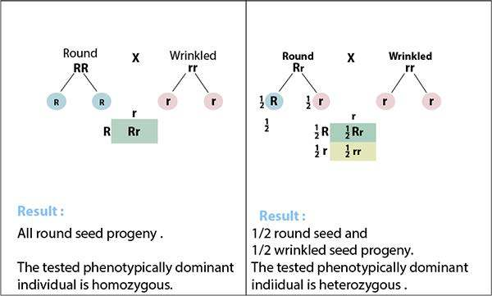

*Fig 22.5 Test cross of a round seed*

### Dihybrid and Dihybrid Cross

After thoroughly studying each trait separately , Mendel decided to study the inheritance of two simultaneously , e.g., seed shape and seed colour. Seed shape could be round or wrinkled. Similarly , seed colour could be yellow or green. He crossed true breeding round and yellow seed plants with true breeding wrinkled and green seed plants . All F1 **dihybrid** were round and yellow seeded due to dominance. Then he made a **dihybrid cross** by allowing self-fertilization among F1 dihybrids. The results was quite surprising. Seeds produced as F2 progeny were ot only in the two **parental combination** i.e., round yellow and wrinkled green, but also in two **new phenotypic combination**

i.e., round green and wrinkled yellow. A clear cut 9:3:3:1 phenotypic ratio was found in F2. Appearance of these new recombinant phenotypes of F2 indicated that some sort of shuling of alleles had occurred during gemete formation. Mendel inferred the mechanism of this shuling as **independent assortment of alleles** into gametes. He concluded that the alleles for seed shape and colour were not bound to remain in parental combination forever, i.e., ‘R’ with ‘Y’ and ‘r’ with ‘y’ ;rather these were free to assort independently . R could go with Y or y in any gamete with equal change.

*Animation 22: Dihyrid Cross*

*Source & Credit:* [*GIF SOUP*](http://http://http://gifsoup.com/view/5291123/alleles.html)

Similarly, r could go with y or Y in any gamete with equal probability. Four types of gametes, i.e., RY, Ry, rY and ry were formed in equal number in a perfect ratio of 1:1 : 1:1. When these gametes randomly fertilized each other, a 9:3:3:1 phenotypic ratio was produced among F2 progeny (Fig 22.6).

Mendel formulated Law of Independent Assortment : “When two contrasting pairs of traits are followed in the same cross, their alleles assort independently into gametes.” Alleles of one pair inherit independently of alleles of the other pair. The distribution of alleles of one trait into gametes has no inluence on the distribution of alleles of the other trait. Thus the chance for a plant to be round or wrinkled is independent of its chance of being yellow or green.

**Probability** is the chance of an event to occur. Inheritance of seed shape is an independent event. In F2 ofspring of a monohybrid cross the independent chance for a seed to be round is 3/4 , or it to be wrinkled is 1/4. Inheritance of seed colour is another separate event. The independent chance in F2 of a monohybrid cross for a seed to he vellow is 3/4 or it to be green is 1/4. When two independent events are occunng simultaneously like m Dihybrid cross, the ratio of each joint phenotypic combination can be obtained by multiplying the probabilities of individual phenotypes. It is called

**product rule.**

The joint probability that both of the independent events will occur simultaneously, is equal to the product of individual probabilities of each event.

*Animation 22: Product Rule Source & Credit:*

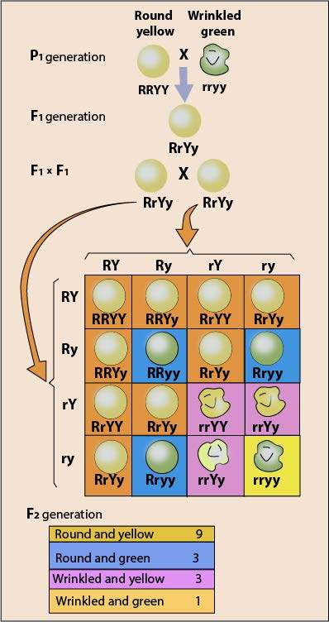

*Fig 22.6 Dihybrid cross produces parental as well as recominant types.*

|  |  |  |
| --- | --- | --- |
| **Event No. 1** | **Event No. 2** | **Both events at a time** |
| **Seed shape** | **Seed colour** | **Seed shape and colour** |
| Independent probability to be: | Independent probability to be: | Joint probability to be: |
| Round =  Round =  Wrinkled =  Wrinkled = | yellow = green = yellow = green = | Round yellow =9/16  Round green = x = 3/16  Wrinkled yellow = x = 3/16  Wrinkled green = |

Genes are located at speciic loci on chromosomes. Independent assortment of genes depends upon independent assortment of their chromosomes. All the genes present on a homologous pair of chromosomes are linked to each other in the form of a linkage group. These cannot assort independently. Those traits assort independently whose alleles are riding non homologous chromosomes. Pea has seven homologous pairs of chromosomes. Mendel knew nothing about chromosomes. The traits he studied were conined to only four chromosomes. He reported independent assortment of those traits whose genes were either on diferent homologous chromosomes, or were so far away from each other on the same chromosome that they appeared to assort independently due to crossing over.

Mendel presented his indings to Brunn Society for the study of Natural Science in 1865. His work was published in the proceedings of the society in 1866. That laid the foundation of classical genetics. His work lay neglected for 34 years. In 1900, 16 years after his death, three botanists; Correns, De Varies and Tschermach independently rediscovered and acknowledged his work.

**Activity:** Normal individuals have melanin pigment in their skin, hair and eyes. Albinos totally lack pigment in their bodies. Albinism is a recessive trait in humans. Two normal parents have an albino child. What is the probability that their next child will also be an albino?

### DOMINANCE RELATIONS

Dominance is a physiological efect of an allele over its partner allele on the same gene locus. There are four types of dominance relations among alleles, each indicating a diferent style of their functional efect upon each other.

1.Complete dominance 2.Incomplete dominance

3.Cociominance 4. Over dominance

#### Complete Dominance

When one allele (R) is completely dominant over the other (r), presence of the recessive allele is functionally hidden, so the heterozygote (Rr) has the same round phenotype as (RR) homozygote.

The contrasting pairs of alleles for all the seven characters chosen by Mendel showed complete dominance. After Mendel, further breeding experiments were carried out on diferent plants and animals. Many novel phenotypes and phenotypic rat tios were observed that could not be explained on the basis of complete dominance.

#### Incomplete Dominance

In 1899 Carl Correns was working on a lowering plant named 4 O’clock. When he crossed a true breeding fed lowered plant with a true breeding white lowered 4 O’clock, all the F] hybrids had pink lowers. This new phenotype had a shade intermediate between those of the parents due to an intermediate amount of pigment in petals. When Correns self-fertilized Fi pink, the F2 showed all three phenotypes of lowers’in the ratio of 1 red : 2 pink : 1 white. Red was homozygous for red alleles, and white was homozygous for white alleles. But when allele for red and allele for white were present together in the same plant, neither of them masked the efect of other; rather these alleles showed incomplete dominance in the form of pink colour.

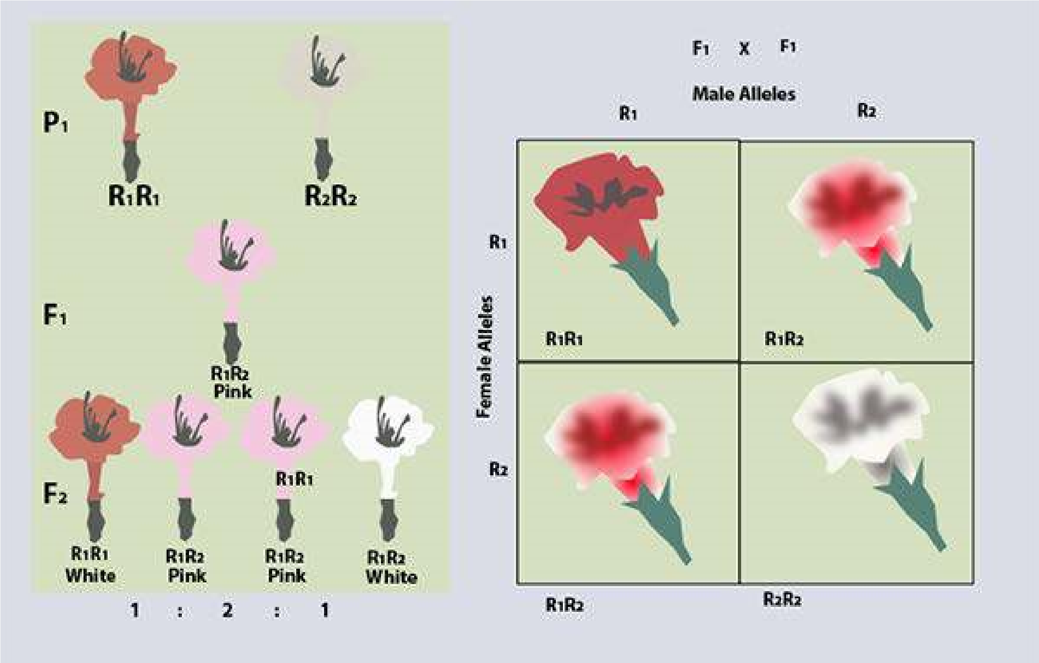

*Fig 22.7 Incomplete dominance in 4 O’ clock*

When the phenotype of the heterozygote is intermediate between phenotypes of the two homozygotes, it is called **incomplete or partial dominance.**

As there is no truly dominant allele, the usual capital and small letter distinction for dominant and recessive trait is not necessary. Both the alleles are represented by the same letter ‘R’ but are numbered diferently to distinguish white from red. Allele for red is designated as R|, and the allele for white as R2 (Fig. 22.7).

Punnett square indicates that the phenotypic ratio is the same as the genotypic ratio. There is absolutely no need of a test cross. Do these results make Mendel’s principles invalid? The lower colour does show blending at phenotypic level in Fi, which is quite contrary to what Mendel observed. But the re-appearance of red and white lowers in F2 conirms that blending does not occur at genetic level.

#### Codominance

The phenotype of heterozygote is distinct in quality from those of the two homozygotes. It is not an intermediate quantitative expression like incomplete dominance. Each allele of the gene pair is associated with a diferent substance, e.g.,

Allele A 1 →Produces  Substance X

Allele A 2 →Produces  Substance Y

Codominance occurs when both the alleless express independently in heterozygote; (A|A2) and form their respective products X and Y. The codominant heterozygote would have both substances at the same time.

Diferent alleles of a gene that are both expressed in a heterozygous condition are called **codominant.**

#### MN BLOOD TYPE OR BLOOD GROUP SYSTEM

Human blood groups can be of many types, e.g. ABO, MN, MNSs, Rh ete. Landsteiner and Levine discovered MN blood types in man on the basis of speciic antigens present on RBC. These RBC antigens induce production of their speciic antibodies. There are three general phenotypes; M,N and MN. M phenotype has antigen M which is produced by gene LM. N phenotype has antigen N that is produced by its allele LN. MN phenotype has both M and N antigens, simultaneously produced by their alleles LM and LN

|  |  |  |
| --- | --- | --- |
| Phenotvoe | Genotype | Antieens on RBC |
| M | lMlM | M |
| N | lN lN | N |
| MN | lMlN | M and N |

If a man of M blood group marries a woman of N blood group, all their children will have MN blood group (Fig. 22.8)

*Animation 22: Blood Group System*

*Source & Credit:* [*waynesword.palomar*](http://http://waynesword.palomar.edu/aniblood.htm)

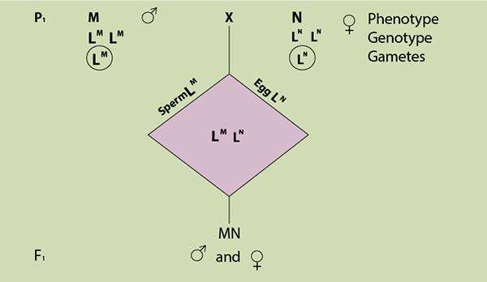

*Fig 22.8 Codominance in MN Blood group alleles.*

Over Dominance

This dominance relation is fascinating because the over dominant heterozygote exceeds in quantity the phenotypic expression of both the homozygotes. In fruit ly Drosophila the heterozygote (w+ / w) has more quantity of luorescent pigments in eyes than wild (w+ / w+) or white eye (w / w) homozygotes.

##### MULTIPLE ALLELES

Gene mutations may produce many diferent alleles of a gene. Some genes may have as many as 300 alleles. All such altered alternative forms of a gene, whose number is more than two, are called multiple alleles. Any two of these multiple alleles can be present in the genome of a diploid organism, but a haploid organism or a gamete can have just one of them in its genome.

##### ABO - The First Discovered Multiple Allelic Blood Group System in Man

ABO blood group system was discovered by Karl Landsteiner in 1901. ABO system has four diferent phenotypes which are distinct from each other on the basis of specic antigens on the surface of RBC. A person having antigen A has blood group A; a person having antigen B has blood group B; a person having both the antigens A and B has blood group AB; but a person having neither antigen A nor B would have blood group O.

Bernstein explained the genetic basis of ABO system in 1925. This blood group system is encoded by a single polymorphic gene I on chromosome 9. It has three multiple alleles IA, IB, and i.

Allele IA speciies production of antigen A, and allele IB speciies production of antigen B, but allele i does not specify any antigen. Their dominance relations are interesting too. Alleles IA and IB are codominant to each other, because each expresses equally in IA IB heterozygote to produce AB phenotype. But allele i is recessive to both IA and IB. Therefore IA IA or IAi genotypes will produce phenotype A. Similarly IB IB or IBi produces phenotype B. The homozygous ii will produce phenotype O.

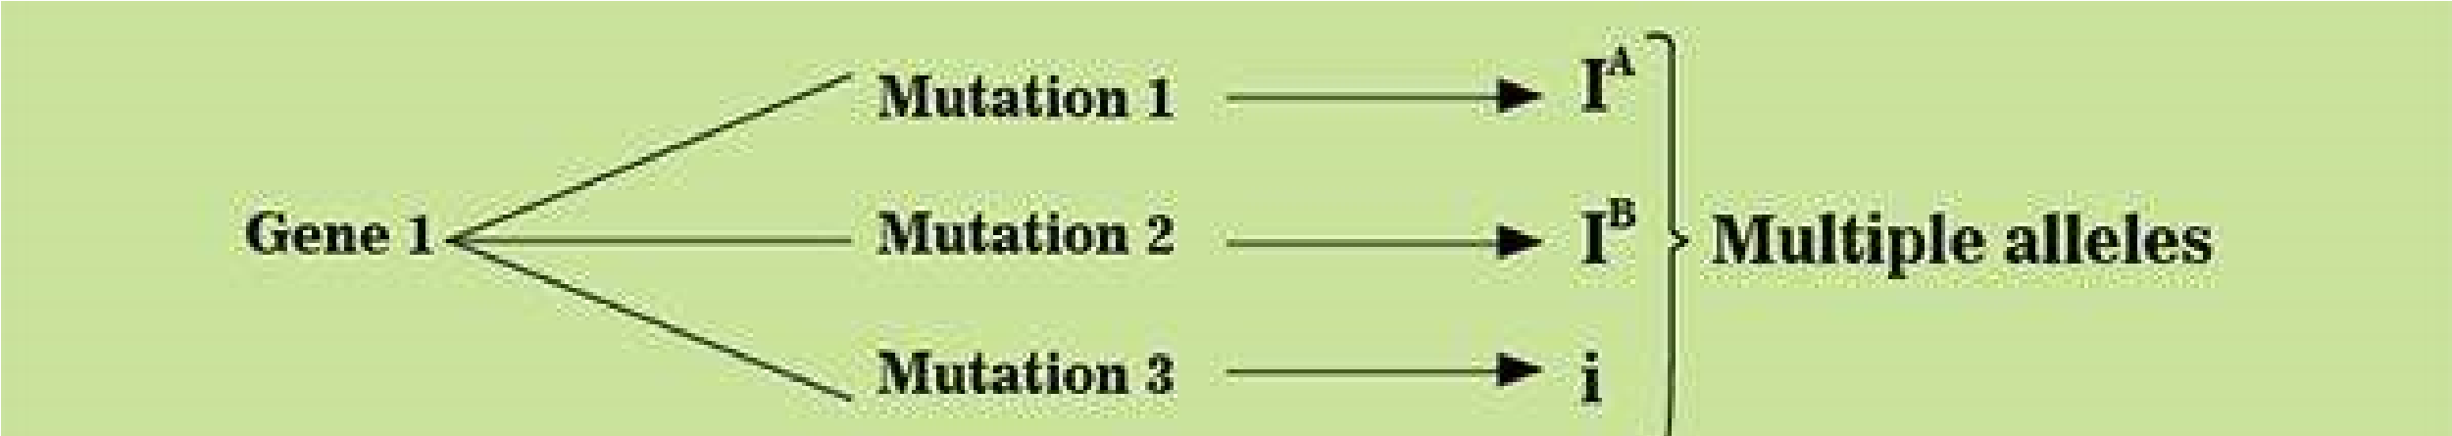

The blood group alleles start their expression at early embryonic stage and keep on expressing themselves till death. Therefore the blood group phenotype of a person never changes throughout life.

Anti-A and anti-B antibodies appear in plasma during the irst few months after birth. They are naturally occuring in the absence of corresponding antigen. The blood serum of A phenotype contains anti-B antibodies. They will agglutinate7or clump any RBC which have B antigens on them. B phenotype contains anti-A antibodies in the serum and agglutinate any RBC with antigen A. Phenotype AB has neither anti-A nor anti-B antibodies in the serum. The serum of O blood type contains both anti-A and anti-B antibodies. The blood serum containing anti-bodies is called antiserum.

Any blood transfusion is ideally safe if it does not cause agglutination in the recipient. Agglutination leads to serious results because clumped cells cannot pass through ine capillaries. The blood samples of the donor and the recipient are cross matched for compatibility before giving transfusion. If incompatible blood is transfused, dangerous hemolytic reaction occurs. Either the antibodies of the recipient destroy the RBC of donor or the antibodies of the donor hemolyze the RBC of the recipient.

Blood group A can be transfused only into A and AB recipients because they do not have anti - A antibodies. Blood group B can be transfused only into B and AB recipients as they do not have anti - B antibodies. AB blood can be transfused only into AB recipients because they have neither anti - A, nor anti B antibodies. O blood has neither A nor B antigen, but it does have anti - A and anti-B antibodies. An O recipient can only be given tranfusion from a donor O. Phenotype O can also be used as donor for small transfusions to A, B and AB recipients because donor’s antibodies are quickly absorbed by other tissues or greatly diluted in the recipient’s blood stream. O blood group individuals are called universal donors. AB blood group individuals are called universal recipients because they can receive transfusions of blood from any of the four blood groups.

A and B antigens can also be present in saliva and other body luids of some persons called secretors. Secretors have dominant secretor gene “Se” on chromosome 19.

Genetic analysis on the basis of blood groups helps in solving cases of disputed parentage. It can only be used to prove that an individual is not the parent of a particular child, e.g. a child of AB phenotype (IA IB) can not be the child of a parent of phenotype O (ii). Similarly a man of B phenotype cannot be father of a blood type A child, whose mother is of phenotype O. His father could either be A or AB phenotype.

Activity : Two new born babies get mixed up in the nursery of a hospital. Baby I is. type B and baby II is of type O. Determine their parentage from the phenotypes of these two couples. Mr. Haris is type A and Mrs. Haris is type AB. Mr. and Mrs. Bilal are both of type A.

#### Rh Blood Group System

ABO blood type is further diferentiated by a + or - sign. This positive or negative sign refers to the presence or absence of another blood group system antigen called Rh factor. Rh blood group system is deined on the basis of **Rh factor** present on the surface of RBC. This system is named Rh after Rhesus monkey, because its antigen was irst discovered in it by Landsteiner in 1930s.

Rh blood group system is encoded by three genes C, D and E, which occupy two tightly linked loci. Alleles of gene D occupy one locus called locus D, while genes C and E alternatively occupy the other locus. The D locus is of prime importance.

Gene D has two alleles, D and d. D is completely dominant over d. Persons having genotype DD or Dd have Rh factor on their RBC and are Rh+. Persons with genotype dd do not have Rh factor and are Rh-. Unlike the naturally occuring anti - A and anti - B antibodies of ABO system, anti - Rh antibody production requires a stimulus by the human Rh antigen itself. An Rh- person does not produce anti - Rh antibodies unless he is exposed to Rh antigen. Rh+ donor is totally incompatible for Rh- recipient. If an Rh- person receives Rh antigen through wrong Rh+ blood transfusion, he will begin to produce anti - Rh antibodies against Rh antigens. Rh- blood, clear of any anti - Rh antibody from a donor who has never been exposed to Rh antigen can be transfused to Rh+ recipient.

Erythroblastosis foetalis : **Maternal-foetal Rh incompatibility** Maternal-foetal incompatibility results when an Rh- woman, married to an Rh+ man conceives a child who is Rh+. If the man’s genotype is DD, all of their ofspring (Dd) will be Rh+. If the man’s genotype is Dd, half of their ofspring with Dd genotype will be Rh+. If RBC of Rh+ foetus cross the placental barrier and enter into Rh- mother’s blood stream, the mother’s immune system reacts to the foetal Rh antigen stimulus by producing a large number of anti - Rh antibodies. When mother’s anti - Rh antibodies seep through placenta into blood circulation of foetus, they start hemolysis (break down / bursting) of RBC of foetus. As this destruction continues, the foetus becomes anaemic. The anaemicfoetus starts to release many -immature erythroblasts into his blood stream. That is why this hemolytic disease of the new bom is called erythroblastosis foetalis. This anaemia may lead to .abortion or still birth. Even if the pregnancy continues, the liver and spleen of the foetus swell as they rapidly produce RBC. The breakdown product of RBC called bilirubin also accumulates in the foetus. Bilirubin damages his brain cells and turns his skin and whites of the eye yellow. This condition is jaundice. So the baby if born alive, sufer from severe hemolytic anaemia and jaundice. Such baby’s blood should be immediately replaced by Rh” blood free of anti - Rh antibodies. The irst Rh incompatible pregnancy may not face much problems if very few of foetal antigens cross placenta into maternal circulation and the amount of maternal antibody production is not very high. But when placenta detaches at birth, a large number of foetal cells enter mother’s blood stream and stimulate production of large amount of anti - Rh antibodies by the mother. These anti - Rh antibodies persist in mother’s blood for a long time and are persistent risk for the next Rh+ foetus. Rh sensitization of Rh’ mother is avoided by a simple therapy. She is given an injection of Rh antiserum during early pregnancy and immediately after birth. The Rh - antibodies in the Rh antiserum will destroy Rh+ RBC of the foetus before they stimulate production of maternal anti - Rh antibodies. The injected antiserum disappears before the next pregnancy

Sometimes a mild ABO incompatibility protects the baby against a more severe Rh incompatibility. If O’ mother conceives A+ or B+ baby, any^ foetal A or B type RBC entering the mother’s blood are quickly destroyed by her anti - A or anti - B antibodies, before she can form anti - Rh antibodies.

Activity: An Rh” woman is married to an Rh+ man whose father was also Rh”. What is the probable risk of erythroblastosis foetalis in their babies? **EPISTASIS**

When an efect caused by a gene or gene pair at one locus interferes with or hides the efect caused by another gene or gene pair at another locus, such a phenomenon of gene interaction is called epistasis. Epistasis must not be confused with dominance. Dominance is the relationship between alleles of the same gene occupying the same locus, but epistasis is the interaction between diferent genes occupying diferent loci.

##### Bombay Phenotype

The expression of-ABO blood type antigens by IA or IB gene depends upon the presence of another gene H. ABO locus is on chromosome 9, while H locus is on chromosome 19. H gene changes a precursor substance into substance H. It produces an enzyme that inserts a sugar onto a precussor glycoprotein on the Surface of RBC. Only then antigen A or antigen B speciied by IA or I gene could attach to this sugar of substance H. The recessive allele h cannot insert sugar molecule to glycoprotein. Therefore, hh individuals lack the site of attachment for antigen A pr antigen B. Thus A and B antigens cannot adhere to their RBC and fall away. Their RBC lack A and B antigens although they do not lack IA and IB genes. They are phenotypically like O, but are not genotypically O. Their phenotype is called Bombay phenotype (Fig. 22.9).

**Activity**: A student, of biology learns about ABO blood types. He knows that he’is type O, and his father is type A and mother is type AB. He wonders how his blood type could have arisen. Suggest how type A and AB parents could produce a child of blood type O.

#### PLEIOTROPY

When a single gene afects two or more traits, the phenomenon is called pleiotropy. Such a gene with multiple phenotypic efect is called **pleiotropic.**

**Examples:**

1. White eye gene in Drosophila also afects the shape of sperm storing organs (spermathecae).
2. Genes that afect growth rate in humans also inluence both weight and height.
3. In cats, the dominant allele W not only makes fur pure white but also causes deafness. In ww homozygous normal pigmented cats, melanocytes produce pigment of fur and also contribute to ‘hair cells in inner ear that sense sound.

When a cat gets W allele, its melanocytes fail to develop properly. Melanocyte failure causes both phenotypes, i.e. white fur and deafness.

#### CONTINUOUSLY VARYING TRAITS

Genotype interacts with environment to produce phenotype. Phenotypic expression of traits has two aspects:

(i) Qualitative

(ji) Quantitative

Qualitative diferences are large and more obvious, but quantitiave variations are small and less striking. Some traits, like pea seed shape, show discontinuous qualitative variations with two sharply distinct phenotypes, round or wrinkled; others like 4 O’clock lower colour can have three phenotypes, red, pink and white; still others like ABO blood group system have four qualitatively diferent phenotypes A, B, AB and O. But many traits like height, weight, intelligence and skin colour in humans, and grain colour in wheat exibit continuous quantitative variation over a range of many phenotypes. endel focused on traits that showed only two qualitatively diferent phenotypes which could be determined by just two alternate alleles of a single gene. Darwin observed small continuous variations within individuals of a population. Such a range of phenotypic spectrum of a trait cannot be traced to a single gene with two alleles. Even a few multiple alleles of a single gene cannot make such a wide range of phenotypes.

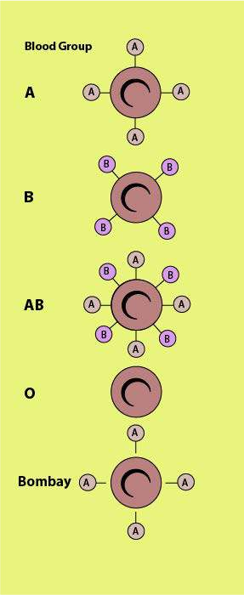

*Fig 22.9 Bombay phenotype results from epistasis*

MA continuously varying trait is encoded by alleles of two or more diferent gene pairs found at diferent loci, all inluencing the same trait in an additive way. These quantitative traits, are called **polygenic traits,** and their genes are **polygenes.** Each polygene has a small positive or negative efect on the character. Polygenes supplement each other and sum of positive and negative efects of all individual polygenes produce quantitative phenotypes of a continuously Varying trait.

Wheat grains vary in colour from white to dark red. This trait shows a continuous spectrum of colour variation. (Fig 22-10). Some grains are white, some are deep red but most grains have shades in between from light pink to moderately dark red. Nilsson - Ehle studied the genetics of wheat grain colour. When he crossed a true breeding dark red grain plant with a true breeding white grain plant, all Fi grains had light red colour, intermediate between two parental shades. It seemed as if it was a case of incomplete dominance. But when Fi.grains were grown to mature plants and crossed with each other, F2 grains had exactly seven shades of colour in the ratio of 1 dark red : 6 moderately dark red : 15 red : 20 light red : 15 pink : 6 light pink : 1 white (Fig. 22-11).

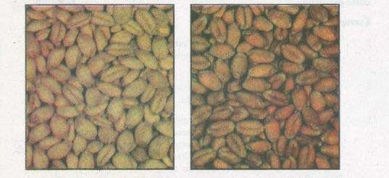

*Fig 22.10 Colour variation in wheat grains is a polygenic traits.*

Three diferent gene pairs, i.e. Aa, Bb, Cc at three diferent loci contribute to the wheat grain colour. Each individual would contain six alleles for the trait. Alleles A, B and C code for an equal amount (dose) of red pigment, which is a positive efect. But none of a, b and c encode red pigment, which is a no (zero) dose negative efect. If all the six alleles code for red pigment (AABBCC), the grain is dark red; when none of the six alleles encode red pigment (aabbcc), the grain is white. When a grain has one allele for red pigment (Aabbcc or aaBbcc or aabbCc) its colour is light pink; if it has two alleles for the pigment (AaBbcc or aaBbCc or AabbCc) it is pink, if it has three pigment alleles (AaBbCc or AABbcc or AabbCC), it will be light red. Similarly four alleles colour dose (AABBcc or aaBBCC or AAbbCC) will make red and ive alleles colour dose (AABBCc or AABbCC or AaBBCC) will produce moderately dark red grain. Thus the colour phenotype of the grain is the sum of the individual efects of all the six alleles.Environmental factors like light, water and nutrients also inluence the amount of grain colour. Environmental variations make the distribution of phenotypes more smooth and continuous.

Human skin colour is also a quantitative trait which is controlled by three to six gene pairs. The greater the number of pigment specifying genes, the darker the skin. A child can have darker or lighter skin than his parents.

Human height is a more complex polygenic trait. The perfectly continuous variation in range of human heights produces a smooth bell - shaped curve (Fig 22-12). A few people are very tall or very short, but most individuals fall in the average or mean value. This trait is controlled by many pairs of genes at diferent loci. Even multiple alleles may be possible at each locus. More the number of alleles for shortness, the shorter the height will be. Similarly greater the number of alleles for tallness, the taller

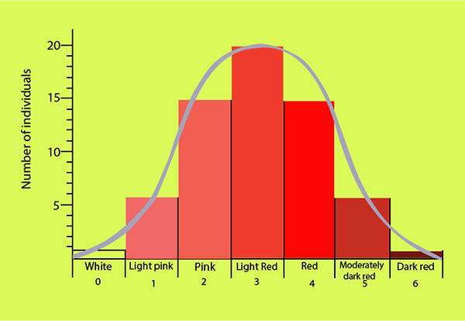

*Fig 22.11 Number of pigment - contributing alleles in F2*

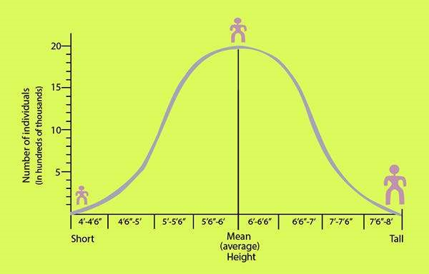

*Fig.22.12-Human hight is a continously varying trait*

the height will be. Environment also has a strong inluence on height, intelligence and skin colour in humans. Constant exposure to sun darkens skin. Poor nutrition prevents achieving genetically determined height. Healthy and encouraging social environment promotes intellegence.

Activity : Study continuous variations in height and discontinuous variation in tongue rolling ability Of man and record your observations as histograms.

Frequency histograms illustrate variations. A frequency histogram is a simple graph. The horizontal or X axis indicates the range of diferent phenotypes of a trait within a population. The vertical or Y axis indicates the number of individuals or their percentage in the population.

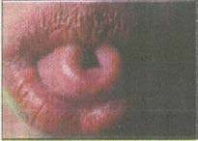Some people can roll their tongue into a distinct U shape when they extend it out of their mouth. They are called rollers (Fig 22.13). This ability is due to a single dominant gene. It is a discontinous variation inherited in simple Mendelian fashion. Its frequency diagram forms asymmetric distribution curve, with much greater frequency of phenotypes at one end than at the other.

Human height is a continuously varying trait. If we plot a frequency diagram of heights of humans in a large population, so many phenotypes are found with categories blending into one another. It forms a smooth bell shaped normal distribution curve. Measure the heights of a fairly large number of students in your college in cms, each to the nearest centimeter. Also note the ability of each student as roller or non roller.

Record your observation in a table like this.

|  |  |  |  |
| --- | --- | --- | --- |
| Sr.NO | Name | Height in cm | Roller/ Non-Roler |
|  |  |  |  |

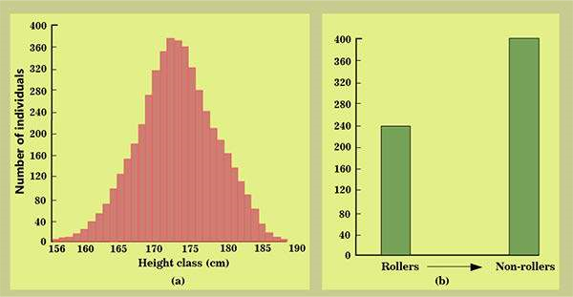

*Fig 22.14 Comparison of a continuous and a discontineous variation in human*

Representing each measurement class as a bar with its height proportional to the number of individuals in each class, plot the graph (Fig 22-14).

#### GENE LINKAGE

Every organism possesses numerous characters controlled by thousands of genes, but the number of chromosomes is limited. .Therefore, each chromosome must carry many genes on it. All the genes located on the same chromosome are linked to each other. This phenomenon of staying together of all the genes of a chromosome is called linkage. Gene linkage is a physical relationship between genes. A chromosome carries its linked genes en bloc in the form of a **linkage group.** The number of linkage groups corresponds to the number of homologous pairs of chromosomes. Man has 23 linkage groups. Genes for colour blindness, haemophilia, gout etc form one linkage group on human X - chromosome. Similarly, gene for sickle cell anaemia, leukemia and albinism make another linkage group on human chromosome 11. Linked genes whose loci are close to each other do not obey Mendel’s law of independent assortment, because these cannot assort independently during meiosis. Gene linkage also minimizes the chances of genetic recombination and variations among ofspring.

*Animation 22: Gene Linkage*

*Source & Credit:* [*Point Pleasant Beach High School*](http://http://www.ptbeach.com/site/default.aspx?PageType=3&ModuleInstanceID=444&ViewID=7b97f7ed-8e5e-4120-848f-a8b4987d588f&RenderLoc=0&FlexDataID=348&PageID=907)

#### CROSSING OVER

Linked genes can be separated by crossing over. Closer the two gene loci, more strongly are their genes linked. The farther apart two genes lie, greater are chances of their separation through crossing over. Crossing over is an exchange of segments between non-sister chromatids of homologous chromosomes during meiosis.’ Let us visualize crossing over by considering only one pair of homologous chromosome (Fig. 22-16). The homologous chromosomes pair up lengthwise, point to point and locus to locus. One homologue carries genes ‘A’ and ‘B \ the other homologue has ‘a’ with ‘b’. Chiasmata are formed at many places between non-sister chromatids of homologous chromosomes. Crossing over occurs at 4 strand stage between non-sister chromatids. It may take place at more than one place along a chromosome. Exchange of chromosome segments logically means exchange of DNA, i.e. genes or alleles. As alleles of non-sister chromatids are diferent, an exchange between their segments results in recombination of genes. Allele ‘b’ crosses over to homologue containing allele ‘A’; and allele ‘B’ comes on the homologue of ‘a’. Then homologous chromosomes separate by opening up chiasmata. The sister chromatids also separate from each other and each becomes an independent chromosome to move singly in each of the four haploid gametes. Four types of gametes are formed; two with parental combinations of linked genes, i.e. AB and ab, and two with recombination of genes, i.e. Ab and aB. If crossing over does not occur, only the two parental types of gametes are formed. Parental types of gametes produce parental types of ofspring, while recombination gametes produce recombinant types of ofspring.

*Animation 22: Crossing Over*

*Source & Credit:* [*GIF SOUP*](http://http://gifsoup.com/view/5204380/crossing-over.html)

Recombination frequency = Recombination types ×100

Sum of all combinations

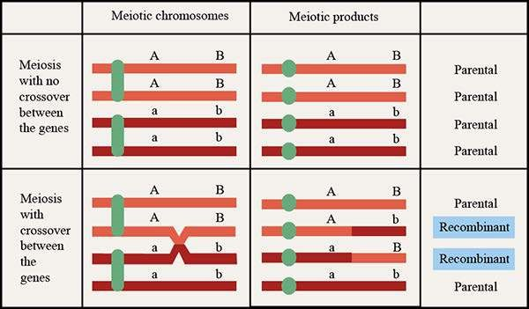

*Fig 22.16 Crossing over recombine genes.*

##### Cross Over or Recombination Frequency

It is the proportion of recombinant types between two gene pairs as compared to the sum of all combinations.

The recombination frequencies between two linked genes can be calculated by backcrossing the heterozygote to a homozygous double recessive (Fig. 22-17).

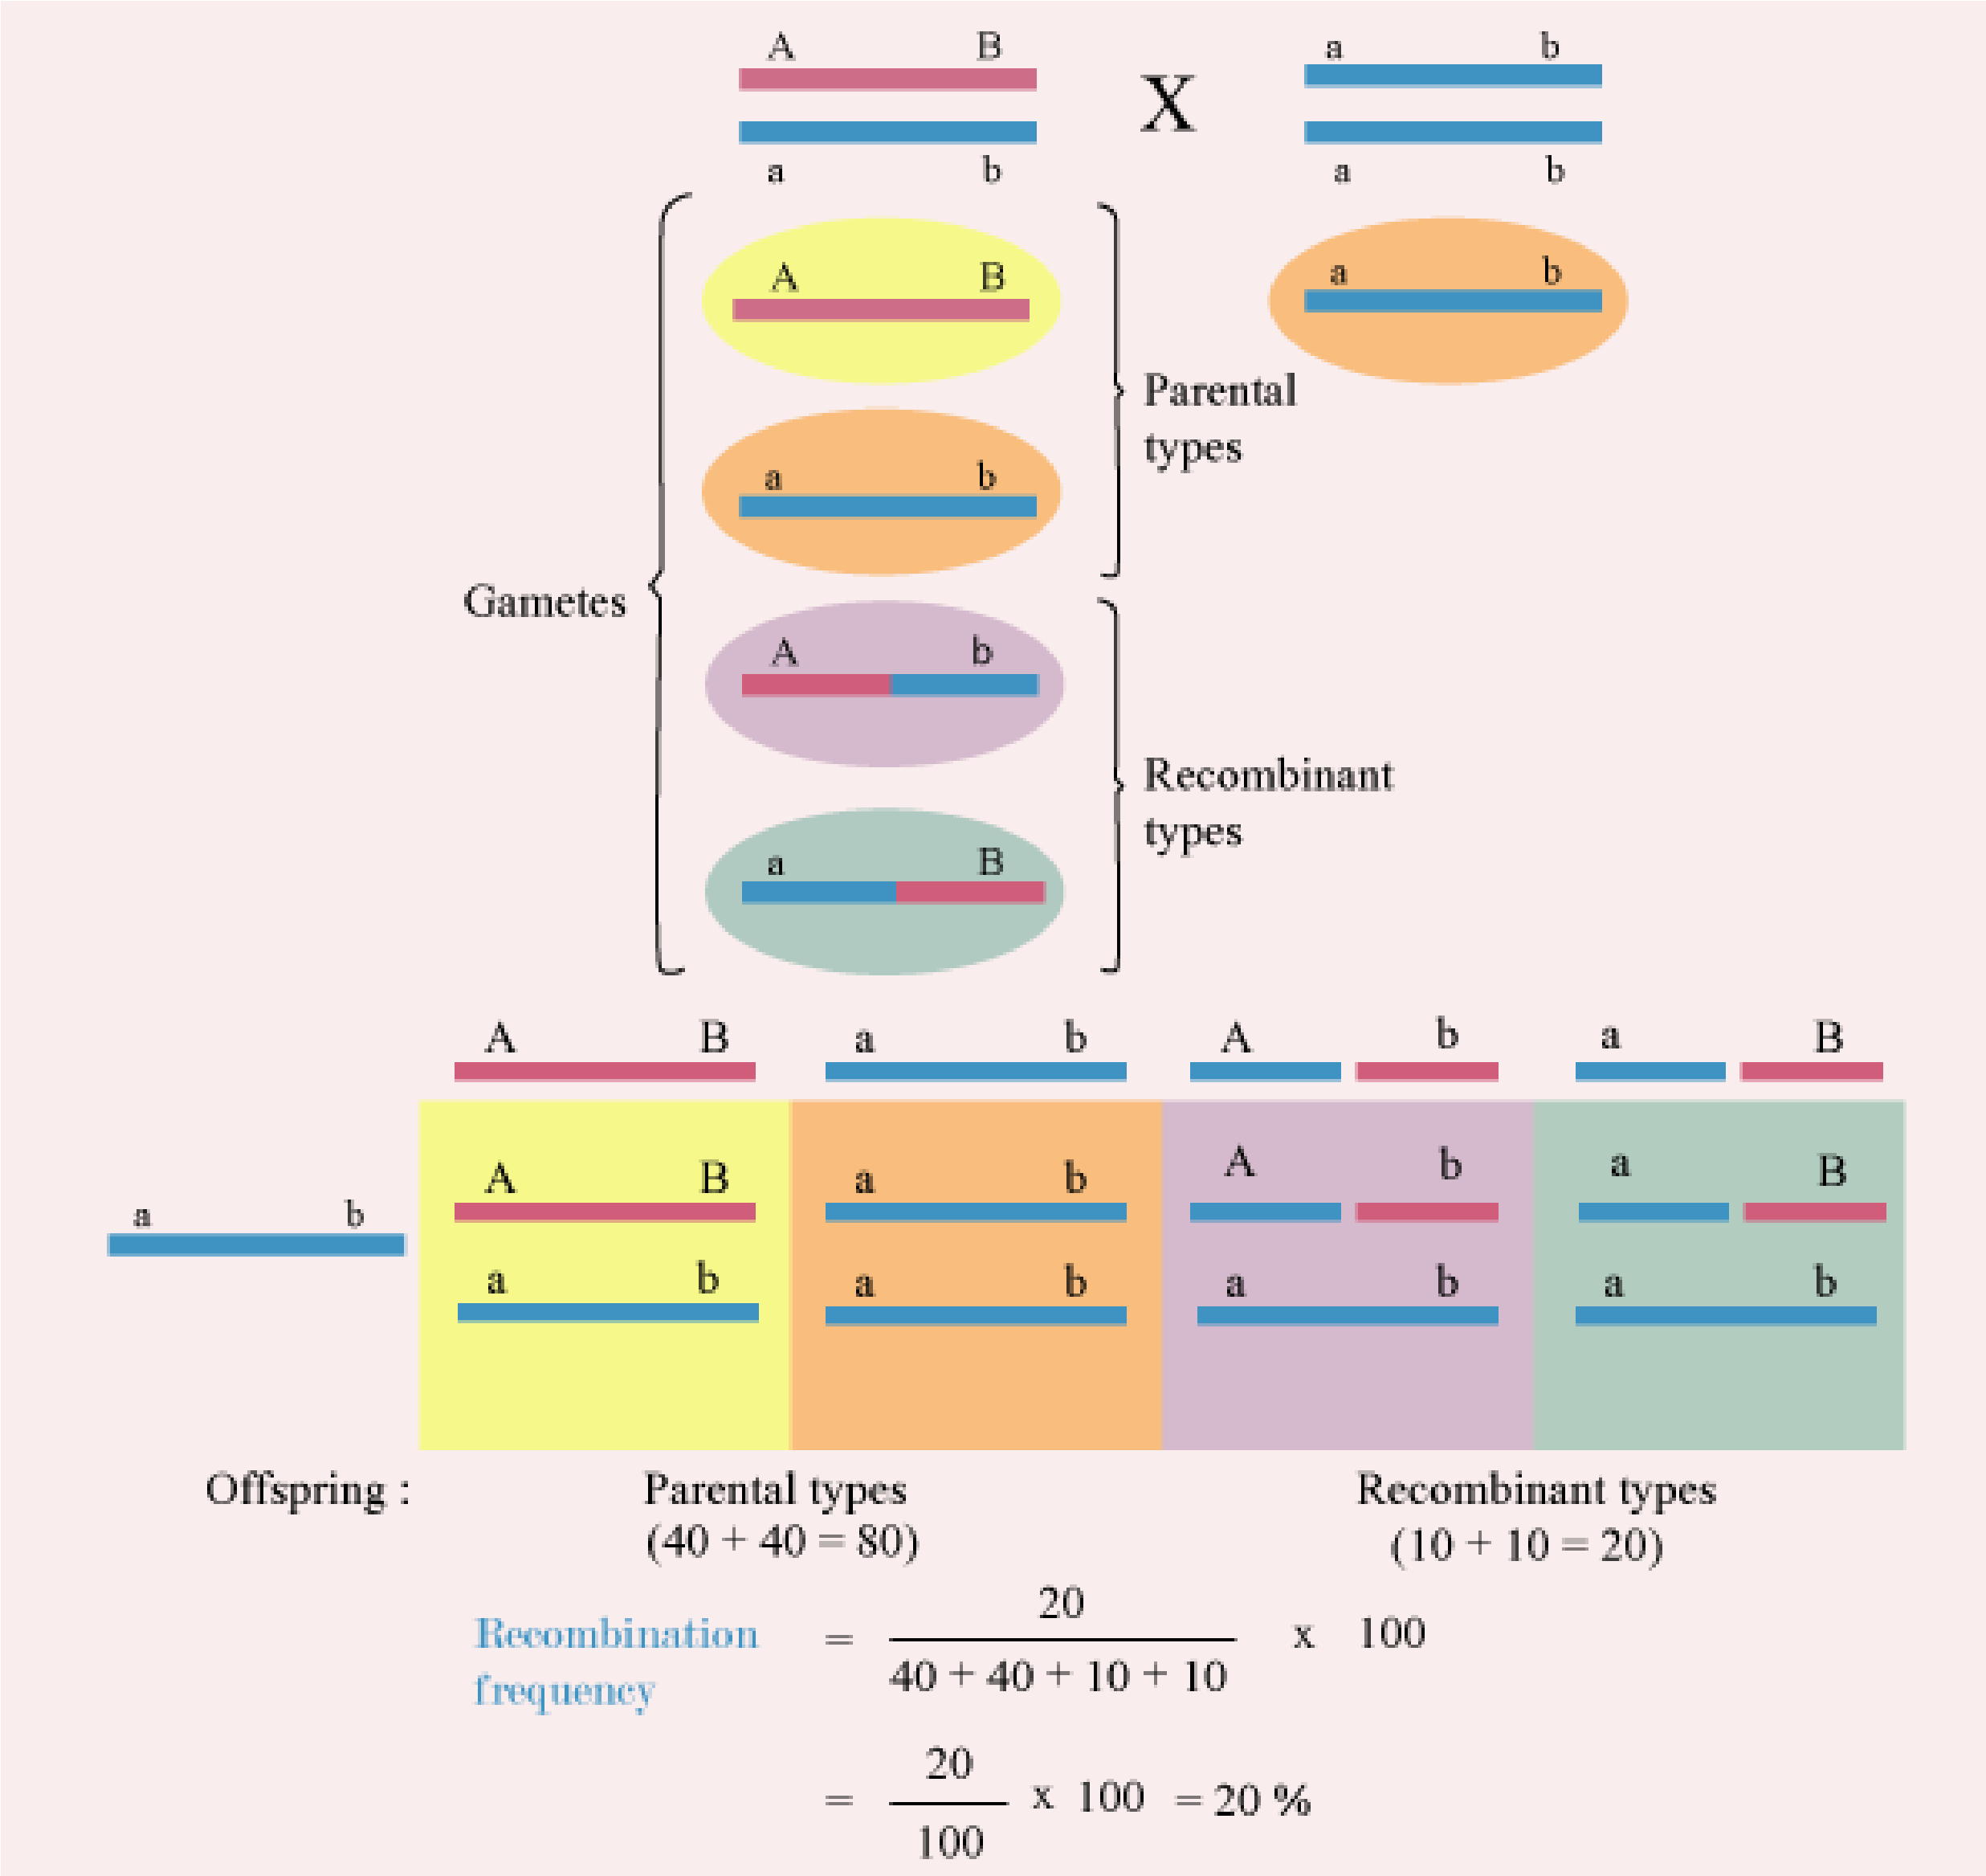

*Fig 22.17 Recombination frequency between two linked genes.*

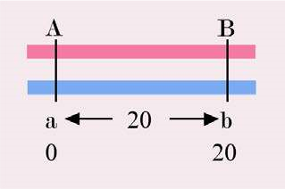The recombination frequency is directly proportional to the distance between the linked gene loci. Genes can be mapped on a chromosome on the basis of their recombination frequencies. If 1% of recombination frequency is equal to 1 unit map distance, the two linked genes A and B with a 20% recombination frequency must be 20 units apart.

Crossing over produces genetic variations among ofspring. Genetic variations lead to tremendous variations in their traits. Variations provide raw material for evolution by letting them adapt successfully to the changing environment.

##### SEX DETERMINATION

###### Sex Chromosomes

The search for mechanism of inheritance of sex started after discovery of Mendel’s wlork in 1900. A clear picture of the genetic basis of sex determination emerged after the discovery of sex chromosomes.

The fruit ly, Drosophila melanogaster has eight chromosomes in the form of four homologous pairs. T.H. Morgan (1911) noticed a peculiar diference in the chromosomes of male and female Drosophila (Fig 22-18). The chromosomes of the three homologous pairs were similar in both of the sexes, but the fourth pair was very diferent. The female had two similar rod shaped X-chromosomes in the fourth pair, while the male had one rod shaped X-chromosome but the other a morphologically diferent, J-shaped Y chromosome in the fourth heteromorphic pair. X and Y chromosomes are called sex- chromosomes because these have genes for determination of sex. Chromosomes of the other three pairs are autosomes. All chromosomes other than sex-chromosomes are called autosomes. Autosomes do not carry any sex determining gene.

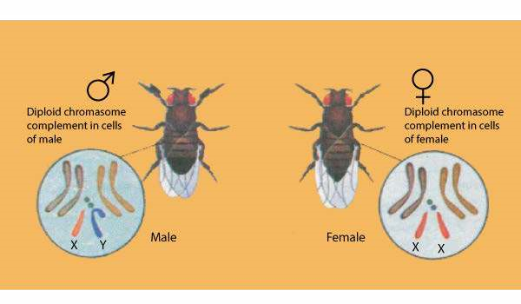

*Fig 22.18 Chromosomed of and Dorsophila melanogaster.*

Humans have 46 chromosomes in the form of 23 pairs. 22 pairs are of autosomes and one pair is of sex-chromosomes. Autosome pairs are common in both the sexes but the 23 rd sex chromosome, pair is very diferent in males and females (Fig. 2219). A woman has two similar X chromosomes in her 23rd pair but a man has an X chromosome along with a much shorter Y chromosome in his 23rd pair. The 23rd pair in man is heteromorphic. She is XX but he is XY.

SRY is the male determining gene. It is located at the tip of short arm of Y-chromosome. Its name SRY stands for “Sex determining regions of Y.”

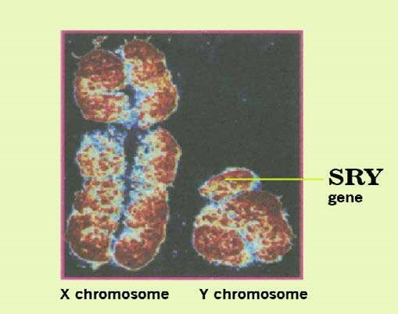

*Fig 22.19 Sex Chromosomes of a man*

In some grasshoppers males and females have diferent number of chromosomes. The female has 24 chromosomes in the form of 11 pairs of autosomes and a pair of X chromosomes. But the male grasshopper has 23 chromosomes. He has 11 pairs of autosomes and only one X chromosome. The other member for sex chromosome pair is entirely missing in male. Thus male is XO and female is XX.

Patterns of Sex Determination

There is a wide variety of sex determining ‘ mechanisms but three patterns are more, pommon.

**1. XO - XX Type** This pattern of sex determination is found Tn grasshopper and Protenor bug. Male is XO because it has only one X chromosome. The other sex chromosome is missing entirely. Male is heterogametic because. it forms t\yp I types of sperms; half the sperms have X ‘ chromosome while the othher half are without any sex chromosome. A gamefe wtihout any sex chromosome is called nullo geamete.

Some species have compound sex chromosomes. They maintain many X or Y or both XY chromosomes of more than one kind that act together as a single sex- determining group. That is why the diference in number of chromosomes between male and female is very large. In the round worm Ascaris incurva, the female has 42 chromosomes in the form of 8 pairs of compound X along with 13 pairs of autosomes (16+26). Its male has 35 chromosomes comprising 8X plus one Y alongwith 13 pairs of auto some (8+1+26).

Female is XX, because it has two X -chromosomes. It is homogametic, it forms only one type of eggs. Every egg carries an X chromosome. Sex of the ofspring depends on the kind of sperm that fertilizes the egg. If an X-carrying sperm fertilizes the egg, an XX female ofspring is produced. If the nubo

sperm fertilizes the egg, an XO male ofspring is produced (Fig. 22-20). Sex ratio between male and female ofspring is 1:1.

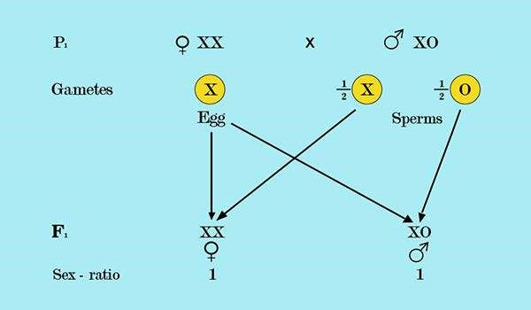

*Fig 22.20 Sex determination in grass hopper and Protenor bug.*

1. XY-XX Type : This pattern of sex determination is found in Drosophila, man and many other organisms. Male is XY and female is XX. Male being heterogametic produces two types of sex-determining sperms. Half the sperms carry X-chromosome and the other half carry Y - chromosome. Chances for both types of sperms are equal.

Female being homogametic produces only one type of eggs, each with an X chromosome. Sex of the ofspring is determined by the type of sperm. If an X - carrying sperm fertilizes the egg, the zygote will be XX, and a female ofspring is produced. If a Y - carrying sperm fertilizes the egg, the zygote will be XY, and a male ofspring will be produced. The sexratio between male and female ofspring is 1:1. Sex ratio indicates chances of the sex of the ofspring. Chances for a son or daughter in human birth are equal (Fig. 22.21).

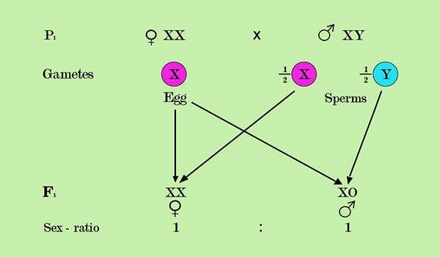

*Fig 22.21 Sex Determination in man and Drosp*

1. **ZZ - ZW Type :** This type of sex - determination pattern is common in birds, butterlies and moths. It was discovered by J. Seiler in 1914 in moth. It is the reverse of XY - XX system. Here the female is heterogametic ZW but the male is homogametic ZZ. Female produces two kinds of eggs Z and W in equal proportions. All sperms are alike, each carrying a Z - chromosome. It is the kind of egg that determines the sex of ofspring. When a Z - carrying egg is fertilized by the sperm, a male ofspring is produced, but when a W - carrying egg is fertilized by the sperm a female ofspring is produced. Sex ratio is 1:1 (Fig. 22.22).

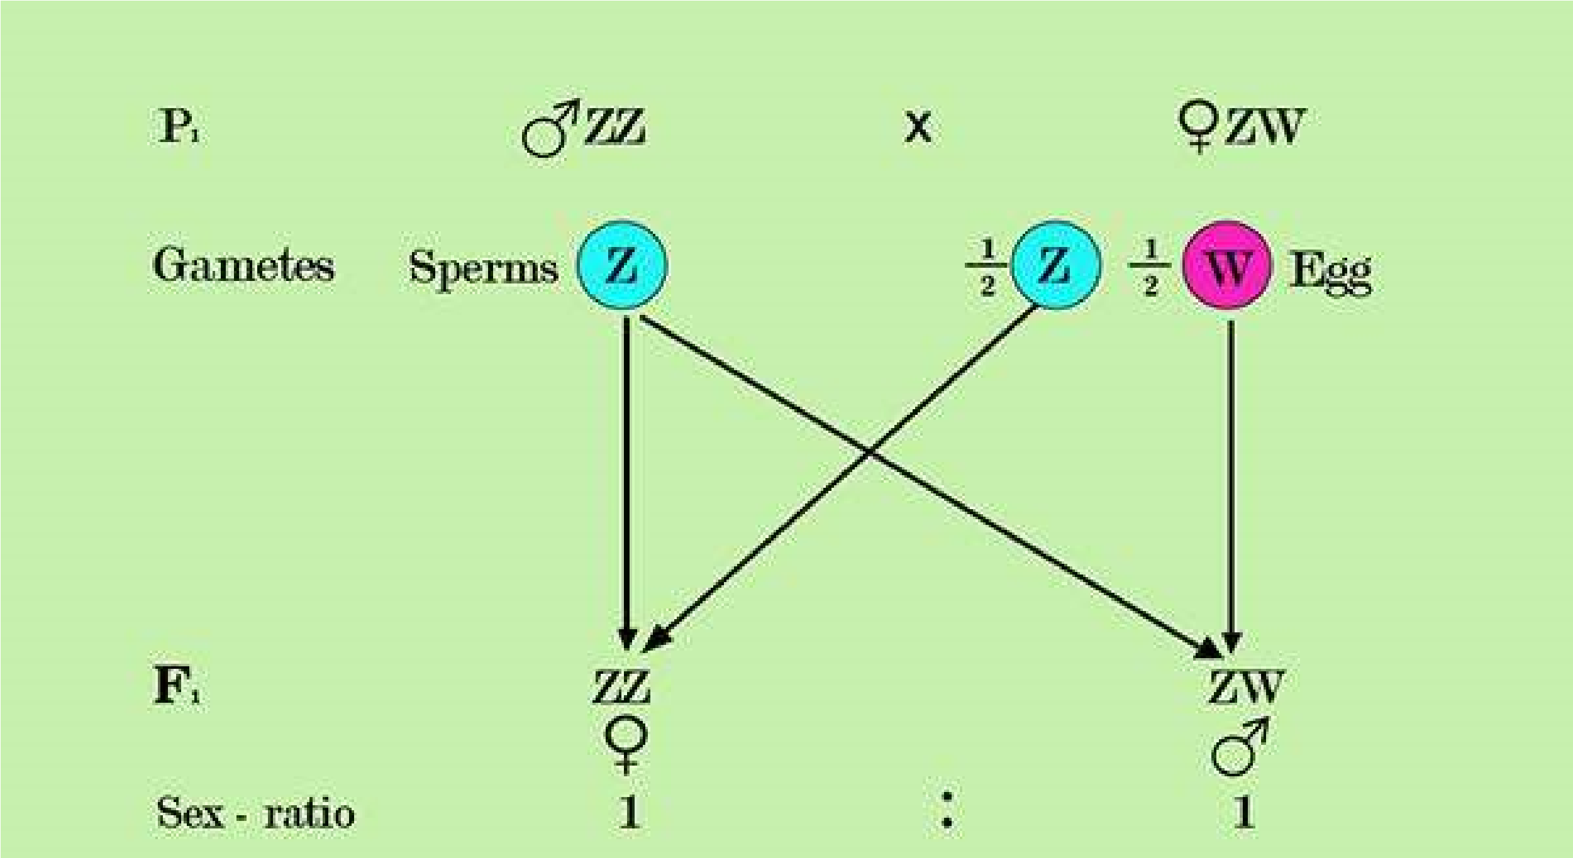

*Fig 22.22 Sex determination in birds and butterlies.*

Comparison of chromosomal determination of sex between Drosophila and Humans

Although both Drosophila and humans follow the same XY - XX sex determining pattern, yet there is a basic technical diference between the two. Presence of ‘SRY’ gene on Y chromosome is essential for triggering the development of maleness in humans. Absence of Y chromosome simply leads to the female development path. XO Turner’s syndrome in humans produced through non-disjunction is a sterile female. But in Drosophila XO is a sterile male. Similarly XXY individual produced through non disjunctional gametes in humans is a sterile male called Klinefelter’s syndrome, but the same XXY set of chromosomes in *Drosophila* produces a fertile female (Fig. 22-23).

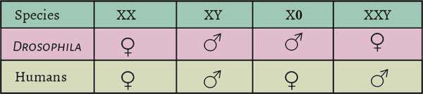

**Fig 22.23 Comparison of sex determination in man and** *Dorsophilia*

There is a close genic balance between genes of diferent chromosomes. Drosophila has an X chromosome-autosome balance system. Its Y chromosome appears to have very little inluence on sex. Here actually the X chromosome is female determining and the autosomes are male determining. Sex of an individual depends more on the number of X chromosomes relative to the number of sets of autosomes. An X : A ratio of 1.00 or higher produces female whereas an X : A ratio of 0.5 or lower produces males.

Sex Determination in Plants

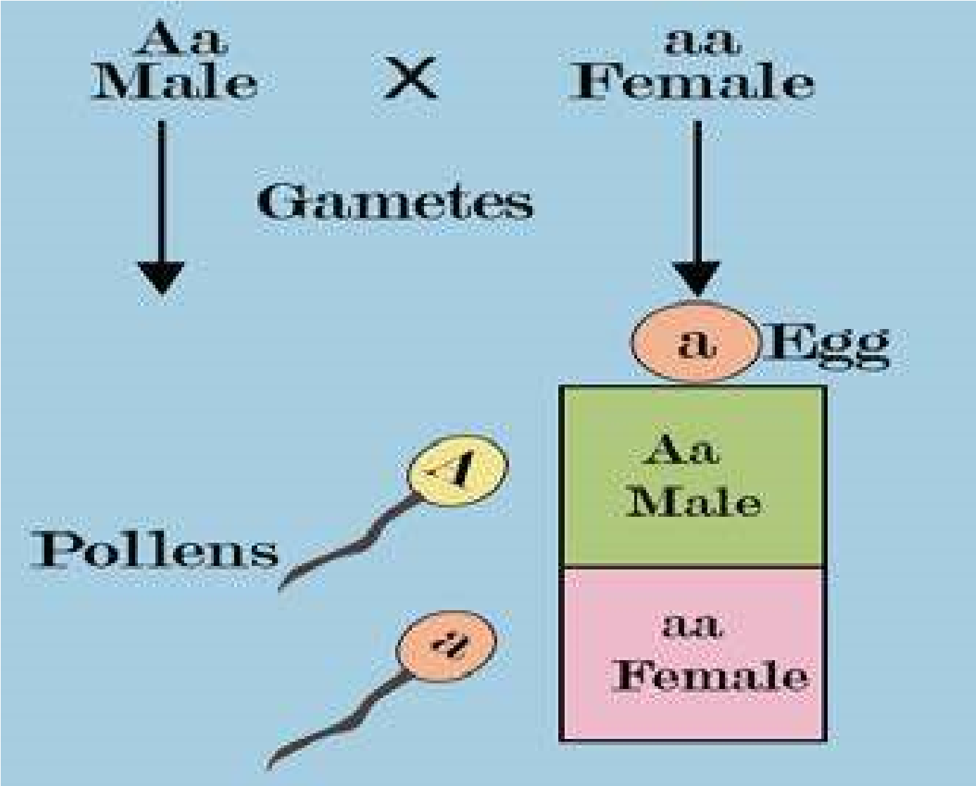Plants show a variety of sexual situations. Some species like Ginkgo are dioecious having plants of separate sexes. Male plants produce lowers with only stamens and female plants produce lowers with only carpels. Some dioecious plants have a diference of sex chromosomes between the sexes. These have an X - Y system. These plants typically exhibit an X - chromosome - autosome balance system for sex determination. Many other sex - determining mechanisms are also seen in dioecious plants. Correns (1907) discovered that pollens of certain plants were sex - determining. All eggs are of one type. Pollens of the two types are produced in equal number. One kind of pollen after fertilizing the egg produces male plant whereas the other kind of pollen after fertilization produces female plant (Fig. 22-24).

Many species of eukaryotic micro organisms like yeast do not have sex chromosome. These depend on genic system for determination of sex. In this system the sexes are speciied by simple allelic diferences at a small number of gene loci e.g., a and a are the two mating types (sexes) of yeast, controlled by MAT a and MAT a alleles respectively.

*Fig 22.24 Pollens determines Sex*

#### SEX LINKAGE

Sex Linkage in Drosophila

Thomas Hunt Morgan (1910) provided experimental evidence in support of chromosomal theory of heredity through discovery of sex linkage in fruitly Drosophila.

Drosophila is a very useful organism for genetic studies for many reasons: *

1. The tiny ly is often seen hovering over rotten fruits. It can be easily collected and cultured on mashed banana and other fruits. It does not need large spacious cages. It lives happily in ordinary glass bottle of jams and marmalades. It eats yeast that grows on mashed banana.
2. Male and female Drosophila show sexual dimorphism i.e. these are morphologically distinct from each other. Male is smaller in size with black rounded abdomen. Female is larger with pointed abdomen. Male has sex combs on front legs.
3. Drosophila has a generation time of just two weeks. It lays a large number of eggs which hatch out into fertile ofspring. Many generations can be raised in a relatively short time.
4. 4. Drosophila is perfectly suited for genetic studies. It shows fairly large number of distinct contrasting traits. Morgan and his colleagues studied pattern of inheritance of more than 85 traits of Drosophila. Its larvae are excellent material for dissection for chromosome study. It has only eight chromosomes in four homologous pairs that can be conveniently studied under a microscope. Its salivary gland cells have giant chromosomes in their nuclei. These giant chromosomes have characteristic banding patterns corresponding to genes.

5 . 5. The entire genome of Drosophila has been successfully sequenced as part of human genome project.

Morgan raised cultures of Drosophila lies to study diferent traits, such as colour of the eye. Normal fruit lies, the wild type, have bright red eyes. One of his coworkers Calvin Bridges, observed an unusual white eye mutant male ly. (Fig. 22.25).

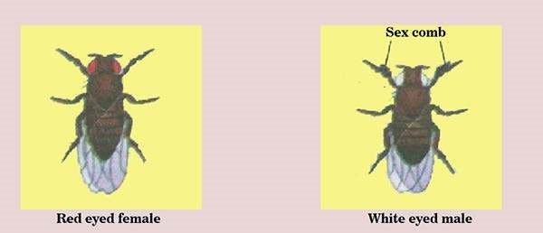

##### Fig 22.25 Wild type red eyed female and mutant white eyed male *Dorsophilia*

Morgan mated this white eyed male with a wild type red eyed female. All 1237 ofspring of this cross had red eyes. Morgan concluded that red eye is a dominant trait (Fig 2226a).

Morgan allowed males and females of F( generation to mate and produce F2 generation. He counted 2459 red-eyed females, 1,011 red-eyed males and 782 white eye males among F2 (Fig. 22.26b).

The proportion of 3470 red eyed to 782 white eyed lies did not perfectly it into Mendelian 3 : 1 ratio. The number of recessive phenotype individuals was too small. There was another pecularity in this result. All the white-eyed lies were only males.

There was no white eye female in F2 generation.

The inheritance of eye colour some how seemed to be related to the ‘sex’ of the ofspring. Morgan proposed that:

(i) The gene for eye colour is located on X chromosome, (ii) the alleles for eye colour are present only on X chromosome. There is no corresponding allele for this trait on Y chromosome.

Thus even a single recessive allele on X chromosome can express itself in males because Y chromosome is empty for that gene. Males are hemizygous as they carry just one allele on their only X chromosome. Females have two X’chromosomes, each carrying an allele of the trait. Females can be homozygous or heterozygous.

Symbol “w” represents the recessive allele for white eye, and “w+” designates its wild type allele for red eye. The genotypes of the parents of Pi cross were: Xw+ Xw+ for red eye female, and Xw Y for the white eye male.

Morgan’s hypothesis explained clearly why all the white eyed lies in F2 generation were only males.

**Step 3: Test cross :** Morgan wanted to test his hypothesis (Fig. 22-26c). He crossed the P| white eyed male (XWY) with one of its own daughters, the red eyed heterozygous female from F| generation. This test cross produced 129 red-eyed females, 132 redeyed males, 88 white-eyed females and 86 white eyed males. White-eyed lies were less viable than red-eyed lies. Half the female ofspring in fact had red eyes and half had white. Similarly half the males had red eyes and half had white.

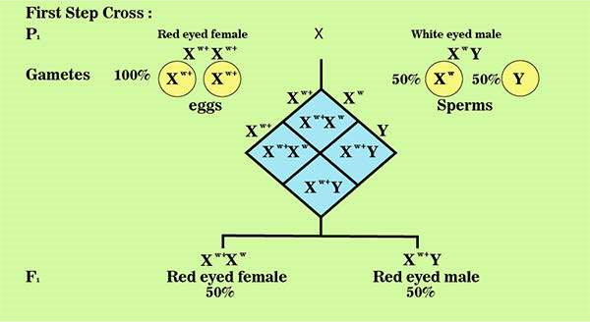

*Fig 22.16(a)*

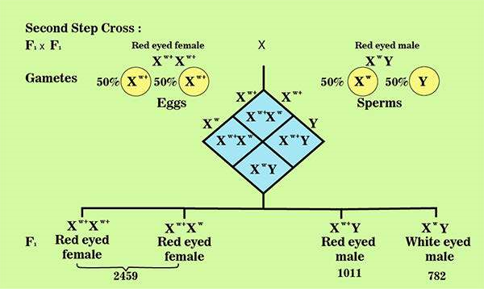

*Fig 22.26(b)*

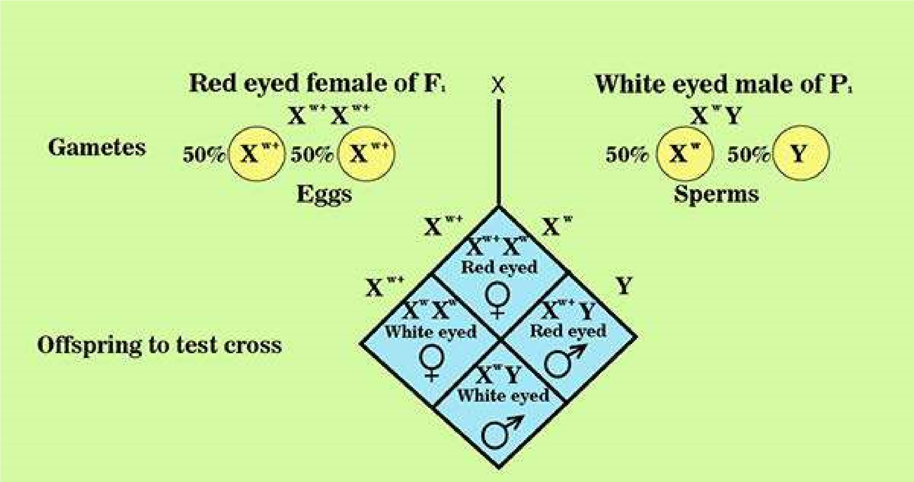

*Fig 22.26(c)*

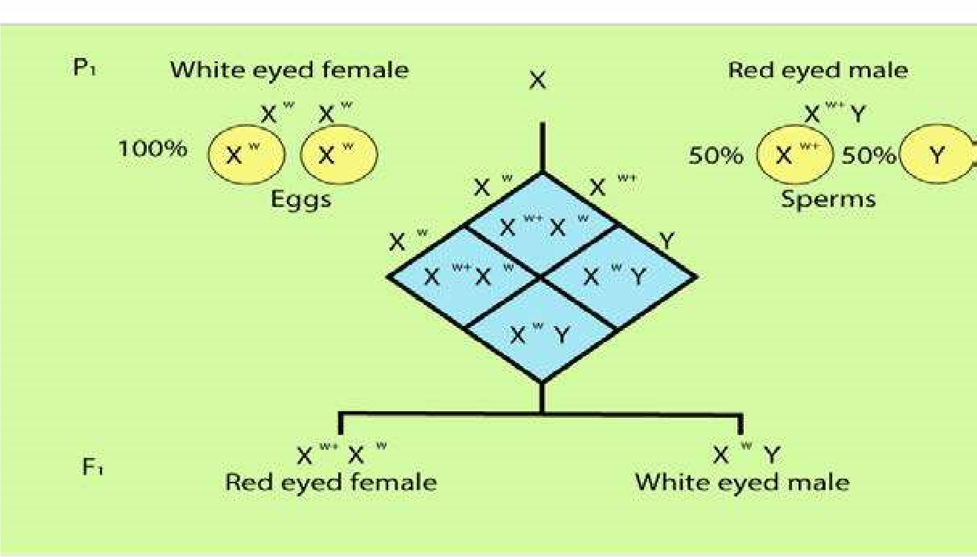

*Fig 22.26(d)*

**Step 4:** Reciprocal cross as a conirmatory test: Appearance of white eyed female provided an opportunity for a further conirmatory test. Morgan mated a white eyed female with a red-eyed male (Fig. 22.26d). All female ofspring had red eyes, and all male ofspring had white eyes. Then these Fi red eyed females and white eyed males were mated to produce F2. Half of the F2 females had red eyes, half had white. Similarly half of the F2 males had red eyes and half had white. This Fi x Fi cross was exactly like step 3 test cross.

A trait whose gene is present on X chromosome is called **X - linked trait.** X - linked traits are commonly referred as **sex-linked traits**. A gene present only on X chromosome, having no counterpart on Y chromosome, is called **X - linked gene.**

Sex-linked inheritance follows a very speciic pattern. As a son inherits his X chromosome only from his mother, and a daughter gets an X chromosome from each parent, an X - linked trait passes in a crisscross fashion from maternal grandfather (Pi) through his daughter (Fi) to the grandson (F2). It never passes direct from father to son because a son inherits only Y chromosome from father.

Morgan’s discovery of sex-linked inheritance was a great contribution to the understanding of genes and chromosome. In 1933, T. H. Morgan was awarded a Nobel Prize for his contributions to genetics.

Y chromosome is not completely inert. It does carry a few genes which have no counterpart on X chromosome. Such genes are called **Y-Linked genes** and their traits are called Y-linked traits e.g. SRY gene on Y chromosome of man determines maleness. Y - linked traits are found only in males. These traits directly pass through Y chromosome from father to son only. As females do not normally inherit Y chromosome, such traits can not pass to them. Some genes like bobbed gene in Drosophila are present on X and Y both. These are called **X - and - Y linked genes**. These are also called pseudoautosomal genes because their pattern of inheritance is like autosomal genes.

##### Sex - Linkage in Humans

Humans have many X - linked traits of which some like haemophilia and colour blindness are recessive while others like hypophosphatemic or vitamin D resistant rickets are dominant. X - linked dominant is a trait which is determined by an X linked dominant gene, while X - linked recessive is a trait that is determined by an X - linked recessive gene. Their patterns of inheritance are very diferent from each other.

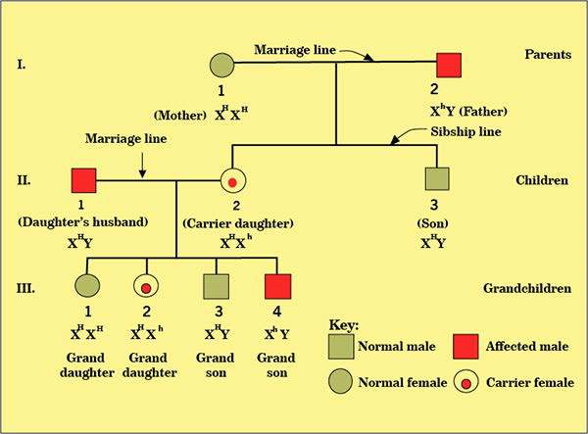

*Fig 22.27 Transmission of X-linked recessive traits(heamophilia) in humans.*

X - linked recessive inheritance: Experimental matings are not practically possible in humans. Mode of inheritance of human traits can be traced through pedigrees.

Genetics of Haemophilia: Haemophilia is a rare X — linked recessive trait. Haemophiliac’s blood fails to clot properly after an injury, because it has either a reduction or malfunction or complete absence of blood clotting factors. It is a serious hereditary disease because a haemophiliac may bleed to death even from minor cuts. Haemophilia is of three types: A, B and C. Haemophilia A and B are non - allelic recessive sex - linked, but haemophilia C is an autosomal recessive trait. 80% haemophiliacs, sufer from haemophilia A due to abnormality of factor VIII, about 20% sufer from haemophilia B due to disturbance in factor IX, but less than 1% sufer from haemophilia C due to reduction in factor XI. Being X - linked recessives, haemophilia A and B afect men more than women, but haemophilia C afects both the sexes equally because it is autosomal. Chances for a man to be afected by haemophilia A and B are greater than a woman. A woman can sufer from haemophilia A or B only when she is homozygous for the recessive allele, but a man with just one recessive allele will display the trait. Haemophilia A and B zigzag from maternal grandfather through a carrier daughter to a grandson. It never passes direct from father to son. Gene for normal is H. Gene for haemophilia A is h. In generation I of this pedigree (Fig. 22.27) a man (I - 2) sufering from haemophilia A marries a normal woman (I - 1). He passes haemophilia gene to his daughter (II - 2) through his X chromosome. He cannot pass this gene to his son (II - 3) because the son receives only Y chromosome from him. His daughter (II - 2) also receives another X but with normal dominant allele from her mother (I - 1).

The daughter looks phenotypically normal, but she is heterozygous and a carrier for the recessive gene. When she marries a normal man (II - 1) she passes her father’s trait to one of her two sons (HI - 4) who inherits grandfather’s X from her. The single recessive allele for haemophilia expresses successfully in the hemizygous son because his Y chromosome does not carry its counterpart. The other son (III - 3) is normal as he Many X - linked traits in man are also found X - linked in other mammals like mouse, rabbit, dog, sheep, horse, donkey, cattle, kangaroo and chimpanzee.Was the mammalian X chromosome conserved throughout mammalian evolution?

inherits grand mother’s X with normal gene, One daughter (III - 1) with both normal X is normal, but the other daughter (III - 2) is carrier like her mother.

Activity: Cases of Haemophilia A are reported in Queen Victoria’s family. Pedigree of Queen Victoria’s family (Fig. 22.28) indicates that Queen Victoria was a carrier mother, because she gave birth to an afected son Prince Leopold. Prince Leopold passed on this recessive X - linked trait in typical zigzag fashion through his carrier daughter (III - 1) to his grandson Rupert (IV - 1). Assign genotype to each individual. Can you explain how Alexis (IV - 3) became haemophiliac?

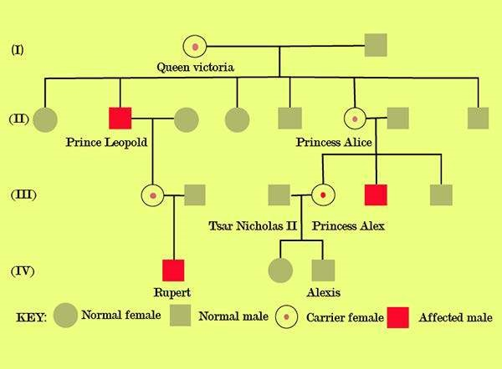

*Fig 22.28 Pedigree of Queen Victoris’s family showing cases of Hemolhilia A.*