##### :Genetics of colour-blindness

Normal trichromatic colour vision is based on three diferent kinds of cone cells in the retina, each sensitive to only one of the three primary colours, red, green or blue. Each type of cone cell has speciic light absorbing proteins called opsins. The genes for red and green opsins are on X chromosome, while the gene for blue opsin is present on autosome 7. Mutations in opsin genes cause three types of colour-biindness. A **dichromat** can perceive two primary colours but is unable to perceive the one whose opsins are missing due to mutation. **Protanopia** is red blindness, deuteranopia is green blindness, while tritanopia is blue blindness. Some people can detect red and green but with altered perception of the relative shades of these colours. They have abnormal but still partially functional opsins. They are protanomalous and deuteranomalous for red and green weakness respectively. A **monochromat** can perceive one colour. Monochromacy is true colour-blindness. Blue cone monochromacy is an X - linked recessive trait in which both red and green cone cells are absent. That is why it is also called red - green colour-blindness. It is a common hereditary disease. Like any sex - linked recessive trait, it also zigzags from maternal grandfather through a carrier daughter to a grandson. It never passes direct from father to son. This type of colourblindness is more common in men than women, because chances for a male to be afected by it are muh more than a female.

Testicular feminization syndrome is a rare X-linked recessive trait.Although the persons afected by this trait have a male set of XY chromosomes, yet tfn gene on their X chromosome develops them physically into females. They have breast, female genitalia, a blind Vagina but no uterus. Degenerated testis are also present in abdomen. Such individuals are happily married as females but are sterile. It is an androgen insensitivity syndrome. Male sex hormone testosterone has no efect on them.

Activity: A sex-linked recessive allele “c” produces red - blindness. Its normal dominant allele is “C”. A normal woman whose father was red-blind, marries a red-blind man.

What proportion of their children can have normal colour vision?

1. - linked dominant inheritance : Pattern of X - linked dominant inheritance is diferent from X - linked recessive. It is more common in females than males. All daughters of an afected father, but none of his sons are afected. Any heterozygous afected mother will pass the trait equally to half of her sons and half of her daughters (Fig. 22.29). Hypophosphatemic rickets is an X - linked dominant trait. It is a rare hereditary disease. It is diferent from common dietary rickets, which could be cured by taking vitamin D. It does not result from vitamin D deiciency but its cause is a genetic communication failure at molecular level. The genes encoding bone proteins never receive vitamin D’s message to function.

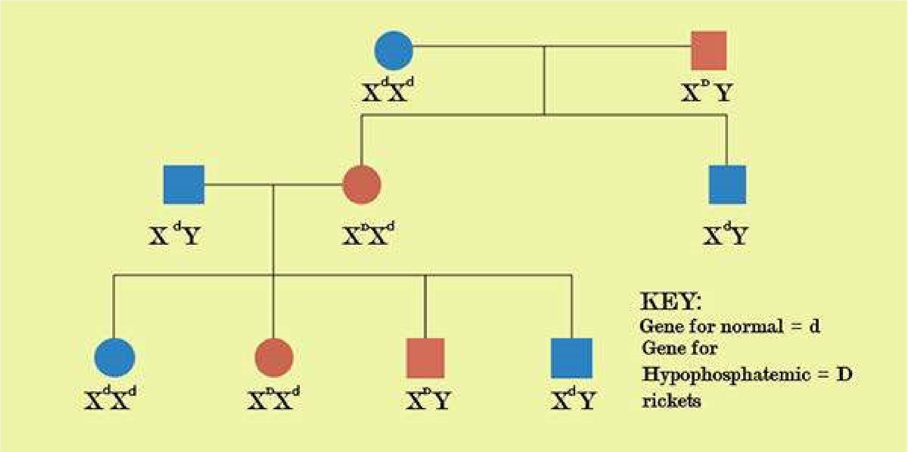

*Fig 22.29 Tranmission Of X-linked dominant traits in humanss.*

1. - Linked inheritance : Pattern of Y - linked inheritance is very peculiar. Maleness is a Y - linked trait. Y - linked trait passes through Y - chromosome from father to son only. Such traits cannot pass to daughters because they do not inherit Y - chromosome. All sons of an afected father are afected by a Y - linked trait (Fig. 22.30). SRY’ gene on Y chromosome determines maleness in man. It is male sex switch which triggers developmental process towards maleness after 6 week pregnancy.

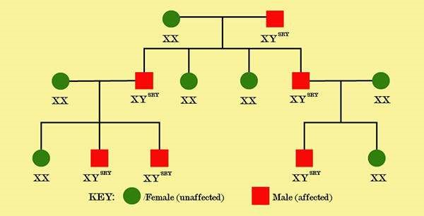

*Fig 22.30 Y-linked inheritance in man*

###### Sex Limited Trait

A sex-limited trait is limited to only one sex due to anatomical diferences. Such trait afects a structure or function of the body present in only males or only females. These trails may be controlled by sex-linked or autosomal genes. Genes for milk yield in dairy cattle afect only cows. Similarly beard growth in humans is limited to men. A woman does not grow a beard herself but she can pass the genes specifying heavy beard growth to her sons.

###### Sex Inluenced Trait

Sex inluenced trait occurs in both males and females but it is more common in one sex. It is controlled by an allele that is expressed as dominant in one sex but recessive in the other. This diference in expression is due to hormonal diference between the sexes. Pattern baldness is a sex inluenced trait. Many more men than women are bald. It is inherited as an autosomal dominant trait in males but as an autosomal recessive trait in females. A heterozygous male is bald but a heterozygous female is not. A woman can be bald only when she is homozygous recessive.

Activity: A man is 45 years old and bald. His wife also has pattern baldness. What is the risk that their son will lose his hair?

DIABETES MELLITUS AND ITS GENETIC BASIS

Diabetes mellitus is a hereditary disease. It is actually a heterogenous group of disorders which are characterized by elevated blood sugar level. Diabetics are unable to metabolise blood sugar in their body. They pass glucose in their urine. Diabetes is the leading cause of kidney failure, adult blindness, lower limb amputation and heart disease.

There are two major types of diabetes: Type I is IDDM or insulin dependent diabetes mellitus. Type II is NIDDM or non insulin dependent diabetes mellitus. Type I is also called Juvenile diabetes because it usually occurs in early age before 40. It arises due to deiciency of pancreatic hormone insulin that normally routes blood glucose to cells for use. Type I is an auto immune disorder. The immune system backires and manufactures auto antibodies against body’s own cells. Sometimes, speciic viral infections activate auto immune response. T - cells of immune system attack pancreas and destroy insulin producing (5 - cells. As a result, pancreas does not produce insulin. Diabetics of type I must receive exogenous (from outside source) insulin to survive.

Progress is being made in understanding the genetic basis of this disease. The •insulin gene is located on short arm of chromosome 11. Polymorphism and genetic variations within this locus is responsible for diabetes type I susceptibility. But today, it is no more just a recessive single gene trait, rather it is a multifactorial (polygenic with environmental inluence) inheritance associated with several alleles.

Diabetes mellitus type II is non insulin dependent. It accounts for 90% of all diabetic patients. These persons produce some endogenous insulin themselves, but their body cells gradually fail to respond to insulin and cannot take up glucose from blood. They develop a sort of insulin resistance. It occurs among people over the age of 40, and is more common among the obese. Obesity increases insulin resistance. As exercise reduces obesity it indirectly increases insulin sensitivity and improves glucose tolerance.

There, deinitely exists a genetic component in the form of an underlying tendency to develop diabetes under certain environmental conditions. About 2% - 5% of type II diabetics get the disease early in life, before 25 years of age. It is called maturity onset diabetes of the young (MODY). MODY can be inherited as an autosomal dominant trait. About 50% of cases of MODY are caused by mutations in glucokinase gene. Glucokinase enzyme usually converts glucose to glucose - 6 - phosphate in pancreas. MODY can also be caused by mutations in any of the four other genes which encode transcription factors involved in pancreatic development and insulin regulation. But these four MODY genes do not play any signiicant role in adult - onset type II.

Blood pressure is also an example of multifactorial trait. There is a correlation between systolic and diastolic blood pressure of parents and their children. This correlation is partly due to genes common in them. Blood pressure is also inluenced by environmental factors such as diet, stress and tension.

**Exercise**

**Q1 Fill in the blanks.**

1. _________is the basic unit of biological information.
2. A sudden change in the structure of a gene is called ______
3. _______is the chance of an event to occur.
4. A cross among monohybrids is a________cross.
5. An individual with a homozygous genotype is called________ .
6. Diferent alleles of a gene that are both expressed in a heterozygote are called____________
7. When a heterozygote exceeds the phenotypic expression of both the homozygotes the phenomenon is called__________ .
8. When a single gene afects two or more traits, the phenomenon is called________
9. A gene with multiple phenotypic efect is called_________ .
10. The phenomenon of staying together of all the genes of a chromosome is called_______
11. _________ minimizes the chances of genetic recombination.
12. _________is an exchange of segments between non-sister chromatids of homologous chromosomes during meiosis.
13. All cliromosomes other than sex chromosomes are called_________.
14. _______is the maleness determining gene in man.
15. Type __________of diabetes mellitus is non insulin dependent.
16. Polygenic inheritance with environmental inluence is called __________ inheritance.

**Q.2 Short questions.**

1. In grasshopper, the male has XY and the female has XX types of sex chromosomes.
2. Pea is normally a self fertilizing plant.
3. Dihybrids are ofspring of the parents who difer in one contrasting pair of trait.
4. X - linked traits pass direct from father to son.
5. A person sufering from Blue cone monochromacy can not see blue colour.
6. In birds and moths eggs determine sex.
7. A homozygote forms all gametes of the same type.
8. The allele for a sex limited trait is dominant in one sex but recessive in the other.
9. Pattern baldness is a sex inluenced trait.
10. Carriers of haemophilia show no symptoms of the disease.

**Q.4 Short Questions.**

1. **Diferentiate between**:

|  |  |
| --- | --- |
| Phenotype and genotype  Homozygous and heterozygous  Autosome and sex chromosome  Allele and multiple allele  Incomplete dominance and codominance  Continuous and discontinuous variations | Gene and allele  Monohybrid and dihybrid  Dominance and epistasis  X-linked trait and Y-linked trait  Sex limited and sex inluenced trait  Dominant trait and recessive trait  Wild type and mutant |

1. What is a gene pool?
2. Was pea a lucky choice for Mendel? What would have happened if he had studied an eighth character?
3. What is a test cross? Why did Mendel devise this cross?
4. What would happen if alleles of a pair do not segregate at meiosis? How would it afect the purity of gamete?
5. If the alleles do not assort independently, which type of combination is missing in the progeny.
6. Why has each gamete equal chance of getting one or the other allele of a pair?
7. Does the dominant allele modify the determinative nature of its recessive partner?.

What sort of relationship do they have?

1. Which type of traits can assort independently?
2. Why does the blood group phenotype of a person remain constant throughout life’?
3. What is a universal blood donor?
4. How can you protect the baby against Rh - incompatibility?
5. Which type of genes do not obey law of independent assortment?
6. How can linked genes be separated from each other ?
7. What is multifactorial inheritance?
8. What is MODY?
9. Can a child have more intelegence (IQ score) than his parents?

**Q.4 Extensive Questions**

1. What is incomplete dominance? Explain it with an example.
2. Deine Mendel’s law of segregation. Explain it with an example.
3. Deine Mendel’s law of independent assortment. Explain it with an example.
4. Deine probability. Derive 9:3:3:1 F2‘ratio of independent assortment through product rule.
5. What is codominance? Explain the phenomenon of codominance with an example.
6. Deine multiple alleles. Describe multiple allelic blood group system of man.
7. What is Rh factor? Describe the genetic basis of Rh - blood group system of man.
8. What is erythroblastosis foetalis? Discuss this adverse efect of Rh incompatibility? Also suggest a therapy to avoid Rh sensitization of an Rh” mother married to an Rh+ man.
9. Deine epistasis. Explain epistatic gene interaction with an example.
10. What is a pleiotropic gene? Discuss pleiotropy with examples.
11. What are polygenes? Explain polygenic inheritance.
12. What is crossing over? Deine recombination frequency and explain its signiicance.
13. What are sex-chromosomes? Discuss the chromosomal patterns of sex determination in organisms.
14. Compare chromosomal determination of sex between Drosophila and humans.
15. Deine gene pool. Explain the concept of gene pool in a sample population.
16. What is sex linkage? Explain T. H. Morgan’s study of sex - linkage in Drosophila.
17. Compare the pattern of inheritance of an X - linked dominant trait with an X - linked recessive trait in humans.
18. Explain diabetes mellitus and its genetic basis.
19. Discuss the genetics of colour-blindness or haemophilia.

CHAPTER 23 BIOTECHNOLOGY

*Animation 23 : Biotechnology*

*Source & Credit: Wikispaces*

Since Mendel’s work was rediscovered in 1900, geneticists have made startling advances which have led to a new era of DNA technology. Modem techniques enable desired substance, for example insulin. Not very long ago, people with insulin dependent they receive human insulin, a product of biotechnology. Since the 1980s, biotechnology has produced drugs and vaccines to curb human illnesses.

Genetically, engineered bacteria have been used to clean up environmental pollutants, increase the fertility of the soil, and kill insect pests. Biotechnology also extends beyond multicellular organisms. It is now possible to alter the genotype and subsequently the phenotype of plants and animals. Indeed, gene therapy in humans, attempting to repair a faulty gene is already undergoing clinical trials. There are those who are opposed to manipulation of genes for any reason. Although, there have been no ill efects as yet, they fear the possibility of health and ecological repercussions in the future.

#### Cloning of a gene

Produces many identical copies. Recombinant DNA technology is used when a very large quantity of a gene is required. The use of polymerase chain reaction (PCR) creates a lesser number of copies within a laboratory test tube.

#### Recombinant DNA Technology

Recombinant DNA technology popularly known as genetic engineering aims at synthesizing recombinant DNA which contains DNA from two diferent sources. In order to produce recombinant DNA, the following are required:

1. Gene of interest, which is to be cloned.
2. Molecular scissors to cut out the gene of interest.
3. Molecular carrier or vector, on which gene of interest could be placed.
4. The gene of interest alongwith the vector is then introduced into an expression system, as a result of which a speciic product is made.

**How to get a gene?**

There are three possible ways to get the gene of interest.

1. to isolate it from the chromosome
2. to synthesize it chemically, and
3. to make it from mRNA

Genes can be isolated from the chromosomes by cutting the chromosomes on the lanking sites of the gene using special enzymes known as restriction endonucleases. If, however, the genes are small, they can also be synthesized in the laboratory. Another very common method of getting the gene is to synthesize it in the laboratory from messenger RNA, using reverse transcriptase. This DNA molecule is called complementary DNA (cDNA).

#### Molecular Scissors: Restriction Endonucleases

These are natural enzymes of bacteria, which they use for their own protection against viruses. The restriction enzyme cuts down the viral DNA, but does no harm to the bacterial chromosofhe. They are called restriction enzymes because they restrict the growth of viruses. In 1970, Hamilton O. Smith, at Johns Hopkins University, isolated the irst restriction enzyme. Bacteria produce a variety of such restriction enzymes, which cut the DNA at very speciic sites characterized by speciic sequence of four or six nucleotides arranged symmetrically in the reverse order. Such sequences are known as palindromic sequences. So far more than 400 such enzymes have been isolated out of which about 20 are frequently used in recombinant DNA technology.

EcoRl, a commonly used restriction enzyme, cuts double-stranded DNA when it has this sequence of bases at the cleavage site (Fig. 23.1). Notice there is now a gap into which a piece of foreign DNA can be placed, if it ends in bases complementary to those exposed by the restriction enzyme. The single stranded but complementary ends of the two DNA molecules are called “sticky ends” because they can bind by complementary base pairing. They, therefore, facilitate the insertion of foreign DNA into vector DNA.

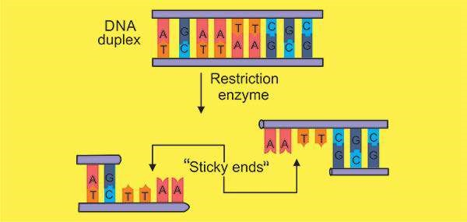

*Fig, 23.1 Restriction enzyme ECoRl, cuts this speciic sequence of nucleotides in such a way that sticky ends are produced.*

#### Molecular Carrier: Vector

To make recombinant DNA, one often begins by selecting a vector, the means by which recombinant DNA is introduced into a host cell. One common type of vector is a plasmid. Plasmids were discovered by investigators studying the sex life of the intestinal bacterium *Escherichia coli*.

Plasmids are natural extra-chromosomal circular DNA molecules which carry genes for antibiotic resistance and fertility etc. One of the plasmids discovered earlier pSC 101 has antibiotic resistance gene for tetracycline, whereas pBR 322 has antibiotic resistance genes for tetracycline as well as ampicillin. Inserting gene of interest in tetracycline resistant gene of plasmid pBR 322 would enable separating out colonies of bacteria in a medium containing ampicillin and vice versa.

##### Recombinant DNA

For preparation of a recombinant DNA, the plasmid is cut with the same enzyme which was used for isolation of the gene of interest (Fig. 23.2). The gene of interest (insulin) is then joined with the sticky ends produced after cutting the plasmid with the help of another special enzyme knqwn as DNA ligase. This enzyme seals the foreign piece of DNA into the vector. Now the two diferent pieces of DNA have been joined together, which is now known as recombinant DNA or chimaeric DNA

*Animation 23.1: Recombinant DNA* [*Source & Credit:Pinterest*](https://www.pinterest.com/pin/103512491408305996/)

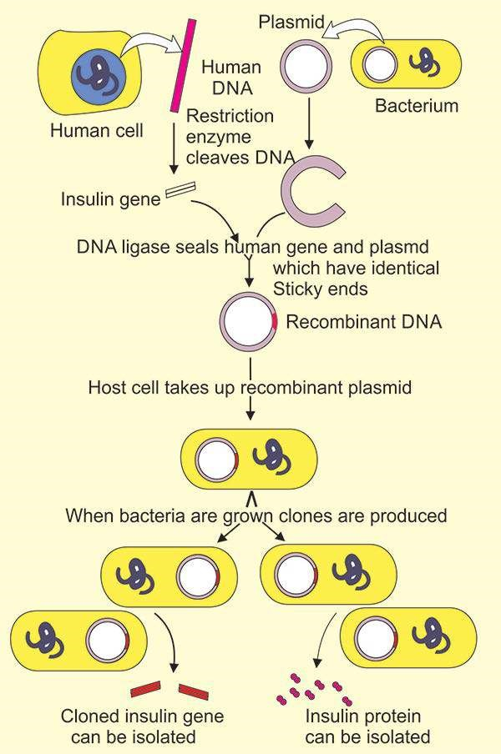

*Fig. 23.2 Cloning of a gene.*

##### Expression of the Recombinant DNA

A clone can be a large number of molecules (i.e. cloned genes) or cells (i.e. cloned bacteria) or organisms that are identical to an original specimen. Fig. 23.3 compares the use of a plasmid and a virus to clone a gene. Bacterial cells take up recombinant plasmid, especially, if they are treated with calcium chloride to make them more permeable. Thereafter, as the cell reproduces, a bacterial clone forms and each new cell contains at least one plasmid. Therefore, each of the bacteria contains the gene of interest, which will express itself and make a product. From this bacterial clone, the cloned gene can be isolated for further analysis, or protein product can be separated (Fig 23.2). Besides plasmids, the DNA of bacterial viruses (for example, lambda phage) can also be used as a vector. After lambda phage attaches to a host bacterium, recombinant DNA is released from the virus and enters the bacterium. Here, it will direct the reproduction of many more viruses. Each virus in bacteriophage clone contains a copy of the gene being cloned (Fig. 23.3).

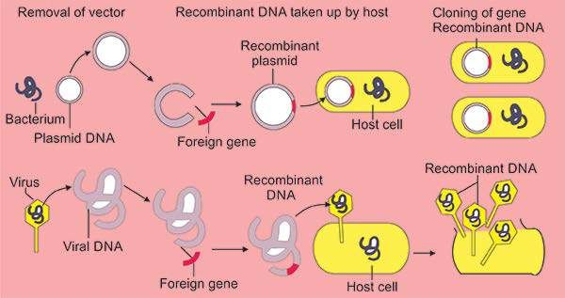

*Fig. 23.3 Plasmid DNA (upper part of igure) as well as viral DNA (lower part of the igure) can be used as vectors for cloning gene*

*of interes*

##### Genoiftic Library

A genome is a full set of genes of an individual. A genomic library is a collection of bacterial or bacteriophage clones, each clone containing a particular segment of DNA from the source cell. For making a genomic library, an organism’s DNA is simply sliced up into pieces, and pieces are put into vectors (i.e. plasmids or viruses) that are taken up by host bacteria as shown in Fig. 23.3. The entire collection of bacterial or bacteriophage clones that result contains all the genes of that organism.

A particular probe can be used to search a genetic library for a certain gene. A probe is a single stranded nucleotide sequence that will hybridize (pair) with a certain piece of DNA. Location of the probe is possible because the probe is either radioactive or luorescent. Bacterial cells, each carrying a particular DNA fragment, can be plated onto agar in a petri dish. After the probe hybridizes into the gene of interest, the genes can be isolated from the fragment (Fig 23.4). Now this particular fragment can be cloned further or even analyzed for its particular DNA sequence.

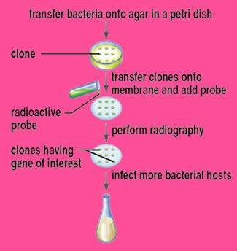

*Fig 23.4 Identiication of a cloned gene*

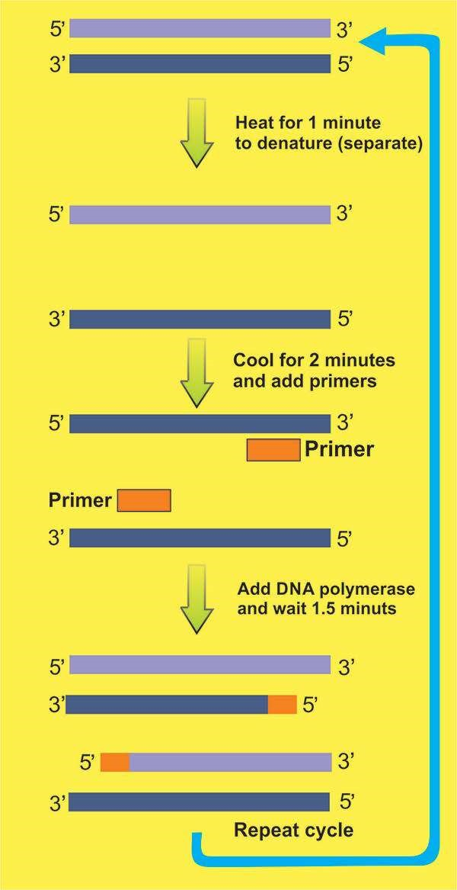

*Fig 23.5 Polymerase chain reaction (PCR)*

##### The polymerase Chain Reaction

Kary B. Mullis developed the polymerase chain reaction (PCR) in 1983. Earlier methods of obtaining multiple copies of a speciic sequence of DNA were time consuming and expensive. In contrast, PCR can create millions of copies of a single gene or any speciic piece of DNA quickly in a test tube. PCR is very speciic - the targeted DNA sequence can be less than one part in a million of the total DNA sample. .This means that a single gene or smaller piece of DNA, among all the human genes can be ampliied (copied) using PCR.

PCR takes its name from DNA polymerase, the enzyme that carries out DNA replication in a cell. It is considered a chain reaction because DNA polymerase will carry out replication over and over again, until there are millions of copies of the desired DNA. PCR does not replace gene cloning, which is still used whenever a large quantity of gene or protein product is needed.

Before carrying out PCR, primers - sequences of about 20 bases that are complementary to the bases on either side of the “target DNA” - must be available. The primers are needed because DNA polymerase does not start the replication process; it only continues or extends the process. After the primers bind by complementary base pairing to the DNA strand, DNA polymerase copies the target DNA (Fig 23.5) .

DNA polymerase used is temperature - insensitive (thermostable) enzyme extracted from the bacterium *Thermus aquaticus*, which lives in hot springs. Commonly, this enzyme is also known as **Taq polymerase**. It can withstand high temperature, which is used to separate double stranded DNA, therefore, replication need not be interrupted by the need to add more enzyme. PCR is done these days in an automatic PCR machine or thermocycler, which is a routine piece of equipment in any laboratory.

*Animation 23.2 : PCR*

[*Source & Credit: members.jcom*](http://members.jcom.home.ne.jp/kisono/pcr/pcr.htm)

##### Analyzing DNA

The entire genome of an individual can be subjected to DNA inger printing, a process described in Fig. 23.6. The genome is treated with restriction enzymes, which results in a unique collection of diferent sized fragments. Therefore, restriction fragment length polymorphism (RFLPs) exists between individuals. During a process called gel electrophoresis, the fragments can be separated according to their lengths (molecular weight or size), and the result is a number of bands that are so close together that they appear as a smear. However, the use of probes for genetic markers produces a distinctive pattern that can be recorded on X-ray ilm.

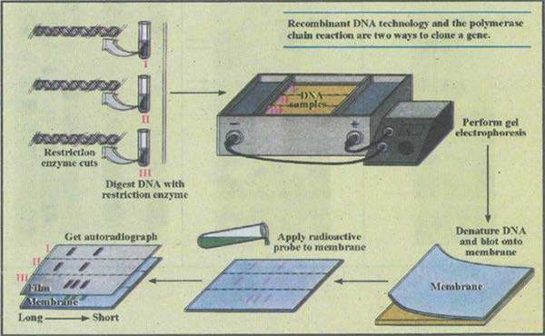

*Fif 23.6 DNA ingerprinting. Three samples of DNA(I , II , IIi)were cut with a restriction enzyme and run on agarose gel. The gel pattren was then transferred to a membrane and DNA was denatured. The denatured DNA on the paper was hybridized with radioactive probe. Since the radioactive probes and complemetary arrangement of bases to the original DNA ,all DNA fragments were labelled , which appeared as black bands with autogradiagram.*

The DNA from a single sperm enough to identify a suspected rapist. Since DNA is inherited, its inger print resembles that of one’s parents. DNA inger printing successfully identiied the remains of a teenager who had been murdered eight years before because the skeletal DNA was similar to that of the parent’s DNA.

In Fig. 23.7 are given some DNA inger prints. The igure 23.7 (a) shows comparison of child’s inger print with that of his parents. The child has received DNA from both of his parents. Arrows indicate that some bands in him are like his father, some like his mother. Some bands are. however, unique to him, which do not match with any of the parents.

Fig. 23.7 (b) shows a case of disputed parenthood. Two persons F1 and F2 claim to be the father of child C, whose mother’s inger print is given under M. The child has received DNA from both of his parents. Obviously F1is not the real father.

The arrows on left side show common bands between mother and child while those on right show common bands between the father and the child.

Fig. 23.7(c) shows DNA inger prints which have been presented as forensic evidence. A criminal on a deserted place assaulted a woman. She scratched his face in her defence but he murdered her and ran away. Forensic scientist recovered murder’s hair and skin cells from underneath her nails. They prepared DNA inger prints from blood of victim, from murderer’s skin and hair, and from three suspects blood. Can you compare them for speciic DNA sequence and tell who is in guilty and who is not? The suspect 1 has inger prints, which is similar to linger print from skin cells taken from underneath nails of the victim.Therefore suspect 1 is the culprit. The suspect 2 and 3 are not.

PCR ampliication and analysis can be used (1) to diagnose viral infections, genetic disorders, and cancer (2) in forensic laboratories to identify criminals; and (3) to determine the evolutionary history’ of human population. It has been possible to sequence DNA taken from a 76,000 years old mummiied human braiti and from a 17 to 20 million years old plant fossil following PCR ampliication.

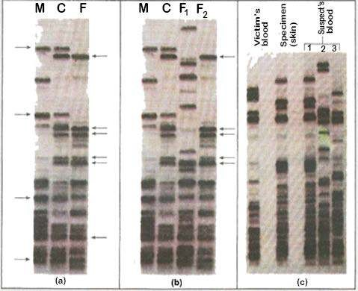

*Fig 23.7(a) Comparison of a child’s DNA (b) DNA ingerprints as evidence for paternity. (c) DNA Test - a powerful tool of ingerprint (c) with his parent’s DNA forensic science.*

*fringerpints (Mand F),*

##### Gene Sequencing

In the late 1970s, methods were developed that allowed the nucleotide sequence of any puriied DNA fragement to be determined simply and quickly. The main principle of these methods is :

1. To generate pieces of DNA of diferent sizes all starting from the same point and ending at diferent points.
2. Separation of these diferent pieces of DNA on agarose gel.
3. Reading of sequence from the gel.

For generation of diferent sized DNA fragments, two methods arc generally used. One is Sanger’s,method in which dideoxyribonucleoside triphosphates arc used to terminate DNA synthesis at diferent sites. The other method is known as Maxam-Giibcrt method in which DNA threads are chemically cut into pieces of diferent sizes

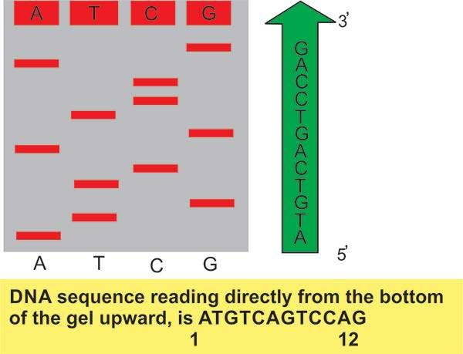

*Fig 23.8 The enzymatic or dideoxy method of sequencing DNA*

Fig 23.8 shows typical gel obtained after dideoxy method. The volume of DNA sequence information is now so large that powerful computers must be used to store and analyze it. DNA sequence is now completely automated, robotic devices mix the reagents and then load, run and read the order of the nucleotide bases from the gel. This is facilitated by using chain terminating nucleotides that are each labelled with a diferent colored luorescent dye; in this case, all four synthesis reactions can be performed in the same tube, and the products can be separated in a single lane of a gel. A detector positioned near the bottom of the gel reads and records the color of luorescent label on each band as it passes through a laser beam. A computer then reads and stores this nucleotide sequence.

Owing to the automation of DNA sequencing, the genomes of many organisms have been sequenced. These include plant chloroplasts and animal mitochondria, large number of bacteria, many of the yeasts, a nematode worm. *Drosophila*, the model plant *Arabidopsis*, the mouse and human. Researchers have also deduced the complete DNA sequence of a variety of human pathogens.

### THE HUMAN GENOME PROJECT

The human genome project is massive efort originally founded by the U.S. government and now increasingly by U.S. pharmaceutical companies to map the human chromosomes. Many non-proit and for proit biochemical laboratories around the world are now involved in the project which has two primary goals.

*Animation 23.3: Human Genome Project Source & Credit: CRDD*

The irst goal is to construct a genetic map of the human genome. The aim is to show the sequence of genes along the length of each type of chromosome, such as depicted for the X chromosome in Fig 23.9. When the DNA sequence of human chromosome no. 22, one of the smallest human chromosomes, was completed in 19.99, it became possible for the irst time to see exactly how genes are arranged along an entire vertebrate chromosome. With the publication of the entire human genome in 2001, the genetic landscape of all human chromosomes suddenly came into sharp focus. The sheer quantity of information provided by the human genome project is unprecedented in biology. The human genome is 25 times larger than any other genome sequenced so far.

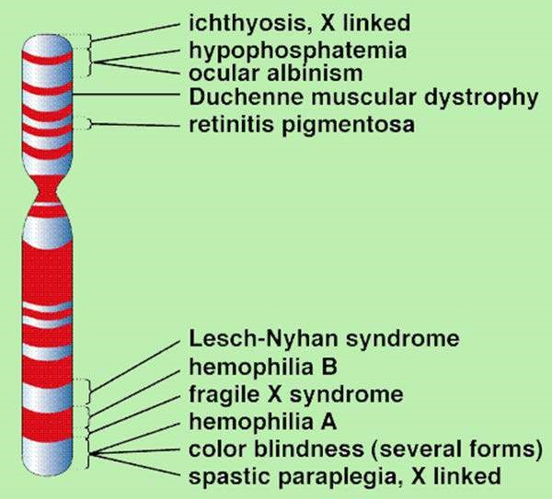

*Fig 23.9 Genetic map of X chromosome*

The map for each chromosome is presently incomplete, and in many instances scientists rely on the placement of RFLPs. These sites eventually allow scientist to pinpoint disease causing genes because a particular RFLP and a defective gene are often inherited together. For example it is known that persons with Huntington disease have a unique site where a restriction enzyme cuts DNA. The test for Huntington disease relies on this diference from the normal.

The second goal is to construct a base sequence map. There are three billion base pairs in the human genome and it is estimated it cohld take an encyclopaedia of 200 volumes, each with 1000 pages, to list all of these. Yet this goal has been reached and all the chromosomes have been sequenced.

### BIOTECHNOLOGY PRODUCTS

Today bacteria, plants and animals are genetically engineered to produce biotechnology products. Organisms that have a foreign gene inserted into them are called **transgenic organisms.**

#### Transgenic Bacteria

Recombinant DNA technology is used to produce bacteria that reproduce in large vats called **bioreactors**. If the foreign gene is replicated and actively expressed, a large amount of protein product can be obtained. Biotechnology products produced by bacteria, such as insulin, human growth hormone, tissue plasminogen activator, haemophilia factor Vm, and hepatitis B vaccine are now in the market.

Transgenic bacteria have been produced to promote health of plants for example, bacteria that normally live on plants and encourage the formation of ice crystals have been changed from frost - plus to frost - minus bacteria. Also, a bacterium that normally colonizes the roots of com plants has now been endowed with genes (from another bacterium) that code for an insect toxin. The toxin protects the roots from insects. Bacteria can be selected for their ability to degrade a particular substance and then this ability can be enhanced by genetic engineering. For instance, naturally occurring bacteria may be engineered to do an even better job of cleaning up beaches after oil spills.

Industry has found that bacteria can be used as bioilters to prevent airborne chemical pollutants from being vented into the air. They can also remove sulfur from coal before it is burned and help to clean up toxic waste dumps. One such strain was given genes that allowed it to clean up levels of toxins that would have killed other strains. Further, these bacteria were given “suicide” genes that caused them to self-destruct when the job had been accomplished.

Organic chemicals are often synthesized by having catalysts act on precursor molecules or by using bacteria to carry out the synthesis. Today, it is possible to go one step further and to manipulate the genes that code for these enzymes. For instance, biochemists discovered a strain of bacteria that is specially good at producing phenylalanine; an organic chemical needed to make aspartame, the dipeptide sweetener better known as Nutrasweet. They isolated, altered and formed a vector for the appropriate genes so that various bacteria could be genetically engineered to produce pucnylaianine. Many major mining companies already use bacteria to obtain various metals. Genetic engineering may enhance the ability of bacteria to extract copper, uranium and gold from low grade sources. Some mining companies are testing genetically engineered organisms that have improved bioleaching capabilities.

*Animation 23.4: Transgenic Bectria*

*Source & Credit: 33rd Square*

#### Transgenic Plants

Techniques have been developed to introduce foreign genes into immature plant embryos, or into plant cells that have had the cell wall removed and are called **protoplasts.** It is possible to treat protoplasts with an electric current while they are suspended in a liquid containing foreign DNA. The electric current makes tiny, selfscaling holes in the plasma membrane through which genetic material can enter. Then a protoplast will develop into a complete plant. Foreign genes transferred to cotton, com and potato strains have made these plants resistant to pests because their cells now produce an insect’toxin. Similarly, soybeans have been made resistant to a common herbicide. Some corn and cotton plants are both pest and herbicide resistant. In 1999 these transgenic crops were planted on more than 70 million acres worldwide and the acreage is expected to triple in about ive years. Improvements still to come for are increased protein or starch content and modiied oil or amino acid composition.

*Animation 23.5:Transgenic Plants*

*Source & Credit: Wikipedia*

Agribusiness companies also are in the process of developing transgenic versions of wheat and rice in addition to com. This is considered an absolute necessity if the 2020 global demand for rice, wheat and com is to be met. World grain harvests have continued to rise since the 1960s when special high-yield hybrid plants were developed during the so called green revolution. But the per capita production has now lattened out because of continued population growth. The hope is that genetic engineering will allow fanners to surpass the yield barrier. Perhaps, the stomata, the pore-like openings in the leaves, could be altered to boost carbon dioxide intake or cut down water loss. Another possible goal is to increase the eiciency of the enzyme Rubisco which captures C02 in most plants. A team of Japanese scientists are attempting to introduce the C4 cycle into the rice. Plants that utilize the C4 cycle avoid the ineiciency of carboxylase by using a diferent means of capturing C02. Unlike the single gene transfers that have been done so far, these modiications would require a thorough re-engineering of plant cells. Single gene transfers will cause plants to produce various products. A weed called mouse-eared cress has been engineered to produce a biodegradable plastic (polyhydroxy-butyrate) in cell granules.

Plants are being engineered to produce human hormones, clotting factors, and antibodies in their seeds. One type of antibody made by com can deliver radio isotopes to tumor cells, and another made by soybeans can be used as treatment for genital herpes. Plant-made antibodies are inexpensive and there is little worry about contamination with pathogens that could infect people. Clinical trials have begun.

#### Transgenic Animals

Techniques have been developed to insert genes into the eggs of animals. It is possible to micro eggs by hand, but another method uses vortex mixing. The eggs and silicon - carbide needles, and the needles make DNA can enter. When these eggs are fertilized, the resulting ofspring are transgenic animals. Using this technique many types of animal eggs have taken up the gene for bovine growth hormone. The procedure has been used to produce larger ishes’, cows, pigs, rabbits and sheep. Genetically engineered ishes are now being kept in ponds that ofer no escape to the wild because there is much concern that they will upset or destroy natural ecosystems.

Gene pharming, the’ use of transgenic farm animals to produce pharmaceuticals is being pursued by a number of irms. Genes that code for therapeutic, and diagnostic proteins are incorporated into the animal’s DNA, and the proteins appear in the animal’s milk. There are plans to produce drugs for the treatment of cystic ibrosis, cancer, blood diseases and other disorders. Antithrombin III, for preventing blood clot during surgery, is currently being produced by a herd of goats, and clinical trials have begun. Figure 23.10 out lines the procedure of producing transgenic mammals. DNA containing the gene of interest is injected into donor eggs. Following in vitro fertilization, the zygotes are placed in host females where they develop. After female ofspring mature, the product is secreted in the milk. The scientists of United States Department

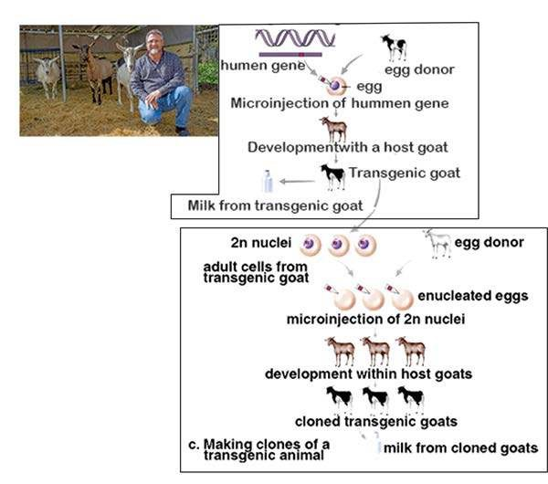

*(*

*a) This goat is genetically engineered to produce*

*antithrobin III , which is secreted in her milk*

*(*

*b) The procedure to produce a*

*transgenic animal.*

*(*

*c) The procedure to clone a*

*transgenic animal*

of Agriculture have been able to genetically engineer mice to produce human growth hormone in their urine instead of in milk. They expect to be able to use the same technique on larger animals. Urine is a preferable vehicle for a biotechnology product than milk because all animals in a herd urinate - only females produce milk; animals start to urinate at birth - females don’t produce milk until maturity; and its easier to extract proteins from urine than from milk.

#### Cloning of Transgenic Animals

Imagine that an animal has been genetically engineered to produce a biotechnology product. What would be the best possible method of getting identical copies of the animals? Asexual reproduction through cloning the animal would be the preferred procedure to use. Cloning is a form of asexual reproduction because it requires only the genes of that one animal. For many years it was believed that adult vertebrate animals could not be cloned. Although each cell contains a copy of all the genes certain genes are turned of in mature specialized cells. Diferent genes are expressed in muscle cells, which contract, compared to nerve cells, which conduct nerve impulses and to glandular cells, which secrete. Cloning of an adult vertebrate requires that all genes of an adult cells be turned on again if development is to proceed normally. It had long been thought this would be impossible. In 1997, scientists at the Roslin Institute in Scotland announced that they achieved this feat and had produced a cloned sheep called Dolly.

Since then calves and goats have been cloned. Figure 23.10 shows that after enucleated eggs have been injected with 2n nuclei of adult cells, they can be coaxed to begin development. The ofspring have the genotype and phenotype of the adult that donated the nuclei; therefore, the adult has been cloned. In the procedure that produced cloned mice, the 2n nuclei were taken from cumulus cells. Cumulus cells are those that cling to an egg after ovulation occurs. A specially prepared chemical bath was used to stimulate the eggs to divide and begin development. Now that scientists have a method to clone mammals, this procedure will undoubtedly be used routinely. In the United States, a presidential order prohibits the cloning of humans. But certain other countries are experimenting with the possibility.

### GENE THERAPY

Gene therapy is the insertion of genetic material into human cells for the treatment of a disorder. It includes procedures that give a patient healthy genes to make up for faulty genes and also includes the use of genes to treat various other human illnesses such as cancer and cardiovascular diseases.

*Animation 23.6: Gene Therapy*

*Source & Credit: Ethris*

There are two main methods used for gene therapy Ex-vivo and in vivo. Ex- vivo gene therapy is shown in Fig. 23.11. in which children in the severe combined immunodeiciency syndrome (SCID) is treated. These children lack an enzyme adenosine deaminase (ADA) that is involved in the maturation of T and B cells and, therefore, they are subjected to life threatening infections. Bone marrow stem cells are removed from the blood and infected with a retrovirus (RNA virus) that carries a normal gene for the enzyme then the cells are returned to the patient. Bone marrow stem cells are preferred for this procedure, because they divide to produce more cells with same genes. Patients who have undergone this procedure do have a signiicant improvement in their immune function that is associated with a sustained rise in the level of ADA enzyme activity in the blood

Among the many gene therapy trials, one is for the treatment of familial hypercholesterolemia a condition that develops when liver cells lack a receptor for removing cholesterol from the blood. The high levels of blood cholesterol make the patient subject to fatal heart attacks at a young age. In a newly developed procedure, a small portion of the liver is surgically excised and infected with a retrovirus containing a normal gene for the receptor. Several patients have experienced a lowering of serum cholesterol levels following this procedure.

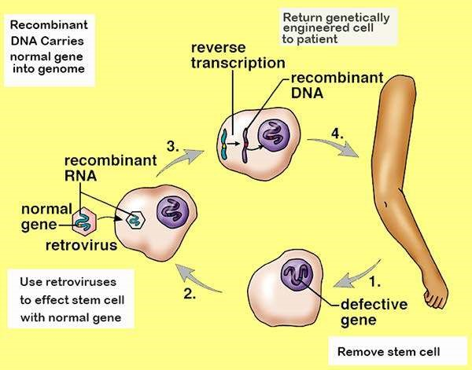

*Fig 23.11 Ex vivo gene therapy in human*

Cystic ibrosis patients lack a gene that codes for trans-membrane carrier of the chloride ion. Patients often die due to numerous infections of the respiratory tract. And in vivo method of treatment is being tried. Liposomes-microscopic vesicles that spontaneously form when lipoproteins are put into a solution, have been coated with the gene needed to cure cystic ibrosis. Then the solution is sprayed into patient’s nostrils. Due to limited gene transfer, this methodology has not as yet been successful. Gene therapy is also being done to cancer patients, which makes them more tolerant of chemotherapy. In clinical trials researchers have given genes to cancer patient that either make healthy cells more tolerant of chemotherapy or make tumors more vulnerable to it. Once the bone marrow stem cells were protected it was possible to increase the level of chemotherapy to kill the cancer cells.

During coronary artery angioplasty, a balloon catheter is sometimes used to open up a closed artery. Unfortunately, the artery has a tendency to close up once again. But investigators have come up with a new procedure. The balloon is coated with a plasmid that contains a gene for vascular endothelial growth factor. The expression of the gene, which promotes the proliferation of blood vessels to bypass the obstructed area, has been observed in at least one patient.

Perhaps it will be possible to used in vivo therapy to cure hemophilia, diabetes. Parkinson disease, or AIDS. To treat hemophilia, patients could get regular doses of cells that contain normal clotting-factor genes or such cells could be placed in organoids, artiicial organs that can be implanted in the abdominal cavity. To cure Parkinson’s disease, dopamine-producing cells could be grafted directly into the brain.

### TISSUE CULTURE

Tissue culture is the growth of a tissue in an artiicial liquid culture medium. German botanist Gottlieb Haberlandt said in 1902 that plant cells are totipotent - each cell has the full genetic potential of the organism - and, therefore, a single cell could become a complete plant. But it wasn’t until 1958 that Cornell botanist F.C. Steward grew a complete carrot plant from a tiny piece of phloem. He provided the cells with sugars, minerals and vitamins, but he also added coconut milk. (Later it was discovered that coconut milk contains the plant hormone cytokinin). When the cultured cells began dividing, they produced a callus, an undiferentiated group of cells.

Then the callus diferentiated into shoot and roots and developed into a complete plant.

Tissue culture techniques have by now led to micropropagation, a commercial method of producing thousands, even millions of identical seedlings in a limited amount of space. One favourite method to accomplish micro propagation is by meristem culture. If the correct proportions of auxins and cytokinin are added to a liquid medium, many new shoots will develop from a single shoot tip. When these are removed more shoots form. Since the shoots are genetically identical the adult plants that develop from them are called clonal plants, all having the same traits. Another advantage of meristem culture is that meristem, unlike other portions of a plant, is virus free, therefore the plants produced are also virus free (The presence of plant viruses weakens plants and makes them less productive).

Because plants are totipotent, it should be possible to grow an entire plant from a single cell. This, too has been done. Enzymes are used to digest the cell walls of a small piece of tissue, usually mesophyll tissue, from a leaf, and the result is naked cells without walls, called protoplasts. The protoplasts regenerate a new cell wall and begin to divide. These clumps of cells can be manipulated to produce somatic embiyos. Somatic embryos that are encapsulated in a protective hydrated gel (and sometimes called artiicial seeds) can be shipped everywhere. It is possible to produce millions of somatic embryos at once in large tanks called bioreactors. This is done for certain vegetables like tomato, celery, asparagus and for ornamental plants like lilies, begonias and African violets. A mature plant develops from each somatic embryo. Plants generated from the somatic embryo vary somewhat because of mutations that arise; dunng the production process. These so called somaclonal variations are another way to produce new plants with desired traits.

Anther culture is a technique in which mature anthers are cultured in a medium containing vitamins and growth regulators. The haploid tube cells with in the pollen grains divide, producing proembryos consisting of as many as 20 to 40 cells. Finally the pollen grains rupture releasing haploid embryos. The experimenter can now generate a haploid plant, or chemical agent can be added that encourages chromosomal doubling. After chromosomal doubling the resulting plants are diploid but homozygous for all their alleles. Anther culture is a direct way to produce plants that express recessive alleles. If the recessive alleles govern desirable traits, the plants have these traits.

The culturing of plant tissues has led to a technique called cell suspension culture. Rapidly growing cultures are cut into small pieces and shaken in’a liquid nutrient medium so that single cells or small clumps of cells break of and form a suspension. These cells will produce the same chemicals as the entire plant. For example cell suspension cultures of Cinchona ledgeriana produce quinine and those of Digitalis lanata produce digitoxin. Scientists envision that it will be possible to maintain cell suspension cultures in bioreactors for the purpose of producing chemicals used in the production of drugs, cosmetics and agricultural chemicals. If so, it will no longer be necessary to farm plants for the purpose of acquiring the chemicals they produce.

#### Genetic Engineering of Plants

Traditionally, hybridization, the crossing of diferent varieties of plants or even species, was used to produce plants with desirable traits. Hybridization, followed by vegetative propagation of the mature plants, generated a large number of identical plants with these traits. Today it is possible to directly alter the genes of organisms. Transgenic plants carry a foreign gene that has been introduced into their cells so that they have new and diferent traits.

Since a whole plant will grow from a protoplast, it is necessary only to place the foreign gene into a living- protoplast. A foreign gene isolated from any type of organism is placed in the tissue culture medium.

High-voltage electric pulses can then be used to create pores in the plasma membrane so that the DNA enters. In one of the irst procedures carried out, a gene for the production of the irely enzyme luciferase was inserted into tobacco protoplast and the adult plants glowed when sprayed with the substrate luciferin (Fig. 23.12).

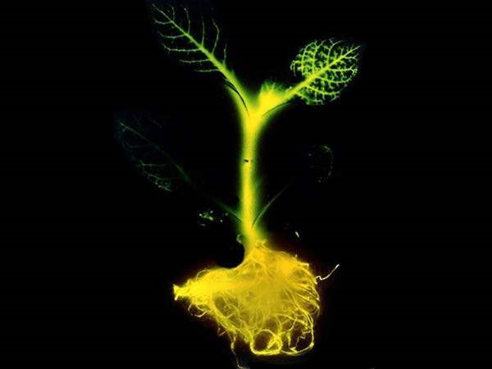

*Fig 23.12 Tabacoo plant containing Luciferase gene glows when sprayed with luciferin*

Unfortunately, the regeneration of cereal grains from protoplasts has been diicult. Com and wheat protoplasts produce infertile plants. As a result, other methods are used to introduce DNA into plant cells with intact cell wall. In one technique, foreign DNA is inserted into the plasmid of the bacterium *Agrobacterium,* which normally infects the plant cells. A plasmid can be used to produce’ recombinant DNA. Recombinant DNA contains genes from diferent sources, namely those of plasmids and the foreign genes of interest. When the bacterium infects the plant the recombinant plasmid is introduced into the plant cells (Fig.23.12). In 1987, John C Sanford and Theodore M. Klein of Cornell University developed another method of introducing DNA into a plant tissue culture callus.

They constructed a device, called the particle gun, that bombards a callus with DNA coated microscopic metal particles. Then genetically altered somatic embryos develop into genetically adult plants. Many plants including com and wheat varieties have been genetically engineered by this method.

#### Agricultural Plants with Improved Traits

Cotton, com, potato and soybean plants have been engineered to be resistant to either insect predation or herbicides that are judged to be environmentally safe. Some com and cotton plants have been produced that are both insect and herbicide resistant. In 1999, transgenic crops were planted on more that 70 million acres world wide and the acreage is expected to triple in about ive years. If crops are resistant to a broadspectrum herbicide and weeds are not then the herbicide can be used to kill the weeds. When herbicide resistant plants were planted weeds were easily controlled, less tillage was needed and soil erosion was minimized.

One aim of genetic engineering is to produce crops that have the improved agricultural or food quality traits such as those listed in the table below:

|  |  |
| --- | --- |
| **Improved Agricultural Traits** |  |
| Herbicide resistant | Wheat, rice, sugar beets, canola |
| Salt tolerant | Cereals, rice, sugarcane |
| Drought tolerant | Cereals, rice, sugarcane |
| Cold tolerant | Cereals, rice, sugarcane |
| Improved yield | Cereals, rice, com, cotton |
| Modiied wood pulp | Trees |
| **Improved Food Quality Traits** |  |
| Fatty acid / oil content | Com, soybeans |
| Protein / starch content | Cereals, potatoes, soybeans, rice, com |
| Amino acid content | Com, soybean |
| Disease protected | Wheat, com, potatoes |

Production of salt tolerant plants had been a dream of genetic engineer. Recently salt - tolerant *Arabidopsis* has been produced. For this the scientists irst identiied a gene coding for a channel protein that transports Na+ along with H+ across a vacuole membrane. Isolating Na+ in a vacuole prevents it from interfering with plant metabolism. Then, the scientists cloned the gene and used it to genetically engineer plants that overproduce the channel protein. The modiied plants thrived when watered with a salty solution. Irrigation, even into fresh water, inevitably leads to a salinization of soil that reduces crop yields. Today, crop production is limited by efects of salinization at about 50% of irrigated levels. The next step to solve this problem is to produce salt - tolerant crops. It is believed that the production not only of salt - but also drought and cold tolerant crops will reduce the need for added farm acreage by increasing agricultural yields that will provide enough food for a world population that is expected to nearly double by 2050.

Some progress has also been made to increase the food quality of crops. Soybeans have been developed that mainly produce the monounsaturated fatty acid, oleic acid, a change that may improve human health. These altered plants also produce vernolic acid and ricinoleic acid, derivatives of oleic acid that can be used as hardenes in paints and plastics. The necessary genes were derived from Vemonia and castor bean seeds and were transferred into the soybean genomes.

Genetic Engineering is also expected to increase productivity. To that end, stomata might be altered to boost carbon dioxide intake or cut down water loss. The eiciency of the enzyme RuBP carboxylase which captures C02 in plants could be improved. A team of Japanese scientists is working on introduc ing the C4 photosynthetic cycle into rice. Unlike C3 plants, C4 plants do well in hot dry weather. These modiications would require a more complete engineering of plant cells than the single gene transfers’ that have been done so far.

#### Production of Products

Single gene transfers have allowed plants to produce various products such as human hormones, clotting factors and antibodies. One type of antibody made by com can deliver radioisotopes to tumor cells and another made by soybeans can be used as treatment for genital herpes clinical triats have begun.

Recently, a group of scientists from Biosource Technologies located in Vacaville, California reported that they have been able to use the tobacco mosaic virus as a vector to introduce a human gene into adult tobacco plants in the ield. Note that this technology by passes the need for tissue culture completely. Tens of grams of a-galactosidase, an enzyme that can be used to treat a human lysosome storage disease, were harvested per acre of tobacco plants. And it only took thirty days to get tobacco plants to produce antigens to treat non-Hodgkin’s lymphoma after being sprayed with a genetically engineered vims.

### EXERCISE

**Q.1. Fill in the blanks.**

|  |
| --- |
| test tube.   1. ___________free living organisms in the environment that have had a foreign gene inserted into them. 2. __________known sequences of DNA that are used to ind complementary DNA strands; can be used diagnostically to determine the presence of particular gene. 3. ___________production of many identical copies of a gene. 4. ___________self duplicating ring of accessory DNA in the cytoplasm of bacteria. |

1. The use of polymerase chain reaction (PCR) creates a _________ of copies in a laboratory

**Q.3. Short questions.**

1. How and why transgenic animals that secrete a product are often cloned?
2. Explain two primary goals of Human Genome Project. What are possible beneits of the project?
3. Explain and give examples of ex vivo and in vivo gene therapies in humans?

**Q.4. Extensive questions.**

1. What is the methodology for producing recombinant DNA to be used in gene cloning?
2. What is a genomic library, how would you locate a gene^of.interest in the library?
3. What is the polymerase chain reaction (PCR), amftow is it carried out to produce multiple copies of a DNA segment?
4. What is DNA inger printing, a process that utilizes the entire genome?
5. For what purpose have bacteria, plants and animals been genetically altered?-

CHAPTER

# 24

## Evolution

*Animation 24: Evolution*

[*Source & Credit: Wikispaces*](http://anatomyeshs.wikispaces.com/Ch.16+Respiratory+System)

Questions of origins of earth and life on it have been on the minds of humans since prehistoric times. Many of us are also concerned with questions of origin: How old is the planet earth? How long has life been on earth? How did life arise on earth? How did a certain animal species come into existence? Answers for these questions come from scientiic inquiry. In this chapter we will study some aspects of organic evolution. Evolution refers to the processes that have transformed life on earth from its earliest forms to the vast diversity that we observe today. Evolutionary change is based mainly on the interactions between populations of organisms and their environments. Whenever we say or hear the word evolution, name of Darwin comes in our mind immediately. In fact, he was the irst person who argued from evidence that species were not specially created in their present forms, rather they had evolved from ancestral species. He also proposed a mechanism for evolution, which he termed Natural Selection.

### CONCEPT OF EVOLUTION VS SPECIAL CREATION

In a bid to explain the cause of diversity of life and interrelationship among living organisms, two schools of thought emerged in the earlier 19th century. Creationists believed in the Theory of Special Creation, whereas evolutionists believed in the Theory of Natural Selection. According to the theory of special creation, all living things came into existence in their present forms especially and speciically created by Nature. Among the scientists who believed in divine creation was Carolus Linnaeus (1707-1778).

*Animation 24.1: Evolution*

*Source & Credit:* [*wilegif*](http://https://wifflegif.com/tags/2653-evolution-gifs?page=15)

|  |  |  |  |
| --- | --- | --- | --- |
| ( | **Scientist’s Name** | **Life Span** | **Achievements** |
| Linnaeus  Lamarck | 1707-1778  1744-1829 | Sought and found order in the diversity of life. He introduced binomial nomenclature for naming species.  Published his theory of evolution. |
| Malthus | 1766-1834 | Published Essay on the  “Principle of Population”. |
| Cuvier | 1769-1832 | Contributed much to the science of Palaeontology and explained Earth’s history by catastrophism. |
| Lyell | 1797-1875 | Published Principles of Geology. |
| Darwin | 1809-1882 | 1. Voyage of the Beagle 2. Began his notebooks on the origin of species. 3. Wrote his essay on the origin of species. |
| Mendel | 1822-1884 | Published papers on inheritance. |
| Wallace | 1823-1913 | Sent his theory to Darwin. |
| The idea that organisms might evolve through time, with one type of organism giving rise to another type of organism, is an ancient one, existing from the days of Aristotle. Aristotle recognized that organisms ranged from relatively simple to very complex structures. However, the present day concept of evolution is based on a known history Table 24.1).  Let us now discuss some details of the work done by these scientists. As you know, Carolus Linnaeus in the eighteenth century classiied organisms. He grouped similar species in the same genus and similar genera in one family. But as a natural theologian, he believed that species were permanent creations. A century later, the taxonomic system of Linnaeus became a focal point in Darwin’s arguments for evolution. | | |

### EVOLUTION FROM PROKARYOTES TO EUKARYOTES

One of the speculations trying to explain the origin of life is that it may have begun deep in the oceans, in underwater hot springs called hydrothermal vents. These vents could have supplied the energy and raw materials (for the origin and survival of early life forms. A group of bacteria, called archaeobactiria-that tolerate temperatures up to 120°C and seem to have undergone less evolutionary ihange than any other living species supports this vent hypothesis.

The nutrients produced in the primitive environment would have limited early life., If life were to continue, another source of nutrients was needed. Photosynthesis, probably freed living organisms from a dwindling supply of nutrients. The irst photosynthetic organisms probably used hydrogen sulide as a source of hydrogen for reducing carbon dioxide to sugars. Later, water served this same purpose, and oxygen liberated by photosynthetic reactions began to accumulate in the atmosphere. Earth and its atmosphere slowly began to change.

Ozone in the upper atmosphere began to ilter ultraviolet radiation from the sun, the reducing atmosphere slowly became an oxidizing atmosphere, and at least some living organisms began to utilize oxygen. About 420 million years ago, enough protective ozone had built up to make life on land possible. Ironically, the change from a reducing atmosphere to an oxidizing atmosphere also meant that life could no longer arise abiotically .The irst cells were most likely very simple prokaryotic forms. The prokaryotes may have arisen more than 3.5 billion years ago. Eukaryotes are thought to have irst appeared about 1.5 billion years ago. The eukaryotic cell might have evolved when a large anaerobic (living without oxygen) amoeboid prokaryote ingested small aerobic (living with oxygen) bacteria and stabilized them instead of digesting them. This idea is known as the endosymbiont hypothesis (Fig.24.la) and was irst proposed by Lynn Margulis. According to this hypothesis, the aerobic bacteria developed into mitochondria, which are the sites of aerobic respiration and most energy conversion in eukaryotic cells. The possession of these mitochondria like endosymbionts brought the advantage of aerobic respiration to the host.

Flagella (whiplike structures) may have arisen through the ingestion of prokaryotes similar to spiral-shaped bacteria called spirochetes. Ingestion of prokaryotes that resembled present-day cyanobacteria could have led to the endosymbiotic development of chloroplasts in plants.

Another hypothesis for the evolution of eukaryotic cells proposes that the prokaryotic cell membrane invaginated (folded inward) to enclose copies of its genetic material (Fig. 24.1b). This invagination resulted in the formation of several double membranebound entities (organelles) in a single cell. These entities could then have evolved into the eukaryotic mitochondrion, nucleus, chloroplast etc.

Whatever the exact mechanism for the evolution of the eukaryotic cell might be, the formation of the eukaryotic cell led to a dramatic increase in the complexity and diversity of life-forms on the earth. At irst, these newly formed eukaryotic cells existed only by themselves. Later, however, some probably evolved into multicellular organisms in which various cells became specialized into tissues, which, in turn, formed organs for many diferent functions. These multicellular forms then adapted themselves to life in a great variety of environments.

*Animation 24.2: Evolution from Prokaryots to Euokaryot Source & Credit:* [*Ameoba Sisters*](http://http://www.amoebasisters.com/)

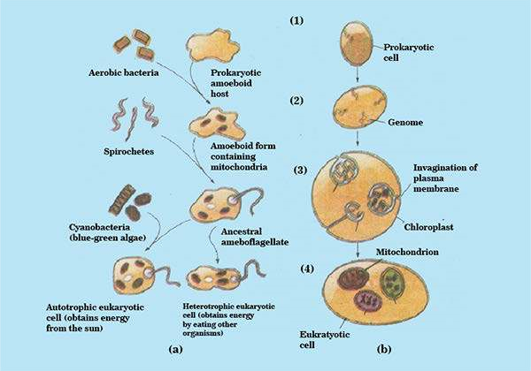

*Figure 24.1: Two hypothesies on the evolution of the eukaryotic cell. (a) Endosymbiont hypothesis, (b) Membrane invagination hypothesis. (1) A prokaryotic cell (2) Duplicates its genetic material (genome) (3) The plasma membrane then invaginates to form double membrane-bound organelles, and the individual genomes separate from each other (4) The nuclear genome eventually enlarges, while the other organelle genomes lose many of their genes, resulting in a eukaryotic cell.*

#### INHERITANCE OF ACQUIRED CHARACTERISTICS

Toward the end of the eighteenth century, several naturalists suggested that life had evolved along with the evolution of earth. But only one of Darwin’s predecessors developed a comprehensive model that attempted to explain how life evolves. Jean Baptiste Lamarck (1744-1829) published his theory of evolution in 1809, the year Darwin was bom. Lamarck was in-charge of invertebrate collection at the Natural History Museum in Paris. He presented a mechanism to explain how speciic adaptations evolve. Lamarck argued that those parts of the body used extensively to cope with the environment become larger and stronger, while those that are not used deteriorate.

Among the examples Lamarck cited were the blacksmith developing a bigger bicep in the arm that works the hammer and girafe stretching its neck to new lengths in pursuit of leaves to eat. The second idea Lamarck adopted, was called the inheritance of acquired characteristics. In this concept of heredity, the modiications an organism acquires during its lifetime can be passed along to its ofspring’e.g. the long neck of the girafe, Lamarck reasoned, evolved gradually as the cumulative product of a great many generations of ancestors stretching higher and higher. However, now we know that acquired characteristics cannot be inherited.

##### Charles Darwin

Charles Darwin was born in Shrewsbury, in Western England, in 1809. He joined ’ the expedition on Beagle to South American coastline. He observed and collected thousands of specimens of diverse fauna and lora of South America. He noticed that the fauna and lora of the diferent regions of the continent had a deinite South American stamp, very distinct from the life forms of Europe. Furthermore, the South American fossils that Darwin found, though clearly diferent from modem species, were distinctly South American in their resemblance to the living plants and animals of that continent.

A particularly puzzling case of geographical distribution was the fauna of the Galapagos islands. Most of the animal species on the Galapagos live nowhere else in the world, although they resemble species living on the South American mainland. It was as though the islands were colonized by plants and animals that strayed from the South American mainland and then diversiied on the diferent islands. Among the birds Darwin collected on the Galapagos were 13 types of inches that, although quite similar, seemed to be diferent species. Some were unique to individual islands, while other species were distributed on two or more islands that were close together.

After returning to Great Britain in 1836, Darwin perceived the origin of new species and adaptations as closely related processes. A new species would arise from an ancestral form by the gradual accumulation of adaptations to diferent environments, separated from original habitat by geographical barriers. Over many generations, the two populations could become dissimilar enough to be designated as separate species.

This is apparently what happened to the***Galapagos***inches.

By the early 1840s, Darwin had worked out the major features of his theory of natural selection as the mechanism of evolution. In 1844, Darwin wrote a long essay on the origin of species and natural selection.

But before it could be published Alfred Wallace, a young naturalist working in the East Indies developed a theory of natural selection essentially identical to Darwin’s. Wallace’s paper, along with extracts from Darwin’s unpublished 1844 essay, were presented to the Linnaean Society of London on July 1, 1858. Darwin quickly inished **The Origin of Species** and published it the next year. In this book Darwin developed two main points:

1. **Descent with Modiication :**

Darwin believed in perceived unity in life, with all organisms related through descent from some common ancestor that lived in the remote past. In the Darwinian view, the history of life is like a tree, with multiple branching and rebranching from a common trunk all the way to the tips of the living twigs, symbolic of the current diversity of organisms. At each fork of the evolutionary tree is an ancestor common to all lines of evolution branching from that fork.

1. **Natural Selection and Adaptation :**

Darwin suggested that populations of individual species become better adapted to their local environments through natural selection. Darwin’s theory of natural selection was based on the following observations.

1. Production of more individuals than the environment can support, leads to a struggle for existence among individuals of a population, with only a fraction of ofspring surviving each generation.
2. Survival in the struggle for existence is not random,, but depends in part on the hereditary constitution of the surviving individuals. Those individuals whose inherited characteristics it them best to their environment are likely to leave more ofspring than the less it individuals.
3. This unequal ability of individuals to survive and reproduce will lead to a gradual change in a population, with favourable characteristics accumulating over the generations thus leading to the evolution of a new species.

##### Neo-Darwinism - The modern evolutionary synthesis

The **Origin of Species** convinced most biologists that species are **products of** evolution. An important turning point for evolutionary theory was the birth of population genetics, which emphasizes the extensive genetic variation within populations and recognizes the importance of quantitative characters. With progress in population genetics in the 1930s, Mendelism and Darwinism were reconciled, and the genetic basis of variation and natural selection was worked out. Thus, a comprehensive theory of evolution that became known as the **modern synthesis or Neo-Darwinism** was developed in the early 1940s. It is called a synthesis because it integrated discoveries and idea« from many diferent ields, including paleontology, taxonomy, biogeography, of course, population genetics. **Evidences of Evolution**

Evolution leaves observable signs. Darwin’s theory of evolution was mainly based on the evidence from the geographical distribution of species and from the fossil record. However, there have been many evidences as biology progressed. New discoveries, continue to validate the evolutionary view of life. Let us discuss now some of the evidences.

Biogeography :It was the geographical distribution of species— biogeography— that irst suggested the idea of evolution to Darwin. Islands have many species of plants and animals that are endemic but closely related to species of the nearest mainland or neighboring island. Consider armadillos, the armored mammals that live only in America. The evolutionary view of biogeography predicts that contemporary armadillos are modiied descendants of earlier species that occupied these continents, and the fossil record conirms that such ancestors existed.

The Fossil Record : The succession of fossil forms is a strong evidence in favour of evolution. It provides a visual record in a complete series showing the evolution of an organism. For instance, evidence from biochemistry, molecular biology, and cell biology places prokaryotes as the ancestors of all life, and predicts that bacteria should precede all eukaryotic life in the fossil record. Indeed, the oldest known fossils are prokaryotes.

Another example is the chronological appearance of the diferent classes of vertebrate animals in the fossil record. Fossil ishes, the earliest vertebrates, with amphibians next, followed by reptiles, then mammals and birds. This sequence is consistent with the history of vertebrate descent. The evolution of horse provides an example of such a history.

Fossils are either the actual remains or - traces of organisms that lived in ancient geological times. The organism may be embedded in sand, resin or ice, or an impression or cast is made of the body parts, the tissue being replaced or petriied by silica or calcium carbonate minerals. Most fossils are found in sedimentary rocks.

Comparative Anatomy : Anatomical similarities between species grouped in the same taxonomic category bring another support to the theory of the Descent with modiication. For example, the same skeletal elements make up the forelimbs of human, cats, whales, bats, and all other mammals, although these appendages have very diferent functions.

The basic similarity of these forelimbs is the consequence of mammals from a common ancestor. The amis, wings, lippers, and forelegs of diferent mammals are variations on a common anatomical theme that has been modiied for divergent functions. Similarity in characteristics resulting from common ancestry is known as homology, and such anatomical signs of evolution are called homologous structures. Comparative anatomy supports that evolution is a remodeling process in which ancestral structures that functioned in one capacity become modiied as they tale on new functions. The lower parts of a lowering plant are homologous. They are considered to have evolved from leaves, to form sepals, petals, stamens and carpels

Homologous organs are functionally diferent but structurally alike e.g. Fore limbs of man, bat, horse, whale etc. are example of divergent evolution. Analogous organs are functionally alike but structurally diferent e.g. wings of bat, birds and insects etc. are examples of convergent evolution.

The oldest homologous structures are vestigial organs, rudimentary structures of marginal, if any, use to the organism. Vestigial organs are historical remnants of structures that had important functions in ancestors but are no longer essential presently. For instance, the skeletons of whales and some snakes retain vestiges of the pelvis and leg bones of walking ancestors, (Fig. 24.2) vermiform appendix in carnivores, ear muscles in man etc.

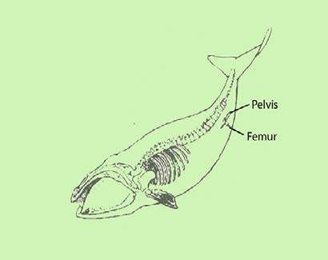

*Fig. 24.2: The whale retains pelvic and leg bones as useless vestiges*

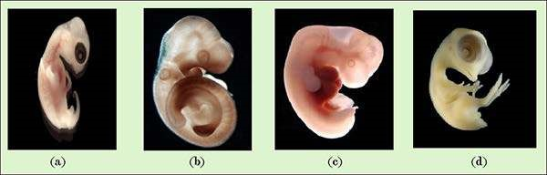

*ig. 24.3 Homologies among vertebrates are clearly evident early in development, as the photos reveal. Embryo (a) turtle, (b) mouse, (c) human, (d) chick.*

Comparative Embryology : Closely related organisms go through similar stages in their embryonic development. For example, all vertebrate embryos go through a stage in which they have gill pouches on the sides of their throats. At embryonic stage of development, similarities between