ishes, frogs, snakes, birds, humans, and all other vertebrates are much more apparent than diferences (Fig.24.3). As development progresses, the various vertebrates diverge more and more, taking on the distinctive characteristics of their classes. In ish, for example, the gill pouches develop into gills; in terrestrial vertebrates, these-embryonic structures become modiied for other functions, such as the eustachian tubes that connect the middle ear with the throat in humans.

Comparative embryology can often establish homology among structures, such as gill pouches, that become so altered in later development that their common origin would not be apparent by comparing their fully developed forms.

**Molecular Biology:** Evolutionary relationships among species are relected in their DNA and proteins—in their genes and gene products. If two species have genes and proteins with sequences of monomers that match closely, the sequences must have been copied from a common ancestor. For example, a common genetic code brings evidence that all life is related. Molecular biology has thus provided strong evidence in support of evolution as the basis for the unity and diversity of life. Similarly, taxonomically remote organisms, such as humans and bacteria, have some proteins in common. For instance, cytochrome c, a respiratory protein is found in all aerobic species. **NATURAL SELECTION AND ARTIFICIAL SELECTION**

Natural selection occurs through an interaction between the environment and the variability inherent in any population. Darwin found evidence in artiicial selection, the breeding of domesticated plants and animals. Humans have modiied other species over many generation by selecting individuals with the desired traits as breeding stock. The plants and animals we grow for food bear little resemblance to their wild ancestors. From the changes achieved by artiicial selection within a relativ ely short period of time, Darvviq postulated that natural selection operating over vast spans of time could account for the entire diversity of life. Population is a group of inter-breeding individuals belonging to a particular species and sharing a common geographic area.

Natural selection can amplify or diminish only those variations that are heritable. It is noteworthy to say that adaptations that an organism acquires by its own actions are not heritable. The speciics of natural selection are regional and timely; environmental factors vary from place to place and from time to time. An adaptation in one situation may be useless or even detrimental in other circumstances. An example of natural selection in action is the evolution of antibiotic resistance in bacteria.

#### POPULATION, GENE POOL, ALLELE AND GENOTYPE FREQUENCIES

A population is a localized group of individuals belonging to the same species. For now, we will deine a species as a group of populations that have the potential to interbreed in nature. Each species has a geographical range within which individuals are not spread out evenly, but are usually concentrated in several localized populations. A population may be isolated from others of the same species, exchanging genetic material only rarely. Such an isolation is particularly common for populations conined to widely separated islands, unconnected lakes, or mountain ranges separated by lowlands. Within a population individuals are concentrated in centers and are more likely to interbreed with members of the same population than with members of other populations. Therefore, individuals near a population center are, on average, more closely related to one another than to members of other populations.

The total aggregate of genes in a population at any one time is called the population’s gene pool. It consists of all alleles at all gene loci in all individuals of the population. For a diploid species, each locus is represented twice in the genome of an individual, who may be either homozygous or heterozygous.

*Animation 24.3: Gene Pool*

*Source & Credit:* [*S-Cool*](http://http://www.s-cool.co.uk/gcse/biology/genetic-crosses/revise-it/selective-breeding-crosses)

If all members of a population are homozygous for the same allele, that allele is said to be **ixed** in the gene pool. More often, there are two or more alleles for a gene, each having relative frequency (proportion) in the gene pool. Let us consider an example. Imagine a wildlower population with two varieties contrasting in lower color. An allele for pink lowers, which we will symbolize by A, is completely dominant over an allele for white lowers, symbolized by a. Suppose these are the only two alleles for this locus in the population. Our imaginary population has 500 plants. Twenty have white lowers because they are homozygous for the recessive allele; their genotype is aa. Of the 480 plants with pink lowers, 320 are homozygous (AA) and 160 are heterozygous (Aa). Since these are diploid organisms, there are a total of lOOOcopies of genes for lower color in the population. The dominant allele accounts for 800 of these genes (320x2 = 640 for AA plants, *Figure 24.4: The Hardy-Weinberg theorem. The genetic* plus 160x1 = 160 for An individuals). *structure of a non evolving population remains constant over*

Thus, the frequency of the A allele in *the generations. Sexual recombination alone will not alter the relative frequencies of alleles or genotypes, (p = frequency of A;* the gene pool of this population is *q = frequency of a)*

80%, or 0.8. And since there are only

two allelic forms of the gene, the a allele must have a frequency of 20%, or 0.2. Related to these allele frequencies are the frequencies of genotypes. In our model wildlower population, these frequencies are: AA=0.64 (64%) (320 out of 500 plants), Aa=0.32 (160/500), and aa = 0.04 (20/500).

##### Hardy-Weinberg Theorem

The frequencies of genotypes of non evolving populations are described by Hardy- Weinberg theorem. Hardy-Weinberg theorem is named for the two scientists who derived the principle independently in 1908. It states that the frequencies of alleles and genotypes in a population’s gene pool remain constant over the generations unless acted upon by agents other than sexual recombination. So shuling of alleles due to meiosis and random fertilization has no efect on the overall genetic structure of a population. A general formula, called the Hardy- Weinberg equation is used for calculating the frequencies of alleles and genotypes in populations at equilibrium.

For a gene locus where only two alleles occur in a population, population geneticists use the letter p to represent the frequency of one allele and the letter q to represent the frequency of the other allele. In the imaginary wildlower population, p=0.8 and <7=0.2. Note that p+q= 1; the combined frequencies of all possible alleles must account for 100% of the genes for that locus in the population. If there are only two alleles and we know the frequency of one, the frequency of other can be calculated:

Ifp + q-1, then 1-p = q, or l-q - p

When gametes combine their alleles to form zygotes, the probability of generating an AA genotype is p2. In the wildlower population, p-0.8, and p2=0.64, the probability of an A sperm fertilizing an A ovum to produce an AA zygote. The frequency of individuals homozygous for the other allele (aa) is q2, or 0.2x0.2=0.04 for the wildlower population. There are two ways in which an Aa genotype can arise, depending on which parent contributes the dominant allele. Therefore, the frequency of heterozygous individuals in the population is 2pq (2x0.8x0.2=0.32, in our example). If we have calculated the frequencies of all possible genotypes correctly, they should add up to 1:

P +2pq + q2 = 1

Frequency Frequency Frequency of AA of Aa plus aA ofaa

For our wildlowers,this is 0.64 + 0.32 + 0.04=1*

* In fact the Hardy-Weinberg equation is a binomial expansion: (p+q)2 or p2+2pq+q2

##### Factors afecting gene frequency

Many factors can alter gene frequency. Out of these ive afect the proportion of homozygotes and heterozygotes enough to produce signiicant deviations form the proportion claimed by Hardy Weinberg principle. They are relected in the table below.

**Table 24.2 Factors for evolutionary change**

|  |  |
| --- | --- |
| **Factor** | **Description** |
| Mutation | The ultimate source of all changes; individual mutations occur so rarely that mutation alone does not change allele frequency much. |
| Migration | A very potent agent of change, migration locally acts to prevent evolutionary changes by preventing populations that exchange members from diverging from one another. Emigration and immigration of members of a population, cause disturbance in the gene pool. |
| Genetic drift | It is the change in frequency of alleles at a locus that occurs by chance. In small populations, such luctuations may lead to the loss of particular alleles. This may occur in a small population when a few individual fail to reproduce and then genes are lost from the population. |
| Non-random mating | Inbreeding is the most common form; it does not alter allele frequency, but lessens the proportion of heterozyote individuals. Individuals with certain genotypes sometimes mate with one another more commonly than would be expected on a random basis. This is called non-random mating, causing the frequencies of particular genotypes to difer greatly from those predicted by the 1 lardyWeinberg principle. |
| Selection | Some individuals leave behind more progeny than others, and the rate at which they do so is afected by their inherited characteristics. This is called selection. Selection can be artiicial selection or natural selection. In artiicial selection, the breeders select for the desired characters. In natural selection, the environment plays this role, thus afecting the proportions of gene in a population. |

#### ENDANGERED SPECIES

Extinction has been the fate of most plant and animal species. It is a natural process that will continue. In recent years, however, the threat to the welfare of wild plants and animals has increased dramatically—mostly as a result of habitat destruction. Tropical rain forests, the most threatened areas on the earth, have been reduced to 44% of their original extent. In certain areas, such as Ecuador, forest coverage has been reduced by 95%. This decrease in habitat has resulted in- tens of thousands of extinctions. Accurately estimating the number of extinctions is impossible in areas like rain forests, where taxonomists have not even described most species. We are losing species -that we do not know exist and we are losing resources that could lead to new medicines, foods, and textiles, Other causes of extinction include climate change, pollution, and invasions from foreign species. Habitats other than rain forest—grasslands,’marshes, deserts, and coral reefs—are also being seriously threatened.

*Animation 24.4: Endangeres Species Source & Credit:* [*TES*](http://https://www.tes.com/lessons/vhJkujzEp-R3Ag/deciduous-forest)

An endangered species is in imminent danger of extinction throughout its range (where it lives). A threatened species is likely to become endangered in the near future. Saving species requires more than preserving a few remnant individuals. It requires a large diversity of genes within species groups to promote species survival in changing environments. This genetic diversity requires large populations of plants and animals. Preservation of endangered species depends on a multifaceted conservation plan that includes the following components:

1. A global system of national parks to protect large tracts of land and wildlife corridors that allow movement between natural areas.
2. Protected landscapes and multiple-use areas that allow controlled private activity but also retain value as a wildlife habitat.
3. Zoos and botanical gardens to save species whose extinction is imminent.

In Pakistan. Cheetah. Tiger. Asian lion. Indian rhino. Cheer pheasant. Crocodile and Gaviul have been declared extinct. While. Indus dolphin. Blackbuck, Common leopard. Great Indian bustard. Houbara bustard. White-headed duck and Marbled teal are among the animal near to extinction.

Deserts, Sub-mountianous tract and Wetlands are habitats in peril. We must protect them rapidly. Endangered species of plants have been recorded to more than 500.

*Animation 24.5: Endangeres Species*

*Source & Credit:* [*Education World*](http://http://www.educationworld.com/a_lesson/lesson310.shtml)

### EXERCISE

**Q1 Fill in the blanks.**

1. Archaebacteria can tolerate high temperature sup to____________
2. The irst eukaryote appeared about________ years ago.
3. _________ presented the theory of the origin of species by means of Natural Selection.
4. ________developed a theory of natural selection essentially identical to Darwin’s.
5. ________are considered to be the ancestors of all life.
6. A respiratory protein called__________is found in all aerobic organisms.
7. Total aggregate of genes in a population at any time is called its____________
8. Hardy Weinberg theorem describes a__________population.
9. __________ is a series of changes in the genetic composition of a population over time.
10. Level of classiication between species and family is called________.
11. Hardy Weinbeig equation is binomial expansion of________.
12. An_______species is in imminent danger of extinction throughout its range.
13. A _______ is a localized group of individuals belonging to the same species.
14. The irst photosynthetic organisms used_________as source of hydrogen for reducing carbon dioxide to sugars.
15. ______________ published an essay on The Principle of Population’.

**Q.2 Short questions.**

1. What are hydrothermal vents?
2. State Endosymbiont hypothesis.
3. Deine population genetics.
4. How does fossil record provide evidence of evolution?
5. Explain the term homology with a suitable example.
6. What are vestigial organs? Give two examples.
7. How are evolutionary relationships relected in DNA and proteins?
8. State Hardy Weinberg theorem.
9. What is the diference between endangered species and threatened species?
10. Name any ive species, declared extinct in Pakistan.

**Q.4 Extensive Questions**

1. What are the endangered species? What measures could be adapted for their preservation?
2. State and explain Hardy-Weinberg theorem.
3. Describe evidences of evolution from any ive branches of biology.
4. How did evolution proceed from prokaryotes to eukaryotes? Analyze the Darwin’s theory of natural selection as mechanism of evolution.

# 25

## ECOSYSTEM

*Animation 25: Ecosystem*

*Source and Credit:* [*Microbewiki*](https://microbewiki.kenyon.edu/index.php/Nitrogen_Cycle)

### INTRODUCTION

The term ecology comes from the Greek words oikos. meaning “the family household”, and logy, meaning “ the study of”. The term originally was coined by the German zoologist Ernst Haeckel in 1866. He called it oecologic and deined it as the study of the relationship of animals (organisms) to their environment.

Environment includes not only the physical but also the biological conditions under which an organism lives. Relationship includes interactions with the physical world and with members of other species and the same species.  **ECOSYSTEM**

The major unit of ecology is the ecosystem. Organisms interact with their environment within the conines of the ecosystem. The eco part of the word is related to the environment and the system part means a collection of related parts that function as a unit. The ecosystem consists of two basic interacting components, the living or biotic, and the physical or abiotic factors.(Fig.25.1)

Biotic components consist of animals, plants, fungi, micro-organisms etc. and abiotic components are atmosphere, climate, soil, and water.

The various kinds of organisms that inhabit an ecosystem make up populations. **Population** is a group of interbreeding individuals (same species) occurring together in space and time. Populations of plants and animals in the ecosystem do not function independently of each other.

*Animation 25: Ecosystem*

*Source and Credit:* [*Water for Life*](http://https://engscience.wordpress.com/ecosystem/)

Some populations compete with other populations for resources, such as food, water, or space. In some cases, one population is the food resource for another. Two populations may mutually beneit each other. All populations within an ecosystem are known as a **community** and are in one or another manner interconnected to one another.

The ecosystem has many levels. On our level, individual organism, including man, both responds to and inluences the physical environment. At the next level, individuals of the same species form population, that can be described in terms of number, growth rate, and age distribution. Further, individuals of these populations interact among themselves and with individuals of other species and form a community.

Major types of ecosystems, those that occupy broad geographical regions are called biomes. Each biome consists of a combination of plants and animals in the fully developed climax community, and is characterized by a uniform life-form of vegetation such as grass or coniferous trees. Some major terrestrial biomes are forest, grass land, and desert. Combined the biomes of earth together form the planetary ecosystem.

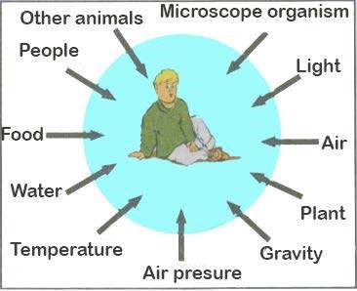

*Fig. 25.1 Your environment*

#### Biosphere

Biosphere is a thin layer of earth in which all living organisms exist. Organisms within the biosphere not only adapt themselves to the environment but also interact to modify and control chemical and physical conditions of the biosphere. An organism lives in a habitat.

An organism responds to a variety of environmental factors, and only when all of them are within the range of tolerance, it can inhabit a location. The actual location of place where an organism lives is called its **habitat.**

In 1917, Joseph Grinnell an American ornithologist irst proposed the term niche in ecology. The habitat and niche are closely related. Niche is deined as the ultimate distributional unit within which a species is restrained by the limitations of its physical structure and its physiology. Charles Eltan considered the niche, the basic role of an organism in the community-what it does in and for living community, its relationship to its food and enemies. In other words, he deined the niche as the species’s occupation.

It refers to a profession or job of an organism. Ecosystems are composed of organisms with diferent jobs or ways of life, particularly concerned with feeding, the role of a particular species within an ecosystem, including all aspects of its interaction with the living and the non-living environment.

“A niche is deined as the role a species plays in a community including behavior and inluence.”

Ecological niche with habitat also speciies how the organism gets its supply of energy and materials - for example organism’s predators, prey and competitors as well as its behavior and interactions are considered elements of its niche.

In addition, niche includes all the physical factors of the environment necessary for survival, such as range of temperature, amount of humidity, the pH of the water and soil.

#### Autecology

Ecology is the study of relationship of living organisms to their environment. When you are studying a single population’s relationship to its environment it will be called as autecology. For example, you are studying 50 to 100 plants of soybean in order to know the efect of water pollution on their growth and yield, you are studying the single or one population of soybean plant, this study is autecology. **Synecology**

Growth responses of individual plants to their environment are a complex factor. One factor can aggaravate the other factor. These factors interact with one another. Complexity of environment depends upon the combination of various factors. The study of the relationship of diferent communities (grouping of populations) to their environment is called **synecology** or **community ecology.**

When you study only one population, at diferent places in an environment it will be autecology. But when you see all the populations at the same time it will be synecology. In synecology (the study of a community) you have to see the various aspects of community like the origin, structure and composition of the community. You have to consider the history of community and also its dynamics because community is not a ixed entity but diferent changes are going to occur at diferent times. While studying the community we come across three levels of integration : (i) individual (ii) population (iii) community.

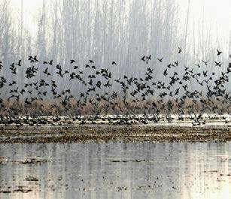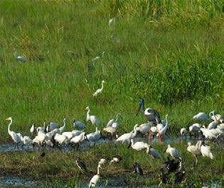

*Fig. 25.2(a) A population of birds Fig. 25.2(b) A community* **COMPONENTS OF ECOSYSTEM**

As discussed earlier the ecosystem can be divided into two main components.

##### 1. Biotic Components

Biotic components include all living organisms including plants and animals supported by biosphere. Biosphere is spread out over the surface of plant earth extending about 8-10 kilometers to the upper reaches of atmosphere and also the same distance into the depths of oceans.

*Animation 25.2:Biotic v/s Abiotic Components Source and Credit:* [*Ameoba Sisters*](http://http://www.amoebasisters.com/)

##### 2. Abiotic Components

Abiotic components include all non-living components air, water, and soil. In ecological term they are called as : (a) atmosphere — (atmo - air, sphere - place) (b) hydrosphere — (hydro - water, sphere - place) (c) lithosphere — (litho - earth,soil, sphere - place). **Processes in Ecosystem and Interaction between Biotic and Abiotic Components:**

The main processes occurring in an ecosystem include feeding and the circulation of chemical elements, together with the energy lowing through the ecosystem.

An ecosystem is made up of three main components, the producers, the consumers and the decomposers. All are concerned with the feeding processes, the circulation of chemical elements and the low of energy.

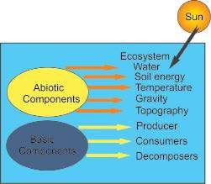 **Producers** are the autotrophs green photosynthetic plants, which capture and bring light energy into the ecosystem. They are able to manufacture organic food from simpler inorganic substances. They are autotrophic organisms.

**Consumers** are all the organisms, primarily animals, which obtain energy directly or indirectly from the producers as ready-made organic food. They are mainly heterotrophic organisms.

**Decomposers** are mainly the fungi and bacteria, which obtain their energy from the dead and decaying plants and animals. They release chemical elements as ions. The main chemical ions are nitrates, ammonia, phosphates, potassium and calcium.

**Food Chain**

Basically, all animals depend on plants for their food. Eagle may eat blue bird, but blue bird eats insects like caterpillar and caterpillar feeds on grass or green leaves. This is an example of a simple food chain.

**Food Web**

Food web is actually “the combination of many food chains”. Food webs are not really as simple as described in Fig. 25.3, because most animals eat more than one type of food at diferent times as fox does not feed entirely on rabbit but also takes beetles, rats etc.

All the food chains and food webs begin with a green plant (producer) and may consist of three to ive links or trophic levels (Fig. 25.3).

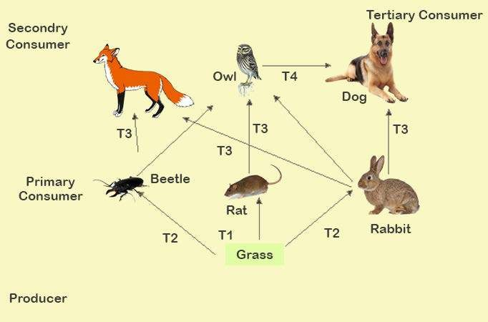

*Fig 25.3 Food Web and various trophic level*

In a food web you will ind more complex trophic levels or food links. In ig (25.3). food chain T1 is the irst trophic producer level, Includes all green plants, grass, and phytoplankton; T2 , second trophic level - primary consumers; T3, third trophic level - secondary consumers; T4 ,fourth trophic level - tertiary consumers.

The variety of pathways in a food web helps to maintain the stability of the ecosystem. For example, owls prey on rabbits and mice. If a disease reduces the rabbit population; fewer plants are consumed. The larger plant population produces more fruits and seeds, which, in turn, support a larger mouse population. The increased number of mice becomes the major food source for the owls. The rabbit population gradually increases, and these primary consumers once again become a food source for the owls. Thus nature maintains a balance.

### SUCCESSION

Succession is a squence of changes in the community structure of an ecosystem over a period of time. Community changes alter the ecosystem in ways that favours the competitors and species to replace their predecessors in somewhat predictable manner until a stable, self sustaining climax community is reached. Succession is a kind of “community relay” in which assemblages of plants and animals replace the earlier ones in a sequence that is at least somewhat predictable. The precise changes occurring during succession are as diverse as the environments in which succession occurs, but certain general stages can be recognized.

*Animation 25.3: Succession*

*Source and Credit:* [*Ameoba Sisters*](http://http://www.amoebasisters.com/)

In each case succession is initiated by a few hardy invaders called **pioneers** and it ends with a diverse and relatively stable **climax community.**

#### Two Major Forms of Succession

Succession on dry land takes two major forms, primary succession and secondary succession. During **primary succession,** an ecosystem is forged from bare rock, sand or clear glacial pool where there was no trace of previous life.

The formation of an ecosystem from scratch is a process often requiring thousands of years. During secondary succession a new ecosystem develops after an existing ecosystem is disturbed as in case of forced ire or an abandoned farm ield. Secondary succession happens much more rapidly than primary succession because the previous community has left its mark in the form of improved soil and seeds. Primary succession starting in a pond is called hydrosere and that on a dry soil or habitat is called xerosere. Plants growing in xeric condition are called xerophytes, which are able to withstand prolonged periods of water shortage. Succullent plants such as the cacti have water stored in large parenchyma tissue, others have leaf modiication. Xerosere has the following diferent stages.

**Crustose lichen stage :** A crust is any external protective surface and crustose means crusts on the substratum. Special types of lichens get impregnated in the form of crust. They can live in extreme conditions. Sometimes, their surface is wet due to rain and dew- drops. They absorb water during dry season. They are quiescent or dormant, normally desiccated during dry season.

Foliage lichen stage: In this stage the lichens are just like crumpled leaves attached at one point. It produces shade to the crustose lichens as a result of which their growth is reduced or decreased. The area becomes rough , as more and more issures and depressions develop. Common examples are, Dermatocarpon, Parmellia, etc. At this stage other plants invade called moss stage, because now soil is more porous with some litter of lichens.

Moss stage : This is the third stage with mosses like, Polytrichum, Tortula etc. They compete with lichens for water and penetrate much deeper into the soil as compared to the lichens, adding more humus to the soil.

Herbaceous (plant) stage : Small seedling of herbaceous plants now establish due to the more availability of moisture, humus and soil for anchorage.

Shrub stage : Shrubby plants now start growing, dominating and shadowing herbaceous plants which die to add more humus to the soil.

Climax forests: The soil is improved to an extent that it now allows the growth/ establishment of woody plants. The shade of these plants inhibits the growth of most plants other than mosses, lichens, a few ferns etc. Woody plants dominate and this stage in succession remains essentially the same if nothing changes in the environment to upset the balance. Because it is a stable stage in succession, the woody forest is considered to be the climax stage for this region (Fig. 25.4).

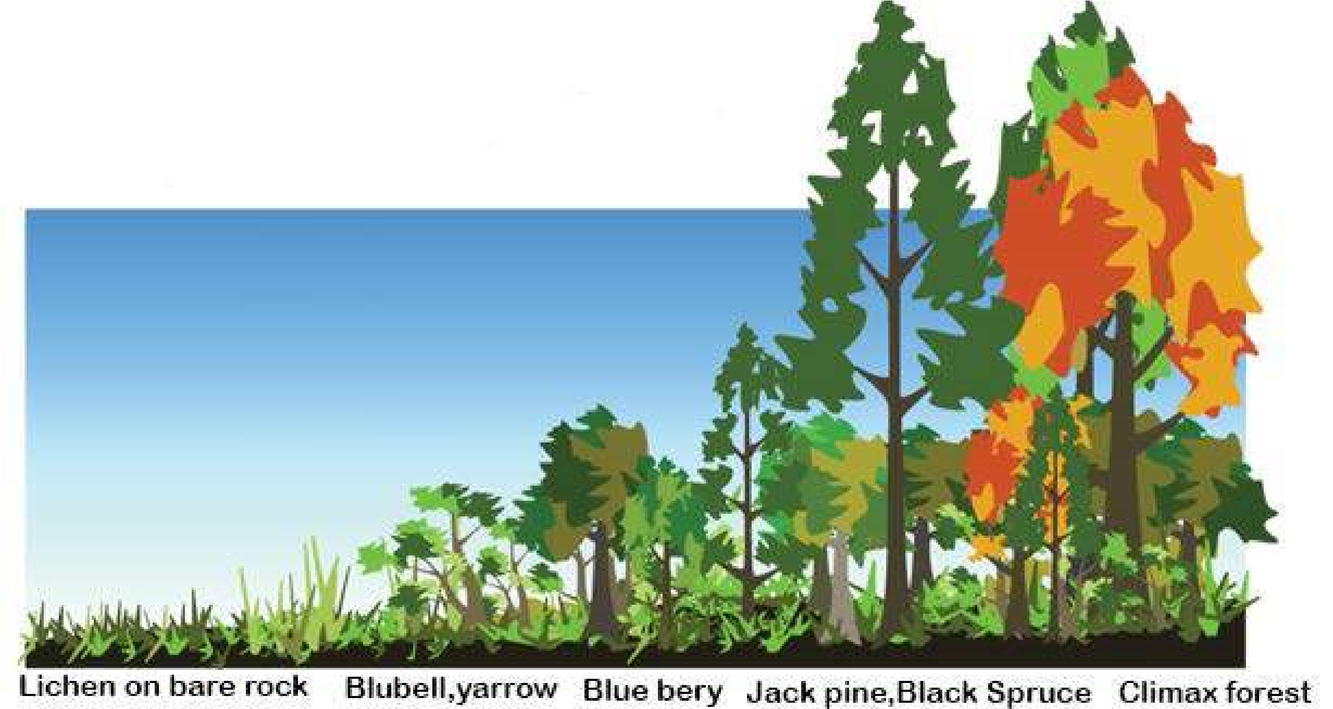

*Fig. 25.4 Primary Succession*

**Seral communities (seral stages)**



Bare ground →Lichens+algae →Mosses+ferns → Grasses → Shrubs → Trees

Pioneer community Climax community

#### Predation and its Signiicance

An animal that preys on other animals is a predator. A predator is a consumer. The animal that is caught and eaten is the **prey.** The over all process is called predation.

The sizes of populations of predator and prey are related to each other. The size of each population is determined by the size of the other. If the number of prey is large, this leads to an increase in the number of predators; as predator feeds upon the prey, the number of prey begins to fall. The number of predators also decreases, since they have smaller food supply. As the number of predators decreases, the number of prey begins to increase. This food relationship of predator - prey creates a “cycle”.

Examples: cat/mouse, fox/rabbit, seal/ish, frog/mosquito, hawk/small birds etc.

#### Parasitism and its Signiicance

This is an association between a host and a parasite, which involves providing the parasite with food, protection and conditions for its survival. The parasite may or may not harm the host. Diseases in living organisms, which are caused by parasites are called **infestations.** Parasites may be **ectoparasites,** living outside the body of the host e.g. fungi causing dandruf in hair and **endoparasites,** living inside the body of the host e.g. tape worm in intestine of man. **Symbiosis**

It is an association between two organisms, which brings beneit to both the organisms. Root Nodules: The legume plant , pea and bean, are the hosts to symbiont bacteria, which inhabit the roots forming root nodules. The bacteria in the root nodules ix nitrogen in soil from air, converting it into amino acid, which the host uses. In return, host provides bacteria with food and protection.

Mycorrhiza : Mycorrhiza is an association between the roots of plants growing in acid soil and certain fungi. The host is pine, beech or heather and it provides the fungus with an enzyme to digest carbohydrates in leaf litter. In return, the fungus symbiont passes mineral ions from the soil to the host. **Mutualism:**

It is the relationship between two organisms in which both the organisms beneit from each other. Lichens are an example of mutualism between a fungus and an alga. The relationship between insects and lowering plants is another example. The insect gets nectar from the lower; the lowers are able to reproduce because the insects carry pollen from lower to lower.

**Lichens:**

Lichen is a dual organism composed of symbiotic association of an alga living within a fungus mycelium. The lichens grow on exposed rock surfaces and are important colonizers of bare ground.

##### Commensalism

In this type of relationship only one organism beneits from the relationship. The other is not afected at all. For example, sharks may have small ish called remoras attached to them. As the shark feeds, the remoras pick up the scraps. The remoras beneit . from this relationship, the shark is not afected at all.

##### Grazing

Many animals like rabbits, goats, sheeps, cows, bufaloes and horses feed on grasses. This mode of feeding is called grazing and these animals are called grazers. These animals live in pastureland where they feed on grasses, herbs and shrubs. If too many animals are kept on pasture, they eat the grasses down to the root though grasses are more resistant than herbaceous plants and have ability to regrow very fast, but the hooves of grazing animals trample the soil into hard layer as a result of which rain water will not penetrate this soil. It runs of from the upper surface removing the fertile topsoil with it. The inal result of over - grazing is totally barren land. Grazing is very important factor in determining the ecosystem. Moderate grazing is very helpful to maintain grassland ecosystem. It destroys the competitors and helps the grass to grow well. Over grazing may lead to the transformation of a grassland into a desert.

### BIOGEOCHEMICAL CYCLES

The chemical elements essential for life in living organisms are called biogenic elements or nutrient elements. Macronutrients are elements required by organisms in large amount like water, carbon, hydrogen, oxygen, nitrogen, phosphorus, sulphur and calcium. Micronutrients are elements required by organisms in small quantity or in trace amount like zinc, molybdenum, iron, iodine. The nutrient cycles are also called biogeochemical cycles as the nutrients move from living to nonliving to living portions of ecosystem in a cyclic manner.

#### The Nitrogen Cycle

The chief reservoir of nitrogen is the atmosphere; in fact nitrogen makes up 78 percent of the gases in atmosphere. Since most living things, however, cannot use elemental atmospheric nitrogen to make amino acids and other nitrogen containing compounds, they are dependent on nitrogen present in soil minerals. So, despite the abundance of nitrogen in the atmosphere, shortage of nitrogen in the soil is often the major limiting factor in plant growth. The process by which this limited amount of nitrogen is circulated and re-circulated throughout the world of living organisms is known as the nitrogen cycle (Fig. 25.5).

*Animation 25.4: Nitrogen Cycle*

*Source and Credit:* [*MicrobeWiki*](http://https://microbewiki.kenyon.edu/index.php/Nitrogen_Cycle)

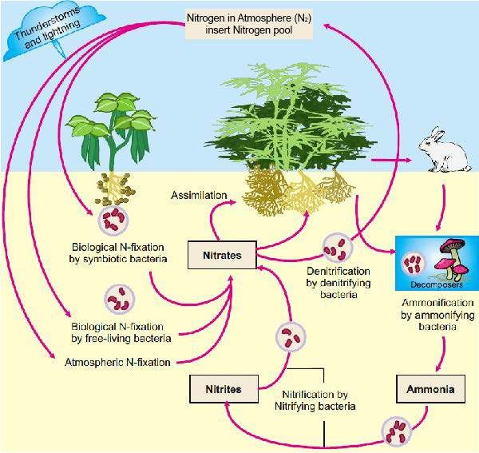

*Fig 25.5 The Nitrogen Cycle*

Three principal stages of this cycle are, **ammoniication, nitriication, and assimilation.**

Much of the nitrogen found in the soil is the result of the decomposition of organic materials and is in the form of complex organic compounds, such as proteins, amino acids, nucleic acids and nucleotides. These nitrogenous compounds are usually rapidly decomposed into simple compounds by soil-dwelling organisms chiely bacteria and fungi. These microorganisms use the proteins and amino acids and release excess of ammonia (NH3) or ammonium ions (NH4+ ). This process is known as ammoniication. Several bacteria in soil are able to oxidize ammonia or ammonium ions, this oxidation is known as nitriication.

Although the plants can utilize ammonium directly, nitrate is the form in which most nitrogen moves from the soil into the roots. Once nitrate is within the plant cell, it is reduced back to ammonium. In contrast to the nitriication, this assimilation process requires energy. The ammonium ions thus formed are transferred to carbon - containing compounds to produce amino - acids and other nitrogenous organic compounds needed by the plant.

*Animation 25.5: Nitrogen Cycle*

*Source and Credit:* [*OrganicSoilTechnology*](http://https://organicsoiltechnology.com/live-organic-nutrients)

#### Nitrogen Depletion and its Remedies

Although the nitrogen cycle appears complete and self - sustaining, nitrates are steadily lost due to the soil erosion, ire and water percolating down through the soil. Nitrates are also lost as a result of the activities of certain soil bacteria; in the absence of oxygen these bacteria break down nitrates releasing nitrogen back into the atmosphere and using the oxygen for their own respiration. This process is known as denitriication, in poorly drained (poorly aerated) soils. The cycle is maintained despite these losses primarily by the activities of the nitrogen - ixing bacteria, which incorporate gaseous nitrogen from air into organic nitrogen containing compounds. Just as all organisms are ultimately dependent on photosynthesis for energy, they all depend on nitrogen ixation for their nitrogen. Soil nitrogen resources are also strengthened by the addition of nitrogen ferlitizers by the man himself. **The low of Energy in Food Chain of an Ecosystem**

Energy in the form of radiant heat and light from the sun lows through an ecosystem passing through the diferent trophic levels (links) and radiates again back into outer space. The total amount of energy ixed by plants is gross primary production. The amount of energy left after plants have met their respiratory needs is net primary production, which shows up as plant **biomass.**

*Animation 25.6:Flow of Energy*

*Source and Credit:* [*Steemit*](http://https://steemit.com/resource/@blockcodes/resource-supply-and-management-in-ecosystems-and-by-extension-social-networks-like-steemit)

About 1% of the total energy from the sun is trapped by the producers in an ecosystem. The remaining 99% of solar energy is used to evaporate water, heat up soil and is then lost to the outer space. As energy is transferred from one trophic level to the next, from producer to primary consumer, between 80 to 90% of last as the original energy is heat as a by product of respiration. However, a continuous lux of energy from the sun prevents ecosystem from running down. A pyramid of energy can be constructed showing energy transfer in a community of organisms.

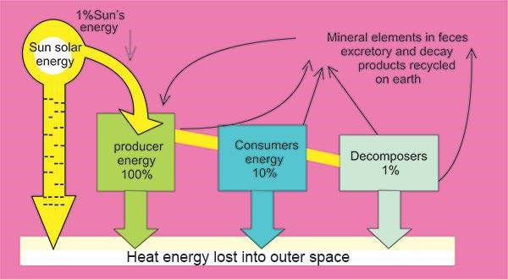

A short food chain of two or three links supports a community more eiciently than a long chain of ive Links where much of the original energy from the producers would never reach those organisms at higher trophic levels. Decomposers are able to obtain energy by converting plant and animal tissues and waste into inorganic mineral ions.

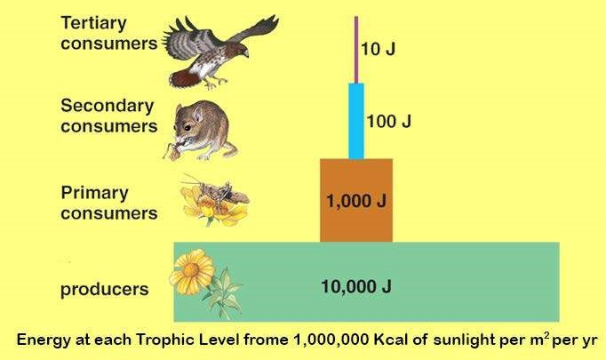

*An Energy Pyramid*

### EXERCISE

**Q1 Fill in the blanks.**

1. A group of similar organisms living together in space and time is called_________ .
2. Organisms which can synthesize their own food are called______ .
3. Animals, non-green plants and microorganisms directly or indirectly depend upon green plants for their food so they so are called____________ .

**Q.2 Write whether the statement is true or false and write the correct statement if false.**

1. At diferent places in an environment when you study only one population, it will be synecology.
2. Abiotic components include all living components.
3. Primary succession starting in a pond is called xerosere.
4. The animal that is caught and eaten is the predator.
5. Endoparasites live inside the body of the host.

**Q.4 Short questions.**

1. What are the biogeochemical cycles?
2. Sketch three mainsteps in nitrogen cycle.
3. Deine grazing.
4. What percentage of sun energy reaches to plants?
5. What is autecology?
6. Deine synecology.

**Q.5 Extensive Questions.**

1. Deine environment. What must environment supply for insects, green plants, birds, animals and people?
2. What factors in the environment can afect all living things? Are they important to survive in a biome?
3. What can you conclude about all the physical and biological factors in an environment?
4. What is biosphere? What must the biosphere provide for living things? Why is a biosphere absent on moon?
5. Deine succession. Discuss succession on land.

CHAPTER

# 26

## Some Major Ecosystems

*Animation 26: Some major Ecosystem*

[*Source & Credit: Wikispaces*](http://anatomyeshs.wikispaces.com/Ch.16+Respiratory+System)

**I**n the previous chapter, you have learned about the ecosystem. In this chapter, we will discuss the aquatic and terrestrial ecosystems, climate and weather.

### CLIMATE

Life on earth, specially on land, is afected by both weather and climate. Weather refers to short-term luctuations in temperature, humidity, cloud cover, wind and precipitation over periods of hours or days. Climate, in contrast, refers to overall patterns of weather that prevail from year to year even century-to-century in a particular region.

### AQUATIC OR HYDROSPHERIC ECOSYSTEM

Hydrospheric ecosystem is a “system in water where living and non-living components exchange materials and transfer of energy also takes place within water”. Salt-water ocean and sea are the largest ecosystems on the earth forming about 71% of its surface. Fresh water ecosystems, in contrast, covers less than 1%. The unique properties of water lend some common features to aquatic ecosystem.

1. Temperature: Water changes its temperature slower than air, so temperature in aquatic ecosystem is more moderate to support life.
2. Absorption of energy: Although water may appear quite transparent, it absorbs a considerable amount of the light energy that sustains life. Even in clearest water, the intensity of light decreases rapidly with depth, so at the depth of 600 feet or more, a little light is left to power photosynthesis.
3. Nutrients : The nutrients in aquatic ecosystem tend to be concentrated near the bottom sediments supporting life where light levels often are too low to support photosynthesis.
4. Abundant water with appropriate temperature : Water is an essential requirement for life. It is available abundantly in aquatic ecosystem to support life. The major factors that detennine the quantity and type of life in aquatic ecosystems are energy and nutrient. Appropriate temperature is present in aquatic ecosystem to carry out all metabolic processes.

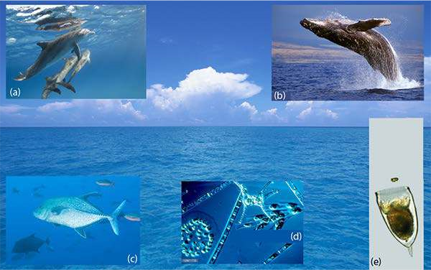

*Fig. 26.1 The open ocean (a) Porpoises skim the surface, (b) rare humpback whales leap on the clear water (c) and ish such as this blue jack swim, (d) the photosynthetic phytoplankton are the producers on which most other life ultimately depends, (e) phytoplankton are eaten by zooplankton, represented by this microscopic crustacean, a copepod. The spiny projections on these planktonic creatures help to keep them from sinking below the photic zone.*

*Animation 26.1: Aquatic Ecosystem*

*Source & Credit:*[*Water System*](http://http://pehop.com/saltwater-ecosystems/)

#### Productivity of Aquatic Ecosystem

The productivity can be indicated by consumption of C02 and evolution of oxygen in the process of photosynthesis.

The productivity of aquatic ecosystem is basically determined by the light and nutrients. Light intensity and quality vary with the water depth, so the primary productivity also varies with light. The amount of nutrients also changes with season. Productivity also varies from zone to zone. Aquatic environment can easily be classiied into fresh water and marine (salty) water. **Fresh Water Lakes**

Fresh water lakes vary tremendously in size, depth, and nutrient content, including distinct life zones and temperature stratiication.

Life zones are based on access to light and nutrients : The distribution of life in lakes depends on access to light, to nutrients and to place for attachment. The lake ecosystem can be divided into three main zones.

Littoral zone (Near-shore): In this zone, the water is shallow, and plants ind abundant light, anchorage and adequate nutrients from the bottom sediments. Plants in littoral zone communities are the most diverse; water lilies and entirely submerged vascular plants and algae lourish at the deepest region of the littoral zone.. The plants of this zone trap sediments carried by stream, increasing the nutrient content in.this region. Living among the anchored plants are microscopic organisms called **plankton**. These can be divided into two groups. **Phytoplankton** (Greek “drifting plants”): these include photosynthetic protista, bacteria and algae. **Zooplankton** (Greek “drifting animals”): such as protozoa and tiny crustaceans. The greatest diversity of animals in the lake is also found in this zone. Littoral invertebrate animals include small crustaceans, insect larvae, snails latworms, Hydra; vertebrates include frogs, aquatic snakes and turtles. As the water increases in depth farther from the shore, plants are unable to anchor to the bottom and still collect enough light for photosynthesis. This open water area is divided into two regions: the upper limnetic zone and the lower profundal zone.

As the water increases in depth farther from the shore, plants are unable to anchor to the bottom and still collect enough light for photosynthesis. This open water area is divided into two regions: the upper limnetic zone and the lower profundal zone. Limnetic zone : In this zone enough light penetrates to support photosynthesis. Here, phytoplankton includes cyanobacteria (blue green algae) which serve as producers. These are eaten by protozoa and small crustaceans, which in turn are consumed by ishes.

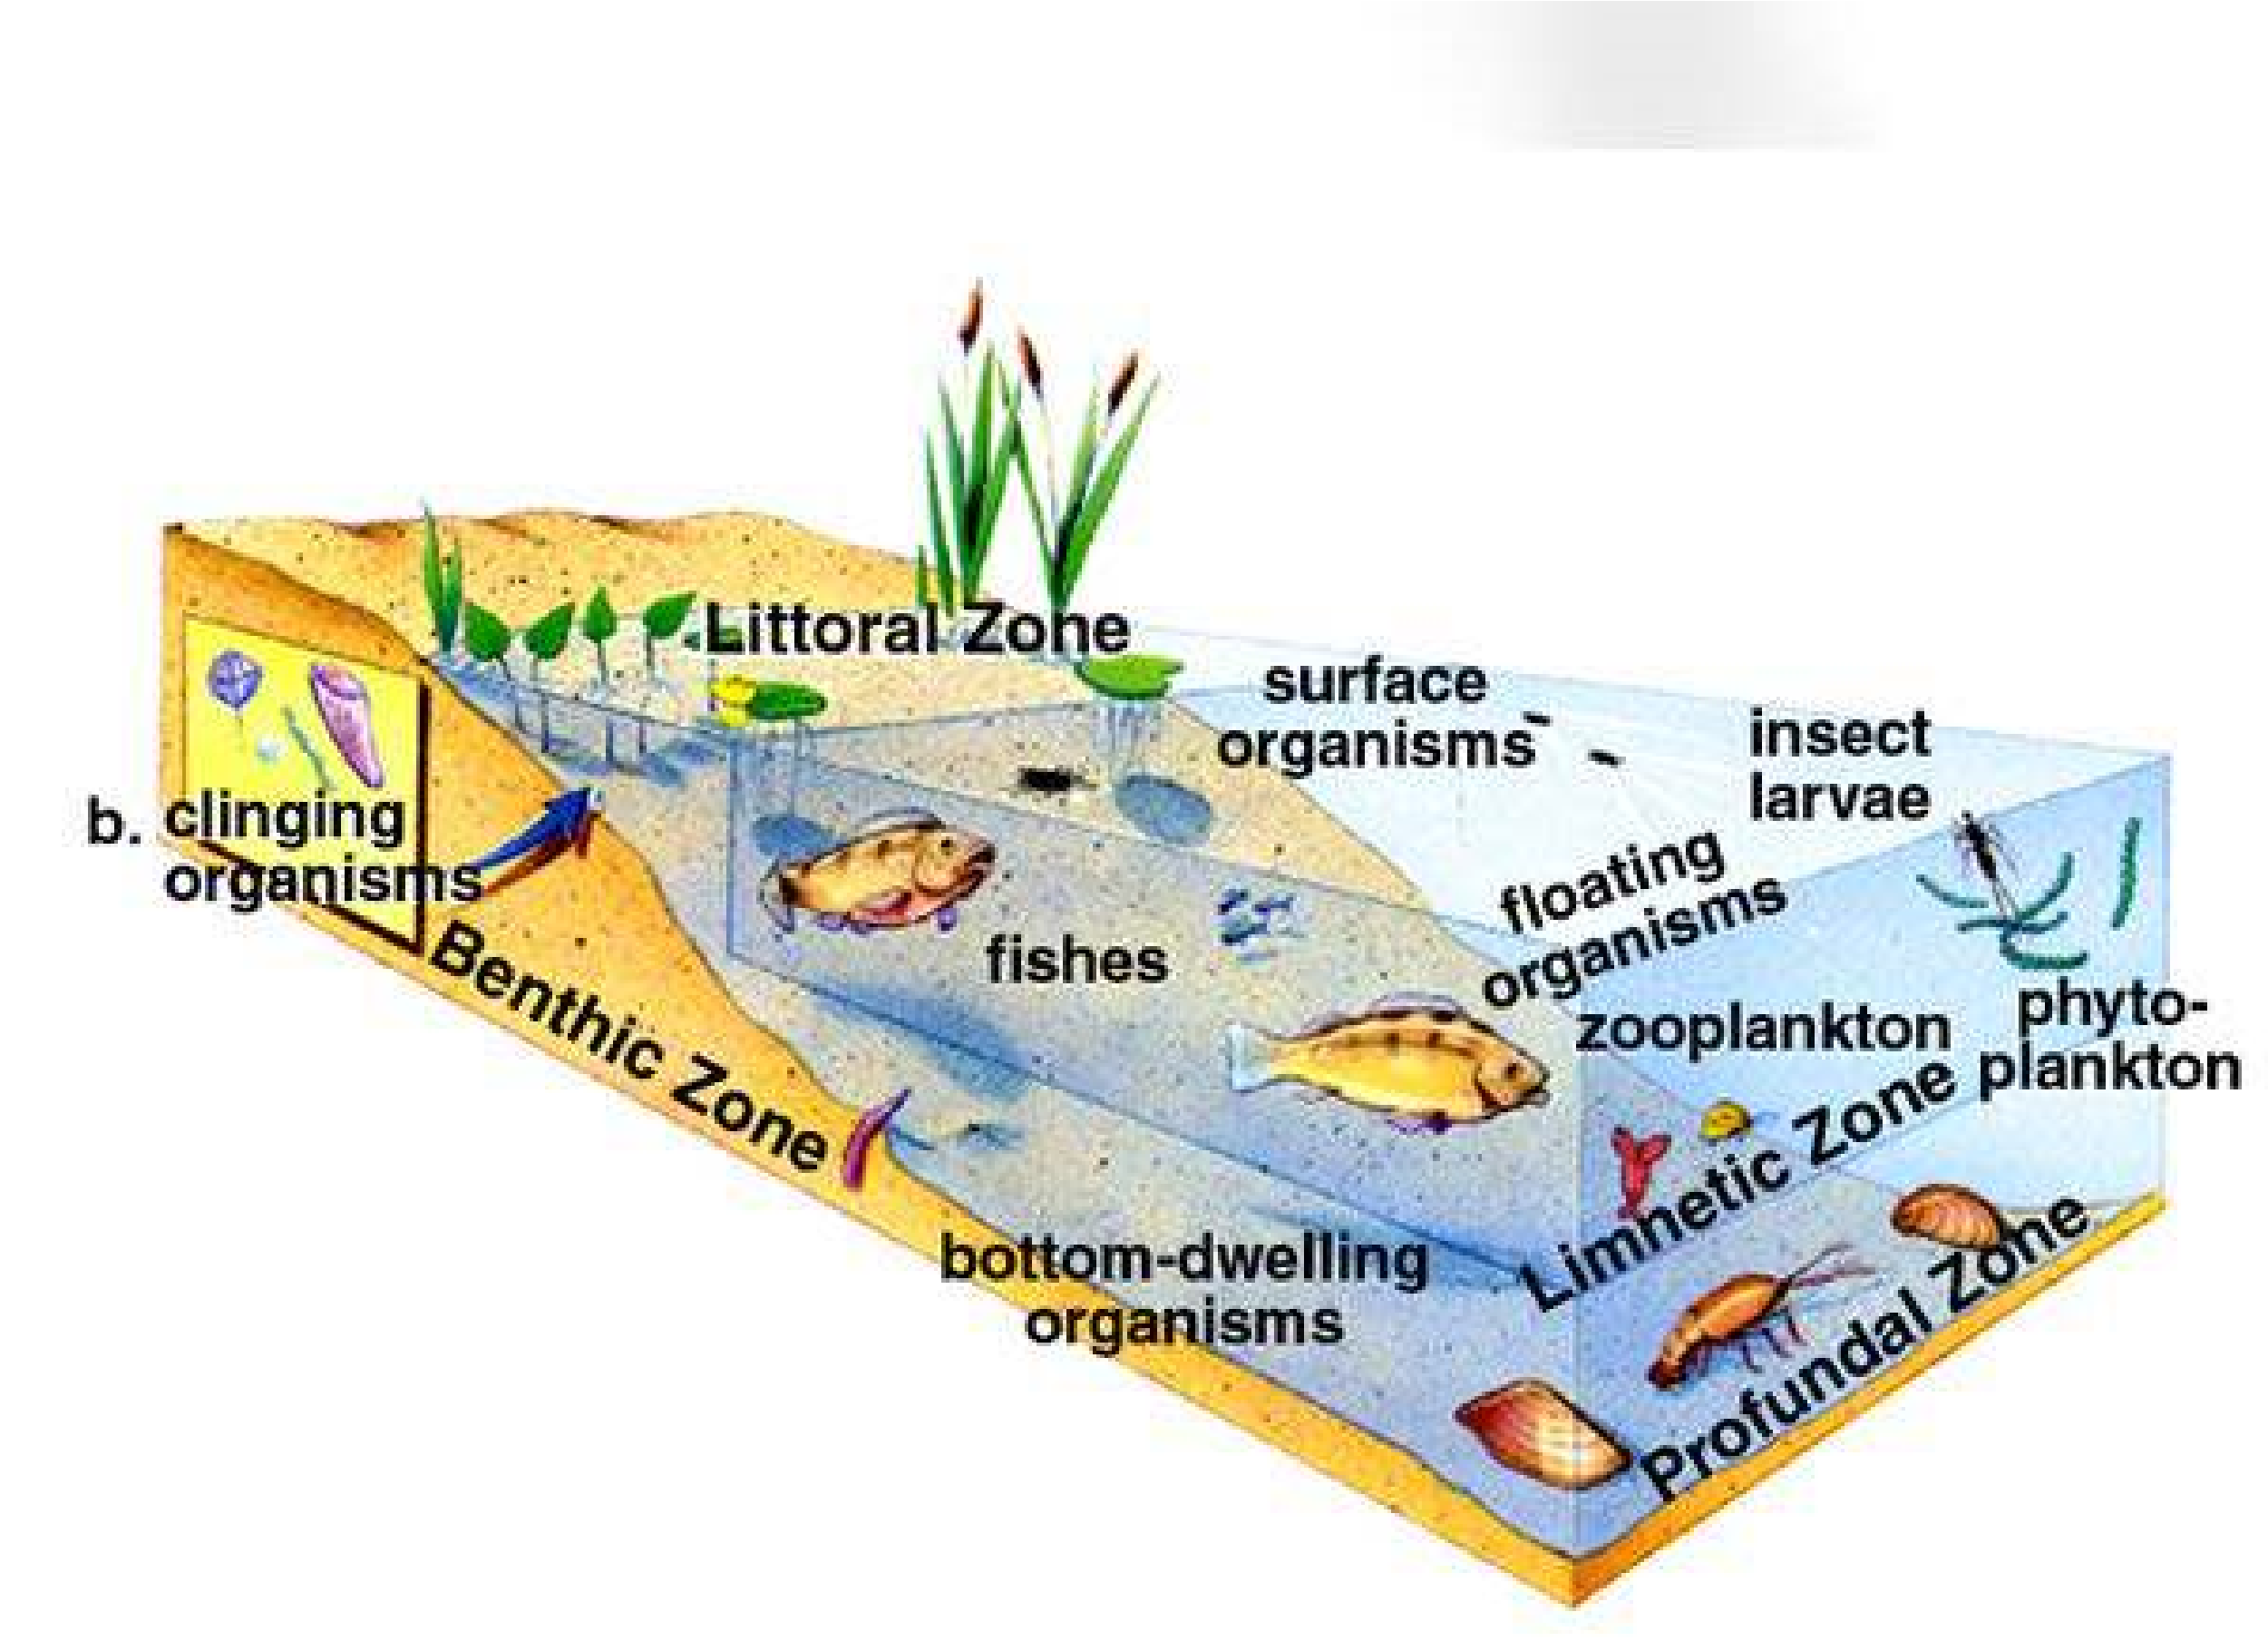

*Fig. 26.2 Lake, life zones There are three life zones in a typical lake : a near-shore littoral zone with rooted plants, an open- water limnetic zone, and a deep, dark profundal zone.*

Profundal zone : Here, light is insuicient to support photosynthesis. The organisms of this zone are mainly nourished by detritus that falls from the littoral and limnetic zone and by incoming sediment. Decomposers and detritus feeders, such as, snails and certain insect larvae, bacteria, fungi and ishes, inhabit it.

#### Intervention of Man in Aquatic Ecosystem

Human activities may greatly accelerate the process of eutrophication (adequate nurition), because nutrients are carried into lakes from farm feedlots and sewage. Even if solid wastes are removed, water discharged from sewage treatment plant is often rich in phosphate and nitrates dissolved from wastes and detergents. Rain water washes of fertilizer from ields where the manure of thousands of cattle is accumulated. The water therefore, becomes highly enriched. The added nutrients support excessive growth of phytoplankton. Producers like blue-green algae form a scum on the lake surface, depriving the submerged plants of sun light; as a result they die. The dead plants bodies are decomposed by bacteria, utilizing the oxygen present in the water, deprived of oxygen, ish, snails and insect larvae die and their decaying bodies fuel more bacterial growth, further depleting oxygen. Even without oxygen, certain bacteria that produce foul smelling gases thrive. Although it is full of life and nutrients, polluted lake smells bad. Most of the trophic levels including the ish are eliminated and the bacteria and blue- green algae dominate the community. Another very serious cause of polluted water is the acid produced by burning of fossil fuels, which poses a diferent threat to fresh-water ecosystem.

Few organisms can withstand the low pH of acidiied lakes.

### TERRESTRIAL OR LITHOSPHERIC ECOSYSTEM

#### Light, Nutrients and Water

The ecosystem present on land or soil is called terrestrial or lithospheric ecosystem. Terrestrial ecosystem receives plenty of light, and the soil provides abundant nutrients. Water, however, is limited and very unevenly distributed both in place and in time. Factors which inluence life on land are given below :

Temperature: Like water, favourable temperatures are very unevenly distributed on land in place and time. On poles, the average temperature is below freezing. In temperate zones, only during certain seasons of the year it is quite favorable, but in tropical zones uniformly, warm, moist climate is present.

Air: In terrestrial ecosystem, air is in constant motion, so its composition is more uniform. The amount of 0 2 and C 02 in air is much constant and most beneicial to terrestrial ecosystem.

#### Adaptations for Terrestrial Ecosystem

Plants and animals shifting from water to land developed various types of adaptations for land habitat e.g.

Supporting tissues : Both plants and animals have evolved supporting tissues like vascular bundles (xylem-phloem) in plants and skeleton in animals to support them on land against the force of gravity.

Conservation of water : Plants and animals evolved various methods to conserve water in their body e.g. homeostasis. The mechanism of temperature regulation was developed by land plants and animals by developing bark and skin respectively.

#### Division of Terrestrial Ecosystem

It can be divided into following main types such as 1. Forest ecosystem. It is further sub-divided into :

(a) tropical rain forests (b) temperate deciduous forests (c) coniferous alpine and boreal forests

2. Grass land ecosystem. 3. Desert ecosystem. 4. Tundra ecosystem.

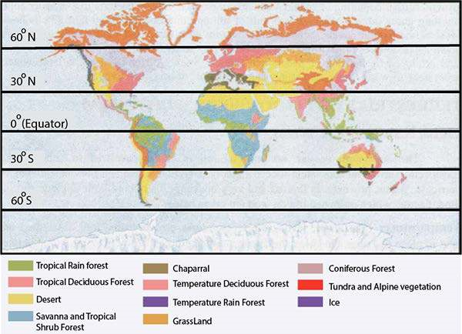

*Fig. 26.3 The distribution of biomes Although mountain ranges and the sheer s >f the continents complicate their pattern, note the overall consistencies. Tundra and coniferous forest always occur in the northernmost parts of the Northern Hemisphere, while the deserts of Mexico, the Sahara, Saudi Arabia, South Africa, and Australia are located around 20° to 30* *° North and South latitude*

### SOME MAJOR ECOSYSTEMS IN PAKISTAN

Pakistan has a variety of seasons and climate ranging from hot dry in plains to cold snowy on mountains. Some major ecosystems existing in Pakistan are;

|  |  |  |  |
| --- | --- | --- | --- |
| **S. No.** | ***Major Terrestrial Ecosystems*** | | **Location in Pakistan** |
| 1 | Temperate Deciduous  Forests. | | Shogran and Neelam valley. |
| 2 | Coniferous Alpine Boreal Forests | and | Northern mountains of Kaghan, Malam Jabba  (Swat) Dir and Chilas |
| 3 | Grassland Ecosystem. |  | Gilgit and Kashmir. Waziristan, lower Chitral and North Kallat. |
| 4 | Desert Ecosystem |  | (Mianwalli, Bakhar) (Fort Abbas, Bahawal Nagar, Yazman, Bahawal Pur, Khan Pur and RahimYar- Khan.  Sind. |
| 5 | Tundra Ecosystem. | | Mountains Kara-Koram and Hindukush. |

#### Temperate Deciduous Forests

In Pakistan, temperate moist conditions are present in Neelam valley and Shogran. These forests originally covered India, Southeast Asia, eastern North America, Europe, China, Australia, Japan, North and South America. Slightly farther away from the equator, the rainfall is not nearly as constant, and there are pronounced wet and dry seasons that means distinct summer and winter seasons. During dry season, the trees cannot get enough water from the soil to compensate for evaporation from their leaves. As a result, the plants have adapted to the dry season by shedding their leaves, thereby minimizing water loss. If the rains fail to return on schedule, the trees delay forming new leaves until the drought passes.

Rain fall: The average rainfall is between 750 - 1500 mm.

Temperature : Moderate temperature ranges from 4°C - 30°C.

Plants : Some dominant plants are Taxus baccata, Pinus wallichiana, Berberis lyceum. Many herbs and shrubs are with height of 5m. Some grasses, ferns and other herbaceous plants make up ield layer. At the bottom or loor level many mosses liverworts and lichens covered with litter layer are present.

Animal life : Some very common animals are *Macca multata*(rhesus monkey), *Solenorctos ubetanus* (black bear), *Felis bengalensis* (leopard cat), deer, and wolves with various types of microorganisms to convert the litter into organic matter such as bacteria, fungi, and earthworms.

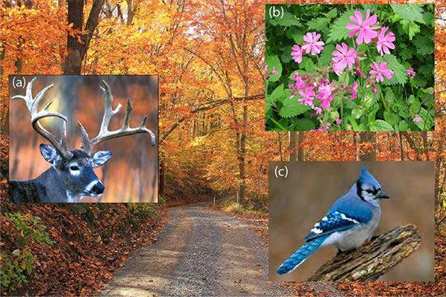

*Fig. 26.4 Temperate deciduous forest (a) White tailed deer is the largest herbivore, (b) Woodland wildlowrs (c) Blue Jay (bird)*

Soil condition : The soil of temperate deciduous forest is grayish brown in colour, very fertile and rich in organic matter, with maximum water holding capacity.

Human impact : On temperate deciduous forest large mammals such as black bear, deer, wolves, bobcats and mountain lions were formerly abundant, but the predators have been largely wiped out by humans. Need of lumber and its use in agriculture has reduced many deciduous forests from the world.

#### Coniferous Alpine and Boreal Forests

In Pakistan these forests are in upper Kaghan, Dir and Chilas, Malam Jaba in Swat valley. In the world, they stretch across Eurasia (Europe + Asia) and North America, Canada just south of the tundra. Northern coniferous forests are also called Taiga. Conditions in taiga are harsher than those in the temperate deciduous forest. The winters are longer and colder, and the growing season is shorter. The few months of warm weather are too short to allow trees the luxurious growth of regrowing. As a result, evergreen coniferous trees populate this type of forest, almost entirely with small waxy needles. The waxy coating and small surface area of the needles reduce water loss by evaporation during cold months, and leaves remain on the trees year around. Coniferous forests located at high altitude are called alpine while coniferous forests located at high latitude are called boreal. Can you diferentiate between altitude and latitude?

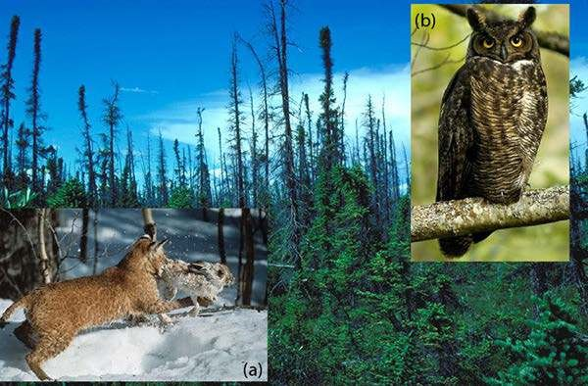

*Fig. 26.5 The Taiga The small needles and pyramidal shape of conifers allows them to shed heavy snows. Winter is a challenge not only for the trees but also for animals such as this snowshoe hare and the bobcat that preys on it (a). The hare is also prey for the great home owl (b). Taiga animals face diminished food supply but increased energy requirements during subfreezing weather.*

Snow cover and temperature : There is a constant cover of snow characterized by long severe winter. Temperatures may be below freezing point, up to 10 °C.

Animal and plant life : Because of its harsh climate, the diversity of life is much low. Large mammals, bison, wolf, black bear, deer, Marco polo sheep and smaller animals such as small Kashmir lying squirrel, snowshoe hare, wolverine, crossbills, are present.’ Plants like *Pinus wallichiana, Pirius roxburgii, Abies pindrow, Picea smithianci Cederous deodara* are present.

Human impact : Due to severity of climate and remoteness most of the coniferous forests remains undisturbed, but these forests are major source of lumber for construction, so forests have been cleared in the world.

#### The Grass Land Ecosystem

Grassland ecosystems are found in Gilgit, Kashmir, Waziristan, lower Chitral and North Kallat. In the world, you can see a large grassland in the center of Eurasian continents. Grassland present in temperate climates are also called Prairies, such as Prairies of North America, Pampas of Argentina. These grasslands do not have woody plants so they are known as Prairies. But the grassland in tropical climates have woody trees and are called Savanna.

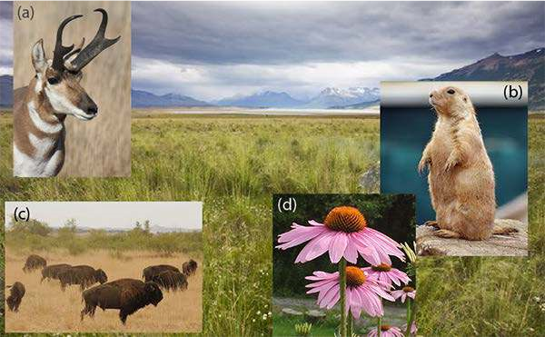

*Fig. 26.6 Grass land ecosystem (a) Pronghorn antelope (b) Prairie dogs (c) Bison herds (d) Conelower*

Rain fall: The grasslands usually face severe droughts(26.7).Annual rainfall is about 250 to 750 ml. In tropical and subtropical grasslands, rainfall eaches about 1500 mm (60 inches). Thus grassland occurs in regions where mean annual rainfall is midway between a forest and a desert. In general, they have a continuous cover of grass and virtually no trees at all except along the rivers. Water and Fire are the crucial factors in die competition between grasses and trees.

Plant life: The dominant spebies are graminoids i.e. grasses, and grass-like plants. Certain forbs such as composites, legumes and many other herbaceous plant species are also associated with grasses.

Layering : Layering is the characteristic of grassland. Tall grasses (Andropogon, Panicum) form the irst) layer, mid high grasses (Stipa, Sporobolus, Oryzopsis) form the second layer and third layer is formed by short grasses and forbs and warfare species (Poa, Bromus) with mosses and lichens.

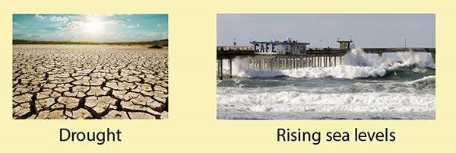

*Fig 26.7*

Soil conditions : The soil moisture is limited on account of low precipitation and high evaporation. Upper soil layer in which grasses are rooted is normally moist but deeper layers are constantly dry. The soil of grassland is basically impermeable with excessive salinity.

Animal life : Dominant species are herbivores; invertebrates including insects are very numerous, grasshoppers become so numerous that they can compete with other herbivores for plant foliage. The predators are reptiles, amphibians and mammals. For example, lizards, toads and turtles prey on insects; foxes and wolves among mammals are very common. Among decomposers many bacteria, actinomycetes and fungi like molds, yeasts, mushrooms, bracket fungi are most common. Large animals like zebras, wild horses, bisons are important.

Productivity ; In temperate grassland the rate of primary production is about 700 - 1500 g/m2 annually. In sub-humid tropical grassland it is more than 4000 g/m2 . In annual grasslands, large grazing animals consume relatively small amount (5 - 10%) of the total herbage produced. Invertebrates, rodents and birds may consume an equal amount or a little more.

Human impact: The natural grasslands in the world are used for crop production and live stock management. Only a small fraction of the world’s grasslands has been in cultivation due to acid climatic condition with soil erosion and salinity. Grazing has prominent efects on grassland; over-grazing causes reduction in herbage cover and result is soil erosion. Many lands are converted into deserts by a process called desertiication due to over grazing

#### Desert Ecosystem

In Pakistan you can ind the desert ecosystem in western Punjab (Mianwali and Bukhar) where it is known as “Thai”.

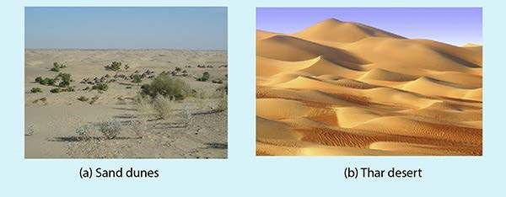

*Fig 26.8*

In southern Punjab, areas like Fort Abbass, Bahawal Nagar, Yazman, Bahawal Pur (Cholistan), Khan pur and Rahim yar khan also have deserts.

In Sindh, this desert ecosystem is called “Thar”.

These biomes are found on every continent often around 20 to 30 north and south latitude and also in the rain shadows of major mountain ranges. Desert includes a variety of environments. At one extreme are certain areas of the Sahara or Chile, where it virtually never tains and there is no vegetation at all (Fig. 26.8a).

The more common deserts, however, are characterized by widely spaced vegetation and large areas of bare ground.

Rain fall: Less than 25 to 50 cm (10 - 20 inches) or not at all.

Plant life: The plants are often spaced evenly as if planted by hand (Fig 26.8b) Frequently, the perennial plants are bushes or cacti with large shallow root systems.

Plants are covered with the waterproof waxy coating to prevent evaporation of precious water. Water is stored in thick stems of cacti and other succulents. Desert plants conserve water in a variety of ways. Cacti and Euphorbia have leshy stems in which water is stored for use during the period of drought.

Animal life: Like plants, animals are also specially adapted to survive on little water. Most deserts appear to be almost completely devoid of animal life during day, because the animals seek relief from the sun and heat in cool under ground burrows. In the dark, when desert cools down, homed lizards, snakes and other reptiles emerge to feed, as do mammals siich as kangaroo, rat, and birds such as burrowing owl.

Most of the smaller animals survive without ever drinking at all, getting all the water they need from their food and what produced during cellular respiration in their tissues. Large animals such as desert bighorn sheep and camel are dependent on permanent water holes during the driest times of the year.

Human im pact: While human activities are reducing the extent of many biomes, they are causing the spread of deserts, a process called desertiication.

A dramatic example is occurring in the Sahel, which borders the southern edge of the Sahara desert in Africa. Twenty-ive years of below average rainfall, coupled with rapid growth of the human population have caused a steady southward spread of desert. The Sahel is an example of a human population exceeding the carrying capacity of the land. The loss of the productivity of the ecosystem is nearly irreversible and massive famines, such has occurred in Ethiopia in the mid 1980s are a tragic result.

#### Tundra Ecosystem

The last biome seen before reaching the polar ice-caps is the arctic tundra, a vast treeless region bordering the Arctic ocean. It is used to describe types of vegetation in treeless high latitudes between taiga and polar ice caps, and at high altitude across the mountain above timberline such as mountain of Karakoram and Koh Hindu Kush in Pakistan.

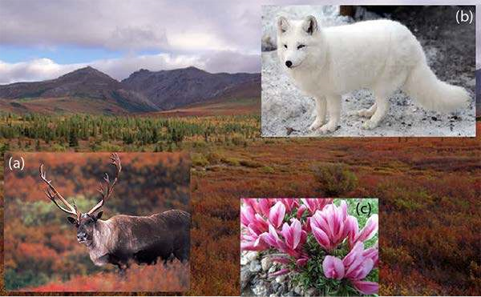

*Fig. 26.9 Tundra : Vegetation and animals, (a) Caribou (b) Arctic foxe (c) Dwarf clover (wild lower)*

Aractic tundra stretches across Northern North America, Northern Europe and Siberia (with high latitude).

Plant and animal life : The ground is carpeted with small perennial lowers and dwarf willows no more than a few centimeters tall often with large lichen called reindeer moss. The standing pools provide superb mosquito habitat. The mosquitoes and other insects provide food for numerous birds (ducks and geese) most of which migrate a long distance to nest and raise their young during the brief summer feast. The tundra vegetation supports lemmings, which are eaten by wolves, snowy owls, arctic foxes and even grizzly bears.

Human impact: The tundra is perhaps the most fragile of all the biomes because of its short growing season. A willow 10 centimeter (4 inches) high may have a trunk 7 centimeter (3 inches) in diameter and be 50 years old. Human activities in the tundra leave scars that persist for centuries. Fortunately, for the tundra inhabitants, the impact of civilization is localized around oil drilling sites, pipelines, mines and military bases.

#### Humans and Ecosystems

The expanding human population has left relatively few ecosystems undisturbed. Our impact on natural ecosystem are so diverse and wide ranging that they far exceed the scope of this book. Ecosystems dominated by people tend to be simple, that is, they have fewer species and fewer community interactions than an undisturbed ecosystem

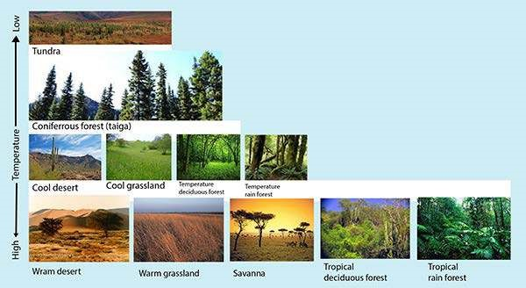

*Fig. 26.10 Temperature and rainfall inluence on biome distribution*

|  |
| --- |
| **EXERCISE** |
| **Q1 Fill in the blanks.** |

1. Water is slower to heat and ________________than air.
2. The distribution of life in lakes depends on access to________, and to place for attachment.
3. Ecosystem on land is also known as_____________ ecosystem.
4. Ecosystem in water is also called as____________ ecosystem.

**Q.2 Short questions.**

1. Defnle productivity of an ecosystem.
2. List four adaptations in plants and animals for terrestrial ecosystem.
3. Name three zones in lake ecosystem.
4. How many biomes are present in the world, name only ive of them.
5. Give the names of some major ecosystems on land in Pakistan.

**Q.4 Extensive Questions**

1. What are the four major requirements for life? Which two are limiting in terrestrial ecosystem?
2. List some adaptations of
3. (a) desert plants (b) desert animals to heat and drought.
4. Where is life in oceans (hydrospheric ecosystem) most abundant and why?
5. Distinguish between three diferent zones in the lake - ecosystem.