CHAPTER

# ALIPHATIC HYDROCARBONS

8

[Animation 8.1 : Cycloalkanes](http://chem.libretexts.org/Textbook_Maps/Organic_Chemistry_Textbook_Maps/Map%3A_Organic_Chemistry_(McMurry)/Chapter_04%3A_Organic_Compounds%3A_Cycloalkanes_and_their_Stereochemistry/4.1_Naming_Cycloalkanes)

[Source and credit : Stackexchange](http://chem.libretexts.org/Textbook_Maps/Organic_Chemistry_Textbook_Maps/Map%3A_Organic_Chemistry_(McMurry)/Chapter_04%3A_Organic_Compounds%3A_Cycloalkanes_and_their_Stereochemistry/4.1_Naming_Cycloalkanes)

|  |
| --- |
| In This Chapter You Will Learn: |
|  |
| 1. How to name the aliphatic hydrocarbons according to IUPAC rules. 2. The synthesis of alkanes, alkenes and alkynes and their important reactions. 3. The comparison of reactivity of s bond and p bond. 4. About the free radical nature of reactions of alkanes and electrophilic addition of alkenes and alkynes. 5. The comparison of reactivities of alkanes, alkenes and alkynes. |

## 8.1 INTRODUCTION

Hydrocarbons are organic compounds which contain carbon and hydrogen only. The number of such compounds is very large because of the property of catenation. Hydrocarbons have been divided into various classes on the basis of structure of the chain or size and nature of the ring.

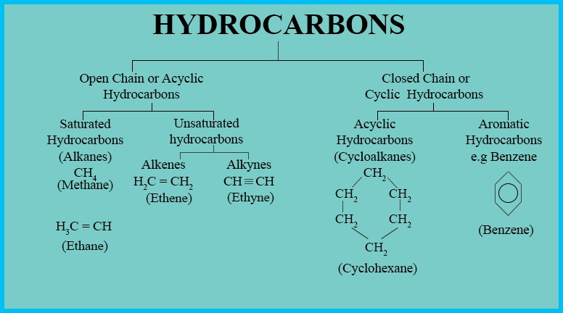

If all the valencies of the carbon atoms in a molecule are fully satisfied and these cannot further take up any more hydrogen atoms, then the hydrocarbons are named as saturated hydrocarbons or alkanes. The compounds of carbon and hydrogen in which all the four valencies of carbon are not fully utilized and they contain either a double or a triple bond, such compounds are called unsaturated hydrocarbons.

Those unsaturated hydrocarbons which contain a double bond are called alkenes while those containing a triple bond are called alkynes. Classification of hydrocarbons has been’ shown at page 136.

## 8.2 NOMENCLATURE

8.2.1 Common or Trivial Names:

In the early days, the compounds were named on the basis of their history, the method of preparation or name of the person working on it, e.g., the name marsh gas was given to methane because it was found in marshy places. Acetic acid derives its name from vinegar (Latin, acetum means vinegar). Organic compounds were named after a person, like barbituric acid after Barbara. Such a system may have a certain charm but is never manageable.

For alkanes with five or more carbon atoms, the root word is derived from the Greek or Latin numerals indicating the number of carbon atoms in a molecule, and the name is completed by adding ‘ane’ as a suffix, e.g. pentane (C5H12), hexane (C6H14), heptane (C7H16), etc. The common or trivial names are applicable to all isomers of a given molecular formula.

The prefixes n, iso, neo are, however, to differentiate between isomers.

CH3 CH2 CH2 CH3 HC CH CH3 | 3

n-butane CH3

Isobutane

## CH3 CH2 CH2 CH2 CH3

n-pentane

CH3

|

H C3 CH| CH2 CH3 H C3 C| CH3

CH3 CH3

Isopentane Neophentane

These prefixes have only limited use, as they are not workable with complex molecules. Moreover, common names give only minimum information about the structure of the compounds.Alkenes are similarly named by replacing the ending -ane of the name of alkane with ylene. e.g.

CH3

|

## HC C=CH3 2 HC=CH2 2 H C3 CH =CH2

Ethylene Propylene Isobutylene

8.2.2 IUPAC Names

In 1889 the solution for naming the organic compounds systematically was sought by International Chemical Congress. A report was accepted in 1892 in Geneva but it was found incomplete. In 1930, International Union of Chemistry (IUC) gave a modified report which is also referred as Liege Rules. This report was further modified by International union of Pure and Applied Chemists (IUPAC) in the year 1947. Since that date the union has issued periodic reports on rules for the systematic nomenclature of organic compounds, the most recent of which was published in the year 1979. IUPAC system of nomenclature is based on the following principle.

‘Each different compound should have a different name’.

Thus through a systematic set of rules, the IUPAC system provides different names for more than 7 million known organic compounds.

Nomenclature of Alkyl Groups:

If we remove one hydrogen atom from an alkane, we obtain what is called an alkyl group. These alkyl groups have names that end in — yl.When the alkane is unbranched and the hydrogen atom that is removed is a terminal hydrogen atom, the names are straight forward:

|  |  |  |  |
| --- | --- | --- | --- |
| Alkane | Alkyl Group |  | Abbreviation |
| CH3 H | CH3 |  | Me- |
| Methane | Methyl |  |  |
| CH3 CH2 H | CHCH3 2 |  | Et- |
| Ethane | Ethyl |  |  |
| CH3 CH2 CH2 H | CH CH CH3 2 2 |  | Pr- |
| Propane | n-propyl |  |  |
| CH CH CH CH H3 2 2 2 | CH CH CH CH3 2 2 2 |  | n-Bu- |
| n-Butane | n-Butyl |  |  |

8.2.3 Nomenclature of Alkanes

Branched-chain alkanes are named according to the following rules.

1. Locate the longest continuous chain of carbon atoms; this chain determines the parent name for the alkane. We designate the following compound as a hexane because the longest continuous chain contains six carbon atoms.

HC CH CH CH CH CH3 2 2 2 3

|

### CH3

The longest continuous chain may not always be obvious from the way the formula is written. Notice, for example, that the following alkane is designated as a heptane because the longest chain contains seven carbon atoms.

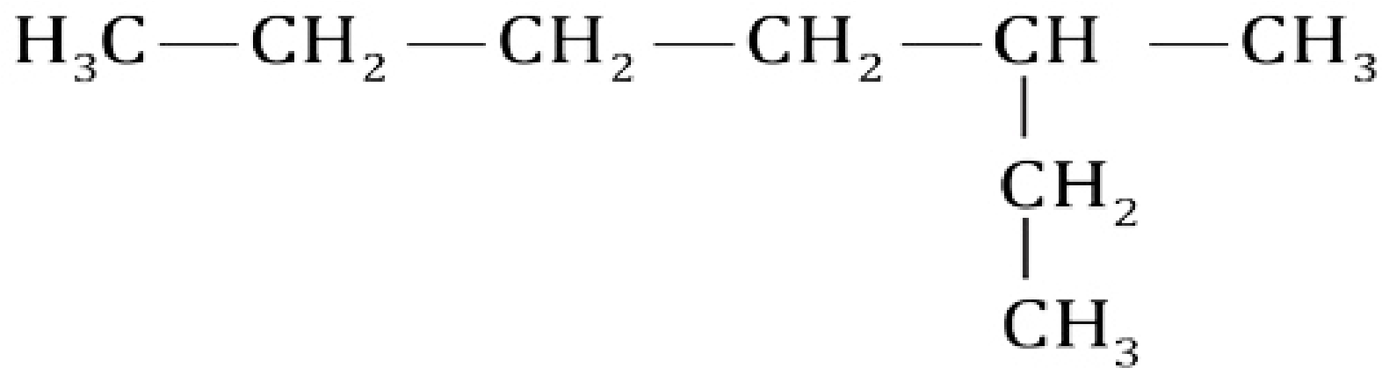

2.Number the longest chain beginning from the end of the chain nearer the substituent. Applying this rule, we number the two alkanes shown above in the following way.

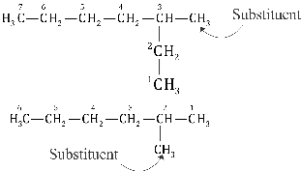

3.Use the numbers obtained by the application of rule 2 to designate the location of the substituent group. The parent name is placed last, and the substituent group, preceded by the number designating its location on the chain, is placed first. Numbers are separated from words by a hyphen. The systematic names ot the two compounds shown above will then be:

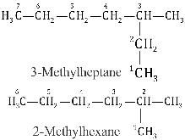

1. When two or more substituents are present, give each substituent a number corresponding to its location on the longest chain. For example, we designate the following compound as 4 -ethyl-2 -methylhexane.

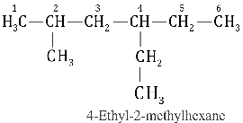

The substituent groups should be listed alphabetically (i.e. ethyl before methyl). In deciding on alphabetical order disregard multiplying prefixes such as “di” and “tri”.

1. When two substituents are present on the same carbon atom, use that number twice.

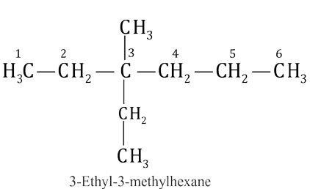

6.When two or more substituents are identical, indicate this by the use of the prefixes di, tri , tetra , and so on. Then make certain that each and every substituent has a number. Commas are used to separate numbers from each other.

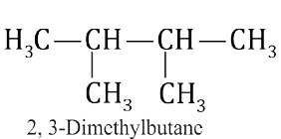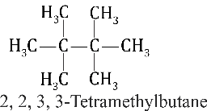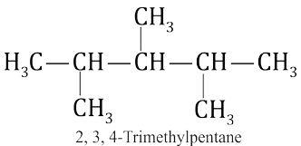

Application of these six rules allows us to name most of the alkanes that we shall encounter. Two other rules, however, may be required occasionally.

7.When two chains of equal length compete for selection as the parent chain, choose the chain with the greater number of substituents.

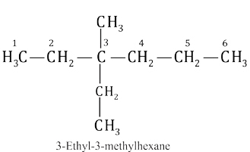

8. When branching first occurs at an equal distance from either end of the longest chain, choose the name that gives the lower number at the first point of difference. 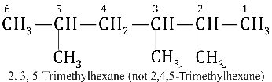

8.2.4 Nomenclature of Alkenes:

The IUPAC rules for naming alkenes are similar in many respects to those for naming alkanes.

1.Select the longest continuous chain that contains the C = C as the parent chain. Change the ending of the name of the alkane of identical length from — ane to — ene, e.g.,

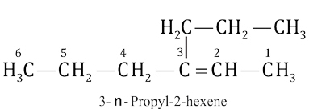

2.Number the chain so as to include both carbon atoms of the double bond. Numbering begins from the end nearer to the double bond.

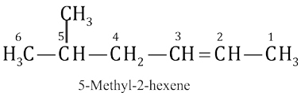

3.Designate the location of the double bond by using the number of the first atom of the double bond as a prefix.

1 2 3 4 5

1 2 3 4

## H C2 =CH CH2 CH3 H C CH CH CH CH2 = 2 2 3

1-Pentene 1-Butene

4.Indicate the locations of the substituent groups by the numbers of the carbon atoms to which they are attached.

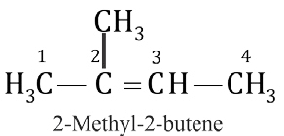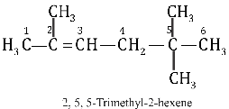

5.If the parent chain contains more than one double bonds, they are alkadienes for two, alkatrienes for three and so on.

1 2 3 4

CH CH CH CH2 = = 2

1,3-Butadiene

8.2.5 Nomenclature of Alkynes:

1.The largest continuous carbon chain containing triple bond is selected.

The name of the identical alkane is changed from ane to — yne. e.g.

3 2 1

### CH CH H C C CH3 ≡

Ethyne

Propyne

2.The position of triple bond is shown by numbering the alkyne, so that minimum number is assigned to the triple bond.

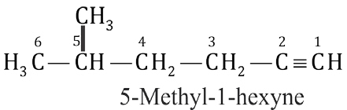 4 3 2 1

### H C CH C CH3 2 ≡

1-Butyne

3.If a hydrocarbon contains more than one triple bonds, it is named as alkadiyne and triyne, etc. depending on the number of triple bonds.

 6 5 4 3 2 1

#### HC C CH CH C CH

1,5 -Hexadiyne

4.If both double and triple bonds are present in the compound then ending enyne is given to the root.

a.Lowest possible number is assigned to a double or a triple bond irrespective of whether ene or yne gets the lower number.

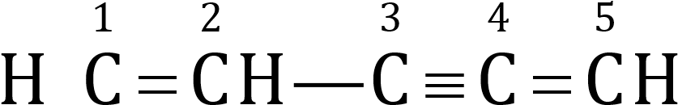 1 2 3 4 5

HC C CH=CH CH≡ 3 2 3

3-Penten-1- yne 1-Penten-3- yne

b.In case a double and a triple bond are present at identical positions, the double bond is given the lower number.

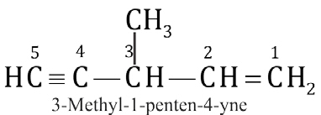

##### 8.3 ALKANES OR PARAFFINS

Alkanes are the simplest organic compounds made up of carbon and hydrogen only. They have a general formula of CnH2n+2. In these compounds the four valencies of carbon atoms are satisfied by single bonds to either other carbon atoms or hydrogen atom. They are, therefore known as Saturated Hydrocarbons. Methane (CH4) is the simplest member of this family. Each carbon atom in alkane is sp3 hybridized and has a tetrahedral geometry.

###### 8.3.1 General Methods of Preparations

(1) Hydrogenation of Unsaturated Hydrocarbons (Sabatier-Sendem’s Reaction)

Hydrogenation of alkenes or alkynes in the presence of nickel at 200-300OC yields alkanes.

R CH =CH + H2 2 →200 300−Ni oC R CH2 CH3

Alkene

#### e.g CH = CH2 2 + H2 →200 300−Ni oC CH3 CH3

Ethane

The hydrogenation can also be carried out with platinum or palladium at room temperature but they are expensive than nickel. The method is of industrial importance. Production of vegetable ghee by the catalytic hydrogenation of vegetable oil (unsaturated fatty acids) is an example of the application of this method on industrial scale.

(2) From Alkyl Halides:

An alkane is produced when an alkyl halide reacts with zinc in the presence of an aqueous acid.

R X + Zn + H + X+ − → R H + ZnX2

Alkyl halide Alkane

CH3 I + Zn + H +I+ − → CH + ZnI4 2

Methyl iodide Methane

CH3 CH2 CH CH3

|

##### Br + Zn + H +Br+ − → CH3 CH2 CH2 CH + ZnBr3

2-Bromo-butane n-Butane

Alkanes can also be prepared from alkyl halides using palladium-charcoal as acatalyst. The method is known as Hydrogenolysis (hydrogenation accompanied by bond cleavage)

##### R X + H2 →Pd/C∆ R H + H X

(3) Decarboxylation of Monocarboxylic Acids

1. When sodium salts of fatty acids are heated with soda-lime (prepared

by

soaking

quick

lime

(

CaO)

with

caustic

soda

solution

and

drying

the

product).

They

eliminate

a

molecule

of

CO

2

to

form

alkanes.

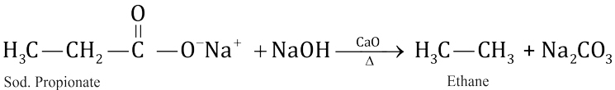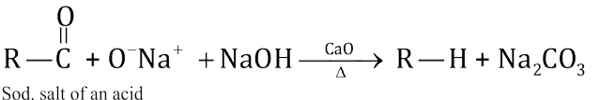

e.g

1. Kolbe's Electrolytic Method

When a concentrated solution of sodium or potassium salt of a mono carboxylic acid is electrolysed, an alkane is produced. This method is only suitable for the preparation of symmetrical alkanes i.e. those of the type R—R. Methane cannot be prepared by this method.

2RCOO Na− + +[1]H O2 →Electrolysis R R+2CO2 +2NaOH+H2

It is known to involve the following mechanism.

When potassium salt of acetic acid is electrolysed, acetate ion migrates towards the anode . gives up one electron to produce acetate free radical . (CH3COO), which decomposes to give a methyl free radical (CH3) and CO2.Two such methyl radicals combine to give ethane.

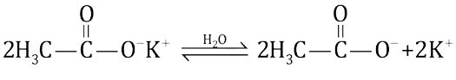

At Anode

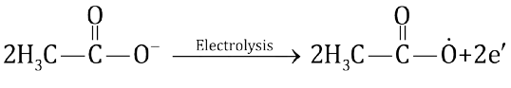

O

||

2H C3 C O → 2CH +2CO 3 2

#### CH CH 3 +  3 →HC CH3 3

At Cathode

#### 2HO+2e2 − → 2OH + H2

1. From Carbonyl Compounds (Aldehydes or Ketones)

The carbonyl groups of aldehydes or ketones are reduced to methyl or methylene group respectively by either Clemmensen or Wolf-Kishner’s reduction. In the former reaction a ketone is reduced to an alkane using zinc amalgam and hydrochloric acid whereas in the later an aldehyde is reduced to alkane with hydrazine in the presence of KOH.

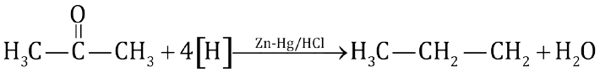

Acetone

Propane

3

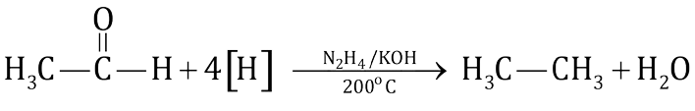

1. From Grignard Reagents

Alkyl halides react in anhydrous ether with magnesium to form alkyl magnesium halides, known as Grignard Reagent. They decompose on treatment with water or dilute acid to give alkanes.

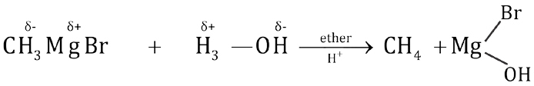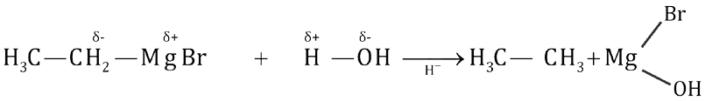

ether

8.3.2. Physical Properties

1. Alkanes containing upto four carbon atoms are colourless, odourless gases while pentane to heptadecane (C5 to C17) are colourless, odourless liquids. The higher members from C18 onwards are waxy solids which are also colourless and odourless.
2. Alkanes are non-polar or very weakly polar and are insoluble in polar solvents like water, but soluble in non-polar solvents like benzene, ether, carbon tetra chloride,etc.
3. Their physical constants like boiling .points, melting points, density, etc increase with the increase in number of carbon atoms, whereas solubility decreases with increase in molecular mass. The boiling point increases by 20 to 30°C for addition of each CH2 group to the molecule. The boiling points of alkanes having branched chain structures are lower than their isomeric normal chain alkanes, e.g. n-butane has a higher boiling point-0.50 C than isobutane (-1 1 .7°C).

4.The melting points of alkanes also increase with the increase in molecular mass but this increase is not so regular.

8.3.3. Reactivity of Alkanes

The alkanes or paraffins (Latin: parum = little, affins = affinity) under ordinary condition are inert towards acids, alkalis, oxidizing and reducing agents. However, under suitable conditions, alkanes do undergo two types of reactions.

1. Substitution Reactions
2. Thermal and Catalytic Reactions

These reactions take place at high temperature or on absorption of light energy through the formation of highly reactive free radicals.

The unreactivity of alkanes under normal conditions may be explained on the basis of the non-polarity of the bonds forming them. The eletronegativity values of carbon (2.5) and hydrogen (2.1) do not differ appreciably and the bonding electrons between C-H and C-C are equally shared making them almost nonpolar. In view of this, the ionic reagents such as acids, alkalies, oxidizing agents, etc find no reaction site in the alkane molecules to which they could be attached.

Inertness of s-bond

The unreactivity of alkanes can also be explained on the basis of inertness of a s-bond. In a s -bond the electrons are very tightly held between the nuclei which makes it a very stable bond. A lot of energy is required to break it. Moreover the electrons present in a s-bond can neither attack on any electrophile nor a nucleophile can attack on them. Both these facts make alkanes less reactive. 8.3.4 Reactions

1. Combustion

Burning of an alkane in the presence of oxygen is known as Combustion.

Complete combustion of an alkane yields CO2, H2O and heat.

The amount of heat evolved when one mole of a hydrocarbon is burnt to

CO2 and H2O is called heat of combustion, e.g;

CH4 ( )g + 2O2 ( )g →Flame  CO2 ( )g + 2H O g 2 ( ) + 891kJmol-1

Although the reaction is highly exothermic, it requires very high temperature to initiate it, e.g. by a flame or a spark.

Combustion is the major reaction occurring in the internal combustion engines of automobiles. A compressed mixture of alkanes and air burns smoothly in the internal combustion engine and increases its efficiency.

1. Oxidation

Oxidation of methane under different conditions gives different products. i) Incomplete oxidation occurs in a limited supply of oxygen or air and results in the formation of CO and carbon black.

3CH g 4O g4 ( )+ 2 ( )→Flame 2CO g 6HO g C s( )+ 2 ( )+ ( )

ii) Catalytic Oxidation: Lower alkanes when burnt in the presence of metallic catalysts, at high temperature and pressure, result in the formation of useful products.

## CH O+[ ]→Cu HC OH

4 400oC/200atm 3

Methyl alcohol H C3 OH +   O →400oC/200atmCu HCHO+H O2

Formaldehyde

### HCHO O+ [ ] →o Cu HCOOH

400 C/200atm

Formic acid

#### HCOOH+ [ ]O →400oC/200atmCu CO + H O2 2

Catalytic oxidation of alkanes is used industrially to prepare higher fatty acids used in soap and vegetable oil industries.

3. Nitration:

It is a substitution reaction of alkanes in which a hydrogen atom of an alkane is replaced by nitro group (-NO2). Alkanes undergo vapour-phase nitration under drastic condition (at 400-500°C) to give nitroalkanes, e.g.

##### CH4 +HONO2 →450oC CH NO + H O3 2 2

Nitromethane

Nitroalkanes generally find use as fuels, solvents, and in organic synthesis.

4. Halogenation

Alkanes react with chlorine and bromine in the presence of sunlight or UV light or at high temperature resulting in the successive replacement of hydrogen atoms with halogens called halogenation. Extent of halogenation depends upon the amount of halogen used.

Reaction of alkanes with fluorine is highly violent and results in a mixture of carbon, fluorinated alkanes and hydrofluoriq acid. Iodine does not substitute directly because the reaction is too slow and reversible. The order of reactivity of halogens is F2>Cl2>Br2>I2.

Halogenation is believed to proceed through free radical mechanism.

It involves the following three steps.

|  |  |  |  |
| --- | --- | --- | --- |
| Step I | Cl Cl →hυ Cl + Cl− − |  | (Initiation) |
| Step 2 | H C3 H + Cl →hυ CH3 +HCl  CH3 + Cl Cl →hυ CH3 Cl +Cl | ] | (Propagation)  (Termination) |

###### Step 3 CH 3 + Cl →CH3 Cl

By repetition of step II, a mixture of halogen substituted products are obtained.The reaction is not synthetically so important.

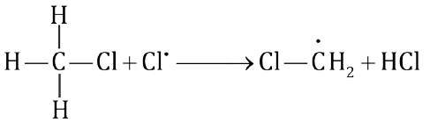

Cl CH2 + Cl Cl →Cl CH2 Cl +Cl

Dichloromethane

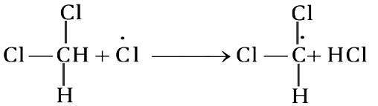

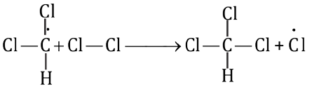

Chloroform

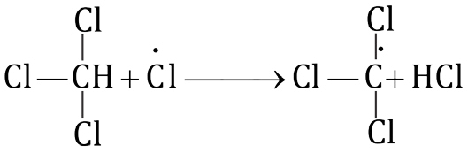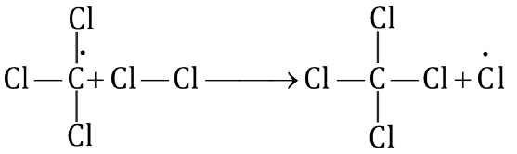

+

+

Tetrachloromethane or carbon tetrachloride

8.3.5 Uses of Methane Methane is used:

1. as a fuel and as an illuminating gas.
2. for the preparation of methylchloride, dichloromethane, chloroform and carbon tetrachloride.
3. for the industrial preparation of methyl alcohol, formaldehyde and hydrogen cyanide.
4. for the preparation of carbon black used in paints, printing inks and automobile tyres.
5. is used to manufacture urea fertilizer.

8.4 ALKENES

Alkenes have two hydrogen atoms less than the coresponding saturated hydrocarbons. They are also known as Olefins (derived from Latin word olefiant meaning oil forming) because lower members form oily products on treatment with chlorine or bromine. The simplest olefin is C2H4, ethene.

Alkene having one double bond are known as mono-enes with general formula CnH2n. Alkenes containing two double bonds are called dienes.

8.4.1 General Methods of Preparation

1. Dehydrohalogenation of Alkyl Halides

Alkyl halides on heating with alcoholic potassium hydroxide undergo dehydrohalogenation i.e. elimination of a halogen atom together with a hydrogen atom from adjacent carbon atoms.

R CH CH2 2 →Alc. KOH R CH CH KX +HO= 2 + 2

|

X

H C2 CH2 + KOH →Alcohol H C=CH2 2 + KBr +H O2

| |

H Br

HC CH3 2 CH2 Br KOH+ →Alcohol HC CH CH KBr HO3 = 2+ + 2

2. Dehydration of Alcohols

Alcohols when dehydrated in the presence of a catalyst give alkene .

The best procedure is to pass vapours of alcohol over heated alumina.

R CH CH2 2 →340 450Al O−2 3oC R CH=CH+HO2 2

|

Alcohol OH Alkene

P4O10, (conc)H2SO4 and H3PO4 are also used for dehydration. The ease of dehydration of various alcohols is in the order. Ter. alcohol > Sec. alcohol >

Pri .alcohol

Thus

R CH CH2 2 →75140 170% H SO− 2 4oC R CH=CH+HO2 2

|

OH

Primary Alcohol

R CH CH CH2 3 →60100% H SOo2 4C R CH=CH CH+HO3 2

|

#### OH

Secondary Alcohol

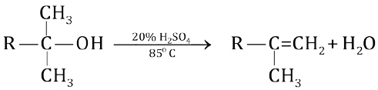

Tertiary Alcohol

3. Dehalogenation of Vicinal Dihalides

Vicinal dihalides have two halogens on adjacent carbon atoms. Dehalogenation occurs when dihalide is treated with Zinc dust in an anhydrous solvent like methanol or acetic acid.

R CH CH Zn2 →CH OH3 HC=CH R+ZnX2 2

| | X X Alkene

##### H C3 CH CH CH + Zn3 →CH OH3 H C3 CH=CH CH +ZnBr3 2

| |

2-Butene

Br Br

4. Electrolysis of Salts of Dicarboxylic acid (Kolbe’s Electrolytic Method)

When sodium or potassium salts of the dicarboxylic acid like succinic acid are subjected to electrolysis in an aqueous solution, alkenes are formed.

##### H C2 COO Na H C- + 2 COO- +2Na+

|  IonizationH O2 | - +

##### HC COONa2 HC COO2

Disodium Succinate

At Anode

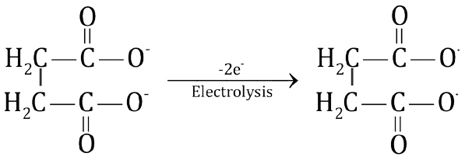

At Cathode

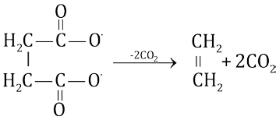

+

###### 2HO + 2e2 − → 2OH + H− 2 2Na + 2OH+ − → 2NaOH

5. Partial Hydrogenation of Alkynes: -

Controlled hydrogenation of alkynes with hydrogen gas in an equimolar ratio over heated catalysts, gives alkenes. The catalyst is finely divided palladium supported on BaSO4 and poisoned by treatment with quinoline (Lindlar’s catalyst).

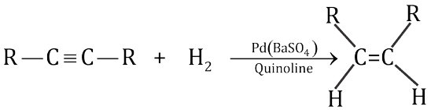

Cis-Alkene

A trans alkene can be obtained by treating an alkyne with Na in liquid NH3 at -33°C.

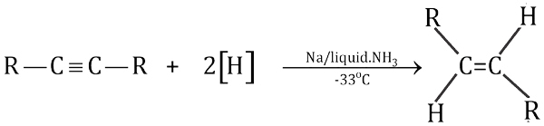

trans-Alkene

8.4.2 Physical Properties

1. First three members i.e. ethene, propene and butene are gases at room temperature while C5 to C15 are liquids and the higher members are solids.
2. They are insoluble in water but soluble in alcohol.
3. They have characteristic smell and burn with luminous flame.
4. Unlike alkanes, they show weakly polar properties because of sp2 hybridization.

8.4.3 Reactivity of a p-bond

In the formation of a p-bond, the partially filled p-orbitals overlap in a parallel fashion. The probability of finding electron is thus away from the line joining the two nuclei. Due to this reason p-electrons are less firmly held between the nuclei. A p-bond is, therefore, a weak bond as compared to a s-bond. During a reaction it breaks comparatively easily rendering alkenes as reactive group of compounds. Moreover, the loosely held p-electrons are more exposed to attack by the electrophilic reagents. Alkenes, therefore, undergo electrophilic reactions very easily.

8.4.4 Reactions of Alkenes

A. Addition Reactions

1. Addition of Hydrogen (Hydrogenation)

Hydrogenation is a process in which a molecule of hydrogen is added to an alkene in the presence of a catalyst and at moderate pressure (1-5 atm.) to give a saturated compound. The process is known as Catalytic Hydrogenation.

It is a highly exothermic process and the amount of heat evolved when one mole of an alkene is hydrogenated is called Heat of Hydrogenation. The heat of hydrogenation of most alkenes is about 120kJmole-1 for each double bond present in a molecule. The catalysts employed are Pt, Pd and Raney nickel.

Raney Nickel

It is prepared by treating a Ni — Al alloy with caustic soda.

Ni Al + NaOH+ H O2 →Ni+ NaAlO2 + 3 H

2 2

Most alkenes are hydrogenated over Raney nickel at about 100°C and upto 3atmosphere pressure.

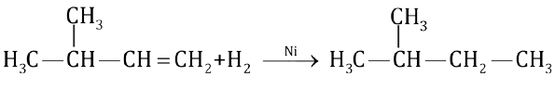

3-Methyl-l-butene iso Bentane

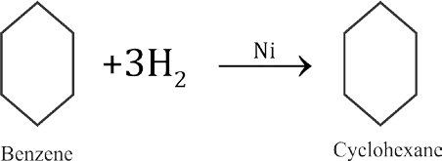

Catalytic hydrogenation of alkenes is used in the laboratory as well as in industry. In industry, it is used for the manufacture of vegetable ghee from vegetable oils. In the laboratory, it is used as a synthetic method as well as an analytical tool, as the reaction is generally quantitative.

1. Addition of Hydrogen Halides

Alkenes react with dry gaseous hydrogen halides to form alkyl halides. The order of reactivity of halogen aicds is HI > HBr > HC1.

R CH=CH +HX2 →R CH CH3

|

X

H C=CH +2 2 HCl →H C3 CH2

|

##### Cl

The addition of a hydrogen halide to an alkene takes place in two steps. Alkene accepts the proton of hydrogen halide to form a carbocation.

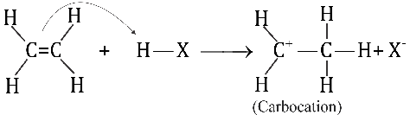

The carbocation then reacts with the halide ion.

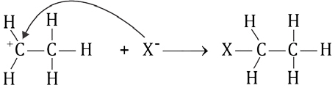

The addition of hydrogen halide over an unsymmetrical alkene is governed by Markownikov’s Rule. The rule states that; in the addition of an unsymmetrical reagent to an unsymmetrical alkene, the negative part of the adding reagent goes to that carbon, constituting the double bond, which has least number of hydrogen atoms.

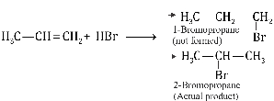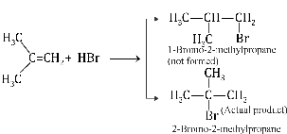

3. Addition of Sulphuric Acid

When alkenes are treated with cold concentrated sulphuric acid, they are dissolved because they react by addition to form alkyl hydrogen sulphate. For example,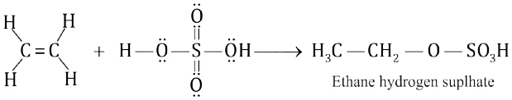

These alkylhydrogen sulphates on boiling with water decompose to give corresponding alcohols. The overall reaction involves the addition of water to an alkene and it is, therefore, called hydration reaction.

###### HC CH O SOH+HO3 2 3 2 →100oC HC CH3 2 OH+HSO2 4

4. Addition of Halogens

The alkenes on treatment with halogen in an inert solvent like carbon tetrachloride at room temperature give vicinal dihalides or 1,2 dihalogenated products. For example,

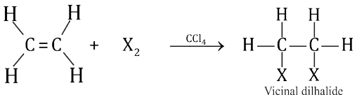

Br2 and Cl2 are effective electrophilic reagents. Fluorine is too reactive to control the reaction. Iodine does not react. Mechanism:

1. A bromine molecule becomes polarized as it approaches the alkene. This polarized bromine molecule transfers a positive bromine atom to the alkene resulting in the formation of a bromonium ion.

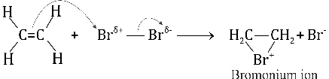

1. The nucleophilic bromide ion then attacks on the carbon of the bromonium ion to form vic. dibromide and the colour of bromine is discharged. A trans product is formed.

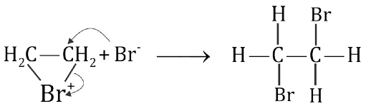

Bromonium ion 1, 2-Dibromoethane

This test is used for the detection of a double bond.

5. Addition of Hypohalous acid (HOX)

If the halogenation of an alkene is carried out in an aqueous solution, haloalcohol is formed called a Halohydrin. In this reaction, molecules of the solvent become reactants too.

X2 + HO2 → HOX+ HX

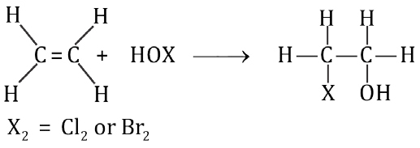

Halohydrin

B. OXIDATION REACTIONS

1. Addition of Oxygen

Alkenes when mixed with oxygen or air and passed over a silver oxide catalyst at high temperature and pressure, add an atom of oxygen to form epoxides. Epoxides serve as the starting substances for the industrial production of glycols.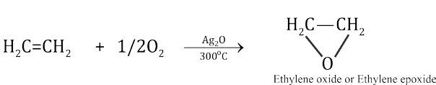

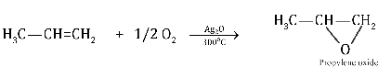

1. Hydroxylation

When alkenes are treated with mild oxidizing reagents like dilute (1%) alkaline KMn04 solution (Baeyer's Reagent) at low temperature, hydroxylation of duoubie bond occurs resulting in the formation of dihydroxy compounds known as vicinal glycols. The pink colour of KMnO4 solution is discharged during the reaction. It is also a test for the presence of unsaturation in the molecules. For example,

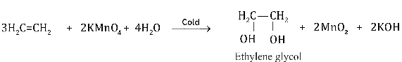

1. Combustion

Alkenes burn in air with luminous flame and produce CO2 and H2O vapours. Ethene forms a highly explosive mixture with air or oxygen.

C H2 4 +3O2 → 2CO2 +2H O heat2 +

1. Ozonolysis

Ozone (O3) is a highly reactive allotropic form of oxygen. It reacts vigorously with alkenes to form unstable molozonide. It rearranges spontaneously to form an ozonide.

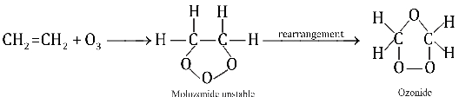

Ozonides are unstable compounds and are reduced directly by treatment with zinc and H2O. The reduction produces carbonyl compounds (aldehydes or ketones).

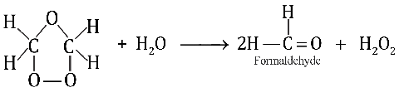

###### HO2 2 + Zn→ ZnO HO+ 2

Ozonolysis is used to locate the position of double bond in an alkene.

C. Polymerization

In this ‘process small organic molecules (monomers) combine together to form larger molecules known as Polymers.Ethene at 400°C and 100 atm pressure, polymerize to polythene or polyethylene.

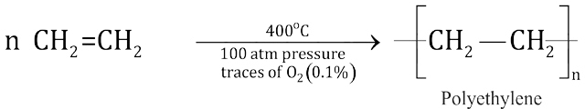

A good quality polythene is obtained, when ethene is polymerized in the presence of aluminium triethyl Al(C2H5)3 and titanium tetrachloride catalysts

(TiCl4).

8.4.5 Uses of Ethene:

Ethene is used:

1. for the manufacture of polythene, a plastic material used for making toys, cables, bags, boxes, etc.
2. for artificial ripening of the fruits.
3. as a general anaesthetic.
4. for preparing ‘Mustard gas’ a chemical used in World War I. The name comes from its mustard like odour. It is not a gas, but a high boiling liquid that is dispersed as a mist of tiny droplets. It is a powerful vesicant i.e., causes blisters.

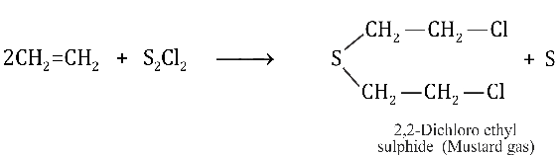

1. as a starting material for a large number of chemicals of industrial use such as glycols (antifreeze), ethyl halide, ethyl alcohol, etc.

8.5 ALKYNES

Unsaturated hydrocarbons which contain a triple bond are called Alkynes.

They have the general molecular formula CnH2n-2 and contain two hydrogen atoms less than the corresponding alkenes.

The first member of the Alkyne series has the formula C2H2 and is known as Ethyne or Acetylene.

8.5.1 General Methods of Preparation

1. Dehydrohalogenation of Vicinal Dihalides

Vicinal dihalide on treatment with a strong base eliminates two molecules of hydrogen halides from two adjacent carbons to give an alkyne.

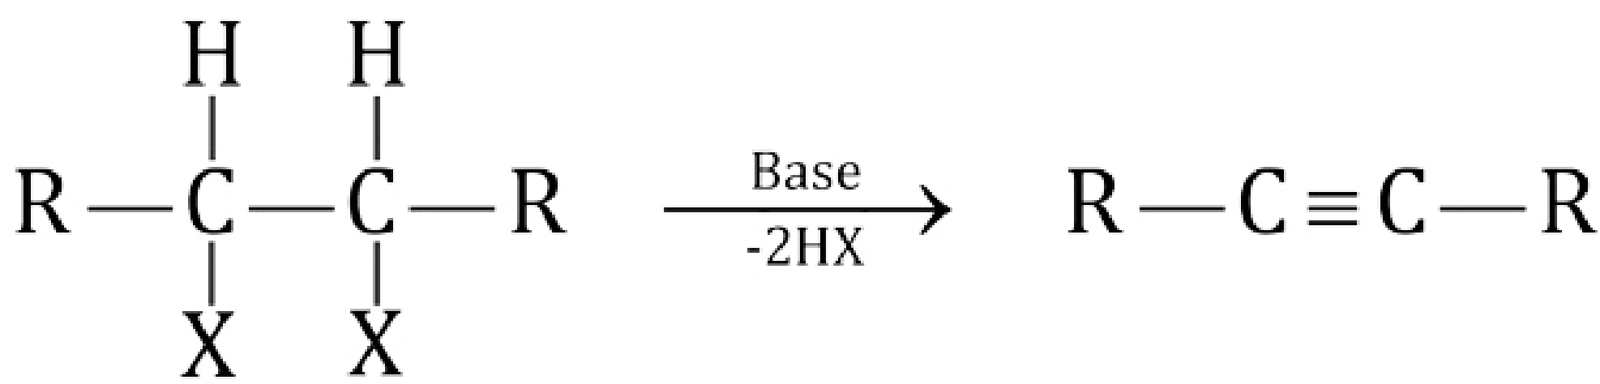

Alkyne

1,2-Dihalide

HC CH + KOH →−HBr80 CAlcoholo HC=CH| 2

| |

##### Br Br Br

1,2-Dibromoethane Vinyl bromide

HC =CH + KOH →Alcoholo HC ≡CH

| | −HBr150 C

Br H

Ethyne

The second molecule of hydrogen halide is removed with great difficulty and requires drastic conditions.

2. DehalogenationofTetrahalides

Tetra haloalkanes on treatment with active metals like Zn, Mg, etc. form alkynes.

(i) 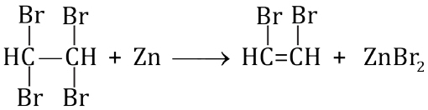

(ii) HC =CH + Zn → HC ≡CH+ZnBr2

| |

##### Br Br

3. Electrolysis of Salts of Unsaturated Dicarboxylic Acids

Kolbe's electrolytic method involves electrolysis of aqueous solution of Na or K salts of unsaturated dicarboxylic acids.

At Anode

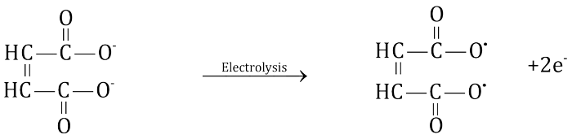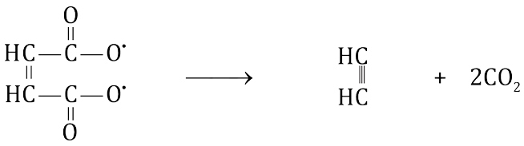

Ethyne

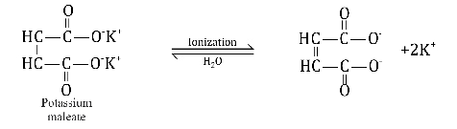

+

At Cathode

2HO + 2e2 − → 2OH−

2K + 2OH+ − → 2KOH

Industrial Preparation of Ethyne

On industrial scale ethyne is prepared by the reaction of calcium carbide (CaC2) with water Calcium carbide is prepared by heating lime (CaO) and coke (C) at a very high temperature in an electric furnace.

##### CaO+3C→2000oC CaC +CO2

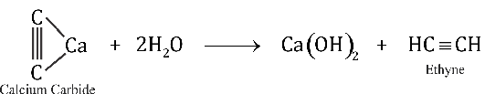

8.5.2 Physical Characteristics

1. They are colourless, odourless, except acetylene which has a garlic like odour,
2. The first three members are gases (ethyne, propyne, butyne) at room temperature, The next eight members (C5 - C12) are liquids and higher members are solids.
3. The melting points, boiling points and densities increase gradually with the increase in molecular masses.
4. They are nonpolar and dissolve readily in solvents like ether, benzene and carbon tetrachloride.

8.5.3 Reactivity of Alkynes

In alkynes, the carbon atoms are held together by a triple bond, a s-bond and two p-bonds. The electron density between the carbon atoms is very high which draws atoms very close to each other. Electrons in a triple bond are, therefore, less exposed and thus less reactive towards electrophilic reagents.

8.5.4 Reactions

A. Addition Reactions:

Alkynes undergo addition reactions like alkenes but add two molecules of the reagent instead of one.

1. Addition of Hydrogen:

Alkynes react with hydrogen gas in the presence of a suitable catalysts like finely divided Ni, Pt, or Pd. Initially alkenes are formed which then take up another molecule of hydrogen to form an alkane.

###### HC ≡CH +H 2 →heatNi H C=CH2 2

Ethyne Ethene

CH =CH2 2 +H 2 →heatNi H C3 CH3

Ethene Ethene

1. Addition of Halogens:

One or two molecules of halogens can be added to alkynes giving dihalides and tetra halides respectively.Chlorine and bromine add readily while iodine reacts rather slowly.

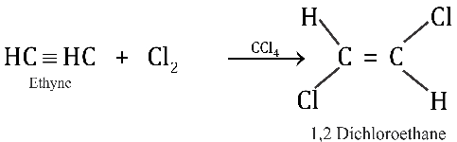

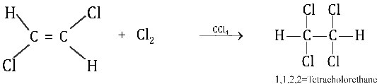

1. Addition of Halogen Acids:

Alkynes react with hydrogen chloride and hydrogen bromide to form dihaloalkanes. The reaction occurs in accordance with Markownikov’s rule.

HC ≡CH + H Br → H C=CH2

|

Ethyne

Br

Vinyl bromide

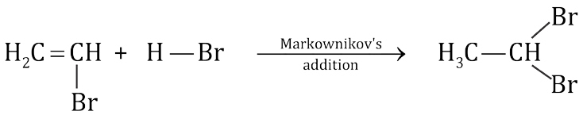

1

, 1- Dibromoethane

4. Addition of Water:

Water adds to alkynes in the presence of mercuric sulphate dissolved in sulphuric acid at 75°C. The reaction is important industrially. For example,

###### HC ≡CH + Hä+ OH ä- →HgSOH SO2 44 H C=CH2 O H

Vinyl alcohol

Vinyl alcohol is an unstable enol. The enol has the hydroxy group attached to a doubly bonded carbon atom and isomerises to acetaldehyde.

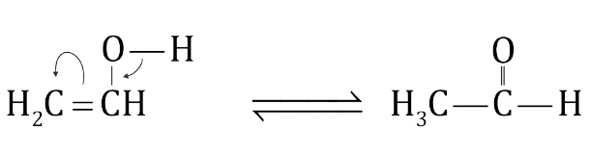Acetaldehyde All other alkynes give ketones.

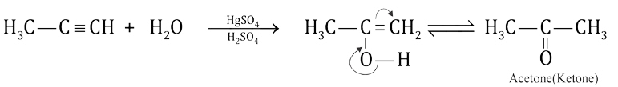

5. Addition of Ammonia and Hydrogen Cyanide:

NH3and HCN react with ethyne in the presence of suitable catalysts, to give nitriles.

HC≡CH + NH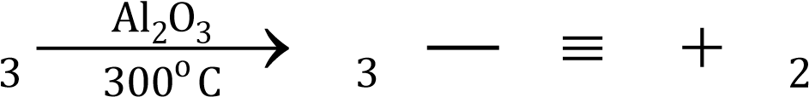 H C C N H

Methyl Nitrile

HC CH +HCN≡ →Cu Cl /NH Cl2 2∆ 4 CH=CH CN2

Acrylonitrile

B. Oxidation Reactions

1. Ethyne on oxidation with strong alkaline KMnO, gives glyoxal.

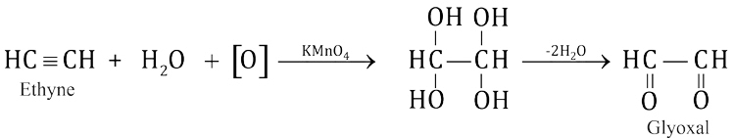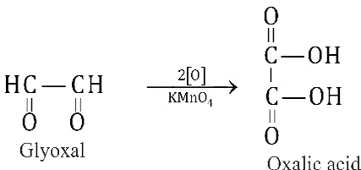

1. Combustion:

Alkynes when burnt in air or oxygen produce heat and evolves CO2 and H2O. The reaction is highly exothermic for acetylene and the resulting oxyacetylene flame is used for welding and cutting of metals.

2HC CH + 5O≡ 2 → 4CO + 2H O + heat2 2

C. Polymerization

Alkynes polymerize to give linear or cyclic compounds depending upon the temperature and catalyst used. However, these polymers are different from the polymers of the alkenes as they are usually low molecular weight polymers.

1. Conversion of Acetylene to Divinyl Acetylene

When acetylene is passed through an acidic solution of cuprous chloride and ammonium chloride and then allowed to stand for several hours at

|  |  |  |
| --- | --- | --- |
| room | temperature, vinyl acetylene and divinyl acetylene are  HC CH +HC CH≡ ≡ →Cu Cl ,NH Cl2 2 o 4 HC CH C CH2 = ≡  300 C  Vinyl acetylene  (1- Buten-3-yne | obtained. |

H C=CH2  C ≡CH+HC ≡ →CH Cu Cl ,NH Cl2 2 4 H C2 = CH C ≡C CH =CH2

Divinyl acetylene

(l,5-Hexdiene-3-yne)

If HCl is added to vinyl acetylene, chloroprene is obtained which readily polymerize to neoprene, used as synthetic rubber.

H C=CH2  C ≡ CH+(conc.)HCl →Cu Cl ,NH Cl2 2 4 H C2 = CH C=CH2

|

Vinyl acetylene

Cl

Chloroprene

Chloroprene →Polymerization Neoprene synthetic rubber( )

2. Conversion of Acetylene to Benzene

When acetylene is passed through a copper tube at 300°C, it polymerizes to benzene. 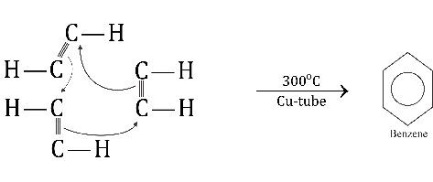

D. Acidic Nature of Alkynes

In ethyne and other terminal alkynes like propyne, the hydrogen atom is bonded to the carbon atom with sp-s overlap. An sp hybrid orbital has 50% s-character in it and renders the carbon atom more electronegative than sp2 and sp3 hybridized carbons. As a result, the sp hybridized carbon atom of a terminal alkyne pulls the electrons more strongly making the attached hydrogen atom slightly acidic.

H C C≡ ä- Hä+

1. When 1-alkyne or ethyne is treated with sodamide in liquid ammonia or passed over molten sodium .alkynides or acetylides are obtained.

R C CH + NaNH≡ 2 →liqNH3 R C CNa +NH≡ - + 3

HC CH + 2Na≡ → Na C CNa +H+ - ≡ - + 2

Sodium acetylide

Sodium acetylide is a very valuable reagent for chemical synthesis and is essentially ionic in nature. Acetylides of copper and silver are obtained by passing acetylene in the ammoniacal solution of cuprous chloride and silver nitrate respectively.

HC ≡CH + Cu Cl +2NH OH2 2 4 → CuC ≡CCu+2NH Cl +2H O4 2

Dicopperacetylide

(Reddish brown ppt.)

HC CH + 2AgNO +2NHOH≡ 3 4 → AgC CAg+2NHNO +2HO≡ 4 3 2

Disilver acetylide (white ppt.)

Silver and copper acetylides react with acids to regenerate alkynes.

AgC ≡CAg + H SO (dil.)2 4 → ≡HC CH + Ag SO2 4

AgC ≡CAg + 2HNO (dil.)3 →HC ≡CH + 2AgNO3

These alkynides are used for the preparation, purification, separation, and identification of alkynes.

8.5.5 Uses of Ethyne

Ethyne is used:

1. in oxyacetylene torch which is in turn used for welding and cutting metals.
2. for the preparation of alcohols, acetic acid and acetaldehyde.
3. for the manufacture of polymers like PVC, polyvinyl acetate, polyvinyl ethers, orlon and neoprene rubber.
4. to prepare acetylene tetrachloride a solvent for varnishes, resins, and rubber.
5. for ripening of fruits.

8.5.6 Comparison of Reactivities of Alkanes, Alkenes and Alkynes

The general decreasing reactivity order of alkanes, alkenes and alkynes is as follows:

Alkenes > Alkynes > Alkanes

It has already been explained that a p-bond in alkenes is not only weak but its electrons are more exposed to an attack by an electrophilic reagent. Both these facts make the alkenes a very reactive class of compounds.

Alkynes although contain two p-bonds are less reactive than alkenes towards electrophilic reagents. This is because the bond distance between the two triple bonded carbon atoms is very short and hence the p -electrons are not available to be attacked by electrophilic reagents.Alkynes are, however, more reactive than alkenes towards nucleophilic reagents.

KEYPOINTS

1. Hydrocarbons are made up of carbon and hydrogen only. Saturated hydrocarbons are called alkanes. They do not contain functional groups.
2. Alkanes react with halogens by a free radical mechanism to give haloalkanes. Then mechanism consists of three steps, initiation, propagation and termination.
3. Alkenes are unsaturated hydrocarbons with at least one C=C. The double bond is composed of a s and a p bond. Carbon atoms in alkenes are sp2 hybridized.
4. Alkenes are very reactive compounds. They undergo electrophilic reactions very easily.
5. Addition of unsymmetrical reagent to an unsymmetrical alkene takes place in accordance with the Markownikov's rule.
6. Alkenes can be very easily oxidized with cold KMnO4 solution, O2 or ozone. With ozone both the bonds between carbon atoms are cleaved.
7. Hydrocarbons containing a triple bond are known as alkynes or acetylenes.
8. Alkynes undergo addition reactions and two molecules of a reagent are added in it.
9. Ethyne and other terminal alkynes contain a weakly acidic hydrogen and they react with ammoniacal cuprous chloride and ammoniacal silver nitrate to give acetylides
10. The decreasing reactivity order of alkanes, alkenes and alkynes are as follows:

Alkenes > Alkynes > Alkanes

CHAPTER

## 15 COMMON CHEMICAL INDUSTRIES IN PAKISTAN

|  |
| --- |
| **In This Chapter You Will Learn:** |
| A brief description of the processes alongwith flow sheet diagrams and the reactions involved in the important industries like fertilizers, cement and paper. |

### 15.1 INTRODUCTION

Pakistan had an almost negligible industrial base at the time of its creation in l947. For the past 55 years the country has undergone a structural change from a purely agrarian economy to a semi-chemical industrial state. Pakistan has developed most of the consumer goods industries. Heavy industries like iron, fertilizer, cement and paper are also on the road to development.

The natural resources are being exhausted with growing population and increase in the standard of living all over the world. To meet this situation the scientists and technologists are busy in the development of the substitute materials from cheaper and reusable sources, e.g. the natural fibres like cotton, silk, wool cannot meet the clothing requirements of the world, therefore, scientists have developed the artificial fibres.

Similarly, crop yield has been increased by the development of the fertilizers, pesticides and herbicides to meet the world food requirements. All these materials require their chemical preparation on industrial scales. In fact the magnitude of chemical industry of a country is a measure of its economic development and progress. Different chemical industries such as fertilizer, cement and paper are developing very fast in Pakistan.

### 15.2 FERTILIZERS

#### 15.2.1 Early History

Agriculture has been one of the oldest industry known to man. The use of manure as a fertilizer dates back to the beginning of agriculture. Since 5000 B.C, the Chinese have been using animal manure in their fields. A manure is an organic material used to fertilize land and it usually consists of faeces and urine of domestic livestock.

The first prerequisite to the use of fertilizers was an understanding of the function of plant nutrients in plant growth. Compounds of these elements namely nitrogen, phosphorus and potassium are considered to be the most important nutrients essential for plant growth.The elements, like sulphur, magnesium and calcium are considered of secondary importantance **15.2.2 What are Fertilizers**

Fertilizers are the substances added to the soil to make up the deficiency of essential elements like nitrogen, phosphorus and potassium (NPK) required for the proper growth of plants. Fertilizers enhance the natural fertility of the soil or replenish the chemical elements taken up from soil by the previous crops.

### 15.3 ELEMENTS ESSENTIAL FOR PLANT GROWTH

Plants need nutrients from the soil for a healthy growth.The elements essential for the plant growth can be classified as micro-nutrients and macro- nutrients.

#### 15.3.1 Micro-nutrients (Trace elements)

|  |
| --- |
| 2 3 |

The nutrients which are required in a very small amount for the growth of plant, are called micro-nutrients. These include Boron, Copper, Iron, Manganese, Zinc, Molybdenum and Chlorine.

Only minute amounts of these elements are needed for healthy plant growth and it may be dangerous to add too much quantity because they are poisonous in larger quantities. These are generally required in quantities ranging from 6 grams to 200 grams per acre.

#### 15.3.2 Macro-nutrients

The nutrients which are required in a large amount for the growth of plants, are called macro-nutrients. These include Nitrogen, Phosphorus, Potassium, Calcium, Magnesium, Sulphur, Carbon, Hydrogen and Oxygen.These are generally required in quantities ranging from 5 kg to 200 kg per acre.

#### 15.3.3 Requirement of a Fertilizer

Every compound of the desired elements cannot be a fertilizer. The desired elements should be present in the compound in a water soluble form (so that the plant can take it up) readily available to the plants.The compound employed as fertilizer should be stable in soil as well as in storage e.g., it should not be deliquescent or set to hard stony materials with time. Above all it should be cheap to manufacture.

#### 15.3.4 Essential Qualities of a Good Fertilizer

The essential requisites of a good fertilizer are:

1. The nutrient elements present in it must be readily available to the plant.
2. It must be fairly soluble in water so that it thoroughly mixes with the soil.
3. It should not be injurious to plant.
4. It should be cheap.
5. It must be stable so that it is available for a longer time to the growing plant.
6. It should not alter the pH of the soil.
7. By rain or water, it should be converted into a form, which the plant can assimilate easily.

### 15.4 CLASSIFICATION OF FERTILIZERS

Fertilizers are classified according to the nature of the elements like nitrogen, phosphorus and potassium which they provide to the soil. This classification gives the following types of fertilizers.

i) Nitrogeneous fertilizers ii) Phosphatic fertilizers

iii) Potassium fertilizers

#### 15.4.1 Nitrogeneous Fertilizers

These fertilizers supply nitrogen to the plants or soil. Nitrogen is required during the early stage of plant growth for the development of stems and leaves. It is the main constituent of protein, imparts green colour to the leaves and enhance the yield and quality of the plants. Some of the examples of nitrogen fertilizers are: - ammonium sulphate, calcium ammonium nitrate, basic calcium nitrate, calcium cyanamide, ammonia, ammonium nitrate, ammonium phosphate, ammonium chloride and urea.

#### (i) Ammonia (NH3) as a Fertilizer

Ammonia is used in liquid state while all the other fertilizers are used in the solid form. All the nitrogen fertilizers except calcium nitrate, sodium nitrate and potassium nitrate make the soil acidic but this acidity can easily be controlled through liming of the soil (by the addition of lime) at regular intervals.

|  |
| --- |
| 4 5 |

liquid ammonia has become an important fertilizer for direct application to soil. It contains 82% nitrogen and it is injected about 6 inches under the surface of soil to avoid it from seeping out. **(ii) Urea (NH2- CO - NH2)**

Urea is a high quality nitrogeneous fertilizer.It contains about 46% nitrogen and is the most concentrated solid nitrogen fertilizer.It is the most widely used nitrogen fertilizer in Pakistan. **Manufacturing Process**

Urea is produced by the reaction of liquid ammonia with gaseous carbon dioxide. Following steps are involved in the manufacture of urea.

i) Preparation of Hydrogen and Carbon dioxide ii) Preparation of Ammonia

iii) Preparation of Ammonium Carbamate iv) Preparation of Urea

v) Concentration of Urea. vi) Prilling

#### Preparation of Ammonium Carbamate

Gaseous CO2 is mixed with ammonia in the volume ratio of 1:2 in a reactor to produce ammonium carbamate.

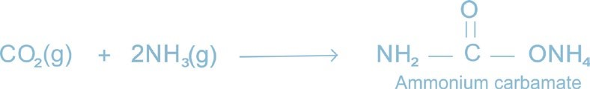

#### Preparation of Urea

Dehydration of ammonium carbamate gives urea.

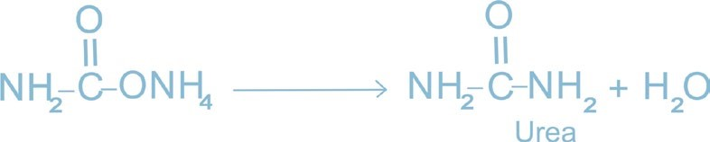

#### Concentration of Urea Solution

The urea solution is concentrated in an evaporation section where water is evaporated by heating with steam under vacuum in two evaporation stages whereby 99.7% urea melt is obtained.

It is then pumped to prilling tower.

#### Prilling

The molten urea is sprayed at the prilling tower by means of prilling bucket where it is cooled by the air rising upward. Molten droplets solidify into the form of prills. Urea prills thus produced are either sent to the bagging section or to the bulk storage, Fig. 15.1.

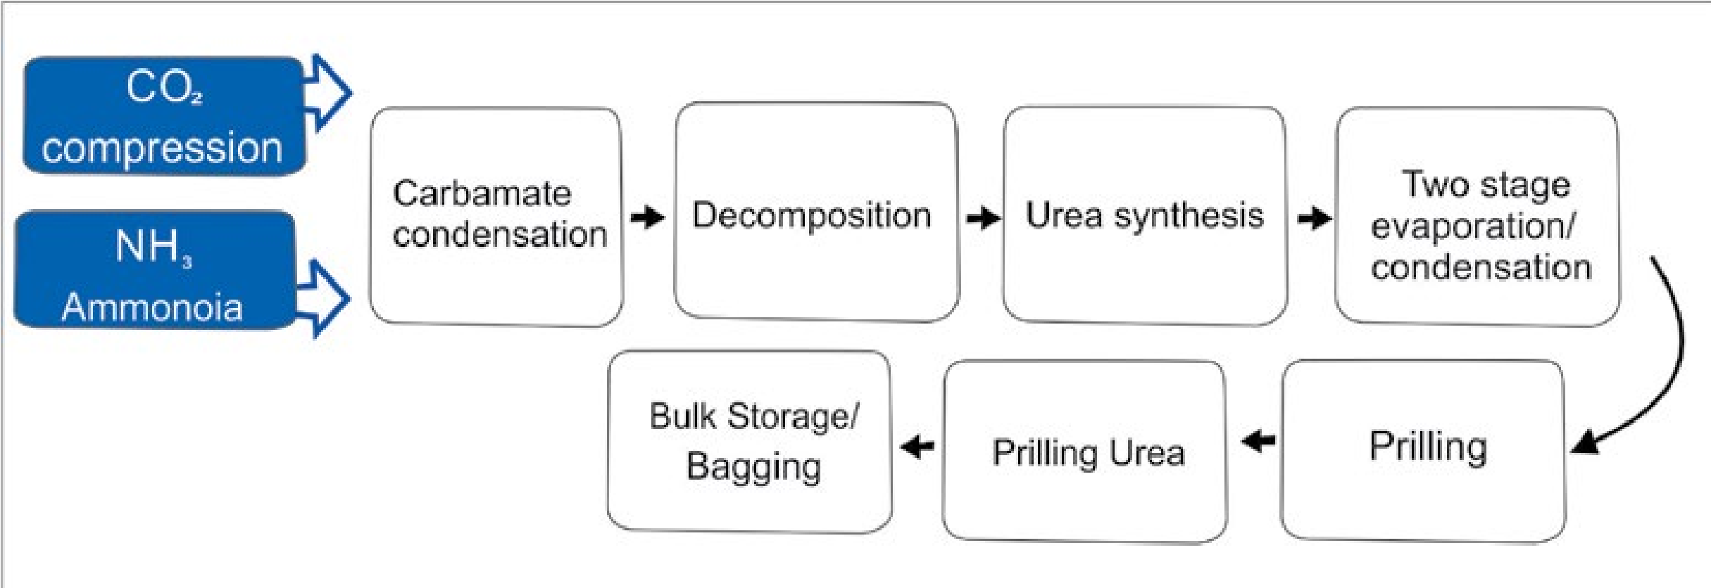

*Fig. 15.1 Flow sheet diagram for manufacture of urea*

#### (iii) Ammonium Nitrate (NH4NO3)

It is manufactured by the neutralization reaction between ammonia and nitiic acid as given below.

|  |
| --- |
| 7 |

### NH (g) + HNO (g) 3 3 → NH NO (s)4 3

After neutralization, the water is evaporated. The solid ammonium nitrate is melted and then sprayed down from a tall tower. The falling droplets are dried by an upward current of air. The fertilizer solidifies as tiny, hard pellets called prills. Prills of fertilizers are free of dust, easy to handle and easy to spread on the field.Ammonium nitrate contains 33 33.5% nitrogen.

It is a useful fertilizer for many crops except paddy rice because the microbial bacteria in flooded fields decomposes it to nitrogen gas. It is also used in combination with limestone. It is hygroscopic in nature.

#### 15.4.2 Phosphatic Fertilizers

These fertilizers provide phosphorus to the plants or soil. Phosphorus is required to stimulate early growth to accelerate the seed and fruit formation during the later stages of growth. It also increases resistance to diseases. The various phosphatic fertilizers have different compositions, due to which they have different solubilities. The two most important water soluble fertilizers are super phosphate (calcium super phosphate) Ca(H2PO4)2and triple phosphate (diammonium- phosphate (NH4)2HPO4). **(i) Diammonium Phosphate (NH4)2HPO4**

This compound of fairly high purity is prepared by continuous process that consists of reacting anhydrous ammonia gas and pure phosphoric acid at 60 - 70 °C and pH 5.8 - 6.0.

#### 2NH (g) + H PO (l3 3 4 ) → (NH ) HPO + heat4 2 4

It is an exothermic reaction. The heat of reaction vaporizes water from the liquor and the crystals of diammonium phosphate are taken out, centrifuged, washed and dried. It contains 16% nitrogen and 48% P2O5. This product contains about 75% plant nutrients and is deemed suitable for use either alone or in mixed with other fertilizers.

##### 15.4.3 Potassium Fertilizers

These fertilizers provide potassium to the plant or soil. Potassium is required for the formation of starch, sugar and the fibrous material of the plant. They increase resistance to diseases and make the plants strong by helping in healthy root development. They also help in ripening of seeds, fruits and cereals. Potassium fertilizers are especially useful for tobacco, coffee, potato and corn.

##### (i) Potassium Nitrate (KNO3)

On industrial scale it is prepared by the double decomposition reaction between sodium nitrate and potassium chloride. NaNO (aq) + KCl(aq)3 → NaCl(aq) + KNO (aq)3

A concentrated hot solution of sodium nitrate is prepared and solid potassium chloride is added into it. On heating, the potassium chloride crystals change into sodium chloride crystals, and the hot potassium nitrate is run through the sodium chloride crystals at the bottom of the kettle. A little water is added to prevent further deposition of sodium chloride as the solution is cooled, which results into a good yield of pale yellow solid potassium nitrate.It contains 13% nitrogen and 44% potash.

###### 15.4.4 Fertilizer Industry in Pakistan

Pakistan is essentially an agricultural country. In order to keep up the production of agricultural commodities and to compensate for the depletion of nutrients which get exhausted by repeated cultivation, the urea fertilizer has gained importance.

For a developing country like Pakistan, there is an ever-growing demand for urea fertilizer. Government of Pakistan is trying its utmost to narrow the gap between supply and demand of fertilizers. Consistant efforts have been made to instal fertilizer manufacturing plants. At present, there are about 14 fertilizer plants in private as well as public sectors in the country which are manufacturing different types of fertilizers.

8 9

The total production of urea fertilizer in 2002 in Pakistan is about 56,30,100 metric tons/annum

##### 15.5 CEMENT

###### 15.5.1 Early History

Cement is a very important building material which was first introduced by an English Mason Joseph Aspdin. He found it when strongly heated mixture of limestone and clay was mixed with water and allowed to stand, it hardened to a stone like mass which resembled Portland rock; a famous building stone of England. Since then the name of **Portland Cement** is given to the mixture of lime (obtained from limestone), silica, iron oxide and alumina.

This was the start of Portland cement industry, as we know today. The cement is now low in cost, as it is applied everywhere in the construction of houses, public buildings, roads, industrial plants, dams, bridges and many other structures.

###### 15.5.2 Definition

Cement is the material obtained by burning an intimate mixture of calcarious and argillaceous materials at sufficiently high temperature to produce clinkers. These clinkers are then ground to a fine powder.

The essential constituents are lime (obtained from limestone) silica and alumina (present in clay).

15.5.3 Raw Materials

The important raw materials used for the manufacture of cement are:

1. Calcarious material (limestone, marble, chalks, marine shell) as source of CaO.
2. Argillaceous material (clay, shale, slate, blast furnace slag) They provide acidic components such as aluminates and silicates,
3. Other raw material being used is gypsum.

10

**An average composition of a good sample of Portland cement is as follows:**

|  |  |
| --- | --- |
| **Compound** | **%age** |
| Lime (CaO)  Silica (SiO2) Alumina (AI2O3)  Magnesia (MgO)  Iron oxide (Fe2O3)  Sulphur trioxide (SO3)  Sodium oxide (Na2O)  Potassium oxide (K O) | 62  22  7.5 2.5 2.5 1.5 1.0  1.0 |

2

15.5.4 .Manufacturing Process of Cement

The manufacturing process of cement involves either a dry process or a wet process. The choice of dry or wet process depends on the following factors.

1. Physical condition of the raw materials.
2. Local climatic conditions of the factory.
3. The price of the fuel.

In Pakistan most of the factories use wet process for the production of cement. Dry process needs excessive fine grinding and it is more suited for the hard material, Wet process, on the other hand, is free from dust, grinding is easier and the composition of the cement can easily be controlled.

15.5.5 Wet Process

In this process grinding is done in the presence of water. There are five stages in the manufacture of Portland cement Fig. 15.2.

1. Crushing and grinding of the raw material.
2. Mixing the material in correct proportion.
3. Heating the prepared mixture in a rotary kiln.
4. Grinding the heated product known as clinker.
5. Mixing and grinding of cement clinker with gypsum.

11

1. Crushing and Grinding

Soft raw materials are first crushed into a suitable size, often in two stages, and then ground in the presence of water, usually in rotating cylindrical ball or tube mills containing a charge of steel balls.

2. Mixing of Raw Material

The powdered limestone is then mixed with the clay paste in proper proportion (limestone 75%, clay 25%); the mixture is finely ground and made homogeneous by means of compressed air mixing arrangement. The resulting material is known as slurry. The slurry, which contains 35 to 45% water, is sometimes filtered to reduce the water content from 20 to 30% and the filler cakes are stored in storage bins. This reduces the fuel consumption for heating stage.

1. K +2OH+ →2KOH

   This reaction has limited synthetic applications as it forms a number of side products.