## CHAPTER 10 ELECTROCHEMISTRY

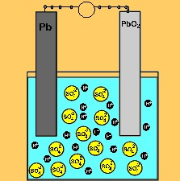

Animation 10.1: ELECTROCHEMICAL CELLS

Source & Credit: [dynamicscience](http://www.dynamicscience.com.au/)

### INTRODUCTION

Electrochemistry is concerned with the conversion of electrical energy into chemical energy in electrolytic cells as well as the conversion of chemical energy into electrical energy in galvanic or voltaic cells.

In an electrolytic cell, a process called electrolysis takes place. In this process electricity is passed through a solution or the fused state of electrolyte. The electricity provides suicient energy to cause an otherwise non-spontaneous oxidation-reduction reaction to take place. A galvanic cell, on the other hand, provides a source of electricity. This source of electricity results from a spontaneous oxidation-reduction reaction taking place in the solution.

First of all, we should learn, the theoretical background of oxidation and reduction reaction and try to understand the balancing of equation.

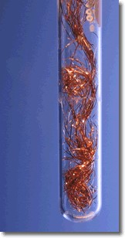

*Animation 10.2: ELECTROCHEMISTRY*

*Source & Credit :*

[*spirits*](https://www.spiritsd.ca/curr_content/chem30_05/6_redox/redox_index.htm)

[*d*](https://www.spiritsd.ca/curr_content/chem30_05/6_redox/redox_index.htm)

#### 10.1 OXIDATION STATE AND BALANCING OF REDOX EQUATIONS

**10.1.1 Oxidation Number or State**

It is the apparent charge on an atom of an element in a molecule or an ion. It may be positive or negative or zero.

**Rules for Assigning Oxidation Number**

1. The oxidation number of all elements in the free state is zero. This is often shown as a zero

written on the symbol. For example, Ho 2 , Nao , Mgo .

1. The oxidation number of an ion, consisting of a single element, is the same as the charge on the ion. For example, the oxidation number of K+, Ca2+, Al3+ , Br- , S2- are + 1, +2, +3, -1, -2, respectively.
2. The oxidation number of hydrogen in all its compounds except metal hydrides is +1. In metal hydrides it is -1. (Na+H- , Mg2+ H2(-1)2)
3. The oxidation number of oxygen in all its compounds except in peroxides, OF2 and in super oxides is -2. It is -1 in peroxides +2 in OF2 and -1/2 in super oxides.
4. In neutral molecules, the algebraic sum of the oxidation numbers of all the elements is zero.
5. In ions, the algebraic sum of oxidation number equals the charge on the ion.
6. In any substance the more electronegative atom has the negative oxidation number.

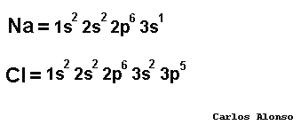

*Animation 10.3: Oxidation Number*

*Source & Credit :*

[*alonsoformul*](http://www.alonsoformula.com/inorganic/numero_oxidacion.htm)

[*a*](http://www.alonsoformula.com/inorganic/numero_oxidacion.htm)

**10.1.2 To Find Oxidation Number of an Element in a Compound or a Radical**

The oxidation number or state of any atom of an element present in a compound or a radical can be determined by making use of the above said rules.

**Example 1:**

Calculate the oxidation number (O.N) of manganese in KMnO4 .

**Solution**

(Oxidation number of K) + (oxidation number of Mn )+4 (oxidation number of O) = 0

|  |  |
| --- | --- |
| Where oxidation number of K | = +1 |
| oxidation number of O | = -2 |
| Let oxidation number of Mn  Putting these values in the above equation. | = x |
| (+1) + x + 4(-2) | = 0 |
| or x | = +7 |

Thus the oxidation state of Mn in KMnO4 is + 7.

**Example 2:**

Calculate the oxidation number (O.N) of sulphur in SO42- .

**Solution**

[oxidation number of S] + 4[oxidation number of O ] = -2 x + 4 (-2 ) = -2 x = +6

Thus the oxidation number of sulphur in SO42-is + 6 .

**10.1.3 Balancing of Redox Equations by Oxidation Number Method**

Carry out the following steps for balancing of redox equations by oxidation number method. (i) Write down the skeleton equation of the redox reaction under consideration.

1. Identify the elements, which undergo a change in their oxidation number during the reaction.
2. Record the oxidation number above the symbols of the element, which have undergone a change in the oxidation number.
3. Indicate the change in oxidation number by arrows joining the atoms on both sides of the equation. It shows number of electrons gained or lost.
4. Equate the increase or decrease in the oxidation number, i.e. electrons gained or lost by multiplying with a suitable digit.
5. Balance the rest of the equation by inspection method.

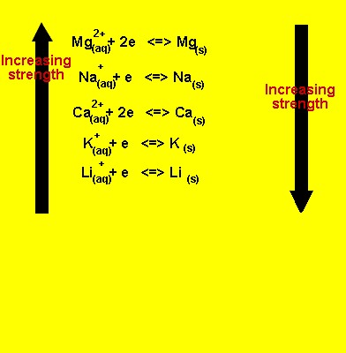

*Animation 10.4: Redox reation*

*Source & Credit :*

[*dynamicscienc*](http://www.dynamicscience.com.au/tester/solutions1/chemistry/redox/oxidisinreducinstrengthspontaneous.htm)

[*e*](http://www.dynamicscience.com.au/tester/solutions1/chemistry/redox/oxidisinreducinstrengthspontaneous.htm)

**Example 3:**

Balance the following equation by oxidation number method.

K Cr O + HCl2 2 7 → KCl + CrCl + Cl + H O3 2 2

**Solution**

Let us balance the equation stepwise:

1. Write the equation with the oxidation number of each element

(+1)2 (+6)2 (-2)7 +1 -1 +1 -1 +3 (-1)3 (+1)2 -2

K Cr O + HCl2 2 7 → KCl + CrCl + Cl3 2o + H O2

2 . Identify, those elements whose oxidation numbers have changed. Equation shows that Cr goes from + 6 to +3 and it is reduced. Cl goes from -1 to zero and is oxidized. Moreover, the oxidation number of chlorine remains the same, i.e from -1 to -1 when KCl and CrCl3 are produced. So, we should write HCl, twice on the left hand side. One of HCI on left side shows those Cl atoms which do not change their oxidation numbers Other HCI shows those Cl atoms which undergo a change in their oxidation numbers.

reduction

-1

+6

-1

o

+3

-1

-1

2

2

7

3

2

2

HCl + KCrO + HCl

KCl + CrCl + Cl+ HO

→

(

does not change oxidation number)

oxidation

1. Draw the arrows between the same elements whose oxidation numbers have changed. Also, point out the change in oxidation number. Cr has changed its oxidation number from + 6 to + 3 and chlorine has changed from -1 to zero . It means 6 electrons have been gained by two Cr atoms and 1 electron has been lost by 1 chlorine atom.

(1

e

-

oxidation

)

+6

-1

o

7

2

2

3

2

2

HCl + K Cr O + HCl

KCl + CrCl + Cl+ HO

→

2(+3

e

-

+6e

)=

-

reduction

1. In order to balance the number of electrons lost and gained multiply HCl with six. In this way, the 6 electrons lost by 6 Cl- will be gained by 2Cr+6 to give 2Cr+3. But do not multiply other HCl molecules with anything at this moment.

HCl + K Cr O + 6HCl2 2 7 → KCl + CrCl + Cl + H O3 2 2

1. Let us, balance Cr atoms by multiplying CrCl3 by 2 . Balance Cl2 on right hand side, whose oxidation number has changed by multiplying it with 3. In this way, the atoms which have been oxidized and reduced get balanced.

HCl + K Cr O + 6HCl2 2 7 → KCl + 2CrCl + 3Cl + H O3 2 2

6 . To balance K atoms, multiply KCl by 2.

HCl + K Cr O + 6HCl2 2 7 → 2KCl + 2CrCl + 3Cl + H O3 2 2

7. Now balance those atoms of chlorine which have not been oxidized or reduced. There are 8 such chlorine atoms on the right hand side with KC1 and 2CrCl3. So multiply HCl with eight. This HCl has produced KCl and CrCl3 .

8HCl + K Cr O + 6HCl2 2 7 → 2KCl + 2CrCl + 3Cl + H3 2 2O

8 . Balance the rest of the equation by inspection method. To balance O atoms multiply H2O with 7.

8HCl + K Cr O + 6HCl2 2 7 → 2KCl + 2CrCl + 3Cl + 7H O3 2 2

or

K Cr O + 14HCl2 2 7 → 2KCl + 2CrCl + 3Cl + 7H O3 2 2

This is the inal balanced equation.

**10.1.4 Balancing of Redox Equations by Ion-Electron Method**

The balancing of redox equations by the loss and gain of electrons, usually involves quite a few ions, which do not undergo change in valence and which are not really necessary for the process of balancing. The ion-electron method eliminates all the unnecessary ions and retains only those, which are essential. Following, are the general rules for balancing the redox equations by ion-electron method.

1. Write a skeleton equation that shows only those substances that are actually involved in the reaction.
2. Split the equation into two half reactions, one showing oxidation half reaction and the other reduction half reaction.
3. The element should not be written as a free atom or ion unless it really exists as such. It should be written as a real molecular or ionic species.
4. Balance each partial equation as to the number of atoms of each element. In neutral or acidic solution, H2O or H+ ions may be added for balancing oxygen and hydrogen atoms. Oxygen atoms are balanced irst. If the solution is alkaline, OH- may be used for each excess oxygen on one side of the equation.
5. Balance each half reaction as to the number of charges by adding electrons to either the left or the right side of the equation.
6. Multiply each half reaction by a number chosen so that the total number of electrons lost by the reducing agent equals the number of electrons gained by the oxidizing agent
7. Add the two half reactions. Count the number of atoms of each element on each side of the equation and also check the net charge on each side, which should be equal on both sides.

Balancing of redox equations by ion-electron method, making use of the above rules. There are two types of such reactions Le. in acidic medium and basic medium. Now, let us discuss one example of each.

**Example 4: (acidic medium)**

Balance the equation for the reaction of HCl with KMnO4 where Cl- is oxidized to Cl2 and MnO4- is reduced to Mn[1]+. The skeleton equation which does not contain either H+ or H2O, is

**Solution** Cl +MnO- 4- → Cl +Mn2 2+

It is clear that Cl- is oxidized to Cl2 and MnO1-4 reduces to Mn2+

Splitting the equation into half-reactions,

Oxidation half reaction

Cl- → Cl

Balancing atoms on both sides of oxidation half reaction.

2Cl- → Cl2 ............. (1)

Now, balance the reduction half reaction. To balance O-atoms, add 4H2O on R.H.S. and to balance H-atoms add 8H+ on L.H.S. The reason is that medium is acidic.

8H +MnO+ 4- → Mn2+ +4H O ............. 2 (2)

Balancing the charges by adding electrons in equation (1) and (2), we get (3) and (4).

2Cl- → Cl2 + 2e- .............. (3)

8H + MnO + 5e+ 4- - → Mn2+ + 4H O ......... (4)2

For making the number of electrons lost in irst equation equal to the number of electron gained in the second equation, multiply the irst equation by 5 and second by 2. After adding both equations and cancelling the common species on both sides, balanced equation is obtained.

[2Cl- → Cl +2e ]x52 -

[5e- + 8H + MnO+ 4- → Mn2+ + 4H O]x2 2

10Cl- +16H + 2MnO+ 4- → 5Cl + 2Mn2 2+ + 8H O2

**Example 5: (basic medium)**

Balance the following equation in basic aqueous solution by ion-electron method.

MnO1-4(aq)+C O2 42-(aq)+H O2 → MnO (s)+CO (g)+OH (aq)2 2 -

**Solution**

The following steps are involved in balancing of equation in basic aqueous solution by ionelectron method.

(i) Identify those elements, which undergo change in oxidation number by writing number above each element.

+ −7 8 ( 3)2+ − 8 + −2 2 + −4 4 + −4 4 − +2 (1)

##### (MnO ) +(C O ) H O4 1- 2 4 2- 2 → MnO + CO + (OH)2 2 1-

The elements undergoing a change in oxidation number are Mn and C.

(ii) Split the reaction into two half reactions, the oxidation and reduction half reactions.

CO2 42- →CO2(oxidation half reaction)

MnO4-1 →MnO2(reduction half reaction)

The elements undergoing a change in oxidation number are Mn and C.

(ii) Split the reaction into two half reactions, the oxidation and reduction half reactions.

C O2 42- →CO2(oxidation half reaction)

MnO4-1 →MnO2(reduction half reaction)

**Balancing of Oxidation Half Reaction:**

CO2 4-2 →CO2

Balancing the C atoms in both sides of the half reaction.

CO2 4-2 →2CO2

Balancing the charges on both sides of the half reaction by adding the appropriate number of electrons to the more position side.

C O2 4-2 → 2CO2 + 2e- ....... (1)

The oxidation half reaction is balanced.

**Balancing of Reduction Half Reaction:**

MnO4- →MnO2

Balance in O-atoms by adding OH- ions on the side needing the oxygen. Add two OH- ions for each oxygen atom needed. So, we have to add 4OH- on R.H.S:

##### MnO4- →MnO 4OH2 + -

Balance the hydrogen, by adding H2O on the other side of the half reaction. Add one H2O for each two OH- ion. In this way, oxygen and hydrogen atoms are balanced.

2H O + MnO2 4- → MnO2 + 4OH-

Balance the charges by adding three electrons to L.H.S. of equation

3e + 2H O + MnO- 2 4- → MnO2 + 4OH- ....... (2)

The reduction half reaction is balanced.

1. Multiply each half reaction by an appropriate number, so that the number of electrons on both the half reactions becomes equal. For this purpose, multiply the oxidation half reaction by 3 and the reduction half reaction by 2.

3C O2 4-2 → 6CO2 + 6e- ........ (3)

2 x [3e + 2H O + MnO- 2 4- → MnO2 + 4OH-]

6e + 4H O + 2MnO- 2 4- → 2MnO2 + 8OH- ........ (4)

1. Add the two half-reactions to get the net ionic equation and cancel out anything appearing on both sides of the equation. For this purpose, add equation and equation (4).

3C O2 4-2 → 6CO2 + 6e-

6e + 4H O + 2MnO- 2 4- → 2MnO2 + 8OH-

3C O2 42- + 4H O + 2MnO2 4- → 6CO2 + 2MnO2 + 8OH-

Hence, the balance ionic equation is

2MnO4 (- aq) + 3C O2 42- + 4H O 2 → 2MnO2(s) + 6CO2(g) + 8OH-

(aq)

##### 10.2.0 ELECTROLYTIC CONDUCTION

We know, that most metals are conductors of electricity because of the relatively free movement of their electrons throughout the metallic lattice. This electronic conduction is simply called metallic conduction.

Electrolytes in the form of solution or in the fused state have the ability to conduct electricity. In this case, the current is not carried by free electrons through the solution or through the fused electrolyte. Here, the current is carried by ions having positive and negative charges. These ions are produced in the solution or in fused state due to ionization of the electrolyte. Ionization is the process in which ionic compounds when fused or dissolved in water split up into charged particles called ions.

PbBr 2 (s) ฀ ฀฀฀฀฀฀฀฀฀fused Pb2+ (aq) + Br - (aq)

NaCl (s) ฀ ฀฀฀฀฀฀฀H O2 ฀ Na + (aq) + Cl - (aq)

Two electrodes are dipped in the solution of an electrolyte and electrolysis takes place. This forms an electrolytic cell An electrolytic cell is an electrochemical cell in which electric current is used to drive a non-spomaneous reaction. When a non-spontaneous reaction takes place at the expense of electrical energy, the process is called electrolysis. During this non-spontaneous reaction, the substances are deposited at respective electrodes and electrolyte is decomposed. Examples of electrolytic cells are Down’s cell and Nelson’s cell, etc.

**10.2.1 Electrochemical Cells**



*Animation 10.5: ELECTROCHEMICAL CELLS*

*Source & Credit :*

[*dynamicscienc*](http://www.dynamicscience.com.au/tester/solutions1/chemistry/redox/electrochemical%20cell1.htm)

[*e*](http://www.dynamicscience.com.au/tester/solutions1/chemistry/redox/electrochemical%20cell1.htm)

**10.2.2 Electrolytic Cells.**

Look at the arrangement as shown in Fig. (10.1). It represents, an electrolytic cell, The electrolyte consists of positive and negative ions which are free to move in the solution. When a direct current (D.C) source is connected to the electrodes of the cell, each electrode acquires an electric charge. Thus, on applying electric potential, the positive ions migrate towards the negative electrode, called cathode and the negative ions move towards the positive electrode, called the anode.

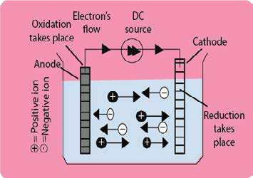

Ftg (10.1) The migration of ions in electrolytic cell

This movement of ionic charges through the liquid brought by the application of electricity is called electrolytic conduction and the apparatus used is known as electrolytic cell.

When electrolytic conduction occurs, electrochemical reactions takes place. The ions in the liquid come in contact with the electrodes. At the anode the negative ions give up electrons and are, therefore, oxidized. At the cathode the positive ions pick up electrons and are reduced. Thus during electrolytic conduction, oxidation takes place at the anode and the reduction takes place at the cathode. The liquid will continue to conduct electricity only as long as oxidation-reduction reactions, occurring at the electrodes, continue.

The electrochemical reactions that occur at the electrodes during the electrolytic conduction constitute the phenomenon of electrolysis.

###### **Table (10.1a) Products of electrolysis**

(using inert electrodes of platinum or graphite)

|  |  |  |
| --- | --- | --- |
| Electrolyte | Cathode | Anode |
| PbBr2(molten)  NaCl(molten)  NaCl(aq)  CuCl (aq)2  CuSO (aq)4  KNO (aq)3 NaOH(aq)  H SO (aq)2 4 | Pb(s)  Na(s)  H (g)2  Cu(s)  Cu(s)  H (g)2  H (g)2  H (g)2 | Br (g)2 Cl (g)2  Cl (g)2  Cl (g)2  O (g)2  O (g)2  O (g)2  O (g)2 |

When a molten salt is electrolyzed , the products a re predictable. When an aqueous solution of a salt is electrolyzed, hydrogen and oxygen appear at the cathode and anode, respectively in certain cases. The products formed from a few electrolytes are shown in Table (10. 1).

**Table (10.1b) Products of electrolysis** (when electrodes take part in the reaction)

|  |  |  |
| --- | --- | --- |
| Electrolyte | Copper cathode | Copper anode |
| CuSO4(aq) | Cu deposits | Cu (s) dissolves to form CU2- ions |
| Electrolyte | Silver cathode | Silver anode |
| AgNO3(aq) and HNO3(aq) | Ag deposits | Ag (s) dissolves to form Ag+ ions |

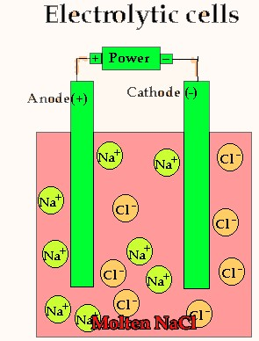

*Animation 10.6: Electrolytic Cells*

*Source & Credit :*

[*dynamicscienc*](http://www.dynamicscience.com.au/tester/solutions1/chemistry/redox/Electrolysis.htm)

[*e*](http://www.dynamicscience.com.au/tester/solutions1/chemistry/redox/Electrolysis.htm)

**10.2.3 Explanation of Electrolysis**

**(a) Fused Salts**

When a fused salt is electrolyzed, the metal ions called cations arrive at the cathode which being negatively, charged supply electrons to them and thus discharge the cations. The anions move towards the anode, give up their electrons and are thus discharged. In the case of fused lead chloride, the equations for electrode processes are given as under.

At anode: Pb2+( ) + 2e- → Pb(s) (oxidation)

At cathode: 2Cl-( ) → Cl2(g) +2e- (reduction)

So, oxidation happens at anode and reduction at the cathode.

Similarly, for fused NaCl and fused PbBr2 the electrolytes are decomposed during electrolysis. Fused Pb and Na are deposited at cathode and Cl2(g) and Br2 at anode.

Electrons low through the external circuit from anode to cathode. The electric current is conducted through the cell by the ions and through the external circuit by the electrons.

**(b) Aqueous Solutions of Salts**

The electrolysis of aqueous solutions is somewhat more complex. Its reason is the ability of water, to be oxidized as well as reduced. Hence, the products of electrolysis are not precisely predictable. Some, metal cations are not discharged from their aqueous solutions. While, electrolyzing aqueous sodium nitrate (NaNO3) solution, sodium ions present are not discharged at the cathode. A small concentration of hydronium and hydroxyl ions arises from the dissociation of water:

NaNO3 → Na +NO+ 3-

2H O2 ( ) → H O3 +(aq) + OH-(aq)

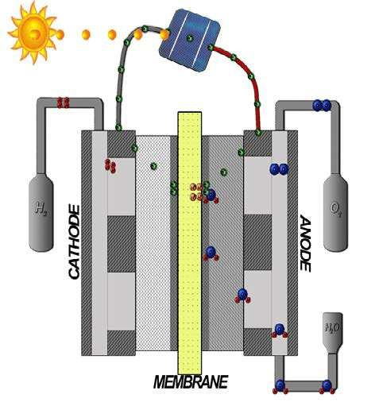

*Animation 10.7: Electrolysis*

*Source & Credit :*

[*revolv*](http://www.revolvy.com/main/index.php?s=Electrolysis&item_type=topic)

[*y*](http://www.revolvy.com/main/index.php?s=Electrolysis&item_type=topic)

Hydronium ions accept electrons from the cathode to form hydrogen atoms:

At cathode: H O3 +(aq) + e- → H(g) + H O2 ( ) (reduction)

Subsequently, hydrogen atoms combine rapidly to form hydrogen molecules at the cathode.

H(g) + H(g) → H 2(g)

So, H2 gas evolves at the cathode.

The concentration of hydronium ions is only 10-7 moles dm-3 in pure water. When these are discharged then more are formed by further dissociation of water molecules. This gives a continuous supply of such ions to be discharged. Sodium ions remain in solution, while hydrogen is evolved at the cathode. Thus, the reduction of the solute cations depends on the relative ease of the two competing reactions.

At the anode, both nitrate and hydroxide ions are present. Hydroxide ions are easier to discharge than nitrate ions. Nitrate ions remain in solution while the electrode reaction is:

At anode: OH−(aq) → OH(aq) + e- (oxidation)

The OH groups combine to give O2 gas as follows.

4OH → O2(g) + 2H O2 ( ) (anode)

So, O2 gas evolves at the anode.

But, remember that the expected order of the discharge of ions may also depend upon their concentrations.

**10.2.4 Electrolytic Processes of Industrial Importance**

Various types of electrolytic cels are employed on industrial scale. Some of the important ones are given here.

1. Extraction of sodium by the electrolysis of fused sodium chloride is carried out in Down’s cell. In this case, molten sodium chloride is electrolyzed between iron cathode and graphite anode. The cell is planted to get sodium metal commercially chlorine is obtained as a by product.

NaCl → Na+ + Cl-

(s) ( ) ( )

At anode

|  |  |
| --- | --- |
|  | ( ) (g) |
| At cathode | Cl(g) + Cl(g) → Cl2(g) |
|  | 2Na+( ) + 2e- → 2Na(s) (reduction) |

2Cl- → 2Cl + 2e- (oxidation)

By adding the two reactions at anode and cathode, the overall reaction is

2Na+( ) + 2Cl-( ) → 2Na□(s) + Cl□(g)

1. Caustic soda is obtained on industrial scale by the electrolysis of concentrated aqueous solution of sodium chloride using titanium anode and mercury or steel cathode This electrolysis is carried out in Nelson cell and Castner- Kellner cell or Hg- cell.

|  |  |  |  |
| --- | --- | --- | --- |
|  | NaCl(s) ฀ Na(aq) + Cl-(aq) |  |  |
| At anode | 2Cl-(g) → Cl2(g) + 2e- |  | (oxidation) |
| At cathode | - → - |  | (reduction) |
| 2H O2 ( ) + 2e H2(g) + 2OH (aq) | |

+

By combining, the electrode reactions and including Na+ ions, the overall reaction is

2Na+(aq) + 2Cl-(aq) + 2H O2 (l) → Cl2(g) + H2(g) + 2Na+(aq) + 2OH-

(aq)

Here, chlorine and hydrogen are obtained as by products, and Na+ is not discharged at cathode.

1. Magnesium and calcium metals are extracted by the electrolysis of their fused chlorides. Mg and Ca are collected at cathodes while Cl2 at anodes
2. Aluminium is extracted by electrolyzing fused bauxite, Al2O32H2O in the presence of fused cryolite, Na3AlF6. This process is called Hall-Beroult process.
3. Anodized aluminium is prepared by making it an anode in an electrolytic cell containing sulphuric acid or chromic acid, which coats a thin layer of oxide on- it. The aluminium oxide layer resists attack for corrosive agents. The freshly anodized aluminium is hydrated and can absorb dyes.

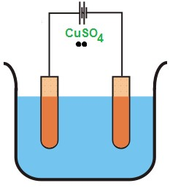

*Animation 10.8: Application of Electrolysis*

*Source & Credit :*

[*electrical4*](http://www.electrical4u.com/applications-of-electrolysis-electroplating-electroforming-electrorefining/)

[*u*](http://www.electrical4u.com/applications-of-electrolysis-electroplating-electroforming-electrorefining/)

1. Electrolyticcell can also be used for the puriication of copper. Impure copper is made the anode and a thin sheet of pure copper is made the cathode. Copper sulphate solution is used as an electrolyte. The atoms of Cu from impure Cu- anode are converted to Cu2+ions and migrate to cathode which is made up of pure Cu. In this way Cu anode is puriied. Impurities are left at anode.
2. Copper, silver, nickel and chromium plating is done by various types of electrolytic cells. One metal is deposited at the surface of another metal.

**10.2.5 Voltaic or Galvanic Cell**

A voltaic or a galvanic cell consists of two half-cells that are electrically connected. Each half cell is a portion of the total cell in which a half reaction takes place. Fig. (10.2) shows such a galvanic cell. The left half cell consists of a strip of zinc metal dipped in 1.0 M solution of zinc sulphate giving the following equilibrium:

Zn → Zn2+ +2e-

(s) (aq)

.

The right half-cell is a copper metal strip that dips into 1.0 M copper sulphate solution and the equilibrium here is represented as follows:

Cu(s) → Cu2+ +2e-

These half-cells in Fig (10.2) are connected electrically by a salt bridge. If the solutions were to mix, direct chemical reactions would take place, destroying the half-cells. The salt bridge contains an aqueous solution of potassium chloride in a gel. Zinc tends to lose electrons more readily than copper.

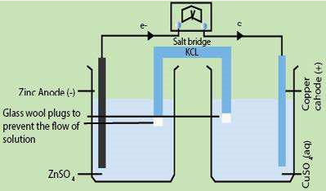

Fig (10.2) A Galvanic cell consisting of Zn and Cu electrodes at 25°C and unit concentration of electrolytic solutions.

Zn electrode takes on a negative charge relative to the copper electrode. If the external circuit is closed by connecting the two electrodes as shown in the igure, electrons low from the zinc through the external circuit to copper electrode. The following half-cell reactions occur at two electrodes and cell potential at standard conditions is 1.1volts . It is denoted by E°.

At anode Zn(s) → Zn2+(aq) +2e- (oxidation)

At cathode Cu2+(aq) +2e- → Cu(s) (reduction)

The overall voltaic cell reaction is the sum of these two half cell reactions.

Zn + Cu2+ → Zn2+ + Cu Eo =1.1V

(s) (aq) (aq) (s)

This voltaic cell can be represented as follows;

Zn(s) /Zn2+(aq)1M ฀Cu2+(aq) +1M/Cu(s) E =1.1Vo

Note that reduction occurs at the copper electrode and oxidation occurs at the zinc electrode. Sign ฀shows the presence of salt bridge.

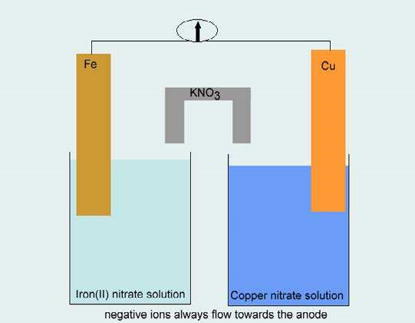

*Animation 10.9: Galvanic Cell*

*Source & Credit :*

[*dynamicscienc*](http://www.dynamicscience.com.au/tester/solutions1/chemistry/redox/galvanic.html)

[*e*](http://www.dynamicscience.com.au/tester/solutions1/chemistry/redox/galvanic.html)

**Function of Salt Bridge**

Let us, examine the purpose of the salt bridge. Since, zinc ions are produced as electrons leave the anode, we have a process which tends to produce a net positive charge in the left beaker. Actually, the concentration of Zn2+ ions increase in the left compartment. Similarly, the arrival of the electrons at the copper cathode and their reaction with copper ions tend to produce a net negative charge in the right beaker.

The purpose of the salt bridge is to prevent any net charge accumulation in either beaker by allowing negative ions to leave the right beaker, difuse through the bridge and enter the left beaker. If this difusional exchange of ions does not occur, the net charge accumulating in the beakers would immediately stop the low of electrons through the external circuit and the oxidationreduction reaction would stop.

Many other oxidation - reduction reactions can be carried out successfully in galvanic cells using diferent electrodes. It is natural to think of these cell processes as separated into two halfreactions which occur at the two electrodes. In a voltaic cell the electric current in the external circuit can be used to light a bulb, drive a motor and so on.

**Voltaic Cell is Reversible Cell**

On the other hand, if the external circuit is replaced by a source of electricity that opposes the voltaic cell, the electrode reactions can be reversed. Now, the external source pushes the electrons in the opposite direction and supplies energy or work to the cell so that the reverse nonspontaneous reaction occurs. Such, a cell is called a reversible cell.

For the zinc-copper cell, the half cell reactions are reversed to give.

Zn2+(aq) +2e- → Zn(s) (reduction)

Cu → Cu2+ +2e- (oxidation)

(s)

and the overall reaction being reversed, becomes

Zn2+ + Cu → Zn + Cu2+

(aq) (s) (s) (aq)

Oxidation occurs at the copper electrode and reduction takes place at the zinc electrode and the cell operates as an electrolytic cell in which energy from an external source drives a nonspontaneous reaction.

When a cell operates as a voltaic the electrode at which reduction occurs is called the cathode while the electrode at which oxidation takes place is called the anode. Hence in voltaic cell, Zn acts as an anode and Cu acts as a cathode.

##### 10.3.0 ELECTRODE POTENTIAL

When a metal strip is placed in a solution of its own ions, there are two tendencies. The metal atoms may dissolve as positive ions. In this way, the electrons are deposited on the metal electrode. On the other hand, the metal ions present in solution may take up electrons from the metal and get discharged as atoms.

It imparts a positive charge to the metal. In either case, a potential diference is set up between the metal and the solution, which is called single electrode potential.

The potential set up when an electrode is in contact with one molar solution of its own ions at 298 K is known as standard electrode potential or standard reduction potential of the element. It is represented as E°.

Standard electrode potential of hydrogen has arbitrarily been chosen as zero, while the standard electrode potentials of other elements can be found by comparing them with standard hydrogen electrode potential. The electrode potential, set up when a metal piece is placed in a solution containing its own ions, can be explained in terms of equilibrium between the atoms of the metal and its ions in solution. It is believed that when a metal is placed in a solution, some of its atoms tend to give electrons to the piece of metal and pass into the solution as positively charged ions.

At the same time the metallic ions already present in solution tend to take up electrons from the piece of metal and deposit themselves as neutral atoms. Whichever tendency is greater in a given case determines w hether the metal becomes negatively or positively charged, compared with the solution. When equilibrium is eventually attained, the two opposing processes continue at the same rate and there is no further change in the potential diference.

A rod of zinc , for example, will bear an accumulation of negative charges. This is due to the net ionization of some of its atoms. The negative charge on the Zn-rod will attract an atmosphere of positively charged zinc ions around the rod to form an electrical double layer as shown in Fig. (10.3). The equilibrium can, therefore, be represented as:

Zn(s) ฀ Zn2+(aq) +2e-

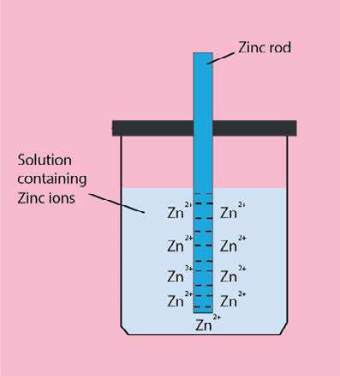

Fig. (10.3) Equilibrium between zinc and its ions in solution

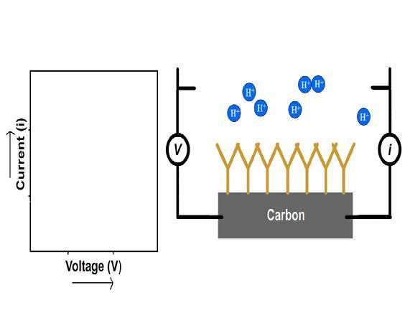

*Animation 10.10: ELECTRODE*

*Source & Credit :*

[*senovasystem*](http://senovasystems.com/blog/isfet-ph-electrodes-senova-systems-ph-sensor)

[*s*](http://senovasystems.com/blog/isfet-ph-electrodes-senova-systems-ph-sensor)

**10.3.1 Standard Hydrogen Electrode (SHE)**

A standard hydrogen electrode which is used as a standard is shown in Fig. (10.4). It consists of a piece of platinum foil, which is coated electrolytically with inely divided platinum black, to give it a large surface area and suspended in one molar solution of HCl.

Pure hydrogen gas at one atmosphere pressure is continuously bubbled into 1M HCl solution. The platinum acts as an electrical conductor and also facilitates the attainment of equilibrium between the gas and its ions in solution. The potential of this electrode is arbitrarily taken as zero.

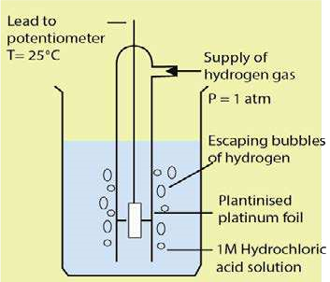

Fig. (10.4) Standard hydrogen electrode (S.H.E)

**10.3.2 Measurement of Electrode Potential**

In any measurement of electrode potential, the concerned electrode is joined electrolytically with the standard hydrogen electrode (SHE) and a galvanic cell is established. The two solutions are separated by a porous partition or a salt bridge containing a concentrated solution of potassium chloride. The salt bridge is used to provide a highly conducting path between the two electrolytic solutions. The potential diference is measured by a voltmeter which gives the potential of the electrode, as the potential of SHE is zero. An oxidation or reduction may take place at SHE depending upon the nature of the electrode which is coupled with it.

To measure the electrode potential of zinc, a galvanic cell is established between zinc electrode dipped in 1 M solution of its ions and standard hydrogen electrode at 25 °C as shown in Fig (10.5). Under the standard conditions, the voltmeter reads 0.76 volts and the delection is in such a direction as to indicate that zinc has a greater tendency to give of electrons than hydrogen has. In other words, the half reaction Zn(s) → Zn2+ +2e-has greater tendency to occur than H2(g) → 2H + 2e+ - by 0.76 volts. The standard electrode potential of zinc is, therefore, 0.76 volts. It is called oxidation potential of Zn and is given the positive sign.

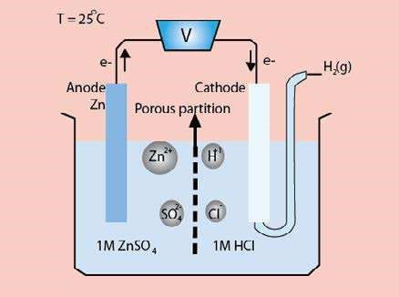

Fig (10.5) Electrode potential of zinc.

The reduction potential Zn-electrode is -0.76 volt. The electrode reactions will be shown as follows.

At anode Zn(s) → Zn2+(aq) + 2e- (oxidation)

At cathode 2H+(aq) + 2e- → H2(g) (reduction)

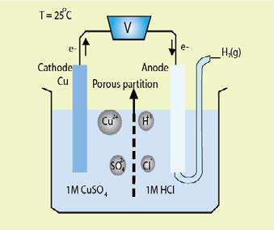The electrode potential of copper can also be measured using the same type of galvanic cell in which copper is an electrode dipped in 1 M solution of its ions and connected with .SHE Fig (10.6). Under standard conditions, the voltmeter reads 0.34 volts and the delection is in such a direction, as to indicate that hydrogen has a greater tendency to give of electrons than copper has.

In other words, the half reaction

H2(g) → 2H + 2e+ - has a greater tendency to occur than Cu(s) → Cu2+ +2e- by 0.34 volt. So the standard electrode potential of Cu is 0.34 volts. It is called reduction potential

Fig (10.6) Electrode potential of copper of Cu. When the sign is reversed, then the

-0.34 V is called oxidation potential of Cu electrode. The reactions taking place at two electrodes will be shown as follows.

At anode H2(g) → 2H + 2e+  At cathode Cu2+ +2e- → Cu(s)

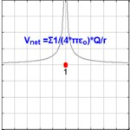

*Animation 10.11: Electric potential*

*Source & Credit :*

[*wikipedi*](https://en.wikipedia.org/wiki/Electric_potential)

[*a*](https://en.wikipedia.org/wiki/Electric_potential)

#### 10.4 THE ELECTROCHEMICAL SERIES

When elements are arranged in the order of their standard, electrode potentials on the hydrogen scale, the resulting list is known as electrochemical series.

Such a series of elements is shown in Table (10.2). The electrode potentials have been given in the reduction mode as recommended by the International Union of Pure and Applied Chemists (IUPAC). In some textbooks, half reactions are written in the oxidation mode and the corresponding potentials are oxidation potentials. The magnitude of the potential is not afected by the change in mode but the signs are reversed. Therefore, before using standard electrode potential data, it is necessary to ascertain which mode is being used. An important point to remember in using reduction potential values is that they relate only to standard conditions i.e. 1 M solution of ions, 25°C and one atmospheric pressure. Changes in temperature, concentration and pressure will afect the values of reduction potential.

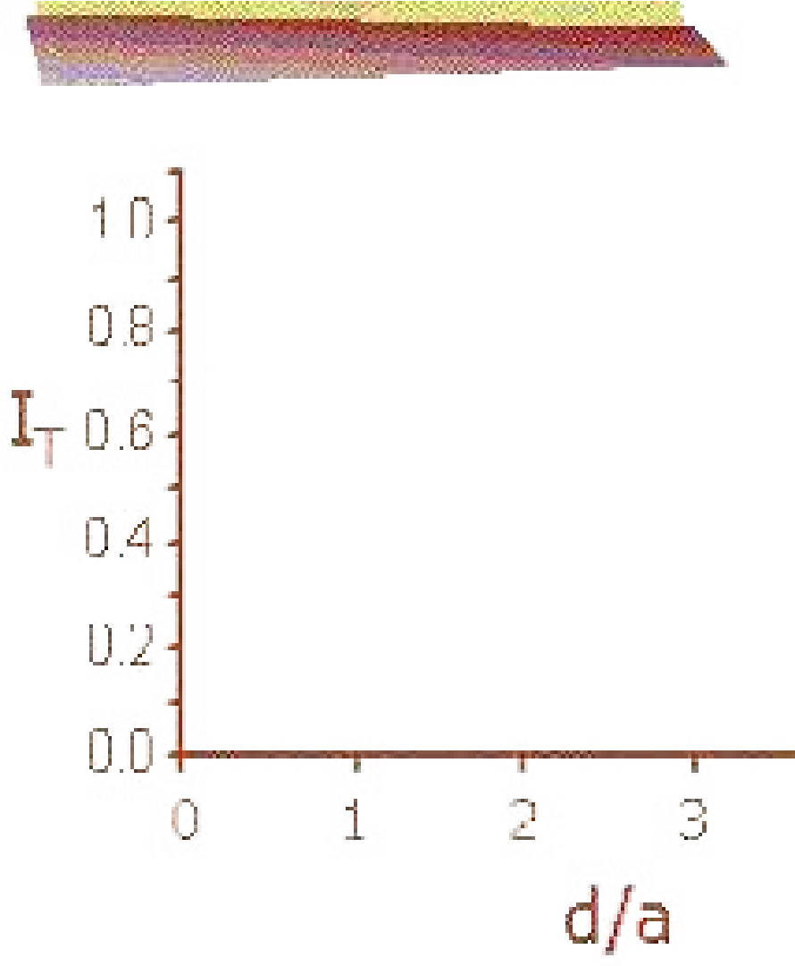

*Animation 10.12: ELECTROCHEMICAL*

*Source & Credit :*

[*sklea*](http://skleac.ciac.jl.cn/english/lessons/secm/secm.html)

[*c*](http://skleac.ciac.jl.cn/english/lessons/secm/secm.html)

**Table (10.2) Standard reduction potentials (E°) of substances at 298 K**

|  |  |  |  |  |  |
| --- | --- | --- | --- | --- | --- |
| Element |  |  | Electrode |  | Standard Reduction Potential (E0) |
| Li |  |  | Li +e+ - → Li |  | -3.045 |
| K |  |  | K +e+ - → K |  | -2.925 |
| Ca |  |  | Ca2+ +2e- → Ca |  | -2.87 |
| Na |  |  | Na +e+ - → Na |  | -2.714 |
| Mg  Al  Zn  Cr  Fe  Cd  Ni  Sn  Pb  H2 Cu  Cu  I2  Fe  Ag Hg  Br2  Cl2  Au  F2 | Increasing reduction potentials | Increasing strength as an oxidizing agent | Mg2+ +2e- → Mg  Al3+ +3e- → Al  Zn2+ +2e- → Zn  Cr3+ +3e- → Cr  Fe2+ +2e- → Fe  Cd2+ +2e- → Cd  Ni2+ +2e- → Ni  Sn2+ +2e- → Sn  Pb2+ +2e- → Pb  2H +2e+ - → H2  Cu2+ +2e- → Cu  Cu +e+ - → Cu  I +2e2 - → 2IFe3+ +3e- → Fe  Ag +e+ - → Ag  Hg2+ +2e- → Hg Br +2e2 - → 2Br-  Cl +2e2 - → 2ClAu3+ +3e- → Au  F +2e2 - → 2F- | Decreasing    reduction potentials | -2.37  -1.66  -0.76  Increasing strength as a reducing agent    -0.74  -0.44  -0.403  -0.25  -0.14  -0.126  (Reference Electrode) 0.000  +0.34  +0.521  +0.535  +0.771  +0.7994  +0.885  +1.08  +1.360  +1.50  +2.87 |

**10.4.1 Applications of Electrochemical Series**

1. **Prediction of the feasibility of a Chemical Reaction**

When we look at the electrochemical series, it is easy to predict whether a particular reaction will take place or not. For example, Cu2+ (aq) can oxidize solid zinc but Zn2+ (aq) cannot oxidize solid copper. Standard reduction potential values of copper and zinc can explain this

Cu2+(aq) + 2e- → Cu(s)  E =+0.34volto

Zn2+ + 2e- → Zn E = -0.76 voltso

(aq) (s)

Since zinc is being oxidized so the reverse reaction will be considered.

Zn → Zn2+  + 2e-  E = -0.76 volts (oxidation)o

(s) (aq)

The overall reaction will thus be

Cu2+(aq) + Zn(s) → *C*u(s) + Zn2+(aq) Eocell = 1.10 volts

The overall positive value for the reaction potential suggests that the process is energetically feasible. If the sum of E° values of the two half cell reactions is negative, then the reaction will not be feasible.

1. **Calculation of the Voltage or Electromotive Force (emf) of Cells:**

In a galvanic cell, the electrode occupying a higher position in the electrochemical series, will act as anode and oxidation takes place on it. Similarly, the electrode occupying the lower position in the series will act as a cathode and reduction will take place on it. Let us ind out a cell potential or the emf of the cell already discussed as above. The half cell reactions are:

|  |  |  |
| --- | --- | --- |
| Zn →  (s) | Zn2+(aq) + 2e- | (oxidation half reaction) |
| Cu2+  + 2e-  (aq) | → Cu(s) | (reduction half reaction) |
| Cu2+  + Zn →  (aq) (s) | *C*u(s) + Zn2+(aq) | (complete cell reaction) |

The oxidation potential of Zn is positive. The reduction potential of Cu2+ is also positive. The cell voltage or emf of the cell is given by

Eocell = Eooxi + Eo red

Eocell= 0.76 + 0.34 = 1.10 volts

The cell voltage or emf measures the force with which electrons move in the external circuit and therefore measures the tendency of the cell reaction to takes place. Galvanic cells, thus, give quantitative measure of the relative tendency of the various reactions to occur.

1. **Comparison of Relative Tendency of Metals and Nonmetals to Get Oxidized or Reduced**

The value of the reduction potential of a metal or a nonmetal tells us the tendency to lose electrons and act as a reducing agent. It also gives the information about the tendency of a species to gain electrons and act as an oxidizing agent. Greater the value of standard reduction potential of a given species, greater is its tendency to accept electrons to undergo reduction and hence to act as an oxidizing agent. For example, ions like Au3+, Pt2+, Hg2+, Ag+, Cu2+ and the nonmetals elements like F2, Cl2, Br2 and I2 which lie below the SHE, have a strong tendency to gain electrons and undergo reduction.

The series tell us that strong oxidizing agents like F2, Cl2, Br2, etc. have a large positive value of standard reduction potentials, while strong reducing agents have large negative values like Li, K, Ca, Na,etc. which lie above SHE.

1. **Relative Chemical Reactivity of Metals**

Greater the value of standard reduction potential of a metal, smaller is its tendency to lose electrons to change into a positive ion and hence lower will be its reactivity. For example, metals like Li, Na, K and Rb are highly reactive. Coinage metals, Cu, Ag, and Au are the least reactive because they have positive reduction potentials.

Similarly, metals like Pb, Sn, Ni, Co and Cd which are very close to SHE react very slowly with steam to liberate hydrogen gas, while the metals like Fe, Cr, Zn, Mn, Al and Mg which have more negative reduction potentials react with steam to produce the metallic oxides and hydrogen gas.

1. **Reaction of Matels with Dilute Acids**

Greater the value of standard reduction potential of a metal, lesser is its tendency to lose electrons to form metal ions and so weaker is its tendency to displace H+ ions from acids as H2 gas. For example, metals like Au, Pt, Ag and Cu which have suiciently high positive values of reduction potentials, do not liberate hydrogen gas from acids. While, metals like Zn, Mg and Ca which are close to the top of the series and have very low reduction potentials, liberate hydrogen gas, when they react with acids.

1. **Displacement of One Metal by Another from its Solution**

One metal will displace another metal from the aqueous solution of its salt if it lies above in the electrochemical series. For example, Fe can displace Cu from CuSO4, Zn does not displace Mg from solution of MgSO4.

#### 10.5 MODERN BATTERIES AND FUEL CELLS

Those cells which cannot be recharged are called primary cells. Examples are dry cell, alkaline battery, mercury and silver battery. Those ones which can be recharged are called secondary cells.

Examples are lead-acid battery, Ni-Cd-battery and fuel cells. A few examples of some modern batteries and fuel cell are described in this section.

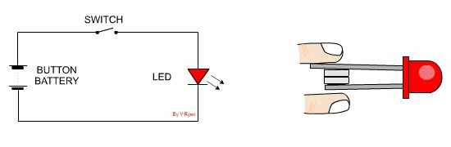

*Animation 10.13: MODERN BATTERIES*

*Source & Credit :*

[*technologystuden*](http://www.technologystudent.com/elec_flsh/button1.html)

[*t*](http://www.technologystudent.com/elec_flsh/button1.html)

**10.5.1 Lead Accumulator or Lead-Acid Battery (Rechargeable)**

It is commonly used as a car battery. It is secondary or a storage cell. Passing a direct current through it must charge it. The charged cell can then produce electric current when required. The cathode of a fully charged lead accumulator is lead oxide, PbO2 and its anode is metallic lead. The electrolyte is 30% sulphuric acid solution (density 1.25 g cm-3). When the two electrodes are connected through an external circuit, it produces electricity by discharge Fig (10.7). A single cell provides around 2 volts. For 12 volts, 6 cells are connected in series.

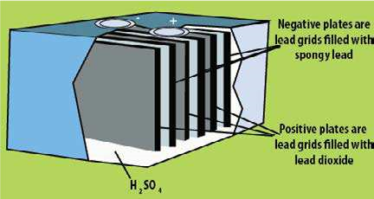

Fig (10.7) Lead accumulator

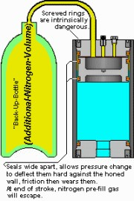

*Animation 10.14: Hydraulic Accumulators*

*Source & Credit :*

[*hydrauli*](http://www.hydraulic-accumulators.com/hydraulicaccumulators.aspx.htm)

[*c*](http://www.hydraulic-accumulators.com/hydraulicaccumulators.aspx.htm)

**Discharging**

At the anode the lead atoms release two electrons each to be oxidized to Pb2+ ions, which combine with SO42- ions present in the electrolyte and get deposited on the anode as PbSO4.

At the cathode

PbO2(s) + 4H+(aq) + SO42-(aq) + 2e → PbSO4(s) + 2H O2 ( ) (reduction) At the anode

Pb(s) + SO42-(aq) → PbSO4(s) + 2e− (oxidation)

The electrons released pass round an external circuit as an electric current to be used for starting the engine of a vehicle, for lighting up of car lights and so on.

At the cathode the electrons from the anode are accepted by PbO2 and hydrogen ions from the electrolyte then undergo a redox reaction to produce lead ions and water as follows:

The Pb2 ions then combine with the SO42 ions and they both deposit at the cathode as PbSO4. When both electrodes are completely covered with PbSO4 deposits, the cell will cease to discharge any more current until it is recharged. The overall reaction is

Pb(s) + PbO2(s) + 4H+(aq) + 2SO42-(aq) → 2PbSO4(s) + 2H O2 ( ) 

A typical 12-V car battery has six cells connected in series. Each delivers 2V Each cell contains two lead grids packed with the electrode materials. The anode is spongy lead , and cathode is powered PbO4. The grid is immersed in an electrolytic solution of ≈ 3.2M H2SO4 (30%). Fibre glass sheets between the grids prevent shorting by accidental physic al contact. When the cell is discharged, it generates electrical energy as a voltaic cell.

**Recharging**

During the process of recharging, the anode and the cathode of the external electrical source are connected to the anode and the cathode of the cell respectively. The redox reactions at the respective electrodes are then reversed. These reactions are summarized as follows:

|  |  |  |
| --- | --- | --- |
| At anode | PbSO4(s) + 2e → Pb(s) + SO42-(aq) | (reduction) |
| At cathode | PbSO4(s) + 2H O2 → PbO2(s) + 4H+(aq) + SO42-(aq) 2e- | (oxidation) |

The overall reaction is

2PbSO4(s) + 2H O2 → Pb(s) + PbO2(s) + 4H+(aq) + SO 2-

4 (aq)

During the process of discharging, the concentration of the acid falls decreasing its density to 1.15g cm3. After recharging, the acid is concentrated again bringing its density to its initial value of 1.25g cm3. At the same time the voltage of the battery, which has dropped during discharging, return to around 12 volts.

**10.5.2 Alkaline Battery (non-rechargeable)**

It is a dry alkaline cell, which uses zinc and manganese dioxide as reactants. Zinc rod serves as the anode and manganese dioxide functions as the cathode. The electrolyte, however, contains potassium hydroxide and is therefore basic (alkaline).

The battery is enclosed in a steel container. The zinc anode is also slightly porous giving it a larger efective area. This allows the cell to deliver more current than the common dry cell. It has also longer life. The reactions in the alkaline battery.are shown as follows:

Zn(s) + 2OH-(aq) → Zn(OH)2(s) + 2e- (anode)

2MnO2(s) + H O2 ( ) + 2e- → Mn O2 3(s) + 2OH-(aq) (cathode)

The overall reaction is

Zn(s) + 2MnO2(s) + H O2 (l) → Zn(OH)(s) + Mn O2 3(s)

The voltage of the cell is 1.5 V



*Animation 10.15: Alkaline Battery*

*Source & Credit :*

[*adafrui*](https://www.adafruit.com/product/617?hidden=yes&main_page=product_info&products_id=617)

[*t*](https://www.adafruit.com/product/617?hidden=yes&main_page=product_info&products_id=617)

**10.5.3 Silver Oxide Battery**

These tiny and rather expensive batteries Fig. 10.8 have become popular as power sources in electronic watches, auto exposure cameras and electronic calculators. The cathode is of silver oxide, Ag,0, and the anode is of zinc metal. The following reactions occur in a basic electrolyte.

At the anode

Zn(s) + 2OH-(aq) → Zn(OH)2(s) + 2e- (oxidation)

At the cathode

Ag O2 (s) + H O2 ( ) + 2e- → 2Ag(s) + 2OH-(aq) (reduction).

The overall reaction is

Zn(s) + Ag O2 (s) + H O2 (l) → Zn(OH)2 + 2Ag (s)

The voltage of silver oxide battery is about 1.5 V

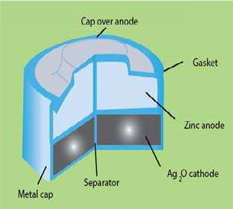

Fig (10.8) A silver oxide battery

**10.5.4 Nickel Cadmium Cell (Rechargeable)**

A strong cell that has acquired wide spread use in recent years is the NICAD or nickel cadmium battery. It is a rechargeable cell. The anode is composed of cadmium, which undergoes oxidation in an alkaline electrolyte.

At the anode

Cd(s) + 2OH-(aq) → Cd(OH)2(s) + 2e- (oxidation)

The cathode is composed of NiO2 which undergoes reduction.

At the cathode

NiO + 2H O2 2 ( ) + 2e- → Ni(OH)2(s) + 2OH-(aq) (reduction)

The net cell reaction during the discharge is :

Cd(s) + NiO2(s) + 2H O2 ( ) → Cd(OH)2(s) + Ni(OH)2(s)

Just like lead storage cell, the solid reaction products adhere to the electrodes. For this reason, the reaction is easily reversed during recharging. Because no gases are produced during either charging or discharging, the battery can be sealed. It is used in battery operated tools and portable computers. It also inds its application in cordless razors, photolash units. It is light weight. Voltage of the cell is 1.4 V.

**10.5.5 Fuel Cells (rechargeable)**

Fuel cells are other means by which chemical energy may be converted into electrical energy. When gaseous fuels, such as hydrogen and oxygen are allowed to undergo a reaction, electrical energy can be obtained.

This cell inds importance in space vehicles. The cell is illustrated in Fig. (10.10). The electrodes are hollow tubes made of porous compressed carbon impregnated with platinum, which acts as a catalyst. The electrolyte is KOH. At the electrodes, hydrogen is oxidized to water and oxygen is reduced to hydroxide ions.

[H2(g) + 2OH-(aq) → 2H O2 ( ) + 2e ] x 2-  (anode)

O2(g) + 2H O2 ( ) + 4e- → 4OH-(aq) (cathode)

2H2(g) + O2(g) → 2H O2 ( ) (overall reaction)

Such a cell runs continuously as long as reactants are supplied.

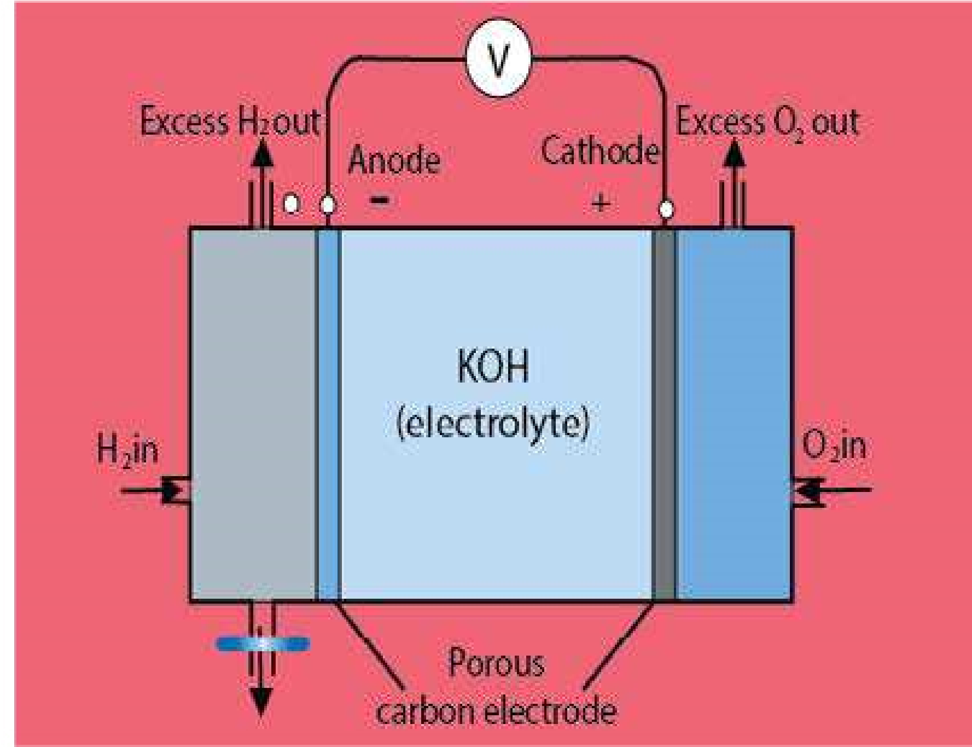

Fig (10.10) Hydrogen - Oxygen Fuel cell

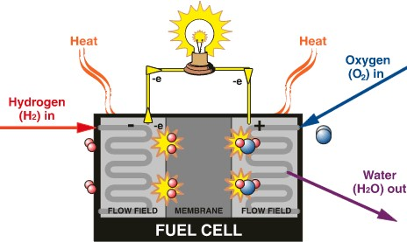

*Animation 10.16: Fuel Cells*

*Source & Credit :*

[*solare*](http://www.solaren.sk/en/hydrogen-techologies)

[*n*](http://www.solaren.sk/en/hydrogen-techologies)

This fuel cell is operated at a high temperature so that the water formed as a product of the cell reaction evaporates and may be condensed and used as drinking water for an astronaut. A number of these cells are usually connected together so that several kilowatts of power can be generated.

The fuel cell produce electricity and pure water during space lights. Fuel cell are light, portable and sources of electricity. Many fuel cells do not produce pollutants. Some other cell reactions in fuel cell are :

1. 2NH + 3/2 O3 2 → N + 3H O2 2 ( )
2. N H + O4 4 2 → N + 2H O2 2 ( )
3. CH + 2O4 2 → CO + 2H O2 2 ( )

Fuel cells are very eicient. They convert about 75% of fuels bond energy into electricity.

### KEY POINTS

1. Electrochemistry is the branch of science which deals with the conversion of electrical energy to chemical energy and vice versa.
2. Electrolytic conduction is carried out by the ions produced when an ionic compound is in fused state or dissolved in water. Electrolysis is the process in which a chemical reaction takes place at the expense of electrical energy. Electrolysis is used for the extraction of elements and for the commercial preparation of several compounds. It is also used for electroplating.
3. A Galvanic or a voltaic cell produces electrical energy at the expense of chemical energy. Electrode potential is developed when a metal is dipped into a solution of its own ions.
4. The potential of standard hydrogen electrode is arbitrarily ixed as 0.00 volts. Electrode potential of an element is measured when it is coupled with standard hydrogen electrode. When elements are arranged in order of their standard electrode potentials on the hydrogen scale, the resulting list is known as electrochemical series. Electrochemical series is used to predict the feasibility of a redox chemical reaction.
5. Modern batteries and fuel cell include lead accumulator, alkaline battery, silver oxide battery, nickel cadmium cell and hydrogen oxygen fuel cell.
6. The oxidation number is the apparent charge which an atom has in a molecule. Redox chemical equations can be balanced using oxidation number method and ion electron method.

### EXERCISE

Q.1 Multiple choice questions. For each question there are four possible answers a, b, c and d.

Choose the one you consider correct.

(i) The cathodic reaction in the electrolysis of dil. H2SO4 with Pt electrodes is:-

(a) Reduction (b) Oxidation

(c) Both oxidation and reduction (d) Neither oxidation or reduction (ii) Which of the following statements is not correct about galvanic cell?

(a) Anode is negatively charged (b) Reduction occurs at anode (c) Cathode is positively charged (d) Reduction occurs at cathode (iii) Stronger the oxidizing agent, greater is the:

(a) oxidation potential (b) reduction potential

(c) redox potential (d) E.M.F of cell

1. If the salt bridge is not used between two half cells, then the voltage.

(a) Decrease rapidly (b) Decrease slowly

(c) Does not change (d) Drops to zero

1. If a strip of Cu metal is placed in a solution of FeSO4:

(a) Cu will be deposited (b) Fe is precipitated out

(c) Cu and Fe both dissolve (d) No reaction take place

Q.2 Fill in the blank.

* + 1. The oxidation number of O-atom is ___________ in OF2 and is ___________ in H2O2.
    2. Conductivity of metallic conductors is due to the low of ________while that of electrolytes is due to low of_________ .
    3. Reaction taking place at the ________is termed as oxidation and at the _________ is called as reduction.
    4. _________ is set up when a metal is dipped in its own ions.
    5. Cu metal__________ the Cu-cathode when electrolysis is performed for CuSO4 solution with Cu- cathodes.
    6. The reduction potential of Zn is __________ volts and its oxidation potential is __________ volts.
    7. In a fuel cell,___________react together in the presence of______ .

Q.3 Mark the following statements true or false.

* + 1. In electrolytic conduction, electrons low through the electrolyte.
    2. In the process of electrolysis, the electrons in the external circuit low from cathode to anode.
    3. Sugar is a non-electrolyte in solid form and when dissolved in water will allow the passage of an electric current.
    4. A metal will only allow the passage of an electric current when it is in cold state.
    5. The electrolytic products of aqueous copper (II) chloride solution are copper and chlorine.
    6. Zinc can displace iron form its solution.
    7. S.H.E. acts as cathode when connected with Cu-electrode.
    8. A voltaic cell produces electrical energy at the expense of chemical energy.
    9. Lead storage battery is not a reversible cell.
    10. Cr changes its oxidation number when K2Cr2O7 reacts with HCl.

Q.4 (a) Explain the term oxidation number with examples.

* + 1. Describe the rules used for the calculation of oxidation number of an element in molecules and ions giving examples.
    2. Calculate the oxidation number of chromium in the following compounds.

(i) CrCl3 (ii) Cr (SO )2 4 3 (iii) K CrO2 4 (iv) K Cr O2 2 7

(v) CrO3 (vi) Cr O2 3 (vii) Cr O2 72-

(Ans: (i)+3,(ii)+3,(iii)+6,(iv)+6,(v) + 6(vi)+3)

(d) Calculate the oxidation numbers of the elements underlined in the following compounds.

(i) Ca(ClO )3 2 (ii) Na2CO3 (iii) Na2PO4 (iv) HNO3

(v) Cr (2 SO )4 3 (vi) HPO3 (vii) K2 MnO4

(Ans : (i) +5, (ii) +4, (iii) +5, (iv) +5, (v) +6 , (vi)+5 (vii) + 6)

Q.5 (a) Describe the general rules for balancing a redox equation by oxidation number method.

(b) Balance the following equations by oxidation number method

* + 1. Cu + HNO3 → Cu(NO ) + NO + H O3 2 2 2
    2. Zn + HNO3 → *Z*n(NO ) + NO + H O3 2 2
    3. Br + NaOH 2 → NaBr + NaBrO + H O3 2
    4. MnO + HCl 2 → MnCl + H O + Cl2 2 2
    5. FeSO + K Cr O + H SO4 2 2 7 2 4 → Fe (SO ) + Cr (SO ) + K SO + H O2 4 3 2 4 3 2 4 2
    6. HNO + HI3 → NO + H O + I2 2
    7. Cu + H SO2 4 → CuSO + SO + H O4 2 2
    8. HI + H SO2 4 → I + SO + H O2 2 2
    9. NaCl + H SO + MnO2 4 2 → Na SO + MnSO + H O + Cl2 4 4 2 2

Q.6 (a) Describe the general rules for balancing a redox equation by ion-electron method. (b) Balance the following ionic equations by ion-electron method.

* + 1. Fe3+ + Sn2+ → Fe2+ + Sn4+
    2. MnO41-(aq) + C O2 42-(aq) → Mn2+(aq) + CO2(g)
    3. Cr O2 72- + Cl- → 2Cr3+ + 3Cl2
    4. Cu + NO31- → Cu2+ + 2NO2
    5. Cr O2 72- + Fe2+ → Cr3+ + Fe3+ (acidic media)

* + 1. S O2 32- + OCl1- → Cl + S O- 4 62- (acidic media) (vii) IO31- + AsO33- → I + AsO- 43- (acidic media) (viii) Cr3+ + BiO31- → Cr O2 72- + 3Bi3+ (acidic media)
    2. H AsO + Cr O3 3 2 72- → 3H AsO + 2Cr3 4 3+ (acidic media)
    3. CN + MnO- 41- → CNO + MnO- 2(s) (basic media)
  1. Describe the electrolysis of molten sodium chloride, and a concentrated solution of sodium chloride.
  2. What is the diference between single electrode potential and standard electrode potential? How can it be measured? Give its importance.
  3. Outline the important applications of electrolysis. Write the electrochemical reactions involved therein.Discuss the electrolysis of CuSO4 using Cu-electrodes and AgNO3 solution using Ag electrode.
  4. Describe the construction and working of standard hydrogen electrode.
  5. Is the reaction Fe3+ + Ag → Fe2+ + Ag+ spontaneous? If not, write spontaneous reaction involving these species.
  6. Explain the diference between

(a) Ionization and electrolysis. (b) Electrolytic cell and voltaic cell (c) Conduction through metals and molten electrolytes.

* 1. Describe a galvanic cell explaining the functions of electrodes and the salt bridge.
  2. Write comprehensive notes on:
     1. Spontaneity of oxidation reduction reactions.
     2. Electrolytic conduction.
     3. Alkaline, silver oxide and nickel-cadmium batteries, fuel cell. (d) Lead accumulator, its desirable and undesirable features.

Q.15 Will the reaction be spontaneous for the following set of half reactions. What will be the value of Ecell ?

* + 1. Cr3+(aq) + 3e- → Cr(s)
    2. MnO2(s) + 4H + 2e+ - → Mn2+(aq) + 2H O2 ( )

(Standard reduction potential for reaction (i) = -0.74V and for the reaction (ii) = + 1.28V).

Q16. Explain the following with reasons.

* + 1. A porous plate or a salt bridge is not required in lead storage cell.
    2. The standard oxidation potential of Zn is 0.76 V and its reduction potential is -0.76 V (c) Na and K can displace hydrogen from acids but Pt, Pd and Cu can not.
    3. The equilibrium is set up between metal atoms of electrode and ions of metal in a cell.
    4. A salt bridge maintains the electrical neutrality in the cell.
    5. Lead accumulator is a chargeable battery.
    6. Impure Cu can be puriied by electrolytic process.
    7. SHE acts as anode when connected with Cu electrode but as cathode with Zn electrode.

1. Reduction half reaction

   MnO4- → Mn2+