CHAPTER

# 3 GASES

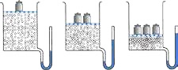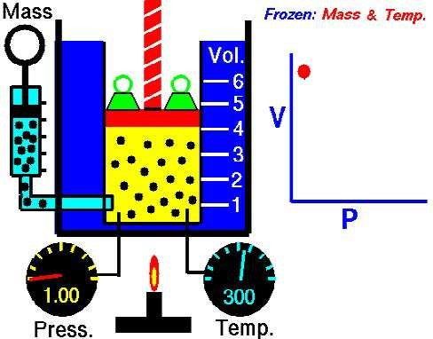

Animation 3.1: [Boyle’s Law](https://en.wikipedia.org/wiki/File:Boyles_Law_animated.gif)

Source & credit: [wikipedia](https://en.wikipedia.org/wiki/File:Boyles_Law_animated.gif)

## 3.1 STATES OF MATTER

Matter exists in four states i.e., solid, liquid, gas and plasma. The simplest form of matter is the gaseous state and most of matter around us is in the solid state.

Liquids are less common than solids, gases and plasmas. The reason is that the liquid state of any substance can exist only within a relatively narrow range of temperature and pressure.

Let us look at the general properties of gases, liquids and solids. Kinetic molecular theory of gases can help us understand their properties.

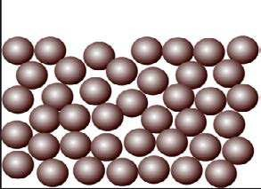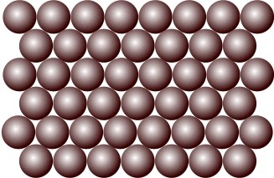

Animation 3.2.: [States of Matter](http://www.knockhardy.org.uk/states.htm)

Source & Credit: [knockhardy](http://www.knockhardy.org.uk/states.htm)

**3.1.1 Properties of Gases**

1. Gases don’t have a deinite volume and occupy all the available space. The volume of a gas is the volume of the container.
2. They don’t have a deinite shape and take the shape of the container just like liquids.
3. Due to low densities of gases, as compared to those of liquids and solids, the gases bubble through liquids and tend to rise up.
4. Gases can difuse and efuse. This property is negligible in solids but operates in liquids as well.
5. Gases can be compressed by applying a pressure because there are large empty spaces between their molecules.
6. Gases can expand on heating or by increasing the available volume. Liquids and solids, on the other hand, do not show an appreciable increase in volume when they are heated.
7. When sudden expansion of gases occurs cooling takes place, it is called Joule Thomson efect.
8. Molecules of gases are in a constant state of random motion They can exert a certain pressure on the walls of the container and this pressure is due to the number of collisions.
9. The intermolecular forces in gases are very weak.

**3.1.2 Properties of Liquids**

1. Liquids don’t have a deinite shape but have a deinite volume. Unlike solids they adopt the shape of the container.
2. Molecules of liquids are in a constant state of motion. The evaporation and difusion of liquid molecules is due to this motion.
3. The densities of liquids are much greater than those of gases but are close to those of solids.
4. The spaces among the molecules of liquids are negligible just like solids.
5. The intermolecular attractive forces in liquids are intermediate between gases and solids. The melting and boiling points of gases, liquids and solids depend upon the strength of such forces.
6. Molecules o f liquids possess kinetic energy due to their motion. Liquids can be converted into solids on cooling i.e., by decreasing their kinetic energy. Molecules of liquids collide among themselves and exchange energy but those of solids can not do so.

**3.1.3 Properties of Solids**

1. The particles present in solid substances are very close to each other and they are tightly packed. Due to this reason solids are non-compressible and they cannot difuse into each other.
2. There are strong attractive forces in solids which hold the particles together irmly and for this reason solids have deinite shape and volume.
3. The solid particles possess only vibrational motion.

**3.1.4 Units of Pressure:**

The pressure of air that can support 760 mmHg column at sea level, is called one atmosphere. It is the force exerted by 760mm or 76cm long column of mercury on an area of 1cm2 at 0°C.It is the average pressure of atmosphere at sea level 1mmHg=1torr. The S.I. unit of pressure is expressed in Nm-2 . One atmospheric pressure i.e 760 torr is equal to 101325Nm-2 .

1pascal=1Nm-2 . So, 760 torr = 101325Pa = 101.325 kilopascals (kpa is another unit of pressure) The unit pounds per square inch (psi) is used most commonly in engineering work, and 1 atm = 760 torr=14.7 pounds inch-2 . The unit millibar is commonly used by meteorologists.

## 3.2 GAS LAWS

It is a matter of common observation that when external conditions of temperature and pressure are changed, the volume of a given quantity of all gases is afected. This efect is nearly the same irrespective of the nature of the gas. So gases show a uniform behaviour towards the external conditions. The gas laws describe this uniform behaviour of gases. The relationships between volume of a given amount of gas and the prevailing conditions of temperature and pressure are called the gas laws. Diferent scientists, like Boyle, Charles, Graham and Dalton have given their laws relating to the properties of gases.

**3.2.1 Boyle’s Law**

In Boyle’s law the pressure and volume are variables while the temperature and quantity of a gas remains constant. Boyle’s law is stated as follows:-

**The volume of a given mass of a gas at constant temperature is inversely proportional to the pressure applied to the gas.**

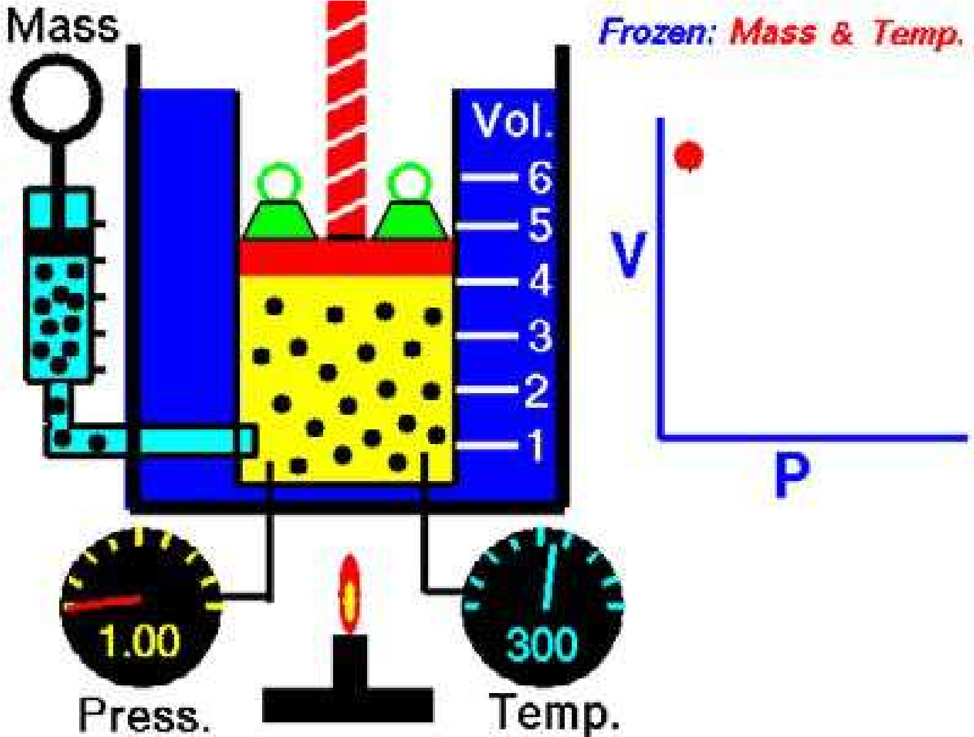

Animation 3.3: [Boyle’s Law](https://en.wikipedia.org/wiki/File:Boyles_Law_animated.gif)

Source & credit: [wikipedia](https://en.wikipedia.org/wiki/File:Boyles_Law_animated.gif)

So

Va1/P (when the temperature and number of moles are constant)

or V=k/p

PV = k (when T and n are constant) (1)

‘k’ is proportionality constant. The value of k is diferent for the diferent amounts of the same gas. According to the equation (1), Boyle’s law can also be deined as **The product of pressure and volume of a ixed amount of a gas at constant temperature is a constant quantity.**

So P1V1 = k and P2V2 = k

Hence P1V1 = P2V2

P1V1 are the initial values of pressure and volume, while P2V2 are the inal values of pressure and volume.

### 3.2.2 Experimental Veriication of Boyle’s Law

The following diagram Fig. (3.1) indicates that at constant temperature say at 250C,the volume of a given quantity of a gas is reduced in proportion to the increase in pressure. Let us take a gas in a cylinder having a moveable piston.

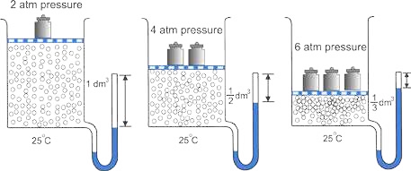

Fig (3.1) Veriication of Boyle’s Law

The cylinder is also attached with a manometer to read the pressure of the gas directly. Let the initial volume of gas is 1 dm3 and its pressure is 2 atmospheres when the piston has one weight on it. When the piston is pressed twice with the help of two equal weights, the pressure becomes four atmospheres.

Similarly, when the piston is loaded with a mass three times greater, then the pressure becomes six atmospheres. The initial volume of the gas at two atmospheres is 1 dm3 it is reduced to 1/2 dm3 and then 1/3 dm3 with increase of weights, respectively Fig (3.1).

**P1V1 = 2 atm x 1 dm3 = 2 dm3 atm = k**

**P2V 2 = 4 atm x 1/2 dm3 = 2 dm3 atm = k P 3V 3 = 6 atm x 1/3 dm3 = 2 dm3 atm = k** Hence Boyle’s law is veriied.

The value of k will remain the same for the same quantity of a gas at the same temperature.

**Example 1**

A gas having a volume of 10 dm3 is enclosed in a vessel at 00C and the pressure is 2.5 atmospheres. This gas is allowed to expand until the new pressure is 2 atmospheres. What will be the new volume of this gas, if the temperature is maintained at 273 K.

**Solution**

Initial volume of gas (V1) = 10 dm3

Initial temperature (T1) = 00C + 273 K = 273 K Initial pressure (P1) = 2.5 atm

Final pressure (P2) = 2 atm Final temperature (T2) = 273 K Final volume (V2) = ?

Since the temperature is constant ( T1= T2) Boyle’s law is applicable

P1V1= P2V2 (when T and n are constant)

V2 = P1V1 P2

V2 =2.5 atm x 10 dm3  2 atm

= 12.5 dm3 Answer

### 3.2.3 Graphical Explanation of Boyle’s Law

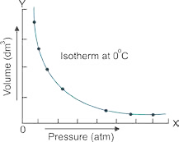Let us take a particular amount of a gas at a constant temperature say 00C and enclose it in a cylinder having a piston in it. When the pressure of the gas is varied, its volume changes. Increase in pressure decreases the volume. If a graph is plotted between pressure on the x-axis (abscissa) and volume on the y-axis (ordinate), then a curve is obtained as shown in the Fig (3.2). This curve is called isotherm ‘iso’ means same, “therm” means heat.

Now increase the temperature of the gas to 25°C. Fig (3.2) Isotherm of a gas at 0 0C.

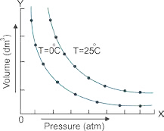Keep this temperature constant and again vary the pressure and volume, and plot the isotherm. It goes away from both the axes Fig (3.3). The reason is that at higher temperature, the volume of the gas has increased. Similarly, if we increase the temperature further, make it constant and plot another isotherm, it further goes away from the axis.

If a graph is plotted between 1/V on x-axis and the pressure P on

the y-axis then a straight line is obtained as shown in the Fig Fig (3.3) Isothermes o f a gas at different (3.4). This shows that the pressure and inverse of volume are temperatures.

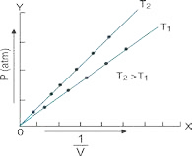directly proportional to each other. This straight line will meet at the origin which means that when the pressure is very close to zero, then the volume is so high that its inverse is very close to zero.

By increasing the temperature of the same gas from T1 to T2 and keeping it constant, one can vary pressure and volume. The graph of this data between P and 1/V will give another straight line. This straight line at T2 will be closer to the pressure-axis Fig (3.4).

Now, plot a graph between pressure on x-axis and the product PV on Fig (3.4) A plot between P and Y-axis. A straight line parallel to the pressure axis is obtained Fig(3.5).

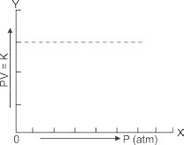

1

*V*

This straight line indicates that 'k' is a constant quantity. At higher constant temperature, the volume increase and value of product PV should increase due to increase of volume at same pressure, but PV remains constant at this new temperature and a straight line parallel to the pressure axis is obtained. This type of straight line will help us to understand the non-ideal behaviour of gases. Boyle's law is applicable only to ideal gases.

Fig (3.5) A plot between pressure and product of P V

**3.2.4 Charle s 's Law**

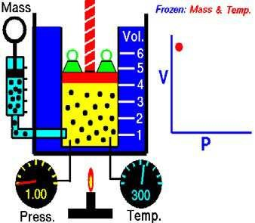It is a quantitative relationship between temperature and volume of a gas and was given by French scientist J.

Charles in 1787. According to this law, **the volume of the given mass of a gas is directly proportional to the absolute temperature when the pressure is kept constant.**

**V** a **T (when pressure and number of moles**

**are constant)**

**V = kT**

**V/T=k** If the temperature is changed from T1 to T2 and

volume changes from V1 to V2 , then Animation 3.4: [Charle s 's Law](http://www.pef.uni-lj.si/eprolab/comlab/sttop/sttop-ht/isothermal.htm) **V1/T1=k and V2/T2=k** Source & Credit: [docsity](http://www.docsity.com/en/news/chemistry/basic-gas-laws-compiled-explained-gifs/)

**So, V1/T1= V2/T2  ................................. (2)**

The ratio of volume to temperature remains constant for same amount of gas at same pressure.

### 3.2.5 Experimental Veriication of Charles ‘s Law

Let us consider a certain amount of a gas enclosed in a cylinder itted with a movable piston. The volume of the gas is **V1** and its temperature is **T1**. When the gas in the cylinder is heated both volume and the temperature of the gas increase.

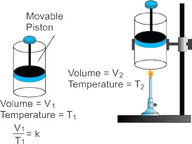The new values of volume and temperature are **V2** and

**T2**  respectively Fig(3.6). Experiment shows that

**V1/T1= V2/T2**

Hence Charles’s law is veriied.

**Example 2**

250 cm3 of hydrogen is cooled from 127oC to -27°C by

maintaining the pressure constant Calculate the new Fig (3.6) Veriication of Charles's law volume of the gas at low temperature.

**Solution**

Pressure has been kept constant so this gas is obeying the Charles’s law.

Initial volume (V1) = 250 cm3 = 0.25 dm3

Initial temperature (T1) = 127 °C + 273 K = 400 K

Final temperature (T2) = -27 °C + 273K - 246 K Final volume (V2) = ?

According to Charles’s law

**V1/T1= V2/T2** (when pressure and number of moles are constant)

**V2 = V1x T2**

**T1**

**V2 = 0.25 dm3 x 246K = 0.153 dm3 = 153 cm3 Answer**

**400 K**

So by decreasing the temperature the volume of the gas has decreased at constant pressure.

**3.2.6 Derivation of Absolute Zero**

In order to derive absolute zero of temperature, consider the following quantitative deinition of Charles’s law.

At constant pressure, the volume of the given mass of a gas increases or decreases by 1/273 of its original volume at 0oC for every 1 °C rise or fall in temperature respectively.

In order to understand the above statement, look at the Table (3.1) of temperature volume data of a hypothetical gas. At 0 oC the volume of the gas taken is 546 cm3 It is twice 273cm3, and is being supposed for the sake of convenience of understanding. At 273 oC, the volume of the gas has doubled (1092 cm3) and it should become practically zero at -273oC. The general equation to know the volumes of the gas at various temperatures is

Vt = Vo(1+ 273*t* ) ………. (3)

Where Vt = volume of gas at temperature T

Vo = Volume of gas at 0oC

t = Temperature on centigrade or celsius scale

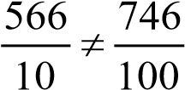If a gas is warmed by 1oC, it expands by 1 of its original volume at 0oC. Since original volume is 546 cm3 ,so, for 1oC rise in temperature, 2 cm[1]73 3 increase in volume will take place. 2cm3 is the 1 of 546 cm3. Similarly, for 100 oC rise in temperature, a change of 200 cm3 will take place. The 273 Table (3.1) shows that the volume does not increase corresponding to increase in temperature on celsius scale. For example, the increase in temperature from 10 oC to 100 oC, increases the volume from 566cm3 to 746cm3.

Applying Charles’s law

V1 V

= 2 T1 T

### Table(3.1) volume-Temperature data for a given amount of a gas at constant pressure

|  |  |  |  |
| --- | --- | --- | --- |
| **Volumes (cm3)** | **CelsiusTemperature (oC)** | **Temperature (K)** | *V* **= k = cm3 K-1**  *T* |
| 1092 | 273 | 546 | 2 |
| 846 | 150 | 423 | 2 |
| 746 | 100 | 373 | 2 |
| 646 | 50 | 323 | 2 |
| 566 | 10 | 283 | 2 |
| 548 | 1 | 274 | 2 |
| 546 | 0 | 273 | 2 |
| 544 | -1 | 272 | 2 |
| 526 | -10 | 263 | 2 |
| 400 | -73 | 200 | 2 |
| 346 | -100 | 173 | 2 |
| 146 | -200 | 73 | 2 |
| 0 | -273 | 0 |  |

### Graphical Explanation

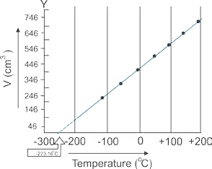If we plot a graph between temperature on x-axis and the volume of one mole of an ideal gas on y-axis, we get a straight line which cuts the temperature axis at -273.16 °C. This can be possible only if we extrapolate the graph upto -273.16 oC. This temperature is the lowest possible temperature, which would have been achieved if the substance remains in the gaseous state Fig (3.7). Actually, all the gases are converted into liquids above this temperature.

Fig (3.7) The graph between volume and temperature for a gas according to Table (3.1).

Charles’s law is obeyed when the temperature is taken on the Kelvin scale. For example, at 283 K (10 oC) the volume is 566 cm3, while at 373 K (100 oC) the volume is,746cm3 Table (3.1). According to Charles’s law.

V1 V2

= =K

T1 T

2

566 746

= = =2 *K*

283 373

Greater the mass of gas taken, greater will be the slope of straight line. The reason is that greater the number of moles greater the volume occupied. All these straight lines when extrapolated meet at a single point of -273.16 °C ( 0 Kelvin). It is apparent that this temperature of -273.16 °C will be attained when the volume becomes zero. But for a real gas the zero volume is impossible which shows that this temperature can not be attained for a real gas. This is how we recognize that -273.16 °C must represent the coldest temperature.

#### 3.2.7 Scales of Thermometry

There are three scales of thermometery which are used for temperature measurements.

1. **Centigrade Scale:** It has a zero mark for the temperature of ice at one atmospheric pressure. The mark 100°C indicates the temperature of boiling water at 1 atmospheric pressure. The space between these temperature marks is divided into 100 equal parts and each part is 1°C.
2. **Fahrenheit Scale:** The melting point of ice at 1 atmospheric pressure has a mark 32°F and that of boiling water is 212 oF. The space between these temperature marks is divided into 180 equal parts and each part is 1 oF.
3. **Absolute or Kelvin Scale:** The melting Point of ice at 1 atmospheric pressure is 273K. The water boils at 373K or more precisely at 373.16K.

Temperature on Kelvin scale = Temperature °C + 273.16

Following relationships help us to understand the interconversion of various scales of temperatures.

K = ° C + 273.16

°C = 5/9[°F-32] oF =9/5(°C)+32

## 3.3 GENERAL GAS EQUATION

While describing Boyle’s and Charles’s laws, some of the variables are held constant during the changes produced in the gases. According to Boyle’s law.

V ∝ 1 (when ‘n‘ and ‘T’ are held constant) P

According to Charles’s law

V ∝ T (when n and P are held constant)

It is a well known fact that volume of the given gas at constant temperature and pressure is directly proportional to the number of moles (Avogadro’s law).

V ∝ n (when Pand T a re held constant)

If we think for a moment that none of the variables are to be kept constant then all the above three relationships can be joined together.

V ∝ nT

P

V= Constant *nT*

*P* The constant suggested is R which is called general gas constant.

nT

V=R P

PV = nRT ............ (4)

The equation (4) is called an ideal gas equation. It is also known as general gas equation. This equation shows that if we have any quantity of an ideal gas then the product of its pressure and volume is equal to the product of number of moles, general gas constant and absolute temperature. This equation is reduced to Boyle’s law, Charles’s law and Avogadro’s law, when appropriate variables are held constant.

PV = nRT, when T and n are held constant, PV = k (Boyle’s law)

V = R nT , when P and n are held constant, V = kT (Charles’s law)

P

V = R nT , when P and T are held constant V = kn (Avogadro’s law)

P

For one mole of a gas, the general gas equation is

PV = RT or *PV* = R

*T*

It means that ratio of PV to T is a constant quantity (molar gas constant)

Hence

PV1 1 = R P V2 2 =R

T1 T2

Therefore,

PV1 1 = P V2 2 ........... (5)

T1 T2

**3.3.1 Ideal Gas Constant R**

The values and units of R can be calculated by Avogadro's principle very easily. Its value depends upon the units chosen for pressure, volume and temperature. The volume of one mole of an ideal gas at STP (one atmospheric pressure and 273.16 K ) is 22.414 dm3. Putting these values in the general gas equation will give the value of R.

R= PV

nT

Putting their values, alongwith units

R= 1 atm x 22.414 dm3

1 mole x 273.16 K

R = 0.0821 dm3 atm K-1 mol-1

When the pressure is in atmospheres, volume in dm3, then the value of R, used should be 0.0821 dm3 atm K-1 mol-1

The physical meanings of this value is that, if we have one mole of an ideal gas at 273.16 K and one atmospheric pressure and its temperature is increased by 1 K, then it will absorb 0.0821 dm3 -atm of energy, dm3 -atm is the unit of energy in this situation. Hence, the value of R is a universal parameter for all the gases. It tells us that the Avogadro’s number of molecules o f all the ideal gases have the same demand of energy.

If the pressure is expressed in mm of mercury or torr and the volume of the gas in cm3 then values of R are,

R = 0.0821 dm3 atm K-1 mol-1

= 0.0821 x 760 dm3 mm Hg K-1 mol-1

= 62.4 dm3 mm Hg K-1 mol-1 Since, (1 mm o f Hg = 1 to rr)

= 62.4 dm3 torr K-1 mol-1

= 62400 cm3 torr K-1 mol-1 As, (1 dm3 = 1000 cm )

Using SI units of pressure, volume and temperature in the general equation, the value of R is calculated as follows. The SI units of pressure are Nm-2 and of volume are m3. By using Avogadro’s principle

1 atm = 760 torr = 101 325 Nm-2 lm3 = 1000 dm3 n = 1 mole T = 273.16 K

P = 1 atm = 101325 Nm-2

V = 22.414 dm3 = 0.022414 m3

Putting their values, alongwith units.

R= PV = 101325 N m x 0.0224l m-2 3

nT 1 mol x 273.16 K

R = 8.3143 Nm K-1 mol-1 = 8.3143 J K-1 mol-1 (1 Nm = 1J) Since 1cal. = 4.18 J

so R= 8.31434.18 = 1.989cal K-1 mol-1

Keep in mind that, wherever the pressure is given in Nm-2 and the volume in m3, then the value of R used must be 8.3143 JK-1 mol-1.

**3.3.2 Density of an ideal Gas**

For calculating the density of an ideal gas, we substitute the value of number of moles (n) of the gas in terms of the mass (m), and the molar mass (M) of the gas.

n= m

M

PV = m RT ................. (6)

M

Equation (6 ) is an other form of general gas equation that may be employed to calculate the mass of a gas whose P, T, V and molar mass are known. Rearranging equation (6) PM = m R T

V

PM = d RT (d= m )

V

d= PM ....................................... (7)

RT

Hence the density of an ideal gas is directly proportional to its molar mass. Greater the pressure on the gas, closer will be the molecules and greater the density. Higher temperature makes the gases to expand, hence density falls with the increase in temperature. With the help of equation (7), one can calculate the relative molar mass (M ) of an ideal gas if its temperature, pressure and density are known.

**Example 3**

A sample of nitrogen gas is enclosed in a vessel of volume 380 cm3 at 120 oC and pressure of 101325 Nm-2 .This gas is transferred to a 10 dm3 lask and cooled to 27oC. Calculate the pressure in Nm-2 exerted by the gas at 27oC.

**Solution**

All the three parameters of this gas have been changed, so we can solve this problem

by using the general gas equation of the form PV1 1 = P V2 2

T1 T

2

Preferably, convert the volume to dm3 and temperature to Kelvin scale.

Initial volume of the gas (V1) = 380 cm3 = 0.38 dm3

Initial temperature (T1) = 120 °C + 273 K = 393 K

Initial pressure (P1) = 101325 N m-2

Final temperature (T2) = 27oC + 273 K = 300 K

Final volume (V2) = 10 dm3 Final pressure (P2) = ?

PV1 1 = P V2 2

T1 T

2

P2 = PVT1 1 1 x VT22

101325*Nm*−2 ×0.38*dm*3 ×300*K*

*p*2 =

393*K* ×10*dm*3

=2938.4Nm-2 Answer

**Example 4**

Calculate the density of CH4 (g) at 0 °C and 1 atmospheric pressure. What will happen to the density if (a)temperature is increased to 27 °C, (b) the pressure is increased to 2 atmospheres at 0 °C.

**Solution**

Temperature of the gas = 0°C + 273 K - 273 K

Pressure of the gas = 1atm

Molecular mass of the gas =16g mol-1

Gas constant (R) = 0.0821 dm3 atm K-1 mol-1

Formula for density of a gas at any temperature and pressure d = PM

RT

Putting values d = 0.0821 *dm atm K*1 *atm x*3 16 −*g mol*1 *mol*−−11 273*x*  *K*

Simplifying the units d = = 1 1 *x* 6 *g dm* −3 0.0821 273*x*

|  |
| --- |
| 0.7138 *g dm*−3 |

d = *Answer*

It means that under the given conditions 1 dm3 of CH4 gas has a mass of 0.7138 g.

### (a) Density at 27 °C

Temperature = 27 + 273 = 300 K

Putting values in the equation of density and simplifying the units.

d = PM = 1 atm x 16 g mol3 -1 -1-1 = 0.649 g dm-3 RT 0.0821 dm .atm.K .mol x 300 K

So, by increasing the temperature from 0°C to 27°C the density of gas has decreased from 0.7138 g dm-3 to 0.649 g dm-3. The increase of temperature makes the molecules of a gas to move away from each other.

### (b ) Density at 2 atmospheric pressure and 0°C

T = 0 + 273 = 273 K

P = 2 atm

Putting values in the equation and simplifying the units.

d = PM = 2 atm x 16 g mol3 -1 -1-1 = 1 .427 g dm-3 RT 0.0821 dm .atm.K .mol x 273 K

The increase of pressure has increased the density of CH4. The density has almost doubled by doubling the pressure. The reason is that increase of pressure makes the molecules to come close to each other.

**Example 5**

Calculate the mass of 1 dm3 of NH3 gas at 30 °C and 1000 mm Hg pressure, considering that NH3 is behaving ideally.

**Solution**

Pressure of the gas = 1000 mm Hg = 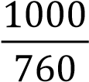 = 1.315 atm

Volume of the gas = 1dm3

Temperature of the gas = 30oC + 273 K = 303 K

Molecular mass of the gas = 17 g mol-1

General gas equation PV = m RT can be used to calculate the mass m of the gas.( )

M

Rearranging m = PVM

RT

Putting values along with units

1.315 atm x 1 dm x 17 g mol3 -1

Mass of NH = 3 3 -1 -1

0.0821 dm atm K mol x 303 K

Simplifying the units

1.315 x 1 x 17g

Mass of NH = 3 = 0.907 g Answer 0.0821 x 303

This is the mass of 1 dm3 of NH3 under the given conditions. In other words, it is the density of NH3, if it is acting as an ideal gas.

## 3.4 AVOGADRO’S LAW

According to this law, **“equal volumes of all the ideal gases at the same temperature and pressure contain equal number of molecules”.** This statement is indirectly the same as has been used for evaluating the general gas constant R i.e., one mole of an ideal gas at 273.16K and one atm pressure has a volume of 22.414 dm3. Since one mole of a gas has Avogadro’s number of particles, so 22.414 dm3 of various ideal gases at S T P will have Avogadro’s number of molecules i.e. 6.02 x 1023. 22.414 dm3 of a gas at 273.16 K and one atmospheric pressure has number of molecules = 6.02 x1O23.

In other words, if we have one dm3 of each of H2, He, N2, O2 , and CO in separate vessels at STP, then the number of molecules in each will be 2.68 x 1022 This is obtained by dividing 6.02x 1023 with 22.414 dm3 .

Similarly, when the temperature or pressure are equally changed for these four gases, then the new equal volumes i.e. 1dm3 each will have the same number of molecules i.e. 2 . 6 8 x 1022.

No doubt, one dm3 of H2 at STP weighs approximately 0.0899 grams and one dm3 of O2 at STP weighs 1.4384 g, but their number of molecules are the same. Although, oxygen molecule is 16 times heavier than hydrogen, but this does not disturb the volume occupied, because molecules of the gases are widely separated from each other at STP One molecule is approximately at a distance of 300 times its own diameter from its neighbour at room temperature.

## 3.5 DALTON’S LAW OF PARTIAL PRESSURES

John Dalton studied the mixtures o f gases and gave his law of partial pressures. According to this law, **the total pressure exerted by a mixture of non-reacting gases is equal to the sum of their individual partial pressures.** Let the gases are designated as 1,2,3, and their partial pressures are p1, p2, p3.The total pressure (P) of the mixture of gases is given by

Pt = p1+ p2 + p3

The partial pressure of a gas in a mixture of gases is the pressure that it would exert on the walls of the container, if it were present all alone in that same volume under the same temperature.

Let us have four cylinders of same volume, i.e., 10 dm3 each and three gases H2, CH4 and O2 are separately enclosed in irst three of them at the same temperature. Let their partial pressures be 400 torr, 500 torr and 100 torr respectively.

All these gases are transferred to a fourth cylinder of capacity 10 dm3 at the same temperature.

According to Dalton’s law

P = pt H2 + pCH4 + pO2= 400 + 500 + 100 torr( )

P = 1000 torrt

These three non-reacting gases are behaving independently under the normal conditions. The rapidly moving molecules of each gas in a mixture have equal opportunities to collide with the walls of the container. Hence, each gas exerts a pressure independent of the pressure of other gases. The total pressure is the result of total number of collisions per unit area in a given time.

Molecules of each gas move independently, so the general gas equation (PV = nRT ) can be applied to the individual gases in the gaseous mixture.

RT

pH2V =nH2RT pH2 =nH2  pH2 a nH

V 2

RT

pCH4V =nCH4RT pCH4 =nCH4  pCH2 a nCH

V 4

RT

pO2V =nO2RT pO2 =nO2  pO2 a nO

V 2

RT

is a constant factor for each gas.

V

All these gases have their own partial pressures. Since volumes and temperatures are the same, so their number of moles will be diferent and will be directly proportional to their partial pressures. Adding these three equations

P = pt H2 + pCH4 + pO2

RT

P = (nt H2 + nCH4 + nO2)

V RT

P = n t t  where n = nt H2 + nCH4 + nO

V 2

P V = n RTt t ................ (8)

According to equation (8), the total pressure of the mixture of gases depends upon the total number of moles of the gases.

### 3.5.1 Calculation of Partial Pressure of a Gas

The partial pressure of any gas in a mixture of gases can be calculated, provided one knows the mass of that gas or its number of moles alongwith the total pressure and the total number of moles present in the mixture.

In order to have a relationship, let us suppose that we have a mixture of gas A and gas B. This mixture is enclosed in a container having volume (V). The total pressure is one atm.

The number of moles of the gases A and B are nA and nB respectively. If they are maintained at temperature T, then

P V = n RT t t  ........... (equation for the mixture of gases)

p V = n RT A A  ........... (equation for gas A ) p V = n RTB B  ........... (equation for gas B)

Divide the irst two equations

p VA  = n RTA

P Vt n RTt p n

PAt = nAt . . . . . . . . . . (9)

nA Pt . . . . . . . . . . (10)

pA = nt

pA = x A Pt (x is mole fraction of gas A)A pB = x B Pt

Similarly

Partial pressure of a gas is the mole fraction of that gas multiplied by the total pressure of the mixture. Remember that mole fraction of anyone of the gases in the mixture is less than unity. Moreover, the sum of mole fractions is always equal to unity.

**Example 6**

There is a mixture of hydrogen, helium and methane occupying a vessel of volume 13 dm3 at 37 °C and pressure of 1 atmosphere. The masses of H2 and He are 0.8 g and 0.12 g respectively. Calculate the partial pressures in torr of each gas in the mixture. **Solution**

Volume of the mixture of gases = 13 *dm*3

Temperature of the mixture = 37 273 310 + = *K* Pressure of the mixture = 1 *atm*

First calculate the total number of moles present in the mixture of gases by applying the general gas equation. Since

PV = nRT PV n =

or RT

Putting values along with the units and simplifying

1 atm x 13 dm3   n = 3 -1 -1  = 0.51 moles 0.0821 dm atm. K mol x 310 K

So, the total number of moles of H , He 2 and CH = 0.51 m4 oles

Mass of H = 0.8 g2

mass of H2 0.8 g

Number of moles of H = 2  = -1 = 0.40 molar mass 2.0 g mol

Mass of He = 0.12 g

mass of He 0.12 g

Number of moles of He = = -1 = 0.03 molar mass 4 g mol

Number of moles of CH = total moles - moles of H - moles of He4 2

= 0.51 - 0.396 - 0.03

= 0.084

2 ( H2 ) no of moles of H2 0.40

Mole fraction of H X = = = 0.784 total number of moles 0.51

Mole fraction of He X( He ) = no of moles of He  = 0.03 = 0.058 total number of moles 0.51

4 ( CH4 ) no of moles of CH 4 0.084

Mole fraction of CH X = = = 0.164 total number of moles 0.51

(Being a ratio mole fraction has no units.)

*Partial pressure of H* 2 ( *pH*2 ) = *X PH*2

== 0.776 1.00 *x*  0.776 *atm*

== 0.776 760 *x*  589.76 *torr*

*Partial pressure of He* ( *pHe*) = *XHe* P

== 0.058 1.00 *x*  0.058 *atm*

== 0.058 760 *x*  44.08 *torr*

*Partial pressure of* C*H*4 ( *pCH*4 ) = *XCH*4 P

== 0.164 1.00 *x*  0.164 *atm*

== 0.164 760 *x*  124.64 *mm of Hg* *Answer*

The sum of individual pressures i.e. 589.76.44.08 and 124.64 is almost 760 mm of Hg, i.e. total pressure of the mixture.

### 3.5.2 Applications of Dalton’s Law of Partial Pressures

Following are the four important applications of Dalton’s Law of partial pressures.

1. Some gases are collected over water in the laboratory. The gas during collection gathers water vapours and becomes moist. The pressure exerted by this moist gas is, therefore, the sum of the partial pressures of the dry gas and that of water vapours.

The partial pressure exerted by the water vapours is called aqueous tension.

Pmoist = pdry + pw.vap

Pmoist = pdry + aqueous tension

pdry = Pmoist - aqueous tension

While solving the numericals the aqueous tension is subtracted from the total pressure (P moist).

1. Dalton's law inds its applications during the process of respiration. The process of respiration depends upon the diference in partial pressures. When animals inhale air then oxygen moves into lungs as the partial pressure of oxygen in the air is 159 torr, while the partial pressure of oxygen in the lungs 116 torr. CO2 produced during respiration moves out in the opposite direction, as it's partial pressure is more in the lungs than that in air.
2. At higher altitudes, the pilots feel uncomfortable breathing because the partial pressure of oxygen in the un-pressurized cabin is low, as compared to 159 torr, where one feels comfortable breathing.
3. Deep sea divers take oxygen mixed with an inert gas say He and adjust the partial pressure of oxygen according to the requirement. Actually, in sea after every 100 feet depth, the diver experiences approximately 3 atm pressure, so normal air cannot be breathed in depth of sea. Moreover, the pressure of N2 increases in depth of sea and it difuses in the blood.

## 3.6 DIFFUSION AND EFFUSION

**Diffusion**

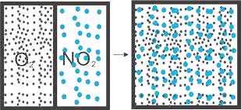According to the kinetic molecular theory of gases, the molecules of the gases move haphazardly. They collide among themselves, collide with the walls of the vessel and change their directions. In other words the molecules of gases are scattered after collisions. This spontaneous intermingling of molecules of one gas with another at a given temperature and pressure is called difusion.

Fig (3.8) Diffusion

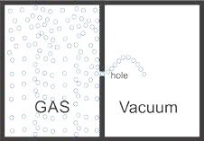The spreading of fragrance of a rose or a scent is due to difusion. When two gases difuse into each other, they wish to make their partial pressures same every where. Suppose NO2, a brown coloured gas and O2, a colourless gas, are separated from each other by a partition Fig (3.8).When the partition is removed, both difuse into each other due to collisions and random motion.

A stage reaches when both gases generate a homogeneous Fig (3.9) Escape of gas mixture and partial pressures of both are uniform throughout molecules through a hole is effusion. the mixture.

**Effusion**

The efusion of a gas is it's movement through an extremely small opening into a region of low pressure. This spreading of molecules is not due to collisions, but due to their tendency to escape one by one. Actually, the molecules of a gas are habitual in colliding with the walls of the vessel. When a molecule approaches just in front of the opening it enters the other portion of the vessel. **This type of escape of molecules is called of efusion Fig( 3.9).**

**3.6.1 Graham 's Law of Diffusion**

Thomas Graham (1805 -1869), an English scientist, found that the rate of difusion or efusion of a gas is inversely proportional to the square root of it's density at constant temperature and pressure.

Rate of diffusion ∝ 1 at constant temperature and pressure( )

Rate of diffusion =

d

k

d

Rate of diffusion x d = k or Rate x d = k

The constant k is same for all gases, when they are all studied at the same temperature and pressure. Let us have two gases 1 and 2, having rates of difusion as r1 and r2 and densities as d1 and d2 respectively. According to Graham's law

r x 1 d = k1 r x 2 d = k2

Divide the two equations and rearrange

*r*1 *d*2

= . . . . . . . . . . (11) *r*2 *d*1

Since the density of a given gas is directly proportional to its molecular mass. Graham’s law of difusion can also be written as follows.

*r*1 *M*2

= . . . . . . . . . (12) *r*2 *M*1

Where M1 and M2 are the molar masses of gases.

### Demonstration of Graham‘s Law

This law can also be very easily veriied in the laboratory by noting the rates of difusion of two gases in a glass tube, when they are allowed to move from opposite ends Fig (3.10). Two cotton plugs soaked in HCl and NH3 solutions are introduced in the open ends of 100 cm long tube simultaneously. HCl molecules travel a distance of 40.5 cm while NH3 molecules cover 59.5 cm in the same duration. They produce dense white fumes of ammonium chloride at the point of junction. So

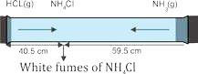 *rNH*3 *M*

= *HCI*

*rHCI MNH*3

59.5 36.5

=

40.5 17

Fig (3.10) Veriication of Graham's law of diffusion

1.46 = 1.46

Hence the law is veriied.

**Example 7**

250 cm3 of the sample of hydrogen efuses four times as rapidly as 250 cm3 of an unknown gas. Calculate the molar mass of unknown gas. **Solution**

Let the unknown gas is given the symbol X

*Rate of effusion of unknown gas r* ( )*x* = 1

*Rate of effusion of hydrogen gas r* ( *H*2 ) = 4

*Molar mass of H gas M* 2 ( *H*2 ) = 2 g mol−1 *Molar mass of unknown gas* (*Mx* ) = ?

*rH*2 *M*

= *x*

*rx MH*2

4 *M*

= *x*

1. 2

*Mx* 16

=

1. 1

|  |
| --- |
| −1 |

*Mx* = 16 2 = 32 g mol*x* Answer

## 3.7 KINETIC MOLECULAR THEORY OF GASES

The behaviour of gases has already been discussed in gas laws. These laws were based on experimental observations quite independent of nature of a gas. In order to illustrate the behaviour of gases quantitatively, Bernoulli (1738) put forward kinetic molecular theory of gases. This theory lead Clausius (1857) to derive the kinetic equation and deduced all the gas laws from it. The theory was later on elaborated and extended by Maxwell, who gave the law of distribution of velocities. According to this law,molecules are in the form of groups having deinite velocity ranges. Boltzmann also Contributed and studied the distribution of energies among the gas molecules. Among some other names Van der Waal is the prominent scientist in this ield.

Following are the fundamental postulates of this kinetic theory of gases.

1. Every gas consists of a large number of very small particles called molecules. Gases like He, Ne, Ar have monoatomic molecules.
2. The molecules of a gas move haphazardly, colliding among themselves and with the walls of the container and change their directions.
3. The pressure exerted by a gas is due to the collisions of its molecules with the walls of a container. The collisions among the molecules are perfectly elastic.
4. The molecules of a gas are widely separated from one another and there are suicient empty spaces among them.
5. The molecules of a gas have no forces of attraction for each other.
6. The actual volume of molecules of a gas is negligible as compared to the volume of the gas.
7. The motion imparted to the molecules by gravity is negligible as compared to the efect of the continued collisions between them.
8. The average kinetic energy of the gas molecules varies directly as the absolute temperature of the gas.

Keeping in view the basic assumptions given above, R.J Clausius deduced an expression for the pressure of an ideal gas. Actually,pressure on the walls of the vessel is due to collisions. Whenever the molecules move they collide among themselves and with the walls of the container. Due to these collisions,a force is exerted on the walls of the container. This force when divided by the area of the vessel gives force per unit area, which is called pressure. In this way, the inal form of kinetic equation is as follows.

−

PV = mN*c*2 . . . . . . . . . (13)

Where,

P = pressure V = volume

m = mass of one molecule of the gas

N = number of molecules of gas in the vessel c2= mean square velocity

The idea of the mean square velocity is important. All the molecules of a gas under the given conditions don’t have the same velocities. Rather diferent velocities are distributed among the molecules. To understand it study Maxwell’s law of distribution of velocities. If there are n1 molecules with velocity c1, n2 molecules with velocity c2, and so on then,

2 c12 + c22 + c32 + .......

c = . . . . . . . . (14) n + n + n + .......1 2 3

In this reference n1+n2+n3 .......=N c2 is the average of the squares of all the possible velocities. When we take the square root of this c2 , then it is called root mean square velocity (Crms). So, (Crms) = c2

The expression for the root mean square velocity deduced from the kinetic equation is written as follows.

3RT

Crms = . . . . . . . . . (15)

M

Where, Crms = root mean square velocity

M = molar mass of the gas T = temperature

This equation (15) is a quantitative relationship between the absolute temperature and the velocities of the gas molecules. According to this equation, higher the temperature of a gas, greater the velocities. Kinetic equation can be used to explain gas laws.

### 3.7.1 Explanation of Gas Laws from Kinetic Theory of Gases

Kinetic theory of gases gives birth to kinetic equation of gases, which can be employed to justify the gas laws. In other words, it proves that gas laws get their explanation from kinetic theory of gases **(a) Boyle’s Law** According to one of the postulates of kinetic theory of gases, the kinetic energy is directly proportional to the absolute temperature of the gas. The kinetic energy of N molecules is 1 mNc2 so 2 .2

mNc ∝ T



mNc = kT . . . . . . . . . . . (16)2

Where k is the proportionality constant. According to the kinetic equation of gases

PV= mNc2

Multiplying and dividing by 2 on right hand side

*PV* = 2 (1mNc ) . . . . . . . . . (17)2

3 2

Putting equation (16) into equation (17).

PV= kT . . . . . . . . . (18)

If the temperature (T) is constant then right hand side of equation (18)  kT is constant. Let that constant be k’.

So, PV = k’ (which is Boyle’s law)

Hence at constant temperature and number of moles, the product PV is a constant quantity.

#### (b) Charles’s law

Consider the equation (18) which has just been derived

Or *PV* = *kT*

*V* = 2 *kT* = ( 2*k* ) *T*

3 *P* 3*P*

At constant pressure,

Therefore, 2 *k*

= k" (a new constant)

3 *P*

or V = k" T

*V*

= k" (which is Charles's law)

*T*

#### (c) Avogadro’s Law

Consider two gases 1 and 2 at the same pressure P and having the same volume V.Their number of molecules are N1 and N2 , masses of molecules are m1 and m2 and mean square velocities are c12 and c22 respectively.

Their kinetic equations can be written as follows:

1 2 for gas(1)

PV= m N c1 1 1

3

PV = 1 m N c2 222 for gas(2)

3

Equalizing 1 m N c1 1 12 = 1 m N c2 2 22

3 3

Hence, m N c1 1 12 = m N c2 2 22 . . . . . . . . . (19)

When the temperature of both gases is the same, their mean kinetic energies per molecule will also be same, so

1 m c 2 = 1 m c2 22

1 1

22

m c1 12 = m c2 22 . . . . . . . . . (20)

Divide equation (19) by (20)

*N*1 = N2

Hence equal volumes of all the gases at the same temperature and pressure contain equal number of molecules, which is Avogadro’s law.

#### (d ) Graham‘s Law of Difusion

*PV* =  mNc . . . . . . . . . . (13)2

Applying the kinetic equation

*PV* =  mN c*A* 2

If we take one mole of a gas having Avogadro’s number of molecules (N = NA) then the equation (13) can be written as:

*PV* =  Mc (M = mN ) . . . . . . . . . (21)2 *A*

c = 2 3*PV* or *M*

where M is the molecular mass of the gas

Taking square root

2 3PV

c =

M

2 3P 3P M

c = = ( = d )

M/V d V

'V' is the molar volume of gas at given conditions. Since the root mean square velocity of the gas is proportional to the rate of difusion of the gas.

so c 2 ∞ r

r ∞ 3*P d*

At constant pressure

r ∞ 1

*d*

which is Graham’s law of difusion

## 3.8 KINETIC INTERPRETATION OF TEMPERATURE

According to kinetic molecular theory of gases the molecules of a gas move randomly. They collide among themselves, with the walls of the vessels and change their directions. The collisions are elastic and the pressure of the gas is the result of these collisions with the walls of the container. Let us rewrite the kinetic equation of gases (13) as already mentioned

PV = mNc . . . . . . . . . (13)2

Here m is the mass o f one molecule of the gas, N is the number of molecules in the vessel and c2is their mean square velocity. The average kinetic energy associated with one molecule o f a gas due to its translational motion is given by the following equation.

E k = m*c*2 . . . . . . . . . (22)

Remember that Ek is the average translational kinetic energy of gas molecules.

Equation (13) can be rewritten as:

*PV* = 2 N ( 1 mc ) . . . . . . . . . (23)2

3 2

Putting equation (22) into (23)

So *PV* =  N E . . . . . . . . . . (24)*k*

Equation (24) gives an important insight into the meaning of temperature. To understand it, consider one mole of a gas.

So *N* = N*A*

*PV* =  N E . . . . . . . . . . (25)*A k*

According to the general gas equation for 1 mole of a gas

*PV* = RT . . . . . . . . . . (4)

Comparing equation (4) and (25)

2

N E = RT . . . . . . . . . . . (26)*A k*

3

3R

E = *k*  T . . . . . . . . . . . (27)

2NA

The equation (27) gives a new deinition of temperature according to which the kelvin temperature of a gas is directly proportional to the average translational kinetic energy of its molecules. This suggests that a change in temperature means change in the intensity of molecular motion. When heat lows from one body to another, the molecules in the hotter body give up some of their kinetic energy through collisions to molecules in the colder body. This process of low of heat continues until the average translational kinetic energies of all the molecules become equal. This equalises the temperature of both bodies.

In gases and liquids, temperature is the measure of average translational kinetic energies of molecules. In solids, where molecules cannot move freely temperature becomes a measure of vibrational kinetic energy.

Keeping in view this kinetic interpretation of temperature, w e have a way of looking at absolute zero of temperature. It is that temperature at which the molecular motions cease. The absolute zero is unattainable. Anyhow, current attempts have resulted in temperature as low as 10-5K.

1. The two sides of equation are not equal. So, Charles’s law is not being obeyed when temperature is measured on the Celsius scale.

   For this reason a new temperature scale has been developed. It starts from 273 °C (more precisely -273.16 °C) which is called zero Kelvin or zero absolute. Let us now explain how the new temperature scale has been developed. The best way is to plot a graph between the variables of Charles’s law.