## 3.9 LIQUEFACTION OF GASES

### 3.9.1 General Principle of Liquefaction

The conversion of a gas into a liquid requires high pressure and low temperature. High pressure brings the molecules of a gas close to each other. Low temperature deprives the molecules from kinetic energy and attractive forces start dominating.

For every gas there exists a temperature above which the gas cannot be liqueied, no matter how much pressure is applied. **The highest temperature at which a substance can exist as a liquid, is called its critical temperature (Tc)**. There is a corresponding pressure which is required to bring about liquefaction at this critical temperature (Tc). This is called critical pressure (Pc).

The critical temperature and the critical pressure of the substances are very important for the workers dealing with the gases. These properties provide us the information about the condition under which gases liquefy. For example, O2 has a critical temperature 154.4 K (-118.75 °C). It must be cooled below this temperature before it can be liqueied by applying high pressure. Ammonia is a polar gas. Its critical temperature is 405.6 K (132.44 °C), so it can be liqueied by applying suicient pressure close to room temperature.

Table (3.2) shows the critical parameters of some common substances. Non- polar gases of low polarizability like Ar have a very low critical temperature. The substances like H2O vapours and NH3 gas are among the polar gases and they have better tendencies to be liqueied CO2, can not be liqueied above 31.1 oC, no matter how much the pressure is applied. Anyhow, if temperature of CO2 is maintained below 31.1 oC, then lower pressure than critical pressure is required to liquefy it. The value of the critical temperature of a gas depends upon its size, shape and intermolecular forces present in it.

When a gas is measured at its critical temperature and critical pressure, then at that stage volume of 1 mole of gas is called critical volume which is represented by Vc. The critical volume of O2 is 74.42 cm3 mol-1, of CO2 , is 95.65 cm3 mol-1 and that of H2 is 64.51 cm3 mol-1.

### Table (3.2) Critical Temperatures and Critical Pressures of Some Substances

|  |  |  |
| --- | --- | --- |
| **Substance** | **Critical Temperature Tc (K)** | **Critical Pressure Pc (atm)** |
| Water vapours, H2O  Ammonia, NH3  Freon-12 , CCl2F2  Carbon dioxide, CO2  Oxygen, O2  Argon, Ar  Nitrogen, N2 | 647.6 (374.44 °C)  405.6 (132.44 °C)  384.7 (111.54 °C)  304.3 (31.142 °C)  154.4 (-118.75 °C)  150.9 (-122.26 °C)  126.1 (-147.06 °C) | 217.0  111.5  39.6 73.0  49.7 48  33.5 |

#### 3.9.2 Methods of Liquefaction of Gases

There are various methods to liquefy a gas . One of them is Linde’s method. It is based on JouleThomson efect.

##### Joule Thomson Efect

Low temperature can be achieved by Joule-Thomson efect, according to which when a compressed gas is allowed to expand into a region of low pressure it gets cooled.

The molecules of the compressed gas are very close to each other and appreciable attractive forces are present among them. When a gas is allowed to undergo sudden expansion through the nozzle of a jet, then the molecules move apart. In this way energy is needed to overcome the intermolecular attractions. This energy is taken from the gas itself, which is cooled.

##### Linde’s Method of Liquefaction of Gases

Linde has employed Joule-Thomson efect as the basis for liquefaction. The apparatus designed for this purpose is shown in the Fig (3.11).

For the liquefaction of air, it is compressed to about 200 atmospheres, and then passed though a water cooled pipe where the heat of compression is removed. It is then allowed to pass through a spiral pipe having a jet at the end. When the air comes out of the jet the expansion takes place from 200 atm. to 1 atm. In this way, considerable fall of temperature occurs.

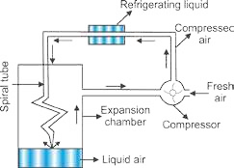

Fig (3.11) Linde's method for

Animation 3.5.: [Liquefaction](https://ja.wikipedia.org/wiki/%E3%83%95%E3%82%A1%E3%82%A4%E3%83%AB:Liquefaction.gif) the liquefaction of air

Source& Credit: [wikipedia](https://ja.wikipedia.org/wiki/%E3%83%95%E3%82%A1%E3%82%A4%E3%83%AB:Liquefaction.gif)

This cooled air goes up and cools the incoming compressed air. It returns to the compression pump. This process is repeated again and again. The liquid air is collected at the bottom of the expansion chamber. All gases except H2, and He can be liqueied by the above procedure.

## 3.10 NON-IDEAL BEHAVIOUR OF GASES

Whenever, we discuss gas laws it.is proposed that ideal gases obey them. Particularly an ideal gas obeys Boyle’s law, Charles’s law and the general gas equation under all conditions of temperature and pressure. Let us try to understand the behaviour of a few real gases like H2, He, N2 and CO2 at °C.keeping in view the variation of the pressure on the gas and consequently the change in its volume.

For this purpose, irst of all plot a graph between pressure on x-axis and the *nRTPV* on Y-axis for an ideal gas.

The factor *PV* is called the compressibility factor. Its

*nRT* value is unity under all conditions for an ideal gas. Since the increase of pressure decreases the volume in such a way that *nRTPV* remains constant at a constant temperature, so a straight line is obtained parallel to the pressure axis. This is shown in the Figs (3.12 a, b). All the real gases have been found to show marked deviations from this behaviour. It is observed that the

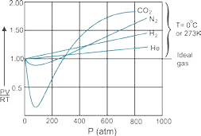

Fig (3.12 a) Non-ideal behaviour of gases at 0 oC

graph for helium gas goes along with the expected horizontal dotted line to some extent but goes above this line at very high pressures. lt means that at very high pressure the decrease in volume is not according to general gas equation and the value of *PV* has increased from the expected values. With this type of behaviour, we

*RT* would say that the gas is non-ideal.

In the case of H2 the deviation starts even at low pressure in comparison to He. N2 shows a decrease in *RTPV* value at the beginning and shows marked deviation even at low pressure than H2. CO2 has a very strange behaviour as it is evident from the graph.

The extent of deviation of these four gases shows that these gases have their own limitations for obeying general gas equation. It depends upon the nature of the gas that at which value of pressure, it will start disobeying.

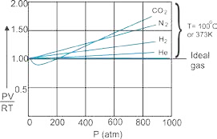When we study the behaviour of all these four gases at elevated temperature i.e., 100oC then the graphs come closer to the expected straight line and the deviations are shifted towards higher pressure. This means that the increase in temperature makes the gases ideal Fig (3.12 b). This discussion on the basis of experimental observations, convinces us that

1. Gases are ideal at low pressure and non-ideal at high pressure
2. Gases are ideal at high temperature and non-ideal at low temperature.

Fig (3.12 b) Non-ideal behaviour of gases at 100 °C.

**3.10.1 Causes for Deviations from Ideality**

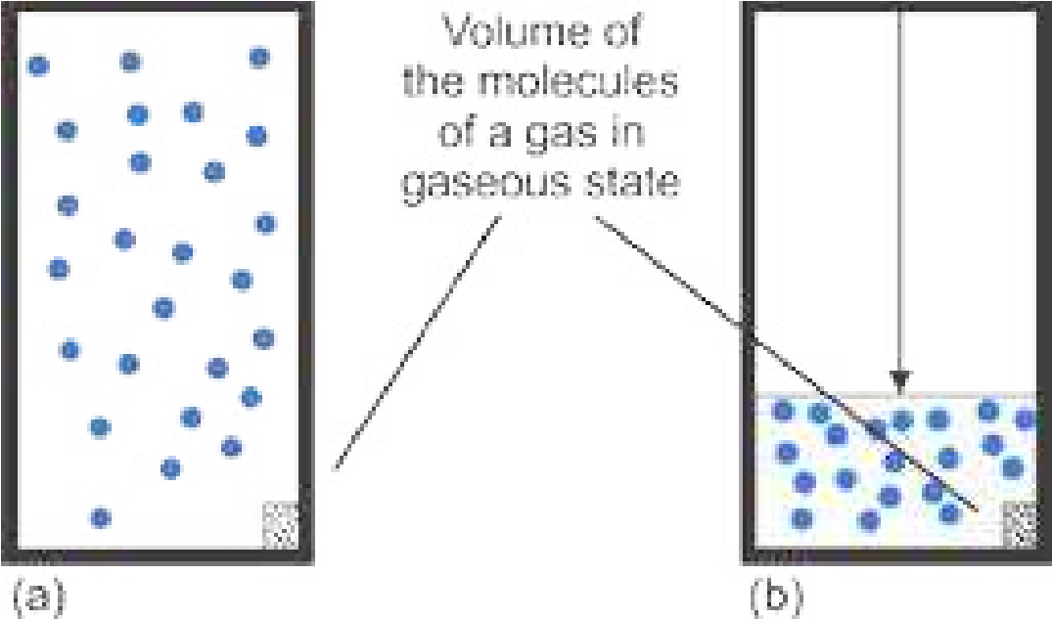It was van der W aals (1873) who attributed the deviation of real gases from ideal behaviour to two of the eight postulates of kinetic molecular theory of gases.

These postulates are as under.

1. There are no forces of attraction among the molecules of a gas.
2. The actual volume of gas molecules is negligible as compared to the volume of the vessel.

When the pressure on a gas is high and the temperature Fig(3.13.a) A gas at low pressure w hen actual pressure when actual volume Kig(3.13.b) A gas at high is low then the attractive forces among the molecules volume is negligible. is not negligible. become signiicant, so the ideal gas equation PV = nRT does not hold. Actually, under these conditions, the gas does not remain ideal.The actual volume of the molecules of a gas is usually very small as compared to the volume of the vessel and hence it can be neglected. This volume, however, does not remain negligible when the gas is subjected to high pressure. This can be understood from the following Figs (3.13 a, b).

**3.10.2 van der Waals Equation for Real Gases**

Keeping in view the above discussion, van der Waals pointed out that both pressure and volume factors in ideal gas equation needed correction in order to make it applicable to the real gases.

### Volume Correction

When a gas is compressed, the molecules are pushed so close together that the repulsive forces operate between them. When pressure is increased further it is opposed by the molecules themselves. Actually the molecules have deinite volume, no doubt very small as compared to the vessel, but it is not negligible. So van der Waals postulated that the actual volume of molecules can no longer be neglected in a highly compressed gas. If the efective volume of the molecules per mole of a gas is represented by b, then the volume available to gas molecules is the volume of the vessel minus the volume of gas molecules.

*Vfree* = V*vessel* - b ........... (28)

Vfreeis that volume which is available to gas molecules. The factor b is termed as the excluded volume which is constant and characteristic of a gas. It’s value depends upon the size of gas molecules. Table (3.3) shows the b values for some important gases. It is interesting to know that the excluded volume b is not equal to the actual volume of gas molecules. In fact, it is four times the actual volume of molecules. b = 4Vm

Where Vm is the actual volume of one mole of gas molecules, 'b' is efective volume or excluded volume of one mole of a gas. It is that volume of gas which is occupied by 1 mole of gas molecules in highly compressed state, but not in the liquid state.

### Pressure Correction

A molecule in the interior of a gas is attracted by other molecules on all sides, so these attractive forces are cancelled out. However, when a molecule strikes the wall of a container, it experiences a force of attraction towards the other molecules in the gas. This decreases the force of its impact on the wall. Consider the molecule "A" which is unable to create pressure on the wall due to the presence of attractive forces due to 'B' type molecules Fig (3.14). Let the observed pressure on the wall of the container is P. This pressure is less than the actual pressure Pi, by an amount P', so P = Pi - P'

Pi is the true kinetic pressure, if the forces of attractions would have been absent. P' is the amount of pressure lessened due to attractive forces. Ideal pressure Pi is

Pi = P + P’

It is suggested that a part of the pressure P for one mole of a gas used up against intermolecular attractions should decrease as volume increases. Consequently, the value of P' in terms of a constant 'a' which accounts for the attractive forces and the volume V of vessel can be written as

a

P' =

V2

### How to prove it

P’ is determined by the forces of attraction between molecules of type A, which are striking the wall of the container and molecules of type B, which are pulling them inward. The net force of attraction is proportional to the concentrations of A type and B type molecules.

∴ P' ∞ C . CA

B

Let n is the number o f moles o f A and B separately and total volume of both types of molecules is ‘V’ .he n/V is moles dm-3 of A and B, separately.

P' ∞ n . n

V V n2

P' ∞

V2

an2

P' ∞

V2

(‘a’ is a constant of proportionality)

If, n = 1 (one mole of gas)

then P' = a2 . . . . . . . (29)

V

Greater the attractive forces among the gas molecules, smaller the volume of vessel, greater the value of lessened pressure P’.

This ‘a’ is called co-eicient of attraction or attraction per unit volume. It has a constant value for a particular real gas. Thus efective kinetic pressure of a gas is given by Pi, which is the pressure if the gas would have been ideal.

a

P = P + i 2 . . . . . . . (30)

V

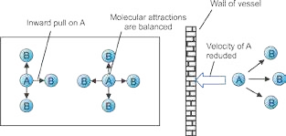

Fig (3.14) Forces of attraction and pressure correction

Once the corrections for pressure and volume are made, the kinetic equation for one mole of a gas can be constructed by taking pressure as ( P + *Va*2 )and volume as (V - b) for one mole of a gas.

*a*

( P + *V* 2 ) (V - b) = RT . . . . . . . . . (31)

For ‘n’ moles of a gas ( P + *n aV*22 ) (V - nb) = nRT . . . . . . . . . (32)

This is called van der Waal’s equation, ‘a’ and ‘b’ are called van der Waal’s constants. **Units of ’a‘.** Since,

*n a*2

P' = *V* 2

So

P'V2

a = n2

atm x (dm )3 2

a = (mol)2

a = atm dm mol6 -2

In S.I. units, pressure is in Nm and volume in m-2 3

or a = Nm x (m )(mol-2 )2 3 2 ora = Nm+4 mol-2

**Units o f ‘b’:** b’ is excluded or incompressible volume /mol-1 of gas. Hence its units should be dm3 mol-1 or m3 mol-1

The values of ’a’ and ‘b’ can be determined by knowing the values of P, V and T of a gaseous system under two diferent conditions. Following Table (3.3) gives the values of ‘a’ and ‘b’ for some common gases.

### Table(3.3) van der Waals Constant for Some Common Gases

|  |  |  |
| --- | --- | --- |
| **Gas** | **‘a’ (atm dm6 mol-2)** | **‘b’ (dm3 mol-1)** |
| Hydrogen  Oxygen  Nitrogen  Carbon dioxide Ammonia  Sulphur dioxide Chlorine | 0.245  1.360 1.390 3.590 4.170 6.170  6.493 | 0.0266 0.0318 0.0391 0.0428 0.0371 0.0564  0.0562 |

The presence of intermolecular forces in gases like Cl2 and SO2 increases their ‘a’ factor.The least value of ‘a’ for H2 is due to its small size and non-polar character. The ‘b’ value of H2 is 0.0266 dm3 mol-1. It means that if 2.016g (1mole) of H2 is taken, then it will occupy 0.0266 dm3 or 266cm3 of volume at closest approach in the gaseous state.

**Example 8**

One mole of methane gas is maintained at 300 K. Its volume is 250 cm3. Calculate the pressure exerted by the gas under the following conditions.

(i) when the gas is ideal (ii) when the gas is non-ideal a = 2.253 atm dm6 mol-2 , b = 0.0428 dm3 mol-1

**Solution**

(i) When the gas is ideal, general gas equation is applied i.e.,

PV = nRT

V = 250 cm3 = 0.25 dm3 1 dm3 = 1000 cm3

*n* = 1 mole

*T* = 300 K

R = 0.0821 dm atm K3 −1 mol−1

*nRT*

P =

*V*

Putting the values alongwith units

1 mol x 0.0821 dm atm K3 −1 mol−1 x 300 K

*P* =

0.25 *dm*3

*P* = 98.5 atm (Answer)

If CH4 gas would have been ideal, under the given conditions, 98.5 atm. pressure would have been exerted.

(ii) When the gas is behaving as non-ideal, we should use the van der Waals equation

 *n a*2 

P + *V* 2  (V-nb) = n R T

By rearranging the equation and taking the pressure on L.H.S.

P + n a22 = n R T or V V-nb2

n R T n a

P = -

V-nb V2

Substituting the following values (ignore the units for sake of simplicity) n = 1 mol, R = 0.0821 dm3 atm K-1 mol-1,

V = 0.25 dm3, T = 300 K, a = 2.253 dm6 atm mol-2, b = 0.0428 dm3 mol-1

1 x 0.0821 x 300 1 x 2.253 24.63 2.253

- = -

0.25-1 0.0428( ) (0.25) 0.207 0.0625

P = 118.985 - 36.048 = 82.85 atm.

In the non-ideal situation the pressure has lessened upto

98.5 - 82.85 = 15.65 atm. Answer **Conclusion:**

## The diference of these two pressures shows th3.11 PLASMA STATE

**What is plasma?**

Plasma is often called the “fourth state of matter”, the other three being solid, liquid and g a s. Plasma was identiied by the English scientist William Crookes in 1879. In addition to being important in many aspects of our daily life, plasmas are estimated to constitute more than 99 percent of the visible universe. Although, naturally occurring plasma is rare on earth, there are many man-made examples.

Inventors have used plasma to conduct electricity in neon signs and luorescent bulbs. Scientists have constructed special chambers to experiment with plasma in laboratories. It occurs only in lightning discharges and in artiicial devices like luorescent lights, neon signs, etc. It is everywhere in our space environment.

**How is Plasma formed ?**

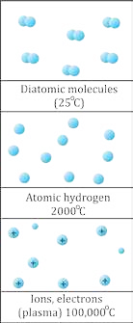When more heat is supplied, the atoms or molecules may be ionized. An electron may gain enough energy to escape its atom. This atom loses one electron and develops a net positive charge. It becomes an ion. In a suiciently heated gas, ionization happens many times, creating clouds of free electrons and ions. However, all the atoms are not necessarily ionized, and some of them may remain completely intact with no net charge. This ionized gas mixture, consisting of ions, electrons and neutral atoms is called plasma.

It means that a plasma is a distinct state of matter containing a signiicant number of electrically charged particles a number suicient to afect its electrical properties and behaviour.

### Natural and Artiicial Plasma

Artiicial plasma can be created by ionization of a gas. as in neon signs. Plasma at low temperatures is hard to maintain because outside a vacuum low temperature plasma reacts rapidly with any molecule it encounters. This aspect makes this material, both very useful and hard to use. Natural plasma exists only at very high temperatures, or low temperature vacuums.

Natural plasma on the other hand do not breakdown or react rapidly, but is extremely hot (over 20,000°C minimum). Their energy is so high that they vaporize any material they touch.

**Characteristic of Plasma:**

1. A plasma must have suicient number of charged particles so as a whole, it exhibits a collective response to electric and magnetic ields. The motion of the particles in the plasma generate ields and electric currents from within plasma density. It refers to the density of the charged particles. This complex set of interactions makes plasma a unique, fascinating, and complex state of matter.
2. Although plasma includes electrons and ions and conducts electricity, it is macroscopically neutral. In measurable quantities the number of electrons and ions are equal.

**Where is Plasma found ?**

Entire universe is almost of plasma. It existed before any other forms of matter came into being.

Plasmas are found in everything from the sun to quarks, the smallest particles in the universe.

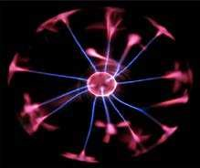As stated earlier plasma is the most abundant form of matter in the universe. It is the stuf of stars. A majority of the matter in inner-stellar space is plasma. All the stars that shine are all plasma. The sun is a 1.5 million kilometer ball of plasma, heated by nuclear fusion.

Animation 3.6.[:Plasma ball](http://giphy.com/gifs/ball-plasma-10taULf3CZ6tLa) source & Credit: [giphy](http://giphy.com/gifs/ball-plasma-10taULf3CZ6tLa)

One arth it only occurs in a few limited places, like lightning bolts, lames, auroras, and luorescent lights. When an electric current is passed through neon gas, it produces both plasma and light.

**Applications of Plasma:**

Plasma has numerous important technological applications. It is present in many devices. It helps us to understand much of the universe around us. Because plasmas’ are conductive respond to electric and magnetic ields and can be eicient sources of radiation, so they can be used in innumerable applications where such control is needed or when special sources of energy or radiation are required.

1. A luorescent light bulb is not like regular light bulbs. Inside the long tube is a gas. When the light is turned on, electricity lows through the tube. This electricity acts as that special energy and charges up the gas. This charging and exciting of the atoms creates a glowing plasma inside the bulb.
2. 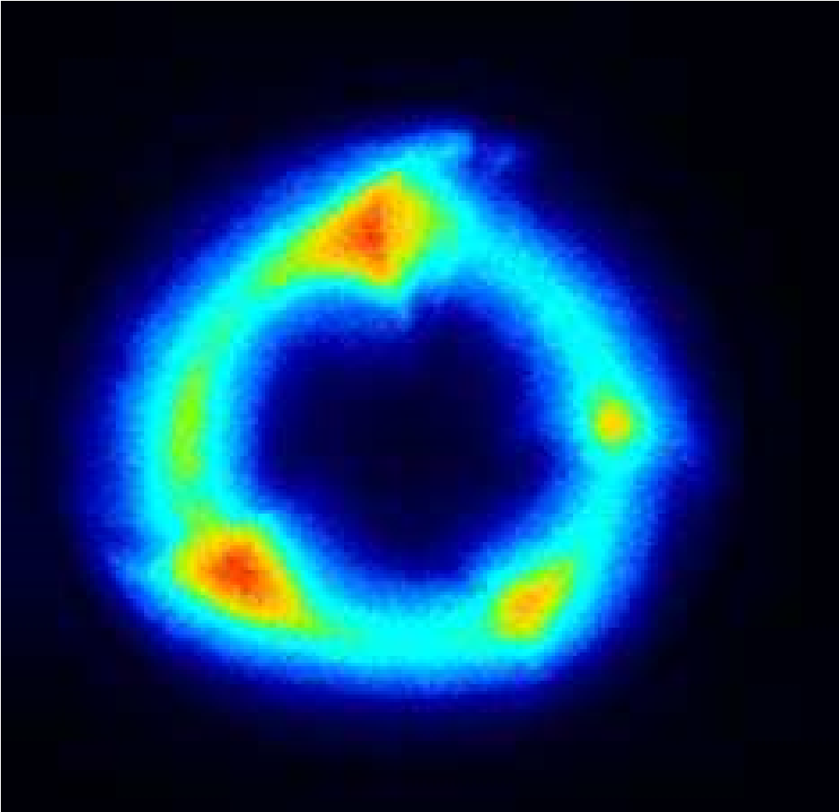Neon signs are glass tubes illed with gas. When they are turned on then the electricity lows through the tube. The electricity charges the gas, possibly neon, and creates a plasma inside the tube. The plasma glows with a special colour depending on what kind of gas is inside.
3. They ind applications such as plasma processing of semiconductors, sterilization of some medical prodjucts, lamps, lasers, diamond coated ilms, high power microwave sources and pulsed power switches.
4. They also provide the foundation for important potential applications such as the generation of electrical energy from fusion pollution control and removal of hazardous

chemicals. Animation 3.7.[:Application of Plasma](http://pag.lbl.gov/)

1. Plasma light up our oices and homes, make our computers Source & Credit: [pag](http://pag.lbl.gov/) and electronic equipment work.
2. They drive lasers and particle accelerators, help to clean up the environment, pasteurize foods and make tools corrosion-resistant.

**Future Horizons:**

Scientists are working on putting plasma to efective use. Plasma would have to be low energy and should be able to survive without instantly reacting and degenerating. The application of magnetic ields involves the use of plasma. The magnetic ields create low energy plasma which create molecules that are in what scientist call a metastable state. The magnetic ields used to create the low temperature plasma give the plasma molecules, which do not react until they collide with another molecule with just the right energy. This enables these metastable molecules to survive long enough to react with a designated molecule. These metastable particles are selective in their reactivity. It makes them a potentially unique solution to problems like radioactive contamination. Scientist are currently experimenting with mixtures of gases to work as metastable agents on plutonium and uranium, and this is just the beginning.

## KEY POINTS

1. The behaviour of a gas is described through four variables i.e., pressure, volume , temperature and its number of moles. The relationships between gas variables are known as the simple gas laws. Boyle’s law relates pressure of a gas with its volume, while Charles’s law relates gas volume with temperature. Avogadro’s law is concerned with volume and amount of a gas. The important concept of absolute zero of temperature originates from the simple gas laws.
2. By combining the above mentioned three laws, a more general equation about the behaviour of gas is obtained i.e., PV = n RT. This equation can be solved for any one of the variables when values for others are known. This equation can be modiied for the determination of molar masses and the density of the gas.
3. Dalton’s law of partial pressures can be used to calculate the partial pressures of gases.
4. The processes of difusion and efusion are best understood by Graham’s law of difusion.
5. Kinetic molecular theory of gases provides a theoretical basis for various gas laws. With the help of this theory a relationship is established between average molecular kinetic energy and kelvin temperature. The difusion and efusion of the gases can be related to their molar masses through the kinetic molecular theory of gases.
6. The real gases show ideal behaviour under speciic conditions. They become non-ideal at high pressure and low temperature. The non-ideal behaviour results chiely from intermolecuiar attractions and the inite volume occupied by the gas molecules.
7. Gases can be liquiied by applying suicient pressure but temperature should either be critical one or below it.
8. To calculate the pressure or volume of a real gas under the non-ideal conditions, alternative kinetic equation has been developed. This is known as the van der Waal’s equation.
9. The plasma, a forth state of matter, consist of neutral particles, positive ions and negative electrons, 99% of the known universe is in the plasma state.

### Excercise

Q 1: Select the correct answer out of the following alternative suggestions.

1. Pressure remaining constant, at which temperature the volume of a gas will become twice of what it is at 0°C.
   1. 546°C b. 200°C c. 546K d. 273K
2. Number of molecules in one dm3 of water is close to
   1. 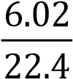 x 1023 b. 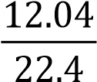 x 1023 c. 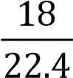 x 1023 d. 55.6 x 6.02 x 1023 (iii) Which of the following will have the same number of molecules at STP?
   2. 280 cm3 of CO2 and 280 cm3 of N2O
   3. 11.2 dm3 of O2 and 32 g of O2
   4. 44 g of CO2 and 11.2 dm3 of CO
   5. 28 g of N2 and 5.6 dm3 of oxygen
3. If absolute temperature of a gas is doubled and the pressure is reduced to one half, the volume of the gas will
   1. remain unchanged b. increase four times

c. reduce to 1/4 d. be doubled

1. How should the conditions be changed to prevent the volume of a given gas from expanding when its mass is increased?
   1. Temperature is lowered and pressure is increased.
   2. Temperature is increased and pressure is lowered.
   3. Temperature and pressure both are lowered.
   4. Temperature and pressure both are increased.
2. The molar volume of CO2 is maximum at
   1. S TP b. 127°C and 1 atm c. 0°C and 2 atm d. 273°C and 2 atm
3. The order of the rate of difusion of gases NH3, SO2, Cl2, an CO2 is:
   1. NH > SO > Cl > CO3 2 2 2 b. NH > CO > SO > Cl3 2 2 2

c. Cl > SO > CO > NH2 2 2 3 d. NH > CO > Cl > SO3 2 2 2

1. Equal masses of methane and oxygen are mixed in an empty container at 25°C. The fraction of total pressure exerted by oxygen is
   1. 1/3 b. 8/9 c. 1/9 d. 16/17
2. Gases deviate form ideal behaviour at high pressure. Which of the following is correct for non-ideality?
   1. At high pressure, the gas molecules move in one direction only.
   2. At high pressure, the collisions between the gas molecules are increased manifold.
   3. At high pressure, the volume of the gas becomes insigniicant.
   4. At high pressure, the intermolecular attractions become signiicant.
3. The deviation of a gas from ideal behaviour is maximum at
   1. -10°C and 5.0atm b. -10 °C and 2.0 atm

c. 100 °Cand2.0 atm d. 0 °C and 2.0 atm

1. A real gas obeying van derW aals equation will resemble ideal gas if
   1. both ’a’ and ’b’ are large b. both’a’and’b’are small

c. ‘a’ is small and ’b’ is large d. ‘a’ is large and ’b’ is small

**Q2: Fill in the blanks**

(i). The product PV has the S.I. unit of _____________

(ii).Eight grams each of O2, and H2, at 27 °C will have total K.E in the ratio of _____________

(iii).Smell of the cooking gas during leakage from a gas cylinder is due to the property of_____________ of _____________ gases.

(iv).Equal _________ of ideal gases at the same temperature and pressure contain______________ number of molecules.

(v).The temperature above which a substance exists only as a gas is called_____________.

Q3: Label the follow in g sentences as True or False.

(i). Kinetic energy of molecules of a gas is zero at 0oC.

(ii). A gas in a closed container will exert much higher pressure at the bottom due to gravity than at the top.

(iii). Real gases show ideal gas behaviour at low pressure and high temperature.

(iv). Liquefaction of gases involves decrease in intermolecular spaces.

(v). An ideal gas on expansion will show Joule-Thomson efect.

Q4 . a. What is Boyle’s law of gases? Give its experimental veriication.

1. What are isotherms? What happens to the positions of isotherms when they are plotted at high temperature for a particular gas.
2. Why do w e get a straight line when pressures exerted on a gas are plotted against inverse of volumes? This straight line changes its position in the graph by varying the temperature.

Justify it.

1. How will you explain that the value of the constant k in the equation PV = k depends upon (i) the temperature of a gas (ii) the quantity of a gas

Q5.a. What is the Charles's law? Which scale of temperature is used to verify that V/T = k (pressure and number of moles are constant)?

1. A sample of carbon monoxide gas occupies 150.0 mL at 25.0°C. It is then cooled at constant pressure until it occupies 100.0 mL. What is the new' temperature? (Ans: 198.8K or -74.4 °C )
2. Do you think that the volume of any quantity of a gas becomes zero at - 273.16 °C. Is it not against the law of conservation of mass? How do you deduce the idea of absolute zero from this information?

Q6 . a. What is Kelvin scale of temperature? Plot a graph for one mole of an a real gas to prove that a gas becomes liquid, earlier than -273.16 ’C.

b. Throw some light on the factor 1/273 in Charles's law.

Q7. a. What is the general gas equation? Derive it in various forms.

1. Can we determine the molecular mass of an unknown gas if we know the pressure, temperature and volume along with the mass of that gas.
2. How do you justify from general gas equation that increase in temperature or decrease of pressure decreases the density of the gas?

c. Why do we feel comfortable in expressing the densities of gases in the units of g dm-3 rather than g cm-3, a unit which is used to express the densities of liquids and solids.

Q8 . Derive the units for gas constant R in general gas equation:

1. when the pressure is in atmosphere and volume in dm3.
2. when the pressure is in N m-2 and volume in m3.
3. when energy is expressed in ergs.

Q9. a. What is Avogadro’s law of gases?

1. Do you think that 1 mole of H2 and 1 mole of NH3 at 0 oC and 1 atmpressure will have Avogadro’s number of particles?
2. Justify that 1 cm3 of H2 and 1 cm3 of CH4 at STP will have same number of molecules, when one molecule of CH4 is 8 times heavier than that of hydrogen.

Q10. a. Dalton’s law of partial pressures is only obeyed by those gases which don’t have attractive forces among their molecules. Explain it.

1. Derive an equation to ind out the partial pressure of a gas knowing the individual moles of component gases and the total pressure of the mixture.
2. Explain that the process of respiration obeys the Dalton’s law of partial pressures.
3. How do you diferentiate between difusion and efusion? Explain Graham’s law of difusion.

Q11. a. What is critical temperature of a gas? What is its importance for liquefaction of gases? Discuss Linde's method of liquefaction of gases.

b. What is Joule-Thomson efect? Explain its importance in Linde's method of liquefaction of gases.

Q12. a. What is kinetic molecular theory of gases? Give its postulates.

b. How does kinetic molecular theory of gases explain the following gas laws:

(i) Boyle's law (ii) Charles's law

(iii) Avogadro's law (iv) Graham’s law of difusion

Q13. a. Gases show non-ideal behaviour at low temperature and high pressure. Explain this with the help of a graph.

1. Do you think that some of the postulates of kinetic molecular theory of gases are faulty? Point out these postulates.
2. Hydrogen and helium are ideal at room temperature, but SO2 , and Cl2 are nonideal. How will you explain this?

Q14. a. Derive van der Waal's equation for real gases.

b. What is the physical signiicance of van der Waals'constants, ’a’ and ’b? Give their units.

Q15 Explain the following facts

1. The plot of PV versus P i s a straight line at constant temperature and with a ixed number of moles of an ideal gas.
2. The straight line in (a) is parallel to pressure-axis and goes away from the pressure axis at higher pressures for many gases.
3. Pressure of NH3 gas at given conditions (say 20 atm pressure and room temperature) is less as calculated by van der Waals equation than that calculated by general gas equation.
4. Water vapours do not behave ideally at 273K.
5. SO2 is comparatively non-ideal at 273K but behaves idealy at 327 “C.

Q16 Helium gas in a 100 cm3 container at a pressure of 500 torr is transferred to a container with a volume of 250 cm3. What will be the new pressure

1. if no change in temperature occurs (Ans: 2 0 0 torr)
2. if its temperature changes from 20 “C to 15°C? (Ans: 196.56 torr)

Q17

1. What are the densities in kg/dm3 of the following gases at STP (P = 101325 Nm-2, T = 273 K, molecular masses are in kg mol-1

(i) methane, (ii) oxygen, (iii) hydrogen

1. Compare the values of densities in proportion to their mole masses.
2. How do you justify that increase of volume upto 100 dm3 at 27°C of 2 moles of NH3 will allow the gas behave ideally, as compared to S.T.P conditions. (Ans: CH4=0.714kgm, O2=1.428kgm-3, H2=0.089kgm-3)

Q18 A sample of krypton with a volume of 6.25 dm3 , a pressure of 765 torr and a temperature of 20 °C is expanded to a volume of 9.55 dm3 and a pressure of 375 torr. What will be its inal temperature in °C? (Ans: T = -53.6°c)

Q19 Working at a vacuum line, a chemist isolated a gas in a weighing bulb with a volume of 255 cm3, at a temperature of 25 °C and under a pressure in the bulb of 10.0 torr. The gas weighed 12.1 mg. What is the molecular mass of this gas?

(Ans: 87.93g mol-1)

Q20 What pressure is exerted by a mixture of 2.00g of H2 and 8.00g of N2 at 273K in a 10 dm3 vessel? (Ans: P = 2.88 atm)

Q21. a. The relative densities of two gases A and B are 1:1.5. Find out the volume of B which will difuse in the same time in which 150 dm3 of A will difuse?

(Ans: 122.47dm3)

1. Hydrogen (H2) difuses through a porous plate at a rate of 500 cm3 per minute at 0 “C. What is the rate of difusion of oxygen through the same porous plate at0 oC?

(Ans: 125 cm3)

1. The rate of efusion of an unknown gas A through a pinhole is found to be 0.279 times the rate of efusion of H2 gas through the same pinhole. Calculate the molecular mass of the

unknown gas at STP. (Ans: = 25.7 gmol-1)

Q22 Calculate the number of molecules and the number of atoms in the given amounts of each gas

1. 20 cm3 of CH4 at 0 °C and pressure of 700 mm of mercury (Ans: 4.936 x1020, 24.7 x 1020
2. 1 cm3 of NH3 at 100 °C and pressure of 1.5 atm (Ans:2.94x1019,1.177 x 1020)

Q23 Calculate the masses of 1020 molecules of each of H2, O2, and CO, at STP. What will happen to the masses of these gases, when the temperature of these gases are increased by 100 oC and the pressure is decreased by 100 torr.

(Ans: 3.3 x 10-4g; 5.31 x 10-3g; 7.30 x 10-3g)

Q24 a. Two moles of NH3 are enclosed in a 5 dm3 lask at 27 oC. Calculate the pressure exerted by the gas assuming that

(i) it behaves like an ideal gas (ii) it behaves like a real gas a=4.17 atm dm6 mol-2

b = 0.0371 dm3 mol-1 (Ans: 9.85 atm)

1. Also calculate the amount of pressure lessened due to forces of attractions at these conditions of volume and temperature. (Ans: 0.51atm)
2. Do you expect the same decrease in the pressure of two moles of NH3 having a volume of 40 dm3 and at temperature of 27 °C.

at this gas is non-ideal. Actually CH4 is thought to be ideal near 1 atm, but around 100 atmospheres, it develops non-ideal attitude. This diference of ideal and non-ideal pressure goes on decreasing when gas is considered at low pressures.