**4.7.3. Molecular Solids**

Those solid substances in which the particles forming the crystals are polar or non-polar molecules or atoms, of a substance are called molecular solids. For instance, in solidiied noble gases, there are non-polar atoms. Two types of of diamond intermolecular forces hold them together.

(i) Dipole-dipole interactions. (ii) van der Waals forces.

These intermolecular forces are much weaker than the forces of attraction between the cations and the anions in ionic crystals, and between the atoms in the covalent crystals.

Ice and sugar are the best examples of crystals having polar molecules whereas iodine, sulphur, phosphorus and carbon dioxide form the molecular crystals containing nonpolar molecules. Polar molecular solids have usually higher melting and boiling points as compared to non-polar molecular solids.

**Properties of the Molecular Solids**

X-ray analysis has shown the regular arrangements of atoms in constituent molecules of these solids, and we get the exact positions of all the atoms.

The forces, which hold the molecules together in molecular crystals, are very weak so they are soft and easily compressible.

They are mostly volatile and have low melting and boiling points. They are bad conductors of electricity, have low densities and sometimes transparent to light. Polar molecular crystals are mostly soluble in polar solvents, while non-polar molecular crystals are usually soluble in non-polar solvents.

Iodine is one of the best examples of a molecular solid. Let us discuss the structure of iodine molecule.

**Structure of Solid Iodine**

In the solid state the molecules of iodihe align in the form of layer lattice. This is shown in Fig (4.19). I -I bond distance is 271.5 pm and it is appreciably longer than in gaseous iodine (266.6 pm).

As expected from its structure, iodine is a poor conductor of electricity.

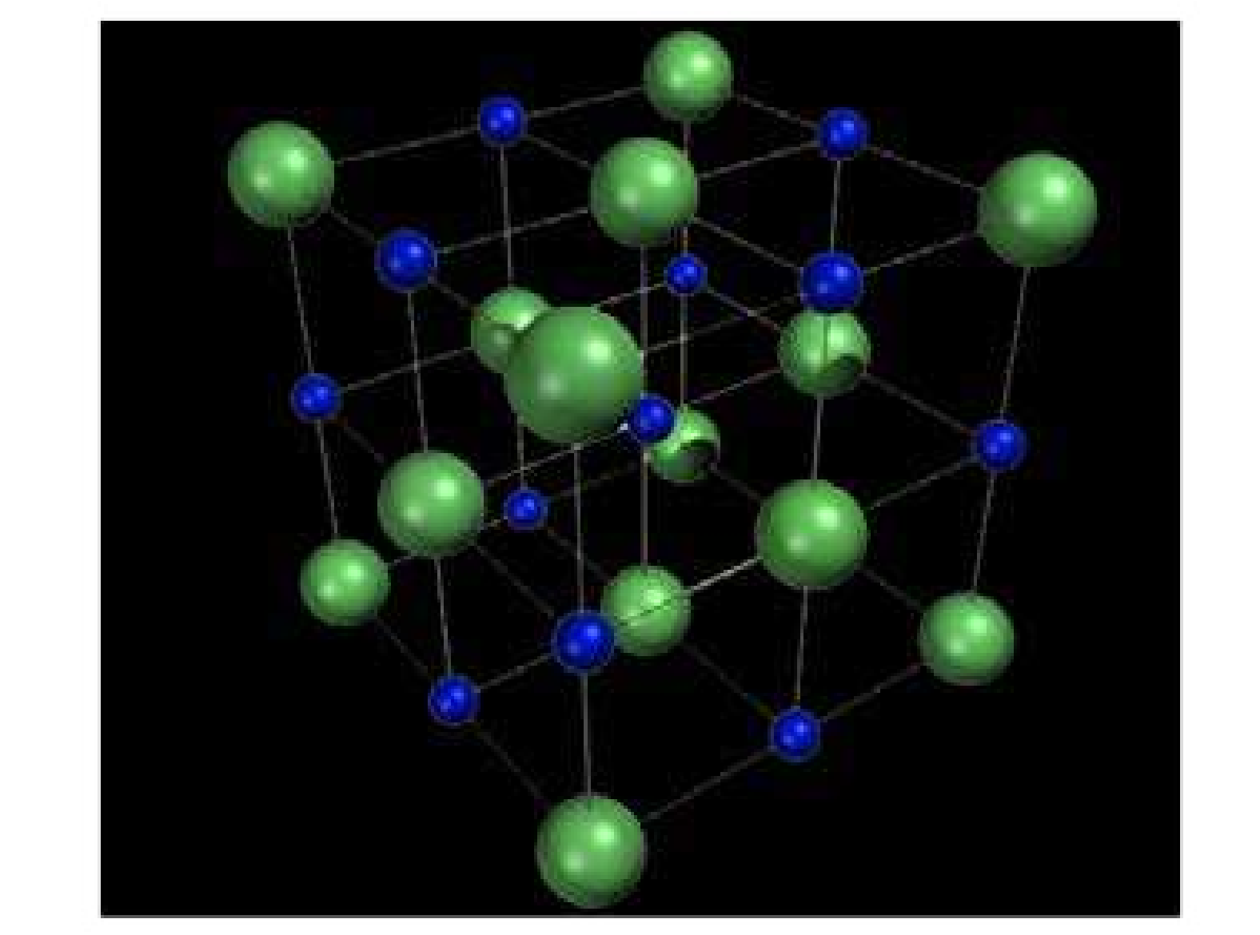

Fig (4.19) Face centered cubic structure of iodine

**4.7.4. Metallic Solids**

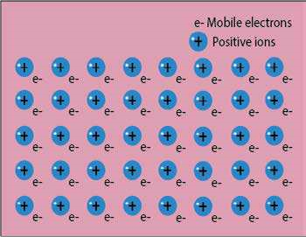 In order to explain properties of metallic solids various theories have been proposed. A few of them are mentioned here.

The irst theory of metallic bonding is called electron pool or electron gas theory. This theory was proposed by Drude and extended by Loren (1923). According to this theory, each atom in a metal crystal loses all of its valence electrons. These valence electrons form a pool or a gas. The positively charged metal ions are believed to be held together by electron pool or gas. These positively charged ions occupy deinite positions at measurable Fig (4.20) Positive ions surrounded by mobile electrons distances from each other in the crystal lattice. Valence elect rons are not attached to any individual ion or a pair of ions rather belong to t he crystal as a whole. These electrons are free to move about from one part of the crystal to the other. The force, which binds a metal cation to a number of electrons within its sphere of- inluence, is known as metallic bond. The following Fig. (4.20) gives an idea of electron gas model.

L. Pauling has tried to explain the metallic bond according to valence bond theory. According to this theory, the metallic bond is treated essentially as covalent in character. However, it is assumed that the covalent bonds are not localized but are highly delocalized in metal structure.

Recently, molecular orbital theory was applied to explain the characteristics of metallic solids. According to this theory, it is assumed that the electrons in the completely illed orbitals are essentially localized, while atomic orbitals containing the valence electrons interact or overlap to form a set of delocalized orbitals. These delocalized orbitals are the molecular orbitals which extend over the entire crystal lattice. Such a combination of atomic orbitals produce as a large number of closely spaced states. These states of energy are also known as bands of energy. That is why it is also called a band theory. The energy gap between two bands determines the properties of the metallic solids.

**Properties of Metallic crystals**

Metals are good conductor of electricity. When electric ield is applied between two ends of a metal then the mobile electrons begin to move towards the positive pole and the new electrons from the negative pole take their place Fig. (4.21a) Sometimes, the electrical conductivity of metals decrease with the increase in temperature. The reason is that with the increase in temperature the positive metal ions also begin to oscillate and the motion hinders the free movement of mobile electrons between the positive ions. This hindrance decreases the electrical conductivity.

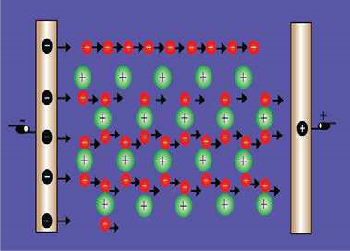

Fig (4.21a) Explanation of electrical conductivity of a metal

The rmal conductivity is another property associated with metallic solids. When a piece of metal is heated at one end, the mobile electrons at this end absorb heat energy and move very rapidly through the metallic lattice towards the cooler end. During the process they collide with adjacent electrons and transfer their heat energy to them.

Whenever the metals are freshly cut, most of them possess metallic luster which means that they have a shining surface. When light falls on the metallic surface, the incident light collides with the mobile electrons and they are excited. These electrons when deexcited give of some energy in the form of light. This light appears to be relected from the surface of the metal which gives a shining look.

Metals are malleable and ductile whenever stress is applied on them. Their layers slip pass each other. The structure of the metal changes without fracturing as shown in the Fig. (4.21b).

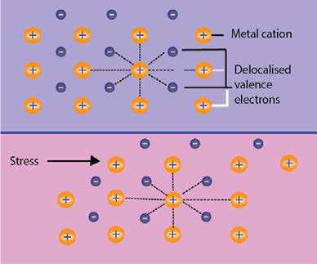

Fig(4.21b) Deformation of metal structures

###### Structure of Metals

In the previous article of metallic solids, we have learnt that metal atoms are arranged in deinite pattern. Free electrons are roaming about in the crystal lattice. So a metal may be regarded as an assembly of the positively charged spheres of identical radii which are packed together to ill the space as completely as possible. To understand the closed packing of atoms in metal structures, let us suppose that the metal atoms are like hard spherical balls. Take twelve spherical balls and pack in a box as shown in Fig (4.22 a).

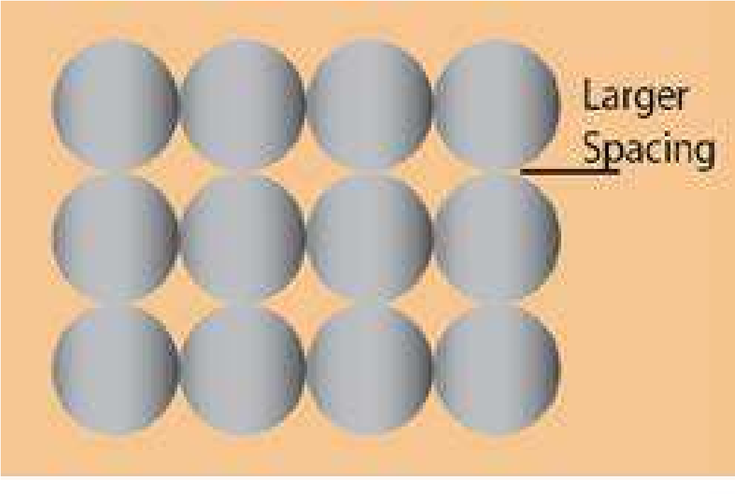

Fig (4.22 a) Packing of twelve sphere in a box (two dimensional view)

The spaces during the packing are larger. When the box is shaken, the balls will rearrange as shown in Fig (4.22 b). The arrangement of these balls are now stable and more closely packed. It is the natural tendency of the balls to have closely packed arrangement of eleven spheres after shaking.

In order to understand,how various unit cells of the crystal lattice are developed, consider three balls which join together in one plane. The fourth ball is inserted in the space created by the other three as a second layer. In this way tetrahedral structure is obtained Fig (4.22 c). Actually, the fourth ball of the second layer is placed in

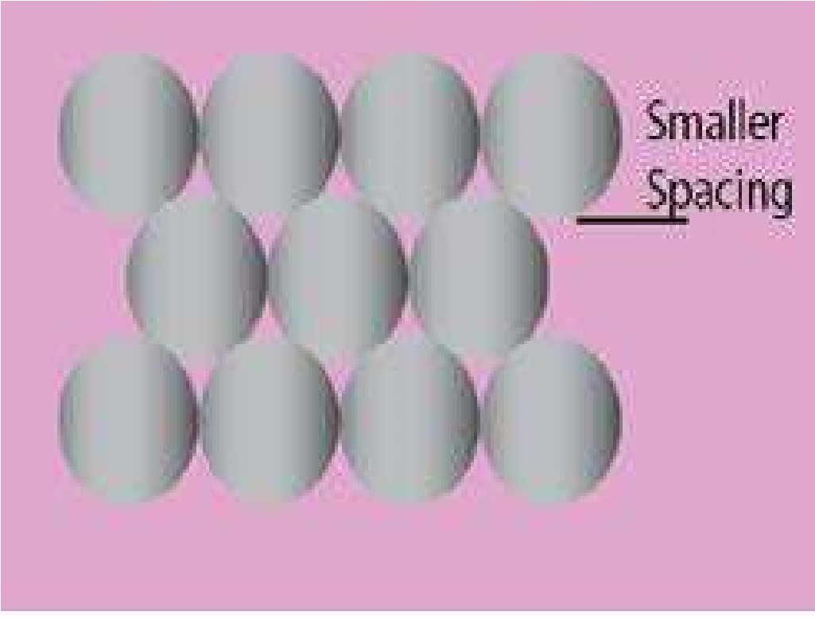

Fig (4.22 b)Packing of eleven spheres in a box ( two dimentional view)

the depression created by the irst three balls. These depressions are also called interstices or crevices or voids.

Consider the Fig (4.22 d) in which eleven balls of Fig. (4.22 b) are present in the irst layer (circles with shade). The balls of the second layer (circle without shade) can it into the depressions or interstices created by the irst layer. When the balls of the second layer are arranged, then all the depressions of the irst layer are not occupied. There are two types of depressions as ‘a’ and ‘b’. The depressions marked ‘b’ are not occupied by the second layer and one can see the ground from looking at the top through depressions ‘b’. The new depressions marked ‘a’ are created by the second layer. Through the depressions ‘a’, we can not see the ground, but balls of the irst layer. Now arrange the balls of third layer in the depression of second layer. When the balls of the third layer are placed abov the second layer then there are two possibilities. Third layer balls may be accommodated in ‘a’- type or ‘b’-type interstices or depressions.

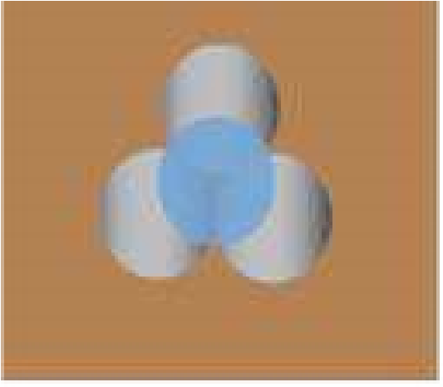Fig (4.22 c) The formation of a 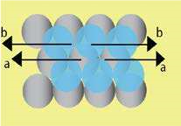tetrahedral site, due to four balls

Fig (4.22 d) Close packing of spheres, showing 11 balls in irst layer and 6 balls in second layer.

1. **Cubic Close Packing**

When the atoms of the third layer it into the interstices marked b, then the atoms of the third layer will not lie directly above those of the atoms of irst layer. This pattern of arrangement is called ABC ABC-------------- or 123 123-----------------. It is named as face centred cubic arrangement Fig. (4.23a). The balls of fourth, seventh and tenth layers will be in front of each other.

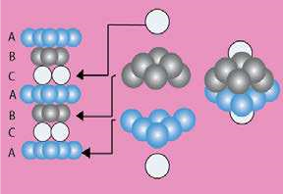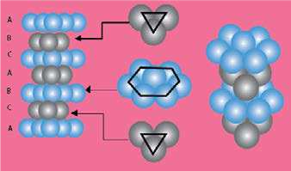

Fig (4.23 a) Cubic close packing or Fig (4.23 b) Hexagonal close packing (ABAB . . . ) Face centred cubic arrangement (ABCABC . . . )

1. **Hexagonal Close Packing**

When the atoms of the third layer are arranged in such a way that they occupy the depressions created by the second layer i.e., in the ‘a’ types crevices then these atoms will directly lie above the atoms of irst layer. This pattern of arrangement is usually written as ABAB ....... or 1212 . This pattern has been named as hexagonal close packing Fig(4.23b). The balls of third, ifth, seventh layers will be in front of each other.

Comparison of Properties of Various Types of Crystals

The following table gives a view to the comparison of properties of four types of crystals.

**Table (4.9) Type of Crystalline Solids**

|  |  |  |  |  |
| --- | --- | --- | --- | --- |
| Type of Solid | Structural Particles | Intermolecular Forces | Typical Properties | Examples |
| Metallic | cations plus delicalized electrons | metallic bons | hardness varies from soft to Very hard; melting points varied from low to very high; lustrous; ductile; malleable; very good conductors of heat and electricity | Na; Mg; Al  Fe; Zn; Cu;  Ag; W |
| Ionic | cations and anions | electrostatic  attractions | hard; moderate to very high melting points: nonconductors  of electricity (but good  electrical  conductors in the molten state) | NaCl;NaNO3, MgO |
| Molecular | molecules  (atoms of noble gases) | Landon and/or dipole-dipole and/or  hydrogen bonds | soft; low melting points: nonconductors of heat and  electricity; sublime easily in many cases | noble-gas elements; CH4; CO2; P4  S8; I2; H2O |
| Network covalent | atoms | covalent bonds | very hard; very high melting points: nonconductors of elecrioity | C(diamonds);  SiC; SiO2 |

##### 4.8 Determination of Avogadro’s Number (NA)

Avagadro number can be calculated in a number of diferent ways. One of the most accurate methods for determining this number is based on the study of crystalline solids.

In order to calculate this number, we need to know the volume of one gram-mole of a crystalline solid and the distance between its atoms or ions in the crystal lattice.

The volume of one gram-mole of a solid can be calculated from its density while the spacing between its atoms can be measured by X-rays.

The method of determining Avogadro’ s number is explained with a help of following solved example which gives a reasonably good value of this number. The crystal of LiF is primitive cubic and can be used to calculate the Avogadro’s number.

**Example:**

The density of LiF is 2.65 g cm-3. It is made up of cubic array of alternate Li+ and F- ions and the distance between these ions is 2.01 Ao (2.01 x 10-8 cm). Calculate the Avogadro’s number.

**Solution:**

The formula mass of LiF = 6.939 + 18.9984

= 25.9374 g mol-1

Density of LiF = 2.65 g cm-3

From the density and molar mass, calculate the volume of 1 mole of solid LiF

The volume occupied

by one formula unit of LiF = 25.9374g mol−3 −1 2.65g cm

= .7889 cm3 mol-1

From this volume, we can calculate the edge length of the cube. For this, we suppose that 9.788cm3 of LiF i.e., 1 mole of LiF, is present in the form of a cube. The cube root of this volume will give the length of one edge of cube.

Edge length of the cube = 3 9.788cm3  = .1392 cm

The number of ions of both Li+ and F- on one edge length can be calculated by dividing the edge length by distance between ions. Hence, the number of (Li+and F- ) ions along one edge length

= 2.139−8 cm

###### 2.01×10 cm ion−1

= .064x101 8

When we take the cubes of these ions we get the total number of ions i.e. Li+ and F- in the cube.

Total number (Li+F-) of ions in the cube = (1.064x108)3

= .204x101 24

Since the cube of LiF crystal contains one Avogadro’s number of Li+ and one Avogadro’s number of F- , so the Avogadro’s number will be

1.204*x*108 =6.02x1023

2

###### **KEY POINTS**

1. Among three states of matter i.e. gases, liquids and solids, the intermolecular attractive forces in the gases are negligible. In liquids intermolecular forces are strong enough to keep the molecules close together. Anyhow, the molecules in liquids are free to move with respect to one another. In solids the particles occupy speciic locations in three dimensional arrangement. Molecules in liquids are free to move with respect to one another. In solids the particles occupy speciic locations in three dimensional arrangement.
2. There are four types of intermolecular forces i.e. dipole-dipole forces, London dispersion forces, hydrogen bonding and Ion-dipole forces. The relative strengths of dipole-dipole and dispersion forces depend upon the polarity, polarisability, size and shape of the molecules. Hydrogen bonding occurs in compounds containing 0-H,N - H, H - F bonds.
3. The vapour pressure of a liquid measures the tendency of a liquid to evaporate. It is the pressure exerted by the vapours on the surface of a liquid when the rate of evaporation is equal to the rate of condensation. A liquid boils when its vapour pressure equals the external pressure.
4. Many crystalline solids melt to give a turbid liquid before melting to give a clear liquid. These turbid liquids possess some degree of order and are called liquid crystals. Liquid crystals have the luidity of liquids and the optical properties of solids.
5. In crystalline solids the particles are arranged in a regular and repeating manner. The essential structural features of a crystalline solid can be represented by its unit cell. The three dimensional array of points representing atoms, ions or molecules is called crystal lattice. The points in the crystal lattice represent positions in the structure where they have identical environments.
6. The simplest unit cell is a cubic unit cell. There are seven crystal systems overall.
7. The properties of solids depend on the arrangement of particles and the attractive forces between them. Ionic solids are hard and brittle and have high melting points. Covalent solids consist of atoms held together by covalent bonds and these bonds extend throughout the solid. They are hard and have high melting points. Metallic solids consist of metal cations immersed in a sea of electrons and give a wide range of properties. Molecular solids consist of atoms or molecules held together by intermolecular forces.
8. The properties of solids depend on the arrangement of particles and the attractive forces between them. Ionic solids are hard and brittle and have high melting points. Covalent solids consist of atoms held together by covalent bonds and these bonds extend throughout the solid. They are hard and have high melting points. Metallic solids consist of metal cations immersed in a sea of electrons and give a wide range of properties. Molecular solids consist of atoms or molecules held together by intermolecular forces.

#### EXERCISE (QUESTIONS OF LIQUIDS)

Q1. Choose the best answers from the given choices.

1. London dispersion forces are the only forces present among the
   * 1. molecules of water in liquid state
     2. atoms of helium in gaseous state at high temperature (c) molecules of solid iodine.

(d) molecules of hydrogen chloride gas.

1. Acetone and chloroform are soluble in each other due to

(a) intermolecular hydrogen bonding (b) ion-dipole interaction

(c) instantaneous dipole (d) all of the above

1. NH, shows a maximum boiling point among the hydrides of Vth group elements due to (a) very small size of nitrogen (b) lone pair of electrons present on nitrogen.
   * 1. enhanced electronegative character of nitrogen
     2. pyramidal structure of NH3
2. When water freezes at 0"C, its density decreases due to

(a) cubic structure of ice (b) empty spaces present in the structure of ice

(c) change of bond lengths (d) change of bond angles

1. In order to raise the boiling point of water upto 110°C, the external pressure should be

(a) between 760 torr and 1200 torr (b) between 200 torr and 760 torr

(c) 765 torr (d) any value of pressure

Q2. Fill in the blanks with suitable words

* + 1. The polarizability of noble gases________down the group and results in the increase in their boiling points.
    2. ________ is developed in acetone and chloroform when they are mixed together.
    3. Exceptionally weak_____of HF is due to strong hydrogen bonding present in it.
    4. The concept of dynamic equilibrium is the ultimate _______of all reversible systems.
    5. ∆Hv of C6H14 should be_____ than that of C2H6.
    6. During the formation of ice from liquid water there is a______ % increase in volume.
    7. The rate of increase of vapour pressure of water_______at high temperatures.
    8. A layer of ice on the surface of water____the water underneath for further heat loss.
    9. Evaporation is a ________process.
    10. Liquid crystals are used in the display of_________ devices.

Q3. Indicate true or false as the case may be

* + 1. Dipole-dipole forces are weaker than dipole-induced dipole forces.
    2. The ion dipole interactions are responsible for the dissolution of an ionic substance in water.
    3. The high polarizability of iodine is responsible for its existence in solid form and its diference from other halogens.
    4. The strong hydrogen bonding in H2S makes it diferent from water.
    5. Hydrocarbons are soluble in water because they are polar compounds.
    6. The viscosities of liquids partially depend upon the extent of hydrogen bonding.
    7. The state of equilibrium between liquid state and vapours is dynamic in nature.
    8. Heat of vapourization of liquids depend upon the intermolecular forces of attraction present between their molecules.
    9. Ice does not show any vapour pressure on its surface at -1oC. (x) Boiling point of a liquid is independent of external pressure.

Q4 (a) What type of intermolecular forces will dominate in the following liquids.

(i) Ammonia, NH3 (ii) Octane, C8 H18 (iii) Argon, Ar

(iv) Propanone, CH3COCH3 (v) Methanol, CH3OH

(b) Propanone (CH3COCH3), propanol (CH3CH2CH2OH) and butane (CH3CH2CH2CH3) have very similar relative molecular masses. List them in the expected order of increasing boiling points. Explain your answer.

Q.5 Explain the following with reasons.

* + 1. In the hydrogen bonded structure of HF, which is the stronger bond: the shorter covalent bond or the longer hydrogen bond between diferent molecules.
    2. In a very cold winter the ish in garden ponds owe their lives to hydrogen bonding?
    3. Water and ethanol can mix easily and in all proportions. (iv) The origin of the intermolecular forces in water.

Q6 (a) Briely consider some of the efects on our lives if water has only a very weak hydrogen bonding present among its molecules.

(b) All gases have a characteristic critical temperature. Above the critical temperature it is impossible to liquefy a gas. The critical temperatures of carbon dioxide and methane are 31.14 0C and -81.9 0C, respectively. Which gas has the stronger intermolecular forces? Briely explain your choice?

Q7 Three liquids have the properties mentioned against their names

|  |  |  |  |  |
| --- | --- | --- | --- | --- |
|  |  | Water | Propanone | Pentane |
| (i) | Molecular Formula | H2O | C3H6O | C5H12 |
| (ii) | Relative molecular mass (a.m.u.) | 18 | 58 | 72 |
| (iii) | Enthalpy change of vapourization (kJ mol-1) | 41.1 | 31.9 | 27.7 |
| (iv) | Boiling point (0C) | 100 | 56 | 36 |

(a) What type of intermolecular force predominates in each liquid?

(i) water (ii) propanone (iii) pentane

* + 1. What do you deduce about the relative strength of these forces in the liquids?

Justify your conclusions.

* + 1. If the liquids are shaken together in pairs, (i) Which pair would be unlikely to mix?
       1. Explain this immiscibility in terms of the forces between the molecules.
       2. Choose one of the pairs that mix and say whether the enthalpy change on mixing would be positive or negative.

Q8 Describe the various forces responsible for keeping the particles together in the following elements and compounds and their efects on physical properties making use of the data below.

|  |  |  |  |
| --- | --- | --- | --- |
| Substance | Formula | Molar Mass (a.m.u.) | M.P(°C) |
| Neon | Ne | 20 | -248 |
| Argon | Ar | 40 | -189 |
| Water | H2O | 18 | 0 |
| Sodium luoride | NaF | 42 | 993 |
| Diamond | C | 12 | 3350 |

Q9 The boiiing points and molar masses of hydrides of some irst row elements are tabulated below:

|  |  |  |
| --- | --- | --- |
| Substance | Boiling Point (K) | Molar Mass (g mol-1) |
| CH4 | 109 | 16 |
| NH3 | 240 | 17 |
| H O | 373 | 18 |

2

Suggest reasons for the diference in their boiling points in terms of the type of molecules involved and the nature of the forces present between them.

Q10 Explain the term saturated vapour pressure. Arrange in order of increasing vapour pressure: ldm3 water, 1 dm3 ethanol, 50 cm3 water, 50 cm3 ethanol and 50 cm3 of ether.

Q11 While a volatile liquid standing in a breaker evaporates, the temperature of the liquid remains the same as that of its surrounding. If the same liquid is allowed to vapourize into atmosphere in an insulated vessel, its temperature falls below that of its surrounding. Explain the diference in behaviour.

Q12 How does hydrogen bonding explain the following indicated properties of the substances?

(i) Structure of DNA (ii) Hydrogen bonding in proteins

1. Formation of ice and its lesser density than liquid water
2. Solubilities of compounds

Q13 What are liquid crystals? Give their uses in daily life.

Q14 Explain the following with reasons.

1. Evaporation causes cooling.
2. Evaporation takes place at all temperatures.
3. Boiling needs a constant supply of heat.
4. Earthenware vessels keep water cool.
5. One feels sense of cooling under the fan after bath.
6. Dynamic equilibrium is established during evaporation of a liquid in a closed vessel at constant temperature.
7. The boiling point of water is diferent at Murree hills and at Mount Everest.
8. Vacuum distillation can be used to avoid decomposition of a sensitive liquid.
9. Heat of sublimation of a substance is greater than its heat of vaporization.
10. Heat of sublimation of iodine is very high.

#### (QUESTIONS OF SOLIDS)

Q1. Multiple choice questions.

1. Ionic solids are characterized by

(a) low melting points. (b) good conductivity in solid state, (c) high vapour pressures. (d) solubility in polar solvents.

1. Amorphous solids
   * 1. have sharp melting points.
     2. undergo clean cleavage when cut with knife.
     3. have perfect arrangement of atoms.
     4. can possesses small regions of orderly arrangement of atoms.
2. The molecules of CO2 in dry ice form the

(a) ionic crystals (b) covalent crystals (c) molecular crystals (d) any type of crystal

1. Which of the following is a pseudo solid?

(a) CaF2 (b) Glass (c) NaCl (d) All

1. Diamond is a bad conductor because

(a) it has a tight structure (b) it has a high density

(c) there are no free electron present in the crystal of diamond to conduct electricity (d) is transparent to light

Q2. Fill in the blanks

* + 1. In a crystal lattice, the number of nearest neighbours to each atom is called the_______.
    2. There are__________ Bravis lattices.
    3. A pseudo solid is regarded as__________liquid.
    4. Glass may begin to crystallize by a process called__________ .
    5. Crystalline solids which exhibit the same _________ in all directions are called_________. (vi) The branch of science which deals with the __________________ of crystals is called crystallography.

Q.3 Indicate True/False as the case mav be

* + 1. There are ive parameters in unit cell dimensions of a crystal.
    2. Ionic crystals are very hard, have low volatility and very low melting and boiling points.
    3. The value of lattice energy of the ionic substances depends upon the size of ions.
    4. Molecular orbital theory of solids is also called band theory.
    5. Ionic solid is good conductor of electricity in the molten state.

Q.4 What are solids? Give general properties of solids. How do you diferentiate between crystalline solids and amorphous solids?

Q5

(a) Explain the following properties of crystalline solids. Give three examples in each case.

* + 1. Anisotropy (v) Polymorphism
    2. Cleavage (vi) Transition temperature
    3. Habit of a crystal (vii) Symmetry
    4. Isomorphism (viii) Growing of a crystal

(b) How polymorphism and allotropy are related to each other? Give examples.

Q6

* + 1. Deine unit cell. What are unit cell dimensions? How the idea of crystal lattice is developed from the concept of unit cell?
    2. Explain seven crystal systems and draw the shapes of their unit cells.

Q7

* + 1. What are ionic solids? Give their properties. Explain the structure of NaCl. Sketch a model to justify that unit cell of NaCl has four formula units in it.
    2. What are covalent solids? Give their properties. Explain the structure of diamond.
    3. What are molecular crystals? Give their properties. Justify that molecular crystals are softer than ionic crystals.

Q8

(a)Give diferent theories of a metallic bond. How does electron sea theory justify the electrical conductivity, thermal conductivity and shining surfaces of metals?

(b) Explain with the help of a diagram

* + - 1. Cubic close packing in the structure of metals.
      2. Hexagonal close packing in the structure of metals.

Q9 Crystals of salts fracture easily but metals are deformed under stress without fracturing. Explain the diference.

Q10 What is the coordination number of an ion? What is the coordination number of the cation in (a) NaCl structure and (b) CsCl structure? Explain the reason for this diference?

Q11 Give examples of ionic solids, molecular solids and covalent macromolecular solids. What are the factors which determine whether each of these types of solid will dissolve in water or not?

Q12 Explain the following with reasons:

* + 1. Sodium is softer than copper, but both are very good electrical conductors.
    2. Diamond is hard and an electrical insulator.
    3. Sodium chloride and caesium chloride have diferent structures.
    4. Iodine dissolves readily in teterachloromethane.
    5. The vapour pressures of solids are far less than those of liquids.
    6. Amorphous solid like glass is also called super cooled liquid.
    7. Cleavage of the crystals is itself anisotropic behaviour.
    8. The crystals showing isomorphism mostly have the same atomic ratios.
    9. The transition temperature is shown by elements having allotropic forms and by compounds showing polymorphism.
    10. One of the unit cell angles of hexagonal crystal is 120°.
    11. The electrical conductivity of the metals decrease by increasing temperature.
    12. In the closest packing of atoms of metals, only 74% space is occupied.
    13. Ionic crystals don’t conduct electricity in the solid state.
    14. Ionic crystals are highly brittle.
    15. The number of positive ions surrounding the negative ion in the ionic crystal lattice depends upon the sizes of the two ions.

## 5 ATOMIC STRUCTURE

CHAPTER

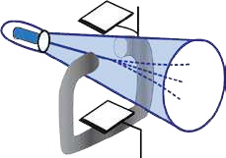

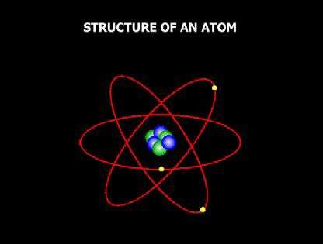

Animation 5.1: Atomic Structure

Source & Credit: [nuceng](http://www.nuceng.ca/igna/atomic_nucleus.htm)

### 5.1 SUB-ATOMIC PARTICLES OF ATOM

We are familiar with the nature of matter, which is made up of extremely small particles called atoms. According to Dalton’s theory, atoms were considered to be ultimate particles which could not be divided any further. Our ideas about structure of atom have undergone radical changes over the years. A number of subatomic particles have been discovered. The experiments which led to the discovery of electron, proton and neutron are described below.

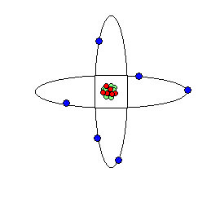

*Animation 5.2: Atomic nucleus Model*

*Source & Credit :*

[*myweb.rollin*](https://www.google.com/search?q=SUBATOMIC+PARTICLES+OF+ATOM&biw=1366&bih=643&tbm=isch&source=lnms&sa=X&ved=0ahUKEwjugJjmtMnKAhWjn4MKHW5qBZ4Q_AUIBigB#q=SUBATOMIC+PARTICLES+OF+ATOM&tbm=isch&tbs=itp:animated&imgrc=tAjDJsPzhGAxvM%3A)

[*s*](https://www.google.com/search?q=SUBATOMIC+PARTICLES+OF+ATOM&biw=1366&bih=643&tbm=isch&source=lnms&sa=X&ved=0ahUKEwjugJjmtMnKAhWjn4MKHW5qBZ4Q_AUIBigB#q=SUBATOMIC+PARTICLES+OF+ATOM&tbm=isch&tbs=itp:animated&imgrc=tAjDJsPzhGAxvM%3A)

**5.1.1Discovery of Electron (Cathode Rays)**

A gas discharge tube is itted with two metallic electrodes acting as cathode and anode. The tube is illed with a gas, air or vapours of a substance at any desired pressure. The electrodes are connected to a source of high voltage. The exact voltage required depends upon the length of the tube and the pressure inside the tube. The tube is attached to a vacuum pump by means of a small side tube so that the conduction of electricity may be studied at any value of low pressure Fig (5.1).

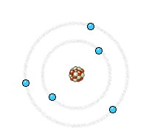

*Animation 5.3: Cathode Rays*

*Source & Credit :*

[*wikipedi*](https://www.google.com/search?q=SUBATOMIC+PARTICLES+OF+ATOM&biw=1366&bih=643&tbm=isch&source=lnms&sa=X&ved=0ahUKEwjugJjmtMnKAhWjn4MKHW5qBZ4Q_AUIBigB#tbs=itp:animated&tbm=isch&q=Discovery+of+Electron+(Cathode+Rays)&imgrc=tQMTZZnKSKZ2CM%3A)

[*a*](https://www.google.com/search?q=SUBATOMIC+PARTICLES+OF+ATOM&biw=1366&bih=643&tbm=isch&source=lnms&sa=X&ved=0ahUKEwjugJjmtMnKAhWjn4MKHW5qBZ4Q_AUIBigB#tbs=itp:animated&tbm=isch&q=Discovery+of+Electron+(Cathode+Rays)&imgrc=tQMTZZnKSKZ2CM%3A)

It is observed that current does not low through the gas at ordinary pressure even at high voltage of 5000 volts. When the pressure inside the tube is reduced and a high voltage of 5000-10000 volts is applied, then an electric discharge takes place through the gas producing a uniform glow inside the tube. When the pressure is reduced further to about 0.01 torr, the original glow disappeares. Some rays are produced which create luorescence on the glass wall opposite to the cathode. These rays are called cathode rays. The colour of the glow or the luorescence produced on the walls of the glass tube, depends upon the composition of glass.

**5.1.2 Properties of Cathode Rays**

To study the properties of cathoe rays systematic investigations were made by many scientists.

They established the following properties of cathode rays.

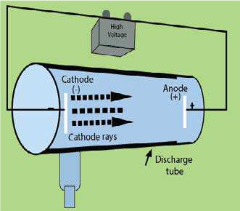

Fi g (5.1) Projduct ion of the cath,ode rays

1. Cathode rays are negativelycharged. In 1895, J Perrin showed that when the cathode rays passed between the poles of the magnet, the path of the negatively charged particles was curved downward to point 2 by the magnetic ield. Fig (5.2)

In 1897, J. Thomson established their electric charge by the application of electric ield, the cathode ray particles were delected upwards (towards the positive plate) to point 3. Fig. (5.2)

Thomson found that by carefully controlling the charge on the plates when the plates and the magnet were both around the tube, he could make the cathode rays strike the tube at point 1 again Fig.(5.2). In other words, he was able to cancel the efect of the magnetic ield by applying an electric ield that tended to bend the path of the cathode rays in the opposite direction.

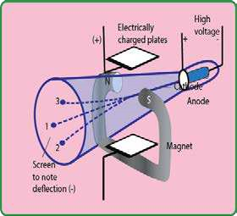

Fig (5.2) Delection of cathode rays in electric and magnetic ields

1. They produce a greenish luorescence on striking the walls of the glass tube. These rays also produce luorescence in rare earths and minerals. When placed in the path of these rays, alumina glows red and tin stone yellow.

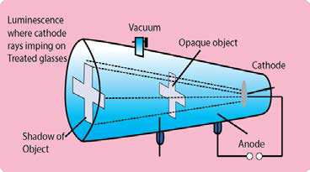

Fig (5.3) Cathode rays cast a shadow of an opaque object

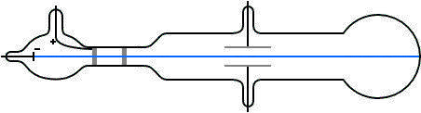

*Animation 5.4: X-ray Safety template*

*Source & Credit :*

[*adm.uwaterlo*](https://www.google.com/search?q=SUBATOMIC+PARTICLES+OF+ATOM&biw=1366&bih=643&tbm=isch&source=lnms&sa=X&ved=0ahUKEwjugJjmtMnKAhWjn4MKHW5qBZ4Q_AUIBigB#tbs=itp:animated&tbm=isch&q=Production+of+Positive+Rays&imgdii=RhJKXcm1UxKX6M%3A%3BRhJKXcm1UxKX6M%3A%3BQlWUOkEOBACSYM%3A&imgrc=RhJKXcm1UxKX6M%3A)

[*o*](https://www.google.com/search?q=SUBATOMIC+PARTICLES+OF+ATOM&biw=1366&bih=643&tbm=isch&source=lnms&sa=X&ved=0ahUKEwjugJjmtMnKAhWjn4MKHW5qBZ4Q_AUIBigB#tbs=itp:animated&tbm=isch&q=Production+of+Positive+Rays&imgdii=RhJKXcm1UxKX6M%3A%3BRhJKXcm1UxKX6M%3A%3BQlWUOkEOBACSYM%3A&imgrc=RhJKXcm1UxKX6M%3A)

1. Cathode rays cast a shadow when an opaque object is placed in their path. This proves that they travel q straight line perpendicular to the surface of cathode Fig (5.3).
2. These rays can drive a small paddle wheel placed in their path. This shows that these rays possess momentum. From this observation, it is inferred that cathode rays are not rays but material particles having a deinite mass and velocity Fig (5.4).

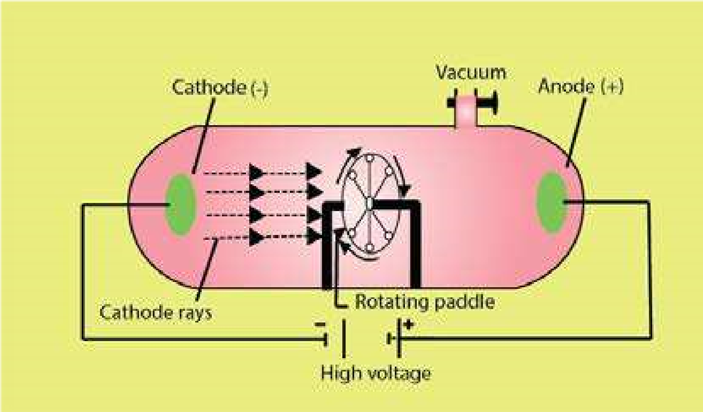

Fig (5.4) cathode rays derive a sman paddle wheel

1. Cathode rays can produce X-rays when they strike an anode particularly with large atomic mass Fig (5.18).
2. Cathode rays can produce heat when they fall on matter e.g. when cathode rays from a concave cathode are focussed on a platinum foil, it begins to glow.
3. Cathode rays can ionize gases.
4. They can cause a chemical change, because they have a reducing efect.
5. Cathode rays can pass through a thin metal foil like aluminum or gold foil.
6. The e/m value of cathode rays shows that they are simply electrons. J.J. Thomson concluded from his experiments that cathode rays consist of streams of negatively charged particles. Stoney named these particles as electrons. Thomson also determined the charge to mass ratio (e/m) of electrons. He found that the e/m value remained the same no matter which gas was used in the discharge tube. He concluded that all atoms contained electrons.

**5.1.3 Discovery of Proton (Positive Rays)**

In 1886, German physicist, E. Goldstein took a discharge tube provided with a cathode having extremely ine holes in it. When a large potential diference is applied between electrodes, it is observed that while cathode rays are travelling away from cathode, there are other rays produced at the same time. These rays after passing through the perforated cathode produce a glow on the wall opposite to the anode. Since these rays pass through the canals or the holes of cathode, they are called canal rays. These rays are named as positive rays owing to the fact that they carry positive charge Fig (5.5).

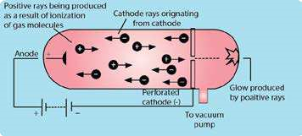

Fig (5.5) Production of positive rays

**Reason for the Production of Positive Rays**

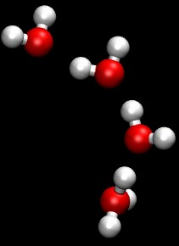

*Animation 5.5: Protons*

*Source & Credit :*

[*wikipedi*](https://www.google.com/search?q=SUBATOMIC+PARTICLES+OF+ATOM&biw=1366&bih=643&tbm=isch&source=lnms&sa=X&ved=0ahUKEwjugJjmtMnKAhWjn4MKHW5qBZ4Q_AUIBigB#tbs=itp:animated&tbm=isch&q=proton&imgrc=rvfyTPyfZD_FGM%3A)

[*a*](https://www.google.com/search?q=SUBATOMIC+PARTICLES+OF+ATOM&biw=1366&bih=643&tbm=isch&source=lnms&sa=X&ved=0ahUKEwjugJjmtMnKAhWjn4MKHW5qBZ4Q_AUIBigB#tbs=itp:animated&tbm=isch&q=proton&imgrc=rvfyTPyfZD_FGM%3A)

These positive rays are produced, when high speed cathode rays (electrons) strike the molecules of a gas enclosed in the discharge tube. They knock out electrons from the gas molecules and positive ions are produced, which start moving towards the cathode Fig (5.5).

M+e- → M +2e+ -

**5.1.4 Properties of Positive Rays**

1. They are delected by an electric as well as a magnetic ield showing, that these are positively charged.
2. These rays travel in a straight line in a direction opposite to the cathode rays.
3. They produce lashes on ZnS plate.
4. The e/m value for the positive rays is always smaller than that of electrons and depends upon the nature of the gas used in the discharge tube. Heavier the gas, smaller the e/m value. When hydrogen gas is used in the discharge tube, the e/m value is found to be the maximum in comparison to any other gas because the value of’m’ is the lowest for the positive particle obtained from the hydrogen gas. Hence the positive particle obtained from hydrogen gas is the lightest among all the positive particles. This particle is called proton, a name suggested by Rutherford. The mass of a proton is 1836 times more than that of an electron.

**5.1.5 Discovery of Neutron**

Proton and electron were discovered in 1886 and their properties were completely determined till 1895. It is very strange to know that upto 1932 it was thought that an atom was composed of only electrons and protons. Rutherford predicted in 1920 that some kind of neutral particle having mass equal to that of proton must be present in an atom, because he noticed that atomic masses of atoms could not be explained,if it were supposed that atoms had only electrons and protons.

Chadwick discovered neutron in 1932 and was awarded Nobel prize in Physics in 1935.

**Experiment**

A stream of a-particles produced from a polonium source was directed at beryllium ( 94 *Be*) target. It was noticed that some penetrating radiation were produced. These radiations were called neutrons because the charge detector showed them to be neutral Fig (5.6). The nuclear reaction is

as follows. 24 *He* +94 *Be* →126 *C* + 01*n*

(a -paricle)

Actually a-particles and the nuclei of Be ate re-arranged and extra neutron is emitted.

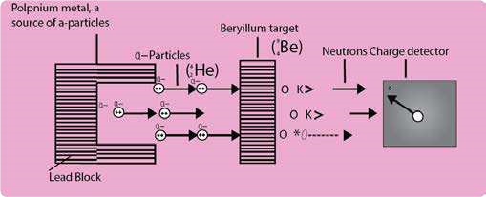

Fig (5.6) Bombardment of Be with a- particles and discovery of neutron

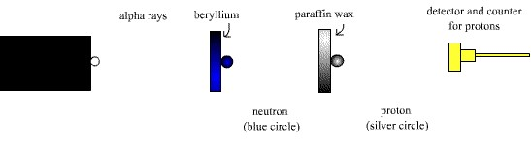

*Animation 5.6: chad wicks experiment*

*Source & Credit :*

[*sites.googl*](https://www.google.com/search?q=SUBATOMIC+PARTICLES+OF+ATOM&biw=1366&bih=643&tbm=isch&source=lnms&sa=X&ved=0ahUKEwjugJjmtMnKAhWjn4MKHW5qBZ4Q_AUIBigB#tbs=itp:animated&tbm=isch&q=Discovery+of+Neutron&imgrc=tvxMv6_c6hu-hM%3A)

[*e*](https://www.google.com/search?q=SUBATOMIC+PARTICLES+OF+ATOM&biw=1366&bih=643&tbm=isch&source=lnms&sa=X&ved=0ahUKEwjugJjmtMnKAhWjn4MKHW5qBZ4Q_AUIBigB#tbs=itp:animated&tbm=isch&q=Discovery+of+Neutron&imgrc=tvxMv6_c6hu-hM%3A)

**5.1.6 Properties of Neutron**

1. Free neutron decays into a proton +1*P*with the emission of an electron −10*e*and a neutrino 00*n*.

01*n*→ +11*P* + −10*e* + 00*n*

1. Neutrons cannot ionize gases.
2. Neutrons are highly penetrating particles.
3. They can expel high speed protons from parain, water, paper and cellulose.
4. When neutrons travel with an energy 1.2 Mev (Mega electron volt 106), they are called fast neutrons but with energy below 1ev are called slow neutrons. Slow neutrons are usually more efective than fast ones for the ission purposes.
5. When neutrons are used as projectiles, they can carry out the nuclear reactions. A fast neutron ejects an a-particle from the nucleus of nitrogen atom and boron is produced, alongwith and a-particles.

714 *N* +10 *n*→511 *B* + 24*He*

1. When slow moving neutrons hit the Cu metal then γ gamma radiations are emitted. The

radioactive 2966*Cu* is converted into 3066*Zn*

6529*Cu*+10 *n*→6629 *Cu*+*hv*(γ−*raditions*)

2966*Cu*→ 3066*Zn*+ −10*e* (electron)

Actually, neutron is captured by the nucleus of 2965*Cu* and 2966*Cu* is produced. This radio active 2966*Cu* emits an electron (b-particle) and its atomic number increases by one unit. Because of their intense biological efects they are being used in the treatment of cancer.

**5.1.7 Measurement of** e **Value of Electron**

m

In 1897, J.J Thomson devised an instrument to measure the e/m value of electron. The apparatus consists of a discharge tube shown in Fig. (5.7).

The cathode rays are allowed to pass through electric and magnetic ields. When both the ields are of then a beam of cathode rays, consisted of electrons, produces bright luminous spot at P1 on the luorescent screen.

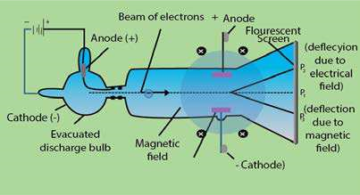

Fig (5.7) Measurement of e/m value of an electron by J.J. Thomson

The north and south poles of magnetic ield are perpendicular to the plane of paper in the diagram. The electrical ield is in the plane of paper. When only magnetic ield is applied, the cathode rays are delected in a circular path and fall at the point P3. When only electric ield is applied, the cathode rays produce a spot at P2. Both electric and magnetic ields are then applied simultaneously and their strengths adjusted in such a way that cathode rays again hit the point P1.

In this way by comparing the strengths of the two ields one can determine the e/m value of eIlectrons. It comes out to be 1.7588 x 1011 coulombs kg-1. This means that 1 kg of electrons have 1.7588 x 1011 coulombs of charge.

**5.1.8 Measurement of Charge on Electron - Millikan's Oil Drop Method**

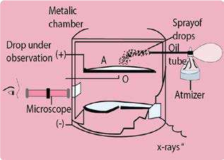 In 1909, Millikan determined the charge on electron by a simple arrangement. The apparatus consists of a metallic chamber.It has two parts. The chamber is illed with air, the pressure of which can be adjusted by a vacuum pump.

There are two electrodes A and A’ These electrodes are used- to generate an electrical ield in the space between the electrodes. The upper electrode has a hole in it as shown in Fig (5.8).

A ine spray of oil droplets is created by Fig (5.8) Millikan's oil drop method for an atomizer. A few droplets passes through determination of charge of electron the hole in the top plate and into the region between the charged plates, where one of them is observed though a microscope. This droplet, when illuminated perpendicularly to the direction of view, appears in the microscope as bright speck against a dark background. The droplet falls under the force of gravity without applying the electric ield. The velocity of the droplet is determined. The velocity of the droplet (V1) depends upon its weight, mg.

*v*1a *mg*  .............. (1) where ’m’ is the mass of the droplet and ‘g’ is the acceleration due to gravity. After that the air between the electrodes is ionized by X-rays. The droplet under observation takes up an electron and gets charged. Now, connect A and A’ to a battery which generates an electric ield having a strength, E. The droplet moves upwards against the action of gravity with a velocity (v2).

*v*2a *Ee* −*mg*  .............. (2)

where ‘e’ is the charge on the electron and Ee is the upward driving force on the droplet due to applied electrical ield of strength E.

Dividing equation (1) by (2)

v1 mg

.............. (3)v2 = Ee-mg

The values of v1 and v2 are recorded with the help of microscope. The factors like g and E are also known. Mass of the droplet can be determined by varying the electric ield in such a way that the droplet is suspended in the chamber. Hence ‘e’ can be calculated.

By changing the strength of electrical ield, Millikan found that the charge on each droplet was diferent. The smallest charge which he found was 1.59 x 10-19 coulombs, which is very close to the recent value of 1.6022 x 10-19 coulombs. This smallest charge on any droplet is the charge of one electron. The other drops having more than one electron on them, have double or triple the amount of this charge. The charge present on an electron is the smallest charge of electricity that has been measured so far.

**Mass of Electron**

The value of charge on electron is 1.602 x 10-19 coulombs, while e/m of electron is 1.7588 x

1011 coulombs kg-1. So,

e =1.6022×10 -19coulombs = = 1.7588x10 coulombs kg11 -1

m Mass of electrons

Mass of electron= 1.6022×10-19coulombs

1.7588×1011coulombs kg-1

Rearranging

Mass of electron= 9.1095x10-31  kg

**Properties of Fundamental Particles**

The Table (5.1) shows the properties of three fundamental particles electron, proton and neutron present in an atom.

#### Table (5.1) Properties of three fundamental particles

|  |  |  |  |  |
| --- | --- | --- | --- | --- |
| Particle | Charge  (coul) | Relative charge | Mass  (kg) | Mass (amu) |
| Proton | +1.6022 x 10-19 | +1 | 1.6726 x 10-27 | 1.0073 |
| Neutron | 0 | 0 | 1.6750 x 10-27 | 1.0087 |
| Electron | -1.6022 x 10-19 | -1 | 9.1095 x 10-31 | 5.4858x10-4 |

### 5.2 Rutherford's Model of Atom (Discovery of Nucleus)

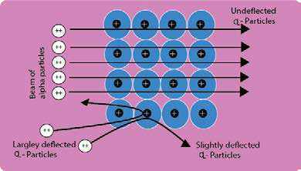In 1911, Lord Rutherford performed a classic experiment. He studied the scattering of high speed a-particles. which were emitted from a radioactive metal (radium or polonium)

A beam of a-partides was directed onto a gold foil of 0.00004 cm thickness as target through a pin-hole in lead plate, Fig (5.9).

A photographic plate or a screen coated with zinc sulphide

was used as a detector. Whenever, Fig (5.9) Rutherford's experiment for scattering 0f a-partices an a-partide struck the screen, lash of light was produced at that point. It was observed that most of the particles went through the foil undelected. Some were delected at fairly large angles and a few were delected backward. Rutherford proposed that the rebounding particles must have collided with the central heavy portion of the atom which he called as nucleus.

On the basis of these experimental observations, Rutherford proposed the planetary model (similar to the solar system) for an atom in which a tiny nucleus is surrounded by an appropriate number of electrons. Atom as a whole being neutral, therefore, the nucleus must be having the same number of protons as there are number of electrons surrounding it.

In Rutherford’s model for the structure of an atom, the outer electrons could not be stationary. If they were, they would gradually be attracted by the nucleus till they ultimately fall into it. Therefore, to have a stable atomic structure, the electrons were supposed to be moving around the nucleus in closed orbits. The nuclear atom of Rutherford was a big step ahead towards understanding the atomic structure, but the behaviour of electrons remained unexplained in the atom.

Rutherford’s planet-like picture was Electron defective and unsatisfactory because the moving electron must be accelerated towards the nucleus Fig (5.10).

Therefore, the radius of the orbiting electron should become smaller and smaller and the electron should fall into the nucleus. Thus, an atomic structure as proposed by Rutherford would collapse.

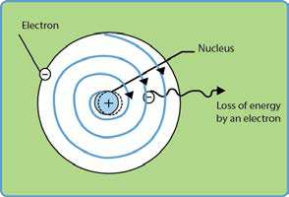

Fig (5.10) Rotation of electron around the nucleus and expected spiral path

### 5.3 PLANCK'S QUANTUM THEORY

Max Planck proposed the quantum theory in 1900 to explain the emission and absorption of radiation. According to his revolutionary’ theory, energy travels in a discontinuous manner and it is composed of large number of tiny discrete units called quanta. The main points of his theory are: (i) Energy is not emitted or absorbed continuously. Rather, it is emitted or absorbed in a discontinuous manner and in the form of wave packets. Each wave packet or quantum is associated with a deinite amount of energy. In case of light, the quantum of energy is often called photon. (ii) The amount of energy associated with a quantum of radiation is proportional to the frequency (v) of the radiation. Frequency is the number of waves passing through a point per second.

E ∝ v

E = hv ............................. (4)

Where ’h’ is a constant known as Planck’s constant and its value is 6.626x10-34 Js. It is, in fact, the ratio of energy and the frequency of a photon.

(iii) A body can emit or absorb energy only in terms of quanta.

E = hv

The frequency ‘v ‘ is related to the wavelength of the photon as

v=c/l

Greater the wavelength, smaller the frequency of photon So, E=hc/l ............................(5)

o

Wavelength is the distance between the two adjacent crests or troughs and expressed in A ,

o nm or pm. (1A=10 -10’m’, lnm = 10-9m, lpm=10-12m)

Greater the wavelength associated with the photon, smaller is its energy. Wave number (v) is the number of waves per unit length, and is reciprocal to wavelength.

*v*= 1/l

Putting the value of l in equation (5)

E = h c v............................(6)

So, the energy of a photon is related to frequency, wavelength and wave number.

Greater the wave number of photons, greater is the energy associated with them. The relationships of energy, frequency, wavelength, wave number about the photon of light are accepted by scientists and used by Bohr in his atomic model.

### 5.4 BOHR’S MODEL OF ATOM

Bohr made an extensive use of the quantum theory of Planck and proposed that the electron, in the hydrogen atom, can only exist in certain permitted quantized energy levels. The main postulates of Bohr’s theory are:

1. Electron revolves in one of the circular orbits outside the nucleus. Each orbit has a ixed energy and a quantum number is assigned to it.
2. Electron present in a particular orbit neither emits nor absorbs energy while moving in the same ixed orbits. The energy is emitted or absorbed only when an electron jumps from one orbit

to another.

1. When an electron jumps, the energy change AE is given by the Planck’s equation

฀*E* =E2-E1 = hv .................. (7)

Where ฀*E*is the energy diference of any two orbits with energies E1 and E2 Energy is absorbed by the electron when it jumps from an inner orbit to an outer orbit and is emitted when the electron jumps from outer to inner orbit. Electron can revolve only in those orbits having a ixed angular momentum (mvr). The angular momentum of an orbit depends upon its quantum number and it is an integral multiple of the factor h/2 π i.e. mvr= nh ............................ (8)

#### 2p

Where n = 1,2,3,.............

The permitted values of angular momenta are, therefore, h 2h 3h ..............

2p, 2p , 2p

The electron is bound to remain in one of these orbits and not in between them. So, angular momentum is quantized.

**Derivation of Radius and Energy of Revolving Electron in nth Orbit.**

By applying these ideas, Bohr derived the expression for the radius of the nth orbit in hydrogen atom.

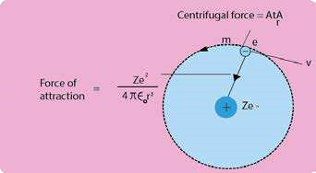 For a general atom, consider an electron of charge ‘e’ revolving around the nucleus having charge Ze+. Z being the proton number and e+ is the charge on the proton Fig

(5.11).

Let m be the mass of electron, r the radius of the orbit and v the velocity of the revolving electron. According to Coulombs law, the electrostatic force of attraction between the electron and the nucleus will be given by the f ollowing

formula .

Fi'g (5.11) .E, lectr.o n rev. olvingv +m an atom with nuclear charge Ze (If Z=l, then the picture is for H-atom)

Ze .e+ - Ze2

2 =

4π∈0 r 4π∈0 r2

∈0 is the vacuum permittivity and its value is 8.84 x 10 -12C2J-1m-1. This force of attraction is balanced

mv2

by the r Therefore, for balanced conditions, we can write

or mvr 2 = Ze2 2

4p∈0 r

*mv*2 = 4pZe∈02 r2 ......................... (9)

Rearranging the equation (9)

Ze2

r = 4p∈0 mv2  .......................... (10)

According to equation (10), the radius of a moving electron is inversely proportional to the square of its velocity. It conveys the idea, that electron should move faster nearer to the nucleus in an orbit of smaller radius. It also tells, that if hydrogen atom has many possible orbits, then the promotion of electron to higher orbits makes it move with less velocity.

The determination of velocity of electron is possible while moving in the orbit. In order to eliminate the factor of velocity from equation (10), we use Bohr’s postulate (iv). The angular momentum of the electron is given by.

#### nh

mvr =

2p

Rearranging the equation of angular momentum

|  |  |  |
| --- | --- | --- |
| Taking square |  | =  2pmr |
|  |  | =2 n h22 22 2 ................... (11) |

#### nh

4pm r

Substituting the value of v2 from eq. (11) into eq. (10), we get

Ze ×42 p2m r2 2

r = 4pe0mn h2 2

Rearranging the above equation, we get

r = e0n h2 22 **.............................. (12)**

pmZe

For hydrogen atom Z = 1, so the equation for radius of H-atom is r =ep0men h2 2 =( e0h22 )n2 **............................ (13)**

### 2 pme

According to the equation (13), the radius of hydrogen atom is directly proportional to the square of number of orbit (n). So, higher orbits have more radii and vice versa. The collection of parameters (peme0h22 ) in equation (13) is a constant factor.

When we put the value of ∈0, h2 π, m and e2 alongwith the units then the calculations show that it is equal to 0.529 x I0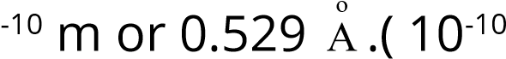 m = l Ao )

Hence r=0.529 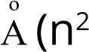 ) .............................. (14)

By putting the values of na s 1,2.3,4............. the radii of orbits of hydrogen atom are

n=1 r1=0.529 Aon=4 r4=8.4 Ao  n=2 r2=2.11 Aon=5 r5=13.22 Ao

3 n= r 3=4.75 Ao

The comparison of radii shows that the distance between orbits of H-atom goes on increasing as we move from 1st orbit to higher orbits. The orbits are not equally spaced. r -r <r -r <r -r <..........................2 1 3 2 4 3

The second orbit is four times away from the nucleus than irst orbit, third orbit is nine times away and similarly fourth orbit is sixteen times away.

**Energy of Revolving Electron**

The total energy of an electron in an orbit is composed of two parts, the kinetic energy which is equal to mv2 and the potential energy. The value of potential energy can be calculated as follows.

Ze2  The electrostatic force of attraction between the nucleus and the electron is given by 4pe0r2 . If the electron moves through a small distance dr, then the work done for moving electron is given by

Ze2

4pe0 2 dr because work=(force x distance)

r

In order to calculate the potential energy of the electron at a distance r from the nucleus, we calculate the total work done for bringing the electron from ininity to a point at a distance r from the nucleus. This can be obtained by integrating the above expression between the limits of ininity and r.

r 2 Ze2 r dr Ze2 -1r

∫∞ Ze dr0 = 0 ∫∞ = 0  r ∞= 4Zep∈2 0 -1r  = − 4pZe∈20 r

4p∈ r2 4p∈ r2 4p∈

The work done is the potential energy of electron, so

Ze2

Work done = Epotential =− 4pe0r ............................... (15)

The minus sign indicates that the potential energy of electron decreases, when it is brought from ininity to a point at a distance ’r’ from the nucleus. At ininity, the electron is not being attracted by any thing and the potential energy of the system is zero. Whereas at a point nearer the nucleus, it will be attracted by the nucleus and the potential energy becomes less than zero. The quantity less than zero is negative. For this reason, the potential energy given by equation (15) is negative.

The total energy (E) of the electron, is the sum of kinetic and potential charges.

So, E = Ekinetic +Epotential

= 1 2 Ze2 .............................. (16) mv -

2 4peor

Now, we want to eliminate the factor of velocity from equation (16). So, from equation (9), substitute the value of mv2 in eq. (16)

Sincemv2 = Ze2  ................................... (9)

#### 4p∈0 r Ze2 Ze2 8p∈0 r 4p∈0 r

E = −

Ze2

Simplifying it, E =− ...................................... (17)

8p∈0 r

Now substitute the value of r from eq (12) into eq (17) we get

|  |  |  |  |  |  |  |  |
| --- | --- | --- | --- | --- | --- | --- | --- |
| Since |  |  |  |  | ∈ n h  mZe |  | .............................. (12) |

2 2

En 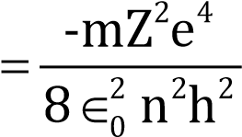 .............................. (18)

Where En is the energy of nth orbit.

For hydrogen atom , the number of protons in nucleus is one, so ( Z = 1).

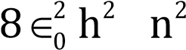 En =− me4  1  ................................ (19)

Eq.(19) gives the energy of electron revolving around the nucleus of hydrogen atom.

The factors outside the brackets in equation (19) are all constants. When the values of these constants are substituted along with their units, then it comes out to be 2.178 x 10 -18 J. The equation (19) can be written as,

E = -2.178x10n -18 n12 J ............................. (20)

This equation (20) gives the energy associated with electron in the nth orbit of hydrogen atom. Its negative value shows that electron is bound by the nucleus i.e. electron is under the force of attraction of the nucleus. Actually, the electron has been brought from ininity to distance r from the nucleus. The value of energy obtained for the electron is in joules/atom. If, this quantity is multiplied by Avogadro’s number and divided by 1000, the value of En will become

En = 6.02×1023 ×2.18×10−18− n12 kJmol-1

#### 1000 

En =−1313.315n2 kJmol-1 .................................... (21)

This energy is associated with 1.008g of H-atoms i.e. with Avogadro’s number of atoms of hydrogen.

Substituting, the values of n as 1,2,3,4,5, etc. in equation (21), we get the energy associated with an electron revolving in 1st, 2nd, 3rd, 4th and 5th orbits of H-atom.

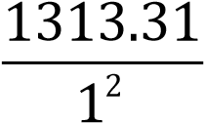E = -1 = -1313.31 kJmol-1

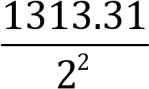E2 =−= -328.32 kJmol-1

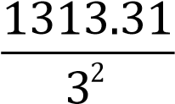E3 = −= -145.92 kJmol-1

E =−1313.31= -82.08 kJmol-1

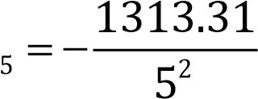 E = -52.53 kJmol-1

E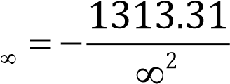 = 0 kJmol-1(electron is free from the nucleus)

The values of energy diferences between adjacent orbits can be calculated as follows

E2-E1 = (-328.32)-(-1313.31) = 984.99 kJmol-1

E3-E2 = (-145.92)-(-328.32) = 182.40 kJmol-1

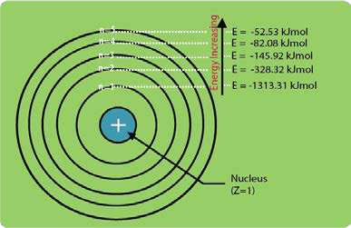E4-E3 = (-82.08)-(-145.92) = 63.84 kJmol-1 The diferences in the values of energy go on decreasing from lower to higher orbits.

E -E >E -E >E -E >..........................2 1 3 2 4 3

The energy diference between irst and ininite levels of energy is calculated as:

E„ - E1 = 0 - (-1313.31) = 1313.31 kJmol-1

1313.31 kJmol-1 is the ionization energy of hydrogen. This value is the same as determined

experimentally. These values show electron in vanous orbits in hydrogen atomFig (5.12) Energy values associated with an that the energy diferences between adjacent orbits of Bohr’s model of hydrogen atom go on decreasing sharply.

Keep in mind, that distances between adjacent orbits increase. The Fig (5.12) makes the idea clear.

#### 5.5 SPECTRUM

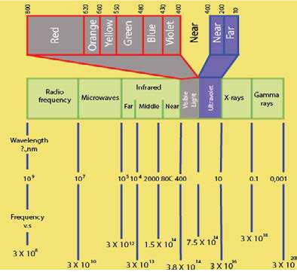 When a radiation of light is passed through a prism, the radiation undergoes refraction or bending. The extent of bending depends upon the wavelength of the photons. A radiation of longer wavelength is bent to a smaller degree than the radiation of a shorter wavelength. Ordinary, white light consists of radiation of all wavelengths, and so after passing through the prism, white light is splitted up into radiations of diferent wavelengths.

The colours of visible spectrum are violet, indigo, blue, green, orange, yellow and red and their wavelengths range from 400 nm to 750 nm. In addition to the visible region of the spectrum, there are seven other regions. Ultraviolet, X-rays, y-rays and cosmic rays are

towards the lower wavelength end Fig (5.13) The visible and otherregions of spectrum of the spectrum and they possess the photons with greater energies. On the other side of the visible region, there lies infrared, microwave and radio frequency regions. Fig. (5.13) shows the continuity of wavelengths for all types of regions of spectrum. Hence, a visual display or dispersion of the components of white light, when it is passed through a prism is called a spectrum.

Spectrum is of two types.

(i) Continuous spectrum (ii) Line spectrum

**5.5.1** **Continuous Spectrum**

In this type of spectrum, the boundry line between the colours cannot be marked. The colours difuse into each other. One colour merges into another without any dark space. The best example of continuous spectrum is rainbow. It is obtained from the light emitted by the sun or incandescent (electric light) solids. It is the characteristic of matter in bulk.

**5.5.2 Atomic or Line Spectrum**

When an element or its compound is volatilized on a lame and the light emitted is seen through a spectrometer, We see distinct lines separated by dark spaces. This type of spectrum is called line spectrum or atomic spectrum. This is characteristic of an atom. The number of lines and the distance between them depend upon the element volatilized. For example, line spectrum of sodium contains two yellow coloured lines separated by a deinite distance. Similarly, the spectrum of hydrogen consists of a number of lines of diferent colours having diferent distances from each other. It has also been observed that distances between the lines for the hydrogen spectrum decrease with the decrease in wavelength and the spectrum becomes continuous after a certain value of wavelength Fig (5.14).

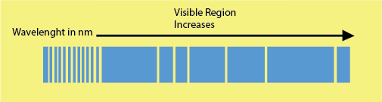

Fig (5.14) Atomic spectrum of hydrogen

Atomic spectrum can also be observed when elements in gaseous state are heated at high temperature or subjected to an electric discharge.

There are two ways in which an atomic spectrum can be viewed.

1. Atomic emission spectrum
2. Atomic absorption spectrum

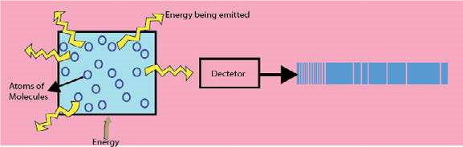

Fig (5.15) Atomic emission spectrum

**5.5.3 Atomic Emission Spectrum**

When solids are volatilized or elements in their gaseous states are heated to high temperature or subjected to an electrical discharge, radiation of certain wavelengths are emitted. The spectrum of this radiation contained bright lines against a dark background. This is called atomic emission spectrum. Fig (5.15)

**5.5.4 Atomic Absorption Spectrum**

When a beam of white light is passed through a gaseous sample of an element, the element absorbs certain wavelengths while the rest of wavelengths pass through it. The spectrum of this radiation is called an atomic absorption spectrum. The wavelengths of the radiation that have been absorbed by the element appear as dark lines and the background is bright, Fig (5.16).

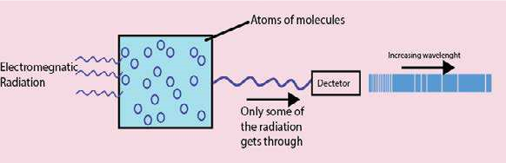

Fig (5.16) Atomic absorption spectrum

It is interesting to note that the positions or the wavelengths of lines appearing in both emission and absorption spectra are exactly the same. In emission spectrum, these lines appear bright because the corresponding wavelengths are being emitted by the element, whereas they appear dark in absorption spectrum because the wavelengths are being absorbed by the element.