## CHAPTER 4 LIQUIDS AND SOLIDS



Source & Credit:Animation 4.1: Solid, Liquid, Gas [everythingscientiic](http://everythingscientific.net/i/fourstagesofmatter.html)

### INTRODUCTION

The existence of matter in our surrounding in the form of gases, liquids and solids is due to diference of interacting forces among the constituent particles.

**4.1 INTERMOLECULAR FORCES**

To understand the properties of liquids and solids, we need to know the kinds of intermolecular forces present in them and their relative strength. It is important to realize that the attraction between the molecules is much weaker than the attraction between atoms within a molecule. In a molecule of HCl, there is a covalent bond between H and Cl which is due to the mutual sharing of electrons. Both atoms satisfy their outermost shells and it is their irm need to remain together, hence this linkage is very strong.

HCl molecules in the neighbourhood attract each other, but the forces of attraction are weak. These forces are believed to exist between all kinds of atoms and molecules when they are suiciently close to each other. Such intermolecular forces are called van der Waals forces and they have nothing to do with the valence electrons.

These intermolecular forces bring the molecules close together and give particular physical properties to the substances in gaseous, liquid and solid states. Four types of such forces are mentioned here. 1. Dipole-dipole forces

1. Ion-dipole forces
2. Dipole-induced dipole forces
3. Instantaneous dipole-induced dipole forces or London dispersion forces

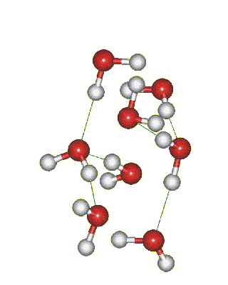

*Animation 4.2 : Intermolecular forces*

*Source & Credit:*

[*intermolecularforces*](http://intermolecularforcess.weebly.com/hydrogen-bonds.html)

[*s*](http://intermolecularforcess.weebly.com/hydrogen-bonds.html)

**4.1.1 Dipole-dipole Forces**

In case of HCl molecule both atoms difer in electronegativity. Chlorine being more electronegative, develops the partial negative charge and hydrogen develops the partial positive charge. So, whenever the molecules are close to each other, they tend to line up. The positive end of one molecule attracts the negative end of the other molecule and these electrostatic forces of attraction are called dipole-dipole forces. However, thermal energy causes the molecules not to have a perfect alignment.

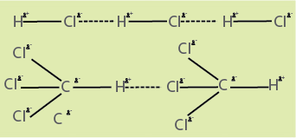 Anyhow, there is a net attraction between the polar molecules. These forces are called as dipole-dipole forces and they are approximately one percent as efective as a covalent bond. The strength of these forces depends upon the electronegativity diference between the bonded atoms and the distance between the molecules. The distances between molecules in the gaseous phase are greater so these forces are very weak in this phase. In liquids these forces are reasonably strong. The examples of the molecules which show dipole-dipole attractions are numerous. Two of these are given below i.e., for HCl and CHCl3 (chloroform) Fig (4.1).

Greater the strength of these dipoledipole forces, greater are the values of thermodynamic parameters like melting Show Fig. (4.1) Dipole - dipole forces present in HC1molecules and chloroform (CHCl3) molecules. points, boiling points, heats of vapourization and heats of sublimation.

**4.1.2 Dipole-induced Dipole Forces**

Sometimes, we have a mixture of substances containing polar and non-polar molecules. The positive end of the polar molecule attracts the mobile electrons of the nearby non-polar molecule. In this way polarity is induced in non-polar molecule, and both molecules become dipoles. These forces are called dipole-induced dipole forces or as Debye forces. The following igure makes the idea clear Fig (4.2).

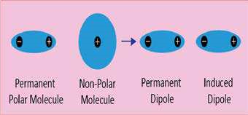

Fig (4.2) Dipole-induced dipole interactions

**4.1.3 Instantaneous Dipole-induced Dipole Forces or London Dispersion Forces**

Intermolecular forces among the polar molecules, as discussed in section 4.1.1 are very easy to understand. But the forces of attraction present among the non-polar molecules like helium, neon, argon, chlorine and methane need special attention because under normal conditions such molecules don’t have dipoles. We know that helium gas can be liqueied under appropriate conditions. In other words forces of attraction operate among the atoms of helium which cause them to cling together in the liquid state.

A German physicist Fritz London in 1930 ofered a simple explanation for these weak attractive forces between non-polar molecules.

In helium gas, the electrons of one atom inluence the moving electrons of the other atom. Electrons repel each other and they tend to stay as far apart -as possible. When the electrons of one atom come close to the electron of other atom, they are pushed away from each other. In this way,a temporary dipole is created in the atom as shown in the Fig (4.3). The result is that, at any moment, the electron density of the atom is no more symmetrical. It has more negative charge on one side than on the other. At that particular instant, the helium atom becomes a dipole. This is called instantaneous dipole.

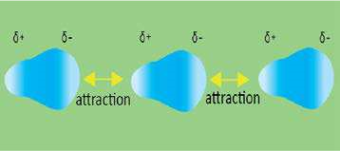

Fig. (4.3) Instantaneous dipole-induced dipole attractions between helium atoms.

This instantaneous dipole then disturbs the electronic cloud of the other nearby atom. So,a dipole is induced in the second atom. This is called induced dipole. The momentary force of attraction created between instantaneous dipole and the induced dipole is called instantaneous dipoleinduced dipole interaction or London force.

It is a very short-lived attraction because the electrons keep moving. This movement of electrons cause the dipoles to vanish as quickly as they are formed. Anyhow, a moment later, the dipoles will appear in diferent orientation and again weak attractions are developed.

London forces are present in all types of molecules whether polar or non-polar, but they are very’ signiicant for non-polar molecules like Cl2, H2 and noble gases (helium, neon,etc.)

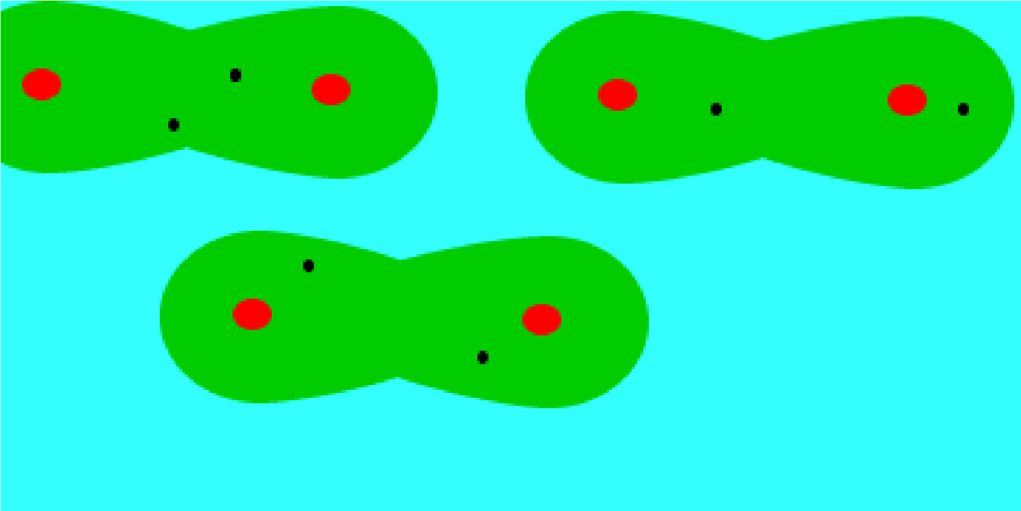

*Animation 4.3 : London Dispersion Forces*

*Source & Credit:*

[*dynamicscienc*](http://www.dynamicscience.com.au/tester/solutions1/chemistry/bonding/bonding8a.htm)

[*e*](http://www.dynamicscience.com.au/tester/solutions1/chemistry/bonding/bonding8a.htm)

**4.1.4 Factors Affecting the London Forces**

London forces are weaker than dipole- dipole interactions. The strength of these forces depend upor the size of the electronic cloud of the atom or molecules. When the size of the atom or molecule is large then the dispersion becomes easy and these forces become more prominent. The elements of the zero group in the periodic table are all mono-atomic gases. They don’t make covalent bonds with other atoms because their outermost shells are complete. Their boiling points increase down the group from helium to radon. Boiling points of noble gases are given in Table (4.1)

The atomic number increases down the group and the outermost electrons move away from the nuclei. The dispersion of the electronic clouds becomes more and more easy. So the polarizability of these atoms go on increasing.

Polarizability is the quantitative  **Table(4.1) Boiling points of halogens and**

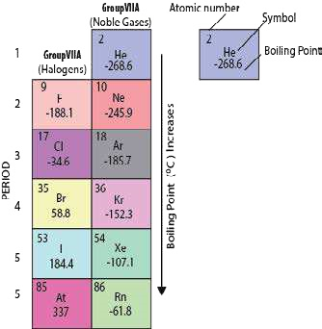measurement of the extent to which **noble gases** the electronic cloud can be polarized or distorted. When we say that a species (atom, molecule or ion) is polarized, it means that temporary poles are created. This is possible if electronic cloud can be disturbed or distorted. This increased distortion of electronic cloud creates stronger London forces and hence the boiling points are increased down the group.

Similarly, the boiling points of halogens in group VII-A also increase from luorine to iodine Table (4.1). All the halogens are nonpolar diatomic molecules, but there is a big diference in their physical states at room temperature. Fluorine is a gas and boils at -188.1 °C, while iodine is a solid at room temperature which boils at +184.4 °C. The polarizability of iodine molecule is much greater than that of luorine.

Another important factor that afects the strength of London forces is the number of atoms in a non-polar molecule. Greater the number of atoms in a molecule, greater is its polarizability. Let us discuss the boiling points of saturated hydrocarbons. These hydrocarbons have chain of carbon atoms linked with hydrogen atoms. Compare the length of the chain for C2H6 and C6H14.

They have the boiling points - 88.6 °C and 68.7 C,respectively. This means that the molecule with a large chain length experiences stronger attractive forces. The reason is that longer molecules have more places along its length where they can be attracted to other molecules. It is very interesting to know that with the increasing molecular mass of these hydrocarbons, they change from gaseous to liquid and then inally become solids. The Table (4.2) gives the boiling points and the physical states of some hydrocarbons.

**Table (4.2) Boiling points and physical states of some hydrocarbons**

|  |  |  |  |  |  |
| --- | --- | --- | --- | --- | --- |
| Name | B.P 0C (1 atm) | Physical state at S.T.P | Name | B.P 0C (1 atm) | Physical state at S.T.P |
| Mathane  Ethane  Propane  Butane | -164  -88.6  -42.1  0.5 | Gas  Gas  Gas  Gas | Pentane  Hexane  Decane  Isodecane | 36.1  68.7  174.1  327 | Liquid  Liquid  Liquid  Solid |

**4.1.5 Hydrogen Bonding**

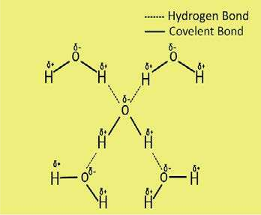 To understand hydrogen bonding, let us consider the molecule of water. Oxygen is more electronegative element as compared to hydrogen, so water is a polar molecule. Hence there will be dipole-dipole interactions between partial positively charged hydrogen atoms and partial negatively charged oxygen atoms. Actually, hydrogen bonding is something more than simple dipoledipole interaction. Firstly, oxygen atom has two lone pairs. Secondly hydrogen has suicient partial positive charge. Both the hydrogen atoms of water molecule create strong electrical ield due to their small sizes.

The oxygen atom of the other molecule links to form a coordinate covalent bond with hydrogen using one of its lone pairs of electrons. Fig (4.4).

Thus loose bond formed is deinitely Fig (4.4) Hydrogen bonding in water. stronger than simple dipole-dipole interaction. Because of the small size of the hydrogen atom, it can take part in this type of bonding. This bonding acts as a bridge between two electronegative oxygen atoms. Hence hydrogen bonding is the electrostatic force of a atraction between a highly electronegative atom and partial positively charged hydorgen atom.

The electronegative atoms responsible for creating hydrogen bonding are luorine, oxygen, nitrogen and rarely chlorine. The strength of hydrogen bond is generally twenty times less than that of a covalent bond.

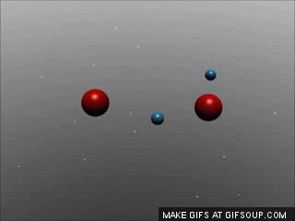

*Animation 4.4 : hydrogen bonding*

*Source & Credit:*

[*stream*](http://stream1.gifsoup.com/view2/3128815/hydrogen-bond-o.gif)

[*1*](http://stream1.gifsoup.com/view2/3128815/hydrogen-bond-o.gif)

It is not advisable to limit the hydrogen bonding to the above-m entioned electronegative atoms. The three chlorine atoms in chloroform are responsible for H- bonding with other molecules.

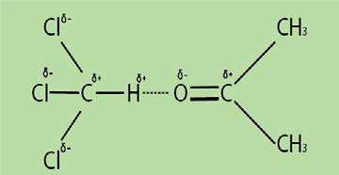These atoms deprive the carbon atom of its electrons and the partial positively charged hydrogen can form a strong hydrogen bond with oxygen atom of acetone Fig (4.5).

Fig (4.5) Hydrogen bonding between chloroform and acetone

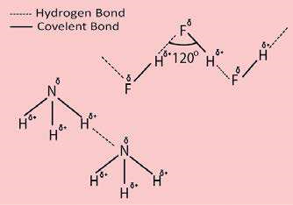The hydrogen bonding present in the molecules of ammonia and those of hydrolouric acid can be depicted as follows Fig (4.6).The molecules of HF join with each other in a zig- zag manner.

The exceptional, low acidic strength of

HF molecule as compared to HCl, HBr and HI is due to this strong hydrogen bonding, because the partial positively charged hydrogen is entrapped between two highly electronegative atoms.

Fig (4.6) Hydrogen bonding in NH3 and HF molecules.

**4.1.6 Properties and Application of Compounds Containing Hydrogen Bonding**

**1. Thermodynamic Properties of Covalent Hydrides**

Our discussion shows that hydrogen bonding exists in compounds having partial positively charged hydrogen and highly electronegative atoms bearing partial negative charge. Obviously such intermolecular attractions will inluence the physical properties like melting and boiling points. Let us compare the physical properties of hydrides of group IV-A, V-A, VI-A and VII-A. The graphs are plotted between the period number of the periodic table on x-axis and boiling points in kelvin on y-axis Fig (4.7).

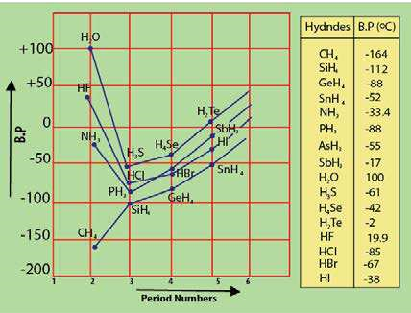

Fig (4.7) A Graph between period number and the boiling points of hydrides of IV-A, V-A, VI-A and VII-A group elements.

A look at the boiling points of hydrides of group IV-A convinces us, that they have low boiling points as compared to those of group V-A, VI-A, VII-A. The reason is that these elements are least electronegative. CH4 has the lowest boiling point because it is a very small molecule and its polarizability is the least.

When we consider the hydrides of group V-A, VI-A, VII-A then NH3, H20 and HF show maximum boiling points in the respective series. The reason is, the enhancec electronegative character of N, 0 and F. That is why, water is liquid at room temperature, but H2S and H2Se are gases.

It is interesting to know that the boiling point of water seems to be more afected by hydrogen bonding than that of HF Fluorine is more electronegative than oxygen. So, we should expect H-bonding in HF to be stronger than that in water and as a result the boiling point of HF should be higher than that of H20. However, it is lower and the reason is that the luorine atom can make only one hydrogen bond with electropositive hydrogen of a neighboring molecule. Water can form two hydrogen bonds per molecule, as it has two hydrogen atoms and two lone pairs on oxygen atom.

Ammonia can form only one hydrogen bond per molecule as it has only one lone pair.

The boiling point of HBris slightly higher than that of HCl. It means that chlorine is electronegative enough to form a hydrogen bond. Sometimes it is thought that HCl has a strong dipole-dipole interaction but in reality, it is a border line case. The hydrides of fourth period GeH4, AsH3, H2Se, HBr show greater boiling points than those of third period due to greater size and enhanced poiarizabilities.

1. **Solubility of Hydrogen- Bonded Molecules**

Water is the best example of H-bonded system. Similarly ethyl alcohol (C2H5OH) also has the tendency to form hydrogen bonds. So, ethyl alcohol can dissolve in water because both can form hydrogen bonds with each other. Similarly carboxylic acids are also soluble in water, if their sizes are small. Hydrocarbons are not soluble in water at all, because they are non-polar compounds and there are no chances of hydrogen bonding between water and hydrocarbon molecules.

1. **Structure of Ice**

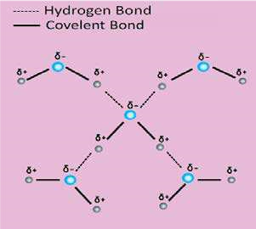 The molecules of water have tetrahedral structure. Two lone pairs of electrons on oxygen atom occupy two corners of the tetrahedron. In the liquid state, water molecules are extensively associated with each other and these associations break and are reformed because the molecules of water are mobile. When the temperature of water is decreased and ice is formed then the molecules become more regular and this regularity extends throughout the whole structure. Empty spaces are created in the structure as shown in the following Fig (4.8b). That is why when water freezes it occupies 9% more space and its density decreases. The result is that ice loats on water. The structure of ice is just like that of a diamond because each atom of carbon in diamond is at the center of tetrahedron just like the oxygen of water molecule in ice, Fig (4.8 b).

Fig (4.8 a) Structure of liquid water

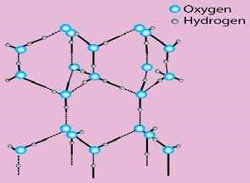 The lower density of ice than liquid water at 0 °C causes water in ponds and lakes to freeze from surface to the downward direction. Water attains the temperature of 4°C by the fall of temperature in the surrounding. As the outer atmosphere becomes further cold, the water at the surface becomes less dense. This less dense water below 4 °C stays on the top of slightly warm water underneath. A stage reaches when it freezes. This layer of ice insulates the water underneath for further heat loss. Fish and plants survive under

this blanket of ice for months. Fig (4.8 b) Structure of ice Keeping the whole discussion in view we are

forced to believe that the pattern of life for the plants and animals would have been totally diferent in the absence of hydrogen bonding in water.

1. **Cleansing Action of Soaps and Detergents**

Soaps and detergents perform the cleansing action because the polar part of their molecules are water soluble due to hydrogen-bonding and the non-polar parts remain outside water, because they are alkyl or benzyl portions and are insoluble in water.

1. **Hydrogen Bonding in Biological Compounds and Food Materials**

Hydrogen bonding exists in the molecules of living system. Proteins are the important part of living organisms. Fibres like those found in the hair, silk and muscles consist of long chains of amino acids. These long chains are coiled about one another into a spiral. This spiral is called a helix. Such a helix may either be right handed or left handed. In the case of right handed helix the groups like >N H and > C = 0 are vertically adjacent to one another and they are linked together by hydrogen bonds. These H-bonds link one spiral to the other. X-ray analysis has shown that on the average there are 27 amino acid units for each turn of the helix, Fig (4.9 a).

Deoxyribonucleic acid (DNA) has two spiral chains. These are coiled about each other on a common axis. In this way, they give a double helix. This is 18-20 Å in diameter. They are linked together by H-bonding between their sub units, Fig (4.9 b).

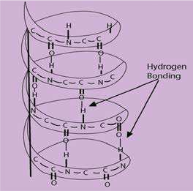 Fig (4.9 a) Hydrogen bonding 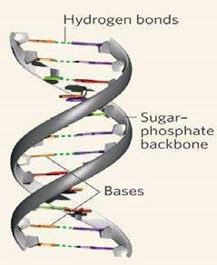

Fig (4.9 b) Hydrogen bonding in

DNA double helix

The food materials like carbohydrates include glucose, fructose and sucrose. They all have -OH groups in them which are responsible for hydrogen bonding in them.

**6. Hydrogen Bonding in Paints, Dyes and Textile Materials**

One of the most important properties of paints and dyes is their adhesive action. This property is developed due to hydrogen bonding. Similar type of hydrogen bonding makes glue and honey as sticky substances.

We use cotton, silk or synthetic ibres for clothing. Hydrogen bonding is of vital importance in these thread making materials. This hydrogen bonding is responsible for their rigidity and the tensile strength.

#### 4.2.0 EVAPORATION

In order to understand evaporation, we have to examine the movement of molecules in liquids. The molecules of a liquid are not motionless. The energy of molecules is not equally distributed. The molecules which have low kinetic energy move slowly, while others with high kinetic energy move faster. If one of the high speed molecules reaches the surface, it may escape the attractions of its neighbouring molecules and leaves the bulk of the liquid. **This spontaneous change of a liquid into its vapours is called evaporation and it continues at all temperatures.**

Evaporation causes cooling. The reason is that when high energy molecules leave the liquid and low energy molecules are left behind, the temperature of the liquid falls and heat moves from the surrounding to the liquid and then the temperature of the surrounding also falls.

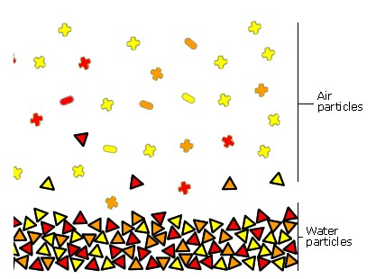

*Animation 4.5 : Evaporation*

*Source & Credit:*

[*ste*](http://11567.stem.org.uk/images/r1_evaporation_animation.gif)

[*m*](http://11567.stem.org.uk/images/r1_evaporation_animation.gif)

There are many factors which control the rate of evaporation of a liquid. Since evaporation occurs from liquid surface, so if surface area is increased then more molecules are able to escape and liquid evaporates more quickly. For liquids having same surface area, the rate of evaporation is controlled by the temperature and the strength of intermolecular forces.

At high temperature, the molecules having greater energy increase and so rate of evaporation increases. Similarly, if intermolecular forces are weak, the rate of evaporation is faster. For example, gasoline, whose molecules experience weaker London forces of attraction, evaporate much faster than water.

**4.2.1 Vapour Pressure**

When the molecules of a liquid leave the open surface, they are mixed up with air above the liquid. If the vessel is open these molecules go on leaving the surface. But if we close the system the molecules of liquid start gathering above the surface. These molecules not only collide with the walls of the container, but also with the surface of the liquid as well.

There are chances that these molecules are recaptured by the surface of liquid. This process is called condensation. The two-processes i.e., evaporation and condensation continue till a stage reaches when the rate of evaporation becomes equal to the rate of condensation. This is called the state of dynamic equilibrium Fig (4.10). So the vapour pressure of a liquid is a pressure exerted by the vapours of the liquid in equilibrium with the liquid at a given temperature.

*Liquid*฀ ฀฀฀ ฀฀ *Vapour*

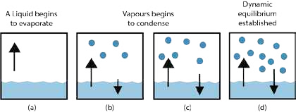

Fig (4.10) Evaporation of a liquid and establishment of dynamic equilibrium between liquid and its vapours.

The number of molecules leaving the surface is just equal to the number of molecules coming back into it at a constant temperature. The molecules which are in the liquid state at any moment may be in vapour state in the next moment.



*Animation 4.6 : Vapour Pressure*

*Source & Credit:*

[*mecalu*](http://www.mecaflux.com/en/Saturation%20vapor%20pressure.htm)

[*x*](http://www.mecaflux.com/en/Saturation%20vapor%20pressure.htm)

The magnitude of vapour pressure does not depend upon the amount of liquid in the container or the volume of container. It also does not depend on surface area of a liquid. The larger surface area also presents a larger target for returning the molecules, so the rate of condensation also increases.

**Vapour Pressure Increases with Temperature**

The values of vapour pressures of various liquids depend fairly upon the nature of liquids i.e. on the sizes of molecules and intermolecular forces, but the most important parameter which controls the vapour pressure of a liquid is its temperature. At an elevated temperature, the kinetic energy of molecules is enhanced and capability to leave the surface increases.

|  |  |
| --- | --- |
| Temperature  (0C) | Vapour  Pressure (Torr) |
| 0 | 4.579 |
| 10 | 9.209 |
| 20 | 17.54 |
| 30 | 31.82 |
| 37 | 47.07 |
| 40 | 55.32 |
| 50 | 92.51 |
| 60 | 149.4 |
| 70 | 233.7 |
| 80 | 355.1 |
| 90 | 527.8 |
| 100 | 760.0 |

It causes the increase of vapour pressure. Table(4.3) **Tablc (4.3) Vapour pressures of water** shows change in vapour pressure of water at diferent **(torr) at various temperatures** temperatures. The Table (4.3) shows that increases of vapour pressure goes on increasing for the same diference of temperature from 0°C to 100°C for water. There is increase of vapour pressure from 4.579 torr to 9.209 torr for change of temperature from 0°C to 10°C. But the increase is from 527.8 torr to 760 torr when temperature changes from 90°C to 100°C.

The diference in the strength of intermolecular forces in diferent liquids is directly related to their vapour pressures at a particular temperature. The stronger the intermolecular forces the lower the vapour pressure. The following Table (4.4) shows that at 20 °C isopentane has the highest vapour pressure, while glycerol has the lowest.

**4.2.2 Measuremerr of Vapour Pressure**

There are many methods for the measurement of vapour pressure of a liquid. One of the important methods is described in the following paragraph.

**Table (4.4) Vapour pressure of some important liquids at 20°C**

|  |  |
| --- | --- |
| Name of compound | Vapour pressure at 20 0C (torr) |
| Isopentane | 580 |
| Ethyl ether | 442.2 |
| Chloroform | 170 |
| Carbon Tetrachloride | 87 |
| Ethanol | 43.9 |
| Mercury | 0.012 |
| Glycerol | 0.00016 |

**Manometric Method**

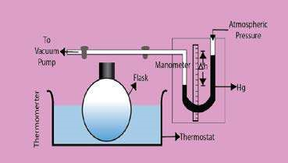Manometric method is comparatively an accurate method. The liquid whose vapour pressure is to be determined is taken in a lask placed in a thermostat, as shown in the Fig(4.11). One end of the tube from the lask is connected to a manometer and the other end is connected to a vacuum pump. The liquid is frozen with the help of a freezing mixture and the space above the liquid is evacuated. In this way, the air is removed from the surface of the liquid alongwith the vapours of that liquid. The frozen liquid is then melted to release any entrapped air. Liquid is again frozen and realeased air To is

evacuated. This process is repeated in the heights of the columns of-Hg in liquid by manometric methodFig. (4.11) Measurement of vapour pressure of a many times till almost all the air is removed.

Now the liquid is warmed in the thermostat to that temperature at which its vapour pressure in the lask is to be determined. Diference in the heights of the columns of-Hg in liquid by manometric method the two limbs of the manometer determines the vapour pressure of the liquid.

The column of mercury in the manometer facing the vapours of the liquid is depressed. The other column, which faces the atmospheric pressure, rises. Actually, the pressure on the surface of the liquid in the lask is equal to the sum of the atmospheric pressure and the vapour pressure of liquid. For this reason, the column of manometer facing the liquid is more depressed than facing the atmosphere, and it is given by the following equation.

P = Pa + ∆h

Where P = Vapour pressure of the liquid at one atm pressure.

P= Atmospheric pressure.

∆h = Diference in the heights of the mercury levels in the two limbs of the manometer, giving us the vapour pressure of liquid.

**4.2.3 Boiling Point**

When a liquid is heated, the vapour pressure goes on increasing. A stage reaches when the vapour pressure of the liquid becomes equal to the external atmospheric pressure. This temperature is called the boiling point of the liquid. The reason for this is that the bubbles of vapours which are formed in the interior of the liquid have greater internal pressure than atmospheric pressure on the surface of liquid. This thing makes the bubble to come out of the liquid and burst upon the surface. Thus a constant stream of bubbles comes out at the boiling point.

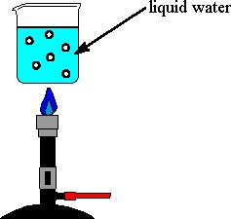

*Animation 4.7 : Boiling Point*

*Source & Credit:*

[*che*](https://www.chem.purdue.edu/gchelp/liquids/boil.html)

[*m*](https://www.chem.purdue.edu/gchelp/liquids/boil.html)

When a liquid is heated, the kinetic energy of its molecules increases and hence the temperature also increases. At the boiling point, the kinetic energy of the molecules becomes maximum and any further heating at this stage will not increase the temperature.

This heat will only be utilized to break the intermolecular forces and convert the liquid into its vapours. **The amount of heat required to vapourize one mole of a liquid at its boiling point is called its molar heat of vapourization.** The molar heat of vapourization of water is 40.6 kjmol-1. The boiling points of some commonly available liquids at one atmospheric pressure are shown in the Table (4.5).

**Table (4.5) Boiling points of some common liquids at 760 torr.**

|  |  |  |  |
| --- | --- | --- | --- |
| Liquid | B.P (0C) | Liquids | B.P (0C) |
| Acetic Acid | 118.50 | Carbon tetrachloride | 76.50 |
| Acetone | 56.00 | Ethanol | 78.26 |
| Aniline | 184.4 | Naphthalene | 218.00 |
| Benzene | 80.15 | Phenol | 181.80 |
| Carbon disulphide | 46.30 | Water | 100.00 |

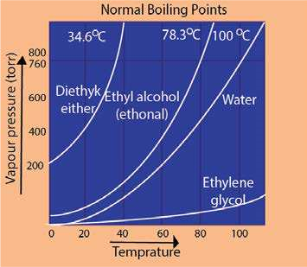 The Fig. (4.12) shows the variation of vapour pressure of water, ethyl alcohol, ethylene glycol and diethylether with temperature. It shows that the liquids reach upto their boiling points when their vapour pressures are equal to 760 torr at sea level. The way these curves start at 0 0C is interesting. Water takes start at 4.8 torr while diethyl ether at around 200 torr. This is due to diference in the strengths of their intermolecular forces. The curve for water goes alongwith temperature axis to a greater extent at the beginning as compared to ether. It means that water can hardly overcome its intermolecular forces at low temperatures. It is clear from the curves that the vapour pressure increases very rapidly when the liquids are closer to their boiling points.

Fig (4.12) Vapour pressures(torr) of four common liquids shown as a function of temperature(°C).

**4.2.4 Boiling Point and External Pressure**

We have already explained that when vapour pressure of a liquid becomes equal to the external pressure then the liquid boils, so when external pressure is changed, its boiling point will also be changed. A liquid can be made to boil at any temperature by changing the external pressure. When the external pressure is high the liquid requires greater amount of heat to equalize its vapour pressure to external pressure. In this way boiling point is raised. Similarly, at a lower external pressure a liquid absorbs less amount of heat and it boils at a lower temperature. For example, water shows B.P of 120 °C at 1489 torr pressure and boils at 25 °C at 23.7 torr. Water boils at 98 °C at Murree hills due to external pressure of 700 torr while at the top of Mount Everest water boils at only 69 0C 323 torr.

We can increase the external pressure artiicially on the surface of boiling water by using a pressure cooker. Pressure cooker is a closed container. The vapours of water formed are not allowed to escape. In this way, they develop more pressure in the cooker and the boiling temperature increases. As more heat is absorbed in water, so food is cooked quickly under increased pressure. Liquids can be made to boil at low temperatures, where they can be distilled easily. This process is called vacuum distillation. Vacuum distillation has many advantages. It decreases the time for the distillation process and is economical because less fuel is required. The decomposition of many compounds can be avoided e.g. glycerin boils at 290 °C at 760 torr pressure but decomposes at this temperature. Hence, glycerin cannot be distilled at 290 °C. Under vacuum, the boiling temperature of glycerin decreases to210 0C at 50 torr. It is distilled at this temperature without decomposition and hence can be puriied easily.

**4.2.5 Energetics of Phase Changes**

Whenever, matter undergoes a physical change, it is always accompanied by an energy change. This change in energy is the quantitative measurement of the diference in the strength of intermolecular forces.

The change in energy is mostly in the form of heat. **If a physical or a chemical change takes place at a constant pressure, then the heat change during this process is also called enthalpy change.** This is denoted by ΔH. These enthalpy changes are usually expressed per mole of the substances. Three types of enthalpy changes are associated with usual physical changes.

##### (i) Molar Heat of Fusion (ΔHf)

It is the amount of heat absorbed by one mole of a solid when it melts into liquid form at its melting point. The pressure, during the change is kept one atmosphere.

##### (ii) Molar Heat of Vapourization (ΔHv)

It is the amount of heat absorbed when one mole of a liquid is changed into vapours at its boiling point. The pressure, during the change is kept one atmosphere.

##### (iii) Molar Heat of Sublimation (ΔHs)

It is the amount of heat absorbed when one mole of a solid sublimes to give one mole of vapours at a particular temperature and one atmospheric pressure.

All these enthalpy changes are positive, because they are endothermic processes.

**4.2.6 Energy Changes and Intermolecular Attractions**

When a solid substance melts then atoms, molecules or ions undergo relatively small changes in intermolecular distances and the potential energy also undergoes a small change. But when a liquid evaporates, then larger changes in intermolecular distances and in potential energy takes place. So ΔH of vapourization of a substance is greater than ΔH of fusion. The values of ΔHs are even larger than ΔHv because attractive forces in solids are stronger than those in liquids.

The values of ∆Hv and ∆Hs tell us directly the energy needed to separate molecules from each other. So from these values, we can compare the strengths of intermolecular forces in diferent compounds.

From the following Table (4.6), we are convinced that ΔHv for H20, NH3 and S02 are reasonably high due to polar nature of molecules. ΔHV for iodine is the highest amongst its family members due to its greater polarizability. Similarly, hexane (C6H14) has the highest ΔHv value amongst the hydrocarbons due to larger size of its molecules. Actually, the London dispersion forces in I2 and C6H14 are suiciently strong and these are responsible for such a behaviour.

**Table (4.6) Heats of**

**Vaporization of some substances**

|  |  |
| --- | --- |
| Substance | ΔHv (kJ/mol) |
| H2O | +40.6 |
| NH3 | +21.7 |
| HCl | +15.6 |
| SO2 | +24.3 |
| F2 | +5.9 |
| Cl2 | +10.00 |
| Br2 | +15.00 |
| I2 | +22.00 |
| CH4 | +8.60 |
| C2H6 | +15.1 |
| C3H8 | +16.9 |
| C H | 30.1 |

6 14

**4.2.7 Change of State and Dynamic Equilibrium**

Whenever, a change of state occurs the system moves towards the condition of dynamic equilibrium. Dynamic equilibrium is a situation when two opposing changes occur at equal rates. Being a chemist, we should know that the concept of dynamic equilibrium is the fate or the ultimate goal of all the reversible chemical reactions and all the physical changes.

At 0°C, solid water (ice) exists in dynamic equilibrium with liquid water. *ice*฀ ฀฀฀฀฀฀฀0*oC water*

#### 4.3 Liquid Crystals

Whenever we study the properties of crystalline solids, we come to know that the pure solids melt sharply. The temperature remains constant at the melting point until all the solid melts.

In 1888, Frederick Reinitzer, an Austrian botanist discovered a universal property. He was studying an organic compound cholesteryl benzoate. This compound turns milky liquid at 145°C and becomes a clear liquid at 179°C. When the substance is cooled, the reverse process occurs. This turbid liquid phase was called liquid crystal.

Uptil now, it has been reported that, there are many crystalline solids which melt to a turbid liquid phase, before inally melting to a clear liquid. These turbid liquid phases can low as liquids. They have the properties like liquids as surface tension, viscosity, etc. But it is very interesting to know that the molecules of such turbid liquids possess some degree of order as well. It means that these turbid liquids resemble crystals in certain properties and the most important properties are optical ones. These turbid liquids are hence called liquid crystals. So, **a liquid crystalline state exists between two temperatures i.e. melting temperature and clearing temperature.** A crystalline solid may be isotropic or anisotropic, but liquid crystals are always anistropic.

*Crystal*฀ ฀฀฀฀฀ *Liquidcrystal*฀฀฀฀฀฀ *Liquid*

From 1888 to until about 30 years ago, liquid crystals were largely a laboratory curiosity. But now they have found a large number of applications.

Those substances which make the liquid crystals are often composed of long rod like molecules. In the normal liquid phase, these molecules are oriented in random directions. In liquid crystalline phase, they develop some ordering of molecules. Depending upon the nature of ordering, liquid crystals can be divided into nematic, smectic and cholesteric.

The properties of liquid crystals are intermediate between those of crystals and isotropic liquids. They have the luidity of the liquids and the optical properties of the crystals.

**Uses of Liquid Crystals**

Due to the remarkable optical and electrical properties, liquid crystals ind many practical applications. Many organic compounds and biological tissues behave as liquid crystals. The unique properties of liquid crystals have intrigued the scientists since their discovery, nearly hundred years ago. Some of their important uses are as follows.

1. Like solid crystals, liquid crystals can difract light. When one of the wavelengths of white light is relected, from a liquid crystal it appears coloured. As the temperature changes, the distances between the layers of the molecules of liquid crystals change. Therefore, the colour of the relected light changes accordingly. Thus liquid crystals can he used as temperature sensors.
2. Liquid crystals are used to ind the point of potential failure in electrical circuits. Room thermometers also contain liquid crystals with a suitable temperature range. As the temperature changes, igures show up in diferent colours.
3. Liquid crystalline substances are used to locate the veins, arteries, infections and tumors. The reason is that these parts of the body are warmer than the surrounding tissues. Specialists can use the techniques of skin thermography to detect blockages in veins and arteries. When a layer of liquid crystal is painted on the surface of the breast, a tumor shows up as a hot area which is coloured blue. This technique has been successful in the early diagnosis of breast cancer.
4. Liquid crystals are used in the display of electrical devices such as digital watches, calculators and laptop computers. These devices operate due to the fact that temperature, pressure and electro-magnetic ields easily afect the weak bonds, which hold molecules together in liquid crystals.
5. In chromatographic separations, liquid crystals are used as solvents.
6. Oscillographic and TV displays also use liquid crystal screens.

### SOLIDS

#### 4 .4INTRODUCTION

**Solids are those substances which are rigid, hard, have deinite shape and deinite volume.** The atoms, ions and molecules that make up a solid are closely packed. They are held together by strong cohesive forces. The constituent atoms, ions or molecules of solids cannot move at random. There exists a well ordered arrangement in solids.

**4.4.1 Types of Solids**

Solids can be classiied on the basis of the regular arrangements of constituent atoms, ions or molecules. There are two types of solids in this respect.

1. **Crystalline Solids**

Those solids in which atoms, ions or molecules are arranged in a deinite three dimensional pattern are called crystalline solids This recurring regular geometrical pattern of structure extends three dimensionally.

1. **Amorphous Solids**

All solids are not crystalline .The word amorphous means shapeless. **Amorphous substances are those whose constituent atoms, ions, or molecules do not possess a regular orderly arrangement.** The best examples are glass, plastics, rubber, glue, etc. These substances have solid state properties and virtually complete maintenance of shape and volume. But they do not have an ordered crystalline state.

Many crystalline solids can be changed into amorphous solids by melting them and then cooling the molten mass rapidly. In this way the constituent particles do not ind time to arrange them selves.

A long range regularity does not exist in amorphous solids but they can possess small regions of orderly arrangements. These crystalline parts of otherwise amorphous solids are known as crystallites. Amorphous solids don’t have sharp melting points that is why particles of glass soften over a temperature range and can be moulded and blown into various shapes. They do not possess deinite heats of fusion.

**4.4.2 Properties of Crystalline Solids**

1. **Geometrical Shape**

All the crystalline solids have a deinite, distinctive geometrical shape due to deinite and orderly arrangement of atoms, ions or molecules in three-dimensional space. For a given crystal, the interfacial angles, at which the surfaces intersect, are always the same no matter in which shape they are grown. The faces and angles remain characteristic even when the material is ground to a ine powder.

1. **Melting Points**

Crystalline solids have sharp melting points and can be identiied from their deinite melting points.

1. **Cleavage Planes**

Whenever the crystalline solids are broken they do so along deinite planes. These planes are called the cleavage planes and they are inclined to one another at a particular angle for a given crystalline solid. The value of this angle varies from one solid to another solid.

1. **Anisotropy**

**Some of the crystals show variation in physical properties depending upon the direction. Such properties are called anisotropic properties and the phenomenon is referred to as anisotropy.** The physical properties of crystalline solids like refractive index, coeicient of thermal expansion, electrical and thermal conductivities are sometimes anisotropic in nature for some crystals.

The variation in these properties with direction is due to fact that the orderly arrangement of the particles in crystalline solids is diferent in diferent directions. For example, electrical conductivity of graphite is greater in one direction than in another. Actually electrons in graphite are mobile for electrical conduction parallel to the layers only. Therefore, its conductivity in this direction is far better than perpendicular to the other direction. Similarly, cleavage itself is an anisotropic behaviour.

1. **Symmetry**

**The repetition of faces, angles or edges when a crystal is rotated by 360° along its axis is called symmetry.** This an important property of the crystal and there are various types of symmetry elements found in crystals like, center of symmetry, plane of symmetry and axis of symmetry, etc.

1. **Habit of a Crystal**

**The shape of a crystal in which it usually grows is called habit of a crystal.** Crystals are usually obtained by cooling the saturated solution or by slow cooling of the liquid substance. These are formed by growing in various directions. If the conditions for growing a crystal are maintained, then the shape of the crystal always remains the same. If the conditions are changed the shape of the crystal may change. For example, a cubic crystal of NaCl becomes needle like when 10% urea is present in its solution as an impurity.

1. **Isomorphism**

**Isomorphism is the phenomenon in which two diferent substances exist in the same crystalline form.**  These diferent substances are called isomorphs of each other.

A crystalline form is independent of the chemical nature of the atoms and depends only on the number of atoms and their way of combinations.

Mostly the ratio of atoms in various compounds are such that isomophism is possible. Their physical and chemical properties are quite diferent from each other. Anyway, isomorphic substances crystallize together in all proportions in homogeneous mixtures. Following examples tell us the nature of the compound, their crystalline forms and the ratio of their atoms.

|  |  |  |
| --- | --- | --- |
| Isomorphs | Crystalline form | Atomic ratio |
| NaNO3, KNO3 | rhombohedral | 1:1:3 |
| K2SO4, K2CrO4 | orthorhombic | 2:1:4 |
| ZnSO4, NiSO4 | -do- | 1:1:4 |
| NaF, MgO | cubic | 1:1 |
| Cu, Ag | cubic | 1:1 |
| Zn, Cd | hexagonal | 1:1 |

The structures of the negatively charged ions like NO3-1 and CO32-, are the same. Similarly shapes of

SO42- and CrO42- are also alike. CO32- and NO31- are triangular planar units, while SO42-  and CrO42- are both tetrahedral.

1. **Polymorphism**

**Polymorphism is a phenomenon in which a compound exists in more than one crystalline forms. That compound which exists in more than one crystalline forms is tailed a polymorphic, and these forms are called polymorphs, and these forms are called polymorphs of each other.**

Polymorphs have same chemical properties, but they difer in the physical properties. The diference in physical properties is due to diferent structural arrangement of their particles.

The following compounds are important polymorphs.

|  |  |
| --- | --- |
| Substance | crystalline forms |
| AgNO3 CaCO | Rhombohedral, Othorhombic Trigonal and orthorhombic |

3

1. **Allotropy**

**The existence of an element in more than one crystalline forms is known as allotropy and these forms of the element are called allotropes or allotropic forms.** Sulphur, phosphorus, carbon and tin are some important examples of elements which show allotropy.

|  |  |
| --- | --- |
| Element | Crystalline forms |
| Sulphur, S  Carbon, C  Tin, Sn | Rhombic, monoclinic  cubic (diamond), hexagonal (graphite) grey tin (cubic), white tin (tetragonal) |

1. **Transition Temperature**

**It is that temperature at which two crystalline forms of the same substance can co-exist in equilibrium with each other. At this temperature, one crystalline form of a substance changes to another.**

Above and below this temperature, only one form exists. A few examples for those substances which show allotropy and possess a transition temperature are given below

* 1. Grey Tin (cubic) ฀ ฀฀฀฀฀฀฀฀฀13.2*oC* White tin (Tetragonal)
  2. Sulphur S8 (rhombic) ฀ ฀฀฀฀฀฀฀฀฀95.5*oC* Sulphur S8(monoclinic)
  3. KNO3 (orthorhombic) ฀ ฀฀฀฀฀฀฀฀฀128*oC* KNO3(rhombohedral)
  4. Na2S04-10H20 (hydrated form) ฀ ฀฀฀฀฀฀฀฀฀32.38*oC* N a2S04(anhydrous from) + 10 H20
  5. Na2CO3- 10 H20 (higher hydrated form) ฀ ฀฀฀฀฀฀฀฀฀32.38*oC* Na2CO3-7H20 (lower hydrated form) + 3H20

It has been noticed that the transition temperature of the allotropic forms of an element is always less than its melting point.

##### 4.5 CRYSTAL LATTICE

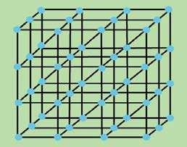 A crystal is made up of atoms, ions or molecules. In crystalline solids, these atoms, ions or molecules are located at deinite positions in space. These positions are represented by points in a crystal. These points are called as lattice points or lattice sites. This arrangement of points in a crystal is called crystal lattice or space lattice.

**So a crystal lattice is an array of points representing atoms, ions or molecules of a crystal, arranged at diferent sites in three dimensional space.** Fig. (4.13) shows a crystal lattice with a cubic structure.

Fig (4.13) Cubic crystal lattice

**4.5.1 Unit Cell**

When we look at the cubic crystal lattice in Fig (4.14), we see that it is actually composed of many small parts. **The smallest part of the crystal lattice has all the characteristic features of the entire crystal and is called a unit cell.**

It means that a unit cell of a crystal lattice is the smallest block or geometrical igure, from which the entire crystal can be built up by repeating it in three dimensions. It shows the structural properties of a given crystal. The complete information about the crystalline structure is present within a unit cell which repeats itself in three dimensions to form a crystal.

If we know the exact arrangement of atoms in a unit cell, we in fact know their arrangement in the whole crystal.

The quantitative aspects of a crystal lattice are deduced from the size and shape of the unit cell. There are three unit cell lengths a, b, c and three unit cell angles a , b and γ. These six parameters are shown in Fig (4.14)

The angle ‘a’ is between the lengths ‘b’ and ‘c’, the angle ‘b’ is between the sides ‘a’ and ‘c’ and angle’ γ’ is between sides ‘a’ and ‘b’. The unit cell lengths a, b, c, may be assigned along x, y and z axis, respectivly but angles a , b and γ have to be decided accordingly. The choice of x, y, z may be along any of the three axis. These six parameters of the unit cell are called unit cell dimensions or crystallographic elements.

Keeping in view the structure of the unit cell we can understand the crystal system.

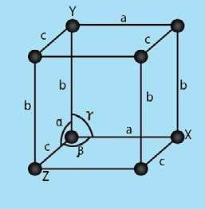

Fig (4.14) Six crystallographic elements specify the size and shape of a unit cell

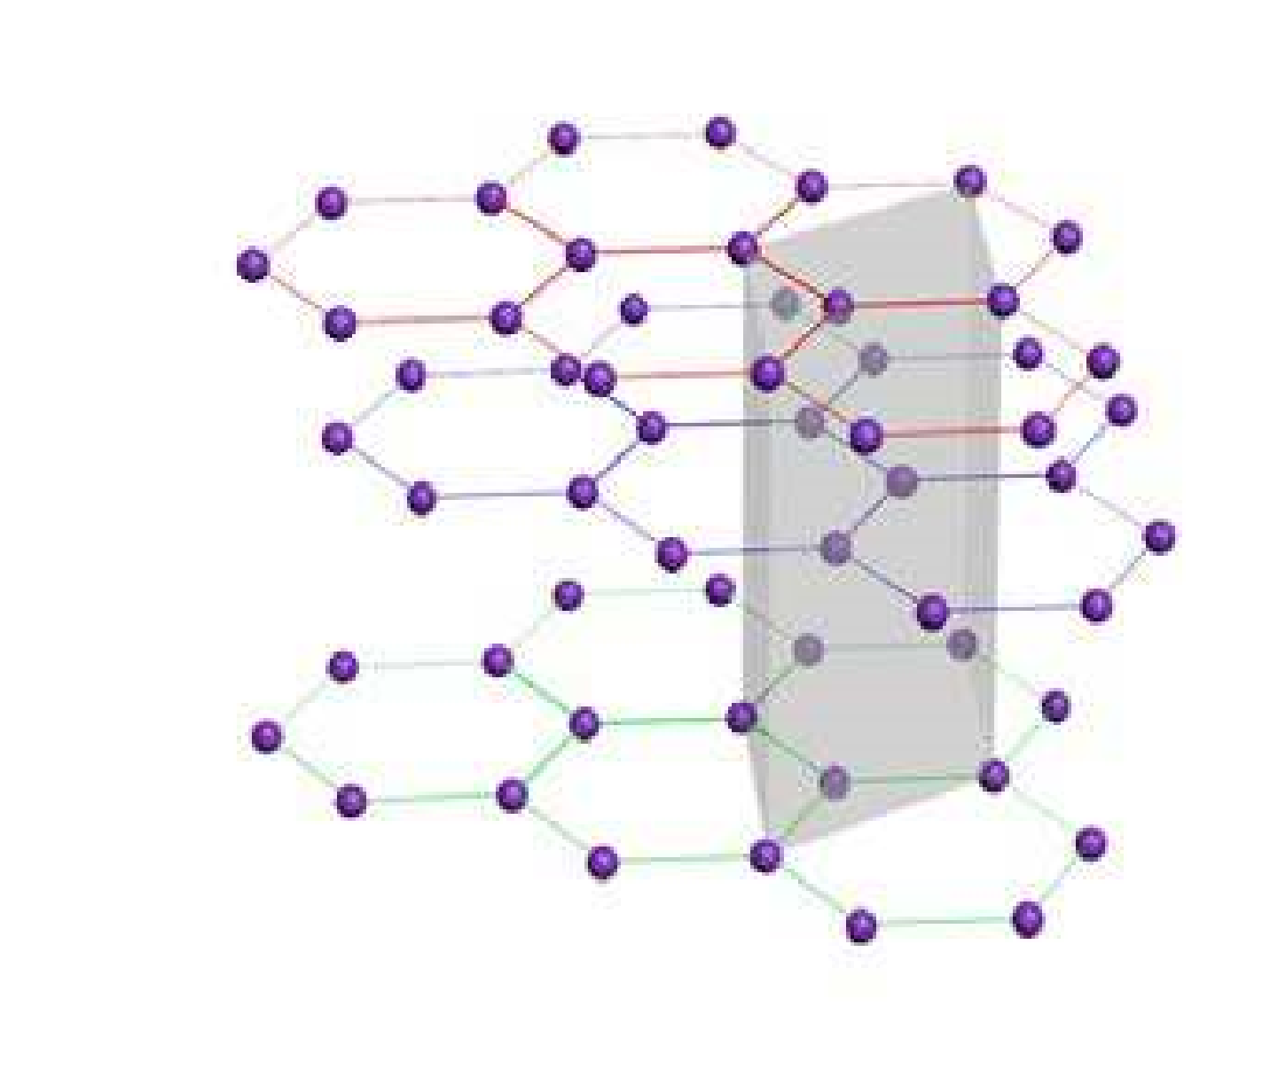

*Animation 4.8: Unit Cell*

*Source & Credit:*

[*Common*](https://commons.wikimedia.org/wiki/File:Graphite_unit_cell.gif)

[*s*](https://commons.wikimedia.org/wiki/File:Graphite_unit_cell.gif)

##### 4.6 CRYSTALS AND THEIR CLASSIFICATION

A crystal system may be identiied by the dimensions of its unit cell along its three edges or axes, a, b, c and three angles between the axes a , b , γ.

There are seven crystal systems. These seven crystal systems are described as follows Fig (4.15).

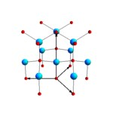

*Animation 4.9: Classiication of Crystals*

*Source & Credit:*

[*wikipedi*](https://en.wikipedia.org/wiki/Wurtzite_crystal_structure)

[*a*](https://en.wikipedia.org/wiki/Wurtzite_crystal_structure)

1. **Cubic system**

In this system all the three axes are of equal length and all are at right angles to one another.

1. 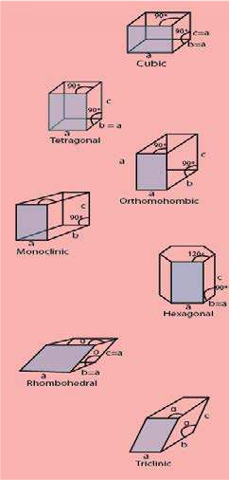**Tetragonal system**

In this system two axes are of equal length and the third axis is either shorter or larger than the other two. All angles are 90°.

1. **Orthorhombic Or Rhombic System**

All the three axes are of unequal length and all are at right angle to each other.

1. **Monoclinic System**

All the three axes are of unequal length; two of these axes are at right angle to each other while the third angle is greater then 90°.

1. **Hexagonal System**

In this system two axes are of equal length and are in one plane making an angle of 120o with each other. The third axis which is diferent in length than the other two is at right angle to these two axes.

1. **Rhombohedral System Or Trigonal System**

All the three axes are of an equal length like cubic system but the three angles are not equal and lie between Fig (4.15) Seven crystal systems 900 and 120°.

1. **Triclinic System**

All the three axes and the three angles are unequal and none of the angles is 900.

Table (4.7) shows the unit cell dimensions of the seven crystal systems alongwith their examples

###### **Table (4.7) Seven Crystal Systems**

|  |  |  |  |  |  |
| --- | --- | --- | --- | --- | --- |
| Sr.  No | Crystal system | Axes | Angles |  | Examples |
| 1. | cubic | *a* = *b*=*c* | a b γ= = = 90*o* |  | Fe, Cu, Ag, Au, NaCl, NaBr, Dimond |
| 2. | Tetragonal | *a* = *b*≠ *c* | a b γ= = = 90*o* |  | Sn, SnO2, MnO2, NH4Br |
| 3. | Orthorhombic | *a* ≠ *b*≠ *c* | a b γ= = = 90*o* |  | Idoine, Rhombic, Sulphur, BaSO4, K2SO4 |
| 4. | Monoclinic | *a* ≠ *b*≠ *c* | a γ= = 90*o*,b≠ 90*o* |  | Sugar, Sulphur, Borax, NaSO.10H2O |
| 5. | Hexagonal | *a* = *b*≠ *c* | á=â=90 , ã=120o 0 |  | Graphite, ZnO, CdS, Ice, Zn, Cd |
| 6. | Rhombohedral  or Trignol | *a* = *b*=*c* | a b γ= = < 90*o*and | 120*o* | Bi, Al2O3, NaNO3, KNO3 |
| 7. | Triclinic | *a* ≠ *b*≠ *c* | a b γ≠ ≠ ≠ 90*o* |  | H3BO3, K2Cr2O7, CuSO4.5H2O |

##### 4.7 CLASSIFICATION OF SOLIDS

In the preceding section, we noted that the crystals are classiied into seven systems depending upon the dimensions of the unit cells. A unit cell contains a deinite number of atoms, ions, or molecules. These atoms, ions or molecules are held together by diferent types of cohesive forces. These forces may be chemical bonds or some type of interactions. There are four types of crystalline solids depending upon the type of bonds present in them.

1. Ionic solids
2. Covalent solids
3. Metallic solids
4. Molecular solids

**4.7.1 Ionic Solids**

Crystalline solids in which the particles forming the crystal are positively and negatively charged ions are called ionic solids. These ions are held together by strong electrostatic forces of attraction. These attractive forces are also called ionic bonds. The crystals of NaCl, KBr, etc are ionic solids.

**Properties of Ionic Solids**

The cations and anions are arranged in a well deined geometrical pattern, so they are crystalline solids at room temperature. Under ordinary conditions of temperature and pressure they never exist in the form of liquids or gases.

Ionic crystals are very stable compounds. Very high energy is required to separate the cations and anions from each other against the forces of attraction. That is why ionic crystals are very hard, have low volatility and high melting and boiling points.

Ionic solids do not exist as individual neutral independent molecules. Their cations and anions attract each other and these forces are non-directional. The close packing of the ions enables them to occupy minimum space. A crystal lattice is developed when the ions arrange themselves systematically in an alternate manner.

The structure of the ionic crystals depends upon the radius ratio of cations and anions. For example.NaCl and CsF have the same geometry because the radius ratio in both the cases is the same.

In the case of ionic crystals we always talk about the formula mass of these substances and not the molecular mass, because they do not exist in the form of molecules.

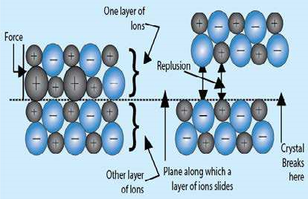

Fig (4.16) Explanation of brittleness of ionic crystals

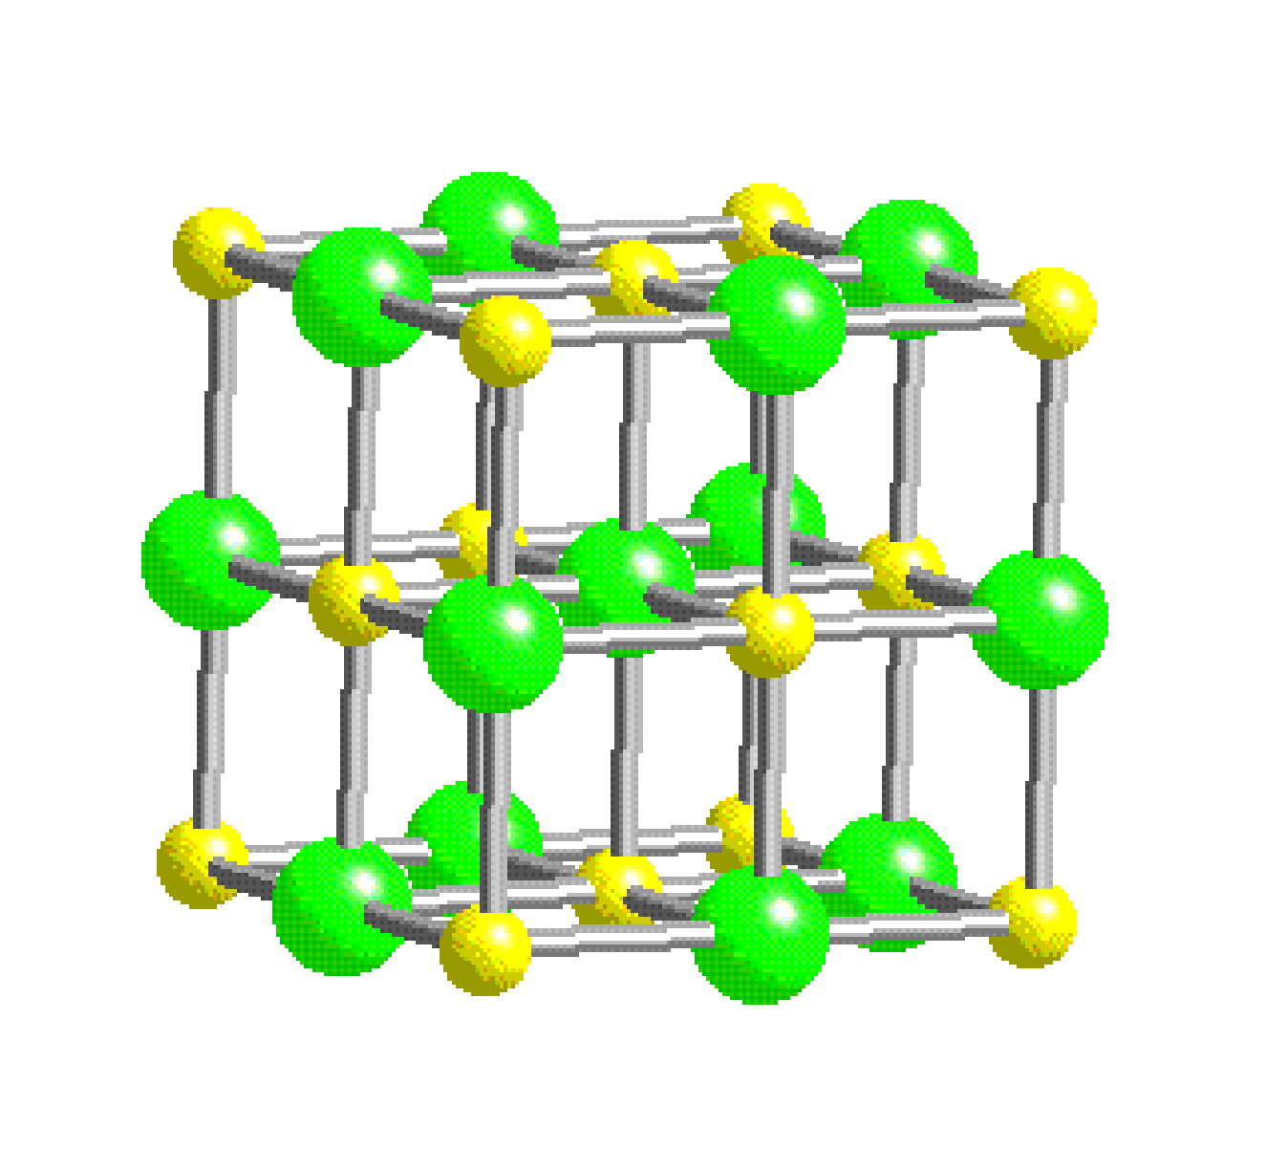

*Animation 4.10: Ionic Solids*

*Source & Credit:*

[*Grandinett*](http://www.grandinetti.org/ionic-bonding)

[*i*](http://www.grandinetti.org/ionic-bonding)

Ionic crystals do not conduct electricity in the solid state, because on account of electrostatic force existing between them the cations and anions remain tightly held together and hence occupy ixed positions. Ionic crystals conduct electricity when they are in solution or in the molten state. In both cases ions become free.

Ionic crystals are highly brittle because ionic solids are composed of parallel layers which contain cations and anions in alternate positions, so that the opposite ions in the various parallel layers lie over each other.

When an external force is applied, one layer of the ions slides a bit over the other layer along a plane. In this way the like ions come in front of each other and hence begin to repel. So, the application of a little external force develops repulsion between two layers causing brittleness Fig (4.16). Ionic solids are mostly of high density due to close packing of ions. Such compounds having the ionic crystals give ionic reactions in polar solvents and these are very fast reactions.

The properties like isomorphism and polymorphism are also associated with the ionic crystals. In order to understand the structure of ionic crystals, let us explain the structure of sodium chloride crystals.

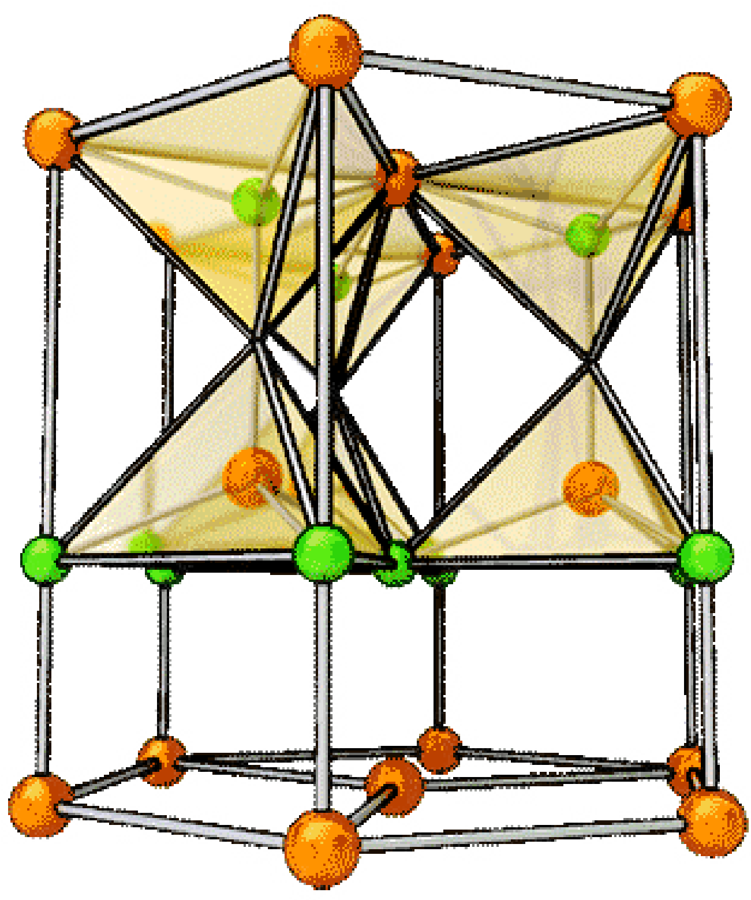

*Animation 4.11: classiication of solids*

*Source & Credit:*

[*Askiitian*](http://www.askiitians.com/iit-jee-solid-state/classification-of-solids/)

[*s*](http://www.askiitians.com/iit-jee-solid-state/classification-of-solids/)

**Structure of Sodium Chloride**

The structure of ionic crystals depends upon the structure and the size of their ions. Each ion is surrounded by a certain number of ions of opposite charge. In the structure of NaCl each Na+ ion is surrounded by six chloride ions. Fig (4.17) shows how these ions are arranged in the crystal lattice. It is clear that Na+ has ten electrons while Cl- has total 18 electrons. The size of the Cl- is bigger than that of Na+  The distance between two nearest ions of the same kind i.e., Cl- ions is 5.63 Ao . So the distance between two adjacent ions of diferent kind is 5.63/2 = 2.815 Ao .

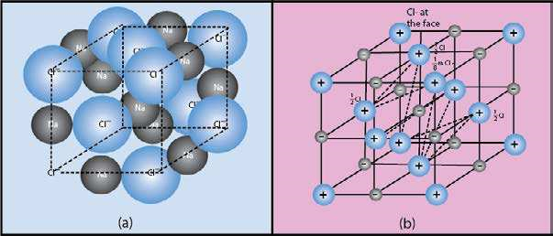

Figs (4.17 a, b) The unit cell of sodium chloride showing that four NaCl formula units are present in a unit cell.

The location of Na+ and Cl- is such that each Na+ is surrounded by six Cl- placed at the corners of a regular octahedron Fig. (4.17 a). So the coordination number of each Na+ is six. Similarly, each Cl- is also surrounded by six Na+. Na+ and C1- are not connected to one another by pairs because all six Cl- ions are at the same distance away from one Na+. It has been observed that independent molecules of NaCl do exist in the vapour phase. Anyhow, in solid NaCl there are no independent molecules of NaCl. That is why NaCl is said to have formula unit of NaCl. While looking at the Fig.(4.17 b), we see that there are eight Cl- at the comers of the cube, and each is being shared amongst eight cubes. l/8th part of each Cl- ion is considered for this unit cell. So, one complete Cl- is contributed by eight corners. Similarly,six chloride ions are present at the face centres and each is being shared between t wo cells. Thus.per unit cell there are 8/8 + 6/2 = 4 Cl- ions. You can justify the presence of 4 Na+ , if you take a unit cell having 8Na+ at eight corners and 6Na+ at faces. So, there are equal number of Na+ ions, and therefore 4 NaCl units are present per unit cell. Fig (4.17b)

**Lattice Energy**

Solids are composed of atoms, ions or molecules. However, many solids of daily importance are ionic in nature. As mentioned earlier these ions exist in a three dimensional array which is called as lattice.

When the oppositely charged ions are brought, close to each other energy is released. **So the lattice energy is the energy released when one mole of the ionic crystal is formed from the gaseous ions. It is also deined as the energy required to break one mole of solid into isolated ions in the gas phase.** It is expressed in kj mole-1.

*Na*+(g)+Cl (g)− →*NaCl s*( )฀H =−787kJmole−1

**Tables (4.8) Lattice energies of ionic compounds**

|  |  |
| --- | --- |
| Ionic  compound | Lattice energy (kJ/mol-1) |
| LiCl | -833 |
| NaF | -895 |
| NaCl | -787 |
| KCl | -690 |
| NaBr | -728 |
| KBr | -665 |
| Nal | -690 |

Table (4.8) shows the lattice energies of many ionic compounds. It is clear from the table that lattice energy decreases with the increase in the size of the cation keeping the anion same. It also decreases with the increase in the size of anion. The reason in both cases is the same. With the increase in the size of either cation or anion, the packing of oppositely charged ions becomes less and less tight. The calculations related to the measurement of lattice energy will be discussed in chapter seven.

**4.7.2. Covalent Solids**

Covalent solids are also called atomic solids, because they are composed of neutral atoms of the same or of diferent elements. These atoms are held together by covalent bonds.

Covalent solids are of two types.

(i) When the covalent bonds join to form giant molecules like diamond, silicon carbide or aluminium nitride. (ii) When atoms join to form the covalent bonds and separate layers are produced like that of graphite, cadmium iodide and boron nitride.

**Properties of Covalent Crystals**

The bonding in covalent crystals extend in three dimensions. They contain a network of atoms. The valencies of atoms are directed in deinite directions, so the packing of atoms in these crystals is looser than those of ionic and metallic crystals. Thus covalent crystals have open structure.

These crystals are very hard and considerable amount of energy is required to break them. They have high melting points and their volatility is very low.

Due to the absence of free electrons and ions they are bad conductors of electricity. However, graphite has a layered structure and the electrons are available in between the layers. These electrons are delocalised and conductivity becomes possible. Graphite is not a conductor perpendicular to the layers.

Mostly covalent crystalline solids are insoluble in polar solvents like water but they are readily soluble in non-polar solvents like benzene and carbon tetrachloride. The covalent crystals having giant molecules like diamond and silicon carbide are insoluble in all the solvents. Because of their big size, they do not interact with the solvent molecules. The chemical reactions of such crystalline solids are very slow.

Let us try to understand the structure of diamond, which is a well known covalent solid.

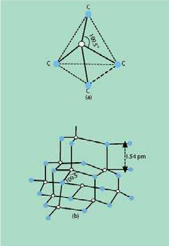**Structure of Diamond**

Diamond is one of the allotropic modiications of carbon. It is best understood by taking into consideration the number of electrons in the outermost shell of carbon, which are four. The four atomic orbitals (one 2s and three 2p) undergo sp3 hybridization to give four sp3 hybridized orbitals. They are directed in space along the four corners of a tetrahedron Fig. (4.18 a).

This is the unit cell of diamond and a large number of such unit cells undergo sp3-sp3 overlapping to form a huge structure. Each carbon atom is linked with four other carbon atoms. The bonds between carbon atoms are covalent which run through the crystal in three-dimensions. All the bond angles are 109.5° and the bond lengths are 154 pm.

The whole lattice is, therefore, continuous and because of the continuity of C-C covalent bonding, the entire diamond crystal behaves as a huge or giant three-dimensional carbon molecule. This is also called a macro-molecule.

Fig.(4.18b), The overall structure of diamond looks face centred-cubic Fig. (4.18 c)

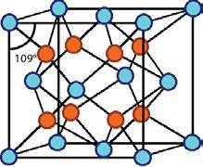

Fig(4.18 c) face-centered cubic structure

of diamond