**6.4.6. Molecular Orbital Theory**

The molecular orbital approach considers the whole molecule as a single unit. It assumes that the atomic orbitals of the combining atoms overlap to form new orbitals called molecular orbitals which are characteristic of the whole molecule. The molecular orbital surrounds two or more nuclei of the bonded atoms. Two atomic orbitals, after overlapping, form two molecular orbitals which difer in energy. One of them, having lower energy, is called bonding molecular orbital while the other having higher energy is called anti-bonding molecular orbital.

The bonding molecular orbital is symmetrical about the axis joining the nuclei of the bonded atoms (molecular axis). It is designated as sigma (s) bonding molecular orbital while the antibonding molecular orbital, is called s*. The process of formation of molecular orbitals from 1s atomic orbitals of hydrogen is shown in Fig (6.19).

The illing of electrons into the molecular orbitals takes place according to the Aufbau principle, Pauli’s exclusion principle and Hund’s rule.The two electrons (one from each hydrogen atom), thus ill the low energy s1s-orbital and have paired spin ( ↿⇂), while the high energy s*1s orbital remains empty.

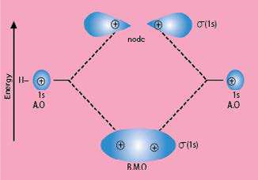

Fig (6.19). Formation of bonding and anti-bonding molecular orbitals for hydrogen molecule (H2)

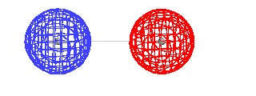

*Animation 6.31: Molecular Orbital Theory*

*Source & Credit :*

[*andrew.cm*](http://www.andrew.cmu.edu/)

[*u*](http://www.andrew.cmu.edu/)

So far, we have considered s and s orbital overlap for the formation of molecular orbitals of hydrogen molecule. Other types of overlaps occurring between p and p atomic orbitals to form molecular orbitals are described below. There are three 2p atomic orbitals directed along the three perpendicular x, y and z coordinates. For the formation of molecular orbitals from p- orbitals, two cases arise:

1. **Head on Approach**

Here, the p-orbitals of the two atoms approach along the same axis (i.e. px axis) as shown in

Fig. (6.20).

This combination of the atomic orbitals gives rise to s(2px) bonding and s* (2px) antibonding molecular orbitals. Both are symmetrical about the nuclear axis.

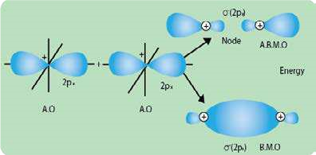

Fig. (6.20) Head on overlap of two p-orbitals

1. **Sideways Approach**

When the axes of two p-orbitals (i.e py or pz orbitals) are parallel to each other, they interact to form molecular orbitals as shown in Fig.(6.21).

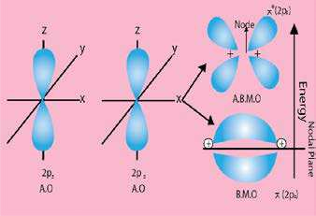

Fig. (6.21) Sideways overlap of two p-orbitals

The bonding molecular orbitals p(2py) or p (2pz) have zero electron density on the nuclear axis (called the nodal plane). The electron density is uniformly distributed above and below the nodal plane.

On the other hand, anti-bonding molecular orbitals p* (2py) and p* (2pz) have the least electron density in the p inter-nuclear region. Since the 2py and 2pz atomic orbitals are degenerate (having the same energy), the p - molecular orbitals i.e. p (2py) and p (2pz) are also degenerate. So,are also the p*(2py) and p*(2pz) molecular orbitals.

Overall six molecular orbitals (three bonding and three anti-bonding) are formed from two sets of 2p atomic orbitals. The bond formed as a result of linear overlap is ó bond, while that formed as a result of sideways overlap is called a p (pi) bond. As there are three bonding molecular orbitals, the p-orbitals overlap can lead to the formation of at the most three bonds: one sigma and two p -bonds.

**Relative Energies of the Molecular Orbitals**

The relative energies of the molecular orbitals formed from 2s and 2p atomic orbitals in the case of homonuclear di-atomic molecules are shown in Fig. (6.22).

The energies of the molecular orbitals are determined by spectroscopic measurements.

The molecular orbitals of diatomic molecules such as O2, F2 and their positive and negative ions can be arranged in the following-increasing order of energy (Fig 6.22a).

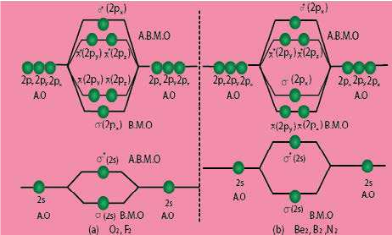

Fig (6.22) (a) Molecular orbital energy diagram for O2, F2 and their positive and negative ions (b) Molecular orbital energy diagram.for Li2, Be2, B2 and N2.

s s(1s)< * (1s < 2s) s s( )< * (2s < 2p < 2p = 2p) s( ) p( ) p( )<p* (2p = 2p) p( )<s* (2p )

x y z y z x

The diatomic molecules, such as N2 and other -lighter molecules like B2, C2 show slightly diferent energy order. See Fig. (6.22 b):

s s s1s< 1* *s*< (2s)<s*(2s)<p(2p )=p(2p )<s(2p )<p*(2p )=p*(2p )<s*(2p )

z z x y z x

**Reason**

It has been observed that in case of B2, C2 and N2 ,s2px is higher in energy than p2py=p2px. MOs. This reversal is due to mixing of 2s and 2px atomic orbitals.

Actually, the energy diference of 2s and 2p atomic orbitals is small. There is a possibility of mixing of these orbitals (i.e. hybridization of A.O.) as a result of which s2s and s*2s MOs do not retain pure s-character. Similarly, s2px and s*2px MOs do not have pure p-character. All the four MOs acquire sp-character. Due to this mixing, their energies change’in such a way that MOs s2s and s*2s become more stable and are lowered in energy MOs as s2px and s*2px become less stable and are raised in energy. Since, pp-orbitals are not involved in mixing, so energy of p2py=p2pz remains unchanged.s 2px is raised to such an extend that it becomes higher in energy than p-bondings.

Anyhow, O2 and F2  do not do so. The re ason is high energy diference of their 2s and 2p i.e. 1595 and 2078 kJmol-1, for O2 and F2 , respectively. These values are 554kJmol-1 for boron, 846kJmol-1 for carbon, and 1195kJmol-1 for nitrogen. These energy diferences have been calculated by spectroscopic techniques.

**Bond Order**

The number of bonds formed between two atoms after the atomic orbitals overlap, is called the bond order and is taken as half of the diference between the number of bonding electrons and anti-bonding electrons. The number of bonds formed between H-atoms in hydrogen molecule may be calculated as follows:

Number of electrons in the bonding orbitals = 2 Number of electrons in the anti-bonding orbitals = 0

Bond order = 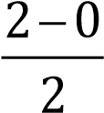 = 1

It is a common practice that only MOs formed from valence orbital are considered in bond order calculations.

**Molecular Orbital Structures of Some Diatomic Molecules**

1. **Helium, He2**

The electronic coniguration of He is 1s2. The 1s orbitals of He-atoms combine to form one bonding s (1s) and one anti-bonding s* (1s) orbitals as shown in Fig (6.23).

Each He-atom contributes two electrons. Two electrons enter bonding molecular orbital s (ls) and the remaining two go to antibonding s* (Is) molecular orbital.

The bond order for He2 is zero i.e. 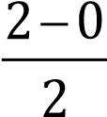 picture of He2 molecule is not formed.

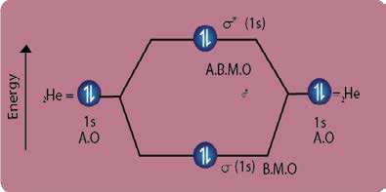

Fig Fig. (6.23) Hypothetical orbital picture of He2 molecule.

1. **Nitrogen, N2**

The molecular orbital structure of N2 molecule is shown in Fig (6.24). Electronic coniguration of N2 molecule is

s(1s2)<s*(1s2)<s(2s2)<s*(2s2)<p(2p2 )=p(2p2 )<s(2p2 )<p*(2p )=p*(2p )< s*(2p )

*y* z x y z x

From the electronic coniguration of N2, it is clear that six electrons enter into three outermost bonding orbitals while no electrons enter into anti-bonding orbitals. Thus, the bond order in N2 molecule is 62−0 = 62 =3, which corresponds

to the triple bond consisting of one sigma and two p bonds. The bond dissociation energy of N2 is very high, i.e. 941kJmol-1.

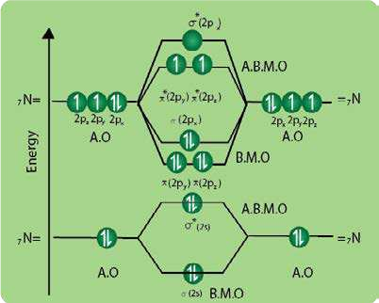

Fig. (6.24) Molecular orbitals picture of N2 molecule.

1. **Oxygen, 02**

The formation of molecular orbitals in oxygen molecule is shown in Fig. (6.25). The electronic coniguration of O2 is

s(1s)2<s*(1s)2 <s(2s)2 <s*(2s)2 <s(2p < 2p = 2px ) p( y )2 p( z)2<p*(2py )1=pz*(2pz)1 <s*2px

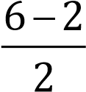 The bond order in O2, is =2, which corresponds to a double bond.

This is consistent with the large bond energy of 496kJ mol-1 of oxygen molecule. Fig(6.25) shows that the illing of molecular orbitals leaves two unpaired electrons in each of the p*(2py) and p*(2pz) orbitals. Thus, the | electronic coniguration of the molecular orbitals accounts admirably for the paramagnetic properties of oxygen. This is one of the greatest successes of the molecular orbital theory. Liquid O2 is attracted towards the magnet.

Anyhow, when two more electrons are given to O2, it becomes O22-. The paragmanetism vanishes. Similarly, in O22+ the unpaired electrons are removed and paragmagnetic property is no more there. Bond order of O22- are also diferent from O2 and are one and three, respectively.

Similarly, M.O.T justiies that F2 has bond order of one and Ne does not make a bond with Ne.

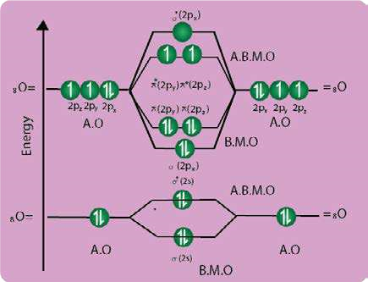

Fig. (6.25) Molecular orbitals in 0, molecule.

#### 6.5 BOND ENERGY, BOND LENGTH AND DIPOLE MOMEN

**6.5.1 Bond Energy (bond enthalpy)**

When a bond is formed between two atoms, energy is released. The same amount of energy is absorbed when the bond is broken to form neutral atoms. So, the bond energy is the average amount of energy required to break all bonds of a particular type in one mole of the substance. It is determined experimentally, by measuring the heat involved in a chemical reaction. It is also called bond enthalpy, as it is a measure of enthalpy change at 298 K. The enthalpy change in splitting a molecule into its component atoms is called, enthalpy of atomization.

The bond energy is given in kj mol-1 which is the energy required to break an Avogadro’s number (6.02 x 1023) of bonds. It is also released when an Avogadro’s number of bonds are formed. Table (6.5).

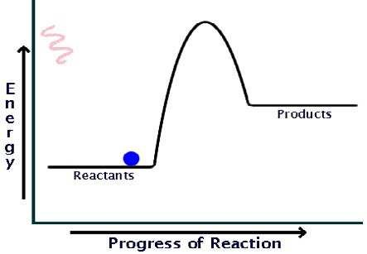

*Animation 6.32: Bond Energy (bond enthalpy)*

*Source & Credit : packbackbooks*

**Table (6.5) Average bond enthalpies of some important bonds (kjmol-1).**

|  |  |  |  |  |  |  |  |
| --- | --- | --- | --- | --- | --- | --- | --- |
| Bond | Bond energy  (kJmol-1) | Bond | Bond energy  (kJmol-1) | Bond | Bond energy  (kJmol-1) | Bond | Bond energy  (kJmol-1) |
| C-C | 348 | H-H | 436 | O-O | 146 | Si-H | 323 |
| C=C | 614 | H-F | 567 | O=O | 495 | Si-Si | 226 |
| C ≡C | 839 | H-Cl | 431 | O-H | 463 | Si-C | 301 |
| C-H | 413 | H-Br | 366 | O-F | 190 | Si-O | 368 |
| C-N | 293 | H-I | 299 | O-Cl | 203 | F-H | 155 |
| C=N | 615 | N-N | 163 | O-I | 234 | Cl-F | 253 |
| C≡N | 891 | N=N | 418 | S-S | 266 | Cl-Cl | 242 |
| C-O | 358 | N≡N | 941 | S=S | 418 | Br-F | 237 |
| C=O | 799 | N-H | 391 | S=O | 523 | Br-Cl | 218 |
| C≡ O | 1072 | N-O | 201 | S-H | 339 | Br-Br | 193 |
| C-F | 485 | N-F | 272 | S-F | 327 | I-Cl | 208 |
| C-Cl | 328 | N-Cl | 200 | S-Cl | 253 | I-Br | 175 |
| C-Br | 276 | N-Br | 243 | S-Br | 218 | I-I | 151 |
| C-I | 240 |  |  |  |  |  |  |
| C-S | 259 |  |  |  |  |  |  |

It may be noted that energies of multiple bonds are greater than those of single bonds. But a double bond is not twice as a strong as a single bond or a triple bond is not thrice as strong as a single bond. It means that s- bond is stronger than a p-bond. Similarly, a polar covalent bond is stronger than a non-polar covalent bond.

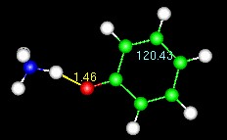

*Animation 6.33: BOND ENERGY, BOND LENGTH*

*AND DIPOLE MOMENT*

*Source & Credit : chem.utah*

**6.5.2 Ionic Character and Bond Energy**

Bond energy is a measure of the strength of a bond. The strength of a bond depends upon the following factors.

(i) Electronegativity diference of bonded atoms (ii) Sizes of the atoms (iii)Bond length Let us consider, irst the part played by electronegativity diference. Look at the bond energies of H-X type of compounds, where X=F, Cl, Br, I, Table (6.6).This data show that electrons are not equally shared between the bonded atoms i.e. HX. As halogen atom is more electronegative, the bonded pair is more attracted towards X atom and thereby polarity develops. This gives rise to additional attractive force for binding.

From the diference between experimental bond energies and those calculated by assuming equal sharing, it is possible to estimate relative electronegativities. The comparison of these values shows that the discrepancy is the greatest for HF and the least for HI, Table (6.9).

Let us calculate, the increase in the strength of H-Cl bond,due to the ionic character present in it.The H-H bond energy is 436 kJ mol-1

It means 436 kJ of heat is required to break the Avogadro’s number of H2 molecules into individual atoms. Thus, bond energy per bond is 72.42 x 10-23kJ. This is obtained by dividing 436 by 6.02 x 1023. As the bonding electron pair is equally shared between the two H atoms, we can assume that each bonded H-atom contributes half of the bond energy i.e., 36.21x10-23kJ.

Similarly, the bond energy for Cl2 is 240 kJ mol-1. Therefore, each Cl-atom should contribute 19.93 x 10-23 kJ to any bond, where sharing of an electron pair is equal.

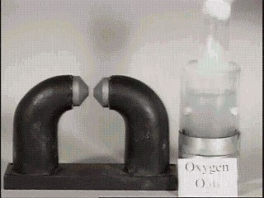

*Animation 6.34: Ionic Character and Bond Energy*

*Source & Credit :*

[*av8*](http://www.av8n.com/)

[*n*](http://www.av8n.com/)

H+H→ H2 ∆H=-436kJmol-1

**Table (6.6) Comparison of experimental and theoretical bond energies**

|  |  |  |  |  |
| --- | --- | --- | --- | --- |
| Bond | Bond energies (kJmol-1) | | | |
| X-X | X=F | X=Cl | X=Br | X=I |
| 155 | 242 | 193 | 151 |
| H-X  (calculated) | 293 | 336 | 311 | 291 |
| H-X (observed) | 567 | 431 | 366 | 299 |
| diference | 274 | 95 | 55 | 8 |

Let us, now consider, the bond in HCl. This bond is polar, but we consider the electron pair to be equally shared. On adding up the bond energy contributions of H-atom and Cl-atom, we expect the bond energy of H-Cl to be 56.14 x 10-23kJ per molecule which is the sum of 36.21xl0-23kJ and 19.93x1023kJ. For Avogadro’s number of HCl molecules, the calculated bond energy is 337.96 kJmol-1 which is obtained by multiplying 56.14 x 10 -23 with 6.02 x 10-23 The experimentally found bond energy for HCl is 431 kJmol-1.The observed bond energy is signiicantly greater than the calculated value and that means a more stable H-Cl bond. This stability is due to the ionic character present in the molecule.The decreasing polarity from HF to HI shows a trend toward equal sharing of electrons which is consistent with decreasing electronegativity from F to I.

The bonds with higher bond energy values have shorter bond lengths. The bond energies of C to C bonds being in the order C ≡C >C=C>C-C. Their bond lengths are in the reverse order i.e. C -C > C=C > C ≡C.

**6.5.3 Bond Length**

The distance between the nuclei of two atoms forming a covalent bond is called the bond length. The bond lengths are experimentally determined by physical techniques. The techniques may be electron difraction, X-ray difraction or spectral studies.

The covalent bond length between two atoms is often but not always independent of the nature of the molecules. For instance, in most of the aliphatic hydrocarbons, the C-C bond length is very close to 154 pm. The C-C bond length is also found to be the same in diamond.

The covalent radii for diferent elements are almost additive in nature. The single bond covalent radius of carbon is 77 pm which is half of the C-C bond length (154 pm). Similarly, the covalent radius of Cl is 99 pm i.e. one half of the Cl-Cl bond length (198 pm). So the bond length of C-Cl bond will be 77 + 99= 176 pm. Some selected bond lengths are given in Table (6.7).

**Table (6.7) Some selected bond lengths alongwith**  **and hybridization of central atom.**

|  |  |  |  |
| --- | --- | --- | --- |
| Compound | Hybridization | Bond | Bond length (pm) |
| BF3  (Boron triluoride) | sp2 | B-F | 130 |
| BCl3 (Boron triluoride) | sp2 | B-Cl | 175 |
| SiH4 (Monosilane) | sp3 | Si-H | 148 |
| SiF4  (silicon tetraluoride) | sp3 | Si-F | 155 |
| C2H6 (Ethene) | sp3 | C-C | 154 |
| C2H4 (Ethene) | sp2 | C=C | 133 |
| C2H2 (Ethene) | sp | C ≡C | 120 |
| (CH3)2 C=O (Acetone) | sp2 | C=O | 122 |

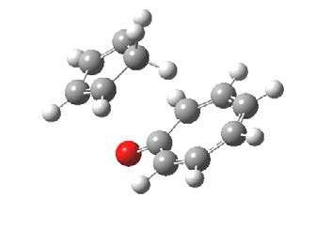

*Animation 6.35: Bond Length*

*Source & Credit :*

[*ch.ic.a*](http://www.ch.ic.ac.uk/)

[*c*](http://www.ch.ic.ac.uk/)

With an increase in electronegativity diference between the bonded atoms, the bond becomes shortened. For example, Si-F bond length in SiF4 is found to be 154-159 pm, whereas the addition of their covalent radii (Si=117 pm and F=64 pm) give Si-F bond length to be equal to 181 pm, Table (6.7). The calculated values are almost always higher due to electronegativity diferences. The ionic character results in shortening of the bond length due to force of attraction between the polar ends.

Moreover, hybridization scheme involved, also explains the shortening of bonds due to the predominant participation of s-orbitals. Since, the 2s-orbital of carbon has smaller mean radius than the 2p-orbitals, it would be expected that greater the s character in the hybrid orbitals used, the shorter will be the bond distance. Thus, the C-C bond lengths are 154,133 and 120 pm for ethane, ethene and ethyne, respectively where s orbital contribution increases from sp3 to sp. Further, p-bonding also reduces the internucleft bond distance.

The bond length increases, as we move from top to bottom in group IV-A of the periodic table. Thus, Si-Si bond length is more than C-C bond length in group IV-A and P-P bond length is much more than N-N bond length in group V-A. As the atomic radii increase in a group (N to P or C to Si), the efect of the efective nuclear charge decreases on electrons. As a result the bond length will increase. In the periodic table, shortening of bond lengths occurs from left to right in, a period. This can be attributed to the pull by nuclear charge with the same value of principal quantum number. Therefore, C-C bond length is greater than N-N bond length.

**6.5.4 Dipole Moment**

In heteronuclear molecules, e.g. HCl where the bonded atoms are of diferent elements, the molecule becomes polar due to the electronegativity diference. Partial positive and negative charges become separated on the bonded atoms. The se paration of these charges on the molecule is called a dipole and the molecule is said to have a dipole moment.

The dipole moment is a vector quantity, which has a magnitude as well as a direction. Fig . (6.26) illustrates the dipole and its vecrtor representation. The dipole moment (m) is be deined as the product of the electric charge (q) and the distance between the positive and negative centres (r):

m **= q x r**

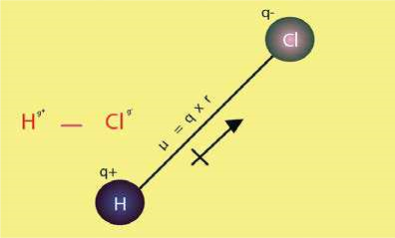

Fig. (6.26) Dipole moment and its vector representation

The dipole moments of simple heteronuclear diatomic molecules like HF, HCl, HBr. HI, CO, NO, etc. are directed from electropositive ends to electronegative ends.

The dipole moments are measured in Debye (D) units. Let us consider a hypothetical molecule (A*—B-), or a unit negative charge separated from a unit positive charge by distance r = 100 pm (1 Å)The dipole moment of such a molecule can be calculated by multiplying the distance 100pm to charge of one electron or proton is 1.6 orx10-19C m=(1.6022x10-19C)x(100x10-12m) = 1.6022x10-29 mC

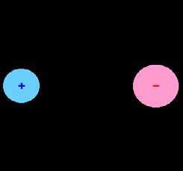

*Animation6.36: Dipole Moment*

*Source & Credit : chemwiki.ucdavis*

Another unit of dipole moment is Debye. The **Table (6.8) Dipole moments of** equivalence of Debye and mC is 1 D = 3.336x10-30mC. So, **some substances in Debyes** the dipole moment of the, above system in Debye units is

|  |  |
| --- | --- |
| Compound | Dipole moment  (D) |
| H2 | 0.00 |
| HCl | 1.03 |
| HBr | 0.78 |
| HI | 0.38 |
| H2O | 1.85 |
| H2S | 0.95 |
| NH3 | 1.49 |
| SO2 | 1.61 |
| CO2 | 0.00 |
| CO | 0.12 |
| NO | 0.16 |
| H2O2 | 2.20 |
| CH4 | 0.00 |
| CH3F | 1.81 |
| CH3Cl | 1.45 |
| CH3Br | 1.85 |
| CH3l | 1.35 |
| C H OH | 1.69 |

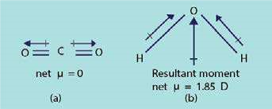 = 1.6022x 103.336x 10−30−29mCmC = 4.8 D

The dipole moments of some substances in Debye units are given in Table (6.8). If the molecule is polyatomic and contains two or more dipoles, then the net dipole moment is the resultant of the vector addition of the individual bond moments. Examples of CO2 and H2O are shown in Fig (6.26).

Fig (6.26) Vector addition of bond moments in

(a) linear C02 molecule and (b) angular H20 molecular

2 5

**6.5.5 Dipole Moments and Molecular Structure**

Dipole moment provides two types of information about the molecular structure:

1. Percentage ionic character of a bond
2. Angles between the bonds or the geometry of molecules

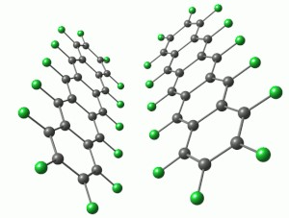

*Animation 6.37: Dipole Moments and Molecular Structure*

*Source & Credit :*

[*uni-marbur*](http://www.uni-marburg.de/)

[*g*](http://www.uni-marburg.de/)

**(1) Percentage Ionic Character**

From the experimentally determined dipole moments, the percentage ionic character in a bond can be calculated. For this purpose, we should know the actual dipole moment mobs of the molecule and actual bond, length. The dipole moment of 100% ionic compound is represented as mionic.

%age of ionic character = mobs x100

mionic

**Example 1:**

The observed dipole moment of HF is 1.90 D. Find the percentage ionic character in H-F bond. The distance between the charges is 0.917 x 10-10 m.

(Unit positive charge= 1.6022 x 10-19 C).

**Solution:**

Let us suppose that HF molecules is 100% ionic. It means that H has full positive charge and F has full negative charge.

To calculate its dipole moment multiply the bond length with full charge of electron or proton i.e.

1.6022 x 10-19 C. This dipole moment is called mionic.

So, mionic =qxr

=(1.6022x10-19C)(0.917x10-10m)

=1.469x10-29 mC

Scince 1 D =3.336x10-30 mC

So, = mionic = 1.469x10−−2930mc = 4.4D

3.336x10 mc

The actual dipole moment is given as it is observed. mobserved=1.90 D

%ionic character= mobserved x100

mionic

= 1.90Dx100 = 43.2% Answer

4.4D

Hence, 43% of HF bond is ionic in nature and 57% covalent. The bond is predominantly covalent.

**(ii) Bond Angles or the Geometry of Molecules**

We can understand this aspect by taking some important examples.

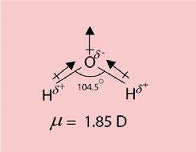 The dipole moment of water is 1.85 D which ruled out its linear structure. The calculations show that water has an angular structure with a bond angle 104.5° between the two O-H bonds. A linear H2O molecule (H-O-H) would have zero dipole moment.

Similarly, the triatomic molecules H2S or SO2 etc. are also bent like H2O.

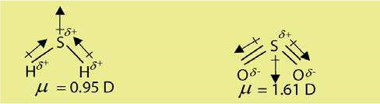

CO has a dipole moment while CO2 does not have any. The reason is that CO2 has a linear structure, where the dipoles being equal and opposite, cancel out each other’s efect. Similarly, CS2 has zero dipole moment.

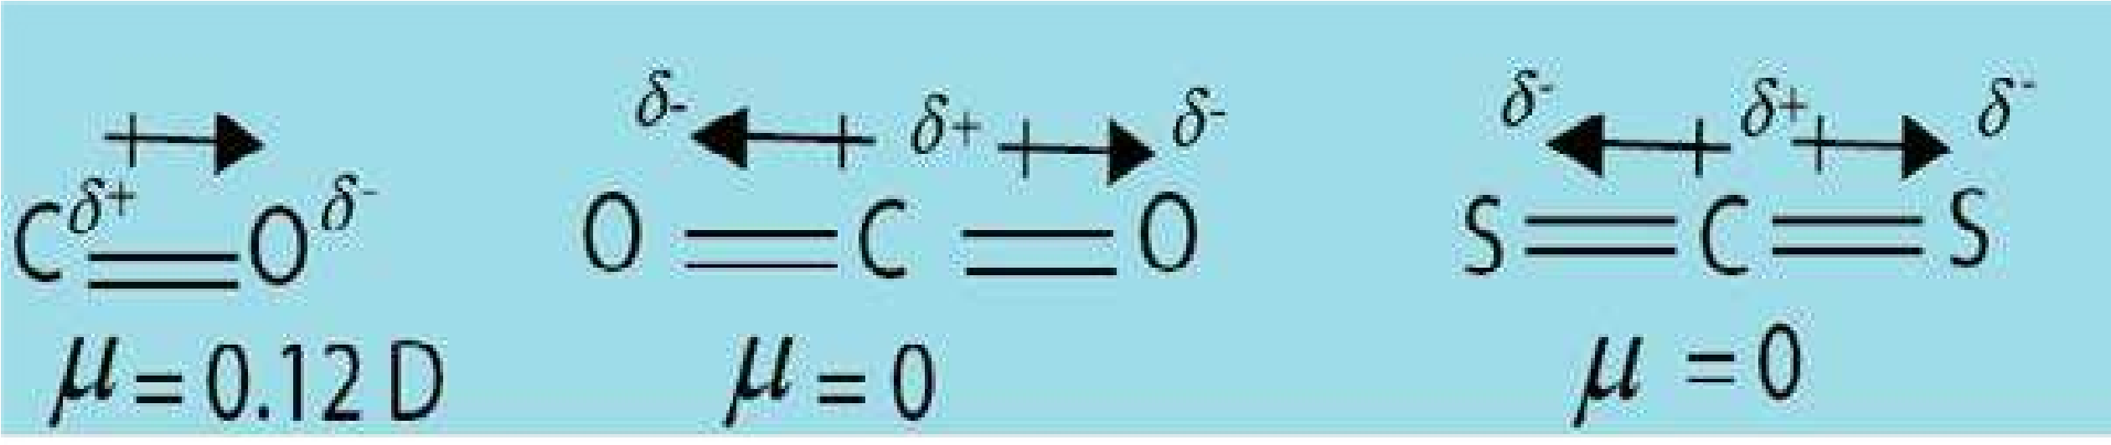

Symmetrical triangular planar molecules of BF3, AlCl3 and perfectly tetrahedral molecules like CH4, SiH4, CCl4 also have zero dipole moments. This is all due to the cancellation of individual bond moments.

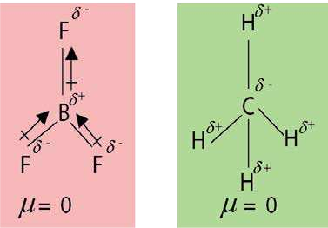

#### 6.6 THE EFFECT OF BONDING ON THE PROPERTIES OF COMPOUNDS

The properties of substances are characterized by the types of bonding present in them. Here, we shall consider the efects of the type of bond on physical and chemical properties of compounds.

**(1) Solubility**

**(a ) Solubility of Ionic Compounds**

Mostly, ionic compounds are soluble in water but insoluble in non-aqueous solvents. When a crystal of an ionic substance is placed in water, the polar water molecules detach the cations and anions from the crystal lattice by their electrostatic attraction. Thus, the ions are freed from the crystal lattice by hydration. This happens when the hydration energy is greater than the lattice energy and the ions are freed from their positions in the crystal. Many ionic compounds do not dissolve in water, as the attraction of water molecules cannot overcome the attraction between the ions. For the same reason, non-polar solvents like benzene and hexane do not dissolve, ionic compounds.

**(b) Solubility of Covalent Compounds**

In general, covalent compounds dissolve easily in non-polar organic solvent (benzene, ether, etc.)

Here, the attractive forces of solvent molecules are enough for overcoming the intermolecular forces of attraction. Mostly, covalent compounds are insoluble in water. However, some of them dissolve in water due to hydrogen bonding.

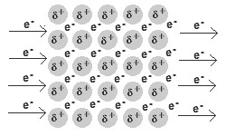

*Animation 6.38: THE EFFECT OF BONDING ON THE*

*PROPERTIES OF COMPOUNDS*

*Source & Credit :*

[*ausetut*](http://www.ausetute.com.au/)

[*e*](http://www.ausetute.com.au/)

**(2) Isomerism**

1. **Non-Directional Nature of Ionic Bonds**

The ionic compounds involve electrostatic lines of forces between oppositely charged ions. Therefore, such bonds are non-rigid and non-directional. Because of this, ionic compounds do not exhibit the phenomenon of isomerism.

1. **Directional Nature of Covalent Bonds**

Covalent compounds are rigid and directional. This leads to the possibility of a variety of isomerism. For example, the compounds, C2H6O, shows structural isomerism.

H

H





O

H

C

C

H

H

H

H





O

H

C

C

H

H

H

H

Dimethyl ether Ethanol

**(3) Reaction Kinetics:**

1. **Speed of Reaction of Ionic Compounds**

The ionic compounds exist in the form of ions in an aqueous solution. The chemical reaction between ions occur rapidly.

For example, addition of silver nitrate solution to sodium chloride solution produces a white precipitate of silver chloride instantaneously. The reaction is rapid because on mixing the solutions, no bonds have to be broken, only a new bond is formed. The ionic compounds have already been broken while forming their aqueous solutions.

1. **Speed of Reactions of Covalent Compounds**

Since, there is no strong electrical force to speed up a chemical reaction (like in ionic reaction), the covalent bonds are generally much slower to react as they involve bond breaking and making of bonds. The molecules undergo a chemical change as a whole. Covalent bonds react in a variety of ways and their reactivity depends upon the way a reaction proceeds and the kind of a reaction.

#### KEY POINTS

1. Atoms combine together due to their inherent tendency to attain the nearest noble gas electronic conigurations and the formation of a chemical bond always results in a decrease of energy.
2. The size of an atom is expressed in terms of atomic radius, ionic radius and covalent radius and van der Waals radius.
3. It is necessary to understand thermodynamic properties of elements. The minimum amount of energy required to remove an electron from an atom in gaseous state is called ionization energy. It depends upon the atomic size, nuclear charge and shielding efect of electrons. The electron ainity of an atom is the energy given out when an electron is added to a gaseous atom. The tendency of an atom to attract a shared pair of electrons to itself is called electronegativity. Fluorine, is the most electronegative atom and it has arbitrarily been given a value of 4.0.
4. The ionic bonds are formed by transfer of electron from one atom to another. Covalent bonds are formed by mutual sharing of electrons between combining atoms. After the formation of a coordinate covalent bond, there is no distinction between a covalent bond and a coordinate covalent bond.
5. A polar covalent bond is formed when atoms having diferent electronegativity values mutually share their electrons. Due to polarity, bonds become shorter and stronger and dipole moment may develop.
6. According to valence bond theory, the atomic orbitals overlap to form bonds but the individual character of the atomic orbitals are retained. The greater the overlap, the stronger will be the bond formed.
7. The VSEPR theory gives information about the general shapes and bond angles of molecules. It is based upon repulsion between bonding and lone pairs of electrons, which tend to remain at maximum distance apart so that interaction between them is minimum. The concept provides an alternate way to explain various geometrical shapes of molecules.
8. The geometrical shapes and bond angles are better explained by diferent hybridization schemes, where diferent atomic orbitals are mixed to form hybrid orbitals.
9. According to molecular orbital theory, atomic orbitals overlap to form molecular orbitals, n atomic orbitals combine to form n molecular orbitals. Half of them are bonding molecular orbitals and half antibonding molecular orbitals. In this combination, the individual atomic orbital character is lost in order to form an entirely new orbital that belongs to the whole molecule. The theory successfully explains bond order and paramagnetic property of O2.
10. The bond energy in deined as the average amount of energy required to break all bonds of a particular type in one mole of the substance. It is a measure of the strength of the bond.

Stronger the dipole of a bond, greater will be the bond energy.

11.The distance between the nuclei of two atoms forming a covalent bond is called bond length. In general, it is the sum of the covaleht radii of the combined atoms.

1. The dipole moment may be deined as the product of electric charge (q) and the distance (r) between the two oppositely charged centres. It is a vector quantity as it has magnitude and direction. It plays a major role, in determining the % age ionic character of a covalent bond and the shapes of molecules. It has magnitude and direction.
2. Properties of substances are characterized by the type of bonds present in them.

#### EXERCISE

Q.1 Select the correct statement

1. An ionic compound A+B- is most likely to be formed when

(a) the ionization energy of A is high and electron ainity of B is low. (b) the ionization energy of A is low and electron ainity of B is high.

* + 1. both the ionization energy of A andelectron ainity of B are high.
    2. both the ionization energy of A and electron ainity of B are low.

1. The number of bonds in nitrogen molecule is
   * 1. one ó and one p
     2. one ó and two p
     3. three sigma only
     4. two ó and one p
2. Which of the following statement is not correct regarding bonding molecular orbitals?
   * 1. Bonding molecular orbitals possess less energy than atomic orbitals from which they are formed.
     2. Bonding molecular orbitals have low electron density between the two nuclei. (c) Every electron in the bonding molecular orbitals contributes to the attraction between atoms.

(d) Bonding molecular orbitals are formed when the electron waves undergo constructive interference.

1. Which of the following molecules has zero dipole moment?

(a) NH3 (b) CHCl3 (c)H2O (d) BF3

1. Which of the hydrogen halides has the highest percentage of ionic character?

(a) HCl (b) HBr (c)HF (d)Hl

1. Which of the following species has unpaired electrons in antibonding molecular orbitals.

(a) 022+ (b) N22- (c) B2 (d) F2

Q.2 Fill in the blanks

1. The tendency of atoms to attain maximum ________ of electrons in the valence shell is called completion of octet.
2. The geometrical shape of SiCl4 and PCl3 can be explained on the basis of__________and________ hybridizations.
3. The VSEPR theory stands for__________________ .
4. For N2 molecule, the energy of ó (2p)x orbital is________________ than p(2py) orbital. (v) The paramagnetic property of O2 is well explained on the basis of MO theory in terms of the presence of_________________ electrons in two MO orbitals.
5. The values of dipole moment for CS2 is __________while for SO2 is __________
6. The bond order of N2 is________________ while that of Ne2 is _______________ .

Q.3 Classify the statements as true or false. Explain with reasons.

1. The core of an atom is the atom minus its valence shell.
2. The molecules of nitrogen (N ≡N) and acetylene (HC ≡CH) are not isoelectronic. (iii) There are four coordinate covalent bonds in NH4+ ion.
3. A ó -bond is stronger than a p-bond and the electrons of s-bond are more difused than p-bond.
4. The bond energy of heteroatomic diatomic molecules increases with the decrease in the electronegativities of the bonded atoms.
5. With increase in bond order, bond length decreases and bond strength increases.(vii) The irst ionization energies of the elements rise steadily with the increasing atomic number from top to bottom ina group.

(viii) A double bond is stronger than a single bond and a triple bond is weaker than a double bond. (ix) The bonds formed between the elements having electronegativity diference more than 1.7 are said to be covalent in nature.

1. The re pulsive force between the two bonding pairs is less than that between the two lone pairs.
2. The number of covalent bonds an atom can form is related to the number of unpaired electrons it has.
3. The rules which govern the illing of electrons into the atomic orbitals also govern illing of electrons into the molecular orbitals.

Q.4 What is a chemical bond? Discuss the formation of ionic and covalent bonds. How does the electronegativity diferences diferentiate between ionic and covalent bond?

Q.5

* + 1. Deine ionization energy and electron ainity. How these quantities change in the periodic table. What factors are responsible for their variation?
    2. Explain, what do you understand by the term electronegativity? Discuss its variations in the periodic table. How does it afect the bond strengths?

Q.6 Write the Lewis structures for the following compounds:

(i)HCN (ii)CCl4 (iii) CS2 (iv) H3N → AlF3

(v)NH4OH (vii)H2SO4 (vii)H3PO4 (viii) K2Cr2O7

(ix)N2O5 (x) Ag(NH3)2NO3

Q.7

* + 1. Explain qualitatively the valence bond theory. How does it difer from molecular orbital theory?
    2. How the bonding in the following molecules can be explained with respect to valence bond theory? Cl2, O2, N2, HF, H2S.
  1. Explain VSEPR theory. Discuss the structures of CH4, NH3, H2O, BeCl2, BF3,S02, SO3 with reference to this theory.
  2. The molecules NF3 andBF3 all have molecular formulae of the type XF3. But they have diferent structural formulas. Keeping in view VSEPR theory sketch the shape of eachtnolecule and explain the origin of difering in shapes.
  3. The species NH2-, NH3, NH4+ have bond angles of 105°, 107.5° and109.50 respectively. Justify these values by drawing their structures.

Q.11

* + 1. Explain atomic orbital hybridization with reference to sp3, sp2 and sp modes of hybridizations for PH3, C2H4 and C2H2. Discuss geometries of CCl4, PCl3, and H2S by hybridization of central atoms.
    2. The linear geometry of BeCl2 suggests that central Be atom is sp-hybridized. What type of hybridization a central atom undergoes, when the atoms bonded to it are located at the corners of (a) an equilateral triangle (b) a regular tetrahedron and (c) triangular bipyramide?

Q.12

* + 1. Give the basis .of the molecular orbital theory and discuss the molecular orbital conigurations of the following molecules?

(i)He2 (ii)N2 (iii) O2  (iv)O22+ (v)O22-

* + 1. How does molecular orbital theory explain the paramagnetic character of O2,O22+ and O22- species ?

Q.13

1. Sketch the molecular orbital pictures of

(i) p(2px) and p*(2px) (ii) O2, O22+ ,O22- (iii) He2 and Ne2

1. Sketch the hybrid orbitals of the species, PCI3, SiCl4 and NH4+

Q.14

1. Deine bond energy. Explain the various parameters which determine its strength.
2. How do you compare the bond strengths of

(i) Polar and non-polar molecules (ii) s-and p-bonds?

1. Calculate the bond energy of H-Br. The bond energy of H-H is 436 kJmol-1 and that of Br- Br is 193 kJmol-1.

(Ans : 314.5kJmol-1)

Q.15

1. Deine dipole moment. Give its various units. Find relationship between Debye and mc. How does it help to ind out the shapes of molecules?
2. The bond length of H-Br is 1.4 x10-10m. Its observed dipole moment is 0.79D. Find the percentage ionic character of the bond. Unit positive charge = 1.6022 x 10-19C and 1D = 3.336 x 10-30 mc.

(Ans: 11.7%)

* 1. PF3 is a polar molecule with dipole moment 1.02 D and thus the P-F bond is polar. Si, is in the proximity of P in the periodic table. It is expected that Si-F bond would also be polar, but SiF4 has no dipole moment. Explain it?
  2. Which of the following molecules will be polar or non-polar, sketch the structures and justify your answer.

(i) CCl4 (ii) SO3 (iii)NF3 (iv)SO2

Q.18 Explain the following with reasons:

1. Bond distance is the compromise distance between two atoms.
2. The distinction between a coordinate covalent bond and a covalent bond vanishes after bond formation in NH4+, H3O+ and CH3NH3+ .
3. The bond angles of H2O and NH3 are not 109.5° like that of CH4. Although, O- and N-atoms are sp3 hybridized.

(vi) p-bonds are more difused than s-bonds.

1. The abnormality of bond length and bond strength in HI is less prominent than that of HCl.
2. The dipole moments of CO2, and CS2 are zero, but. that of SO21.61D.
3. The melting points, boiling points, heat of vaporizations and heat of sublimations of electrovalent compounds are higher as compared with those of covalent compounds.

# CHAPTEREXPERIMENTAL TECHNIQUES 2 IN CHEMISTRY

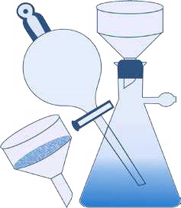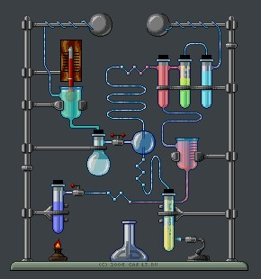

Animation 2.1 :Basic Concepts

Source & Credit: [chem.ucsb](http://chem.ucsb.edu/home)

**Analytical chemistry is the science of chemical characterization**. A complete chemical characterization of a compound must include both qualitative and quantitative analyses.In qualitative analysis, the chemist is concerned with the detection or identiication of the elements present in a compound. Whereas in quantitative analysis, the relative amounts of the elements are determined. A complete quantitative determination generally consists of four major steps (i) Obtaining a sample for analysis (ii) Separation of the desired constituent (iii) Measurement, and calculation of results (iv) Drawing conclusion from the analysis. In this chapter, we will restrict ourselves to only important techniques of separation. The students will practice these techniques during their laboratory work whereas their theoretical treatment is given here.

## 2.1 FILTRATION

The process of iltration is used to separate insoluble particles from liquids. It can be performed with several types of ilter media. Nature of the precipitate and other factors dictate which ilter medium must be used. The most convenient ways of iltration are either through a ilter paper or through a ilter crucible.

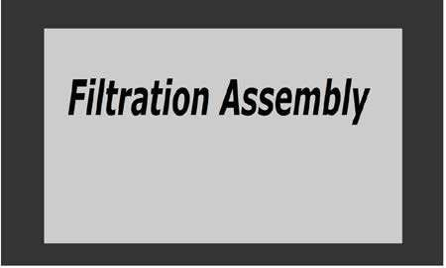

Animation 2.2: Filtration Assembly

Source & Credit:eLearn.punajb

**2.1.1 Filtration Through Filter Paper**

Filtration by a glass funnel and ilter paper is usually a slow process. As the mixture is poured onto the ilter paper, the solvent (water) passes through leaving behind the suspended particles on the ilter paper. Filter papers are available in a variety of porosites (pore sizes) . Which pore size is to be used, depends upon the size of particles in the precipitate. The ilter paper should be large enough so that it is one-fourth to one-half full of precipitate at the end of iltration. The funnel should, in turn, be large enough for its rim to extend 1 to 2 cm above the top circumference of the paper. If the process of iltration is to run smoothly, the stem of the funnel should remain continuously full of liquid as long as there is liquid in the conical portion.

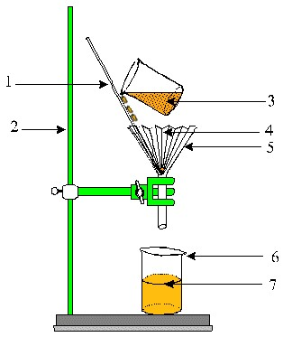

Animation 2.3[: iltration](http://shermanqmatrangas.blogspot.com/2011/09/filtration.html)

Source & Credit[:shermanqmatrangas](http://shermanqmatrangas.blogspot.com/2011/09/filtration.html)

The stem of the funnel should be several inches long so that it can extend a few centimeters down into the receiving beaker, and the tip should touch the side of the beaker. In this way, the iltrate runs down the side of beaker without splashing. A complete ilter paper assembly is shown in

Fig(2.1).

**Folding of Filter Paper**

The folding of ilter paper is important and the following points should be kept in mind. The paper should be folded twice. The irst fold should be along the diameter of the paper.The second fold should be such that edges do not quite match.

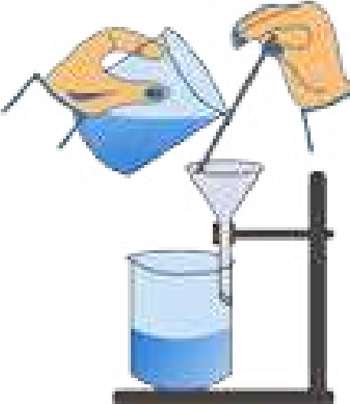The paper should be opened on the slightly larger section. This provides a cone with three fold thickness halfway around and one thickness the other halfway around, and an apex angle very slightly greater than 60 degrees.

The paper may then be inserted into 60 degree funnel, moistened with water and irmly pressed down. The iltering operation could be very time consuming if it were not aided by a gentle suction as liquid passes through the stem. This suction cannot develop unless the paper its tightly all around its upper circumference.

Fig. (2.1)Filtration assembly

**Fluted Filter Paper**

The rate of iltration through conical funnel can be considerably increased using a **Fluted Filter Paper.** For preparation of such a paper ordinary ilter paper is folded in such a way that a fan like arrangement with alternate elevations and depressions at various folds is obtained Fig (2.2).

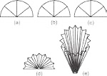

Fig. (2.2) Fluted ilter paper

**2.1.2 Filtration Through Filter Crucibles**

Another convenient way to ilter a precipitate is by suction through a crucible. Two types of crucibles are generally used.

**Gooch Crucible**

It is made of porcelain having a perforated bottom which is covered with paper pulp or a ilter paper cut to its size Fig (2.3 a). Quick iltration can be done by placing the Gooch crucible in a suction iltering apparatus. It is useful for the iltration of precipitates, which need to be ignited at high temperature. If its perforations are covered with asbestos mat then it may be used to ilter solutions that react with paper e.g. concentrated HCl and KMnO4 solutions.

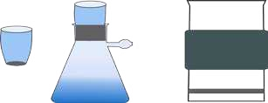

Fig. (2.3a) Gooch Crucible Fig. (2.3b) Sintered with iltering apparatus glass Crucible

**Sintered glass crucible**

Sintered glass crucible is a glass crucible with a porous glass disc sealed into the bottom. It is very convenient to use because no preparation is needed as with the Gooch crucible Fig (2.3b)

## 2.2 CRYSTALLIZATION

Crystallization is the removal of a solid from solution by increasing its concentration above the saturation point in such a manner that the excess solid separates out in the form of crystals.

The preparation of a chemical compound usually afords a crude product and there is a need to purify it by crystallization from a suitable solvent. The basic principle of crystallization is the fact that the solute should be soluble in a suitable solvent at high temperature and the excess amount of the solute is thrown out as crystals when it is cooled. The process of crystallization involves the following steps.

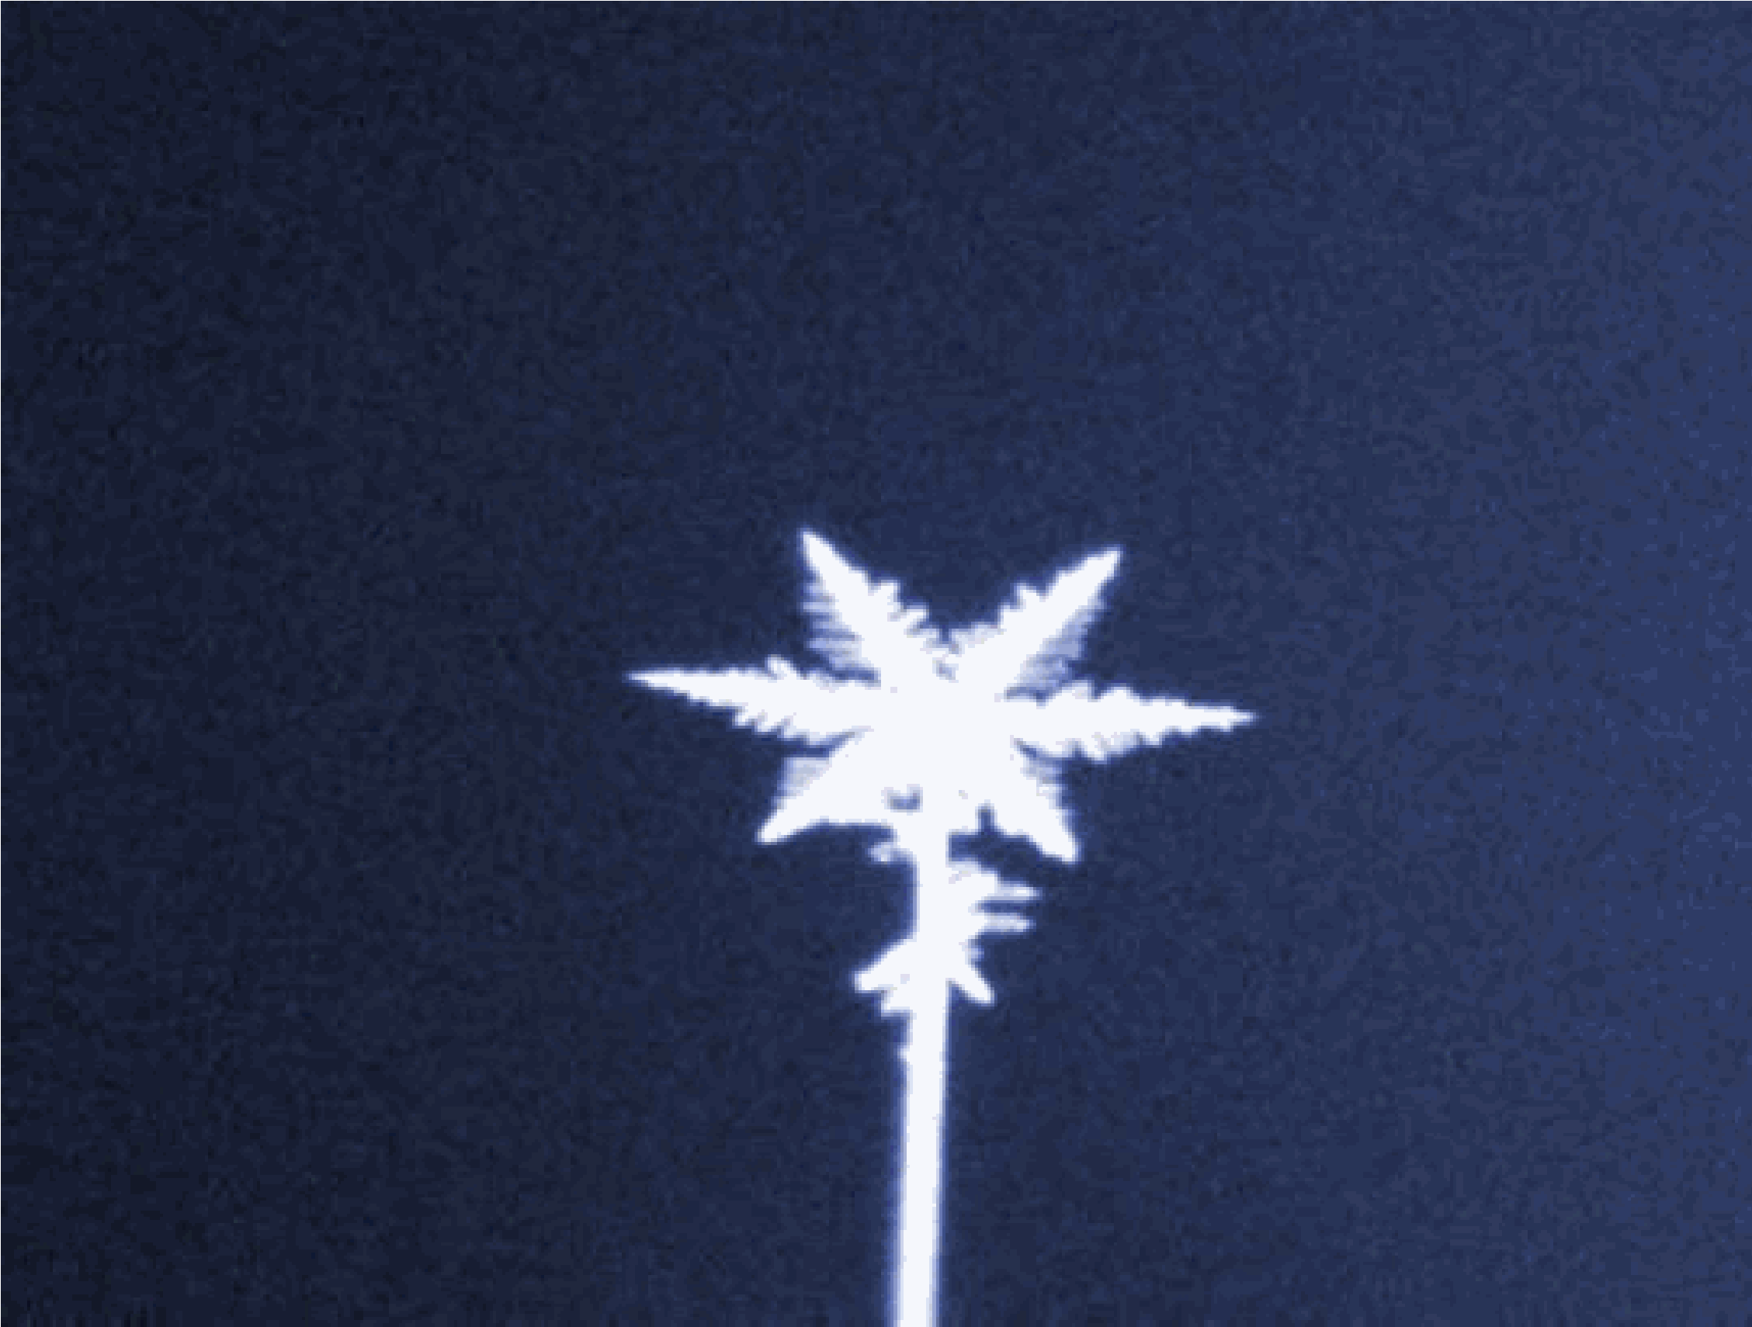

Animation 2.4: [crystilization](http://evilforalltime.blogspot.com/2012_04_01_archive.html)

Source & Credit: [evilforalltime](http://evilforalltime.blogspot.com/2012_04_01_archive.html)

**2.2.1 Choice of a Solvent**

The solvent is chosen on hit and trial basis and it is necessary to try a number of solvents before arriving at a conclusion. An ideal solvent should have the following features.

1. It should dissolve a large amount of the substance at its boiling point and only a small amount at the room temperature.
2. It should not react chemically with the solute.iii. It should either not dissolve the impurities or the impurities should not crystallize from it along with the solute.

iv. On cooling it should deposit well-formed crystals of the pure compound. v. It should be inexpensive.

vi. It should be safe to use and should be easily removable.

The solvents which are mostly used for crystallization are, water, rectiied spirit (95% ethanol), absolute ethanol, diethyl ether, acetone, chloroform, carbon tetrachloride, acetic acid and petroleum ether. If none of the solvents is found suitable for crystallization, a combination of two or more miscible solvents may be employed. If the solvent is inlammable then precaution should be taken while heating the solution so that it does not catch ire. In such cases, water bath is used for heating purpose.

**2.2.2 Preparation of the Saturated Solution**

After selecting a suitable solvent, the substance is then dissolved in a minimum amount of solvent and is heated directly or on a water bath with constant stirring. Add more solvent to the boiling solution if necessary until all the solute has dissolved.

**2.2.3 Filtration**

The insoluble impurities in the saturated solution are then removed by iltering the hot saturated s olution, through a normal or a luted ilter paper. This avoids the premature crystallization of the solute on the ilter paper or in the funnel stem. If necessary hot water funnel should be used for this purpose.

**2.2.4 Cooling**

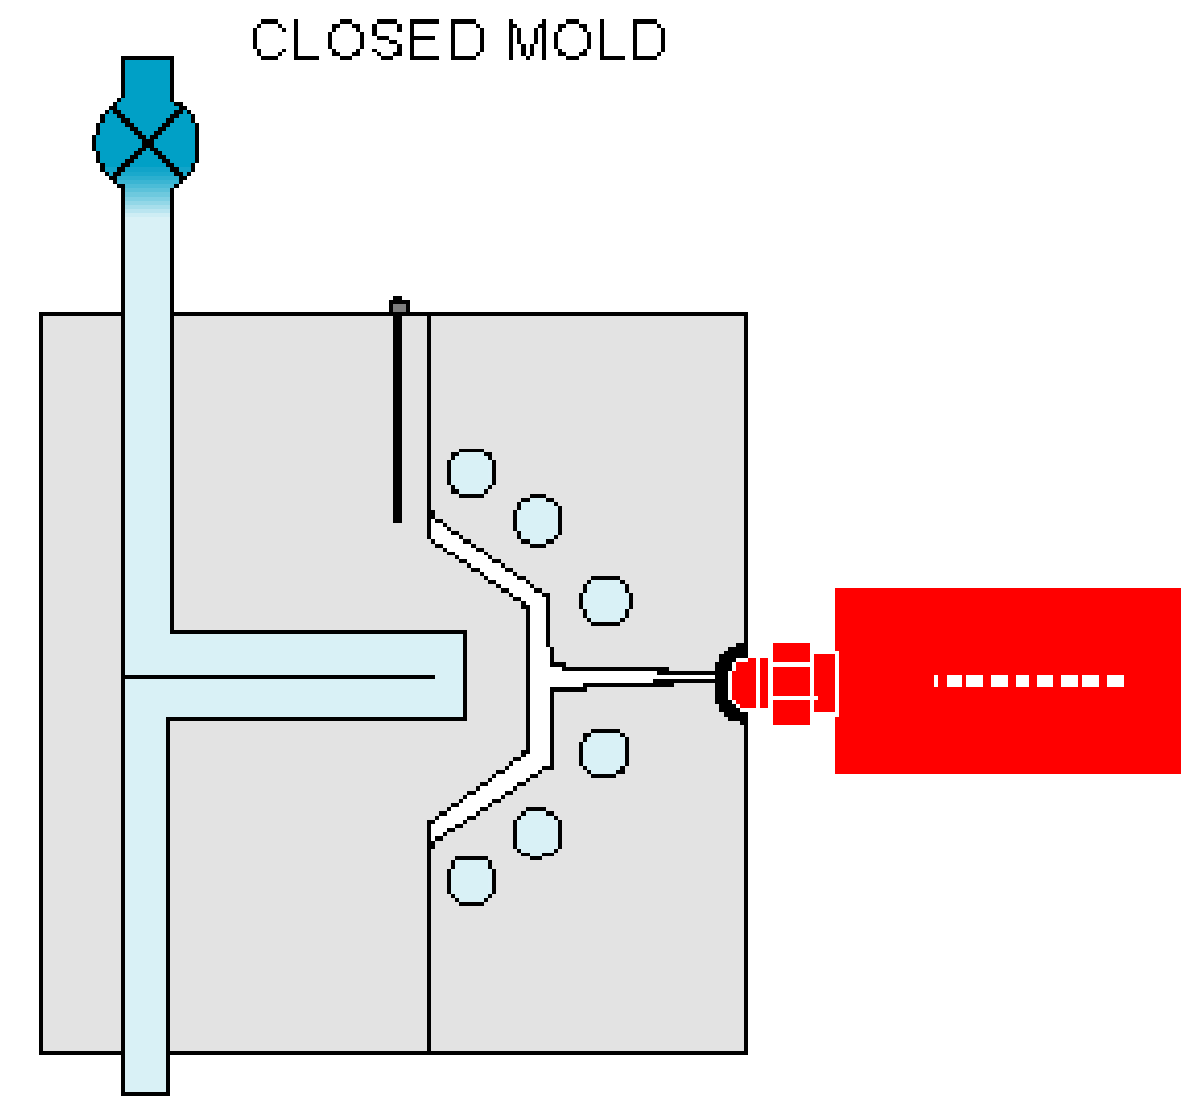The hot iltered solution is then cooled at a moderate rate so that medium sized crystals are formed. Slow cooling yields bigger crystals which are likely to include considerable amount of solvent carrying impurities with it and complicating the drying process.

**2.2.5 Collecting the Crystals**

When the crystallization is complete, the mixture of crystals and the mother liquor is iltered through a Gooch crucible using a vacuum pump. Full suction is applied in order to drain the mother-liquor from the

crystals as efectively as possible. When the ilter cake Source & Credit:Animation 2.5: [Pulsecoolin Cooling](http://www.pulsecooling.com/) [g](http://www.pulsecooling.com/) is rigid enough it is pressed irmly with a cork to drain

the left-over liquid. The crystals are then washed with a small portion of cold solvent and the process is repeated several times. The mother liquor is quite often concentrated by evaporation and cooled to obtain a fresh crop of crystals. The process of crystallization appears to be very simple yet the success of operation lies in the amount or the percentage of crystallized product obtained from the crude substance.

**2.2.6 Drying of the Crystallized Substance**

Pressing it between several folds of ilter papers and repeating the process several times dries the crystallized substance. This process has the disadvantage that the crystals are crushed to a ine powder and sometimes the ibres of ilter paper contaminate the product. Alternatively,the crystals are dried in an oven provided the substance does not melt or decompose on heating at 100° C. A safe and reliable method of drying crystals is through a vacuum desiccator. In this process the crystals are spread over a watch glass and kept in a vacuum desiccator for several hours. The drying agents used in a desiccator are CaCl2 , silica gel or phosphorus pentaoxide.

**2.2.7 Decolourization of Undesirable Colours**

Sometimes during the preparation of a crude substance, the colouring matter or resinous products afect the appearance of product and it may appear coloured. Such impurities are conveniently removed by boiling the substance in the solvent with the suicient quantity of inely powdered animal charcoal and then iltering the hot solution.

The coloured impurities are adsorbed by animal charcoal and the pure decolourized substance

crystallizes out from the iltrate on cooling.

## 2.3 SUBLIMATION

It is a process in which a solid, when heated, vapourizes directly without passing through the liquid phase and these vapours can be condensed to form the solid again. It is frequently used to purify a solid. Examples of such solids are ammonium chloride, iodine, naphthalene, benzoic acid, etc. To carry out the process, the substance is taken in a watchglass covered with an inverted funnel. The substance is then heated slowly over a sand-bath and the funnel is cooled with wet cotton. The pure solid deposits on the inner side of the funnel Fig (2.4).

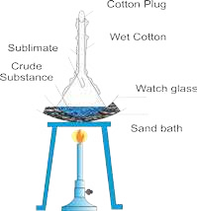

Fig (2.4) SUBLIMATION

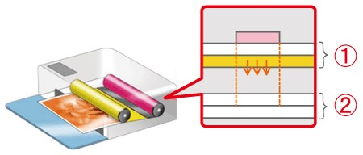

Animation 2.6: [SUBLIMATION](http://support-th.canon-asia.com/contents/TH/EN/8200987500.html) Source & Credit[: support-th](http://support-th.canon-asia.com/contents/TH/EN/8200987500.html)

## 2.4 SOLVENT EXTRACTION

Solvent extraction is an important technique in chemical analysis. According to this technique a solute can be separated from a solution by shaking the solution with a solvent in which the solute is more soluble and the added solvent does not mix with the solution. Usually it is done by placing the solution and the second liquid into a separating funnel Fig (2.5). The funnel is stoppered and the two liquids are shaken together.

The most common laboratory example of solvent extraction is ether extraction. This is used to separate the products of organic synthesis from water. In a typical organic synthesis, the aqueous solution containing the organic product is shaken up with ether in a separating funnel and allowed to separate.

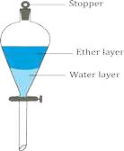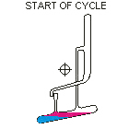Animation 2.7: [Solvent extraction](http://www.chem.uoa.gr/applets/AppletCraig/Appl_Craig2.html)

Source & Credit: [chem](http://www.chem.uoa.gr/applets/AppletCraig/Appl_Craig2.html)

Fig.(2.5) Separating funnel

The inorganic impurities remain in aqueous phase whereas the organic compound goes to the ether layer. The ether layer is separated and the organic product is obtained by evaporating the ether. Repeated extractions using small portions of solvent (ether) are more eicient than using a single but larger volume of solvent. The technique is particularly useful when the product is volatile or thermally unstable.

**Solvent extraction is an equilibrium process and follows the distribution law or partition law. This law states that a solute distributes itself between two immiscible liquids in a constant ratio of concentrations irrespective of the amount of solute added.**

The law is based on experimental evidence. Consider, for example, the distribution of iodine between two immiscible solvents, water in the presence of KI and carbon tetrachloride. Iodine reacts with iodide ion to produce tri-iodide ion in a reversible reaction.

The following dynamic equilibrium is established.

I + I (aq)

2 - ฀ I (aq)3-

soluble in CCl4 soluble in water

At this point the rate at which iodine passes from CCl4 to water equals the rate at which it passes from water to CCl4.

So, if we add CCl4 to an aqueous solution of I3- ions, the iodine will transfer from the aqueous layer into the organic layer. As a result,the brown colour of the tri-iodide ions fades and the purple colour of free iodine molecules appears in organic phase. To achieve a good separation, the two liquids are gently shaken to increase their area of contact and improve the chances of transferring iodine molecules. No matter how much iodine is used, the ratio of the inal concentrations at equilibrium is constant. The constant is called distribution coeicient, K and is given by

K=[l2(CCl4)]/[*I*3(−*aq*) ]

## 2.5 CHROMATOGRAPHY

Another important application of the distribution phenomenon is chromatography. The word chromatography originates from the Greek word “Khromatos” meaning colour writing.

Chromatography is a method used primarily for the separation of a sample of mixture. It involves the distribution of a solute between a stationary phase and a mobile phase. The stationary phase may be a solid or a liquid supported as a thin ilm on the surface of an inert solid. The mobile phase lowing over the surface of the stationary phase may be a gas or a liquid.

In chromatography, substances are separated due to their relative ainities for the stationary and mobile phases. The distribution of the components of a mixture between the two phases is governed by distribution coeicient K.

Concentration of a component in the moving phase

Concentration of that component in the Stationary phaseK=

The component of a mixture with a small value of K mostly remains in the stationary phase as the moving phase lows over it. The component with a greater value of K remains largely dissolved in the mobile phase and passes over the stationary phase quickly.

Chromatography in which the stationary phase is a solid, is classiied as adsorption chromatography. In this type, a substance leaves the mobile phase to become adsorbed on the surface of the solid phase.

Chromatography in which the stationary phase is a liquid, is called partition chromatography. In this type, the substances being separated are distributed throughout both the stationary and mobile phases.

There are various techniques of chromatography. One such technique namely paper chromatography is discussed below.

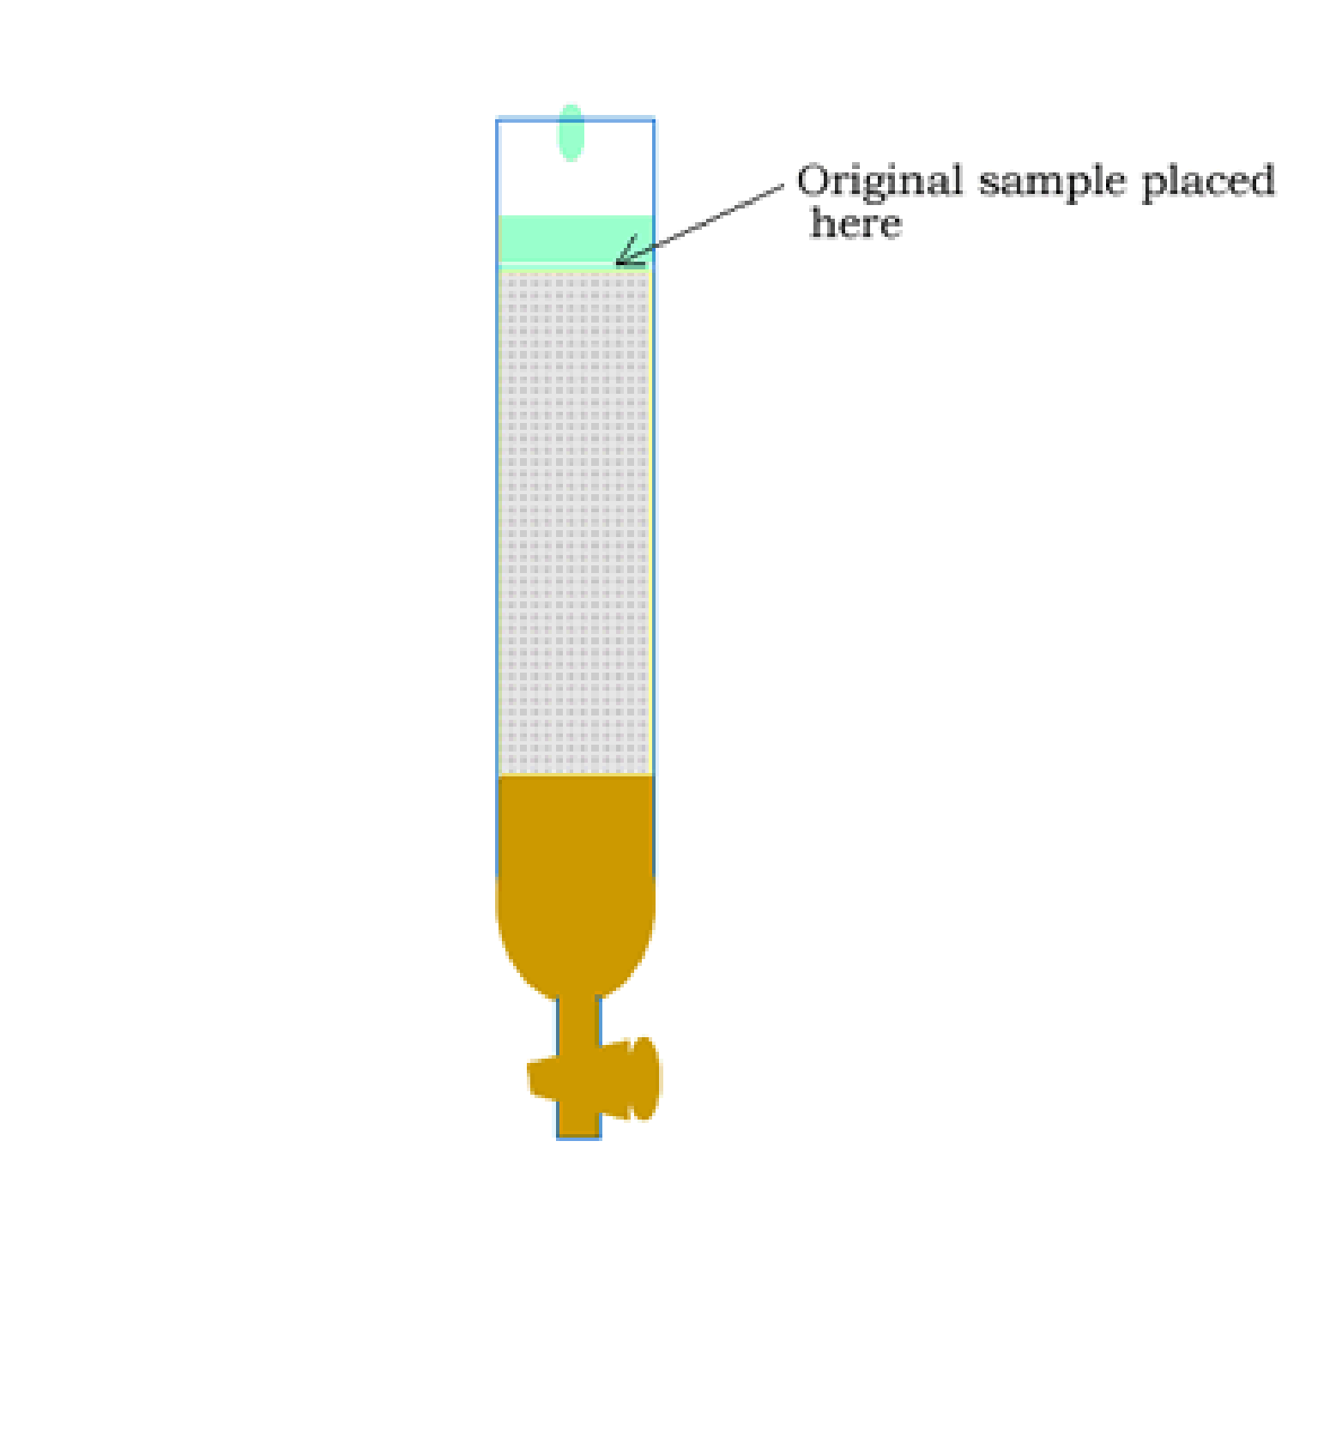

Animation 2.8[:Chromatography](http://www.dynamicscience.com.au/tester/solutions1/chemistry/analytical%20chem/columnchromatography.htm)

Source & Credit: [Support-th](http://www.dynamicscience.com.au/tester/solutions1/chemistry/analytical%20chem/columnchromatography.htm)

**2.5.1 PAPER CHROMATOGRAPHY**

It is a technique of partition chromatography. Here the stationary phase is a liquid (say H2O) adsorbed on paper. The adsorbed water behaves as an immiscible liquid towards the mobile phase, which passes over the paper. The mobile phase is usually an organic liquid.

There are three common ways of carrying out paper chromatography namely (i) ascending (ii) descending (iii) radial/circular. Only the ascending type will be discussed here. In this technique the solvent is in a pool at the bottom of a vessel in which the paper is supported and the solvent travels upwards by capillary action.

A solvent mixture, specially composed in accordance with the sample to be separated, is poured into the chromatographic tank Fig (2.6). Cover the tank to homogenise its inner atmosphere. Take about 20 cm strip of Whatmann's chromatographic paper No.1 and draw on it a thin pencil line about 2.5 cm from one end. Spot a point, on the pencil line, with the sample mixture solution. To facilitate identiication of the components of the mixture, spots of the known compounds may also be placed alongside.

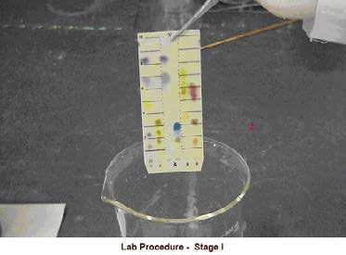

Animation 2.9:  [PAPER CHROMATOGRAPHY](https://www.mshp.dps.missouri.gov/MSHPWeb/PatrolDivisions/CLD/Toxicology/toxicology.html)

Source & Credit: [chem](https://www.mshp.dps.missouri.gov/MSHPWeb/PatrolDivisions/CLD/Toxicology/toxicology.html)

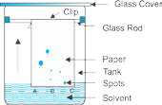When the spots have dried, suspend the paper with clips so that the impregnated end dips into solvent mixture to a depth of 5-6 mm. Cover the tank. As the solvent front passes the spots, the solutes begin to move upward. The rate at which they move depends on their distribution coeicients. When the solvent front has risen to about 3/4 th of the length of the paper, remove the strip, mark the

solvent front with a pencil and allow the strip to dry. Fig. (2.6) Paper chromatography Once the paper is dried, the pattern on the paper is called a chromatogram. The diferent components of the mixture, if coloured, can visually be identiied. If colourless, the chromatogram has to be developed by chemical methods or physical techniques used to identify the spots. Each component has a speciic retardation factor called Rf value. The Rf value is related to its distribution coeicient and is given by:

Distance travelled by a component from the original spot

Rf= Distance travelled by solvent from the original spot

With reference to Fig 2.7 the chromatogram shows that the sample A contains both components B and C. The Rf values for B and C are given by:

**Rf(B)= x/y**

**Rf(C)=z/y**

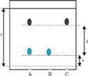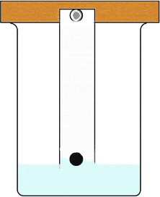Fig. (2.7) Chromatogram

**Uses of Chromatography**

The techniques of chromatography are very useful in organic synthesis for separation, isolation and puriication of the products. They are equally important in qualitative and quantitative analyses and for determination of the purity of a substance.

Animation 2.10: [Uses of Chromatography](http://iqa.evergreenps.org/science/chemistry/separating-mixtures.html)

Source & Credit: [Dynamicscience](http://iqa.evergreenps.org/science/chemistry/separating-mixtures.html)

## KEY POINTS

1. A complete characterization of a compound must include both qualitative and quantitative analyses.
2. A complete quantitative analysis of a compound generally involves four major steps.
3. The process of iltration is used to separate insoluble particles from liquids and it can be performed with several types of ilter media.
4. If the process of iltration with the ilter paper is to run smoothly, the stem of the funnel should remain continuously full of liquid as long as there is liquid in the conical portion.
5. The iltering operation with the ilter paper could be very time consuming if it were not aided by a gentle suction as liquid passes through the stem. This suction cannot develop unless the paper its tightly all around the upper circumference of the funnel.
6. The rate of iltration can be considerably increased using a luted ilter paper.
7. A solid compound is puriied by crystallization from a suitable solvent. A solvent for crystallization should be able to dissolve the solute at high temperature and the maximum amount of the solute should be thrown out by the solvent when the solution is cooled. The process of crystallization involves many steps.
8. The process of sublimation involves converting a solid directly into vapours and these vapours are then condensed to form solid again. It is frequently used to purify a solid.
9. Solvent extraction technique involves the separation of a solute from a solution by shaking it with an immiscible solvent in which the solute is more soluble. The technique is mostly applied to separate organic compounds from water.
10. Repeated extractions using small portions of solvent are more eicient than using a single extraction but large volume of solvent.
11. Solvent extraction is an equilibrium process and it is controlled by distribution law. The technique is particularly useful when the compound to be separated is volatile or thermally unstable.
12. Chromatography is a technique used for separating the components of a mixture. These components are distributed between a stationary and a mobile phase. The stationary phase may be a solid or a liquid supported on a solid. It adsorbs the mixture under separation. The mobile phase may be a liquid or a gas and while passing over the stationary phase, competes with it for the constituents of the mixture.
13. In paper chromatography, the stationary phase is water adsorbed on paper. The mobile phase is usually an organic liquid.
14. The techniques of chromatography are very useful in organic synthesis for separation, isolation and puriication of the products.

## EXERCISE

Q.1 Multiple choice questions.

1. A iltration process could be very time consuming if it were not aided by a gentle suction which is developed:
   1. if the paper covers the funnel upto its circumference.
   2. if the paper has got small sized pores in it.
   3. if the stem of the funnel is large so that it dips into the iltrate.(d) if the paper its tightly.
2. During the process of crystallization, the hot saturated solution:
   1. is cooled very slowly to get large sized crystals.
   2. is cooled at a moderate rate to get medium sized crystals.
   3. is evaporated to get the crystals of the product.
   4. is mixed with an immiscible liquid to get the pure crystals of the product.
3. Solvent extraction is an equilibrium process and it is controlled by.
   1. law of mass action. (b) the amount of solvent used.

(c) distribution law. (d) the amount of solute.

1. Solvent extraction method is a particularly useful technique for separation when the product to be separated is:
   1. non-volatile or thermally unstable. (b) volatile or thermally stable.

(c) non-volatile or thermally stable. (d) volatile or thermally unstable.

1. The comparative rates at which the solutes move in paper chromatography, depend on:
   1. the size of paper (b) R values Of solutes.

(c) temperature of the experiment. (d) size of the chromatographic tank used.

Fill in the blanks.

1. A complete chemical characterization of a compound must include_________.
2. During iltration the tip of the stem of the funnel should touch the side of the beaker to avoid_________.
3. A luted ilter paper is used to_________ the process of iltration.
4. A solvent used for crystallization is required to dissolve of the substance at its boiling point and_______ at the room temperature.
5. Repeated solvent extractions using small portions of solvent are__________________ than using a single extraction with larger volume of the solvent.

Q.3 Tick the correct sentences. If the sentence is incorrect, write the correct statements.

* + 1. A qualitative analysis involves the identiication of elements present in a compound.
    2. If the process of iltration is to run smoothly, the stem of the funnel should remain empty.

(iii)If none of the solvents is found suitable for crystallization a combination of two or more immiscible solvents may be used.

* + 1. A solute distributes itself between two immiscible liquids in a constant ratio of concentrations depending upon the amount of solvent added.
    2. Paper chroma tography is a technique of partition chromatography.
  1. Why is there a need to crystallize the crude product?
  2. A water insoluble organic compound aspirin is prepared by the reaction of salicylic acid with a mixture of acetic acid and acetic anhydride. How will you separate the product from the reaction mixture?
  3. A solid organic compound is soluble in water as well as in chloroform. During its preparation, it remains in aqueous layer. Describe a method to obtain from this layer.
  4. The following igure shows a developed chromatogram on paper with ive spots.
     + 1. 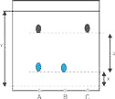Unknown mixture X
       2. Sample A
       3. Sample B (iv) Sample C

(v) Sample D

Find out (i) the composition of unknown mixture X

(ii) which sample is impure and what is its composition.

* 1. In solvent extraction technique, why repeated extraction using small portions of solvent are more eicient than using a single extraction but larger volume of solvent?
  2. Write down the main characteristics of a solvent selected for crystallization of a compound.
  3. You have been provided with a mixture containing three inks with diferent colours. Write down the procedure to separate the mixture with the help of paper chromatography.