## CHAPTER 7 THERMOCHEMISTRY

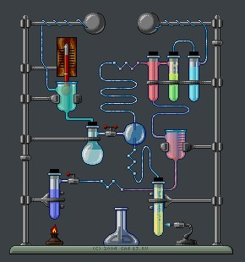

Animation 7.1: Thermochemistry

Source & Credit: wikispaces

### 7.0.0 INTRODUCTION

It is matter of common observation that energy in the form of heat, is either evolved or absorbed as a result of a chemical change. This is due mostly to the breaking of bonds in the reactants and formation of new bonds in the products. Bond breaking absorbs energy but bond making releases it. The overall energy change that occurs, results from the diference between energy supplied for the breaking of reactant bonds and that evolved in the making of product bonds. The study of heat changes accompanying a chemical reaction is known as thermochemistry. Substances exist, because they possess energy. Diferent substances have diferent amounts of energy associated with them. Due to this reason, the total energy of the products is never equal to that of reactants. Hence, in a chemical change, the energy in the form of heat will either be evolved or absorbed and this is called heat of reaction.

Generally, in all chemical changes, energy is exchanged with the surroundings. When it is given out by the reaction, the change is said to be exothermic when it is absorbed, the reaction is endothermic. When an exothermic reaction occurs, heat is given out by the system and the temperature of the system rises above the room temperature. Eventually, the temperature of the system falls to room temperature again as the heat produced is lost to the surroundings.

When an endothermic reaction occurs, the heat required for the reaction is taken from the reacting materials (system) and the temperature of the system falls below the initial temperature. Eventually, the temperature of the system rises to room temperature again as heat is absorbed from the surroundings.

The energy units in which heat changes, usually expressed in SI system are joule (J) and kilojoule

(kJ).

Some of the examples of exothermic and endothermic reactions are given below.

1. The combustion of carbon in oxygen is a common reaction.

C(s) +O2(g) → CO2(g) H=-393.7kJ mol .∆ −1

The reaction is exothermic and 393.7kJmol ‘ of heat is evolved during the reaction.

1. The formation of water from hydrogen and oxygen is an exothermic reaction.

H2(g) +O2(g) → H O H=-285.58kJ mol .2 (l) ∆ −1

1. In the Haber’s process, the formation of ammonia is also an exothermic reaction.

N2(g) +3H2(g) ฀ 2NH3(g) H=-41.6kJ mol .∆ −1

1. The decomposition of water into oxygen and hydrogen is an endothermic reaction.

H O2 (l) → H2(g) +1/2 O2(g) H=+285.58kJ mol .∆ −1

1. When one mole of nitrogen combines with one mole of oxygen to yield nitrogen oxide (NO), 180.51 kJ of heat is absorbed by the system and the reaction is endothermic.

N2(g) + O2(g) → 2NO(g) H=+180.51kJ mol .∆ −1

The subject matter of thermochemistry is based on the irst law of thermodynamics. The subject has an important practical utility as it gives us information about the energy or heat contents of compounds, a knowledge of which is necessary for the study of chemical bonding and chemical equilibrium. The scope of thermochemistry is limited mainly, because only a few of many chemical reactions are such, whose heats of reaction can be accurately measured.

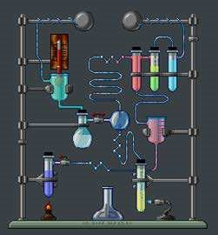

*Animation 7.2 : Thermochemistry*

*Source & Credit :*

[*pamcox.wikispace*](https://www.google.com.pk/search?q=thermochemistry&biw=1366&bih=643&source=lnms&tbm=isch&sa=X&ved=0ahUKEwjClJPtybDLAhWENxQKHfASB3MQ_AUIBygC#q=thermochemistry&tbm=isch&tbs=itp:animated&imgrc=y_0lQW28hZAHkM%3A)

[*s*](https://www.google.com.pk/search?q=thermochemistry&biw=1366&bih=643&source=lnms&tbm=isch&sa=X&ved=0ahUKEwjClJPtybDLAhWENxQKHfASB3MQ_AUIBygC#q=thermochemistry&tbm=isch&tbs=itp:animated&imgrc=y_0lQW28hZAHkM%3A)

### 7.1 SPONTANEOUS AND NON-SPONTANEOUS REACTIONS

A process which takes place on its own without any outside assistance and moves from a nonequilibrium state towards an equilibrium state is termed as spontaneous process or natural process. It is unidirectional, irreversible and a real process. Some examples of spontaneous processes are given below.

1. Water lows from higher level to the lower level. The low cannot be reversed without some external aid.
2. Neutralization of a strong acid with a strong base is a spontaneous acid-base reaction.

NaOH(aq) + HCI(aq) ฀ NaCl(aq) + H O2 (l)

1. When a piece of zinc is added to the copper sulphate solution, blue colour of the solution disappears due to the spontaneous redox reaction.

CuSO4(aq) + Zn(s) → ZnSO4(aq) +Cu(s)

A reaction will also be called a spontaneous process, if it needs energy to start with, but once it is started, then it proceeds on its own. Burning of coal and hydrocarbon in air are examples of such spontaneous reactions. A piece of coal does not burn in air on its own rather the reaction is initiated by a spark and once coal starts burning, then the reaction goes spontaneously to completion.

Non-spontaneous process is the reverse of the spontaneous process. It does not take place on its own and does not occur in nature. Reversible processes constitute a limiting case between spontaneous and non-spontaneous processes. Some non-spontaneous processes, can be made to take place by supplying energy to the system from external source. Some examples of nonspontaneous processes are given below.

1. Pumping of water uphill.
2. Transfer of heat from cold interior part nof the refrigerator to the hot surroundings.
3. When nitrogen reacts with oxygen, nitric oxide is formed. This reaction takes place by the absorbance of heat. Although, N2 and O2 are present in air, but they do not react chemically at ordinary conditions.The reaction takes place when the energy is provided by lightning.

N2(g) + O2(g) ฀ 2NO(g) (Non-spontaneous reaction)

Our common experience, shows that spontaneous processes proceed with a decrease in energy. We might expect, therefore, that a chemical reaction would proceed spontaneously if the reaction system decreases in energy by transferring heat to its surroundings. In other words, we might expect all exothermic reactions to be spontaneous. This is usually true, but not always. There are many endothermic changes that proceed spontaneously although they absorb heat. For example,

Ammonium chloride dissolves in water and this process is also endothermic.

H O 2 (l) → H O2 (g) H=44.0kJmol∆ −1

NH Cl4 (s) ฀ NH4+(aq) + Cl (aq) H=15.1kJmol∆ −1

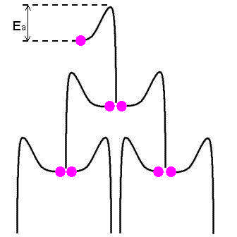

*Animation 7.3: SPONTANEOUS AND NON-SPONTANEOUS REACTIONS*

*Source & Credit :*

[*thompsona.free.f*](https://www.google.com.pk/search?q=thermochemistry&biw=1366&bih=643&source=lnms&tbm=isch&sa=X&ved=0ahUKEwjClJPtybDLAhWENxQKHfASB3MQ_AUIBygC#tbs=itp:animated&tbm=isch&q=SPONTANEOUS+AND+NON-SPONTANEOUS+REACTIONS&imgrc=bZjGP3jS4FIyJM%3A)

[*r*](https://www.google.com.pk/search?q=thermochemistry&biw=1366&bih=643&source=lnms&tbm=isch&sa=X&ved=0ahUKEwjClJPtybDLAhWENxQKHfASB3MQ_AUIBygC#tbs=itp:animated&tbm=isch&q=SPONTANEOUS+AND+NON-SPONTANEOUS+REACTIONS&imgrc=bZjGP3jS4FIyJM%3A)

Thus, energy change alone cannot help us to predict, whether a reaction will occur spontaneously or not. To predict whether a reaction will occur spontaneously or not it is necessary to study the free energy of the system. The concept of free energy can help us to understand the processes in terms of entropy change. Anyhow, its discussion is outside the scope of this book.

### 7.2 SYSTEM, SURROUNDING AND STATE FUNCTION

These are the terms employed in the study of thermochemistry. To understand the energy changes in materials, let us deine these terms.

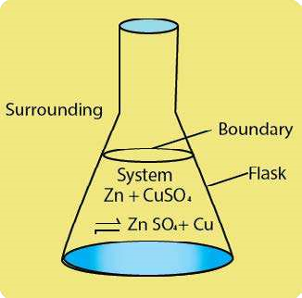 We shall be using them frequently later on. The term system is used for anything (materials) under test in the laboratory, or under consideration in the classroom for the purpose of argument. We can say that any portion of the universe which is under study is called a system and the remaining portion of the universe is known as its surroundings.

The real or imaginary surface separating the system from the surroundings is called the boundary, Fig. (7.1). In an experimental work, a speciic amount of one or more substances constitute a system, e.g. one mole of oxygen conined in a cylinder itted with a piston is a system. The cylinder, the piston and all other objects outside the cylinder are surroundings. Similarly, a cup of water is a system. The air surrounding it, the table on which it is lying, etc. are surroundings.

Consider, the reaction between Zn and CuSO4 solution. This can be called a system under observation. The lask, the air, etc. are the surroundings, Fig (7.1).

Fig (7.1) System and surroundings

The state of a system is the condition of a system. When any process is performed on a system its state is altered in some ways. Let us consider a beaker containing water. It will be a system having certain temperature and volume.

This initial condition of the system may be called the initial state. Suppose we heat the beaker. The system will undergo a change after heating. The inal condition of the system may now be called the inal state of the system. By comparing both initial and inal states of the system, we can describe the.change taking place in the system.

Let T1 and T2 denote the temperatures of water before and after heating, respectively. The change in temperature ∆T , may then be represented as

∆T = Final temperature - Inital temperature

∆T = T - T2

1

A state function is a macroscopic property of a system which has some deinite values for initial and inal states, and which is independent of the path adopted to bring about a change. By convention, we use capital letters as symbols for a state function, e.g. pressure (P), temperature (T), volume (V), internal energy (E) and enthalpy (H), are all state functions.

Let us suppose, that V1 is the initial volume of a gas. A change is brought about in the gas and its inal volume becomes V2. The change in volume (∆V ) of the gas is given by

∆V = V - V2

1

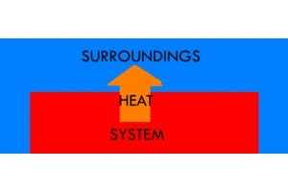

*Animation 7.4: SYSTEM, SURROUNDING AND STATE FUNC-*

*TION*

*Source & Credit :*

[*kastedu.weebl*](https://www.google.com.pk/search?q=thermochemistry&biw=1366&bih=643&source=lnms&tbm=isch&sa=X&ved=0ahUKEwjClJPtybDLAhWENxQKHfASB3MQ_AUIBygC#tbs=itp:animated&tbm=isch&q=SYSTEM%2C+SURROUNDING+AND+STATE+FUNCTION&imgrc=Cb0n9GpXPwh6FM%3A)

[*y*](https://www.google.com.pk/search?q=thermochemistry&biw=1366&bih=643&source=lnms&tbm=isch&sa=X&ved=0ahUKEwjClJPtybDLAhWENxQKHfASB3MQ_AUIBygC#tbs=itp:animated&tbm=isch&q=SYSTEM%2C+SURROUNDING+AND+STATE+FUNCTION&imgrc=Cb0n9GpXPwh6FM%3A)

Now, this change in volume of the gas can be brought about either by changing temperature or pressure of the gas. Since V is a state function, so ∆V will be independent of the way the volume of the gas has been changed. It will only depend upon the initial and inal volumes of the gas.

### 7.3 INTERNAL ENERGY AND FIRST LAW OF THERMODYNAMICS

A system containing some quantity of matter has deinite amount of energy present in it. This energy is the sum of kinetic as well as the potential energies of the particles contained in the system. The kinetic energy is due to the translational, rotational and vibrational movements of particles, Fig (7.2). The potential energy accounts for all the types of attractive forces present in the system. These attractive forces, include all the types of bonds and the van der Waal’s forces present among the particles.

The total of all the possible kinds of energies of the system is called its internal energy, E. The change in internal energy of the system ∆E is a state function.

It is not possible, to measure the absolute value of internal energy of a system, but it is often possible to measure the value of ∆E for a change in the state of the system.

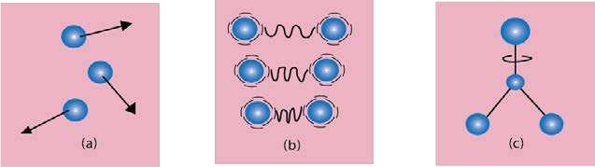

Translational m otion o f He A diatomic molecule A tetra-atomic molecule gas m olecu les H2 is vibrating say BF3 is rotating on an axis

Fig (7.2) Translational, vibrational and rotational movements of molecules. Diatomic molecules have translational motions as well.

Anyhow triatomic and higher molecules have translational, vibrational and rotational motions.

There are two fundamental ways of transferring energy to or from a system. These are heat and work. Heat is not a property of a system. It is therefore not a state function. It is deined as the quantity of energy that lows across the boundary of a system during a change in its state due to the diference in temperature between the system and the surroundings.Heat evolved or absorbed by the system is represented by a symbol q. Work is also a form in which energy is transfered from one system to another. It is deined as the product of force and distance i.e. W = F x S. Work is measured in Joules in SI units. There are diferent kinds of work. The type of work we most commonly encounter in thermochemistry is pressure-volume work. For example, expansion can occur when a gas is evolved during a chemical reaction Fig (7.3).

In such cases, the work W done by the system is given by

W = -P V∆ (In pressure volume work, force becomes pressure and distance becomes volume change where P is the external pressure and ∆V is the change in volume. Work is not a state function. The sign of W is positive when work is done on the system and it is negative when work is done by the system.

Similarly the sign of q is positive when heat is absorbed by the system from surroundings, and it is negative when heat is absorbed by the surroundings from the system.

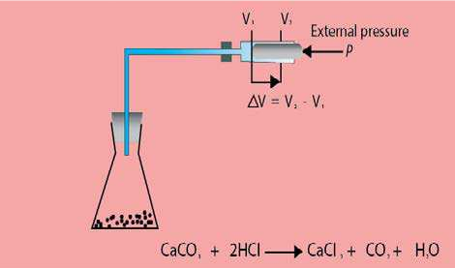

Fig (7.3) Pressure-volume work during expansion of a gas.



*Animation 7.5: INTERNAL ENERGY AND FIRST LAW OF THER-*

*MODYNAMICS*

*Source & Credit :*

[*ashamedparent*](https://www.google.com.pk/search?q=thermochemistry&biw=1366&bih=643&source=lnms&tbm=isch&sa=X&ved=0ahUKEwjClJPtybDLAhWENxQKHfASB3MQ_AUIBygC#tbs=itp:animated&tbm=isch&q=INTERNAL+ENERGY+AND+FIRST+LAW+OF+THERMODYNAMICS&imgrc=fLOOya-sGD5E6M%3A)

[*s*](https://www.google.com.pk/search?q=thermochemistry&biw=1366&bih=643&source=lnms&tbm=isch&sa=X&ved=0ahUKEwjClJPtybDLAhWENxQKHfASB3MQ_AUIBygC#tbs=itp:animated&tbm=isch&q=INTERNAL+ENERGY+AND+FIRST+LAW+OF+THERMODYNAMICS&imgrc=fLOOya-sGD5E6M%3A)

**7.3.1 First Law of Thermodynamics**

The irst law of thermodynamics, also called the law of conservation of energy, states that energy can neither be created nor destroyed, but can be changed from one form to another. In other words, a system cannot destroy or create energy. However, it can exchange energy with its surroundings in the form of heat and work. Thus, the energy change is the sum of both heat and work, so that the total energy of the system and its surroundings remains constant.

Consider, a gas enclosed in a cylinder having a frictionless piston Fig (7.4). When a quantity of heat ‘q’ is supplied to the system, its internal energy E1 changes to E2 and piston moves upwards.

The change in internal energy ∆E is given by the following equation.

∆E = E -E = q+w2 1

∆E = q+w

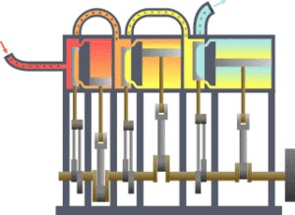

*Animation 7.6: First Law of Thermodynamics*

*Source & Credit :*

[*docsit*](https://www.google.com.pk/search?q=thermochemistry&biw=1366&bih=643&source=lnms&tbm=isch&sa=X&ved=0ahUKEwjClJPtybDLAhWENxQKHfASB3MQ_AUIBygC#tbs=itp:animated&tbm=isch&q=First+Law+of+Thermodynamics&imgrc=znv4enQ0iA_LOM%3A)

[*y*](https://www.google.com.pk/search?q=thermochemistry&biw=1366&bih=643&source=lnms&tbm=isch&sa=X&ved=0ahUKEwjClJPtybDLAhWENxQKHfASB3MQ_AUIBygC#tbs=itp:animated&tbm=isch&q=First+Law+of+Thermodynamics&imgrc=znv4enQ0iA_LOM%3A)

In this equation ‘q’ represents the amount of heat absorbed by the system and V is the work done by the system in moving the piston up, Fig (7.4).

If ‘w‘ is pressure-volume work, then the above expression assumes the following form

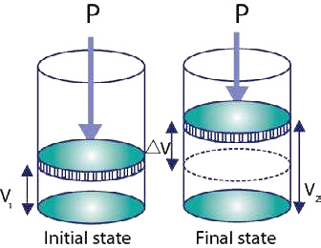 ∆E = q - P V ............ (2)∆

When the piston is kept in its original position or the volume of the gas is not allowed to change, then ∆V = 0 and equation (2) will take the following form.

∆E = qv ............. (3)

This shows that a change in internal energy of a system, at constant volume is equal to heat absorbed by the system

(qv).

Fig (7.4) Expansion of a gas and pressure-volume work.

### 7.4 ENTHALPY

Again consider the same process as described above. A quantity of heat q is given to the system (gas) which is now kept at constant atmospheric pressure.

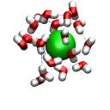

*Animation 7.7: ENTHALPY*

*Source & Credit :*

[*physik.fu-berlin.d*](https://www.google.com.pk/search?q=thermochemistry&biw=1366&bih=643&source=lnms&tbm=isch&sa=X&ved=0ahUKEwjClJPtybDLAhWENxQKHfASB3MQ_AUIBygC#tbs=itp:animated&tbm=isch&q=+ENTHALPY&imgrc=ycTTlt9y_oU6pM%3A)

[*e*](https://www.google.com.pk/search?q=thermochemistry&biw=1366&bih=643&source=lnms&tbm=isch&sa=X&ved=0ahUKEwjClJPtybDLAhWENxQKHfASB3MQ_AUIBygC#tbs=itp:animated&tbm=isch&q=+ENTHALPY&imgrc=ycTTlt9y_oU6pM%3A)

A part of this heat is used to increase the internal energy of the gas and the rest is used to do work on the surroundings. This work is done by the gas, when it expands against a constant pressure. To take account of increase in internal energy and accompanying work done by the gas, there is another property of the system called enthalpy or heat content. It is represented by H. In general, enthalpy is equal to the internal energy, E plus the product of pressure and volume (PV).

H = E + PV

Enthalpy is a state function. It is measured in joules. It is not possible, to measure the enthalpy of a system in a given state. However, change in enthalpy (∆H ) can be measured for a change in the state of system . A change in enthalpy of a system can be written as:

∆ ∆ ∆H = E + (PV)

or ∆ ∆H = E + V P + P V∆ ∆

Since, the gas is kept at constant pressure, = 0

Hence ∆ ∆H = E + P V .......... (4)∆

In case of liquids and solids, the changes in state do not cause signiicant volume change i.e.

∆V = 0. For such process, ∆H and ∆E are approximately the same i.e. ∆ ≈∆H E  According to irst law of thermodynamics:

∆E = q + w

If w is pressure - volume work done by the system, then:

w = - P V∆

So ∆E = q - P V∆

Putting the value of ∆E in equation (4) we get:

∆H = q - P V + P V∆ ∆

∆H = q

Since the pressure is constant, therefore,

∆H = qp ......... (5)

This shows that change in enthalpy is equal to heat of reaction at constant pressure. The reactions are carried out at constant pressure more frequently than at constant volume. So, working with ∆H is more convenient rather than ∆E .

**Example 1:**  When 2.00 moles of H2 and 1.00 mole of O2 at 100°C and 1 torr pressure react to produce 2.00 moles of gaseous water, 484.5 kJ of energy are evolved. What are the values of (a) ∆H (b) ∆E for the production of one mole of H2O (g)?

**Solution:**

(a) The reaction is occurring at constant pressure.

2H2(g) + O2(g) → 2H O2 (g)

The enthalpy change for one mole of water vapours is

|  |
| --- |
| -242.2kJ mol-1 |

∆ -484.5kJ

H= 2 moles of H O2 = Answer

The minus sign shows that the reaction is exothermic for the production of 1 mole of water, (b) To calculate ∆E from ∆H , we use the equation (4)

∆ ∆H = E + P V∆

Let us, irst calculate the value of P V∆ using the ideal gas equation

|  |  |
| --- | --- |
|  | PV = nRT |
| Or | P V = nRT∆ ∆ |
| Now, | ∆n = No. of moles of the products - No. of moles of the reactants |
|  | = 2moles - 3moles = -1mole |
|  | R = 8.314JK mol-1 -1 |
|  | T = 373K |
|  | P V = nRT ................... (6)∆ ∆ |
|  | P V = -1 mole x 8.314J mol K∆ −1 x 373K |
|  | P V = -3100J=-3.10kJ∆ |

This is the value for 2 moles of water. For the formation of 1 mole of water,

P V = ∆ 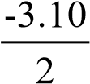=-1.55kJmol-1

On substituting, these values into equation (4).

∆ ∆H = E + P V∆

∆ ∆E = H - P V∆

= -242.2-(-1.55) = -242.2+1.55

|  |
| --- |
| -1 |

∆E = -240.6kJ mol Answer

**7.4.1 Enthalpy of a Reaction (**∆**Ho)**

In an exothermic reaction, the heat content or enthalpy of the products H2 is less than that of the reactants H1. Since, the system has lost heat, we can say the enthalpy change for the reaction ∆H is negative, Fig (7.5 a)

In an endothermic reaction, the enthalpy of products H2, is greater than that of the reactants H1 and the enthalpy change, ∆H is positive. These enthalpy changes are represented in Fig (7.5 b). The standard enthalpy of a reaction ∆Ho is the enthalpy change which occurs when the certain number of moles of reactants as indicated by the balanced chemical equation, react together completely to give the products under standard conditions, i.e 25 °C (298K) and one atmosphere pressure. All the reactants and products must be in their standard physical states. Its units are kJ mol-1.

2H2(g) + O2(g) → 2H O2 ( ) ∆H = -285.8kJmolo -1

-285.8 kJmol-1 is standard enthalpy of reaction.

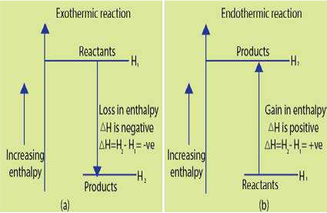

Fig (7.5) Enthalpy changes in thermochemical reactions

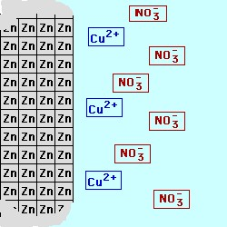

*Animation 7.8: Enthalpy of a Reaction (DH)*

*Source & Credit :*

[*web.ms*](https://www.google.com.pk/search?q=thermochemistry&biw=1366&bih=643&source=lnms&tbm=isch&sa=X&ved=0ahUKEwjClJPtybDLAhWENxQKHfASB3MQ_AUIBygC#tbs=itp:animated&tbm=isch&q=Enthalpy+of+a+Reaction&imgrc=BGwPO5XPTWXS_M%3A)

[*t*](https://www.google.com.pk/search?q=thermochemistry&biw=1366&bih=643&source=lnms&tbm=isch&sa=X&ved=0ahUKEwjClJPtybDLAhWENxQKHfASB3MQ_AUIBygC#tbs=itp:animated&tbm=isch&q=Enthalpy+of+a+Reaction&imgrc=BGwPO5XPTWXS_M%3A)

**7.4.2 Enthalpy of Formation (**∆**H0f)**

The standard enthalpy of formation of a compound is the amount of heat absorbed or evolved when one mole of the compound is formed from its elements. It is denoted by ∆H°f. All the substances involved are in their standard physical states and the reaction is carried out under standard conditions i.e. at 25°C (298 K) and one atm. pressure. Its units are kJ mol-1. For example, the enthalpy of formation, ( ∆H°f) for MgO(s) is - 692 kJ mol-1



Mg(s) + O2(g) → MgO(s) H∆ of = -692kJ mol-1

Similarly, when carbon reacts with oxygen to form CO2, 393.7 kJ mol-1 of energy is released. It is ∆H°f, of CO2(g).

C(s) +O2(g) → CO2(g) ∆Hof =-393.7kJ mol-1



*Animation 7.9: Enthalpy of Formation (DHf)*

*Source & Credit :*

[*users.humbold*](https://www.google.com.pk/search?q=Enthalpy+of+Formation&hl=en&biw=1366&bih=599&site=webhp&source=lnms&tbm=isch&sa=X&ved=0ahUKEwi3ia6O0LDLAhVK7xQKHVxzDEgQ_AUIBigB#q=Enthalpy+of+Formation&hl=en&tbm=isch&tbs=itp:animated&imgrc=IYH2G8UO-YDqFM%3A)

[*t*](https://www.google.com.pk/search?q=Enthalpy+of+Formation&hl=en&biw=1366&bih=599&site=webhp&source=lnms&tbm=isch&sa=X&ved=0ahUKEwi3ia6O0LDLAhVK7xQKHVxzDEgQ_AUIBigB#q=Enthalpy+of+Formation&hl=en&tbm=isch&tbs=itp:animated&imgrc=IYH2G8UO-YDqFM%3A)

**7.4.3 Enthalpy of Atomization (**∆**Hoat)**

The standard enthalpy of atomization of an element is deined as the amount of heat absorbed when one mole of gaseous atoms are formed from the element under standard conditions. It is denoted by Hoat. For example, the standard enthalpy of atomization of hydrogen is given below.

H2(g) → H(g) H∆ oat =218kJ mol-1

A wide range of experimental techniques, are available for determining enthalpies of atomization of elements.

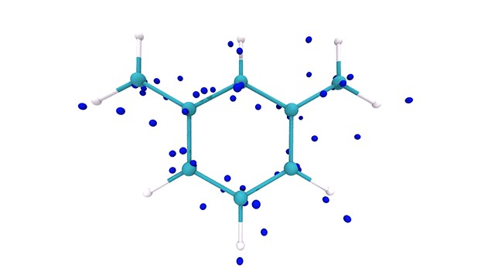

*Animation 7.10: Enthalpy of Atomization (DHat)*

*Source & Credit :*

[*githu*](https://www.google.com.pk/search?q=Enthalpy+of+Formation&hl=en&biw=1366&bih=599&site=webhp&source=lnms&tbm=isch&sa=X&ved=0ahUKEwi3ia6O0LDLAhVK7xQKHVxzDEgQ_AUIBigB#hl=en&tbs=itp:animated&tbm=isch&q=+Enthalpy+of+Atomization&imgrc=d0t9B60khzwhVM%3A)

[*b*](https://www.google.com.pk/search?q=Enthalpy+of+Formation&hl=en&biw=1366&bih=599&site=webhp&source=lnms&tbm=isch&sa=X&ved=0ahUKEwi3ia6O0LDLAhVK7xQKHVxzDEgQ_AUIBigB#hl=en&tbs=itp:animated&tbm=isch&q=+Enthalpy+of+Atomization&imgrc=d0t9B60khzwhVM%3A)

**7.4.4 Enthalpy of Neutralization (**∆**Ho )**

**n**

The standard enthalpy of neutralization is the amount of heat evolved when one mole of hydrogen ions [H+] from an acid, react with one mole of hydroxide ions from a base to form one mole of water. For example, the enthalpy of neutralization of sodium hydroxide by hydrochloric (OH-) acid is -57.4 kJ mol-1. Note that a strong acid HCl and a strong base, NaOH, ionize completely in dilute solutions as follows.

HCl(aq) ฀ H+(aq) + Cl-(aq)

NaOH(aq) ฀ Na+(aq) + OH-(aq)

When these solutions are mixed together during the process of neutralization, the only change that actually occurs is the formation of water molecules leaving the sodium ions and the chloride ions as free ions in solution. Thus, the enthalpy of neutralization is merely the heat of formation of one mole of liquid water from its ionic components,

H+(aq) + Cl-(aq) + Na+(aq) + OH-(aq) ฀ Na+(aq) + Cl(aq) + H O2 ( )

Or H+(aq) + OH-(aq) ฀ H O2 ( ) H∆ on =-57.4kJ mol-1

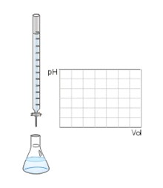

*Animation 7.11: Enthalpy of Neutralization (DHn)*

*Source & Credit :*

[*Wik*](https://en.wikipedia.org/wiki/Neutralization_(chemistry))

[*i*](https://en.wikipedia.org/wiki/Neutralization_(chemistry))

Enthalpy of neutralization for any strong acid with a strong base is approximately the same i.e. -57.4 kJ mole-1.

**7.4.5 Enthalpy of Combustion (**∆**Ho )**

**c**

The standard enthalpy of combustion of the substance is the amount of heat evolved when one mole of the substance is completely burnt in excess of oxygen under standard conditions. It is denoted by ∆Ho .

c

For example, standard enthalpy of combustion of ethanol ∆H0c is -1368kJ mol-1. The reaction is represented by the following equation.

C H OH( ) + 3O2 5  2(g) → 2CO2(g) + 3H O2 ( ) ∆Hoc =-1368kJ mol−1

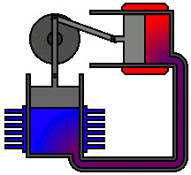

*Animation 7.12: Enthalpy of Combustion (DHc)*

*Source & Credit :*

[*wikipedi*](https://www.google.com.pk/search?q=Enthalpy+of+Formation&hl=en&biw=1366&bih=599&site=webhp&source=lnms&tbm=isch&sa=X&ved=0ahUKEwi3ia6O0LDLAhVK7xQKHVxzDEgQ_AUIBigB#hl=en&tbs=itp:animated&tbm=isch&q=Enthalpy+of+Combustion&imgrc=rEKaV31cPQl3QM%3A)

[*a*](https://www.google.com.pk/search?q=Enthalpy+of+Formation&hl=en&biw=1366&bih=599&site=webhp&source=lnms&tbm=isch&sa=X&ved=0ahUKEwi3ia6O0LDLAhVK7xQKHVxzDEgQ_AUIBigB#hl=en&tbs=itp:animated&tbm=isch&q=Enthalpy+of+Combustion&imgrc=rEKaV31cPQl3QM%3A)

**7.4.6 Enthalpy of Solution (**∆**Hosol.)**

The standard enthalpy of a solution is the amount of heat absorbed or evolved when one mole of a substance is dissolved in so much solvent that further dilution results in no detectable heat change.

For example, enthalpy of solution (∆Hosol.) of ammonium chloride is +16.2 kJmol-1 and that of sodium carbonate is -25.0 kJmol-1. In the irst case, heat absorbed from the surroundings is indicated by cooling of the solvent (water), an endothermic process. While in the second case, the temperature of the solvent rises showing that the process is exothermic.

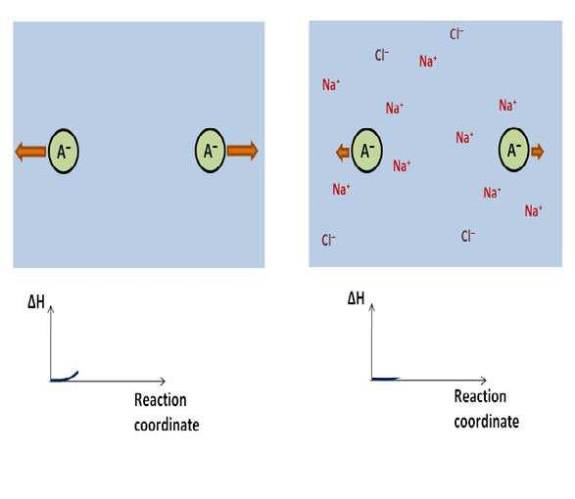

*Animation 7.13: Enthalpy of Solution (DHsol.)*

*Source & Credit :*

[*commons.wikimedi*](https://www.google.com.pk/search?q=Enthalpy+of+Formation&hl=en&biw=1366&bih=599&site=webhp&source=lnms&tbm=isch&sa=X&ved=0ahUKEwi3ia6O0LDLAhVK7xQKHVxzDEgQ_AUIBigB#hl=en&tbs=itp:animated&tbm=isch&q=+Enthalpy+of+Solution&imgrc=B0EM-a9ZqvIPEM%3A)

[*a*](https://www.google.com.pk/search?q=Enthalpy+of+Formation&hl=en&biw=1366&bih=599&site=webhp&source=lnms&tbm=isch&sa=X&ved=0ahUKEwi3ia6O0LDLAhVK7xQKHVxzDEgQ_AUIBigB#hl=en&tbs=itp:animated&tbm=isch&q=+Enthalpy+of+Solution&imgrc=B0EM-a9ZqvIPEM%3A)

**7.4.7 Measurement of Enthalpy of a Reaction**

Exothermic and endothermic reactions can easily be detected by observing the temperature of the reaction vessel before and after the reaction, as long as the heat of reaction evolved or absorbed is considerable. More accurate values of ∆H can be determined by using calorimeters as described below.

**(i) Glass Calorimeter**

For most purposes, an ordinary glass calorimeter can be used to determine the value of ∆H. This usual type of calorimeter, is basically an insulated container with a thermometer and a stirrer, Fig (7.6).

Reactants in stoichiometric amounts are placed in the calorimeter. When the reaction proceeds, the heat energy evolved or absorbed will either warm or cool the system. The temperature of the system is recorded before and after the chemical reaction. Knowing the temperature change the mass of reactants present and the speciic heat of water, we can calculate the quantity of heat q evolved or absorbed during the reaction. Thus:

q = m x s x T ................ (7)∆

Where m = mass of reactants, s = speciic heat of the reaction mixture and ∆T is the change in temperature. The product of mass and speciic heat of water is called heat capacity of the whole system.

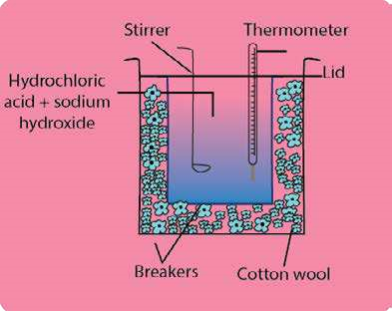

Fig (7.6) Glass calorimeter to measure enthalpy change of reactions.

**Example 2:**

Neutralization of 100 cm3 of 0.5 M NaOH at 250C with 100 cm3 of 0.5 M HCl at 250C raised the temperature of the reaction mixture to 28.50C. Find the enthalpy of neutralization. Speciic heat of water = 4.2 J K-1g-1

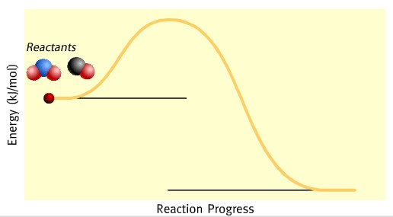

*Animation 7.14: Measurement of Enthalpy of a Reaction*

*Source & Credit :*

[*3ddrawing.onlin*](https://www.google.com.pk/search?q=Enthalpy+of+Formation&hl=en&biw=1366&bih=599&site=webhp&source=lnms&tbm=isch&sa=X&ved=0ahUKEwi3ia6O0LDLAhVK7xQKHVxzDEgQ_AUIBigB#hl=en&tbs=itp:animated&tbm=isch&q=Measurement+of+Enthalpy+of+a+Reaction&imgrc=9gf1RBZr8nbmXM%3A)

[*e*](https://www.google.com.pk/search?q=Enthalpy+of+Formation&hl=en&biw=1366&bih=599&site=webhp&source=lnms&tbm=isch&sa=X&ved=0ahUKEwi3ia6O0LDLAhVK7xQKHVxzDEgQ_AUIBigB#hl=en&tbs=itp:animated&tbm=isch&q=Measurement+of+Enthalpy+of+a+Reaction&imgrc=9gf1RBZr8nbmXM%3A)

**Solution:**

Speciic heat of water, s = 4.2 JK-1g-1

Density of H2O is around 1gcm-3, so 200 cm3 of total solution is approximately = 200g

Hence, total mass of the reaction mixture = 200g

Rise in temperature, ∆T = 28.5-25.0 = 3.50C = 3.5 K

100cm3 of 0.5 M NaOH = 100cm3 of 0.5 MHCl

0.5 M solution means that 1000 cm3 of solution has 0.5 moles of solute

So 100 cm3 of 0.5 M solutions =0.05 moles of HCl and NaOH, respectively

Amount of total heat evolved, (q) = m x s x ∆T

= 200g x 4.2 Jg-1K-1 x 3.5 K = 2940 J

=2940 J = 2.94 kJ

Since, the reaction is exothermic

So, q =-2.94kJ

When this heat is divided by number of moles, then ∆ Hn0 is for one mole

Enthalpy of neutralization. (∆ Hn0)

|  |
| --- |
| = -58.8kJ mol-1 |

= -2.94kJ Answer

0.05 mol

**(ii) Bomb Calorimeter**

A bomb calorimeter is usually used for the accurate determination of the enthalpy of combustion for food, fuel and other compounds.

A bomb calorimeter is shown in Fig (7.7). It consists of a strong cylindrical steel vessel usually lined with enamel to prevent corrosion. A known mass (about one gram) of the test substance is placed in a platinum crucible inside the bomb. The lid is screwed on tightly and oxygen is provided in through a valve until the pressure inside is about 20 atm. After closing the screw valve, the bomb calorimeter is then immersed in a known mass of water in a well insulated calorimeter.

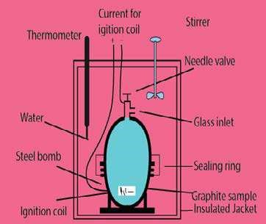

Fig (7.7) Bomb calorimeter

Then, it is allowed to attain a steady temperature. The initial temperature is measured, by using the thermometer present in the calorimeter. The test substance is then, ignited, electrically by passing the current through the ignition coil. The temperature of water, which is stirred continuously, is recorded at 30 sec intervals.

From the increase of temperature ∆T, heat capacity (c) in kJK-1 of bomb calorimeter including bomb, water etc., we can calculate the enthalpy of combustion.

The heat capacity ’c’ of a body or a system is deined as the quantity of heat required to change its temperature by 1 kelvin.

q = c x T∆

**Example 3:**

10.16g of graphite is burnt in a bomb calorimeter and the temperature rise recorded is 3.87K. Calculate the enthalpy of combustion of graphite, if the heat capacity of the calorimeter (bomb, water, etc.) is 86.02 kJ K-1

**Solution:**

Heat capacity of bomb calorimeter =86.02 kJK-1

Rise in temperature of the calorimeter and its contents = 3.87 K

Heat gained by the system (bomb calorimeter and water etc.) q = c x T∆

= 86.02 kJK x 3.87K-1

= 332.89 kJ

This heat is evolved by burning 10.16g of graphite = 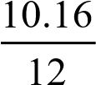 mole of graphite

= 0.843 mole of graphite

Hence enthalpy of combustion of graphite per mole = 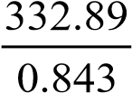 kJmol-1

395kJmol= -1

Since heat is evolved during combustion, so the sign of the answer would be negative.

= -395 kJmol Answer-1

#### 7.5.0 HESS’S LAW OF CONSTANT HEAT SUMMATION

There are many compounds, for which ∆H cannot be measured directly by calorimetric method. The reason is, that some compounds like tetrachloromethane (CCl4), cannot be prepared directly by combining carbon and chlorine. Similarly, it does not decompose easily into its constituent elements. In the same way, boron oxide (B2O3) and aluminium oxide (Al2O3) provide problems for the measurement of standard enthalpies of their formation. In these cases, it is diicult to burn these elements completely in oxygen, because a protective layer of oxides covers the surface of the unreacted element. Similarly, heat of formation of CO cannot be measured directly due to the formation of CO2 with it.

As a result, of above mentioned problems, the chemists had to look for methods of obtaining standard enthalpies of formation indirectly. The energy cycle shows two routes for converting graphite and oxygen to CO2, whilst the alternative route goes via CO. It would seem reasonable that the overall enthalpy change for the conversion of graphite to CO is independent of the route taken, that is,

∆H = H + H .......................∆ 1 ∆ 2 (8)

If the enthalpy of combustion for graphite to form CO and the enthalpy of combustion of CO

2

to form CO2 are known, we can determine the enthalpy of formation for CO. To clear the idea look at the following cycle. The oxidation of carbon (graphite) can be written as follows.

C(graphite) + O2(g) → CO2(g) H ∆ (graphite) =-393.7kJ mol-1

CO(gas) + 1 O2(g) → CO2(g) ∆H (CO)=-283kJ mol2 -1

2

C(graphite) +O2(g) → CO(g) H (CO)∆ 1 = ?

Applying equation (8) ∆H = H + H∆ 1 ∆ 2

ΔH

2

2

CO

C + O

→

1

H

∆

2

1

O

2

2

1

O

2

2

H

∆

CO

or ∆H = H - H1 ∆ ∆ 2

= -393- (-283)

= -110kJ mol-1

So, the enthalpy change for the formation of CO(g) is -110.0 kJmol-1.

The method we have just used in obtaining equation (8), is a speciic example of Hess’s law of constant heat summation. This law states that

If a chemical change takes place by several diferent routes, the overall energy change is the same, regardless of the route by which the chemical change occurs, provided the initial and inal conditions are the same.

Let A can be converted to D directly in a single step and heat evolved is ∆H. If the reaction can have a route from A → →B C as shown below.

|  |
| --- |
| →∆H *D*  A  ∆H ∆H  1 3  *B*→  ∆H2 *C* |

According to Hess’s law, ∆H = H + H +∆ 1 ∆ 2 ∆H3

Mathematically, ∑∆H(cycle) = 0

Of course, Hess’s law is simply an application of the more fundamental law of conservation of energy. So, S∆H (cycle) = 0

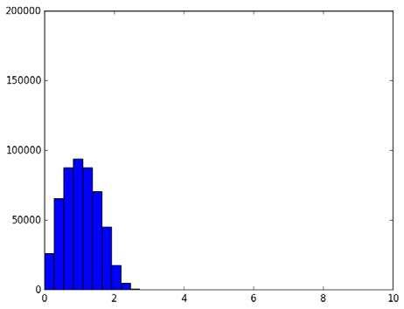

*Animation 7.15: HESS’S LAW OF CONSTANT HEAT SUMMATION*

*Source & Credit :*

[*jeremyku*](https://www.google.com.pk/search?q=Enthalpy+of+Formation&hl=en&biw=1366&bih=599&site=webhp&source=lnms&tbm=isch&sa=X&ved=0ahUKEwi3ia6O0LDLAhVK7xQKHVxzDEgQ_AUIBigB#hl=en&tbs=itp:animated&tbm=isch&q=+HESS%E2%80%99S+LAW+OF+CONSTANT+HEAT+SUMMATION&imgrc=48rj6Z_l3-dBIM%3A)

[*n*](https://www.google.com.pk/search?q=Enthalpy+of+Formation&hl=en&biw=1366&bih=599&site=webhp&source=lnms&tbm=isch&sa=X&ved=0ahUKEwi3ia6O0LDLAhVK7xQKHVxzDEgQ_AUIBigB#hl=en&tbs=itp:animated&tbm=isch&q=+HESS%E2%80%99S+LAW+OF+CONSTANT+HEAT+SUMMATION&imgrc=48rj6Z_l3-dBIM%3A)

It means that if one goes form A to D directly and comes back to A through B and C then ∆H = 0.

The formation of sodium carbonate, is another example for the veriication of Hess’s law. The formation of sodium carbonate may be studied as a single step process, or in two steps as via sodium hydrogen carbonate.

**Single Step Process**

2NaOH(aq) + CO2(g)→ Na CO2 3(aq) + H O H= -89.08 kJ2 (l) ∆

**Two Step Process**

NaOH(aq) + CO2(g) → NaHCO3(aq) H = -48.06 kJ∆ 1

NaHCO3(aq) + NaOH(aq) → Na CO2 3(aq) +H O2 ( ) H = -41.02 kJ∆ 2

According to Hess’s law,

∆H = H + H∆ 1 ∆ 2 ............ (8)

Putting the values of ∆H, ∆H1 , ∆H2 , in equation (8)

-89.08 =-48.06-41.02

-89.08 =-89.08

This illustrates, how heats of reactions may be added algebraically and this proves Hess’s law. Hess’s law inds its best applications in Born-Haber cycle.

**7.5.1 The Bom-Haber Cycle**

This cycle has wide applications. It inds its special applications in Hess’s law. It states that energy change in a cyclic process is always zero. It enables us, to calculate the lattice energies of binary ionic compounds such as M+X-.

The lattice energy of an ionic crystal is the enthalpy of formation of one mole of the ionic compound from gaseous ions under standard conditions.

Thus, the lattice energy of NaCl corresponds to the following process.

Na+(g) + Cl-(g) → Na Cl+ -(s) H∆ oLatt = -787 kJ mol-1

Lattice energies cannot be determined directly but values can be obtained indirectly by means of an energy cycle. In Fig (7.8), an energy triangle of sodium chloride is shown.

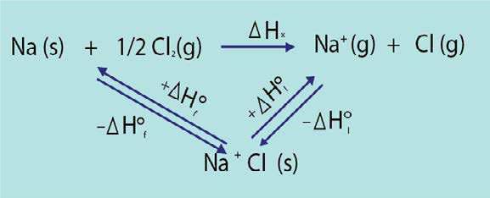

Fig (7.8) Energy triangle for sodium chloride

Since, ∆Hof, the standard enthalpy of formation of sodium chloride, can be measured conveniently in a calorimeter. ∆H°l, can be obtained if ∆Hx, which is the total energy involved in changing sodium and chlorine from their normal physical states to gaseous ions, can be calculated.

In Fig (7.9), the previous energy triangle has been extended to show the various stages involved in inding ∆Hx. The complete energy cycle is called a Born -Haber cycle.

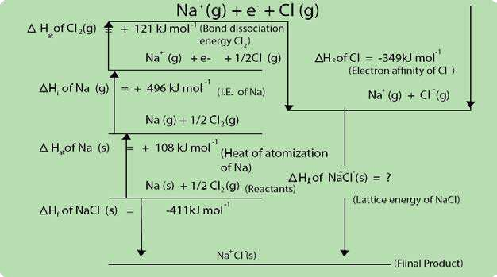

Fig (7.9) Born-Haber cycle

It is clear from the picture of Born-Haber cycle in Fig (7.9) that

∆H = Hx ∆ at(Na) + H∆ i(Na) + H∆ at(Cl) + H∆

e(Cl)

The irst two stages in this process involve atomizing and the ionizing of sodium. The heat of atomization of sodium can be obtained from values of its heat of fusion, heat of vaporization and speciic heat capacity. The irst ionization energy of sodium can be determined spectroscopically.

Na(s) → Na(g) ∆H =108kJ mol*at* -1

Na(g) → Na(g) +1e − ∆H =496kJ mol*i* -1

The third and fourth stages in the expression for ∆Hx above, involve the atomization of chlorine and the conversion of chlorine atoms to chloride ions, respectively. The later process is, of course, called the electron ainity of chlorine.

The heat of atomization of chlorine can be obtained from spectroscopic studies:

Cl2(g) → Cl(g)  H =121 kJ mol∆ at -1

whilst, the electron ainity for chlorine can also be found by similar methods.

Cl(g) + e − → Cl−(g) H∆ *e* = -349 kJ mol-1

Thus ∆H = (108+496+121-349) = 376 kJ molx -1

The lattice energy for sodium chloride can thus be obtained:

∆Hof = H∆ o + H∆ x

∆Ho = H∆ of - H∆ x

Using the values from Fig (7.9)

∆H = -411-376 = -787 kJ mol -1

The lattice energy, gives us some idea of the force of attraction between Na+ and Cl- ions in crystalline sodium chloride. Lattice energies are very helpful in discussing the structure, bonding and properties of ionic compounds.

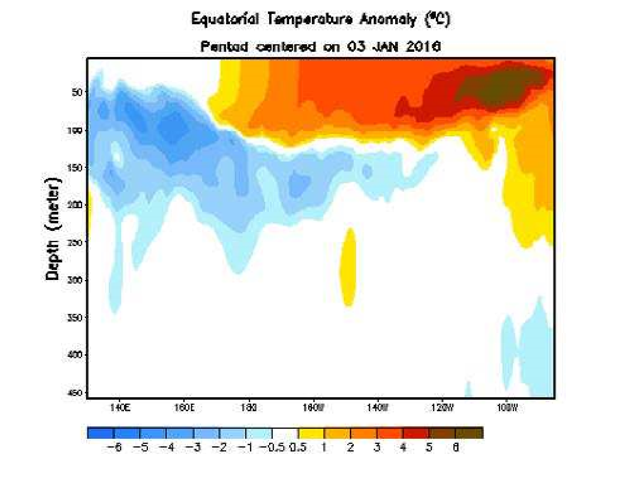

*Animation 7.16: The Bom -H aber Cycle*

*Source & Credit :*

[*climate.go*](https://www.google.com.pk/search?q=Enthalpy+of+Formation&hl=en&biw=1366&bih=599&site=webhp&source=lnms&tbm=isch&sa=X&ved=0ahUKEwi3ia6O0LDLAhVK7xQKHVxzDEgQ_AUIBigB#hl=en&tbs=itp:animated&tbm=isch&q=The+Bom+-H+haber+Cycle&imgrc=skzVkpSI3BwuSM%3A)

[*v*](https://www.google.com.pk/search?q=Enthalpy+of+Formation&hl=en&biw=1366&bih=599&site=webhp&source=lnms&tbm=isch&sa=X&ved=0ahUKEwi3ia6O0LDLAhVK7xQKHVxzDEgQ_AUIBigB#hl=en&tbs=itp:animated&tbm=isch&q=The+Bom+-H+haber+Cycle&imgrc=skzVkpSI3BwuSM%3A)

### KEY POINTS

1. Substances exist because they possess energy. Energy can be transformed in form of heat and the study of heat changes accompanying a chemical reaction is called thermochemistry.
2. Whenever, a reaction happens, then the driving force is the enthalpy change, along with the entropy change. Both these parameters decide upon spontaneity of reaction.
3. Most of the thermodynamic parameters are state functions.
4. First law of themodynamics is the law of conservation of energy and helps us to understand the equivalence of heat and work.
5. When heat is supplied to the system at constant pressure, then it is the enthalpy change of the system. Anyhow, at constant volume, the heat supplied is just equal to internal energy change.
6. There is diference between heat and temperature. The amount of heat evolved or absorbed can be measured in laboratory by using glass calorimeter or bomb calorimeter. The amount of heat is calculated from mass of the reactants, speciic heat and change of temperature. Hess’s law of heat summation is another form of irst law of thermodynamics. It helps us to determine the enthalpy changes of those chemical reactions, which can not be carried out in laboratory or heat changes are diicult to measure.
7. According to Born-Haber cycle, another form of Hess’s law, the energy change in a cyclic process is always equal to zero. With the help of this cycle, we can calculate lattice energy of ionic crystals.

### EXERCISE

Q.1 Select the suitable answer from the given choices.

1. If an endothermic reaction is allowed to take place very rapidly in the air, the temperature of the surrounding air
   1. remains constant (b) increases

(c) decreases (d) remains unchanged

1. In endothermic reactions, the heat content of the
   1. products is more than that of reactants (b) reactants is more than that of products
   2. both (a) and (b)
   3. reactants and products are equal
2. Calorie is equivalent to
   1. 0.4184J (b) 41.84J (c) 4.184J (d) 418.4J
3. The change in heat energy of a chemical reaction at constant temperature and pressure is called
   1. enthalpy change (c) heat of sublimation
   2. bond energy (d) internal energy change
4. Which of the following statements is contrary to the irst law of thermodynamics?
   1. Energy can neither be created nor destroyed.
   2. One form of energy can be transferred into an equivalent amount of other kinds of energy.
   3. In an adiabatic process, the work done is independent of its path.
   4. Continuous production of mechanical work without supplying an equivalent amount of heat is possible.
5. For a given process, the heat changes at constant pressure (qp) and at constant volume (qv) are related to each other as
   1. q =q (b) q <q (c) q >q (d) q =q /p v p v p v p v 2
6. For the reaction: NaOH+HCl → NaCl+H O2 the change in enthalpy is called
   1. heat of reaction (b) heat of formation

(c) heat of neutralization (d) heat of combustion

1. The net heat change in a chemical reaction is same,whether it is brought about in two or more diferent ways in one or several steps. It is known as
   1. Henry’s law (b) Joule’s principle

(c) Hess’s law (d) Law of conservation of energy

1. Enthalpy of neutralization of all the strong acids and strong bases has the same value because(a) neutralization leads to the formation of salt and water.
   1. strong acids and bases are ionic substances.
   2. acids always give rise to H+ ions and bases always furnish OH- ions.
   3. the net chemical change involve the combination of H+ and OH- ions to form water. Q.2 Fill in the blanks with suitable words.
2. The substance undergoing a physical or a chemical change forms a chemical .
3. The change in internal energy__________ be measured.
4. Solids which have more than one crystalline forms possess_______ values of heats of formation.
5. A process is called________ if it takes place on its own without any external assistance.
6. A________ is a macroscopic property of a system which is__________ of the path adopted to bring about that change.

Q.3 Indicate the true or false as the case may be.

1. It is necessary that a spontaneous reaction should be exothermic.
2. Amount of heat absorbed at constant volume is internal energy change.
3. The work done by the system is given the positive sign.
4. Enthalpy is a state function but internal energy is not.
5. Total heat content of a system is called enthalpy of the system.

Q.4 Deine the following terms and give three examples of each

1. System (v) Exothermic reaction
2. Surroundings (vi) Endothermic reaction
3. State function (vii) Internal energy of the system
4. Units of energy (viii) Enthalpy of the system

Q.5

1. Diferentiate between the following:
   * 1. Internal energy and enthalpy
     2. Internal energy change and enthalpy change
     3. Exothermic and endothermic reactions
2. Deine the following enthalpies and give two examples of each.
   * 1. Standard enthalpy of reaction
     2. Standard enthalpy of combustion (iii) Standard enthalpy of atomization

(iv) Standard enthalpy of solution

Q.6 (a) What are spontaneous and non-spontaneous processes. Give examples. (b) Explain that burning of a candle is a spontaneous process.

1. Is it true that a non-spontaneous process never happens in the universe? Explain it.

Q.7 (a) What is the irst law of thermodynamics. How does it explain that

(i) q = Ev ∆ (ii) q = Hp ∆

(b) How will you diferentiate between ∆E and ∆H? Is it true that ∆H and ∆E have the same values for the reactions taking place in the solution state.

Q.8

* + 1. What is the diference between heat and temperature? Write a mathematical relationship between these two parameters.
    2. How do you measure the heat of combustion of a substance by bomb calorimeter.

Q.9 Deine heat of neutralization. When a dilute solution of a strong acid is neutralized by a dilute solution of a strong base, the heat of neutralization is found to be nearly the same in all the cases. How do you account for this?

Q. 10

1. State the laws of thermochemistry and show how are they based on the irst law of thermodynamics.
2. What is a thermochemical equation. Give three examples. What information do they convey?
3. Why is it necessary to mention the physical states of reactants and products in a thermochemical reaction? Apply, Hess’s law to justify your answer.

Q .11

1. Deine and explain Hess’s law of constant heat summation. Explain it with examples and give its application.
2. Hess’s law helps us, to calculate the heats of those reactions, which cannot be normally carried out in a laboratory. Explain it.

Q.12

1. What is lattice energy? How does Born-Haber cycle help to calculate the lattice energy of NaCl?
2. Justify that heat of formation of compound is the sum of all the other enthalpies.

Q. 13 50 cm3 of 1.0 M HCl is mixed with 50 cm3 of 1.00 M NaOH in a glass calorimeter. The temperature of the resultant mixture increases from 21.0°C to 27.5°C. Assume, that calorimeter losses of heat are negligible. Calculate the enthalpy change mole-1 for the reactions. The density of solution to be considered is 1gcm-3 and speciic heat is 4.18Jg-1k-1.

(Ans: -54 kJ mol-1) Q .14 Hydrazine (N2H4) is a rocket fuel. It burns in O2 give N2 and H2O.

N H2 2( ) + O2(g) → N2(g) + 2H O2 (g)

1.00 g of N2H4 is burned in a bomb calorimeter. An increase of temperature 3.510C is recorded. The speciic heat of calorimeter is 5.5kJK-1g-1. Calculate the quantity of heat evolved. Also, calculate the heat of combustion of 1 mole of N2H4.

(Ans: -19.3kJ, -618kJmol-1)

1. 15 Octane (C8H18) is a motor fuel. 1.80 g of a sample of octane is burned in a bomb calorimeter having heat capacity 11.66 kJK-1. The temperature of the calorimeter increases from 21.360C to 28.780C. Calculate the heat of combustion for 1.8g of octane. Also, calculate the heat for 1 mole of octane.

(Ans: 86.51kJ, -5478.84kJmol-1)

* 1. By applying, Hess’s law calculate the enthalpy change for the formation of an aqueous solution of NH4Cl from NH3 gas and HCl gas. The results for the various reactions are as follows.

(i)

(ii) NH3(g) + aq → NH3(aq) H=-35.16kJ mol∆ -1 (iii) HCl(g) + aq → HCl(aq) H=-72.41kJ mol∆ -1

NH3(aq) + HCl(aq) → NH Cl4 (aq) H=-51.48kJ mol∆ -1

( A n s : -159.08 kJ mol-1)

* 1. Calculate the heat of formation of ethyl alcohol from the following information
     1. Heat of combustion of ethyl alcohol is -1367 kJ mol-1
     2. Heat of formation of carbon dioxide is-393.7 kJ mol-1
     3. Heat of formation of water is -285.8 kJ mol-1

(Ans:-278.4 kcal mol-1)

* 1. If the heats of combustion of C2H4, H2 and C2H6 are -337.2, -68.3 and -372.8k calories respectively, then calculate the heat of the following reaction.

C H2 4(g) +H2(g) → C H2 6(g)

* 1. Graphite and diamond are two forms of carbon. The enthalpy of combustion of graphite at 250C is -393.51 kJ mol-1 and that of diamond is -395.41 kJ mol-1. What is the enthalpy change of the process?

Graphite → Diamond at the same temperature?

(Ans: 1.91 kJmol-1)

* 1. What is the meaning of the term enthalpy of ionization? If the heat of neutralization of HCl and NaOH is -57.3 kJ mol-1 and heat of neutralization of CH3COOH with NaOH is -55.2 kJ mol-1, calculate the enthalpy of ionization of CH3COOH.

(Ans: 2.1 kJmol-1)

Q.21

* + 1. Explain what is meant by the following terms.
       1. Atomization energy
       2. Lattice energy
    2. Draw a complete, fully labeled Born-Haber cycle for the formation of potassium bromide. (c) Using the information given in the table below, calculate the lattice energy of potassium bromide.

|  |  |  |
| --- | --- | --- |
| Reactions |  | ∆H/kJ mol-1 |
| K(s) +1 2/ Br2( ) → K Br+ -(s)  K(s) → K(g)  K(g) → K+(g) +e−  1/2Br2( ) → Br(g)  Br +e(g) − → Br−(g) | -392  +90  +420  +112  -342 |  |

(Ans: -672 kJ mol-1)