### 9.8 HYDRATION AND HYDROLYSIS

**9.8.1 Hydration**

When ionic compounds are dissolved in water, they are dissociated into ions. Negative ions are surrounded by water molecules. The partial positively charged hydrogen atoms of water surround and attract the anions with electrostatic forces of attraction. Similarly positive ions of solute create attractions with partial negative oxygen atoms of water molecules. In this way, all the ions in the aqueous solution are hydrated.

The process in which water molecules surround and interact with solute ions or molecules is called hydration.

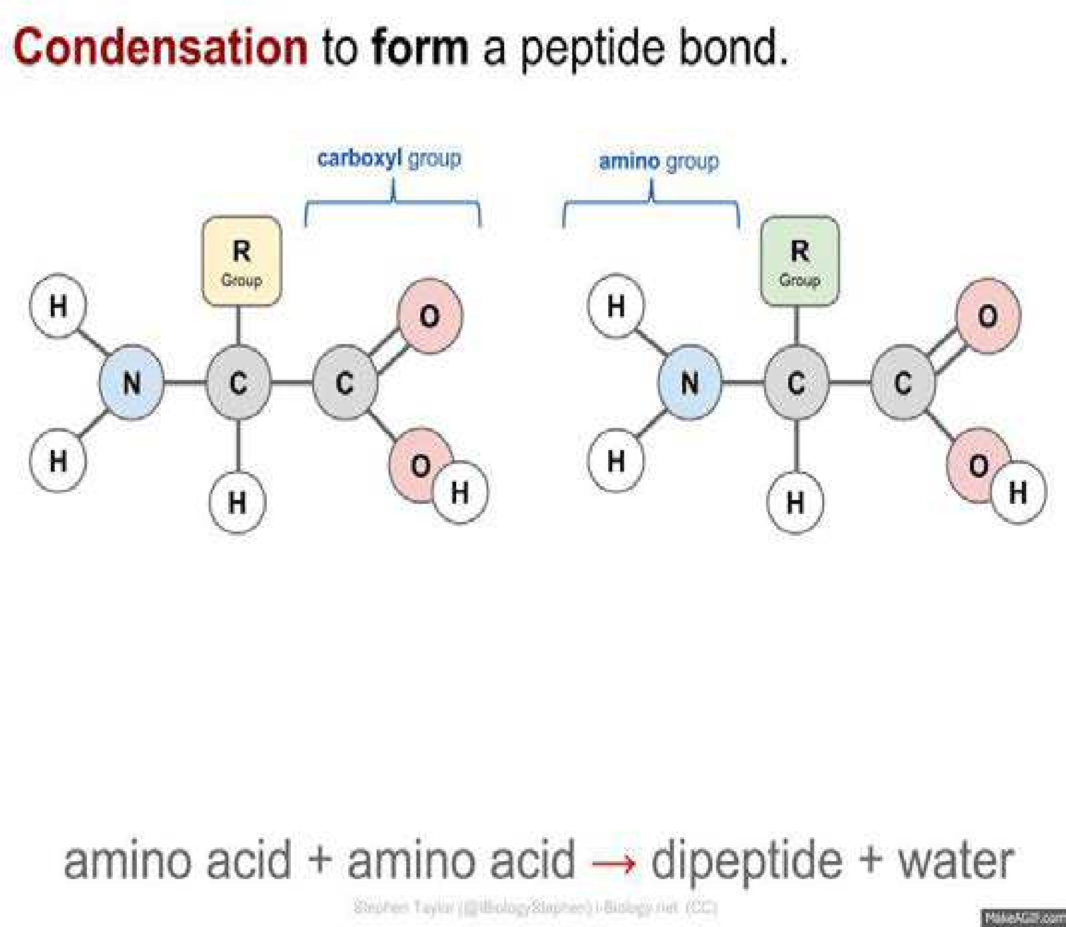

*Animation 9.25: HYDRATION AND HYDROLYSIS*

*Source & Credit: i-biology.net*

The ions, which are surrounded by water molecules, are called hydrated ions. The number of water molecules, which surround a given ion depends upon the size of the ions and the magnitude of its charge (charge/area). If the size of the ion is small and is highly charged positive ion, it has high charge density. Hence, greater number of water molecules will surround it.

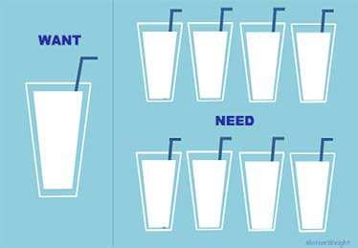

*Animation 9.26: Hydration*

*Source & Credit: rebloggy*

Negatively charged ions have low charge density, and have smaller number of water molecules surrounding them. Hence, the ion with high charge density has a greater ability to attract polar water molecules than ions with smaller charge density.

**9.8.2 Hydrates**

The crystalline substances, which contain chemically combined water in deinite proportions is called a hydrate. Hydrates are mostly, produced when aqueous solution of soluble salt is evaporated. The formation of hydrates is not limited to salts but is common with acids, bases and elements. The water molecules are attached with cations in the hydrates. Anyhow, in CuSO4 .5H20, four water molecules, are attached with Cu2+ and one with SO42-. The reason is that Cu2+ has a greater charge density. The size of Cu2+ is much smaller than SO42-, which has same amount of charge.

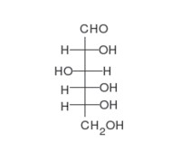

*Animation 9.27: Hydrates*

*Source & Credit: wikipedia*

**Water of Crystallization**

Those water molecules, which combine with substances as they are crystallized from aqueous solutions, are called water of crystallization or water of hydration. Some familiar examples are as follows: (COOH) .2H O2 2 (oxalic acid), BaCl .2H O2 2 , Na CO .10H O2 3 2 , MgCl .6H O2 2 , Na B O .10H O2 4 7 2 (borax), CaSO .2H O4 2 (gypsum), MgSO .7H O4 2 (epsom salt) and AlCl .6H O3 2 .

**9.8.3 Hydrolysis**

When NaCl is dissolved in water, the resulting solution is neutral i.e. the concentration of each of H+ and OH- ions are equal to 10-7 M, as in pure water. But this balance between H+ and OH- ions can be disturbed with resulting change in the pH of solution when other salts are dissolved in water.

It is commonly, observed that diferent salts, upon dissolving in water, do not always form neutral solutions. For example, NH Cl4 , AlCl3 , CuSO4 give acidic solutions in water. On the other hand, Na CO2 3 and CH COONa3 form basic solutions in water. These interactions between salts and water are called hydrolytic reactions and the phenomenon is known as hydrolysis.It involves the reactions of the ions of diferent salts to give acidic or basic solutions. It is the decomposition of compounds with water, in which water itself is decomposed.

The hydrolysis of the salts mentioned above are shown as follows:

NH Cl + H O4 2 ฀ NH OH + H + Cl4 + -

AlCl + 3H O ฀ Al(OH) + 3H + 3Cl+ -

3 2 3

CuSO + 2H O4 2 ฀ Cu(OH) + 2H + SO2 + 42-

These hydrolytic reactions, produce weak bases Al(OH)3 , NH OH4 and Cu(OH)2 . But, Cl- and SO42- are weak conjugate bases of HCl and H2SO4. They are not hydrolysed in water. H+ ions remain free in solution and so their solution are acidic in character.

The Ka values of HCl and H2SO4 are very high as compared to Kb values of Al(OH)3 , NH OH4  and

Cu(OH)2 . For CH COONa3  the reaction with water is

CH COONa + H O3 2 ฀ CH COOH + Na + OH3 + -

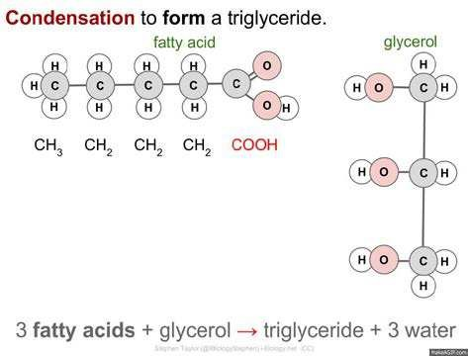

*Animation 9.28: Hydrolysis*

*Source & Credit: i-biology.net*

The acetate ion is hydrolyzed in water to give CH3COOH and OH- becomes free. Na+ is not hydrolysed.

The result is that the solution becomes basic in nature. .Similarly, Na PO3 4 , Na AsO3 4 etc give basic solutions in water due to the formation of a Na+ ,OH- and weak acids Na PO3 4 and H AsO3 4 , which are least dissociated. The dissolution of KCl, Na2SO4, KBr, etc in water give neutral solutions. Because these salts are not hydrolysed in water. Their positive ions K+, Na+ are not hydrolysed by water. Similarly, their negative ions Cl-, Br-, SO42- are also not hydrolysed. It means that the salts of strong bases and strong acids are not hydrolysed by water.

Anyhow, the salts derived from weak acids and weak bases may not give neutral solutions. It depends upon the pKa and pKb values of acid and base produced.

### KEY POINTS

1. A solution, on average, is a homogeneous mixture of two or more kinds of diferent molecular or ionic substances. The substance, which is present in a large quantity is called a solvent and the other in small quantity is, called a solute.
2. Solutions containing relatively lower concentrations of solute are called dilute solutions, whereas those containing relatively higher concentrations of solutes are called concentrated solutions. Solubility is the concentration of a solute in a solution, when the solution is at equilibrium with the solute at a particular temperature.
3. The concentration of a solution may be expressed in a number of ways. i) percentage composition, ii) molarity, iii) molality, iv) mole fraction, v) parts per million.
4. Solutions may be ideal or non-ideal. Those solutions, which obey Raoult’s law are ideal solutions. Raoult’s law tells us that the lowering of vapour pressure of a solvent by a solute, at a constant temperature, is directly proportional to the concentration of solute.
5. Many solutions do not behave ideally, as they show deviations from Raoult’s law. A solution may show positive or negative deviation from Raoult’s law. Such liquid mixtures, which distill without change in composition, are called azeotropic mixtures.
6. Colligative properties of a solution are those properties, which depend on the number of solute and solvent molecules or ions and are independent of the nature of solute. Lowering of vapour pressure, elevation of boiling point and depression of freezing point and osmotic pressure are the important colligative properties of solutions.
7. Elevation of boiling point of a solvent in one molal solution is called molal boiling point constant or ebullioscopic constant. Depression of freezing point of a solvent in one molal solution is called molal freezing point constant or cryoscopic constant.
8. The enthalpy or heat of solution of a substance is the heat change when one mole of the substance is dissolved in a speciied number of moles of solvent at a given temperature.
9. The process in which water molecules surround and interact with solute ions or molecules is called hydration. The crystalline substances, which contain molecules of water in their crystal lattices, are called hydrates. They are mostly produced, when aqueous solutions of soluble alts are evaporated.
10. Salts of weak acids with strong bases react with water to produce basic solutions, whereas salts of weak bases with strong acids react to give acidic solutions. Such reactions are called hydrolytic reactions, and the salts are said to be hydrolysed. Salts of strong acids and strong bases do not hydrolyse and give neutral solution.

### EXERCISE

Q 1. Choose the correct answer for the given ones. i) Molarity of pure water is

(a) 1 (b) 18 (c) 55.5 (d) 6

1. 18 g glucose is dissolved in 90 g of water. The relative lowering of vapour pressure is equal to
   1. 1/5 (b) 5.1 (c) 1/51 (d) 6
2. A solution of glucose is 10% w/v. The volume in which 1 g mole of it is dissolved will be
   1. 1dm3 (b) 1.8dm3 (c) 200cm3 (d) 900cm3
3. An aqueous solution of ethanol in water may have vapour pressure
   1. equal to that of water (b) equal to that of ethanol

(c) more than that of water (d) less than that of water

1. An azeotropic mixture of two liquids boils at a lower temperature than either of them when:
   1. it is saturated
   2. it shows positive deviation from Raoult’s law
   3. it shows negative deviation from Raoult’s law
   4. it is metastabl
2. In azeotropic mixture showing positive deviation from Raoult’s law, the volume of the mixture is
   1. slightly more than the total volume of the components
   2. slightly less than the total volume of the components
   3. equal to the total volume of the components
   4. none of these
3. Which of the following solutions has the highest boiling’point?
   1. 5.85 % solution of sodium chloride (b) 18.0 % solution of glucose

(c) 6.0 % solution of urea (d) All have the same boiling point

1. Two solutions of NaCl and KCl are prepared separately by dissolving same amount of the solute in water. Which of the following statements is true for these solutions?
   1. KCl solution will have higher boiling point than NaCl solution
   2. Both the solutions have diferent boiling points
   3. KCl and NaCl solutions possess same vapour pressure
   4. KCl solution possesses lower freezing point than NaCl solution
2. The molal boiling point constant is the ratio of the elevation in boiling point to
   1. molarity (b) molality

(c) mole fraction of solvent (d) mole fraction of solute

1. Colligative properties are the properties of
   1. dilute solutions which behave as nearly ideal solutions
   2. concentrated solutions which behave as nearly non-ideal solutions
   3. both (i) and (ii)
   4. neither (i) nor (ii)

Q 2. Fill in the blanks with suitable words

1. Number of molecules of sugar in 1 dm3 of 1M sugar solution is______ .
2. 100g of a 10% aqueous solution of NaOH contains 10g of NaOH in______ g of water.
3. When an azeotropic mixture is distilled, its ______ remains constant.
4. The molal freezing point constant is also known as____________ constant.
5. The boiling point of an azeotropic solution of two liquids is lower than either of them because the solution shows___________ from Raoult’s law.
6. Among equimolal aqueous solutions of NaCl, BaCl2 and FeCl3, the maximum depression in freezing point is shown by____________solution.
7. A solution of ethanol in water shows_________ deviations and gives azeotropic solution with________boiling point than other components.
8. Colligative properties are used to calculate____________ of a compound.
9. The hydration energy of Br- ion is__________ than that of F- ion.
10. The acqueous solution of NH4Cl is______ while that of Na2SO4 is_____.

Q 3. Indicate True or False from the given statements

1. At a deinite temperature the amount of a solute in a given saturated solution is ixed.
2. Polar solvents readily dissolve non-polar covalent compounds.
3. The solubility of a substance decreases with increase in temperature, if the heat of a solution is negative.
4. The rate of evaporation of a liquid is inversely proportional to the intermolecular forces of attraction.
5. The molecular mass of an electrolyte determined by lowering of vapour pressure is less than the theoretical molecular mass.
6. Boiling point elevation is directly proportional to the molality of the solution and inversely proportional to boiling point of solvent.
7. All solutions containing 1g of non-volatile non-electrolyte solutes in some solvent will have the same freezing point.
8. The freezing point of a 0.05 molal solution of a non-volatile non-electrolyte in water is -0.93 0C. (ix) Hydration and hydrolysis are diferent process for Na2SO4.

(x) The hydration energy of an ion only depends upon its charge.

Q4. Deine and explain the followings with one example in each case.

|  |  |
| --- | --- |
| (a) A homogeneous phase | (f) Zeotropic solutions |
| (b) A concentrated solution | (g) Heat of hydration |
| (c) A solution of solid in a solid | (h) Water of crystallization |
| (d) A consulate temperature | (i) Azeotropic solution |
| (e) A non-ideal solution | (j) Conjugate solution |

Q5. (a) What are the concentration units of solutions. Compare molar and molal solutions (b) One has one molal solution of NaCl and one molal solution of glucose.

1. Which solution has greater number of particles of solute?
2. Which solution has greater amount of the solvent?
3. How do we convert these concentrations into weight by weight percentage?

Q6. Explain the following with reasons

1. The concentration in terms of molality is independent of temperature but molarity depends upon temperature.
2. The sum of mole fractions of all the components is always equal to unity for any solution.iii) 100 g of 98 % H2SO4 has a volume of 54.34 cm3 of H2SO4 .(Density = 1.84 g cm-3) iv) Relative lowering of vapour pressure is independent of the temperature.

v) Colligative properties are obeyed when the solute is non-electrolyte, and also when the solutions are dilute. vi) The total volume of the solution by mixing 100 cm3 of water with 100 cm’3of alcohol may not be equal to 200 cm3. Justify it. vii) One molal solution of urea, in water is dilute as compared to one molar solution of urea, but the number of particles of the solute is same. Justify it.

viii) Non-ideal solutions do not obey the Raoult’s law.

Q7. What are non ideal solutions? Discuss their types and give three example of each.

Q8.(a) Explain fractional distillation. Justify the two curves when composition is plotted against boiling point of solutions.

(b) The solutions showing positive and negative deviations cannot be fractionally distilled at their speciic compositions. Explain it.

Q9(a) What are azeotropic mixtures? Explain them with the help of graphs? (b) Explain the efect of temperature on phenol-water system.

Q10.(a) What are colligative properties? Why are they called so?

(b) What is the physical signiicance of Kb and Kf values of solvents?

Q 11. How do you explain that the lowering of vapour pressure is a colligative property? How do we measure the molar mass of a non volatile, non- electrolyte solute in a volatile solvent?

Q12. How do you justify that

1. boiling points of the solvents increase due to the presence of solutes.
2. freezing points are depressed due to the presence of solutes.
3. the boiling point of one molal urea solution is 100.52 °C but the boiling point of two molal urea solution is less than 101.040C.
4. Beckmann’s thermometer is used to note the depression in freezing point.
5. in summer the antifreeze solutions protect the liquid of the radiator from boiling over.(f) NaCl and KNO3 are used to lower the melting point of ice.

Q13. What is Raoult’s law. Give its three statements. How this law can help us to understand the ideality of a solution.

Q 14. Give graphical explanation for elevation of boiling point of a solution. Describe one method to determine the boiling point elevation of a solution.

Q 15. Freezing points of solutions are depressed when non-volatile solutes are present in volatile solvents. Justify it. Plot a graph to elaborate your answer. Also, give one method to record the depression of freezing point of a solution.

Q16. Discuss the energetics of solution. Justify the heats of solutions as exothermic and endothermic properties.

Q17.(a) Calculate the molarity of glucose solution when 9 g of it are dissolved in 250 cm3 of solution.

(Ans: 0.2 mol dm-3) (b) Calculate the mass of urea in 100 g of H2O in 0.3 molal solution.

(Ans: 1.8g) (c) Calculate the concentration of a solution in terms of molality, which is obtained by mixing 250 g of 20% solution of NaCl with 200 g of 40 % solution of NaCl.

(Ans: 6.94m) Q18.(a) An aqueous solution of sucrose has been labeled as 1 molal. Find the mole fraction of the solute and the solvent.

(Ans: 0.0176, 0.9823) (b) You are provided with 80% H2SO4 w/w having density 1.8 g cm-3 . How much volume of this H2SO4 sample is required to obtain one dm3 o f 20% w/w H2SO4, which has a density o f 1.25 g cm-3.

(Ans: 173.5cm1) Q19. 250 cm3 of 0.2 molar K2SO4 solution is mixed with 250 cm3 of 0.2 molar KCl solution. Calculate the molar concentration of K+ ions in the solution.

(Ans: 0.3 molar) Q 20. 5g of NaCl are dissolved in 1000 g of water. The density of resulting solution is 0.997 g/cm3. Calculate molality, molarity and mole fraction of this solution. Assume that the vol ume of the solution is equal to that of solvent.

(Ans: M = 0.08542, m = 0.0854, Mole fraction of NaCl= 0.00154, Mole fraction of H2O =0.9984.)

Q 21. 4.675g of a compound with empirical formula C3H3O were dissolved in 212.5 g of pure benzene. The freezing point of solution, was found 1.020C less than that of pure benzene. The molal freezing point constant of benzene is 5.10C. Calculate (i) the relative molar mass and (ii) the molecular formula of the compound.

(Ans:110gmol-1, C6H6O2)

Q 22. The boiling point of a solution containing 0.2 g of a substance A in 20.0 g of ether (molar mass = 74) is 0.17 K higher than that of pure ether. Calculate the molar mass of A. Molal boiling point constant of ether is 2.16 K.

(Ans: 127gmol-1)

Q 23. 3 g of a non-volatile, non-electrolyte solute ‘X’ are dissolved in 50 g of ether (molar mass = 74) at 293 K. The vapour pressure of ether falls from 442 torr to 426 torr under these conditions.

Calculate the molar mass of solute ‘X’.

(Ans: 122.6 g mol-1)

CHAPTER

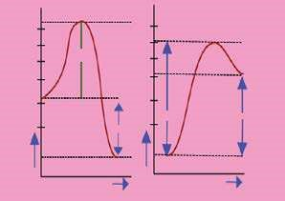

## 11 REACTION KINETICS

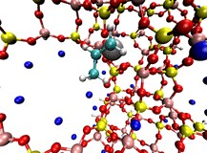

Animation 11.1: Spectrometer

Source & Credit: eLearn

### 11.0.0 INTRODUCTION

It is a common observation that rates of chemical reactions difer greatly. Many reactions, in aqueous solutions, are so rapid that they seem to occur instantaneously. For example, a white precipitate of silver chloride is formed immediately on addition of silver nitrate solution to sodium chloride solution. Some reactions proceed at a moderate rate e.g. hydrolysis of an ester. Still other reactions take a much longer time, for example,the rusting of iron, the chemical weathering of stone work of buildings by acidic gases in the atmosphere and the fermentation of sugars.

The studies concerned with rates of chemical reactions and the factors that afect the rates of chemical reactions constitute the subject matter of reaction kinetics. These studies also throw light on the mechanisms of reactions. All reactions occur in single or a series of steps. If a reaction consists of several steps, one of the steps will be the slowest than all other steps. The slowest step is called the rate determining step. The other steps will not afect the rate. The rates of reactions and their control are often important in industry. They might be the deciding factors that determine whether a certain chemical reaction may be used economically or not. Many factors inluence the rate of a chemical reaction. It is important to discover the conditions under which the reaction will proceed most economically.

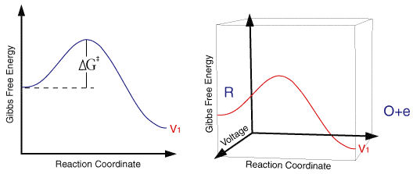

*Animation 11.2: Kinetics*

*Source & Credit :*

[*ceb.ca*](http://www.ceb.cam.ac.uk/research/groups/rg-eme/teaching-notes/electrode-kinetics)

[*m*](http://www.ceb.cam.ac.uk/research/groups/rg-eme/teaching-notes/electrode-kinetics)

### 11.1.0 RATE OF REACTION

During a chemical reaction, reactants are converted into products. So the concentration of the products increases with the corresponding decrease in the concentration of the reactants as they are being consumed.

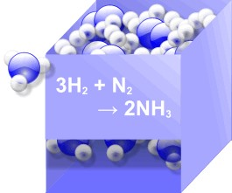

*Animation 11.3: RATE OF REACTION*

*Source & Credit :*

[*blob*](http://www.blobs.org/science/article.php?article=42)

[*s*](http://www.blobs.org/science/article.php?article=42)

The situation is explained graphically in Fig.(11.1) for the reactant A which is changing irreversibly to the product B.

The slope of the graph for the reactant or the product is the steepest at the beginning. This shows a rapid decrease in the concentration of the reactant and consequently, a rapid increase in the concentration of the product. As the reaction proceeds, the slope becomes less steep indicating that the reaction is slowing down with time. It means that the rate of a reaction is changing every moment. The following curve for reactants should touch the time axis in the long run. This is the stage of completion of reaction. The rate of a reaction is deined as the change in concentration of a reactant or a product divided by the tim e taken for the change.

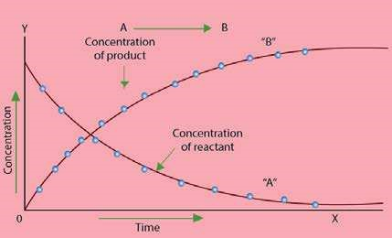

Fig. (11.1) Change in the concentration of reactants and products with time for the reaction

A → B

The rate of reaction has the units of concentration divided by time. Usually the concentration is expressed in mol dm-3 and the time in second, thus the units for the reaction rate are mol dm-3s-1.

change in concentration of the substance

Rate of reaction = time taken for the change

For a gas phase reaction, units of pressure are used in place of molar concentrations. It follows from the above graph that the change in concentration of the reactant A or the product B is much more at the start of reaction and then it decreases gradually.

So the reaction rate decreases with time. It never remains uniform during diferent time periods. It decreases continuously till the reaction ceases.

mol dm-3 -3 -1

Rate of reaction = = mol dm s

seconds

**11.1.1 Instantaneous and Average Rate**

The rate at any one instant during the interval is called the instantaneous rate. The rate of reaction between two speciic time intervals is called the average rate of reaction.

The average rate and instantaneous rate are equal for only one instant in any time interval. At irst, the instantaneous rate is higher than the average rate. At the end of the interval the instantaneous rate becomes lower than the average rate. As the time interval becomes smaller, the average rate becomes closer to the instantaneous rate.

The average rate will be equal to the instantaneous rate when the time interval approaches zero. Thus the rate of reaction is instantaneous change in the concentration of a reactant or a product at a given moment of time.

dx

Rate of reaction =

dt

Where dx is a very small change in the concentration of a product in a very small time interval dt. Hence, dx/dt is also called rate of change of concentration with respect to time.

The rate of a general reaction, A → B, can be expressed in terms of rate of disappearance of the reactant A or jthe rate of appearance of the product B. Mathematically,

-d[A] d[B]

Rate of reaction = = + dt dt

Where d[A] and d[B] are the changes in the concentrations of A and B, respectively. The negative sign in the term indicates a decrease in the concentration of the reactant A. Since the concentration of product increases with time, the sign in rate expression involving the change of concentration of product is positive.

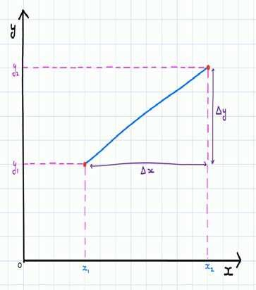

*Animation 11.4: Average and Instantaneous Rate of Change*

*Source & Credit :*

[*brillian*](https://brilliant.org/wiki/instantaneous-rate-of-change/)

[*t*](https://brilliant.org/wiki/instantaneous-rate-of-change/)

#### 11.1.2 Speciic Rate Constant or Velocity Constant

The relationship between the rate of a chemical reaction and the active masses, expressed as concentrations, of the reacting substances is summarized in the law of mass action. It states that the rate of reaction is proport ional to the active mass of the reactant or to the product of active masses if more than one reactants are involved in a chemical reaction.

For dilute solutions, active mass is considered as equal to concentration. By applying the law of mass action to a general reaction.

aA + bB → cC + dD

Rate of reaction = k [A] [Ba ]b

This expression is called rate equation. The brackets [ ] represent the concentrations and the proportionality constant k is called rate constant or velocity constant for the reaction.

If [A] = 1 mol dm and [B] = 1 mol dm-3 -3

Rate of reaction = k × 1 × 1 = ka b

Hence the speciic rate constant of a chemical reaction is the rate of reaction when the concentrations of the reactants are unity. Under the given conditions, k remains constant, but it changes with temperature.



*Animation 11.5: Velocity Constant*

*Source & Credit :*

[*wiki*](http://powerlisting.wikia.com/wiki/Absolute_Constant_Velocity)

[*a*](http://powerlisting.wikia.com/wiki/Absolute_Constant_Velocity)

**11.1.3 Order of Reaction**

For a general reaction between A and B where ‘a’ moles of A and ‘b’ moles of B react to form ’c’ moles of C and ’d’ moles of D.

aA + bB → cC + dD

We can write the rate equation as:

R =k [A] [B]a b

The exponent ’a’ or ‘b’ gives the order of reaction with respect to the individual reactant. Thus the reaction is of order ‘a’ with respect to A and of order b with respect to B. The overall order of reaction is (a+b). The order of reaction is given by the sum of all the exponents to which the concentrations in the rate equation are raised. The order of reaction may also be deined as the number of reacting molecules, whose concentrations alter as a result of the chemical change.

It is important to note that the order of a reaction is an experimentally determined quantity and can not be inferred simply by looking at the reaction equation. The sum of the exponents in the rate equation may or may not be the same as in a balanced chemical equation. The chemical reactions are classiied as zero, irst, second and third order reactions. The order of reaction provides valuable information about the mechanism of a reaction.



*Animation 11.6: Rate and Order of Reac-*

*tion*

*Source & Credit :*

[*science.uwaterlo*](http://www.science.uwaterloo.ca/~cchieh/cact/c123/rate.html)

[*o*](http://www.science.uwaterloo.ca/~cchieh/cact/c123/rate.html)

#### Examples of Reactions Showing Different Orders

1. Decomposition of nitrogen pentoxide involves the following equation.

2N O (g) 2 5 → 2N O (g) + O (g2 4 2 )

The experimentally determined rate equation for this reaction is as follows:

Rate = k[N O ]2 5

This equation suggests that the reaction is irst order with respect to the concentration of N2O5.

1. Hydrolysis of tertiary butyl bromide

3

CH

3

CH

3

CH

C

2

Br + H O

→

3

CH

C

OH + HBr

3

CH

3

CH

The rate equation determined experimentally for this reaction is

Rate = k[(CH ) CBr]3 3

The rate of reaction remains efectively independent of the concentration of water because, being a solvent, it is present in very large excess. Such type of reactions have been named as pseudo irst order reactions.

1. Oxidation of nitric oxide with ozone has been shown to be irst order with respect to NO and irst order with respect to O3. The sum of the individual orders gives the overall order of reaction as two.

NO(g)+O (g)3 → NO (g)+O (g)2 2

Rate = k[NO][O ]3

1. Consider the following reaction

2FeCl (aq) + 6KI(aq3 ) → 2FeI (aq) + 6KCI(aq) + I2 2

This reaction involves eight reactant molecules but experimentally it has been found to be a third order reaction.

Rate = k[FeCl ][KI]3 2

This rate equation suggests that the reaction is, in fact, taking place in more than one steps.

The possible steps of the reaction are shown below.

FeCl (aq) + 2KI(aq)3 →slow FeI (aq) + 2KCI(aq) + Cl (aq)2 −

2KI(aq) + 2Cl (aq- ) →fast 2KCl(aq) + I (s2 )

1. The order of a reaction is usually positive integer or a zero, but it can also be in fraction or can have a negative value. Consider the formation of carbon tetrachloride from chloroform.

CHCl ( )+Cl (g)3  2 → CCl ( )+HCl(g)4 

Rate = k[CHCl ][Cl ]3 2 1/2

The sum of exponents will be 1 + 1/2= 1.5, so the order of this reaction is 1.5.

From the above examples, it is clear that order of reaction is not necessarily depending upon the coeients of balanced equation. The rate equation is an experimental expression. A reaction is said to be zero order if it is entirely independent of the concentration of reactant molecules. Photochemical reactions are usually zero order.

##### 11.1.4 Half Life Period

Half life period of a reaction is the time required to convert 50% of the reactants into products. For example, the half life period for the decomposition of N2O5 at 45°C is 24 minutes.

It means that if we decompose 0.10 mole dm-3 of N2O5 at 45 °C, then after 24 minutes 0.05 mole dm-3 of N2O5 will be left behind. Similarly after 48 minutes 0.025(25%) mole dm-3 of N2O5 will remain unreacted and after 72 minutes (3 half times) 0.0125 (12.5%) mole dm-3 of N2O5, will remain unreacted.

Decomposition of N2O5 is a irst order reaction and the above experiment proves that the half-life period of this reaction is independent of the initial concentration of N2O5. This is true for all irst order reactions. The disintegration of radioactive 23592 U has a half-life of 7.1x108 or 710 million years. If one kilogram sample disintegrates, then 0.5 kg of it is converted to daughter elements in 710 million years. Out of 0.5 kg of 23592 U , 0.25kg disintegrates in the next 710 million years. So, the half-life period for the disintegration of a radioactive substance is independent of the amount of that substance.

What is true for the half-life period of irst order reactions does not remain true for the reactions having higher orders. In the case of second order reaction, the half-life period is inversely proportional to the initial concentration of the reactant. For a third order reaction, half life is inversely proportional to the square of initial concentration of reactants. Briely we can say that

[t1/2 1] ∝ 1o , scince[t1/2 1] = 0.693 a k

1 1

[t1/2 2] ∝ a1 , scince[t1/2 2] = ka

[t1/2 3] ∝ 12 , scince[t1/2 3] = 1.52 a ka

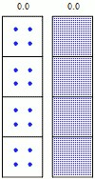

*Animation 11.7: Half Life*

*Source & Credit :*

[*askiitian*](http://www.askiitians.com/iit-jee-radioactive-decay-of-substances/calculate-half-life-of-radioactive-substance/)

[*s*](http://www.askiitians.com/iit-jee-radioactive-decay-of-substances/calculate-half-life-of-radioactive-substance/)

Where [t1/2 1] , [t1/2 2] , and [t1/2 3] are the half-life periods for 1st, 2nd and 3rd order reactions respectively and ‘a’ is the initial concentration of reactants. In general for the reaction of nth order:

[t1/2 n] ∝ 1n-1

a

The half-life period of any order reaction is, thus, inversely proportional to the initial concentration raised to the power one less than the order of that reaction. So, if one knows the initial concentration and half-life period of a reaction, then order of that reaction can be determined.

**Example 1:**

Calculate the half-life period of the following reaction when the initial concentration of HI is 0.05 M.

2HI(g) ฀ H (g) + I (g)2 2

The value of rate constant k = 0.079 dm3 mol-1 s-1 at 508 °C and rate expression is

Rate = k[HI]2

**Solution:**

According to the rate expression it is a second order reaction. The half life paired of a second order reaction is

  1 1

 t 1 = 2-1 =

 2 2 ka ka

Putting the values of k and a.

So,   t 1 = 1 = 3 -1 -11 -3 = 1 sec.

  k x a (0.079dm mol s )(0.050moldm ) 0.079 x 0.05

2 2

 

 t 1 = 253secAnswer

 

2 2

So, in 253 seconds, the half of HI i.e., 0.05/2=0.025 moles is decomposed.

**11.1.5 Rate Determining Step**

Finding out the rate equation of a reaction experimentally is very useful. Actually it gives us an opportunity to look into the details of reaction. Rate equation of example (4) in article 11.1.3 showed clearly that the reaction is taking place in more than one steps. There are many such reactions in chemistry which occur in a series of steps.

If a reaction occurs in several steps, one of the steps is the slowest. The rate of this step determines the overall rate of reaction. This slowest step is called the rate determining or rate limiting step. The total number of molecules of reacting species taking part in the rate determining step appear in the rate equation of the reaction.

Let us consider the following reaction

NO (g) + CO(g)2 → NO(g) + CO (g)2

The rate equation of the reaction is found to be

Rate = k[NO ]2 2

This equation shows that the rate of reaction is independent of the concentration of carbon monoxide. In other words the equation tells us that reaction involves more than one steps and two molecules of NO2 are involved in the rate determining step. The proposed mechanism for this reaction is as follows.

NO (g) + NO (g)2 2 →slow NO (g) + NO(g)3 (rate determining step)

NO (g) + CO(g)3 →fast NO (g) + CO (g)2 2

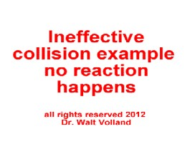

*Animation 11.8: Rate Determining Step*

*Source & Credit :*

[*800mainstree*](http://www.800mainstreet.com/7/0007-005-rea-t-cat.html)

[*t*](http://www.800mainstreet.com/7/0007-005-rea-t-cat.html)

The irst step is the rate determining step and NO3 which does not appear in the inal balanced equation, is called the reaction intermediate. The reaction intermediate has a temporary existence and it is unstable relative to the reactants and the products. This is a species with normal bonds and may be stable enough to be isolated under special conditions. This reaction is a clear example of the fact that a balanced chemical equation may not give any information about the way the reaction actually takes place.

### 11.2.0 DETERMINATION OF THE RATE OF A CHEMICAL REACTION

Determination of the rate of a chemical reaction involves the measurement of the concentration of reactants or products at regular time intervals as the reaction progresses. When the reaction goes on, the concentrations of reactants decrease and those of products increase. The rate of a reaction, therefore, is expressed in terms of the rates at which the concentrations change.

∆C mol dm-3  Rate of reaction = =

∆t seconds

=mol dm s-3 -1

Suppose, the concentration of a reactant of any chemical reaction changes by 0.01 mol dm-3

in one second, then rate of reaction is, 0 .01 mole dm-3 s-1.

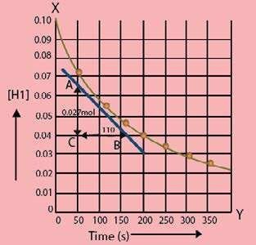 Rate of a chemical reaction always decreases with the passage of time during the progress of reaction. To determine the rate of reaction for a given length of time, a graph is plotted between time on x-axis and concentration of reactant on y-axis whereby a curve is obtained.

To illustrate it, let us investigate the decomposition of HI to H2 and I2 at 508°C. Table(11.1) tells us that the change in concentration of HI for irst 50 seconds is 0.0284 mol dm-3 but between 300 to 350 sec, the decrease is 0.0031 mol dm3. By using the data, a graph is plotted as shown in Fig (11.2). The graph is between time on x-axis and concentration of HI in mol dm-3 on y-axis. Since HI is a reactant, so it is a falling curve. The steepness of the concentration-time curve relects the progress

of reaction. Greater the slope of curve near the Fig.(l1.2) T he change in the HI concentration with time for the start of reaction, greater is the rate of reaction. reaction 2HI(g) ฀ H (g) + I (g)2 2 at 508°C.

**Table (11.1) Change in**

#### concentration of HI with regular

**intervals** 2HI(g) ฀ H (g) + I (g)2 2

|  |  |
| --- | --- |
| Concentration of HI (mol dm-3) | Time (s) |
| 0.100  0.0716 0.0558 0.0457 0.0387 0.0336 0.0296  0.0265 | 0  50  100  150  200  250  300  350 |

In order to measure the rate of reaction, draw a tangent say, at 100 seconds, on the curve and measure the slope of that tangent. The slope of the tangent is the rate of reaction at that point i.e., after 100 seconds. A right angled triangle ABC is completed with a tangent as hypotenuse. Fig.

(11.2) shows that in 110 sec, the change in concentration is 0.027 mole dm-3, and hence the

0.027mol dm-3

Slope or rate =

110 sec

=2.5x10-4 mol dm s-3 -1



*Animation 11.9: Chemical Reaction Rates*

*Source & Credit :*

[*crescento*](http://crescentok.com/staff/jaskew/isr/chemistry/class19.htm)

[*k*](http://crescentok.com/staff/jaskew/isr/chemistry/class19.htm)

This value of rate means that in a period of one sec in 1 dm3 solution, the concentration of HI disappears by 2.5 x 10-4 moles, changing into the products.

The right angled triangle ABC can be of any size, but the results for the rate of reaction will be the same.

If we plot a graph between time on x-axis and concentration of any of the products i.e H2 or I2, then a rising curve is obtained. The value of the tangent at 100 seconds will give the same value of rate of reaction as 2.5 x 10-4 mol dm-3S-1.

The change in concentrations of reactants or products can be determined by both physical and chemical methods depending upon the type of reactants or products involved.

##### 11.2.1 Physical Methods

Some of the methods used for this purpose cure the following: In these methods, a curve has to be plotted as mentioned in 11.2.0. The nature of the curve may be rising for products and falling for reactants. Anyhow, the results will be same for the same reaction under the similiar conditions.

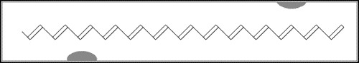

*Animation 11.10: Electrical Conductivity of materials focused on polymer*

*Source & Credit :*

[*wikido*](http://electrons.wikidot.com/create-new-page)

[*t*](http://electrons.wikidot.com/create-new-page)

##### (i) Spectrometry

This method is applicable if a reactant or a product absorbs ultraviolet, visible or infrared radiation. The rate of reaction can be measured by measuring the amount of radiation absorbed.

##### (ii) Electrical Conductivity Method

The rate of a reaction involving ions can be studied by electrical conductivity method. The conductivity of such a solution depends upon the rate of change of concentration of the reacting ions or the ions formed during the reaction. The conductivity will be proportional to the rate of change in the concentration of such ions.

##### (iii) Dilatometric Method

This method is useful for those reactions, which involve small volume changes in solutions. The volume change is directly proportional to the extent of reaction.

##### (iv) Refractrometric Method

This method is applicable to reactions in solutions, where there are changes in refractive indices of the substances taking part in the chemical reactions.

##### (v) Optical Rotation Method

In this method, the angle through which plane polarized light is rotated by the reacting mixture is measured by a polarimeter. The extent of rotation determ ines the concentration of optically active substance. If any of the species in the reaction mixture is optically active, then this method can be followed to ind out the rate of reaction.

###### **11.2.2 Chemical Method**

This is particularly suitable for reactions in solution. In this method, we do the chemical analysis of a reactant or a product.

The acid hydrolysis of an ester (ethyl acetate) in the presence of a small amount of an acid is one of the best examples.

3 2 5 2 ฀ ฀฀฀฀฀฀฀฀฀฀฀฀฀H (catalyst)+ CH COOH( ) + C H OH( )3  2 5  CH COOC H ( ) + H O( ) 

In case of hydrolysis of an ester, the solution of ester in water and the acid acting as a catalyst are allowed to react. After some time, a sample of reaction mixture is withdrawn by a pipette and run into about four times its volume of ice cold water. The dilution and chilling stops the reaction. The acid formed is titrated against a standard alkali, say NaOH, using phenolphthalein as an indicator.

The analysis is repeated at various time intervals after the start of reaction. This would provide an information about the change in concentration of acetic acid formed during the reaction at diferent time intervals. The diferent concentrations of acetic acid are plotted against the time whereby a rising curve is obtained as shown in Fig (11.3).

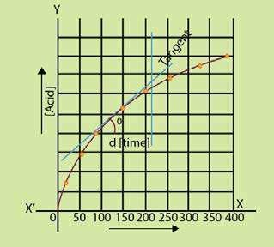

Fig. (11.3 ) Measurement of rate of ester hydrolysis

The slope of the curve at any point will give the rate of reaction. Initially, the rate of reaction is high but it decreases with the passage of time. When the curve becomes horizontal, the rate becomes zero.

If we plot the graph for decreasing concentrations of CH3COOC2H5, then falling curves are obtained as shown in Fig.(11.2) If we have any laboratory technique to record the changing concentration of ester or alcohol, we can measure the rate of the reaction. This is a pseudo irst order reaction. Actually water being in large excess in comparison to ester does not afect the rate and we think that water is not taking part in the reaction.

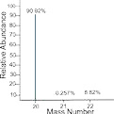

*Animation 11.11: Chemical Method*

*Source & Credit :*

[*fg-*](http://www.fg-a.com/clipart_science_2.shtml)

[*a*](http://www.fg-a.com/clipart_science_2.shtml)

### 11.3. ENERGY OF ACTIVATION

For a chemical reaction to take place, the particles atoms, ions or molecules of reactants must form a homogeneous mixture and collide with one another. These collisions may be efective or inefective depending upon the energy of the colliding particles. When these collisions are efective they give rise to the products otherwise the colliding particles just bounce back. The efective collisions can take place only when the colliding particles will possess certain amount of energy and they approach each other with the proper orientation. The idea of proper orientation means that at the time of collision, the atoms which are required to make new bonds should collide with each other. The minimum amount of energy, required for an efective collision is called activation energy.

If all the collisions among the reacting species at a given temperature are efective in forming the products, the reaction is completed in a very short time. Most of the reactions, are, however, slow showing that all the collisions are not equally efective.

Let us study a reaction between molecules A2 and B2 to form a new molecule AB. If these molecules will have energy equal to or more than the activation energy, then upon collisions their bonds will break and new bonds will be formed. The phenomenon is shown in Fig. (11.4)

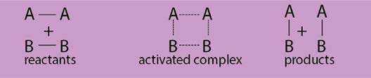

Fig. (11.4) Collisions of molecules, formation of activated complex and formation of products

Activated complex is an unstable combination of all the atoms involved in the reaction for which the energy is maximum. It is a short lived species and decomposes into the products immediately. It has a transient existence, that is why it is also called a transition state.

When the colliding molecules come close to each other at the time of collision, they slow down, collide and then ly apart. If the collision is efective then the molecules lying apart are chemically diferent otherwise the same molecules just bounce back.

When the molecules slow down just before the collision, their kinetic energy decreases and this results in the corresponding increase in their potential energy. The process can be understood with the help of a graph between the path of reaction and the potential energy of the reacting molecules. Fig. (11.5a,b)

The reactants reach the peak of the curve to form the activated complex. Ea is the energy of activation and it appears as a potential energy hill between the reactants and the products. Only, the colliding molecules with proper activation energy, will be able to climb up the hill and give the products. If the combined initial kinetic energy of the reactants is less than Ea, they will be unable to reach the top of the hill and fall back chemically unchanged.

This potential energy diagram can also be used to study the heat evolved or absorbed during the reaction. The heat of reaction is equal to the diference in potential energy of the reactants and the products. For exothermic reactions, the products are at a lower energy level than the reactants and the decrease in potential energy appears as increase in kinetic energy of the products Fig. (11.5a). For endothermic reactions, the products are at higher energy level than the reactants and for such reactions a continuous source of energy is needed to complete the reaction Fig. (11.5b).

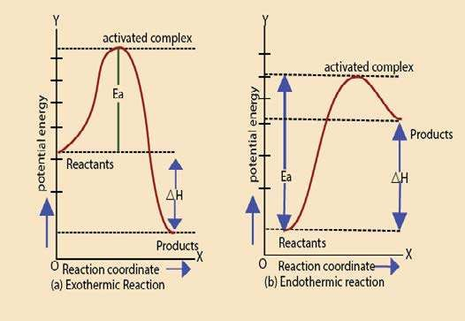

Fig. (11.5) A graph between path of reaction and the potential energy of the reaction

The energy of activation of forward and backward reactions are diferent for all the reactions. For exothermic reactions the energy of activation of forward reaction is less than that of backward reaction, while reverse is true for endothermic reactions. Energy of activation of a reaction provides a valuable information about the way a reaction takes place and thus helps to understand the reaction.

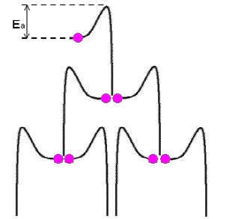

*Animation 11.12: Activation Energy and Spontaneous reactions*

*Source & Credit :*

[*thompson*](http://thompsona.free.fr/Activation_Energy_and_Spontaneous_reactions.html)

[*a*](http://thompsona.free.fr/Activation_Energy_and_Spontaneous_reactions.html)

### 11.4 FINDING THE ORDER OF REACTION

The order of a reaction is the sum of exponents of the concentration terms in the rate expression of that reaction.

It can be determined by the following methods.

1. Method of hit and trial
2. Graphical method
3. Diferential method
4. Half life method
5. Method of large excess

Here we will only discuss half-life method and the method of large excess.

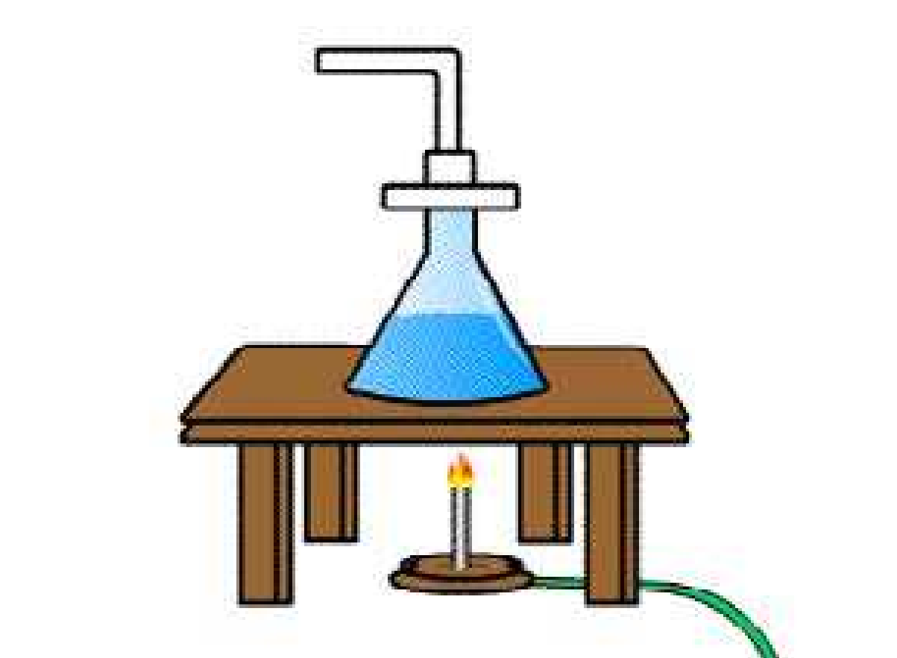

*Animation 11.13: Determination of Order of a Reaction*

*Source & Credit :*

[*askiitian*](http://www.askiitians.com/iit-jee-physical-chemistry/chemical-kinetics/methods-for-determination-of-order-of-reaction.aspx)

[*s*](http://www.askiitians.com/iit-jee-physical-chemistry/chemical-kinetics/methods-for-determination-of-order-of-reaction.aspx)

#### 11.4.1 Half Life Method

As mentioned earlier, half life of a reaction is inversely proportional to the initial concentration of reactants raised to the power one less than the order of reaction.

Therefore, (t1/2 )n ∝ 1n-1

a

Let us perform a reaction twice by taking two diferent initial concentrations ‘a1’ and ‘a2’ and their half-life periods are found to be t1 and t2 respectively.

|  |  |
| --- | --- |
| t1 ∝ 1n-1 a1 | and t2 ∝ 1n-1 a2 |
| Dividing the two relations: | t  a n-1 1 2  =  t2  a1 |
| Taking log on both sides: | t  a log 1 =(n-1)log 2 |

t2  a1

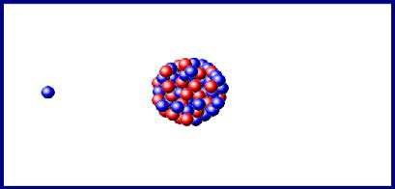

*Animation 11.14: Half Life*

*Source & Credit :*

[*wikipedi*](https://en.wikipedia.org/wiki/Half-life)

[*a*](https://en.wikipedia.org/wiki/Half-life)

 t1 log  n 1− =  t2

 a2 log 

 a1

 t1 log 

Rearranging n = +1  t2

 a2 log   a1

So, if we know the two initial concentrations and two half life values we can calculate the order of reaction (n).

**Example 2:**

In the thermal decomposition of N2O at 760 °C, the time required to decompose half of the reactant was 255 seconds at the initial pressure of 290 mm Hg and 212 seconds at the initial pressure of 360 mmHg. Find the order of this reaction.

**Solution:**

The initial pressures of N2O(g) are the initial concentrations.

Data a = 290mm Hg1 t = 255 seconds1

a = 360mm Hg2 t = 212 seconds2

Formula used

 t1 log 

n = +1  t2

 a2 log   a1

Putting the values in the above equation

255

log

n = +1 212

360

log290

0.0802

n = 1+

0.0940

n = 1 + 0.85 = 1.85 ≈ 2

1.85 is close to 2, hence the reaction is of second order.

#### 11.4.2 Method of Large Excess

In this method, one of the reactants is taken in a very small amount as compared to the rest of the reactants. The active masses of the substances in large excess remain constant throughout. That substance taken in small amount controls the rate and the order is noted with respect to that. The reason is that a small change in concentration of a substance taken in very small amount afects the value of rate more appreciably. The hydrolysis of ethyl acetate as mentioned earlier shows that water being in large excess does not determine the order.

In this way, the reaction is repeated by taking rest of the substances in small amounts one by one and overall order is calculated. The method will be further elaborated in article 11.5.2.

### 11.5. FACTORS AFFECTING RATES OF REACTIONS

All those factors which change the number of efective collisions per second, afect the rate of a chemical reaction. Some of the important factors are as follows.

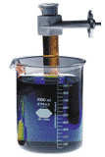

*Animation 11.15: FACTORS AFFECTING*

*RATES OF REACTIONS*

*Source & Credit :*

[*askiitian*](http://www.askiitians.com/iit-jee-physical-chemistry/chemical-kinetics/factors-effecting-rate-of-reaction.aspx)

[*s*](http://www.askiitians.com/iit-jee-physical-chemistry/chemical-kinetics/factors-effecting-rate-of-reaction.aspx)

**11.5.1 Nature of Reactants**

The rate of reaction depends upon the nature of reacting substances. The chemical reactivity of the substances is controlled by the electronic arrangements in their outermost orbitals. The elements of I-A group have one ejectron in their outermost s-orbital. They react with water more swiftly than those of II-A group elements having two electrons in their outermost s-orbital. Similarly, the neutralization and double decomposition reactions are very fast as compared to those reactions in which bonds are rearranged. Oxidation-reduction reactions involve the transfer of electrons and are slower than ionic reactions.

**11.5.2 Concentration of Reactants**

The reactions are due to collisions of reactant molecules. The frequency with which the molecules collide depends upon their concentrations. The more crowded the molecules are, the more likely they are to collide and react with one another. Thus, an increase in the concentrations of the reactants will result in the corresponding increase in the reaction rate, while a decrease in the concentrations will have a reverse efect. For example, combustion that occurs slowly in air (21 % oxygen) will occur more rapidly in pure oxygen.

Similarly, limestone reacts with diferent concentrations of hydrochloric acid at diferent rates. In the case of a gaseous reactant, its concentration can be increased by increasing its pressure. Therefore, a mixture of H2 and Cl2 will react twice as fast if the partial pressure of H2 or Cl2 is increased from 0.5 to 1.0 atmosphere in the presence of excess of the other component.

The efect of change in concentration on the rate of a chemical reaction can be nicely understood from the following gaseous reaction.

2NO(g) + 2H (g2 ) → 2H O(g) + N (g2 2 )



*Animation 11.16: Reactants*

*Source & Credit :*

[*giph*](http://giphy.com/search/reactants)

[*y*](http://giphy.com/search/reactants)

In this reaction, four moles of the reactants form three moles of the products, so the pressure drop takes place during the progress of reaction. The rates of reaction between NO and H2 at 800°C are studied by noting the change in pressure. The following Table (11.2 ) has been obtained experimentally for the above reaction.

#### Table (11.2) Effect of change in concentrations of reactants on the rate of reaction

|  |  |  |
| --- | --- | --- |
| [NO] in  (mol dm-3) | [H2] in (mol dm-3) | Initial rate (atm min-1) |
| 0.006 0.006 0.006 0.001 0.002  0.003 | 0.001 0.002 0.003 0.009 0.009  0.009 | 0.025 0.050  0.075  0.0063  0.025  0.056 |

Table (11.2)shows the results of six experiments. In the irst three experiments the concentration of H2 is increased by keeping the concentration of NO constant. By doubling the concentration of H2, the rate is doubled and by tripling the concentration of H2, the rate is tripled. So, the rate of reaction is directly proportional to the irst power of concentration of H2.

Rate [H ]

In the next three experiments, the concentration of H2 is kept constant. By doubling the concentration of NO, the rate increases four times and by tripling the concentration of NO the rate is increased nine times. So, the rate is proportional to the square of concentration of NO.

Rate ∝[NO]2

The overall rate equation of reaction is,

Rate ∝[H ][NO2 ]2

or Rate = k[H ] [NO]2 1 2

Hence, the reaction is a third order one. This inal equation is the rate law for this reaction. It should be kept in mind that rate law cannot be predicted from the balanced chemical equation.

This set of experiments helps us to determine the order of reaction as well.

The possible mechanism consisting of two steps for the reaction is as follows:

1. 2NO(g) + H (g2 ) →slow  N (g) + H O (g)2 2 2  (rate determining)
2. H O (g)2 2 + H (g)2 →fast 2H O(g2 )

The step (i) is slow and rate determining.

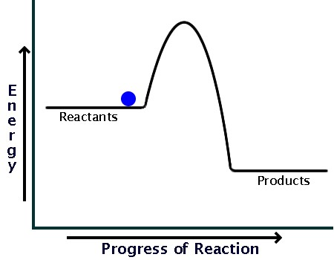

*Animation 11.17: Concentration of Reactants*

*Source & Credit :*

[*socrati*](https://socratic.org/questions/how-can-i-draw-a-simple-energy-profile-for-an-exothermic-reaction-in-which-100-k)

[*c*](https://socratic.org/questions/how-can-i-draw-a-simple-energy-profile-for-an-exothermic-reaction-in-which-100-k)

**11.5.3 Surface Area**

The increased surface area of reactants, increases the possibilities of atoms and molecules of reactants to come in contact with each other and the rates enhance. For example, AI foil reacts with NaOH moderately when warmed, but powdered AI reacts rapidly with cold NaOH and H2 is evolved with frothing.

2AI + 2NaOH + 6H O2 → 2NaAI(OH) + 3H4 2

Similarly, CaCO3 in the powder form reacts with dilute H2SO4 more eiciently than its big pieces.

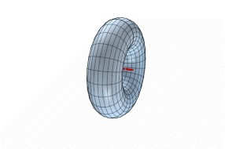

*Animation 11.18: Surface Area*

*Source & Credit :*

[*darelhard*](http://darelhardy.com/topics-in-math/animations/surfaces/surface-area/)

[*y*](http://darelhardy.com/topics-in-math/animations/surfaces/surface-area/)

##### 11.5.4 Light

Light consists of photons having deinite amount of energies depending upon their frequencies. When the reactants are irradiated, this energy becomes available to them and rates of reactions are enhanced. The reaction of CH4 and Cl2 requires light. The reaction between H2 and Cl2 at ordinary pressure is negligible in darkness, slow in daylight, but explosive in sunlight. Similarly, light is vital in photosynthesis, and the rate is inluenced by light.

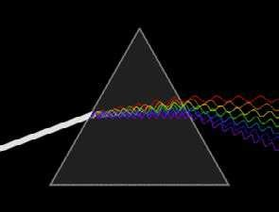

*Animation 11.19: Light*

*Source & Credit :*

[*wikipedia*](https://en.wikipedia.org/wiki/Light)

**11.5.5 Effect of Temperature on Rate of Reaction**

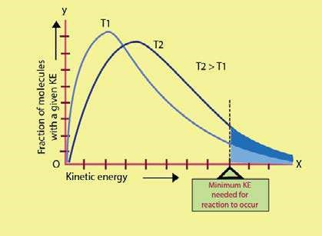 The collision theory of reaction rates convinces us that the rate of a reaction is proportional to the number of collisions among the reactant molecules. Anything, that can increase the frequency of collisions should increase the rate. We also know, that every collision does not lead to a reaction. For a collision, to be efective the molecules must possess the activation energy and they must also be properly oriented. For nearly all chemical reactions, the activation energy is quite large and at ordinary temperature very few molecules are moving fast enough to have this minimum energy. All the molecules of a reactant do not possess the same energy at a particular temperature. Most of the molecules will possess average energy. A fraction of total molecules will have energy more than the average energy. This fraction of molecules is indicated as shaded area in Fig.(11.6). As the temperature increases, the number of molecules in this fraction also increases. There happens a wider distribution of velocities. The curve at higher temperature T2 has lattened. It shows that molecules having higher energies have increased and those with less energies have deceased. So, the number of efective collisions increases and hence the rate increases. When the temperature of the reacting gases is raised by 10K, the fraction of molecule with energy more than Ea roughly doubles and so the reaction rate also doubles. Arrheinus has studied the quantitative relationship between temperature, energy of activation and rate constant of a reaction. Fig. (11.6) Kinetic energy distributions for a reaction mixture at two different

temperatures. The size of the shaded areas under the curves are proportional to the total fraction of the molecules that possess the minimum activation energy.

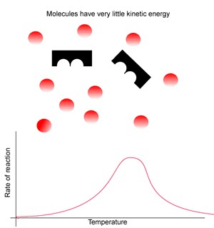

*Animation 11.20: Effect of Temperature on Rate of Reaction*

*Source & Credit :*

[*dynamicscience*](http://www.dynamicscience.com.au/tester/solutions1/biology/enztemp.html)

##### 11.5.6 Arrhenius Equation

Arrhenius equation explains the efect of temperature on the rate constant of a reaction. The rate constant ‘k’ for many simple reactions is found to vary with temperature. According to Arrhenius:

k=Ae-Ea/RT ........ (1)

So, ‘k’ is exponentially related to activation energy (Ea) and temperature (T). R is general gas constant and e is the base of natural logarithm. The equation shows that the increase in temperature, increases the rate constant and the reactions of high activation energy have low ’k’ values.

The factor ‘A’ is called Arrhenius constant and it depends upon the collision frequency of the reacting substances. This equation helps us to determine the energy of activation of the reaction as well. For this purpose, we take natural log of Arrhenius equation, which is expressed as n . The base of natural log is e and its value is 2.718281. Now, take natural log on both sides

|  |  |  |  |
| --- | --- | --- | --- |
|  |  | nk = n(Ae -Ea/RT ) |  |
| or |  | nk = nA + ne  -Ea/RT |  |
| or |  | -E nk = nA +  ne RT |  |
| Since |  | ne = 1 | (log of a quantity with same base is unity) |

Therefore nk = -Ea + nA ........... (2)

RT

The equation (1) is the equation of straight line, and from the slope of straight line Ea can be calculated. In order to convert this natural log into common log of base 10, we multiply the n term with 2.303.

-Ea (The base of common log is 10)

2.303 log k = + 2.303 log A

#### RT

Dividing the whole equation by 2.303

-Ea log k = + log A ........... (3)

2.303RT

This equation (3) is again the equation of straight line resembling.

y = -mx + c

Where ‘m’ is slope of straight line and ‘c’ is the intercept of straight line. Temperature is independent variable in this equation while rate constant k is dependent variable. The other factors like Ea, R and A are constants for a given reaction.

When a graph is plotted between T1 on x-axis and log k on y-axis, a straight line is obtained with a negative slope. Actually, Ea has negative sign so the straight line has two ends in second and fourth quadrants, Fig. (11.7). RT

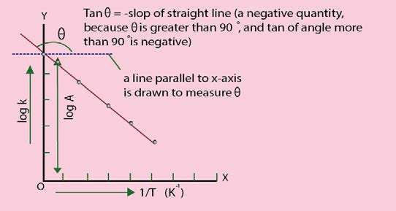

Fig. (11.7) Arrhenuis plot to calculate the energy of activation

The slope of the straight line is measured by taking the tangent of that angle θ which this straight line makes with the x-axis. To measure the slope, draw a line parallel to x-axis and measure angle θ . Take tan θ which is slope. This slope is equal to 2.303-Ea R .

-E

Slop = a

2.303 R

Therefore E = -Slop x 2.303 R ..........(4)a

The straight lines of diferent reactions will have diferent slopes and diferent ‘Ea’ values. The units of slope are in kelvins (K).

Since Slop = J mol-1-1 -1 = K

2.303 JK mol

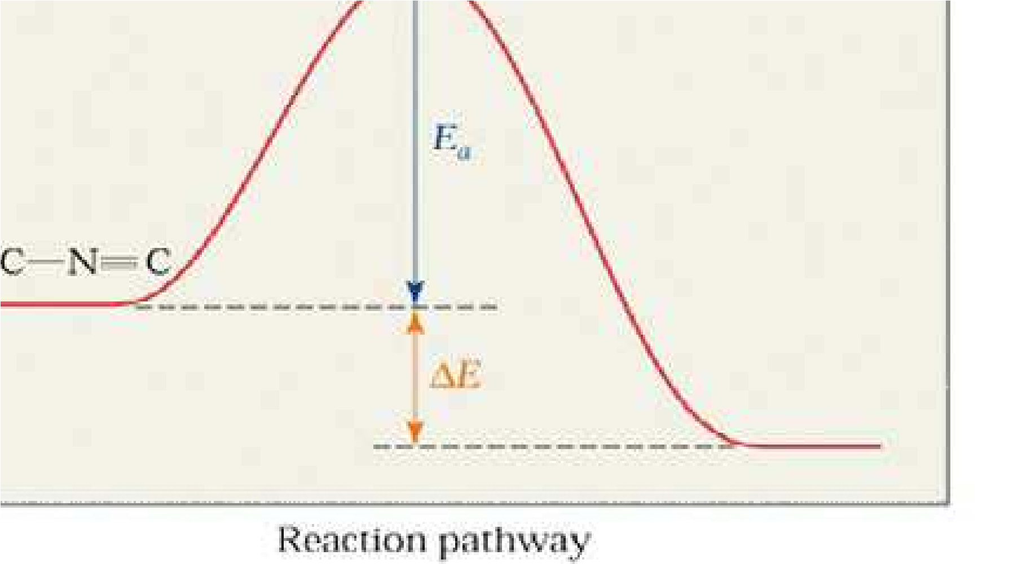

*Animation 11.21: Arrhenius Equation*

*Source & Credit :*

[*wp*](http://wps.prenhall.com/wps/media/objects/4679/4791471/ch12_10.htm)

[*s*](http://wps.prenhall.com/wps/media/objects/4679/4791471/ch12_10.htm)

**Example 3:**

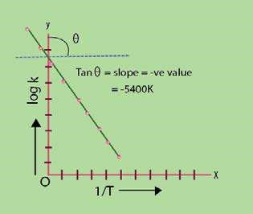 A plot of Arrhenius equation Fig (11.8 ) for the thermal decompositions of N2O5 is shown in the following igure. The slope is found to be -5400 K. Calculate the energy of activation of this reaction.

**Solution:**

(i) The reaction is

N O2 5 ฀ 2NO +1/2O2 2

Fig. (11.8) Arrhenius plot for decomposition of N2O5

Slope of the straight line = -5400 K

Equation used, Ea = -slope x 2.303 R

R = 8.3143JK-1mol-1

Putting the values,

Ea =-(-5400K)x 2.303 x 8.3143JK-1mol-1

Ea= +103410 J mol-1

Ea = 103.410 kJ mol-1

Hence, the decomposition of N2O needs 103.4kJmol-1 energy more than the average energy to cross the energy barrier Fig.(11.9)

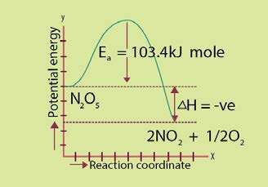

Fig. (11.9) Potential energy diagram of N2O5 decomposition