## CHAPTER 9 SOLUTIONS

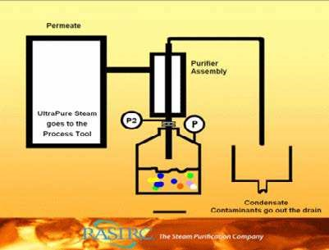

Animation 9.1: RAOULT’S LAW

Source & Credit:  [rasirc](https://www.google.com.pk/search?q=CONCEPT+OF+A+SOLUTION&biw=1366&bih=643&source=lnms&tbm=isch&sa=X&ved=0ahUKEwiNtYfNycTLAhVIMBoKHb-iCxoQ_AUIBigB#tbs=itp:animated&tbm=isch&q=RAOULT%E2%80%99S+LAW&imgrc=utZLz6Xj5TCwyM%3A)

### 9.0.0 CONCEPT OF A SOLUTION

Every sample of matter with uniform properties and a ixed composition is called a phase. For example, water at room temperature and normal pressure exists as a single liquid phase, that is, all the properties of water are uniform throughout this liquid phase. If a small amount of sugar is added to this sample of water, the sugar dissolves but the sample remains as a single liquid pha. se. However, the properties and composition of this new liquid phase, now the sugar solution, are diferent from those of pure water. As this solution of sugar in water is containing two substances (binary solution), so it is a mixture and since its properties are uniform, therefore, it is homogeneous in character.

A solution, on average, is a homogeneous mixture of two or more kinds of diferent molecular or ionic substances. The substance which is present in large quantity is called a solvent and the other component in small quantity is called a solute.

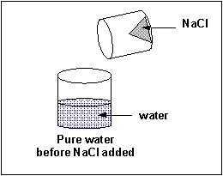

*Animation 9.2: CONCEPT OF A SOLUTION*

*Source & Credit: employees.csbsju*

For a given solution, the amount of solute dissolved in a unit volume of solution (or a unit amount of solvent) is termed as the concentrat ion of the solution. Solutions containing relatively lower concentrations of solute are called dilute solutions, whereas those containing relatively higher concentrations of solutes are called concentrated solutions.

### 9.1.0 CONCENTRATION UNITS OF SOLUTIONS

There are various types of concentration units of solutions. They are discussed as follows.

**9.1.1 Percentage composition**

The amounts of solute and solvent can be expressed in percentage composition by four diferent ways.

1. Percentage weight/weight
2. Percentage weight/volume
3. Percentage volume/weight
4. Percentage volume/volume

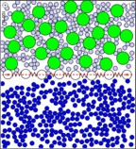

*Animation 9.3: CONCENTRATION UNITS OF SOLUTIONS*

*Source & Credit: chempaths.chemeddl*

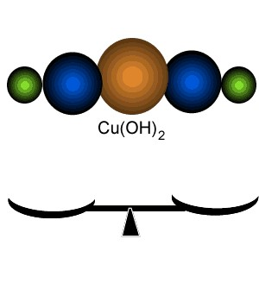

*Animation 9.4: Percentage composition*

*Source & Credit:*

[*dynamicscienc*](http://www.dynamicscience.com.au/)

[*e*](http://www.dynamicscience.com.au/)

**(a ) Percentage weight / weight**

It is the weight of a solute dissolved per 100 parts by weight of solution. 5% w/w sugar solution will contain 5 g of sugar dissolved in 100 g of solution in water. This solution contains 95 g of water.

Mass of solute

% by weight = x100  Mass of solution

**Example (1):**

Calculate the percentage by weight of NaCl, if 2.0g of NaCl is dissolved in 20 g of water.

**Solution:**

Weight of NaCl = 2.0g

Weight of sovent = 20.0g

Weight of solution = 20+2 = 22g

2.0g

% of NaCl by weight = 22.0g x100 = 9.09% Answer

**(b ) Percentage Weight/Volume**

It is the weight of a solute dissolved per 100 parts by volume of solution. 10 g of glucose dissolved in 100 cm3 of solution is 10% w/v solution of glucose. The quantity of the solvent is not exactly known. In such solutions, the total volume of the solution is under consideration.

1. **Percentage Volume /Weight**

It is the number of cm3 of a solute dissolved per 100 g of the solution. If we dissolve 10 cm3 of alcohol in water and the total weight of the solution is 100 g, then it is 10% v/w solution of alcohol in water. In such type of solutions, we don’t know the total volume of the solution.

1. **Percentage Volume / Volume**

It is the volume of a solute dissolved per 100 cm3 of the solution. This unit of concentration is best applicable to the solutions of liquids in liquids. A 12 % alcohol beverage is 12 cm3 of alcohol per 100 cm3 of solution. In such solutions, the total volume of the solution may not be necessarily equal to the sum of volumes of solute and the solvent.

**9.1.2 Molarity (M)**

Molarity is the number of moles of solute dissolved per dm3 of the solution. To prepare one molar solution of glucose in water, we take 180 g of glucose and add suicient water to make the total volume 1 dm3 (llitre) in a measuring lask.

In case of one molar solution of sucrose, 342 g of sucrose are dissolved in water to make it 1 dm3. Since the volume of 342 g of sucrose is greater than 180 g of glucose so the volume of water in 1 molar sucrose solution is less than that of 1 molar glucose solution. Anyhow, to calculate the volume of the solvent, we need to know the density of the solute. Following formula is used to prepare the solution of any molarity.

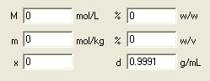

*Animation 9.5: Molarity (symbol, M )*

*Source & Credit:*

[*chembudd*](http://www.chembuddy.com/)

[*y*](http://www.chembuddy.com/)

Mass of solute 1

Molarity(M) = x 3

Molar mass of solute Volume of soultion (dm )

or Molarity(M) = Number of moles of solute3

Volume of soultion (dm )

**Examples (2):**

Calculate the molarity of a solution containing 20.7 g of K2CO3 dissolved in 500 cm3 of the

|  |  |
| --- | --- |
| given solution.  **Solution:** |  |
|  | Mass of K CO =20.7g2 3 |
|  | Molar mass of K CO =138gmol2 3 −1 |
|  | volume of solution = 500cm = 0.5dm3 3 |
| Formula: | Mass of solute 1  Molarity = x 3 Molar mass of solute Volume of soultion in dm |

20.7g 1 -3

|  |
| --- |
| -3 |

Molarity= -1 x 3 =0.3mol dm = 0.3mol dm Answer

138gmol 0.5dm

**9.1.3 Molality (m)**

Molality is the number of moles of solute in 1000 g (1 kg) of the solvent. In order to prepare molal solutions, we don’t have to take any lask. 180 g of glucose when dissolved in 1000 g of water gives one molal solution of glucose. The total mass of the solution is 1180 g. We don’t know the volume of the solution. In order to know the volume we need the density of the solution. For one molal sucrose solution, 342 g of sucrose are dissolved in 1000 g of H2O.

So,one molal solution of diferent solutes in water have their own masses and volumes.

In order to get the molality of any solution, we use the following equation.

Mass of solute 1

Molality(m) = x

Molar mass of solute Mass of solvent in kg

or Molality(m) = Number of moles of solute

Mass of solvent in kg

**Example (3):**

What is the molality of a solution prepared by dissolving 5g of toluene (C7H8) in 250g of benzene.

**Solution:**

Mass of toluene = 5g

Mass of benzene = 250g = 0.25kg

Molar mass of toluene = 12x7+1x8=92

Formula used

Mass of solute 1

Molality(m) = x

Molar mass of solute Mass of solvent in kg

5g 1

Molality(m) = -1 x

92g mol 0.250 kg

|  |
| --- |
| -1 |

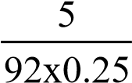=mol kg = 0.217mol kg-1 Answer

=0.217m

The molality of a solution is indirect expression of the ratio of the moles of the solute to the moles of the solvent. The molal aqueous solution of a solute say glucose or NaOH is dilute in comparison to its molar solution. The reason is that in molal solution the quantity of the solvent is comparatively greater.

The value of concentration given in the units of molality does not change with temperature but that of molarity does. The reason is that the volume of liquids are afected by the variation in temperature.

**9.1.4. Mole Fraction (x)**

This unit of concentration may be for any type, of solution i.e. gas in gas, liquid in liquid or solid in liquid, etc. This unit is also applicable to a solution having more than two components. The mole fraction of any component in a mixture is the ratio of the number of moles of it to the total number of moles of all the components present.

Let there be three components A, B, C making a solution. The number of moles are na, nb, nc respectively. If the mole fraction of A, B and C are denoted by xa, xb, xc respectively, Then,

n

X =A A

n + n + nA B C

n

X =B B

n + n + nA B

C

n

X =C C

n + n + nA B

C

The sum of the mole fractions of all the components of a solution must be equal to one. There are no formal units of mole fraction. Anyhow, we sometimes multiply mole fraction by 100 to get mole percent.

**Example (4):**

Calculate the mole fraction and mole percent of each component in a solution having 92 g of ethyl alcohol, 96 g of methyl alcohol and 90 g of water.

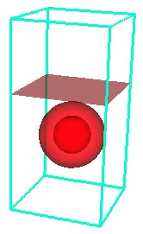

*Animation 9.6: Mole Fraction (symbol,*

*x)*

*Source & Credit:*

[*ima.um*](http://www.ima.umn.edu/)

[*n*](http://www.ima.umn.edu/)

**Solution:**

First of all get the number of moles of each component.

Mass in grams of the substance Number of moles of the substance =

Molecular mass in grams

Molar mass of ethyl alchohol (C H OH) = 46 gmol2 5 -1

92g

Number of moles of ethyl alchohol = -1 = 2 mol 46 gmol

Molar mass of methyl alchohol (CH OH) = 32 gmol3 -1

96g

Number of moles of methyl alchohol = -1 = 3 mol 32 gmol

Molar mass of water(H O) = 18 gmol2 -1

90g

Number of moles of water = -1 = 5 mol

18 gmol

The mole fraction of any components is ratio of its moles to total number of moles.

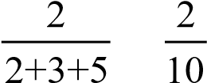 Xethyl alcohol = = = 0.2 Answer

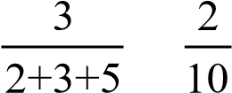 Xmethyl alcohol = = = 0.3 Answer

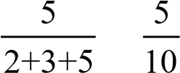 XH O2 = = = 0.5 Answer

Now, multiply the mole fractions with 100, to get mole percent.

Moles % of ethyl alcohol = 0.2x100 = 20 Answer

Moles % of methyl alcohol = 0.3x100 = 30 Answer

Moles % of H O = 0.5x100 = 2 50 Answer

In the case of mixture of gases, one can determine the mole fraction from the partial pressure data of the mixture. Hence

pA pB p

X =A ,X =B ,X =C C

p +p +pA B C p +p +pA B C p +p +pA B

C

Where pa, pb, pc are the partial pressures of various gases in the mixture. Generally, we can say that

Partial pressure of that gas

Mole fraction of any gas= Total pressure of the mixture of gases

**9.1.5. Parts Per Million (ppm)**

It is deined as the number of parts (by weight or volume) of a solute per million parts (by weight or volume) of the solution.

This unit is used for very low concentrations of solutions, e.g. to express the impurities of substances in water.

Mass of solute 6

Parts per million (ppm) = x 10

Mass of solution

**Example (5):**

Sea water has 5.65 x 10-3 g of dissolved oxygen in one kg of water. Calculate the concentration of oxygen in sea water in parts per million ppm of oxygen in sea water = 5.65x10-3g x 106 = 5.65 ppm Answer

1000g

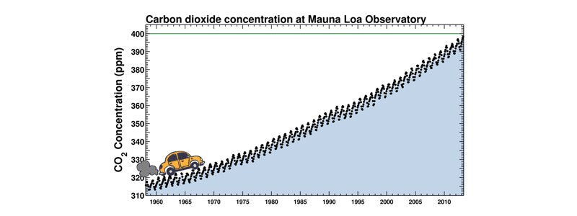

*Animation 9.7: Parts Per Million (symbol, p p m)*

*Source & Credit:*

[*media.tumbl*](http://66.media.tumblr.com/a3c8f6365ba56f8aa45c959dc2f1f51b/tumblr_mmny06ze371qbh26io1_1280.gif)

[*r*](http://66.media.tumblr.com/a3c8f6365ba56f8aa45c959dc2f1f51b/tumblr_mmny06ze371qbh26io1_1280.gif)

**9.1.6 Interconversion of Various Concentration Units of Solutions**

Sometimes, we get prepared solutions from the chemical supply houses. For example, we are working with a solution whose molarity is given by the supplier, but we need to know its molality or w/w percentage. For such purpose, we need to convert one unit of concentration into other. These conversions are usually done if we know the formula masses and the densities of the solutes or solutions. Following table shows the ive important chemicals whose w/w%, molarities and densities are given.

|  |  |  |  |
| --- | --- | --- | --- |
| Name  of Acid | %  (w/w) | Molarity  (M dm-3) | Density (gcm-3) |
| H2SO4  H3PO4  HNO3  HCl  CH COOH | 98%  85.5% 70.4% 37.2%  99.8% | 18  4.8  15.9 12.1  17.4 | 1.84 1.70 1.42 1.19  1.05 |

One should be able to interconvert these concentration units into each other and moreover to molalities and mole fractions for laboratory work Let us do some calculations in this respect.

**Example (6):**

3

Calculate the molality of 8% w/w NaCl solution.

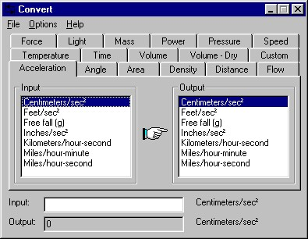

*Animation 9.8: Interconversion of Various Concentration Units of Solutions*

*Source & Credit:*

[*mechanicaldesignforu*](http://www.mechanicaldesignforum.com/)

[*m*](http://www.mechanicaldesignforum.com/)

It means that 0.1367 moles of NaCl is dissolved in 0.092 kg of water.

Number of moles of solute 0.1367 moles

Molality(m)= =

Mass of solvent in kg 0.092 kg

=1.487 m Answer

The given solution is 1.487 molal.

**Example (7):**

Hydrochloric acid available in the laboratory is 36% (w/w). The density of HCl solution is 1.19 g cm-3. Determine the molarity of HCl solution.

**Solution:**

36% (w/w) HCl solution means that 36g of HCI dissolved in 100g of solution.

Mass of HCl =36g

Mass of solution =100g

In case of molarity, the inal volume of solution is 1000 cm3. Convert this volume into mass, by using density of 1.19 gcm-3.

Mass of 1000cm of HCl solution =1000x1.19 =1190g3

Since, (Mass=volume x density)

100g of solution has HCl =36g

1190x36

so, mass of HCl in 1190g of solution = =428.4g

100g

Molar mass of HCl =36.5g mol-1

428.4g

Number of moles of HCl, in 428.4g of HCl = -1 =11.73

36.5gmol

So, 1000 cm3 solution of HCl has 11.73 moles of HCl

Hence, molarity of HCl=11.73mol dm-3Answer **Example (8):**

9.2 molar HClO4 is available in the market. The density of this solution is 1.54gcm3. What is the percentage by weight of HClO4.

**Solution:**

Molarity of HClO4 = 9.2g moles dm-3

Density of solution = 1.54 gcm-3

Let us calculate the mass of solution which is 1dm3 in volume and has 9.2moles of HClO4 in it.

Since, Mass = volume x density

Mass of 1000cm3 solution =1000cm x1.54gcm =1540g3 -3

Molar mass of HCIO4 =100.5gm mol-1

9.2 moles of HCIO4 , can be converted to its mass

Mass of HCIO4 =100.5g mol x 9.2mol = 924.6 g-1

Mass of H20 = mass of solution - mass of HCIO4 = 1540-924.6 = 615.4 g

% of HCIO4 by weight = mass of solutionmass of HClO4 x100= 1540924.6g x100 =60.04

% of H2O by weight = 100-mass of HClO4 =100-60.04= 39.96 Answer

### 9.2 TYPES OF SOLUTIONS

Most commonly, we come across solutions, where solute is a solid and the solvent is a liquid. As a matter of fact, all the three states of matter i.e. solid, liquid or gas can act as solute or solvent.

Examples for nine possible types of solution are given in Table (9.2).

**Table (9.2) Common types and examples of solutions**

|  |  |  |
| --- | --- | --- |
| State of Solute | State of Solvent | Example |
| Gas  Gas  Gas  Liquid  Liquid  Liquid  Solid  Solid  Solid | Gas  Liquid  Solid  Gas  Liquid Solid  Liquid  Gas  Solid | Air  O2 in water, CO2 in water.  H2 adsorbed by palladium  Mist, fog, clouds, liquid air pollutants.  Alcohol in water, milk, benzene in toluene.  Mercury in silver, butter, cheese.  Sugar in water, jellies, paints.  Dust particles in smoke.  Metal alloys pearls, opals, carbon in iron (steel). |

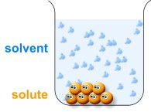

*Animation 9.9:TYPES OF SOLUTIONS*

*Source & Credit:*

[*blob*](http://www.blobs.org/)

[*s*](http://www.blobs.org/)

**9.2.1 Solutions of Solids in Liquids**

When a solid comes in contact with a suitable liquid, it dissolves forming a solution i.e. a homogeneous mixture. This process of dissolution can be explained in terms of attraction between the particles of a solute and that of a solvent. The molecules or ions in solids are arranged in such a regular pattern that the inter-molecular or inter-ionic forces are at a maximum.

The process of dissolution is to overcome these forces of attraction holding together the solute molecules or ions in the crystal lattice, by the solute-solvent forces. In molecular crystals, the intermolecular forces of attraction are either dipole-dipole or London dispersion type. These forces are relatively weak and can easily be overcome. Hence, non-polar or less polar molecular crystals usually dissolve in non-polar solvents like benzene.

In the crystal lattice, the inter-molecular or inter-ionic forces of attraction between highly polar molecules or ions are quite strong, hence the polar solids fail to dissolve in nonpolar solvents. These strong electrostatic forces cannot be overcome or shattered by the weak solute-solvent attractions. Take the case of cane sugar. Due to hydrogen bonding, it has tightly bound molecules, so it will not be dissolved by solvents like kerosene oil, petrol, benzene, etc. It will be dissolved readily in water, because water attracts sugar molecules almost in the same way as the sugar molecules attract one another.

The inter-ionic forces of attraction are very strong in ionic solids so, equally strong polar solvents are needed to dissolve them. Such solids cannot be dissolved by moderately polar solvents e.g. acetone. A moderately polar solvent, fails to dissolve sodium chloride, which is an ionic solid. Thus the solubility principle is that “ like dissolves like’ .

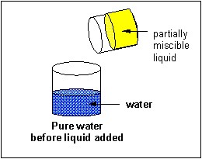

*Animation 9.10: Solutions of Solids in Liquids*

*Source & Credit: employees.csbsju*

**9.2.2 Solutions of Liquids in Liquids**

The solutions of liquids in liquids may be divided into three classes.

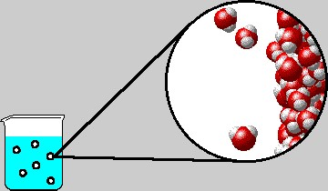

*Animation 9.11: Solutions of Liquids in Liquids*

*Source & Credit:*

[*chem.purdu*](http://www.chem.purdue.edu/)

[*e*](http://www.chem.purdue.edu/)

1. **Completely Miscible Liquids**

Liquids like alcohol and water or alcohol and ether mix in all proportions. However, the properties of such solutions are not strictly additive. Generally, the volume decreases on mixing but in some cases it increases. Heat may be evolved or absorbed during the formation of such solutions. These types of solutions can usually be separated by fractional distillation.

1. **Partially Miscible Liquids** A large number of liquids are known which dissolve into one another up to a limited extent.

For example, ether C H2 5 − −O C H2 5 dissolves water to the extent of about 1.2 % and water dissolves ether up to the extent of about 6.5%.

As the mutual solubilities are limited, the liquids are only partially miscible. On shaking equal volumes of water and ether, two layers are formed. Each liquid layer is a saturated solution of the other liquid. Such solutions are called conjugate solutions. The mutual solubility of these conjugate solutions is afected by temperature changes. Typical examples of such systems are: a. Phenol-water system

* 1. Triethylamine-water system
  2. Nicotine-water system

**Phenol-Water System (H2O + C6H5OH )**

The example of phenol in water is interesting. If equal volumes of water and phenol are mixed together, they show partial miscibility. It has been observed that around room temperature, phenol will dissolve in a lot of water giving us the upper layer and water will dissolve in a lot of phenol giving us the lower layer.

At 250C the upper layer is 5% solution of phenol in water and the lower layer is 30% water in phenol. These two solutions are conjugate solutions to each other. The lower layer has a greater density due to greater percentage of phenol. Water acts as a solute in the lower layer while phenol is a solute in the upper layer. When the temperature of water-phenol system is increased, the compositions of both layers change. Water starts travelling from upper to the lower layer and phenol travels from lower to the upper layer.

When the temperature of this system approaches 65.90C, a homogeneous mixture of two components is obtained. This homogeneous mixture contains 34% phenol and 66% water. The temperature of 65.90C at which two conjugate solutions merge into one another, is called critical solution temperature or upper consulate temperature. Some other partially miscible pairs of liquids have their own consulate temperatures with deinite compositions.

For example, water-aniline system has a single layer at 167.00 C with 15% water. Methanolcyclohexane system has consulate temperature of 49.10 C with 29% methanol.

**(iii) Liquids Practically Immiscible**

Those liquids which do not dissolve into each other in any proportion are immiscible. Examples: (i) Water and benzene (H20 + C6H6) (ii) Water and carbon disulphide (H2O + CS2)

#### 9.3.0 IDEAL AND NON-IDEAL SOLUTIONS

When two or more than two liquid substances are mixed, the solutions may be ideal or non-ideal. To distinguish between such solutions we look at the following aspects:-

i. If the for ces of interactions between the molecules of diferent components are same as when they were in the pure state, they are ideal solutions, otherwise non-ideal. ii. If the volume of solution is not equal to the sum of the individual volumes of the components, the solution is non-ideal.

iii. Ideal solutions have zero enthalpy change as their heat of solution. iv. If the solutions obey Raoult’s law, then they are ideal. This is one of the best criterion for checking the ideality of a solution

Let us irst study, the Raoults’s law and then try to understand ideality of solutions, the process of fractional distillation and the formation of azeotropes.

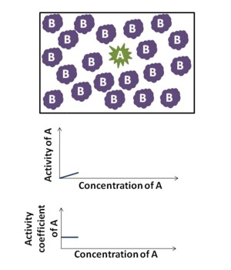

*Animation 9.12: Ideal and Non-Ideal Solutions*

*Source & Credit: wikipedia*

#### 9.3.1 RAOULT’S LAW

**Raoult’s law can be deined in these ways:**

The vapour pressure ol a solvent above a solution is equal to the product of the vapour pressure of pure solvent and the mole fraction of solvent in solution. Mathematically, it can be written in equation form as follows:

p = p x ............... (1)o 1

Where p is the vapour pressure of solvent in the solution, p° is the vapour pressure of pure solvent and x1 is the mole fraction of solvent.

We also known that

X + X = 11 2  (x2 is the mole fraction of solute)

or X = 1 - X1 2

Putting the value of x1 in equation (1)

p = p (1 - X )o 2  or p = p - p Xo o 2  or p -p = p Xo o 2

or ∆p = p Xo 2 .................(2)

Equation (2) gives another deinition of Raoult’s law. “The lowering of vapour pressure is directly proportional to the mole of fraction of solute.” Now rearrange equation (2) to get equation

(3).

∆p

=X2 ................ (3) po

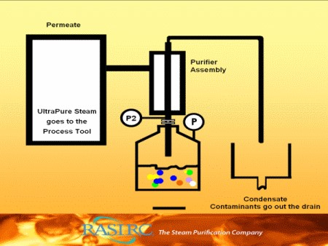

*Animation 9.13: RAOULT’S LAW*

*Source & Credit:*

[*rasir*](http://www.rasirc.com/)

[*c*](http://www.rasirc.com/)

∆p/p° is called relative lowering of vapour pressure and it is more important than actual lowering of vapour pressure (∆p). The equation (3) gives us another deinition of Raoult’s law. “The relative lowering of vapour pressure is equal to the mole fraction of solute”. The relative lowering of vapour pressure:

1. is independent of the temperature
2. depends upon the concentration of solute.
3. is constant when equimolecular proportions of diferent solutes are dissolved in the same mass of same solvent.

**Example (9):**

The vapour pressure of water at 30° C is 28.4 torr. Calculate the vapour pressure of a solution containing 70g of cane sugar (C12H22O11) in 1000g of water at the same temperature. Also calculate the lowering of vapour pressure.

**Solution:**

Mass of cane sugar dissolved =70g

Molar mass of cane sugar = 342 g mole-1

Number of moles of a compound =mass

molar mass

Number of moles of sugar, C12H22O11 (n2) = 34270g/molg  =0.20

Mass of H2O in solution =1000g

Number of moles of water, H20 (n1) = 18.021000g/molg  =55.49

Total number of moles = 0.20 + 55.49= 55.69

Mole fraction of sugar, C12H22O11(x2) = n +n1n2 2 = 55.690.2 = 0.0036

Mole fraction of water, H2O (x1) = n +n1n1 2 = 55.4955.69 = 0.9964

Vapour pressure of pure water =28.4 torr

Applying the formula for vapour pressure of solution

p = p X = (28.4)(0.9964) =28.29 torro 1

So, vapour pressure of solution = 28.29 torr Answer

Lowering of vapour pressure, ∆p = 28.4 - 28.29 = 0.11 torr Answer

**9.3.2 Raoult’s Law (when both components are volatile)**

Raoult’s law can be applied to understand the relationship between mole fractions of two volatile components and their vapour pressures before making the solution and after making the solution. Consider two liquids ‘A’ and ‘B’ with vapour pressures p°A and p°B in the pure state at a given temperature. After making the solution, the vapour pressures of both liquids are changed. Let the vapour pressures of these liquids in solution state be pA and pB with their mole fractions xA and xB respectively.

Applying Raoult’s law to both components

p =pA oAx

A

p =pB oBxB

P =p +p =pt A B oAx +pA oBxB where Pt is total vapour pressure)

since x +x =1A B

x =1-xB

A

P = p x + p (1 - x )t oA A oB A

P = p x + p - p xt oA A oB oB

A

P = (p - p )x + pt oA oB A oB ............ (4)

The component A is low boiling liquid and B is high boiling liquid. The vapour pressure of A is more than B at a given temperature.

Equation (4) is a equation of straight line If a graph is plotted between xBor mole % of B on x-axis and Pt on y-axis, a straight line will be obtained Fig (9.1).

Only those pairs of liquids give straight lines which form ideal solutions. So, Raoult’s law is one of the best criterion to judge whether a solution is ideal or not.

All the possible solutions of two components A and B have their vapour pressures on the straight line connecting p°A with p°B. All such solutions will be ideal. Each point on this straight line represents the vapour pressure of a solution, at a given temperature, with the corresponding contribution of both the components A and B. The two dotted lines represent the partial pressures of the individual components of solution. They show the increase of vapour pressure of a component with increase in its mole fraction in solution.

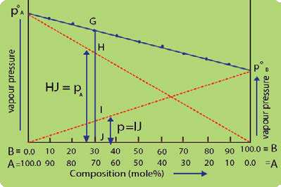

Fig. (9.1) Graph between composition and vapour pressure

In order to explain it, consider a point G on the straight line. This point represents the vapour pressure of solution with 30% moles contribution of the component B and 70% of component A. Since, A is more volatile component, so its contribution towards the vapour pressure of solution is represented by pA.

The contribution of the less volatile component B is represented by pB. Similarly, we can calculate the relative contributions of A and B towards the total vapour pressure of solution by taking other points along the line joining poA to poB.

The total vapour pressure of the solution (Pt) corresponding to the point G will be equal to the sum of the vapour pressures of the individual components (pA + pB) as shown in the Fig. (9.1).

### 9.4 VAPOUR PRESSURES OF LIQUID -LIQUID SOLUTIONS

Binary mixtures of miscible liquids may be classiied as (i) ideal (ii) non-ideal or real solutions. The vapour pressures of solutions provides a simple picture about their behaviour. Let us discuss the vapour pressures of ideal and real solutions one by one.

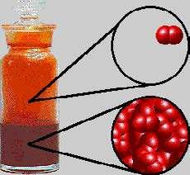

*Animation 9.14:VAPOUR PRESSURES OF LIQUID LIQ-*

*UID SOLUTIONS*

*Source & Credit:*

[*chem.purdu*](http://www.chem.purdue.edu/)

[*e*](http://www.chem.purdue.edu/)

**(i) Ideal solutions**

An ideal solution is that which obeys Raoult’s law. Some typical ideal solution forming liquid pairs are: benzene-toluene, benzene-ether, chlorobenzene-bromobenzene, ethyl iodide-ethyl bromide, etc.

**Fractional Distillation of Ideal Mixture of Two Liquids**

Let us have two liquids A and B which form a completely miscible solution. A is a more volatile component so its boiling point is less than B. If we have various solutions of these two components and a graph is plotted between compositions on x-axis and temperature on y-axis, then two curves are obtained as shown in the Fig. (9.2).

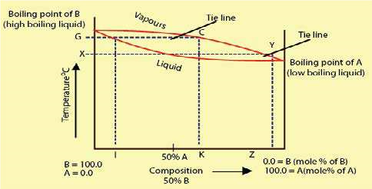

Fig (9.2) Composition - temperature curve of an ideal solution.

The upper curve represents the composition of the vapours of diferent solutions while the lower curve represents the composition of the liquid mixtures. The reason is that at any temperature the composition of vapou rs is d ife r e n t from the composition of liquid mixture.

Consider the temperature, corresponding to the point G. It is the boiling point of solution corresponding to composition I. It meets liquid curve at point H and the vapour curve at the point C. The composition of liquid mixture corresponding to the point H is shown by the point I. At point I the mixture has greater percentage of B and less percentage of A. While at the same temperature the vapours of the mixture have the composition K. At the point K, the percentage of A is comparatively greater than B when we compare it with composition of liquid mixture corresponding to point I.

Because A is a low boiling liquid, it is present in the vapour state in greater percentage than at point

I.

If the temperature of the mixture is maintained corresponding to point G, the distillate will have greater percentage of A and the residue will have greater percentage of B. The reason is that the fraction going to distillate is that which is in vapour state and it has greater % of A. The distillate of composition K is again subjected to distillation. Its boiling point is X, and at this temperature the distillate of composition Z is obtained. This distillate of composition Z is further distilled. In this way, the distillate becomes more and more rich in A and residue is more and more rich in B. So, process of distillation is repeated again and again to get the pure component A. Thus we can completely separate the components by fractional distillation. Such liquid mixtures, which distil with a change in composition, are called zeotropic mixtures. For example, methyl alcohol-water solution can be separated into pure components by distillation.

**ii. Non-Ideal Solutions (azeotropic mixtures)**

Many solutions do not behave ideally. They show deviations from Raoult’s Law due to diferences in their molecular structures i.e. size, shape and intermolecular forces. Formation of such solutions is accompanied by changes in volume and enthalpy. The vapour pressure deviations may be positive or negative in such solutions.

Azeotropic mixtures are those which boil at constant temperature and distil over without change in composition at any temperature like a pure chemical compound. Such mixtures can not be regarded as chemical compounds as changing the total pressure alongwith the boiling point changes their composition. Whereas, for a chemical compound, the composition remains constant over a range of temperature and pressure.

The deviations of solutions are of two types:

1. Positive deviations
2. Negative deviations

**(a) Positive Deviations**

If a graph is plotted between composition and vapour pressure of a solution which shows positive deviation from Raoult’s law, the total vapour pressure curve rises to a maximum. The vapour pressure of some of solutions are above the vapour pressure of either of the pure components.

Let us consider the mixture of A and B components at point C in Fig (9.3 ). At the point C Fig (9.3 ), the mixture has the highest vapour pressure and, therefore, the lowest, boiling point.

On distilling this type of solution, the irst fraction will be a constant boiling point mixture i.e. azeotropic mixture having a ixed composition corresponding to the maximum point. For this type of solution, it is not possible to bring about complete separation of components by fractional distillation. Ethanol-water mixture is an example of this type. It boils at 78.1°C with 4.5% water and 95.5 % alcohol. 78.1oC is lower than the boiling point of ethanol (78.5°C) and water (100°C).

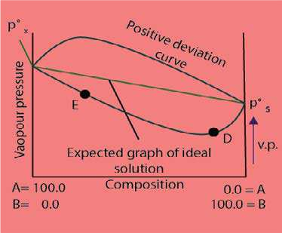

Fig (9.3 ) Non-ideal solutions and azeotropic mixtures for positive deviation

**(b) Negative Deviations**

For this type of solution, the vapour pressure curve shows a minimum. Let us consider a point E in Fig (9.3). Here, the more volatile component A is in excess. On distilling this solution, the vapours will contain more of A and the remaining mixture becomes richer in less volatile component B’. Finally, we reach the point D where vapour pressure is minimum and the boiling point is maximum. At this point, the mixture will distill over unchanged in composition.

Therefore, it is not possible to separate this type of solution completely into its components. We can give the example of hydrochloric acid solution in water for this type of solutions. HCl forms an azeotropic mixture with water, boiling at 110oC and containing 20.24% of the acid.

### 9.5 SOLUBILITY AND SOLUBILITY CURVES

Whenever a solid solute is put in a liquid solvent then the molecules or ions break away from the surface of the solid and pass into the solvent. These particles of solid are free to difuse throughout the solvent to give a uniform solution. The solute and solvent molecules are constantly moving about in the solution phase because of kinetic energy possessed by them. In this way some of the particles of the solute may come back towards the solid due to collisions. These molecules or ions are entangled in its crystal lattice and get deposited on it. This is called re-crystallization or precipitation.If excess of solid is present in the solution then the rate of dissolution and rate of crystallization become equal. This is a state of dynamic equilibrium.

The concentration of the solute at equilibrium with the solution is constant for a particular solvent and at a ixed temperature. The solution thus obtained is called saturated solution of the solid substance and the concentration of this solution is termed as its solubility. So the solubility is deined as the concentration of the solute in the solution when it is in equilibrium with the solid substance at a particular temperature.

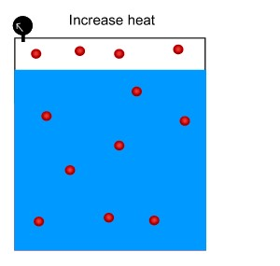

*Animation 9.15: SOLUBILITY AND SOLUBILITY CURVES*

*Source & Credit:*

[*dynamicscience*](http://www.dynamicscience.com.au/)

Solubility is expressed in terms of number of grams of solute in 1000g of solvent. At a particular temperature, saturated solution of NaCl in water at 0°C contains 37.5g of NaCl in lOOg of water. Similarly the solubility of CuSO4 in water at 0°C is 14.3g/100g, while at 100°C it is 75.4g/100g.

To determine the solubility of substance, a saturated solution of a solid is prepared at a constant temperature. Then this solution is iltered. A known volume of this solution is evaporated in a china dish and from the mass of the residue, the solubility can be calculated.

**Solubility Curves**

Temperature has a marked efect on the solubility of many substances. A graical representation between temperature and solubility of solution is called solubility curves.There are two types of solubility curves.

1. Continuous solubility curves
2. Discontinuous solubility curves
3. **Continuous Solubility Curves**

Continuous solubility curves don’t show sharp breaks anywhere. According to Fig.(9.4). KCIO3, K2Cr2O7, Pb(NO3)2 and CaCI2 are showing continuous solubility curves. The solubility curves of KCl, NaCl and NaNO3 give the straight lines. NaCl shows a very small change of solubility from 0°C to 100°C increase of temperature.

Ce2(SO4)3 shows the exceptional behaviour whose solubility decreases with the increase in temperature and becomes constant from 40°C onwards. Anyhow, it shows continuous solubility curve.

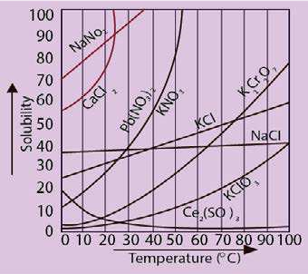

Fig (9.4) Continuous solubility curves

1. **Discontinuous Solubility Curves**

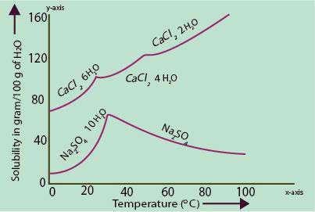 Sometimes, the solubility curves show sudden changes of solubilities and these curves are called discontinuous solubility curves. The best examples in this reference are Na2SO4.10 H20, CaCl2.6 H2O. Actually, these curves are combination of two or more solubility curves. At the break a new solid phase appears and another solubility curve of that new phase begins. It is the number of molecules of water crystallization which changes and hence solubility

changes, Fig (9.5). Fig (9.5) Discontinuous solubility curves

**9.5.1 Fractional Crystallisation**

The curves in Fig (9.4) show that the variation in solubility with temperature is diferent for diferent substances. For example, the change in solubility in case of KNO3 is very rapid with changing temperature, while such a change is more gradual in other cases like KBr, KCl, alanine, etc.

These diferences in the behaviour of compounds provide the basis for fractional crystallisation, which is a technique for the separation of impurities from the chemical products.

By using the method, the impure solute is dissolved in a hot solvent in which the desired solute is less soluble than impurities. As the hot solution is cooled, the desired solute being comparatively less soluble, separates out irst from the mixture, leaving impurities behind. In this way, pure desired product crystallizes out from the solution.

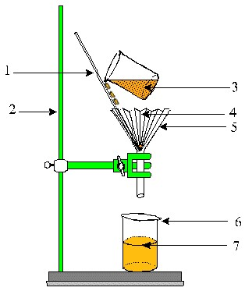

*Animation 9.16: Fractional Crystallisation*

*Source & Credit: mind42*

### 9.6 COLLIGATIVE PROPERTIESOF SOLUTIONS

The colligative properties are the properties of solution that depend on the number of solute and solvent molecules or ions. Following are colligative properties of dilute solution.

1. Lowering of vapour pressure
2. Elevation of boiling point
3. Depression of freezing point
4. Osmotic pressure

The practical applications of colligative properties are numerous. The study of colligative properties has provided us with methods of molecular mass determination and has also contributed to the development of solution theory.

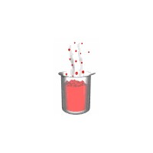

*Animation 9.17: COLLIGATIVE PROPERTIESOF SOLU-*

*TIONS*

*Source & Credit: web.mst*

**9.6.1 Why Some of the Properties are Called Colligative**

The reason for these properties to be called colligative can be explained by considering three solutions. Let us take 6 g of urea, 18 g of glucose and 34.2 g of sucrose and dissolve them separately in 1 kg of H20.

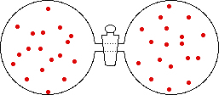

*Animation 9.18: Why Some of the Properties are*

*Called Colligative*

*Source & Credit: web.mst*

This will produce 0.1 molal solution of each substance. Pure H2O has certain value of vapour pressure at a given temperature. In these three solutions, the vapour pressures will be lowered. The reason is that the molecules of a solute present upon the surface of a solution decrease the evaporating capability. Apparently, it seems that sucrose solution should show the maximum lowering of vapour pressure while urea should have the minimum lowering of vapour pressure. The reality is that the lowering of vapour pressure in all these solutions will be same at a given temperature. Actually, the number of particles of the solute in all the solutions are equal. We have added 1/10th of Avogadro’s number of particles (6.02 x 1022). The lowering of vapour pressure depends upon the number of solute particles and not upon their molar mass and structures. Well, it should be kept in mind that these three solutes are non-volatile and non-electrolyte.

The boiling points of these solutions are higher than that of pure solvent. It is observed that the boiling point elevation of these three solutions is 0.052 oC. Similarly, freezing points will be depressed for these solutions and the value of depression in these three cases is 0.186°C. The reason again is that the elevation of boiling point and the depression of freezing point depend upon number of particles of solute.

Now, let us deduce the values of elevation of the boiling point and the depression of the freezing point of water for 1 molal solutions. For that purpose, try to dissolve 60 g of urea. 180 g of glucose and 342 g of sugar separately in 1 kg of water. If, it is possible then the elevation of boiling point and depression of freezing point of water will be 0.52 oC and 1.86 oC, respectively. All the three solutions will boil at 100.52 °C and freeze at -1.86 oC. These values of elevation of boiling point and depression of freezing point are called molal boiling point constants and molal freezing point constants of H2O denoted by Kb and Kf respectively.

These are also named as ebullioscopic and cryoscopic constants, respectively. These constants depend upon the nature of solvent and not upon the nature of solute. Following Table (9.3) give the values of Kb and Kf for some common solvents.

#### Table (9.3) Kb and Kf values for some solvents

|  |  |  |  |  |
| --- | --- | --- | --- | --- |
| Solvent | B.P.(0C) | Kb(0C/m) | F.P.(0C) | Kf(0C/m) |
| H2O  Ether  Aceticacid  Ethanol  Benzene | 100  34.4  118  79  80 | 0.52 2.16 3.07 1.75  2.70 | 0  -116.3 17  -114.5  5.5 | 1.86 1.79 3.90 1.99  5.10 |

To observe the colligative properties, following condition should be fulilled by the solutions.

1. Solution should be dilute
2. Solute should be non-volatile
3. Solute should be non-electrolyte.

Now, let us discuss these colligative properties one by one. (We will not discuss osmotic pressure over here).

**9.6.2 Lowering of Vapour Pressure**

The particles can escape from all over the surface of a pure solvent Fig. (9.6a). When the solvent is containing dissolved non-volatile non-electrolyte solute particles, the escaping tendency of solvent particles from the surface of the solution decreases and its vapour pressure is lowered Fig (9.6 b)

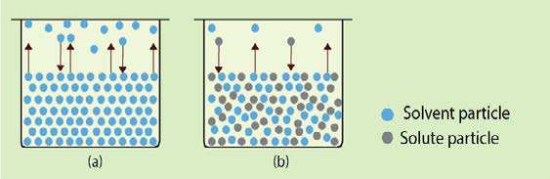

Fig (9.6) Lowering of vapour pressure

A quantitative relationship between the change of vapour pressure of a solvent due to addition of non-volatile and non-electrolyte solute and the mole fraction of solute has been given by Raoult. According to equation (3), Raoult says that relative lowering of vapour pressure isequal to the mole fraction of solute. ∆p =x

po 2

If n2 and n1 are the number of moles of a solute and solvent respectively, then

n

x =2 2

n +n1

2

So, ∆po n

= 2

p n +n1

2

For a dilute solution, n2 can be ignored in denominator

Hence, ∆po n

= 2 p n1

The number of moles of solute and solvent are obtained by dividing their masses in grams with their respective relative molecular masses. If W1 and W2 are the masses of solvent and solute while M1 and M2 are their relative molecular masses receptively, then

W

1

1

n=

and

2

2

2

W

n=

M

2

2

o

1

1

W

p

M

=

W

p

M

∆

............

(5)

(6)

.............

The molecular mass (M

2

of a non-volatile solute

)

can be calculated from the equation (6).

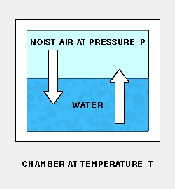

*Animation 9.19: Lowering of Vapour Pressure*

[*thunderscientii*](http://www.thunderscientific.com/)

*Source & Credit:*

[*c*](http://www.thunderscientific.com/)

M1

∆p W2 M o = x 1

p M2 W

1

po W M2

M =2 x 1

฀p W1

**Example 10:**

Pure benzene has a vapour pressure of 122.0 torr at 32°C. When 20g of a non- volatile solute were dissolved in 300g of benzene, a vapour pressure of 120 torr was observed. Calculate the molecular mass of the solute. The molecular mass of benzene being 78.1. **Solution**

Let the molecular mass of the solute be = M2

Mass of solute dissolved (W2) = 20 g

Vapour pressure of pure solvent (p°) = 122.0 torr

Vapour pressure of solution (p) = 120.0 torr

Lowering of vapour pressure (∆p) = 122.0 - 120.0 = 2.0 torr

Mass of solvent (W1) = 300 g

Molar mass of solvent (M1) = 78.1

Formula applied ∆po W2 M

= x 1

p M2 W1

po W M2

M =2 x 1

∆p W

|  |
| --- |
| g mol-[1] |

**9.6.3 Elevation of Boiling Point**

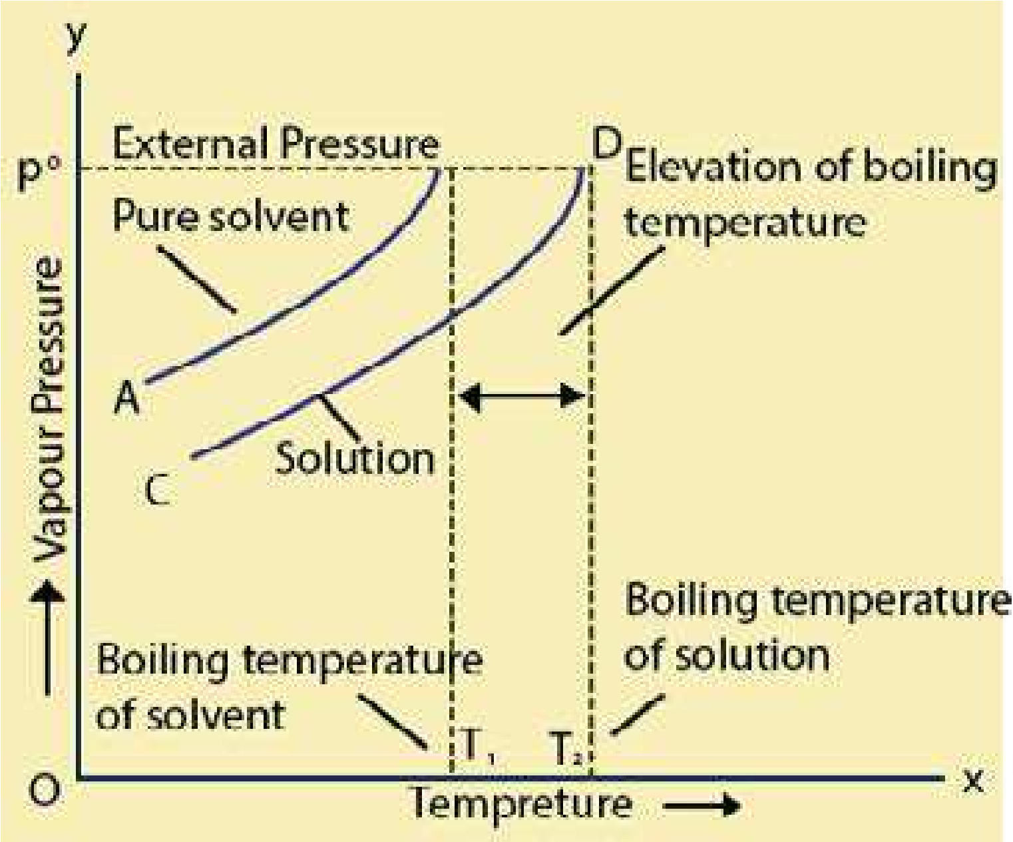 The presence of a non-volatile non-electrolyte solute in the solution decreases the vapour pressure of the solvent. Greater, the concentration of solute, greater will be the lowering of vapour pressure. Therefore, the temperature at which a solvent in the solution state boils is increased. In order to understand it, determine the vapour pressures of a solvent at various temperatures. Plot a graph between temperatures on x-axis and vapour pressures on y-axis. A rising curve is obtained with the increase of temperature. The slope of the curve at high temperature is greater, which shows that at high temperature the vapour pressure increases more rapidly. Temperature T1 on the curve AB which is for the pure solvent, corresponds to the boiling point of the solvent. The solvent boils when its vapour pressure becomes equal to the external pressure represented by p°.

When the solute is added in the solvent and vapour pressures are plotted vs temperatures, then a curve CD is obtained. This curve is lower than the curve AB because vapour pressures of solution are less than those of pure solvent. Solution will boil at higher temperature T2 to equalize its pressure to p°. The diference of two boiling points gives the elevation of the boiling point ∆Tb.

The higher the concentration of Fig (9.7) Elevation of boiling temperature curve solute, the greater will be the lowering in vapour pressure of solution and hence higher will be its boiling point. So, elevation of boiling point ∆Tb is directly proportional to the molality of solution.

∆T = K m ................ (8)b b

Where Kb is called the ebullioscopic constant or molal boiling point constant.

According to equation (8), molality of any solute determines the elevation of boiling point of a solvent. You may dissolve 6 g of urea in 500 g of H2O or 18 g of glucose in 500 g of H2O both give 0.2 molal solution and both have same elevation of boiling points i.e. 0.1 °C, which is l/5th of 0.52°C. We say that ∆Tb (not T) is a colligative property. We know that

Mass of solute 1

Molality(m) = x

Molar mass of solute Mass of solvent in kg

or m = W2 1 = 1000 W2 .......... (9)

2

1

2

1

M

W/1000

MW

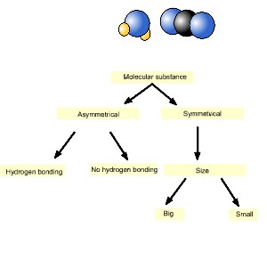

*Animation 9.20: Elevation of Boiling Point*

*Source & Credit:*

[*gif2l*](http://www.gif2fly.com/)

[*y*](http://www.gif2fly.com/)

Putting the value of m from equation (9) into equation (8 )

∆T = K b b 1000 W2 ......... (10)

M W2 1

Rearranging equation (10)

Molecular mass (M2) = ∆KTbb x WW12 x 1000 ............ (11)

Equation (11) can be used to determine the molar mass of a non-volatile and nonelectrolyte solute in a volatile solvent.

**9.6.4 Measurement of Boiling Point Elevation: Landsberger’S Method**

This is one of the best methods for the measurement of boiling point elevation of a solution.

The apparatus consists of four major parts.

1. An inner tube with a hole in its side. This tube is graduated.
2. A boiling lask which sends the solvent vapours into the graduated tube through a rosehead.
3. 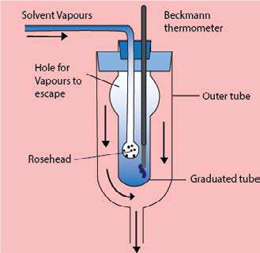An outer tube, which receives hot solvent vapours coming from the side hole of the inner tube.
4. A thermometer which can read up to 0.01K.

The solvent is placed in the inner tube. Some solvent is also taken in a separate lask and its vapours are sent into this tube. These vapours cause the solvent in the tube to boil by its latent heat of condensation. This temperature is noted which is the boiling point of the pure solvent.

The supply of the vapours is temporarily cut of and a weighed pellet of the solute is dropped in the inner tube. The vapours of the solvent are again passed through it until the

solution is boiled. This temperature is again Fig (9.8) Landsberger method for measurement of elevation

noted. Fig (9.8). of boiling point

Now, the supply of the solvent vapours is cut of. The thermometer and the rosehead are removed and the volume of the solution is measured. The diference of the two boiling points gives the value of ∆Tb. The following formula is used to calculate the molecular mass of solute.

Kb 1000 W2

M = 2  ............ (11) ∆Tb W1

**Example 11:**

The boiling point of water is 99.725 °C. To a sample of 600g of water are added 24.0 g of a solute having molecular mass of 58 g mol-1, to form a solution. Calculate the boiling point of the solution.

**Solution**

Boiling point of pure H2O =99.725oC

Mass of solvent (H2O) W1  =600 g

Mass of solute (W2) =24.00 g

Molar mass of solute (M2) =58 g mol-1

The molal boiling point constant of H2O (Kb) =0.52oC

Formula

∆T = K x b b 1000 W2

W x M1 2

0.52 x 1000 x 24.00 o

= = 0.358 C

600 x 58

Boiling point of solution = boilingpoint of pure solvent + elevation of boiling point

=99.725 + 0.358 =100.083oC Answer

**9.6.5 Depression of the Freezing Point of a Solvent by a Solute**

The freezing point of a substance is the temperature at which the solid and liquid phases of the substance co-exist. Freezing point is also deined as that temperature at which its solid and liquid phases have the same vapour pressures. When a non-volatile solute is added to a solvent, its vapour pressure is decreased. At the freezing point, there are two things in the vessel i.e. liquid solution and the solid solvent. The solution will freeze at that temperature at which the vapour pressures of both liquid solution and solid solvent are same. It means that a solution should freeze at lower temperature than pure solvent.

In order to understand it, plot a graph between vapour pressure temperature for pure solvent and that of solution. The curve ABC is for the pure solvent. The solvent freezes at temperature T1 corresponding to the point B when the vapour pressure of freezing solvent is p°. The portion of the curve BC is for the solid solvent. This portion has a greater slop, showing that the change of vapour pressure with the change of temperature is more rapid Fig (9.9).

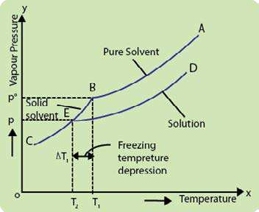

Fig (9.9) Depression of freezing point curve

The curve DEC for the solution will meet the curve BC at the point E. This is the freezing point of solution T2, and corresponds to the vapour pressure p which is lower than p°. The reason is that vapour pressure of solution is less than the pure solvent.

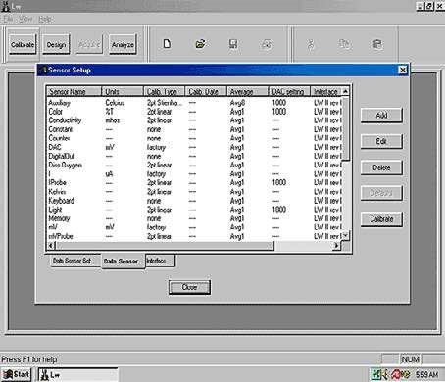

*Animation 9.21: Depression of the Freezing Point of a Solvent by a Solute*

*Source & Credit:*

[*co*](http://www.cod.edu/)

[*d*](http://www.cod.edu/)

Depression of freezing point = freezing point of pure solvent - freezing point of solution.

So, ∆T =T -Tf 1 2

This depression in freezing point ∆Tf is related to the molality (m) of the solution. The relationship is similar to that of elevation of the boiling point.

∆ ∝Tf m

∆T =K m ............. (12)f f

Kf is called the molal freezing point constant or the cryoscopic constant and m is the molality of the solution. To get the inal expression, let us put the following expression (9) of molality into the equation (12) i.e.

m = 1000 W2 ......... (9)

M xW2 1

We get ∆T =K f f 1000 W2 .................. (13)

M xW2 1

Where W2= mass of solute and M2= molar mass of the solute, W1= mass of solvent in kg Re-

|  |  |  |
| --- | --- | --- |
| arranging equation (13) |  |  |
|  | K 1000 W  Molar mass of solute (M )=2 f 2 | ......... (14) |

∆Tf W1

**9.6.6 Measurement of Freezing Point Depression Beckmann’s Freezing Point Apparatus:**

There are many methods but Beckmann’s method is easy to perform The apparatus consists of three major parts. Fig.(9.10).

1. A freezing tube with a side arm. It contains solvent or solution and is itted with a stirrer and a Beckmann’s thermometer.
2. An outer larger tube into which the freezing tube is adjusted. The air jacket in between these tubes help to achieve a slower and more uniform rate of cooling.
3. A large jar containing a freezing mixture. Around 20 to 25g of the solvent is taken in the freezing tube. The bulb of the thermometer, is immersed in the solvent. First of all, approximate freezing point of the solvent is measured by directly cooling the freezing point tube in the freezing mixture.

The freezing tube is then put in the air jacket and cooled slowly. In this way, accurate freezing point of the solvent is determined. Now, the solvent is re-melted by removing the tube from the bath and weighed amount of 0.2 to 0.3 g of the solute is introduced in the side tube.

The freezing point of the solution is determined while stirring the solution. The diference of the two freezing points gives the value of ∆Tf and the following formula is used to calculate the

|  |  |  |
| --- | --- | --- |
| molar mass of solute. |  |  |
| M =2 Kf 1000 W2 | ......... | (14) |

∆Tf W1

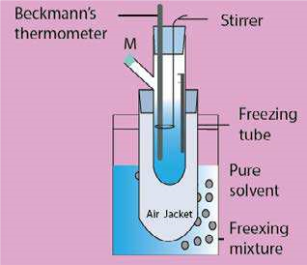

Fig (9.10) Beckmann's freezing point apparatus

**Example 12:**

The freezing point of pure camphor is 178.4°C. Find the freezing point of a solution containing 2.0 g of a non-volatile compound, having molecular mass 140, in 40g of camphor. The molal freezing point constant of camphor is 37.7 °C kg mol-1.

**Solution:**

|  |  |
| --- | --- |
| Freezing point of camphor | = 178.4 °C |
| Mass of solute (W2) | =2.00g |
| Mass of solvent (W1) | = 40 g |
| Molar mass of solute (M2) | = 140 |
| Molal freezing point constant of solvent | = 37.7° C kg mol-1. |
| Freezing point of solution  Applying the equation | = ? |

∆T =K f f 1000 W2

W x M1 2

We have to calculate, the freezing point of solution, so irst we get the depression in freezig point ∆Tf then subtract it from freezing point of pure solvent.

∆T =f 37.7 x 1000 x 2 =13.46oC

40 x 140

Freezing point of solution =178.4 - 13.4 = 164.94oC Answer

**9.6.7 Applications of Boiling Point Elevation and Freezing Point Depression Phenomena**

Apart from the molecular mass determination, the presence of a solute increases the liquid range of the solution both by raising the boiling point and lowering the freezing point. The most important application of this phenomenon is the use of an antifreeze in the radiator of an’automobile. The solute is ethylene glycol, which is not only completely miscible with water but has a very low vapour pressure and non-volatile in character. When mixed with water, it lowers the freezing point as well as raises the boiling point.

During winter it protects a car by preventing the liquid in the radiator from freezing, as water alone, if it were used instead. In hot summer, the antifreeze solution also protects the radiator from boiling over.

Another, common application is the use of NaCl or KNO3 to lower the melting point of ice. One can prepare a freezing mixture for use in an ice cream machine.

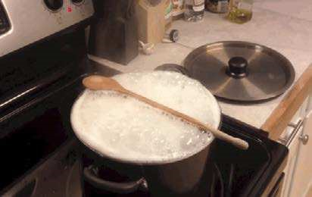

*Animation 9.22: Applications of Boiling Point Elevation and Freezing Point Depression*

*Phenom ena*

*Source & Credit: lifestyle*

#### 9.7.0 ENERGETICS OF SOLUTION

In a solution, the distances between solute and solvent molecules or ions increase somewhat as compared with their pure states. This increase in the distance of solvent molecules requires energy to overcome the cohesive intermolecular forces. Hence, it is an endothermic process. Similarly, the separation of solute molecules also needs energy so it is also an endothermic process. The intermixing of solute with solvent molecules is to establish new intermolecular forces between unlike molecules. It releases energy and thus is an exothermic phenomenon. The strengths of the two type of forces will decide whether the process of dissolution will be endothermic or exothermic.

Thus, the process of dissolution occurs with either an absorption or release of energy. This is due to breakage and re-establishment of intermolecular forces of attraction between solute and solvent molecules.

When potassium nitrate is dissolved in water, the temperature of the solution decreases. It shows it to be an endothermic process. The solution of lithium chloride in water produces heat, showing that the process of dissolution is exothermic. The quantity of heat energy, that is absorbed or released when a substance forms solution, is termed as heat of solution.

So, the enthalpy or heat of solution of a substance is deined as the heat change when one mole of the substance is dissolved in a speciied number of moles of solvent at a given temperature. It is given the symbol ∆Hsolu . The ∆Hsolu gives the diference between the energy possessed by the solution after its formation and the original energy of the components before their mixing i.e.

∆Hsolu =Hsolution -Hcomponents

Here, ∆Hsolu is the energy content of solution after its formation, while Hcomponents  represents the energy contents of components before their mixing. However, both these factors can not actually be measured, only their diference i.e. the change ∆Hsolu is practically measurable. If the value of ∆Hsolu is negative, it would mean that the solution is having less energy than the components from

which it was made, hence the dissolution process is an exothermic one. On the other hand, an endothermic process would have a positive ∆Hsolu value. In Table (9.4) are given values of heats of solution of diferent ionic solids in water at ininite dilution.

**Table (9.4) Heats of solution of some ionic solids**

|  |  |
| --- | --- |
| Substance | Heats of solution (kJ mol-  1) |
| NaCl  NH4NO3  KCl  KI  NH4Cl  LiCl  Li CO | 4.98 26.0 17.8 21.4  16.2  -35.0  -12.8 |

2 3

The magnitude of heat of solution gives information regarding the strength of intermolecular forces of attraction between components which mix to form a solution.

When one mole of sodium chloride (58.5g) is dissolved in 10 moles of water (180g), then 2.008 kJ of energy is absorbed.

NaCl+10H O → NaCl (10H O) H=+2.008kJ.∆

2

2

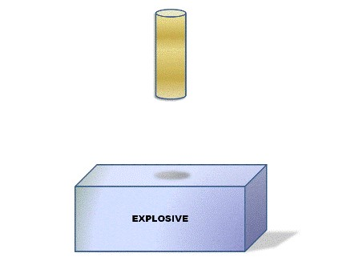

*Animation 9.23: ENERGETICS OF SOLUTION*

*Source & Credit:*

[*ntu*](http://www3.ntu.edu.sg/)

**9.7.1 Hydration Energy of Ions**

When an ionic compound, say potassium iodide is dissolved in water, the irst step, is the separation of K+ and I ions from solid. In the second step, these separated ions are surrounded by solvent molecules. The irst step breaks the lattice to separate the ions.

Since, energy is required to accomplish this step, so this step is endothermic. The amount of energy needed to separate a crystalline compound into isolated ions (or atoms) is known as lattice energy. The lattice energy of ionic solids is always higher than molecular solids.

**Table (9.5) Hydration energies of common ions**

|  |  |
| --- | --- |
| Ion | ∆H0  (ion mole-1) |
| H+  Li+  Na+  Ag+ K+  Mg2+  Cu2+  NH4+  FClBr-  OH- | -1075  -499  -390  -464  -305  -1891  -1562  -281  -457  -384  -351  -460 |

In the second step, the ions are brought into water and get hydrated (solvated) Fig (9.11). A hydrated ion is attracted by the solvent dipoles and energy is released, so this step is exothermic. The energy given out by this step is known as the hydration energy (or solvation energy).

K + I + xH O+ - 2 → K (aq) + I (aq)+ -

The inal equation will be as follows:

Kl(s) + xH O2 → K (aq) + I (aq)+ -

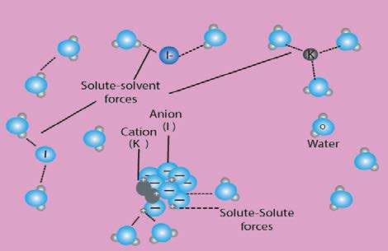

Fig (9.11) Interaction between water molecules and cations and anions provide the energy- necessary to overcome both the intermolecular forces between water molecules and the ionic bond in a potassium iodide

The values of hydration energies of individual ions, i.e. cations and anions are given in Table (9.5). It is interesting to compare these values with the ionic radii of the ions. Greater the size of monovalent cation, lesser is the heat of hydration. Divalent and trivalent cations have higher values due to high charge densities. Anions also show a deinite trend of heat of hydration, depending upon their sizes.

On diluting a concentrated solution, there is a further heat change. This heat change depends on the amount of water used for dilution. The heat of dilution gradually decreases, so that eventually increasing the dilution produces no further heat change. This occurs when there are 800-1000 moles of water to one mole of solute. This stage is called ininite dilution and the heat of solution is expressed as:

NaCl(s) + H O → NaCl(aq) ฀ Na (aq)+ + Cl (aq)− ∆H = + 4.98kJ mol-1

2 soln

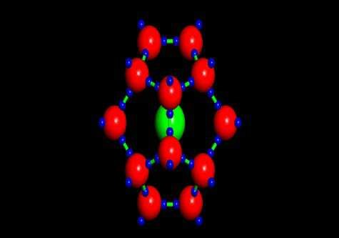

*Animation 9.24: Hydration Energy of Ions*

*Source & Credit:*

[*arizon*](http://www.geo.arizona.edu/)

[*a*](http://www.geo.arizona.edu/)

1. Putting the values

   M =2 x = 317.6 Answer