CHAPTER

Periodic Classification Of

1

Elements And Periodicity

[Animation 1.1 : Periodic Table](http://elearn.punjab.gov.pk/animations/chemistry/index.html)

Source and Credit: [eLearn.Punjab](http://elearn.punjab.gov.pk/animations/chemistry/index.html)

|  |  |
| --- | --- |
| IN THIS CHAPTER YOU WILL LEARN |  |
|  |  |
| 1. To describe the periodic table in terms of groups and periods. 2. To describe and explain periodicity in physical and properties. 3. To describe the position of hydrogen in the periodic table. | chemical |

# 1.1 INTRODUCTION

To achieve a thorough understanding of a complex subject like chemistry, it would be highly desirable to fit all the facts into a simple logical pattern. The periodic table of elements has served the purpose to systematize the properties of the elements for well over 100 years.The development of periodic table is one of the most significant achievements in the history of chemical sciences.

The Periodic Table provides a basic framework to study the periodic behaviour of physical and chemical properties of elements as well as their compounds. In previous classes, you have learnt about the periodic classification of elements. This chapter describes in more detail the periodic table and the periodicity of elements.

## 1.1.1 Historical Background

The early history of ideas leading up to the Periodic classification of elements is fascinating but will not be treated in detail.Those who made memorable contributions in this field are Al-Razi,Dobereiner,Newland and Mendeleev. Al-Razi’s classifications was based on the physical and chemical properties of substances . Dobereiner, a German chemist in 1829, arranged then known elements in group called Triads, as each contained three elements with similar properties. Newland who was an English chemist , in 1864, classified 62 elements, known at that time , in increasing order of thier atomic masses. He noticed that every eighth element had some properties in common with the first one. The principle on which this classification is based was called the Law of Octaves.

In 1871, a Russian Chemist, Dmitri Mendeleev, gave a more useful and comprehensive scheme for the classification of elements. He presented the first regular periodic table in which elements of similar chemical properties were arranged in eight vertical columns called Groups.The horizontal rows of the table were called Periods.

Mendeleev also started by arranging the elements in ascending order of their atomic masses and found that elements having similar chemical properties appeared at regular intervals. This significant observation was called Periodic Law. Mendeleev left some gaps in his table for elements, which had not yet been discovered, and by considering their positions in the periodic table, he predicted properties of these elements. For example, germanium was not known at that time, but Mendeleev was confident that this element must exist so he predicted its properties. A few years later, germanium was indeed discovered and a remarkable agreement was found with Mendeleev’s predictions.

### 1.1.2 Improvements In Mendeleev 's Periodic Table

In order to make the periodic table more useful and accurate, a few improvements were made in Mendeleev s periodic table. After the discovery of atomic number by Moseley in 1911, it was noticed that elements could be classified more satisfactorily by using their atomic numbers, rather than their atomic masses.

Hence, the periodic table was improved by arranging the elements in ascending order of their atomic numbers instead of their atomic masses. This improvement rectified a number of confusions present in the old periodic table.The modern Periodic Law states that: “if the elements are arranged in ascending order of their atomic numbers, their chemical properties repeat in a periodic manner”

Another improvement was the addition of an extra group (group VIIIA) at the extreme right of the periodic table. This group contains noble gases, which had not been discovered in

Mendeleev’s time.

Another confusion in Mendeleev’s table was that elements like Be, Mg, Ca, Sr, Ba and Zn, Cd, Hg were placed in a single vertical group, while according to their properties they belonged to two different categories. The same was true for so many other elements placed in the same vertical group. In modern periodic table, the confusion was removed by dividing the elements in two types of vertical groups, A and B. In modern periodic table, Be, Mg, Ca, Sr and Ba are placed in group IIA and Zn, Cd, Hg in group IIB.

## 1.2 THE MODERN PERIODIC TABLE

In modern periodic table (see periodic table) all the elements are arranged inascending order of their atomic numbers.

Followings are the essential features of the periodic table.

### 1. Group and Periods

Elements with similar properties are placed in vertical columns called Groups.

There are eight groups ,which are usually numbered by Roman numerals I to VIII.Each group is divided into two subgroups, designated as A and B subgroups. The subgroups, containing the representative or normal elements are labelled as A subgroups, whereas B subgroup contain less typical elements, called transition elements and are arranged in the centre of the periodic table. The horizontal rows of the periodic table are called Periods.The essential features of periods are as follows:

1. There are 7 periods in the periodic table numbered by Arabic numerals 1 to 7.
2. The period 1 contains only two elements, hydrogen and helium.
3. The periods 2 and 3 contain eight elements each and are called short periods. All the elements in these periods are representative elements and belong to A subgroup . In these periods, every eighth element resembles in properties with the first element. As lithium and beryllium in the 2nd period resemble in most of their properties with sodium and magnesium of the 3rd period, respectively. Similarly, boron and aluminium both show oxidation state of +3, fluorine in 2nd period has close resemblances with chlorine of 3rd period.

### Table 1.1 MODERN PERIODIC TABLE OF THE ELEMENTS

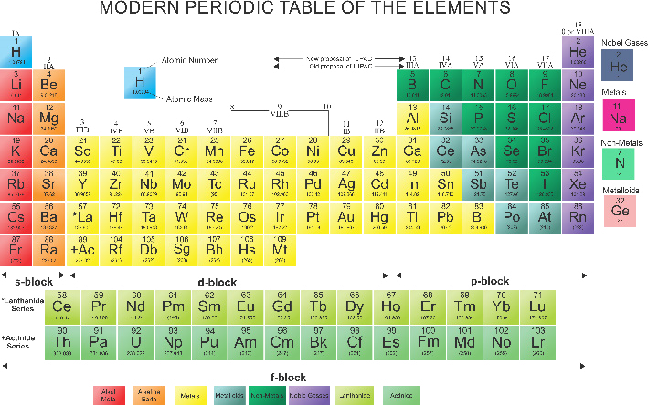

1. The periods 4 and 5 are called long periods. Each long period consists of eighteen elements. Out of these, eight are representative elements belonging to A subgroup similar to second and third periods. Whereas the other ten elements, placed in the centre of the table belong to B subgroups and are known as transition elements. In these periods, the repetition of properties among the elements occurs after 18 elements. As after 19K (having atomic number 19) the next element with similar properties is 37Rb.
2. The period 6 is also a long period, which contains thirty-two elements. In this period there are eight representative elements, ten transition elements and a new set of fourteen elements called Lanthanides as they start after 57La. Lanthanides have remarkably similar properties and are usually shown separately at the bottom of the periodic table.
3. The period 7 is incomplete so far. It contains only two normal elements 87Fr and 88Ra, ten transition elements and fourteen inner transition elements. The inner transition elements of this period are called Actinides, as they follow 89Ac.The actinides are also shown at the bottom of the periodic table under the Lanthanides. Due to their scarcity, the inner transition elements are also called rare earth elements.

2. Some More Families in the Periodic Table:

While studying about periods you have noticed that certain rows of elements with similar properties have assigned common names such as transition elements, Lanthanides, Actinides or Rate Earth elements.Similarly, due to their peculiar characteristics, some typical elements belonging to sub-groups A, have also been assigned family names. For example,elements of the group IA are called Alkali Metals, because of their property to form strong alkalies with water.

2Na +2H O ——-—> 2NaOH + H

2 2

Similarly,due to their presence in Earth’s crust and alkaline character,the elements of group IIA are known as Alkaline Earth Metals. Another important family in the periodic table is Halogen family. The name “Halogens” is given to the elements of group VIIA, due to their salt forming properties. As the gases of group VIIIA ‘are least reactive they are called “Noble Gases”,These family names are useful for a quick recognition of an element in the periodic table.

#### 3. Blocks in the Periodic Table

Elements in the periodic table can also be classified into four blocks. This classification is based upon the valence orbital of the element involved in chemical bonding. According to this classification, elements of IA and IIA subgroups are called s-block elements because their valence electrons are available in s orbital.The elements of IIIA to VlllA subgroups (except He) are known as p-block elements as their valence electrons are present in p orbital.

Similarly in transition elements, electrons in d-orbital are responsible for their valency hence they are called d-block elements. For Lanthanides and Actinides valence electrons are present in f- orbital hence these elements are called f-block elements. This classification is quite useful in understanding the chemistry of elements and predicting their properties especially the concept of valency or oxidation state.

#### 4. Metals, Non-metals and Metalloids

Another basis for classifying the elements in the periodic table is their metallic character. Generally, the elements on the left hand side, in the centre and at the bottom of the periodic table are metals, while the non-metals are in the upper right corner of the table. Some elements, especially lower members of groups, III A, IVA and VA(as shown in Table 1.1) have properties of both metals as well as non-metals. These elements are called semi-metals or metalloids. In the periodic table elements of groups IVA to VIIIA, at the top right hand corner above the stepped line, are non-metals. The elements just under the “steps’ such as Si, As, and Te are the metalloids. All the remaining elements, except hydrogen, are metals.

## 1.3 PERIODIC TRENDS IN PHYSICAL PROPERTIES

As you have studied so far that in modern periodic table the elements are arranged in ascending order of their atomic numbers and their classification in groups and periods is based on the similarity in their properties. Yet, due to the gradual increase in the number of protons in the nucleus and electrons in outer shells the physical and chemical properties of the elements steadily vary within a group or a period. Here, we study some trends in physical properties.

### 1. ATOMIC SIZE

a) Atomic Radius:

Atoms are so small that it is impossible to see an atom even with a powerful optical microscope. The size of a single atom therefore cannot be directly measured. However, techniques have been developed which can measure the distance between the centres of two bonded atoms of any element. Half of this distance is considered to be the radius of the atom. In the periodic table, the atomic radius increases from top to bottom within a group due to increase in atomic number . This is because of the addition of an extra shell of electrons in each period. In a period, however, as the atomic number increases from left to right, the atomic radius decreases . This gradual decrease in the radius is due to increase in the positive charge in the nucleus . As the positive nuclear charge increases, the negatively charged electrons in the shells are pulled closer to the nucleus. Thus, the size of the outermost shell becomes gradually smaller. This effect is quite remarkable in the elements of longer periods in which “d” and “f ” subshells are involved. For example, the gradual reduction in the size of Lanthanides is significant and called Lanthanide Contraction. b) Ionic Radius:

When a neutral atom loses one or more electrons, it becomes a positive ion. The size of the atom is decreased in this process because of the two reasons.

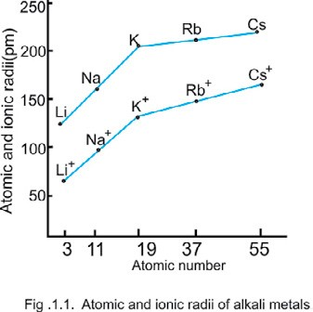

First the removal of one or more electrons from a neutral atom usually results in the loss of the outermost shell and second, the removal of electrons causes an imbalance in proton-electron ratio. Due to the greater attraction of the nuclear charge, the remaining electrons of the ion are drawn closer to the nucleus.

Thus, a positive ion is always smaller than the neutral atom from which it is derived. The radius of Na is 157pm and the radius of Na+ is 95pm. On the contrary, a negative ion is always bigger than its parent atom.

The reason is that addition of one or more electrons in the shell of a neutral atom enhances repulsion between the electrons causing expansion of the shell.

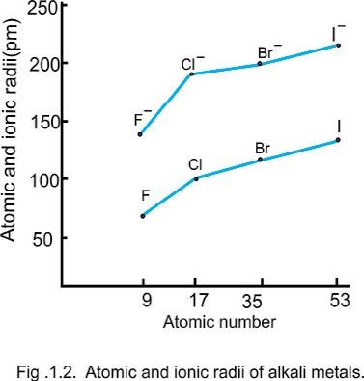

Thus, the radius of fluorine atom is 72pm and that of the fluoride ion (F ) is 136pm.

In a group of the periodic table, similar charged ions increase in size from top to bottom. Whereas within a period, isoelectronic positive ions show a decrease in ionic radius from left to right, because of the increasing nuclear charge.

The same trend is observed for the isoelectronic negative ions of a period; ionic size decreases from left to right. The variations in atomic and ionic radii of alkali metals and halogens are shown in Fig 1.1 and Fig.1.2.

### 2. Ionization Energy

The ionization energy of an element is the minimum quantity of energy which is required to remove an electron from the outermost shell of its isolated gaseous atom in its ground state. The ionization energy of sodium is 496kJ mol-1.

### Na(g) →Na+(g) + e- i = 496 kJ mol-1

Elements with greater number of electrons have more than one values of ionization energy. So for magnesium, the first ionization energy value is the energy required to remove the first electron:

### Mg (g) →Mg+ (g) + e- i1 = 738 kJ mol-1

Similarly, the second ionization energy value is the energy required to remove the second electron.

Mg+ (g) →Mg++ + e- i2= 1451kJ mol-1

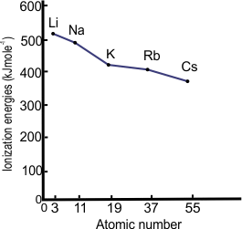a) Variation Within a Group:

The factors upon which the ionization energy of an atom mainly depends are magnitude of nuclear charge, size of the atom, and the “shielding effect”. The shielding effect is actually the repulsion due to electrons in between the nucleus and the outermost shell.

This effect increases, as the size of the atom increases due to addition of an extra shell successively in each period hence more number of electrons shields the nucleus.

Fig. 1.3 Ionization energies of alkali metals

Going down in a group, the nuclear charge increases but as the size of the atom and the number of electrons causing the shielding effect also increases therefore ionization energy decreases from top to bottom. That is why in alkali metals, for example, it is easier to remove an electron from caesium atom than from lithium atom. The change in ionization energies of IA elements is shown in Fig. 1.3. b) Variation Across a Period:

Generally, smaller the atom with greater nuclear charge, more strongly the electrons are bound to the nucleus and hence higher the ionization energy of the atom. By moving from left to right in a period, the outer shell remains the same, while the nuclear charge increases effectively that makes the removal of an electron difficult and hence the value of ionization energy increases.

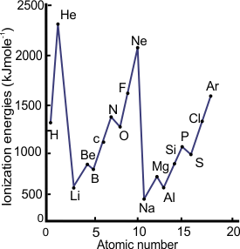

Fig. 1.4 Ionization energies of elements of short periods.

Although, the number of electrons also increases in this case but the shielding is not very effective within the same shell. The trend of ionization energies of short periods is shown in Fig.1.4 The figure also reveals that inert gases have the highest values of ionization energy because due to complete outermost shell in them, the removal of electron is extremely difficult.

#### 3. Electron Affinity (E.A)

The electron affinity is the energy released or absorbed, when an electron is added to a gaseous atom to form a negative ion.

### F (g) +e- → F-(g) E.A= -337 kJ mol-1

Energy is usually released when electronegative elements absorb the first electron and E.A. in such cases is expressed in negative figures, as in the case of halogens. When a second electron is added to a uninegative ion, the incoming electron is repelled by the already present negative charge and energy is absorbed in this process.

O(g) + e- → O-(g) E.A1= -141 kJ mol-1

O- (g)+ e- O→ 2-(g) E.A2= +780 kJ mol-1

The absorbed energy is expressed as the electron affinity in positive figures. Electron affinity depends upon size of the atom, nuclear charge and vacancies in the outermost shell. Relatively smaller atoms with one or two vacancies in the outermost shell show large values of electron affinity.

Electron affinity generally increases with increasing atomic number within a period and decreases from lighter to heavier elements in a given group of the periodic table. Knowledge of electron affinities can be combined with the knowledge of ionization energies to predict which atoms can easily lose electrons and which can accept electrons more readily.

#### 4. Metallic and Non-Metallic Character

It has already been discussed in this chapter that elements of periodic table can be divided into metals, non-metals and metalloids. Chemically all the elements which have a tendency to form positive ions by losing electrons are considered metals. All metals are good conductor of heat and electricity. A characteristic property of metals is that they form basic oxides which give bases when dissolved in water.

# Na2O (s) + H2O (l) 2 NaOH → (aq)

As it becomes easier to remove the electron of an atom bigger in size, therefore metallic character increases from top to bottom in a given group of elements. On the contrary, it decreases from left to right across a period. The elements of group VIIA (the halogens) are least metallic in nature.The elements which gain electrons and form negative ions are called non-metals. All the gases are non-metals. The non-metals are normally poor conductor of heat and electricity. Nonmetals form acidic oxides which yield acids on dissolving in water.

# SO3(g) + H2O (l) 2 H→ 2SO4 (aq)

Non-metallic character of an element, decreases as the atomic size increases. Therefore in a group of non-metals like halogens, the non-metallic character decreases from top to bottom. The member at the top, fluorine, is the most non-metallic element of the periodic table. This trend can also be verified in the elements of groups VA and VIA. Nitrogen and oxygen are pure non-metals and usually exist in gaseous state while bismuth and polonium, the members at the bottom of these groups, are fairly metallic in nature.

## 5. Melting And Boiling Points

Melting and boiling points of elements tell us something about how strong the atoms or molecules in them are bound together.

## (a) Variation in a Period

Across the short periods, the melting and boiling points of elements increase with the number of valence electrons upto group IVA and then decrease upto the noble gases. The melting points of group IA elements are low because each atom in them provides only one electron to form a bond with other atom. Melting points of group IIA elements are considerably higher than those of group IA elements because each atom in them provides two binding electrons. 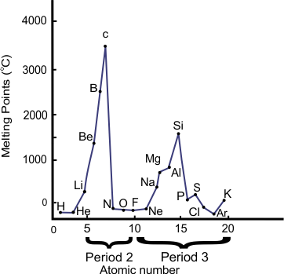

Fig. 1.5 Variation of melting points with atomic number

Since carbon has the maximum number of binding electrons, thus it has a very high melting point in diamond in which each carbon is bound to four other carbon atoms. In general, the elements which exist as giant covalent structures have very high melting points, Fig. 1.5.

An important change occurs when we move from group IVA to groups VA, VIA, VIIA as the lighter elements of these group exist as small, covalent molecules, rather than as three dimensional lattices. For instance, nitrogen,oxygen and fluorine exist as individual molecules which have very weak intermolecular forces between them. Consequently, their melting and boiling points are extremely low.

(b) Variation in a Group

The melting and boiling points of IA and IIA group elements decrease from top to bottom due to the increase in their atomic sizes. The binding forces present between large sized atoms are relatively weaker as compared to those between smaller atoms, Fig. 1.6.

For elements of group VIIA, which exist in the form of molecules, the melting and boiling points increase down the group, Fig. 1.7. This is because large molecules exert stronger force of attraction due to their higher polarizabilities.

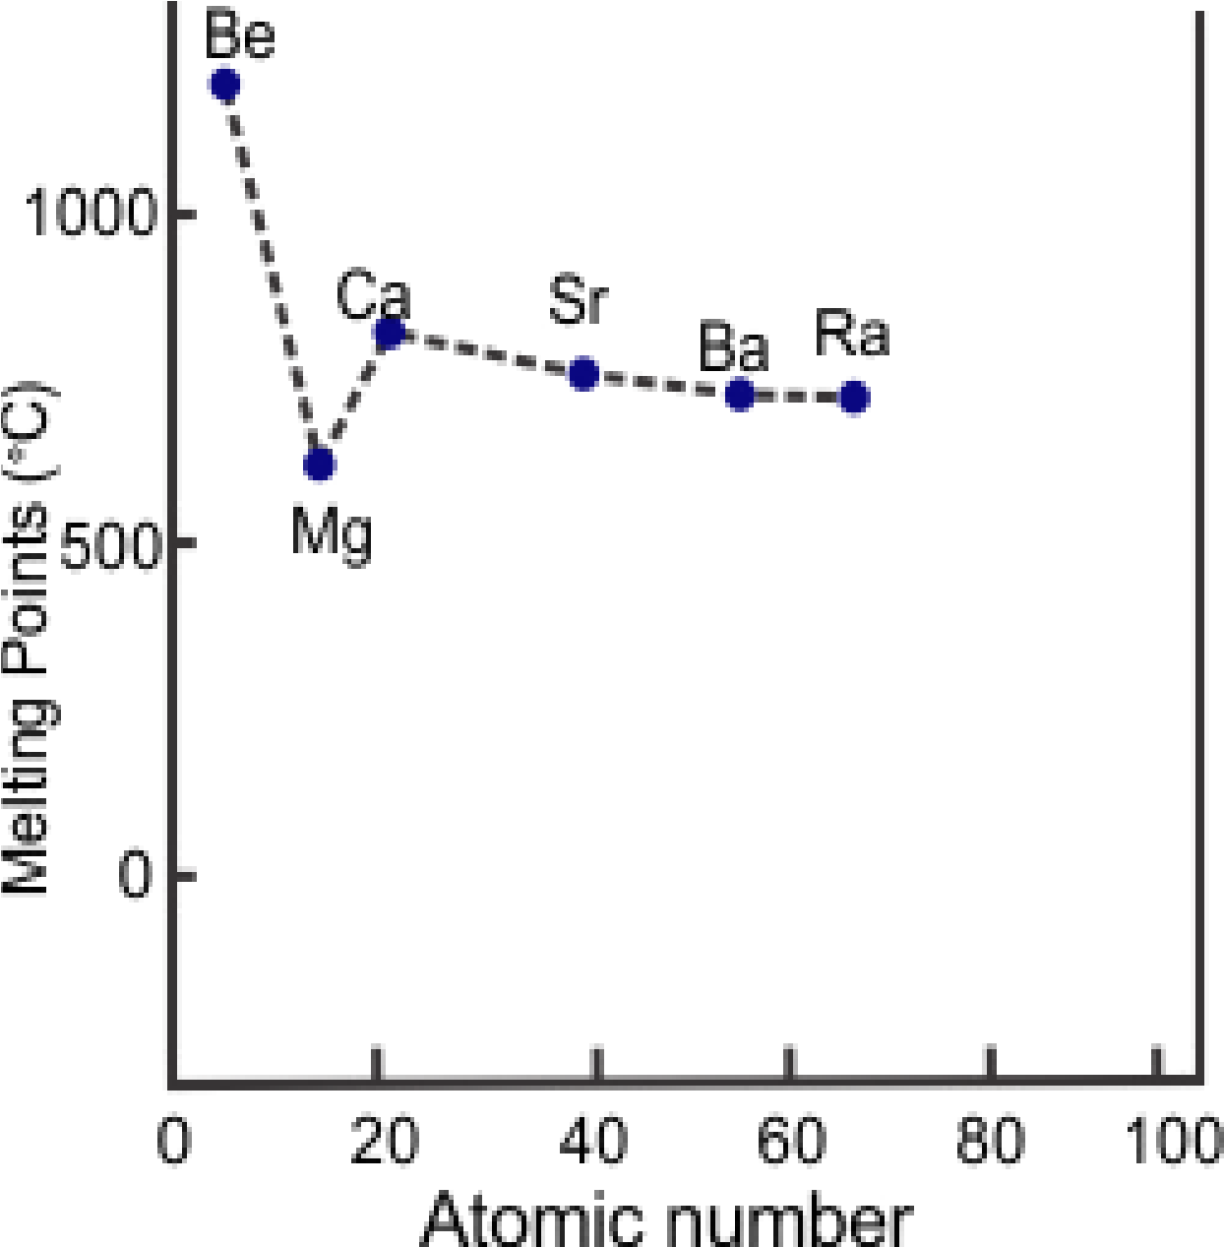

Fig.1.6 Melting points of Group IIA elements.

### 6. Oxidation State

The oxidation state of an atom in a compound is defined as the charge (with the sign), which it would carry in the compound. In ionic compounds, it is usually the number of electrons gained or lost by the atom. As in the case of sodium chloride, the oxidation states of sodium and chlorine are + 1 and -1, respectively. In covalent compounds, it is decided on the basis of the difference in their relative electronegativities. For example, SnCl4 is a covalent compound. The oxidation state of tin is + 4 and that of chlorine is -1. The oxidation state of an element is zero in its free state.

The oxidation state of a typical element is directly or indirectly related to the group number to which the element belongs in the periodic table. The elements of group IA to IVA have the same oxidation states as their group numbers are. Just as B, Al and Ga belong to group IIIA, hence, they always show oxidation state of +3. So, for the elements

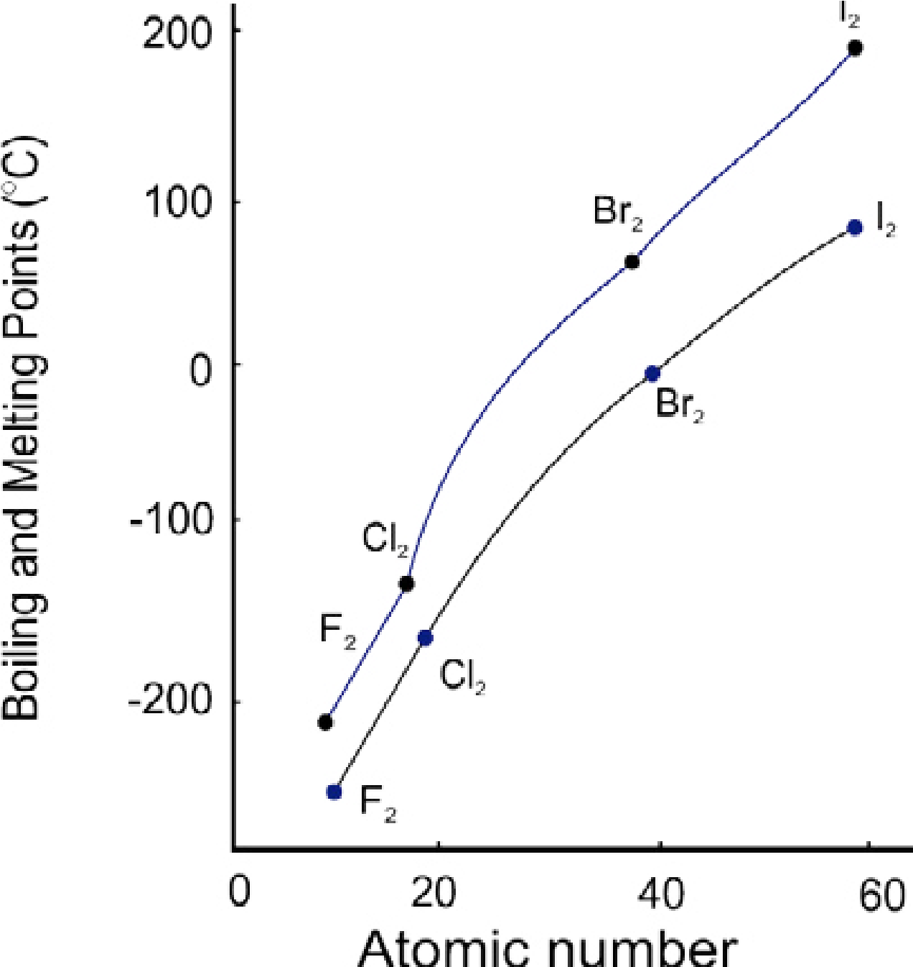

Fig.1.7 . Bloiling (.---------) and melting points(;_______) of halogens.

of these groups, the oxidation state is same as the number of electrons present in the valence shells of the elements. However, for the elements of group VA, the oxidation states are either the number of electrons present in the valence shell (which is same as their group number) or the number of vacancies available in these shells.

For example, N, P, As and Sb frequently show +3 as well as +5 oxidation states. Elements of group VIA show almost similar behaviour. In H2SO4, sulphur shows the oxidation state of +6, which is the number of electrons in its outermost shell whereas its oxidation state is -2 in H2S, which is the number of vacancies in the shell.

In group VIIA elements oxidation state is mostly - 1, which is again the number of vacancies in their outermost shells. Group VIIIA elements, which are also called zero group elements, usually show zero oxidation state because there is no vacancy in their outermost shells.

Transition elements, which are shown in B subgroups of the periodic table, also show the oxidation states equal to their group number as it can be seen for Cu(I), Zn(II), V(V), Cr(VI) and Mn (VII). But due to greater number of valence electrons available in partly filled d-orbitals these elements usually, show more than one oxidation states in their compounds.

### 7 Electrical Conductance

One of the most familiar properties of metals is their ability to conduct electricity. This property is mainly due to the presence of relatively loose electrons in the outermost shell of the element and ease of their movement in the solid lattice. The electrical conductance of metals in groups IA and IIA, generally increases from top to bottom. However, the trend is not free from the individual variation in different atoms. Metals of group IB, which are known as coinage metals, have extraordinary high values of electrical conductance. Non-metals, on the other hand, especially of groups VIA and VIIA, show such low electrical conductance that they can be considered as nonconductors.

In the series of transition metals, the values of electrical conductance vary so abruptly that no general trend can be assigned to them. Carbon, in the form of diamond is non-conductor because all of its valence electrons are tetrahedrally bound and unable to move freely, while in the form of graphite, carbon is fairly good conductor because one of its four valence electrons is relatively free to move. The lower elements of group IVA, tin and lead, are fairly good conductors and their values of electrical conductivity are comparable with those of their counterparts in group IA. 8 Hydration Energy

The hydration energy is the heat absorbed or evolved when one mole of gaseous ions dissolve in water to give an infinitely dilute solution. For example, when one mole of gaseous hydrogen ions are dissolved in water resulting an infinitely dilute solution, a large amount of heat is liberated:

H+ (*g*) + H2O (***l***) → H3O+(aq) DHh = - 1075 kJ mol-1

Hydration energies of a few negative and positive ions are shown in the Table 1.2. Table 1.2 Hydration It is evident from the table that hydration  Energies of Ions

|  |  |
| --- | --- |
| Ion | Hh  kJ mol-1 |
| Li+ | -499 |
| Na+ | -390 |
| K+ | -305 |
| Mg2+ | -1891 |
| Ca2+ | -1562 |
| Al3+ | -4613 |
| F- | -457 |
| Cl- | -384 |
| Br_ | -351 |
| I- | -307 |

energies highly depend upon charge to size ratio of the ions. For a given set of ions, for example of group IA, charge to size ratio decreases from top to bottom in a group, the hydration energy also decreases in the same fashion. On the contrary, the hydration energy increases significantly by moving from left to right in a period as the charge to size ratio increases, as found in the metal ions of third period.

1.4 PERIODIC RELATIONSHIP IN COMPOUNDS a) Halides:

Halides are the binary compounds which halogens form with other elements. The physical properties of halides are largely determined by the nature of bonding present in them. On this basis, halides can be classified into twogeneral classes: ionic and covalent.In between the two, there is another class of halides in which the halogen atom acts as a bridge between the two atoms of the other element, such halides are termed as “Polymeric” halides.Strongly electropositive elements, having greater electronegativity difference with halogen atom, form ionic halides.The halides of group IA are considered purely ionic compounds, which are high melting point solids. Such halides have three-dimensional lattices consisting of discrete ions.

Table 1.3 Melting Points of Chlorides of Period

Three Elements and Their Bonding Character

|  |  |  |
| --- | --- | --- |
| Name  of compounds | Property  Melting  Type of bonding point (°C) | |
| NaCl | 808 | Ionic |
| MgCl2 | 715 | Partly ionic |
| AlCl3 | 192 | Partly ionic |
| SiCl4 | -68 | Partly covalent |
| PCI3 | -93 | Partly covalent |
| S2CI2 | -80 | Partly covalent |

Among the pure ionic compounds, the fluorides have the highest lattice energies due to the small size of fluoride ion. Thus for ionic halides, the fluorides have the highest melting and boiling points which decrease in the order: fluoride > chloride > bromide > iodide. Less electropositive elements, such as Be, Ga and AI form polymeric halides having partly ionic bonding with layer or chain lattices.

The lattice of SiCl4 consists of discrete molecules, which are highly polar. The bonds in PCI3, and S2Cl2 are less polar than those of SiCl4. On moving across the periodic table from left to right, the electronegativity difference reduces and the trend shifts towards covalent halides. The gradual change in bond type and melting points of the chlorides on moving across period 3 of the periodic table is shown in Table. 1.3.

As the intermolecular forces in covalent halide molecules are weak van der Waal’s forces so they are often gases, liquids or low melting point solids. Physical properties of covalent halides are influenced by the size and polarizability of the halogen atom.Iodides, as being the largest and more polarizable ions, possess the strongest van der Waal’s forces and therefore have higher melting and boiling points than those of other covalent halides.

The variation in bonding character is also present in descending from top to bottom in the halogen group. In general, for a metal the order of decreasing ionic character of the halides is: fluoride > chloride > bromide > iodide. For example, AlF3 is purely ionic compound having melting point 1290°C and fairly a good conductor, whereas AlI3  is predominantly covalent with melting point 198°C and electrically a non-conductor. In case of an element forming more than one halides, the metal halide in its lower oxidation state tends to be ionic, while that in the higher oxidation state is covalent. For example, PbCl2 is mainly ionic and PbCl4 is fairly covalent. This can again be explained by the high polarizing power of Pb4+ as compared to that of Pb2+.

## b) Hydrides

The binary compounds of hydrogen with other elements are called hydrides. According to the nature of bonding, hydrides may be broadly classified into three classes: ionic, covalent and intermediate. The elements of group IA and the heavier members of group IIA form ionic hydrides, which contain H- (Hydride) ion.These hydrides are crystalline solid compounds, with high melting and boiling points and which conduct electricity in molten state.

The tendency towards covalent character increases by moving from left to right in the Periodic Table. Hydrides of beryllium and magnesium represent the class of intermediate hydrides. Their properties are in between the ionic and covalent hydrides. They have polymeric structures and covalent nature, Table 1.4.

Table 1.4. Hydrides of the Elements of IA to VIIA and IIB Subgroups.

|  |  |  |  |  |  |  |  |
| --- | --- | --- | --- | --- | --- | --- | --- |
| IA IIA | | IIB IIIA | | IVA | VA | VIA | VIIA |
| LiH | BeH2 |  | BH3 | CH4 | NH3 | H2O | HF |
| NaH | MgH2 |  | AIH3 GaH3 | SiH4  GeH4 | PH3 AsH3 | H2S H2Se | HCl HBr |
| KH CaH2 RbH SrH2 | | ZnH2 |
| CdH2 InH3 | | SnH4 | SbH3 | H2Te | HI |
| CsH BaH2 | |  | | PbH4 | BiH3 |  |  |
| IONIC | | INTERMEDIATE | |  | COVALENT | |  |

The covalent hydrides are usually gases or volatile liquids. They are non-conductors and dissolve in organic solvents. Their bond energies depend on the size and the electronegativity of the element. Stability of covalent hydrides increases from left to right in a period and decreases from top to bottom in a group.Fluorine forms the most stable hydride and the least stable are those of thallium, lead and bismuth. These hydrides are formed by elements with electronegativity values greater than 1.8 (Pauling Scale). Since the electronegativity of hydrogen is

2.1, most of these hydrides have polar covalent bonds in which hydrogen is carrying a slight positive charge.

On moving from left to right across a period the electronegativity of the other element increases and the hydrogen-element bond becomes more polar. Due to high polarity the hydrides like H2O and HF are capable of forming hydrogen bonds between their molecules. The boiling points of covalent hydrides generally increase on descending a group as shown in Table 1.5, except the hydrides like H2O, HF and NH3 which, due to hydrogen bonding, have higher boiling points than might be expected.

Table. 1.5. Melting and Boiling points of Hydrides of Groups IV A and VI A

|  |  |  |
| --- | --- | --- |
| Hydrides | Property | |
| (Group IVA) |
| Melting point (°C) | Boiling point ‘ (°C) |
| CH4 | -184 | -164 |
| SiH4 | -185 | -112 |
| GeH4 | -165 | -90 |
| SnH4 | -150 | -52 |
| (Group VIA) | 0.00 | 100 |
| H2O |
| H2S | -82.9 | -59.6 |
| H2Se | -65.7 | -41.3 |
| H Te | -48 | -1.8 |

2

c) Oxides

Oxygen forms compounds, called oxides, with almost every other element in the periodic table. Since, many of these have quite unusual properties, there is an extensive and varied chemistry of the compounds of oxygen. Oxides can be classified in more than one ways: based upon the type of bonding they have as well as their acidic or basic character.We shall discuss here the classification based on their acidic or basic behaviour. In this chapter, you have already studied that metal oxides are basic in character as they yield bases in water and non-metallic oxides are acidic because they form acids in water.Basic oxides and acidic oxides react with one another to give salts, for example:

## Na2O (s) + SO3 (g) Na→ 2SO4 (s)

There is a third type of oxides, which show both acidic and basic properties, these oxides are called amphoteric oxides. The classification of elements which form oxides of acidic or basic properties is shown in Table 1.6.

Table 1.6 Classification of Oxides Based on their Acid and Base Character

|  |  |  |  |  |  |  |  |  |  |
| --- | --- | --- | --- | --- | --- | --- | --- | --- | --- |
| IA | IIA | IIB | IIIA | IVA | | VA | VIA | | VIIA |
| Li | Be |  | B | C | | N | O | | F |
| Na K | Mg  Ca |  | AI | Si | | P | S | | Cl |
| Zn | Ga | Ge | | As | Se  Te  Po | | Br  I  At |
| Rb | Sr | Cd | In | Sn | | Sb |
| Cs | Ba | Hg | TI | Pb | | Bi |
| BASIC | | | | | | AMPHOTERIC | | | ACIDIC | | |

The oxides of alkali and alkaline earth metals except beryllium are basic and contain O2- ions. The O2- ion has high affinity for proton and cannot exist alone in an aqueous solution. Therefore, it immediately takes proton from water and forms OH- ion. Oxides of nonmetallic elements i.e. of C, N, P and S are acidic in nature. They generally dissolve in water to produce acidic solutions. Oxides of relatively less electropositive elements, such as BeO, Al2O3, Bi2O3 and ZnO are amphoteric and behave as acids towards strong bases and as bases towards strong acids.

ZnO(s) + H2SO4 (aq) ZnSO→ 4 (aq) + H2O(l)

ZnO (s) + 2NaOH (aq) + H2O (l) Na→2[Zn(OH)4] (aq)

In a given period, the oxides progress from strongly basic through weakly basic,amphoteric, and weakly acidic to strongly acidic, e.g. Na2O, MgO, Al2O3, P4O10 , SO3 , Cl2O7.The basicity of main group metal oxides increases on descending a group of the periodic table, (e.g. BeO<MgO<CaO<SrO<BaO), though the reverse trend is observed in the transition metal oxides. The oxidation state of the metal also affects the acid/base character of its oxide. The acidity increases with increasing oxidation state (e.g. the acidity of MnO < Mn2O3 < MnO2 < Mn2O7).

### 1.5 THE POSITION OF HYDROGEN

Although, it is not a metal but in most of the modern versions of periodic table, hydrogen is placed at the top of the group IA. This is because of the fact that some of the properties of hydrogen resemble with those of alkali metals. Like alkali metals hydrogen atom has one electron in Is sub-shell, which it can lose to form H+ .

Both hydrogen and alkali metals have a strong tendency to combine with electronegative elements such as halogens. Similar to alkali metals hydrogen also forms ionic compounds, which dissociate in water. However, hydrogen is also markedly different from alkali metals. For example, hydrogen is a nonmetal in true sense. It does not lose electron as easily as most of the alkali metals do. Unlike alkali metals molecular hydrogen exists in open atmosphere.

Hydrogen resembles halogens in certain respects and can be placed at the top of VIIA group in the periodic table. Hydrogen is a gas like most of the halogens and is stable in diatomic form such as F2, Cl2  and Br2. As required by halogens, hydrogen also needs one electron to complete its outermost shell. By accepting one electron hydrogen forms H- (Hydride ion) similar to F- , Cl- and Br-. Both hydrogen and halogens form stable ionic compounds with alkali metals. However, hydrogen differs from halogens as well. By losing its only electron, hydrogen forms H+ but halogens do not form positive ions. Combining with oxygen, hydrogen forms very stable oxides while halogens lack this property.

Some of the characteristic properties of hydrogen also resemble with those of group IVA elements such as C and Si, etc. For example, valence shell of hydrogen is half filled like those of group IVA elements. Both, hydrogen and group IV elements combine with other elements through covalent bonding. Like carbon, hydrogen also possesses remarkable reducing properties.

CuO (s) + H2O (l) Cu → (s)+ H2O (l)

SnO2 (s) + C (s) Sn → (s)+ CO2 (g)

Hydrogen also shows marked differences with carbon and rest of the group members. For example, carbon and silicon form long chain compounds, when their atoms combine with each other, while hydrogen do not form such compounds. Similarly, carbon can simultaneously form bonds with more than one elements, whereas hydrogen due to having only one electron can combine with only one element at a time.

Some of the properties of hydrogen are similar to those of the elements of certain groups, as discussed above, but this is a fact that hydrogen is a unique element whose properties do not match exactly with any of the groups in the periodic table. However, due to partial resemblance in properties with alkali metals and monovalent nature, hydrogen is usually placed at the top of elements in group IA.

Key Points

1. Although a number of chemists attempted to classify the elements but Dmitri Mendeleev gave the most useful and comprehensive classification.
2. In Mendeleev’s periodic table the elements were arranged according to the ascending order of their atomic masses.
3. The modern periodic law states “if the elements are arranged in ascending order of their atomic numbers, their chemical properties repeat in a periodic manner.”
4. In modern periodic table elements with similar properties are placed in eight vertical columns called groups. Each group is divided into two subgroups A and B. Normal or typical elements are placed in subgroups A and transition elements are placed in subgroups B.
5. The seven horizontal rows of the periodic table are called “periods”.
6. Metals of subgroups IA and IIA are called Alkali metals and Alkaline-earth metals, respectively. Members of subgroup VIIA are called halogens.
7. Due to their less reactivity the elements shown in subgroup VIII A are called noble gases.
8. Elements of periodic table can also be classified into s-block, p-block, d-block and f-block elements depending upon the valence orbital which is in the process of completion.
9. Elements of periodic table can also be divided into metals, non-metals and metalloids depending upon their properties.
10. Atomic radii increase from top to bottom in a group and decrease along a period.
11. Positive ions are always smaller than their parent atoms while the negative ions are usually larger than the atoms from which they are formed.
12. Ionization energies increase along a period and decrease down the group.
13. Electron affinities generally increase with increasing atomic number within a period and decrease from lighter to heavier elements in a given group.
14. Metallic character of elements increases down the group and decreases along a period.
15. The oxidation state of a typical element is directly or indirectly related to the group number to which the element belongs in the periodic table.
16. The electrical conductance of an element depends upon the number of free or moveable electrons.
17. There are three types of halides: ionic, polymeric and covalent. Halides of group IA are ionic in nature, have three dimensional lattices with high melting and boiling points.
18. There are three types of hydrides formed by the elements of periodic table:

ionic, intermediate and covalent.

1. Highly polar hydrides show hydrogen bonding in them.
2. Oxides may be divided on the basis of their acidic, basic or amphoteric character.
3. Metallic oxides are basic in character, non-metallic oxides are acidic in character and oxides of less electropositive elements like Zn and Pb are amphoteric. 22. Hydrogen is unique element of the periodic table. Due to similarities in properties it can be placed at the top of group IA or IVA or VIIA.

|  |  |  |
| --- | --- | --- |
|  | EXERCISE |  |

Q1. Fill in the blanks

1. Mendeleev in his periodic table, arranged the elements according to their atomic____________.
2. Vertical columns in modern periodic table are called_________and horizontal rows are called_______.
3. Members of group VIlA are called _______ and alkali metals is the family name of________ group members.
4. Metals form___________ oxides and non-metals form_________ oxides.
5. Hydrogen can be placed above the groups_______ of the periodic table.
6. Shielding effect is actually the_______________ due to electrons in between the nucleus and the outermost shell.
7. Noble gases have the____________ values of ionization energy due to their complete outermost shells.
8. When a second electron is added to a uni-negative ion, the incoming electron is __________ by the already present negative charge.
9. Due to having partly filled d-orbitals _____________metals usually show variable valency.
10. Melting and boiling points of halogens_________down the group.

Q2. Indicate True or False

1. In Mendeleev’s periodic table elements Be, Mg, Zn and Cd are placed in the same group.
2. The second and third periods contain eighteen elements each.
3. Alkaline earth metals are present in Group IIA.
4. Metals are present in the top right corner of the periodic table. (v) Metalloids are present in the lower half of Groups IVA, VA and VIA
5. Hydrogen forms uninegative ion like halogens.
6. Oxidation state of an element is related to the number of period it belongs.
7. Diamond is a good conductor of electricity.
8. Melting points of halogens decrease down the group.
9. Zinc oxide is an example of amphoteric oxide.

Q 4. What are the improvements made in the Mendeleev's periodic table ?

Q 5. How the classification of elements in different blocks helps in understanding their chemistry?

Q 6. How do you justify the position of hydrogen at the top of various groups?

Q 7. Why the ionic radii of negative ions are larger than the size of their parent atoms? Q 8. Why ionization energy decreases down the group and increases along a period?

Q 9. Why the second value of electron affinity of an element is usually shown with a positive sign?

Q10. Why metallic character increases from top to bottom in a group of metals?

Q11. Explain the variation in melting points along the short periods.

Q12. Why the oxidation state of noble gases is usually zero?

Q13. Why diamond is a non-conductor and graphite is fairly a good conductor?

Q14. Give brief reason for the following.

1. d and f-Block elements are called transition elements.
2. Lanthanide contraction controls the atomic sizes of elements of 6th and

7th periods.

1. The melting and boiling points of the elements increase from left to the right upto the middle of s- and p-block elements and decrease onward.
2. The oxidation states vary in a period but remain almost constant in a group.
3. The hydration energies of the ions are in the following order: Al3+> Mg2+ > Na+
4. Ionic character of halides decreases from left to the right in a period.
5. Alkali metals give ionic hydrides.
6. Although both sodium and phosphorus are present in the same period of the periodic table yet their oxides are different in nature, Na2O is basic while P2O5 is acidic in character.

# CHAPTER 2 s-BLOCK ELEMENTS

[Animation 2.1 : s block elements](http://elearn.punjab.gov.pk/animations/chemistry/index.html)

Source and Credit: [eLearn.Punjab](http://elearn.punjab.gov.pk/animations/chemistry/index.html)

|  |
| --- |
| IN THIS CHAPTER YOU WILL LEARN |
| 1. To write the electronic configuration of s-block elements in sequence. 2. The occurrence of group IA and IIA elements and the peculiar behaviours of lithium and beryllium. 3. The difference in the physical properties of group IA and IIA elements as well as the differences in the chemical behaviour of their compounds. 4. The commercial preparation of sodium. 5. How sodium hydroxide is commercially prepared. 6. The role of gypsum and lime in agriculture and industry. |

## 2.1 INTRODUCTION

The s-block elements are the metals in Group IA and Group IIA of the periodic table.They are called the s-block elements because s-orbitals are being filled, in their outer most shells.The elements of group IA except hydrogen are called “Alkali metals” while those of IIA are named “Alkaline-earth metals”.

The name alkali came from Arabic, which means ‘The Ashes’. The Arabs used this term for these metals because they found that the ashes of plants were composed chiefly of sodium and potassium. Alkali metals include the elements, lithium, sodium, potassium, rubidium, caesium and francium. These are very reactive metals, produce strong alkaline solutions with water.The alkaline-earth metals are beryllium, magnesium, calcium, strontium, barium and radium.They are called alkaline-earth because they produce alkalies in water and are widely distributed in earth’s crust.

The alkali and alkaline-earth metals include the most reactive electropositive elements and a study of their electronic configurations will help in understanding their properties.

Animation 2.2 : [Haloform_reaction](https://en.wikipedia.org/wiki/Haloform_reaction)

Source and Credit[: wiki](https://en.wikipedia.org/wiki/Haloform_reaction)

2.1.1 Electronic Configurations of s-Block Elements.

Alkali Meta1

Alkali metals have only one electron in ‘s’ orbital of their valence shell. All alkali metals lose their one electron of the valence shell to form monopositive ions M+ because their ionization energy values are very low. They form ionic compounds and show +1 oxidation state. The electronic configurations and some physical constants of alkali metals are given in Table2.1

Table 2.1 Electronic Configurations and Physical Constants of Alkali Metals

|  |  |  |  |  |  |
| --- | --- | --- | --- | --- | --- |
| Properties | Li | Na | K | Rb | Cs |
| Atomic number | 3 | 11 | 19 | 37 | 55 |
| Electronic configurations | 1s22s1 | [Ne]3s1 | [Ar]4s1 | [Kr]5s1 | [Xe]6s1 |
| Ionization energy (kJ/ mol) | 520 | 496 | 419 | 403 | 376 |
| Electron affinity (kJ/mol) | 60 | 53 | 48 | 47 | 48 |
| Electronagetivity | 1.0 | 0.9 | 0.8 | 0.8 | 0.7 |
| Atomic radius | 123 | 158 | 203 | 216 | 235 |
| Ionic radius of 1+ion (pm) | 60 | 95 | 133 | 148 | 169 |
| Melting points (°C) | 187.0 | 97.5 | 63.6 | 39.0 | 28.5 |
| Boiling points (°C) | 1325 | 889 | 774 | 688 | 690 |
| Density gm/cm3 at (20°C) | 0.53 | 0.97 | 0.86 | 1.53 | 1.9 |
| Heat of hydration (kJ/mol) | 505 | 475 | 384 | 345 | 310 |

Alkaline-Earth Metals

Alkaline earth metals have two electrons in ‘s’ orbital of their valence shell. All alkaline earth metals lose their two electrons to form dipositive ions M2+, because their ionization energy values are low. They form ionic compounds and show + 2 oxidation state.

The electronic configurations and some physical constants of alkaline earth metals are given in Table 2.2.

Table 2.2 Electronic Configurations and Physical Constants of AlkalineEarth Metals

|  |  |  |  |  |  |
| --- | --- | --- | --- | --- | --- |
| Properties | Be Mg | | Ca | Sr | Ba |
| Atomic number | 4 | 12 | 20 | 38 | 56 |
| Electronic configurations | 1s22s2 | [Ne]3s2 | [Ar]4s2 | [Kr]5s2 | [Xe]6s2 |
| Ionization energy (kJ/ mol) | 899 | 738 | 590 | 549 | 503 |
| Electron affinity (kJ/mol) | 240 | 230 | 156 | 168 | 52 |
| Electronagetivity | 1.5 | 1.2 | 1.0 | 1.0 | 0.9 |
| Atomic radius | 89 | 136 | 174 | 191 | 198 |
| Ionic radius of 2+ion (pm) | 31 | 65 | 99 | 113 | 135 |
| Melting points (°C) | 1289 | 649 | 839 | 769 | 725 |
| Boiling points (°C) | 2970 | 1107 | 1484 | 1384 | 1640 |
| Density gm/cm3 at (20°C) | 1.85 | 1.74 | 1.55 | 2.6 | 3.5 |
| Heat of hydration (kJ/mol) | 2337 | 1897 | 1619 | 1455 | 1250 |

In going down a group the number of shells increase by one at each step and equal to the number of the period to which the element belongs.

Animation 2.3 : [s-block elements](http://crescentok.com/staff/jaskew/isr/chemistry/class4.htm)

Source and credit: [Crescen](http://crescentok.com/staff/jaskew/isr/chemistry/class4.htm)

2.1.2 Occurrence of Alkali Metals

Due to high reactivity, the alkali metals occur in nature in the combined state. None of the alkali metals is found free in nature. Sodium and potassium are abundant alkali metals and each constitute about 2.4 percent of earth’s crust. Most of the earth’s crust is composed of insoluble alumino-silicates of alkali metals.

Table 2.3 Common Minerals of The Most Important Alkali Metals

Name of Mineral

Chemical Formula

Lithium

Spodumene

LiAl(SiO

3

)

2

S

odium

Rock Salt (Halite)

NaCl

Chile saltpetre

NaNO

3

Natron

Na

2

CO

3

.H

2

O

Trona

Na

2

CO

3

.2

NaHCO

3

.2

H

2

O

Borax

Na

2

B

4

O

7

.10

H

2

O

Pot

assium

Carnallite

KCl.MgCl

2

.6

H

2

O

Sylvite

KCl

Alunite(Alum Stone)!

K

2

SO

4

, Al

2

(

SO

4

)

3

.4

Al(OH

)

3

Animation 2.4 [: Metals](https://technos21.wordpress.com/download/)

Source and credit: [wordpress](https://technos21.wordpress.com/)

Lithium deposits, usually in the form of complex minerals, are widely scattered over the earth. An important commercial source of lithium is the mineral spodumene, LiAl(SiO3)2.

Small amounts of rubidium and caesium are found in potassium salts deposits. Francium has not been found in nature. It has been prepared artificially in the laboratory and is very unstable, so that a very little is known about this metal.

2.1.3 Occurrence of Alkalme-Earth Metals

Being very reactive, alkaline earth metals also do not occur in free state. The compounds of these metals occur widely in nature.

Magnesium and calcium are very abundant in earth’s crust. The outer portion of the earth was originally in the form of silicates and aluminosilicates of alkaline-earth metals. Magnesium and calcium, with sodium and potassium are present in the rocks as cations.Magnesium halides are found in sea water. Magnesium is an essential constitutent of chlorophyll. Calcium phosphate, Ca3(PO4)2 and calcium fluoride, CaF2 are also found as minerals.Calcium is an essential constituent of many living organisms. It occurs as skeletal material in bones, teeth, sea-shells and egg shells.Radium is a rare element. It is of great interest because of its radioactive nature.

Table 2.4 Common Minerals of the Alkaline-Earth Metals

Name of Mineral

Chemical Formula

Beryllium

Beryl

Be

3

Al

2

(

SiO

3

)

6

Chrysoberyl

Al

2

BeO

4

Mag

nesium

Magnesite

MgCO

3

Dolomite

MgCO

3

. CaCO

3

Carnallite

KCl.MgCl

2

.6

H

2

O

Epsom salt

MgSO

4

.7

H

2

O

Soap stone (talc)

H

2

Mg

3

SiO

(

3

)

4

Asbestos

CaMg

3

(

SiO

3

)

4

Ca

lcium

Calcite (Lime Stone)

CaCO

3

Gypsum

CaSO

4.

H

2

2

O

Fluorite

CaF

2

Phosphorite

Ca

3

(

PO

4

)

2

Str

ontium

Strontionite

SrCO

3

B

arium

Barite

BaSO

4

2.1.4

Peculiar Behaviour of Lithium

In many of its properties, lithium is quite different from the other alkali metals.This behaviour is not unusual, because the first member of each main group of the periodic table shows marked deviation from the regular trends of the group as a whole.

The deviation shown by lithium can be explained on the basis of its small radius and high charge density. The nuclear charge of Li+ ion is screened only by a shell of two electrons. The so-called ‘anomalous’ properties of lithium are due to the fact that lithium is unexpectedly far less electropositive than sodium. Some of the more important differences of lithium from other alkali metals are listed below:

1. Lithium is much harder and lighter than the other alkali metals. 2. The lithium salts of anions with high charge density are generally less soluble in water than those of the other alkali metals, e.g. LiOH, LiF, Li3PO4, Li2CO3.

1. Lithium forms stable complex compounds, althongh complex formation generally is not a property of alkali metals.

One of the stable complexes formed by lithium is [Li(NH3)4]+

1. Lithium reacts very slowly with water, while other alkali metals react violently.5. Lithium salts of large polarizable anions are less stable than those of other alkali metals. Unlike other alkali metals lithium does not form bicarbonate, tri-iodide or hydrogen sulphide at room temperature.
2. When burnt in air lithium forms only normal oxide, whereas the others form peroxides or superoxides.
3. Lithium hydride is more stable than the hydrides of other alkali metals.8. Lithium compounds are more covalent, that is why its halides are more soluble in organic solvents and the alkyls and aryls of lithium are more stable than those of other alkali metals. 9. Lithium is the least reactive metal of all the alkali metals.

Animation 2.5 [: ALKALI METALS](http://www.docbrown.info/page03/Alkali_Metals.htm)

Source and Credit: [Docbrown](http://www.docbrown.info/)

10. When acetylene is passed over strongly heated lithium, it does not produce lithium acetylide, but other alkali metals form the corresponding metallic acetylides.

2Na(s) + C H2 2(g) → Na C + − ≡ C Na + H− + 2(g)

Sodium acetylide

11.Lithium has low electropositive character, thus its carbonate and nitrate are not so stable and therefore decompose giving lithium oxide. Carbonates of other alkali metals do not decompose.Decomposition of lithium nitrate gives different products than the nitrates of other alkali metals.

Li CO2 3(s) → Li O2 (s) + CO2(g)

4LiNO3(s) → 2Li O2 (s) + 4NO2(g) + O2(g)

2NaNO3(s) → 2NaN O2(s) + O2(g)

12. Lithium hydroxide when strongly heated , forms lithium oxide but the other alkali metal hydroxides do not show this behaviour.

## 2LiOH →Red hot Li O2 (s) + H O2 ()l

13. Lithium reacts with nitrogen to form nitride, while the other members of the group do not give this reaction.

## 6Li(s) + N2(g) → 2Li N3 (s)

1. Lithium chloride has an exothermic heat of solution, whereas chlorides of sodium and potassium have endothermic heats of solution.
2. Lithium carbide is the only alkali metal carbide formed readily by the direct reaction.

2.1.5 Peculiar Behaviour of Beryllium

Beryllium is the lightest member of the series and differs from the other group IIA elements in many ways.This is due to its small atomic size and comparatively high electronegativity value.

The main points of difference are:

1. Beryllium metal is almost as hard as iron and hard enough to scratch glass. The other alkaline earth metals are much softer than beryllium but still harder than the alkali metals.
2. The melting and boiling points of beryllium are higher than other alkaline earth metals. (Table 2.2)
3. As reducing agents, the group IIA metals are all powerful enough to reduce water, at least in principle. However, with water, beryllium forms insoluble oxide coating that protects it from further attack.
4. Beryllium in particular is quite resistant towards complete oxidation, even by acids, because of its BeO coating.
5. Beryllium is the only member of its group which reacts with alkalies to give hydrogen. The other members do not react with alkalies.

Be(s) + 2NaOH(aq) → Na BeO2 2(aq) + H2(g)

Sodium beryllate