6.4.3 Manufacture of Wroughtlron from Cast Iron

It is manufactured from cast iron by puddling i.e. by heating cast iron in a special type of reverberatory furnace called puddling furnace, Fig. 6.6 . This funance has a low roof to deflect the hot gases and flames downwards and to melt cast iron. The hearth of the furnace is lined with haematite (Fe2O3). The cast iron is placed on the hearth, melted by hot gases and stirred or puddled with long iron rods called rabbles through the doors to bring it in thorough contact with the lining of the hearth, i.e.Fe2O3 The haematite (Fe2O3) lining supplies oxygen, necessary for the oxidation of carbon, sulphur, silicon, manganese and phosphorus present in the cast iron. Oxides of carbon and sulphur, being volatile escape out at high temperature.

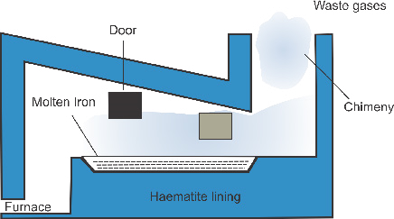

*Fig. 6.6 Puddling furnace for the manufacture of wrought iron.*

3*C FeO*+ 2 3 →2*Fe CO*+3

3*S*+ 2*FeO*2 3 →4*Fe*+3*SO*2

While those of manganese, silicon and phosphorus form slags. Thus

3*C FeO*+ 2 3 →2*Fe CO*+3

2*Mn O*+ 2 →2*MnO*

*MnO*+ *SiO*2 →*MnSiO Slag*3( )

## 4*P O*+5 2 →2*PO*2 5

*Fe O*2 3 + *PO*2 5 →2*FePO Slag*4( )

With the removal of impurities, the melting point of the metal rises and it becomes a semi-solid mass. At this stage, it is taken out in the form of balls or blooms on the ends of rabbles. While still hot, these balls are subjected to hammering to squeeze out, as much of slag as possible. The product so obtained is known as wrought iron.

6.4.4 Steel

Steel is an alloy of iron containing 0.25 to 2.5% of carbon and traces of

S, P, Si and Mn.

Classification of Steel

1. Mild Steel (0.1 - 0.2 % C)

It is fairly soft, malleable and ductile, can be forged (shaped by hammering and pressing while hot). It is used in making tubes, nuts, bolts, bars and boiler plates.

1. Medium Carbon Steel (0.2 - 0.7 % C)

It is harder than mild steel. It is also malleable and ductile. It is used in making rails, axles, castings.

1. High Carbon Steel(0.7 -1.5 % C)

It is hard and can be forged, when containing less than 1.0% carbon. Steel containing more than 1.0% carbon cannot be forged. It is used to make hammers, taps, dies, cutting tools, machine tools, hard steel parts of machinery and all sort of engines.

Steel is intermediate in carbon content between cast iron and wrought iron. It can be produced from:

1. Cast iron by removing some carbon alongwith sulphur, phosphorus and silicon.
2. By adding the required amount of carbon to wrought iron, then adding some special constituents, e.g. tungsten, chromium, vanadium, molybdenum, manganese, nickel and cobalt which impart desired properties to the steel. At present most of the steel is manufactured from cast iron.

6.4.5 Manufacture of Steel.

In can be manufactured by the following processes.

1. Open hearth process ( using cast iron, wrought iron or steel scrap)
2. Bessemer’s process (using cast iron only)

Some other processes are also used to prepare special type of steel from pure wrought iron.

6.4.6 Open Hearth Process

This is the most modern method for the manufacture of steel. It is carried out in an open hearth furnace. This furnace has a low roof to deflect the hot gases and flames downward to melt the charge. The open hearth furnance works on the regenerative principle of heat economy Fig.6.7.

Open hearth process is of two types.

1. Furnace with acidic lining like SiO2 is used when the impurities are Mn, Si,etc.
2. Furnace with basic lining like dolomite (CaO, MgO ) is used when the impurities are P and S, etc.

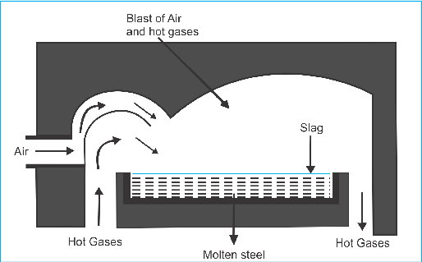

*Fig. 6.7 Open Hearth furnace for the manufacture of steel from cast iron*

Process

A mixture of cast iron, scrap steel and quick lime is charged into the furnace. At about 1600°C Si, Mn, C, S, and P are burnt out and removed according to the following reactions.

*C O*+ 12 2 →*CO*

*Si*+*O*2 →*SiO*2

*Mn*+ 12*O*2 →*MnO*

CO escapes in the flue gases. Silica (SiO2) combines with CaO, MnO and FeO to form silicates (slag) which float on the surface of the molten metal.

*SiO*2 +*CaO* →*CaSiO*3

*SiO*2 + *MnO* →*MnSiO*3

*SiO*2 + *FeO* →*FeSiO*3

Phosphorus and sulphur react with Fe2O3 to form P2O5 and SO2.

2*FeO*2 3 +3*S*→4*Fe*+3*SO*2

5*Fe O*2 3 +6*P*→10*Fe*+3*PO*2 5

These oxides react with calcium oxide to form slag.

*PO*2 5 +3*CaO*→*Ca PO*3( 4 2) (Fertilizer)

### SO +CaO2 →*CaSO*3

Samples are taken at intervals and the percentage of carbon in the steel is determined regularly. When this is reduced to about 0.1%, the calculated weight of ferromanganese (Fe, Mn, C) is added. Manganese desulphurises the steel. Carbon raises the carbon contents to the required values. After giving time for mixing, a little more ferromanganese is added and the charge is allowed to run into moulds where it solidifies to ingots

The whole process takes about 10 hours. Slag contains calcium phosphate. It is ground to powder and sold as a fertilizer.

6.4.7 Bessemer's Process

The furnace used in this process is called Bessemer's Converter which is a pear shaped vessel made of steel plates. At the bottom the converter is provided with a number of holes through which hot air can be introduced. The converter is held on a central axis so that it can be tilted in any desired position for feeding and pouring out the finshed materials, Fig.6.8.

Molten pig or cast iron (25 to 30 tons) from the blast furnace is fed into the converter and hot air blast is injected through the perforated base. This oxidizes carbon, silicon, and manganese.

*C O*+ 12 2 →*CO*

*Si*+*O*2 →*SiO*2

2*Mn O*+ 2 →2*MnO*

These oxides form a slag of MnSiO3.The heat evolved during the oxidation is enough to keep iron in the molten state.

## *MnO*+ *SiO*2 →*MnSiO*3

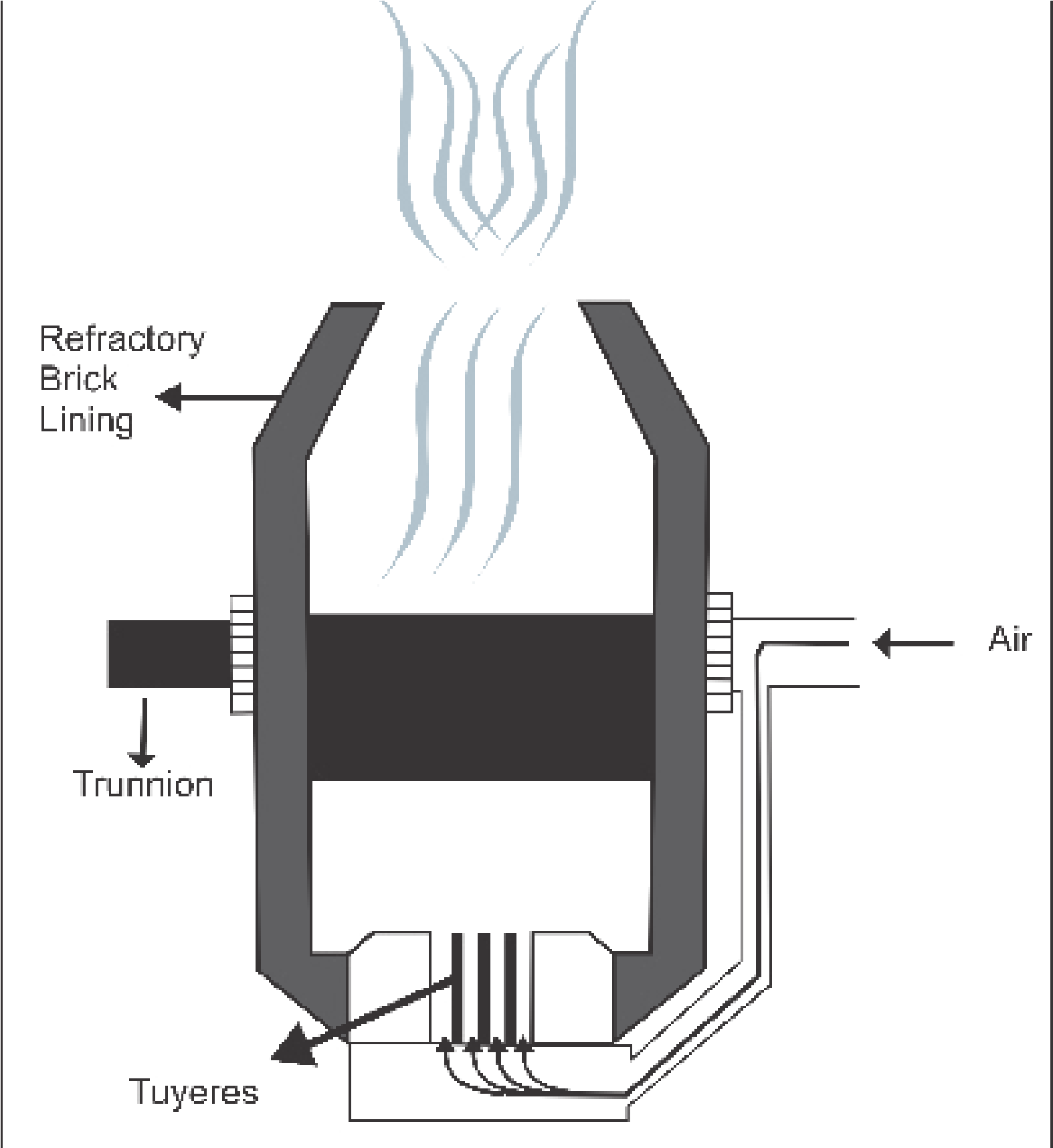

*Fig 6.8 Bessemer’s converter for the manufacture of steel from cast iron.*

CO produced burns at the mouth of the converter with a blue flame. Iron is partly oxidized to ferric oxide (Fe2O3) which also extracts carbon from cast iron to form CO.

4*Fe O*+3 2 →2*FeO*2 3

*FeO*2 3 +3*C*→2*Fe CO*+3

Within 10 to 15 minutes the flame due to CO subsides indicating that the carbon is completely oxidized. At this stage ferromanganese is added to correct the proportion of carbon to obtain the desired qualities. A blast of air is continued for a moment to ensure thorough mixing.

The addition of Mn imparts increased hardness and tensile strength.

In order to remove entraped bubbles of gases (blow holes), such as O2, N2, CO2, a little aluminum or ferrosilicon is also added. Aluminum removes nitrogen as nitride.

### 2 1*A* + *N*2 →2 1*A N*

At the end of the operation , the molten steel is poured out into mouldes for casting. Such casting are free from any defect.

#### 6.5 CORROSION

Any process of chemical decay of metals due to the action of surrounding medium is called corrosion.

The simplest case of corrosion occurs when metals come into contact with gases of the atmosphere. The surface of metals becomes coated with compounds such as oxides, sulphides and carbonates. Such compounds sometime form a compact layer on the surface protecting the metal from further attack.

The case would be different when the metal is in contact with water. The compounds formed in this case may dissolve in water, allowing the corrosion to penetrate further into the metal. Besides dissolving the compounds, water also promotes electrochemical process which is one of the main causes of rapid corrosion.

6.5.1 Electrochemical Theory

Pure metals are not easily corroded, even iron hardly gets corroded if absolutely pure. The impurities present in the metal promote corrosion. To understand why impurities accelerate the corrosion of metals, consider what happens when two different metals come in contact with one another in moist air. Suppose, for instance, Cu is brought in contact with Al. After sometime, we will notice that aluminium gets corroded while copper remains intact. This can be explained by the electrochemical theory. According to this theory, moisture and CO2 are present on the surface of the metal. Water ionizes into H+ and OH- ions. CO2 dissolves in water forming H2CO3 which ionizes as follows:

#### *HCO*2 3   *H HCO*+ + 3 −

Copper and aluminium are, in a sense, immersed in the solution containing H+, OH- and HCO-3 ions. This forms a galvanic cell in which aluminium releases electrons and changes to Al3+ ion (being more reactive- than Cu) i.e it acts as positive electrode and Cu acts as a negative electrode, Fig.6.9.

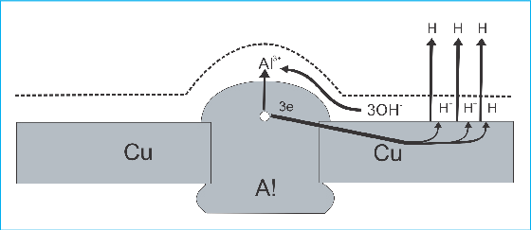

*Fig.6.9 Diagram of the corrosion of aluminium in contact with copper*

Aluminium ions attract OH- ion to form, Al (OH)3 i.e it starts dissolving. The H+ ions present on the Cu receive the electrons and released as H2. In this way, aluminium corrodes rapidly when in contact with copper which is lower in electrochemical series. From this, we can conclude that when an active metal Al (higher in the electrochemical series) comes in contact with less active metal Cu (lower in the electrochemical series) a galvanic cell is established. In this process active metal corrodes rapidly, while the other remains intact.

6.5.2 Prevention from Corrosion

It has been observed that the amount of iron destroyed each year by corrosion equals to about one fourth of its annual production. It is therefore necessary to prevent such a damaging process and avoid this loss. Different methods are used to prevent corrosion. The simplest of them consists of protecting the surface of the metal from coming in direct contact with the surrounding by coating it with oil, paint, varnish or enamel. It can also be prevented by alloying the metals or by coating the metal with a thin layer of another metal.

6.5.3 Tin Plating or Coating Iron with Tin (cathode coating)

The process of tin plating consists of dipping the clean sheet of iron in a bath of molten tin and then passing it through hot pair of rollers. Such plates are used in the manufacture of tin canes, oil containers and other similar articles.

Tin itself is very stable and protects the metals effectively as long as its coating on the iron is intact.

If the protective coating is damaged, then iron comes into contact with moisture. A galvanic cell is established in which tin acts as a cathode and iron as an anode. The electron’s flow from iron to tin, where they discharge H+ ions, leaving behind OH- in the solution. These hydroxide ions react with iron forming Fe(OH)3, which dissolves rapidly in water. From this, it can be concluded that plated iron gets rust more rapidly when the protective coating is damaged than the non-plated iron.

6.5.4 Galvanizing or Zinc Coating (anode coating)

Galvanizing is done by dipping a clean iron sheet in a zinc chloride bath and heating. The iron sheet is then removed, rolled into zinc bath and air cooled. In this case, if a protective layer of zinc is damaged a galvanic cell is established in the presence of moisture. Iron serves as a cathode and zinc as an anode. Electrons flow from zinc to iron, as a result of which Zn decays while Fe remains intact. This is called sacrificial corrosion.

### *Fe*2+ *Zn Zn*2+ *Fe*

+ → +

This is the way galvanizing helps protecting iron from rust. This process is used in water pipes, etc.

#### 6.6 CHROMATES AND DICHROMATES

Chromates and dichromates are the salts of chromic acid, H2CrO4 , and dichromic acid, H2Cr2O7 respectively. Both acids exist only in aqueous solution and when attempts are made to isolate them from solution they decompose immediately into chromic anhydride (CrO3)and water.

Their salts are, however, quite stable.

6.6.1 Potassium Chromate (K2CrO4)

Preparation

1. The chromates of alkali metals, which are soluble in water, are obtained by oxidizing trivalent chromium compounds in the presence of an alkali.

#### 2*KCrO*2 +3*Br*2 +8*KOH* →2*K CrO*2 4 +6*KBr* +4*H O*2

2. Chromates can also be produced by fusing Cr2O3 with an alkali in the presence of an oxidant, such as potassium chlorate.

##### *CrO*2 3 +4*KOH KC O*+ 1 3 →2*K CrO*2 4 +*KC*1 2+ *H O*2

3. Chromates are usually prepared from natural chromite (FeO. Cr2O3), if the latter is strongly heated with potassium carbonate in the presence of the oxygen. The resulting fused mass will contain potassium chromate, which can be extracted with water.

#### 4*FeCrO*2 4 +8*K CO*2 3 +7*O*2 →8*K CrO*2 4 +2*Fe O*2 3 +8*CO*2

6.6.2 Properties

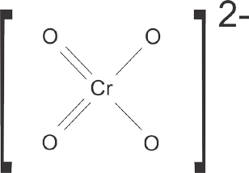Structure of Chromate Ion

Almost all the chromates are yellow in colour. Some of them are used as pigments. For instance, insoluble lead chromate, PbCrO4, is employed for the preparation of yellow oil colour called yellow crown.

K2CrO4 and K2Cr2O7 show similar properties, because in an aqueous solution Cr2O72- and CrO42- ions exist in equilibrium.

## 2*CrO*42− +2*H*+   *Cr O*22 72− +*H O*2

If an alkali is added to such a solution the hydroxyl ions will bind the hydrogen ion in solution, the equilibrium will shift towards left and, as a result, dichromate ions will be converted into chromate ions. Similarly on adding an acid the equilibrium will shift towards right and dichromate ions will be formed.

6.6.3 Potassium Dichromate (K2Cr2O7) Preparation

1. K2CrO4 is converted to K2Cr2O7 by using the above mentioned equilibrium. In an acidic medium, the equilibrium will shift in the forward direction i.e changing chromate ions into dichromate ions.

### 2*K CrO*2 4 +*H SO*2 4 →*K CrO*2 2 7 +*K SO*2 4 +*H O*2

2. Sometimes sodium dichromate is converted into potassium dichromate by reacting it with KCl.

*Na CrO*2 2 7 + 2*KC*1→*K CrO*2 2 7 + 2*NaC*1

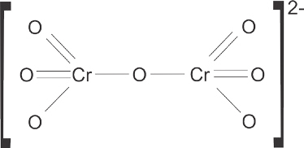6.6.4 Properties

Physical Properties

It is an orange red crystalline solid which melts at 396°C, it is fairly soluble in water. Dichromates are very powerful oxidizing agents. Oxidation is carried out in an acid solution.In this process, hexavalent chromium ion is reduced to trivalent chromium ion.

(a) Reaction W ith H2S

#### *K CrO*2 2 7 + 4*H SO*2 4 →*K SO*2 4 +*Cr SO*2( 4 3) + 4*H O*2 +3[ ]*O* 3*H S*2 +3[ ]*O* →3*H O*2 +3*S K CrO*2 2 7 +3*H S*2 + 4*H SO*2 4 →*K SO*2 4 +*Cr SO*2( 4 3) +7*H O*2 +3*S*

(b ) Reaction with Ferrous Sulphate

Potassium dichromate oxidizes ferrous sulphate to ferric sulphate in the presence of sulphuric acid.

##### *K CrO*2 2 7 +7*H SO*2 4 +6*FeSO*4 →3*Fe SO*2( 4 3) +*Cr SO*2( 4 3) +*K SO*2 4 +7*H O*2

(c ) Reaction with Potassium Iodide

Potassium dichromate also oxidizes KI in the presence of H2SO4,

##### *K CrO*2 2 7 +6*KI* +7*H SO*2 4 →4*K SO*2 4 +*Cr SO*2( 4 3) + +3*I*2 7*H O*2

(d ) Chromyl Chloride Test

When solid potassium dichromate is heated with solid metal chloride in the presence of concentrated sulphuric acid chrorny 1 chloride is produced.

##### *K CrO*2 2 7 +4*NaC*1 6+ *H SO*2 4 →2*KHSO*4 +4*NaHSO*4 +2*CrO C*2 1 32 + *H O*2

*Chromyl* chloride

Uses

. K2Cr2O7 finds extensive use in dyeing.

. It is used in leather industries for chrome tanning. . It is used as an oxidizing agent.

##### 6.7 POTASSIUM PERMANGANATE (KMnO4)

This compound is the salt of permanganic acid, HMnO4. It is an unstable acid and exists only in solution.

Preparation

It is prepared by acidifying the solution of potassium manganate,

K2MnO4 by H2SO4.

###### 3*K MnO*2 4 +2*H SO*2 4 →2*K SO*2 4 +2*KMnO MnO*4 + 2 +2*H O*2

On a large scale it is prepared from the mineral pyrolusite, MnO2. The finely powdered mineral is fused with KOH in the presence of air or an oxidizing agent like KNO3 or KClO3, etc. This treatment gives us green coloured potassium manganate, K2MnO4, in fused state.

2*MnO*2 + 4*KOH* +*O*2 →2*K MnO*2 4 + 2*H O*2

*MnO*2 + 2*KOH* + *KNO*3 →*K MnO*2 4 + *KNO*2 + *H O*2

3*MnO*2 +6*KOH KC O*+ 1 3 →3*K MnO KC*2 4 + 1 3+ *H O*2

The fused K2MnO4 obtained as above is extracted with water and the solution, after filtration, is converted into potassium permanganate (KMnO4) by any of the following methods. (a) Stadeler’s Process

In this method Cl2 is passed through the green solution of K2MnO4 until it becomes purple due to the formation of KMnO4. Here, Cl2 oxidizes K2MnO4 into KMnO4.

2*K MnO C*2 4 + 12 →2 1 2*KC* + *KMnO*4

(b) In this process CO2 is passed though the green solution of K2MnO4  until it becomes purple.

#### 3*K MnO*2 4 +2*H O CO*2 +4 2 →2*KMnO MnO*4 + 2 +4*KHCO*3

(c) Electrolytic Oxidation Process

In this process, manganate is converted to permanganate by electrolytic oxidation. During electrolysis of an aqueous solution of K2MnO4, water is decomposed to evolve hydrogen gas at the cathode and oxygen gas at the anode.Oxygen liberated at the anode oxidizes manganate ion (MnO4)2- into permanganate ion (MnO4)1-, while hydrogen is liberated at the cathode.

#### 2*K MnO H O O*2 4 + 2 +[ ]→2*KMnO*4 + 2*KOH*

The purple solution of KMnO4, obtained as above is filtered through asbestos, concentrated and allowed to crystallize when KMnO4 deposits as deep purple-red rhombic prisms.

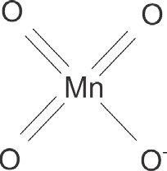6.7.1 Properties

Potassium permanganate forms dark purple lustrous crystals giving deep pink colour in solution. Its solubility in water at 20°C is only about 7%, while it dissolves more at higher temperature (25% at 63°C).

Potassium permanganate is a powerful oxidizing agent.

Oxidation is usually carried out in an acid solution.

*Structure of*

1. ) Reaction with H2S *permanganate ion*

It oxidises H2S to sulphur.

2*KMnO*4 +3*H SO*2 4 →*K SO*2 4 + 2*MnSO*4 +3*H O*2 +5[*O*]

5*H S*2 +5[*O*]→5*H O S*2 +5

2*KMnO*4 +3*H SO*2 4 +5*H S*2 →*K SO*2 4 + 2*MnSO*4 + +5*S H O*8 2

1. ) Reaction with FeSO4 It oxidizes FeSO4 to Fe2(SO4)3

##### 2*KMnO*4 +10*FeSO*4 +8*H SO*2 4 →*K SO*2 4 +2*MnSO*4 +5*Fe SO*2( 4 3) +8*H O*2

(c ) Reaction with Oxalic Acid

It oxidizes oxalic acid to CO2 and H2O

###### 2*KMnO*4 +5*H CO*2 2 4 +3*H SO*2 4 →*K SO*2 4 +2*MnSO*4 +10*CO*2 +8*H O*2

(d ) Reaction with KOH

When an alkaline solution of KMnO4 is heated, O2 is evolved.

##### 4*KMnO*2 + 4*KOH* → 4*K MnO*2 4 + 2*H O*2 +*O*2

Uses

It is used

* as an oxidizing agent.
* as a disinfectant and a germicide.
* in the manufacture of many organic compounds

###### KEY POINTS

1. Transition elements have partially filled d or f-subshells in atomic state or in any of their commonly occurring oxidation states.
2. IIB and IIIB group elements are called non-typical transition elements.
3. Binding energies, melting points, paramagnetism and oxidation states of transition metals increase with increasing number of unpaired electrons.
4. Such compounds containing the complex molecules or complex ions and capable of independent existence are called coordination compounds or complex compounds.
5. When a complex ion absorbs a wavelength from visible light, it transmits a set of radiation that impart colour.
6. Wrought iron contains 0.12% - 0.25% carbon, while steel contains 0.25% - 2.25% carbon.
7. Chromate and dichromate ions exist in equilibrium in an aqueous solution.
8. Chemical decay of metals under the action of their surrounding medium is called corrosion. It can be prevented by tin plating and galvanizing.

###### EXERCISE

Q l. Fill in the blanks

1. The property of paramagnetism is due to the presence of _____ electrons.
2. MnO4- ion has_________ colour andCr2O72- has______colour.
3. When potassium chromate is treated with an acid_____ is produced.
4. The d-block elements are located between____and______block elements.
5. Oxidation number of Fe in K4[Fe(CN)6] is ________ while in K3[Fe(CN)6] it is _______.
6. The presence of _______ in a metal promotes corrosion.
7. If copper is in contact with aluminium _______ gets corroded.
8. Complexes having sp3d2 hybridization have _______ shape.
9. In naming the complexes, all the ligands are named in ______.
10. In an aqueous solution, CrO42- and Cr2O72- exist in the form of ______.

Q.2 Indicate true or false.

1. A substance which is attracted into a magnetic field is said to be diamagnetic.
2. Compounds of the transition elements are mostly coloured.(iii) Fe3+ ions are blue when hydrated.
3. An extreme case of paramagnetism is called diamagnetism.
4. Tin plating is used to protect iron sheets from corrosion.
5. In galvanizing, zinc prevents corrosion of iron.
6. Tin plated iron gets rusted more rapidly when the protective coating is damaged than the unplated Iron.
7. The name of anionic ligands in a complex ends in suffix ‘O’.
8. Pig iron contains greater percentage of carbon than steel.
9. Complex compounds having dsp2 hybridization have tetrahedral geometry.

Q 3. Multiple choice questions. Encircle the correct answer.

1. Which of the following is a non-typical transition element?
   1. Cr (b) Mn (c) Zn (d) Fe
2. Which of the following is a typical transition metal?
   1. Sc (b) Y (c) Ra (d) Co
3. f-block elements are also called
   1. non-typical transition elements. (b) outer transition elements. (c) normal transition elements. (d) None is true
4. The strength of binding energy of transition elements depends upon
   1. number of electron pairs (b) number of unpaired electrons

(c) number of neutrons (d) tiumber of protons

1. Group VIB of transition elements contains
   1. Zn, Cd, Hg (b) Fe, Ru, Os (c) Cr, Mo, W (d) Mn, Te, Re
2. Which is the formula of tetraammine chloro-nitro-platinum (IV ) sulphate?
   1. [Pt(NH3)4(NO2)]SO4 (b) [Pt NO22Cl(NH3)4]SO4

(c) [Pt Cl(NO2)(NH3)4]SO4 (d) [Pt(NH3)4(NO2)Cl]SO4

1. The percentage of carbon in different types of iron products is in the order of
   1. cast iron > wrought iron > steel (b) wrought iron > steel > cast iron (c) cast iron > steel > wrought iron (d)cast iron= steel > wrought iron.
2. The cololur of transition metal complexes is due to (a) d-d transition of electrons.
   1. paramagnetic nature of transition elements.
   2. ionization.
   3. loss of s-electrons.
3. Coordination number of Pt in [Pt Cl(NO2)(NH3)4] is
   1. 2- (b) 4 (c) 1 (d) 6
4. The total number of transition elements is
   1. 10 (b) 14 (c) 40 (d)58

Q4. How does the electronic configuration of valence shell affect the following properties of the transition elements?

(a) Binding energy (b) Paramagnetism (c) Melting points (d) Oxidation states

Q 5. Explain the following terms giving examples.

(a) Ligands (b) Coordination sphere (c) Substitutional alloy (d) Central metal atom

Q 6. Describe the rules for naming the coordination complexes and give examples.

Q 7. What is the difference between wrought iron and steel. Explain the Bessemer’s process for the manufacture of steel.

Q 8. Explain the following giving reasons.

1. Why does damaged tin plated iron get rusted quickly.
2. Under what conditions does aluminium corrode?
3. How does the process of galvanizing protect iron from rusting?

Q 9. How chromate ions are converted into dichromate ions?

Q 10. Describe the preparation of KMnO4 and K2CrO4.

Q 11 . Give systematic names to following complexes.

(a) [Fe(CO)5] (b) [CO(NH3)6]Cl3 (c) [Fe(H2O)6]2+

(d) Na3[CoF6] (e ) K2[Cu(CN)4] (f) K2[PtCI6]

(g) [Pt(OH)2(NH3)4]SO4 (h) [Cr(OH )3(H2O)3]

CHAPTER

Fundamental Principles of

7

# Organic Chemistry

Animation 7.1 : [Organic Chemistry](http://i.stack.imgur.com/foC1H.gif)

Source and credit : [Stackexchange](http://chemistry.stackexchange.com/)

|  |
| --- |
| In This Chapter You Will Learn: |
| 1. The special features of carbon chemistry with reference to its ability to form chains, rings and isomers. 2. The importance of organic chemistry in daily life.  3. About the sources of carbon and its compounds like coal, petroleum and natural gas with reference to their availability in Pakistan. 4. Refining, reforming and cracking of petroleum and to enlist products in a tabular form. 5. How can petroleum serve as a source of different type of fuels. 6. About the classification of organic compounds based on the carbon skeleton.   1. About functional groups and the dependence of chemical properties on functional groups. 2. About the structural isomerism in organic compounds. 9. That cis-trans isomerism arises due to restricted rotation around a carboncarbon double bond.   10. How the hybridization theory can help us understand the type of bonding and the shapes of organic compounds. |

## 7.1 INTRODUCTION

More than 200 years ago, early chemists recognized organic compounds distinct from inorganic compounds because of the differences in their origin and properties. Organic compounds were considered as those obtained from living things, plants or animals, and inorganic compounds were those obtained from non-living or mineral sources.

The early chemists never succeeded in synthesizing organic compounds and their failure led them to believe that organic compounds could be manufactured only by and within living things and these compounds could never be synthesized from inorganic materials. This theory was referred to as vital force theory. This theory was rejected by Friedrick Wohler when he obtained urea (NH2)2CO , an organic compound in the urine of mammals, from ammonium cyanate, NH4CNO, a substance of known mineral origin.

## NH CNO4  (NH ) CO2 2

7.1.1 Modern Definition of Organic Chemistry.

Since the synthesis of urea from ammonium cyanate, millions of organic compounds have been prepared and analyzed. All these compounds contain carbon as an essential element. Apart from carbon, most of the organic compounds also contain hydrogen. Other elements which may also be present include oxygen, nitrogen, sulphur, etc. For historical and conventional reasons a few of the carbon compounds such as CO,CO2, carbonates, bicarbonates, etc are studied as inorganic compounds. It also has been recognized that the chemical forces in organic compounds are similar to those, which exist, in inorganic compounds. Thus it was felt that organic chemistry should be redefined. According to the modern definition, organic chemistry is that branch of chemistry which deals with the study of compounds of carbon and hydrogen (hydrocarbons) and their derivatives.

### 7.2 SOME FEATURES OF ORGANIC COMPOUNDS

Following are some features of organic compounds.

1. Peculiar Nature of Carbon

Carbon forms a large number of compounds. There are millions of organic compounds known at present. The main reason for such a large number of compounds is its unique property of linking with other carbon atoms to form long chains or rings. This selflinking property of carbon is called catenation. Carbon also forms stable single and multiple bonds with other atoms like oxygen, nitrogen and sulphur, etc. It can thus form numerous compounds of various sizes, shapes and structures.

1. Non-ionic Character of Organic Compounds

Organic compounds are generally covalent compounds, therefore, do not give ionic reactions.

1. Similarity in Behaviour

There exists a close relationship between different organic compounds.

This is exemplified by the existence of homologous series.

This similarity in behaviour has reduced the study of millions of compounds to only a few homologous series.

1. Complexity of Organic Compounds

Organic molecules are usually large and structurally more complex. For example, starch has the formula (C6H10O5)n where n may be several thousands. Proteins are very complex molecules having molecular masses ranging from a few thousands to a million. (5) Isomerism

Isomerism is a very common phenomenon in organic compounds. Very often more than one compounds are represented by the same molecular formula. However, they have different structural formulas.

1. Rates of Organic Reactions

The reactions involving organic compounds are slow and in general the yields are low. The slow rate of the organic reactions is due to the molecular nature of organic compounds.

1. Solubility

Most organic compounds are insoluble in water and dissolve readily in non-polar organic solvents, such as, benzene, petroleum ether, etc.

### 7.3 IMPORTANCE OF ORGANIC CHEMISTRY

The importance of organic chemistry can hardly be over emphasized. Almost all the chemical reactions that take place in living systems, including our own bodies, are organic in nature because they involve such life molecules like proteins, enzymes, carbohydrates, lipids, vitamins and nucleic acids, all contain thousand of carbon atoms.

We have become dependent upon organic compounds that occur in nature for our food, medicines and clothing. Over the years,the chemists have learned to synthesize plastics, synthetic rubber, medicines, preservatives, paints, varnishes, textile fibres, fertilizers, pesticides, detergents, cosmetics, dyes, etc. Many of these synthetic compounds prevent the shortages of naturally occurring products.

### 7.4 SOURCES OF ORGANIC COMPOUNDS

Petroleum, coal and natural gas are vast reservoirs from which many organic compounds are obtained. These are called fossil fuels and are formed, over long period of time, from the decay of plants and animals.

#### Coal

It is believed that coal in nature was formed from the remains of the trees buried inside the earth crust some 500 millions years ago. Due to the bacterial and chemical reactions on wood it got converted into peat. Then, as a result of high temperature and high pressure inside the earth crust, peat got transformed into coal.

Coal is an important solid fuel and becomes a source of organic compounds when subjected to carbonization or destructive distillation. When coal is heated in the absence of air (temperature ranging form 500-1000° C); it is converted into coke, coal gas and coal tar. Coal tar contains a large number of organic compounds, which separate out on fractional distillation.

The total coal resources of Pakistan are estimated by the geological survey of Pakistan to be 184 billion tonnes. About 80% of this coal is used to bake bricks in lime kilns; besides, some quantity is used for domestic purposes. Conscious efforts are being made by the government to induct coal into industry by setting up coal based powrer units. The Sindh Coal Authority and the directorates of Mineral Developments of the Punjab, Baluchistan and Khyber Pakhtunkhwa are all keen to expand coal utilization in power generation for which many incentives have been made available.

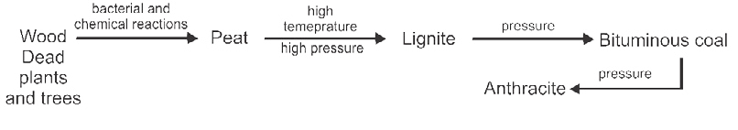

Animation 7.2 : [What is coal seam gas](http://www.aplng.com.au/home/what-coal-seam-gas) Source and credit: [Aplng](http://www.aplng.com.au/)

#### Natural Gas

Natural Gas is an important means of energy especially for countries like Pakistan, which are deficient in the production of mineral oil and coal. It is a mixture of low boiling hydrocarbons. Major portion of the natural gas is methane. It is also formed by the decomposition of organic matter. In Pakistan the gas, being cheaper, is used for power generation, in cement and fertilizer industries; as a fuel in general industries and for domestic purposes.

Animation 7.3 : [Coal fired power station](http://www.gif2fly.com/Coal.html) Source and credit: [Gif2fly](http://www.gif2fly.com/)

#### Petroleum

Mineral oil is called petroleum when it is in the refined form. It is thought to have been formed by slow chemical and biochemical decomposition of the remains of organic matters found between the sedimentary rocks. When extracted from rocks it appears like a liquid of blackish colour known as

'crude oil'.

##### Table 7.1 Principal Fractions Obtained from Petroleum

|  |  |  |  |
| --- | --- | --- | --- |
| Fraction | Boiling Point Rang (oC) | Composition | Uses |
| Natural gas | < 20 | CH 4- C4H10 | Fuel,  petrochemicals |
| Petroleum Ether | 20 - 60 | C5H12 , C6H14 | Solvent |
| Ligroin, or naphtha | 60 - 100 | C6H14 , C7H16 | Solvent, raw material |
| Gasoline | 40- 220 | C4H10- C13H28 mostly C6H14- C8H18 | Motor fuel |
| Kerosene | 175 - 325 | C8H8 . C14H30 | Heating fuel |
| Gas oil | > 275 | C12H26 . C18H38 | Diesel and heating fuel |
| Lubricating oils and greases | Viscous liquids | > C18H38 | Lubrication |
| Paraffin | M.p. 50 - 60 | C23H48 - C29H60 | Wax products |
| Asphalt, or petroleum coke | Solids | Residue | Roofing, paving, fuel reducing agent |

It is refined to get different petroleum fractions. At present four oil refineries are in operation in our country. One oil refinery known as Attock Oil Refinery is located at Morgah near Rawalpindi. It has about 1.25 million tonnes oil refining capacity. Similarly, two oil refineries have been established at Karachi which have about 2.13 million tonnes of oil refining capacity. Another refinery known as Pak-Arab refinery is located at Mahmud Kot near Multan.

The crude petroleum is separated by fractional distillation into a number of fractions each corresponding to a particular boiling range, Table 7.1.

### 7.5 CRACKING OF PETROLEUM

The fractional distillation of petroleum yields only about 20% gasoline. Due to its high demand this supply is augmented by converting surplus supplies of less desirable petroleum fractions such as kerosene oil and gas oil into gasoline by a process called cracking. It is defined as breaking of higher hydrocarbons having high boiling points into a variety of lower hydrocarbons, which are more volatile (low boiling). For example, a higher hydrocarbons CI6H34 splits according to the following reaction.

C H16 34 →700Heato C H +3CH =CH +CH -CH=CH7 16 2 2 3 2

Alkane

This is the process in which C-C bonds in long chain alkane molecules are broken, producing smaller molecules of both alkanes and alkenes. The composition of the products depends on the condition under which the cracking takes place. Cracking is generally carried out in the following ways.

1. Thermal Cracking

Breaking down of large molecules by heating at high temperature and pressure is called Thermal Cracking. It is particularly useful in the production of unsaturated hydrocarbons such as ethene and propene.

1. Catalytic Cracking

Higher hydrocarbons can be cracked at lower tem perature (500°C) and lower pressure (2 atm), in the presence of a suitable catalyst. A typical catalyst used for this purpose is a mixture of silica (SiO2) and alumina (AI2O3). Catalytic cracking produces gasoline of higher octane number and, therefore, this method is used for obtaining better quality gasoline.

1. Steam Cracking

In this process, higher hydrocarbons in the vapour phase are mixed with steam, heated for a short duration to about 900°C and cooled rapidly. The process is suitable for obtaining lower unsaturated hydrocarbons.

Besides increasing the yield of gasoline, cracking has also produced large amounts of useful by-products, such as ethene, propene, butene and benzene. These are used for manufacturing drugs, plastics, detergents, synthetic fibres, fertilizers, weed killers and important chemicals like ethanol, phenol and acetone.

### 7.6 REFORMING

The gasoline fraction present in petroleum is generally not of good quality. When it burns in an automobile engine, combustion can be initiated before the spark plug fires. This produces a sharp metallic sound called knocking which greatly reduces the efficiency of an engine. The quality of a fuel is indicated by its octane number. As the octane number increases, the engine is less likely to produce knocking. Straight- chain hydrocarbons have low octane numbers and make poor fuels. Experiments have shown that isooctane or 2,2,4- trimethyl pentane burns very smoothly in an engine and has been arbitrarily given an octane number of 100. The octane number of gasoline is improved by a process called reforming. It involves the conversion of straight chain hydrocarbons into branched chain by heating in the absence of oxygen and in the presence of a catalyst.

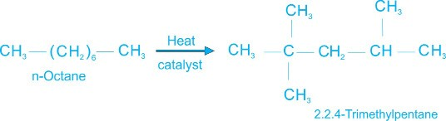

The octane number of a poor fuel can also be improved by blending it with a small amount of additive like tetraethyl lead (TEL). Tetraethyl lead (C2H5)4 Pb, is an efficient antiknock agent but has one serious disadvantage; its combustion product, lead oxide, is reduced to metallic lead which is discharged into the air through the exhaust pipe and causes air pollution.

### 7.7 CLASSIFICATIONS OF ORGANIC COMPOUNDS

There are millions of organic compounds. It is practically not possible to study each individual compound. To facilitate their study, organic compounds are classified into various groups and subgroups. They may be broadly classified into the following classes.

1. Open chain or Acyclic compounds.
2. Closed chain or Cyclic (or ring) compounds.
3. Open Chain or Acyclic Compounds

This type of compounds contain an open chain of carbon atoms. The chains may be branched or non-branched (straight chain). The open chain compounds are also called aliphatic compounds.

Straight Chain (or non- branched) Compounds

Those organic compounds in which the carbon atoms are connected in series from one to the other.

CH -CH -CH -CH3 n-Butane2 2 3 H C=CH-CH -CH2 1-Butene2 3 CH -CH -CH -CH -OH3 21-Butanol2 2

Branched chain compounds

Those organic compounds in which the carbon atoms are attached on the sides of chain.

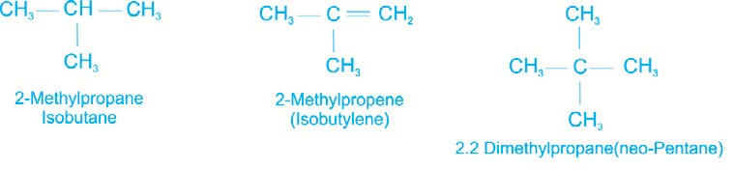

1. Closed Chain Compounds or Cyclic Compounds

These compounds contain closed chains or rings of atoms and are known as cyclic or ring compounds. These are of two types;

1. Homocyclic or carbocycli compounds
2. Heterocyclic compounds

The classification of organic compounds into various classes is shown in Fig.

7.1.

(a) Homocyclic or Carbocyclic Compounds

The compounds in which the ring consists of only carbon atoms,

Homocyclic or carbocyclic compounds.

Homocyclic compounds are further classified as :

1. Alicyclic compounds
2. Aromatic compounds

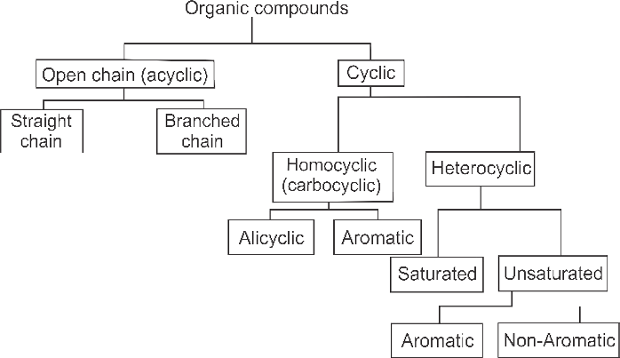

Fig:7.1 Classification of organic compounds.

1. Alicyclic Compounds

The homocyclic compounds which contain a ring of three or more carbon atoms and resembling aliphatic compounds are called alicyclic compounds. The saturated alicyclic hydrocarbons have the general formula CnH2n. Typical examples of alicyclic compounds are given below. One or more hydrogen atoms present in these compounds may be substituted by other group or groups.

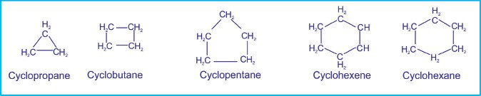

1. Aromatic Compounds

These carbocyclic compounds contain at least one benzene ring, six carbon atoms with three alternate double and single bonds.These bonds are usually shown in the form of a circle. Typical examples of aromatic compounds are given below.

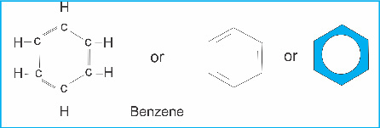

The aromatic compounds may have a side-chain or a functional group attached to the ring. For example:

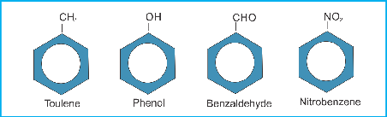

The aromatic compounds may also contain more than one benzene rings fused together.

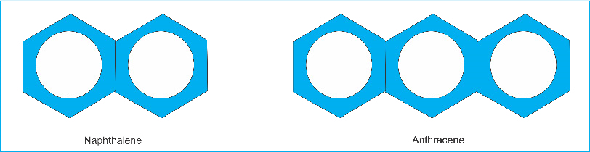

(b) Heterocyclic Compounds

The compounds in which the ring consists of atoms of more than one kind are called heterocyclic compounds or heterocycles. In heterocyclic compounds generally one or more atoms of elements such as nitrogen (N), oxygen (O) or sulphur (S) are present. The atom other than carbon viz, N, 0, or S, present in the ring is called a hetero atom.

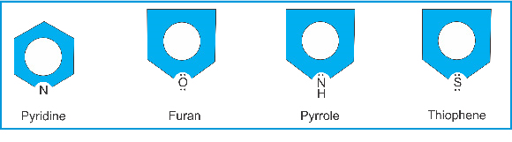

### 7.8 FUNCTIONAL GROUP

An atom or a group of atoms or a double bond or a triple bond whose presence imparts specific properties to organic compounds is called a functional group, because they are the chemically functional parts of molecules.

The study of organic chemistry is organized around functional groups. Each functional group defines an organic family. Although over six million organic compounds are known, there are only a handful of functional groups, and each one serves to define a family of organic compounds. The examples of functional groups are outlined in Table 7.2. TABLE 7.2 FUNCTIONAL GROUPS

|  |  |  |  |
| --- | --- | --- | --- |
| Functional group | | Class of compounds | Example |
| Formula | Name |
| C  C  C  C | None | Alkane | CH — CH3 |
| Double bond | Alkene | H2C = CH2 |
| C C | Triple bond | Alkyne | HC=CH |
| -X(X=F,Cl,Br,I) | Halo (fluoro, chloro, bromo, iodo) | Alkyl halide | CH3-CH2-Cl |
| OH | Hydroxyl group | Alcohol or alkanol | CH3-CH2-OH |
| NH2 | Amino group | Amine | CH3-CH2-NH2 |
| NH  C | Imino group | Imine | CH2=NH |
| OC  C | Ether linkage | Ether | CH3-CH2-O-CH2-CH3 |
| C  O  H  C  O  R  R | Formyl group | Aldehyde or alkanal | |  |  | | --- | --- | | CH3-C | O  H |   CH3  O  CH3  C |
| Carbonyl | Ketone or alkanohe |
| O  OH  C | Carboxyl group | Carboxylicacid (oralkanoicacid) | O  CH3-C  OH |
| C X | Acid halide | Acid halide | O  CH3CCl |
| NH2  C | Acid amide | Acid amide | O  CH3CNH2 |
|
| O  R  OH  C | Ester group | Ester | O  CH3-C  OCH3 |
| SH | Mercapto | Thioalcohol or Thiol | CH3-CH2-SH |
| C N | Cyano | Alkyl cyanide or alkane nitrile | CH3-C N |
| O  N  O | Nitro | Nitro compounds | C6H5NO 2 |

7.9 HYBRIDIZATION OF ORBITALS AND THE SHAPES OF

### MOLECULES

Although the most stable electronic configuration of a carbon atom (having two partially filled 2p orbitals) requires it to be divalent, carbon is tetravalent in the majority of its compounds. In order to explain this apparent anamoly, it is assumed that an electron from the 2s orbital is promoted to an empty 2pz orbital, giving the electronic configuration:

Ground state electronic configuration of carbon = 1s2 2s2 2p1x 2p1y 2p°z

Excited state electronic configuration of carbon = 1s2 2s1 2p1x 2p1y 2p1z

The excited state configuration can explain the tetravalency of carbon but these four valencies will not be equivalent. Orbital hybridization theory has been developed to explain the equivalent tetravalency of carbon.

According to this theory the four atomic orbitals of carbon belonging to valence shell may be mixed in different ways to explain the bonding and shapes of molecules formed by carbon atoms. sp3 Hybridization

In order to explain the bonding and shapes of molecules in which carbon is attached with four atoms, all these four atomic orbitals are mixed together to give rise to four new equivalent hybrid atomic orbitals having same shape and energy. This mode of hybridization is called tetrahedral or sp3 hybridization.

All these four sp3 hybrid orbitals are degenerate (having equal energy) and are directed at an angle of 109.50 in space to give a tetrahedral geometry.

When a carbon atom forms single bonds with other atoms, these hybrid orbitals overlap with the orbitals of these atoms to form four sigma bonds. This type of hybridization explains the bonding and shapes of all those compounds in which carbon atom is saturated.

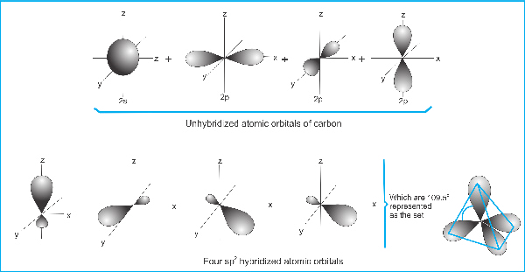

x

y

z

Fig. 7.2 sp3 hybridization of carbon to give methane (CH4)

In the formation of methane, the four hybrid atomic orbitals of carbon overlap separately with four 1s atomic orbitals of hydrogen to form four equivalent C-H bonds. The shape of methane thus formed is very similar to the actual methane molecule. All the four hydrogen atoms do not lie in the same plane.

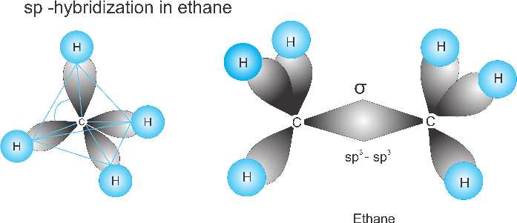

109.5

0

3

In ethane, CH3 - CH3, the two tetrahedrons of each carbon are joined together as shown in the above figure. Further addition of a carbon atom with ethane will mean the attachment of another tetrahedron. At this stage, it is necessary to answer an important question.From where does the energy come to excite the carbon atom?

The answer to this question is simple. Before excitation the carbon should make two covalent bonds releasing an adequate amount of energy. After excitation, however, it will form four covalent bonds releasing almost double the amount of energy. This excess energy is more than that needed to excite the carbon atom. So a tetravalent carbon atom is expected to be more stable than a divalent carbon atom. sp2 Hybridization

In order to explain the bonding in unsaturated compounds, two more modes of hybridization have been developed.

The structure of alkenes can be explained by sp2 mode of hybridizaton. In this type one 2s and two 2p orbitals of carbon are mixed together to give three equivalent and coplanar sp2 hybridized orbitals, Fig. 7.3.

Each sp2 hybrid orbital is directed from the centre of an equilateral triangle to its three corners. The bond angle between any two sp2 hybrid orbitals is 120°.The unhybridized 2pz orbital will remain perpendicular to the triangle thus formed.

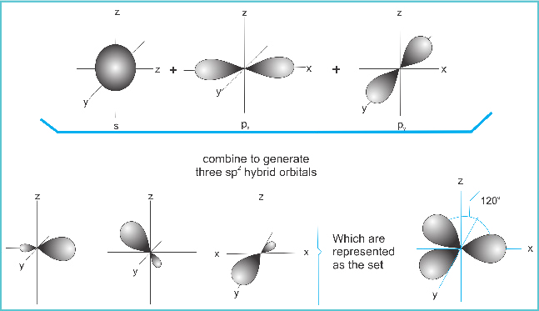

Fig. 7.3 sp2-hybridization of carbon.

In the formation of ethene molecule, three sp2 orbitals of each carbon atom overlap separately with sp2 orbital of another carbon and 1s orbitals of two hydrogen atoms to form three s bonds. This gives rise to what is called the s-frame work of ethene molecule. The unhybridized orbitals of each carbon atom will then overlap in a parallel fashion to form a π - bond, Fig. 7.4

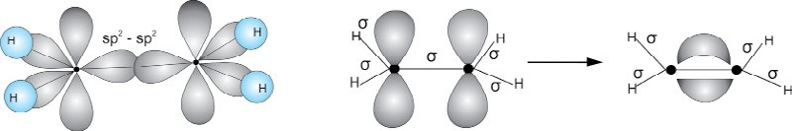

π

-

bond

Fig. 7.4 Formation of ethene.

sp-Hybridization

The structure of alkynes can be explained by yet another mode of hybridization called sp hybridization. In this type one 2s and one 2p orbitals of the carbon atom mix together to give rise to two degenerate sp hybridized atomic orbitals. These orbitals have a linera shape with a bond angle 180o.

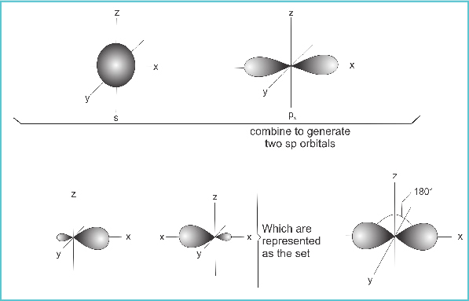

The two unhybridized atomic orbitals, 2py and 2pz are perpendicular to these sp hybridized orbitals.

Ethyne molecule is formed when two sp hybridized carbon atoms join together to from a s-bond by sp-sp overlap. The other sp orbital is utilized to form a s- bond with 1s orbital of hydrogen atom.

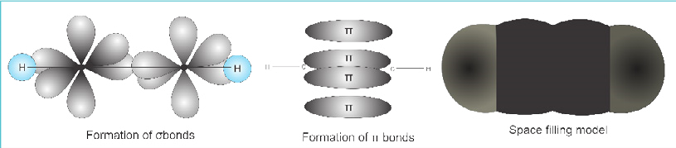

Fig. 7.6 Formation of ethyne

The two unhybridized p orbitals on a carbon atom will overlap separately with the p orbitals of the other carbon atom to give two π -bonds both perpendicular to the s -framework of ethyne. The presence of a s and two π bonds between two carbon atoms is responsible for shortening the bond distance.

#### 7.10 ISOMERISM

The concept of isomerism is an important feature of organic compounds. Two or more compounds having the same molecular formula but different structural formulas and properties are said to be isomers and the phenomenon is called isomerism. The structural formula of a compound shows the arrangement of atoms and bonds present in it.

The simplest hydrocarbon to have structural isomers is butane (C4H10). The alkanes, methane, ethane and propane do not show the phenomenon of isomerism because each exists in one structural form only. If we study the structural formula of butane or other higher hydrocarbons of the alkane family, we will observe that it is possible to arrange the atoms present in the molecule in more than one way to satisfy all valencies.

This means that it is possible to have two or more different arrangements for the same molecular formula.For example, butane molecule can have two different arrangements as represented by the following structural formulas:

## CH -CH -CH -CH3 2 2 3

n-Butane

Isobutane

This fact has been supported by an experimental evidence that there are two compounds with different physical properties but with the same molecular formula of C4H10.

Isomerism is not only possible but common if the compound contains more than three carbon atoms. As the number of carbon atoms in a hydrocarbon increases, the number of possible isomers increase very rapidly. The five carbon compound, pentane, has three isomers. When the number of carbon atoms increases to thirty, the number of isomers amount to over four billions.

7.10.1 Types of Isomerism

(1) Structural Isomerism

The structural isomerism is not confined to hydrocarbons only. In fact, all classes of organic compounds and their derivatives show the phenomenon of structural isomerism. The structural isomerism arises due to the difference in the arrangement of atoms within the molecule. The structural isomerism can be exhibited in five different ways. These are :

1. The Chain Isomerism.

This type of isomerism arises due to the difference in the nature of the carbon chain. For example, for pentane (C5H12), the following arrangements are possible.

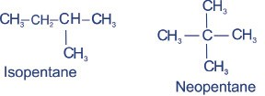 CH -CH -CH -CH -CH3 2 2 2 3

n-Pentane

1. Position Isomerism.

This type of isomerism arises due to the difference in the position of the

same functional group on the carbon chain. The arrangement of carbon atoms remains the same. For example,

(a) Chloropropane can have two positional isomers given below.

### CH -CH -CH -C3 2 2 l

1-Chloropropane

(b) Butene (C4H8) can have two positional isomers.

#### CH -CH -CH=CH3 2 2 CH -CH=CH-CH3 3

I-Butene 2-Butene

1. Functional Group Isomerism

The compounds having the same molecular formula but different functional groups are said to exhibit functional group isomerism. For example, there are two compounds having the same molecular formula C2H6O , but different arrangement of atoms.

CH -O-CH3 3 CH -CH -OH3 2

Dimethyl etherDiethyl ether Eethyl alchohalEthyl alcohol

1. Metamerism

This type of isomerism arises due to the unequal distribution of carbon atoms on either side of the functional group. Such compounds belong to the same homologous series. For example, diethyl ether and methyl n-propyl ether are metamers.

CH3 − CH2− −O CH2 − CH3 CH3 − −O CH2 − CH2 − CH3 Diethyl ether Methyl n-propyl ether

For a ketonic compound having the molecular formula C5H10O, the following two metamers are possible.

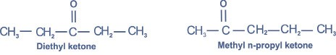

1. Tautomerism

This type of isomerism arises due to shifting of proton from one atom to other in the same molecule.

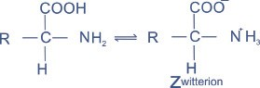

(2) Cis-trans Isomerism or Geometric Isomersim

Two carbon atoms joined by a single bond are capable of free rotation about it. However, when two carbon atoms are joined by a double bond, they cannot rotate freely. As a result, the relative positions of the various groups attached to these carbon atoms get fixed and gives rise to cis- trans isomers.

Such compounds which possess the same structural formula, but differ with respect to the positions of the identical groups in space are called cistrans isomers and the phenomenon is known as the cis-trans or geometric isomerism.

The necessary and sufficient condition for a compound to exhibit geometric isomerism is that the two groups attached to the same carbon must be different.

2-Butene can exist in the form of cis and trans isomers.

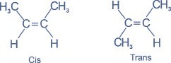

Similarly 2-pentene and l-bromo-2-chloropropene also show cis-trans isomerism.

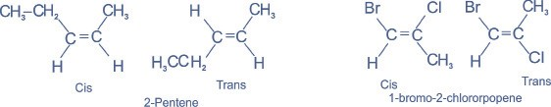

In the cis-form, the similar groups lie on the same side of the double bond whereas in the trans-form, the similar groups lie on the opposite sides of the double bond.

The rotation of two carbon atoms joined by a double bond could happen only if the π bond breaks.This ordinarily costs too much energy, making geometric isomers possible.

#### KEY POINTS

1. Chemical compounds were classified as organic and inorganic compounds based upon their origin. Organic compounds are obtained from living things whereas inorganic compounds are obtained from mineral sources.
2. It was thought that organic compounds could not be synthesized in the laboratory from inorganic sources.
3. Organic chemistry is now-a-days defined as the chemistry of carbon compounds.
4. Most of the commercially important compounds we use everyday are organic in nature.
5. Coal, petroleum and natural gas are important sources of organic compounds.
6. The process of cracking is developed to increase the yield of lower hydrocarbons which serve as important fuels commercially.
7. Organic compounds are classified into acyclic and cyclic compounds.
8. The study of organic chemistry is organized around functional groups. Each functional group defines an organic family.
9. The type of bonding and the shapes of different type of compounds formed by carbon can be explained by sp3, sp2 and sp modes of hybridization.

10.Compounds having the same molecular formula but different structural formulas are called isomers. There are four different type of structural isomers.

11.Isomerism arises due to restricted rotation around a carbon- carbon double bond is called cis-trans isomerism.

##### EXERCISE

Q l. Fill in the blanks

i) Organic compounds having same molecular formula but different ______are called isomers. ii) The state of hybridization of carbon atom in ______ is sp2.

iii) Alkenes show______ due to restricted rotation around a carbon-carbon double bond. iv) Heating an organic compound in the absence of oxygen and in the presence of________as a catalyst is called cracking.

v) A group of atoms which confers characteristic properties to an organic compound is called _________ . vi) 2-Butene is________of 1-butene. vii) Carbonyl functional group is present in both_________and ketones. viii) A heterocyclic compound contains an atom other than______ in its ring. ix) The quality of gasoline can be checked by finding out its_____ . x) A carboxylic acid contains___________ as a functional group.

Q.2 Indicate true or false.

1. There are three possible isomers forpentane.
2. Alkynes do not show the phenomenon of cis-trans isomerism.
3. Organic compounds can not be synthesized from inorganic compounds.
4. All close chain compounds are aromatic in nature.
5. The functional group present in amides is called an amino group.
6. Government of Pakistan is trying to use coal for power generation.
7. Crude petroleum is subjected to fractional sublimation in order to separate it into different fractions,
8. A bond between carbon and hydrogen serves as a functional group for alkanes.
9. o-Nitrotoluene and p-nitrotoluene are the examples of functional group isomerism.
10. Almost all the chemical reactions taking place in our body are inorganic in nature.

Q 3. Multiple choice questions. Encircle the correct answer.

(i) The state of hybridization of carbon atom in methane is:

(a) sp3 (b) sp2 (c) sp (d) dsp2

(ii) In t-butyl alcohol, the tertiary carbon is bonded to:

(a) two hydrogen atoms (b) three hydrogen atoms (c) one hydrogen atom (d) no hydrogen atom

(iii) Which set of hybrid orbitals has planar triangular shape.

(a) sp3 (b) sp (c) sp2 (d) dsp2

(iv) The chemist who synthesized urea from ammonium cyanate was:

(a) Berzelius (b)Kolbe (c) Wholer (d) Lavoisier (v) Linear shape is associated with which set of hybrid orbitals?

(a) sp (b) sp2 (c) sp3 (d) dsp2

(vi) A double bond consists of:

(a) two sigma bonds (b) one sigma and one pi bond (c) one sigma and two pi bonds (d) two pi bond

(vii) Ethers show the phenonenom of:

(a) position isomerism (b) functional group isomerism (c) metamerism (d) cis-trans isomerism

(viii) Select From the following the one which is alcohol:

(a) CH3-CH2-OH (b) CH3-O-CH3

(c) CH3COOH (d) CH3-CH2-Br

Q 4. How organic compounds are classified? Give suitable example of each type. Q 5. What are homocyclic and heterocyclic compounds? Give one example of each.

Q 6. Write the structural formulas of the two possible isomers of C4H10.

Q 7. Why is ethene an important industrial chemical?

Q 8. What is meant by a functional group? Name typical functional groups containing oxygen.

Q 9. What is an organic compound? Explain the importance of Wohler’s work in the developrnent of organic chemistry.

Q 10. Write a short note on cracking of hydrocarbons.

Q 11. Explain reforming of petroleum with the help of suitable example.

Q 12. Describe important sources of organic compounds.

Q13. What is orbital hybridization? Explain sp3 sp2 and sp modes of hybridization of carbon.

Q14. Explain the type of bonds and shapes of the following molecules using hybridization approach.

CH3 - CH3, CH2 = CH2, CH = CH, HCHO, CH3CI

Q 15. Why there is no free rotation around a double bond and a free rotation around a single bond ? Discuss cis-trans isomerism.