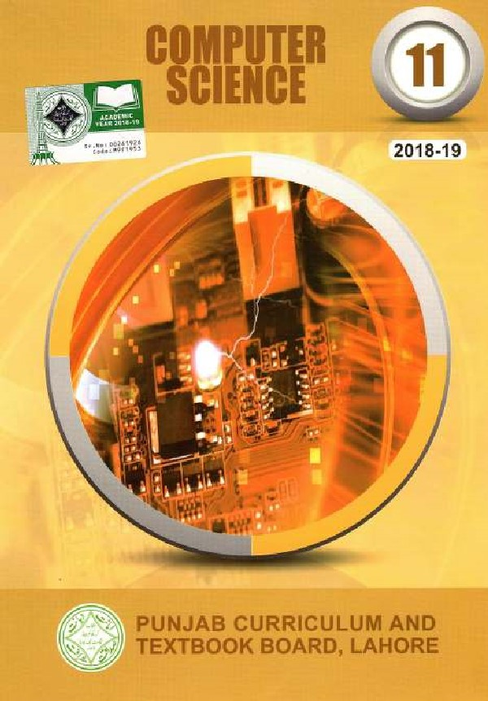

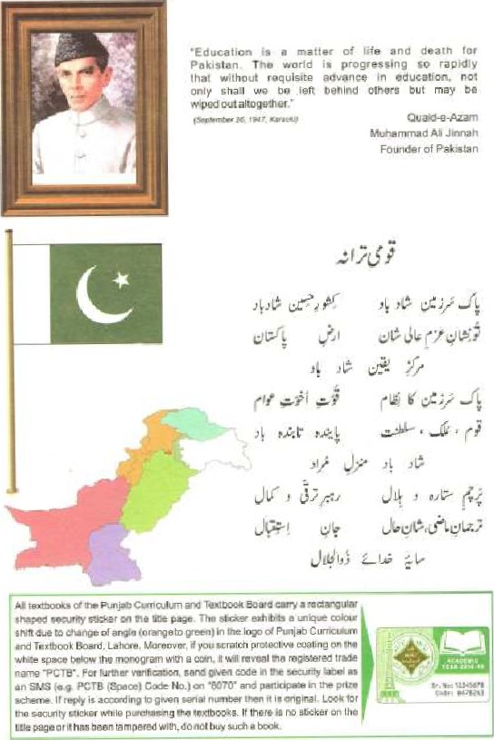



A Textbook of

Computer Science

for class

# 11

PUNJAB CURRICULUM AND

TEXTBOOK BOARD, LAHORE



Approv ed by: Federal



rights

are

the

&

No.

Boud Labo re.

•had. Vide its letter

|  |  |  |
| --- | --- | --- |
|  | CONTENTS |  |
| Cha pter |  | Page |
|  | Basics of Information Technology |  |
| 2 | Information N ctworks | 25 |
|  | Data Communizations | 41 |
|  | Applications and Uses or Cotnputers |  |
|  | C AithiIectiLt'e |  |
| 6 | Security. Copyright and the Law | 91 |
|  | Windows Operating System |  |
|  | Word p |  |
|  | Spread Sheet |  |
| 10 | Fundamentals of the internet | 147 |
|  | GLOSSARY |  |
|  | INDEX |  |

,

Author:

 Mirtå Büig

Associate , Lahore University of Management Sciences, Lahore.

 Ms. Shahina

Head Of Computer Science Department Isbamahad Madel College for Girls, F. I C)/2, Islamabad.

 Mrz AsifAli Magsi

Lecturer of computer Science,

Islamabad College for Boys,

G.Y3, Islamabad,

Edi(or ;

* S Ztltqamain JntTer.'

Rcscarch ASS Oci , 

Deparmcnt of Computer Science,

Lahore University of

Sciences (LUMS); Lahore.



 Aisha Wåiheed pervisio n

 ML Jahanzaib Khan

ISubject Specialist (Computer Science)

P Curriculum & Textbook B oard,

Publisher: Zeeshan Book Center, Lahore,

Printer; Qudrat Ullah Printers,

Date of Printing Edition Impression "Caples Price

April 2018 1st 10,000 67_00

## Chapicr / Basics Technology

|  |
| --- |
| CHAPTER 1 |

Of Information Technology

## Overview

We are in the Information Age Of a Global Village today, That rneans Ifnfdrmation is the key factor in this era and it is rightly said that "Information is the precious commodity of today's day-to-day business", Everything evolves around it whether it is education, medicine, history, geographical phenon%na, sports, research or business, You name the sysæmand Information is Chere to play a key role in its functionality and existence.

Information can be defined as the facts and figures anything i.e. The know-how about any object that exists and plays its role in any system, The system is any identified and known work that accepts data I information into itself, manipulates in the shape of certain output(s) and delivers so that it becomes useful and meaningful And precisely; that is what is known as "Data processiog" or "Convuting», for which we need a computer to accomplish the task.

Few years hack; this accomplished task was available to the users,'clients in a prescribed locality otily, Tliat locality could be his office or organization. But with the advent of Communication technology, our globe has lyeon* Virtually one-community area i_e. Global Village. The organizations expanded to renwte cities and countries and it was felt to make the data,'informauon and the ultimate accomplished task available to them where-ever they are. There  COrnjiiiitiieatiOfi technology to out rescue and a ,tertü ejnergecl i.e. "Inforn:ntion Technology" that can be precisely defined as:

 "Information Technology is the technology that merges computing with highspeed communication links carrying data in the form of text. sound, images. video etc", from place to place over this global villagev For this purpose. the computer Systems are networked in such a way that data/infortnation Stored'proeessed on them is always available from anywhere, at any place, at any moment, Thi'S, the users are almost always sharing und exchanging their information in such a arc Sitting in (o so in Short,

Technology gngblvs the heterogeneous types or industries iosCitutions to digital The is chg

Of through gadgets that inforuullion txtween thenv The industries ure computers, telecommunications, and mub5 media etc, It has trcmgndous significance in modern scenario, It means that from g common electronic base, be gammunigaced to shape users are to phoCQvgphs, movies, audio, grgphiggl *hupgb, form, etc,



## Modern Scenario

The modern Of Enformfiiion Technology has broadened the basc Computing and communication through satellite, fiber-optic, mobile phone, machine, mult i-tnediaJhyp•er-mcdiä, e—commerce, nvcommerce etc, Thus enhancing the implications pf this shift from single isolated technologies to unified digi:al convergence and enabling the computer users to experience a beautiful and fantastic scenario of computer utilization in the fields like:

(i) Artificial Intell

(u) Web-based Applica:ions

1. E-commerce. M-eonuneree (Mobile Conuneree)
2. Computer Anim (ion
3. Multi-media, Hyper-media

(y i) Distributed Computing

Them are numerous fields of computer applications. but we need not to go



into the dc-tails of all those as is beyond the scope of this book' What we need to know here is that (he Information Technoiogy brought about a revolution in our life style, We may call it the Computer Revolution, Information Revolution, Communications Revolution. Internet Revolution. Multi-rticdia Revolution or "'hacsoever. So it is beyond any doubl (Oday, we are livittg in a society that is making use Highway" which is heading towards a real future "Global V illage" of the human biscory.

## 1.1 Hardware and Software

"A computer is a machine that can he programmed to accept data (input), process it into useful information (output), and store it away (in a secondary storage device) for safekeeping or later reuse". We have four words in this Jervnit'0n which are of prime importance in the whole computing pmcess i.e. machine program, input and output. By conventions, machine is hardware, ubereas program is known as software in discussion of computer science. input and output devices are part of the machine that can now be called as a complete computer sysletn. So. to function, a computer system requires four main aspects of data handling i.e. input, processing, output and storage (figurc I El ). The hardware. responsible for these four areas, operates as described below:

* Input devices data in a form that the computer can use, and then sends it to the processing unit.
* The processor (CPU), has the electronic circuitry that manipulates input data into the form of useful informaciun. The processor actually executes the instructions (Programs) in a logical sequence.
* Output devices show us processed data i.e. information, in the shape we want it.

Storage usually sccOndary storage, which consists of secondary storage devices, such as hud disk. floppy diskettes, CDs etc. which can store data and programs aulside rhe computer itself. These devices actually supp/emeur memory. which can hold data and programs only temporarily.



]

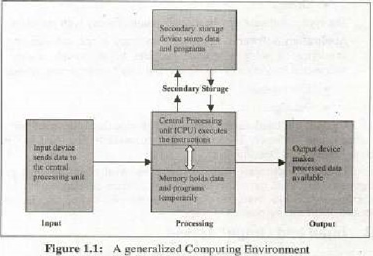

### 1.1.1 Hardware Devices

Following are the hardware devices in any computer system:

* Input Devices Keyboards, Mouse, Microphones etc.

Output Devices Printers, Speakers, Monitors etc. Main Memory cornprising of RAM and ROM  00 Device i,e, Terminals, Touch Screen etc.

* Secondary Memory i.e. Hard disk, Floppy disk, Compact disk, Tape etc.
* Inter-connectors i e- Cables, Pons, Buses etc.
* Networking Devices i.e. Modem. Br]dge. Router ete.

#### 1.1,2 Software Classification

Software can be classified inw following main two categories:

* System Software
* Application Software



is

used

to

control

the

Osage

and

fillocaiioii

System

Software;

Sysvem

Of different hardware components and enables the other application programs ta execute. For example,

* Operating S ystems 

•- Utility Programs (Backup/Restore)

* Drivers

The system software nuy bc a combination of many such programs

Applieaiion Software; Application software is the software that has bee-a developed to solve a specific problem or provide audio, video. or multimedta enterlainn•enl to the users. It may categorized as under

* Custom-built
* Packaged software; This is the software that is designed and developed for particular customer. The custom-built software is diseu"ed in detail in the section 1.6-(Systcnis Development).

Packaged software: This software is the kind of off-the-shelf programs or components. developed for sale to the potential software develope«/users for their use. The examples are: MS-Word, MS-power point. personal Oracle etc. few of these are discussed in the coming

## 1.2 Input and Output devices

We need device(s) to enter the data into the computer (Input and some device(s) to sec the outcome (or processed information) of the computer {Output devices), B 0th discussed as belo w:

### 1.2.1 Input devices

Sometimes, the data is entered directly to the eornputer and sotnetitnes indirectly. In the first ease, the data goes directly to the computer from the source and in second case; wc have to carry out some intennediate handling. [n either case the task is to gather data to be processed by the COItipgter, three gcncra] types input hardware ,

* Keyboards
* Pointing devices
* Source data-entry devices

Keyboard: The keyboard may look like a typewriter keyvad to which special keys have been added. The keys normally available on the keybc'lrds are Numeric, Alphabetic. Function and additional Special.purpose keys,

Figure 2 shows the complete layout of extended keyboard on a personal computer. uddilionul between tbg keypud



numeric keys. and status lights in the upper-right Coqner. This standard keyboard is also called "QWERTY", which describes the beginning keys in the top Of alp haik-tic letters.

Function Keys: The function keys are an easy way to give certain conunfinds to the computer. The particular software we use defines what each funetion key does.

Main Keyboard: The main includes the familiar keys found on a typewriter keypad, as as some special command keys. The command keys have different uses./effects that depend on the sotiware &ing used Some or the most conumn uses are listed here:

|  |  |  |
| --- | --- | --- |
|  |  | -Kev ' 'Enhanced " Keyboard Lavon: |

extra buttons and keys axe based on

'his layoutv

-kcy "Enhanced" keyboard, Of various key gn.•upS.

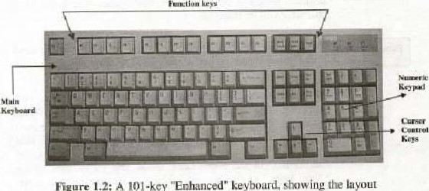

figure

1.2;

A

key, is used in different ways by different often it allows to Fescape" to the previous screen of

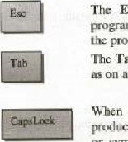

programs;

pmgram.

Tab key, is to tab across the screen and set tab stops typewriter.

the CapsLock key is pressed, ease letters are produced, Numbers and Symbols are not" affected. The number or symbol shown on the bottom of a key is still produced When the CapsLock is pressed, the status light under "CapsLock" lights up ,

Texzbook o/t¯cwnyr/rr Scietic:-e 6 Fm' I

The Shift is pressed in combina:ion with other kcyS to produce upper ease letters and the upper symbols shown on the

|  |
| --- |
| -cei |

The Control key is pressed in combination with other keys to initiale commands as specified by the soft-ware.

The Alternate key is used in combination with other keys to initiate commands.

|  |
| --- |
| Baeks pace |

The Bueksp,aee is used ro delete character left of the eursor. moving the elltsor back one position. The CUTsor is (lw ticslLing indicator on the screen that ghows where the next character Will be inserted.

The Enter key moves the cursor to the heginning of the next line. For vnstance it is used al the end paragraph

Numeric Keys: The numeric keys serve one of the two purposes, depending on Ille status of [he Num key• When the computer is in the Num Lock mode. these keys can be used  enter numeric dala and mathematical symbols for •divided by". * for "multiplied by", for "subzraetion" and + for "addition"). In the Num Lock mode. the status Kiehl under

"Num Lock" key iigbts up, When the computer is not in (he Num Lock mode. the numeric keys can used 10 move cursorMid perform other fmctions. as given Eclow.

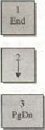In progran-us, the End key moves the cursor to the bottomright earner of the screen,

key nwves the cursor down one line.

The Page Down key advances one full screen while the cursor stays at

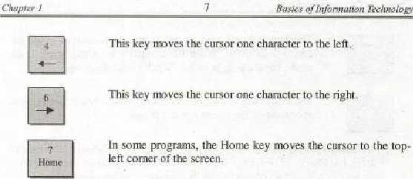

This key  line up,

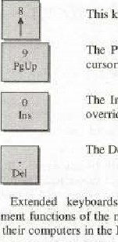

nnveniem

The Page Up key hacks up to the previous screen while the Cursor stays At the same place.

The Insert key, when toggled Off, Causes keyed Characters to overridefåfiäx the existing Characters. 

The Delete key deletes a character. space, or selected text.

include additional keys that duplicate the cursor

(he numeric keys. Users "lio enter a lot of numeric data can leavc thcir computers in thc Num Lock mode and use these additional keys to the cursor.

The Arrow keys. w the left of the numeric keys, move t]lw cursor position, just as the numeric keys and g do when they are not in the Num Lock

Just above the Arrow keys are six keys Insert, Delete, Home, End, Page Vp, and Page Down which duplicate functions of numeric keys 0, decimal point (Del). and 3.

At top of the keyboard. to the right of the function keys. are keys that perform additional :asks. as nwnlioned below:

The Print Scren key causes the current screen display to be taken a copy af information or image on the screen_

key causes lines of text images • not the

Cursor — to mov'c. Whcn computer is in thc SelOIl Lock , the status light under Lock lights up-

The Pause key causes thc screen to pause when information is appearing on the screen too fast to read.

Function Keys: These keys are the top pf a computer keyboard labcl]cd Fl.

F2,F3, F4,F5. F6. FT. F9, FID, Fil  are an easy way to give certain commands to the computer, which are usually operated hy keyboard I-hey have different functions in different program. These functions are particularly important in an application program ,

Pointing devices: Pointing devices control the position of the cursor or pointer on screen. They include the following:

|  |  |
| --- | --- |
| Moose | • Trackball |
| Pointing Stick | Touch pad |
| Touch Screen | • Light pen |

• Digitizing.fGraphic table t • Pen-based system

A brief description is given as under;

Mouse: A mouse is an Input device that looks a little bit like a rtwuse. [t has a ball on its LS on a flat surface or mouse-pad, The nwvement causes corresponding cursor rmvemcnt on the screen. [t enables us to reposition the cursor Iminter) on the screen where ever we want. It also has buttons on its top which communicate certain commands to the computer while pressed. In particular, button is often used to click on an icon (icon represents a computer acLivity or conunano to invoke the comrnand„ Trackball; The trackball is a nwvable ball, on top of a stationary device, thal is rotated with fingers or palm of the hand, rts popularity surged with the advent of laptop computers where traveling users found themselves without a flat surfaee to roll the traditional mouse. It looks like the mouse turned upside down and likewise. has additional buLt01Ls whose functions vary deF11ding on the software.

Pointing Stick A pointing stick is a pointing device that looks like a pencil eraser protruding from the keyboard between the G, H, and B keys, We rmve the painting stick Wilh our forefinger while using the thumb to press buttons tocaled in front of the space har. Anolher device like a Pointing stick is the Joystick, It is a pointing device that consists of a vertical handle like a gearshift lever mounted on a base With in video games and computer-aided design Systems.



buttons.

It

is

basically

used

Touch pad: The touch pad is a  surface which slide our finger. using lhe same movemeui3 as we would with a mouse, As we the finger. the cursor follows the movernenc. We "click" by tapping the finger on the pad's surface or by pressing button positioued close by the pad, Touch pads are now common on the portable computers (laptops).

Touch Screen: A touch screen is a video display screen that is sensitized to receive input from simply touching our fingers onto it. Tt is covered with a plastic layer, behind which are invisible beams of infrared light. We simply touch the provided buttons Or Inenug and get the information on the display accordingly-

Light The light pen is a light-sensitive Or pen-like device, connected by a wirc to thc cornpuvcr terminal, The user beings the pen to desired poinc on display screen and presses tbe pen button, which identifies that screen location to computer, Engineers, graphic desigrwrs, and illustrators use light pens,

Digitiing/GraphiC Tablet; A digiti*ing tablet consists tablet COiineeted by a wire to a  A stylus is pen-like device with which the user '"sketches" an image, A puck is a copying devicc with which the user copies an image, such as an architectural drawing a civil engineering map. A puck looks a hit like a mouse but has diffexenl types of buttons and a clear plastic section extending from one end with crosshairs printed on it, The intersection of the crosshairs points to a location on tbc graphics Which i" turn is mapped to a specific location on the screen.

Digitizing tablets are used primarily in design and engineering. When used with drawing painting software, a digitizing tablet and stylus allow us to do shadi.n; and many other effects similar to those artists schieve with pencil, or charcoal. Alternatively. when use a puck, we can drawing laid on the tablet, and a digitized copy is stored in computer-

Pen-based Systeuns: In the next years, students may be able to take notes in class without ink and paper, if pen-based systems are introduced. These computers use a pen-like stylus to allow to enter handwriting and marks onto computer screen rather than typing on keyboard This system connects an instructor's electronic ' 'whiteboard" on the classroom wall with student's pen computers. so that the students could receive notes directly. without having to copy infornuuion word for word. "The idea is that the students should concentrate on the lecture listening only".

Source Data-Entry Devices: These devices are used for  entry to computer systems. Few of them are as under:



#### Scanning Devices;

* Bar-Code Reader
* Mark. and  device
* MICR (Magnetic-Jok Character Rcc-ognition)
* OMR (Optical Mark. Recognitioo)
* OCR (Optical Character-Recogn  Magnetic-stripe cards



|  |
| --- |
| NOTE . Scanne:s use . laser heattts and reflected light to translate images Of text, drawing.>, photos, iand the like; into digital |

* Fax machine
* ITnaging system
* Audio,'Video Devices
* Audio-input deviec
* Video-input device
* Digilal camera

### Scanning Devices

Bar•Code Reader: codes are the vertical zebra-qripped nifirks we find of the products in the This bar-code system is u]so called the 'Vitiversal Product Code", These arc read by bar-code readers, photoelectric that translate bar-code symbols into digital code, which is then fed to [bc computers for further processing.

MICR: It is method of machine.reading  made of magneli•ræcl particles. MICR Chitractcrs. which are primed with magneriged ink, are read by MICR equipment. producing a digitized signal, which goes (o the compuler as data for tUfther pmee•ssing.

OMR: Optical recognition use light beam to sean input dala convert it into electricaVdigital "gnaEs, u'hich are then sent 10 computer fot  The wen known example is the OMR technology used read the SAT and GRE test nurks.

OCR: It device that reads preprinted characters in particuldr font and converts them digi*al code-The common examples some ulilib' bills andpnce jnthedepårtrncntstores_

Magnetic-strip cards: A mågnetic-sinp has a strip of magnetically encoded dala its back. Oley are used for personal identification during driving, in lhc Stores, at public ctc.

Smart cards: It looks like a credit card but a microprocessor and mernory chip have beca added additionally. Whea inserted into e re.ade!. il exchanges  with the corresponding information on a central computer. It can Store



11

Basics

Of

h•./o

%-chno/ogy

some basic inli)rrnalion also. A MohileSIM card and an ATM eard are good examples of this type,

Fax Machine: The or facsimile transmission machine scans an image and sends il as electrical signals over telephone lines 10 u receiving fax machine. which re.ereates the image on paper. We have two types of fax machines [e. dedicated fax machines and fax rnodems_ Dedicated fax nuehines are the normal fax muchiwcs whcrcas, (be fix n10dem is -a circuit inside the system It a capability to signals directly to someone-else's fax maehinc Or compuler rnoderii, from computer to computer,

Imaging System: Image (graphic  text, drawings, aud ptrotograplvs inqo digital form and stores it to the computer system Ior fianhcr pmyccssing. The system scans each image (color 01 black and whi(ei Wilh light and breaks [he image into light and dark dots or dots, which are theu convened to form. This is also called raster graphics, which refers to the technique of representing a graphte irnage as a nuurix dots.

### Audio/ Video Input Devices

Audio.lnput device: An audio-input device records analog sound and digital sioragc pmcessing_ The principal use of input dcviccs is io p•mvide digital input for multimedia computers, which  incorporate text, grgphics, sound, video and animation in single digital presentation_ Sourbd (analog fat-ml goes through u special circuit board called an audio board. which convcrts analog sound digital form and stores it for further proccssEng And/or plays it back_ Microphone is roost]' used us an audio.input device.

Video-input device: Films and video images from VCR or can-worder are converted to digital forni With the help Of a Special digitizing card (called Video-capture card). It has typest

Frame-grabber video card: It tan capture and digitize only a single framc at a iinic.

Full-motion video card: Also known as adapters. can convert analog to digital signals at the rate of up to 30 frames per second, giving the effect of a continuously flowing motion picture.

Camera: A digital camera uses light-sensitive processor chip to capture phot.ogtaphic dggital rog•m on a small diskette inserted in the or flaxh.menwry chips. The digital  uploaded to t:he computer grunipulation and printing out.

#### 1.2.2 Output Devices

The information processed hy the eomputer is-translated into a form we understand, and displayed by these machines, Normally. ihe output is classified as Sorteopy output or Sound output and Hardcopy output.

Softcopy refer to data that is shown on a disfrlay screen or is in audio or voice form fhis kind croutput is not tangible; it bc touched. Vimaal reality and robots might also be considcrcd softcopy devices, Hardcopy refer printed output. The principal examptes printouts, whcther text or graphics, from printers. plotters etc;

Display Screens: Also known as CRTs. Monitorss or simply screens, differ in size, color, resolution, and video display adapter card. These are used for' inputting the data or displaying the information after pmcessing.

Size: Monitor come in different sizes, from small seteen built into palmtops and laptop to extra large nwnitors used for special purposes,

Color: Many monitors display color. nese RGB displays can create 256 colors and several thousand variations on them by blending shades of Rcd. Green, CRGB). Monochrome displays show information using a single foreground color on a contrasting background color.

Resolution: All the characters and images monitor are up or dot patterns: the number of dot. or pixels, per determines resolution, or the sharpness of [he image. A higher number of pixels means a shaper image. Video Display Adapters: To display graphics, display screen must have video display adapter attached with the cl'mputer. known a video graphics card. ;uld is a circuit that determines resolution. number oi cobors, and speed with which images appear on the display screen, Sa far, there are three types of graphics cards introduced in the market,



FOI

* VGA: Video Graphics colors. dependin;g on screen resolution: At 320 1 and a: 640 X 480

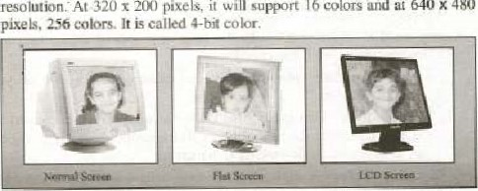

Array,

gupirn-t

16-256

support

16

colors

* SVGA: Super Video Graphics Array, support 256 colors at higher resolution than VGA, It has two graphics modes: 800 x 600 pixels and 1024 x 768 pixels. Ic is called 8-bit eolor,
* XGA; Extended Graphics Array. supports up to 16.7 million colors a resolution of 1024 X 768 pixels. Depending on the video display adapter chip, XGA will support 256, 63536, or colors, [t is called 24-bit color or Trae galor

Types of Screen: Display sereens are of types i.e. Cathode-Ray Tubes and Flat-Panel Displays.

CRT (Cathode-Ray Tube): The most conunon form of display screen is the CRTv A Cathode-Ray tube is vacuum tube used as a display screen in a computer or video display terminal, This same kind of teehnotogy is found not only in the screens of desktop computers but also in television set and in fight, information tnonitors in airport. A stream of hits defining the image from the computer (from the CPU) ta the CRT's electron gun, where the bits are converted ejeclrons. The inside of the front of the CRT screen is coated with phosphor. When a beam of electrons the electron gun (deflected pixels to generate an

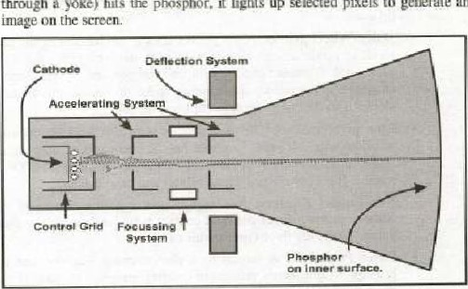

the

up

through

yoke}

hits

phosphor,

it

lights

selected

how CRT screen work

Flat-Panel Displays: The net-panel displays are much thinner, weightless. and consume less power 10 CRT. Thus, they are better for portable computers. Flat-panel displays are made "p of two plates of glass with substance in between them. which is aelivated in different ways. There are three types of technology used in flat-panel display LCD (Liquid-Crystal Display) consists of a substance called liquid crystal, the Of which up in a Way that lighting behind the screen is blocked or allowed through to an image. EL (Electro. Luminescent Display)

When Charged by an electric display is like neon bulb, displuy gas, light the pcvsvncc e b.ctriv

At present, EL are expensive thus are not used ofte:g us technology,

Printers: Printers me used to prior characters, symbols. and graphics on paper- They dre divided into two categories:  lmpact printers

* Non• impact printers

Impact Printers: An impact printer forms characters or images by striking a mechanism such as a  or wheel agai1Ls1 inked ribbon, leaving an image on the paper. Following are a few types of impact print«s;

* Dot-Matrim printer: It contains print head or small pins. which su•ike an inked ribbon against paper, forming characters or images. Print heads are available with g, 18, or24 pins, With the 24-pin head offcrthc quality prints.
* Daisy-Wheel printer: This printer uses a mechanism in the shape Of a senes or petals arranged on petal wheel, Ivv,iing character at end of each petal. A character comes into a print position by wheel rotation and an image is formed by the hanun:r strike on 'he desired character, is slower dot-lnalri% printer but better in q lidlity.
* Line printer: This type of printer is normally used by mainframe minicomputers. prints a whole line of characters at once rather than a single character at d time, Sorne of these can print up 10 lines per 'minute, 1' is types: Chairl printer and hand printer,
* Non-impact Printers: Non-impact printer forms chereeters or imuges without making direct physical contact priT1iJng mechanism and paper. There are three types in this category.
* Laser Printer: It is similar to a. photocopying machine and it use the principle of dot-matrix printers of creating images With dots. These images 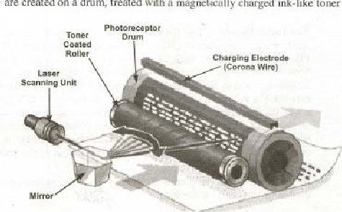are created on a drum, treated with magnct.icelly eharged ink.[ike toner

(powder), and Ihen transferred from drum to paper. The laser primer can produce high quarity of boil' graphics franging from 300 dpi to 12(1) dpi). Its speed varics Eon' 4-32 (ext-only pages per minute for microcomputers up to 200 pages per minute for mainframes.

* Ink-jet Printer: Ink-jel printer sprays electrically chajged droplets of ink four nozzles through holes in a at high speed on paper. Il is cheaper earmpared to laser printer but lower i" resolution {300729 dpi) and is slower Also (1-6) text-only pages per It has another type of printer i.e- hobble-jet printer, which uses miniature healing elements to force specially  through print heads with 128 tiny nozzles-
* Thermal Printer; Thermal printer uses colored waxes heat to produce images by burning dots on to special paper. The colored wax. sheets ave not required for black-find-white output, It produces a high quality printout but is quite expcnsiye compared to other printers

Plotters: A plotter is used to produce high-quality graphics in many colors and used fot specialiicd appliutions i.ev architectural drawings, maps, graphs, and charts. Plotters are of two basic kinds:

* Flatbed plotter
* Drum plotter

Elot:bcd Plotter; A flatbed plotter the one. which has paper lying nat On table-like •curf•ace, The bed-size •varies according to the Onc to four color pens across the paper and the images are printed by the computer accordmg]y.

Drum Plotter: It works Tike a flatbed plotter with a difference that the paper is over a drum. enabligg continuous output. A typical to track an earthquake readings,

Sound Output; Speakers are 01091 commanly used to have this type of out put,

Speaker: As we use microphone to input audio dala to the computer, conversely we use speaker to get audio output the computer_ It works on the same principles to conveft sound data into machine usable A variety of speakers ate avuilahle in the market to satisfy the requirements of the

### System Software vs Application Software

Generally speaking, a computer is "deaf dulnb" machine, which cannot do at»thing at its own unless it is told to do so. We instruct it to do some number calculation to geateftmdify a document. to work on some engineering application and so on. So this instruction(s) is thedriving forec that allows a computer to perfonn  certain task and known Program Of a Software'. It is this "Software" that tells the Inachine's physical co ruponents what to do and how to do-

The software falls into two major categories i.e. System Software and Application Software. They are discussed as below,

#### System Software

The system software basically and monitors the different resources Of whole computer system i.e. Operating system, Backup and Restore utility prograrn. drivers etc

Operating system is the main and foremost part of thc system softwagv, is discussed ineluapter 7,

#### J-3.2 Application Software

Computer Programs Or Application is basically a set Of programs th*t are used t' accomplish a given task, It is basically designed and implemented by the computer users or different software houses, The application software is available in many forms"categories i.e. Commercial software, scientLfic software, Financial packages, Games ete. A comprehensive discussion. about how to design and implement the software, is givcn undcr (opic Development" in section

## 1.4 Basic Units of Data Storage

The memory (main or sccondary) is composed or an electronic circuitry, which is combination c;'f •On" and "Off' switches. This OlÜOff state has conceived by the congputer's manufacturers as the numbers and & , as the circuit can show 1 don stale) or O (off state} at a given ti.rne, Based On these two numbers I and O (the binary numbers*. the computer can construct sophisticated ways of representing data in the memory. Thus, converting the numbers. alphabets, and charaelets (and their combination€} into binary digits enable us to represent them in the computer 

1.4.1 Bit binary or O is called a bit (for binary digit), which the basic unit for storing data in the computer nnernory. The circuit twing go off bit is Kind C)!

### Byte

A byte is a ecmbinution of 8-bits, that can store a single ehaneterof data (a letter, nurnerll or special character). The capacity of the memory or the stocage is expressed in terms of number of byes i; hold or The following table shows the commonly used storage capacity terms.'

|  |  |  |  |  |  |  |  |  |  |  |  |  |  |  |  |  |  |  |  |  |  |  |  |  |  |  |  |  |  |  |  |  |  |  |  |  |  |  |  |  |  |  |  |  |  |  |  |  |  |  |  |  |  |  |  |  |  |  |  |  |  |  |  |  |  |  |  |  |  |  |  |  |  |  |  |  |  |  |  |  |  |  |  |  |  |  |  |  |  |  |  |  |  |  |  |  |  |  |  |  |  |  |  |  |  |  |  |  |  |  |  |
| --- | --- | --- | --- | --- | --- | --- | --- | --- | --- | --- | --- | --- | --- | --- | --- | --- | --- | --- | --- | --- | --- | --- | --- | --- | --- | --- | --- | --- | --- | --- | --- | --- | --- | --- | --- | --- | --- | --- | --- | --- | --- | --- | --- | --- | --- | --- | --- | --- | --- | --- | --- | --- | --- | --- | --- | --- | --- | --- | --- | --- | --- | --- | --- | --- | --- | --- | --- | --- | --- | --- | --- | --- | --- | --- | --- | --- | --- | --- | --- | --- | --- | --- | --- | --- | --- | --- | --- | --- | --- | --- | --- | --- | --- | --- | --- | --- | --- | --- | --- | --- | --- | --- | --- | --- | --- | --- | --- | --- | --- | --- | --- |
| |  |  |  |  |  |  |  |  |  |  |  |  |  |  |  |  |  |  |  |  |  |  | | --- | --- | --- | --- | --- | --- | --- | --- | --- | --- | --- | --- | --- | --- | --- | --- | --- | --- | --- | --- | --- | --- | |  |  |  |  |  |  |  |  |  |  |  |  |  |  |  |  |  |  |  |  |  |  | | Kilobyte | | | K or KB | | | | |  |  | | | | | | | | 1024 | | | | | | Megabyte | | | M or MB | | | | |  |  | | | | | | | | About one million | | | | | | Gigabyte | | | G Of GB | | | | |  |  | | | | | | | | About one billion | | | | | | Terabyte | | |  | | | | |  |  | | | | | | | | Aboutonetrillion— | | | | | |  |

fable 1:: Storage Capacity Terns

Example: Convert 240 MB offiiemo:ry in bytes and kilo-bytes?

Number of bytes in one MB = 220



Total Of bytcs in 240 MB 240 23 bytes

Number of Kilo-bytes in one MB - 210 KB - 1024 KB

Total number of Kilo-bytes in 240 MB = 2.40 * 1024 KB

#### 144.3 Word

A computer word, typically size Of a register, is defined as ibe number Of bits that constitute a conwnon unit or data, as by tlw computer system. fie length of a •word varics from computer to couvutcrv Generally, the the word. the more powerful is the cornputer. Thc following table illustrates this factor;

|  |  |  |  |
| --- | --- | --- | --- |
|  |  |  |  |
| One byte | 8 |  | Vcry Carly personal computers |
| TWO byte | 16 |  | Traditionag micro-computers |
| Single word | 32 |  | Mainframes, son* mini-computers, and some micro-computers |
| Double word |  |  | Super computers and micro— |

Table 2: Capacity Co mputer Era



|  |
| --- |
| •Remember that: Ari 8-bit machine could handle only -one-byte o (a eharaeler) al time, whereas a 64-bitq luaehine handles two Words Or 8 bytes At time, rooking its; processing speed eight times faster'* ' |

Example Convert 606B of nw•mory into words?

Solution:

Number Of bytes in one GB — Number of bytes in 60 CiB

Number ofwords in 4 bytes = I W

NUmbe:r ofwords in 60 (jB= 60/4 * 2'"

— IS words

### 1.5 System Development

#### IS-I System Components

The system comprises Of the iollowiug necessary components

|  |
| --- |
| What is  A system can defined as corubillation Of Sone related cörnpOOC1itS in.e:ract Ydith exh - to perform: iiictuSkS. |
|

(i) Hardware

Software

(iiij People / users

(ivj Data/ Information

Communication setup

Our main discussion Were is focused on the Application Software development process, leaving aside Ibe software packages (which are always available in the rnarkeo.

To develop system, several distinct phases are 10 be worked out. For was devek)ped, It involves five

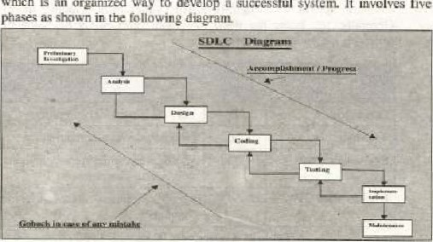

this

purpose,

SDLC

'Software

Development

Life

Cy•le)

which

is

an

organized

way

to

develop

system.

successful



Informanon

Technology

#### 1.S.2 System Development Life Cycle

Preliminary Investigation: The objective of preliminary investigation is to conduct an initial analysis and findings of sysrgn as discussed below:

* System Identification: The system is to be identified ai this stager This is very i mportant step as everything done in future will depend on basis of this definitio n-
* System Scope: The scope of the system is established at this stage. Sornetimes, it heeornes necessary to curtail the projects to certain limits due to finårkial, political, or time constraints,
* Alternate solutions: There may be alternate solutions to develop the sysicm. Identify al] those and choose the best one. The lwst stratcgy in this regard would be interview the concerned people inside the organization, clients or customers of the system, suppliers and  We can also watch what Elk competitors are doing for the same type of systems.
* Feasibility study: We have to see the financial, political, and time-frame viabilities to go ahead far the system. There may be sorr social and lechnical constraint to be considered also.
* Preliminary plan: Here, we need to wind up all the findings and submit as wriilen document for appmval, The readers of this document (also  known as feasibility report) are Eup managers who will then decide about the future actiotus to be taken, based on this report. They might would like to make few amendments in the project shelve depending on the whole preliminary investigation.

Systems Analysis: Here, the analyst will conduct the following activities; Needs Analysis: This activity is also called Requirements Analysis. Herev the analyst would up the requirements of system from t.hc users and the managers- The developed system should satlsfy these requirements during t esting phase,

Data Gathering: For this activity, the systems analyst uses different tools and methods, depending on the situation, They are discussed as under;

* Written documents: In ease we want to computerize the exiszing manual system or upgrade the existing computer-based systetu much of the handful information can bc made available using these documents. They are I-eB»rtg, forms, business plans, policy statements. organizational charts and many Others-
* Interviews: Interviewing the managers, usersiclients, suppliers, and will help the analysts/designers to gain more knowledge about the system, The emphasis is on the Fact that the questions to be asked from them should be precise and relevant.

Questionnaires; It may be difficült to interview many people. so it is bcttcr to dcs'gn some questionnaires to collect the information fmrn as many people as we like, This is very convenient and inexpensive method to collect handful of data but sometimes the response truly ambiguous and insufficient.

 Observations: The analyst or his team may go and watch the working, behavior, and things 10 know rfnre about the similar around. He :iiiåY he participant Or non.palticipant Observer delEnding the permission he got from the other party

* Sampling: If there were a large number Of people or in the systenu it would be IRtte1 w work on a portion of all of 'hem save

Data Analysis; As we are living in the ßlntormation age" so it is generally believed in today's computing scenario that data or information is the nwst precious commodity. Therefore, data must be accurate, complete, and rea{lily available in the we design. So to keep it in proper shape, we have many tools available, For example: DFDs (Data Flow Diagrams), System Flowcharts. Canneetivily Diagrams. Grid Charts. and Decision Tables etc. It is IRyond the scope of this course to discuss them in details here.

Analysis Report; Once the analysis work is over, we need to docurænt it in a presentable form to the higher management for their review and approval of the project. This repon should have three parts : First. it should explain how du eurrent system (manual or automated if exists) works, Second. it should explain the problems in 'he existing system, and finally it should deseribz the requirements for the new system and make recommendations for future

Design; In this phase of SDLC. the analyst works on tir preliminary (Logical) design. detail (Physical) design, and then writes a detailed report.  Logical design: It descrilys the general functional espabilitics of a proposed system, It reviews the system requcrements and considers major system cotnponents. Casc and project- managernent software {MS-Pitiject. Gantt chart, PERT chart etc) may be used to acconyJlish this task. You will learn about these tools •and software in advanced

* Physical design: It describes how a proposed system will deliver the general capabilities described in the Logical design, It will address following points: OuLpuz requirements. input requirements. storage requirements. puoces,s'rvg requirements, and system control and backup/recovery
* Report: A detailed report an logical, physical design is to be submitted to the higher nmnagernent along with some sort of presentation, explaining them the details of the proposed system_

basics

Coding: This is core area of the system development process, It consists Of writing and programs. Which Will be coupled together in the Shape Of a complete System. It needs lot Of time, effort Slid budget to aCLlUire a workable System- The pnpgrarn specifications. algorithms. flowcharts are given to the programmers/ software cnginccrs to code the required programs. Offahe-SheIf-Cotnponen(s (already written programs) carv also be used and embedded in system to save time and effort.

Testing: Having proper hardware  programs can be tested in two

* Unit-testing; It is also called modular testing whcrc individual modules. programs can he tested using lest (sample) data.
* System-testing: In this. parts or modules are linked together to test their workability as a one system. Actual data may be ueed to do the system testing "lid at tbc same time, erroneous data can also be used to. check whether the system rails or not.

[f system passes all the tests; We Can implement the system on the servers. so that organization and Other clients can Life it.

Implementation: This activity consists of transferring the hardware' software and data (files, database etc) to the new working environment (server), Users of the system are also trained in this phase. Ilnpletneniation  may achieved in live approaches.

* Direct Implementation: In this way, the users start using the new system right away and stop working on the old one.
* Parallel Implementation: Using this appmach, the new and old systems are used side by side until it is felt that the new system is quite reliable.
* Phased Implementation± this apptoacm parts of the system are implemented from time to time, until the whole system is implemented.
* Pilot Implementation: This type of implen.entation allows us to implernent the complete system but to a selected group of users Of selected departn•ænts.

|  |
| --- |
| mnrniSÄii pi und phased implementatiqo are 'he unost favored and popular the  Phased 'pprøach i» for different types functions carried whereas I"ikot appt is. pie-ferred where almost Of Ott" |

Users Training: Involving the users in the SDLC process from che beginning and ensuring their proper training is very much essential throughout the system design activity, A variety of methods/tools are used to do so i.e. instruction Manuals Videota»CDs, and Lectures elev The traming may be conducted •In-house" or it may be

"Contracted out

phase adjusts and improves the system by

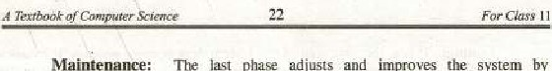

Maintenance:

The

considering the users evaluation, f&dback, and enhancements based on their due recommendations. In this phase. due maintenance and help is also provided to the users against their queries, problems, and ambiguities



1. Fill in the blanks•,

 A bridge is used where the type of networks arc to joined together.

W AN gtand for

* 1. A set of instruction given to thecomputer to solve aproblem is called

computer, 

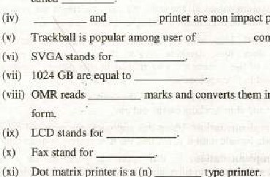

printer.

(xij

Dot

printer

a

(n)

type

printer.

marks and converts them into conputer-usable

1. Choose the correct option:

(i) The name for the screen clarity;

* + 1. Resolution Discrete (e) Pixel (d) LCD (ii) Another word for pointer:

(a) Monochrome Pixel (c) Cursor (d) None of the

* 1. A device used for optical-character_recognition isu

|  |  |  |  |  |  |
| --- | --- | --- | --- | --- | --- |
|  | |  |  | | --- | --- | | (a) Wand reader | (b) Cursor | | (e) Pen. | (d) MICR reader | |

(iv) Irnagin& to input data;



what

device

(g) scanner (b) icon

(c) bar code reader (d) tablet

(v) An ink-jet printer is an example of

|  |  |
| --- | --- |
| (a) Laser printer | (b) Impact printer |
| (c) COM printer  (vi) Soft copy referto. | (d) Non-impact printer |
| (g) Screen output | (b) Peripheral devices |
| (c) OCR | (d) None of the above. |

(vii) Smallest unit of memory ist

* + 1. Byte Bit

(c) Character (d) Word



(Viii) The printer which can print one complete liile at a tifne is: Dot matrix printer (b) Daisy wheel printer  Laser printer (d) Line printer  Thc microphone converts the sound in'o:

 Mechanical signals Electrical signal

• Computer filc (d) Software

(x) An input device , which is lised for playing computer games:

(a) Light Pen (b) Mouse 

(c) Joy Stick" (d) Scanner

3, Write T for true arvd F for false statement:

 The arrangement provided as standard on most keyhoard is the

QWERTY

A picture clement on the screen is called a pixel,

(iii) CRTs are used on portable Computers.

Audio-output device can output only music.

 Non-impact printers are quitter than impact printers.

 A trackball is a pointing input device almost like a mouse turned upside down.

 The disk drives are known as I/O devices. 

(viii) Function keys are used the way with every software application. Ox) EGA stand ior Extended Graphic Adapter.

 The two basic types of plotter are the Drum plotter and the Flatbed plotter,

4. What is the difference between hardware and software?

 What is information Technology? Describ: it in detail?'

6. What implementation? Describe it Approaches

7, is the US-age: of an input device? List few of them, 8, Describe the enhanced Keyboard and it segment?

1. Write the name of thc Input device char can control the cursor rwye:ment
2. What is the function of an output device? List few of them.
3. Describe the functioning of a La ecr printer, Name few of them.
4. Whal is the usage ofa plotter? Najnc its different kinds.
5. Define the term • Operating System" in your own words.

14, Describe the function of the following input device?

(i) Mouse (ii) Joystick (iii) Trackball

(iy) Scanner (v) Light Pen (yi) Digital Camera

15. What do you understand by USDLC"? Define its steps properly

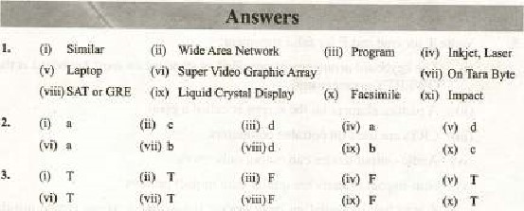



|  |
| --- |
| CHAPTER 2 |

Information Networks

### Overview

Information networks, or computer networks. are at the convergence of two inpottant technologies; computing and telecommunications. This convergence has resulted in local area networks (LiNsj, melmpolitan networks (MANS), wide-area networks (WANs). ang the Internet. Computer networks Were originally research experiments between the computer scientists, telecommunication engineers, and ather researchers. These scientific and engincering experiments, however. have since IE•come imrnense social experiments as well. Iniormalion networks have many useful benefits. At the same time. however€ t.lry have given rise 10 sonle problems as well-

Information networks such as World Wide Web are characterized by the interplay l*twcen leterogeæous content and a complex link strueture involved, Link structure can powerful source of information about the underlying content in the network We can think of a network as a large eireulacory system, through which information continuously This diffusion of information can happen rapidly or



slowly; it can disastrous in panic or failure or beneficial — as in the spread of innovations. So, In of the Web, we tn•• to identify high-quality in rortnation resources it contains,

The information networks can be examined from many points Of View, partly because of the cultural næaning we ascribe to computing and telecommunications and tbc central role that they play in politics. social interactions. and commerce etc, As international business informati.n is fast becoming a prime commodity, so inforjnstion based networks are being frequently developed help small and medium enterprises communicate about business needs, expand their markets, share their resources. knowledge and experience.

## Workgroup Computing

Workgroup computing is highly irnrwrant aspect of modern world computing in today's academic, technological and rcscarch oriented atmosphere, It i: also known as collaborative computing and it cnibles the individuals And tcanas of certain projects 10 use cornputer networks for the of cooperation, consultation. and information sharing. With the help of groupware, many users or researchers can work on their projects by sharing the samc domain of inforrnacion online_ It permits the individuals to  with their colleagues to work on eornpany infornution over the network. At the same time, they can also link to other important contacts outsicle organization,

The information may reside on Ikterogcncous type of databases, it may be made available using altogether different operating systems. und il may be using different platforms. But as [oog as the users are communicating with each other through a common shareware and they IXIong to same group, they will keep gn working without any hassles and problems. In fact, it is the smart service of communication technology tha: has brought aEx•ut a revolution if' this type of computing, The concept of "global village" has Isconk a reality now and the computer community is "chatting" with each other as if they are sitting face to face.

### 2.2 E-mail and its benefits

E-mail or Electronic mail. is the process of sending messages dvreetly from one computer another (linked through wired or wirelcss connections) The sender and receiver rnay be silting in the same building or anywhere in the world. It works perfectly only if the intended receiver has (he e-mail facility to Which the sender is connected. It reaches to many people with the same tnessage* reduces the paper flood. and does mot interrupt næetings as the ringing phone docs. The e-mail allows users to send text messages, documents. and images anywhere over the nctwork, This facility in nosily provided by some specialized "nebsites eal.led E•rnail servers i.e. Yahoo, Hotmail, Gmail edC, and it works purely in a client-server computing environment.

Benefits: E-mail has a number Off advantages over other communication methods such as;

* We orcornmunication with anyone has nothing to do with distance or the or can communicate quickly with any one on the internet, E-mail usually reaches its destination in ä matter of Ellinuzes or seconds,
* Thc cost the message It is cost effective way to communicate with friends, colleagues, or business associates regardless of where they are physically



* We can send letters. notes. files. data, or reports using the techniques. Orge we learn how to use the e—mail program, everything [s sent the sane way.
* The recipient. working on the computer, is not interrupted by the arrival of the e-mail- It is put in his mail box (on server) and can be seen and worked upon later, using e-rruåil program. 
* The user's computers may be off when the mails arrive (all Will stay in the servcrj and can IV read anylimc.
* E-rnails are not anonymous, they always carry an address of the originator. Therefore, we •are always sure atvut where it coming from and where it  is going ton

## 23 Internet

The Lntemet is a wonderful and amazing arena where we can find information about almost any thing of thc world On the we have ocean of knowledge about the books, magazines, encyclopedia, and any other type of reference material readily available. In addition. we can have expert opinions on any topic and can communicate with world community on all ranges of subjects. Essentially, the Internet has brought the world nations to realization 'Global Village", in which we feel, everyone as close as our neighbor.

 Internet is not a real entity or J place that has a building or a place Instead. it is the result of a collahorative effort of people and computers throughout the world. The end result is an electronic link to the worbd of information and entertainment. In simple word5v Internet is u network connected computers that provide us a facility or exchange data, and files with other compuLe1s that are connected the Internet.

### 23.1 Birth of Internet

During late 1960s, it vas designed as ARPANET (Advanced Research Project Agency NETwork) by the US Department of Defense — DARPA. in collaboration With universities and research organizations_ In the  beginning, ARPANET was used Inainly for communication technology research development, With sites connected through -a work, to share the

Later, throughout 1970s arid 1980s. ARPANET evolved into several other networks dedicated rnoslly to military use. In 1989, all the previoug ncworks, creaicd for l:nilitary use' were abandoned and replaced by National Science Foundation's NSFNET- This was the turning point, as the Internet trgan serving the civilian community along with the military as well. Now the service was available to anybody ill the community and people started patronizing and monitoring the Ingerrpet, Today, even the Internet has becomc too much commercialized: NSF is still donating a lot it.

The Internet has grown rapidly Since 1990. According to the Internet Society nuM1i:oring organization), the number of computer networks in the Internet is than TWO Million atid the number Of Computers that eonne:cz to these networks is more than Hundred Million. To understand how the Internet works, we need to have a sufficient knowledge of 'Networking" the conneCtivity of

### 23.2 How the Internet is Useful

The basic understamiing of lay about the Internet is "What kirtl of Information is available on Internet and hog". Before 1998, people used to think about Internet as having only one specific segment i. e. World Wide Web But actually. the Internet has many more components of immense utilization. Few of them are as given t:rlow;

World Wide Web(wwu•): www is a collection of millions of uploading web pages/web sites, It organizes (he Internet. related resources so that we Can easily access the informati8n available on the Internet.

*  mail (e-mail); As defined earlier. it is the process or sending and receiving messages and files among the Internet users.
* Telnet: It is the software tool that allows onc computer to Connect to another computer and make use of the other computer's information,
* File Transfer Protocol UP): It is also an Internet software tool for transferring files from Oue eornputer to another, The process of transferring filc from remote computer to computer is called downloading. The process of transferring file from our own computer to the remote computer (on the Internet) is called uploading.



I

I

Textbook

 Gopher; It is access and retrieval system covering a wide range of information€ from reference materials 10 nugazine articles to government docunÉfitS and speeches.

* Chat group* The Intefnet users with similir interests form up their forums. to have online real-time discussions over the Internet.
* Intranet: An intranet if a privately owned, secure. business network based on Internet technology' although not necessarily connected to the InternetThe tenn "intranet" appeared when companies discovered that could use Internet technologies to make company-internal available to All employees, no matter where the employees were located or what kind of hardware they were using; that they could still secure infornuticm from unwanted access by outsiders: and that. along with these advantages. they could  information available at lowest possible-

Extranet: An "extranet • is two or nore intranets connected in such a way that they enable collaboration among the companies that own the separatc intranets. On an extranet each connected company usually lnakes sone selected part of its intranet accessible to employees of one or other companies. For exarnple, several cornpanies might create an extraret

to consolidate data gathering and share data, to Büntly develop and share trainint program; and other material, coordinate project nnnagement for a conunon work prx*ct, On an extranet each eotnpany uses the security inherent in its own intranet to the keep enaployees of companies from accessing information they do need to see-

The cullalx»rative business application u powerful extranet Cool cost

### 2.4 Components of network

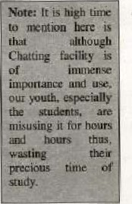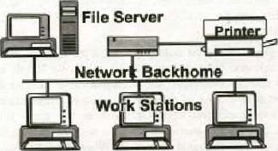LANs do not use LIE telephone network. Its networks ace constructed with standard set of convonenis, as discussed

### Local Area Network (LAN)

* All networks need system for interconnection, tn sone LANs, a shared network cable eonneets the nodes. Low-c6st LANs are connected with twisted wire pairs, but nuny LANs use coaxial cable or fiber optic cable, which are both more expensive and raster. Some LANs- are wireless, using infrared or radio wave transmissions instead of cables. Wireless networks are easy to set up and reconfigure, since tlr:re are no cables to connect the devices. but they have slower transmission rates and limit the distance between nodes.
* A network-interface-card (NIC), connects each cornputw to the wiring in the network. NIC a circuit board fits in one of the currvuter's internal expansion slots. Son-æ computers built in NIC.
* Sitiiilar rictworks can connected by a bl*d.ge, which recognizes the  on a network and passes on those addressed to nodes in other network.
* A gateway is a collection of hardware and software resources that lets a node communicate with a computer on another different network. A attorney a local area network to a legal service offered through a wide-area-network (WAN will be discussed after this topic).

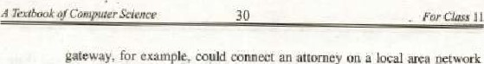

an

* A router is a device that connect' two Inore networks it consist of a combination Of hardware and software. The hardware can be a network server, a separatc computer, or a special black box device. The hardware includes physical interfaces to the various rætworks in the internetwork- These interfaces can Token Ringe Ethernct. Tl, Frame Relay, Asynchronods Transfer Mode (ATM). or any number of other technologies. •Ille two main pieces of software in a router are the operating system and the routing protocol. Management software can be another software component of a. router.

LANts Protoc& Networks have certain rules. called Protocols, to send and receive data, and it is defined in the network software. The most canumn of them are explained as under;

* Ethemet: Currently, this most conunonly used protocol. It uses a high-speed network cable and bus topology, so it is relatively simple and cheaper. Since all the nodes (computers) use cable to send and rcceise data, they musl follow a sel of rules aboyt when to communicate. otherwise, two cir more computers could transmit -at the same time, u•using lost messages. transmitting data, a node listens" to find out if the is in use, If the node must wait, When the cable is free from Other transmission. the node begin transmitting immediately. This is also known as CSMA/CD (Carier Sense Multiple Access with Collision Detection).

If hy chance, two nodes transmit data at the same time. the collide. a collision occurs, a special message, lastmg fraction of a second, is sent out over LIE network ta indicate that it is jammed. Each rwdc Stops transmitting, waits a random period of time, and then transmits again, Since the wait period for each node is random. it is unlikely that they will "*in transmitting the same time again.

* Token Ring; It is closely associated with IBM, works on the concept of a ring 'r:twgrk topology and token (a kind' of eleetrouie signal). The

method of controlling access to the shared network efihle is called token passing.

* Only one token is available on the network. When a node on the network wishes 10 transmit, i: first captures the token, only then it can transmit data. When the node has sent its messagc, it the token back to the network. Since only one coken is circulating around the network. only one device is able to access the network at a time. Thus collision occurs but the only disadvantage is is slow data transfcr rate,

A.RCnet: The ARCne1 topology and uetworking technology all own. It uses either twistcd•paic wire or coaxial cable, and the star trplogy is informed with hubs attached to network.

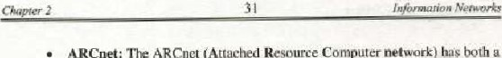

network)

(Attached

Resource

Computer

The original ARCoet protocol was very slow, bui ic '*came popular because it was inexpensivet reliable, and easy to set up-and to expand, Fast ARCnet increased the transmission rate to 100 Mbiis per second and includes the capability io use fiber optic cable.

* TCP/IP (Transmission Conlml Protocol Inbernet Protocol): TCP/IP is the protocol used by every computer on the Internet. A protøc:Ol is a set of rules procedures thal defines how computer receive and transmit data over the network. Every computer the Interne' must have TCP/IP configured,
* TCP/IP ensures reliable connection between the computers communicating over the Internet. It also defines a likehanisrn through which e •.ery computer on Internet is identified separately,
* TCP/IP software differs for different computers but it alwayÅ preent the sank interface to the network It does not matter if the system on the other end is a supercomputer. a mainframe, minicomputer or microcomputer; long as i' is using TCP/IP, it can send and receive data through the Internet.
* 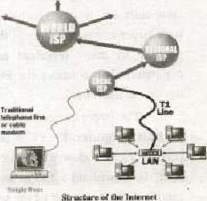ISDN(Intcgrued Scrarjes Digital Network); ISDN is a set of international communication ständredx for software contml oftran.smiuing voice, vidoe, and data simulaoeously as digital signals twisted-pair telephone lines. Basic rate ISDN provides belier quality than analog connections and more reliblc digital connections a: higher speeds than those offered by anatog connections
* DSL (Digital Subscriber L ine): OLS provide high speed, digital data trarvdmwsion from hornes and over existing telephone liticg. The exiting lines analog and the transmission is digital. so modems necessary with DSL techno logy. DSL is a alternative to ISDN.



Scien

ce

11

#### 2.5 LAN VS WAN

##### 2.S.1 Local Area Network (LAN)

A local area network is a collectlon of corrwuters, usually microcomputers. thit share hardware. software, and data. In simple terms. LANs hook personal computers together through communicatioms media so that each computer can sharc thc resources Of others. As name implies, LANs cover short distances, usually ong office or building or group of buildings that are elose to each other,

##### 2.S.2 Wide Area Network (WAN)

|  |  |  |  |
| --- | --- | --- | --- |
|  |  |  |  |
| Local |

A wide area network is a network of geographically distant computers terminals. In practice. a personal computer sending data sone remote area is probably sending it 10 the mainfralne or minicomputer. Since the larger computers are designed be accessed by terminals, a PC can communicate With larger computers only if the PC inlitates to be a terminal. This is rnade possibLc by using terminal emulation softyure on the PCs. The larger computers then consider the PC or workstation as Just another input/output device i. e. a terminal.

The larger Cotnputef to Which the terminal Of PC is attached is called the host computer. If PC is IR*ing used as a terminal. me transfer software Ftnits users to download data tiles fiom the host or upload data files to the host, To download a file means retrieve it front another convuter and to send it to the computer Of the user who requested the file. To upload. file, a user sends a file to another computer

'dop•murion Networks



All the communication across the WAN is made rwssible via ordinary telephotæ lines, microwave or satellite links.

 Typically, WAN is two or more LOANS eonneeted together aeross a wide geographical area using the connectivity mentioned above, The Internet is the ultimate WAN because it connects many thousands of computers and [ÄNg around the w orld. ultimately making it as WWW (World 'Wide Web).

##### Metropolitan Area Network (MAN)

A metropolitan area network (MAN) is a communications network covering a geographical area the size of a city, The purpose of a MAN is Often to bypass local telephone COIiipa1iieS when accessing long distance services. Mobile phones (Cellular) systen•s are ORen MANsv