#### 2.6 Networking Concepts

 network is a way to connect computers together so that ilwy can Communicate, exchange information pool their resources amongst Other.

In business or education, scientific or technological research, educational institutes or office atmospklere, networks have revolutionized the use of computer technology. Be it a local area or wide area network, the world community has come -closer to each other. The ocean of information is virtually on our table, using the powers of browsing and surfing the resöüTCcg Of largest network i.e.

##### 2.6.1 Uses of Networks

Following are few uses Ota Nctwork;

 Ne(works users simultaneous access co shared progrants and data.

* Networks also allow users to share peripheral de vicesm such printers and hard disks.

Networks usually includc the capability to e-mail along with big attachrnents (files etc.)

* SOILE networks also aid communication by providingfor teleconferencing and videoconferencing

##### 2.6.2 Network Modal

We two ty1XS of networkas discussed below;

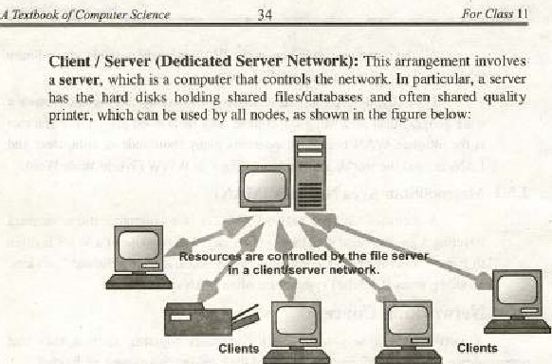

The clients are all the ather computers an the network Under this arrangement* the server usually does processing_ Client I Server has attracted a lot of attention because a well-designed system reduces 'he 'volume af data traffic on the network and allows faster response at each node. (Also, since the server does  heavy work, less expensive cotnputers clients can IR used as nodes)

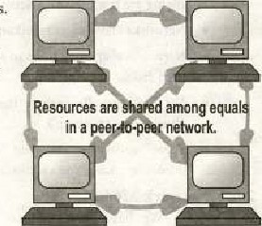Peer-to-Peer•: All computers jn a peer-to-peer arrangement have equal status. No one has control over others. With all files and peripheral de vices distributed across several computers. users share each other's data devices as needed. The main dlsadvantage in this approach is lark of speed as most peer-to-peer networks slow down under heavy use. Its main disadvantage is the Jack security;

H9brid; Many networks hybrid cotnbinati0') ofboth client/server and pee:r• to-peer approaches, This approach advantages the above mentioned

##### 2.6±3 Network Standards

The standards are the precise doeuii'ienls containing technical physical specifications abaui the network heing designed, Normally are taken into considerations, which are worldwide , acceptable. 

By following certain standards. tkx %tworks can be reliable. efficient and trustwofihy, two types standards given IRIow are followed ; De Facto standard; De facto means "hy tradilion" or "by facts". •mese standards are Jnost commonly used by the oæanizatloos worldwidev

De jure standard: De jure urans %ccording to law Or regulation", The networks governing body have properly approved t}wse standards, Few of these governing bodies are:

* American N Standard Institute (ANSI)
* The Institute of Electrical and Electronics Enginccr> ([EEE)  ne Inlernational Standard Organization (ISO}

The Intemallunal Telecommunication Union-Telecomrnunication standardization Sector (ITU-T, formally CCITT) consultative  for international telegraphy andTelephony.

* The Electronic Induslnes Association (El.Aj
* Telco rdia

###### 2.6.4 Network Topologies

 networking. the term topology refers to tlw layout or connected devices on a network. cagt think ofa topology asunetwork's

Network topologies are Caiegorized into the fallowing basic types:

Bus , Ring , Star , Tre and Mesh.

More complex networks can b: built hybrids of two or more of the abö ve basic t01É"øgies.

Bus: Bus nelwOrks (not to be confused with the •stem bus ofa computer) use common backbone to Conncci all dcvicc*. A •inele backbone shared communication medium, that devices Oitach Of tap into with an interfacc conneetor. A device wanting to communicate another device on the-network broadcast mess-age onto ihc wire (hai ull ocher devices see, but only the intended recipient actually accepts the nussagc.

Ethernet bus are relatively easy to inst:ill and require much cabling convarcd to the alternatives. and

both wele Fopular Ethernet cabling options bus nelwnrks work best with hmited number of devices. [f more than few dozen computers are added to a bus. performance probleß)s uill likely result. In addition. if the backbone cable entire network effec(ively becomes unweabie.

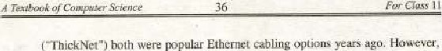

(

CSMA/CD (Carrier Sense Multiple AeceWC011ision Detection).' It is local area net-work •access method in which contention between two or Imre stations is resolved by collision detection. When two stations transniit at the Same time. (hey stop and signal a collision has occurred. Each then tries agavrt after wailing a predetermined time period- To avoid anotl•er collision, the stations involved each choose a random time interval to schedule the retransmission of the collided frame. To sure that the collision is recognized, Echernet requires that a station Inus: continue transmitting until me 50 microsecond has ended. If the station has less than bytes of data to send. then it must pad data hy adding zeros at 'he end. Used with Et hem-el.

CSMMCS (Carrier Sense Multiple Aecess,/Carrier Sense): A node listervs to the bus for a predetermined amount before transmitting and waits until the talking node has completed transmission.

CSMA/CR (Carrier Sense Multiple Access/Collision Rcsolu(ion); It allows multiple devices to talk at once, a determines which device receives priority.

Ring: In ring ne:lwork. every device has exactly two neighbors for conununie;ation purposes. All travel through -a ring ili the direction (effectively either •clockwise- or "counterclockwise"), A failure in any cable or device breaks Ille loop and can lake down 'be entire nelworkl Token passing scheme is used in this, topology, which has been discussed earlier,

Star: Many home networks use the star topology. A star network features a central connection point called a "huh" that may be an actual hub or a suitch, Devices typically connect to the huh with Unshielded Twisted Pair (UTP) Ethernet. Compared to the bus topology. a star network generally requ1Tes cable; hul a failure in any star network cable will only down one computer's network access and not the entire LAN If the hub fails, Fwwever, the entire network fails.

Tree Tree topologies integrate multiple star topologies together onto a busr In its simplest form. only hub dcvic'cs Connect directly to-the tree bus, and each hub functions as the "root" of a. tree of devices. This ms.tstar hybrid approach supports future expandability of the network much better man a bus (limited in the number of devices due to the broadcast traffic it generates) or a star (limited by the number of hub PONS) alone.

Mesh: Mesh topologies involve the coneepl of routes, Unlike -each of the previous topologies. messages sent on a mesh network can rake any of several possible paths from source to destination. (Recall that in a ring, although two cable paths exist, rnessages can only travel in onc direetion.) Somc WANs. like the [nteruct, cmploy mesh muting, A mesh oners sever-a* advantages over other network toÄüvies„

* Mesh network has high taut Dlerance due to nulltiplé links.
* Due to nuJlIiple linksuesh network can work fine even under severe loads,
* Troubleshooting of mesh oetwork is easy ' as compared to other networks, [f data is communicated then it rv»cans (hat thcrc is sunw fault ill' dircct links bctwccn them.

Disadvantages include the difficulty of installation and 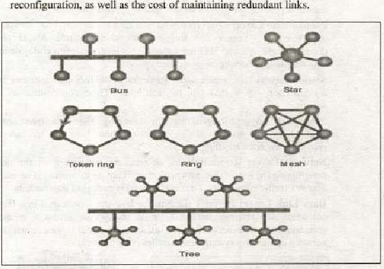reconfiguration. as well as the cosi maintaining redundant links.

###### 2.6-5 Open Systems Interconnection (OSI) Model

The Open Systerry; Interconnection (OSI) nu»del began as a reference n-ndeL but has since been implemented, It was created by the International Organization for Standardization (150) to provide d logical framework for how data processes shouki interact across networks. Standards were created for the computer industry allowing different networks to work together efficiently.

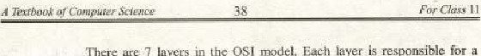There are layers in thc OSI IT10deL Each layer is responsible for a particular aspect of data communication. For exarnple, one layer may be responsible for establishing connections between devices, while another layer may be rcsponsible for checking during transfer.

The layers of the OSI rnodel are divided into gmupq: the upper layer and lower layer. "ppcr layers focus on and how files are represented on the prior Co transport. For the part, network engineers are tilore concerned With the lower layers. It's the lower layers that concentrate on how the communication across a network

Application IAer•. Provides network sen•ices to user applieations. is responsible  information between programs running on the machine, such as an c•mail prograjn, and services running on a network. such a print server or another CornPiitefSi applieatiom.

Presentation Layert Concerned with how data is converted and formatted lor data transfer, F*amples of format conversions include ASCII text for documents and epif and JPG for images, This layer code conversion, data compression find encryption

Session Layer; Determines how two devices establish, maintain and manage a connection - how they talk to each othee- These connections are called sess Ions.

Transport Layer: Responsible for breaking the data into segnrnts, establishing an -end-to-end logicgl eonnection between l•nachines, and pro viding for error handling.

Network Layer: Responsible for determining addressing on the network, deäermininp routes that information Will take on its journey, atid managing retwork traffic congestion. Dataat this level is packaged into packets.

Data Link Layer: Provides the link for how data, packaged into is communicated through hardware to be transported across a medium. It communicates with network cards, uiSn*gcs, physical layer communications bcåwecn  systems and handles error notLfiealiOri ,

|  |  |  |
| --- | --- | --- |
| |  | | --- | | Physical Layer: Specifies how data is processed inle bigs and L pllysienlty transfewed over medium. 'ais cables. It's resporsible for- activating and ining the link  ' between.sy seems. | |  |

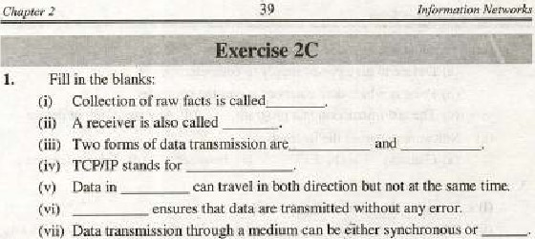Wii) Data traLiS1nission

(viii) WAN stand for_, is a microwave station placed iu outer,space.

used as adevice used for interconnecting different types of networks together.



router

(x)

1. Choose the correct o ption;
   1. A LAN is af
      1. Network adapter cards (b) LAN cables

 (c) LAN application software (d) All of above

* 1. What of OSI nudel does data compression

 Network Presegtation (e) Data Link (d) Pf$sieai

* 1. Cabling on a linear topology can be extetided using which of following."
     1. Terminator (bi Barrel connector

(e) Network adapter card Cd) Medium attachment (iv) The Media Access Control sub lgyer resides in which layer ?

Cai Physical (b) Datalink (c) Network Cd) Transport 

FDD1isa

(a) Ring network (b) Stat network (c) Mesh Cd) Busnetwork (yi) How many pairs of computers can simultaneously conununicate on Ethernet LAN?

Cd) Multiple computers connected to H hub conwu:er is H



Wii)

One

or

(a) Ring network (b) Node (c) Informat ion tility (d) Star network

(viii) Project 802 defines standards for which layers of the OSI model?'

(a) Application and presentation layers [b) Physlcal and Data Link layers

Transport and Network layers (d) Network and Data I i layers



(ix) Terminal is a

* + 1. Device to give power supply to computer
    2. Point at which data enters or leavesihe computer

Cc) last instruction in a program (d) Any input/output device (x) Software to peruse intcrnct

(a) Gateway (b) EFF Browser (d) Teleconferencing

1. Write T for true and F for false statement:

E-mail i: short for electronic mail-

Teleprocessing allows a user to m.±e queries of e computer 000 miles away (iij) An Ethernet system (IEEE 8023 protocol) uses packet switching technique,  ISDN dems Can only with Other ISDN rrndems.

 16 bit and 32 bit are eurrently the two rrnst pnpular bus width,

 FTP, short for File Transfer Protocol is tool that lets transfer files across the internet.

(vii) DSL m uses the cable TV network for data transmission.

(Viii) A WAN is usually limited to onc officc building.

* 1. A gateway connects similar co
  2. A bus network uses a central computer as the server.

1. What is the difference between LAN and WAN?

 What method does an Ethernet network use to control aw-ess to the network?

6. What is Tgpology! Describe the tyT±s of topology, 7: What is •svww

8. Describe the OSI Mode] and types Of layers of OSTModel.

Difference between Intranet and Extranet,

 Difference iktween FTP anu HTTP„ 11. Define the gateway and tOiiter.

12. Define the term 'Operating Systenff in your awn words?

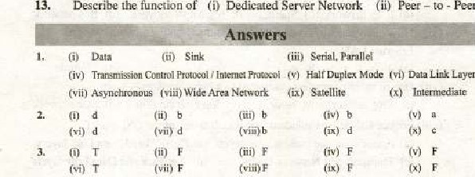

Describe

the

function

Dedicated

Server

Network

(ii)

Peer

to

-

Peer

C,hpler  De.üu Comm.uucurrons

|  |
| --- |
| CHAPTER 3 |

pat.

### Overview

In this chapter, we will describe how we haye arrived at this electronic globål village, Computers, telephones, and wireless devices are being linked by nelwork everywhere in the world of connectivity. We arc rapidly coming into an era in which we can find anyttung we want and reach anywhere,

When we collaborate. we are sharing information. This sharing can local or remote. Bet•æeen individual, local communication usually occurs face to face, While remote communication takes placc over distanve, Data exchange of data two devices via some form of Transmission media such as a wire cible. In other words. we can say thal transfer of inforuution or data from one location 10 another is called Data Communications. The term data •unmunication can generally be defined the movement of encoded information by means Of electrical transmission systems from ane xomputer device to other computer device through communicalwn channels (such as cables, wireless media etc).



is

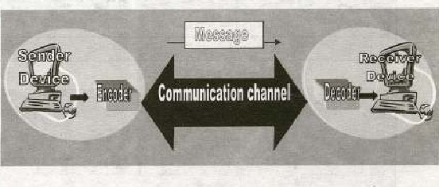

Figure 3.1 : Five different components of Data Communication System,

### Component of Data Communication

There are five CO luponcnts (sce Figure 3, l) in data communication,

* Message: The message is the information (data) to be communicated. It can consist of text. number. pielures_ sound, video 0T any combination of these,
* Sender, The sender is the device that the datar It can be computer, "'01kstati011. tclcphonc. video camera and so ow
* Receiyer: The receiver is the device that receives the data. It- can IR computer. workstülion, telephone. television and so on,
* Communication Channel: The Communication channel is the Physical path by which a data travels from sender to receiver. It can be El twisted pair wire. coaxial cable, fibeJ optic cable, or etc.
* Encoder and Decoder: The encoder converts digital to a form, .which can pass through transmission nkdium and dccoder again coverts signal from encoded form into digital form which is understandable for receiver. Wilhoul these, two devices unay LR eonneeted but tot communicating. such as a student speaking Urdu cannot understand a student who speaks only German without a translarar.

#### 3.2 Signals

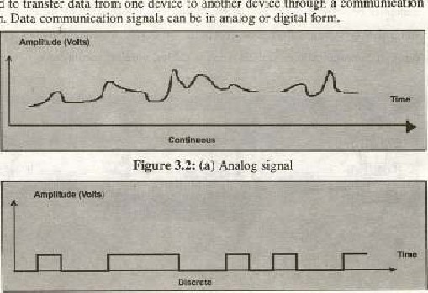

The

electromagnetic

or

light

waves

representing

data

are

called

signals.

These

are

used

to

transfer

data

from

one

device

to

another

device

through

communication

medium.

Figure

3.2:

(b)

Digital

signal

* Analog: The analogue data signals are continuous electrical signal in the form of wave. This wave is cal!ed a carrier wave. Tw•o characteristics of analogue carrier waves that re altered are frequency and amplitude (figure 3.2.a), Frequency is the number of times wave repeats during St*eifie time interval Amplitude is the height gvvcn period of tinw



* Digital; A digital signal uses on-off eleclrical pulses in discontinuous. or discrete form. Most, computers are -digital in nature, represent data as  patterns of binary numbers (Figure 3.2,b).

## 3.3 TypeofData

Data can IY represented in different Ways Stich in data communication, numbers, images, audio, and video etc.

* Text; The text consists of words. sentences. and paragraphs. Text processing refers to the ability to manipulate words, lines, and pages. Typically, the text refers 10 text stored ASCII codes that ise without any fonnatting. Objects that are not text include graphics. numbers and program code.

Numeric dat* Consist of digits from O to g, +(positive) Of — (negativcsj sign and a decimal point .11 can bc integer type or rcal type



Chapley

3

* Irnage: This type of dala includes chart. graph. pictures and freehand drawings. The information in this form more comprehensive. The data are sent as contiguous hits, which, for transfer, are packed into the 8-bit transfer bytes. The receiving site must smote the data as contiguous bits,
* Audio: Sound is representation of audio. It is eonverted into digital code by sampling the sound waves 44.056 times per second and converting each sample into a 16- bit number.

Video: Video can be produced either as a continuous entity Chy carnera), it can be a combination of images, each a discrete entity, arrange to convey the idea or Video creates action and movements.

### 3.3.1 Data Representation

The computer works With binary numbers, binary "Eans i wo digits. Thew are O and l. An electrical pulse inside the computer represents each binary I i' represented by pulse of electrical inside lhc computer and O by an absence or a pulse- Each Binary digit is called bit and it is the smallest element of data.

### 3.4 Encoding of Data

The computer works with binary digits only- Therefore. an data, numeric or non-numeric, be converted into binary digits before the computer can understand it, Computers transmit data in the of binary codes. Both sender and receiver of the data should have saniC standard rules for hoth to understand it.

A coding scheme for communications is a binary systenV that is used in the computer systen:rs. The system consists of groups of bits (O Of l) that represent characters. Some codes use different number of bits such as 5, 7, 8 or 9 to represent that during data communication. The following are some coding schemes to represen data,

 BCD Code: (Binary Coded Decimal) is 4 bits code. A few early computer s processed BCD numbers but were slower and rnore complicated than a rnodern computer, which are able to processalphanumeric (alphabet letters, nurllbzr•s and other symbols).

 EBCDIC Code; Extended Binary Coded Decimal Interchange Code is an 8 — bit code primarily used by International Business Machine (IBM). This type is intended for efficient transfer between hosts. which use EBCDIC foe their internal character representation. For transmission, tiu± data are represented as 8.bit EBCDIC characters. The character code is the only difference between the functional specifieatiorß of EBCDIC and

#### ASCU

ASCII Code: ASCII (American Standard Code for Inforrngtion Interchange) is a 7.bit code and makes 128 character combinaIion5. whereas an 8.bii can make 256 combinations, It Was developed by Anrricatv National Standards Institute (ANSI) and can handle alphanumeric data. It is inicnded primarily for the transfer of text files. except when hoth hosts would find the EBCDIC type mere gonvenientv

 Unicode: Universal Code is a 16-bit code and ean represent up to 65,536  symboLs. Unicode has slartcd to replace ASCII "1.1 levels. It supports a completwnsive set of mathematical and technical sytnbols to simplify scientific information With the UTF-8 (Unicode Transformation Format8) encoding, Unicode can be used in a convcnient and backwards compatible way in envimnments thal were designed entirely arourd ASCII.

### 3.5 Modes or Data Communication

When a person is giving a lecture ar speech. information is primarily conveyed in one direction. During a conversation spoken messages (information) arc usually exchanged in directions. These messages are normally exchanged alternately but. can of course, are exchanged simultaneously! Similarly. when data is transmitted between two pieces of equipment. three types of data uansnui,ssioil modes can be used-

Simplex; Sirnplex is a mode in which data flows in one direction only (Figure 3. S). Because trwst ltwdem communication systems require a twoWay interchange of data. this Of transmission is not as J»pular as it onee was. Hdwever, one current usage of simplex communications in business involves certain point-of-sale terminals in which sales data is entered without reply other examples include radio and T. V transmissions.

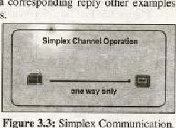

corresponding

Figure

3.3:

Sin-plex

ionv

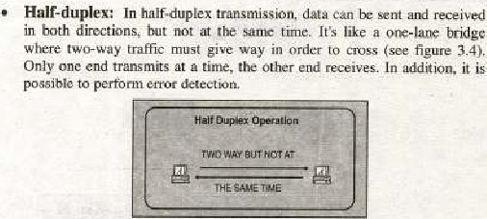

Figure 3.4: Half duplex communication

and request the sender 10 retransmit information that arrived corrupted- some aspects, you can think of Internet surfing as being half-duplex, as a user issues a request for a web document. then that document is downloaded and displayed before the user issues another request e.gwalkle talkie etc. 

Duplex: The directional mode of cunmunication is full-duplex. Here, data is transmitted in both dircx:tions simultaneously on the

 (see figure 3.5). Thus, this type of communication can be tbougbe

Of i,' similar to auton»hilc traffic on a twcvlane road.

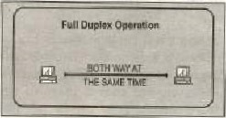

Figure 3.S: Full Duplex atiOri

Full-duplex communication is made possible by devices caned multiplexers, Full-duplex cornmunicaLiøn is primarily limited to  computers because of the expensive hardware required to support this bi-directionül mode e.g. celephgue system-

#### 3.6 Types of Data Transmission

There types of data transmission modes - (see figure 3.6.) parallel transmission and serial transmission.



ofCourpurer

|  |  |
| --- | --- |
|  | Tumissiom |

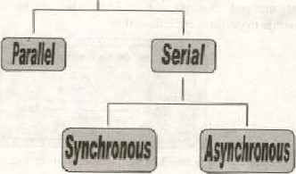

Figure 3.6: Data Transmission

* Parallel Transmission: par-aliel data transmission involves concurrent flow of bits of data through separate communications lines (see figure 3,7). This pattern rcsernb}es the flow automobile traffic an a multilane highway, Internal transfer of binary data in computer uses a parallel mode. If the computer uses a 32-bil internal Structure, all the 32 hits of data are transferred simultaneously on 32 lane connections. parallel dala transmission is commonly far 'interactions between a  and its printing unit. The printer usually located close to the cornputer, because parallel cables need (llany wires and may no! work stably in long distance.

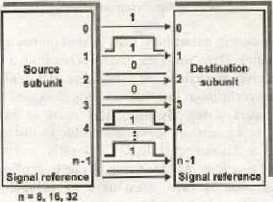

Figure 35: Parallel Transmission Mode

* Serial Data Transmission: dala transmitted over telephone lines use a serial patter-n. That is, each individual bil of information travels abng its Own path', the bits flow in a continuous stg-gam along the communications channel, This pattern is analogous Il-jc flow of traffic down a ane-lane residential street Gee lig 3.8). Serial transmission "is typically slower Than parallel transmission, data are scnt sequencia[ly in a bit-by-bit fashion. Another of classifying datacommunications flow is synchronous or asynchronous.



|  |  |  |  |  |  |  |
| --- | --- | --- | --- | --- | --- | --- |
|  |  |  |  |  |  | Destination |
|  | | | |  |
|  | | | |  |

referenco

Figure 3.8: Serial Transmission Mode

* Asynchronous Transmission: A type oy  that sends data flow n;uher than a clock to synchronize datu between source and desiipruliun, When asynchronous transmission (also called stari/stop transmissi010 is used. a special start signal is transmitted at the beginning of each group of bits. When is about

|  |  |  |  |  |  |  |  |  |
| --- | --- | --- | --- | --- | --- | --- | --- | --- |
|  |  | Stop | 2Sert |  | Step |  |  |  |

Figure 3.9 Asynchron«vs transmission uses sjæls surroundingcach Character

to be transmitted, a start bit is sent, A bit bas a value Oro. (also called a space stateh Thus, when the line switches from a value of 1 to a value of 0, receiver is alerted that a data character is about to come down the line, An asynchronous line that is idle is identified with a value of l, (also called mark grate). By using this value indicate that no data is currently being sent. the devices are able to distinguish twtween an idle slate and a disconnected line. Conversely. asynchronous transmission involves the sending and receiving of onc byte ofdata al a lime. This type of transmission is most often used by computers and other systems characterized by slow sireds;

* Synchronous Transmission.t A type 0/" lransmission that o clack to thc riming of bits being senl_ Large volumes of information can be transmitted at a single time with synchronous transmissionr This type of transmission involves simultaneous flow of several bytes Of data. Because a large block of-data scnt synchronously cannot be 



of

C.omp".rer

Sefemee

|  |  |  |  |  |  |  |  |  |  |  |  |
| --- | --- | --- | --- | --- | --- | --- | --- | --- | --- | --- | --- |
|  |  | Oit |  |  |  |  |  |  |  | cheek |  |
|  |

Transmission transmitted



3.9

Step characters_

interrupted, a synchronized clock is necessary to carefully schedule the transmission of information, This special communications equipment is expensive: but this can be Inade up in part by faster. less expensive transmission of information.

##### 3.6.1 Bandwidth

Each type of communications media has different transmission speed. The bandwidth is a measure of the transmission rate or communications ehannels.

* Baseband: Digital signals are commonly called baseband signals* Baseband is a communications technique in which digital signals are placed onto the transnussion line witlw"ut change in modulation. It transmits up a coupEc or miles, and does not require the complex modems. Typical Token Ring and Ethernet use baseband signalsv
* Broadband: Broadband is a technique for transmitting large anxlunts of data, voice and video Over long distances simultaneously by lwdulating each signal onto a different frequerwy. Using tip FEM (Frequency division multiplexing) technique, several streams Of data can be transmitted simultaneously,

Broadband is bandwidth used for direct communication between very high-speed computers large rnainfrarte co*ters). This bandwidth includes microwave, satellite, coaxial cable. and fiber-optic

media.

##### 3.62 Communication Media

For data to be transmitted from ore location to another, Soup of pathway or nxdium must bc used. These pathways are called communication channels. The communication channels ean be divided into two types Of a*dia.



Daz

Communieanons

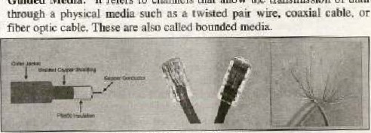

•

Guided

Media:

It

refers

to

eluannels

that

allow

'the

transmission

of

data

Figure 3.10: Twisted pair cables.



1. Pair: The telephone lines used to carry Of the voice atul data communications consist of a pair of thin-diameter insulated copper wires (called twisted parrs) see in fig 3.9, The wires are twisted around each Other to minimize interference from other twisted pairs in  cable. Twisted pairs have fewer bandwidths than coaxial cable or optical fiber. They have been the standard communication channels for data information. are mw diminishing trcause of reliable media such as coaxial cable, optÉal microwave, or

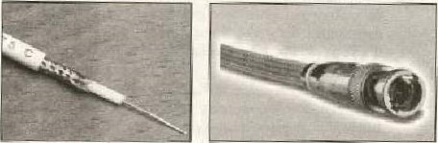

Figure 3.11: COaxia1 Cable

1. Coaxial Cable: Coaxial cable be used for telephone lines for trgnsmission at a high frequency. Coaxial cable consists of a single core of solid copper (see fig 3.10,), A coaxial cable can handle 80 times as many telephone transmissions as twisted pair media, Many computers in heal area networks are linked by coaxial cables. Because of its sturdiness. coaxial cable is used for telephone lines that must carried under water. Because coaxial cables have very litÄle distortion and ate less prune w interference, they have low error rales„

Coaxial cable contains from tour to tuicnty-two coaxial units called Each coaxial tube consists of a 0. IOD-inch copper inner conductor kept centered within a 0.375-inch cylindrical copper outer conductor by polyethylene insulating disks spaced at»ut I inch apart, Th.c outer conductor is formed into cylinder around (he disks and is held closed by interlocking serrated edges along its longitudinal seam. Two steel tapes are wound around the outcr conductor for added



A

In addition to coaxial tubes. coaxial cable contains small number of twisted wite pairs and single wires that Are used for maintenance and alarm irrumsrtant advantage coaxial cable has over paired cable is its capability to operate very high frequencies.. Coaxial, the unique operating environment dictates design, operational, and reliability requirements different from those for cable used on land.

1. FtbepOptie Cable: A fiber-optic cable -consists of tubes of glass thn•ugh which data are transmitted as pulses of lighte Optical fiber consists of thin glass fibers that can earry information at frequencies in  visible light svrctrnm and beyond. The typical optical fiber consists of a very narrow strand of glass called the core. Around the care is a concentric layer Of glass called the cladding. A typical core diarneter is 625 microns (l micron meters). Typically Cladding

has a diameter of 125 microns. Coating the cladding is a protective coating eonsi•ting of plastic, it is called the Jacket, 

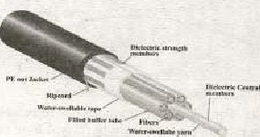

Figure 3.12; Fiber Optic Cables

An important characteristic of fiber optics is refraction. Refraction is the Characteristic of a material to either pass or reflect Light. When light passes through a medium, it "bends" as it passes from one medium to the other. An example of this is when we look into pond af water. Although  fiber• optic cable i' diametrically smaller than human hair, il has 26,000 times the transmission capacity of twisted pair media. A major advantage of fiber-optic rnedia is, its high level of security. These conununications channels are not susceptible to electronic interference. Therefore, arc a nwre reliable form of data tramsmission. Fiber-optic cublcs are also significan'ly expensive coaxial cable.

Unguided Media: It refers to- those channels that transmit data and information in the form of wave. Unguided transmission media consists of  means for data signals to travel but nothing to guide them along h specific path. The data signals are not bound to a cabling media and therefore often called ullboulld media. The atmosphere and the space arc exmnple of unguided media such as microwave. or satellite.

1, Microwa8e Microwave daga transmission differs from the previously mentioned 'communications channels in that data is transmitted through air instead of through cables or wires(see in fig 3.13). Microwaves are high-frequency radio waves that can only be directed in straight lines. Consequently,  transmission usually

. limited communications occurring within the limits of particular

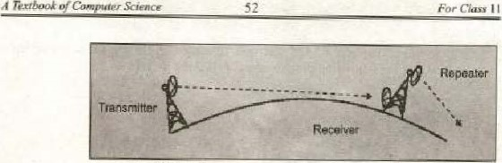

Figure 3.137 Microw aye Committiicatcon, city or community. For microwave transmissions to he able to occur over larger distances. data nessagex must be relayed from one location to another using antennas placed high altitudes usually twenty to thirty apart.

 Satellites: Lnstead of antennas, satellites can also be used to transfer microwave messages from one location to another. Satellites rotate approximately 23,300 miles above the carth in precise locations. Satellite transmission stations that can both send and receive messages are known as earth Stations. major advantage of satellite transmission is that large volumes 01 data can be communicated at once. A particular drawback is bad weather can severely affect the quality of gatellite transmisions. Another one is it has a scri0US security problem, because it is easy to intercept the transmission it travels thro ugh the a!r.

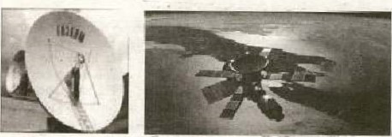

Figure 3.14: Satellite Communication.

Satellite Communications is the generic term for communicNion via satellite. Transmitting a signal from the earth station upto a satellite and then receiving that signal back at earth. The satellite does not have to a huge expensive array of electronies and solar panels, In 'he rman was used, in the early years of satellite communications research, .10 signals off- The time it took for our signals get to the moon and back about 2 seconds. This time is called

###### Chupter3 Daeu Commumratl.pns

satellite delay is Still present today in all Ott Satellite communications. This wide range broadcasting ability given rise to a nucltitudc of different satellites, carrying all kinds of information such as telephone television ['Iternet traffic military communications, weather data, and cvcn radio stations.

3, Mobile Communication; It is radio-based networks that transmit data to and from nubile. compu'er. Computer can be connected 10 network through wired ports or through wireless connections,

### 3.7 Modem

Modem (MOduEate/DEModulate) is a device that converts digital signals into Hnalog form Ca proces"s known AS nodulation) to send Over phone a  receiving at the Other cnd of phone line then converts t,be analog Signal back digital signal (4 pgocess known as demodulation)' It enables users ro Transmit data from one computer co anolhcr by using standard telephone lines instead of spacial communication li/)es such as fiber op'ic or cable. Telephone lines can carry analog singles (see figul* 3, IS).

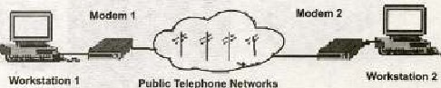Pub-lic Telepho Networks

Figure 3.15: Moderncommunicatlon

* Transmission Rate: It can IR described, as modems high-svEed or low speed to indicate how many bits per second a specific device is capable of transmitting or receiving,
* Speeds: The Specifie teehniquc€ used to encode the digital bits into analog signals are called modulation process- Tlw various modulation standards define the exact methods of encoding and the data transfer speed, The raw speed (the speed withoui data compression) of a Inodem is determined by the  standards, A 2400 bps modem with data compression can theoretically yield 9600 bps throughput is not a high-speed modem, High-speed Inodems are modems that feature rnodulation at 9600 bps and above (the speed at which in bits per second) higher.

#### 3.7.1 Types of Modems

In terms of physical size and shape n»derns can be divided into following categories:

*  modern is attached to the system unit an external device by meand of a telephone cable, It is connected to The telephone Val]



For

Class

1

1

Science

jack by another cable. The modem is a self contained unit which is  connected to the PC using a serial cable to the COMI or COM? port, Jt needs an external power supply, and is easy set up(see tigure3.16ra) 

* Internal Card; An internal is circuit board Ca modem card) that be added to thc system through an expansion Slot. Tha modem cannot be moved easily one PC toanotlb±f. is more difficult to sel up Than other types of nwdem(see figure3.16. b).
* Wireless Modems: Wifeless rnøderns transmit the data signals through the air instead of by using a cable(see  c). 'Tmey somcqimes are a radio-frequency nw•dem. This type oi TIOde1n is designed to work with cellular technology, and wireless local area networks.

Figure 3Ä6(e}:

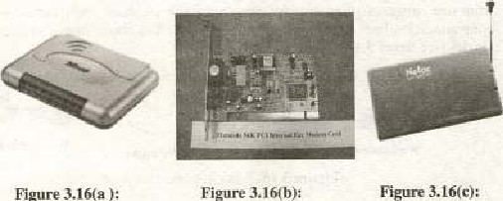

Figure

External MOdem Internal Modern Card Wireless Modem

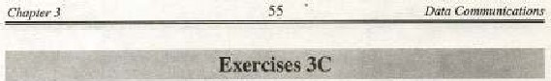

transmission. a stall bit and a stop biv frame a character

Date communication signals can be in

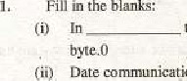

in

(iii) Modem is an electrical device that converts digital signal into analog signals, which is galled

(ivi The transmission involves the concurrent flow of bits Of data through separate communications lines, ASCII is bit (k) code

A television broadcast is an exampletrans mis sion.

(vii) In transmission data is uansmitted character by character,

Cviii} The data is transmitted in hoth directions simultaneously on the same channel—.

optic cable is better for very high speed, high. capacity data transmission thancable because Of the lack Of attenuation and the purity of the signal.

Tbe number of frequencies that Can fit link at one time is-

X Choose the correct option :

(i) Microwave transmission. coaxial cables and fiber optics are examples of.

(a) Modems 1b) Communication links

C') Getways (d) Ring network

(iij Data communication requires only a;



(a) Sender (b) Receiver

(c) Transmission Medium (d) All of the above

(iii)" BIT stands for

 (a) Binary Integer (b) Binary digit

(c) Binary intcrval- (d) None of the above.

Communication between a computer and a keyboard involves_

|  |  |  |  |  |  |  |  |
| --- | --- | --- | --- | --- | --- | --- | --- |
| |  |  | | --- | --- | | transmission. |  | | (a) Simplex | (b) Half-duplex | | (e) Full-duplex | (d) Autarnatie | |  |



is the physical path over which amessage travels,



The

(a) protocol Medium

 Single (d) All the above

3. Wrile T for true *n.d F for fålse statement

O) An internal n»dem ig a circuit board that can added to the system unit of computer.

 In full transmission, the channel capacity is shared by both communicating devices at all time.

cable consists Of tubes Of glass through which data are transmitted as pulses of light.



A

Normally, modem transmission is asynchronous.

 Transmission of signals across communication medium is called signaling. The voice channel bandwidth Of 0-233 kHz.

(Vii ) Synchronous transmission is much faster [Bynchronous-

4, What is data communication? Define the basic component of communication network.

5, Define the Ir.odem and its I ypeSL

6, Differentiate ween ynchro mous and Synchronous7, Briefly explain the various communication 

8, Define the Modenu

1. What is bandwidth' Explain bandwidth briefly,
2. Differenliate bei wen guided media and unguided media.

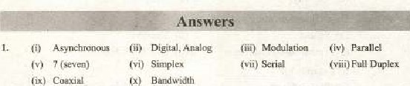

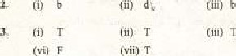



4

C.'tap'eg•

Uses

o/

Computers

|  |
| --- |
| CHAPTER 4 |

Applications and uses Computer

### Overview

The computer technology is vital for every functional area of an organization and IT systems integral to every functional area. In finance and accounting, for example, such systcrus to forecast revenues and business activity' determine the best sources and uses of funds. manage cash other financiÄl resources, analyze investments. and perform audits to ensurelhat the organization is fundamentally sound and that all financial reports and documents are accurate, At home, computers can help us to shop, determine our bank balance and pay hills, At work place. computer skills are needed for success in almost every occupational area. For businesses, with 'oclayrs increased competition and global markets, it is almost impossible for an organization to stay competitive without the widespjea.d use of computer technology, Another advantage Of Computer technology on working practices is the move towards the paperless office in which all data is held in computer files and there is no hard copy at all, The typical traditional office with filing cabinets full Of files, trays ordocuments and correspondence awaiting or baying received attentions desktops strewn with sea of paper would be a thing of the past- An empty desk with telephone and computer tcrmjnal would all thatum required. The writer does not helieye that It'Hny. if any. organizations have actually achieved this but it's supposed to be the coming thing. In the field of education, teaching and learning are being profoundly influenced by the possibilities introduced by computer technology-

Significant changes have also taken place the impact of interactive technology web-cams, video conferencing and so on. Not so long ago if it was necessary to talk with group of clients the only way to do it was either to an-ange a meeting that all of them could attend (always d tough thing to do) dt a reasonably central venue towhichevery body had to trave I too far, travel there (perhaps involving an overnight stay) and confer, or to hold series of telephone conversations with each one individually and keep Oji getting hack to thci:n until tbc matter was settled to everybody's satisfaction Now. through the Internet and web cams a video conference be get up Which everybody can takc part without leaving their own office, This doesn't even take into account the overall impact of the Internet on the information levelsavailabl e to busines ses. The following are some ofthe major applications



rex,'booe

### 4.1 Uses or Computers in different Fields

Our daily encounters with and dependence upon technology is almost invisible as it the Shape Of electronic climate control sysiern.s, wireless communication sysqem.s such as phones and pagers, automatic tellers to dispense money, Inagnelically striped cards to fatililate consumer •ransaetions, cable and



satellite television, and automobiles and mass transit. Free trade agreements have to gböhalization of commerce and increased competitiveness in labor markets. Wc listen to political end scientific deh•al: about global warming arid the effect of OUT IWdern use of fossil fuels, nuclear weapons, chemical contamination food and water supplies. the past several decades wc gone from space exploraJion to. space coloni%ülion_ intelligent machines. and virtual reaEity that lead us into the nc*t millennium. The jobs of (he future may not even exist today, Let us see the use of computer technology in our daily life. 4:1.1 Business



and

The Businesses must understand and adapt in the new source of competitive advantage by  to the core competencies and customer interaction on global scale, global market place. the global business world.

-global interaction is ','ery important. In •every organization thege are major business processes thal provide critical task* that eustc_iftær analyzing sales of various products in different locations etc. In business computers arc used as given below-

Marketingi Marketing applicatioos provide information about the organizatton's products, its distribution system, its advertiéing and personal selling activities, and its priCing strategies. Marketing applications help managers deu=lop strategies that combine the four major elements of marketing: Product, Promotion, Place, and Price,

* Stqxk Exchanges: Stock markets around the are in transition. On some trading floors, paper is disappearing. In fact, the trading floor itself is disappearing in. some places because many scock markets lunched the computerized system that makes it possible for stockbrokers to do their trading electronically. Brokers inlereonnee(ed through a data communications network suhmit and receive bids using their computer workstations or interconnected computer display screens. where brokers match buyers wiqh selleg-s, so that neither tratding floor nor slips of paper are necessary.



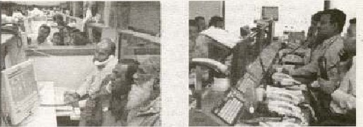

Figure 4.1 : (VÉe of computer ill q Ock exchange rrwarket)

* Banks: Computeeüed banking have provided several benefits such as  the time and eon Vcliienc•e for customer. Intcmational banking and thc abilities to handle trading io multiple currencies are criiical fov tv-a-dev The eheques by MICR (Magnetic Character R cadcr, devk:c used to allow the data on cheques to be read by machines) see iil fig 4L2_ Bank use mainframe computer to maintain their by transaction generated as result of withdrawals and dem»its. Some banks acc used to opcratc• [Wtwork of ATMs Teller Machine) see in figure some

C.gn bé done a credit card

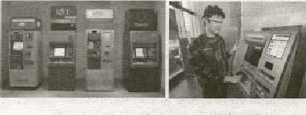

Figure 4.2: ATM Figure4.3: Automated Teller MåehinesßATM) and usage of maehine

Departmental Store: peopjc at ihc starc 'excl, cashiers cntcr sales data into sale terminals by waving a code scanner across package's bar. coded prices *lid numbers_ Bar codes are read by bar -code readers, photoelectric scanners that translate ihc bar code into digital form; in figure 4_4)_ The price of particular item isset within the store's computer appears on the sales-clerk's point of sale terminal

A Textbook For C/a" I I



ten

and on our receipt, Store and departtnejit manager who received report Of store and deparuncnt sale' and inventory' levels are indirect end users. Record of sales are input to the store's computer and used for accounting, restocking sto:re Inventory, and weeding out products that sell well A -Security VCR (video cassette recorder) is widely used in departn%11L stores and other localioréi where aesthctics ure priority. It is virtually impossible to te[l where the camera is pointed. which makes it difficult for woubd-& camera avoiders to stay out 01 the camera's view range', that are equipped with a camera, and lens can be augmented with dummy camerasVCRs use the tapes, hook up the seme way and have all of the standard features-oi today's consumer VCRs, Most imponantiy„ they are just as



easy to use. Security cameras are everywhere these day and the reason is quite clear: there is simply better way to monitor horne or husiness operations and ensure safety, NO" computer hard disk has took place of VCR

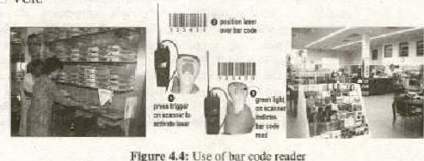

Figure

Use

or

bar

code

reader

• Omce Automation: Office Autoanntion (OA) refers to the toward automating office tasks. An office where workers performs different tasks. Thc management and administrative tasks perfortned in an office- five general categories of activities like decision:making. data manipulation. document handling, eornmunieation. and storage. Many offices have used advance computer technologies to perform various tasks in an affice system such as document n-nnagemgnt system, messagehandling sysmem, and office support systems.

L Document Management Systons (DMS): DMS include word processing. desk;op  reprographic, imagc processing, and archival storage applications, Word processing enable documents created and edited electronically as well as help (o produce high quality memos, letters, pmposals. reports, newsletters and brochures etc„ which are used to send business community. Desktop publishing enables to make documents in attractive form by the of photos, artwork. graphical illustralions ete. Spreadsheet is software package



used to create d table of columns and rows used by people responsible for tracking revenues. expemses, pmfits, loses, statistical, mathematical logical procesing etc. Reprographics is the process of repmducing multiple copies of a document, Image processing allow document to be scanned and storcd image oriented databases.

2, Message-handling systems: It enables to send n%ssåges or documents from one location to other location through facsimile (fax)€ electronic mail Voice Mail etc'.

3. om.ee Support Syste•lns enable: It to coordinate -and nunage the  activities of work group. Groupware and desktop organizers are some examples of office support systems.

#### 4.1.2 E-cogamerce

 E-comrnerce (electronic conuperce) desccilxs the buying, selling. and exchanging of products. services, and information via computer network. The term e-commerce as describe transactions. conducted between business partners. There are many applicalion e-commerce, such as borne banking, shopping in eFectn»nie malls, buying stocks, finding a job, conducting an auction, collaborating electronically with business partners around the marketing & advertising and providing Customer service. There are several types of e-commerce like collaborative commerce, Business to commeree, consumer to consumer. and Mabile- commerce etc, Mobile satellite cxjmniunichtioti" promise to extend the global reach of voice. data and other services. The following services of e-eonuneree are used frequently ine -business.

* Electronic Mail (FAnail): The e-mail is a service that transports text messages from a sender to one or more receivers via computer. Voice nuil Systems capture. store. and transmit spoken messages,
* Video conferencing; Video conferencing is a type of confere neing in which video cameras and microphones capture Sight and sound transmission over networks, It ig a advsnce form of teleconferencing. Videoconferencing should provide complete simulation Of nortnal meeting environment. enabling both parties see; present material, just as if they were in the same room, [t can speed up business process and procedures in the same way that the fax the e-mail have revolutionized the way we share information. Tangible benefits most easily related 'to actual cost savings. The most obvious quantifiable saving is the cost of travel and the eosc of the time wasted during travel,

Video Conferencing actual cost saving  niecting "i different places

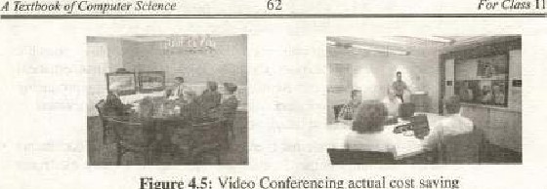

62

Figure

 Electronic-shopping (E-shoppingi: Many business now have sve%site that allow Internet users to buy their goods or services, Shopping can take place using a computer at from work or at a phone and

e.shop he any.vhel'e in the world working 24 hours a day.

Eleeironie Banking: An electronic 8anking is also known as cyberbanking or online includes various banking activities conducted from hone, a business, or on the road instead of a ph»ieal bank location,

#### 4.1.3 Industry

Computers are used to manufacturing system and continuous running of the These are also help in Inonitoring pressure. and also check qualJty and accuracy. mensurement nccdcd in the manu facturin g process, e Robots: A robot is ali automatic programmable machine that nwvcs and performs mechanical tasks (see Fig 4.6.}. Robots arc uscd in hundreds of applications from assembling spray-painting cars, carrying out maimer,ance on overhead power cables. w testing blood samples. outer space experimental programs. in artificial sauellites. and radwactivc environn•.ents etc. Robots work in environment are hazardous to 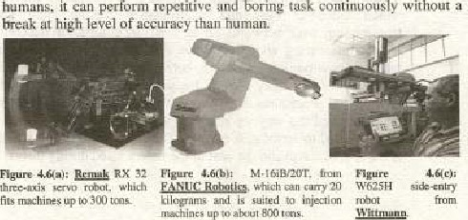without a

##### 4.144 Computer Aided Design (CAD) & Computer•Aided Manufacture (CAM)

CAD are used for display designs and build production prototypes ill software. less: as a computer ohjeet acurding 10 following given parameters.

* Compile pacts and quantities li Sts.
* Outline production and assembly procedures
* Transmit 'he final design directly to machines,

CAD has many different applications scnue at them like designing new ear or aircraft, bridge and building. Making changes to a design requires a large numbex 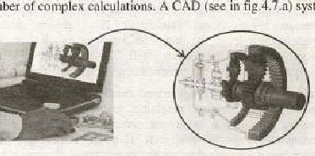ofco A CAD (see in fig.4.1ea) system needs



Compu

Figure 4.7(A): Using ofComputer Figure 4.7/b}: Computer Aided Design

Aided Design software (CAI)), (CAD)

a high-resolution monitors, input devices {such rnause, graphic  tables, and scanners etc.), and output devices (such as printers and plotters). CAD (see in fig 4.7.b) use often has the capability -of displaying a three— dimensional object and speedil)' rotating it in any direclian using controls on the ke



Computer. Aided manufacture (CAM) is used to cont:ml all the part of a manufacturing process- CAM sotiware uses digital dcsign output, such as that from a CAD system, to directly control production machinery. CAM  ' systems are manufactured following goods.

 • Ploduct can b: madc very accurately and istently

* Around Clock productiOn is mu ch
* A product's design can be modified without the need of bringing production10 a computer standstill.

##### 4.1,5 Simulations

A computer simulation is a special type of computer which recreates system that might exist outside the Computer. Simulations are

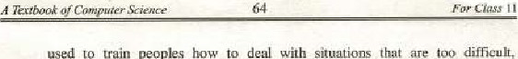

too

used

to

train

peoples

to

deal

with

situations

that

are

expensive or dangerous to recreate and practice for real. For example a night simulation. which is used to train. pilots how to deal with situa:ion that would he expensive and dangemus to praetiee using a real aircraft A flight simulator consists of a working replica of the flight deek of an airplane

###### 4.1.6 Medical

The computers are eomrnonly used in some area of medical fields such as laboratories, researches, scanning, monitoring. pharmacy etc.. which are helping the doctor tn diagnose an illness,

Patient Monitoring: Computers are used in hospitals monitoring critically ill patients in intensive care units. The patients have sensors attached to them, which detect changes in heart rate. pulse rate, blood pressure, breathing and brain activity If any reading dislocates or reaches misbalancing bevel, the computer activates an alarming device to create sound and alerts the staff. The data is also logged and used to gnalyze•the changes in patient'S condition Civet' a period oftime.

* Patient Reeords: Computerized databases are used to store information about patients, doeters, medicines and other ehemieals and equipments. Storing information in proper order to provide rlrc conycnicnt way of arrangements far hospital staff. It makes easy to organize records than paper-based records that are not constantly following patients ground the hospitaL For example if a patient is admitted in one ward but being seen by a consultant and rcceiving in other parts the hospital; their details can be vicwcd and updaced any in hospital's LAN

The computerized databases are used to help match patients who are waiting for organ transplants such as a kidney, liver or heart with suitable organs from donors.

* Diagnosis: It will con* as no sunrise that hospitals and clinics use computers to keep  generate invoice, of

Computeg ig to gean the body Of the patient. A Seattnef sends electromagnetic rays through a patient's body sensors detect that much patient's body have affected to any type of cancer. Actually the body scamxr helps doctor treat any type or cancers. For example, the CAT scanner passes rays over the patient', it displays an image that enables physicians to look beneath the pa'ienc's skin. As the scanner passes over the patient, it displays an image of and tissue structure on a computer screen (see figure 47).

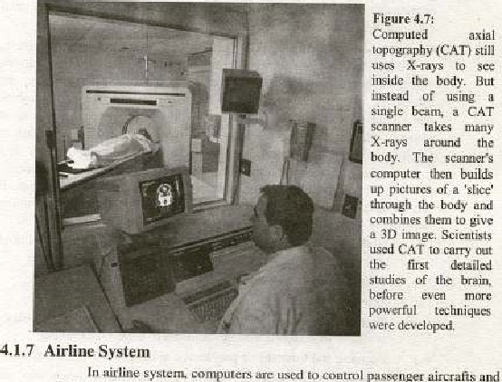axial y (CAT) sec

scanners bu.llds

passenger a.ircxaii:. vehicles. Early a.iRraft Were controlled by moving pa.rts attached to the controls using cables. nu}dern_ ny- Oy .wire system, cecctronic singles from the cockpit are sent to that adjusts the flight surfaces. Computcr is embedded in the or driver's controls. It is linked up among different cities and gives full information about its 2iight and scat reservation.



Chaplev•

4

Uses

###### 4.1.8 Education

Computers in many colleges to pmvide the n*thods of teaching in different ways. The computer eduealion is very familiar and rapidly ijiCr-easing the graph of eompuier students, There number of methods in which educational institutions use computer to educate the students, Many computer-based educational programs software are available, which studcnts can learn to lead* to count. or 10. speak foreign language. Software that combines the Ehrills of games with real information is becoming uwre popular; Some organiRations are using information technology in their employee training programs.

Computer Aided Learning (CAL): Computer Aided Learning {CAL) could IR described as the use of inlOrma1ion technology to assist in the  teaching and enhance learning process, Information Technology may be to aid us in reducing the time on creation and maintenance Of



teaching materialg (one document' for lecture materials./ref•e/vnce noteststudy aids), is reducing administrative load associaqed with teaching and research,

• Computer-Based Training (CBD: CBT or Computer Based Training is a dcf%cult term to adequately define because it encompasses various modes of instruction and has evolved from the silinplest definition, interactive I gurniug experience befieeen the learner cornptier in which  compu!er provideS Ike ruriority of tire stimulus, the learner must respo"d, and' and provides feedback to the learner. Computer-Based Training is about using computers to l•.elp train people. It is nol necessarily about training people to use compulers. Computer based training works. compured with traditional techniques; it can bring many additional benefits any organization. their training  and their Students, For example:

Students eun readily acquire skills at their own pace 'and at times that do not conflict with their uork schedules: 

Training tirnes can usually be rcducéd„

(iii) Retention of course is usually greater.

Civ„) Interactive, visually stimulating, easily absorbed and easily available material encourages students to undertake training,

 Planning tinytabting problems can reduced eliminated-

(vii Essential &ills can taught and refreshed whenever and -wherever needed.

Wii) The quality and consistency of the training material is maint•ined throughout.

 [t: is a hig$ly cost-effective way to train large nurntrr of students, locally or at remote places, 

 Tim.cly and high-quality training on demand leads to increased efficienCy.

Compared to traditional classroom training methods, students using Computer-based training absorb similar material faster and retain more of the information they are taught

##### Weather Forecasting

Computer based weather foxeeasting depends on accurate collection of data from Weather stations, airports, satellites, different Sensitive devices (which are situated on huge lowers and buildings etv.) all around the world. Computer depends on building a model of hot, cold air, dry and humid air interaction, and how these interactions are affected by land sea temperature, season and so on, Once this is done, the data is collected on atmospheric phenomena over a region. The computer n»del then generates forecast of how the air will change. The necessary parameters can never be measured with total accuracy and it is impossible to make a perfect representation of all the factors that affect weatherv Same hosinesses. however, are so dependent on the weather that they need constantly updated information- SPARCO Weather forecxgtine department offer analysis oflive weather data; and pmvide help to make business decisions based on weather foreeasling.

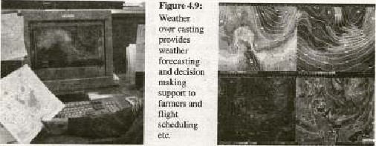

###### 4.1.10 Home

Nowadays many people have computers at honr and it has bccorne a electrical home appliance used in home. Childlen play games, keep track ofthe stamp collections, draw pictures, play view 'Twyies and do some sort of reading and writing according their needs. A typical domestic system consists a PC with a relatively small hard disk ; printer, modem and CD-ROM drive etc. People can ucilize computers for keeping records, making home budgets, using electronic mail and Internet services [earn and increase their knowledge- The uses of nicroprocesor Lecllnolagy in manufacturing of electronic horne appliances like n:ucrowavc, air-conditioning, washing machine, Sewing machine ete, have eomplcicly changed of lifer

#### 4.2 Computer Assistance simplifying our work practices

Mostly people think computer have a brain and can think and decide what to do, this is not true they are primarily machines. whereas the reai thinking is done by Evings who feed computers with information and program them to perform different operationsn There are many reasons for using computers and of these are listed 

1. Computers can work much faster than hurnanes work.
2. Camputecs never get tired or need a rest.
3. Computers can do jobs that it would dangerous for a human do. Computers cag siorc läxge amount of information.
4. Computers can retrieve information very quickly,
5. Computers never lose ormisplace information-

Computers linked through communications systems offer major personal and business to users like speed, consistency, precision, and reliability etc.

* Speed: Computer can perform calculations or process at very high speed in a fraction -of second like nano Seeund or even pico second_ Computer can perform complex calculations, recall stared information, transmit information from one location to another and move øbjccts around a computcr screen almost instantaneously,
* Corwistency: people often h8ve difficulty repeating their actions tly. Indeed, doing somelhing once is not neatly as difficult as doing it the same way, and with the same result repeatedly.



.'i

Computer excels at repeating actions consistently- Whether using a checker built into a word pmeessor or playing nmlrimedia animation for training purposes, a computer will carry out thc activity the same way every Lime.

* Precision: [n additioh to being fast and consistent, computers are extremely precise. They can detect minute differences t.lut people cannot see. [n manufacturing an automobile. for example, the prccise placement of a part as directed by a computer, may make the difference bctween long use and early wear. Computers excel in tnanaging the smallest differences in being precise.
* Reliability: With speed consistency, and precision come reliability. *'hen we know that the procedure be followed rapidly, consistently, and precisely. we can expect reliability of result i.e we can depend on getting the same result again and again with any

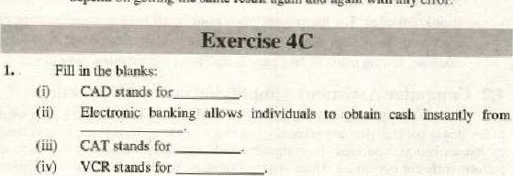

error,

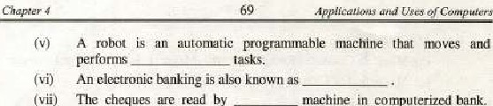

The

cheques

read

by

in

eotnputerized

(viii) Theis a type of conferencing in which video c anwras and microphones capture sight and sound transmission o ver netw orks. 

and manage the activities  of



Office

Support

Systems

to

FAX

1. Choose the correct option.

(i) CET stands for:

* + 1. Computer Based Trade (b) Cornputer Based Training (c) Certificate Based Training (d) None of the (ii) The benefit of CAD may be summed up as:

 Accuracy (b) Repeatability,

(c) Speed and flexibility of production ATI of the above,

(iii) Computcr at hour can bc uscå

{a) Keeping records

 Wat Ching Movies (d) All of thc above (iv) A word pmeessoe can be used to:

(a) Write Text (b) Edit Text (cj Print Text (d) All of the above CAL stands'for; 

(a) Compu ter Aided Learning (b) Computer Assist Learning (c) Compu ter Added Learning (d) Nong of the ve (vi) Typically, an ATM can u sed to:

(a) Keeping records (h) Making budgets

(c) Watching Movies (d) Noneofthe abc' ve

* 1. Modem computer can perform calculations or process at
     1. persecond (b) pcrminute (c) nirw second (d) Nonc of thcal»vc
  2. CAT stands for;

(a) Computevised Axial To—räphy (b) Computer Axial TOB'graphy (c) Cornputer Aided Topography (d) No ne of the above.

Ox) Computer based weather forecasting depends on wcurate collection of data from

* + 1. Television (h) Weather stations (e) Radar (d) Antenna

NIICR stands for:



Tex'boe.k

(a} Magic in Character Redo Magnetic Ink Character Recorder

(c) Magnetic Ink Character Reader (d) None of the above

1. Write T for true and F for fa Ise statement

 CBT is n»re expensive than non-CBT training.

( Eii Videoconferencing is an advanced form of

( iii) The e-shop has opened for limited time period on the web sits

(iv) CAL could be described as the use of information technology to assist in the teaching and Learning processes.

 Bar Code Reader can be read all types of ink characters.

 Fax machine can be insened inside convutcrs,

(yii) A robot is an automatic pro grammable machine,

(viii ) A computer simulation ig a spccral type Of Computer hardware. An electronic banking is also known cyber-banking.

ter can perform c alculationsot a second.

5. Explain the term Computer Aided Manufacturing process. What is meant by Computer Simulation?

1. is an ATM?
2. Explain how computer can be useful in business,
3. Explain how computer can be useful in medical field.
4. Define the role of E-Commcrce in our daily life.

11, How computer can be useful in weather forecasting?

12- Define the CBT training,

 13. Describe the online Shopping banking.

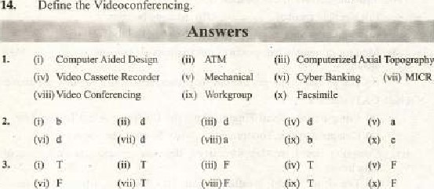

Define

Videoconferencing.

(vi)