

Chapter

|  |
| --- |
| CHAPTER 7 |

Windows Operating System

#### Overview

An operating system ig System sonware that provides an interface for the user to interact with the computer. Without a computer Operating System a computer would be useless. The purpose of an operating system is to organize and control hardware and software so that the devices it manages l*have in flexible but predictable way,

##### 7.1 Types of Operating System

Operating systems are classified on the basis of various features such as user interaction, how nuny tasks they can perform at a tinæ, and how many processors they ean support the basis of user interaetion there are two types of operating system

* GUI (Graphical User Interface) Operating system
* Command Line Operating System

###### 7.1-1 Graphical User Interface Operating System

A GUI operating system provides a graphical user interface to establish tyr user communication with the computer. The Liser does not require ITæmori7,ing cornn-v•nds to perform various tasks such as copying file, opening a document. printing a spreadsheet etc. The Liger useS graphical ob#cts (e.g. icon, windows, buttons etc) to perform difTegent tasks. HeJShe just requires recognizing various graphical objects and tasks that can be performed with them, Examples af GUI system are Windows, Linux, and Solaris etc.

711.2 Command Line Operating System

A command line operating system provides a conmnand prompt to the user for typing different commands to interact with the cofflputer. The user needs to commands to perform deferent tasks- Examples Of Conunand line opxrating system axe DOS (Disk Operating System), Unix el"'

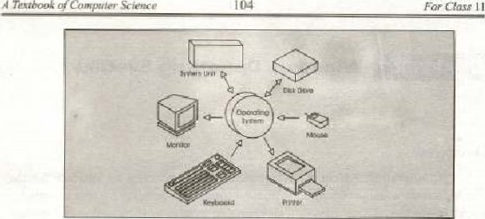

Textbook

o/Coørpuier

Figure 7. L; Operating System

###### 7.13 Command Line Intertaee Operating System Vs Graphical

User Interface Operating System

|  |  |  |  |  |  |  |
| --- | --- | --- | --- | --- | --- | --- |
| Feature | | Command Line OS | |  | |  |
| Ease | | Because of the memorization and familiariiy needed operate a command line interface new users tind it mweh more diftlcu•c to successfully na v*ate and operate a command line inte rfaee. | | Although new users have a difficult -at time learning to use mouse to operatc and usc a GUI users pick up this intcffaee much e*sier when compared to a command linc interface, | | |
|  | | Users have more control of their file system and orrating system in a command line interface. For example users can easily copy *pecific type of filc from one location tn another with a one-line command. | | Although a GUI offers plenty of control of' file system and operating system, often advance users or users who need to do specific task need to resort to command line to complete ihai task | | |
| Multilasking | | Although many command line vironmea:s are capable of multitasking do not offer the same ease and abilily view multiple once on one svreen. | | GUI users have windoys that enable user to easily view, control, and manipulate multiple tasks at once and are eomnwnly much faster, | | |
| Speed | | Because eunumand line users only need to use their k ards to te | | A GUI Illay easier use because of the nwuse. However us a rmuse | | |
|  | | ltne interfhce and often only med to execute a few lines to perform a taske An advanced cottiinand line interface user would be able to sortx%hi done fester. | | and/or keyboard to tiävigate and control your operating syslcm for many tasks is going to be much slower in this case. | | |
|  | | A command line interface enables a user to easily script a sequence of commands to perform task or execute a program. | | Although a GUI enables  User to create Shortcuts, tasks, Or other similar actions to cornplcte a task or run a program it doesn't even come close in comparison to what is available through -a command lineo | | |

7.1.4 Purpose or Operating System

At the simplest levels there are  basic purpose Of operating

• It tiiüfiage:S thc hardware and Of the system. resourecsinclude the processor, memory , disk space, etc.

 It provides a stablc. consistent way applications to deal with Iyard•.vare without having to know all the details of the hardware,

#### 1.2 Starting to Use Windows Operating System

Windows is a GUI operating system developed by Microsoft Corporation, It is 'Widcly used in businesæx, educational institutes. and research organizations. The first successful series of Windows was Windows 3.x series. Windows 3.x was not an operating system; it was rather an operating environmenl providing a GUI that runs on top of DOS, replacing the command line interface with a point-and-eliek system.

lil 1995. Microsoft released Windows 95. a complete operating system for Personal computers. Windows 98 was an improved version of Windows 95 from Microsoft; released in 1998. Meanwhile Microsoft concentrated on incorporating networking features in Windows, So the eornpany released Windows NT (New Technology) with extensive networking features. Since then, all recent versions of Windows i.e. Windows 2000 (server and professional). and Windows XP are based on NT Technology.

##### 7'2.1 Objects of Windows Operating System

Windows consists of number ot graphical objects, which act as  interface belween user and the computer. It controls the overall working of The computer system, manages system resources. and provides a multitasking environrnent for the user to perform rnorc than one task sirnultaneously.

The following are the basic components of Windows Operating

* Desktop: The or—screen work area on which windows, icons, menus and dialog boxes appear is called desktop. The desktop is actually the entering point in Windows. The first abject that you see on starting windows is the desktop (screen). It contains icons (images) for working with different applications that you need to interact on regular basis.
* My Computer: On windows Desktop, you will see arid icon captioned My computer. While installing WLt'idOWS* you divide the hard disk into multiple partitions; each om is rcfcrred to AS drive. When you double click the My Computer icon, it shows you all drives on )ouf system including a floppy drive, and CD drive. These drives are represented t:cons in a window.



For

11

Textbook

* Recycle Bio; You may create folders and files on any drive. It may be required to delete them When you delete a file or folder, it does not remove from the hard desk permanently, Rather Windows  maintain a storage area on the hard disk for storing dcletcd items. This storage space is named as Recycle Bin. The deleted items are nwved to Reeyele Bin. You can permanently delete or restore them from Reeyele Bin.
* My Documents: It a folder created by windows on installation time. 11 is the defåutt folder for storing different kinds of documents. Tf you create document ill Microsoft Word or MS Excel and don't specify the location where il should saved, then by default windows will save it in my documents folder,

Windows Explorer; Windows Expk.rer acts as a directory browser and Filc Manager for Wtndows. It is an efficient w.y for locating and managing files on your computer. Using Explorer you can easily brow through the drives and network resources available.

* internet Explorer: Internet Explorer is web browser that is launched with Microsoft Windows Operating system. It is used to surf [ntemet, It is powerful web browser providing advance features to work on

The Windowt The most important feature of windows operating system is window, This is the basic building block of all graphical Objects Microsoft Window sr Windows view most of the graphical objects as a window such as button, and toolbar etc, are treated  as a separate window, Different applications starts in diffelent window objects e.g. Internet explorer, windows explorer, MS Word. and MS Excel etc,

Control Panel: Control Pane] is the place where you can perform System management tasks such installing/uninstalling new hardware devices, managing system resources through Administrative took, Sharing printers, and setting up and time

* Start Button: Start button is the gateway Of accessing rmst of the programs installed on the cornputer. You can start any program by just making a mouse click, open or find docurnents, can change windows settings, get Help, can manage Files, can maintain system. and can do much more.

##### Working with Mouse and Keyboard

Mouse and keyboard are the basic input devices used with personal computers. every operating system running on PCs providc interaction through these devicesv Microsoft Windows captures different actions performed by the mouse and the keyboard, These actions are referred to as events. Here we discuss sorne important mouse and events'



Chapter

Mouse Events: Mouse events are the action that can be perfornrd by using



LeftC1ick

Right

Click

Drag

etc

,

Left Click: This event triggers When your press the left mouæ hutton_ Windows captures this event and performs certain tasks, Normally this event is used select a graphical object such as a file icon or text in H docunænt, or to press a button such as start button and closing, opening or minimizing a window etc.

Right Click.' This event triggers when you press the right tnouse button. Most of the time this event is used to view the properties of an object such as file. folder, desktop etc,

Drag: This event triggers •when »u press the left button and the mouse while keeping the lett titOiiSe button pressed. Tllis event is used to select tmre than one items at time, or to drop an objcct into another application.

Keyboard Events'. Keybo€nti epeitls are the action that can be performed by using the keyboard. Different applications 'i programs perform different actions against these events Following are the cornn»n events triggered with a Illousec

 Key • Key Down etc.

Key This event triggers when you release an already pressed key Of the keyboard

Key Down: This event triggers when you press any ofthe keyboard's key,

##### 7.243 Features or Wind

Microsoft is a cornplete opceating system Their initial versions •were lacking network support but alnnost of the latcst versions are providing networking features, We shall consider Windows 2000 while discussing features of Windows operating sysceru;

* Multitasking: The capability of an operating system to load multiple progryns into jrætnøry at one time and perform two or Itore processes concurrently, such printing a document while editing another is known as multi tasking

Windows 2000 is a multitasking operating cxccutc multiple tasks at a time. And it responds all so quickly that it seems to paying full attention10 every task,



Textbook

Computer

* Multiprocessing: Windows 2000 provide multiprocessing capability. is capable of supporting and utilizing two or more microprocessors in a computer. A big task is divided into a number of snuilj independent components, and each processor is assigned 06 different earnponent. The processors on different componcnl in parallel, As a result the assigned task is completed in considerably - short inten•al of time as compared to single processing environment.
* Multi-User Operating System: Windows 2004) is a multi-user operating system. A multi-user Operating System allows for multiple users to use the same computer at the sank tinw andlor different times-
* Plug and Play: Plug and Play refers to a set of specifications that allow a computer to automatically detect and configure _d device, and install the appropriate device dri vers.

Windows 2000 is equipped with this feature, It has a Orchanism defined that automatically detects a new hardware device. There are number ofdevice drivers launched with Windows 2000. so you don' t need to install drivers for many devices, windows itself choose an appropriate one for you. However, solnetimes you may need io install a driver for some devices if it is not ayailable.

* Networking: Windows 2000 is equipped with full networking support. Il provides features for establishing, maintaining and troubleshooting a network,

##### 7.3 Disk Management

Windows has strong disk and file management capabilities. Before going into detail of Windows disk and file management features. it is important to understand some basic concepts about them

Prior Windows installation on computer; the disk is divided into multiple partitions, A partition is portion ofphysical disk thal functious as though it were a physically separate disk,

Windows usually create two basic types of partitions. these are:



Oper-u%ing

S'*lem

• Primary Partition Extended partitio n

Primary Partition; A primary partition is one that can be uged as the syslern partition. Windows 2000 and other operating systems can start from a prirnary partition. You can create up to four primary partitions on a basic disk, or three primary partitions and an extended partitiono Primary partitions•aui be creatcd only on basic disks and cannot be sub partitione&

Extended Partitioned: Exteuidéd partition refers io a ponioo a disk that can contain partitions. Only one of the four parttuons allowed per physical can an extended partition. and no primary partition needs to Ix present to create an extended purtition.

###### Disk Management Utility

The Disk Management utility gives you a graphical interface for viewing and performing maintenanee on all of the hard drives and CD drives in your eornputer.rerver. You can see immediately whether your drives (both physical and logical) are healthy or not (figure 7.2),

Management Utility

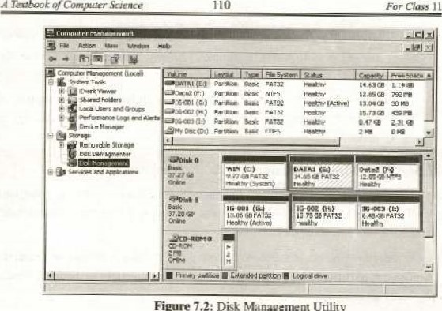

Figure

Disk

As you can you can find the size of the drive, its size and file system and status al a glance, Disk management also indicates which drive contains the system partition. There are several different messages you can receive ag to the status of the disks. and those are at timesdependant on what type of disk it is.

##### 7.4 File Management

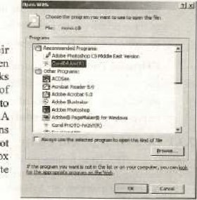Files are rccogniæed by their exænsions in Microsoft Windows _ When you attempt to open file. Windows chccks the file extension against a database of registered file types {windows registry) determine what action it should take, A Tegistered filc type Can have multiple actions

e.g. open and print etc. If windows does not recognize the file type, it offers dialog box and lets yau choose the appropriate applieatin to view ålefile(figure 7.3j.

Figure 7.3: Opening document in approp riate application

###### 7.4.1 Windows Explorer

Windows Explorer acts as a file muknager in Windows Operating System You can- manage files folders -on your computer through

Windows Explorer. files and folders are the basic file management units in Window-

Windows explorer Offers many actioms that can tx performed on files and folders. You eun eute copy, paste, or delete a hie or folder from windows explorer. It shows files and folders in a hierarchical way. It contains two panes; left pane displays foldcrs, and drives on your computer in a tree view shape whereas the righl pane shows the detailed view of folder or drive selected in the left pane

With windows explorer, not only you can tnanage the local files, fOlders and drives but also the remote files and folders.

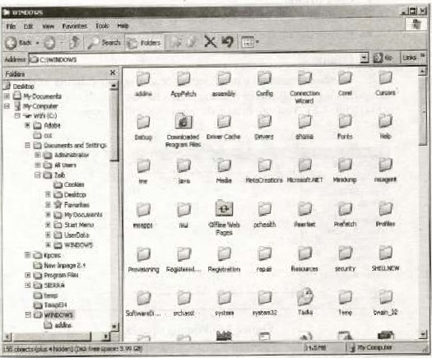

Figure 1.4; Windows Explorer

#### 7.5 Control Printing Jobs

Windows have powerful features control printing jobs. Windows maintains a print queue for the johs (documents) 10 be printed. You can share a printer a as well, so that the whole network can take advantage of thc printer resource.

You can add multiple printers to your computer, But a: a time only one of them will assigned a default status. All jobs are directed to default printer by default. If you want to direct a purticuiar job to another printer, you may specify tirn-e«'f printing, The default printer can be changed al any lime by just selecting printers from the setting suhrnenu of 'he start meou, and then setting on the option "scl as default printeÜ

##### 7.5-1 Adding a new printer

You can add new printer to your oomputer by following these steps:

* Click Start button
* Follow the settings submeni*
* Click printer
* Awindow will appear, double click icon captioned Add Printer
* the steps offered by the wizard to add a new printer

##### 7.S.2 Print Queue

Windows maintain print queue for all ongoing printing jobs. You manipulate printing job in inultiple ways by just double clicking 'he printcv ieen (figure /S). You can follow the alxsve.deseribed steps to view the printer

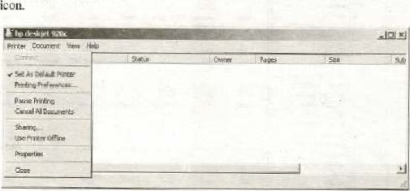

Figure 7.5: Printing options

You can cancel a printing job at any time. Similarly many Other printing options can tv; scl such as changing the printing layout (landscape or portrait). 'ind printing prefercnccs e,g. effects and finishing cte„

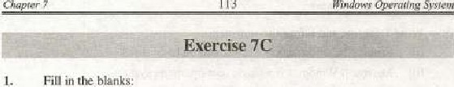

113

Fill

in

(i) GUI stands for

Cii) The capability of an operating system to load multiple pro gums into  memory at ane lime is called

1. With plug and play a counputer can autoinatically a device.
2. Multiple actions gan be perforrned on a partition refers to a ofa disk that can contain other partitions



file

type

operating system -allows multiple users to 

(Vij Windows explorer offers many actions chat can performed on

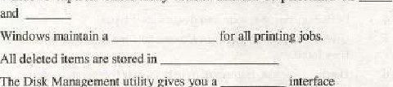

(vii)

(viii)

Ox)

The

Disk

MOnagernen:

utijity

gives

you

a

2. Choose the correct option:

0) Ari operating System is 'a

(a) System Utility  Application Software

(c) System software  Software package

 Ctrl Alt * Del is

(a) An invalid key combination  Recognized by Windows only

(c) Used to close the active window (d) Both band e

( iii) AS  line operating system, a operating system is

More efficient (b) Easier to use (c) More reliabJe (d) All of the above  The maximum number or primary partitions that ean be created on a disk is

(a) Two (S) Three (c) Four (d) None of the above

(v) Windows explorer is used to

(a) Access the Internet (b) system resources

(c) Perform maintenance on the hard disk

(d) Navigate filesand folders on the computer

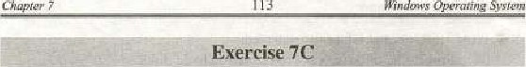

113

Bindervvs

Opera"ng

Sysfem

1. Fill in the blanks:

GUI stands ror

The capability Of an opersting system to load multiple programs into  memory at one time is cålled 

(iiii With plug and play a computer can automatically a device.

div) Multiple actions can performed on a file type partition refers to a of disk that Cau contain other punitions operating System allows multiple users to nwlciple tasks the same lime,

Windows explorer offers many actions that earl perfdrrneki on 

Wii) Windows maintain a for all printing jobs.

(viiij All deleted itemsÄre stored in

(ix) The Disk Manageme nt utility gives you a

 Choose the correct option:

 An Opcr*ting sys lcm is

(a) System Utility (h) Application Software

(e) System software (d) Software package

Ctrl Del is

(a) An invalid key combination (b) Recognized by windows only

(c) Used to close the active window W) Both ande

(iii) As Compared to command linc operating System, a GUI operating System is

(u) More effecicnt (b) Easier to use (c) More reliable (d) All of the above

 The maximurn nurnber ef primary partitions Ihal can created on a disk is

(a) Two (b) Three (c) Four (d) None of the above

(V) Windows explorer is used to

(a) the Internet (b) Explore system resources

(c) Perform maintenance on the hard disk

Cd) Navigate files and folders on the computer

Primary partitions can not bc Created Oji basic disksCii> Microsoft Windows is a Single user operating system.

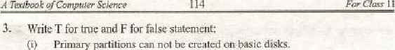

For

Class

 In windows e;cploret, left pane displays folders and drives on your computer in a tree view shap•n

(tv) With Windows explorer, you eau only manage the local files. folders and drives,

 GUI was first introduced by AppleP 5 Macintosh computers.

Cvi) Operating system LS responsible for the effective use of computer system.

Maximum four primary partitions can be created on a basic disk.

1. Windows Cheeks the file extension against a database Of registered file
2. Disk management also indicates Which drive contains the system partition. (i) Prior to Windows installation on a cornputer, the disk is punitioned,  Define operating system and discuss their types.

S. Give a comparison tetwe:en Command Line operating System arid Graphical User Interface.

6, Discuss different features of Windows 2000 0Æærating  Write short note on each of lhs following:

 Dusk Management Utility • Windows Explorer Print Queue What do you mean by Plug and Play? Does Windows 2000 provide this

Define Partitioning_ Briefly descritR primary and extended partitioning.

10. Differentiate Ibe following:

• Multitasking and Multiprocessing • File Management and Disk Manageruent

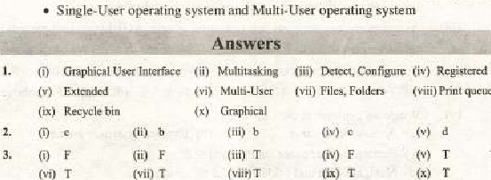

erintqueue

|  |
| --- |
| CHAPTER 8 |

Word Processing

##### Overview

Word processing software pmhably one of the most frequently used packages in any organization, People use it for everything from quick notes to complex, book-length documents. In fact. it has estimated that more than 90 percent of all personal cornputers have a word processor installed. Word processing is more than just electronic typing. It Involves creating, editing, formatting and printing documents in variety of form.

You rnay have observed hundreds of newspapers. magazines, letters and advertisements at your workplace, horne and surrounding; these are all miracles of word processing software. Businesses, Governmem agencies. schools and individuals create thousands of documents for numerous purposes on daily basis. In this ehap•ier we shall discuss different features of word processor. To Tnake clear concepts of these features we shall also discuss 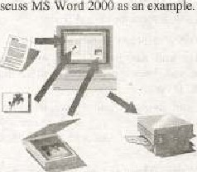MS Word us an example



115

Figure 8.1: Word Processing

8.1 What is n WOrd Processor?

Word processor is an applica1i011 Isohware) that providcs cxtcnsivc tools for creating all kinds of 'ext-haced documents. Word processoT can manipulate not only the text hut. il enables you to add images. sounds. charts and graphics in your document (figure 8.11 With some of advanced word processors can embed video elipg as wen. Word processors can even create documents far pubhshing on the World Wide Web, complete with bype14inked• text arpzl graphics,

* A word, icon, or Other r&ect that When clicked itilnps to another the Feb page. Ä.lE;e called link or

The great advant*ge or word processing over using a typewriter is that you can make changes retyping you make a typing mistake, you simply rmve back the cursor •cid correct your mistake. If you Want (o delete paragraph. you simply remove it. without leaving a trace, is equally easy to insert a word* sentence, ar paragraph in the middle of a document. Word processors also make it easy to move sections of text from one place to another within a document, or between documents. When you hnve made all the changes you want, send printer to get 2 hardcopy8.2 A Simple Word Processor (Text Editor)



to

Word processors vary considerably, but all word processors support some basic features. Word processors  only these basic features (and maybe a  others) called text editors e.g. Word Pad, Note Pad el". All word processors providetbe following basic features:

* Insert text: Allows you to insert text
* Delete text; Allow' you to or pages as easily as you cross them out on papcr,
* Cui and Paste: Allows remove (Cui) u section of lexi from onc place in a document and insert (Pasle) it somewhere else,  Copy: Allows you duplicave a sec'iOa of text.



CJa.#

* Page size and margin: Allows you to define various page sizes and margins, and Ille word processor will automatically readjust the text so it fits properly.
* Search and Replace: Allows you to diree( word processor search tor a particular word or phrase, You c.ari u]so direct the word processor to  ltplace one group of Charoeters- with another everywhere that the first group appears,
* Word Wrap; The word processor automatically move* to ihe neit line When you have filled one linc Wilh and it will readjust if you change the margins.
* Print; Allows you to get Tualdcopy,

##### 83 Full-featured Word Processors

Most word ptoeessors, however. support additional features that enable "'u to manipulate and format docunvms in ITH)re sophisticated ways. These advanced word processors are sometimes called full-featured word processors- Full-featured word processors usually support [he Tl'llowing features:

• File Management: Many word processors contain file management capabililjes that allow you to delete, move, and search for files.

Font Specifications: you [o Change fonts within document. For you specify bou italics, and underlining. Most word processors also iol you cluuvgc lhc font size the

placcmcnr of footnotes and enables you easily cross-reterence iuher section:'

Graphicsi Allows you Lo embed illuslrauons and graphs imu a document. Some word processors let you create the illustrations within word processor; others let you insert illustration by a differenc program.

 Headers, Footers, and Page Numbering: Allows you to specify Cuszomir.ed headers and footers the word proetssur will put at the top and bottom of every page. The word processor automatically keeps track oi page numbers so that the correct nunlhec appears on each 'Sage.  Layout: Allows you to specify d margins within and to specify various for indentin& paragraphs_

 Macros: A macro is that represents a series or keystrokes. The kebcrokcs can represe_nl [ext The ability to define macros to qve yourself a lot of lime hy replacing co romon comb'natiorts of kcyswokes.

* Merges: Allows you text iron' one tile into another file. This is particularly useful fitr genet-alive tiles thal have the same format different daca. Generating ITüiling lahcis is the classic example of using
* Spell Checkers: A utility that allows you to check the •pelling of words. l: will highlight any words il does not recognize,
* Tables of Contents and Indexes: Allows you 10 autojnatieally create table Of contents and index hased On speeiii] codes that you insen in the document.
* Thesaurus; A built-in thesaurus that allows you to search for synonyms without kaving ihe word processor.
* Document Windowsi Allows you In edit two, or more docilrnents at the

particularly valuable when working large project that consists of several different files.

* WYSIWYG (What You see Is What You Get}; WYSIWYG, a document appears on the display screen exactly as it will look when printed-



A full-featured word processor can even have rnany other features. Microsoti Word is one of the nwst popular full-festureg word prueesbors- TO have practical 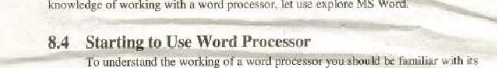of working With a word proeessof€ 1]Se explore MS

interface, The interface represenls the way through which you can interact with the word.proeessing software.



###### 8,4.1 The Word Processor's Interface

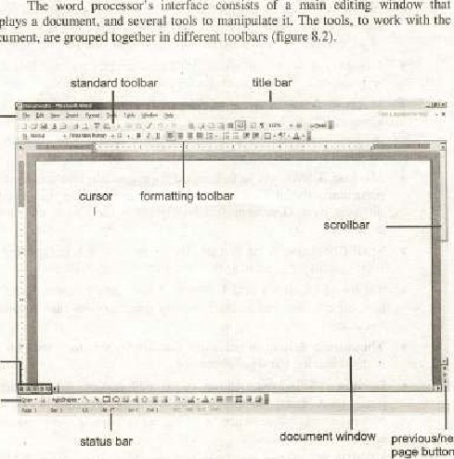

processor'

s

consists

Of

editing

Window

'that

displays

s/ngxt

buttons

Figure

*.2:

Ward

Processor's

Interface

menu

bar

—

choices

drgwr.g



|  |  |
| --- | --- |
| Title Bar: | Displays the name of the active application and document along the top Ota window. |
| Menu Bar: | Displays all menus |
| Standard | Displays sotne of the most common word processing tasks, |
| Tool Bar: | such as opening. copying printing files etc. |
| Formatting | The fir nutting toolbar cOntains bolt01is and options can |
| Tool Bar: | be used to apply cornrnanly used text formats. |
| Ruler: | A ruler shows the positioning of tabs, margins. indents and other elemems on the page. |
| eni | A rectangular portion of the sereen in which you view and |
| Window: | edit a document. |
| St*tus Bar | Shows information and mey.sages at the- bottom of the window that Provides statistics about the position -of the insertion point, the text you see on screen, and the status of some important keys, |

###### 84.2 Entering and Editing Text

To create a docun'tent -the text is entered hy typing On the keyboard The ward pmcessor placcsm blinking insertion (also called a cursor) at the top left corner of the screen Cdocument window), The cursor the position where the next character will placed in the docutxrni. As you type the cursor nwves forward the screen. On reaching at the end of the line the Word processor automatically cnoves it to the start Of the line.

typewriter word processing software lets you change lext Without rctyping the entire document. Changing an existing document is called editing the document, There are many ways to edit an existing document erg' by typiJ1g new or by replacing an existing teit with new one

Typing Modes: All word processor provide two modes of typing;

* Insertion mode
* Overtype triode

In insertion mode the newly entered text is placed at the current position of cursor whereas in ease of overtype mode tl•æ newly entered text is "'Vitten over the cxisting text.

Selecting To any attribute of text it must selected firsCv Select the by dragging the mouse oycr desired while keeping the left mouse pressed. or hold down the SHIH key on the kcyboard while using the arrow Co selecl the text.

Erasing Text: Two keys on the keyboard are used to erase text from a documenc: these are Delete and Back Space keys, The Delete key erases the Character to the right of the cursor whereas the Back Space key erases the character 10 the left the eursor, Both the Delete and the Back Space keys erase just character at a To erase more Characters, setect them first  then press the Deue key.

Undo and Redo: While editing you Tnay need to reverse tlw changes you have made to the doeum:tll. For 'his-purpose the undo option eun be used. If you undo a change and then decide thal the change was Illore appropriate and it should be Tetleeted to the document. use Redo reverse the previous u:ndo. Formatting Text: The formatting of a doeurneiu includes changing the appearance Of the tett, adding pictures and graphics eottlmlling the layout of the text on the page. The formatting toolbar is the easiest way to change any attribgtc of text (figure 8, 3).

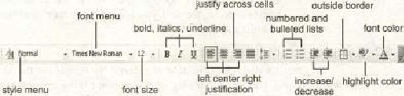

decrease

in

deat

ngure Formatting toolbar

8.43 Forrnatting Fonts

The font refers to the characteristics of letters. symbols. and punctuation marks in the document. Sank characters in different fonts have different appearance. There are general categories of fonts;

* Sans—Serif

Serif fonts have curls or extra decorative lines at the ends of the strokes that make up each character e.g. Times New Roma: sans-serif fonts du not have e.g. Arial (figure 3.4),



Figure 8.4: Comparison of serif and sans seriffonts



One of the nujor features of a word processor is its ability to with fonts, Microsoft Word has number af fealun:s to manipulate fonts. The romiatling toolbar contains a font menu through which many different types of fonts can be selected such Courier, Book Antiqua, and Arial etc.

The characteristics greatly affect [he appearance of text on the page

* Font Size can bc set from the formatting toolbar (figure 813). Font size is treasured in points. A common font sia used in business documents is Il-wants type.
* Style is used to bOkl, italicize and underline the text. Formattülg toolbar contains separate buttons for all of these options.
* Font Color is used to change the color oftbe text.
* In addition to these hasie "haraeterisEics many effeets can also be applied to all types of fonts e.g. strikethrough shadow, and outline etc,



The Font dialog allows you to Choose from a larger selection or options. menu bar to access the Font



dialog

8.4.4 Formatting Paragraph

Paragraph is defined as a group of sentences, But to a processor the word •paragraph' have slightly different meanings. Word processors assume the start of a paragraph every time you press the enter key. Paragraph ionnatting includes settings applied only to one -or entire paragraphs. The sellings include line spacing. paragraph spacing, indents, alignment, tab stops, borders and shadings etc-

In MS Word, to format a paragraph, place cursor within the paragraph and select Format[Paragraph from the bar. The follouing dialog box will appear



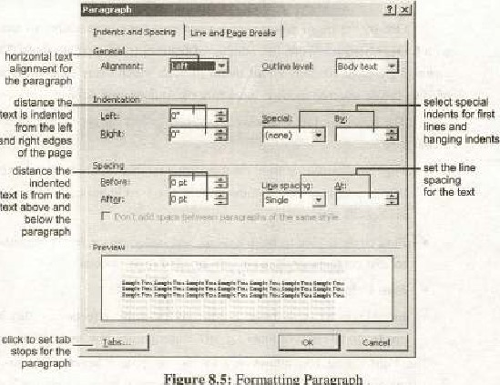

and

Figure

Fonuuttin;

Paragraph

 yvu can select thc indentation (lcft and right). the special paragraph spacing (none, first line or banging indent). spacing before or aner paragraph, and the Line Spacing (single. 1.5. double, 2.5, triple, etcu),

* Line and Paragraph Spacing: Line and paragraph spacing is well controlled in MS Ward. Yau can define the space between different lines of text in a paragraph, The characteristic is known as line spring. Lines can be single-spaced, double-spaced or set to any spacing you want. Paragraph Spacing refers to amount of space lytwe.en paragraphs. By default the paragraph spacing is same as the line spacing but it can be changed.
* Margins define the boundaries Of the text. The text cannot eross tlwse boundaries. In every docunwnt all the four margins (top, l;wttom, Jen and right ) the samc or different
* Indents determine the distance each line of a paragraph to margins. You indent some text in the document to highlight it. You can sei indents so they affect every line of text or a single line in a paragraph. You

•C/eapte,• S Processing

free document co create the indents.



the

RULER

located

above

* Alignment Tiers to the oncntution of the lines of a p aragraph With respect to the margins. There four alignment options — lettr center and justified The be aligned ivfirst selected then aligtunent Can be set from the formatting toolbar by using any of the following buttons,

Align Right Align Center Justify

* A Tab stup is a posilian in document usually measured from left right. The keyboard Tab key moves the insertnon poinz (Cursor) forward. to the right. until it eucounlérs a tab stop,
* Paragraph can be formatted Wich borders or Shading,

8.4.S Formatting a Page

Page formatting refers to ihc of page. its orient*ton, and headers and There are many other features that can Ee apf'lied to page formatting. For formatting a page in MS WordT Select File Page Setup and choose Paper Size tab.

* Page Siu plays an important role in the formauing of the page, Page fbrmatting changes aeeording ta size of the page. Changing the sips of the page can disturb 'he formatting of Whole document. SO il is strictly recommended sel page size before goyng to format
* Document dimensions are determined by the orientation or thic paper. By the documents are Set to use portrait oneniatiocu, where the document is taller that il is wide, You can also use landscape orientation, where the doeunænl is wider thal il is tall.
* A header is text is added to top margin of every page such as -a document title or page number and footer is text added to the margin. Select View Header and Footer from the menu bar. The Header god Footcl toOJtpar will appear at-id the top of the page will be highll%ht
* Page numbers can be assigned to every page of document, Select  Insert Page Numbers the pages of the document.

8.4.6 Introducing Columns

You need to present the text in columns within your document. For example in af newspapets and in some of magazines the •ext appears in column

A @Cornp ce

Columns are very effective format eertaiij types of documents, Presenting text in columns is a powerful fefiiure of MS Word, It is very easy to itiåke columns of the text_ You can two, three or more columns by just clicking a single button on formatting tool hay.

TO place the text in columnS clect FormaiEColumns from the menu bar. The COIii1iiib dialog box allows you 10 choose the properties of the columns (figure 8,6), Select the number and widih of the columns from the dialog box,

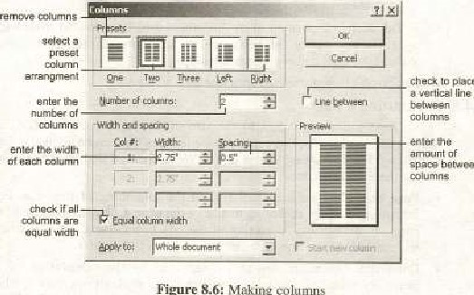

place

between

Figure

Making

8.4.7 Introducing Tables

Tables are used to display data. Most of the word prxessors provide you feature to create tables in few steps. The size of the table is limited only by amount of page space that can be devoted to it' and tables can be formatted in dozens of ways. Tables are useful for arranging images and text on a page. You can intelliger)tJy use tables to create customized page layout.

• Creating a Table: There are multiple way-slo create a table. The easiest one is co coeate from the menu bar. TablelInsertlTable front the menu bar. Select the number of rows and columns for the table and click OK 8.7).

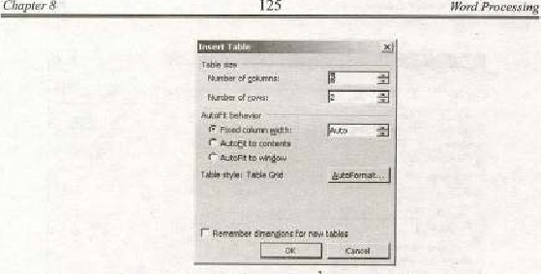

Figure 8.7: Specifying rpamber of rows and columns

11Berting Rows and Columns: the table is Lctcatcd„ additional rows may be inserted into it. the cursor in the row colL:lmn you to be tdÄeni ta [he new Sclcct Table I Ixwert I Rows Above or ROWS Below Select Table Insert Columns the Len or Columns to the Right.

 Moving and Resizing a A four-sided moving arrow and open box resmng handle will appear on the corners of the table ifthe txmse is placed over the table (figure 8B)- Click and drag the four-cnded arrow to rhe table and release 'lic niOusc button whcn thcublc is positioned where you want it, Click  open handle to resize the 'table_ Change the column widths and row heights by clicking the cell dividers and dragging them wilh the nouse.

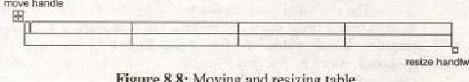

Figure

8.8:

Moving

and

resizing

table

Moreover borders shading can also 1k applied to the tables. You can even find many other options to work Wilh tables, 

8.4.8 Printing a Document

Oiicc you ha ve completed your docurnent, you have the ability to print it out. All word processing programs provide this feature. Select FilelPrint from the menu (figule 8.9).

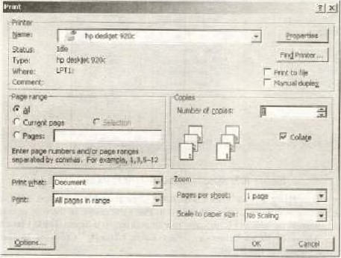

Figure 8.9: Princ dialog box

The print dialog box specify many print options, such as pages per sheet, scaling, number of copies be printed etc. you can print document on the or (e a file by just setting the print to option.

8.4.9 Using Clipboard

The clipboard is tejnporary holding space in the eoniputer•g memory for data that is being copied or The Clipboard is used ror storing text, graphics, sound, video other data. After data lias been placed In the clipboard. can he inserted from the clipboard into other documents, in the samc application or in different applicatioa_

For example, if you want to move paragraph in a document, select the paragraph. and choose tbc Cot con'lltnand; the data is removed the document and placed on the Clipboard you don't wanl to remove the paragraph the original document then use Copy command). After placing the insertion point in the docuirkTit where you wand to place (he paragraph. you choose paste command; the ditta on the Clipboard is placed into the document, In the same way the Clipboard can be used to move data from one document to One important thing äbOLit the Clipboard is that it is part oi 'he operating it is not a separate application.

8-4.10 Using Text Boxes

Sometidues you need (o move text around on a page, free bf the usual constraint of paragraphs. margins and so on. For example, you nilght want to place attention-getting text in margins. Or you might want to create letterhead in wllich the Indy of letters wraps around the block of material containing your name, address. Hild so fonh,

MS Word offers you eon>iderable flexibility in sizing and positioning text boxes, bordering and shading text boxes, rotating the orientation of teÅt with text boxes, and more. Text box can be crcated by selecting InsertlTexi Box from the rnenu bar or by just clicking the icon from the drawing toolbar.

The position of the text box wilhin the text can be adjusted by first selecting the tcxt t:x.x and then selecting (he formatltext box option from the format Text boxes offcT handy way to highlight text in mullicoiumn docunrnts by forcing a small block of Text to span multiple columns (figure



Chapter

8

127

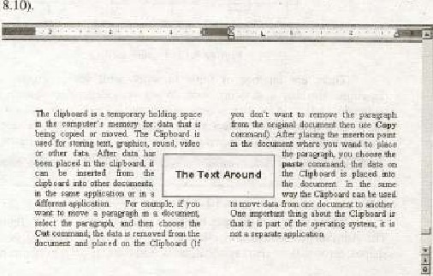

Figure 8.10: Text Box

8.4.11 Using Graphics and Word Art

The word processor remains incomplete without providing graphics handling features- Almost al] word processors can handle text as well as graphics. MS Word contains number Of tools for manipulating graphics.

tools are divided into two main categories; those for bitnup graph/es and for

vector images. Roughly speaking, bitmap graphics thought of as "painted" pictures. while vector graphics can he tlwught or a.s line drawings. Because of the technical dijTeJence iriweert bitmap and vector [mages. different tools are used to work with each of them.



earl

Pictures can added to the document by selecting insertlpieture option from the menu bar, Pictures can be inserted from file. from Clip Art, from Scanner or Camera. Chans and Word Art can also be added to (L document in the same way

A picture toolhax is alternatively available to work with pictures in MS

Word. This can be accessed by selecting  (figure There are so many options in picture toolbar to manipulate a picture. You can work with shapq color, brightness, and siae etc, of the picture easily-

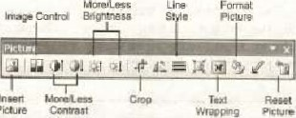

Picture

Figure 8.11: Pieturc toolbar

There are numbcr of to work with vector images line drawings. Besides a drawing tool. Word provides basic shapes such as rectangle. and circle etc. that you can insert into your doeurnent. To work with the Word's Drawing 1001 select viewltoolbarsldrawing. The drawing toolbar contains many options for dramng lines and shapes



Shown

in

figure

8_12.

Figure 8-12: Dr-awing Toolbar

There is an AutoShapes toolbar on the Drawing toolbar (figure 8.13). The AutoShapes toolbar will allow you to draw many differen: geometrical shapes, arrows. flow chart symbols, Stars alid banners on documentv

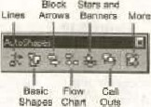

Figure 8.13; AutoShape töOlhat

Chapter S Pn•ce.ssing

Word Art is a Of Microsoft Word'S drawing Il transforms an ordinary text headline, word or phrase in a work of art. The text is transformed into an image that can be in varieiy of ways, The Art is done by text, transformed word art. and selecting insert I picture I Word Art.

You have many options to sclcct thc Word An style. To access it from the Drawing toolbar, go Lo View menu and select Toolbars thawing. The Drawing toolbar appears at the bottom or the window. The Word Art button is a slanted A i.e.

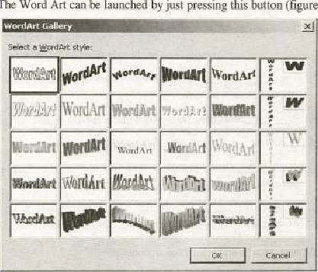

leunched

by

just

pressing

button

(figure

8.14),

-

The

Word

Art

Figure

8.14:

Word

Art

Ot selecting a Word Aft Style. the Edit Word Art dialog appears. This allows you to type in your text and to select the font type, and to choose the style i.e. bold, italic or underlined. As soon as you enter the text click the ok button, the Word Ari toolbar Will appear (figure 8. The contains buttons that Will take you back tn any of the steps you used to create WordArt.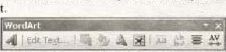

Figure 8.15: Wold Art Toolbar



o/



1. Fill in the blanks:

the of uctivc 4*pli.cation is known as



(i)

(ii) WYSIWYG stand* for

(iii) Tbe appcarancel)r shape of a character is referred to as

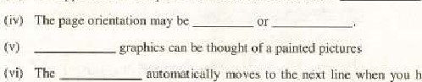

have

filled one line with text.

(viii A is a character or word that represents a series of keystrokes

allows yqu to search for synonyms

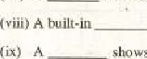shows you positioning of text, margins, indents and other elements on the page.

(x) in ease or ITwde the newly entered text is written over existing text

3. Write T for true and F for false

(i) Word processor is just eJectronic typewriter Tite bar Containing the drop dowry fiicnus is Called

(iii) Font face is shown on Formatting tool bar.

(ivi Footnote appears at of_every page.

The interface represents the way through which you can interact with the word processing software.

 In insertion mode the newly entered text is placed al the current position ofthe cursor



Wii) Sans-Serif fonts have extra decorative lines at lhe ends Of the strokes that make up each character

(viii) Alignment refers to the orientation of the lines of a paragraph with respect 10 the margins,

Ox) Line Spacing refers to amount of space between paragraphs

(x) Clipboard is rnanaged hy Mierosoti Word

2, Select the correct option:

(i) Whith Of the following is a w ord processor

(d) Adobe Aerobat (b) Photo ExpresS (c) MS Excel

 Which ofthe following keyboard shortcuts used io change the case?

(a) Ctr14F3 (b) Shift+F3 (c) Alt (d) Ctrl+Shift+F3

(iii) In MS Word, the is being copied or moved is

(0) Temporarily stored in Recycle bin (b) Permanently stored in Reeycle hin

(C) Temporarily stored in Clipboard

(d) Permanently stored in Clipl»ard

(ivi Which of the following can be used io launch thc Word Art

(a) Status bar Ruler

(c) Standard toolbar (d) Drawing toolbar

(v) Which of the following feature enables you to reverse the •changes you have made to the document?

(a) WYSIWYG (b) Rcdo Undo (d) GUI



4, Write a notc on the following:

• Word processor • Clipt:oard Word Art

 What is a text editor? Describe its basic features.

6, features of a full-featured word processor.

7. Define fom aced discuss its types,

Descr ibe formatting features for paragraph formatting.

9, Draw the mark sheet showing your name, father narne, school narnc, year Of passing SSC examination, date of birth, list of all subjects acid their respective marks, total marks, percentage and the overall grade. [Hint; You can draw a table to complete the taskl

10. Arrange the lest given in the following figure according to thc Incntioned

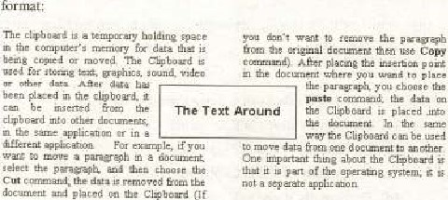

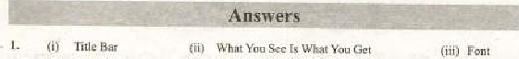

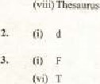(i'/ / Portrait, LandscapeBitmap

Ox) Ruler

Cii) b

(vii)

 Wo rd 1&Tap (vii) 

 Overtype

jiv) F 

(iii) T

Cviii"