|  |
| --- |
| CHAPTER 9 |

Spreadsheet Software

##### Overview

people work with numbers every day. Corporations track profits and losses; economists generate graphs of growth of the country's economy; slatiscicians probability of crashing the market; and manage their household budgets, To perform all these tasks. people use spreadsheet programs.

A Spreadsheet program is & software tool for entering; calculating, manipulating and analyzing sets of numbers. The specialty Of spreadsheet software is •working with numbers, It, large arrwunl data arranged in rows and columns. It can n•wnipulate numbers and present infortnation in numerous ways.

### Features of Spreadsheet Software

WOrd Processors, the Spreadsheet software also varies significantly e.g. LOTUS 123, MS Excel etc. But all of them havc the following basic features:

* Grid of Rows and Columns: The spreadsheet is a grid of rows, and columns, Each row is assigned a number and each a letter. TIR intersection of a row and fi column forms a ceil, Each cell a reference number that is formed by combining column numbcr and row number

e.g. Al. Cii8 etc. A cell contains labels or values. 'A label is a lext cntry such •as "Gross Salary" whereas a value can be a numherw date. a formula or a formula's result.

* Formulas: Formulas are used to express mathematical relationships belween. cells.

tions; Functiioos are used to perform certain tasks

Commands: Commands are used to manipulate the worksheet or its contents

* Text Manipulation: Son* simple text manipulation can also be



* Print: Allows you to send a doeunent to a printer to gel a hardcopy.

#### 9.1-1 Starting to Use Spreadsheet

To understand the functionality of spreadshcct software you should be familiar with its interface. The interface represents the way through which you interact with the spreadshcel ROItwarew

### 92 The Spreadsheet's Interface

I ike word processor, a spreadsheet's interface consists of main document window, and set of various tools to manipulate data, In document window the docunwnt IS displayed 111 a spreadsheet, you actually work in a grid of and columns called a worksheet, Collection of related worksheets forms a workbook. Spreadsheet software allows you to save the whole workbook, cortaining several worksheets, as a file



In addition to document Window, the spreadsheet's interface bar, toolbars, and a formula bar. Formula bar is used to apply certain formulas on different cells of the worksheet.

Unlike today's spn:adshect programs early spreadsheet programs provided only one worksheet at a lime, The workbook contain worksheet, New spreadsheets ace rated as 3D-Worksheets, which are like a pad of worksheets. It is due to this feature 'hal The data in one worksheet can be for calculations performed in another worksheet the sung 01 a different workbook-



A

Science

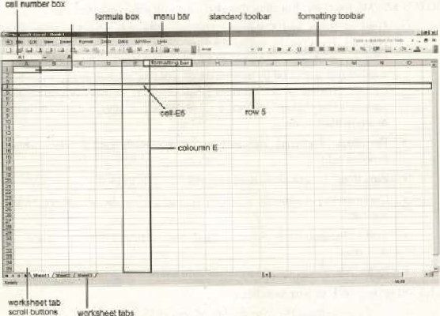

Figure 9.1: Spreadsheet Interface

#### 9.3 Entering Data in a Worksheet

Cell is the basic unit where the data is=gntered in a workkhect, The data can take variety of forms i.e- text, numbers, dazes. and formulas. The cell also can hold graphics, audio files. and video Of animation files, There are two states of cell i.e. active and passive. Beroreentering data, Lhc cc]/ he activated. Using the mouse or arrow keys, you can selcci cell to make it active, A bold rectangular tx)rder indicates an active ceil Every cell in the worksheet has address (figure 9, 1).

When a cell is selected can enter data by simply typing on the keyboard. You can also enter the daia in an active cell through the formula barr Similarly you can edil the contenis of cell in the formula bar. When a cell eontaining a formula is activated, its formula appears in the formula bar, which you can edit there.

Like word processors, the basic operatioms of cut. copy and paste work in same way here in Worksheets, You can nwve dato between the worksheets of the same or different workbooks by using these„opeeations.

##### 9.4 Basics of Worksheet

As it has been discussed that the data entered in a cell can Lake variety of but the most comrnon of these are;

* Labels (Simple text)
* Values (numbers)
* Formulas

Labels are used to identify a value or a series of values. Labels arc helpful in making the workshcct meauingful. It is important note that formulas can be applied only on values; these cannot be applied on labels.

Values are just numbers that you enter in different cells of i worksheet. These can be whole numbers, decimals. negative numbers, currency and other types of values including scientific notations,

Working with Formulas ig the nrus-'t powerful featurc of Spreadsheet. Formula can he calculated an the basis of values or formulas in other eells, Formulas can involve basic arithmetic operators More complex can even evaluate logical conditions and perform certain calculations on the basis of the result of the evaluation. Conditions n•ay evaluate to true or false. Y.4.1 Cell References and Ranges

A cell reference tells formula look up the eontents of rhe referenced cell. This increases the flexibility of 1.1k formula, The change in the contents of the referenced cell is quickly reflected to the result of Elle for•nula iring

calculated on the basis this



or

cell.

cell

referred

by

its

addre«

such

The

is

to

GB, ACS, and YIO etc. there if you want to add values in cells 08 and YIO, your formula might 100k like

If your formula involves contiguous cells, you can refer to all the cells as range. The range is specified as follows:

address of the first cell : address or the last cell

For example, the cells 03. E3, 03 can be referred to as

###### 9.4-2 Relative and Absolute Referencing

Calling cells by just their addresses (such as " Aj is called relative referencing. When a formula eonlains relative t•efemtncing and it is copied ane cell to another, the spreacßhect does ereate an exam copy of the formula. It will change addresses relative to the fOW *lid column, they arc to. For exan-lp'e. iffi simple addition formula in cell Cl i.e. *AI+BI) is copied to ecllCü, the formula would change to  to rcnect the

TO prenent this change, cells must he Called by absolute referencing and this is accomplished by plueinE dollar signs - S" Within the cell addresses in the formula. Continuing the previous example, the for-mula in cell Cl would read if the value of eel' C2 Should be the Sum of cells Al and B I _ Both eolutrvn and row of both cells ure absolute and will not change when enp\ecL

###### 914ß Named Ranges

Range names are names that you defirte ta represent a cell or cell range On a worksheet. These range names can further be used in formulas instead of cell *ddresses or ran;es. They also make il easier to use. maintain, and understand the formulas in the worksheet. e.g. the forrnulo —CIO'•100/C8 calculate the percentage of marks. After giving names to cells, this can be expressed as Marks_Obtained • 100/ Total_Marks

Definin g Range Nan-res

To detire a name for a cell or range of eellS Select InserilNamelDetine from the trrnu hae_ The following dialog will

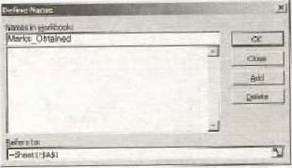

Figure 9.2' Range names

You can even give names cells or cell ranges instead of using their address. After assigning names to cells or eel] ranges you can use these names in formulas instead Of the addresses. c. g. the ubovc formula can rewritten as Valuel + Value2 after assigning (he name Valuel and Value2 to cell GS and Y 10 respectively

##### 9.5 Working with Formulas

The distinguishing feature of spreadsheet program is that it allows you to create mathematical formulas and execute functions. Otherwise. it is much more a large table for displaying text.

Forrnulas are entered in the worksheet cells and must begin with an equal sign The fortiiula is written in (Be formula. bar. The formula includes the addresses Of cells whose values will be manipulated (figure 9.3). After the formula is applied on the cell. the calculation executes immediately. See the example helow to view the formula for calculating the total for a number of textbooks. formula multiplies Ibe quantity and price of each textbook and adds the subtotal ror each book.

###### Linking Worksheets

While applying a formula in a worksheet. you may Want to use value from a eell in another worksheet within the same workbook, For example. the value of cell Al in thex•urrent worksheet and cell A? in the second worksheet ean added using the forgoat

The formula for this exarnplc would where the value or cell Al in the current worksheet is added to the valuc of cell A? in the worksheet narned "Sheet?.

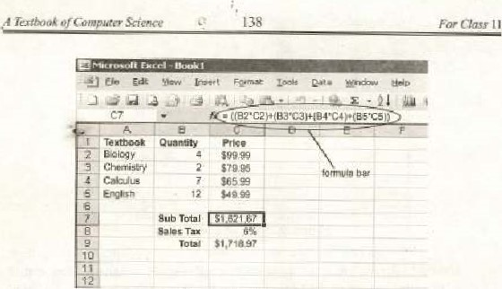

Figure

93:

Calculating

Formula

#### 9.6 Functions

In a spreadsheet, Functions are built-in formulas used to perform eomplex operations. Such as adding the contents of a range or finding the absolute value of a cell's contents. Every function returns value and iiiay accept one or more arguments. An argument is a value passed to the function (0 perform an operation. The arguments are passed to the functions within parenthests. There ave functionsthat arc simple to execute whereas some are more complex-

Functions can he used in formulas. Functions can be a more efficient way of performing mathema'ical operations than formulas. For example, if you wanted add the valucs Of cells DI through you would type the A shorter way would he to use the SUM function and simply type —SUM(DI :DIO). Some conunqnly lised fisncuions and examples are given in the  below:

|  |  |  |
| --- | --- | --- |
|  | Example |  |
|  |  | finds the sum of cells Ai through A IOO |
| VERAG | —AVERAGE{B | firuis the average 01 cells B I through B lg |
|  |  | tuns the highest number from cells CI ugh croo |
|  |  | returns the lowest number cells DI thro tigh DI 00 |
| ORT |  | mds the square root ofthe •value in cell DICI |
| DAY | TODAY() | eturns the current date (leave the parentheses |



9

##### 9.6.1 Function Wizard

To view all functions available in MS Excel spreadsheet) and to apply any of them. ihe function wizard can used- To aelivatc the wizard seleel

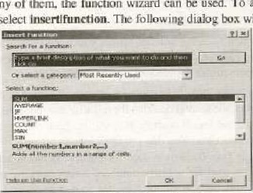

will

appear'

Figure 9.4: Funetion Wizard

You can select any function from the given list of functions. Click Ok to apply the selected function. ne n•nction wizard will ask you the argument(s) for the function. On supplying arguments the result will appear.

##### 9.7 Formatting and Customizing Data

The contents of a highlighted cell can b2 formatce•d in many ways, Font and eel] attributes can be added from shortcut buttons on the formatting bar (figure 9-5).

center ecross gells

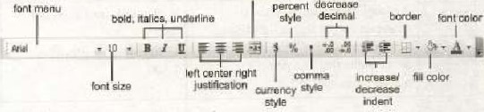

irereased

Figure 9.5: Formatting toolbar

###### Cell Formatting

The default number format assigned to a cell is the General fornuutw General displays whatever is entered in the cell with a couplc of exceptions. If the cell is not wide enough display a long deeirnal numher, General wunds off 'he number and uses scientific notation for especially large or small numbers, For example 0.0000000001 is displayed as in default column width



To customize the format of tlir cell you can select format]eelis command, If the data is number. you WIM presented twelve categories of formal options as shown in figure 9,6,

9.1.2 Creating Custom Format

If you don't see the number format you would like among die listed categories, you can create 'a custom format. Click custom in the category list to create a custom fOrnmat (figure g. 6).

Each number format consists offour parts, 'rue first part describes the positive numbers, clue second describe the numbers. the third describe zero values, hid the fourth describe 'ext values. Each is separated from the other by a semicolon, You don't to specify OLI paris ofthe format, you specify only two, the first is used for positive number-g and zero and the second is used for negative numbersr Text values use general fornlatn If specify only all numbers use same format, and ext value use General format (table 9.1).

###### Symbols used in Custom Format

|  |  |  |
| --- | --- | --- |
| YiiibOl | Meaniryy | Example |
|  | A placeholder that determine how mnny digits display on either side of a decimal nu | If the custom Tannai is 0000 thcn  12 wilt b: displayed 0012  450 will be displayed as 0450 |
|  | A placeho kier to the O character except (hat insignificant reros do no appear if the number has fewer digits than the numbcr or pla_celujlders speified. | If custom forrnat is then  1500 will be displayed as |
|  | A place holder similar to the 0 character, except that space is leit for insignificant zero characters on either side of a decimal point, | If the custom format is 0.22?  For 16543 and 24. if displayed vertically, the decimal point of 16.545 will become under the decimal poinl of 2.4 |



SQÉwure

|  |  |  |
| --- | --- | --- |
|  | Indicate how many digits appear to the tight Of n decimal point. The ceil display will round 'he number of placeholders to the right Of decimal point the formal, | If the custom format is then  1.2 willl;e displayed as 1.20  SS will he displayed 58.00 |

Table 9.1; Syndxlls for custom format

You can choose any forrnat for the cell The contents of Klic cell appear accorxlingly. For example, selecting a Currency formal that disilays the currency symbol followed by a two-decimal number will show the value of 547$5 as SS47.S5 Similarly selecting formal for a cell as mm,ldd/yy convert the "January 16,

2005" to 1/1 #2005 aulornatically_

9-1.3 Aligning Cell Contents

Alignment of the cell contents can be changed from the Alignment tab of the Cell Format dialog (figure9.6). The default and numbers in a is General, Hoe,ever you van change the alignment to Len, Right, Centen Justified. or

Similarly you may control ihc orientation of the worksheet from the

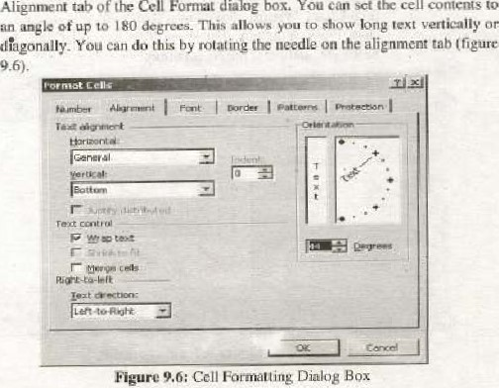

cell

contents

box.

You

Can

sct

the



Texl±ook

9.7.4 Merge Cells and Wrap Text

YOO can merge cells by first highlighting the cells to be merged and then just selecting the Merge Cells op'ion from the Alignment tab of the Format Cells dialog boxe [n the same way, you may select the wrap option from the alignmenl tab of the Format Cells dialog box to allow wrapping of text in a cell.

#### 9.8 Introducing Charts

Charts allow you te present data entered into worksheet in a visual format using a variety of graph typcsv Before can make a chart you 'Mist first enter datg into worksheet_ To generate a chart you can use' Chan

##### 9.8.1 Chart Wizard

The Chart Wizard bringx you through the process of creating a chart by displaying a series of dialog boxes.

* Enter data into the worksheet and highlight all the cells headers) that Will included in the Chart
* Click the Chart Wizard Hutton the standard toolbar view the firs' Chart Wizard dialog This will present you different one Chart, Line, Bar;

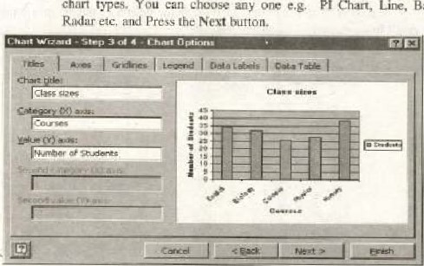

chart

types.

You

can

choose

any

e,g,

Figure 9.1: Chart options

heer Sowv•crye

|  |  |
| --- | --- |
| 143 |  |

* This will lead you to another dialog box where you have to specify the source data for chart (if it is different from one is selected), Aficr specifying the source data press Next button,
* The folk) wing dialog will apixar. Enter the liarrk of the charl and titles for 'he X- Y-axes, Clicking on the tabs change other for the axes. grid lines, legend. data labels. and table, Press Next to move the next set bf optiotvs.

• You may insert the chart as an object in the same worksheet or it cgn be displayed separH1ely on another sheet.

Click Finish to exit the chart wizard

#### 9.9 Printing Worksheets and Charts

ne chart can printed in the same way as a work sheet. You have several while printing a worksheet, Before printing the format of the page must be set. Selecting FilelPage Setup can set the page format. Set onentation of the page from the page tab, ser margins and add hea•ders and tooters (figure 9.8)

##### 9.9.1 Poge Orientation

Select the Orientation under the Puge tab the Pugc Sculp window to the page Landscape or Portrait. The size of the worksheet on the page can be formatting under Sealing, To force a worksheet to print only one page wide so all the dplæar the same pagC, select fit W page(s) Wide.

##### 9-9.2 Margins

Change the top, bottom, left, and right margins under (he Margins tab. Enter values in the header and fields indicate bow far from the edge of the page this ten should appear. Check the boxes for centering horizontally pr veg•tically on the page.

##### 9.9-3 Header/Footer

Add preset headers and footers to the page by clicking the drop-down  under the Header/Foote;r tab,



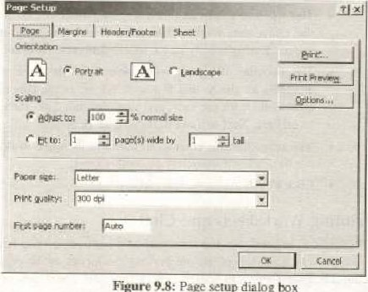

Figure

9-8:

Page

setup

dialog

##### Sheet

Check Gridlines if you the gridlines dividing the cells to printed on the page. If the worksheet is several pages long ard only 'he first page includes titles for the columns, *lect Rows to repeat at top to choose j title row that will be printed at the top of cach page,

Alter setting page format, select FiWPrint option to print the uorksheet, This is same as discussed in chapter 8 (word processing}, Yogi cam take one cu- multiplc copies Of the worksheet.

The intersection

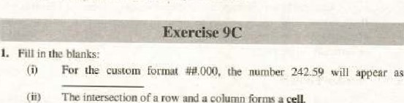

a

and

a

volumn

forms

u

cell.

(iiii In a spreadsheet arc built in formulas

(ivy Labels arc used to U!entify value oe a series of values are narnes that you define to represent a cell or cell range on a worksheet.

 Calling cells by just thcir addresses (such as "Al") is caned relative referencing

AIL is indicated by a bold rectangular border. is a software for manipulating numbers may contain multiple

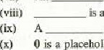

(Wii)

O is a placeholder that determines how digits display Oti either side of a decimal number,

2. Choose the eorreet option:

 Which of the following is spreadsheet?

(a) MS Word (b) MS Excel (c) MS Powerpoint (d) Both b

 The actual working area in Microsoft Excel is

(a) Workbook (b) Worksheet

(e) Spreadsheet (d) Note sheet

(iii) W'hieh of the following is an absolute address?

##### AIS

(e) ASI$ (d) None of the above

Fornuxla can only be applied

(b) Labels



Spreadsheet

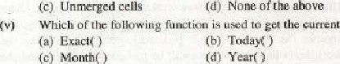

(a)

Values

(d) None date?'

(c) Month(

1. Write T for true and F for false statement:

(i) Because Microsoft Excel is-a spreadsheet. therefore it does not have a spellchecker component.

Functions can be _a mocc efficient way of performing mathematical operations than defining your own formulas.

(iii) A formula can not manipulate labels.

Worksheet is the basic unit where the data is tnanipulated in a workt»ök

 Footnote can not applied in a spreadsheet software

 By default, the numbers us well the text is aligned RIGHT in a cell. Wii) A formula containing relative referencing ig not copied exactly fr,ziii) # is a place holder similar to the 0 character, e@ept that space is left for insignificant Zero characters on either side Of decimal point , A formula containing absolute referencing is not copied exactly

 In MS Excel, a worksheet can have maximum 65,336 rows,

1. Define spreadsheet and discuss its basic features.

Diffeæntiate the following;

* + Workbook and Worksheet
  + Active Ce Il and Passive Cel I
  + Word Processor and S
  + Function and formula
  + Labels and Values

6. Every cell in a worksheet has a reference number, how is it calculated? Discuss with examples the mejor differences trtween Relative and Absolute referencing.

Create a Pie Chart for the marks Obtained by your Class fellows in SSC

1. What do you understand by the term named ranges? Can it be helpful in simplifying the worksheet?
2. What are the advantages of using a spreadsheel program?

10, Insert worksheet in the workl»ok to develop Pie chart for the marks obtained by the students of your neighboring section in SSC examination. Calculate overall pass percentage, and average marks of the students of both sec:ions in another (third) worksheet.

Hint'. You have to insert three Worksheets in worktmpk. Construct Pie chart for the marks of your eluss in sheetl. Similarly, construct another Pie chart in gleet2, In sheen, you hgve to make the three worksheets linked. The data will bc picked from sheetl and sheec2 Co calculate the average und pass percentage in the sheet3.

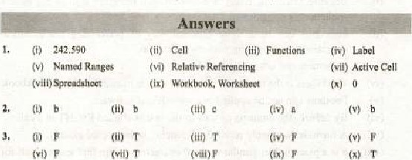



Fundamental Of the

###### Overview

In 1969. Advanced Research Project Agency (ARPA) established a small computer network among different universities and defense organizations. The goal was to establish a large computer network that eould survive in war times. Initially ARPANET was a wide area network connecting a small ofusers. There were only four hosts (A host is a eornputer that provide services to Other computers Of network). But the net work grew rapidly and spanned o ver countries.

Meanwhile another research organization, National seietre foundation, joined the project. NSF established five suixreomputing centers which Were available to all  fot academic purposes. To provide high spxd access to its superconvuters. NSF established a scparute high speed nctwork called NSFnet.

During this period, some Other small networks had also tren established among various universities and organizations. The authorities decided to ARPANET, NSFnet and other small networks so that Chey eun communic.te each other. Thi' link different networks is referred as the Internet.

10.1 How the Internet Works?

The Intemet is a huge collection of milliogms computers, all linked together on a network. The network allows all of corruputers to com:muoicate with one another. A home computer may be linked to the Internet using phorc-lioc modem, DSL or cable modem that communicates to an Internet service provider (ISP). A computer in a business or university will usually haye a network interface card (NIC) that directly Connects it to u Local Area Network (LAN) inside the t%JSiness, The business then connect its LAN to an ISP using a high-speed phone Jine like Tl A T! line can hun;dlc approximately IS million bits per second. While a normal phonc linc using  typicuJly 30,000 to 50.000 bits per second.

ISPs then eonneet to larger ISPs. und the largest ISPs fiber-optic

toe region, around the world are eonneeted through lines, eebles or links, tn every Computer 00 connevwd to ocher Phe Inter* 

A

|  |  |  |
| --- | --- | --- |
| Teühook O/ | Sekhee | For Class I I |

10.2 Addressing Schemes

The purpose of the Internet is to establish conuuunication between widely spread computers. Computers can send and receive data to each other_ Any computer may initiate transaction at any time. For this reason the source machine (cornputer) must haye a unique identification of the destination computer. On the Internet every computerhas a unique address ud can be contacted on this address,

are types ofaddressing schemes recognized on the Internet , these are:

(i) IP Addressing (ii) DNS Addressing

10.2.1 IP Addressing

To keep these machines straight, each machine on the Interrwt is assigned u unique address called an IP address. IP stands for Internet protocol, and addresses are 32-hit numbers, normally expressed as four " octets" ili a "dotted decimal number.- A typical IP address looks like thisi

2162761.137

The four numbers in IP address are called octeås because they can have values between O and 255, which are 28 possibilities per octet, Every machine on the Internet has a unique IP address. A server has a static IP address that does not change very often. A hone nühine that is dialing up through nu'dern often luas an IP address that is assigned by the ISP when the machine dials nat IP address is unique for that session; it may different the next time the gnachine dials in. This Way, an ISP only needs one IP address for each it supports, rather than for each customer.

As far as the Internet's machines are concerned, an IP address is all you need 10 talk to a server. Fowexamplew in browser, you can type the URL http:// 216.2%', l" and arrive machine that contains the Web server for the specified IP-Addrcss.

102.2 DNS Addressing

Because most people have trouble IE1tW1ubering thc strings of numbers that make up IP addresses. and because IP addresses sometimes need to change, all servers on the [nternet also have hum.n.readable names, called domain names, For examples www_hotmail.com is a perinanent. humanreadable nazne. It is easier for most of us to remember it than it is to Address. The natne com Wetually has two parts

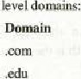a host name and domain. The domain represents instituckon which uses t,lw address. These domain names are called top-level domain. Following is a li5i of top level

Type or Institu tinn

Business (Commercial) nal institutes

.gov Go vernment organizations

Militury organizations other organizations (non profitable)

Sorne large organizations divide their top level domain into sub domains, This let you organize their web references.

10.3 Web Browsing

Searching information on World Wide Weh is referred to as Web Browsing_ A software known as Weh browser is used to search-and view web pages Hundreds of thousands or web pages are available an the World Wide Web that covers information on Olmost every topic. Here we shall discuss important terminology regarding World Wide Web.

10.3.1 World WideWeb(WWW)

The World Wide Web was launched in ] 989 ai t.lr European Particle Physics Laboramry in Geneva, for adding footnote, and cross references in hypertext docunents. The uses http (hyper text transfer protocol) to link hypertext doetmlents (web pages) on the World Wide Web web page is a document that is written in HTML (Hypertext Markup Language). in addition simple 'ext certain tags of HTML arc included in the docunEnt. The language allows embedding hyperlinks (or simply link) in the A hypertext docurnent is called a Web Page. A collection of related web pages is called a Web site. Web sites are hosted on server computers on the internet. These eornputerS are called Web Servers, The process of laurÉhing web page is called publishing the page.

URL (Uniform Resource L«ator)

Every page hus a unique address on World Wide Web. nuis is called

Uniform Resource Locator (URL). If you want to access a web page on the

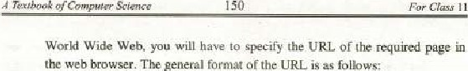

of

the

URL

is

follo

type%i/addresstpath/

The type specifies the type ofthe server on which the page is hosted, gddress specifies the address of the server and path is the path of the page on the did- of the server e.g. hup.v//www.yahoa.com•"

10.3.3 Search Engine

A website that uses powertUt data searching techniques to help the user locate web sites containing specific types of contents or information is known as a Search Engine erg, google„com, ask_eom_ altavista.corn ere. are very popular search engines. Search engines have become very popular all over thc world. Milli01Ls of people use Search Engines to find Out infortnation on various tppics. Search Engines Tnaintain a list of billions of web pages containing information on varie4y of topics- Search engines ask you to enter some key words about data or inforrnation you want to search on the Internet. On the basis Of your provided information, search engine traverse the Jest ot web pages it maintain. and finally display the links of the web pages containing required informatjorv

10.4 Email

Entail is system for delivering messages over the Internet. An e-mail sender or recipient can anywhere in world

E-mail is the first really popular Internet application; it allows people to how discussions over great distances

* E-Mail take as little asfew seconds to go across country, or even around the world.
* It leaves a written record. You can keep copies Of e-mail messages you send and receive. for yuur record.

To creates send and receive email you need email-programs also called email client. Once you send the message, your computer connects to your email and transmits a copy Of message. Email Server is a host computer on the Internet which keeps irack of information about millions of email account holders_ The server checks address you have typed and figures out where the recipient email server is, It connects to seneer and transmits another copy of t.hE message. Once the receiving email server has received the message. lhe recipient is able to retrieve the message when connected 10 the server.

Attachment is povozrfvl feature of email; Which enables you to enclosed add&nal files with your email. You can attach word processing docunrnts, spreadsheets. programs, images. even audio, to your cnni] messages when using email prograrns that support the Internet protocol fot multimedia attachments LeMIME (Multipurpose Internet Mail Extension). Most email clients allow you attach files message. In this way you can send and receive data as well-as program files. Attachment size varies from providerto the other e_gr for free email accounts, Yah(Mj allows file Of Size up to IOMB 10 be attached. This limit varies for paid untS.

10.4.1 Limitati01E on Email

* Entail is not necessarily private: Since messages are passed from one system to another. and sometimes through several systenxs qr networks, there are lnany opportunities for to intervept or read enaaiL Many types Of computer systems have protections built in to stop users from reading others' email, hut it is still passible for a system administrator to read the crnail on a system or for someone to bypass security of a computer system.

Some email systems can send or receive text tiles only: Even though you can send and receive images, programs, files produced by processing programs, 0T multimedia nwssagcs, sortie individuals may not able ta properly view

It is to forge email: This is not common, but it is possible to forge (he address of the sender. You may want to take steps to confirm the source of email you receive.

* It is dithcult to express emotion using email: The recipient does not  have the benefit of viewing your facial expressions or hearing your voice; You have lobe careful with hurnor or irony, since it is easy for someone to take your message 'he wrong "ay.
* You ean receive too much or unwanted You -can receive "junk' ' email in the Same way you other types of junk mail. On the Internet, junk mail is called spanr You rnay have to tuke active steps to delete the email you receive and to stop it from being sent to you in the first place
* You may not know about the person with whom you are communicating: communication is often in text and it is possible for us to get an Incorrect impression of the person sending us email. Also , some peop]c misrepresent themselves.

Email Address

To send and receive an email. you must have an email account on an email server. When you email account. you are assigned a unique email address. You reccivc all incoming emails on this account address and send email to otters by specifying their etjüil addresses. The general format of an email address is:

User name @ DNS Address

For exantple, pikCrick@hotrnaiLc01U, gsm@yahoo.com. info@ptcl.eom.pk e:tCv In these exarnples pakCrick- gsm and info specify the user name whereas second part after @ symbol specify the DNS address.

###### IOS Newsgroups

These are discussion groups on the Internet on the which is only one area of the tnlerne,t). Newsgroupsare classified by subject and do necessarily deal with journalism or "news", Health, hobbies, celebrities, and cultural events '*re the subjects of many newsgroups. Participants in a newsgroup conduct discussions by posting messages others to read. and responding to the messages posted by Others. Because you have time to think of to write in a newsgroup posting, the discussions in newsgroups tend to be Of a more serious nature, though not necessarily less amusing.

You need a software to obtain articles from the news server. A news server is a host computer that exchanges articles with other servers on the Internet: These servers use Network News Transfer Proroeol (NNTP) to communicate To væw articles on a specific topic, you need to be subscribed on a news group.

Fill in the blanks:

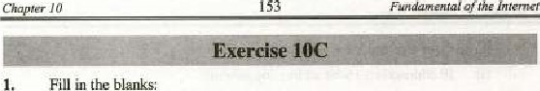

Internet

(i) Collection Of related web pages is called

Initially ARPANET



small

number

of

Ciij) News server useprotocol to transfer articles among

NSF established a separate high speed network called

The LAN Can be connected to ISP using a high-speed phone line called

World Wide Web was established in

Wii) MIMEstands for

The four numbers in an IP address are called

Cix) address is easy to rernember

HTML stands ror

2. Choose the correct option.'

(i) A computer can he linked to the Internet through

(a) A phone-line modem (h) DSL

Cc) Cable modem (d) All of above Cii} Which atche following LS an email c lieot?

(a) Internet Explorer (b) Outlook Express

(c) Google (d) None Of the liii) Which of the following protocol is used to access web pages on World Whde web.

(a) TCP/IP Gopher 1--1T1'P (d) HTML

(iv) Which of the following is used to find information on World Wide Web?

(a) Web Browser (b) WebSite (c) Search Engine (d) Web Server

(y) The length of IP Address is

 8 bit (b) 16 bit32 bit (d) 64 bit



1. Write T for true and F for false statement:

(i) IP address is a 16-hit addressing scheme

 Every computer on a network a Network Interface Card that directly cot:lnects it to the Othel computers.

(lii) URL is used to locate a computer on the Internel  A hypertext document is also called web page  enlail Server is software used to create, send and receive emails  Each computer on the Internet must havc HITP Server configured to connect to Internet

Wii) NNTP stands for National News Transmission Protocol

* 1. On IrMernet, Junk mails are also called spam
  2. News Server is used to Streamline news transmission of t_lE local radio stations
  3. You can not attached a file larger than 20MB Lo an enuil

1. Briefly describe the history of the Internet-
2. Write a nol on World Wide Web.
3. What do we t•nean by Addressing schemes? How many types of addressing is used on ? Discuss briefly.
4. What do you know atwut Email? Discuss briefly.
5. Write a note on the following:

• Newsgroups • Search Engine • TCP/IP

1. Discuss limitations an email,
2. How the use of Internet is affecting our society? Give your cornrnents.

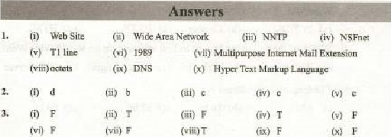(vii) V

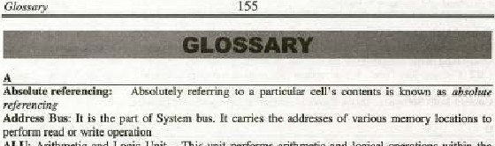

ALE

Arithmetic

and

Unit

—

PÜfarrns

arithmetic

and

logical

within

the

Itis the height or wase a given pet•icnl oftime

Analog Signal: Analog signals are centinuuus electrical sign [he form of wave Anti virw: [t is u software whieh is used to detect und rano•ve a virus the computer Application Software: software is to seve a spæihc problem.

ARPANET; A wide area network connecting a small number There Hue only IA host i S that provi de y:rviccs to othCJ cunputcrs of e network).

ASCII: Äruerican Standard Code Interchange — 7-00

Asynrhrtmous Trarvnission: [n thjs type of transrnissim the data is seat flow control than to synchrtxlize data triweea the and destination

Bandwidth: Band width is a rneasu'* of the transmissi«l rule of communicutjcm channel

Il is technique in Which digital Onto the line without change in modulation

BCD: Binury C.xied Oeein1iLl — four bit "fin g sateme

Bit: s:mullexi unit of with in grid A device that the nei•nrk a:nd those addr—ses to in other network.

Broadband: is a technique oi transmitting a large amount of data, and video nvei long by

Bus: It is also called System Gus, It is am pathway to :onnezt difierent puts ofthe cømputer

Bus This unit i s use' to a:nnæt part Ofthe computa together

Bus Topology In this topology. wmputers are in a series. A special device called is connected on t:oth cnds Of series to the Signals.

Conectioa eight bytes is referred to a byte

CAD: Aided Design

CAM : Computer ded Manufilcturing

(Äient.lSm•er Network: this type of network, one ee mere eornputers {ire dedicated ser•.ers and 'he cornputer3 work as clicnts. 't the Of Client arid operndng system: A aommønd line opemlins %stem command vompt to the for typin g ±tierent commands interae•l with 'he computer.

Conununication cc•auuunication channel is the physiC*Ll path by Which datatravels

from receiver

A eornputer is a machine that eon progran•ur4ed to accept data (input). into useful ag•d sure it •way fin secondary gorage device) fcr safekeeping or later

Control Bus: li is the part of system bus. It IS used to tranSmii control signals parts 01 the (be CPU

T'extbook Of I I

Control ios'ruet:ions from main Illernory ard decodes these instruc [ions CPU Central processing Umt — also known ms *ain Of Lhe ectnputer. [t amtrols the overtili functioning of the compute_

CRT: Cathode-Ray Tutte —il is' a vaeuu,m lure used as a display in or video display

Cwtom-buiit Software: This software is fix u particular customer

Date Bus: Il is the part or overall system bus structure. It carries the actual. data fom the CPC.j memory and VO dcviccs and visc

Data Communication: It is the exchange of data two devices via some of transmissio:' media such as

Deemert Decoder converts the encoded os digital firm

The cm-screen uork On which windows. is-to, menus.

Digital Signal A digital signal uses M-off electrical pulses in discontinueus discreel form DMA: Direct Memory Access — is a technique an FO operation in "'hic* IFO operaticn is completed involving CPU The CPU jug issues aaL L'O uLd the rest the work is completed WIih help Of a DMA module cull ed domain

DOS: Disk operating system

DRAM: Dynamic RAM — Contents ofthis of RAM nccd to rcfrc5hcd pericnlicallY' Subscriber

EBCDIC: E Mended Binary Coded Decimal Interchange

Email: is deli',erjng messages over Intern.et_ E. rnz:il: it is lhc „clcc1rmieIIS' computer network

Email elient: s.onwerc used to create. send and recei

Email Server: nis is the server computer ou the Internet Which is used maintain and streamline the emai.l syftem.

cnccder cOnVertS digital gignills to a form. ivhk'h cun though transmissic:q• inediuni

Ethernet: lt. is a LAN high cable and topology, so it simple and cheaper_

Exte •ded parti'ti•m: Extended partition nefcrs to a porti«l of a disk other

Extranet Two rnwe intranet connected together ill may 'hey enable the companies that own the intranets.

Fetch.DecXKle•Execute Cycle cya e the exe.cutLLJn of the

Frequency: the of times wave repeats during a 'pecific interval "P: File Protocol — il is a (e (0 eotnpu•ter nerw«k is a Of in frog!

senderto receiver and viee •,ersa, Birnulraneously

Functions: In a svea&eei, are built. in as to pcrfru•rn complex cFrdticmse



|  |  |
| --- | --- |
| Gateway is a collection of h,ardware and | resources that ter a ncxle (Carnputer) |

communicate With computer another nctwork

Gopher: It un uecess and retrieval covering wide range of information, frotu r&rence material s to articles to documents and

S onware which is used for computing

GUI operadng sy*em: A GCT up g provides gra$ilical usa interfacc 'to cstablixh the user cumu-nunicaticy' with the computer e.g. Windows 95. Windows 98, Windows NT.

and Windows XP

Guided Media: [t refers to channels that allow the tr M smifsion u *lysical media such

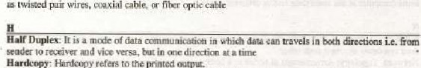: Hørdeopy refers to the printed output,

Hardware: Physical compon enis Ofcomposer ate called hardware

Hyperlink: A o' when clicked_jumps to another on.ihe or an«hcr web paec

VO InpudOutput Unit — unithandies the pre.'.essor's communieati6n withits peripheraLs„

Impact Printers: The primers whigb use sciking Inechanisn3 to print thc papcg

Information Technology: Information Technology is the that tnzges gh speed ccqnrnuuicutiøn Links in the form teap sound, Vid-co front

devices %cdcvices ch are used to give input io the aft input devices Interne'* The huge eolI.eeLton mf of , all linkeri together on netooa-k, It is also called network ofnetw.rks,

Interrupt: Interrupts arc iiuc signals. generated by 110 devices. These signals i:nfmm• dle CHI the occurrence of a certain eyen!s c limplctinn 110

Intranet: jt is -u "iva1eIH*wned. business netwx.rk based Technology (use

*though mol necessarily connected io ihc Internet

Address for prato:ol , IP address is u ed to uniquely identify a computer netmjtk. addresses are 32-Bit nuttlbers, expressed as in

$eci •

Internet *e-rvic•: provi — A provid•ek internet services

LAN: Locul area network that d smull geographical area such as a building campus Of few gs in a enall area.

LAN: Local Area Network — I: spans -a small geu,gruphical such an ea. buildings

LCD: Liqui d Display — As it a different tOdiSÉlay graphics

A macro is a character or represents eries

MAN: Metropolitan Are' — A Metropolitan Area Network comneeeg an aiea than a

LAN tut than WAN, sueh as a city, Phth dedie.aleß "V high-performancehardwwe,

Mesh

net*Otk.

M&m: It is a device converts into analog signals and vice vetsa. is used

connect to me Internet,

Mdtipræessing: By multigcæssing, we mean having more than in a Single cunpucer, -me phencmenon of executing two cm more poresscrs is caned multi vræessing.

MuldWWng:; ne capability of an operating system multiple programs into mernory ut me time *fid to Or rnorc oncumeaily called

Multi-user Ovating System: A System allows fcr multiple users to use rhe computer at the erne time and'%r different timesv

|  |  |  |
| --- | --- | --- |
|  | |  |
|  | A youp of computers cumee(ed togeth« | communieate. exchange information. aid pool |

their resources amnest each other

Nt two" Topology of in a crunputa ne.twuk ig reié.rr«] to

News semr; A news server is hog computer that exehznges with, servers on the

Ne wvoups: muse are discussion groups cm the Cnternet 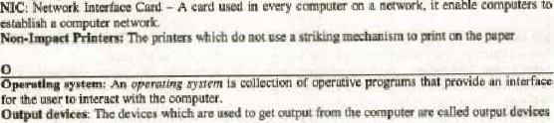Card — A cud used in every

|  |  |  |  |  |  |  |  |  |  |  |  |  |  |
| --- | --- | --- | --- | --- | --- | --- | --- | --- | --- | --- | --- | --- | --- |
|  | | | | | | | | | | | | | |
|  |  |  |  |  |  |  |  |  | ves | flow of | ur data |  |  |

Communication

Partition: A panition is a Ixrtirrl of physical disk •s thwgh it were physica.üy separate disk

Peer-re-peer Network In this type of network, every computcr can play the rote of *ever or Client 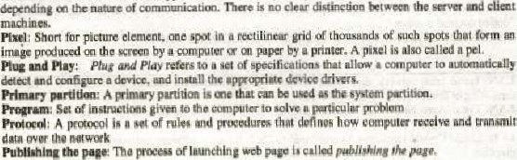thc nature of communication. here is no

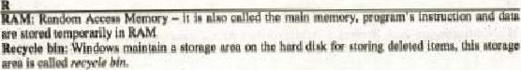

Glossary 159

Register-- are high speed memory lcxations into the mieropcoc.essor, The CPU uses these TO Sure data iiid tenpnrily, to accomplish

Relatiye rerere:ncing: &lling cells by just their Addrc.s.cx (eu.±h A I is galled r/arive referencing

Resolution: peinch the screen s:reen) defines the resoluticm

Ring (n this computerh are connected in ring shape

ROM: Read Chly — is memory and contains the instructicms rquired in boating

Router: Router device kecp track Of all prxsib\e rout— source the

Inessage to the d51ination

S

Sans•srriffati5 do not ha re dxorauye lines at the ends of the (ha' nuke up churacqer e.g. Arial

Search Engine: A website that powerful techniques to help ICE.ate web specific I ypes of or iwfoenul;im ig known as google altavisth,eorn

Transrrdsslon: this bit Of in thccunmunicati(X1

Seriffonts : Seriffonts curls extra decorative lines ihe ends of (he strokes that make character e-g, Times New

Signal : electromagnetic light representati&i Of dub is signal is rncxlc data communication in "Olich data travels to

Receiver is cupublc or e.g. T,V , and Radio transmissim Siitiidütitfii: It is type of computer mtglcl, which rccregiø

Softcopy: S to data St el

Softy-are : A program or collection Of comvwter co certain is referred

Software Puckages: •C?tese are off-the-shell potentid A program is fCK •entering, calculating.

|  |  |
| --- | --- |
| SRAM :  Stur  SVCA; | RAM — this RAM de not need to refreshed thin topology all computers connecta:i to a central de•vigcs 9b,  Away — supports 256 colors at higher resolution thun VGA |

Synchronous type af , is used to the timing

sent

System: A system defined a combinaciom of relatW gompments Iha:inzuct with each other to perform sorne specifie tasks

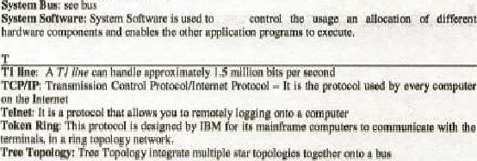

|  |  |  |  |  |  |  |  |  |
| --- | --- | --- | --- | --- | --- | --- | --- | --- |
|  | | | | | | | |  |
|  |  | Universal Code — |  |  |  |  | widely used in | computers. li is capable Of |

regrcscnting chara•ctcrs Of many Sikh Japanese. Arabic, arid French

URL: — i actual ly the a&hess of every pa,gc the World Wide

Web. [t uniquely identifies ewery web page or

VGA: Video Graphvc Array — it Supports 16 dqxndi:ng the resolutioa

Video Conferencing: It is a type of conferencing in whieh video and signp and sound trun over

Video Display A ca,td h uto and ffsplÅy on the monilor.  A virus a program a of progrwnz that e.an cause extensive damage to your exnnpuler

W

|  |  |  |  |  |
| --- | --- | --- | --- | --- |
| WAN: Wide Arca Networ | spans | large |  | canes, countries  us |

Web browser: It is a software thet is use' to view web pages. Web Page: A hypertext document is also galled a Web page.

c server cornpuEers on the Internet where the •websites arc hosted are led web

W.b Sii% or related wapageS called Web rife.

W«-d: A of bytes that cmstitutcs acornmOn unit: Bf datu defined by the n Microsoft Wozd's drawing grogram. It transforms an text headline. word or phrxse in a work ofart.

Ward Word processor is an [Software) thåi vrovides extensive tools f« creaüng ail kinds of text-bused dKxumenLs, Collection ALcd a computing. is a'so known as cohaboratirc comparing and enables the individuals and

Of projects co fm' 'the Of cooperagipn consultation, and in atiOii

W arksheet: In a sFeadsheetT actually a grid Of and columns-cane' a worksheet.

WW": World Wide Web — Il is a eol]eetion ormillim„s 11Tked web pages

WYSIWYG: A g-ruphicü' interface Stand* Yow See Whop Yo" Gel

XGA: Exten ded Graphic Array — it Si.•rtS million colors ai resolurion Of x 768 pixels

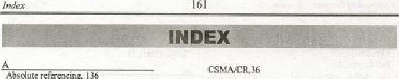CSMA.'CRM

Abu') ute referencing. I

Ad dress Bus, 77 CSMA.CS. 36

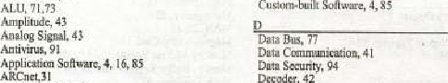Custgm•bui'i: Sodiware,

ARPANET, 27, 147

ASCII,44 Desktcp. 106

Dig:itHl Camera. I 

Digital Conyergence, [

Bandwidth. 48 DigitaE Signal, 

|  |  |
| --- | --- |
| Banx:dc Reader, 10 | Digitizing Ttblei, |
| das&ld, | Display Screer, 12 |
| act), | DMA, 39 |

 16

Bi't:nap Graphics, 1 27

Vitus, 93

|  |  |
| --- | --- |
| Br 49 | DRAM, 14  Dnun plotter, I |

|  |  |
| --- | --- |
| CAL,6i | Address, 152 |
| CAM, | Email |
| CET, 66 | Email Server, 1.10 |

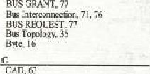DSL Jl



62

EBCDIC. 4-4

E -Commerce, 61

EFPROM, 

26, 28, ,150

Ch.t Encoder, 42



28

EPROM,

E- Shopp 62

Eth ct-net, 30

Coauial Cable, 30 Ethernet

Coding. 21 Extended

Collaboratin Contputiii& 2.5 fvlodetl-.,

|  |  |
| --- | --- |
| Comtuand line operating system, 103 | Extranet, 28 |

Cmnrnunicatian Channel,

Ccgnntunirution Media, 49

Control Bus,

Ccat:rgl. Fitz.Optic.caNe, SO

CPL', 2,72 Panel Display,

 13

CSMA'CD. yo, 36 Video curd. 1 

FTP, 28

Fulk DupLex. 4S

Full Moti cm Video Card, I L



043cway,

Geaerai Purv•se Register, 80-81

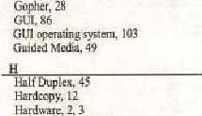

Hyirid Network, 33 Hyperiink I S

t/OLTni1,

LAO write, 77

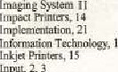

Input,

2,

Input devices, 4



Instructioc Format, 82.'3

Instructic.  80

2328.147

Interrupt* 79

Intranet,

IT Address

ISP.143

|  |  |
| --- | --- |
|  |  |
| joystick, | |



LAN, 23.29, 32,147

Laser frinter. 14

LCD. 13



162

I

j

Light Par, 9





Mau Ma•nory, 71-73

Maintennnce. 22 

MAN,

Magnetic-Strip Card. 10

Memory Addr" Regi (MAR). 80

Memory Buffer Register 80

MICR. 10

Microwave, 51

MIME, Mobil e 'Cottiftiuniätim, SY

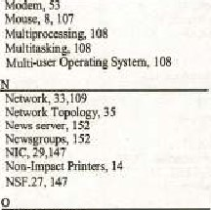

o»jcct calc, 87

 10 Office Autmnatiom, $0

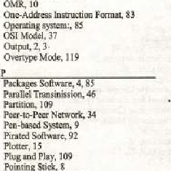

primary parti%i•. 109 Printer. la

|  |
| --- |
| 163  16 |

Program Counter (PC), SC

PROM. 75

Ptoteeol. YO



Read Operation. 75

Receiver, 42

Recycle bin, 106

Redo, 120

Register. 79-80

RcEativc 136

Resoluti«', 12 Ring

ROM. 75

Sans-%nf Satellite, 32 snu•r 18

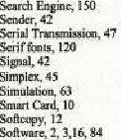

Wker.

15

Spreadsheel. 133-134 SRAM. 74

Stxk Pointe.

Tmlogy.

SVGA, 12

SynchrmOuS 48

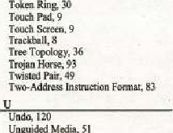Uneuided Media,

Unicode, 44

URL. 14M50

61

Vidw Display Adapter, 12

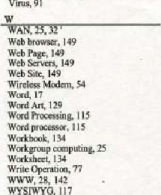

Virus,

9

WYSIWYG,

x



System, 18

Systcm Analysis, 19

System Bus, 76

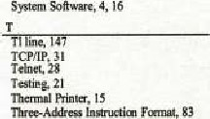



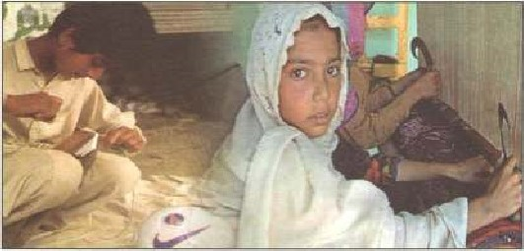Child is meant to learn not to earn.



Drugs

drag

you

down,

down,

tillyou

are

under

thegmund.

|  |  |  |  |
| --- | --- | --- | --- |
| Punjab Curriculum end Textbook Board yovides standard temtbcaks ai low price according to the approved CcjtriCLjle. Suggestions ere tequesled for improvementcfthese books pointing aul any error in spellings, contents. etc.  Managin Director  Cumtt.*um | | | |
|  |  |  |  |



PUNJAB CURRICULUM AND

TEXTBOOK BOARD, LAHORE